**UI Standards**

**Layout:** Bootstrap

**Color Scheme :** Red Black White

**Font :** Helvetica

**Modal:** Yes

**Carousel:** Yes

**Responsive UI:** Yes

**Widgets:**

Facebook

Twitter

Instagram

**Button**

**Names:**

* Submit : Submit
* Log In : Log In
* Exit : X

**Attributes:**

* Filled
* Text-centered
* Red
* Text: White

**System Message:**

**Text :** Yes

**Pop-up/Modal :** No

**Error Checking :** Yes

**Text:**

Log In:

Incorrect: “Email address and password did not match”

Sign Up:

Incorrect(Email address is already in used): “Email Address is already taken”

**Sample Screen Designs:**

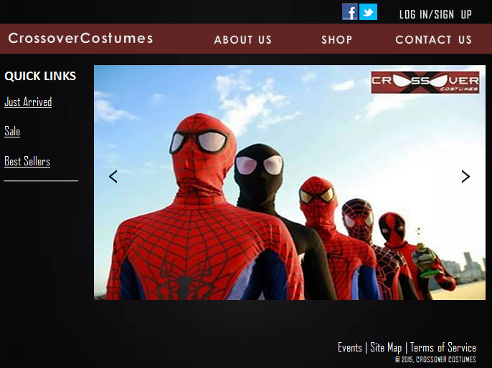**Option 1:**

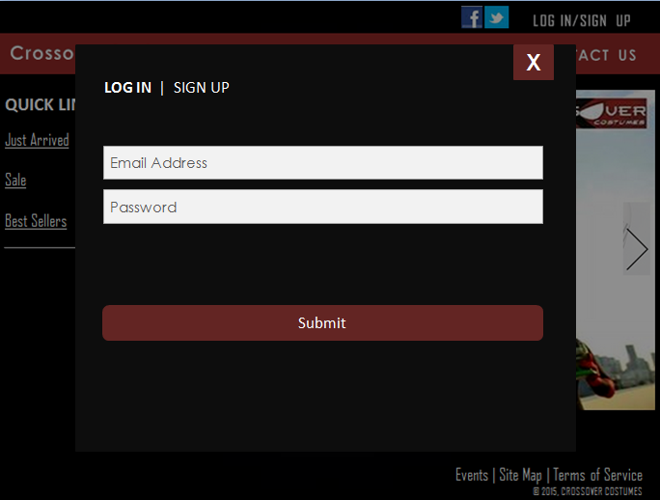

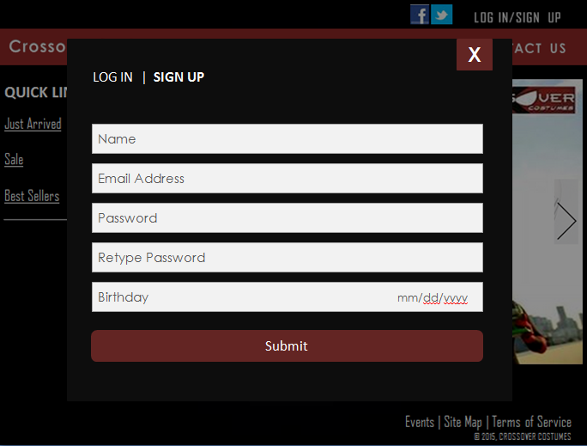

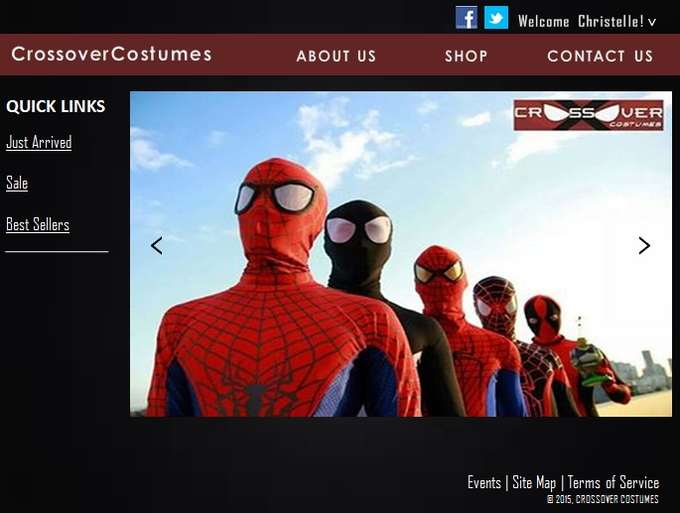

**Option 2:**



