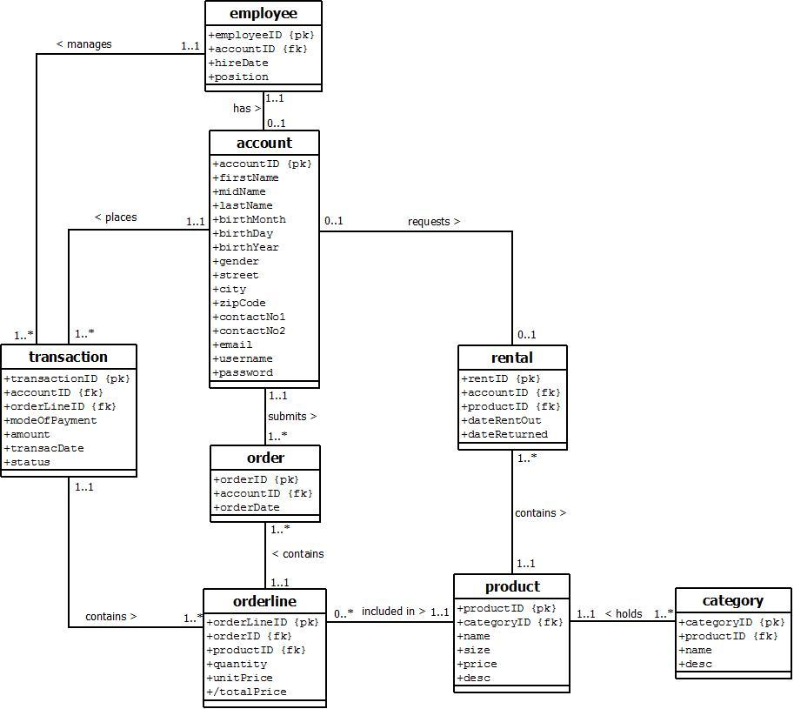

note: please add a short description of the ERD so that we could understand what it means.

each employee has 0-1 account. but what about the clients?

Isn’t employee supposed to be a subclass of account along with master acc and client acc?

employee and master account manages transactions while client accounts can order.

What is the difference of rental and order + orderline? doesn’t it have the same meaning? other than quantity.

apparently there is supposed to be a forSale which was clarified by the analysts. My idea is that you separate orderline into 2 different classes for for Rent and for Sale since rental seems to be the same as order+orderline.

order > forRent

order > forSale

forRent > product

forSale > Product

transaction> order

forSale contains quantity and unit price. total price can be taken from queries.

forRent contains date returned

order will become a superclass and forRent and forSale become a subclass since they both are a type of order.

rechecking:

is account really optional per employee [0..1]?