

**

*By*

Jenolin jeba j

11 a

***Index***

|  |  |  |
| --- | --- | --- |
| **S.No** | **Contents** | **page no** |
| **1.** | **Description** | **Pg : 1** |
| **2.** | **Source Code** | **Pg : 2-41** |
| **3.** | **Output** | **Pg : 42-51** |

**DESCRIPTION :**

The library management system software aims to perform the task involved in the

library such as:

* Books available information
* Borrowing of books
* Reading books
* Returning of books
* Reading magazines, newspapers
* Membership in the library
* Receipt printing

These tasks that happen in a library are included in the software. An user can use the software with the necessary details and permission of the librarian (as there is a need to enter librarian information). Some of the basic personal details are to be given which is mandatory for accessing the software. Once entering the software, the user can perform any task that is mentioned in the bulletin points. Book borrowing, returning and reading not only books, rather magazines and newspapers. At last receipt printing is also done. Membership details regarding a permanent member or a visitor is also collected and further chance for being a permanent member in the library association, is also provided in the software.

This software is used by those users, who are permanent members or visitors for the library. It is useful for making an entry and getting overall details about what the library provides. The librarian name and code is mandatory for accessing the software.

Hence this is a user accessible with very limited restriction offering software which deals with the concept of library management.

1

**Source Code** :

print("*****************************************************************")

print("*****************************************************************")

print("*****************Welcome to DJH Library *******************")

print("****************************************************************")

print("****************************************************************")

namel=input("Enter the librarian name : ")

pw=int(input("Enter your library code :"))

name=input("\nEnter your name : ")

for i in range(1,10):

age=int(input("Enter your age : "))

if age>5 and age<100:

break

else:

print("Enter your correct age")

continue

for i in range(0,10):

gen=input("Gender(male/female) : ")

if gen[0:6]=="female":

break

elif gen[0:4]=="male":

break

else:

continue

2

for i in range(1,10):

date=input("Date(DD/MM/YYYY) : ")

if "2020" in date:

break

elif "2021" in date:

break

else:

continue

add=input("Enter your address : ")

for i in range(0,10):

phone=int(input("Phone number : "))

ph=str(phone)

if len(ph)!=10:

p=print("*****Give the Correct Phone number*****")

continue

else:

break

#Library books available

for i in range(1,20):

choice=int(input("\nTypes of book available are :\n\t1.General book \n\t2.Noval book \n\t3.Fantasy and Comic Book\n\t4.Action and Adventure \n\t5.Horror,Detective and Mystery \n\t6.Move onto the next step.\n\nEnter the type of book you recommend :"))

if choice==1:

print("\nGeneral book")

choice=int(input("\n The books under this category are:\n\t1.Encyclopedia \n\t2.General knowledge quiz book \n\t3.Oxford Dictionary\n\nSelect the book :"))

3

if choice==1:

print("\nTitle of the book : Encyclopedia")

aut="Jean le Rond d Alembert and Denis Diderot"

acc=101

typ="Scholarly source"

print("Author of the book :",aut)

print("Account number :",acc)

print("Type of book :",typ)

elif choice==2:

print("\nTitle of the book : General knowledge quiz book")

aut="Derek O Brien"

acc=102

typ="Quiz"

print("Author of the book :",aut)

print("Account number :",acc)

print("Type of book :",typ)

elif choice==3:

print("\nTitle of the book : Oxford Dictionary")

pub="Oxford University Press"

acc=103

typ="Dictionary"

print("Publisher of the book :",pub)

print("Account number :",acc)

print("Type of book :",typ)

else:

print("\nIf you want other general book please say us")

general=input("Enter the general book name : ")

4

elif choice==2:

print("\nNoval book")

choice=int(input("\nThe books under this category are \n\t1.Normal People \n\t2.An Era of Darkness \n\t3.Fear:Trump in the White House \n\t4.The Farthest Field \n\t5.Golden Child \n\t6.Half The Night Is Gone \n\t7.The Overstory \n\t8.Interior Chinatown \n\t9. King and the Dragonflies \n\t10.The Dead Are Arising : The Life of Malcolm X\n\nSelect the type of noval book:"))

if choice==1:

print("\nTitle of the book : Normal People")

aut="Sally Rooney"

acc=201

typ="Love Story"

Award="Costa book award 2019"

print("Author of thebook :",aut)

print("Account number :",acc)

print("Type of book :",typ)

print("Award :",Award)

elif choice==2:

print("\nTitle of the book : An Era of Darkness")

aut="Shashi Tharoor"

acc=202

typ="Inglorious Empire"

Award="Sahitya Akademi Award 2019"

print("Author of the book :",aut)

print("Account number :",acc)

print("Type of book :",typ)

print("Award :",Award)

5

elif choice==3:

print("\nTitle of the book - Fear:Trump in the White House")

aut="Bob Woodward"

acc=203

typ="Story of the President of the United of America"

Award="PEN America Literary Service Award 2019"

print("Author of the book :",aut)

print("Account number :",acc)

print("Type of book :",typ)

print("Award :",Award)

elif choice==4:

print("\nTitle of the book : The Farthest Field")

aut="Raghu Karnad"

acc=204

typ="non-friction"

print("Author of the book :",aut)

print("Account number :",acc)

print("Type of book :",typ)

elif choice==5:

print("\nTitle of the book : Golden Child")

aut="Claira Adam"

acc=205

typ="Story about Clyde and his twin sons"

Award="Desmond Elliott Prize"

print("Author of the book :",aut)

print("Account number :",acc)

print("Type of book :",typ)

6

print("Award :",Award)

elif choice==6:

print("\nTitle of the book : Half The Night Is Gone")

aut="Amitabha Bagchi"

acc=206

Award="DSC Prize"

print("Author of the book :",aut)

print("Account number :",acc)

print("Award :",Award)

elif choice==7:

print("\nTitle of the book : The Overstory")

aut="Richard Power"

acc=207

typ="Tree and people(Friction)"

Award="Pulitzer Prize"

print("Author of the book :",aut)

print("Account number :",acc)

print("Type of book :",typ)

print("Award :",Award)

elif choice==8:

print("\nTitle of the book : Interior Chinatown")

aut="Charles Yu"

acc=208

typ="Friction"

print("Author of the book :",aut)

print("Account number :",acc)

print("Type of book :",typ)

7

elif choice==9:

print("\nTitle of the book : King and the Dragonflies")

aut= "Kacen Callender"

acc=209

typ="Young people literature"

print("Author of the book :",aut)

print("Account number :",acc)

print("Type of book :",typ)

elif choice==10:

print("\nTitle of the book - The Dead Are Arising: The Life of Malcolm X")

aut="Les Payne and Tamara Payne"

acc=210

typ="Non-friction"

print("Author of the book :",aut)

print("Account number :",acc)

print("Type of book :",typ)

else:

print("\nIf you want other noval book please say us")

noval=input("Enter the noval name : ")

elif choice==3:

print("\nFantasy and Comic Book")

choice=int(input("\nThe books under this category are\n\t1.Nimona \n\t2.Saga \n\t3.The Secret of the nagas \n\t4.Rat Queen \n\t5.The spire \n\t6.The Stonekeeper \n\t7.Seven to Eternity \n\t8.Sandman \n\t9.Bone \n\t10.Birthright\n\nSelect the type of Fantasy and Comic book:"))

if choice==1:

print("\nTitle of the book : Nimona")

8

aut="Noelle Stevenson"

acc=301

print("Author of the book :",aut)

print("Account number :",acc)

elif choice==2:

print("\nTitle of the book : Saga")

aut="Brian K.Vaughan,Fiona Staples"

acc=302

print("Author of the book :",aut)

print("Account number :",acc)

elif choice==3:

print("\nTitle of the book : The Secret of the nagas")

aut="Amish Tripathi"

acc=303

print("Author of the book :",aut)

print("Account number :",acc)

elif choice==4:

print("\nTitle of the book : Rat Queen")

aut="Kurtis J Wiebe,Roc Upchurch"

acc=304

print("Author of the book :",aut)

print("Account number :",acc)

elif choice==5:

print("\nTitle of the book : The spire")

aut="Simon Sprrier,Jeff Stokely"

acc=305

print("Author of the book :",aut)

9

print("Account number :",acc)

elif choice==6:

print("\nTitle of the book : The Stonekeeper")

aut="Kazu Kibuishi"

acc=306

print("Author of the book :",aut)

print("Account number :",acc)

elif choice==7:

print("\nTitle of the book : Seven to Eternity")

aut="Rich Remender,Jerome Opena"

acc=307

print("Author of the book :",aut)

print("Account number :",acc)

elif choice==8:

print("\nTitle of the book : Sandman ")

aut="Neil Gaiman"

acc=308

print("Author of the book :",aut)

print("Account number :",acc)

elif choice==9:

print("\nTitle of the book : Bone")

aut="Jeff Smith"

acc=309

print("Author of the book :",aut)

print("Account number :",acc)

elif choice==10:

print("\nTitle of the book : Birthright")

10

aut="Nora Roberts"

acc=310

print("Author of the book :",aut)

print("Account number :",acc)

else:

print("\nIf you want other fantasy and comic book please say us")

fantasy , comic=input("Enter the fantasy and comic book name : ")

elif choice==4:

print("\nAction and Adventure")

choice=int(input("\nThe books under this category are \n\t1.Jurassic Park \n\t2.The Hunger Game \n\t3.The Da Vinci Code \n\t4.The Bourne Identity \n\t5.Divergent \n\t6.The Count of Monte Cristo \n\t7.The Hunt for Red October \n\t8.Harry Potter \n\t9.Rhythm of War \n\t10.Devoted\n\nSelect the type of action and adventure book:"))

if choice==1:

print("\nTitle of the book : Jurassic Park")

aut="Michael Crichton"

acc=401

print("Author of the book :",aut)

print("Account number :",acc)

elif choice==2:

print("\nTitle of the book : The Hunger Game")

aut="Suzanne Collins"

acc=402

print("Author of the book :",aut)

print("Account number :",acc)

11

elif choice==3:

print("\nTitle of the book :The Da Vinci Code")

aut="Dan Brown"

acc=403

print("Author of the book :",aut)

print("Account number :",acc)

elif choice==4:

print("\nTitle of the book : The Bourne Identity ")

aut="Robert Ludlum"

acc=404

print("Author of the book :",aut)

print("Account number :",acc)

elif choice==5:

print("\nTitle of the book : Divergent ")

aut="Veronica Roth"

acc=405

print("Author of the book :",aut)

print("Account number :",acc)

elif choice==6:

print("\nTitle of the book : The Count of Monte Cristo")

aut="Alexandre Dumas"

acc=406

print("Author of the book :",aut)

print("Account number :",acc)

elif choice==7:

print("\nTitle of the book : The Hunt for Red October")

aut="Tom Clancy"

12

acc=407

print("Author of the book :",aut)

print("Account number :",acc)

elif choice==8:

print("\nTitle of the book : Harry Potter ")

aut="J.K. Rowling."

acc=408

print("Author of the book :",aut)

print("Account number :",acc)

elif choice==9:

print("\nTitle of the book : Rhythm of War ")

aut=" Brandon Sanderson"

acc=409

print("Author of the book :",aut)

print("Account number :",acc)

elif choice==10:

print("\nTitle of the book : Devoted")

aut="Dean Koontz"

acc=410

print("Author of the book :",aut)

print("Account number :",acc)

else:

print("\nIf you want other action and adventure book please say us")

action , adventure=input("Enter the action and adventure book name : ")

13

elif choice==5:

print("\nHorror,Detective and Mystery")

choice=int(input("\nThe books under this category are\n\t1.The Last Dickens \n\t2.Bookhunter \n\t3.The Turkish Gambit \n\t4.The Hound of the Baskervilles \n\t5.Dracula \n\t6.The Mystery of Marie Roget \n\t7.The Silence of the Lambs \n\t8.Last Days \n\t9.The Shining \n\t10.Red Dragon\n\nSelect the type of Horror,Detective and Mystery book :"))

if choice==1:

print("\nTitle of the book : The Last Dickens")

aut="Matthew Pearl"

acc=501

print("Author of the book :",aut)

print("Account number :",acc)

elif choice==2:

print("\nTitle of the book :Bookhunter")

aut="John Hill Burton"

acc=502

print("Author of the book :",aut)

print("Account number :",acc)

elif choice==3:

print("\nTitle of the book : The Turkish Gambit ")

aut="Boris Akunin"

acc=503

print("Author of the book :",aut)

print("Account number :",acc)

elif choice==4:

print("\nTitle of the book : The Hound of the Baskervilles")

aut="Arthur Conan Doyle"

14

acc=504

print("Author of the book :",aut)

print("Account number :",acc)

elif choice==5:

print("\nTitle of the book : Dracula ")

aut="Bram Stoker"

acc=505

print("Author of the book :",aut)

print("Account number :",acc)

elif choice==6:

print("\nTitle of the book : The Mystery of Marie Roget")

aut="Edgar Allan Poe"

acc=506

print("Author of the book :",aut)

print("Account number :",acc)

elif choice==7:

print("\nTitle of the book : The Silence of the Lambs ")

aut="Thomas Harris"

acc=507

print("Author of the book :",aut)

print("Account number :",acc)

elif choice==8:

print("\nTitle of the book : Last Days")

aut="Adam Nevill"

acc=508

print("Author of the book :",aut)

print("Account number :",acc)

15

elif choice==9:

print("\nTitle of the book : The Shining ")

aut="Stephen King"

acc=509

print("Author of the book :",aut)

print("Account number :",acc)

elif choice==10:

print("\nTitle of the book : Red Dragon")

aut="Thomas Harris"

acc=510

print("Author of the book :",aut)

print("Account number :",acc)

else:

print("\nIf you want other Horror,Detective and Mystery book please say us")

Horror,Detective ,Mystery=input("Enter the Horror,Detective and Mystery book name : ")

elif choice==6:

break

print("\nYou are here to:")

choice=int(input("\n\t1.Borrow a book \n\t2.Read a book \n\t3.Return the book \n\t4.Read a newspaper \n\t5.Read a magazine\nEnter the choice : "))

print("\nYou can enter the library ")

print("\n.........After your work is done,you have to answer some questions and then get a receipt to leave the library...........")

if choice==1:

print("\n**********************************************************\n")

print("\n************** You have borrowed a book ************\n")

16

print("\n**********************************************************\n")

for i in range(1,10):

n=input("Name : ")

if n==name:

break

else:

print("Enter the same name as above")

continue

for i in range(1,10):

a=int(input("Age : "))

if a==age:

break

else:

print("Enter the same age as above")

continue

for i in range(0,10):

gen=input("Gender(male/female) : ")

if gen[0:6]=="female":

break

elif gen[0:4]=="male":

break

else:

continue

for i in range(1,10):

phone=int(input("Phone number : "))

ph=str(phone)

17

if len(ph)!=10:

p=print("*****Give the Correct Phone number*****")

continue

else:

break

a=input("Address : ")

for i in range(1,10):

nl=input("In which language do you want the book(english/malayalam/tamil/telugu/kannadam/hindi) : ")

if nl=="english" or nl=="malayalam" or nl=="tamil" or nl=="telugu" or nl=="kannadam" or nl=="hindi":

break

else:

continue

ls=[101,102,103,201,202,203,204,205,206,207,208,209,210,301,302,303,304,305,306,307,308,309,310,401,402,403,404,405,406,407,408,409,410,501,502,503,504,505,506,507,508,509,510]

l=len(ls)

while True:

ac=int(input("Account number of the book : "))

if ac in [101,102,103]:

print("General book\n\t1.Encyclopedia\n\t2.General knowledge quiz book\n\t3.Oxford Dictionary")

t=int(input("Title of the book : "))

break

18

elif ac in[201,202,203,204,205,206,207,208,209,210]:

print("Noval book \n\t1.Normal People\n\t2.An Era of Darkness\n\t3.Trump in the White House\n\t4.The Farthest Field\n\t5.Golden Child\n\t6.Half The Night Is Gone\n\t7.The Overstory\n\t8.Interior chinatown\n\t9.King and the Dragonflies\n\t10.The dead are arising:The Life Of Malcolm X")

t=int(input("Title of the book : "))

break

elif ac in [301,302,303,304,305,306,307,308,309,310]:

print("Fantasy and Comic Book\n\t1.Nimona\n\t2.Saga\n\t3.The Secret of the Nagas\n\t4.Rat Queen\n\t5.The Spire\n\t6.The Stonekeeper\n\t7.Seven to Eternity\n\t8.Sandman\n\t9.Bone\n\t10.Birthright")

t=int(input("Title of the book : "))

break

elif ac in [401,402,403,404,405,406,407,408,409,410]:

print("Action and Adventure\n\t1.Jurassic Park\n\t2.The Hunger Game\n\t3.The Da Vinci Code\n\t4.The Bourne Identity\n\t5.Divergent\n\t6.The Count of Monte Cristo\n\t7.The hunt for red october\n\t8.Harry Potter\n\t9.Rhythm of war\n\t10.Devoted")

t=int(input("Title of the book : "))

break

elif ac in [501,502,503,504,505,506,507,508,509,510]:

print("Horror,Detective and Mystery\n\t1.The Last Dickens\n\t2.Bonehunter\n\t3.The Turkish Gambit\n\t4.The Hound of the Baskervilles\n\t5.Dracula\n\t6.The Mystery of Marie Roget\n\t7.The Silence of the lambs\n\t8.Last Days\n\t9.The Shining\n\t10.Red Dragon")

t=int(input("Title of the book : "))

break

pg=int(input("No of pages in a book : "))

for i in range(1,10):

bd=input("Borrowing Date(DD/MM/YYYY): ")

19

if "2020" in bd:

break

elif "2021" in bd:

break

else:

print("Enter a date from the current year or upcoming year(2020/2021)")

continue

for i in range(1,10):

rd=input("Returning Date(DD/MM/YYYY): ")

if "2020" in rd:

break

elif "2021" in rd:

break

else:

print("Enter a date from the current year or upcoming year(2020/2021)")

continue

d=int(input("No of days to be borrowed : "))

amount=d*10

am=print("Amount to be paid on the returning day is ",amount)

print(" ***************** Fine should be paid for late submission of library book **************** ")

elif choice==2:

print("\n***********************************************************\n")

print("\n*************** You have read a book ****************\n ")

print("\n***********************************************************\n")

20

for i in range(1,10):

n=input("Name : ")

if n==name:

break

else:

print("Enter the same name as above")

continue

for i in range(1,10):

a=int(input("Age : "))

if a==age:

break

else:

print("Enter the same age as above")

continue

for i in range(0,10):

gen=input("Gender(male/female) : ")

if gen[0:6]=="female":

break

elif gen[0:4]=="male":

break

else:

continue

for i in range(1,10):

d=input("Date(DD/MM/YYYY): ")

if "2020" in d:

break

21

elif "2021" in d:

break

else:

print("Enter a date correctly(2020/2021)")

continue

ad=input("Address : ")

for i in range(1,10):

nl=input("In which language do you want the book(english/malayalam/tamil/telugu/kannadam/hindi) : ")

if nl=="english" or nl=="malayalam" or nl=="tamil" or nl=="telugu" or nl=="kannadam" or nl=="hindi":

break

else:

continue

ls=[101,102,103,201,202,203,204,205,206,207,208,209,210,301,302,303,304,305,306,307,308,309,310,401,402,403,404,405,406,407,408,409,410,501,502,503,504,505,506,507,508,509,510]

l=len(ls)

while True:

ac=int(input("Account number of the book : "))

if ac in [101,102,103]:

print("General book\n\t1.Encyclopedia\n\t2.General knowledge quiz book\n\t3.Oxford Dictionary")

t=int(input("Title of the book : "))

choice=int(input("Press 1 to continue and 2 to exist : "))

if choice==2:

break

22

else:

continue

elif ac in[201,202,203,204,205,206,207,208,209,210]:

print("Noval book \n\t1.Normal People\n\t2.An Era of Darkness\n\t3.Trump in the White House\n\t4.The Farthest Field\n\t5.Golden Child\n\t6.Half The Night Is Gone\n\t7.The Overstory\n\t8.Interior chinatown\n\t9.King and the Dragonflies\n\t10.The dead are arising:The Life Of Malcolm X")

t=int(input("Title of the book : "))

choice=int(input("Press 1 to continue and 2 to exist : "))

if choice==2:

break

else:

continue

elif ac in [301,302,303,304,305,306,307,308,309,310]:

print("Fantasy and Comic Book\n\t1.Nimona\n\t2.Saga\n\t3.The Secret of the Nagas\n\t4.Rat Queen\n\t5.The Spire\n\t6.The Stonekeeper\n\t7.Seven to Eternity\n\t8.Sandman\n\t9.Bone\n\t10.Birthright")

t=int(input("Title of the book : "))

choice=int(input("Press 1 to continue and 2 to exist:"))

if choice==2:

break

else:

continue

elif ac in [401,402,403,404,405,406,407,408,409,410]:

print("Action and Adventure\n\t1.Jurassic Park\n\t2.The Hunger Game\n\t3.The Da Vinci Code\n\t4.The Bourne Identity\n\t5.Divergent\n\t6.The Count of Monte Cristo\n\t7.The hunt for red october\n\t8.Harry Potter\n\t9.Rhythm of war\n\t10.Devoted")

t=int(input("Title of the book : "))

23

choice=int(input("Press 1 to continue and 2 to exist : "))

if choice==2:

break

else:

continue

elif ac in [501,502,503,504,505,506,507,508,509,510]:

print("Horror,Detective and Mystery\n\t1.The Last Dickens\n\t2.Bonehunter\n\t3.The Turkish Gambit\n\t4.The Hound of the Baskervilles\n\t5.Dracula\n\t6.The Mystery of Marie Roget\n\t7.The Silence of the lambs\n\t8.Last Days\n\t9.The Shining\n\t10.Red Dragon")

t=int(input("Title of the book : "))

choice=int(input("Press 1 to continue and 2 to exist:"))

if choice==2:

break

else:

continue

elif choice==3:

print("\n***********************************************************\n")

print("\n**************** You returned the book ****************\n")

print("\n***********************************************************\n")

for i in range(1,10):

n=input("Name : ")

if n==name:

break

else:

print("Enter the same name as above")

continue

24

for i in range(1,10):

a=int(input("Age : "))

if a==age:

break

else:

print("Enter the same age as above")

continue

for i in range(0,10):

gen=input("Gender(male/female) : ")

if gen[0:6]=="female":

break

elif gen[0:4]=="male":

break

else:

continue

ad=input("Address : ")

for i in range(0,10):

phone=int(input("Phone number : "))

ph=str(phone)

if len(ph)!=10:

p=print("*****Give the Correct Phone number*****")

continue

else:

break

25

ls=[101,102,103,201,202,203,204,205,206,207,208,209,210,301,302,303,304,305,306,307,308,309,310,401,402,403,404,405,406,407,408,409,410,501,502,503,504,505,506,507,508,509,510]

l=len(ls)

while True:

ac=int(input("Account number of the book : "))

if ac in [101,102,103]:

print("General book\n\t1.Encyclopedia\n\t2.General knowledge quiz book\n\t3.Oxford Dictionary")

t=int(input("Title of the book : "))

break

elif ac in[201,202,203,204,205,206,207,208,209,210]:

print("Noval book \n\t1.Normal People\n\t2.An Era of Darkness\n\t3.Trump in the White House\n\t4.The Farthest Field\n\t5.Golden Child\n\t6.Half The Night Is Gone\n\t7.The Overstory\n\t8.Interior chinatown\n\t9.King and the Dragonflies\n\t10.The dead are arising:The Life Of Malcolm X")

t=int(input("Title of the book : "))

break

elif ac in [301,302,303,304,305,306,307,308,309,310]:

print("Fantasy and Comic Book\n\t1.Nimona\n\t2.Saga\n\t3.The Secret of the Nagas\n\t4.Rat Queen\n\t5.The Spire\n\t6.The Stonekeeper\n\t7.Seven to Eternity\n\t8.Sandman\n\t9.Bone\n\t10.Birthright")

t=int(input("Title of the book : "))

break

26

elif ac in [401,402,403,404,405,406,407,408,409,410]:

print("Action and Adventure\n\t1.Jurassic Park\n\t2.The Hunger Game\n\t3.The Da Vinci Code\n\t4.The Bourne Identity\n\t5.Divergent\n\t6.The Count of Monte Cristo\n\t7.The hunt for red october\n\t8.Harry Potter\n\t9.Rhythm of war\n\t10.Devoted")

t=int(input("Title of the book : "))

break

elif ac in [501,502,503,504,505,506,507,508,509,510]:

print("Horror,Detective and Mystery\n\t1.The Last Dickens\n\t2.Bonehunter\n\t3.The Turkish Gambit\n\t4.The Hound of the Baskervilles\n\t5.Dracula\n\t6.The Mystery of Marie Roget\n\t7.The Silence of the lambs\n\t8.Last Days\n\t9.The Shining\n\t10.Red Dragon")

t=int(input("Title of the book : "))

break

for i in range(1,10):

bda=input("Date in which the book is borrowed(DD/MM/YYYY): ")

if "2020" in bda:

break

elif "2021" in bda:

break

else:

print("Enter a date from the current year or upcoming year(2020/2021)")

continue

for i in range(1,10):

dat=input("Date in which book should be returned(mentioned on the borrowing day)(DD/MM/YYYY): ")

if "2020" in dat:

break

27

elif "2021" in dat:

break

else:

print("Enter a date from the current year or upcoming year(2020/2021)")

continue

d2=int(input("Number of days you should have the book : "))

for i in range(1,10):

rda=input("Date in which the book is returned(DD/MM/YYYY): ")

if "2020" in rda:

break

elif "2021" in rda:

break

else:

print("Enter a date from the current year or upcoming year(2020/2021)")

continue

if dat!=rda:

print(" ***************** Fine should be paid for late submission of library book **************** ")

d3=int(input("No of extra days you had the book : "))

d4=(d2*10)+(d3*15)

am=print("Amount that should be paid today including the fine is RS.",d4)

else:

du=int(input("Number of days you had the book : "))

amo=du*10

am=print("Amount to be paid today is ",amo)

28

elif choice==4:

print("\n***********************************************************\n")

print("\n************** You have read a newspaper ***********\n")

print("\n***********************************************************\n")

for i in range(1,10):

n=input("Name : ")

if n==name:

break

else:

print("Enter the same name as above")

continue

for i in range(1,10):

a=int(input("Age : "))

if a==age:

break

else:

print("Enter the same age as above")

continue

for i in range(0,10):

gen=input("Gender(male/female) : ")

if gen[0:6]=="female":

break

elif gen[0:4]=="male":

break

else:

continue

29

for i in range(1,10):

dn=input("Date(DD/MM/YYYY): ")

if "2020" in dn:

break

elif "2021" in dn:

break

else:

print("Enter a date from the current year or upcoming year(2020/2021)")

continue

ad=input("Address : ")

for i in range(1,10):

nl=input("In which language do you want the newspaper(english/malayalam/tamil/telugu/kannadam/hindi) : ")

if nl=="english" or nl=="malayalam" or nl=="tamil" or nl=="telugu" or nl=="kannadam" or nl=="hindi":

break

else:

continue

newsp=input("The newspaper that you recommend is ")

elif choice==5:

print("\n***********************************************************\n")

print("\n************ You have read a magazine **************\n")

print("\n***********************************************************\n")

for i in range(1,10):

n=input("Name : ")

if n==name:

break

30

else:

print("Enter the same name as above")

continue

for i in range(1,10):

a=int(input("Age : "))

if a==age:

break

else:

print("Enter the same age as above")

continue

for i in range(0,10):

gen=input("Gender(male/female) : ")

if gen[0:6]=="female":

break

elif gen[0:4]=="male":

break

else:

continue

for i in range(1,10):

dm=input("Date(DD/MM/YYYY): ")

if "2020" in dm:

break

elif "2021" in dm:

break

else:

print("Enter a date from the current year or upcoming year(2020/2021)")

continue

31

ad=input("Address : ")

for i in range(1,10):

nl=input("In which language do you want the magazine(english/malayalam/tamil/telugu/kannadam/hindi) : ")

if nl=="english" or nl=="malayalam" or nl=="tamil" or nl=="telugu" or nl=="kannadam" or nl=="hindi":

break

else:

continue

m=input("The magazines that you recommend : ")

li=input("Are you a member of the library association(yes/no) : ")

if li=="no" :

no=input("Do you want to be a member of library association(yes/no) : ")

if no=="yes" :

print("\n****************************************************\n")

print("\n**************** Answer these questions to become a member of the library association ****************\n")

print("\n****************************************************\n")

for i in range(1,10):

n=input("Name : ")

if n==name:

break

else:

print("Enter the same name as above")

continue

32

for i in range(1,10):

Age=int(input("Age : "))

if Age==age:

break

else:

print("Enter the same age as above")

continue

if Age>=5 and Age<=15:

print("You belong to kids group")

elif Age>15 and Age<=25:

print("You belong to teenage group")

elif Age>25 and Age<=50:

print("You belong to adult group")

elif Age>50 and Age<=100:

print("You belong to oldage group")

else:

print("Enter your correct age")

for i in range(0,10):

gen=input("Gender(male/female) : ")

if gen[0:6]=="female":

break

elif gen[0:4]=="male":

break

else:

continue

33

for i in range(0,10):

phone=int(input("Phone no : "))

ph=str(phone)

if len(ph)!=10:

p=print("*****Give the Correct Phone number*****")

continue

else:

break

n1=input("Is the whatsapp number same as phone num(yes/no)? ")

if n1=="yes":

print("**Arrival of new books will be notified through whatsapp**")

elif n1=="no":

for i in range(0,10):

n2=int(input("Whatsapp number : "))

n=str(n2)

if len(n)!=10:

p=print("*****Give the Correct Whatsapp number*****")

continue

else:

print("**Arrival of new books will be notified through whatsapp**")

break

else:

print("Enter either (yes) or (no)")

Ad=input("Enter your residental address : ")

Addr=input("Enter your additional address : ")

city=input("Enter your city : ")

g=input("Are you a graduate(yes/no) : ")

34

if g=="yes":

p=input("Enter your profession : ")

elif g=="no":

s=input("Enter your school or college name : ")

r=int(input("Enter your roll number : "))

else:

print("Enter either (yes) or (no)")

Email=input("Enter your email id : ")

Hobbies=input("Enter your special interest or hobbies : ")

bk=input("Books to be recommended : ")

choice=int(input('What will you be using the library for ?\n\t1.Reference\n\t2.Relaxation\n\t3.Knowledge gathering\n\t4.Job seeking\n\t5.All of the above\n\tEnter your choice'))

if choice==1:

print("\nI will you be using the library for Reference\n")

elif choice==2:

print("\nI will you be using the library for Relaxation\n")

elif choice==3:

print("\nI will you be using the library for Knowledge gathering\n")

elif choice==4:

print("\nI will you be using the library for Job seeking\n")

elif choice==5:

print("\nI will you be using the library for All of the above choices\n")

choice=int(input('What section of the library would you like access to ?\n\t1.Magazines\n\t2.Fiction\n\t3.Non-fiction\n\t4.Research&Reference\n\t5.Education\n\t6.Poetry\n\t7.Others\n\tEnter your choice '))

35

if choice==1:

print("\nYou can access Magazines from the first group\n")

elif choice==2:

print("\nYou can access Fiction from the second group\n")

elif choice==3:

print("\nYou can access Non-fiction from the third group\n")

elif choice==4:

print("\nYou can access Reseaerch & Reference from the fourth group\n")

elif choice==5:

print("\nYou can access Education from the fifth group\n")

elif choice==6:

print("\nYou can access Poetry from the sixth group\n")

elif choice==7:

print("\nYou can access Other type of books from seventh to tenth group\n")

print("****************************************************\n")

print("\n******** Now,you are also a member of the library association ********\n")

print("*******************************************************\n")

elif no=="no":

print("\nAs a member you can have many benifits.\nYou can give it a try.\n")

else:

print("Enter either (yes) or (no)")

elif li=="yes":

print("\n******************************************************\n")

print("\n********As a member of the library association,you have to answer some general question*********\n ")

36

print("\n**********************************************************\n")

for i in range(1,10):

n=input("Name : ")

if n==name:

break

else:

print("Enter the same name as above")

continue

for i in range(1,10):

Age=int(input("Age : "))

if Age==age:

break

else:

print("Enter the same age as above")

continue

if Age>=5 and Age<=15:

print("You belong to kids group")

elif Age>15 and Age<=25:

print("You belong to teenage group")

elif Age>25 and Age<=50:

print("You belong to adult group")

elif Age>50 and Age<=100:

print("You belong to oldage group")

else:

print("Enter your correct age.")

37

for i in range(0,10):

gen=input("Gender(male/female) : ")

if gen[0:6]=="female":

break

elif gen[0:4]=="male":

break

else:

continue

for i in range(0,10):

phone=int(input("Phone no : "))

ph=str(phone)

if len(ph)!=10:

p=print("*****Give the Correct Phone number*****")

continue

else:

break

n1=input("Is the whatsapp number same as phone num(yes/no)? ")

if n1=="yes":

print("**Arrival of new books will be notified through whatsapp**")

elif n1=="no":

for i in range(0,10):

n2=int(input("Whatsapp number : "))

n=str(n2)

if len(n)!=10:

p=print("*****Give the Correct Whatsapp number*****")

continue

38

else:

print("**Arrival of new books will be notified through whatsapp**")

break

else:

print("Enter either (yes) or (no)")

Ad=input("Enter your residental address : ")

Addr=input("Enter your additional address : ")

city=input("Enter your city : ")

g=input("Are you a graduate(yes/no) : ")

if g=="yes":

p=input("Enter your profession : ")

elif g=="no":

s=input("Enter your school or college name : ")

r=int(input("Enter your roll number : "))

else:

print("Enter either (yes) or (no)")

Email=input("Enter your email id : ")

Hobbies=input("Enter your special interest or hobbies : ")

choice=int(input('What will you be using the library for?\n\t1.Reference\n\t2.Relaxation\n\t3.Knowledge gathering\n\t4.Job seeking\n\t5.All of the above\nEnter your choice: '))

if choice==1:

print("\nI will you be using the library for Reference\n")

elif choice==2:

print("\nI will you be using the library for Relaxation\n")

elif choice==3:

print("\nI will you be using the library for Knowledge gathering\n")

39

elif choice==4:

print("\nI will you be using the library for Job seeking\n")

elif choice==5:

print("\nI will you be using the library for All of the above choices\n")

choice=int(input('What section of the library would you like access to ?\n\t1.Magazines\n\t2.Fiction\n\t3.Non-fiction\n\t4.Research&Reference\n\t5.Education\n\t6.Poetry\n\t7.Others\nEnter your choice:'))

if choice==1:

print("\nYou can access Magazines from the first group\n")

elif choice==2:

print("\nYou can access Fiction from the second group\n")

elif choice==3:

print("\nYou can access Non-fiction from the third group\n")

elif choice==4:

print("\nYou can access Reseaerch&Reference from the fourth group\n")

elif choice==5:

print("\nYou can access Education from the fifth group\n")

elif choice==6:

print("\nYou can access Poetry belongs from sixth group\n")

elif choice==7:

print("\nYou can access Other type of books from seventh to tenth group\n")

else:

print("Enter either (yes) or (no)")

for i in range (1,10):

aso=input("Are you a member of the library association(yes/no) : ")

if aso=="yes":

break

40

elif aso=="no":

break

else:

print("Enter either (yes) or (no)")

continue

print("You have answered all our questions")

print("\nHere is your receipt : ")

print("\n***************************************************************")

print("\n****************************************************************")

print("********************** DJH Library**************************")

print("*****************************************************************")

print("\tEnter the librarian name : ",namel)

print("\tEnter your library code : ",pw)

print("\n********************Visitor Details*************************")

print("\n\tEnter your name : ",name)

print("\tEnter your age : ",age)

print("\tEnter your gender(male/female) : ",gen)

print("\tDate(DD/MM/YYYY) : ",date)

print("\tEnter your address : ",add)

print("\tPhone number : ",phone)

print("\tAre you a member of the library association(yes/no) : ",aso)

print("\n***You can visit the Library at 9:00 am to 10:00 pm ***")

print("*****Library will be closed on all saturdays*****")

print("************Thank You ,Visit Again Later************")

print("\n***************************************************************")

print("*****************************************************************")

41

**Output** :

**#INTRODUCTION OF THE LIBRARY**

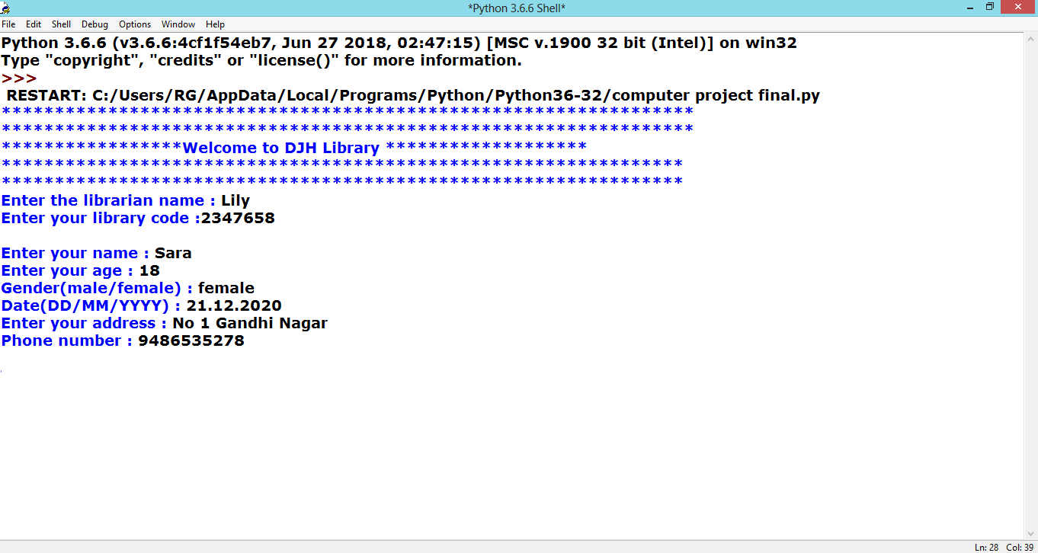

42

**# BOOKS AVAILABLE**

**#GENERAL BOOK**

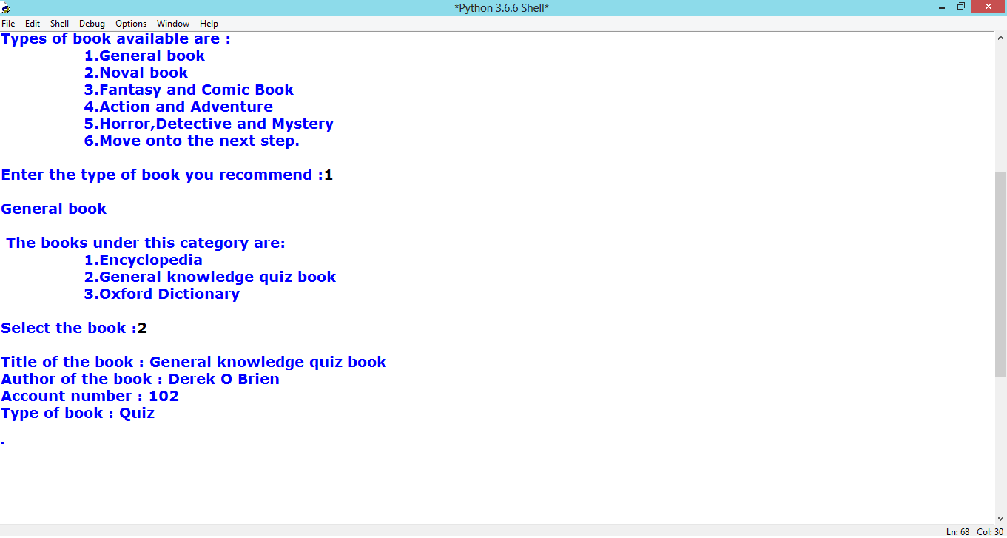

**#NOVAL BOOK**

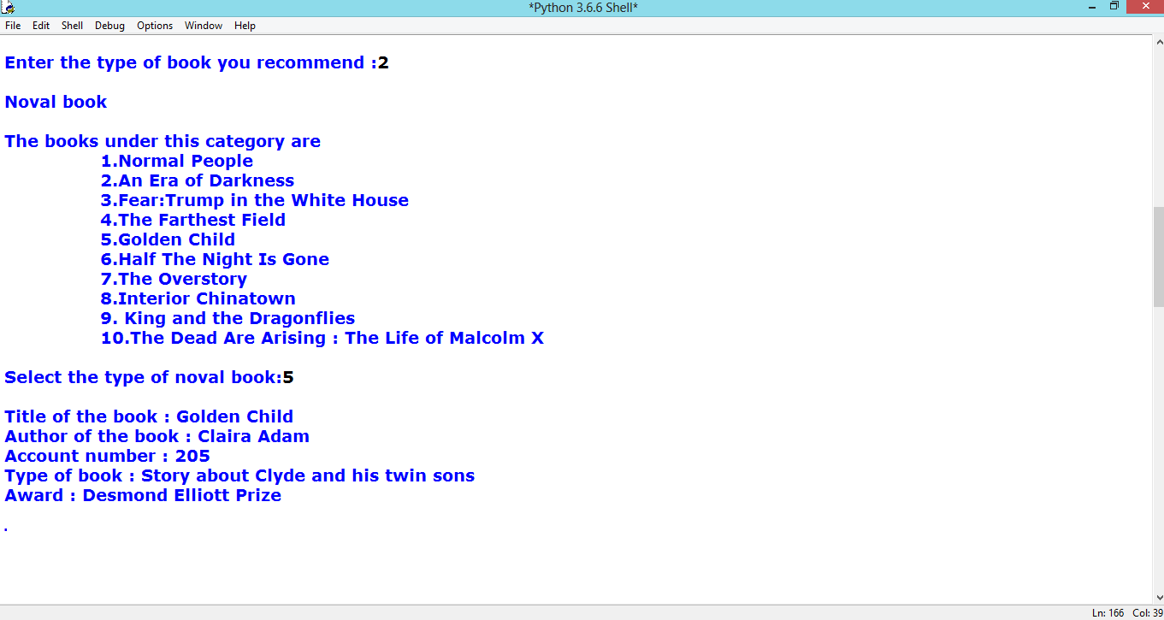

43

**#FANTASY AND COMIC BOOK**

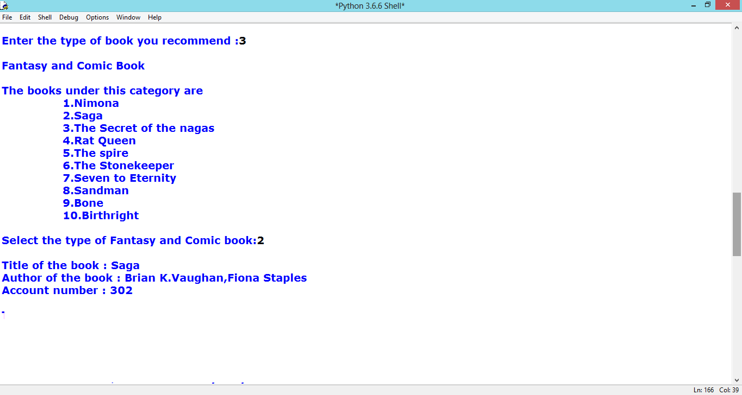

**#ACTION AND ADVENTURE**

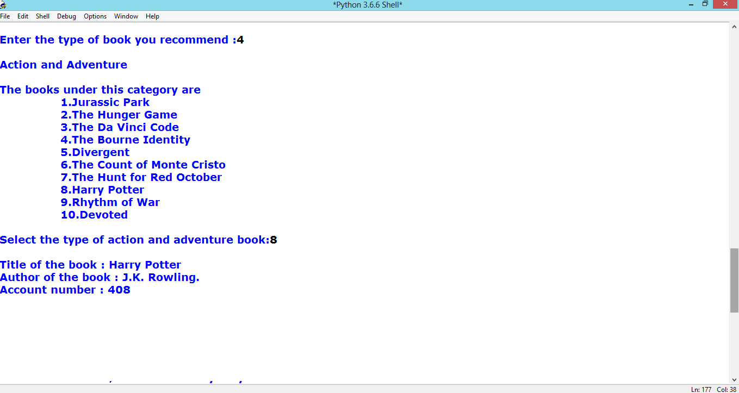

44

**#HORROR , DETECTIVE AND MYSTERY**

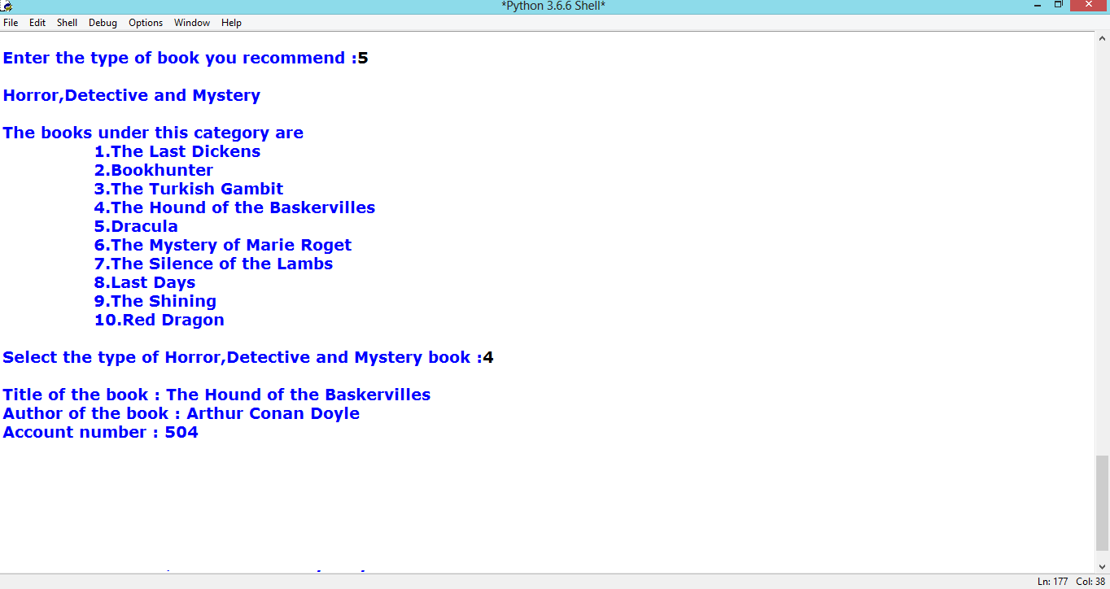

**#MOVE ON TO THE NEXT STEP**

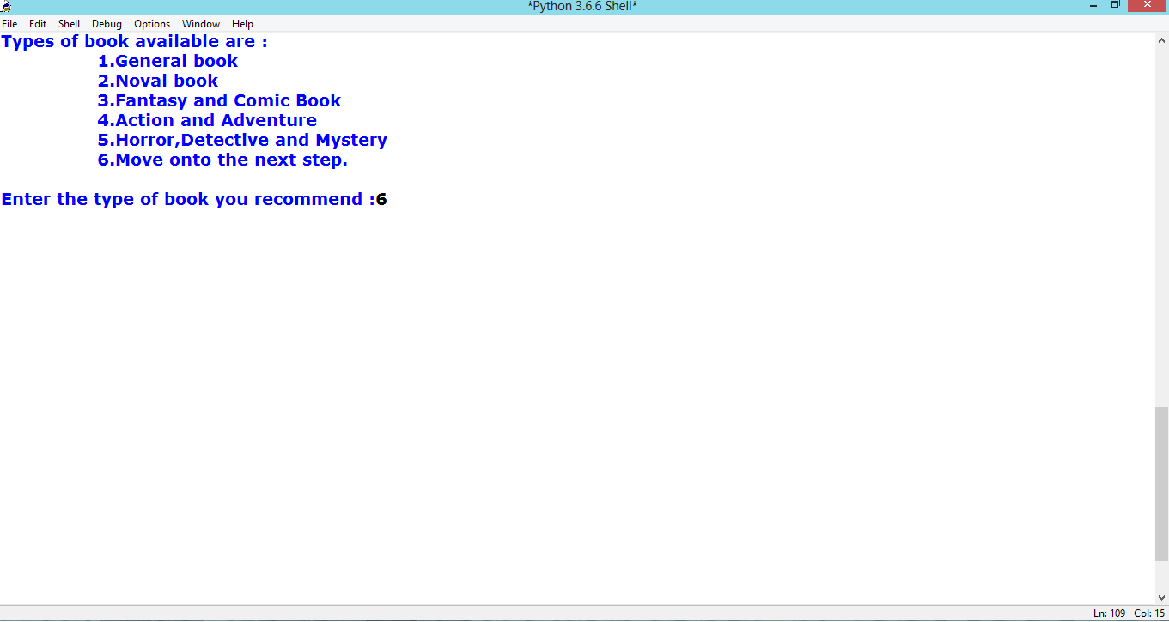

45

**# BORROWING OF THE BOOK**

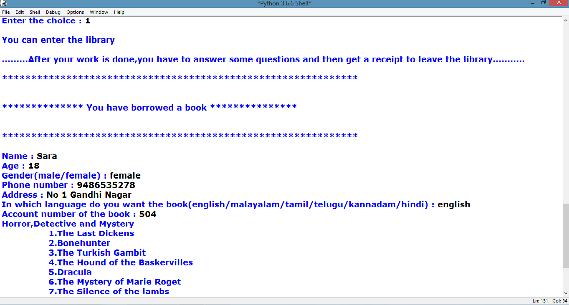

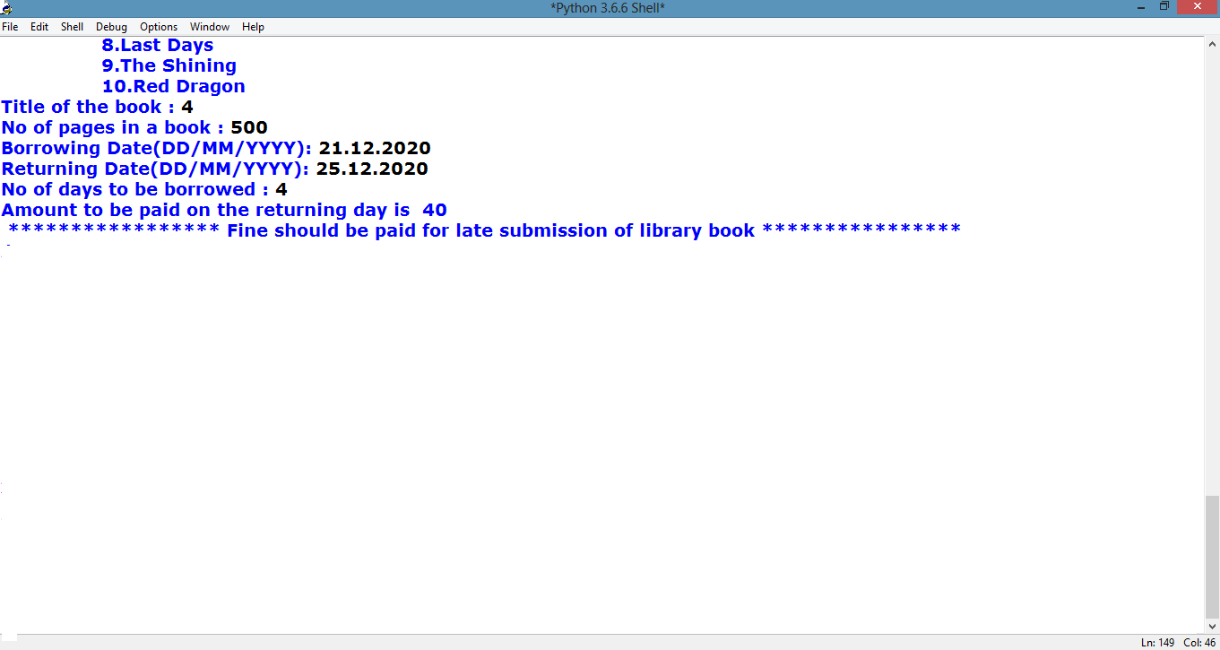

46

**# TO READ A BOOK**

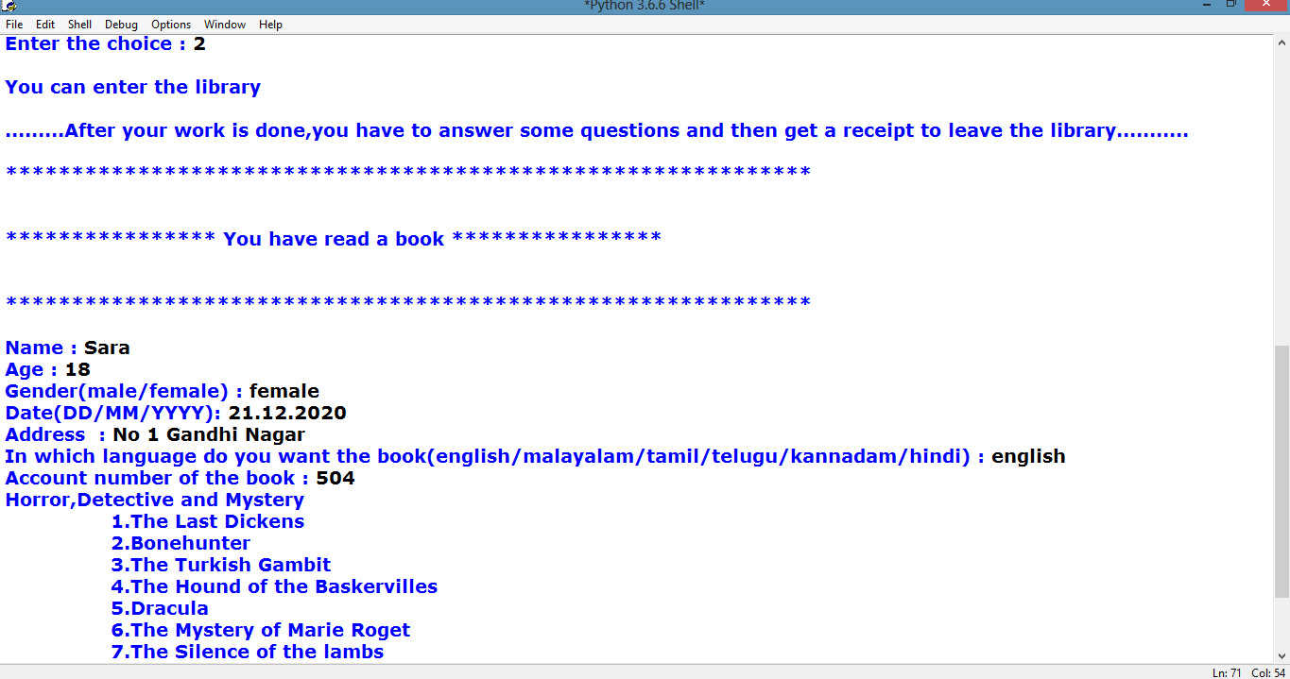

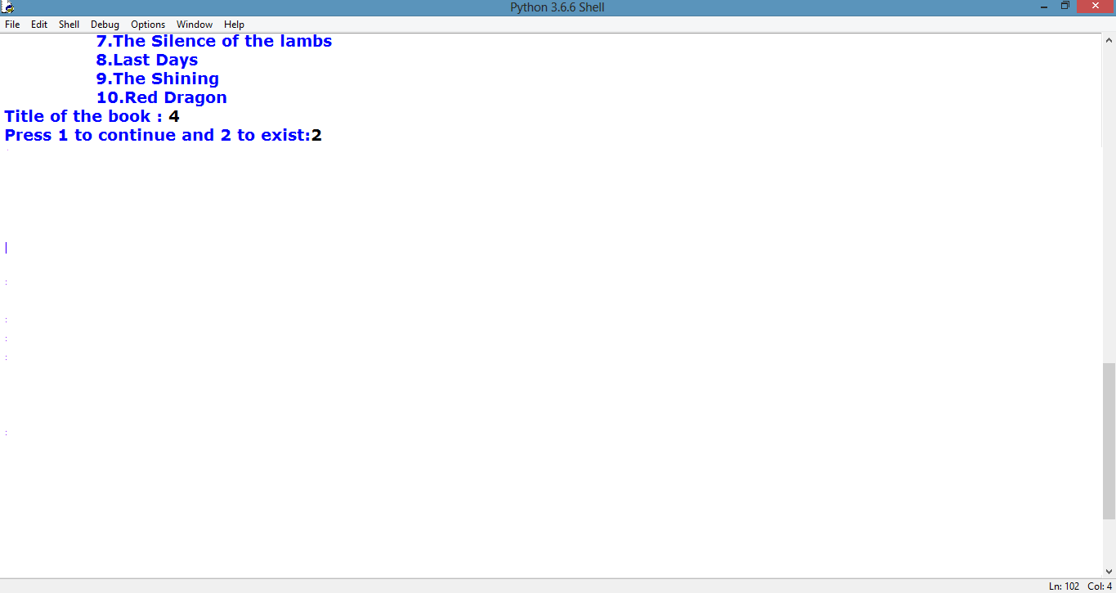

47

**# TO RETURN THE BOOK**

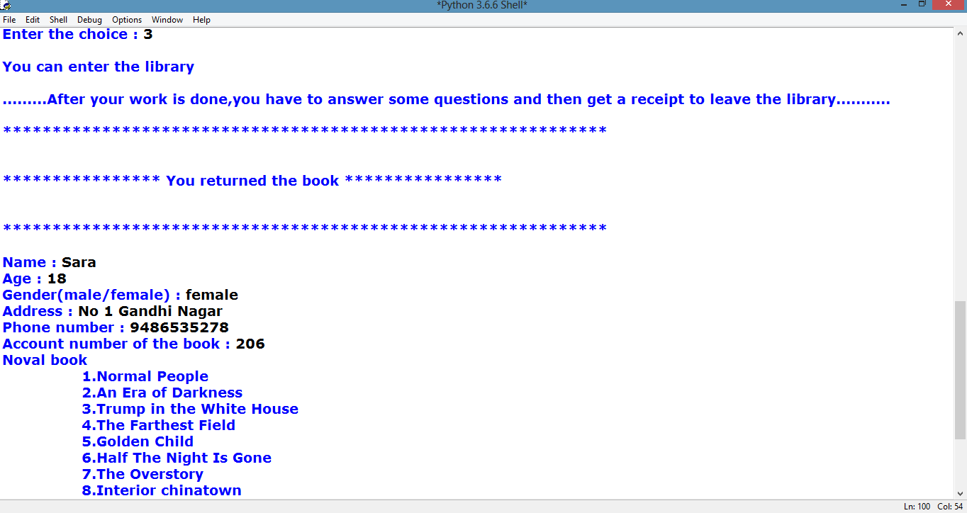

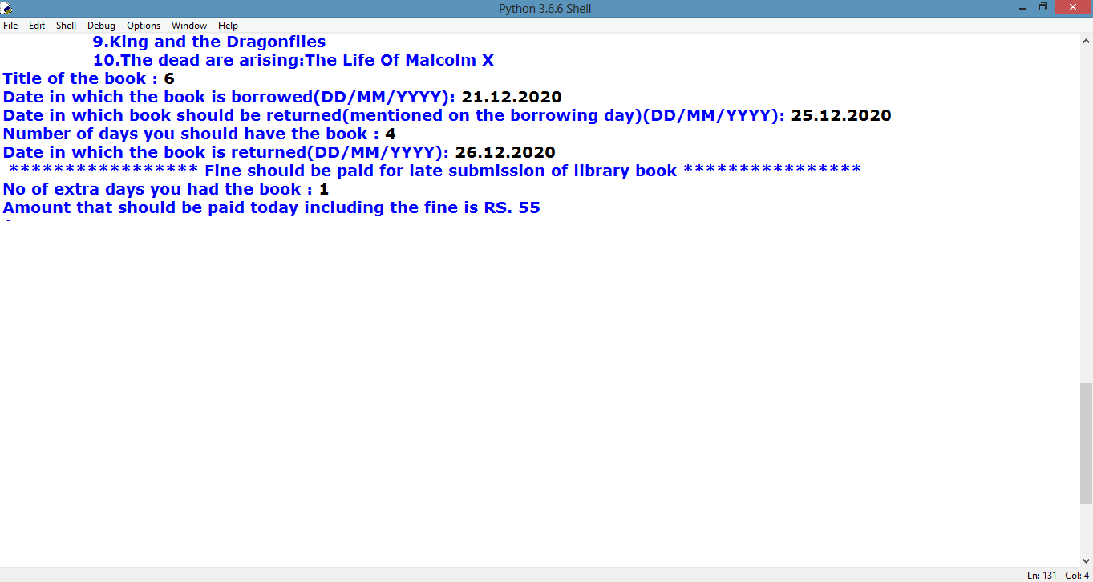

48

**# READ A NEWSPAPER**

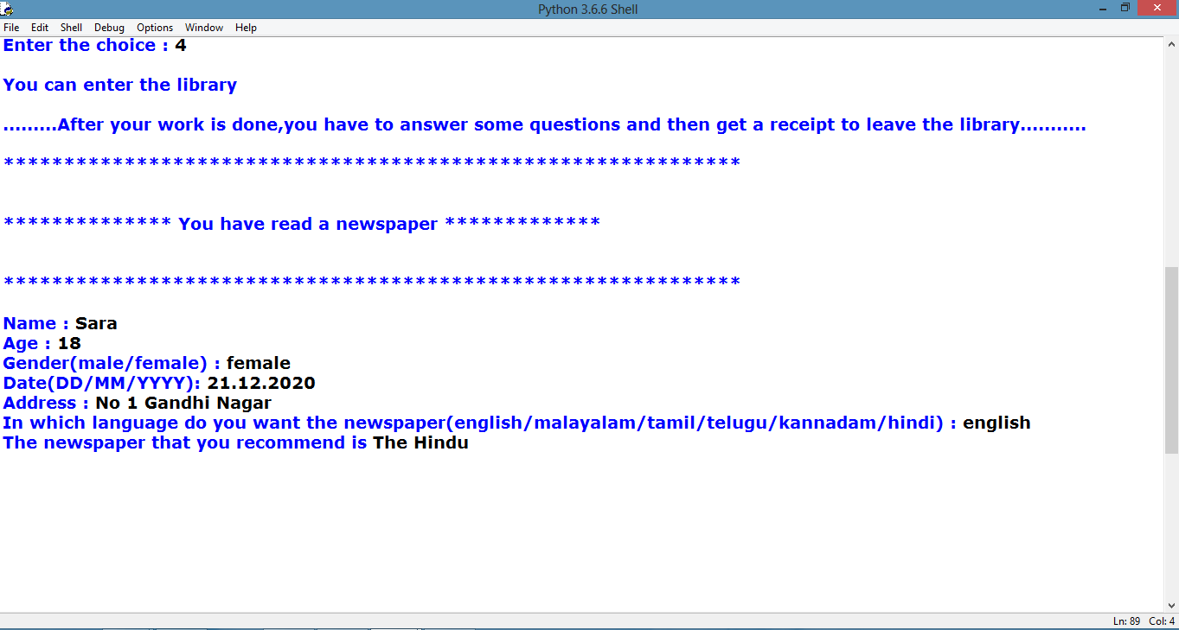

**# READ A MAGAZINE**

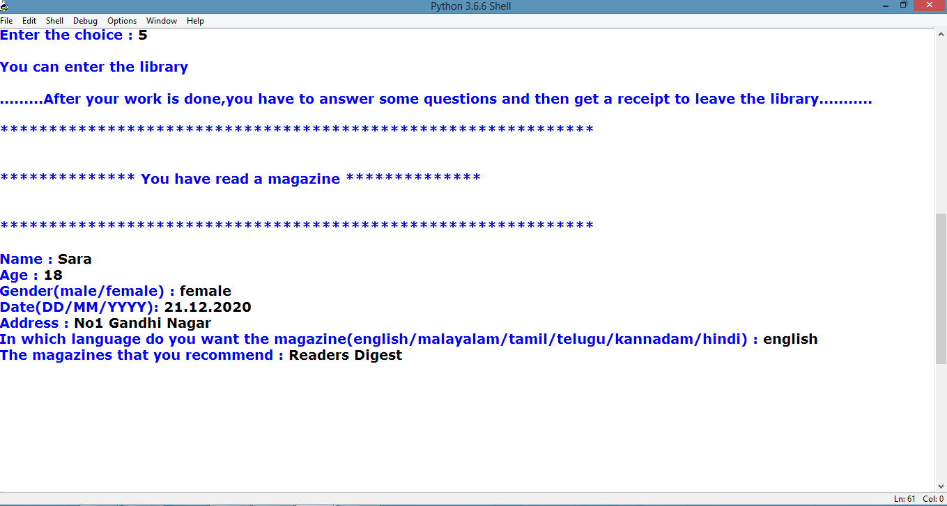

49

**#MEMBERSHIP OF THE LIBRARY**

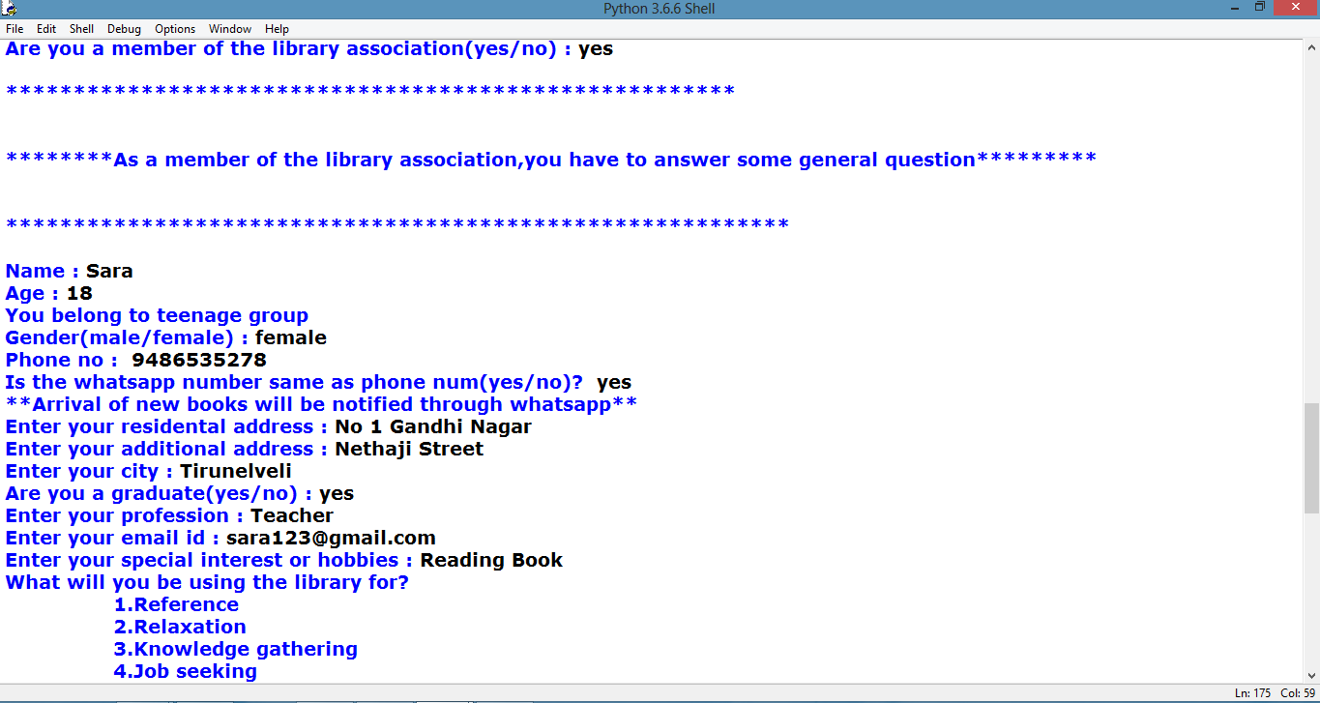

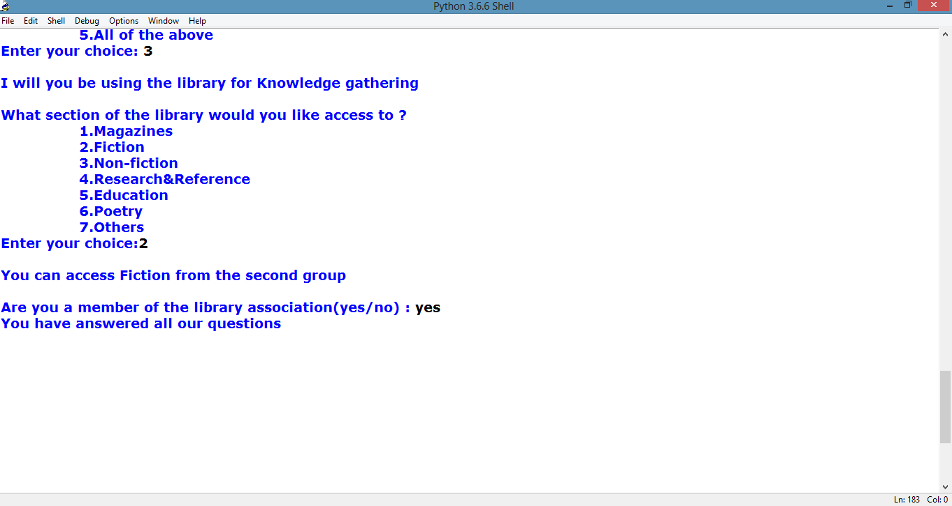

50

**#RECEIPT**

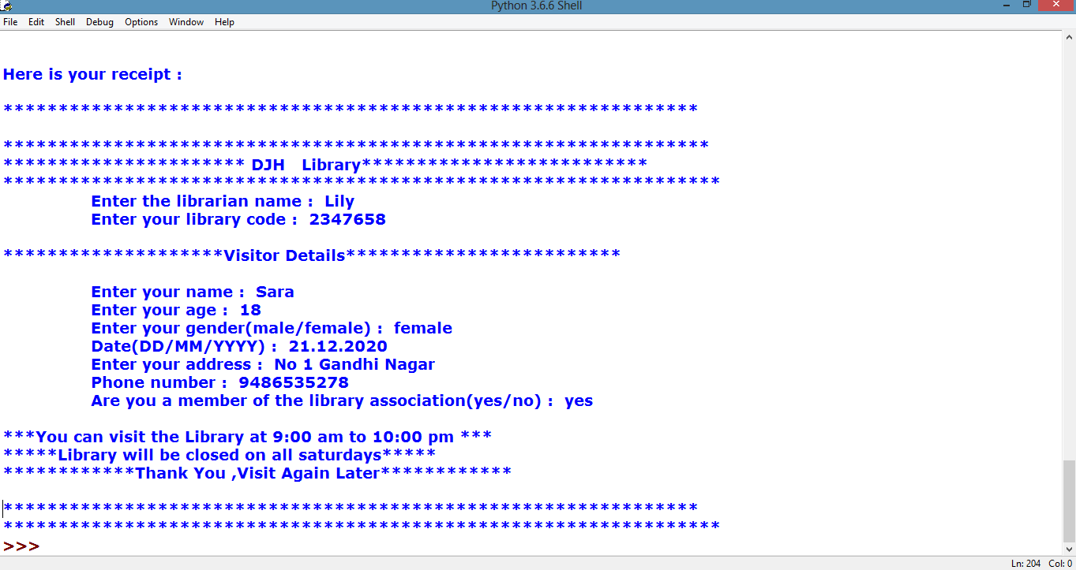

51

*Thank you*