Confirmatory 1B Analysis Markdown Part 1

# PREPARATION

## Load Packages

library(tidyverse)  
library(janitor)  
library(grid)  
library(cowplot)  
library(httr)  
library(extrafont)  
library(here)  
library(ggeasy)  
library(rstatix)  
library(apa)  
library(ez)  
library(afex)  
library(papaja)  
library(patchwork)  
library(jmv)

## Read in data

## First factor: Subfield

## Second factor: Time

## Selecting only relevant data

# DATA ANOVA Analysis

## Coefficient covariances computed by hccm()

## ANOVA Table (type II tests)  
##   
## Effect DFn DFd F p p<.05 ges  
## 1 subfield_groups 3 181 3.313 0.021 * 0.052  
## 2 time_period 2 181 3.676 0.027 * 0.039  
## 3 subfield_groups:time_period 6 181 1.110 0.358 0.035

Our two-way between-subjects ANOVA generated a significant main effect of subfield, F(3, 181) = 3.313, p = 0.021, ges = 0.052, and time period, F(2, 181) = 3.676, p = 0.027, ges = 0.039. However, the interaction between subfield and time period, F(6, 181) = 1.11, ges = 0.035, was not statistically significant.

## Contrasts set to contr.sum for the following variables: time_period, subfield_groups

## Anova Table (Type 2 tests)  
##   
## Response: total_data_score  
## num Df den Df MSE F ges Pr(>F)   
## time_period 2 181 70.923 3.6760 0.039033 0.02723 *  
## subfield_groups 3 181 70.923 3.3127 0.052049 0.02128 *  
## time_period:subfield_groups 6 181 70.923 1.1099 0.035488 0.35824   
## ---  
## Signif. codes: 0 '***' 0.001 '**' 0.01 '*' 0.05 '.' 0.1 ' ' 1

(#tab:unnamed-chunk-7)

*Between-subjects ANOVA for Open Data Scores*

|  |  |  |  |  |  |  |
| --- | --- | --- | --- | --- | --- | --- |
| Effect | $F$ | ${df}_{1}$ | ${df}_{2}$ | $MSE$ | $p$ | ${\hat{η}}_{G}^{2}$ |
| Time period | 3.68 | 2 | 181 | 70.92 | .027 | .039 |
| Subfield groups | 3.31 | 3 | 181 | 70.92 | .021 | .052 |
| Time period $×$ Subfield groups | 1.11 | 6 | 181 | 70.92 | .358 | .035 |

*Note.* This table was created with apa_table().

Our two-way between-subjects ANOVA generated a significant main effect of time period, $F(2,181)=3.68$, $MSE=70.92$, $p=.027$, ${\hat{η}}_{G}^{2}=.039$, and a significant main effect of subfield, $F(3,181)=3.31$, $MSE=70.92$, $p=.021$, ${\hat{η}}_{G}^{2}=.052$. However, the interaction between time period and subfield, $F(6,181)=1.11$, $MSE=70.92$, $p=.358$, ${\hat{η}}_{G}^{2}=.035$, was not statistically significant.

# MATERIALS ANOVA Analysis

## Coefficient covariances computed by hccm()

## ANOVA Table (type II tests)  
##   
## Effect DFn DFd F p p<.05 ges  
## 1 subfield_groups 3 181 5.236 0.002 * 0.080  
## 2 time_period 2 181 0.366 0.694 0.004  
## 3 subfield_groups:time_period 6 181 0.481 0.822 0.016

Our two-way between-subjects ANOVA generated a significant main effect of subfield, F(3, 181) = 5.236, p = 0.002, ges = 0.08. However, the main effect of time period, F(2, 181) = 0.366, p = 0.694, ges = 0.004, and the interaction between subfield and time period, F(6, 181) = 0.481, ges = 0.016, were not statistically significant.

## Contrasts set to contr.sum for the following variables: time_period, subfield_groups

## Anova Table (Type 2 tests)  
##   
## Response: total_materials_score  
## num Df den Df MSE F ges Pr(>F)   
## time_period 2 181 53.872 0.3657 0.004025 0.69419   
## subfield_groups 3 181 53.872 5.2357 0.079851 0.00173 **  
## time_period:subfield_groups 6 181 53.872 0.4813 0.015704 0.82171   
## ---  
## Signif. codes: 0 '***' 0.001 '**' 0.01 '*' 0.05 '.' 0.1 ' ' 1

(#tab:unnamed-chunk-9)

*Between-subjects ANOVA for Open Materials Scores*

|  |  |  |  |  |  |  |
| --- | --- | --- | --- | --- | --- | --- |
| Effect | $F$ | ${df}_{1}$ | ${df}_{2}$ | $MSE$ | $p$ | ${\hat{η}}_{G}^{2}$ |
| Time period | 0.37 | 2 | 181 | 53.87 | .694 | .004 |
| Subfield groups | 5.24 | 3 | 181 | 53.87 | .002 | .080 |
| Time period $×$ Subfield groups | 0.48 | 6 | 181 | 53.87 | .822 | .016 |

*Note.* This table was created with apa_table().

Our two-way between-subjects ANOVA generated a significant main effect of subfield, $F(3,181)=5.24$, $MSE=53.87$, $p=.002$, ${\hat{η}}_{G}^{2}=.080$, however the main effect of time period, $F(2,181)=0.37$, $MSE=53.87$, $p=.694$, ${\hat{η}}_{G}^{2}=.004$, and the interaction between time period and subfield, $F(6,181)=0.48$, $MSE=53.87$, $p=.822$, ${\hat{η}}_{G}^{2}=.016$, were not statistically significant.

# PLOTS

## DATA

### Subfield x Data Score

## # A tibble: 4 × 5  
## subfield_groups mean_data_score SD N stderr  
## <fct> <dbl> <dbl> <int> <dbl>  
## 1 Cognition 17.2 7.37 61 0.944  
## 2 Development 12.5 8.83 34 1.51   
## 3 Other 13.1 9.07 41 1.42   
## 4 Social 13.3 9.17 57 1.21

### Time Period x Data Score

## # A tibble: 3 × 5  
## time_period mean_data_score SD N stderr  
## <fct> <dbl> <dbl> <int> <dbl>  
## 1 2nd half 2019 12.1 9.19 65 1.14   
## 2 1st half 2020 16.0 8.08 91 0.847  
## 3 2nd half 2020 14.4 8.70 37 1.43

### Interaction between time and subfield - Data scores

## `summarise()` has grouped output by 'subfield_groups'. You can override using the `.groups` argument.

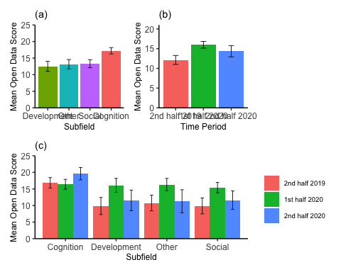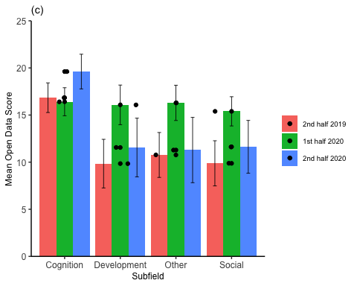

## MATERIALS

### Subfield x Materials Score

## # A tibble: 4 × 5  
## subfield_groups mean_materials_score SD N stderr  
## <fct> <dbl> <dbl> <int> <dbl>  
## 1 Cognition 12.2 7.37 61 0.944  
## 2 Development 6.79 8.83 34 1.51   
## 3 Other 7.88 9.07 41 1.42   
## 4 Social 8.16 9.17 57 1.21

### Time Period x Materials Score

### Interaction between time and subfield - Materials Score

## `summarise()` has grouped output by 'subfield_groups'. You can override using the `.groups` argument.

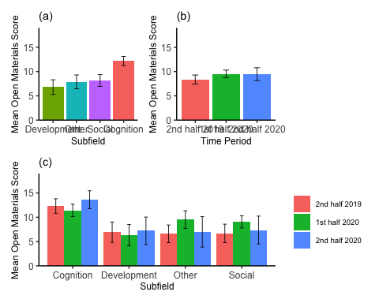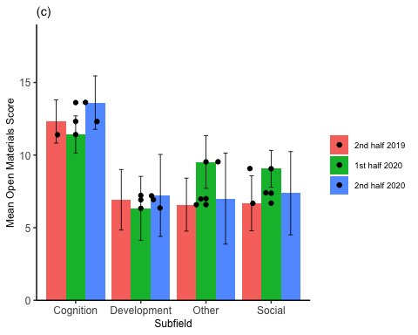

# SUBFIELD T-TESTS

## DATA

### Development vs. Cognition

An independent samples t-test showed that articles published in the field of Cognition generated higher Open Data Scores, on average, than articles published in the field of Developmental Psychology,

## t(58.75) = 2.65, p = .010, d = 0.60

### Development vs. Social

An independent samples t-test showed that articles published in the field of Social Psychology did not generate statistically different Open Data Scores, on average, than articles published in the field of Developmental Psychology,

## t(71.68) = -0.42, p = .675, d = -0.09

### Development vs. Other

An independent samples t-test showed that articles published in the Other subfield did not generate statistically different Open Data Scores, on average, than articles published in the field of Developmental Psychology,

## t(71.12) = -0.31, p = .756, d = -0.07

## MATERIAL

### Developmental vs. Cognition

An independent samples t-test showed that articles published in the field of Cognition generated higher Open Materials Scores, on average, than articles published in the field of Developmental Psychology,

## t(61.36) = 3.45, p = .001, d = 0.77

### Developmental vs. Social

An independent samples t-test showed that articles published in the field of Social Psychology did not generate statistically different Open Materials Scores, on average, than articles published in the field of Developmental Psychology,

## t(68.36) = -0.84, p = .406, d = -0.18

### Developmental vs. Other

An independent samples t-test showed that articles published in the Other subfield did not generate statistically different Open Materials Scores, on average, than articles published in the field of Developmental Psychology,

## t(70.45) = -0.62, p = .539, d = -0.14

# TIME T-TESTS

## DATA

### Second half 2019 vs. First half 2020

An independent samples t-test showed that articles published in the first half of 2020 generated significantly higher Open Data Scores, on average, than articles published in the second half of 2019,

## t(126.73) = -2.70, p = .008, d = -0.45

### First half 2020 vs. Second half 2020

An independent samples t-test showed that articles published in the second half of 2020 did not generate significantly higher Open Data Scores than articles published in the first half of 2020,

## t(62.65) = 0.98, p = .331, d = 0.20

## MATERIALS

There time period main effect for Open Materials Scores was not statistically significant, so no t-tests to run here