Exploratory 1A Analysis

# Load packages

# Read and clean data

# DATA

Select only variables we’re interested in

Let’s create some summary tables

Let’s bind all these statistics together

## # A tibble: 28 × 4  
## # Groups: subfield_groups [4]  
## subfield_groups Real_Stage Number Percent  
## <chr> <chr> <dbl> <dbl>  
## 1 Cognition Reportedly Available 24 100   
## 2 Development Reportedly Available 9 100   
## 3 Other Reportedly Available 12 100   
## 4 Social Reportedly Available 28 100   
## 5 Cognition Actually Locatable 18 78.3  
## 6 Development Actually Locatable 7 87.5  
## 7 Other Actually Locatable 12 100   
## 8 Social Actually Locatable 23 85.2  
## 9 Cognition Correct Data 16 84.2  
## 10 Development Correct Data 6 85.7  
## # … with 18 more rows

Let’s plot

## Warning: It is deprecated to specify `guide = FALSE` to remove a guide. Please  
## use `guide = "none"` instead.

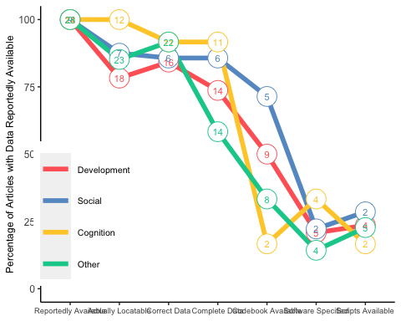

# MATERIALS

Select only the variables we’re interested in

Let’s create some summary tables

Let’s bind all these statistics together

Let’s plot

## Warning: It is deprecated to specify `guide = FALSE` to remove a guide. Please  
## use `guide = "none"` instead.

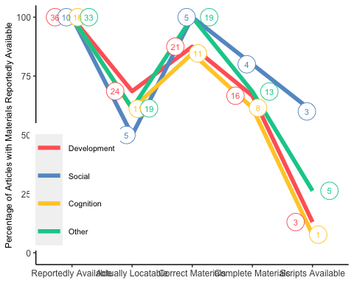

## Warning: position_dodge requires non-overlapping x intervals  
  
## Warning: It is deprecated to specify `guide = FALSE` to remove a guide. Please  
## use `guide = "none"` instead.

