## ASTM D3612-C

**ASTM 6786**

Particles Particles Particles Particles

Particles

5 to 15 um :

15 to 25 um :

25 to 50 um :

50 to 100 um :

> 100 um :

Sample Date : Laboratory No. : Container No. : Temperature :

:

H2 CH4 C2H6 C2H4 C2H2 CO CO2 N2

O2

Hydrogen Methane Ethane Ethylene Acetylene

Carbon monoxide Carbon dioxide Nitrogen

Oxygen

(ppm)

(ppm)

(ppm)

(ppm)

(ppm)

(ppm)

(ppm)

(ppm)

(ppm)

:

:

:

:

:

:

:

:

Total (ppm) : TDCG (ppm) : SHL (%) :

ETCG (% in blanket) :

2/9/2022

5119893

79.9

8

12

0

0

0

406

3906

32269

10819

47420

426

11.30

0.80

22820

1295

700

170

35

1/27/2021

5115804

67.1

10

8

0

0

0

355

5474

66517

16116

88480

373

10.95

0.36

31795

800

365

40

5

1/30/2020

5113163

0

9

0

0

0

307

4238

76523

21129

102206

316

12.35

0.25

37220

735

275

15

0

3/22/2019

5110273

74.1

5

6

1

0

0

259

3727

33869

8163

46030

271

11.34

0.51

2315475

700

510

40

10

D1533

Moisture

(ppm) : 8

5 7 10

D1816 Dielectric BV (kV) :

59.9

59.6

45.1

55.2

D974

Acid Number

(mg KOH/g) :

<0.02

<0.02

<0.02

<0.02

D971 Interfacial Tension (mN/m) :

D1500 Color Number (ASTM) :

42.3

<1.0

49.4

<0.5

45.9

<0.5

46.7

<0.5

D924 Power Factor

(% @25C) :

D2668 Oxidation Inhibitor (%) :

## ASTM D5837

5 HMF

2 FAL

2 ACF

5 MEF

2 FOL

5 hydroxymethyl-2-furaldehyde

2 furaldehyde

2 acetylfuran

5 methyl-2-furaldehyde

2 furfurol

(ppm) :

(ppm) :

(ppm) :

(ppm) :

(ppm) :

0.266

<10 ppb

12 ppb

<10 ppb

<10 ppb

<10 ppb

0.234

<10 ppb

<10 ppb

<10 ppb

<10 ppb

<10 ppb

0.212

<10 ppb

<10 ppb

<10 ppb

<10 ppb

<10 ppb

0.216

<10 ppb

<10 ppb

<10 ppb

<10 ppb

<10 ppb

Estimated DP

: 957

>1000

>1000

>1000

Transformer Condition Assessment Diagnostic Evaluation

TCA Assessment : Sampling Interval : Operating Procedure :

1

Retest in one year.

Continue normal operation. (PF@100 = 0.14)

1 1 1

Comments : Field Comments :

No abnormal gas generation is indicated. (Specific GR = 0.8749)

Fluid condition is within acceptable in-service parameters. Paper condition is "as new".

TJ|H2b Analytical Services issues reports in a simplified manner; not all ASTM and ISO/IEC 17025 requirements are addressed in this report; however, all required information is retained and available upon request. TJ|H2b does not perform sampling services and provides results for tests performed on samples as received. TJ|H2b assumes no responsibility for the quality or condition of the samples it receives or for the accuracy of any information provided with those samples. Test reports shall not be reproduced, except in full, without prior written consent of TJ|H2b.

# Approved by:

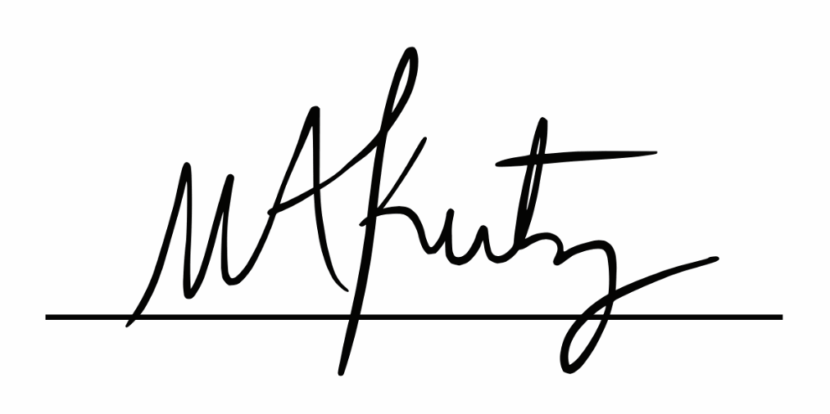Michelle Kutzleb, PhD Director of Operations