**FACULTY OF COMPUTING**

**UNIVERSITI MALAYSIA PAHANG**



**MCT1044 WEB TECHNOLOGIES**

**FINAL ASSIGNMENT**

**Random Joke Generator**

Prepared by: Jens Aaron Essig

Instructor’s Name:

NURZETY AHMAD AZUAN

Content

List of Figures 2

1. Introduction of the Application 3

2. Feature and Function 4

2.1. Features 4

2.2. Functions 6

3. Main Feature 7

4. Challenges 8

5. Appendix 9

List of Figures

Figure 1: Website structure 3

Figure 2: Toast Messages 4

Figure 3: Input Validation - Login 5

Figure 4: Favicon 5

Figure 5: Responsive Design 5

Figure 6: Show Joke 7

Figure 7: Rate Joke 7

Figure 8: Communication Structure 8

Figure 9: Login Page 9

Figure 10: Register Page 9

Figure 11: Change Password Page - User Validation 10

Figure 12: Change Password Page - New Password 10

Figure 13: Delete User Page 11

Figure 14: Joke Display Page - Show Joke 11

Figure 15: Joke Display Page - Rate Joke 12

Figure 16: Create Joke Page 12

1. Introduction of the Application

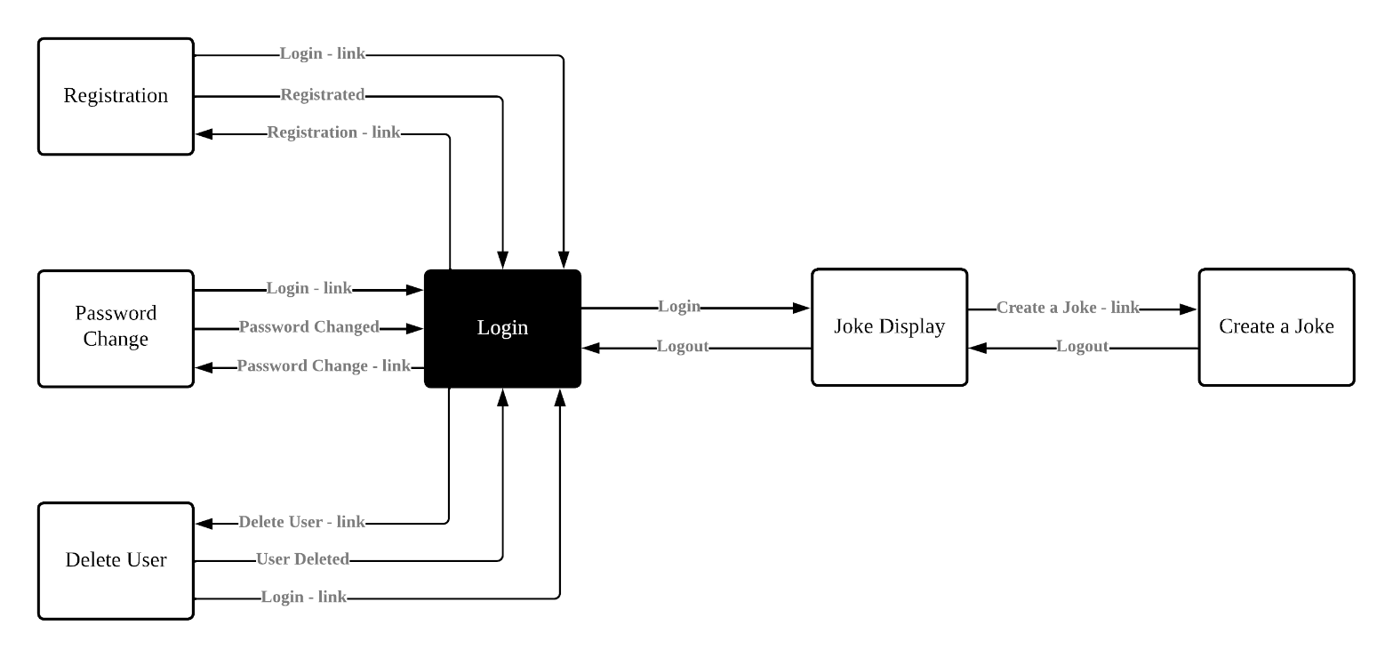The Application has the name “Random Joke Generator”. As the name implicates it has the function, of randomly showing jokes, when the user wants to see a joke. The therefore created Application, was created by using the framework: React. The React App consists of 10 JavaScript files, 7 Cascading Style Sheets, 1 HTML file and 3 JSON files. Those files build a website consisting of 6 webpages. Those Webpages are connected through links, the user can either use those to manually switch pages or the webpages switch automatically, when a task was performed successfully. Figure 1 shows the structure of the website and how the webpages are linked with each other and Figure 9 until Figure 16 show those webpages

Figure 1: Website structure

1. Feature and Function
   1. Features

The Features of the “Random Joke Generator” are, that it uses toast messages, checks all the input the users inserts, is responsive and uses a Favicon, for better recognizing the tab.

The Toast messages are used to display information and signalizing success or failure of a function. They are used, whenever a user starts a function, by pressing a button. The outcome of this function is then displayed by the toast message. Thereby the usability gets increased. Figure 2 shows a example for each kind of toast message used.



Figure 2: Toast Messages

Also all input fields get constantly checked, if the input fulfills certain input guidelines. This is done by a combination of the UseEffect function, which gets triggered, every time an input field gets selected or its input changes, and the REGEX function, which allows to prove strings for certain guidelines. Also an information box appears, when users change the input and the current input is invalid. This information box shows the user the guidelines, for the input. Also there is an icon, next to the title of the input field. The icon is only visible if information was inserted. The icon shows a green check if the input is valid or a red cross if the input is invalid. When that’s the case the submit button is disabled.

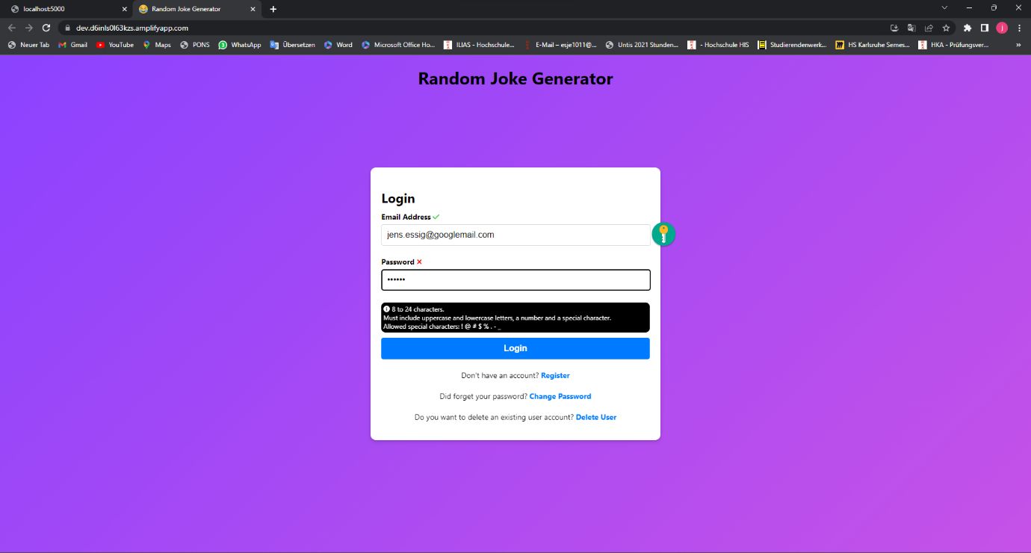

Figure 3: Input Validation - Login

Figure 4 shows the Favicon, a small image displayed in the Tab-heading next to the website name: “Random Joke Generator”. The used Favicon is a laughing smiley.



Figure 4: Favicon

The last feature that needs to be named, is the responsive design of the web application. Figure 5 shows 2 example screenshots, taken from the *Login* and the *Display Joke* Page. For this screenshots, the device toolbar of the chrome browser was used, to set the display size to the display size of an IPhone SE. The fact that the Layout adapts on the screen size shows that the website is responsive.

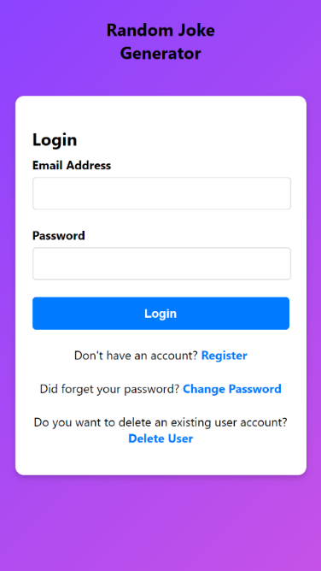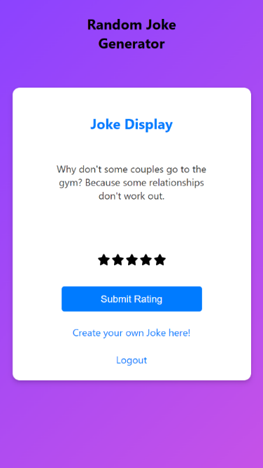

Figure 5: Responsive Design

* 1. Functions

The Functions of the “Random Joke Generator” are 8 CRUD functions and the check, if a user is actually logged in or accessed the webpages, by manipulating the URL.

CRUD operations are used to communicate with a storage. CRUD is an acronym for: create, read, update and delete. The used CRUD operations are:

Create:

* Register a new user
* Create a new joke
* Rate a joke

Read:

* Login
* Validate user data for password change
* Fetch a joke

Update:

* Change password

Delete:

* Delete a user

Besides the CRUD functions, the “Random Joke Generator” has a functionality, to check if the user is logged in, or accessed the webpage, by manipulation the URL. Therefore a variable gets set, when the user logs in. If the *Joke Display* or the *Create a Joke* page get accessed it checks this variable at first. If the states, that the user is not logged in, then the user gets redirected to the *login* page and an error toast message gets displayed, that explains the user he wasn’t logged in.

1. Main Feature

The main feature of the “Random Joke Generator”, is the randomly displaying jokes and giving the user the opportunity to rate those jokes. Figure 6 and Figure 7 show the webpage, which enables the user to do so. When the user presses the “Show Joke” button, a joke gets fetched randomly from the database and displayed in the webpage. Also 5 rating starts get visible and the “Show Joke” buttons changes to the “Submit Rating” button. The default rating is 0, because none of the stars I selected by default. When the “Submit Rating” button is pressed, the rating, together with the Joke-ID and the User-ID gets send to the database.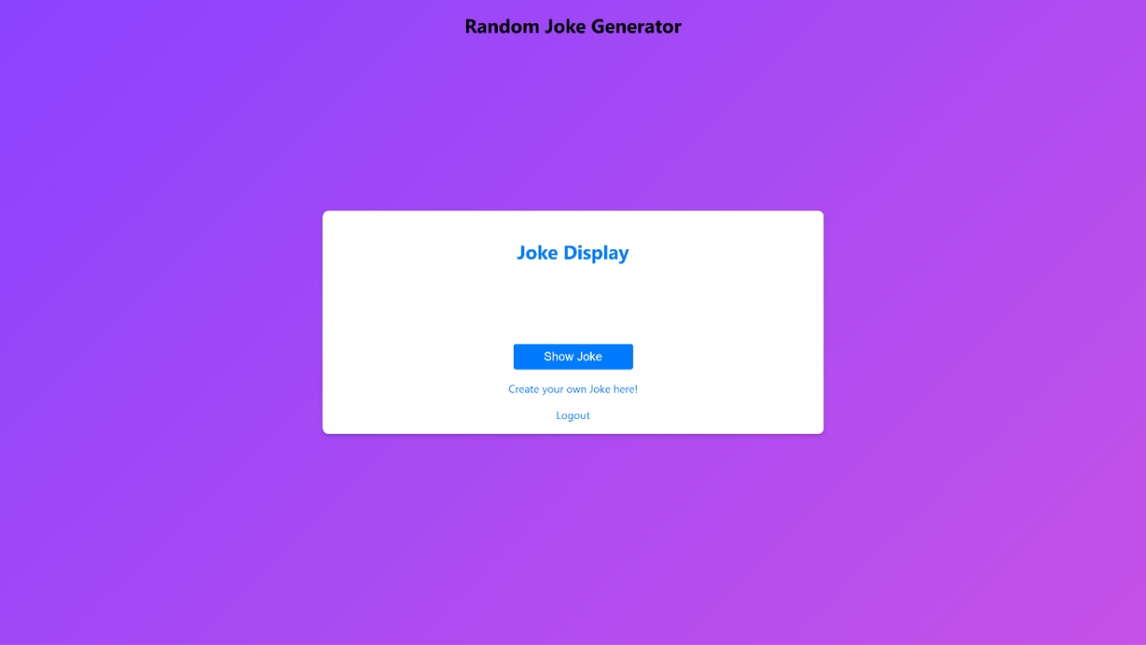

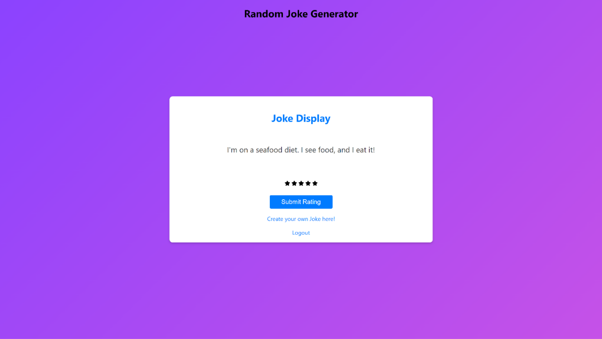Figure 6: Show Joke

Figure 7: Rate Joke

1. Challenges

The biggest challenge of this final assignment was the connection of the database and the React App and the final hosting. A React App cannot communicate with a database by itself. To do so, a Server is needed, that covers the database communication.

The Server can pass SQL statements to the database and send the response as a json variable back to the website. Therefore the Server gets hosted on localhost and the website can address him, by using his URL. Figure 8 shows this structure.

For hosting the website the problem occurred, that the Server couldn’t be hosted using any tested free hosting tool. That’s why the Server is hosted on localhost and the Website, as well as the database are hosted using amazon web services (aws).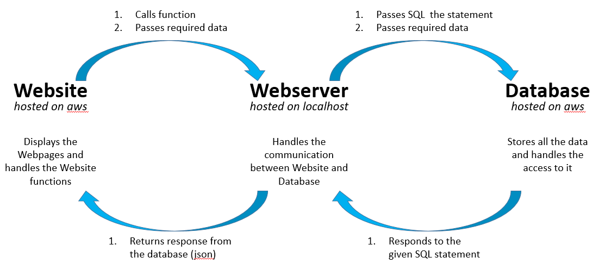

Figure 8: Communication Structure

1. Appendix

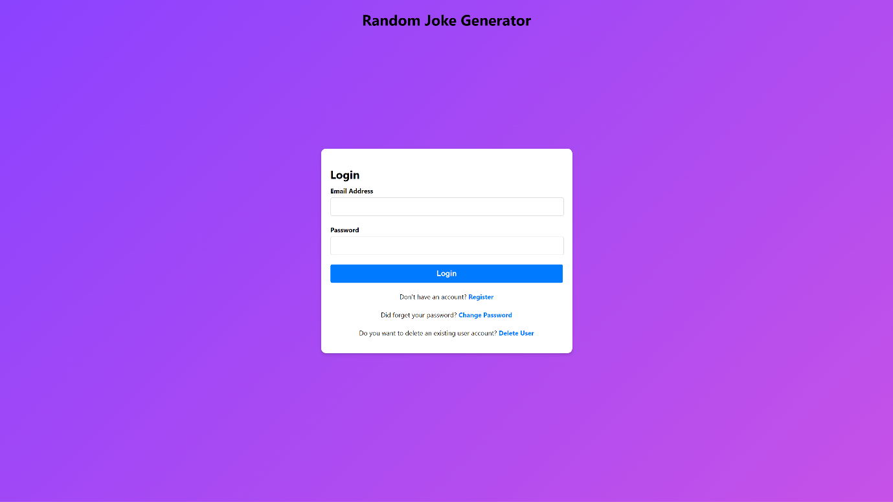

Figure 9: Login Page

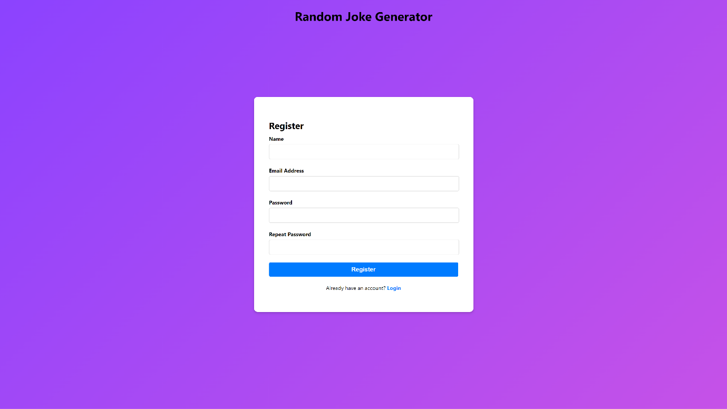

Figure 10: Register Page

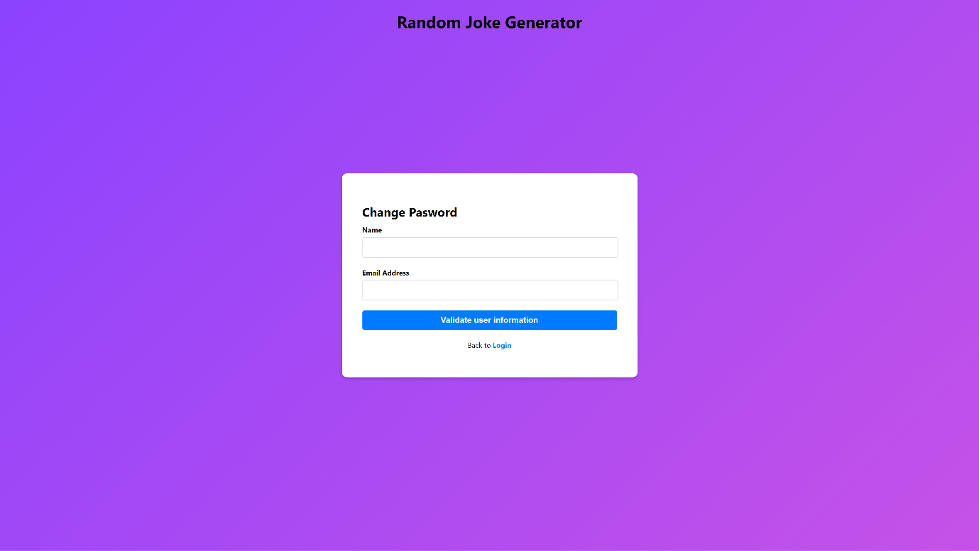

Figure 11: Change Password Page - User Validation

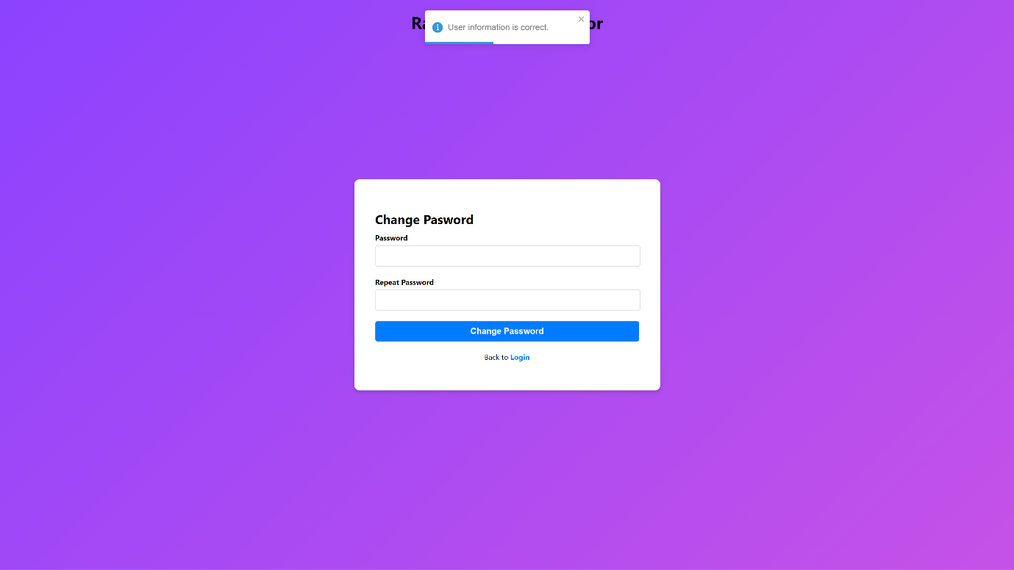

Figure 12: Change Password Page - New Password

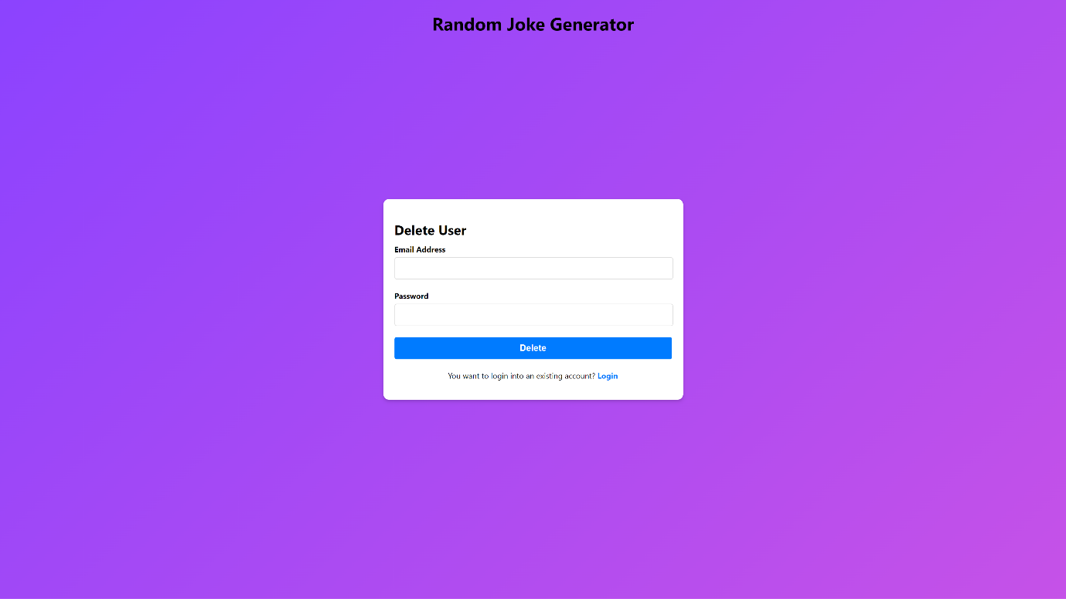

Figure 13: Delete User Page

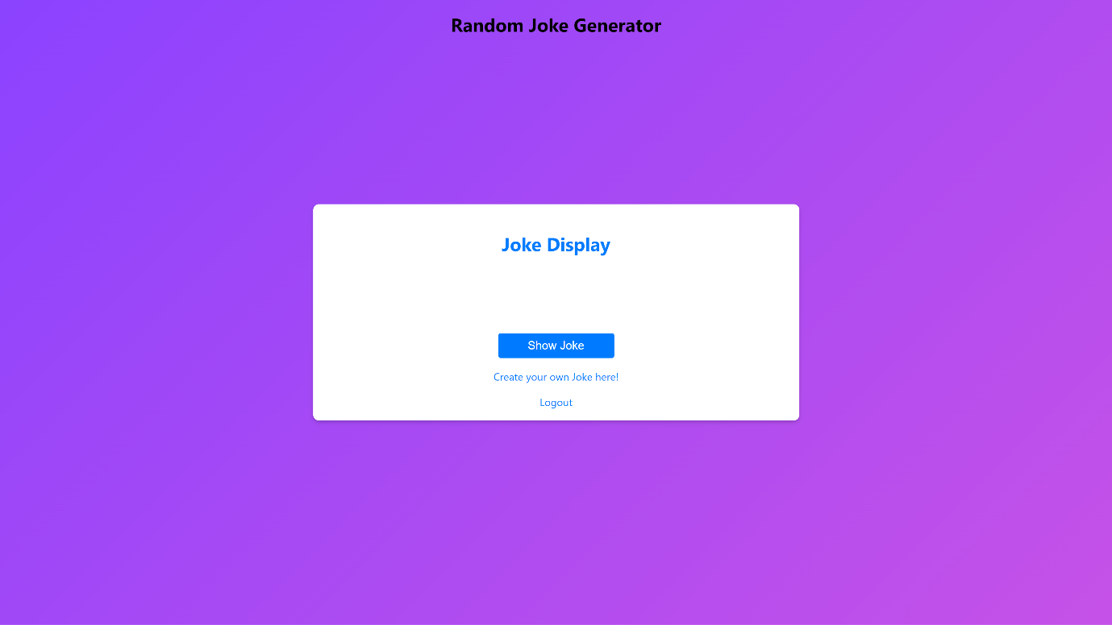

Figure 14: Joke Display Page - Show Joke

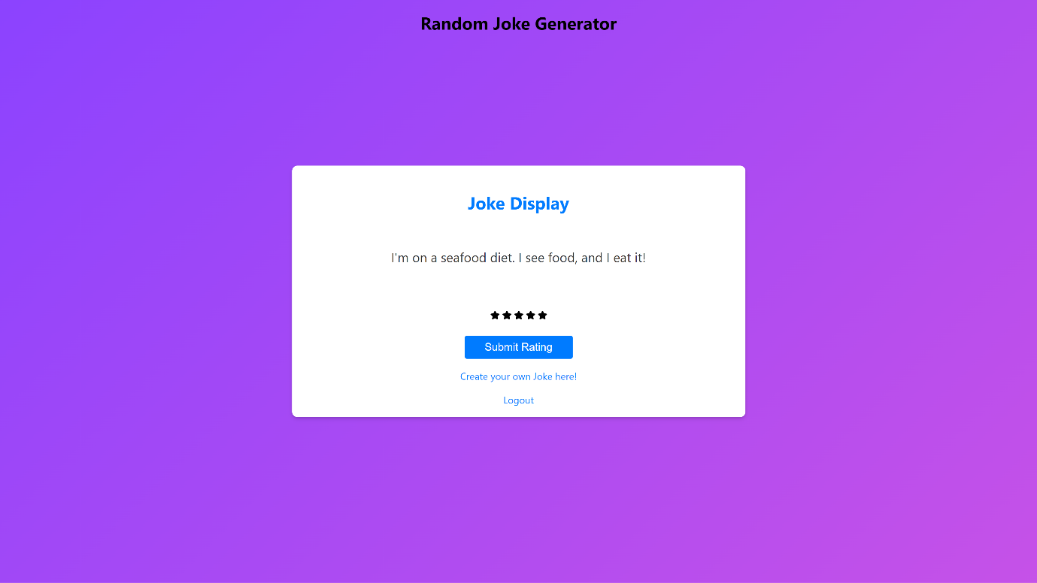

Figure 15: Joke Display Page - Rate Joke

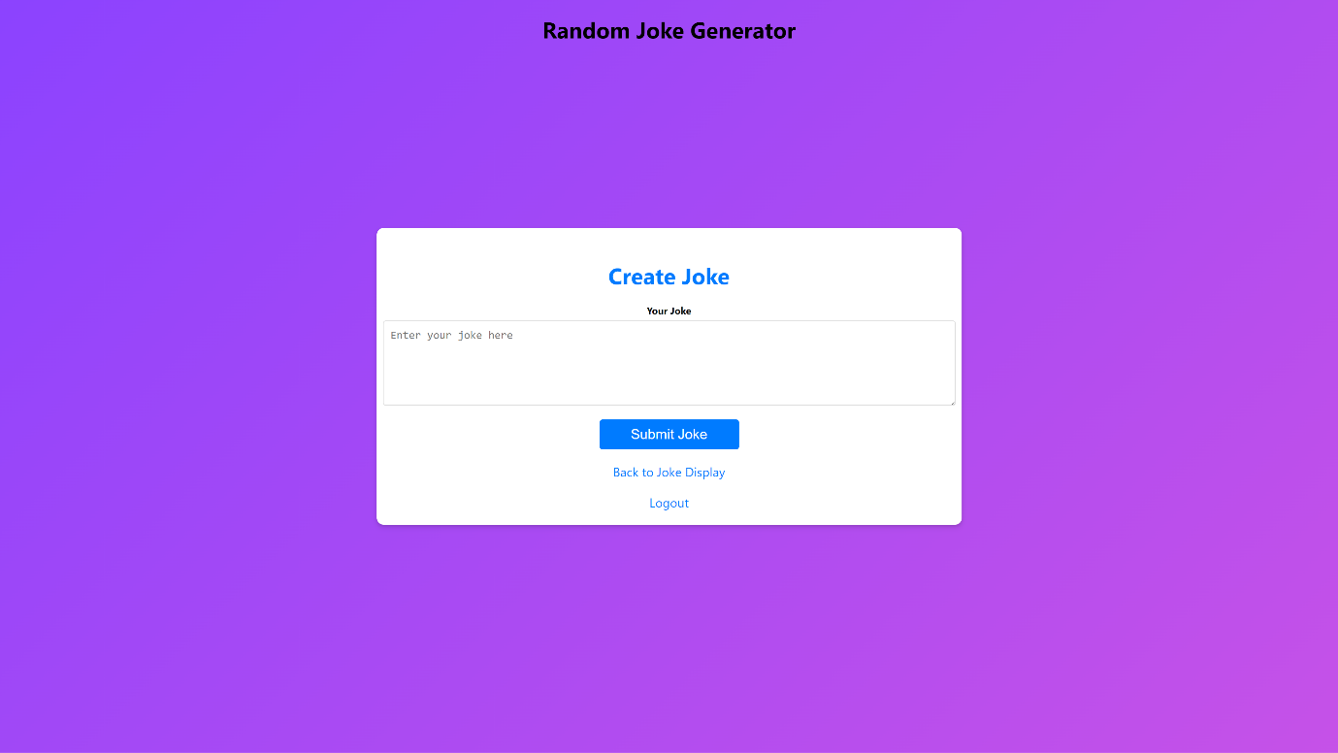

Figure 16: Create Joke Page