Estimating the drivers of insect abundance when detection is imperfect.
Abstract
Effective insect biodiversity conservation hinges on understanding the drivers of insect abundance. To estimate insect abundance drivers, researchers typically apply GLMs to count data from field surveys. However, conventional GLMs do not account for the failure to detect some individuals that are present in study landscapes. This shortcoming could bias model estimates. To alleviate this issue, some researchers have adopted approaches that account for imperfect detection, including the application of multinomial N-mixture (multimix) models to mark-recapture data. Unfortunately, however, mark-recapture data are challenging to collect. Binomial N-mixture (binmix) models provide an alternative that also accounts for imperfect detection. Binmix models are attractive because they can be applied to the simple count data used for GLMs. However, they may be more sensitive to violations of model assumptions. Currently, we lack side-by-side comparisons that determine when more cumbersome approaches are needed to accurately estimate insect abundance drivers. Using a unique system where we had field data compatible with all three approaches, we compared their estimates of the effect of habitat restoration on wild bee abundance. We found that individual bees have a detection rate of ~5%, but that restored habitats with more flowers and taller vegetation increased detection rate. Accounting for the effect of restored habitat on detection, binmix and multimix models estimated smaller effects of restoration on bee abundance compared to a GLM. We paired our field study with simulation experiments to identify potential causes of model divergence. For GLMs, we found that increasing baseline detection rate reduced bias caused by covariates that have confounding effects on detection and abundance. Conversely, increased sample size exacerbated bias. To best approximate the unbiased estimates produced by binmix or multimix approaches, studies of insect abundance that apply standard GLMs to count data should prioritize increased sampling intensity over increased sample size. In addition, we found that multimix models were more robust to simulated immigration/emigration or mortality compared to binmix models. Multimix models were also more precise. Because insects tend to be highly mobile and short-lived, we recommend multimix or related approaches over binmix approaches. Together, these results provide needed guidance on how to design field studies that accurately quantify the drivers of insect abundance.
1. Introduction
Insects provide crucial ecosystem services including pollination, decomposition, and biological control (Schowalter, Noriega, and Tscharntke 2018). At the same time, many insects are facing widespread declines (Wagner et al. 2021). Evidence-based strategies for mitigating or reversing insect declines require a clear understanding of the environmental pressures that drive insect abundance patterns (Wagner et al. 2021). Quantifying the drivers of species abundance allows us to assess population trends, identify population threats, or evaluate the success of management interventions (Schultz and Hammond 2003; Waltz and Covington 2004; Blaauw and Isaacs 2014; Rundlöf et al. 2015).
However, accurately estimating abundance drivers is challenging because abundance itself is difficult to measure. For insects, abundance data are often collected as counts from nets, traps or visual assessments. Because many insect species are small, elusive, and/or mobile these counts undoubtedly overlook some individual insects (Nowicki et al. 2008; Taron and Ries 2015; Portman, Bruninga-Socolar, and Cariveau 2020). To quantify drivers of abundance, researchers typically apply generalized linear models (GLMs) to these imperfect counts (Bolker et al. 2009). Crucially, GLMs rely on the assumption that the relationship between imperfectly detected counts and the true abundance of insects is constant across space, time, and species (Williams, Nichols, and Conroy 2002). Systematic variation in the ability to detect individuals causes variation in this relationship and, consequently, can bias GLM estimates of abundance drivers (Figure 1) (Williams, Nichols, and Conroy 2002). For example, researchers argue that concentration of food resources and/or habitat complexity impacts the ability to capture insects with nets or traps (Portman, Bruninga-Socolar, and Cariveau 2020). The potential effects on insect detection would confound GLM estimates of abundance effects (M. Kery and Royle 2020).
Mark-recapture provides an alternative approach that estimates and accounts for imperfect detection. Mark-recapture methods quantify detection rate using information about the odds of resighting marked or tagged individuals across successive sampling events (Figure 1) (Williams, Nichols, and Conroy 2002). Researchers have used mark-recapture methods for decades (Lincoln 1930), including for insects such as butterflies and bees (Haddad et al. 2008; Briggs et al. 2022). Building on classic mark-recapture approaches (Lincoln 1930), hierarchical multinomial N-mixture models (hereafter, “multimix” models) allow researchers to pool mark-recapture data across multiple sites (M. Kery and Royle 2010). Compared to classic mark-recapture, this enables more precise estimation of detection rate and true abundance as well as more straightforward inclusion of abundance and detection covariates such as site habitat quality (M. Kery and Royle 2010). This approach can also be applied to communities of species simultaneously, rather than single species individually (M. Kery and Royle 2020). Multimix mark-recapture approaches are increasingly popular for studies of birds and other vertebrates (M. Kery and Royle 2020), but they have not yet been widely adopted for studies of insects.
While mark-recapture methods are considered the most rigorous way to estimate drivers of insect abundance, they also have limitations. In particular, mark-recapture data can be difficult and time consuming to collect (Haddad et al. 2008; Taron and Ries 2015; Briggs et al. 2022). Additionally, placing marks could damage or harm insects (Morton 1982). Further, multimix models can require custom-tailored code and large computational resources (M. Kery and Royle 2020). Therefore, it is important to better understand when using this laborious method will be worthwhile.
Binomial N-mixture models (“binmix” models) provide a second alternative that also accounts for imperfect detection. Like multimix models for mark-recapture data, binmix models are more inaccessible than GLMs because their implementation can require heavy computational resources and strong coding demands. However, binmix models may be more attractive than multimix mark-recapture models because they can be applied to the simple count data used for GLMs (J. A. Royle 2004; Madsen and Royle 2023). This means that binmix models might provide good estimates of abundance drivers without requiring the laborious effort of marking or tagging individual insects. Binmix models account for imperfect detection by leveraging information about variation in the size of counts that are collected across repeat surveys; this means that counts must be repeated at least for some sites (Figure 1) (J. A. Royle 2004). Binmix models are increasingly utilized for insect abundance studies (Mimnagh, Parnell, and Prado 2023). For example, insect ecologists have used them to determine the effects of urban land use on mosquito abundance, the impacts of flower resource density on wild bee abundance, and the effects of seasonality on butterfly abundance (Manica et al. 2019; Mccune et al. 2020; Riva et al. 2020).
While binmix approaches provide an easier way to account for detection biases, many have criticized their validity (Barker et al. 2018; Madsen and Royle 2023). In particular, binmix models assume that populations are “closed”, i.e., that populations do not change across repeat survey events. Births and deaths or immigration and emigration from sites would violate this assumption of closure (Link et al. 2018). Previous studies show that binmix estimates for total abundance are highly sensitive to violations of this assumption (Link et al. 2018). Currently, however, there is limited information on how these violations impact the ability of binmix models to estimate abundance covariates (Fogarty and Fleishman 2021), which is often the more relevant goal of insect studies (Taron and Ries 2015). To guide field study designs that balance effort and rigour, we need more information about the reliability of binmix models.
GLMs, binmix models, and multimix mark-recapture approaches could have trade-offs in required effort and performance. Ecologists may wish to implement the simplest approach that accurately and precisely estimates drivers of insect abundance. Determining the appropriate modelling approach for the task at hand requires clear knowledge of the ecological and study design conditions that could cause the conclusions made by these different methods to diverge. For this study, we first used all three approaches to assess the effects of an environmental covariate (habitat restoration) on the detection and abundance of wild bees. Specifically, we used net collection methods to obtain mark-recapture data for eight wild bee species in five urban parks with habitat restorations and in five control parks that were not restored. Restored parks had taller, unmowed vegetation and more flower resources (i.e., more food resources for bees). There are mixed arguments for positive versus negative effects of habitat complexity and resource density on bee detection rate, however, we lack studies that quantify potential detection effects (Portman, Bruninga-Socolar, and Cariveau 2020). We fit a multimix model to the detection histories of our marked bees. Alternatively, we ignored individual marks and treated our data as simple repeated counts for a multi-species GLM or binmix model. We used the multimix and binmix models to determine the rate of detection for wild bees in our net collecting surveys and to quantify whether restored habitat changed our ability to detect bees with net collecting methods. Additionally, we compared the estimated effects of restored habitat on abundance. This allowed us to determine the extent to which imperfect detection compromised our ability to quantify the effects of restoration on insect abundance.
Next, using simulation, we investigated factors that reduce or exacerbate the bias of less rigorous GLM and binmix approaches compared to a more cumbersome mark-recapture protocol. In particular, we examined whether changes to baseline detection rate and/or site sample size impact the ability of these models to accurately estimate an abundance covariate despite a confounding effect on detection. We also compared model precision under these different scenarios. These tests aimed to provide guidance on whether GLMs can provide better estimates if studies prioritize increased sampling intensity as opposed to adding more site replicates. Second, we tested robustness of simulated violations of population closure for binmix compared to multimix models. To do so, we varied the probability that individual insects immigrate/emigrate from sites between successive surveys, while simultaneously varying whether those odds were impacted by a site environmental covariate. This allowed us to test whether binmix models fail to estimate an abundance driver when habitat influences the tendency for individuals to remain within a sampling plot. In combination, our studies aim to provide needed information on how to better design and conduct unbiased abundance studies given the difficulty of detecting insects. In turn, unbiased understanding of abundance drivers will help us to develop optimal strategies for confronting insect biodiversity declines.
2. Methods
2.1 Field study design and data collection
For the field-based component, our aim was to estimate the effects of restored habitat on the detectability and the abundance of wild bees. To do so, we implemented an abundance protocol that was compatible with all three modeling approaches: GLM, binmix and multimix (Figure 1). We selected a sample of five urban parks in Vancouver, Canada, that received a habitat restoration. We compared these against five similar urban parks that did not receive a habitat restoration (hereafter, “control” parks). We conducted a separate study (Ulrich and Sargent 2024), using a wider sample of parks that encompasses the ten included here. In brief, in that study we found that the restorations increased pollinator species occurrence. This translated into sustained species richness gains. However, we did not quantify the effects of restoration on species abundance. In the separate study, we found that the restorations altered a site’s resource availability: Restoration was strongly associated with increased flower species richness and marginally associated with increased flower species abundance. Although we did not measure vegetation complexity, vegetation was approximately knee-height in restored parks compared to approximately ankle-height in control parks (add a Supplemental figure with images of park vegetation). In restored parks, vegetation was left unmowed during April – September season compared to mowed bi-weekly in control parks. Restored parks contained a mix of spontaneous and seeded flowers that provide food resources for wild bees; control parks were dominated by turfgrass but contained spontaneous flower. Managed flowering woody plants (trees and shrubs) occurred sporadically across all sites.
We targeted our abundance surveys on eight wild bee species from four different wild bee families: Agapostemon texanus (Halictidae), Andrena prunorum (Andrenidae), Anthidium oblongatum (Megachilidae), Bombus flavifrons (Apidae), Bombus mixtus (Apidae), Halictus rubicundus (Halictidae), Megachile spp. (not including the invasive Megachile rotundata) (Megachilidae), and Melissodes microstictus (Apidae). We chose these species because we could easily identify them in the field. This allowed us to avoid lethal sampling which would cause violations of population closure assumptions while also potentially reducing bee populations. Additionally, the species were common enough in our system that we could estimate the timing of peak abundance from previous studies (Ulrich and Sargent 2024). Targeting our sampling at the timing of peak abundance allowed us to limit changes in abundance caused by rapid births or deaths, which would also violate population closure assumptions. We collected counts during two different sampling periods. In early June we conducted three repeat surveys for three earlier phenology species: A. texanus, B. flavifrons and B. mixtus. In mid July we conducted the repeat surveys for five later phenology species: A. prunorum, A. oblongatum, H. rubicundus, Megachile spp., and M. microstictus. To reduce closure violations, we conducted the repeat counts within the most rapid timescale possible, conducting the first and last repeat surveys at each site within a maximum of eight days. A. prunorum was only surveyed in the second year of the study.
For the count surveys, a one-hectare sampling area was designated in each park. The sampling area focusing on a restored vegetation area for the restored parks or conventionally managed turfgrass space in control parks (the same survey areas used in Ulrich and Sargent 2024). We collected pollinators with a sweep net, walking a spiral-transect through the survey area and netting all individuals thought to be our focal species. We repeated the spiral transect until the survey time ended. Surveys lasted 45 minutes, with the timer paused for insect handling. Netted insects were placed on ice until the completion of the survey. After the survey ended, we confirmed species identifications and applied marks. Marks were applied by placing chilled bees in a vial with a plunger on one end and a wide mesh covering on the other (Briggs et al. 2022). After pressing bees against the mesh, we painted a colour-coded mark on the back of the thorax using a paint pen (Molotow brand with 2.0mm round tip) (Figure S_). Simple counts of the number of individuals captured during the survey were noted for the GLM or binmix approaches. To limit additional detection biases, all surveys were conducted by the same researcher, and only during full sun conditions between 10:00 AM and 4:00 PM.
2.2 Statistical analyses
To estimate the effects of restoration on insect abundance, we developed custom-tailored models written in the probabilistic programming language Stan (ref), implemented in R (ref) using the package rstan (ref). These models use Bayesian inference to estimate distributions of parameter values that are conditioned on our data and our specified prior probability distributions.
For the GLM model, we specified counts of $y_{i}$ distinct individuals on sampling events $i$ = 1, …, $R$ to be outcomes of a negative binomial distribution with an expected mean $λ_{i}$ and dispersion $ϕ$ (Equation 1). We used negative binomial distributions for the GLM (and the binmix and multimix models) because our posterior predictive checks indicated that this overcame a strong lack of fit that was evident for Poisson models (supplement). We modelled variation in $λ_{i}$ using a log-link function (Equation 2) as a function of a global abundance intercept ($α_{0}$), a species-specific random intercept effect ($α_{1}$), a site-specific random intercept effect ($α_{2}$), an effect of year ($α_{3}$), and a species-specific random effect of restoration ($α_{4}$), with restoration treated as a categorical variable.
- $y_{i} \sim negative binomial(λ_{i}, ϕ)$;
- $log(λ_{i})= α_{0}+ α_{1}\left[species\right]+α_{2}\left[site\right]+ α_{3}\left[year\right]+ α_{4}\left[species\right] ×restoration[i]$
We presumed that species-specific random effects of habitat were normally distributed with a mean and a variance term estimated from the data, i.e., $α_{4}\left[species\right] \sim normal(μ_{α_{4}}, σ_{α_{4}})$. Species- and site-specific random effects for the intercept were centered on a mean of zero, and presumed to be normally distributed with a variance term that was estimated from the data.
The binmix model assumes that the counts $y_{i,t}$ of distinct individuals at $i$ = 1, …, $R$ sites during $j$ = 1, …, $J$ sampling events are conditioned on a detection rate $p_{i}$ and a true abundance $N_{i}$, which we assume is fixed across the $J$ occasions, i.e., that the population is closed. We considered $N_{i}$ to be the outcome of a negative binomial distribution with a mean $λ_{i}$ and dispersion $ϕ$ (Equation 3). We specified the number of successfully detected individuals on each survey event ($y_{i,t}$) as the outcome of a binomial trial. With this formulation, effects of predictors on abundance versus detection can be differentiated (Marc Kery 2017). We described variation in $λ_{i}$ as in Equation 2. We modelled variation in $p_{i}$ using a logit-link function (bounding the outcome to a probability range of 0 to 1) as function of a global detection intercept ($β_{0}$), a species-specific random intercept effect ($β_{1}$), a site-specific random intercept effect ($β_{2}$), an effect of year ($β_{3}$), and a species-specific random effect of restoration ($β_{4}$) (Equation 5). We presumed that species-specific random effects of habitat were normally distributed with a mean and a variance term estimated from the data, i.e., $β_{4}\left[species\right] \sim normal(μ_{β_{4}}, σ_{β_{4}})$.:
- $N_{i} \sim negative binomial(λ_{i}, ϕ)$;
- $y_{i,j} \sim binomial(N_{i}, p_{i})$;
- $logit\left(p_{i}\right)= β_{0}+ β_{1}\left[species\right]+β_{2}\left[site\right]+β_{3}\left[year\right]+β_{4}\left[species\right] ×restoration[i]$
The programming language Stan does not allow for latent discrete variables, where the likelihood of the data is estimated with respect to a single discrete value of the parameter $N_{i}$. As such, we calculated the marginal likelihood of the data across a range of $N_{i}$, from a lower bound of $N_{i}=max(y_{i,1:J})$ to an upper bound of a large finite value $K$ (J. A. Royle 2004). The lower bound is set at the maximum observed number of counts across occasion 1:$J$; any lower values would allow the likelihood of a binomial trial to be zero (J. A. Royle 2004). $K$ should be large enough that values of $N_{i}$approaching $K$ do not contribute to the likelihood (J. A. Royle 2004). We evaluated sensitivity to the choice of $K$ to ensure that stable results were obtained (Marc Kery 2017). For the field study, we used a value of $K_{i}=(max\left(y_{i,1:J}\right)+5) ×12$, i.e., that the true abundance is within the range of the maximum number of individuals detected to an upper bound of twelve times the sum of five plus the maximum number of individuals detected. In other words, that the number of unique individuals detected during our best survey (plus five extra individuals) only managed to detect ~8% of the individuals that are present. Our model estimation proceeds by proposing new values for the abundance parameters and detection parameter values and then evaluating whether the likelihood of the data across all possible values of $N_{i}$ has improved.
Finally, for the multimix approach, we specified a three-level model with a multinomial observation process for detection histories (M. Kery and Royle 2010). Where 0 represents non-detection and 1 represents detection, the possible observable detection histories for three repeat surveys are: 111, 110, 101, 100, 011, 010, and 001. 000 represents the eighth possible history, which is not observable. More generally, for a study with $J$ repeat surveys, there are $2^{J}$ possible detection histories (J Andrew Royle et al. 2007). The outcome variable $y_{i}$ was defined as a vector with each element representing the number of individuals in each of the seven detection history categories (Figure 1). The likelihood of the observed detection histories is specified as the outcome of a multinomial trial with some number of individuals observed one or more times ($n_{i}$) and given a vector of probabilities for each of the observable histories ($π_{i}^{c}$) (Equation 6). To estimate the remaining number of individuals at the site, we treated the number of observed individuals ($n_{i}$) as the outcome of a binomial trial depending on the size of the total population ($N_{i}$) and the probability of not being observed ($π_{i}^{0}$, i.e., probability of a detection history of 000) (Equation 7). As with the binmix model, the population size $N_{i}$ was modelled as the outcome of a negative binomial distribution (Equation 3) with a dispersion term and a linear predictor for the mean $λ_{i}$ (Equation 2). We used the same value of $K$ outlined for the binmix approach. Heterogeneity in detection rate was modelled using a linear predictor for detection rate $p_{i}$ (Equation 5), but where $p_{i}$ is estimated by defining its relation to $π_{i}^{1:8}$. For example, where probability of detection history 111 or $π_{i}^{1}= p_{i}×p_{i}×p_{i}$; probability of detection history 110 or $π_{i}^{2}= p_{i}×p_{i}×(1-p_{i})$; probability of detection history 101 or $π_{i}^{3}= p_{i}×{\left(1-p_{i}\right)×p}_{i}$; and so on.
- $y_{i} \sim multinomial(n_{i}, π_{i}^{c})$;
- $n_{i} \sim binomial(N_{i}, 1-π_{i}^{0})$;
We employed best practices for model development and fitting by (1) using weakly-informative priors to discourage unrealistic parameter values (Table S_) (2) confirming sufficient mixing of chains (Gelman-Rubin R-hat values < 1.05), minimal within-chain autocorrelation (effective sample size/steps > 0.1) and no divergent transitions (Figures S_ and S_) (3) running our model for a length of 4000 HMC steps, discarding the first 2000; and (4) using posterior predictive checks to assess the fit of our models (Stan Development Team 2023b; Gelman, Hill, and Vehtari 2020; Kery and Royle 2020).
2.3 Simulation study
We wrote a simulation program in R (version, ref) that generates species abundance and detections. The simulation produces abundance by sampling from a Poisson distribution. We used a Poisson process for abundance because they can be fit more quickly than negative binomial models. We included species, site, and year predictors for the mean of the Poisson generating process, exactly as in Equation 2. Conditional on simulated abundance and an input detection rate, the program then produces detection histories and detection counts. The simulation script allows detection rate to vary by species, site, and/or year, exactly as in Equation 5. All simulations were run on the University of British Columbia Sockeye computing platform (citation from website).
We used this simulation routine to determine how aspects of study properties and closure violations impact the ability of the different models to estimate the effect size of a driver of insect abundance. To accomplish this goal, we fit each of the three models to data that were simulated under some different scenarios. For all simulations we specified half of the sites as “restored” and the other half of sites as “control”. In these simulations, restoration represents a hypothesized driver of insect abundance that a researcher may wish to quantify; the term could be replaced with another hypothesized driver such as land cover, temperature, invasive species presence or pollution. The effect size of the restoration parameter $μ_{α_{4}}$ (as defined by Equation 2) was held constant at a value of 1, representing a positive effect on abundance.
First, we assessed how changes in baseline insect detection rates impact model bias and precision. To do so, we simulated detections for twenty sites, sixteen species, and two years, with three repeat surveys per year. We varied the detection intercept ($β_{0}$) across values of -3, -2, -1, and 0 (on a logit-scaled). On the probability scale, a value of 0 represents 50% odds of an individual insect being detected on a given survey given that it is present, whereas a value of -3 represents a <5% odds. For each level of detectability, we varied the effect of restoration on detection rate ($μ_{β_{4}}$) across values of -1, -0.5, 0, 0.5, and 1 (logit-scaled). A positive value indicates that insects are easier to detect at restored sites compared to control sites. The abundance intercept was held constant at a value of 1 (log-scaled), with no effect of year on abundance or detection. For each combination of baseline detection rate and effect of restoration on detection we simulated insect abundance for twenty systems, and then fit all three of the models to each of these systems. We then extracted 250 samples from the posterior distribution for each fit, equating to 5,000 sampled estimates for each model type for each combination of detection parameters. To calculate model bias, we subtracted the sampled effect size estimates from the true value ($μ_{α_{4}})$ and calculated the mean and 50% and 90% BCIs for the difference. A negative bias indicates a tendency to underestimate of the effect, while a positive value indicates a tendency for overestimation. Values closer to zero would indicate good accuracy. To assess model precision, we tracked the width of the 90% BCI for each model fit. A larger value indicates high uncertainty in the value of the parameter. A smaller value indicates low uncertainty in the value of the parameter. It is possible that models could be highly precise but inaccurate, or vice versa.
Next, we assessed how changes in the number of sites included in a study impacts model bias and precision. To do so, we simulated scenarios with 10, 20 or 30 sites. For each scenario, we again varied the effect of restoration on detection rate between -1, -0.5, 0, 0.5, and 1 (logit-scaled). The detection intercept was held constant at a value of -2 (logit-scaled). All other parameters and study dimensions were held constant as described in the previous paragraph. We used the same approach to quantify accuracy and precision.
Finally, we examined how violations in populationclosure assumptions impact binmix and multimix estimates. For this test of model robustness, we still considered $N_{i}$ to be the outcome of a Poisson trial. However, we also included an ability for individuals to immigrate/emigrate from the site. Each individual in $N_{i}$ was randomly “available” for detection at the timing of a survey with some probability $θ_{i}$: ${availability}_{i} \sim binomial(N_{i}, θ_{i})$. In this scenario, $N_{i}$ more closely represents the larger population of mobile insects in a broader landscape that have some chance of being in the sampling area at some point during the study. We specified a linear predictor for $θ_{i}$, with an availability intercept $θ_{0}$ and a fixed effect of restoration on availability $θ_{1}$. We varied $θ_{0}$ between -1, 0, 1, and 2; and $θ_{1}$ between -1, 0 and 1 (logit-scaled). A negative value of $θ_{1}$ represents a scenario in which individuals are less likely to remain within sampling areas if they are restored, whereas a positive value would indicate a higher probability of remaining within the sampling areas. We held the abundance intercept at 3 (log-scaled), and held the baseline detection rate constant at -2 (logit-scaled) with no effect of restoration on detection. All other parameters and study dimensions were held constant as described above, with the same approach used to quantify bias and precision.
3. Results
To determine the abundance and detection patterns for our real insect populations, we fit each of our models to the wild bee count data collected from our ten field sites (Figure 2). As expected, given that GLM’s do not account for imperfect detection, the GLM estimated a lower abundance intercept ($α_{0}$ mean = 0.23; 90%BCI = [-0.82, 1.27]) compared to either the binmix or multimix models: The binmix model estimated a higher intercept with 98.1% probability and the multimix model with 99.5% probability. The GLM estimated a positive effect of restoration on insect abundance: $μ_{α_{4}}$mean = 1.30; 90% BCI = [0.34, 2.25]. Effect size estimates were smaller for the binmix model: $μ_{α_{4}}$mean = 0.74; 90% BCI = [-0.02, 1.53]; 77.3% probability of a smaller effect size compared to the GLM approach. Effect size estimates were also smaller for the multimix model: $μ_{α_{4}}$mean = 0.91; 90% BCI = [0.05, 1.85]; 60% probability of a smaller effect size compared to the GLM approach.
Consistent with its estimation of a higher abundance intercept, the multimix model estimated a lower baseline detection rate ($β_{0}$ mean = -3.17; 90% BCI = [-3.66, -2.62]) than the binmix model ($β_{0}$ mean = -1.32; 90% BCI = [-1.79, -0.92]). On a probability scale, the mean estimates of these models equate to a 4% (multimix) or 20% (binmix) odds of detecting individual bees during a 45-minute survey of the one hectare plot. The binmix model estimated a positive effect of restoration on detection rate: $μ_{β_{3}}$ mean = 0.72; 90% BCI = [0.11, 1.26]. The multimix model also estimated a positive effect: $μ_{β_{3}}$ mean = 0.56; 90% BCI = [0.07, 1.05]. The positive effects of restoration on detection are consistent with estimates for the effects of restoration on abundance that are smaller than those provided by the GLM.
We used simulation to determine how aspects of a study impact the ability of these models to estimate insect abundance drivers. First, we examined how changes in baseline detection rate and effects of habitat on detection rate impact accuracy and precision of covariate estimates (Figure 3). We found that the GLM bias was marginal when the odds of detecting an individual insect were relatively high: When the odds of detecting an insect were 50% (0 on the logit scale), there was minimal bias even when restorations strongly increased detection rate (mean bias = 0.45; 90% BCI = [-0.2, 1.1]). Results were still not consistently biased when the odds of detecting individual insects were set to ~25% (-1 on the logit scale). Further decreasing the odds of detecting an insect caused clear biases to emerge in the GLM models. When the odds of detecting an insect were <5% (-3 on the logit scale), GLM biases followed the direction of the effect of restoration on detection rate: There was a clear positive bias when restoration increased detection rate (mean bias = 0.81; 90% BCI = [0.23, 1.3]) or a clear negative bias when restoration decreased detection rate (input the values). In contrast, the binmix and multimix did not show a clear bias. Mean estimates for the effect of restoration on abundance tended to be <0.1 away from the true value of 1. The largest divergences occurred for the binmix models when baseline detection rates were lowest, at -3 on the logit scale and with an effect of restoration on detection rate: mean bias = 0.33; 90% BCI = [-0.85, 1.3]. For the GLM, precision did not vary systematically with detection patterns. However, binmix and multimix showed systematic declines in precision along a gradient of decreasing baseline detection rate. Multimix models tended to be more precise than the binmix models.
Next, we used simulation to examine how the number of sites in a study influences accuracy and precision (Figure 4). We found that increasing the number of sites made GLMs both more biased and more precise. In other words, in these scenarios the GLM models provided increased confidence in an incorrect conclusion. For example, when there was a strong positive effect of restoration on detection rate and only ten study sites, GLMs slightly overestimated the effect of restoration on abundance (mean bias = 0.65; 90% BCI = [-0.3, 1.7]) and provided relatively wide confidence intervals (mean 90% BCI width = 0.91). When we increased the number of study sites to thirty, overestimates were larger (mean bias = 0.91; 90% BCI = 0.41, 1.6) and confidence intervals narrowed (mean 90% BCI width = 0.57). Binmix and multimix models were not clearly biased by changes in site number. Consistent with increasing availability of data to inform parameter estimation, binmix and multimix precision increased systematically with increasing number of sites.
Finally, we assessed the robustness of binmix and multimix models to violations in closure assumptions (Figure 5). Binmix model outcomes were sensitive to systematic violation of closure. This was especially evident when baseline availability odds were low: when $θ_{0}$ = -1 and habitat restorations negatively increase odds of availability ($θ_{1}$ = -1), the binmix model underestimated the effect of habitat restoration on abundance by an average of -0.61 (90% BCI = [-1.6, 0.4]). In contrast, we found that multmix models did not have biased estimates of the effects of restoration on abundance. Across all availability scenarios, the multimix model tended to miss the true effect size of restoration on insect abundance by less than a magnitude of 0.2. Multimix models adapted to changes in availability by underestimating the true detection rate: Multimix models estimated detection rate as the probability that an individual is available for capture at the time of the survey and the probability of detecting an individual given that is present. By capturing availability in the detection rate, multimix models also provided better estimates of the abundance intercept term, which tended to be more underestimated by binmix models (provide details when the simulation re-runs finish).
4. Discussion
Evidence-based strategies for mitigating or reversing insect declines require a clear understanding of the drivers of insect abundance (Wagner et al. 2021). At the same time, the difficulty of detecting insects complicates our ability to quantify abundance drivers. In this study, we examined the impacts of imperfect detection on the estimation of insect abundance drivers. We compared abundance driver estimation using three approaches: commonly used conventional GLMs, binmix models which account for imperfect detection and can be applied to repeat count data, and multimix mark-recapture models that also account for imperfect detection. In the field, our multimix mark-recapture model estimated that wild bees have less than 5% odds of being detected during a standard sweep-net survey. Both the multimix and binmix models suggested that restored habitats with more flowers and taller vegetation positively impacted wild bee detection rates. After accounting for this confounding detection bias, these models estimated a less pronounced (but still positive) impact of restoration on wild bee abundance as compared to a GLM approach. These results suggest researchers should use caution in interpreting the magnitude of predictors such as habitat type when that same predictor has the potential to influence the observation or capture of insects. Using a simulation approach, we also found that a higher detection rate reduced bias of GLM estimates of an abundance driver, whereas higher sample size exacerbated GLM bias. This indicates that studies using less rigorous but also less cumbersome GLM approaches should prioritize increasing site sampling intensity rather over increasing number of study sites. Finally, we found that multimix models were robust to violations of system closure. Conversely, binmix models were sensitive to systematic violations of closure, such as when individual movement in/out of a study site or individual mortality is influenced by site covariates. It may be infeasible to determine whether closure violations vary systematically a priori. Consequently, researchers should consider tracking individual detection histories if closure violations are likely, for example, if focal insect species have high mobility or short lifespans. Together, these results provide needed guidance on how to maximize the accuracy and precision of insect population studies, which is necessary for promoting insects in a changing world.
For our field study data, all three models estimated a positive effect of restoration on wild bee abundance. This is consistent with the positive effect of these restorations on wild bee and hoverfly species occurrence (Ulrich and Sargent 2024). More broadly, habitat amendments that increase floral resources tend to be associated with increased abundance of pollinator insects such as bees or butterflies (Hyjazie and Sargent 2022; Waltz and Covington 2004). Similar pollinator habitat amendments including reduced mowing and seeding for urban turfgrass are growing in popularity and are promising approach for supporting sustainable urban development (Wolfin et al. 2023; Cloutier et al. 2024; Brown et al. 2024). Compared to a GLM, binmix and multimix models estimated a smaller magnitude of the effect of restoration on abundance. The larger effect size estimated by the GLM can be explained by a confounding effect of restoration on the ease of detecting wild bees. The binmix and multimix models accounted for this and reduced the abundance effect size accordingly.
Bees may have been easier to detect in the restored sites for multiple reasons, including the taller vegetation and higher flower resource density. A methodological study of distance sampling methods found that bumble bee detection rates decline with distance from the observer (McNeil et al. 2019). Bees foraging on knee-height flowers in the restored parks might have been easier to sight since they were closer to the observer compared to bees foraging on ankle-height flowers in the control parks. Alternatively, the higher floral resource diversity in restored parks may have effected bee behaviour in a way that improved detectability. Heinrich (1979) showed that bees spend more time probing individual flowers in habitat patches with high flower diversity. It is likely that we had less difficulty capturing bees if they had a more stationary foraging behaviour. Many researchers have debated whether floral resources positively or negatively impact sampling of wild bees, including for similar net collecting protocols or for other sampling methods such as passive pan traps (Cane, Minckley, and Kervin 2000; Joshi et al. 2015; Portman, Bruninga-Socolar, and Cariveau 2020). To our knowledge, our study provides the first quantification of a positive effect of floral resources on the ability to net-collect wild bees.
Other factors besides flower resources and vegetation height have the potential to obscure insect detection. For example, looking at urban mosquito populations, Manica et al. (2019) found that increased vegetation cover improves trap capture rates. This aligned with mosquito preference for ovipositing near dense vegetation. Other studies have pointed towards observer differences or species traits as other potential sources of insect detection bias. In a study of UK butterfly populations, Isaac et al. (2011) data collectors with more field experience had a higher butterfly detection rate. Another study found that larger and more brightly coloured butterfly species are easier to detect during transect walks compared to smaller and duller species (Kral-O’Brien et al. 2020). This provides evidence that insect morphological traits bias GLM among-species comparisons of abundance. Overall, our results combine with other studies of insect detection to emphasize that abundance effect size estimates produced by conventional GLM’s should be interpreted with caution.
Still, conventional GLM’s are widespread and are likely to continue to serve as the standard methodology for insect population and community studies. As such, we aimed to provide guidance on when they are most appropriate and/or how to reduce their bias. Our simulation showed that, despite imperfect detection, GLM estimates for an environmental covariate were unbiased when there was no effect of the same covariate on detection rate ($μ_{β_{4}}$ = 0). GLM bias emerged only when the covariate had a confounding effect on detection. Increased detection rate reduced GLM bias. Under our simulation setup, we found minimal bias at baseline detection rates of 25% or 50%. On the other hand, adding more sites exacerbated the bias. Adding more sites reduced the uncertainty around inaccurate estimates. Given these results, we recommend that GLM studies wishing to avoid detection confounds prioritize increased detection rate over increased site replication. Increasing detection rate could be achieved by improved sampling intensity: for example, by increasing the length of surveys, increasing the number of surveyors, or increasing the number of traps deployed per sampling location.
Applied to our empirical data, the mark-recapture model suggested that wild bee detection rates were below 5% (_ to _%) in control sites and about _% (_ to _%) in restored sites. These estimates are in line with those provided by other net-collection wild bee mark-recapture studies, including capture probabilities ranging between 4% and 52% for four species/morphospecies in North Carolina forests where each site was sampled for 1 hour per day (Briggs et al. 2022). Detection rates could be larger for other insects such as butterflies. In central Europe, surveyors detected the Iolas blue, Iolana iolas with an odds of 86% (Heer et al. 2013). Conversely, detection rates for other insects might be lower, with mosquitos detected at an average rate of only 0.022% (Manica et al. 2019). Given the relationship between baseline detection rate and abundance covariate bias, detection modelling approaches should especially be considered for insect taxonomic groups that are more difficult to detect.
Even minor violations of the closure assumption are well known to cause severe bias for binmix estimates of total population size (Duarte, Adams, and Peterson 2018; Fogarty and Fleishman 2021). Our closure violation simulations also reflect this issue. Therefore, binmix models are unlikely to provide robust estimates of the true abundance of insects in study landscapes. In addition, we found some evidence that systematic closure violations ($θ_{1}$ greater than or less than 0) biased binmix estimates for an abundance covariate. However, biases were minimal unless baseline odds of availability ($θ_{0}$) were less than 50%. Our study design did not allow us to estimate insect availability rates in a real field system. If insect availability rates are much lower than those used in our simulation, then systematic closure violations could have more pronounced impacts on the ability of binmix models to estimate abundance covariates.
High mobility or rapid mortality could increase closure violations. For our study, we surveyed 100 by 100 metre plots. Although they have the potential for larger movements (Greenleaf et al. 2007), even the most mobile wild bees such as bumble bees tend to exhibit strong site fidelity; this may be a mechanism that limits energy expenditure on movement between foraging patches and a fixed nest locations (Ogilvie and Thomson 2016). This means that individual bees are unlikely to immigrate/emigrate from study sites between survey rounds. As a result of this limited closure violation potential, binmix models should provide reasonable estimates of wild bee abundance covariates. Insects with larger daily movements and no fixed nest position may be less likely to satisfy high levels of availability. For example, the chequered skipper butterfly, Carterocephalus palaemon, occasionally moves over a kilometre in a single day (Wildman et al. 2024). In addition, unlike bees, butterflies do not maintain fixed nest locations. Therefore, they may be less suitable for binmix approaches. Discrete habitat edges like roads or hedges are known to limit insect immigration/emigration rates (ref). Therefore, researchers using binmix models should also standardize the presence of discrete borders across study sites to minimize systematic closure violations caused by movement. Insect lifespans should also be considered before implementing binmix models. Wild bees are typically active for several weeks, for example, with a flight period of about 18 days for Andrena hattorfiana (Larsson and Franzén 2008), a reasonably broad window for our repeat surveys which were conducted within eight days. Conducting repeat surveys within a single day could help limit closure violations for insect groups with more rapid mortality (Nowicki et al. 2008). Overall, binmix models will be most appropriate when mobility is limited and individual insects are longer-lived. For example, where they have been used to estimate abundance of a rare stag beetles, Lucanus cervus (Della Rocca et al. 2020). Adult male Lucanus cervus are long-lived with an active flight period of several months; they are also fairly immobile, tending to move by less than a few dozen meters per day (Tini et al. 2018).
Multimix models for mark-recapture data consistently provided the most accurate estimates of abundance drivers. Therefore, to provide the strongest basis for evidence-based insect management strategies, we recommend implementation of multimix models whenever possible. Multimix models were also more precise than binmix models, in agreement with other studies comparing estimates for total abundance (Bötsch, Jenni, and Kéry 2020). As such, multimix model approaches can allow researchers to leverage maximum information from a limited sample size. This could be especially important when a focal species is rare and occurs at a limited number of sites or where site survey permitting is a limiting factor.
Multimix models for mark-recapture data were difficult to implement. Marking and releasing captured individuals took significant time, which can translate into substantial survey costs (Hamm 2013). Second, marking could injure insects or otherwise alter population trajectories by changing predation rates or mating success. Studies have provided mixed evidence on whether marking effects insect survival or behaviour (Morton 1982; Gall 1984). For our study, we observed bees resume their normal foraging activity immediately after release. Nonetheless, possible damage may still be an important consideration for extremely vulnerable insect populations (Haddad et al. 2008). In addition, our study required custom-built statistical models, which may be inaccessible for some researchers. The R package “unmarked” provides allows researchers to fit both binmix and multimix models in a frequentist framework using user-friendly commands (ref unmarked). Currently, however, users cannot apply the “unmarked” package to multispecies systems such as ours, limiting application for community studies (ref unmarked). An inability to specify informative priors with “unmarked” may also hinder identifiability of “unmarked” models (Marc Kery 2017).
One key drawback of both binmix and multimix approaches is the need to assign taxonomic identity to individuals in the field. Many insect species are not readily recognizable in the field. Close to 100 wild bee species were previously detected in our study system (Ulrich and Sargent 2024). We were only able to focus on 8 of these, in part because we could not identify many other species without lethal sampling. Multimix or binmix models that ignore rare or obscure species could mask the importance of certain abundance drivers, for example, where rare insect species are more strongly impacted by changes in landscape complexity (László, Rákosy, and Tóthmérész 2014). In contrast to binmix or multimix models, GLM’s do not require tracking detection histories and so specimens can be removed from the field for identification, allowing for full community samples. This reinforces that conventional GLM’s are likely to remain widespread and important for studies of insect populations and communities.
Multimix models can be applied to other sampling protocols. Alternative protocols include removal sampling, multiple observer recording, territory tracking, or distance sampling methods (M. Kery and Royle 2020). Distance sampling appears promising for insect studies and has been applied to bumble bees and butterflies (McNeil et al. 2019; Kral-O’Brien et al. 2020). This approach leverages the decline in observations across increasing distances from the observer to estimate detection rates (M. Kery and Royle 2020). Distance sampling is attractive because it does not require that individuals be marked, it does not require repeat surveys, and it does not require defining discrete sampling area boundaries (Taron and Ries 2015). One drawback is that distance sampling requires visual identification without capture, possibly explaining why this method has not been applied to insects other than butterflies and bumble bees, which are relatively large and can be often identified from colour patterns.
In this study, we showed that habitat covariates can simultaneously influence insect abundance and detection. Multimix model for mark-recapture data and a binmix model for repeated counts estimated that wild bees were easier to detect in restored habitats with taller vegetation and more floral resources. GLMs, which do not account for detection effects, overestimated the impact of restoration on wild bee abundance. Compared to binmix detection models, multimix models were more precise and were also more robust to movement or mortality of insects. Therefore, to account for detection bias, we recommend the use of multimix approaches especially when insect mobility exceeds the spatial area of sampling or when insect life spans are shorter than the distance between repeat survey events. At the same time, multimix approaches are challenging to implement. New approaches for collecting mark-recapture data could lessen these burdens. These approaches include photographic mark-recapture and genetic mark-recapture (Wildman et al. 2024). Alternatively, researchers could use distance sampling, which does not require tracking individual detection histories (Kral-O’Brien et al. 2020). Integrated models also provide a way to combine powerful mark-recapture data from a subset of sites or species with more simple count data from a larger number of sampling units (Besbeas et al. 2002; Jarrett et al. 2022). We anticipate that GLM approaches will remain common for studies of insect abundance. As such, we recommend designing studies that minimize detection biases. Our study suggests that this can be achieved by increasing sampling intensity. By accounting for or minimizing detection biases, researchers can provide accurate and precise evidence that is needed to recommendations for stemming insect declines.
References
Barker, Richard J., Matthew R. Schofield, William A. Link, and John R. Sauer. 2018. “On the Reliability of N-Mixture Models for Count Data.” Biometrics 74 (1): 369–77. https://doi.org/10.1111/BIOM.12734.
Besbeas, P., S. N. Freeman, B. J.T. Morgan, and E. A. Catchpole. 2002. “Integrating Mark–Recapture–Recovery and Census Data to Estimate Animal Abundance and Demographic Parameters.” Biometrics 58 (3): 540–47. https://doi.org/10.1111/J.0006-341X.2002.00540.X.
Blaauw, Brett R., and Rufus Isaacs. 2014. “Flower Plantings Increase Wild Bee Abundance and the Pollination Services Provided to a Pollination-Dependent Crop.” Journal of Applied Ecology 51 (4): 890–98. https://doi.org/10.1111/1365-2664.12257.
Bolker, Benjamin M., Mollie E. Brooks, Connie J. Clark, Shane W. Geange, John R. Poulsen, M. Henry H. Stevens, and Jada Simone S. White. 2009. “Generalized Linear Mixed Models: A Practical Guide for Ecology and Evolution.” Trends in Ecology and Evolution 24 (3): 127–35. https://doi.org/10.1016/J.TREE.2008.10.008/ATTACHMENT/BC246FFE-E4DF-4091-BACA-87ABB8F552E6/MMC3.ZIP.
Bötsch, Yves, Lukas Jenni, and Marc Kéry. 2020. “Field Evaluation of Abundance Estimates under Binomial and Multinomial N-Mixture Models.” Ibis 162 (3): 902–10. https://doi.org/10.1111/ibi.12802.
Briggs, Emma L, Christopher Baranski, Olivia Münzer Schaetz, Gabriela Garrison, Jaime A Collazo, and Elsa Youngsteadt. 2022. “Estimating Bee Abundance: Can Mark-Recapture Methods Validate Common Sampling Protocols?” Apidologie 53 (1): 10. https://doi.org/10.1007/s13592-022-00919-4.
Brown, J., C. Threlfall, L. Harrison, J. Baumann, and N. Williams. 2024. “Rapid Responses of Bees and Butterflies but Not Birds to Targeted Urban Road Verge Habitat Enhancements.” Journal of Applied Ecology. https://doi.org/10.1111/1365-2664.14648.
Cane, J., R. Minckley, and L. Kervin. 2000. “Sampling Bees (Hymenoptera: Apiformes) for Pollinator Community Studies: Pitfalls of Pan-Trapping.” Journal of the Kansas Entomological Society 73 (4): 225–31. https://www.jstor.org/stable/25085973.
Cloutier, S., P. Mendes, J. Cimon-Morin, S. Pellerin, V. Fournier, and M. Poulin. 2024. “Assessing the Contribution of Lawns and Semi-Natural Meadows to Bee, Wasp, and Flower Fly Communities across Different Landscapes.” Urban Ecosystems, 1–18. https://doi.org/10.1007/s11252-024-01516-2.
Duarte, Adam, Michael J. Adams, and James T. Peterson. 2018. “Fitting N-Mixture Models to Count Data with Unmodeled Heterogeneity: Bias, Diagnostics, and Alternative Approaches.” Ecological Modelling 374 (April): 51–59. https://doi.org/10.1016/J.ECOLMODEL.2018.02.007.
Fogarty, Frank A., and Erica Fleishman. 2021. “Bias in Estimated Breeding-Bird Abundance from Closure-Assumption Violations.” Ecological Indicators 131 (November): 108170. https://doi.org/10.1016/J.ECOLIND.2021.108170.
Gall, Lawrence F. 1984. “The Effects of Capturing and Marking on Subsequent Activity in Boloria Acrocnema (Lepidoptera: Nymphalidae), with a Comparison of Different Numerical Models That Estimate Population Size.” Biological Conservation 28 (2): 139–54. https://doi.org/10.1016/0006-3207(84)90032-6.
Gaston, K. J., and B. H. McArdle. 1994. “The Temporal Variability of Animal Abundances: Measures, Methods and Patterns.” Philosophical Transactions of the Royal Society of London. Series B: Biological Sciences 345 (1314): 335–58. https://doi.org/10.1098/RSTB.1994.0114.
Greenleaf, S., N. Williams, R. Winfree, and C. Kremen. 2007. “Bee Foraging Ranges and Their Relationship to Body Size.” Oecologia 153: 589–96. https://doi.org/10.1007/s00442-007-0752-9.
Haddad, Nick M., Brian Hudgens, Chris Damiani, Kevin Gross, Daniel Kuefler, and Ken Pollock. 2008. “Determining Optimal Population Monitoring for Rare Butterflies.” Conservation Biology 22 (4): 929–40. https://doi.org/10.1111/J.1523-1739.2008.00932.X.
Hamm, Christopher A. 2013. “Estimating Abundance of the Federally Endangered Mitchell’s Satyr Butterfly Using Hierarchical Distance Sampling.” Insect Conservation and Diversity 6 (5): 619–26. https://doi.org/10.1111/ICAD.12017.
Heer, Patrick, Jérôme Pellet, Antoine Sierro, and Raphaël Arlettaz. 2013. “Evidence-Based Assessment of Butterfly Habitat Restoration to Enhance Management Practices.” Biodiversity and Conservation 22 (1): 239–52. https://doi.org/10.1007/S10531-012-0417-9/METRICS.
Heinrich, Bernd. 1979. “Resource Heterogeneity and Patterns of Movement in Foraging Bumblebees.” Oecologia 40 (3): 235–45. https://doi.org/10.1007/BF00345321/METRICS.
Hyjazie, B., and R. Sargent. 2022. “Floral Resources Predict the Local Bee Community: Implications for Conservation.” Biological Conservation 273: 109679. https://doi.org/10.1016/j.biocon.2022.109679.
Isaac, Nick J.B., Katie L. Cruickshanks, Ann M. Weddle, J. Marcus Rowcliffe, Tom M. Brereton, Roger L.H. Dennis, David M. Shuker, and Chris D. Thomas. 2011. “Distance Sampling and the Challenge of Monitoring Butterfly Populations.” Methods in Ecology and Evolution 2 (6): 585–94. https://doi.org/10.1111/J.2041-210X.2011.00109.X.
Jarrett, Crinan, Daniel T. Haydon, Juan M. Morales, Diogo F. Ferreira, Francis Alemanji Forzi, Andreanna J. Welch, Luke L. Powell, and Jason Matthiopoulos. 2022. “Integration of Mark–Recapture and Acoustic Detections for Unbiased Population Estimation in Animal Communities.” Ecology 103 (10): e3769. https://doi.org/10.1002/ECY.3769.
Joshi, Neelendra K., Timothy Leslie, Edwin G. Rajotte, Melanie A. Kammerer, Mark Otieno, and David J. Biddinger. 2015. “Comparative Trapping Efficiency to Characterize Bee Abundance, Diversity, and Community Composition in Apple Orchards.” Annals of the Entomological Society of America 108 (5): 785–99. https://doi.org/10.1093/AESA/SAV057.
Kery, M., and J. A. Royle. 2010. “Hierarchical Modelling and Estimation of Abundance and Population Trends in Metapopulation Designs.” Journal of Animal Ecology 79: 453–61. https://doi.org/10.1111/j.1365-2656.2009.01632.x.
———. 2020. Applied Hierarchical Modeling in Ecology: Analysis of Distribution, Abundance and Species Richness in R and BUGS: Volume 2: Dynamic and Advanced Models. Academic Press.
Kery, Marc. 2017. “Identifiability in N-Mixture Models: A Large-Scale Screening Test with Bird Data.” https://doi.org/10.1002/ecy.2093.
Kral-O’Brien, Katherine C., Brooke M. Karasch, Torre J. Hovick, Raymond A. Moranz, and Jason P. Harmon. 2020. “Morphological Traits Determine Detectability Bias in North American Grassland Butterflies.” Ecosphere 11 (12): e03304. https://doi.org/10.1002/ECS2.3304.
Krebs, C. J. 1978. Ecology: The Experimental Analysis of Distribution and Abundance. 2d Ed. New York: Harper & Row.
Larsson, Magnus, and Markus Franzén. 2008. “Estimating the Population Size of Specialised Solitary Bees.” Ecological Entomology 33 (2): 232–38. https://doi.org/10.1111/J.1365-2311.2007.00956.X.
László, Zoltán, László Rákosy, and Béla Tóthmérész. 2014. “Landscape and Local Variables Benefit Rare Species and Common Ones Differently.” Journal of Insect Conservation 18 (6): 1203–13. https://doi.org/10.1007/S10841-014-9734-5/FIGURES/3.
Lincoln, F. C. 1930. “Calculating Waterfowl Abundance on the Basis of Banding Returns.” Washington DC.
Link, William A., Matthew R. Schofield, Richard J. Barker, and John R. Sauer. 2018. “On the Robustness of N-Mixture Models.” Ecology 99 (7): 1547–51. https://doi.org/10.1002/ECY.2362.
Madsen, Lisa, and J. Andrew Royle. 2023. “A Review of N-Mixture Models.” Wiley Interdisciplinary Reviews: Computational Statistics 15 (6): e1625. https://doi.org/10.1002/WICS.1625.
Manica, Mattia, Beniamino Caputo, Alessia Screti, Federico Filipponi, Roberto Rosà, Angelo Solimini, Alessandra della Torre, and Marta Blangiardo. 2019. “Applying the N-Mixture Model Approach to Estimate Mosquito Population Absolute Abundance from Monitoring Data.” Journal of Applied Ecology 56 (9): 2225–35. https://doi.org/10.1111/1365-2664.13454.
Mccune, F., É. Normandin, M. Mazerolle, and V. Fournier. 2020. “Response of Wild Bee Communities to Beekeeping, Urbanization, and Flower Availability.” Urban Ecosystems 23: 39–54. https://doi.org/10.1007/s11252-019-00909-y.
McNeil, Darin J., Clint R.V. Otto, Erin L. Moser, Katherine R. Urban-Mead, David E. King, Amanda D. Rodewald, and Jeffery L. Larkin. 2019. “Distance Models as a Tool for Modelling Detection Probability and Density of Native Bumblebees.” Journal of Applied Entomology 143 (3): 225–35. https://doi.org/10.1111/JEN.12583.
Mimnagh, Niamh, Andrew Parnell, and Estevão Prado. 2023. “Bayesian N-Mixture Models Applied to Estimating Insect Abundance.” In Modelling Insect Populations in Agricultural Landscapes, 185–210. Springer International Publishing. https://doi.org/10.1007/978-3-031-43098-5_10.
Morton, A. C. 1982. “The Effects of Marking and Capture on Recapture Frequencies of Butterflies.” Oecologia 53 (1): 105–10. https://doi.org/10.1007/BF00377143/METRICS.
Nowicki, Piotr, Josef Settele, Pierre Yves Henry, and Michal Woyciechowski. 2008. “Butterfly Monitoring Methods: The Ideal and the Real World.” Israel Journal of Ecology & Evolution 54 (1): 69–88. https://doi.org/10.1560/IJEE.54.1.69.
Ogilvie, Jane E., and James D. Thomson. 2016. “Site Fidelity by Bees Drives Pollination Facilitation in Sequentially Blooming Plant Species.” Ecology 97 (6): 1442–51. https://doi.org/10.1890/15-0903.1.
Portman, Zachary M, Bethanne Bruninga-Socolar, and Daniel P Cariveau. 2020. “The State of Bee Monitoring in the United States: A Call to Refocus Away From Bowl Traps and Towards More Effective Methods.” Annals of the Entomological Society of America 113 (5): 337–42. https://doi.org/10.1093/aesa/saaa010.
Riva, Federico, Giorgio Gentile, Simona Bonelli, John H. Acorn, Francisco V. Denes, Andrew D. Crosby, and Scott E. Nielsen. 2020. “Of Detectability and Camouflage: Evaluating Pollard Walk Rules Using a Common, Cryptic Butterfly.” Ecosphere 11 (4): e03101. https://doi.org/10.1002/ECS2.3101.
Rocca, Francesca Della, Pietro Milanesi, Francesca Magna, Livio Mola, Tea Bezzicheri, Claudio Deiaco, and Francesco Bracco. 2020. “Comparison of Two Sampling Methods to Estimate the Abundance of Lucanus Cervus with Application of N-Mixture Models.” Forests 2020, Vol. 11, Page 1085 11 (10): 1085. https://doi.org/10.3390/F11101085.
Royle, J. A. 2004. “N-Mixture Models for Estimating Population Size from Spatially Replicated Counts.” Biometrics 60 (1): 108–115. https://doi.org/https://doi.org/10.1111/j.0006-341X.2004.00142.x.
Royle, J Andrew, Marc Kéry, Roland Gautier, and Hans Schmid. 2007. “Hierarchical Spatial Models of Abundance and Occurrence from Imperfect Survey Data.” Ecological Monographs 77 (3): 465–81. https://doi.org/10.1890/06-0912.1.
Rundlöf, Maj, Georg K.S. Andersson, Riccardo Bommarco, Ingemar Fries, Veronica Hederström, Lina Herbertsson, Ove Jonsson, et al. 2015. “Seed Coating with a Neonicotinoid Insecticide Negatively Affects Wild Bees.” Nature 521 (7550): 77–80. https://doi.org/10.1038/nature14420.
Schowalter, T. D., J. A. Noriega, and T. Tscharntke. 2018. “Insect Effects on Ecosystem Services—Introduction.” Basic and Applied Ecology 26 (February): 1–7. https://doi.org/10.1016/J.BAAE.2017.09.011.
Schultz, Cheryl B., and Paul C. Hammond. 2003. “Using Population Viability Analysis to Develop Recovery Criteria for Endangered Insects: Case Study of the Fender’s Blue Butterfly.” Conservation Biology 17 (5): 1372–85. https://doi.org/10.1046/J.1523-1739.2003.02141.X.
Taron, D., and L. Ries. 2015. “Butterfly Monitoring for Conservation.” In Butterfly Conservation in North America: Efforts to Help Save Our Charismatic Microfauna, 35–57. Dordrecht: Springer Netherlands.
Tini, Massimiliano, Marco Bardiani, Stefano Chiari, Alessandro Campanaro, Emanuela Maurizi, Ilaria Toni, Franco Mason, Paolo A. Audisio, and Giuseppe M. Carpaneto. 2018. “Use of Space and Dispersal Ability of a Flagship Saproxylic Insect: A Telemetric Study of the Stag Beetle (Lucanus Cervus) in a Relict Lowland Forest.” Insect Conservation and Diversity 11 (1): 116–29. https://doi.org/10.1111/ICAD.12260.
Ulrich, J., and R. Sargent. 2024. “Habitat Restorations in an Urban Landscape Rapidly Assemble Diverse Pollinator Communities That Persist.” Ecology Letters (Accepted).
Wagner, D., E. Grames, M. Forister, M. Berenbaum, and D. Stopak. 2021. “Insect Decline in the Anthropocene: Death by a Thousand Cuts.” PNAS 118 (2). https://doi.org/10.1073/PNAS.2023989118.
Waltz, Amy E.M., and W. Wallace Covington. 2004. “Ecological Restoration Treatments Increase Butterfly Richness and Abundance: Mechanisms of Response.” Restoration Ecology 12 (1): 85–96. https://doi.org/10.1111/J.1061-2971.2004.00262.X.
Wildman, Jamie P., Jeff Ollerton, Nigel A.D. Bourn, Susannah O’Riordan, and Duncan McCollin. 2024. “Using Photographic Mark-Recapture to Estimate Population Size, Movement, and Lifespan of a Reintroduced Butterfly.” Biodiversity and Conservation 33 (6–7): 2011–36. https://doi.org/10.1007/S10531-024-02837-6/TABLES/5.
Williams, B. K., J. D. Nichols, and M. J. Conroy. 2002. Analysis and Management of Animal Populations. Academic Press.
Wolfin, James, Eric Watkins, Ian Lane, Zachary M Portman, and Marla Spivak. 2023. “Floral Enhancement of Turfgrass Lawns Benefits Wild Bees and Honey Bees (Apis Mellifera).” Urban Ecosystems 26: 361–75. https://doi.org/10.1007/s11252-023-01339-7.

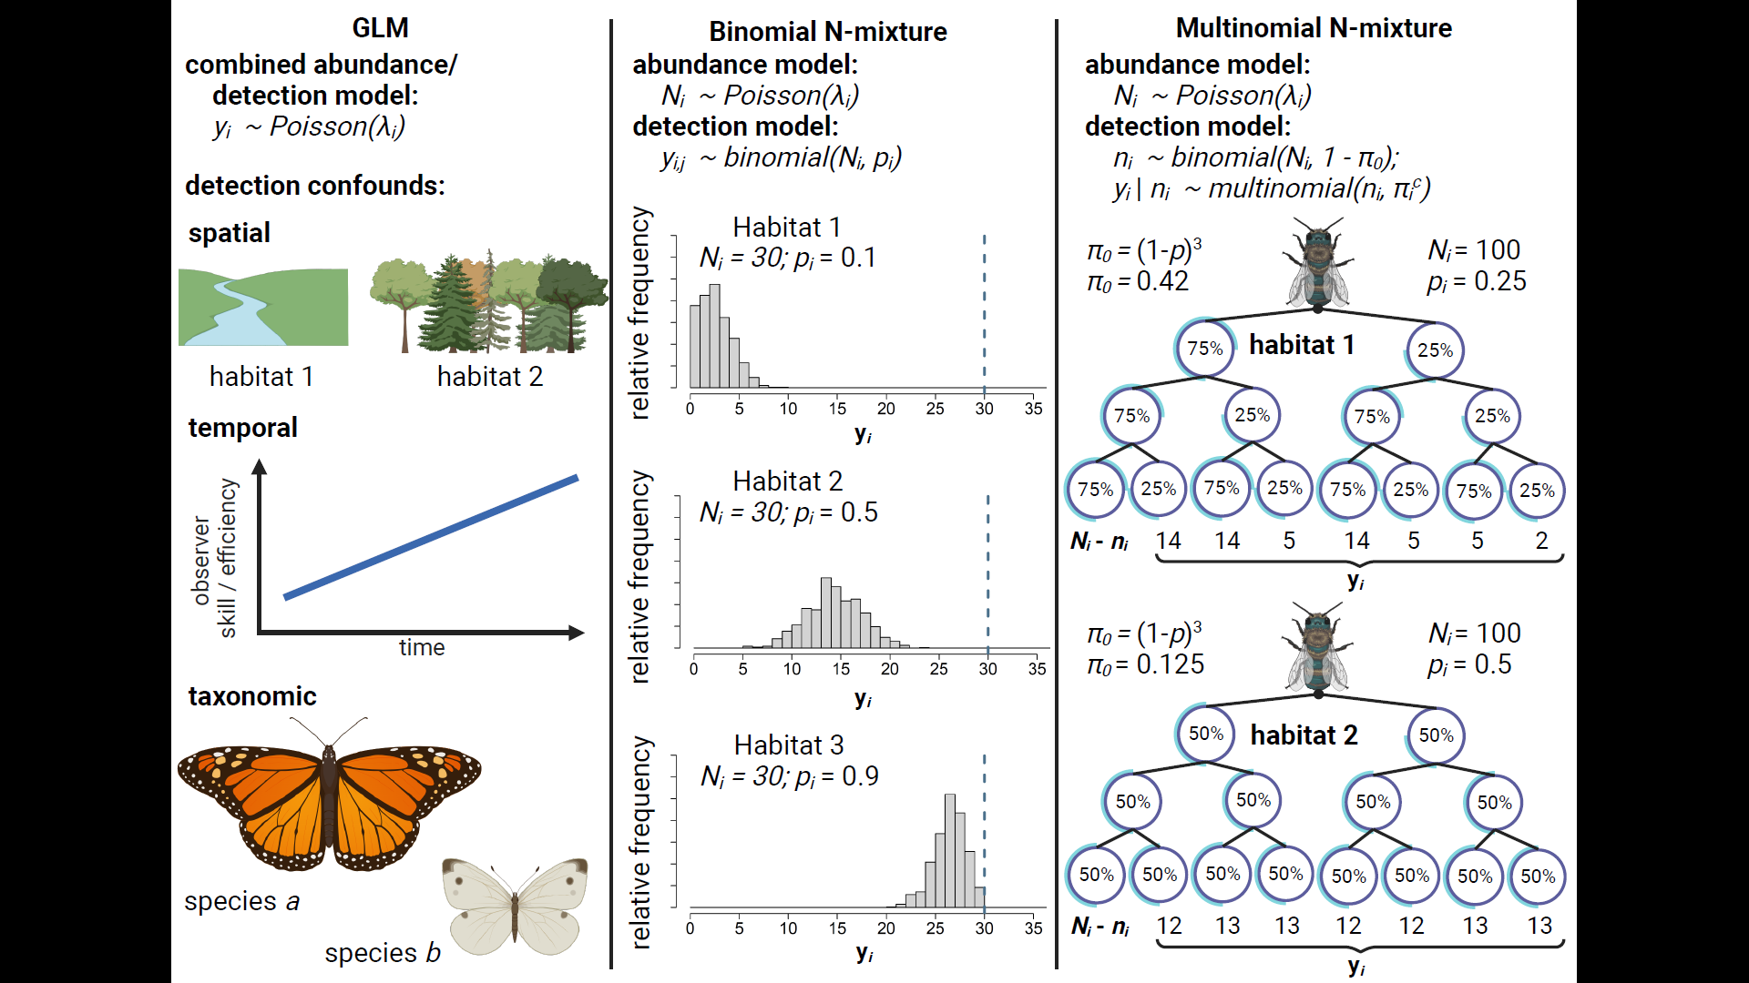
Figure 1: Comparison of three methods for estimating insect abundance. GLM’s (column 1) estimate the effects of spatiotemporal and taxonomic predictors ($λ_{i}$) on abundance by treating count data y_{i} as the outcome of a random process that generates positive integers, e.g., a Poisson distribution. GLM’s are unable to disentangle effects of these predictors on abundance from their potential effects on detection rate, e.g.: Habitat obscures detectability; observers improve their detection skills over time; or larger and more colorful species are detected at a higher rate than smaller and more dull-colored species. Binmix models (column 2) leverage the variation in counts $y$ across repeat surveys $j$ to units $i$ to simultaneously estimate detection rate $p$ and total abundance $N$. A more tightly clustered right-tailed distribution of repeat counts in Habitat 1 has a high likelihood when detection rate is low (counts heavily underestimate $N$); a tightly clustered left-tailed distribution of repeat counts in Habitat 3 has a high likelihood when detection rate is high (counts nearly approximate $N$); a wider and more symmetrical distribution in Habitat 1 has a higher likelihood when the detection rate is close intermediate. Multimix models (column 3) classify $y_{i}$ as the number of individuals in each observable encounter history, with the total number of individuals detected one or more times $n_{i}$ considered to be the outcome of a total population size and the probability of an individual having any of the observable detection histories (1 - $π_{0}$). In a study with three repeat surveys, the probability of never being captured ($π_{0}$) is equal to (1 - $p$)³. Encounter histories are typically tracked by placing marks on individual insects. Encounter histories that skew towards infrequent detection in Habitat 2 suggest that there is a high probability of failing to detect individuals across all repeat surveys, i.e., that $π_{0}$ is greater in Habitat 2 versus Habitat 1 and, correspondingly, that $n_{i}$ is a smaller proportion of $N_{i}$.
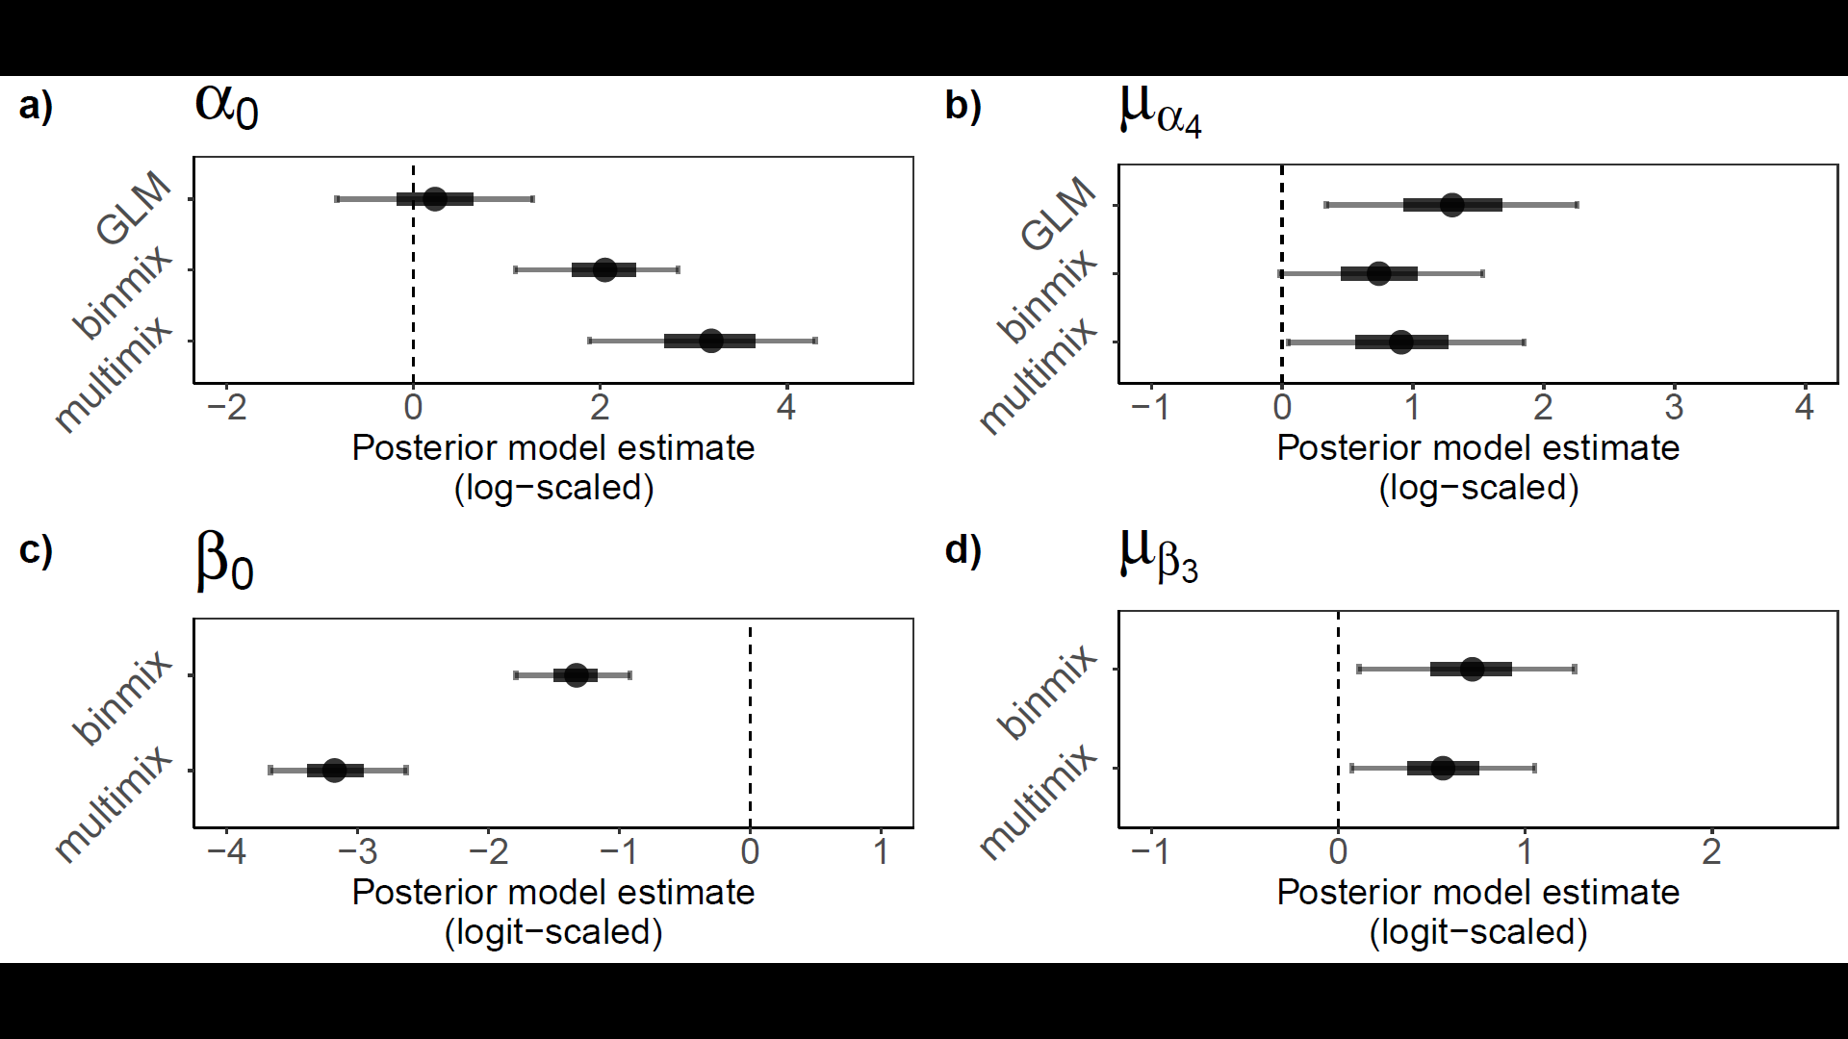Figure 2: Field study estimates of wild bee abundance and detection. We estimated abundance intercepts (a) and community mean effect of restoration on abundance (b) with all three model types. We estimated detection rate intercepts (c) and community mean effect of restoration on detection (d) for binmix and multimix models, which are designed to estimate and account for imperfection detection. Mean estimates are displayed with filled circles. Thick and thin error bars represent 50% and 90% BCI’s.

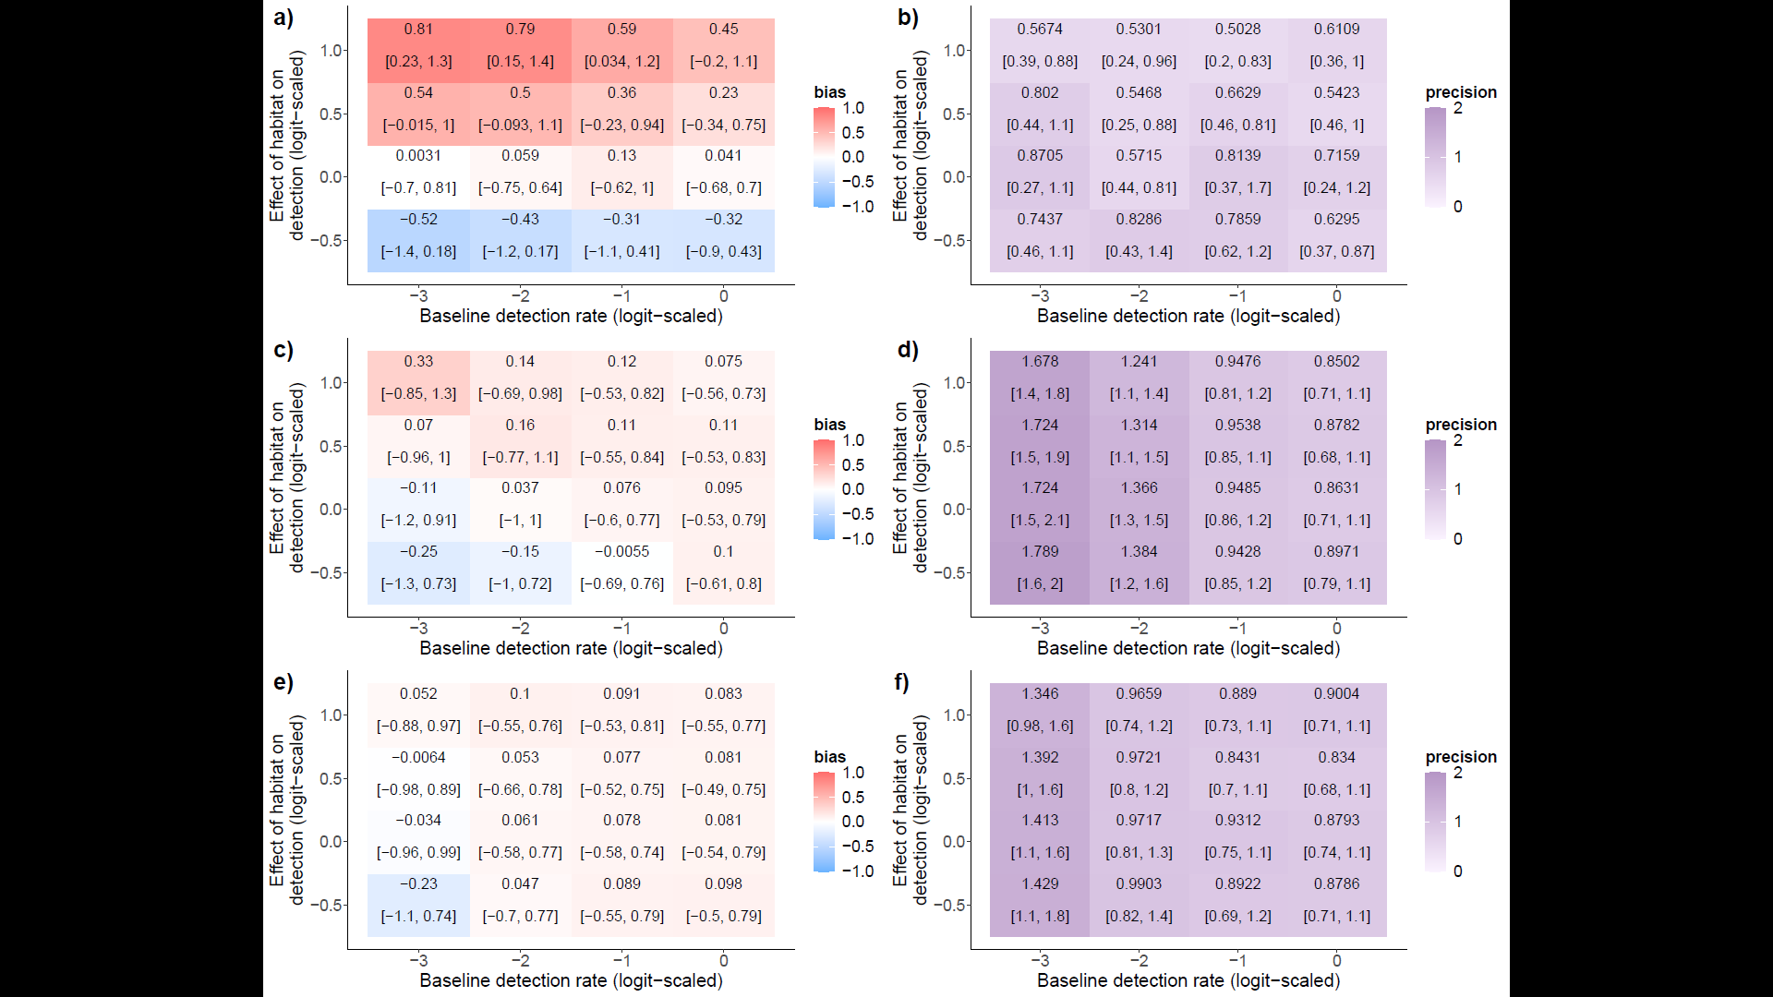
Figure 3: Bias and precision of abundance models under simulated changes in detection rate and effects of habitat restoration on detection: GLM bias (a) and precision (b); binmix bias (c) and precision (d); and multimix bias (e) and precision (f). Positive bias (red) indicates a tendency to overestimate the effect of habitat restoration on abundance while a negative bias (blue) indicates a tendency to underestimate the effect. A value of zero indicates no model bias. Models should return unbiased estimates of abundance drivers that are also precise. Higher values for precision (dark purple) represent wider BCI’s. Lower values (light purple) represent BCI’s with less uncertainty.
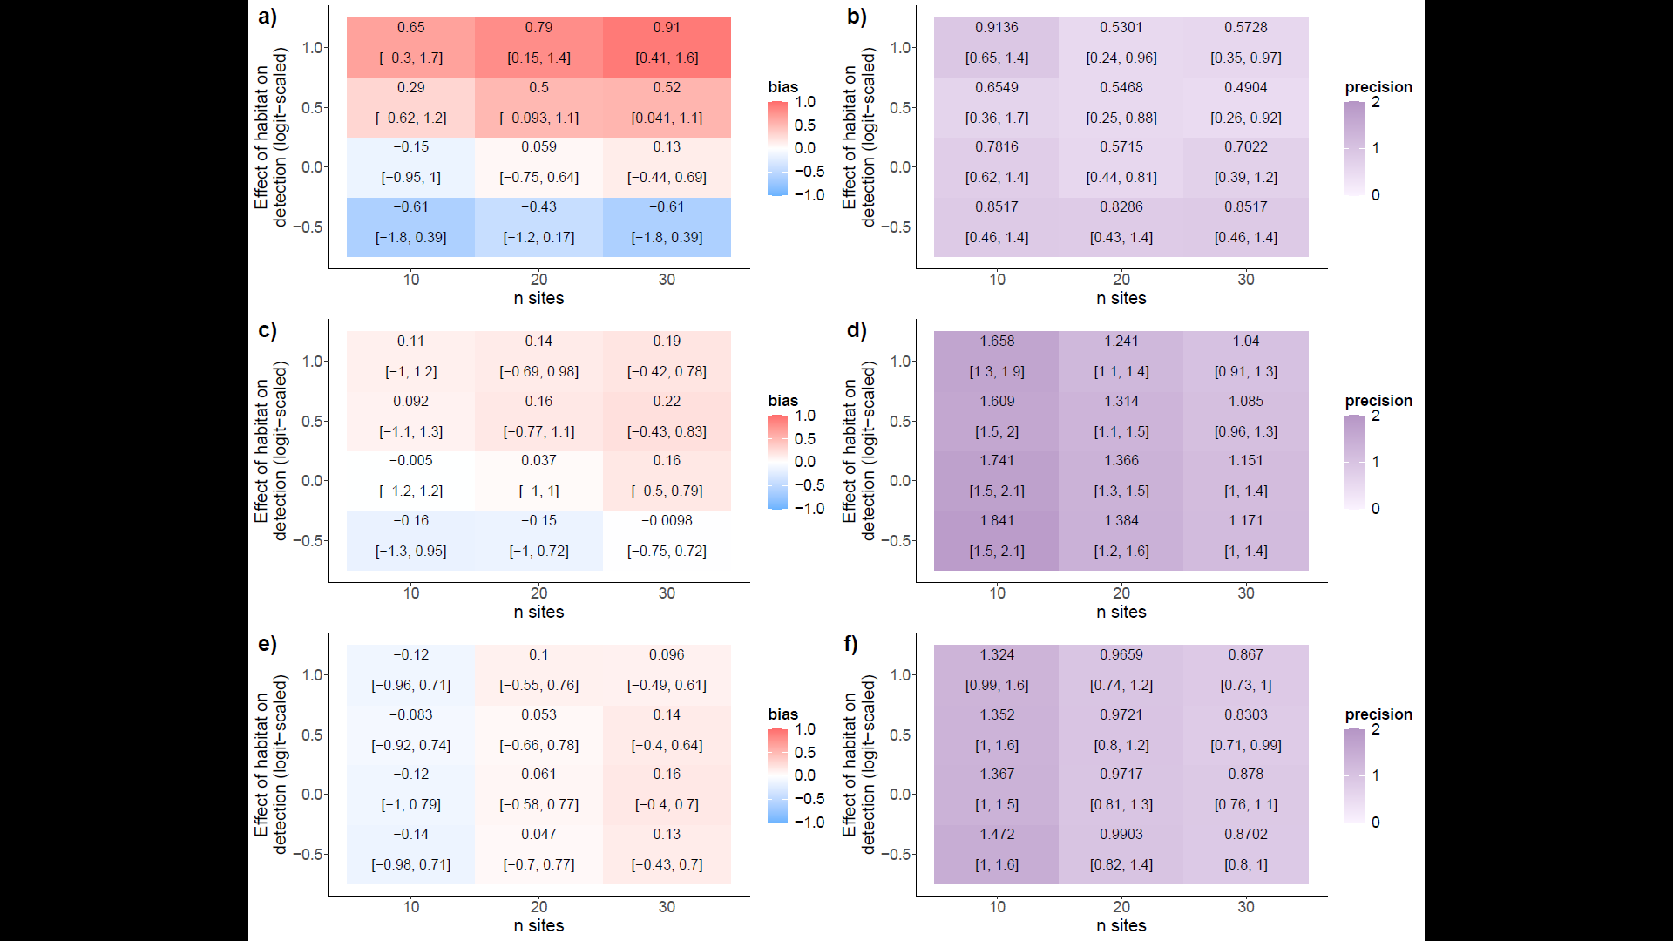
Figure 4: Bias and precision of abundance models under simulated changes in site number and effects of habitat category on detection. GLM bias (a) and precision (b); binmix bias (c) and precision (d); and multimix bias (e) and precision (f). Positive bias (red) indicates a tendency to overestimate the effect of habitat restoration on abundance while a negative bias (blue) indicates a tendency to underestimate the effect. A value of zero indicates no model bias. Models should return unbiased estimates of abundance drivers that are also precise. Higher values for precision (dark purple) represent wider BCI’s. Lower values (light purple) represent BCI’s with less uncertainty.

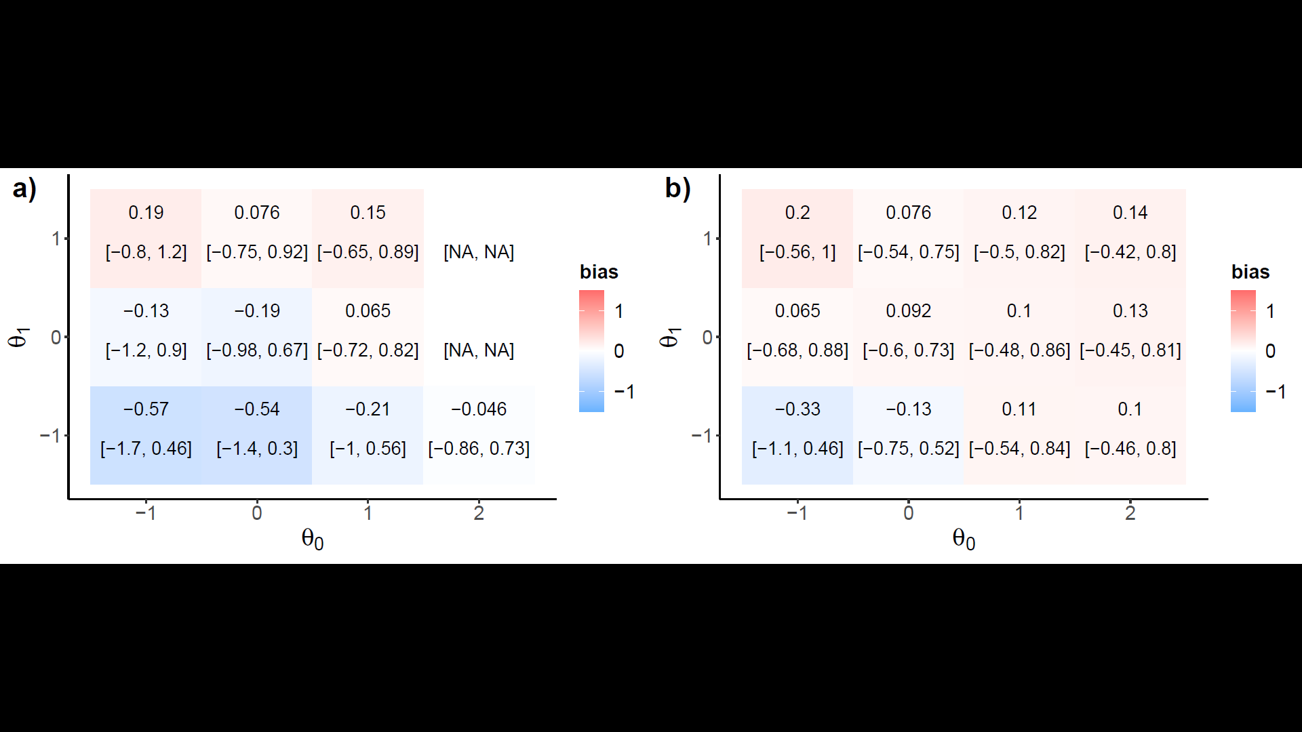
Figure 5: Robustness to closure violations. Binmix bias (a) compared to multimix bias (b), with respect to changing baseline availability odds (theta0) and systematic effects of restoration on availability odds (theta1). Positive bias (red) indicates a tendency to overestimate the effect of habitat restoration on abundance while a negative bias (blue) indicates a tendency to underestimate the effect. A value of zero indicates no model bias. Also add panel with overall abundance estimate and baseline detection rate to show how multimix is adapting by combining the odds of detection and availability.

