Estimating the drivers of insect abundance when detection is imperfect: a comparison of GLM, binomial N-Mixture and multinomial N-Mixture (hierarchical mark-recapture) approaches.
Abstract
To prevent insect biodiversity declines, we need to be able to estimate the drivers of insect abundance. Failure to detect individual insects that are present could bias estimates of abundance drivers made by widely used generalized linear models (GLM’s). Relying on information from detections across repeated surveys, binomial N-mixture models (binmix) and multinomial N-mixture (multimix) models have potential to disentangle drivers of abundance from factors that cause imperfect detection. In this study, we assessed the ability of GLM, binmix and multimix approaches to estimate a driver of insect abundance with accuracy and precision. First, we collected field data on wild bee abundance from control and restored urban parks using a sampling protocol that was compatible with all three approaches. The binmix and multimix models estimated that restoration had a small positive effect on the ease of detecting wild bees. After accounting for this detection effect, the binmix and multmix models produced lower estimates of a positive effect of restoration on abundance compared to the GLM. We paired our field study with a simulation experiment to identify potential causes of model divergence. We found that all models provided similar estimates when insects were easier to detect (detection odds of ~25-50%), but that GLM’s diverged at lower detection rates. We also found increasing the study sample size caused GLM’s to become increasingly sensitive to confounded effects of a simultaneous driver of abundance and detection. Finally, we found that abundance driver estimates from multimix models were robust to closure violations that could be caused by high mobility or rapid births/deaths of insects. Binmix models were not robust. Based on our results, we recommend that GLM studies prioritize sampling intensity that increases detection rate over increasing site sample size to minimize biased conclusions. We also recommend that researchers interested in accounting for detection biases should use multimix over binmix approaches unless focal species are sedentary and long-lived. Together, these results provide needed guidance on how to best estimate the drivers of insect abundance despite imperfect detection.

1. Introduction
One of the primary goals of ecology is to determine the drivers of species abundance (Krebs 1978; Gaston and McArdle 1994). Comparing the abundance of different species across space and time allows us to understand how the abiotic and biotic environment combine to shape patterns of biodiversity (Krebs 1978; Gaston and McArdle 1994). From a conservation perspective, quantifying the drivers of abundance allows us to assess population trends, identify population threats, or evaluate the success of a management intervention (Schultz and Hammond 2003; Waltz and Covington 2004; Blaauw and Isaacs 2014; Rundlöf et al. 2015). Accurately and precisely estimating the drivers of abundance is especially critical for insects, a functionally important group that is facing widespread declines (Wagner et al. 2021).
Typically, ecologists estimate the drivers of insect abundance by fitting generalized linear models (GLM’s) to count data from transect or trap surveys. Yet, count data are almost always affected by false-negative and false-positive measurement errors (Kery and Royle 2020). False-negative measurement errors, i.e., the failure to detect individuals that are present, are likely to be especially rampant for insect counts. Compared to other taxonomic groups, insects are particularly small and are often highly mobile, making them difficult to detect and/or capture (Portman, Bruninga-Socolar, and Cariveau 2020). If false-negatives are commonplace, standard GLM’s will underestimate the true abundance of insects (Kery and Royle 2020). More importantly, systematic variation in detection rates could bias GLM estimates of abundance drivers (Kery and Royle 2020).
There are several reasons why insect detection rates could vary systematically (Figure 1). For example, taller or more obscuring vegetation could impede researcher search ability and/or change the mobility or trap susceptibility of insects (ref). Alternatively, data collectors could improve their collecting skill or efficiency over time (ref). Species traits could create further variation in detection rate. Butterfly colouration and morphological features diversity have been linked to ease of detection (Goldstein et al. 2024). Larger insects could also be easier to detect compared to smaller insects. Among wild bees sizes can vary widely between species: small carpenter bees (Ceratina spp.) typically measure less than 8 mm in length while closely related large carpenter bees (Xylocopa spp.) frequently top 20 mm in length (ref).
These spatial, temporal, and taxonomic detection biases have the potential to confound estimates of ecological drivers of abundance (Kery and Royle 2020). For example, a positive effect of a habitat type on detection rate could cause GLM’s to overestimate the effect of that habitat type on abundance (Kery and Royle 2020). Crucially, GLM’s and their associated sampling protocols assume that the relationship between count surveys and true abundance is constant across space, time, and species (Williams et al., 2002). Despite the strong potential for variation in insect detection rates to bias GLM estimates, there is limited information on if or when other approaches should be considered.
Several statistical models and associated sampling protocols have been developed to estimate the underlying drivers of abundance while accounting for the false-negative errors caused by imperfect detection. For decades, mark-recapture methods have been used for this purpose (Lincoln 1930), including for insects such as butterflies and bees (Haddad et al. 2008; Briggs et al. 2022). Mark-recapture methods infer the total number of species that are present using information about the number of marked individuals that are re-detected compared to the number of unmarked individuals that are newly detected over a series of two or more sampling occasions. Mark-recapture models can be fit with the user-friendly software Program MARK (White and Burnham 1999 ADD REF), as in a study of wild bee abundance by (Briggs et al. 2022). However, classic mark-recapture models such as those implemented in MARK can only be fit to capture history data for single species within single sites at single time points. To estimate the drivers of abundance, this approach requires post-hoc regression between predictors like habitat type and independently derived abundance estimates from different spatial, temporal or taxonomic units (e.g., REF).
In contrast to classic mark-recapture, more recently developed hierarchical mark-recapture models use encounter histories from multiple sites and/or species to make more precise inference about detection rates and the number of individuals that occur at each site (Royle and Young 2008). Typical hierarchical Hierarchical mark-recapture models allow detection rates and abundance to be specified as outcomes of site or species predictors (Royle and Young 2008). This enables direct rather than post-hoc estimation of the drivers of abundance. A prevalent specification of hierarchical mark-recapture models is the multinomial N-mixture model (hereafter, “multimix”), which treats encounter histories of marked individuals as the outcome of a multinomial probability distribution (Kery and Royle 2020). The frequency of individuals observed in each possible encounter history category helps estimate of the number of individuals that were never detected (Figure 1). A larger number of individuals detected on most or all repeat visits suggests a relatively high detection rate, with fewer individuals that were never detected. Hierarchical multimix models are increasingly popular for population studies of birds, mammals, and reptiles and amphibians (REF). While classic mark-recapture models are considered a staple of butterfly population monitoring programs (Haddad et al. 2008), hierarchical multimix models have only rarely been applied to insects (e.g. that beetle removal paper). Multimix models offer a solution for estimating the drivers of insect abundance when detection is imperfect. However, these models also have limitations. In particular, mark-recapture data can be difficult and time consuming to collect, imposing financial costs (). Additionally, placing marks could damage or harm insects, an important consideration for rare or sensitive species (). Further, implementing hierarchical multimix models for mark-recapture data can be cumbersome, typically requiring custom-tailoring of complex code and large computational resources.
Another class of models, binomial N-mixture models (hereafter, “binmix”), are also designed to account for imperfect detection. Binmix protocols may be easier to implement than their multimix counterparts. In particular, binmix models do not require the expensive mark data required for multimix models. Instead, binmix models leverage the distribution of the number of individuals that are detected across repeat surveys to approximate true abundance (Figure 1; Royle et al., 2004). At one end of the spectrum, a tight left-tailed distribution of repeat counts suggests a high probability that the true abundance is not much larger than the maximum observed count. Conversely, tightly distributed right-tailed counts suggest a high probability that only a fraction of the true abundance is ever observed. In the middle of these scenarios, a widely spread symmetrical distribution of counts is consistent with a 50/50 odds of being detected on a given survey. For insects, binmix models have been used, for example, to estimate the effects of urban land use on mosquito abundance, the impacts of flower resource density on wild bee abundance, and the effects of seasonality and Arctic fritillary abundance (Manica et al., 2019, McCune et al., Riva et al., 2020, Della-Rocca et al., 2020).
While binmix models may offer a cheap solution for detection biases, many have criticized binmix model validity, emphasizing that abundance estimates are highly sensitive to model assumption violations (e.g., Link et al., 2018). In particular, binmix models assume that population size is closed across the time span of repeated surveys, i.e., that birth, death, immigration, and emigration do not drive observed variation in counts (). Variation due to closure violations should bias detection rate estimates and estimates of true population size (Link et al., 2018). Yet, it is currently unclear how closure violations impact estimates of the drivers of abundance. Insects tend to have short life spans (ref) and can be highly mobile (Greenleaf). This increases their potential for closure assumptions to be violated. Therefore, it is critical to understand how assumption violations impact the ability of these models to capture the drivers of insect abundance or whether more costly mark-recapture data is required to make reliable inference.
GLM’s, binmix, and multimix models could have trade-offs in cost and performance. Ecologists or conservation biologists with resource constraints may wish to implement the simplest approach that accurately and precisely estimates drivers of insect abundance. Determining the appropriate modeling approach for the task at hand requires clearer knowledge of the ecological and study design conditions that could cause the conclusions made by these different methods to diverge. In this study, we first collected insect abundance data using a sampling protocol that was compatible with all three modeling approaches. Specifically, we collected counts of eight wild bee species from five urban parks with habitat restorations and five control parks that were not restored. We collected the abundance data across 2022 and 2023, with three repeat surveys conducted within each season. We fit each model to the count data and compared the estimates for the effect of habitat restoration on abundance. To understand more broadly how these modeling protocols compare, we used estimates of abundance and detection obtained from our field study to inform a simulation-based model comparison. For each modelling approach, we tested how key elements of insect ecology including baseline detection rate and population size and typical components of study design including sample size and number of repeat visits impact the bias and precision of the estimated effect of a simulated “restoration”. Further, we used the simulation to test whether multimix models versus binmix models are more resilient to violations of population closure assumptions. In combination, our results from the field study and simulation study provide needed guidance on selecting the appropriate approach for estimating the drivers of insect abundance when detection is imperfect.
2. Methods
2.1 Field study design and data collection
For our field-based case study, we aimed to estimate the effects of urban park habitat restoration on the abundance of wild bees. To do so, we implemented an abundance protocol that was compatible with all three modeling approaches (GLM, binmix and multimix). We selected a sample of five urban parks in Vancouver, Canada, that received a habitat restoration. We compared these against five similar urban parks that did not receive a habitat restoration (hereafter, “control” parks). In another study, using a wider sample of parks that encompasses the ten included here, we examined the effects of the habitat restoration and found that the restorations increased pollinator species occurrence (Ulrich and Sargent, 2024). Increased pollinator occurrence translated into sustained species richness gains in restored parks (Ulrich and Sargent, 2024). In that study, we did not quantify the effects on species abundance (Ulrich and Sargent, 2024). Restorations changed habitat structure and resource availability. Restoration was strongly associated with increased flower species richness and marginally associated with increased flower species abundance (Ulrich and Sargent, 2024). Although we did not measure vegetation complexity, vegetation was approximately knee-height in restored parks compared to approximately ankle-height in control parks (Supplemental figure with images of park vegetation). In restored parks, vegetation was unmowed during April – September season compared to mowed bi-weekly in control parks. Restored parks contained a mix of spontaneous and seeded flowers that provide food resources for wild bees; control parks were dominated by turfgrass but contained spontaneous flower resources (Ulrich and Sargent, 2024). Managed flowering woody plants (trees and shrubs) occurred sporadically across all sites (Ulrich and Sargent, 2024).
We targeted abundance surveys on eight wild bee species from four different wild bee families: Agapostemon texanus (Halictidae), Andrena prunorum (Andrenidae), Anthidium oblongatum (Megachilidae), Bombus flavifrons (Apidae), Bombus mixtus (Apidae), Halictus rubicundus (Halictidae), Megachile spp. (not including the invasive Megachile rotundata) (Megachilidae), and Melissodes microstictus (Apidae). We chose species that we could identify in the field. This allowed us to avoid lethal sampling which would cause violations of population closure assumptions. Additionally, the species were common enough in our system that previous studies (Ulrich and Sargent, 2024) could provide a priori information on the timing of peak abundance. Targeting our sampling at the timing of peak abundance allowed us to limit changes in abundance caused by rapid births or deaths which would also violate population closure assumptions. We collected counts in two sampling periods. In early June we conducted three repeat surveys for three earlier phenology species: A. texanus, B. flavifrons and B. mixtus. In mid July we conducted the repeat surveys for five later phenology species: A. prunorum, A. oblongatum, H. rubicundus, Megachile spp., and Melissodes microstictus. To reduce closure violations, we conducted the repeat counts within the most rapid timescale possible, conducting the first and last repeat surveys at each site within a maximum window of eight days. A. prunorum was only surveyed in the second year of the study.
For the count surveys, a one-hectare sampling area was designated for each park. The sampling area focusing on a restored vegetation area for the restored parks or conventionally managed turfgrass space in control parks (the same survey areas used in Ulrich and Sargent, 2024). We collected pollinators with a sweep net, walking a spiral-transect through the survey area and netting all individuals thought to be our focal species. We repeated the spiral transect until the survey time ended. Surveys lasted 45 minutes, with the timer paused for insect handling. Netted insects were placed on ice until the completion of the survey. After the survey ended, we confirmed species identifications and applied marks. Marks were applied by placing chilled bees in a vial with a plunger on one end and a wide mesh covering on the other. After pressing bees against the mesh, we painted a colour-coded mark on the back of the thorax using a paint pen (Molotow brand with 2.0mm round tip) (Figure S_). Marking required approximately 30 seconds of effort per captured bee. Simple counts of the number of individuals captured during the survey were noted for the GLM or binmix approaches. To limit additional detection biases, all surveys were conducted by a single consistent observer, only during full sun conditions between 10:00 AM and 4:00 PM.
2.2 Statistical analyses
To estimate the effects of restoration on insect abundance, we developed custom-tailored models written in the probabilistic programming language Stan (ref), implemented in R (ref) using the package rstan (ref). These models use Bayesian inference to estimate distributions of parameter values that are consistent with both the data and our specified prior probability distributions.
For the GLM model, we specified counts of $y_{i}$ distinct individuals on sampling events $i$ = 1, …, $R$ to be outcomes of a negative binomial distribution with a mean $λ_{i}$ and dispersion $ϕ$ (Equation 1). We used negative binomial distributions for the GLM (and the binmix and multimix models) because our posterior predictive checks indicated that this added flexibility overcame a strong lack of fit that was evident for Poisson models (supplement). We modelled variation in $λ_{i}$ using a log-link function (Equation 2) as a function of a global abundance intercept ($α_{0}$), a species-specific random intercept effect ($α_{1}$), a site-specific random intercept effect ($α_{2}$), an effect of year ($α_{3}$), and a species-specific random effect of restoration ($α_{4}$), with restoration treated as a categorical variable.
- $y_{i} \sim negative binomial(λ_{i}, ϕ)$;
- $log(λ_{i})= α_{0}+ α_{1}\left[species\right]+α_{2}\left[site\right]+ α_{3}\left[year\right]+ α_{4}\left[species\right] ×restoration[i]$
We presumed that species-specific random effects of habitat were normally distributed with a mean and a variance term estimated from the data, i.e., $α_{4}\left[species\right] \sim normal(μ_{α_{4}}, σ_{α_{4}})$. Species- and site-specific random effects for the intercept were centered on a mean of zero, and presumed to be normally distributed with a variance term that was estimated from the data.
The binmix model assumes that the counts $y_{i,t}$ of distinct individuals at $i$ = 1, …, $R$ sites during $j$ = 1, …, $J$ sampling events are conditioned on a detection rate $p_{i}$ and a true abundance $N_{i}$, which we assume is fixed across the $J$ occasions. We considered $N_{i}$ to be the outcome of a negative binomial distribution with a mean $λ_{i}$ and dispersion $ϕ$ (Equation 3). We specified the number of successfully detected individuals on each survey event ($y_{i,t}$) as the outcome of a binomial trial. With this formulation, effects of predictors on abundance versus detection can be differentiated. We described variation in $λ_{i}$ as in Equation 2. We modelled variation in $p_{i}$ using a logit-link function (bounding the outcome to a probability range of 0 to 1) as function of a global detection intercept ($β_{0}$), a species-specific random intercept effect ($β_{1}$), a site-specific random intercept effect ($β_{2}$), and a species-specific random effect of restoration ($β_{3}$) (Equation 5):
- $N_{i} \sim negative binomial(λ_{i}, ϕ)$;
- $y_{i,j} \sim binomial(N_{i}, p_{i})$;
- $logit(p_{i})= β_{0}+ β_{1}\left[species\right]+β_{2}\left[year\right]+β_{3}\left[species\right] ×restoration[i]$
The programming language Stan does not allow for latent discrete variables, i.e., where the likelihood of the data is estimated with respect to a single discrete value of the parameter $N_{i}$. As such, calucated the marginal likelihood of the data across a range of $N_{i}$, from a lower bound of $N_{i}=max(y_{i,1:J})$ to an upper bound of a large finite value $K$ (as in Hocking et al., 2020). Our model proceeds by proposing new values for the abundance generating parameters and detection parameter values and then evaluating whether the likelihood of the data has improved. The lower bound is set at the maximum observed number of counts across occasion 1:$J$ because any lower values would allow the likelihood of a binomial trial to be zero (Kery et al., 2004). $K$ should be large enough that values of $N_{i}$approaching $K$ do not contribute to the likelihood (Kery et al., 2004). We evaluated sensitivity to the choice of $K$ to ensure that stable results were obtained (Kery et al., 2018). For the field study, we used a value of $K_{i}=(max\left(y_{i,1:J}\right)+5) ×12$, i.e., that the true abundance is within the range of the maximum number of individuals detected to an upper bound of twelve times the sum of five plus the maximum number of individuals detected. In other words, that the number of unique individuals detected during our best survey (plus five extra individuals) only managed to detect ~8% of the individuals that are present.
Finally, for the multimix, we specified a three-level model with a multinomial observation process for detection histories (Kery and Royle 2010). Where 0 represents non-detection and 1 represents detection, the possible observable detection histories for three repeat surveys are: 111, 110, 101, 100, 011, 010, and 001. 000 represents the eighth possible history, which is not observable. More generally, for a study with j repeat surveys, there are 2^{j} possible detection histories (Royle et al. 2007). The outcome variable $y_{i}$ was defined as a vector with each element representing the number of individuals in one of the seven detection history categories. The likelihood of the observed detection histories is specified as the outcome of a multinomial trial with some number of individuals observed one or more times ($n_{i}$) and given a vector of probabilities for each of the observable histories ($π_{i}^{c}$) (Equation 6). To estimate the remaining number of individuals at the site, we treated the number of observed individuals ($n_{i}$) to be the outcome of a binomial trial depending on the size of the total population ($N_{i}$) and the probability of not being observed ($π_{i}^{0}$, i.e., probability of a detection history of 000) (Equation 7). As with the binmix model, the population size $N_{i}$ was modelled as the outcome of a negative binomial distribution (Equation 3) with a dispersion term and a linear predictor for the mean $λ_{i}$ (Equation 2). We used the same value of $K$ outlined for the binmix approach which also yielded stable results for the field study. Heterogeneity in detection rate was modelled using a linear predictor for detection rate $p_{i}$ (Equation 5), but where $p_{i}$ is estimated by defining its relation to $π_{i}^{1:8}$. For example, where probability of detection history 111 or $π_{i}^{1}= p_{i}×p_{i}×p_{i}$; probability of detection history 110 or $π_{i}^{2}= p_{i}×p_{i}×(1-p_{i})$; probability of detection history 101 or $π_{i}^{3}= p_{i}×{\left(1-p_{i}\right)×p}_{i}$; and so on.
- $y_{i} \sim multinomial(n_{i}, π_{i}^{c})$;
- $n_{i} \sim binomial(N_{i}, 1-π_{i}^{0})$;
We employed best practices for model development and fitting by: using weakly-informative priors to discourage unrealistic parameter values (Table S_); confirming sufficient mixing of chains (Gelman-Rubin R-hat values < 1.05), minimal within-chain autocorrelation (effective sample size/steps > 0.1) and no divergent transitions (Figures S_ and S_); running our model for a length of 4000 HMC steps, discarding the first 2000; and using posterior predictive checks to assess the fit of our models (Stan Development Team 2023b; Gelman, Hill, and Vehtari 2020; Kery and Royle 2020).
2.3 Simulation study
We wrote a simulation program in R that generates species abundance and detections. The simulation produces abundance from a Poisson distribution. We used a Poisson process for abundance because Poisson models could be fit more quickly than negative binomial models. We included species, site, and year predictors for the mean of the Poisson generating process, exactly as in Equation 2. Conditional on simulated abundance and an input detection rate, the program then produces detection histories and detection counts. The simulation script allows detection rate to vary by species, site, and/or year, exactly as in Equation 5. All simulations were run on the University of British Columbia Sockeye computing platform.
We used this simulation setup to determine how aspects of insect population ecology, study design and closure violations impact the ability of the different models to estimate the effect size of a driver of insect abundance. To accomplish this goal, we fit each of the three models to data that were simulated under some different scenarios. For all simulations we specified half of the sites as “restored” and the other half of sites as “control”. In these simulations, restoration represents a potential driver of insect abundance that a researcher may wish to quantify, but the term could easily be replaced with any hypothesized driver of insect abundance such as land cover, temperature, resource density or pollution. The effect size of the restoration parameter $μ_{α_{4}}$ (as defined by Equation 2) was held constant at a value of 1, representing a positive effect on abundance.
First, we assessed how changes in baseline insect detection rates impact model bias and precision. To do so, we simulated detections for twenty sites, sixteen species, and two years, with three repeat surveys per year. We varied the detection intercept across values of -3, -2, -1, and 0 (on a logit-scaled). On the probability scale, a value of 0 represents 50% odds of an individual insect being detected on a given survey given that it is present, whereas a value of -3 represents a <5% odds. For each level of detectability, we varied the effect of restoration on detection rate across values of -0.5, 0, 0.5, and 1 (logit-scaled). A positive value indicates that insects are easier to detect at restored sites compared to control sites. The abundance intercept was held constant at a value of 1 (log-scaled), with no effect of year on abundance or detection. For each combination of baseline detection rate and effect of restoration on detection we simulated abundance for ten systems, and then fit all three of the models to each of the ten systems. We then extracted 250 samples from the posterior distribution for each fit, equating to 2,500 samples for each model type for each combination of detection parameters. To calculate model bias, we subtracted the sampled effect size estimates from $μ_{α_{4}}$ and calculated the mean and 50% and 90% BCIs for the difference. A negative bias indicates tendency to underestimate of the effect, while a positive value indicates tendency for overestimation. To assess model precision, we calculated the width of the 90% BCI for each model fit and then described the mean and distribution of widths for each model type. A larger value indicates a lack of precision or high uncertainty in the true value of the parameter. A smaller value indicates high precision or low uncertainty in the true value of the parameter. It is possible that models could be highly precise but inaccurate, or vice versa.
Next, we assessed how changes in site number impact model bias and precision. To do so, we simulated detections across n sites = 10, 20 or 30. For each value of n sites, we again varied the effect of restoration on detection rate between -0.5, 0, 0.5, and 1 (logit-scaled). The detection intercept was held constant at a value of -2 (logit-scaled). All other parameters and study dimensions were held constant as described in the previous paragraph. We used the same approach to quantify bias and precision.
Finally, we examined how violations in closure assumptions impact binmix and multimix estimates. For this test of model robustness, we still considered $N_{i}$ to be the outcome of a Poisson trial. However, we also simulated whether each individual in $N_{i}$ was “available” for detection, where each individual has some stochastic chance of being available for detection at the timing of the survey: ${availability}_{i} \sim binomial(N_{i}, θ_{i})$. Only available individuals were then eligible for detection. In this scenario, $N_{i}$ more closely represents a superpopulation, where some individuals may move in or out of the study area or be born or die within the period of the study. We specified a linear predictor for $θ_{i}$, with an availability intercept $θ_{0}$ and a fixed effect of restoration on availability $θ_{1}$. We varied $θ_{0}$ between -1, 0, 1, and 2; and $θ_{1}$ between -1, 0 and 1 (logit-scaled). Negative values of $θ_{i}$ represent scenarios where insects have a higher odds of being unavailable than of being available. We held the abundance intercept at 2 (log-scaled), and held the baseline detection rate constant at -2 (logit-scaled) with no effect of restoration on detection. All other parameters and study dimensions were held constant as described above, with the same approach used to quantify bias and precision.
3. Results
To determine abundance and detection patterns for real insect populations, we fit each of our models to wild bee count data collected from ten field sites (Figure 2). As expected given that GLM’s do not account for imperfect detection, the GLM estimated a lower abundance intercept ($α_{0}$ mean = 0.23; 90%BCI = [-0.82, 1.27]) compared to either the binmix or multimix models: The binmix model estimates a higher intercept with 98.1% probability and the multimix model with 99.5% probability. The GLM estimated a positive effect of restoration on insect abundance: $μ_{α_{4}}$mean = 1.30; 90% BCI = [0.34, 2.25]. Effect size estimates were smaller for the binmix model: $μ_{α_{4}}$mean = 0.74; 90% BCI = [-0.02, 1.53]; 77.3% probability of a smaller effect size compared to the GLM approach. Effect size estimates were also smaller for the multimix model: $μ_{α_{4}}$mean = 0.91; 90% BCI = [0.05, 1.85]; 60% probability of a smaller effect size compared to the GLM approach.
Consistent with estimating a higher abundance intercept, the multimix model estimated a lower baseline detection rate ($β_{0}$ mean = -3.17; 90% BCI = [-3.66, -2.62]) than the binmix model ($β_{0}$ mean = -1.32; 90% BCI = [-1.79, -0.92]). On a probability scale, the mean estimates of these models equate to a 4% (multimix) or 20% (binmix) odds of detecting individual bees during a 45 minute survey of the one hectare plot. The binmix model estimated a positive effect of restoration on detection rate: $μ_{β_{3}}$ mean = 0.72; 90% BCI = [0.11, 1.26]. The multimix model also estimated a positive effect: $μ_{β_{3}}$ mean = 0.56; 90% BCI = [0.07, 1.05]. The positive effects of restoration on detection are consistent with estimates for the effects of restoration on abundance that are smaller than those provided by the GLM.
We used simulation to determine how aspects of insect ecology or study design impact the ability of these models to estimate a driver of insect abundance. First, we examined how changes in baseline detection rate and effects of habitat on detection rate impact accuracy and precision of abundance driver estimation (Figure 3). We found that GLM bias was marginal when the odds of detecting an individual insect were relatively high: When the odds of detecting an insect were 50% (0 on the logit scale), no clear bias emerges even when restoration simultaneously increase detection rate (mean bias = 0.45; 90% BCI = [-0.2, 1.1]). Results were still not consistently biased when the odds of detecting individual insects were ~25% (-1 on the logit scale). Decreased odds of detecting an insect caused clear GLM biases to emerge. When the odds of detecting an insect were <5% (-3 on the logit scale), GLM biases followed the direction of the effect of restoration on detection rate: There was a clear positive bias when restoration increases detection rate (mean bias = 0.81; 90% BCI = [0.23, 1.3]) or a clear negative bias when restoration decreases detection rate (input the values). In contrast, the binmix and multimix did not show clear bias. Mean estimates for the effect of restoration on abundance tended to be <0.1 away from the true value of 1. The largest divergences occurred for the binmix models when baseline detection rates were lowest, at -3 on the logit scale and with an effect of restoration on detection rate: mean bias = 0.33; 90% BCI = [-0.85, 1.3]. For the GLM, precision did not vary systematically with detection patterns. However, binmix and multimix showed systematic declines in precision along a gradient of decreasing baseline detection rate. Multimix models tended to be more precise than the binmix models.
Next, we used simulation to examine how site sample size and the effect of habitat on detection rate combine to influence accuracy and precision of abundance driver estimation (Figure 4). We found that increasing the number of sites made GLM’s both more biased and more precise. In other words, in these scenarios GLM’s increased their confidence in an incorrect conclusion. For example, when there was a strong positive effect of restoration on detection rate and only ten study sites, GLM’s slightly overestimated the effect of restoration on abundance (mean bias = 0.65; 90% BCI = [-0.3, 1.7]) and provided relatively wide confidence intervals (mean 90% BCI width = 0.91). When we increased the number of study sites to thirty, overestimates were larger (mean bias = 0.91; 90% BCI = 0.41, 1.6) while confidence intervals narrowed (mean 90% BCI width = 0.57). Binmix and multimix models were not clearly biased by changes in site number. Consistent with increasing availability of data to inform parameter estimation, binmix and multimix precision increased systematically with increasing number of sites.
Finally, we assessed the robustness of binmix and multimix models to violations in closure assumptions (Figure 5). Binmix model outcomes were sensitive to systematic violation of closure. This was especially evident when baseline availability odds were low: when $θ_{0}$ = -1 and habitat restorations negatively increase odds of availability ($θ_{1}$ = -1), the binmix model underestimated the effect of habitat restoration on abundance by an average of -0.57 (90% BCI = [-1.7, 0.46]). In contrast, we found that multmix models did not yield biased estimates of the effects of restoration on abundance. Across all levels of baseline odds of availability and impacts of restoration on availability, the multimix model tended to miss the true effect size of restoration on insect abundance by less than a magnitude of 0.2. Multimix models adapted to changes in availability by underestimating the true detection rate. Specifically, multimix models estimated detection rate as the probability that an individual is available for capture at the time of the survey and the probability of detecting an individual given that is present.
4. Discussion
Addressing widespread insect biodiversity declines requires an ability to quantify drivers of insect abundance with accuracy and precision. Surveys of insect abundance are likely to suffer from imperfect detection (), which could bias estimates made by widely used GLM modeling approaches. In this study, we paired a field study and simulation study to compare the performance of GLM’s against costlier and more cumbersome binomial N-mixture (binmix) and multinomial N-mix (multimix) modelling approaches. In a real field setting, both binmix and multimix models suggested that site covariates influence insect detection rates: wild bees were easier to detect at restored sites compared to control sites. After accounting for this confounding detection bias, these models estimated a less pronounced (but still positive) impact of restoration on wild bee abundance as compared to a GLM. These results suggest caution in interpreting the magnitude of predictors such as habitat type when that same predictor has the potential to influence the observation or capture of insects. Using a simulation approach, we also found that decreasing baseline detection rate and increasing sample size exacerbate the divergence between GLM versus binmix and multimix models. This suggests that increasing site sampling intensity rather than adding more field sites can help limit the bias of GLM approaches. Finally, we found that multimix models were robust to violations of system closure. Conversely, binmix models were sensitive to systematic violations of closure, such as when individual movement in/out of a study site or individual mortality is influenced by site covariates. It may be infeasible to determine whether closure violations vary systematically a priori. Consequently, researchers should consider tracking individual detection histories if closure violations are likely, for example, if focal insect species have high mobility or short lifespans. Together, these results provide needed guidance on how to maximize the accuracy and precision of insect population studies, which is necessary for promoting insects in a changing world.
For our field study data, all three models estimated a positive effect of restoration on wild bee abundance. This is consistent with Ulrich and Sargent 2024, who showed a positive effect of these restorations on wild bee and hoverfly species occurrence. More broadly, habitat amendments that increase floral resources tend to be associated with increased abundance of pollinator insects such as bees or butterflies (Hyjazie and Sargent, Waltz and Covington 2003). Compared to the effect size estimated by the GLM, the magnitude of the effect was smaller for binmix and multimix models. The larger effect size estimated by the GLM can be explained by a confounding effect of restoration on detection, which was estimated and accounted for by both the binmix and multimix models. Bees may have been easier to detect in restored sites due to the taller vegetation: bees foraging on knee-height flowers in the restored parks would have been closer to eye-level and net-level compared to bees foraging on ankle-height flowers in the control parks. Supporting this hypothesis, a methodological study of distance sampling methods found that bumble bee detection rates can decline when the distance from an observer and the insect increases by even 1 metre (McNeil et al. 2019). Alternatively, the higher floral resource diversity in restored parks may have increased detection rates through effects on bee movement. Previous studies have shown that floral resources density or distribution affect wild bee foraging behaviours, for example, with bees spending more time probing individual flowers in habitat patches with high flower diversity (Heinrich 1979). Decreased foraging mobility could have increased our ability to sight and/or capture wild bees using our net collecting approach. Many have debated whether floral resources positively or negatively impact sampling of wild bees, including for similar net collecting protocols or for other sampling methods such as passive pan traps (Cane et al., 2000 (bowls), Joshi et al., 2015 (netting), Portman et al., 2019 (more general)). To our knowledge, our study provides the first quantification of a positive effect of floral resources on the ability to net collect wild bees.
Other habitat qualities have the potential to obscure insect detection. For example, looking at urban mosquito populations, Manica et al. 2019, found that increased vegetation cover improves trap capture rates, aligning with mosquito preference for ovipositing near dense vegetation. Other studies have pointed towards additional potential sources of insect detection bias. In a study of butterfly populations, Isaac et al. 2011 found that detection rates were higher for their subset of sites in England compared to those in Wales, potentially due to recorder differences. Unaccounted for, those differences would have pointed towards regional divergence in butterfly population trends. Kral-O’Brien et al. 2020 found that larger and more colourful butterfly species are easier to detect, providing evidence that insect morphological traits can also bias estimates of population sizes or trend estimates from GLM approaches. Overall, our results combine with other studies of insect detection to emphasize that abundance effect size estimates produced by conventional GLM’s should be interpreted with caution.
Still, conventional GLM’s are widespread and are likely to continue to serve as a standard workhorse for insect population and community studies. As such, we aimed to provide guidance on when they are most appropriate and/or how to reduce their bias. Our simulation showed that, despite imperfect detection, GLM estimates for a site effect were consistently unbiased when there was no effect of the same covariate on detection rate. GLM bias emerged only when the covariate had a confounding effect on detection. The bias was exacerbated either when individuals were extremely harder to detect or when sample size increased. Given these results, we recommend that GLM based studies prioritize increasing detection rate over site replication if there is suspicion of a confounding predictor of abundance and detection. This may be counterintuitive to conventional wisdom to find generality through increasing spatiotemporal replication. Increasing detection rate could be achieved by improved sampling intensity: by increasing the length of a survey, by increasing the number of surveyors, or by increasing the number of traps deployed per sampling location. In our simulation, a sample consisting of 20 sites and 16 species for 3 repeat surveys in each of two years were relatively unbiased by strong effects of habitat on detection when baseline insect detection rates neared 50%. Increasing detection rates to these higher levels could help to ensure unbiased results in future studies.
Applied to our empirical data, the mark-recapture model suggested that wild bee detection rates were below 5% (_ to _%) in control sites and about _% (_ to _%) in restored sites. These estimates are in line with those provided by other net-collection wild bee mark-recapture studies, including capture probabilities ranging between 4% and 52% for four species/morphospecies in North Carolina forests where each site was sampled for 1 hour per day (Briggs et al., 2020). Detection rates could be larger for butterflies. In central Europe, surveyors detected the Iolas blue, Iolana iolas with an odds of 86% (Heer et al., 2013). Conversely, detection rates for other insects might be lower, with mosquitos detected at an average rate of only 0.022% (Manica et al., 2019). The differences in detection rates could stem from biological differences but also from differences in sampling methodologies. Manica et al., 2019’s low mosquito detection rates were obtained using passive rather than active sampling methods. Passive sampling traps are widely used across insect groups, including wild bees, and could yield different detection rates than the ones observed in our study (https://doi.org/10.3390/insects9040170). Taxonomic differences in detection rates, stemming from differences in biology or sampling schemes, mean that some insect groups might be more likely than others to require detection models such as binmix or multimix to yield reliable results.
It is well established that binmix estimates of population size can be biased by even minor violations of the closure assumption (Fogarty and Fleishman, 2021; Duarte et al. 2018). Our closure violation simulations also reflect this deficiency of binmix models. Therefore, binmix models are unlikely to provide a robust means for estimating true abundance of insect populations. However, we found that binmix models were only biased estimators of the drivers of abundance when the violations were systematically driven by a predictor. Still, the bias introduced by closure violations were minimal, with the 90% BCI for bias at least somewhat overlapping with zero under all of the scenarios that we tested. This agrees with studies focused on birds, that found that estimates of site-specific predictors of abundance were minimally biased by movement of individuals into and/or out of sampling areas (Fogarty and Fleishman, 2021). Low rates of availability exacerbated the bias of binmix models caused by systematic violations of closure, with higher bias when Theta0 less than or equal to 0.
Lower availability for detection could be driven by mobility or mortality. An insect that spends more time foraging/feeding or pursuing reproduction outside of the sampling area relative to inside the sampling area would have a value of theta0 less than 0. For our study, we surveyed 100 metre by 100 metre plots. Although they have the potential for larger movements, even the most mobile wild bees such as bumble bees tend to limit their foraging activity within a few hundred metre area (ref). At the same time, wild bees are central-place foragers that search for resources in an area surrounding a fixed nest location (ref). Together, this means that individual bees have potential to retain availability for detection across repeat surveys. This would be reduced by tendency to supplement diet with resources from complementary habitats, which can occur in wild bees (ref). Insects with larger daily movements and no fixed nest position may be less likely to satisfy high levels of availability. For example, the chequered skipper butterfly, Carterocephalus palaemon, occasionally moved over a kilometre in a single day (https://link.springer.com/article/10.1007/s10531-024-02837-6). Without a fixed nest location, these butterflies have little pressure to return to the original capture location where they would be available for detection on a repeat survey. Discrete habitat edges such as roads or hedges have been shown to restrict movement of insects, including for wild bees and hoverflies (). Designing surveys in landscapes with discrete habitat edges could help to reduce closure violations caused by movement. Mortality should also be considered before implementing binmix models. Wild bees are typically active for several weeks, for example, with a flight period of about 18 days for Andrena hattorfiana (Larsen and Franzen, 2008), a reasonably broad window for our repeat surveys which were conducted within eight days. Conducting repeat surveys within a single day could help limit closure violations for insect groups with more rapid mortality (Nowicki et al., 2008). Overall, binmix models will be most appropriate when mobility is limited and individual insects are longer-lived. A binmix model and sampling approach for estimating abundance of rare stag beetles, Lucanus cervus, represents a good implementation (Della-Rocca). Adult male Lucanus cervus have an active flight period of several months during which time they tend to move by less than a few dozen meters per day (Tini et al., 2017).
Multimix models consistently provided the most accurate results. Therefore, to obtain reliably unbiased estimates of the drivers of insect abundance, we recommend implementation of multimix models whenever possible. In response to closure violations, multimix models negatively adjusted the detection rate to encapsulate both the odds of availability and the odds of detection given availability. This could explain why the multimix model provided lower estimates of baseline detection rate compared to the binmix. Multimix models were also more precise than binmix models, in agreement with (ref). As such, multimix model allow researchers to leverage maximum information from a limited sample size. This could be especially important when a focal species is rare and occurs at a limited number of sites or where site survey permitting is a limiting factor ().
Implementation of multimix models was not trivial. Marking and releasing captured individuals took significant time, which can translate into substantial survey costs (Hamm et al., 2013). Second, marking could injure insects or otherwise alter population trajectories by changing predation rates or mating success. Numerous studies have provided evidence that marking does not effect insect survival (Morton 1982; Gall 1984). For our study, we observed bees resume foraging activity immediately after release from our marking tube. Nonetheless, possible damage may still be an important consideration for extremely vulnerable insect populations. In addition, for our study, we applied custom-built statistical models written in the programming language Stan. We provided open-access code that can be used as a template for other studies. However, tweaking the models to suit unique study design parameters such as the number of repeat surveys would require familiarity with these programming languages. The R package “unmarked” provides a user-friendly resource for fitting both binmix and multimix models in a frequentist framework (ref unmarked). Unfortunately, users cannot currently apply “unmarked” to multispecies systems such as ours, limiting application for community abundance studies (ref unmarked). An inability to specify informative priors with “unmarked” may also hinder identifiability of “unmarked” models (ref).
One key drawback of both binmix and multimix approaches is the need to assign taxonomic identity to individuals in the field. Many insect species are not readily recognizable in the field: In our same system, Ulrich and Sargent 2025 detected close to 100 wild bee species. We were only able to focus on 8 species/morphospecies in part because we could not identify many other species without a microscope and reference specimen resources. We could not include these other species in our study because removing them from the system for identification would have undermined our mark-recapture study design. Ignoring rare or obscure species could mask the importance of covariates: The environment can have important impacts on composition while the total number of species or the abundance of common species remains unaffected (). In contrast to binmix or multimix models, GLM’s do not require tracking detection histories and so specimens can be removed from the field for identification. This reinforces that conventional GLM’s are likely to remain widespread and important for studies of insect populations and communities. It is essential to understand how to minimize GLM bias rather than abandon them altogether.
Multimix models can be applied to other sampling protocols. Alternative protocols include removal sampling, multiple observer recording, territory tracking, or distance sampling methods (Kery and Royle 2020). Similar to mark-recapture, these other sampling protocols leverage categorical outcomes of detections. For example, with a multiple observer approach, an individual detected by three out of three surveyors would receive a detection history of 111 compared to an individual detected by only the first of three surveyors receiving a detection history of 100 (ref). Similar to our mark-recapture approach, analysis can proceed by calculating the likelihood of observing some set of individuals in each detection history category given some abundance and detection parameters (ref). _ applied a multinomial N-mixture model to beetles from pitfall traps using a removal sampling scheme… Distance sampling appears promising for insect studies and has been applied to bumble bees and butterflies (). This approach leverages the decline in observations across increasing distances from the observer to estimate detection rates (ref). Distance sampling is attractive because it does not require that individuals be marked, it does it require repeat surveys, and it does not require defining discrete sampling area boundaries (ref). One drawback is that distance sampling requires visual identification without capture, possibly explaining why this method has not been applied to insects other than butterflies and bumble bees, which are relatively large and can be often identified from colour patterns.
Conclusions and recommendations:
We showed that habitat covariates can simultaneously influence insect abundance and detection, with wild bees being both more abundant but also easier to detect in habitats that had taller vegetation and more floral resources. Binmix and multmix models account for detection biases to provide more accurate estimates of the drivers of insect abundance. Multimix models were more precise and were also more robust to movement or mortality of insects as compared to binmix models. Therefore, to account for detection bias, we recommend the use of multimix approaches especially when insect mobility exceeds the spatial area of sampling or when insect life spans are shorter than the distance between repeat survey events. At the same time, multimix approaches are significantly more challenging to implement. New approaches for collecting mark-recapture data could lessen these burdens. These approaches include photographic mark-recapture and genetic recapture to track detection histories (). Alternatively, researchers could use other methods such as distance sampling for generating multinomial detection outcomes. Integrated models also provide a way to combine widespread count data with expensive but powerful mark-recapture data from a subset of sites or species (). We anticipate that GLM approaches will remain widespread for estimating drivers of insect abundance. As such, we recommend interpreting estimates with caution or designing studies in such a way as to minimize the potential for imperfect detection to cause bias. Our study suggests that this can be achieved by increasing sampling intensity. By accounting for or minimizing detection biases, researches can provide accurate and precise recommendations for stemming insect declines.

Some notes (ignore this):
Repeat sampling on the same day: Nowicki P, Settele J, Henry P-Y, Woyciechowski M (2008) Butterfly monitoring methods: the ideal and the real world. Israel J Ecol Evol 54:69–88
Detection rates for a butterfly were near 86% Heer, P., Pellet, J., Sierro, A. and Arlettaz, R., 2013. Evidence-based assessment of butterfly habitat restoration to enhance management practices. Biodiversity and conservation, 22(1), pp.239-252.

Field evaluation of abundance estimates under binomial and multinomial N‐mixture models

Compare above with mosquitos: The estimated capture rate on average was 0.022% (95% ci: 0.017%–0.026%) Manica et al. 2019
Movement of up to 2.2km over a period of 17 days: https://link.springer.com/article/10.1007/s10531-024-02837-6
Netting and nonlethal observations are labor intensive and can be influenced by the experience of the observer (Westphal et al. 2008)
it is not clear whether bowl traps catch more bees when there are no flowers (bees searching for flowers to visit find only bowl traps and visit those instead) or if bowl traps catch more bees when there are many flowers (flowers draw in more bees to the area which then die in the bowl traps): Cane, J. H., R. L. Minckley, and L. J. Kervin. 2000. Sampling bees (Hymenoptera: Apiformes) for pollinator community studies: pitfalls of pan-trapping. J. Kansas Entomol. Soc. 73: 225–231. AND Joshi, N. K., T. Leslie, E. G. Rajotte, M. A. Kammerer, M. Otieno, and D. J. Biddinger. 2015. Comparative trapping efficiency to characterize bee abundance, diversity, and community composition in apple orchards. Ann. Entomol. Soc. Am. 108: 785–799.
Portman et al: One of the primary weaknesses of current trapping methods (bowls, netting, and observation) is that the relationship between capture rate and the actual abundance of bees is unknown and unexplored, and it is currently impossible to infer actual abundance from capture rates. However, there have been almost no studies that explore the relationship between sampling method and actual pollinator abundance. Similar studies are needed in bees in order to make inferences about the actual abundance of bees based on capture rates in both bowl traps and other methods. Larsson and Franzen (2008) measured the efficacy of survey walks compared to mark-recapture abundance estimates and found that each walk observed 5.5–23.4% of the population of the solitary bee Andrena hattorfiana (Fabricius) - Larsson, M., and M. Franzén. 2008. Estimating the population size of specialised solitary bees. Ecol. Entomol. 33: 232–238.
with Estimated cost of mark recapture in USD: https://resjournals.onlinelibrary.wiley.com/doi/full/10.1111/icad.12017?casa_token=FIo2PGT3RNMAAAAA%3AuzG4WY-A5YX1PEf07l8mrtVkLlwq1lDj6fh3YWYdG-Gm9D9zcYCQSQi-JsskLamySG40d1G3wox-tDMw

The active foraging span of female A. hattorfiana was 18.4: https://resjournals.onlinelibrary.wiley.com/doi/full/10.1111/j.1365-2311.2007.00956.x?casa_token=IofWTyfNLcwAAAAA%3ACy-RLqtWxqofVyN8cPKaqzu4J7Ajbr7lOK-0KbG0xbPJWG9i5LxB1ycbPEf8_Wa7Wnh0Rcz9xHil87qm
However, opinion on the impact of capture to recapture probability, wing damage caused by handling, and effect of marking on predation and mating behaviour is varied and uncertain (e.g. Ehrlich and Davidson 1960; Singer and Wedlake 1981; Morton 1982; Gall 1984). : https://link.springer.com/article/10.1007/s10531-024-02837-6
Final conclusions and recommendations…

References
Blaauw, Brett R., and Rufus Isaacs. 2014. “Flower Plantings Increase Wild Bee Abundance and the Pollination Services Provided to a Pollination-Dependent Crop.” Journal of Applied Ecology 51 (4): 890–98. https://doi.org/10.1111/1365-2664.12257.
Briggs, Emma L, Christopher Baranski, Olivia Münzer Schaetz, Gabriela Garrison, Jaime A Collazo, and Elsa Youngsteadt. 2022. “Estimating Bee Abundance: Can Mark-Recapture Methods Validate Common Sampling Protocols?” Apidologie 53 (1): 10. https://doi.org/10.1007/s13592-022-00919-4.
Gaston, K. J., and B. H. McArdle. 1994. “The Temporal Variability of Animal Abundances: Measures, Methods and Patterns.” Philosophical Transactions of the Royal Society of London. Series B: Biological Sciences 345 (1314): 335–58. https://doi.org/10.1098/RSTB.1994.0114.
Goldstein, Benjamin R., Sara Stoudt, Jayme M.M. Lewthwaite, Vaughn Shirey, Eros Mendoza, and Laura Melissa Guzman. 2024. “Logistical and Preference Bias in Participatory Science Butterfly Data.” Frontiers in Ecology and the Environment, October. https://doi.org/10.1002/FEE.2783.
Haddad, Nick M., Brian Hudgens, Chris Damiani, Kevin Gross, Daniel Kuefler, and Ken Pollock. 2008. “Determining Optimal Population Monitoring for Rare Butterflies.” Conservation Biology 22 (4): 929–40. https://doi.org/10.1111/J.1523-1739.2008.00932.X.
Kery, M., and J. A. Royle. 2010. “Hierarchical Modelling and Estimation of Abundance and Population Trends in Metapopulation Designs.” Journal of Animal Ecology 79: 453–61. https://doi.org/10.1111/j.1365-2656.2009.01632.x.
———. 2020. Applied Hierarchical Modeling in Ecology: Analysis of Distribution, Abundance and Species Richness in R and BUGS: Volume 2: Dynamic and Advanced Models. Academic Press.
Krebs, C. J. 1978. Ecology: The Experimental Analysis of Distribution and Abundance. 2d Ed. New York: Harper & Row.
Lincoln, F. C. 1930. “Calculating Waterfowl Abundance on the Basis of Banding Returns.” Washington DC.
Portman, Zachary M, Bethanne Bruninga-Socolar, and Daniel P Cariveau. 2020. “The State of Bee Monitoring in the United States: A Call to Refocus Away From Bowl Traps and Towards More Effective Methods.” Annals of the Entomological Society of America 113 (5): 337–42. https://doi.org/10.1093/aesa/saaa010.
Royle, J. Andrew, and K. Young. 2008. “A Hierarchical Model for Spatial Capture-Recapture Data.” Ecology 89 (8): 2281–89. https://doi.org/10.1890/10-1440.1.
Royle, J Andrew, Marc Kéry, Roland Gautier, and Hans Schmid. 2007. “Hierarchical Spatial Models of Abundance and Occurrence from Imperfect Survey Data.” Ecological Monographs 77 (3): 465–81. https://doi.org/10.1890/06-0912.1.
Rundlöf, Maj, Georg K.S. Andersson, Riccardo Bommarco, Ingemar Fries, Veronica Hederström, Lina Herbertsson, Ove Jonsson, et al. 2015. “Seed Coating with a Neonicotinoid Insecticide Negatively Affects Wild Bees.” Nature 521 (7550): 77–80. https://doi.org/10.1038/nature14420.
Schultz, Cheryl B., and Paul C. Hammond. 2003. “Using Population Viability Analysis to Develop Recovery Criteria for Endangered Insects: Case Study of the Fender’s Blue Butterfly.” Conservation Biology 17 (5): 1372–85. https://doi.org/10.1046/J.1523-1739.2003.02141.X.
Wagner, D., E. Grames, M. Forister, M. Berenbaum, and D. Stopak. 2021. “Insect Decline in the Anthropocene: Death by a Thousand Cuts.” PNAS 118 (2). https://doi.org/10.1073/PNAS.2023989118.
Waltz, Amy E.M., and W. Wallace Covington. 2004. “Ecological Restoration Treatments Increase Butterfly Richness and Abundance: Mechanisms of Response.” Restoration Ecology 12 (1): 85–96. https://doi.org/10.1111/J.1061-2971.2004.00262.X.

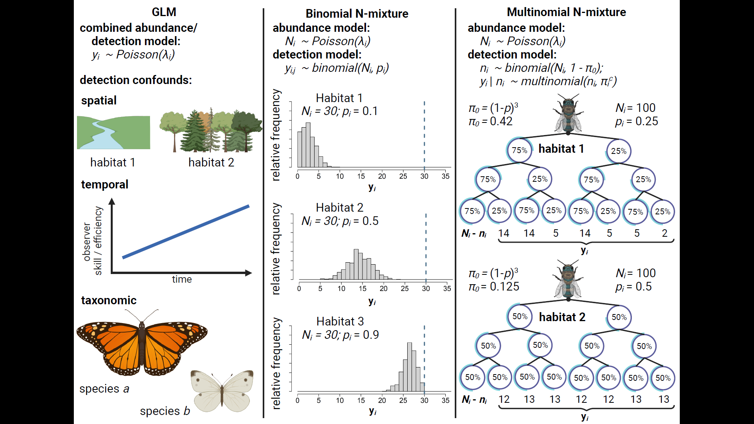
Figure 1: Comparison of three methods for estimating insect abundance. GLM’s (column 1) estimate the effects of spatiotemporal and taxonomic predictors ($λ_{i}$) on abundance by treating count data y_{i} as the outcome of a random process that generates positive integers, e.g., a Poisson distribution. GLM’s are unable to disentangle effects of these predictors on abundance from their potential effects on detection rate, e.g.: Habitat obscures detectability; observers improve their detection skills over time; or larger and more colorful species are detected at a higher rate than smaller and more dull-colored species. Binmix models (column 2) leverage the variation in counts $y$ across repeat surveys $j$ to units $i$ to simultaneously estimate detection rate $p$ and total abundance $N$. A more tightly clustered right-tailed distribution of repeat counts in Habitat 1 has a high likelihood when detection rate is low (counts heavily underestimate $N$); a tightly clustered left-tailed distribution of repeat counts in Habitat 3 has a high likelihood when detection rate is high (counts nearly approximate $N$); a wider and more symmetrical distribution in Habitat 1 has a higher likelihood when the detection rate is close intermediate. Multimix models (column 3) classify $y_{i}$ as the number of individuals in each observable encounter history, with the total number of individuals detected one or more times $n_{i}$ considered to be the outcome of a total population size and the probability of an individual having any of the observable detection histories (1 - $π_{0}$). In a study with three repeat surveys, the probability of never being captured ($π_{0}$) is equal to (1 - $p$)³. Encounter histories are typically tracked by placing marks on individual insects. Encounter histories that skew towards infrequent detection in Habitat 2 suggest that there is a high probability of failing to detect individuals across all repeat surveys, i.e., that $π_{0}$ is greater in Habitat 2 versus Habitat 1 and, correspondingly, that $n_{i}$ is a smaller proportion of $N_{i}$.
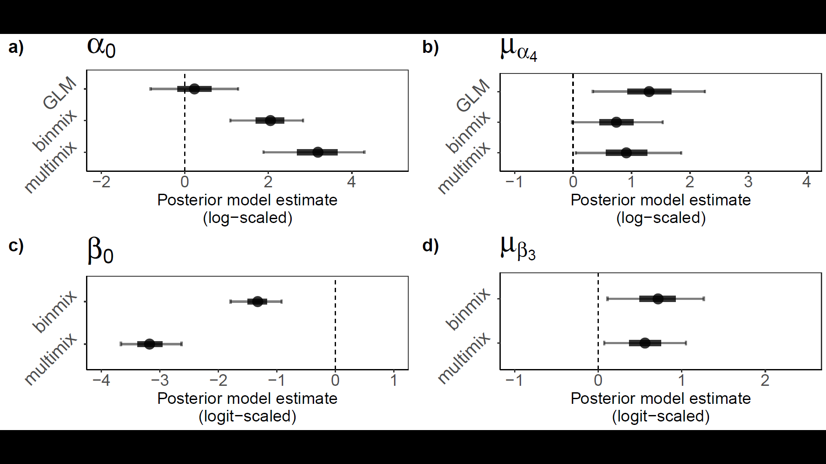Figure 2: Field study estimates of wild bee abundance and detection. We estimated abundance intercepts (a) and community mean effect of restoration on abundance (b) with all three model types. We estimated detection rate intercepts (c) and community mean effect of restoration on detection (d) for binmix and multimix models, which are designed to estimate and account for imperfection detection. Mean estimates are displayed with filled circles. Thick and thin error bars represent 50% and 90% BCI’s.

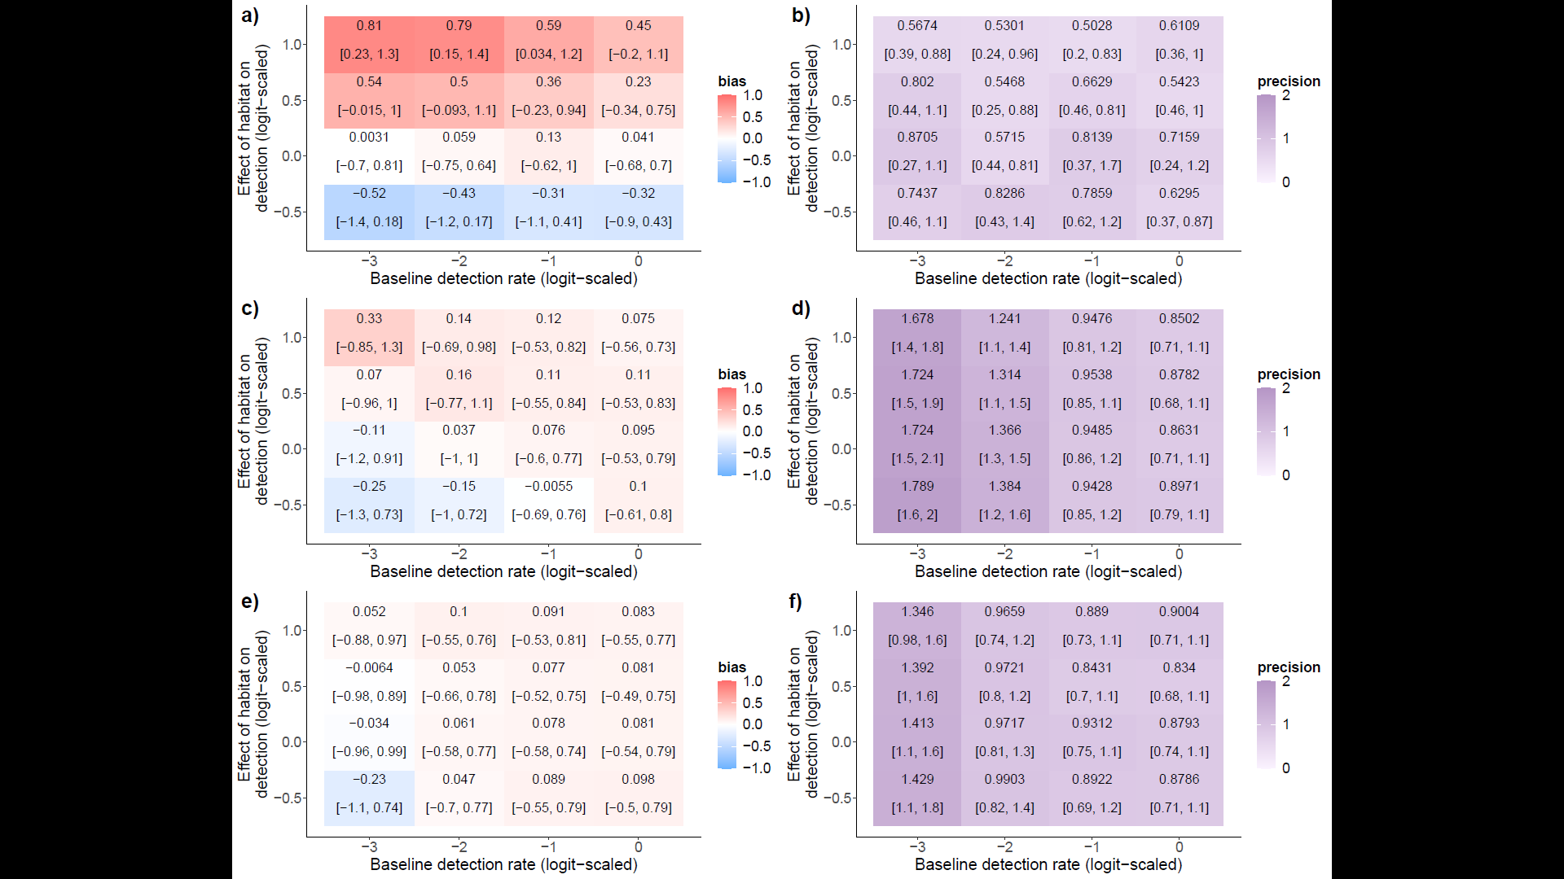
Figure 3: Bias and precision of abundance models under simulated changes in detection rate and effects of habitat restoration on detection: GLM bias (a) and precision (b); binmix bias (c) and precision (d); and multimix bias (e) and precision (f). Positive bias (red) indicates a tendency to overestimate the effect of habitat restoration on abundance while a negative bias (blue) indicates a tendency to underestimate the effect. A value of zero indicates no model bias. Models should return unbiased estimates of abundance drivers that are also precise. Higher values for precision (dark purple) represent wider BCI’s. Lower values (light purple) represent BCI’s with less uncertainty.
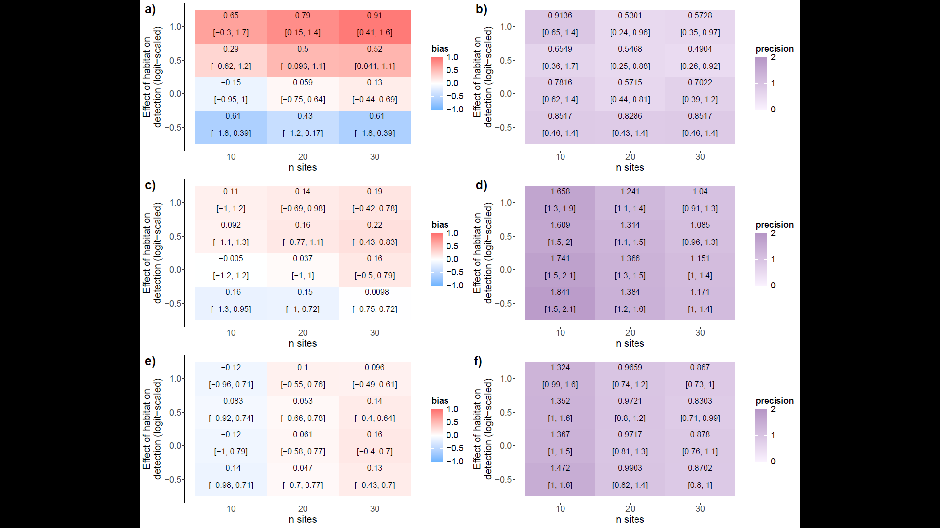
Figure 4: Bias and precision of abundance models under simulated changes in site number and effects of habitat category on detection. GLM bias (a) and precision (b); binmix bias (c) and precision (d); and multimix bias (e) and precision (f). Positive bias (red) indicates a tendency to overestimate the effect of habitat restoration on abundance while a negative bias (blue) indicates a tendency to underestimate the effect. A value of zero indicates no model bias. Models should return unbiased estimates of abundance drivers that are also precise. Higher values for precision (dark purple) represent wider BCI’s. Lower values (light purple) represent BCI’s with less uncertainty.

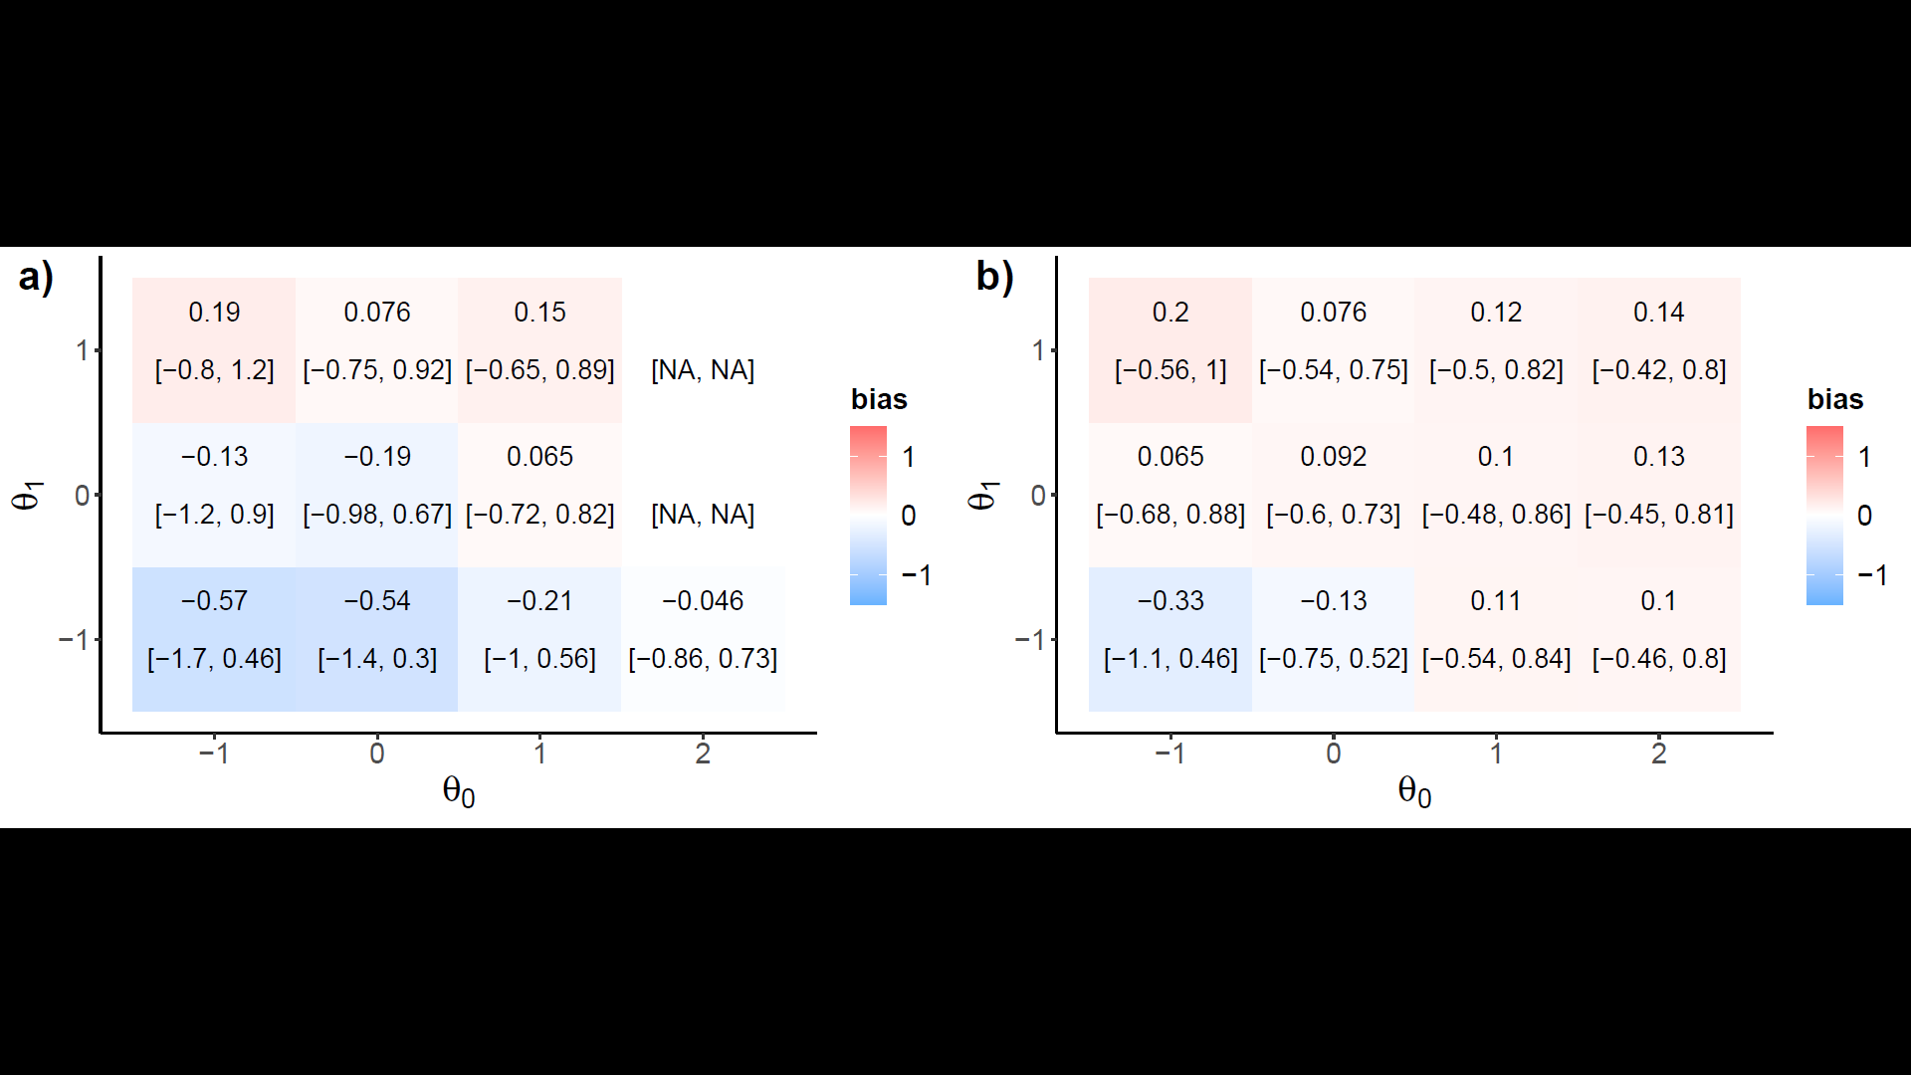
Figure 5: Robustness to closure violations. Binmix bias (a) compared to multimix bias (b), with respect to changing baseline availability odds (theta0) and systematic effects of restoration on availability odds (theta1). Positive bias (red) indicates a tendency to overestimate the effect of habitat restoration on abundance while a negative bias (blue) indicates a tendency to underestimate the effect. A value of zero indicates no model bias. Also add panel with overall abundance estimate and baseline detection rate to show how multimix is adapting by combining the odds of detection and availability.

