Estimating the ecological drivers of insect abundance when detection is imperfect.
Abstract
Biodiversity conservation hinges on a clear understanding of the ecological drivers of species abundance. In studies of insect abundance, researchers typically estimate effects of hypothesized abundance drivers by applying generalized linear models (GLMs) to count data from field surveys. However, a significant issue with conventional GLMs is that they cannot account for the failure to detect some individuals that are present in study landscapes (‘imperfect detection’), which could bias model estimates. To alleviate this issue, some researchers have adopted approaches that account for imperfect detection. These approaches include the application of multinomial N-mixture (multimix) models to mark-recapture data and binomial N-mixture (binmix) models for repeated count data. At the same time, these approaches can be more difficult to implement. Currently, we lack side-by-side comparisons to determine when these more cumbersome approaches are needed to accurately estimate insect abundance drivers. In this study, we collected abundance data for wild bees in a natural experiment designed to compare unrestored urban parks to restored parks, which had more flowers and taller vegetation. We applied all three modelling approaches to these data, either using the mark-recapture data (multimix approach) or ignoring whether individuals were marked and treating the data as counts (binmix and GLM approaches). Our models indicate that individual bees were detected less than ~5% of the time. We also found that bees were ~1.6 fold more likely to be detected in restored habitats. Thus?, GLMs that did not account for this detection bias overestimated the effects of restoration on bee abundance. Our results emphasize that environmental factors can influence our ability to detect insects in field studies. Consequently, effect sizes from studies that use conventional GLMs for count data should be interpreted with caution. Using simulation, we found that multimix mark-recapture models were the most robust and precise approach; however, we also found that increasing the baseline detection rate minimized the impacts of detection bias on GLM estimates. We recommend that studies planning to apply GLMs to count data prioritize methods that maximize improved detection over other aspects of study design such as the number of study sites. Together, our results provide needed guidance on how to design and implement studies that accurately quantify the ecological drivers of insect abundance.
1. Introduction
Insects provide crucial ecosystem services including pollination, decomposition, and biological control (Schowalter, Noriega, and Tscharntke 2018). At the same time, many insects are facing widespread declines (Biesmeijer et al. 2006; Koh et al. 2016; Sánchez-Bayo and Wyckhuys 2019). Evidence-based strategies for mitigating or reversing insect declines require a clear understanding of the environmental pressures that drive species abundance patterns (Wagner et al. 2021). Quantifying the ecological drivers of species abundance allows us to assess population trends, identify population threats, and/or evaluate the success of management interventions (Schultz and Hammond 2003; Waltz and Covington 2004; Blaauw and Isaacs 2014; Rundlöf et al. 2015).
However, accurately estimating the drivers of abundance is challenging because abundance itself is difficult to measure in natural environments. For insects, abundance data are often collected as counts from nets, traps or visual assessments (Mccravy 2018). Because many insect species are small, elusive, and/or mobile, these counts undoubtedly overlook some individuals (Nowicki et al. 2008; Taron and Ries 2015; Portman, Bruninga-Socolar, and Cariveau 2020). To quantify the ecological drivers of abundance, researchers typically apply generalized linear models (GLMs) to these imperfect counts (Bolker et al. 2009). Crucially, GLMs rely on the assumption that the relationship between imperfectly detected counts and the true abundance of insects is constant across space, time, and species (Williams, Nichols, and Conroy 2002). Systematic variation in the ability to detect individuals causes variation in this relationship and, consequently, can bias GLM estimates of abundance drivers (Figure 1) (Williams, Nichols, and Conroy 2002). For example, researchers argue that a concentration of food resources and/or habitat complexity can impact the ability to capture insects with nets or traps (Portman, Bruninga-Socolar, and Cariveau 2020). These potential effects on insect detection could confound GLM estimates (Kery and Royle 2020).
Mark-recapture is an alternative approach that estimates and accounts for imperfect detection. Mark-recapture methods quantify the detection rate using information about the odds of resighting marked or tagged individuals across successive sampling events (Figure 1) (Williams, Nichols, and Conroy 2002). Essentially, researchers capture as many insects within a prescribed location and time period as possible. Researchers mark the captured individuals with identifiable labels or markers and then release them. After a set period of time, the research team returns, and conducts the recapture sample, capturing as many insects again and noting how many individuals are recaptured relative to newly captured. Researchers can continue to repeat recapture surveys to gather additional information about insect detection rates. Researchers have used mark-recapture methods for decades (Lincoln 1930), including for insects such as butterflies and bees (Haddad et al. 2008; Briggs et al. 2022). Building on classic mark-recapture approaches, hierarchical multinomial N-mixture models (hereafter, “multimix” models) allow researchers to pool mark-recapture data across multiple sites (Kery and Royle 2010). Compared to classic mark-recapture, this enables more precise estimation of detection rate and true abundance as well as more straightforward inclusion of abundance and detection covariates such as site habitat quality. Extensions of this approach can also be applied to communities of species simultaneously, rather than single species individually. Multimix mark-recapture approaches are increasingly popular for studies of birds and other vertebrates, but they have not yet been widely adopted for studies of insects (Kery and Royle 2010).
While mark-recapture methods are considered the most rigorous way to estimate drivers of insect abundance, they also have limitations. In particular, mark-recapture data can be difficult and time consuming to collect (Haddad et al. 2008; Taron and Ries 2015; Briggs et al. 2022). Additionally, placing marks could damage or harm insects (Morton 1982). Further, multimix models for mark-recapture data can require custom-tailored code and large computational resources (Kery and Royle 2020). Therefore, it is important to have clarity about when using this laborious method will be worthwhile.
Binomial N-mixture models (“binmix” models) provide a second alternative approach that also accounts for imperfect detection. Like multimix models for mark-recapture data, binmix models tend to be less accessible than GLMs because their implementation can require heavy computational resources and coding skills. However, binmix models may be more attractive than multimix mark-recapture models because they can be applied to the same count data used for GLMs, provided that counts are repeated for at least some sites (Royle 2004; Madsen and Royle 2023). This fact means that binmix models might provide unbiased estimates of abundance drivers without requiring the laborious effort of marking individual insects. Binmix models account for imperfect detection by leveraging information about the variation in the size of counts that are collected across repeat surveys (Figure 1) (Royle 2004). Binmix models are increasingly utilized for insect abundance studies (Mimnagh, Parnell, and Prado 2023). Recently, researchers have used them to determine the effects of urban land use on mosquito abundance, the impacts of flower resource density on wild bee abundance, and the effects of seasonality on butterfly abundance (Manica et al. 2019; Mccune et al. 2020; Riva et al. 2020).
While binmix approaches provide an easier way to account for detection biases, they are not without controversy (Barker et al. 2018; Madsen and Royle 2023). In particular, binmix models assume that populations are “closed”, i.e., that populations do not change across repeat survey events. Births and deaths or immigration and emigration from sites violates this assumption of closure (Link et al. 2018). Previous studies show that binmix estimates for total abundance (i.e., the size of a population) are highly sensitive to violations of this assumption (Link et al. 2018). Currently, however, there is limited information on how these violations impact the ability of binmix models to estimate effects of environmental covariates that are hypothesized to drive abundance (Fogarty and Fleishman 2021), which is often the primary goal of insect ecology studies (Taron and Ries 2015). To guide field study designs that balance effort and rigour, we need more information about the reliability of binmix models in different scenarios.
Generalized linear models, binmix models, and multimix mark-recapture approaches all have trade-offs in terms of required effort and performance. Researchers may wish to implement the simplest approach that accurately and precisely estimates drivers of insect abundance. Determining the appropriate modelling approach for the task at hand requires clear knowledge of the ecological and study design conditions that cause divergence in the conclusions from the different methods. To address this, we first conducted a field study to assess the effects of an environmental covariate on the abundance and detectability of wild bees in an urban ecosystem. Specifically, we used net collection methods to obtain mark-recapture abundance data for eight wild bee species in five urban parks with habitat restorations and in five control parks that were not restored, with surveys repeated across two sampling years. Restored parks had taller, unmowed vegetation and more floral resources that provide food for bees. While numerous studies argue that habitats with more flowers or taller vegetation impact bee detection rates, we currently lack studies that quantify these effects (Portman, Bruninga-Socolar, and Cariveau 2020). We fit a multimix model to the mark-recapture data to quantify effects of restoration on bee abundance while simultaneously estimating and accounting for impacts of restoration on bee detectability. Then, in a second approach, we ignored the individual marks and treated our data as if they were simple repeated counts for a GLM or binmix model. We compared results from the multimix model against a GLM, which does not account for imperfect detection, and against a binmix model, which accounts for imperfect detection using information about count size variation rather than mark-recapture detection histories. These comparisons allowed us to determine whether accounting for imperfect detection influenced estimates of a potential driver of insect abundance.
Next, using simulation, we investigated factors that could reduce or exacerbate the bias of less rigorous GLM and binmix approaches compared to the mark-recapture approach. In particular, we examined whether changes to baseline detection rate and/or site sample size impacted the ability of these models to accurately estimate an abundance covariate despite a confounding effect on detection. We also compared model precision under these different scenarios. These tests aimed to provide guidance on whether GLMs can provide better estimates if studies prioritize increased sampling intensity as opposed to adding more site replicates. Finally, we tested the robustness of simulated violations of the population closure assumption for binmix compared to multimix models. To do so, we varied the probability that individual insects immigrated/emigrated from sites between successive surveys, while simultaneously varying whether those odds were impacted by a site environmental covariate. This procedure allowed us to ask? whether an effect of habitat on the tendency for individuals to remain within a sampling plot compromised binmix estimates. In combination, our field and simulation studies provide needed information on how to better design and conduct unbiased insect abundance studies.
2. Methods
2.1 Field study design and data collection
For the field-based component, our aim was to estimate the effect of habitat restoration on the abundance and detectability of wild bees using three different modelling approaches. The different models required different forms of abundance data. The multimix model required mark-recapture data, i.e., detection histories of individual bees. In contrast, the GLM and binmix model required count data, i.e., the number of individual bees detected per sampling event. We collected mark-recapture abundance data for the multimix model. To fit the GLM and binmix model, we did not collect new abundance data. Rather, for each sampling event we summed the number of marked and newly detected bees to yield a simple count of the number of individual bees detected per sampling event. This strategy allowed us to examine a single abundance dataset with all three models.
We collected the abundance data from a sample of five urban parks in Vancouver, Canada, that had received habitat restoration amendments in 2020 (Table S1). As a comparison, we also collected data from five similar urban parks that had not received the habitat restoration (hereafter, “control” parks) (Table S1). In restored parks, conventional turfgrass vegetation was left unmowed during April – September season compared to mowed bi-weekly in control parks. Restored parks were also seeded with flowers that provide food resources for wild bees. In a separate study we compared the plant communities in control and restored parks. We found that restoration was strongly associated with increased flower species richness and marginally associated with increased flower species abundance (Ulrich and Sargent 2025). Although we did not measure vegetation complexity, vegetation was approximately knee-height in restored parks compared to approximately ankle-height in control parks (Figure S1). We collected abundance data in 2022 and repeated our survey efforts again in 2023.
We targeted our surveys on eight wild bee species from four different families: Agapostemon texanus (Halictidae), Andrena prunorum (Andrenidae), Anthidium oblongatum (Megachilidae), Bombus flavifrons (Apidae), Bombus mixtus (Apidae), Halictus rubicundus (Halictidae), Megachile spp. (not including the non-native alfalfa leafcutter, Megachile rotundata) (Megachilidae), and Melissodes microstictus (Apidae) (Figure S2). We chose these species because we could easily identify them in the field. The ability to identify the species allowed us to avoid lethal sampling which would cause violations of population closure assumptions while also potentially harming local bee populations. Additionally, in our system, the species were common enough that we could estimate the timing of peak abundance from a previous study (Ulrich and Sargent 2025). Targeting our sampling at the timing of peak abundance allowed us to limit changes in abundance caused by rapid births or deaths, which would also violate population closure assumptions. We collected abundance data during two different sampling periods. In early June we conducted three repeat surveys for species with an ‘early’ phenology: Agapostemon texanus, B. flavifrons and B. mixtus. Then, in mid-July we conducted the repeat surveys for five species exhibiting a ‘late’ phenology: Andrena prunorum, A. oblongatum, H. rubicundus, Megachile spp., and M. microstictus. To reduce the chance that we violated the assumption of population closure, we conducted the repeat abundance surveys within the most rapid timescale possible, conducting the first and last repeat surveys at each site within a maximum of eight days. For this study, we only included female bees. Andrena prunorum was only surveyed in 2023.
We conducted the abundance surveys in one-hectare (100 metre by 100 metre) sampling areas. The sampling areas focused on a restored vegetation area for the restored parks or conventionally managed turfgrass space in control parks. We collected bees using a sweep net method, walking a spiral-transect through the survey area and netting all individuals thought to be one of our focal species. We repeated the spiral transect until the survey time ended. Surveys lasted 45 minutes, with the timer paused for insect handling. Netted insects were placed on ice until the completion of the survey. After the survey ended, we confirmed species identifications and applied marks. Marks were applied by placing chilled bees in a vial with a plunger on one end and a wide mesh covering on the other (as in Briggs et al. 2022). By pressing bees against the mesh to inhibit movement, we were able to paint a colour-coded mark on the back of the thorax using a paint pen (Molotow brand, 2.0mm round tip) (Figure S3). To later implement the GLM and binmix model approaches, we counted the total number of individuals that we captured, ignoring whether individuals were marked or not. To limit observer bias, all surveys were conducted by the same researcher, and only during full sun conditions between 10:00 AM and 4:00 PM.
2.2 Statistical analyses
To estimate the effects of restoration on insect abundance, we developed custom models written in the probabilistic programming language Stan (Stan Development Team 2023b), implemented in R (R Core Team 2022) using the package rstan (Stan Development Team 2023a). These models use Bayesian inference to estimate distributions of parameter values that are conditioned on our data and our specified prior probability distributions.
For the GLM model, we specified counts of $y_{i}$ distinct individuals on sampling events $i$ = {1, …, $R$} to be the outcome of a negative binomial distribution with an expected mean $λ_{i}$ and dispersion $ϕ$ (Equation 1). We used negative binomial distributions for the GLM (and the binmix and multimix models) because our posterior predictive checks indicated that this overcame a strong lack of fit that was evident for Poisson models. Using a log-link function, we modelled variation in $λ_{i}$ (Equation 2) as a function of a global abundance intercept ($α_{0}$), a species-specific random intercept effect ($α_{1}$), a site-specific random intercept effect ($α_{2}$), an effect of year ($α_{3}$), and a species-specific random effect of restoration ($α_{4}$), with restoration treated as a categorical variable.
- $y_{i} \sim negative binomial(λ_{i}, ϕ)$;
- $log(λ_{i})= α_{0}+ α_{1}\left[species\right]+α_{2}\left[site\right]+ α_{3}\left[year\right]+ α_{4}\left[species\right] ×restoration[i]$
We assumed that species-specific random effects of habitat were normally distributed with a mean and a variance term estimated from the data, i.e., $α_{4}\left[species\right] \sim normal(μ_{α_{4}}, σ_{α_{4}})$. Species- and site-specific random effects for the intercept were centered on a mean of zero, and assumed to be normally distributed with a variance term that was estimated from the data.
The binmix model assumes that the counts $y_{i,j}$ of distinct individuals at $i$ = {1, …, $R$} sites during $j$ = {1, 2, 3} sampling events are conditioned on a detection rate $p_{i}$ and a true abundance $N_{i}$. We assumed that populations were closed, that is, that $N_{i}$ does not change across the three sampling events. We considered $N_{i}$ to be the outcome of a negative binomial distribution with a mean $λ_{i}$ and dispersion $ϕ$ (Equation 3). We specified the number of successfully detected individuals on each survey event ($y_{i,t}$) as the outcome of a binomial trial. With this formulation, effects of predictors on abundance versus detection can be differentiated (Kery 2017). We described variation in $λ_{i}$ as in Equation 2. Using a logit-link function which bounds outcomes within a probability range of zero to one, we modelled variation in $p_{i}$ as function of a global detection intercept ($β_{0}$), a species-specific random intercept effect ($β_{1}$), a site-specific random intercept effect ($β_{2}$), an effect of year ($β_{3}$), and a species-specific random effect of restoration ($β_{4}$) (Equation 5). We presumed that species-specific random effects of habitat were normally distributed with a mean and a variance term estimated from the data, i.e., $β_{4}\left[species\right] \sim normal(μ_{β_{4}}, σ_{β_{4}})$.:
- $N_{i} \sim negative binomial(λ_{i}, ϕ)$;
- $y_{i,j} \sim binomial(N_{i}, p_{i})$;
- $logit\left(p_{i}\right)= β_{0}+ β_{1}\left[species\right]+β_{2}\left[site\right]+β_{3}\left[year\right]+β_{4}\left[species\right] ×restoration[i]$
The programming language Stan does not allow for latent discrete variables, where the likelihood of the data is estimated with respect to a single discrete value of the parameter $N_{i}$. As such, we calculated the marginal likelihood of the data across a range of $N_{i}$, from a lower bound of $N_{i}=max(y_{i,1:3})$ to an upper bound of a large finite value $K_{i}$ (Royle 2004; Hocking et al. 2021). The lower bound is set at the maximum observed number of counts across occasion 1:$3$; any lower values would allow the likelihood of a binomial trial to be zero (Royle 2004). $K$ should be large enough that values of $N$ approaching $K$ do not contribute to the likelihood (Royle 2004). We evaluated the sensitivity of our estimates to the choice of $K$ to ensure that stable results were obtained (Kery 2017). For the field study, we used a value of $K_{i}=(max\left(y_{i,1:3}\right)+5) ×12$. Our model estimation proceeds by proposing new values for the abundance and detection parameters and then evaluating whether the likelihood of the data across all possible values of $N_{i}$ has improved.
Finally, for the multimix approach, we specified a three-level model with a multinomial observation process for detection histories (Kery and Royle 2010). Where 0 represents non-detection and 1 represents detection, the possible observable detection histories for three repeat surveys are: 111, 110, 101, 100, 011, 010, and 001. The eighth possible history, 000, is not observable. More generally, for a study with $J$ repeat surveys, there are $2^{J}$ possible detection histories (Royle et al. 2007). The outcome variable $y_{i}$ was defined as a vector with each element representing the number of individuals in each of the seven detection history categories (Figure 1). The likelihood of the observed detection histories is specified as the outcome of a multinomial trial with some number of individuals observed one or more times ($n_{i}$) with a vector of probabilities for each observable history ($π_{i}^{c}$) (Equation 6). To estimate the remaining number of individuals at the site, we treated the number of observed individuals ($n_{i}$) as the outcome of a binomial trial that depends on the size of the total population ($N_{i}$) and the probability of not being observed ($π_{i}^{0}$, i.e., probability of a detection history of 000) (Equation 7):
- $y_{i} \sim multinomial(n_{i}, π_{i}^{c})$;
- $n_{i} \sim binomial(N_{i}, 1-π_{i}^{0})$;
As with the binmix model, the population size $N_{i}$ was modelled as the outcome of a negative binomial distribution (Equation 3) with a dispersion term and a linear predictor for the mean $λ_{i}$ (Equation 2). We bounded $N_{i}$ within the range $K_{i}=((n_{i}+5) ×12)$. Heterogeneity in detection rate was modelled using a linear predictor for $p_{i}$ (Equation 5), but where $p_{i}$ is estimated by defining its relation to $π_{i}^{1:8}$. For example, where probability of detection history 111 or $π_{i}^{1}= p_{i}×p_{i}×p_{i}$; probability of detection history 110 or $π_{i}^{2}= p_{i}×p_{i}×(1-p_{i})$; probability of detection history 101 or $π_{i}^{3}= p_{i}×{\left(1-p_{i}\right)×p}_{i}$; and so on (Figure 1).
We employed best practices for model development and fitting by (1) using weakly-informative priors to discourage unrealistic parameter values (Table S2 – S4); (2) confirming sufficient mixing of chains (Gelman-Rubin R-hat values < 1.05), minimal within-chain autocorrelation (effective sample size/steps > 0.1) and no divergent transitions (Figures S4 and S5); (3) running our model for a length of 4000 HMC steps, discarding the first 2000; and (4) using posterior predictive checks to assess the fit of our models (Figure S6) (Stan Development Team 2023b; Gelman, Hill, and Vehtari 2020; Kery and Royle 2020).
2.3 Simulation study
We wrote a simulation program in R (R Core Team 2022) to generate species abundance and detection patterns. We simulated abundance from a Poisson distribution. We included species, site, and year predictors for the mean of the Poisson generating process, as in Equation 2. Conditional on simulated abundance and an input detection rate, the program then produces detection histories and detection counts. The simulation script allows the detection rate to vary by species, site, and/or year, as in Equation 5. All simulations were run on the University of British Columbia’s Sockeye computing platform.
We used this simulation routine to determine how particular aspects of the study design and violations of the closure assumption impacted the ability of the different models to estimate the effect size of an ecological driver of insect abundance. To accomplish this goal, we fit each of the three models to data that were simulated under a set of scenarios. For all simulations we specified half of the sites as “restored” and the other half of sites as “control”. In these simulations, restoration represents a hypothesized ecological driver of insect abundance that a researcher may wish to quantify; the term could be replaced with another hypothesized driver such as land cover, temperature, presence of an invasive species or pollutant. The effect size of the restoration parameter $μ_{α_{4}}$ (as defined by Equation 2) was held constant at a value of 1, representing a positive effect on abundance.
First, we assessed how changes in baseline insect detection rates impact model bias and precision. To do so, we simulated detections for twenty sites, sixteen species, and two years, with three repeat surveys per year. We varied the detection intercept ($β_{0}$) across values of -3, -2, -1, and 0 (on a logit-scaled). On the probability scale, a value of 0 represents 50% odds of an individual insect being detected during a given survey given that it is present, whereas a value of -3 represents a <5% odds. For each level of detectability, we varied the effect of restoration on the detection rate ($μ_{β_{4}}$) across values of -1, -0.5, 0, 0.5, and 1 (logit-scaled). A positive value indicates that insects are easier to detect at restored sites compared to control sites. The abundance intercept was held constant at a value of 1 (log-scaled), with no effect of year on abundance or detection. For each combination of baseline detection rate and effect of restoration on detection we simulated insect abundance for twenty systems, and then fit all three of the models to each of these systems. We then extracted 250 samples from the posterior distribution for each fit, equating to 5000 sampled estimates for each model type for each combination of detection parameters. To calculate model bias, we subtracted the sampled effect size estimates from the true value ($μ_{α_{4}})$ and calculated the mean and 50% and 90% Bayesian credible intervals (BCIs) for the difference. A negative bias indicates a tendency to underestimate of the effect, while a positive value indicates a tendency for overestimation. Values closer to zero indicate high accuracy. To assess model precision, we tracked the 90% BCI for each model fit. A larger value indicates higher uncertainty in the value of the parameter; smaller values indicate lower uncertainty in the value of the parameter. It is possible that models could be highly precise but inaccurate, or vice versa.
Next, we assessed how changes in the number of sites included in a study impacted model bias and precision. To do so, we simulated scenarios with 10, 20 or 30 sites. For each scenario, we again varied the effect of restoration on detection rate between -1, -0.5, 0, 0.5, and 1 (logit-scaled). The detection intercept was held constant at a value of -2 (logit-scaled). All other parameters and study dimensions were held constant as described in the previous paragraph. We used the same approach to quantify accuracy and precision.
Finally, we examined how violations of the population closure assumption impacted binmix and multimix estimates. For this test of model robustness, we still considered $N_{i}$ to be the outcome of a Poisson trial. However, we also included an ability for individuals to immigrate/emigrate from the site. Each individual $k$ in $N_{i}$ was randomly “available” for detection at the time of a survey $j$ with some probability $θ_{i}$: ${availability}_{i,j, k} \sim binomial(N_{i}, θ_{i})$. Available individuals represent those that immigrated to a site and were remaining within that site at the time of the survey. In this scenario, $N_{i}$ more closely represents the larger population of mobile insects in a broader landscape that have some chance of being in the sampling area at some point during the study. We specified a linear predictor for $θ_{i}$, with an availability intercept $θ_{0}$ and a fixed effect of restoration on availability $θ_{1}$. We varied $θ_{0}$ between -1, 0, 1, and 2; and $θ_{1}$ between -1, 0 and 1 (logit-scaled). A negative value of $θ_{1}$ represents a scenario in which individuals are less likely to remain within sampling areas if the site was restored, whereas a positive value would indicate a higher probability of remaining within the sampling areas. A value of zero indicates a scenario where individuals may move in/out of the plot, but that the odds of doing so are equivalent in restored and control sites. We held the abundance intercept at 3 (log-scaled) and kept the baseline detection rate constant at -2 (logit-scaled) with no effect of restoration on detection. All other parameters and study dimensions were held constant as described above, with the same approach used to quantify bias and precision.
All data and code required to reproduce the field analyses and simulation analyses are available at: https://github.com/jensculrich/pollinator_abundance.
3. Results
To determine the abundance and detection patterns for insect populations in the field, we fit each of our models to the wild bee abundance data collected from our ten field sites (Figure 2). As expected, given that GLMs do not account for imperfect detection, the GLM estimated a lower abundance intercept ($α_{0}$ mean = 0.23; 90% Bayesian credible interval (BCI) = [-0.82, 1.27]) compared to either the binmix or multimix models: The binmix model estimated a higher intercept with 98.7% probability and the multimix model with 99.5% probability. The GLM estimated a positive effect of restoration on insect abundance: $μ_{α_{4}}$mean = 1.30; 90% BCI = [0.34, 2.25]. Effect size estimates were smaller for the binmix model: $μ_{α_{4}}$mean = 1.11; 90% BCI = [0.16, 2.11]; 60% probability of a smaller effect size compared to the GLM approach. Effect size estimates were also smaller for the multimix model: $μ_{α_{4}}$mean = 0.91; 90% BCI = [0.05, 1.85]; 67% probability of a smaller effect size compared to the GLM approach.
Consistent with its estimation of a higher abundance intercept, the multimix model estimated a lower baseline detection rate ($β_{0}$ mean = -3.17; 90% BCI = [-3.66, -2.62]) than the binmix model ($β_{0}$ mean = -2.47; 90% BCI = [-3.2, -1.65]). On a probability scale, the mean estimate of the multimix model equates to a 4.3% odds of detecting an individual bee during a survey of a control plot (90% BCI = [2.5%, 7.4%]). The multimix model also estimated a positive effect: $μ_{β_{4}}$ mean = 0.56; 90% BCI = [0.07, 1.05]. On a probability scale, the mean estimate of the multimix model equates to a 6.8% odds (1.6 fold increase) of detecting individual bees during surveys of restored sites (90% BCI = [3.9%, 11.8%]). The binmix model tended to estimate a positive effect of restoration on detection rate, although only the 50% BCI was in the positive direction: $μ_{β_{4}}$ mean = 0.25; 50% BCI = [0.01, 0.48]. The positive effect of restoration on detection is consistent with relatively lower estimated effect of restoration on abundance compared to the GLM.
We used simulation to determine how certain aspects of a study impact the ability of these models to estimate insect abundance drivers. First, we examined how changes in baseline detection rate and effects of habitat on detection rate impact the accuracy and precision of covariate estimates (Figure 3). We found that the GLM bias was marginal when the odds of detecting an individual insect were relatively high: When the odds of detecting an insect were 50% (0 on the logit scale), there was minimal bias even when restorations strongly increased detection rate (mean bias = 0.45; 90% BCI = [-0.2, 1.1]). The results remained relatively unbiased when the odds of detecting individual insects were set to ~25% (-1 on the logit scale). However, GLMs were not able to overcome confounding effects of restoration on abundance and detection when baseline detection rates were lower. For example, when the odds of detecting an insect were <5% (-3 on the logit scale), the GLM bias followed the direction of the effect of restoration on detection rate: There was a clear positive bias when restoration increased detection rate (mean bias = 0.81; 90% BCI = [0.23, 1.3]). In contrast, the binmix and multimix did not show any clear bias when we simulated confounding effects of restoration on abundance and detection. Mean estimates for the effect of restoration on abundance tended to be <0.1 from the true value of 1. The largest divergences occurred for the binmix models when baseline detection rates were lowest (at -3 on the logit scale and with a positive effect of restoration on detection rate, mean bias = 0.33; 90% BCI = [-0.85, 1.3]). For the GLM, precision did not vary systematically with detection patterns. However, estimates from the binmix and multimix models exhibited systematic declines in precision along a gradient of decreasing baseline detection rate. Multimix models tended to be more precise than the binmix models.
Next, we used simulation to examine how the number of sites in a study influenced the accuracy and precision of the estimated effects (Figure 4). We found that increasing the number of sites made estimates from the GLM approach both more biased and more precise. In other words, when data were collected from more sites, the GLM models provided increasing confidence in an incorrect conclusion. For example, when there was a strong positive effect of restoration on detection rate and only ten study sites, GLMs slightly overestimated the effect of restoration on abundance (mean bias = 0.65; 90% BCI = [-0.3, 1.7]) and provided relatively wide confidence intervals (mean 90% BCI width = 0.91). When we increased the number of study sites to thirty, overestimates were larger (mean bias = 0.91; 90% BCI = 0.41, 1.6) and confidence intervals narrowed (mean 90% BCI width = 0.57). Binmix and multimix models were not clearly biased by changes in site number. Consistent with an increase in the amount of data available to inform parameter estimation, binmix and multimix precision increased systematically with increasing number of sites.
Finally, we assessed the robustness of binmix and multimix models to violations of the closure assumption (Figure 5). Across all simulation scenarios, binmix models underestimated the abundance intercept term, whereas the multimix model did not. For both model types, abundance covariate estimates were robust to closure violations when the probability of immigration/emigration was unrelated to whether or not a site was restored ($θ_{1}$ = 0). Binmix model estimates were more sensitive to systematic violation of the closure assumptions when the baseline odds of remaining in the site were low: When $θ_{0}$ = -1 and habitat restoration negatively decreased odds of remaining in the site ($θ_{1}$ = -1), the binmix model underestimated the effect of habitat restoration on abundance by an average of -0.61 (90% BCI = [-1.6, 0.4]). In contrast, we found that multimix models produced the least biased estimates of the effects of restoration on abundance even when closure assumptions were systematically violated. Across all simulation scenarios, the multimix model tended to miss the true effect size of restoration on insect abundance by a magnitude of less than 0.2.
4. Discussion
To develop evidence-based strategies for mitigating or reversing insect declines, we require the ability to accurately and precisely estimate the effects of ecological factors on insect abundance patterns (Wagner et al. 2021). At the same time, insects are difficult to detect with standard ecological survey tools, complicating our ability to quantify the drivers of their abundance. Researchers have developed approaches that account for imperfect detection, including multinomial N-mixture (multimix) models for mark-recapture data and binomial N-mixture (binmix) models for count data. However, because these approaches are cumbersome, it is important that we better understand when their implementation will be worthwhile or, alternatively, how to limit bias in insect abundance studies that use more accessible approaches such as conventional GLMs for count data.
Using an existing natural experimental system, we collected wild bee abundance data that we could treat either as mark-recapture histories or as traditional counts. Both multimix mark-recapture and binmix model approaches found that individual bees were easier to detect in restored habitats that had more flowers and taller vegetation. Applied to the same dataset, GLMs that did not account for this detection confound overestimated the effects of restoration on bee abundance. These findings highlight that imperfect detection can bias GLM estimates of insect abundance drivers. As such, we should interpret effect sizes produced by GLMs with caution when the environment has the potential to influence our ability to observe or capture insects. Using simulation, we found that multimix mark-recapture models were the most robust and precise approach, however, we also found that increasing the baseline detection rate minimized the tendency for detection bias to impact estimates reported by GLMs. This emphasizes that studies making use of GLM approaches can increase their accuracy by prioritizing increased detection rate over other aspects of study design such as increased number of sites. Together, these results provide needed guidance on how to design and implement studies that improve our understanding of how to promote insects in a changing world.
While the GLM may have exaggerated the size of the effect, all three models still estimated a positive effect of restorations on wild bee abundance. This is consistent with a positive effect of restorations on wild bee and hoverfly species occurrence found in a separate study of the same system (Ulrich and Sargent 2025). More broadly, habitat amendments that increase floral resources tend to be associated with increased abundance of insect pollinators such as bees and butterflies (Hyjazie and Sargent 2022; Waltz and Covington 2004). Similar pollinator habitat amendments including reduced mowing and seeding for urban turfgrass are growing in popularity and are promising approach for supporting sustainable urban development (Wolfin et al. 2023; Cloutier et al. 2024; Brown et al. 2024). The larger effect size estimated by the GLM can be explained by a confounding effect of restoration on the ease of detecting wild bees. The multimix model estimated that bees were approximately 60% more likely to be detected in restored sites compared to control sites. The detection models accounted for this positive detection effect and reduced their estimates of abundance effects accordingly.
Bees may have been easier to detect in the restored sites for multiple reasons, including the taller vegetation and higher flower resource density. A methodological study of distance sampling methods found that bumble bee detection rates decline with distance from the observer (McNeil et al. 2019). Bees foraging on knee-height flowers in the restored parks might have been easier to see since they were closer to the observer compared to bees foraging on ankle-height flowers in the control parks. Alternatively, the higher floral resource diversity in restored parks may have affected bee behaviour in ways that improved their detectability. For example, bees may have exhibited more sedentary foraging behaviour in the restored parks that had higher flower species diversity, potentially increasing their detectability (Heinrich 1979). Researchers have debated whether floral resources and/or vegetation complexity positively or negatively impact survey detection of wild bees, including for similar net collecting protocols or for other sampling methods such as passive pan traps (Cane, Minckley, and Kervin 2000; Joshi et al. 2015; Portman, Bruninga-Socolar, and Cariveau 2020). To our knowledge, our study provides the first quantification of a positive effect of restored habitat on the ability to net-collect wild bees. Future work should aim to disentangle whether increased floral resources or vegetation height were responsible for improved detection rates.
Other factors besides floral resources and vegetation height have the potential to impact insect detection. For example, looking at urban mosquito populations, Manica et al. (2019) found that dense vegetation cover improved trap capture rates, aligning with preferences in the location of mosquito oviposition. Other studies have pointed to observer differences as sources of insect detection bias. For example, in a study of UK butterfly populations, Isaac et al. (2011) found that one field team had a higher butterfly detection rate than another field team, potentially because those surveyors had more field experience. Another study found that larger and more brightly coloured butterfly species were easier to detect during transect walks compared to smaller and duller species (Kral-O’Brien et al. 2020). This provides evidence that insect morphological traits can bias among-species abundance comparisons made by GLMs. Taken together, these results emphasize that estimates of the effects of ecological drivers of abundance produced by conventional GLMs should be interpreted with caution.
Still, conventional GLMs are popular with ecologists and are likely to remain the standard methodology for insect population and community studies. As such, we aimed to provide guidance as to when they are most appropriate and/or how to reduce their bias. Our simulation showed that, despite imperfect detection, GLM estimates for an environmental covariate were unbiased when there was no effect of the same covariate on the detection rate (i.e., in the simulation when $μ_{β_{4}}$ equals zero). GLM bias emerged when the covariate had a confounding effect on detection (i.e., when $μ_{β_{4}}$ does not equal zero). On the other hand, we found that increased detection reduced GLM bias. Under our simulation setup, we found minimal bias despite a detection confound at baseline detection rates of 25% or 50%. Conversely, adding more sites exacerbated GLM bias while simultaneously reducing the uncertainty around inaccurate estimates. Given these results, we recommend that GLM studies wishing to avoid detection confounds prioritize increased detection rate over increased site replication. Increasing detection rate could be achieved by improved sampling intensity: for example, by increasing the length of surveys, by increasing the number and/or expertise of surveyors, or by increasing the number of traps deployed per sampling location (Mccravy 2018).
Across our field sites, the mark-recapture model reported wild bee detection rates that ranged between 2% and 12%. These estimates are in line with those provided by other net-collection wild bee mark-recapture studies, including capture probabilities ranging between 4% and 52% for surveys of bees in North Carolina forests (Briggs et al. 2022). Detection rates could be higher for other insects such as butterflies. For example, in central Europe, surveyors detected the Iolas blue, Iolana iolas with an odds of 86% (Heer et al. 2013). Conversely, detection rates for other insects might be lower, with mosquitos detected at an average rate of only 0.022% in a study of urban habitats that relied on passive trap sampling methods rather than active sweep netting (Manica et al. 2019). Given the relationship between baseline detection rate and abundance covariate bias, detection modelling approaches should be considered particularly for those insect taxonomic groups that are known to be more difficult to detect.
Even minor violations of the closure assumption are known to cause severe bias for binmix estimates of total population size (Duarte, Adams, and Peterson 2018; Fogarty and Fleishman 2021). Our closure violation simulations confirmed this: Binmix models consistently underestimated the abundance intercept, which would translate to underestimates of total population size. Therefore, binmix models are unlikely to provide robust estimates of the true abundance of insects in study landscapes. On the other hand, we found that binmix estimates of a simulated effect of restoration on abundance were only impacted by closure violations under particular circumstances. Specifically, estimates of the abundance covariate were only biased when closure violations were rampant (baseline odds of being within a sampling plot at the time of a survey were low less than 50%), and simultaneously when there was a confounding effect of habitat the degree of closure violations (i.e., when $θ_{1}$ does not equal zero). Because it may be difficult to know how the environment will affect the rate of closure violations prior to implementing a study, more rigorous multimix mark recapture models should be preferred over binmix models in situations where populations are thought to be dynamic.
High mobility or rapid mortality make populations more dynamic and increase the chance of population closure violations. For our study, we surveyed one-hectare plots. Although they can disperse farther (Greenleaf et al. 2007), even the most mobile wild bees such as bumble bees tend to exhibit strong site fidelity within a few hundred metres (Ogilvie and Thomson 2016). This means that individual bees are unlikely to immigrate/emigrate from one-hectare sampling areas between survey rounds. As a result of this limited potential for closure violations in our system, binmix model estimates for abundance covariates were unlikely to be compromised by bee movement. Insects with larger daily movements and no fixed nest position may be less likely to satisfy the assumption of high levels of closure. For example, butterflies such as the checkered skipper butterfly, Carterocephalus palaemon, can move more than a kilometre in a single day, although it does so infrequently (Wildman et al. 2024). In addition, unlike bees, butterflies do not maintain fixed nest locations where they must return after each foraging bout. Therefore, butterflies may be less suitable for binmix approaches. Habitat edges like roads or hedges can impact the tendency for insects to move across sampling area boundaries (Markovits, Dorian, and Crone 2025; Wratten et al. 2003). Consequently, researchers using binmix models should also standardize the presence of discrete site borders to minimize systematic closure violations caused by insect movement. In addition, insect lifespan should be considered before implementing binmix models. Wild bees are typically active for several weeks, for example, with a flight period of about 18 days for Andrena hattorfiana (Larsson and Franzén 2008), a reasonably broad window for our repeat surveys, which were conducted within eight day periods. Conducting repeat surveys within a single day could help limit violations of the closure assumption for insect groups with shorter lifespans (Nowicki et al. 2008). Overall, binmix models will be most appropriate when mobility is limited and individual insects are longer-lived. These requirements were well satisfied when binmix models were used to estimate the abundance of a rare stag beetle, Lucanus cervus (Della Rocca et al. 2020). Adult L. cervus are long-lived with an active flight period of several months; simultaneously, they are also fairly immobile, tending to move by less than a few dozen meters per day (Tini et al. 2018).
In our simulation study, multimix models for mark-recapture data consistently provided the most accurate estimates of abundance drivers. Therefore, to provide the strongest basis for evidence-based insect management strategies, we recommend implementation of multimix models whenever possible. Multimix models were also more precise than binmix models, in agreement with other studies comparing estimates for total abundance (Bötsch, Jenni, and Kéry 2020). As such, multimix model approaches can allow researchers to leverage maximum information from a limited sample size. This could be especially important when a focal species is rare and occurs at a limited number of sites or where site survey permitting is a limiting factor.
Unfortunately, multimix models for mark-recapture data are logistically difficult to implement. Marking and releasing captured individuals takes significant time, which can translate into substantial survey costs (Hamm 2013). Second, marking could injure insects or otherwise alter population trajectories by changing predation rates or mating success. Evidence on whether marking affects insect survival or behaviour is mixed (Morton 1982; Gall 1984). For our study, we observed that bees resumed their normal foraging activity immediately following release. Nonetheless, damage may still be an important consideration for extremely vulnerable insect populations (Haddad et al. 2008). In addition, our study required custom-built statistical models, which may be infeasible for some researchers. The R package “unmarked” allows researchers to fit both binmix and multimix models in a frequentist framework using user-friendly commands (Kellner et al. 2023). Currently, however, users cannot apply the “unmarked” package to multispecies systems such as ours, limiting application for community studies. An inability to specify priors with “unmarked” may also hinder model identifiability (Kery 2017).
One key drawback of both binmix and multimix approaches is the need to assign taxonomic identity to individuals in the field. Many insect species are not readily recognizable in the field. Close to 100 wild bee species were previously detected in our study system (Ulrich and Sargent 2025). We were only able to focus on eight of these, in part because we could not identify additional species without lethal sampling. We were also unable to mark some species that were particularly small such as species of Lasioglossum or Ceratina. Multimix or binmix models that ignore rare or functionally unique species could provide inaccurate estimates of certain abundance drivers, for example, where rare insect species are more strongly impacted by changes in landscape complexity (László, Rákosy, and Tóthmérész 2014). In contrast to binmix or multimix models, GLMs do not require tracking detection histories, allowing specimens to be removed from the field for identification, thereby allowing full community samples. This reinforces that conventional GLMs are likely to remain widespread and important for studies of insect populations and communities.
Multimix models can be applied to data generated using sampling protocols other than mark-recapture. Alternative protocols include removal sampling, multiple observer recording, territory tracking, or distance sampling methods (Kery and Royle 2020). Distance sampling appears promising for insect studies and has been applied to bumble bees and butterflies (McNeil et al. 2019; Kral-O’Brien et al. 2020). With this approach, a researcher typically walks a line transect through a sampling area, recording the distance between the observer and sighted insects. Researchers then infer the detection probability from the observed pattern of distances (Taron and Ries 2015; Kery and Royle 2020). The distance sampling method is attractive because it does not require that individuals be marked, it does not require repeat surveys, and it does not require defining discrete sampling area boundaries (Taron and Ries 2015). One key drawback is that distance sampling requires visual identification without capture, possibly explaining why this method has not been applied to insects other than butterflies and bumble bees, which are relatively large and oftentimes can be identified from distinctive colouration patterns.
In this study, we showed that habitat restoration can simultaneously influence insect abundance and detection. A multimix model for mark-recapture data and a binmix model for repeat counts estimated that wild bees were easier to detect in restored habitats with taller vegetation and more floral resources. Generalized linear models, which do not account for detection effects, overestimated the impact of restoration on bee abundance. Compared to binmix detection models, multimix models were more precise and were also more robust to population closure violations that can be caused by movement or mortality of insects. Therefore, to account for detection bias, we recommend the use of multimix approaches especially when insect mobility exceeds the spatial area of sampling or when insect life spans are shorter than the distance between repeat survey events. At the same time, multimix approaches are especially challenging to implement. New approaches for collecting mark-recapture data such as photographic and genetic mark-recapture could reduce these burdens (Wildman et al. 2024). Alternatively, researchers could use other techniques that do not require tracking individual detection histories, such as distance sampling (Kral-O’Brien et al. 2020). Integrated modelling approaches could also be useful, since they allow researchers to combine powerful mark-recapture data from a subset of sites or species with more simple count data from a larger number of sampling units (Besbeas et al. 2002; Jarrett et al. 2022). We anticipate that GLM approaches will remain common for studies of insect abundance. As such, we recommend designing studies that minimize detection bias. Our study demonstrates that this can be achieved by prioritizing increased sampling intensity over increased number of study sites. By accounting for or minimizing detection biases, researchers can provide the accurate and precise evidence that is needed to make recommendations for mitigating insect declines.
Acknowledgements: Jack Tupper, Krista Voth, and Jo Fitzgibbons from the City of Vancouver assisted with access to the field study sites. Jessica DeBiasio, Erin McHugh, and Daniel Yiyang Shen assisted with field work. Juli Carrillo and Claire Kremen provided valuable feedback throughout. This research was supported in part through the computational resources and services provided by Advanced Research Computing at the University of British Columbia. JU was supported by an NSERC graduate student fellowship and RDS was supported by an NSERC Discovery Grant.
References
Barker, R., M. Schofield, W. Link, and J. Sauer. 2018. “On the Reliability of N-Mixture Models for Count Data.” Biometrics 74 (1): 369–77. https://doi.org/10.1111/BIOM.12734.
Besbeas, P., S. N. Freeman, B. J.T. Morgan, and E. A. Catchpole. 2002. “Integrating Mark–Recapture–Recovery and Census Data to Estimate Animal Abundance and Demographic Parameters.” Biometrics 58 (3): 540–47. https://doi.org/10.1111/J.0006-341X.2002.00540.X.
Biesmeijer, J. C., S. P.M. Roberts, M. Reemer, R. Ohlemüller, M. Edwards, T. Peeters, A. P. Schaffers, et al. 2006. “Parallel Declines in Pollinators and Insect-Pollinated Plants in Britain and the Netherlands.” Science 313 (5785): 351–54. https://doi.org/10.1126/science.1127863.
Blaauw, B., and R. Isaacs. 2014. “Flower Plantings Increase Wild Bee Abundance and the Pollination Services Provided to a Pollination-Dependent Crop.” Journal of Applied Ecology 51 (4): 890–98. https://doi.org/10.1111/1365-2664.12257.
Bolker, B., M. Brooks, C. Clark, S. Geange, J. Poulsen, M. Stevens, and J. White. 2009. “Generalized Linear Mixed Models: A Practical Guide for Ecology and Evolution.” Trends in Ecology and Evolution 24 (3): 127–35. https://doi.org/10.1016/J.TREE.2008.10.008.
Bötsch, Y., L. Jenni, and M. Kéry. 2020. “Field Evaluation of Abundance Estimates under Binomial and Multinomial N-Mixture Models.” Ibis 162 (3): 902–10. https://doi.org/10.1111/ibi.12802.
Briggs, E., C. Baranski, O. Schaetz, G. Garrison, J. Collazo, and E. Youngsteadt. 2022. “Estimating Bee Abundance: Can Mark-Recapture Methods Validate Common Sampling Protocols?” Apidologie 53 (1): 10. https://doi.org/10.1007/s13592-022-00919-4.
Brown, J., C. Threlfall, L. Harrison, J. Baumann, and N. Williams. 2024. “Rapid Responses of Bees and Butterflies but Not Birds to Targeted Urban Road Verge Habitat Enhancements.” Journal of Applied Ecology. https://doi.org/10.1111/1365-2664.14648.
Cane, J., R. Minckley, and L. Kervin. 2000. “Sampling Bees (Hymenoptera: Apiformes) for Pollinator Community Studies: Pitfalls of Pan-Trapping.” Journal of the Kansas Entomological Society 73 (4): 225–31. https://www.jstor.org/stable/25085973.
Cloutier, S., P. Mendes, J. Cimon-Morin, S. Pellerin, V. Fournier, and M. Poulin. 2024. “Assessing the Contribution of Lawns and Semi-Natural Meadows to Bee, Wasp, and Flower Fly Communities across Different Landscapes.” Urban Ecosystems, 1–18. https://doi.org/10.1007/s11252-024-01516-2.
Duarte, A., M. Adams, and J. Peterson. 2018. “Fitting N-Mixture Models to Count Data with Unmodeled Heterogeneity: Bias, Diagnostics, and Alternative Approaches.” Ecological Modelling 374 (April): 51–59. https://doi.org/10.1016/J.ECOLMODEL.2018.02.007.
Fogarty, F., and E. Fleishman. 2021. “Bias in Estimated Breeding-Bird Abundance from Closure-Assumption Violations.” Ecological Indicators 131 (November): 108170. https://doi.org/10.1016/J.ECOLIND.2021.108170.
Gall, L. 1984. “The Effects of Capturing and Marking on Subsequent Activity in Boloria Acrocnema (Lepidoptera: Nymphalidae), with a Comparison of Different Numerical Models That Estimate Population Size.” Biological Conservation 28 (2): 139–54. https://doi.org/10.1016/0006-3207(84)90032-6.
Gelman, A., J. Hill, and A. Vehtari. 2020. Regression and Other Stories. Cambridge University Press.
Greenleaf, S., N. Williams, R. Winfree, and C. Kremen. 2007. “Bee Foraging Ranges and Their Relationship to Body Size.” Oecologia 153: 589–96. https://doi.org/10.1007/s00442-007-0752-9.
Haddad, N., B. Hudgens, C. Damiani, K. Gross, D. Kuefler, and K. Pollock. 2008. “Determining Optimal Population Monitoring for Rare Butterflies.” Conservation Biology 22 (4): 929–40. https://doi.org/10.1111/J.1523-1739.2008.00932.X.
Hamm, C. 2013. “Estimating Abundance of the Federally Endangered Mitchell’s Satyr Butterfly Using Hierarchical Distance Sampling.” Insect Conservation and Diversity 6 (5): 619–26. https://doi.org/10.1111/ICAD.12017.
Heer, P., J. Pellet, A. Sierro, and R. Arlettaz. 2013. “Evidence-Based Assessment of Butterfly Habitat Restoration to Enhance Management Practices.” Biodiversity and Conservation 22 (1): 239–52. https://doi.org/10.1007/S10531-012-0417-9.
Heinrich, B. 1979. “Resource Heterogeneity and Patterns of Movement in Foraging Bumblebees.” Oecologia 40 (3): 235–45. https://doi.org/10.1007/BF00345321/METRICS.
Hocking, D., J. Crawford, W. Peterman, J. Milanovich, and M. Joseph. 2021. “Abundance of Montane Salamanders over an Elevational Gradient.” 1378 | Ecology and Evolution 11: 1378–91. https://doi.org/10.1002/ece3.7142.
Hyjazie, B., and R. Sargent. 2022. “Floral Resources Predict the Local Bee Community: Implications for Conservation.” Biological Conservation 273: 109679. https://doi.org/10.1016/j.biocon.2022.109679.
Isaac, N., K. Cruickshanks, A. Weddle, Marcus R., T. Brereton, R. Dennis, D. Shuker, and C. Thomas. 2011. “Distance Sampling and the Challenge of Monitoring Butterfly Populations.” Methods in Ecology and Evolution 2 (6): 585–94. https://doi.org/10.1111/J.2041-210X.2011.00109.X.
Jarrett, C., D. Haydon, J. Morales, D. Ferreira, F. Forzi, A. Welch, L. Powell, and J. Matthiopoulos. 2022. “Integration of Mark–Recapture and Acoustic Detections for Unbiased Population Estimation in Animal Communities.” Ecology 103 (10): e3769. https://doi.org/10.1002/ECY.3769.
Joshi, N., T. Leslie, E. Rajotte, M. Kammerer, M. Otieno, and D. Biddinger. 2015. “Comparative Trapping Efficiency to Characterize Bee Abundance, Diversity, and Community Composition in Apple Orchards.” Annals of the Entomological Society of America 108 (5): 785–99. https://doi.org/10.1093/AESA/SAV057.
Kellner, K., A. Smith, J. A. Royle, M. Kéry, J. Belant, and R. Chandler. 2023. “The Unmarked R Package: Twelve Years of Advances in Occurrence and Abundance Modelling in Ecology.” Methods in Ecology and Evolution 14 (6): 1408–15. https://doi.org/10.1111/2041-210X.14123.
Kery, M. 2017. “Identifiability in N-Mixture Models: A Large-Scale Screening Test with Bird Data.” https://doi.org/10.1002/ecy.2093.
Kery, M., and J. A. Royle. 2010. “Hierarchical Modelling and Estimation of Abundance and Population Trends in Metapopulation Designs.” Journal of Animal Ecology 79: 453–61. https://doi.org/10.1111/j.1365-2656.2009.01632.x.
———. 2020. Applied Hierarchical Modeling in Ecology: Analysis of Distribution, Abundance and Species Richness in R and BUGS: Volume 2: Dynamic and Advanced Models. Academic Press.
Koh, I., E. Lonsdorf, N. Williams, C. Brittain, R. Isaacs, J. Gibbs, and T. Ricketts. 2016. “Modeling the Status, Trends, and Impacts of Wild Bee Abundance in the United States.” PNAS 113 (1): 140–45. https://doi.org/10.1073/pnas.1517685113.
Kral-O’Brien, K., B. Karasch, T. Hovick, R. Moranz, and J. Harmon. 2020. “Morphological Traits Determine Detectability Bias in North American Grassland Butterflies.” Ecosphere 11 (12): e03304. https://doi.org/10.1002/ECS2.3304.
Larsson, M., and M. Franzén. 2008. “Estimating the Population Size of Specialised Solitary Bees.” Ecological Entomology 33 (2): 232–38. https://doi.org/10.1111/J.1365-2311.2007.00956.X.
László, Z., L. Rákosy, and B. Tóthmérész. 2014. “Landscape and Local Variables Benefit Rare Species and Common Ones Differently.” Journal of Insect Conservation 18 (6): 1203–13. https://doi.org/10.1007/S10841-014-9734-5.
Lincoln, F. C. 1930. “Calculating Waterfowl Abundance on the Basis of Banding Returns.” Washington DC.
Link, W., M. Schofield, R. Barker, and J. Sauer. 2018. “On the Robustness of N-Mixture Models.” Ecology 99 (7): 1547–51. https://doi.org/10.1002/ECY.2362.
Madsen, L., and J. A. Royle. 2023. “A Review of N-Mixture Models.” Wiley Interdisciplinary Reviews: Computational Statistics 15 (6): e1625. https://doi.org/10.1002/WICS.1625.
Manica, M., B. Caputo, A. Screti, F. Filipponi, R. Rosà, A. Solimini, A. della Torre, and M. Blangiardo. 2019. “Applying the N-Mixture Model Approach to Estimate Mosquito Population Absolute Abundance from Monitoring Data.” Journal of Applied Ecology 56 (9): 2225–35. https://doi.org/10.1111/1365-2664.13454.
Markovits, C., N. Dorian, and E. Crone. 2025. “Roads Are Partial Barriers to Foraging Solitary Bees in an Urban Landscape.” Oecologia 207 (1): 1–11. https://doi.org/10.1007/S00442-024-05652-6.
Mccravy, K. 2018. “A Review of Sampling and Monitoring Methods for Beneficial Arthropods in Agroecosystems.” Insects 9 (4): 170. https://doi.org/10.3390/insects9040170.
Mccune, F., É. Normandin, M. Mazerolle, and V. Fournier. 2020. “Response of Wild Bee Communities to Beekeeping, Urbanization, and Flower Availability.” Urban Ecosystems 23: 39–54. https://doi.org/10.1007/s11252-019-00909-y.
McNeil, D., Cl. Otto, E. Moser, K. Urban-Mead, D. King, A. Rodewald, and J. Larkin. 2019. “Distance Models as a Tool for Modelling Detection Probability and Density of Native Bumblebees.” Journal of Applied Entomology 143 (3): 225–35. https://doi.org/10.1111/JEN.12583.
Mimnagh, N., A. Parnell, and E. Prado. 2023. “Bayesian N-Mixture Models Applied to Estimating Insect Abundance.” In Modelling Insect Populations in Agricultural Landscapes, 185–210. Springer International Publishing. https://doi.org/10.1007/978-3-031-43098-5_10.
Morton, A. C. 1982. “The Effects of Marking and Capture on Recapture Frequencies of Butterflies.” Oecologia 53 (1): 105–10. https://doi.org/10.1007/BF00377143.
Nowicki, P., J. Settele, P. Henry, and M. Woyciechowski. 2008. “Butterfly Monitoring Methods: The Ideal and the Real World.” Israel Journal of Ecology & Evolution 54 (1): 69–88. https://doi.org/10.1560/IJEE.54.1.69.
Ogilvie, J., and J. Thomson. 2016. “Site Fidelity by Bees Drives Pollination Facilitation in Sequentially Blooming Plant Species.” Ecology 97 (6): 1442–51. https://doi.org/10.1890/15-0903.1.
Portman, Z., B. Bruninga-Socolar, and D. Cariveau. 2020. “The State of Bee Monitoring in the United States: A Call to Refocus Away From Bowl Traps and Towards More Effective Methods.” Annals of the Entomological Society of America 113 (5): 337–42. https://doi.org/10.1093/aesa/saaa010.
R Core Team. 2022. “R: A Language and Environment for Statistical Computing.” R Foundation for Statistical Computing, Vienna, Austria. 2022. https://www.r-project.org/.
Riva, F., G. Gentile, S. Bonelli, J. Acorn, F. Denes, A. Crosby, and S. Nielsen. 2020. “Of Detectability and Camouflage: Evaluating Pollard Walk Rules Using a Common, Cryptic Butterfly.” Ecosphere 11 (4): e03101. https://doi.org/10.1002/ECS2.3101.
Rocca, F. Della, P. Milanesi, F. Magna, Li. Mola, T. Bezzicheri, C. Deiaco, and F. Bracco. 2020. “Comparison of Two Sampling Methods to Estimate the Abundance of Lucanus Cervus with Application of N-Mixture Models.” Forests 2020, Vol. 11, Page 1085 11 (10): 1085. https://doi.org/10.3390/F11101085.
Royle, J. A. 2004. “N-Mixture Models for Estimating Population Size from Spatially Replicated Counts.” Biometrics 60 (1): 108–115. https://doi.org/https://doi.org/10.1111/j.0006-341X.2004.00142.x.
Royle, J. A., M. Kéry, R. Gautier, and H. Schmid. 2007. “Hierarchical Spatial Models of Abundance and Occurrence from Imperfect Survey Data.” Ecological Monographs 77 (3): 465–81. https://doi.org/10.1890/06-0912.1.
Rundlöf, Maj, Georg K.S. Andersson, Riccardo Bommarco, Ingemar Fries, Veronica Hederström, Lina Herbertsson, Ove Jonsson, et al. 2015. “Seed Coating with a Neonicotinoid Insecticide Negatively Affects Wild Bees.” Nature 521 (7550): 77–80. https://doi.org/10.1038/nature14420.
Sánchez-Bayo, Francisco, and Kris A.G. Wyckhuys. 2019. “Worldwide Decline of the Entomofauna: A Review of Its Drivers.” Biological Conservation 232 (April): 8–27. https://doi.org/10.1016/J.BIOCON.2019.01.020.
Schowalter, T. D., J. A. Noriega, and T. Tscharntke. 2018. “Insect Effects on Ecosystem Services—Introduction.” Basic and Applied Ecology 26 (February): 1–7. https://doi.org/10.1016/J.BAAE.2017.09.011.
Schultz, C., and P. Hammond. 2003. “Using Population Viability Analysis to Develop Recovery Criteria for Endangered Insects: Case Study of the Fender’s Blue Butterfly.” Conservation Biology 17 (5): 1372–85. https://doi.org/10.1046/J.1523-1739.2003.02141.X.
Stan Development Team. 2023a. “RStan: The R Interface to Stan. R Package Version 2.21.8.” 2023. https://mc-stan.org/.
———. 2023b. “Stan Modeling Language Users Guide and Reference Manual, v2.31.0.” 2023. https://mc-stan.org.
Taron, D., and L. Ries. 2015. “Butterfly Monitoring for Conservation.” In Butterfly Conservation in North America: Efforts to Help Save Our Charismatic Microfauna, 35–57. Dordrecht: Springer Netherlands.
Tini, M., M. Bardiani, S. Chiari, A. Campanaro, E. Maurizi, I. Toni, F. Mason, P. Audisio, and G. Carpaneto. 2018. “Use of Space and Dispersal Ability of a Flagship Saproxylic Insect: A Telemetric Study of the Stag Beetle (Lucanus Cervus) in a Relict Lowland Forest.” Insect Conservation and Diversity 11 (1): 116–29. https://doi.org/10.1111/ICAD.12260.
Ulrich, J., and R. Sargent. 2025. “Habitat Restorations in an Urban Landscape Rapidly Assemble Diverse Pollinator Communities That Persist.” Ecology Letters 28 (1): e70037. https://doi.org/https://doi.org/10.1111/ele.70037.
Wagner, D., E. Grames, M. Forister, M. Berenbaum, and D. Stopak. 2021. “Insect Decline in the Anthropocene: Death by a Thousand Cuts.” PNAS 118 (2). https://doi.org/10.1073/PNAS.2023989118.
Waltz, A., and W. Covington. 2004. “Ecological Restoration Treatments Increase Butterfly Richness and Abundance: Mechanisms of Response.” Restoration Ecology 12 (1): 85–96. https://doi.org/10.1111/J.1061-2971.2004.00262.X.
Wildman, J., J. Ollerton, N. Bourn, S. O’Riordan, and D. McCollin. 2024. “Using Photographic Mark-Recapture to Estimate Population Size, Movement, and Lifespan of a Reintroduced Butterfly.” Biodiversity and Conservation 33 (6–7): 2011–36. https://doi.org/10.1007/S10531-024-02837-6.
Williams, B. K., J. D. Nichols, and M. J. Conroy. 2002. Analysis and Management of Animal Populations. Academic Press.
Wolfin, J., E. Watkins, I. Lane, Z. Portman, and M. Spivak. 2023. “Floral Enhancement of Turfgrass Lawns Benefits Wild Bees and Honey Bees (Apis Mellifera).” Urban Ecosystems 26: 361–75. https://doi.org/10.1007/s11252-023-01339-7.
Wratten, S., M. Bowie, J. Hickman, A. Evans, J. Sedcole, and J. Tylianakis. 2003. “Field Boundaries as Barriers to Movement of Hover Flies (Diptera: Syrphidae) in Cultivated Land.” Oecologia 134 (4): 605–11. https://doi.org/10.1007/S00442-002-1128-9.

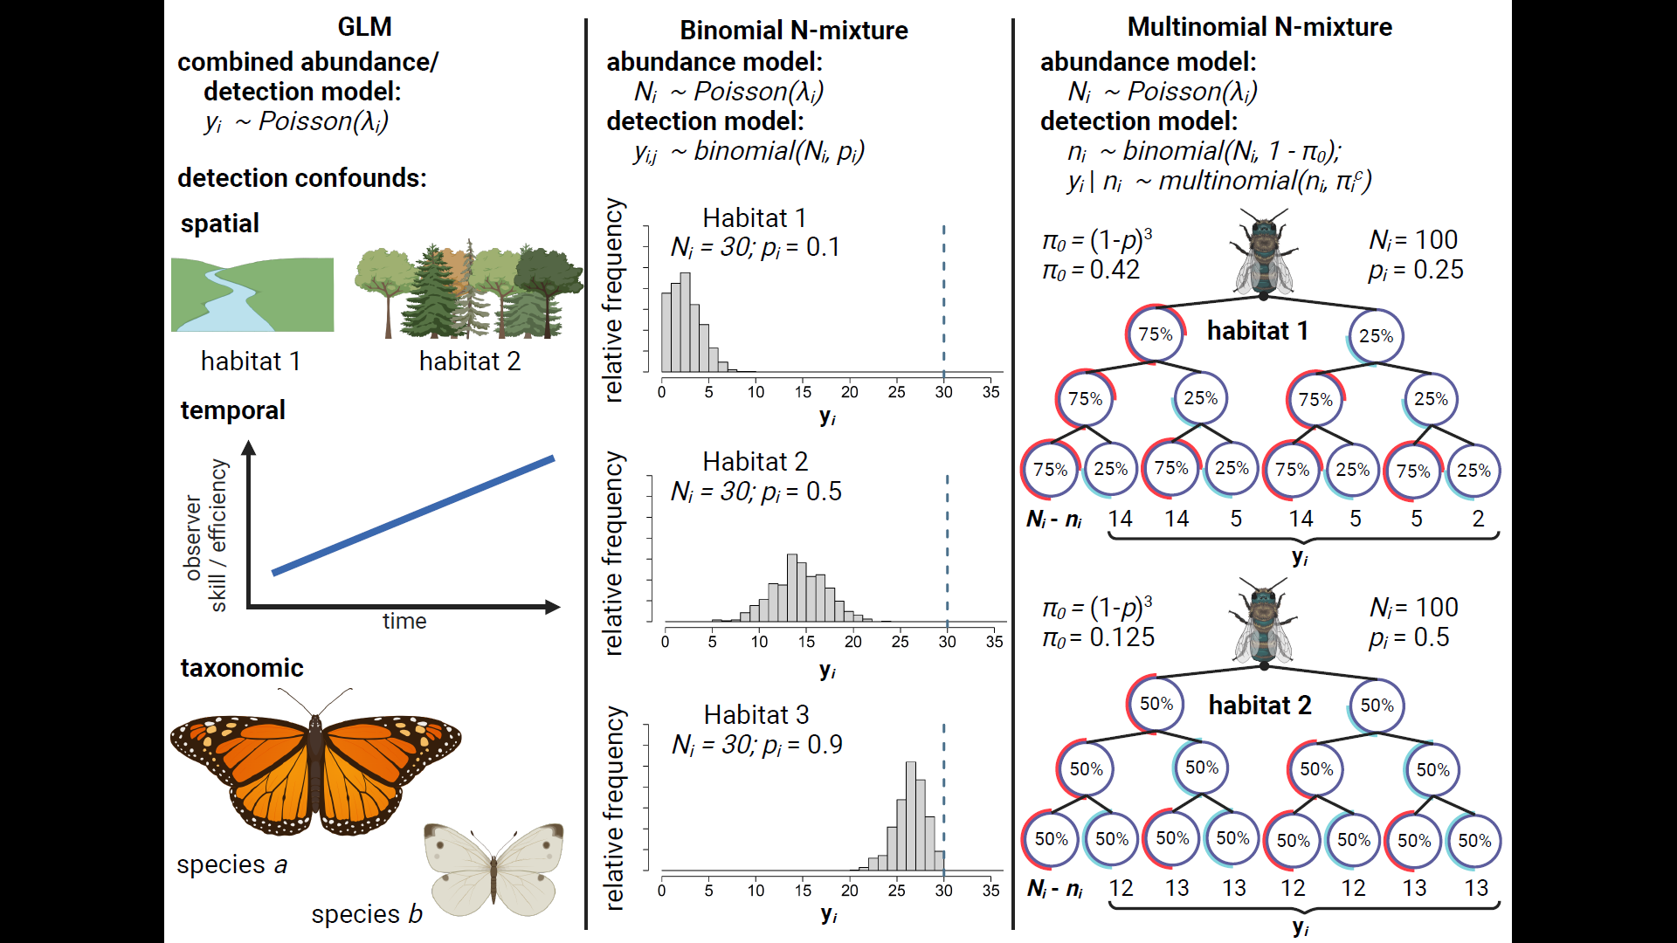
Figure 1: Comparison of three methods for estimating insect abundance. Abundance GLM’s (column 1) treat count data (y_{i} ) as a stochastic outcome that can be affected by some spatiotemporal and taxonomic predictors ($λ_{i}$). GLM’s are unable to disentangle effects of these predictors on abundance from their potential effects on detection rate, e.g.: Habitat obscures detectability; observers improve detection skills over time; or larger and more colorful species are detected at a higher rate than smaller and more dull-colored species. Binmix models (column 2) leverage the variation in counts $y$ across repeat surveys $j$ to units $i$ to simultaneously estimate detection rate $p$ and total abundance $N_{i}$. A more tightly clustered right-tailed distribution of repeat counts in Habitat 1 has a high likelihood when detection rate is low (counts heavily underestimate $N_{i}$); a tightly clustered left-tailed distribution of repeat counts in Habitat 3 has a high likelihood when detection rate is high (counts nearly approximate $N_{i}$); a wider and more symmetrical distribution in Habitat 2 has a higher likelihood when the detection rate is close to a 50%. Multimix models for mark-recapture data (column 3) classify $y_{i}$ as the number of individuals in each observable encounter history, with the total number of individuals detected one or more times ($n_{i}$) dependent on a total population size $(N_{i}$) and the probability of an individual having any of the observable detection histories (1 - $π_{0}$). In a study with three repeat surveys, the probability of never being captured ($π_{0}$) is equal to (1 - $p$)³. Encounter histories are typically tracked by placing marks on individual insects. Encounter histories that skew towards infrequent detection in Habitat 2 suggest that there is a high probability of failing to detect individuals across all repeat surveys, i.e., that $π_{0}$ is greater in Habitat 2 versus Habitat 1 and, correspondingly, that $n_{i}$ is a smaller proportion of $N_{i}$. Figure created in https://BioRender.com.
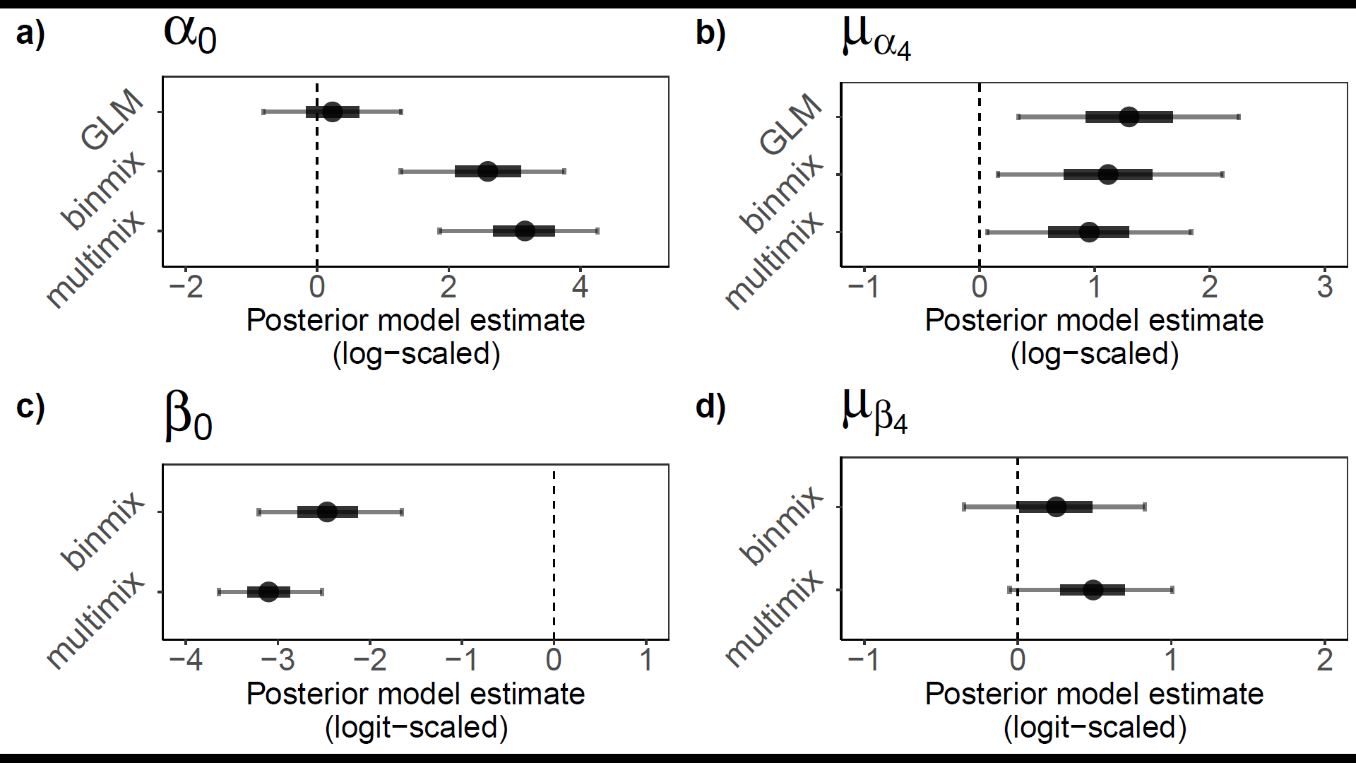
Figure 2: Field study estimates of wild bee abundance and detection. We estimated abundance intercepts (a) and community mean effect of restoration on abundance (b) with all three model types. We estimated detection rate intercepts (c) and community mean effect of restoration on detection (d) for binmix and multimix models, which are designed to estimate and account for imperfection detection. Mean estimates are displayed with filled circles. Thick and thin error bars represent 50% and 90% Bayesian credible intervals.

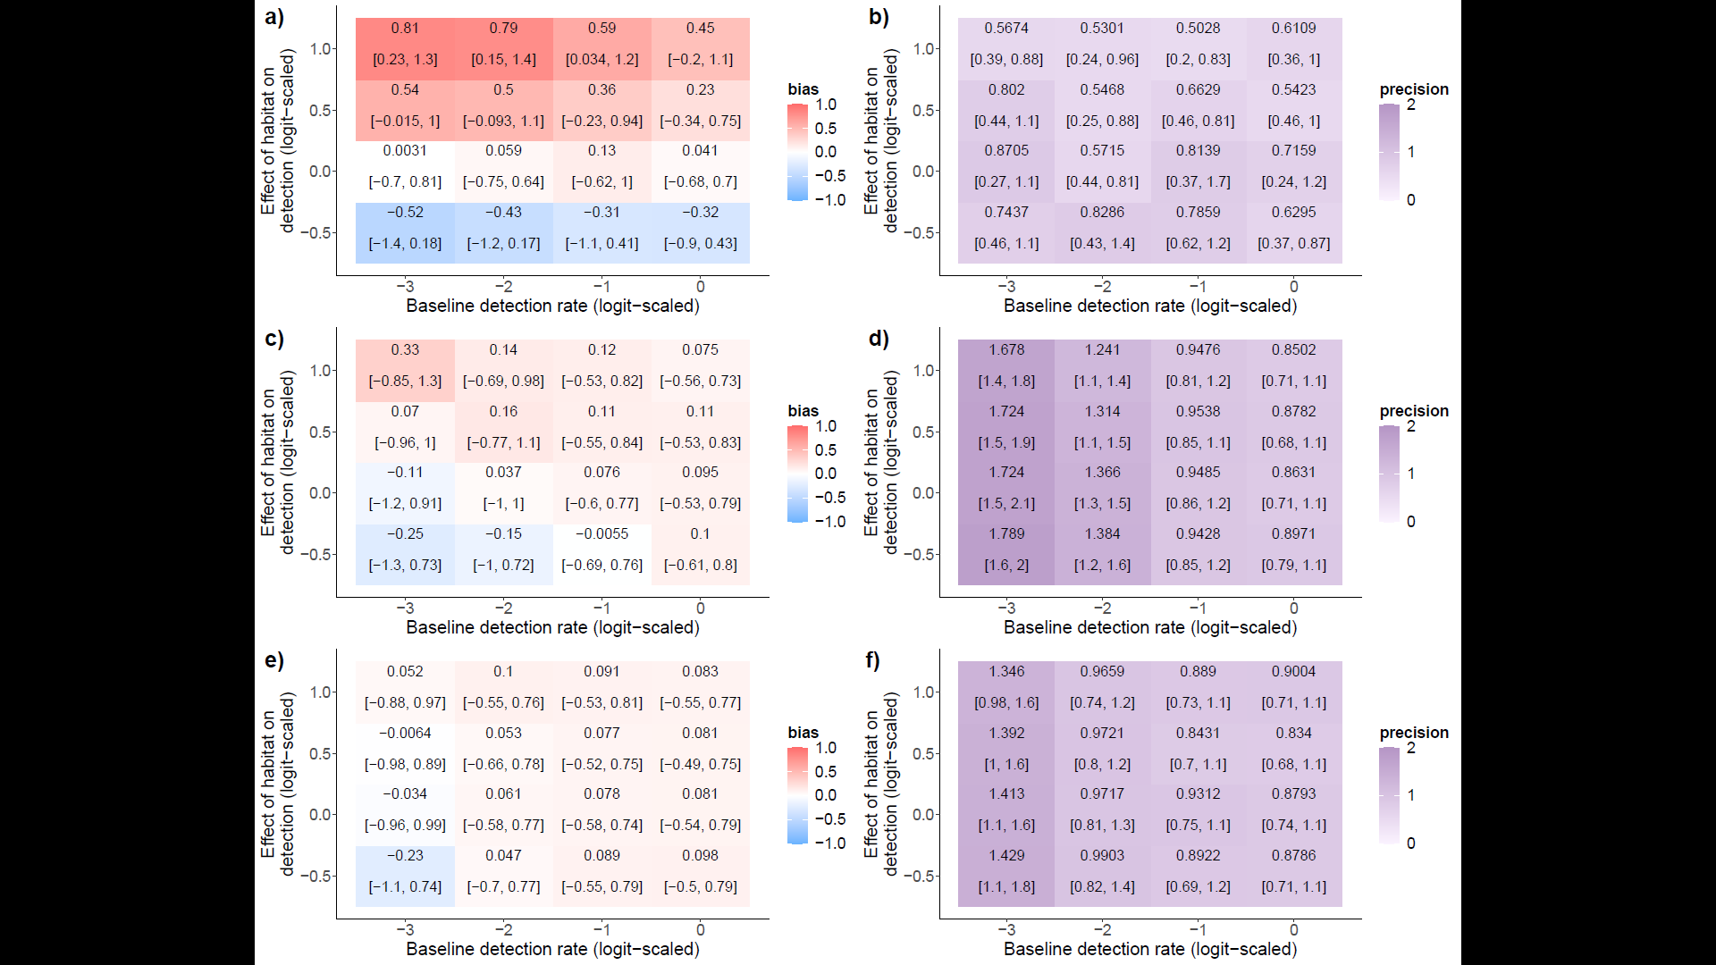
Figure 3: Bias and precision of abundance models under simulated changes in detection rate and effects of habitat restoration on detection: GLM bias (a) and precision (b); binmix bias (c) and precision (d); and multimix bias (e) and precision (f). Positive bias (red) indicates a tendency to overestimate the effect of habitat restoration on abundance while a negative bias (blue) indicates a tendency to underestimate the effect. A value of zero indicates no model bias. Models should return unbiased estimates of abundance drivers that are also precise. Higher values for precision (dark purple) represent wider Bayesian credible intervals (BCIs). Lower values (light purple) represent BCIs with less uncertainty. Text in the panels communicates the mean bias or precision, with lower and upper bounds of the 90% BCIs included in brackets.
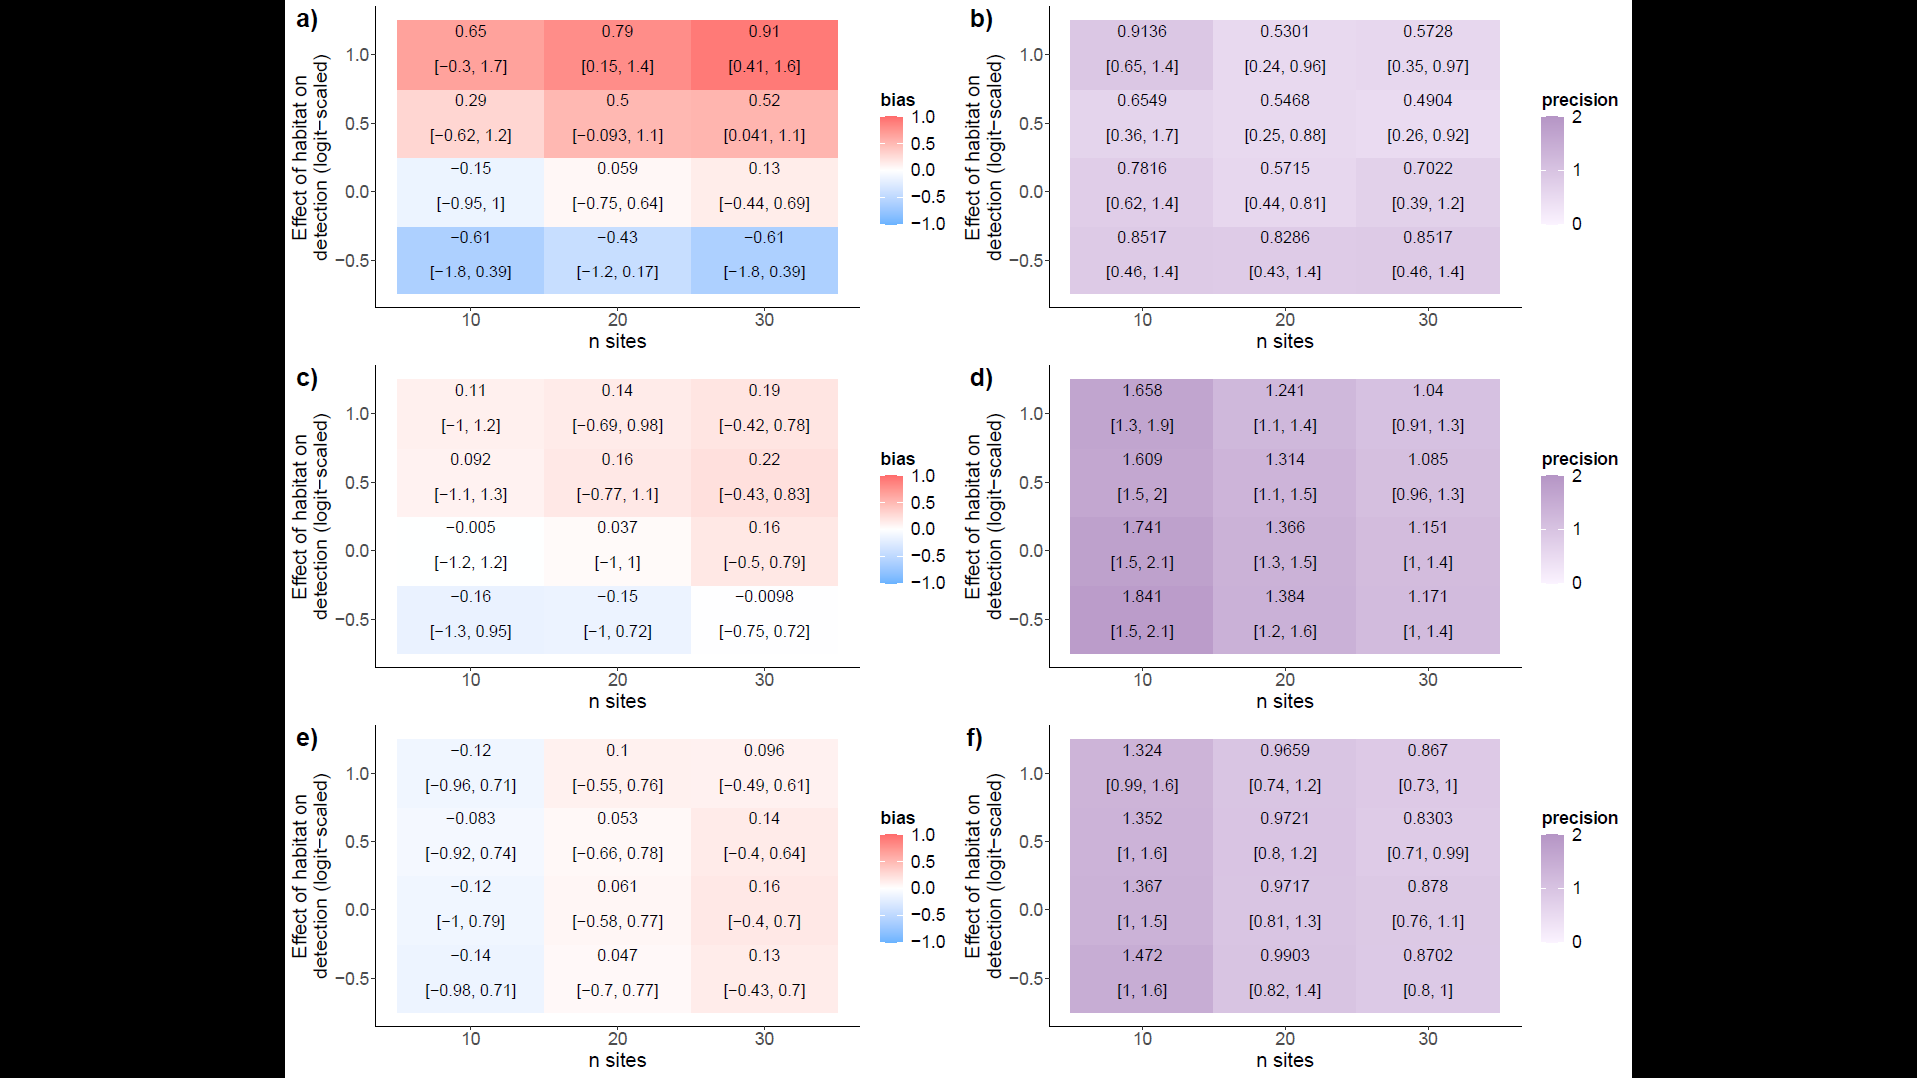
Figure 4: Bias and precision of abundance models under simulated changes in site number and effects of habitat category on detection. GLM bias (a) and precision (b); binmix bias (c) and precision (d); and multimix bias (e) and precision (f). Positive bias (red) indicates a tendency to overestimate the effect of habitat restoration on abundance while a negative bias (blue) indicates a tendency to underestimate the effect. A value of zero indicates no model bias. Models should return unbiased estimates of abundance drivers that are also precise. Higher values for precision (dark purple) represent wider Bayesian credible intervals (BCIs). Lower values (light purple) represent BCIs with less uncertainty. Text in the panels communicates the mean bias or precision, with lower and upper bounds of the 90% BCIs included in brackets.

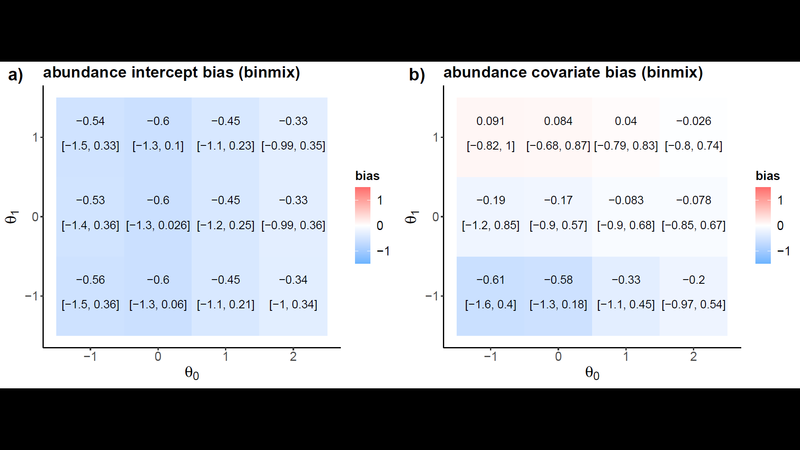
Figure 5: Robustness to closure violations. We simulated variation in the odds that insects remain within a sampling area at the time of a survey effort ($θ_{0}$), and the degree to which a site covariate of habitat restoration impacts these odds either positively or negatively ($θ_{1}$). We recorded the bias for estimates of the abundance intercept and for the abundance covariate of restoration for both a binmix model (a and b) and for a multimix model (c and d). Positive bias (red) indicates a tendency to overestimate the abundance intercept or the effect of habitat restoration on abundance while a negative bias (blue) indicates a tendency to underestimate. A value of zero indicates no model bias. Text in the panels communicates the mean bias, with lower and upper bounds of the 90% Bayesian credible intervals included in brackets.

Supplemental Materials
Supplemental Tables
Table S1: Site Details. We conducted wild bee abundance surveys in 1-hectare plots located in ten urban park sites in Vancouver, Canada. Detailed vegetation and site management data were reported by Ulrich and Sargent 2025.
Site name | Treatment group | Latitude | Longitude
Killarney Park | Restored | 49.227468 | -123.046616
Locarno Park | Restored | 49.273942 | -123.206008
Oak Meadows Park | Restored | 49.238607 | -123.126438
Prince of Wales Park | Restored | 49.243958 | -123.158084
West Memorial Park | Restored | 49.243227 | -123.189281
Bobolink Park | Control | 49.21503 | -123.057
Gordon Park | Control | 49.223993 | -123.069652
Kensington Park | Control | 49.23772 | -123.076
Moberly Park | Control | 49.215687 | -123.086136
Quilchena Park | Control | 49.242885 | -123.148097

Table S2: Prior distributions for abundance GLM.
Parameter | Parameter meaning | Prior Distribution | Justification
$$α_{0}$$ | Global intercept | $Normal$(0, 2) | Weakly-informative centered prior.
$$α_{1}\left[species\right]$$ | Species-specific intercept effects | $Normal$(0, $σ_{α_{1}}$) | Weakly-informative centered prior.
$$σ_{α_{1}}$$ | Variation in species-specific intercept effects | $Half-Normal$(0, 2) | Weakly-informative prior placing more weight near zero, i.e., small variation among groups (positive values only).
$$α_{2}\left[site\right]$$ | Site-specific intercept effects | $Normal$(0, $σ_{α_{2}}$) | Weakly-informative centered prior.
$$σ_{α_{2}}$$ | Variation in site-specific intercept effects | $Half-Normal$(0, 1) | Weakly-informative prior placing more weight near zero, i.e., small variation among groups (positive values only).
$$α_{3}\left[year\right]$$ | Year intercept effects | $Normal$(0, 1) | Weakly-informative centered prior.
$$α_{4}\left[species\right]$$ | Species-specific effects of restoration | $Normal$(0, $σ_{α_{4}}$) | Weakly-informative centered prior.
$$σ_{α_{4}}$$ | Variation in species-specific effects of restoration | $Half-Normal$(0, 2) | Weakly-informative prior placing more weight near zero, i.e., small variation among groups (positive values only).
$$ϕ$$ | Negative binomial dispersion parameter | $Half-Normal$(0, 1) | Weakly-informative prior placing more weight near zero, i.e., overdispersion in counts (positive values only).

Table S3: Prior distributions for binmix model.
Parameter | Parameter meaning | Prior Distribution | Justification
ABUNDANCE PARAMETERS
$$α_{0}$$ | Global intercept | $Normal$(0, 2) | Weakly-informative centered prior.
$$α_{1}\left[species\right]$$ | Species-specific intercept effects | $Normal$(0, $σ_{α_{1}}$) | Weakly-informative centered prior.
$$σ_{α_{1}}$$ | Variation in species-specific intercept effects | $Half-Normal$(0, 2) | Weakly-informative prior placing more weight near zero, i.e., small variation among groups (positive values only).
$$α_{2}\left[site\right]$$ | Site-specific intercept effects | $Normal$(0, $σ_{α_{2}}$) | Weakly-informative centered prior.
$$σ_{α_{2}}$$ | Variation in site-specific intercept effects | $Half-Normal$(0, 1) | Weakly-informative prior placing more weight near zero, i.e., small variation among groups (positive values only).
$$α_{3}\left[year\right]$$ | Year intercept effects | $Normal$(0, 1) | Weakly-informative centered prior.
$$α_{4}\left[species\right]$$ | Species-specific effects of restoration | $Normal$(0, $σ_{α_{4}}$) | Weakly-informative centered prior.
$$σ_{α_{4}}$$ | Variation in species-specific effects of restoration | $Half-Normal$(0, 2) | Weakly-informative prior placing more weight near zero, i.e., small variation among groups (positive values only).
$$ϕ$$ | Negative binomial dispersion parameter | $Half-Normal$(0, 1) | Weakly-informative prior placing more weight near zero, i.e., overdispersion in counts (positive values only).
ABUNDANCE PARAMETERS
$$β_{0}$$ | Global intercept | $Normal$(0, 2) | Weakly-informative centered prior.
$$β_{1}\left[species\right]$$ | Species-specific intercept effects | $Normal$(0, $σ_{β_{1}}$) | Weakly-informative centered prior.
$$σ_{β_{1}}$$ | Variation in species-specific intercept effects | $Half-Normal$(0, 2) | Weakly-informative prior placing more weight near zero, i.e., small variation among groups (positive values only).
$$β_{2}\left[site\right]$$ | Site-specific intercept effects | $Normal$(0, $σ_{β_{2}}$) | Weakly-informative centered prior.
$$σ_{β_{2}}$$ | Variation in site-specific intercept effects | $Half-Normal$(0, 1) | Weakly-informative prior placing more weight near zero, i.e., small variation among groups (positive values only).
$$β_{3}\left[year\right]$$ | Year intercept effects | $Normal$(0, 1) | Weakly-informative centered prior.
$$β_{4}\left[species\right]$$ | Species-specific effects of restoration | $Normal$(0, $σ_{β_{4}}$) | Weakly-informative centered prior.
$$σ_{β_{4}}$$ | Variation in species-specific effects of restoration | $Half-Normal$(0, 2) | Weakly-informative prior placing more weight near zero, i.e., small variation among groups (positive values only).

Table S4: Prior distributions for multimix model.
Parameter | Parameter meaning | Prior Distribution | Justification
ABUNDANCE PARAMETERS
$$α_{0}$$ | Global intercept | $Normal$(0, 2) | Weakly-informative centered prior.
$$α_{1}\left[species\right]$$ | Species-specific intercept effects | $Normal$(0, $σ_{α_{1}}$) | Weakly-informative centered prior.
$$σ_{α_{1}}$$ | Variation in species-specific intercept effects | $Half-Normal$(0, 2) | Weakly-informative prior placing more weight near zero, i.e., small variation among groups (positive values only).
$$α_{2}\left[site\right]$$ | Site-specific intercept effects | $Normal$(0, $σ_{α_{2}}$) | Weakly-informative centered prior.
$$σ_{α_{2}}$$ | Variation in site-specific intercept effects | $Half-Normal$(0, 1) | Weakly-informative prior placing more weight near zero, i.e., small variation among groups (positive values only).
$$α_{3}\left[year\right]$$ | Year intercept effects | $Normal$(0, 1) | Weakly-informative centered prior.
$$α_{4}\left[species\right]$$ | Species-specific effects of restoration | $Normal$(0, $σ_{α_{4}}$) | Weakly-informative centered prior.
$$σ_{α_{4}}$$ | Variation in species-specific effects of restoration | $Half-Normal$(0, 2) | Weakly-informative prior placing more weight near zero, i.e., small variation among groups (positive values only).
$$ϕ$$ | Negative binomial dispersion parameter | $Half-Normal$(0, 1) | Weakly-informative prior placing more weight near zero, i.e., overdispersion in counts (positive values only).
ABUNDANCE PARAMETERS
$$β_{0}$$ | Global intercept | $Normal$(0, 2) | Weakly-informative centered prior.
$$β_{1}\left[species\right]$$ | Species-specific intercept effects | $Normal$(0, $σ_{β_{1}}$) | Weakly-informative centered prior.
$$σ_{β_{1}}$$ | Variation in species-specific intercept effects | $Half-Normal$(0, 2) | Weakly-informative prior placing more weight near zero, i.e., small variation among groups (positive values only).
$$β_{2}\left[site\right]$$ | Site-specific intercept effects | $Normal$(0, $σ_{β_{2}}$) | Weakly-informative centered prior.
$$σ_{β_{2}}$$ | Variation in site-specific intercept effects | $Half-Normal$(0, 1) | Weakly-informative prior placing more weight near zero, i.e., small variation among groups (positive values only).
$$β_{3}\left[year\right]$$ | Year intercept effects | $Normal$(0, 1) | Weakly-informative centered prior.
$$β_{4}\left[species\right]$$ | Species-specific effects of restoration | $Normal$(0, $σ_{β_{4}}$) | Weakly-informative centered prior.
$$σ_{β_{4}}$$ | Variation in species-specific effects of restoration | $Half-Normal$(0, 2) | Weakly-informative prior placing more weight near zero, i.e., small variation among groups (positive values only).

Supplemental Figures
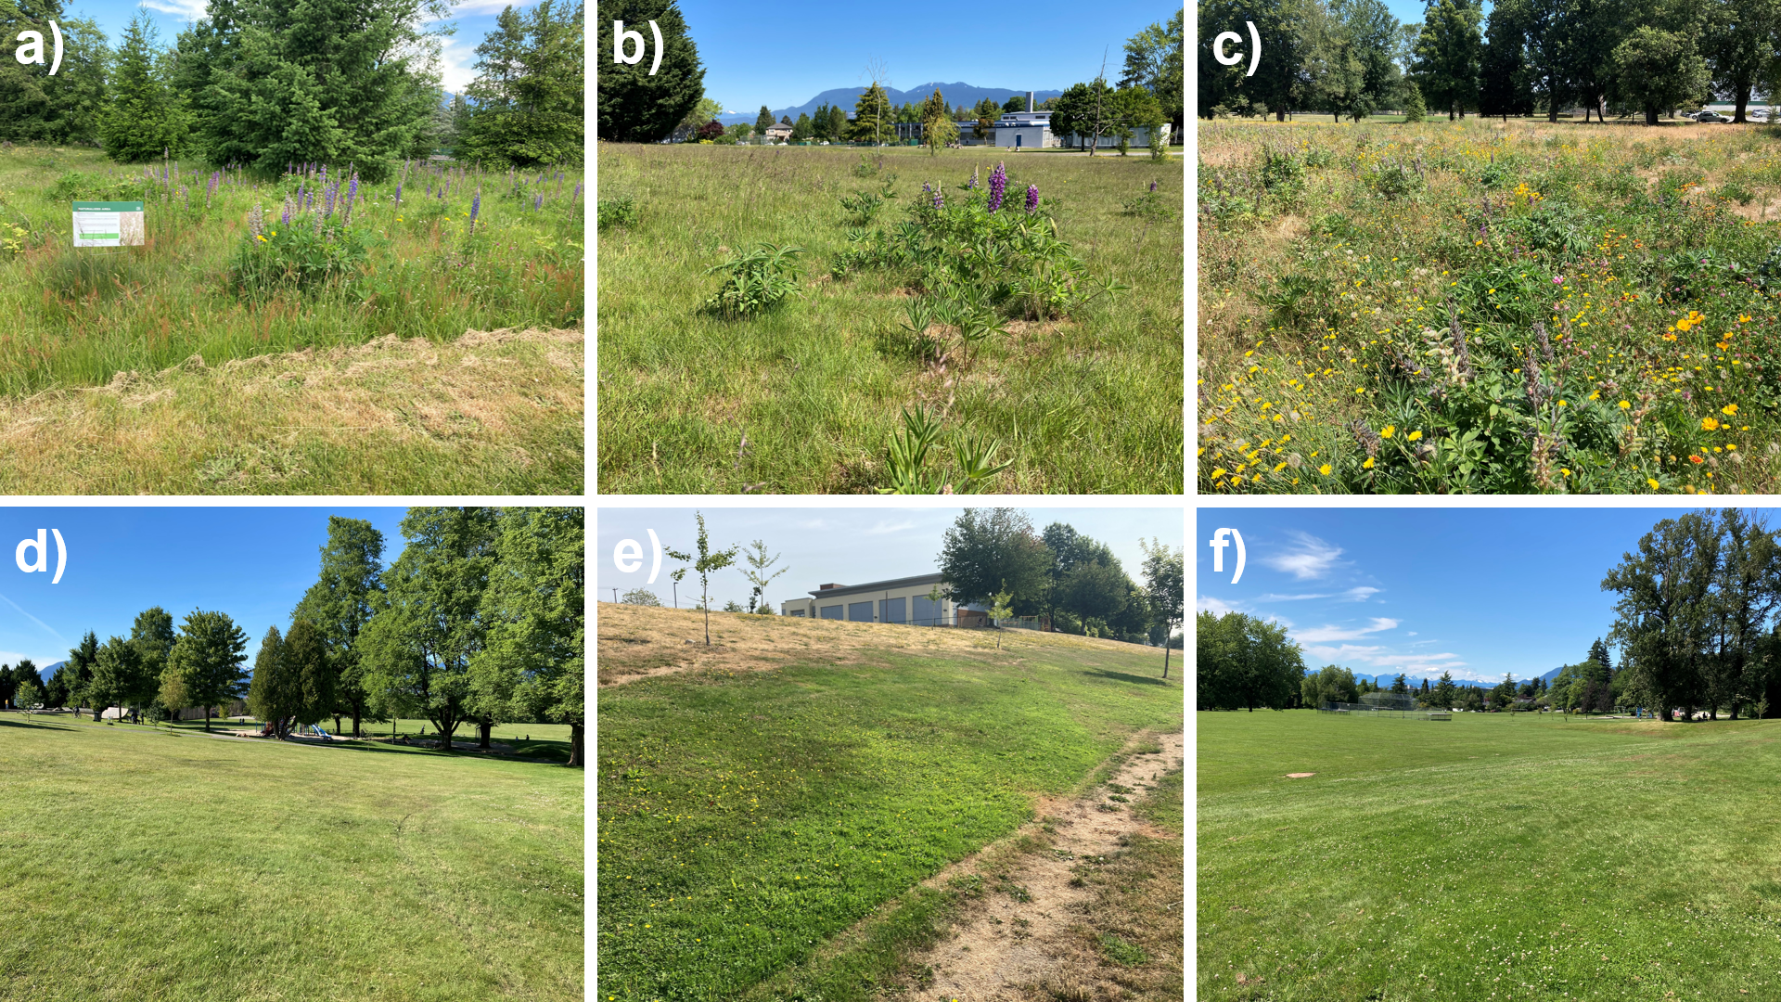
Figure S1: We conducted abundance surveys at ten urban park sites in Vancouver, Canada. Five of the sites were historically turfgrass dominated but received a restoration amendment of about 1 hectare area. The restoration consisted of herbaceous flower seeding combined with no mowing during the spring and summer months. Some restored site examples include Oak Meadows Park (a), Prince of Wales Park (b), and Killarney Park (c). In control sites, turfgrass areas were not amended with a restoration. Some control site examples include Kensington Park (d), Moberly Park (e), and Quilchena Park (f). Restored sites had significantly more flower resources and were characterized by taller herbaceous vegetation.

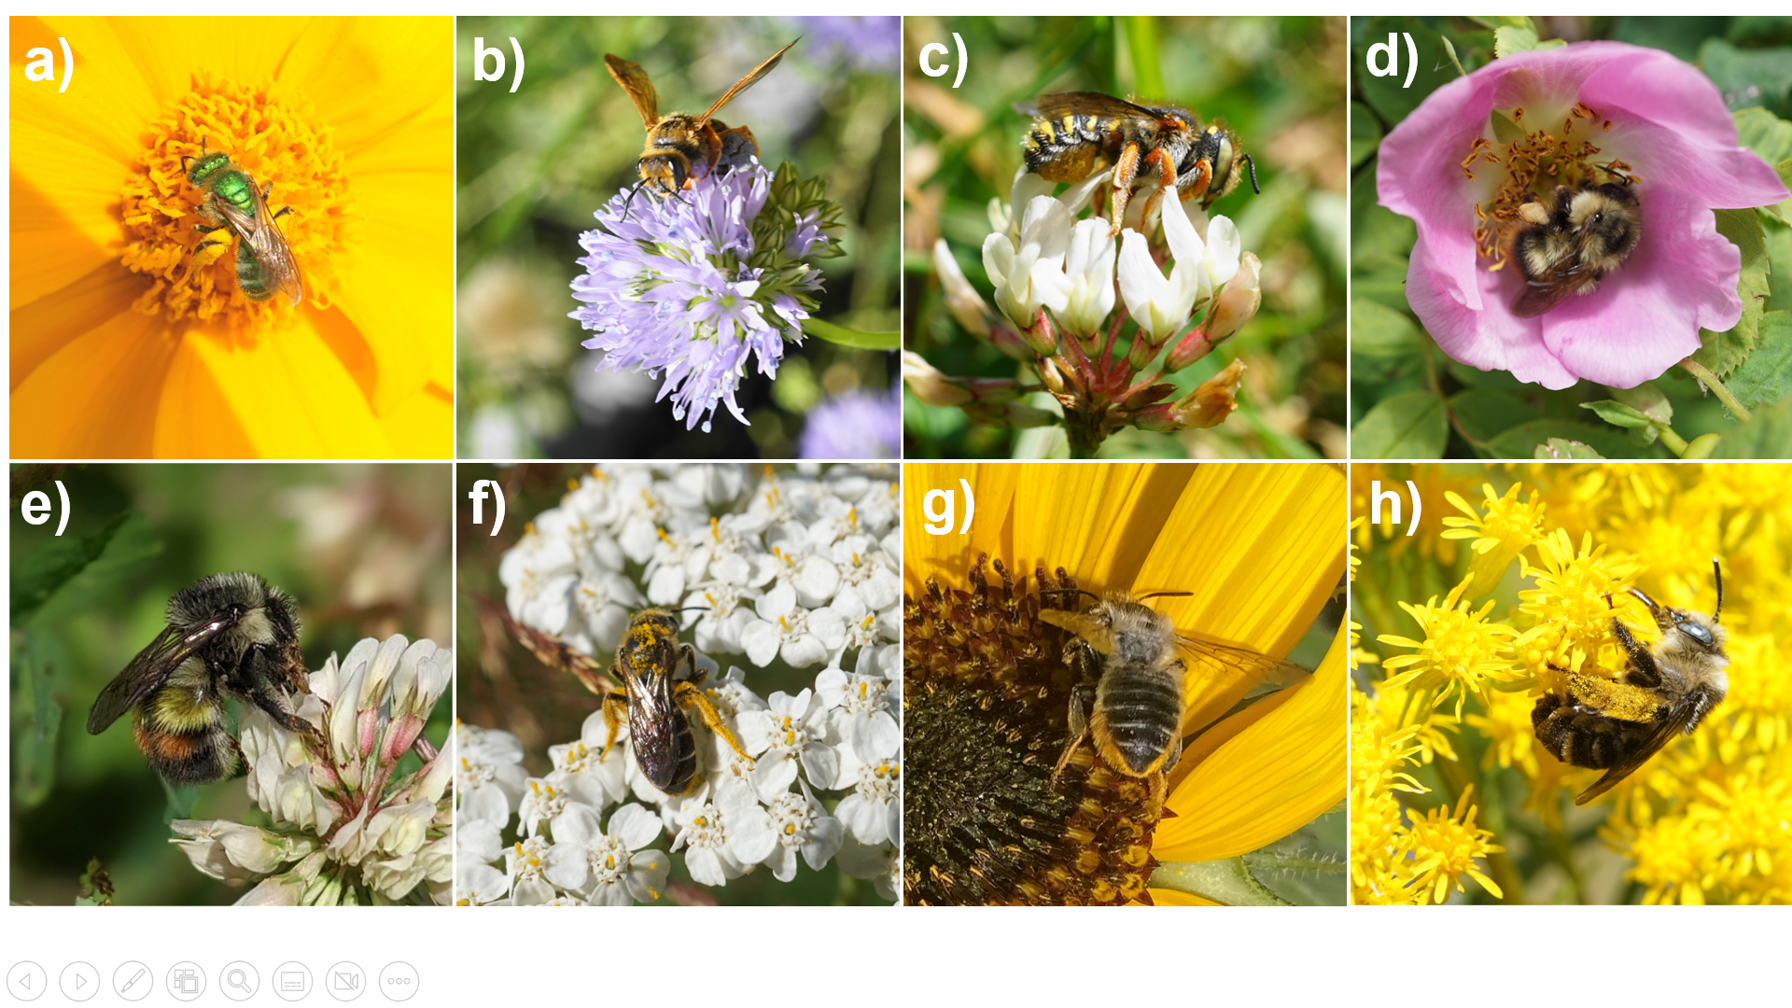
Figure S2: We targeted 8 wild species in our abundance surveys: Agapostemon texanus (a), Andrena prunorum (b), Anthidium oblongatum (c), Bombus mixtus (d), Bombus flavifrons (e), Halictus rubicundus (f), native Megachile spp. (g), and Melissodes microstictus (h). The picture of B. flavifrons was taken by Sarah Knoerr and used with permission.
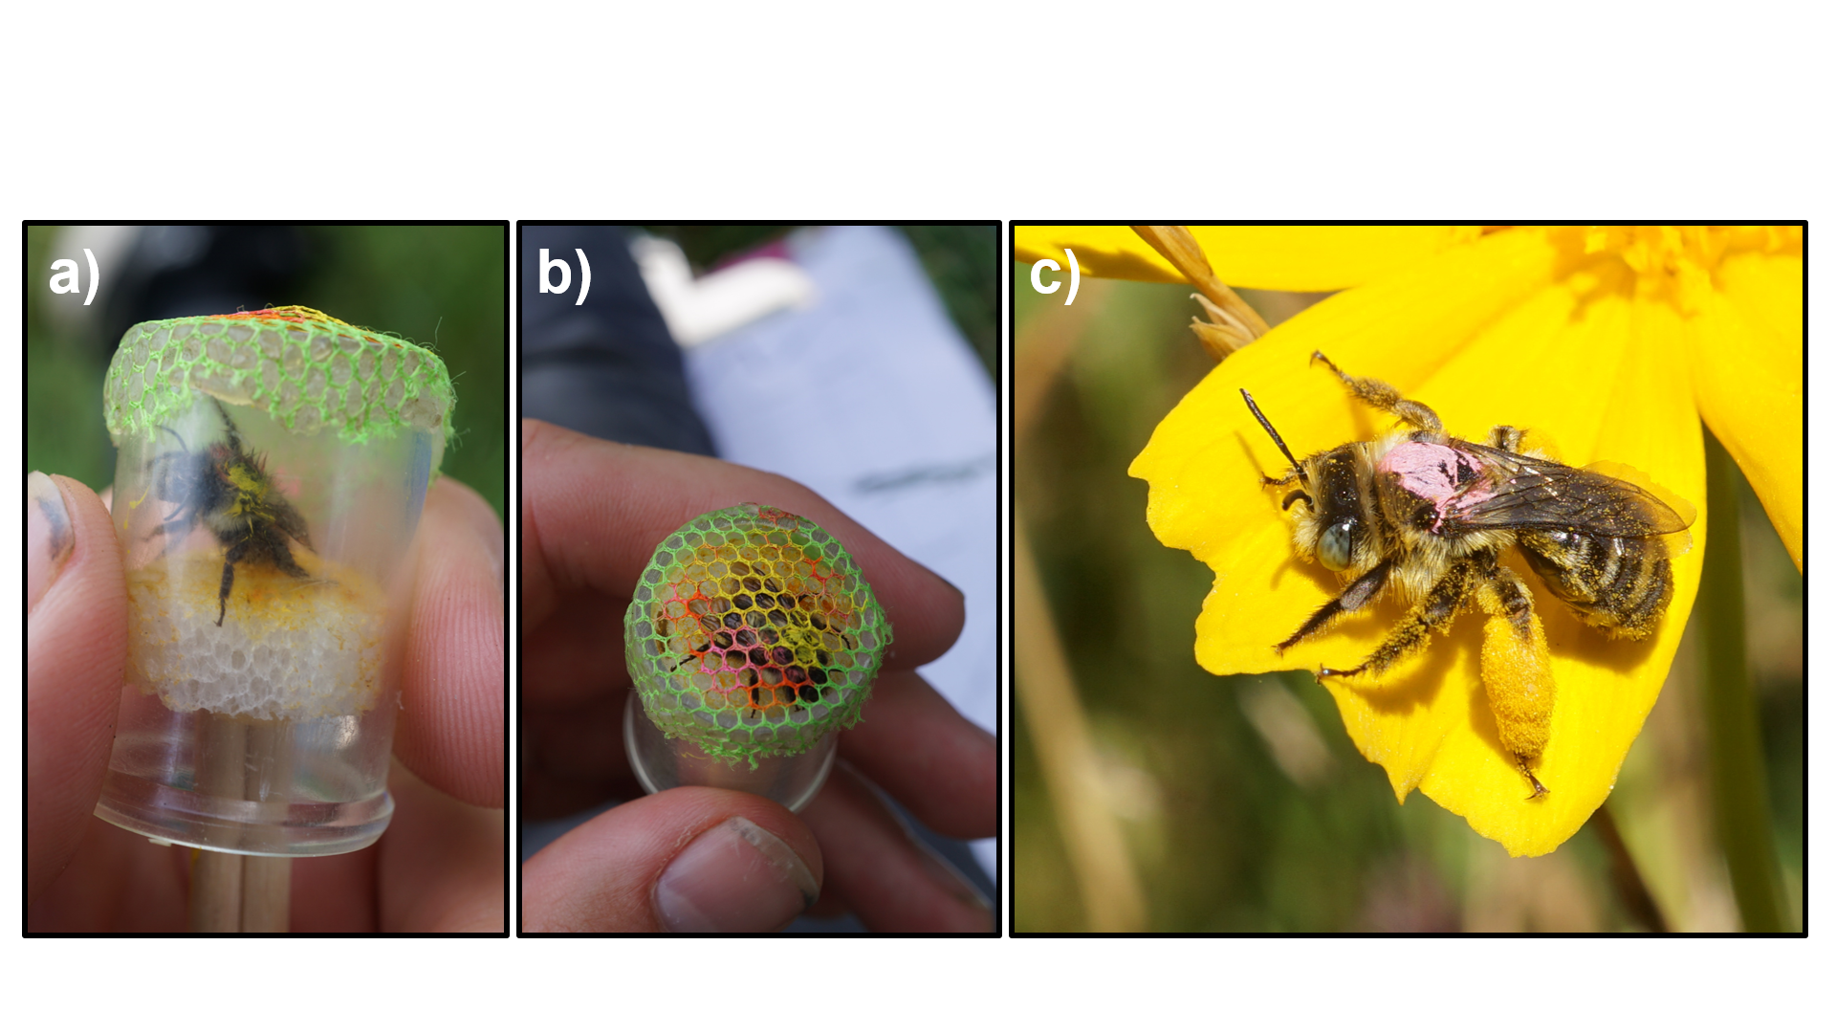
Figure S3: Mark-recapture method. We placed chilled bees in a modified vial with a Styrofoam plunger on one end (a). Chilling the bees allowed for easier handling. We used the plunger to press the thorax of the bee against a mesh covering on the opposite side of the vial (b). We used a paint pen to place a mark on the thorax. The mark was colour-coded to correspond to the unique capture date. In (b), the bee was captured on two occasions. It has a yellow mark indicating the first capture and a pink mark representing the second. After marking, we released the bees back to the survey area. We observed that bees then resumed normal foraging behaviour, usually after sunning themselves for a few minutes (c).

- 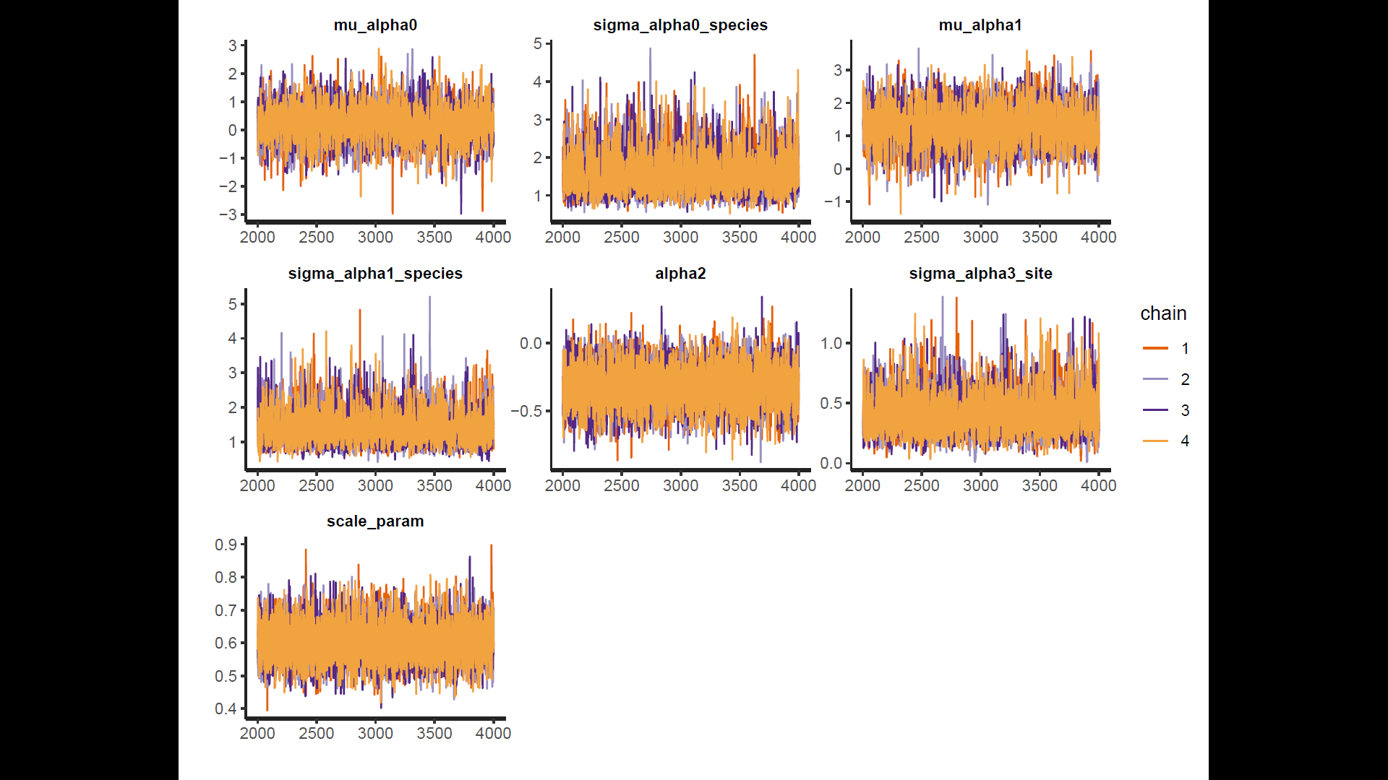
- 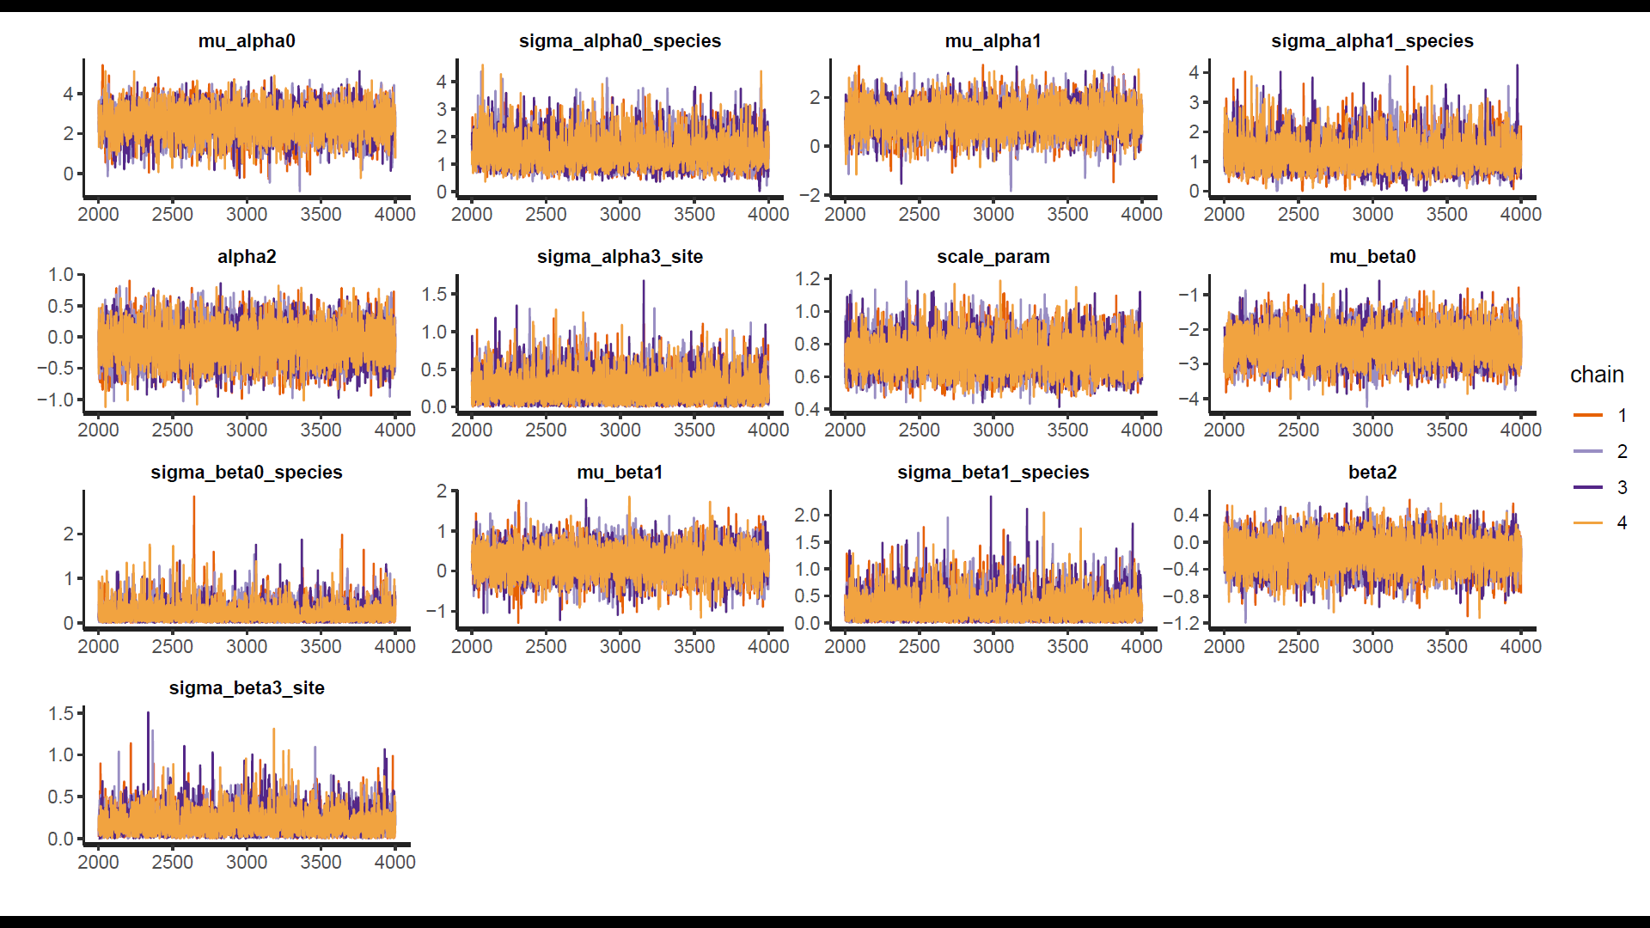
- 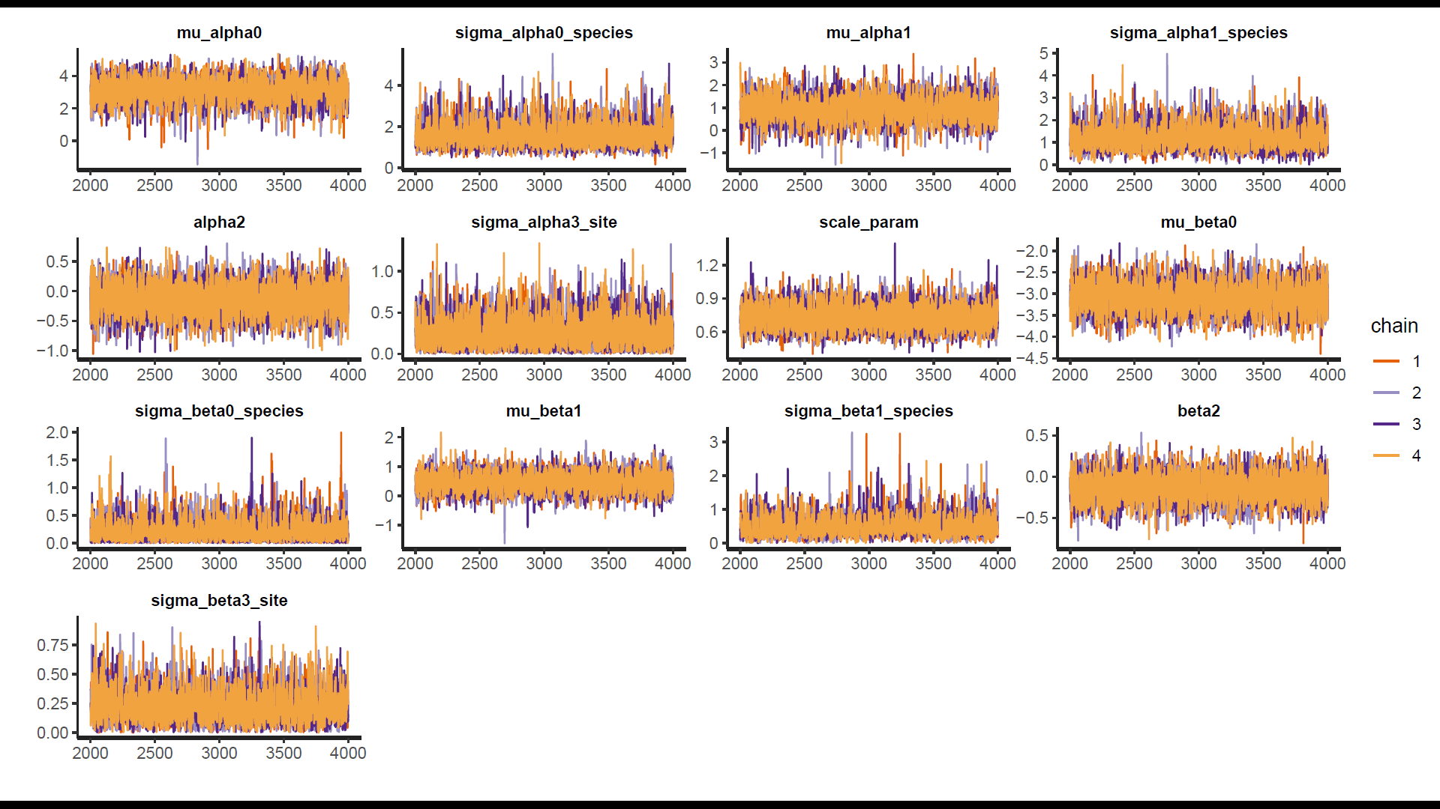
Figure S4: Traceplots for the GLM (a), binmix model (b), and multimix model (c). Overlapping HMC traces indicate that all 4 chains have converged on a similar parameter space.

- 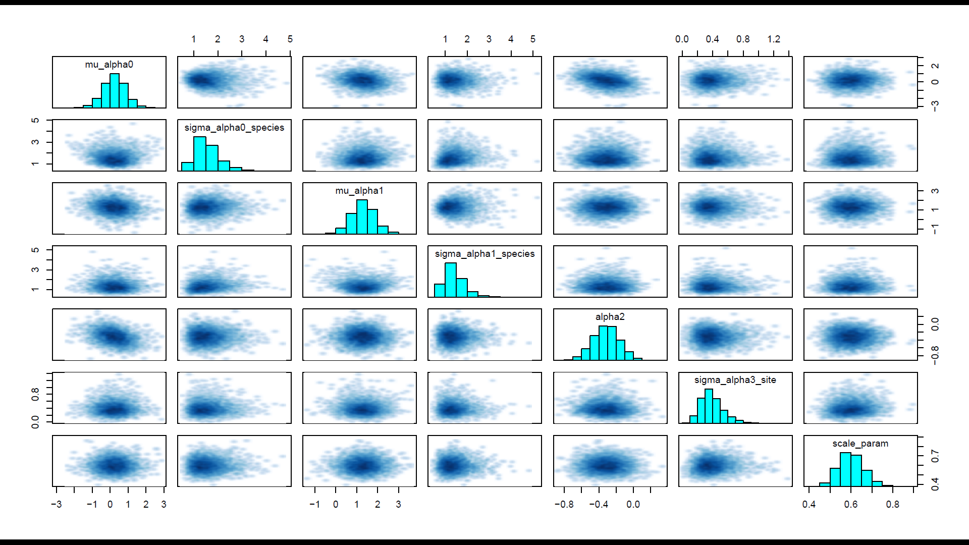
- 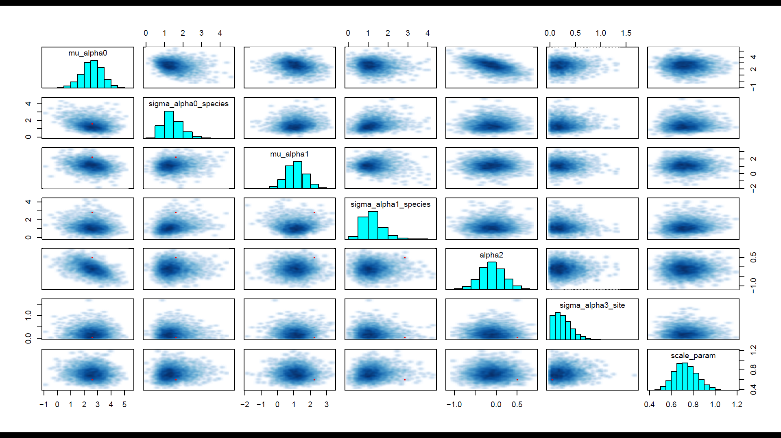
- 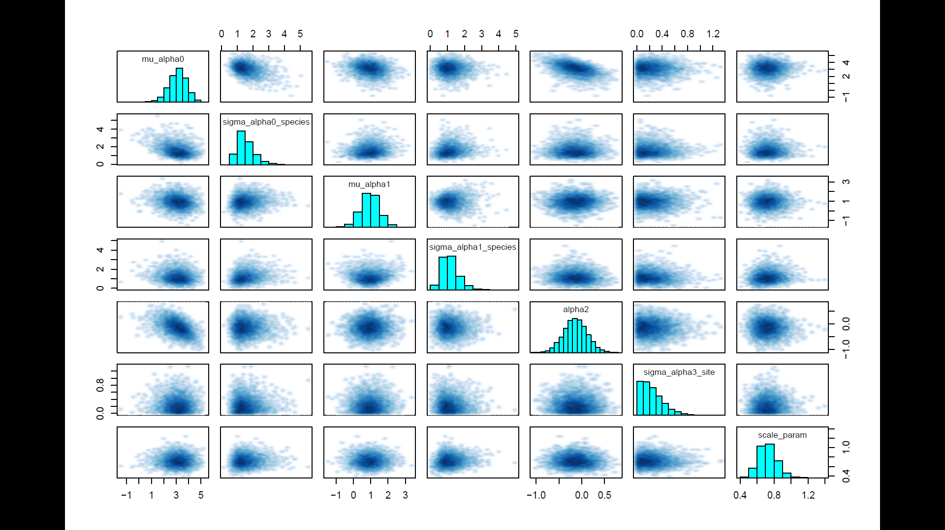
Figure S5: Pairs plots for the GLM (a), binmix model (b), and multimix model (c). Pairs plot are shown for a sample subset of parameters (abundance parameters). Lack of divergent transitions and no visual barriers in the parameter space search support that the posterior distribution has been fully explored.
- 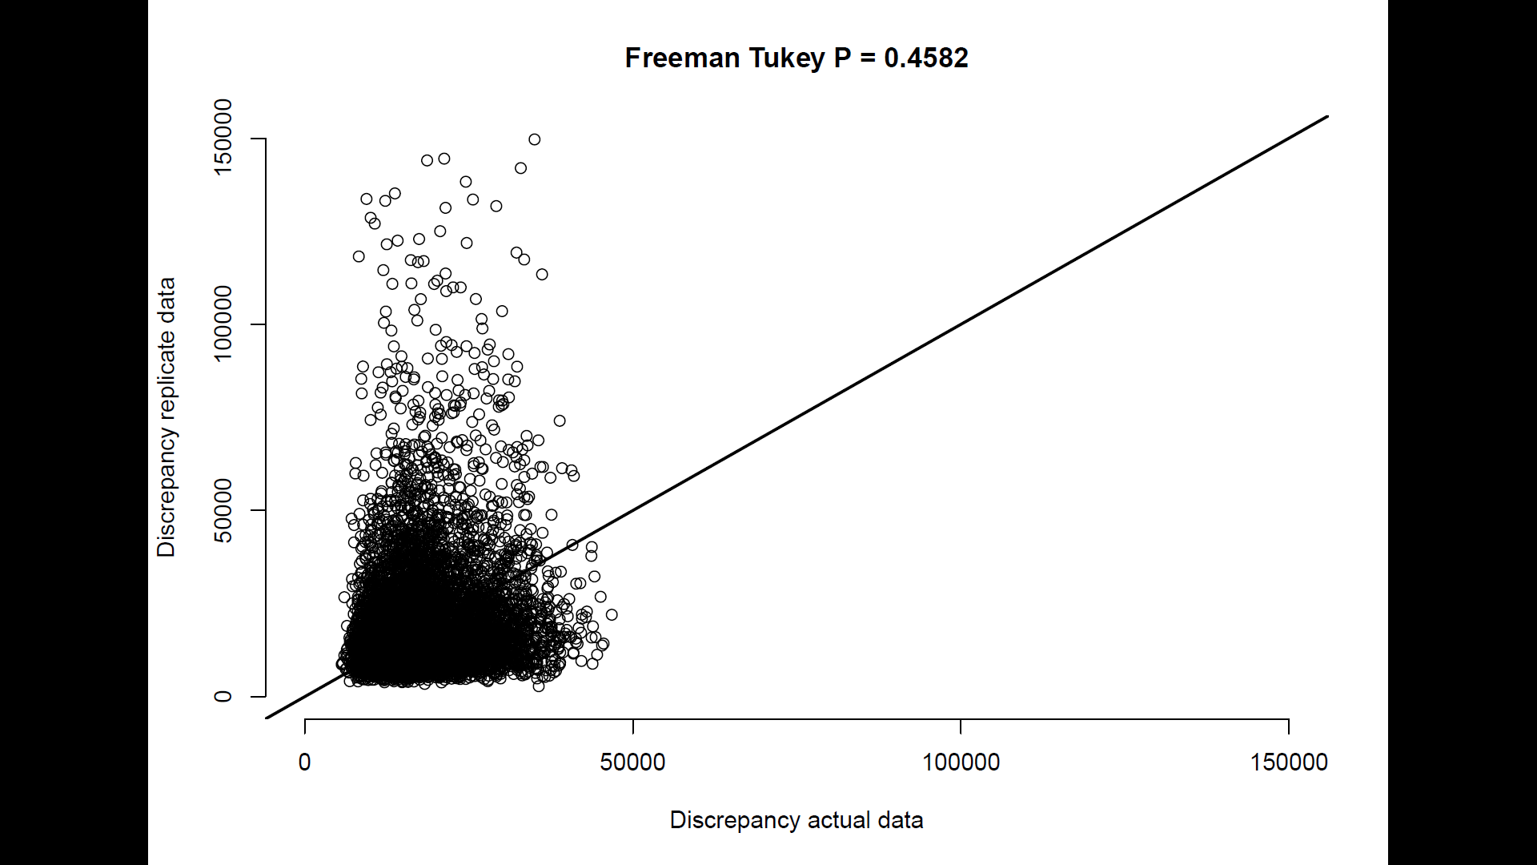
- 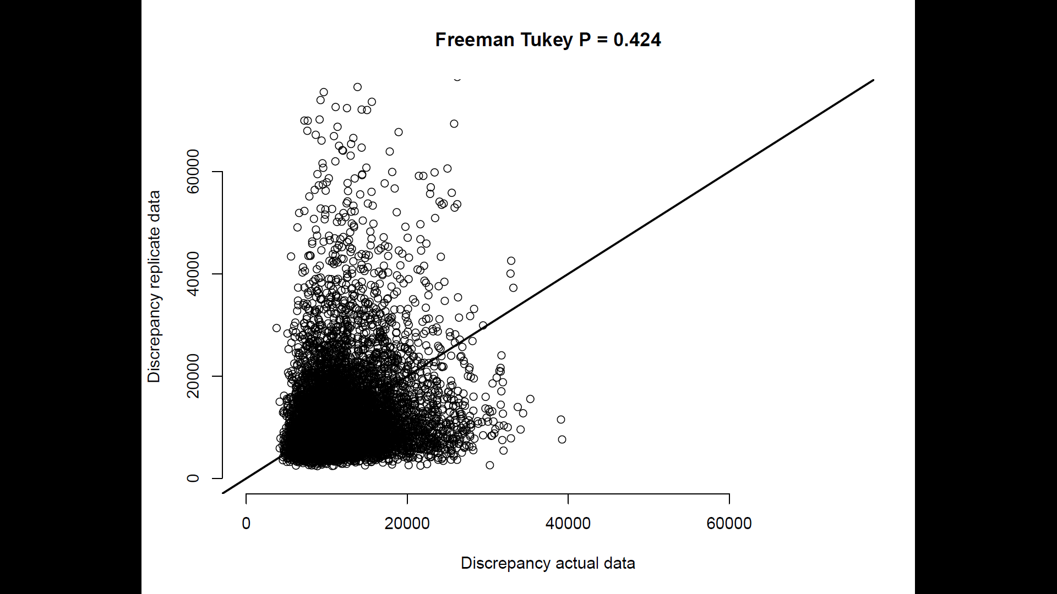
- 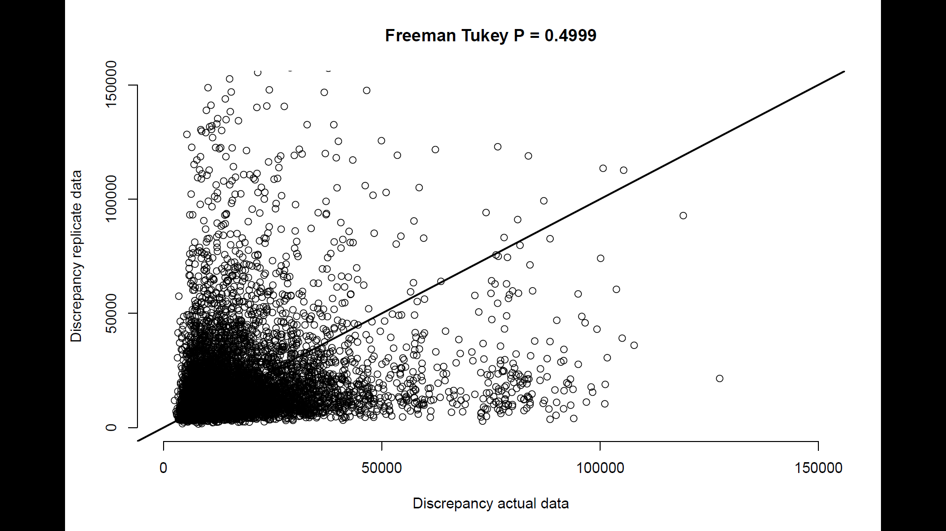
Figure S6: Posterior predictive check plots for GLM (a), binmix model (b), and multimix model (c). To assess model fit, we conducted Freeman-Tukey statistic discrepancy tests for each model (Conn et al., 2018; Kery and Royle, 2020). This test evaluates the difference in discrepancy between simulated data or real data versus an expected outcome. To conduct the test, we simulated some data (y_replicated) using the parameter estimates at each step of the HMC run. Data were counts of the number of individuals detected per species per site-survey (a, b) or the number of individuals detected at least once per species per site across all three surveys (c). We then simulated some new data from the same parameter estimates (y_new). We calculated the Freeman-Tukey discrepancy for all y_new across all sampling events i, and also for our actual data y:
$Fit discrepancy(y_{new})$ = $\sum_{i}^{R}{(square(y_new[i] - y_replicated [i]) / (y_replicated [i] + 0.5)}$
$Fit discrepancy(y)$ = $\sum_{i}^{R}{(square(y[i] - y_replicated [i]) / (y_replicated [i] + 0.5)}$
We then calculated the frequency in the posterior distribution of samples at which the fit discrepancy for $y_{new}$ is greater than the fit discrepancy for $y$. Values near 0.5 suggest reasonable goodness of fit, i.e., that newly simulated data tend to be more or less as far away from some other simulated data as our real data. Values below 0.05 or greater than 0.95 indicate critical lack of model fit.
Conn, P. B., Johnson, D. S., Williams, P. J., Melin, S. R., & Hooten, M. B. (2018). A guide to Bayesian model checking for ecologists. Ecological Monographs, 88(4), 526-542.
Kéry, M., & Royle, J. A. (2020). Applied hierarchical modeling in ecology: Analysis of distribution, abundance and species richness in R and BUGS: Volume 2: Dynamic and advanced models. Academic Press.

