Abstract
Biodiversity conservation hinges on a clear understanding of the ecological drivers of species abundance. In studies of insect abundance, researchers often estimate effects of hypothesized drivers by applying generalized linear models and generalized linear mixed-models (GLMs/GLMMs) to count data. However, a significant issue with conventional GLMs/GLMMs is that they cannot account for a failure to detect some individuals that are present (‘imperfect detection’), which can bias model estimates. To account for this, some researchers have adopted hierarchical modelling approaches, including multinomial N-mixture (multimix) models for mark-recapture data and binomial N-mixture (binmix) models for repeated count data. Currently, we lack side-by-side comparisons to determine the ecological and study design conditions that require the use of these more cumbersome approaches to achieve accurate estimates. We collected abundance data on wild bees in a study designed to compare unrestored to restored urban parks, which had more flowers and taller vegetation. We applied all three modelling approaches to these data, using either mark-recapture data (multimix approach) or ignoring whether individuals were marked and treating the data as traditional counts (binmix and GLMM approaches). Our models indicated that capture rates for individual bees were below ~5%. The multimix mark-recapture model found that bees were ~1.6 fold more likely to be detected in restored habitats. The GLMM approach, which did not account for detection bias, overestimated the effects of restoration on bee abundance. Our results emphasize that environmental factors can influence our ability to detect insects in field studies, and that these factors may be confounded with the experimental design. Using simulation, we found that multimix mark-recapture models had the highest accuracy and precision for estimating an abundance driver, including when individuals have the potential to move in/out of sampling areas; however, we also found that increasing baseline detection rates minimized the impacts of detection bias on GLMM estimates. We recommend that studies planning to apply GLMMs to count data prioritize methods that maximize detection over other aspects of study design such as the number of sites. Together, our results provide needed guidance on how to design and implement studies that accurately quantify the ecological drivers of insect abundance.
Keywords
Mark-recapture, multinomial N-mixture models, binomial N-mixture models, GLMs/GLMMs, abundance estimation, detection, insect sampling, habitat restoration
1. Introduction
Insects provide critical ecosystem services including pollination, decomposition, and biological control (Schowalter et al., 2018). At the same time, many insects are facing widespread declines (Sánchez-Bayo & Wyckhuys, 2019). In order to design evidence-based strategies for mitigating or reversing insect declines, we require a clear understanding of the environmental pressures that underlie species abundance patterns (Wagner et al., 2021). Quantifying the ecological drivers of species abundance allows us to assess population trends, identify population threats, and/or evaluate the success of management interventions (Blaauw & Isaacs, 2014; Schultz & Hammond, 2003; Waltz & Covington, 2004).
Accurately estimating the drivers of abundance is challenging because abundance itself is difficult to measure in natural environments. For insects, abundance data are often collected as counts from nets, traps or visual assessments (Mccravy, 2018). Because many insect species are small, elusive, and/or mobile, these counts undoubtedly overlook some number of individuals (Portman et al., 2020; Taron & Ries, 2015). To quantify the ecological drivers of abundance, researchers typically apply generalized linear models and generalized linear mixed models (GLMs/GLMMs) to these imperfect counts (Bolker et al., 2009). Crucially, GLMs/GLMMs rely on the assumption that the relationship between imperfectly detected counts and the true abundance of insects is constant across space, time, and species. Systematic variation in the ability to detect individuals causes variation in this relationship and, consequently, can bias GLM/GLMM estimates of abundance drivers (Figure 1) (Williams et al., 2002). A concentration of food resources and/or habitat complexity could impact the ability to capture insects with nets or traps (Portman et al., 2020). For example, in a study of wild bees and flies, a higher density of flower resources on the day of a field survey improved the ability to detect insect species that were present (Ulrich & Sargent, 2025). These effects of the environment on detection could confound GLM/GLMM estimates for abundance (Kery & Royle 2020).
Mark-recapture is an alternative approach that estimates and accounts for imperfect detection. Essentially, researchers capture as many insects as possible within a prescribed location and time period. Researchers mark captured individuals with identifiable labels or markers, release them, and later return and resample the population, recording the number of newly captured and recaptured (previously marked) individuals (Williams et al., 2002). Information about the probability of recapturing marked individuals across successive sampling events allows researchers to quantify the detection rate (Figure 1) (Williams et al., 2002). For decades, researchers have estimated abundance using mark-recapture (Lincoln, 1930), including for insects such as butterflies and bees (Briggs et al., 2022; Haddad et al., 2008).
Building on classic mark-recapture approaches for estimating abundance, hierarchical multinomial N-mixture models (hereafter, “multimix” models) allow researchers to pool mark-recapture data across multiple sites, treating site-specific detection histories as the outcome of a stochastic process that is informed by the data obtained from all sites (Kery & Royle 2010). Importantly, this approach allows researchers to estimate detection and abundance for sites with low or no recaptures. Compared to classic mark-recapture, sharing information about recapture rates across sites also increases estimate precision. In addition, this approach allows researchers to directly estimate potential predictors of abundance and detection such as site habitat quality. Further, these models can be extended to estimate detection and abundance for communities of species simultaneously, rather than for single species independently (Kery & Royle 2010).
While mark-recapture methods are considered the most rigorous way to estimate drivers of insect abundance, they also have significant limitations. Collecting mark-recapture data can be difficult and time consuming (Taron & Ries, 2015). Additionally, placing marks could harm insects (Morton, 1982). Further, multimix models for mark-recapture can require substantial coding experience and computational resources (Kery & Royle 2020). Therefore, it is important to clarify the ecological and study design conditions that require the use of this more cumbersome method.
Binomial N-mixture models (“binmix” models) are a third approach for estimating drivers of abundance. Binmix models are attractive because they can account for imperfect detection while being applied to the same count data used for GLMs/GLMMs (Royle 2004; Madsen & Royle 2023). Binmix models account for imperfect detection by leveraging information about the variation in the size of counts collected across repeated surveys (Figure 1) (Royle 2004). Binmix models are increasingly utilized for insect abundance studies (Mimnagh et al., 2023). For example, researchers recently used them to determine the effects of urban land use on mosquito abundance, the impacts of flower resource density on wild bee abundance, the effects of seasonality on butterfly abundance, and to compare sampling methods for grasshoppers and crickets (Manica et al., 2019; Mccune et al., 2020; Nodari et al., 2025; Riva et al., 2020).
While binmix approaches provide an easier way to account for detection biases, they are not without controversy (Link et al., 2018). Both binmix and multimix mark-recapture models assume that populations are “closed”, i.e., that population size is stable across repeated survey events. Movement of individuals in and out of sampling areas or substantial births/deaths across repeated surveys would violate the assumption of population closure (Kery & Royle, 2020). Given the potential for closure violations for many ecological systems, some researchers interpret estimates of abundance as estimates of the number of individuals that spend some portion of time within the sampling area during the window of repeated surveys, i.e., a “superpopulation” (Kery & Royle, 2020). However, simulation studies show that even small variations in the number of individuals contained within a sampling area across repeated surveys can severely bias binmix estimates of the size of the superpopulation (Link et al., 2018). Currently, there is limited information on how binmix models versus multimix models are impacted by violations of population closure assumptions, such as would be caused by movement or mortality.
Sensitivity of binmix models to modelling choices raises further concern about their usage. Model misspecification, for example, not accounting for overdispersion in abundance or heterogeneity in individual detection rates, can impact estimation (Knape et al., 2018; Link et al., 2018). Monroe et al. (2019), also showed that trend estimates in population size are biased when covariate effects are confounded with changes in detection rate. Nonetheless, some studies have shown that binmix models provide good comparisons of relative abundance across sites under certain conditions, for example, when violations such as overdispersion or lack of closure do not covary with ecological predictors of abundance (Fogarty & Fleishman, 2021; Goldstein & de Valpine, 2022). Because of the potential sensitivity of binmix models to modelling assumptions, several studies recommend using mark-recapture methods to estimate abundance (Barker et al., 2018; Link et al., 2018). Currently, however, we lack direct comparisons of how population closure violations impact the ability for binmix and multimix models to estimate effect sizes for environmental covariates that are hypothesized to drive variation in abundance across sites.
Multimix mark-recapture models, binmix models, and GLMs each have trade-offs in terms of their required effort and performance. Researchers will want to implement the simplest approach that accurately and precisely estimates drivers of insect abundance. To test the performance of each approach under specific conditions, we conducted a field study to assess the effects of an environmental covariate (park restoration) on the detectability and abundance of wild bees in an urban ecosystem. Here, we use “abundance” to mean to the number of individual bees that have some distributional overlap with a sampling area during the temporal window of sampling. We used net-collection methods to obtain mark-recapture detection histories for wild bee species in urban parks with or without restorations. Restored parks had taller, unmowed vegetation and more floral resources (ref Ulrich and Sargent here?). While a number of authors have argued that habitats with more flowers or taller vegetation impact bee detection rates, we currently lack studies that quantify these effects (Portman et al., 2020). We expected that restored parks would be associated with higher wild bee detection rates. In restored parks, bees foraging in taller vegetation would be closer to eye level and therefore could be easier to see and capture (McNeil et al., 2019). Furthermore, because floral resource density is associated with more sedentary insect foraging behaviour, greater floral resources in restored parks could also make bees easier to collect (Heinrich, 1979). We fit a multimix model to our mark-recapture data to quantify the effect of restoration on bee abundance and detectability. Alternatively, we ignored the individual marks and treated our data as if they were simply repeated counts collected for a GLM or binmix model. This allowed us to determine how ignoring potential detection bias or using a less robust detection model influenced our estimates of a hypothesized driver of insect abundance.
Next, using simulation, we investigated factors that could influence the accuracy and precision of GLMM and binmix approaches compared to multimix mark-recapture. First, we examined whether changes to baseline detection rate and/or number of study sites impact the ability of these models to estimate the effect of an abundance driver that has a confounding effect on detection. In addition, we tested how violations of the assumption of population closure impacted the ability of binmix and multimix model to estimate an abundance driver. In combination, our results provide needed information on how to better design and conduct unbiased insect abundance field studies.
2. Methods
2.1 Field study design and data collection
We collected wild bee abundance data from five urban parks in Vancouver, Canada, that had received habitat restoration amendments in 2020 and from five similar parks without restorations (hereafter, “control” parks) (Table S1). In restored parks, a section of conventional turfgrass was excluded from regular mowing during April – September. In control parks, turfgrass was mowed approximately once every two weeks. Restored parks were also seeded with a flower mix. A separate study found that restoration of these same parks was strongly associated with increased plant species richness and marginally associated with increased floral abundance (Ulrich & Sargent, 2025). Although we did not measure vegetation complexity, vegetation was approximately knee-height (~50-75 cm) in restored parks compared to approximately ankle-height in control parks (Figure S1). We collected abundance data in 2022 and again in 2023. Site centroids were separated by >1 km, approximately the maximum foraging distance for many bee species (Greenleaf et al., 2007). This allowed us to maintain spatial independence of the abundance for each site, despite the potential for individuals to move in and out of the site sampling areas.
We targeted our surveys on eight wild bee species from four different families: Agapostemon texanus (Halictidae), Andrena prunorum (Andrenidae), Anthidium oblongatum (Megachilidae), Bombus flavifrons (Apidae), Bombus mixtus (Apidae), Halictus rubicundus (Halictidae), Megachile spp. (not including the non-native alfalfa leafcutter, Megachile rotundata) (Megachilidae), and Melissodes microstictus (Apidae) (Figure S2). We chose these species / species groups because we could easily identify them in the field. Identification of many other species or species groups requires lethal sampling. However, we couldn’t kill bees and still carry out mark-recapture. Additionally, in our system, these species were common enough that we could estimate the timing of peak abundance from a previous study (Ulrich & Sargent, 2025). We collected data during two different sampling periods. In early June we conducted three repeated surveys for species with ‘early’ phenology: Agapostemon texanus, B. flavifrons and B. mixtus. Then, in mid-July we conducted the repeated surveys for five species with ‘late’ phenology: Andrena prunorum, A. oblongatum, H. rubicundus, Megachile spp., and M. microstictus. We conducted repeated surveys within a rapid timescale, conducting the first and last repeated surveys at each site within a maximum of eight days. We only collected female bees. Andrena prunorum was only surveyed in 2023. There could be heterogeneity in abundance and detection among the species included in our native Megachile spp. species group that our approach does not account for.
We conducted the abundance surveys in one-hectare sampling areas. The sampling areas focused on a restored vegetation area in the restored parks and an area of conventionally managed turfgrass area in control parks. We collected bees using a sweep net method, walking a spiral-transect through the survey area and netting all individuals thought to be one of our focal species (Mccravy, 2018). We repeated the spiral transect until the survey time ended. Surveys lasted 45 minutes, with the timer paused for insect handling. Netted insects were transferred into individual vials and then placed on ice until the completion of the survey. Placing insects on ice reduced movement and activity, allowing us to confirm species identifications and apply individual marks without causing further distress. We then applied marks by placing chilled bees in a vial with a plunger on one end and a mesh covering on the other (Briggs et al. 2022). Pressing bees against the mesh to inhibit movement, we painted a colour-coded mark on the back of the thorax (Molotow brand paint pen, 2.0mm round tip) (Figure S3). To implement the GLMM and binmix model approaches, we recorded the total number of captured individuals, ignoring whether individuals were marked. To limit observer biases, all surveys were conducted by the same researcher, only during full sun conditions between 10:00 AM and 4:00 PM.
2.2 Statistical analyses
To estimate the effects of restoration on insect abundance, we developed custom models written in the probabilistic programming language Stan (Stan Development Team, 2023b), implemented in R Version 4.2.2 (R Core Team, 2022) with rstan (Stan Development Team, 2023a). These models use Bayesian inference to estimate distributions of parameter values that are conditioned on our data and prior probability distributions.
For the GLMM model, we specified counts of $y_{i}$ individuals from each sampling event as the outcome of a negative binomial distribution with a mean $λ_{i}$ and dispersion $ϕ$ (Equation 1). We used negative binomial distributions for the GLMM (and the binmix and multimix models) because Poisson models showed a clear lack of fit (Figure S4). Using a log-link function, we modelled variation in $λ_{i}$ (Equation 2) as a function of α0a species-specific random intercept effect ($α_{1}$), a site-specific random intercept effect ($α_{2}$), a fixed effect of year ($α_{3}$), and a species-specific random slope effect of restoration ($α_{4}$), with restoration treated as a categorical variable.
- $y_{i} \sim negative binomial(λ_{i}, ϕ)$;
- log(λi)= α0+ α1species+α2site+ α3year+ α4species ×restoration[i]
We assumed that species-specific random intercepts and effects of restoration were normally distributed, α1species ~ normal(μα1, σα1) and $α_{4}\left[species\right] \sim normal(μ_{α_{4}}, σ_{α_{4}})$, where μα1 and μα4 represent the mean abundance intercept and the mean effect of restoration on pollinator abundance across all species.
For our binmix model, we assumed that there was an imperfectly observed latent abundance, $N_{i}$, for each site/species/year combination, $i$. We considered $N_{i}$ to be the outcome of a negative binomial distribution with a mean $λ_{i}$ and dispersion $ϕ$ (Equation 3). We treated the number of successfully detected individuals, $y_{i,j}$, on each sampling event, $j$, as the outcome of a binomial trial with size $N_{i}$ and a success rate, $p_{i}$. This formulation allowed us to differentiate the effects of predictors on abundance from their effects on detection (Kery 2017). We described variation in $λ_{i}$ as in Equation 2. Using a logit-link function, we modelled variation in $p_{i}$ as function of β0a species-specific random intercept effect ($β_{1}$), a site-specific random intercept effect ($β_{2}$), an effect of year ($β_{3}$), and a species-specific random effect of restoration ($β_{4}$) (Equation 5).
- $N_{i} \sim negative binomial(λ_{i}, ϕ)$;
- $y_{i,j} \sim binomial(N_{i}, p_{i})$;
- logitpi= β0+ β1species+β2site+β3year+β4species ×restoration[i]
We assumed that species-specific random intercepts and effects of restoration were normally distributed, β1species ~ normal(μβ1, σβ1) and β4species ~ normal(μβ4, σβ4), where μβ1 and μβ4 represent the mean abundance intercept and the mean effect of restoration on pollinator abundance across all species, respectively.
β4species ~ normal(μβ4, σβ4)μβ4
Stan does not support direct sampling of latent discrete variables, i.e., where the likelihood of the data is estimated with respect to a sampled value of $N_{i}$ (Stan Development Team, 2023b). Instead, we calculated the marginal likelihood of the data across a range of $N_{i}$, from a lower bound of Ni=max(yi,1:3)the largest count observed for a species at a site across all three surveys to an upper bound of a large finite value $K_{i}$ (Royle 2004; Hocking et al. 2021). $K$ should be large enough that values of $N$ approaching $K$ do not significantly contribute to the likelihood (Royle 2004).

Finally, for the multimix approach, we specified a three-level model with a multinomial observation process for detection histories (Kery and Royle 2010). Where 0 represents non-detection and 1 represents detection, the possible observable detection histories for three repeat surveys are: 111, 110, 101, 100, 011, 010, and 001. The eighth possible history, 000, represents unobserved individuals (Royle et al. 2007). The outcome variable $y_{i}$ was defined as a vector with each element representing the number of individuals in each of the seven observable detection history categories (Figure 1). The likelihood of the observed detection histories is specified as the outcome of a multinomial trial with some number of individuals observed one or more times ($n_{i}$), with a vector of probabilities for each observable history ($π_{i}^{c}$) (Equation 6). To estimate the remaining number of individuals at the site, we treated the number of observed individuals ($n_{i}$) as the outcome of a binomial trial that depends on the size of the total population ($N_{i}$) and the probability of not being observed ($π_{i}^{0}$, i.e., probability of a detection history of 000) (Equation 7):
- $y_{i} \sim multinomial(n_{i}, π_{i}^{c})$;
- $n_{i} \sim binomial(N_{i}, 1-π_{i}^{0})$;
As with the binmix model, the population size $N_{i}$ was modelled as the outcome of a negative binomial distribution (Equation 3) with a dispersion term and a linear predictor for the mean (Equation 2). We bounded $N_{i}$ within the range $K_{i}=((n_{i}+5) ×12)$. Heterogeneity in the detection rate was modelled using a linear predictor for $p_{i}$ (Equation 5), but where $p_{i}$ is estimated by defining its relation to $π_{i}^{1:8}$. For example, where probability of detection history 111 is $π_{i}^{1}= p_{i}×p_{i}×p_{i}$, or probability of detection history 110 is $π_{i}^{2}= p_{i}×p_{i}×(1-p_{i})$ (Figure 1). By tracking individual level detection histories, our multimix model estimates for $p_{i}$ combine the probability that an individual is alive and actively foraging in the sampling area at the time of a sampling event along with the probability that we see and capture the individual with a net.
We employed best practices for model development and fitting by (1) using weakly-informative priors to discourage unrealistic parameter values (Table S2 – S4); (2) confirming sufficient mixing of chains (Gelman-Rubin R-hat values < 1.05), minimal within-chain autocorrelation (effective sample size/steps > 0.1) and no divergent transitions (Figures S5 and S6); (3) running our model for a length of 4000 iterations, discarding the first 2000; and (4) using posterior predictive checks to assess the fit of our models (Figure S4) (Stan Development Team 2023b; Gelman, Hill, and Vehtari 2020; Kery and Royle 2020).
2.3 Simulation study
We wrote a simulation program in R to generate species abundance and detection patterns. We simulated abundance from a Poisson distribution. We included species, site, and year predictors for the mean of the Poisson generating process, as in Equation 2. Conditional on input abundance and detection rates, the program then produces mark-recapture histories or summarizes the histories as counts. The simulation script allows the detection rate to vary by species, site, and/or year, as in Equation 5.
We used this simulation to determine how particular aspects of study design and violations of the population closure assumption impact estimates of the effect of an ecological driver of abundance. To accomplish this goal, we fit each of the three models to data that were simulated under different study parameter scenarios. For all simulations we specified half of the sites as “restored” and the other half of sites as “control”. In these simulations, restoration represents a hypothesized ecological driver of insect abundance that a researcher may wish to quantify. The effect of the restoration parameter, $μ_{α_{4}}$ (Equation 2), was held constant at 1 (a positive effect).
First, we assessed how changes in baseline insect detection rates impacted model bias and precision. We simulated detections for twenty sites, sixteen species, and two years, with three repeated surveys per year. We varied the mean detection intercept (μβ1β0) across values of -3, -2, -1, and 0 (on a logit-scaled). On the probability scale, a value of 0 represents a 50% probability of an individual insect being detected during a given survey given that it is present, whereas a value of -3 represents a <5% probability . For each level of detectability, we varied the effect of habitat restoration on detection rate ($μ_{β_{4}}$) across values of -0.5, 0, 0.5, and 1 (logit-scaled). A positive value corresponds to a scenario where restored sites increase detection rate. The abundance intercept was held constant at a value of 2 (log-scaled). We fit all three of the models to twenty systems simulated under each scenario. We extracted 250 samples from the posterior distribution of model estimates for each model fit. To assess model accuracy, we calculated the bias of the estimates: the difference between each of the sampled effect size estimates and the true value of the effect of habitat on abundance ($μ_{α_{4}})$, i.e., how far away the parameter estimate is from the true value of 1 that was used to simulate the data. We calculated model precision as the reciprocal of the standard deviation of all posterior samples from each simulation scenario. Higher precision reflects lower uncertainty in the posterior distributions. Next, we assessed how changes in the number of sites included in a study impacted model accuracy and precision. We simulated scenarios with 10, 20 or 30 sites. For each scenario, we again varied the effect of habitat restoration on detection rate. The detection intercept was held constant at -2 (logit-scaled). All other parameters and study dimensions were held constant as described above.
Finally, we examined how violations of the population closure assumption impacted binmix and multimix estimates. Here, we still considered $N_{i}$ to be the outcome of a Poisson trial. However, we also simulated movement in and out of sites by allowing random variation in whether individuals were “available” for detection: Each individual, $k$, from each superpopulation, $N_{i}$, was randomly available for detection on sampling event, $j$, with some probability $θ_{i}$: ${availability}_{i,j, k} \sim binomial(N_{i}, θ_{i})$. We specified a linear predictor for $θ_{i}$, with an availability intercept $θ_{0}$ and an effect of habitat restoration on availability $θ_{1}$. We varied $θ_{0}$ across -1, 0, and 1; and $θ_{1}$ across -1, 0 and 1 (logit-scaled). A negative value of $θ_{1}$ represents a scenario where restoration reduces the tendency for individuals to remain within the sampling area, whereas a positive value represents a positive effect on this tendency. A value of zero indicates a scenario where individuals may move in and out of the plot, but that restoration does not affect the probability of doing so. For these simulations, we held the abundance intercept at 3 (log-scaled) and kept the baseline detection rate constant at -2 (logit-scaled) with no effect of habitat restoration on detection. We used a larger abundance intercept for these simulations to reflect a larger number of individuals in the wider landscape surrounding a site that have some probability of entering the sampling area during each survey. All other parameters and study dimensions were held constant as described above, with the same approach used to quantify accuracy and precision.
3. Results
Using binmix and multimix models, we estimated wild bee detection rates in the field (Figure 2). With the multimix model, we estimated a lower baseline detection rate (μβ1β0mean = -3.17; 90% BCI = [-3.66, -2.62]) than with the binmix model (μβ1β0mean = -2.47; 90% BCI = [-3.2, -1.65]). On a probability scale, the mean estimate of the multimix model equates to a 4.3% probability of detecting an individual bee during a survey of a control plot (90% BCI = [2.5%, 7.4%]). The multimix model estimated a positive effect of restoration on detection: $μ_{β_{4}}$ mean = 0.56; 90% BCI = [0.07, 1.05]. On a probability scale, the mean estimate of the multimix model equates to a 6.8% probability (1.6 fold increase) of detecting individual bees during surveys of restored sites (90% BCI = [3.9%, 11.8%]). The binmix model tended to estimate a positive effect of restoration on detection rate, although the 90% BCI overlapped with zero: $μ_{β_{4}}$ mean = 0.25; 50% BCI = [-0.34, 0.83].

We used all three model types to estimate the effect of habitat restoration on wild bee abundance (Figure 2). α0The GLMM estimated a positive effect of restoration on insect abundance: $μ_{α_{4}}$mean = 1.30; 90% BCI = [0.34, 2.25]. Effect size estimates for the binmix model were smaller: $μ_{α_{4}}$mean = 1.11; 90% BCI = [0.16, 2.11]. The multimix model also estimated a smaller magnitude of effect of restoration on wild bee abundance: $μ_{α_{4}}$mean = 0.91; 90% BCI = [0.05, 1.85]. Combined with the abundance intercept estimates, the mean estimates from the multimix model equate to a 2.6 fold increase in the number of individuals that are present: exp(3.16) individuals in unrestored parks versus exp(3.16+0.91) individuals in restored sites. In contrast, the mean estimate from the GLMM equates to a 3.7 fold increase in the number of individuals that are present: exp(0.23) individuals in unrestored parks versus exp(0.23+1.30) individuals in restored sites (Figure S7). Therefore, with the GLMM compared to the multimix model, we estimated almost 50% additional increase in the population size of average wild bee species in restored versus unrestored parks.

We used simulation to determine how certain aspects of study design impact the ability of these models to estimate insect abundance drivers. First, we examined how changes in baseline detection rate and the effects of habitat restoration on the detection rate impact the accuracy and precision of estimates of the effect of habitat restoration on abundance. When the probability of detecting an insect was 50% (0 on the logit scale), GLMMs showed minimal bias even when habitat strongly increased detection rate (mean bias = 0.42; 90% BCI = [-0.28, 0.97]) (Figure 3). Lower detection rates increased bias: When the probability of detecting an insect was <5% (-3 on the logit scale), there was a clear positive bias when restoration increased detection rate (mean bias = 0.98; 90% BCI = [0.23, 1.7]). GLMM precision did not vary systematically with changes in baseline detection rate (Figure S7). Across all baseline detection rate levels, binmix and multimix models were not clearly biased by a confounding effect of habitat on detection (Figure 3). Increasing the baseline detection rate improved binmix and multimix precision (Figure 3).
Increasing the number of sites exacerbated GLMM biases (Figure 4), while simultaneously increasing estimate precision (Figure S7). When there was a strong positive effect of restoration on detection rate and only ten study sites, GLMMs slightly overestimated the effect of restoration on abundance (mean bias = 0.77; 90% BCI = [0.03, 1.6]) and provided relatively wide confidence intervals (mean 90% BCI width = 0.82). When we increased the number of study sites to thirty, overestimates were larger (mean bias = 0.93; 90% BCI = 0.23, 1.4) and confidence intervals narrowed (mean 90% BCI width = 0.56). Across variation in number of sites, binmix and multimix models were not clearly biased by a confounding effect of habitat on detection (Figure 4). Increasing the number of study sites increased binmix and multimix precision (Figure 4). In general, multimix models were more precise than binmix models (Figures 3 and 4).
Finally, we assessed the robustness of binmix and multimix models to violations of the closure assumption (Figure 5). Across all simulation scenarios, binmix models underestimated the abundance intercept term, whereas the multimix model did not. For both model types, abundance covariate estimates were robust to closure violations when the probability of movement into/out of sites was unrelated to site conditions ($θ_{1}$ = 0). Binmix model estimates were more sensitive to systematic violations of the closure assumptions when the baseline probability of remaining in the site were low: When $θ_{0}$ = -1 and $θ_{1}$ = -1, the binmix model underestimated the effect of habitat restoration on abundance by an average of -0.70 (90% BCI = [-1.6, 0.23]). In contrast, across all simulation scenarios, the bias of the multimix model was <= 0.13.
4. Discussion
To develop evidence-based strategies to mitigate or reverse insect declines, we require the ability to estimate the effects of ecological factors on insect abundance patterns with accuracy and precision (Wagner et al., 2021). At the same time, insects are difficult to detect with standard ecological survey tools, complicating our ability to quantify the drivers of their abundance. From a sample of urban parks that contained restored or unrestored habitat, we collected wild bee abundance data that we could treat either as mark-recapture histories or as traditional counts. Supporting our hypothesis that more flowers and taller vegetation improve detection, a multinomial N-mixture (multimix) model for the mark-recapture data estimated that bees were approximately 60% more likely to be detected in sites with restored habitats compared to control sites. Our binomial N-mixture (binmix) model for count data also suggested that individual bees were easier to detect in restored sites. To our knowledge, this is the first quantitative evidence that habitat quality can impact our ability to measure wild-bee abundance. A GLMM, which did not account for detection bias, overestimated the effects of restoration on bee abundance, estimating nearly 50% greater increases in abundance in restored versus control parks as compared to the multimix model. This highlights that confounding effects on detection can bias GLMM estimates of insect abundance drivers. As such, we should interpret effect sizes produced by GLMMs with caution when the environment has the potential to influence our ability to observe or capture insects. Finally, using simulation, we demonstrate that multimix mark-recapture models were the most robust and precise approach for estimating a hypothesized driver of abundance, however, we also found that increasing the baseline detection rate minimized the tendency for detection biases to impact GLMM estimates. This emphasizes that studies making use of GLMMs can increase their accuracy by prioritizing increased detection rate over other aspects of study design such as the number of sites. Together, our results provide needed guidance on how to design and implement studies that improve our understanding of how to conserve insects in a changing world.
While the GLMM approach exaggerated the size of the effect, all three models estimated a positive effect of restorations on wild bee abundance, consistent with the findings of a separate study of wild bee and hoverfly species occurrence in the same urban park system (Ulrich & Sargent 2025). More broadly, habitat amendments that increase floral resources tend to be associated with an increased abundance of insect pollinators (Hyjazie & Sargent, 2022). Pollinator habitat amendments, including reduced turfgrass mowing and wildflower seeding, are growing in popularity and offer a promising approach for supporting urban biodiversity conservation (Cloutier et al., 2024; Wolfin et al., 2023).
We found that habitats with more flowers and taller vegetation were associated with increased insect detectability. Recent studies have uncovered other factors that impact insect detection. For example, looking at urban mosquito populations, Manica et al. (2019) found that dense vegetation cover improved trap capture rates, aligning with preferences in the location of mosquito oviposition. Other studies have pointed to observer differences as sources of insect detection bias. For example, in a study of UK butterfly populations, Isaac et al. (2011) found that one field team had a higher butterfly detection rate than another, potentially due to differences prior field experience among the teams. Another study found that larger and more brightly coloured butterfly species were easier to detect during transect walks compared to smaller and duller species, which could bias species abundance comparisons made by GLMMs (Kral-O’Brien et al., 2020). Taken together, these results emphasize that an array of different environmental factors have the potential to confound GLMM estimates of insect abundance drivers. The use of random effects in our GLMMs handled nonindependence of sites and species in our data. GLMs, which do not account for the pseudoreplication of data in this type of study design, may perform even worse when there is a detection confound (Bolker et al., 2009).
Still, conventional GLMs/GLMMs are popular with ecologists and are likely to remain the standard methodology for insect population and community studies. Our simulation showed that increasing the baseline detection rate reduces the tendency for bias. Although bias was more evident when baseline detection rates were low (<25% on a probability scale), a confounding effect on detection rate did not consistently bias model estimates (90% BCI overlapping with zero) when baseline detection rates were held at ~50%. Conversely, adding more sites exacerbated GLMM bias while simultaneously increasing precision (i.e., adding more sites increased the confidence in an inaccurate conclusion). Under our simulation scenario, the expected abundance of the mean species in unrestored sites would be ~7 individuals, with an increase to ~20 individuals in restored sites. A bias of 0.5 would result in an expected abundance of 33 individuals in restored sites (overestimating increases in population size by ~100%), while a bias of 1 would result in an expected abundance of 55 individuals (overestimating increases in population size by ~270%) (Figure S7). This highlights that even small changes in parameter bias can have strong implications for our understanding of management impacts. If researchers planning to employ GLMMs are concerned about a site covariate impacting detection, our results indicate that study design should prioritize increased detection rate over site replication. Increasing the detection rate could be achieved by improved sampling intensity: for example, by increasing the duration of surveys, by increasing the number and/or expertise of surveyors, or by increasing the number of traps deployed per sampling location (Mccravy, 2018).
Across our field sites, the mark-recapture model estimated bee detection rates that ranged between 2% and 12%. These estimates are consistent with those provided by other mark-recapture bee studies; for example, a study of bees in North Carolina forests estimated capture probabilities ranging between 4% and 52% (Briggs et al., 2022). Detection rates may be even higher for some insects, such as Iolas blue butterflies (Iolana iolas ), where researchers reported an 86% detection rate (Heer et al., 2013). Conversely, detection rates for other insects might be lower; researchers collecting mosquitos with passive traps reported a detection probability of <1% (Manica et al., 2019). Our results about the relationship between baseline detection rate and GLMM bias suggest that detection models or study design controls are especially important for insect taxa that are more difficult to detect.
Our simulations confirmed that even minor violations of the closure assumption cause severe bias for binmix estimates of total population size (Link et al., 2018). On the other hand, we found that binmix estimates of a hypothesized driver of abundance were only inaccurate when closure violations were systematic. Specifically, estimates of the simulated abundance driver were biased when closure violations were rampant (i.e., baseline probability of being within a sampling plot at the time of a survey were less than 50%), and simultaneously when there was a confounding effect of habitat on the degree of closure violations (i.e., when $θ_{1}$ does not equal zero). Because it may be difficult to obtain a priori knowledge on whether the environment affects the rate of closure violations, more rigorous multimix mark-recapture models should be applied over binmix models in situations where populations are likely highly dynamic.
High mobility or rapid mortality make populations more dynamic and increase the chance of population closure violations. For our study, we surveyed one-hectare plots. Although they can move further (Greenleaf et al., 2007), as central place foragers, wild bees tend to exhibit strong site fidelity within a few hundred metres (Ogilvie & Thomson, 2016). This means that individual bees likely remained within the one-hectare sampling areas across repeated surveys. Insects with larger daily movements and no fixed nest position may be less likely to satisfy the assumption of high closure. For example, the checkered skipper butterfly, Carterocephalus palaemon, can move more than a kilometre in a single day (Wildman et al., 2024). In addition, unlike bees, butterflies do not maintain fixed nest locations and may move among sampling areas (Ricketts, 2001). Therefore, butterflies may be less suitable for binmix approaches. Habitat edges such as roads or hedges impact insect movement (Markovits et al., 2025; Wratten et al., 2003). To minimize systematic closure violations caused by insect movement, researchers using binmix models should standardize the presence of discrete site borders such as roads. Repeated surveys that are conducted more rapidly relative to insect lifespan would also improve the robustness of binmix models. The activity periods for wild bees typically last several weeks (Larsson & Franzén, 2008), a reasonably broad window for our eight day repeated surveys windows. Conducting repeated surveys within a single day could help limit closure violations for insects with shorter lifespans (Nowicki et al., 2008). Overall, binmix models are most appropriate when mobility is limited and individuals are longer-lived. For example, for stag beetles (Lucanidae), which have months-long activity periods wherein they tend to move less than a few dozen metres per day (Della Rocca et al., 2020).
In our simulation study, multimix models for mark-recapture data consistently provided the most accurate estimates of abundance drivers. Multimix models also provided more precise estimates of a hypothesized abundance driver, in agreement with other studies comparing estimates for total abundance (Bötsch et al., 2020). As such, multimix model approaches allow researchers to leverage maximum information from a limited sample size. This is especially important when a focal species is rare, occurs at a limited number of sites, or where site survey permitting is a limiting factor. Relative to other groups, insects may be more conducive to mark-recapture approaches. During sampling, insects were easily placed on ice to induce calm behaviour and temporary sedation during sampling, which may contrast with the more intensive handling processes for vertebrates such as birds that are known to cause distress and increased mortality risk (Putman, 1995). Further, the smaller ranges of many insects make repeat surveys and resighting more logistically feasible compared to wide ranging animals such as large mammals (Garshelis, 1992).
Multimix models can be applied to data generated using sampling protocols other than mark-recapture. Alternative protocols include removal sampling, multiple observer recording, territory tracking, or distance sampling (Kery & Royle 2020). Distance sampling appears promising for insect studies and has already been applied to studies of bumble bees and butterflies (Kral-O’Brien et al., 2020; McNeil et al., 2019). With this approach, a researcher typically walks a transect through a sampling area, recording the distance between the observer and detected insects. Researchers then infer the detection probability from the observed pattern of distances. The distance sampling method is attractive because it does not require that individuals be marked, it does not require repeated surveys, and it does not require defining discrete sampling area boundaries (Kery & Royle, 2020; Taron & Ries, 2015).
In this study, we demonstrate that habitat restoration can simultaneously influence insect abundance and detection. Given their robustness and precision, we recommend using multimix approaches to account for detection biases, especially when insect mobility exceeds the spatial area of sampling or when insect life spans are shorter than the time period between repeated survey events. At the same time, multimix mark-recapture approaches are challenging to implement. New approaches such as photographic or genetic mark-recapture could make these approaches less cumbersome (Wildman et al., 2024). Integrated modelling approaches, which allow researchers to combine powerful mark-recapture data from a subset of sites or species with simple count data from a larger number of sampling units, could also prove useful (Jarrett et al., 2022). We anticipate that GLM and GLMM approaches will remain common for studies of insect abundance. As such, we recommend designing studies that minimize detection bias, which can be achieved by prioritizing sampling intensity per site over the number of study sites. By accounting for detection biases or by minimizing detection biases through study design, researchers can provide the accurate and precise evidence needed to make recommendations for mitigating insect declines.
References
Barker, R., Schofield, M., Link, W., & Sauer, J. (2018). On the reliability of N-mixture models for count data. Biometrics, 74(1), 369–377. https://doi.org/10.1111/BIOM.12734
Blaauw, B., & Isaacs, R. (2014). Flower plantings increase wild bee abundance and the pollination services provided to a pollination-dependent crop. Journal of Applied Ecology, 51(4), 890–898. https://doi.org/10.1111/1365-2664.12257
Bolker, B., Brooks, M., Clark, C., Geange, S., Poulsen, J., Stevens, M., & White, J. (2009). Generalized linear mixed models: a practical guide for ecology and evolution. Trends in Ecology and Evolution, 24(3), 127–135. https://doi.org/10.1016/J.TREE.2008.10.008
Bötsch, Y., Jenni, L., & Kéry, M. (2020). Field evaluation of abundance estimates under binomial and multinomial N-mixture models. Ibis, 162(3), 902–910. https://doi.org/10.1111/ibi.12802
Briggs, E., Baranski, C., Schaetz, O., Garrison, G., Collazo, J., & Youngsteadt, E. (2022). Estimating bee abundance: can mark-recapture methods validate common sampling protocols? Apidologie, 53(1), 10. https://doi.org/10.1007/s13592-022-00919-4
Cloutier, S., Mendes, P., Cimon-Morin, J., Pellerin, S., Fournier, V., & Poulin, M. (2024). Assessing the contribution of lawns and semi-natural meadows to bee, wasp, and flower fly communities across different landscapes. Urban Ecosystems, 1–18. https://doi.org/10.1007/s11252-024-01516-2
Della Rocca, F., Milanesi, P., Magna, F., Mola, L., Bezzicheri, T., Deiaco, C., & Bracco, F. (2020). Comparison of Two Sampling Methods to Estimate the Abundance of Lucanus cervus with Application of n-Mixture Models. Forests 2020, Vol. 11, Page 1085, 11(10), 1085. https://doi.org/10.3390/F11101085
Duarte, A., Adams, M., & Peterson, J. (2018). Fitting N-mixture models to count data with unmodeled heterogeneity: Bias, diagnostics, and alternative approaches. Ecological Modelling, 374, 51–59. https://doi.org/10.1016/J.ECOLMODEL.2018.02.007
Fiske, I. J., & Chandler, R. B. (2011). unmarked: An R Package for Fitting Hierarchical Models of Wildlife Occurrence and Abundance. Journal of Statistical Software, 43(10), 1–23. https://doi.org/10.18637/JSS.V043.I10
Fogarty, F., & Fleishman, E. (2021). Bias in estimated breeding-bird abundance from closure-assumption violations. Ecological Indicators, 131, 108170. https://doi.org/10.1016/J.ECOLIND.2021.108170
Garshelis, D. (1992). Mark-Recapture Density Estimation for Animals with Large Home Ranges. Wildlife 2001: Populations, 1098–1111. https://doi.org/10.1007/978-94-011-2868-1_84
Gelman, A., Hill, J., & Vehtari, A. (2020). Regression and other stories. Cambridge University Press.
Goldstein, B. R., & de Valpine, P. (2022). Comparing N-mixture models and GLMMs for relative abundance estimation in a citizen science dataset. Scientific Reports, 12(1), 1–12. https://doi.org/10.1038/s41598-022-16368-z
Greenleaf, S., Williams, N., Winfree, R., & Kremen, C. (2007). Bee foraging ranges and their relationship to body size. Oecologia, 153, 589–596. https://doi.org/10.1007/s00442-007-0752-9
Haddad, N., Hudgens, B., Damiani, C., Gross, K., Kuefler, D., & Pollock, K. (2008). Determining optimal population monitoring for rare butterflies. Conservation Biology, 22(4), 929–940. https://doi.org/10.1111/J.1523-1739.2008.00932.X
Heer, P., Pellet, J., Sierro, A., & Arlettaz, R. (2013). Evidence-based assessment of butterfly habitat restoration to enhance management practices. Biodiversity and Conservation, 22(1), 239–252. https://doi.org/10.1007/S10531-012-0417-9
Heinrich, B. (1979). Resource heterogeneity and patterns of movement in foraging bumblebees. Oecologia, 40(3), 235–245. https://doi.org/10.1007/BF00345321/METRICS
Hocking, D., Crawford, J., Peterman, W., Milanovich, J., & Joseph, M. (2021). Abundance of montane salamanders over an elevational gradient. 1378 | Ecology and Evolution, 11, 1378–1391. https://doi.org/10.1002/ece3.7142
Hyjazie, B., & Sargent, R. (2022). Floral resources predict the local bee community: Implications for conservation. Biological Conservation, 273, 109679. https://doi.org/10.1016/j.biocon.2022.109679
Isaac, N., Cruickshanks, K., Weddle, A., R., M., Brereton, T., Dennis, R., Shuker, D., & Thomas, C. (2011). Distance sampling and the challenge of monitoring butterfly populations. Methods in Ecology and Evolution, 2(6), 585–594. https://doi.org/10.1111/J.2041-210X.2011.00109.X
Jarrett, C., Haydon, D., Morales, J., Ferreira, D., Forzi, F., Welch, A., Powell, L., & Matthiopoulos, J. (2022). Integration of mark–recapture and acoustic detections for unbiased population estimation in animal communities. Ecology, 103(10), e3769. https://doi.org/10.1002/ECY.3769
Kery, M. (2017). Identifiability in N-mixture models: a large-scale screening test with bird data. https://doi.org/10.1002/ecy.2093
Kery, M., & Royle, J. A. (2010). Hierarchical modelling and estimation of abundance and population trends in metapopulation designs. Journal of Animal Ecology, 79, 453–461. https://doi.org/10.1111/j.1365-2656.2009.01632.x
Kery, M., & Royle, J. A. (2020). Applied hierarchical modeling in ecology: Analysis of distribution, abundance and species richness in R and BUGS: Volume 2: Dynamic and advanced models. Academic Press.
Knape, J., Arlt, D., Barraquand, F., Berg, Å., Chevalier, M., Pärt, T., Ruete, A., & Żmihorski, M. (2018). Sensitivity of binomial N-mixture models to overdispersion: The importance of assessing model fit. Methods in Ecology and Evolution, 9(10), 2102–2114. https://doi.org/10.1111/2041-210X.13062
Kral-O’Brien, K., Karasch, B., Hovick, T., Moranz, R., & Harmon, J. (2020). Morphological traits determine detectability bias in North American grassland butterflies. Ecosphere, 11(12), e03304. https://doi.org/10.1002/ECS2.3304
Larsson, M., & Franzén, M. (2008). Estimating the population size of specialised solitary bees. Ecological Entomology, 33(2), 232–238. https://doi.org/10.1111/J.1365-2311.2007.00956.X
Lincoln, F. C. (1930). Calculating waterfowl abundance on the basis of banding returns. US Department of Agriculture, No. 118.
Link, W. A., Schofield, M. R., Barker, R. J., & Sauer, J. R. (2018). On the robustness of N-mixture models. Ecology, 99(7), 1547–1551. https://doi.org/10.1002/ecy.2362
Link, W., Schofield, M., Barker, R., & Sauer, J. (2018). On the robustness of N-mixture models. Ecology, 99(7), 1547–1551. https://doi.org/10.1002/ECY.2362
Madsen, L., & Royle, J. A. (2023). A review of N-mixture models. Wiley Interdisciplinary Reviews: Computational Statistics, 15(6), e1625. https://doi.org/10.1002/WICS.1625
Manica, M., Caputo, B., Screti, A., Filipponi, F., Rosà, R., Solimini, A., della Torre, A., & Blangiardo, M. (2019). Applying the N-mixture model approach to estimate mosquito population absolute abundance from monitoring data. Journal of Applied Ecology, 56(9), 2225–2235. https://doi.org/10.1111/1365-2664.13454
Markovits, C., Dorian, N., & Crone, E. (2025). Roads are partial barriers to foraging solitary bees in an urban landscape. Oecologia, 207(1), 1–11. https://doi.org/10.1007/S00442-024-05652-6
Mccravy, K. (2018). A Review of Sampling and Monitoring Methods for Beneficial Arthropods in Agroecosystems. Insects, 9(4), 170. https://doi.org/10.3390/insects9040170
Mccune, F., Normandin, É., Mazerolle, M., & Fournier, V. (2020). Response of wild bee communities to beekeeping, urbanization, and flower availability. Urban Ecosystems, 23, 39–54. https://doi.org/10.1007/s11252-019-00909-y
McNeil, D., Otto, C., Moser, E., Urban-Mead, K., King, D., Rodewald, A., & Larkin, J. (2019). Distance models as a tool for modelling detection probability and density of native bumblebees. Journal of Applied Entomology, 143(3), 225–235. https://doi.org/10.1111/JEN.12583
Mimnagh, N., Parnell, A., & Prado, E. (2023). Bayesian N-Mixture Models Applied to Estimating Insect Abundance. In Modelling Insect Populations in Agricultural Landscapes (pp. 185–210). Springer International Publishing. https://doi.org/10.1007/978-3-031-43098-5_10
Monroe, A., Wann, G., Aldridge, C., & Coates, P. (2019). The importance of simulation assumptions when evaluating detectability in population models. Ecosphere, 10(7), e02791. https://doi.org/10.1002/ECS2.2791
Morton, A. C. (1982). The effects of marking and capture on recapture frequencies of butterflies. Oecologia, 53(1), 105–110. https://doi.org/10.1007/BF00377143
Nodari, A. M., Bonifacino, M., Eustacchio, E., Bonelli, M., & Falaschi, M. (2025). Comparing sampling methods to monitor population abundance while accounting for imperfect detection: An application of N-mixture models on Orthoptera. Global Ecology and Conservation, 58, e03435. https://doi.org/10.1016/J.GECCO.2025.E03435
Nowicki, P., Settele, J., Henry, P., & Woyciechowski, M. (2008). Butterfly Monitoring Methods: The ideal and the Real World. Israel Journal of Ecology & Evolution, 54(1), 69–88. https://doi.org/10.1560/IJEE.54.1.69
Ogilvie, J., & Thomson, J. (2016). Site fidelity by bees drives pollination facilitation in sequentially blooming plant species. Ecology, 97(6), 1442–1451. https://doi.org/10.1890/15-0903.1
Portman, Z., Bruninga-Socolar, B., & Cariveau, D. (2020). The State of Bee Monitoring in the United States: A Call to Refocus Away From Bowl Traps and Towards More Effective Methods. Annals of the Entomological Society of America, 113(5), 337–342. https://doi.org/10.1093/aesa/saaa010
Putman, R. J. (1995). Ethical considerations and animal welfare in ecological field studies. Biodiversity and Conservation, 4(8), 903–915. https://doi.org/10.1007/BF00056197/METRICS
R Core Team. (2022). R: A language and environment for statistical computing. R Foundation for Statistical Computing, Vienna, Austria. https://www.r-project.org/
Ricketts, T. H. (2001). The matrix matters: Effective isolation in fragmented landscapes. American Naturalist, 158(1), 87–99. https://doi.org/10.1086/320863
Riva, F., Gentile, G., Bonelli, S., Acorn, J., Denes, F., Crosby, A., & Nielsen, S. (2020). Of detectability and camouflage: evaluating Pollard Walk rules using a common, cryptic butterfly. Ecosphere, 11(4), e03101. https://doi.org/10.1002/ECS2.3101
Royle, J. A. (2004). N-mixture models for estimating population size from spatially replicated counts. Biometrics, 60(1), 108–115. https://doi.org/https://doi.org/10.1111/j.0006-341X.2004.00142.x
Royle, J. A., Kéry, M., Gautier, R., & Schmid, H. (2007). Hierarchical spatial models of abundance and occurrence from imperfect survey data. Ecological Monographs, 77(3), 465–481. https://doi.org/10.1890/06-0912.1
Sánchez-Bayo, F., & Wyckhuys, K. (2019). Worldwide decline of the entomofauna: A review of its drivers. Biological Conservation, 232(September 2018), 8–27. https://doi.org/10.1016/j.biocon.2019.01.020
Schowalter, T. D., Noriega, J. A., & Tscharntke, T. (2018). Insect effects on ecosystem services—Introduction. Basic and Applied Ecology, 26, 1–7. https://doi.org/10.1016/J.BAAE.2017.09.011
Schultz, C., & Hammond, P. (2003). Using Population Viability Analysis to Develop Recovery Criteria for Endangered Insects: Case Study of the Fender’s Blue Butterfly. Conservation Biology, 17(5), 1372–1385. https://doi.org/10.1046/J.1523-1739.2003.02141.X
Stan Development Team. (2023a). RStan: the R interface to Stan. R package version 2.21.8. https://mc-stan.org/.
Stan Development Team. (2023b). Stan Modeling Language Users Guide and Reference Manual, v2.31.0. https://mc-stan.org
Taron, D., & Ries, L. (2015). Butterfly monitoring for conservation. In Butterfly conservation in North America: efforts to help save our charismatic microfauna (pp. 35–57). Dordrecht: Springer Netherlands.
Ulrich, J., & Sargent, R. (2025). Habitat restorations in an urban landscape rapidly assemble diverse pollinator communities that persist. Ecology Letters, 28(1), e70037. https://doi.org/https://doi.org/10.1111/ele.70037
Wagner, D., Grames, E., Forister, M., Berenbaum, M., & Stopak, D. (2021). Insect decline in the Anthropocene: Death by a thousand cuts. PNAS, 118(2). https://doi.org/10.1073/PNAS.2023989118
Waltz, A., & Covington, W. (2004). Ecological Restoration Treatments Increase Butterfly Richness and Abundance: Mechanisms of Response. Restoration Ecology, 12(1), 85–96. https://doi.org/10.1111/J.1061-2971.2004.00262.X
Wildman, J., Ollerton, J., Bourn, N., O’Riordan, S., & McCollin, D. (2024). Using photographic mark-recapture to estimate population size, movement, and lifespan of a reintroduced butterfly. Biodiversity and Conservation, 33(6–7), 2011–2036. https://doi.org/10.1007/S10531-024-02837-6
Williams, B. K., Nichols, J. D., & Conroy, M. J. (2002). Analysis and management of animal populations. Academic Press.
Wolfin, J., Watkins, E., Lane, I., Portman, Z., & Spivak, M. (2023). Floral enhancement of turfgrass lawns benefits wild bees and honey bees (Apis mellifera). Urban Ecosystems, 26, 361–375. https://doi.org/10.1007/s11252-023-01339-7
Wratten, S., Bowie, M., Hickman, J., Evans, A., Sedcole, J., & Tylianakis, J. (2003). Field boundaries as barriers to movement of hover flies (Diptera: Syrphidae) in cultivated land. Oecologia, 134(4), 605–611. https://doi.org/10.1007/S00442-002-1128-9

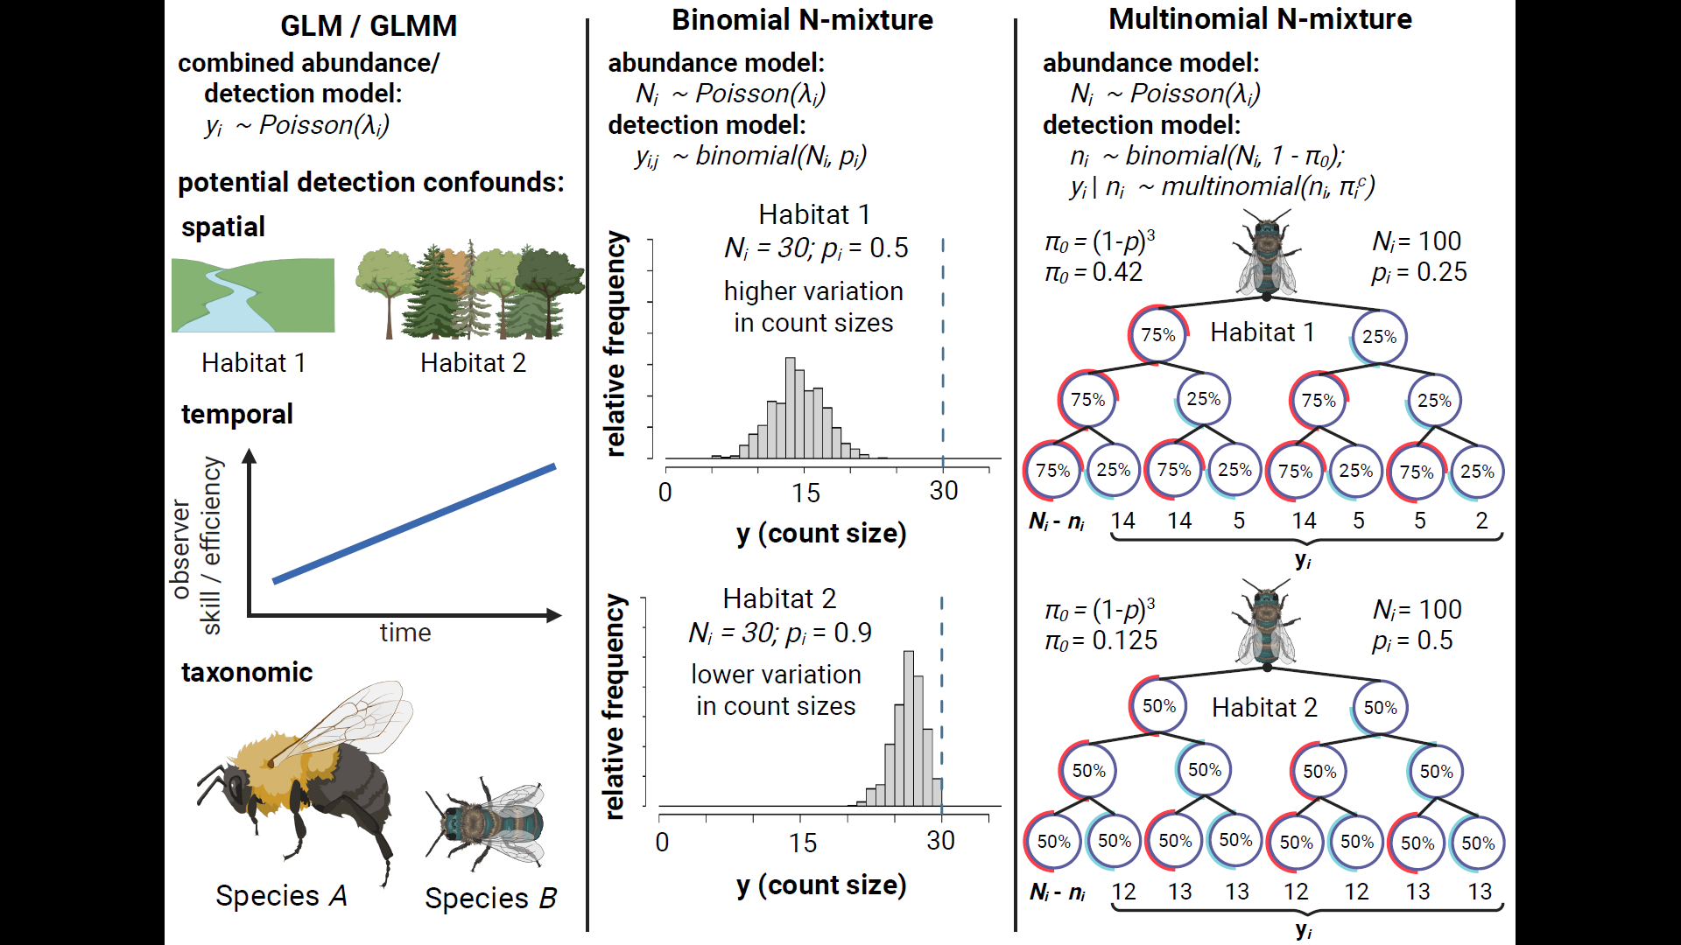
Figure 1: Comparison of three methods for estimating insect abundance. Abundance GLMs/GLMMs (column 1) treat count data ($y_{i}$) as a stochastic outcome with a mean value ($λ_{i}$) that may vary among spatial units, time periods or species. GLMMs are unable to disentangle effects of these predictors on abundance from their potential effects on detection rate, e.g.: Habitat impacts detectability; observers improve detection skills over time; or larger and more colorful species are detected at a higher rate than smaller and more dull-colored species. Binmix models (column 2) leverage the variation in counts ($y_{i}$) across repeated surveys ($j$) to simultaneously estimate detection rate ($p$) and total abundance ($N_{i}$ – represented in Figure 1 by the dashed line). Many count surveys with low variation in Habitat 2 is consistent with higher detection rate (counts nearly approximate $N_{i}$). Higher variation among counts in Habitat 1 is consistent with lower detection rate (counts heavily underestimate $N_{i}$).
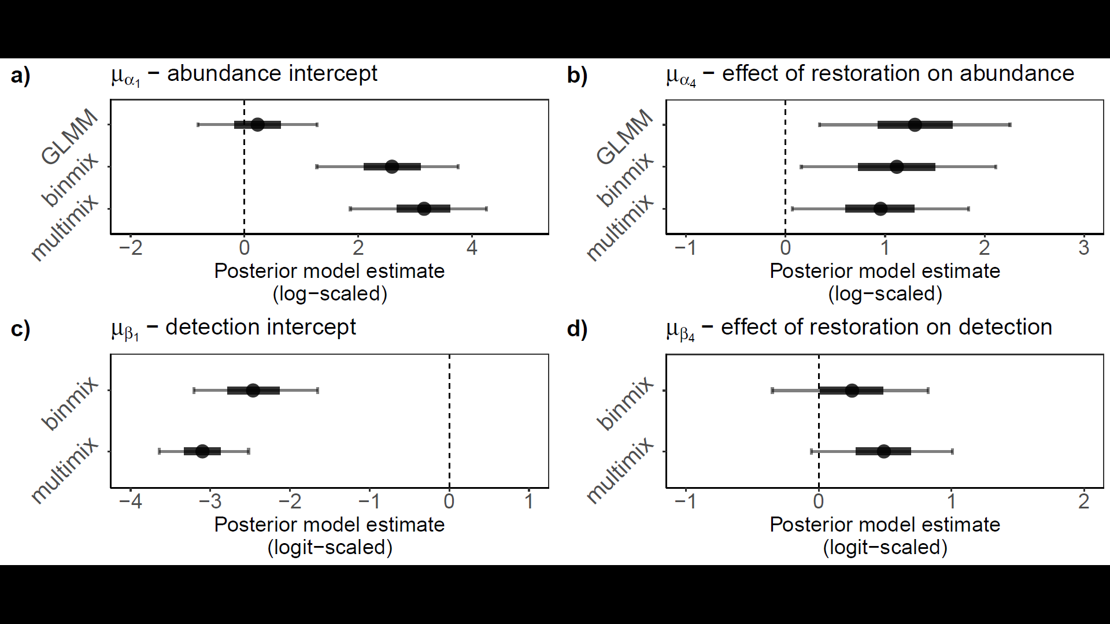
Figure 2: Field study estimates of wild bee abundance and detection. We estimated abundance intercepts (a) and community mean effect of restoration on abundance (b) with all three model types. We estimated detection rate intercepts (c) and community mean effect of restoration on detection (d) for binmix and multimix models, which are designed to estimate and account for imperfection detection. Mean estimates are displayed with filled circles. Thick and thin error bars represent 50% and 90% Bayesian credible intervals.
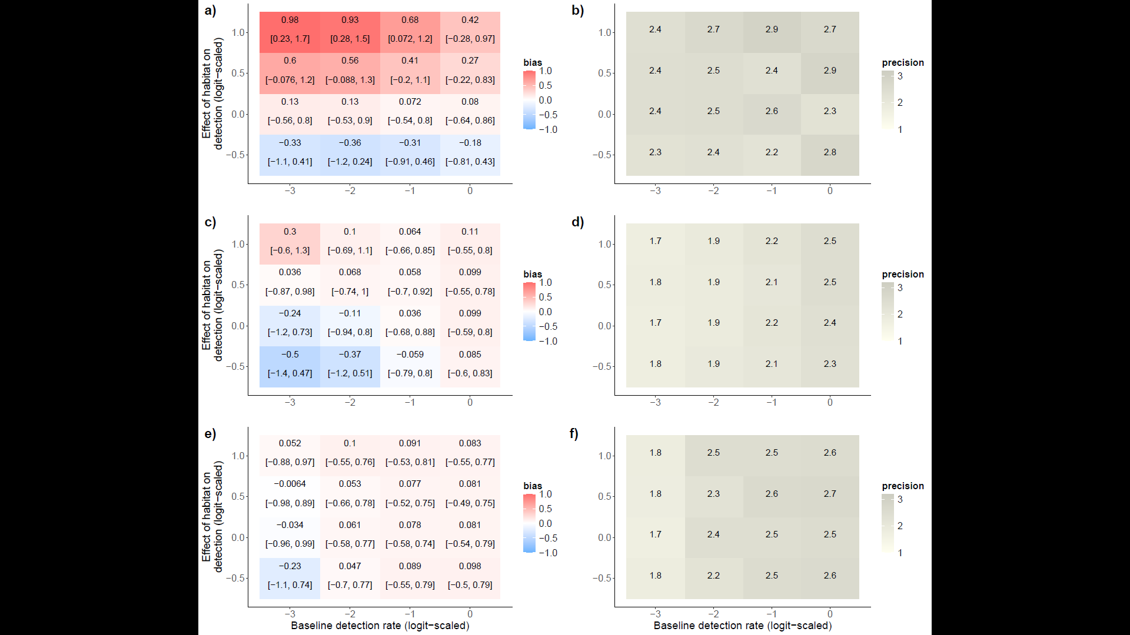
Figure 3: Effects of a simulated detection confounder on model accuracy under changes in baseline detection rate. We simulated abundance counts while simultaneously varying the effect of habitat on detection and the baseline detection rate (community mean detection intercept - μβ1). We fit GLMMs (a, b), binmix (c, d), and multimix (e, f) models to the data and determined the accuracy and precision of the estimate for the effect of habitat on abundance. Positive bias (red) indicates a tendency to overestimate the effect of the hypothesized abundance driver; a negative bias (blue) indicates a tendency towards underestimation. The mean bias and 90% Bayesian credible intervals are displayed for each simulation scenario (a, c, and e). Darker shades of grey indicate higher precision in the parameter estimates (b, d, and f).

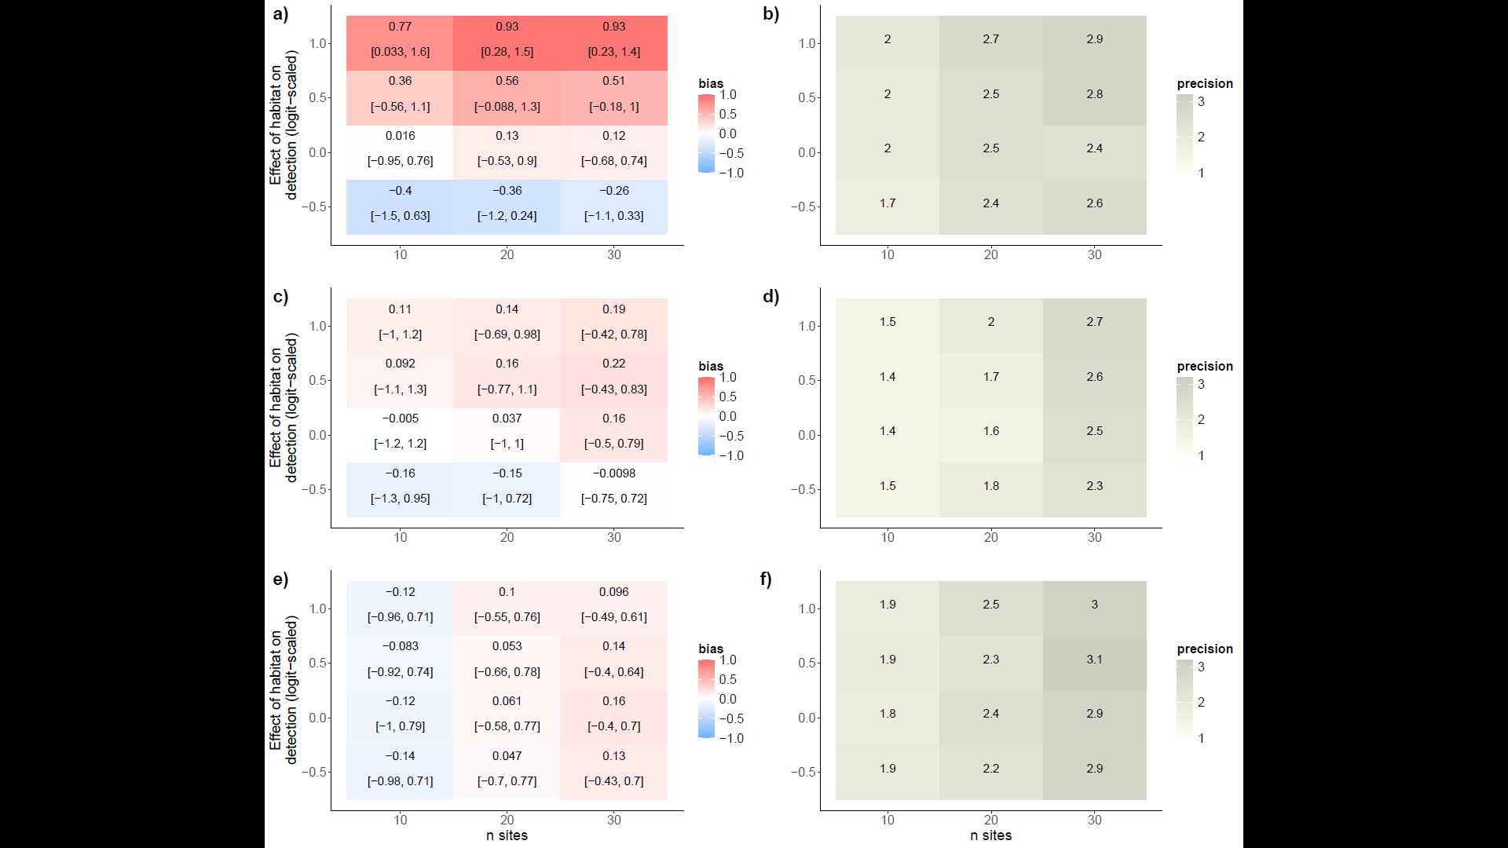
Figure 4: Effects of a simulated detection confounder on model accuracy under changes in the number of study sites sampled. We simulated abundance counts while simultaneously varying the effect of habitat on detection and the number of study sites that were sampled. We fit GLMMs (a, b), binmix (c, d), and multimix (e, f) models to the data and determined the accuracy and precision of the estimate for the effect of habitat on abundance. Positive bias (red) indicates a tendency to overestimate the effect of the hypothesized abundance driver; a negative bias (blue) indicates a tendency towards underestimation. The mean bias and 90% Bayesian credible intervals are displayed for each simulation scenario (a, c, and e). Darker shades of grey indicate higher precision in the parameter estimates (b, d, and f).

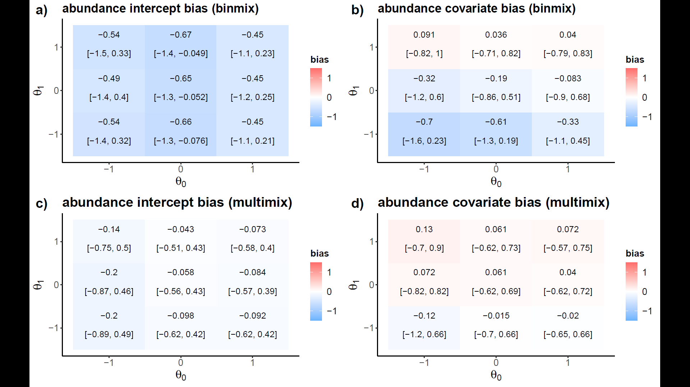
Figure 5: Robustness of binmix and multimx models to closure violations. We simulated variation in the probability that insects remain within a sampling area at the time of a survey event ($θ_{0}$), and the degree to which a site covariate of habitat restoration impacts this probability ($θ_{1}$). We recorded the bias for estimates of the abundance intercept and for the effect of a simulated abundance driver for both a binmix model (a, b) and for a multimix model (c, d). Positive bias (red) indicates a tendency to overestimate the target while a negative bias (blue) indicates a tendency towards underestimation. The mean bias and 90% Bayesian credible intervals are displayed for each simulation scenario.
Supplemental Materials
Supplemental Tables
Table S1: Site Details. We conducted wild bee abundance surveys in 1-hectare plots located in ten urban park sites in Vancouver, Canada. Detailed vegetation and site management data were reported by Ulrich and Sargent 2025.
Site name | Treatment group | Latitude | Longitude
Killarney Park | Restored | 49.227468 | -123.046616
Locarno Park | Restored | 49.273942 | -123.206008
Oak Meadows Park | Restored | 49.238607 | -123.126438
Prince of Wales Park | Restored | 49.243958 | -123.158084
West Memorial Park | Restored | 49.243227 | -123.189281
Bobolink Park | Control | 49.21503 | -123.057
Gordon Park | Control | 49.223993 | -123.069652
Kensington Park | Control | 49.23772 | -123.076
Moberly Park | Control | 49.215687 | -123.086136
Quilchena Park | Control | 49.242885 | -123.148097

Table S2: Prior distributions for parameters estimated by the abundance GLMM.
Parameter | Parameter meaning | Prior Distribution | Justification
$$α_{0}$$ | Global intercept | $Normal$(0, 2) | Weakly-informative centered prior.
$$α_{1}\left[species\right]$$ | Species-specific intercept effects | $Normal$(0, $σ_{α_{1}}$) | Weakly-informative centered prior.
$$σ_{α_{1}}$$ | Standard deviation of species-specific intercept effects | $Half-Normal$(0, 2) | Weakly-informative prior placing more weight near zero, i.e., small variation among groups (positive values only).
$$α_{2}\left[site\right]$$ | Site-specific intercept effects | $Normal$(0, $σ_{α_{2}}$) | Weakly-informative centered prior.
$$σ_{α_{2}}$$ | Variation in site-specific intercept effects | $Half-Normal$(0, 1) | Weakly-informative prior placing more weight near zero, i.e., small variation among groups (positive values only).
$$α_{3}\left[year\right]$$ | Year intercept effects | $Normal$(0, 1) | Weakly-informative centered prior.
$$α_{4}\left[species\right]$$ | Species-specific effects of restoration | $Normal$(0, $σ_{α_{4}}$) | Weakly-informative centered prior.
$$σ_{α_{4}}$$ | Variation in species-specific effects of restoration | $Half-Normal$(0, 2) | Weakly-informative prior placing more weight near zero, i.e., small variation among groups (positive values only).
$$ϕ$$ | Negative binomial dispersion parameter | $Half-Normal$(0, 1) | Weakly-informative prior placing more weight near zero, i.e., overdispersion in counts (positive values only).

Table S3: Prior distributions for parameters estimated by the binmix model.
Parameter | Parameter meaning | Prior Distribution | Justification
ABUNDANCE PARAMETERS
$$α_{0}$$ | Global intercept | $Normal$(0, 2) | Weakly-informative centered prior.
$$α_{1}\left[species\right]$$ | Species-specific intercept effects | $Normal$(0, $σ_{α_{1}}$) | Weakly-informative centered prior.
$$σ_{α_{1}}$$ | Standard deviation of species-specific intercept effects | $Half-Normal$(0, 2) | Weakly-informative prior placing more weight near zero, i.e., small variation among groups (positive values only).
$$α_{2}\left[site\right]$$ | Site-specific intercept effects | $Normal$(0, $σ_{α_{2}}$) | Weakly-informative centered prior.
$$σ_{α_{2}}$$ | Variation in site-specific intercept effects | $Half-Normal$(0, 1) | Weakly-informative prior placing more weight near zero, i.e., small variation among groups (positive values only).
$$α_{3}\left[year\right]$$ | Year intercept effects | $Normal$(0, 1) | Weakly-informative centered prior.
$$α_{4}\left[species\right]$$ | Species-specific effects of restoration | $Normal$(0, $σ_{α_{4}}$) | Weakly-informative centered prior.
$$σ_{α_{4}}$$ | Variation in species-specific effects of restoration | $Half-Normal$(0, 2) | Weakly-informative prior placing more weight near zero, i.e., small variation among groups (positive values only).
$$ϕ$$ | Negative binomial dispersion parameter | $Half-Normal$(0, 1) | Weakly-informative prior placing more weight near zero, i.e., overdispersion in counts (positive values only).
ABUNDANCE PARAMETERS
$$β_{0}$$ | Global intercept | $Normal$(0, 2) | Weakly-informative centered prior.
$$β_{1}\left[species\right]$$ | Species-specific intercept effects | $Normal$(0, $σ_{β_{1}}$) | Weakly-informative centered prior.
$$σ_{β_{1}}$$ | Variation in species-specific intercept effects | $Half-Normal$(0, 2) | Weakly-informative prior placing more weight near zero, i.e., small variation among groups (positive values only).
$$β_{2}\left[site\right]$$ | Site-specific intercept effects | $Normal$(0, $σ_{β_{2}}$) | Weakly-informative centered prior.
$$σ_{β_{2}}$$ | Variation in site-specific intercept effects | $Half-Normal$(0, 1) | Weakly-informative prior placing more weight near zero, i.e., small variation among groups (positive values only).
$$β_{3}\left[year\right]$$ | Year intercept effects | $Normal$(0, 1) | Weakly-informative centered prior.
$$β_{4}\left[species\right]$$ | Species-specific effects of restoration | $Normal$(0, $σ_{β_{4}}$) | Weakly-informative centered prior.
$$σ_{β_{4}}$$ | Variation in species-specific effects of restoration | $Half-Normal$(0, 2) | Weakly-informative prior placing more weight near zero, i.e., small variation among groups (positive values only).

Table S4: Prior distributions for parameters estimated by the multimix model.
Parameter | Parameter meaning | Prior Distribution | Justification
ABUNDANCE PARAMETERS
$$α_{0}$$ | Global intercept | $Normal$(0, 2) | Weakly-informative centered prior.
$$α_{1}\left[species\right]$$ | Species-specific intercept effects | $Normal$(0, $σ_{α_{1}}$) | Weakly-informative centered prior.
$$σ_{α_{1}}$$ | Standard deviation of species-specific intercept effects | $Half-Normal$(0, 2) | Weakly-informative prior placing more weight near zero, i.e., small variation among groups (positive values only).
$$α_{2}\left[site\right]$$ | Site-specific intercept effects | $Normal$(0, $σ_{α_{2}}$) | Weakly-informative centered prior.
$$σ_{α_{2}}$$ | Variation in site-specific intercept effects | $Half-Normal$(0, 1) | Weakly-informative prior placing more weight near zero, i.e., small variation among groups (positive values only).
$$α_{3}\left[year\right]$$ | Year intercept effects | $Normal$(0, 1) | Weakly-informative centered prior.
$$α_{4}\left[species\right]$$ | Species-specific effects of restoration | $Normal$(0, $σ_{α_{4}}$) | Weakly-informative centered prior.
$$σ_{α_{4}}$$ | Variation in species-specific effects of restoration | $Half-Normal$(0, 2) | Weakly-informative prior placing more weight near zero, i.e., small variation among groups (positive values only).
$$ϕ$$ | Negative binomial dispersion parameter | $Half-Normal$(0, 1) | Weakly-informative prior placing more weight near zero, i.e., overdispersion in counts (positive values only).
ABUNDANCE PARAMETERS
$$β_{0}$$ | Global intercept | $Normal$(0, 2) | Weakly-informative centered prior.
$$β_{1}\left[species\right]$$ | Species-specific intercept effects | $Normal$(0, $σ_{β_{1}}$) | Weakly-informative centered prior.
$$σ_{β_{1}}$$ | Variation in species-specific intercept effects | $Half-Normal$(0, 2) | Weakly-informative prior placing more weight near zero, i.e., small variation among groups (positive values only).
$$β_{2}\left[site\right]$$ | Site-specific intercept effects | $Normal$(0, $σ_{β_{2}}$) | Weakly-informative centered prior.
$$σ_{β_{2}}$$ | Variation in site-specific intercept effects | $Half-Normal$(0, 1) | Weakly-informative prior placing more weight near zero, i.e., small variation among groups (positive values only).
$$β_{3}\left[year\right]$$ | Year intercept effects | $Normal$(0, 1) | Weakly-informative centered prior.
$$β_{4}\left[species\right]$$ | Species-specific effects of restoration | $Normal$(0, $σ_{β_{4}}$) | Weakly-informative centered prior.
$$σ_{β_{4}}$$ | Variation in species-specific effects of restoration | $Half-Normal$(0, 2) | Weakly-informative prior placing more weight near zero, i.e., small variation among groups (positive values only).

Supplemental Figures
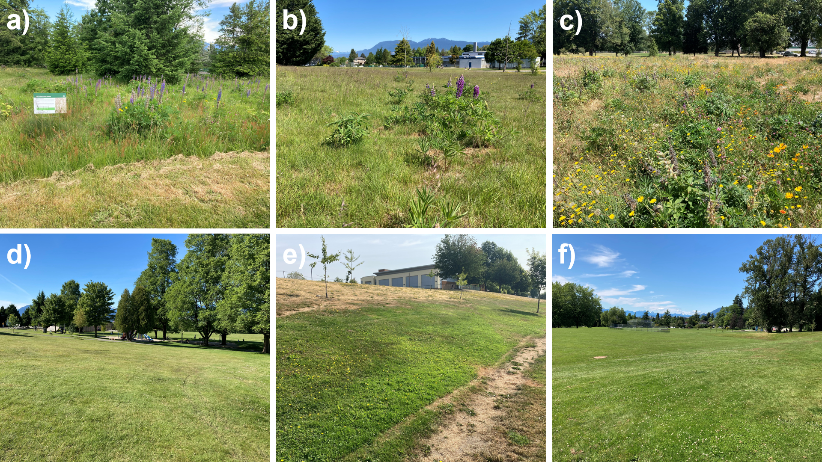
Figure S1: We conducted abundance surveys at ten urban park sites in Vancouver, Canada. Five of the sites were historically turfgrass dominated but received a restoration amendment of about 1 hectare area. The restoration consisted of herbaceous flower seeding combined with no mowing during the spring and summer months. Some restored site examples include Oak Meadows Park (a), Prince of Wales Park (b), and Killarney Park (c). In control sites, turfgrass areas were not amended with a restoration. Some control site examples include Kensington Park (d), Moberly Park (e), and Quilchena Park (f). Restored sites had significantly more flower resources and were characterized by taller herbaceous vegetation.
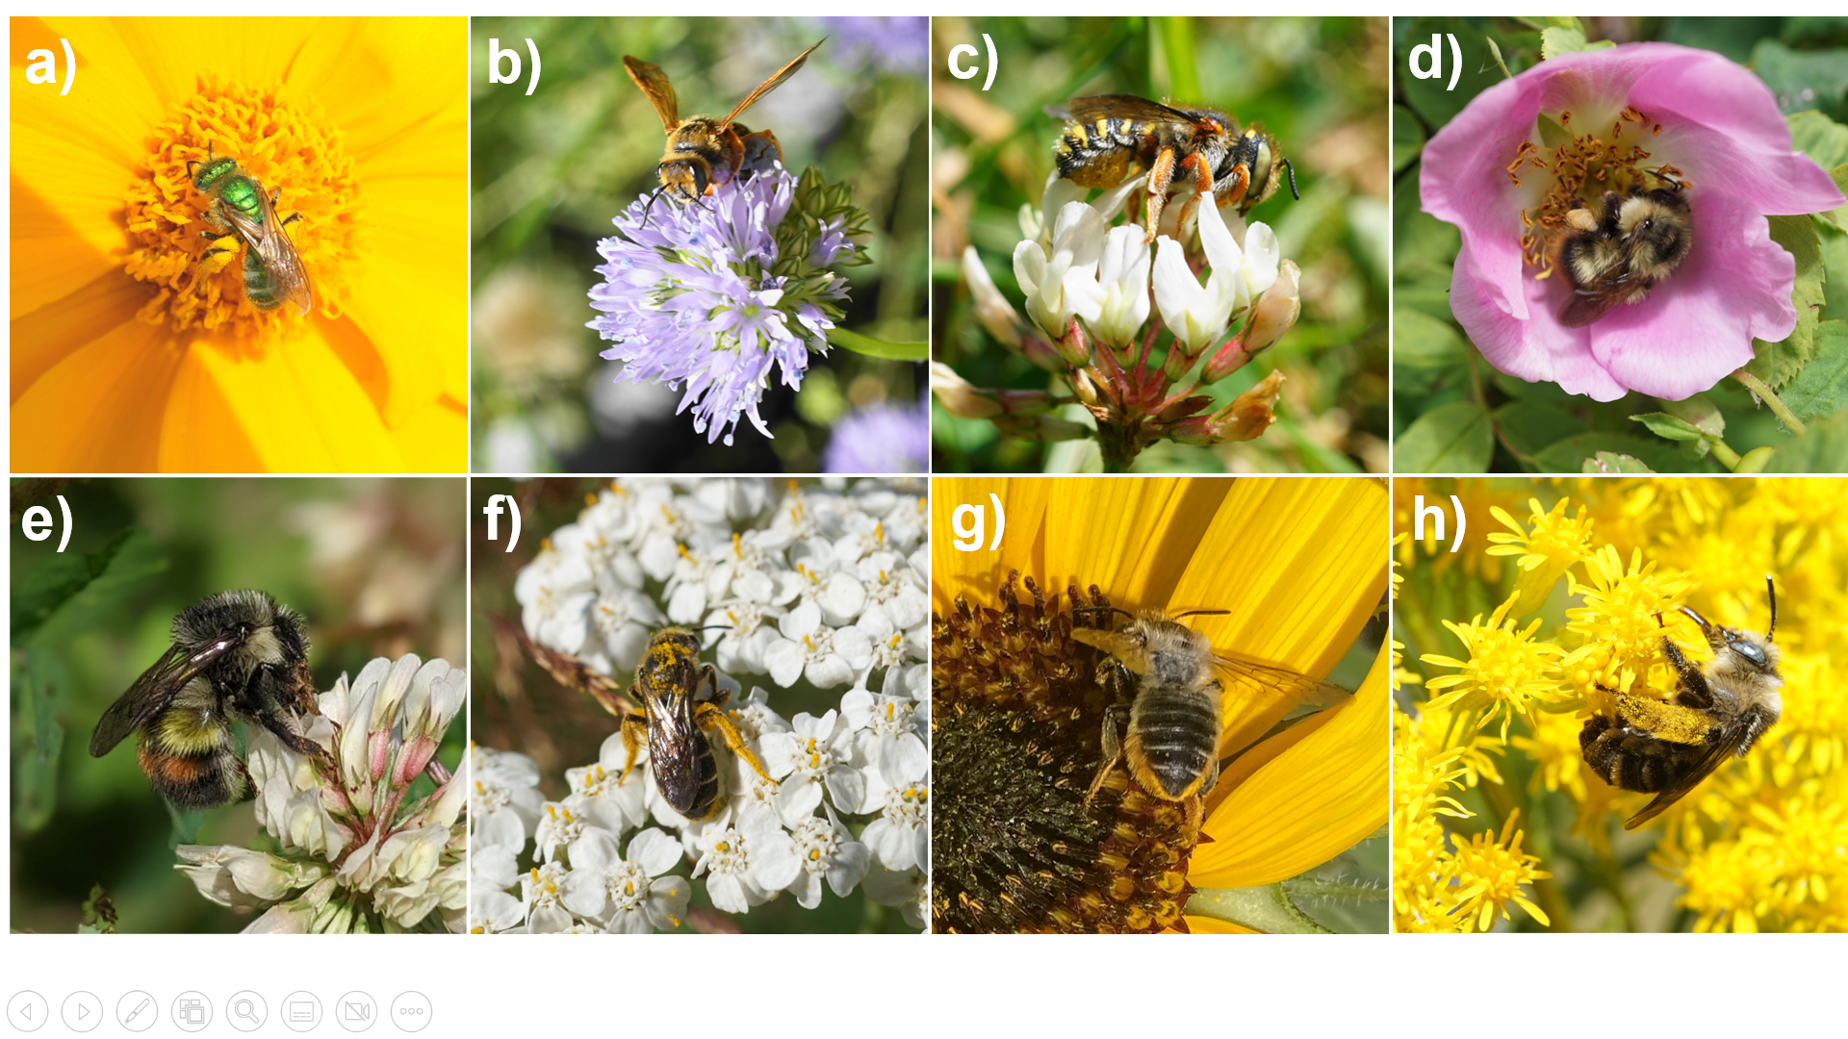
Figure S2: We targeted 8 wild species in our abundance surveys: Agapostemon texanus (a), Andrena prunorum (b), Anthidium oblongatum (c), Bombus mixtus (d), Bombus flavifrons (e), Halictus rubicundus (f), native Megachile spp. (g), and Melissodes microstictus (h). The picture of B. flavifrons was taken by Sarah Knoerr and used with permission.
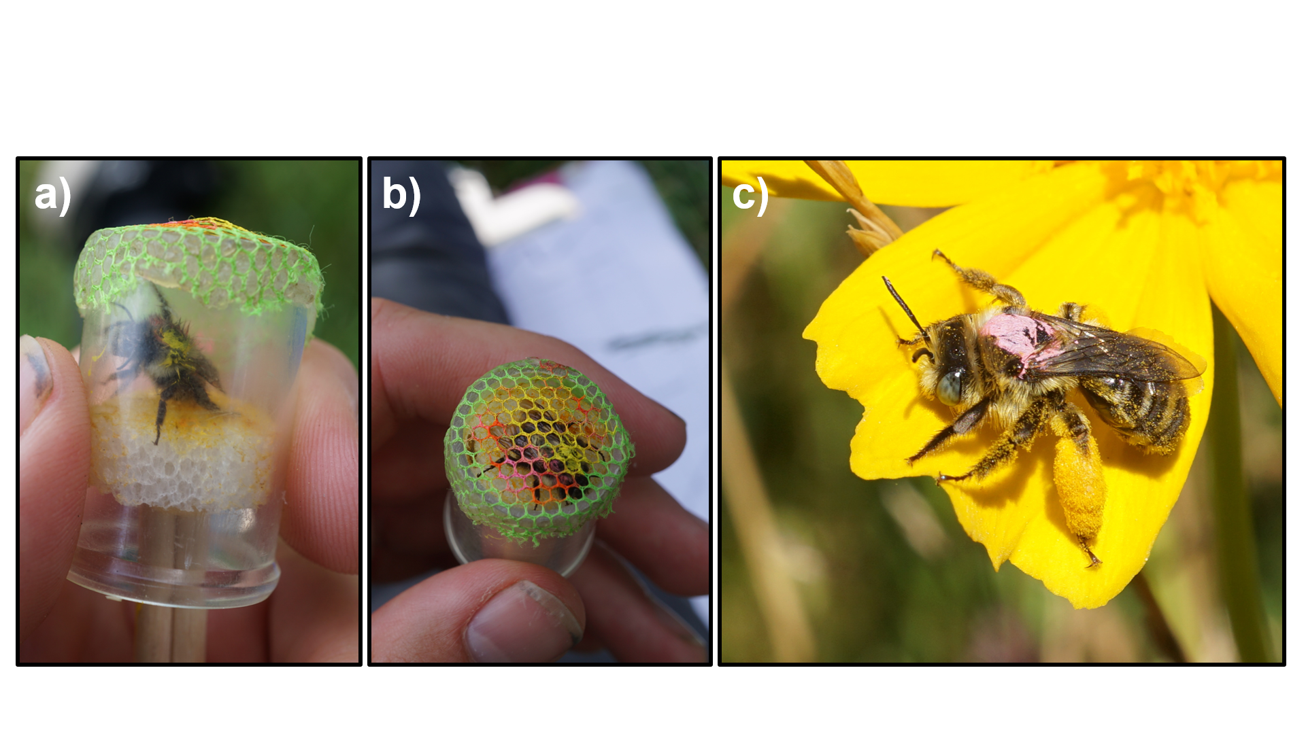
Figure S3: Mark-recapture method. We placed chilled bees in a modified vial with a styrofoam plunger on one end (a). Chilling the bees allowed for easier handling. We used the plunger to press the thorax of the bee against a mesh covering on the opposite side of the vial (b). We used a Molotow brand paint pen to place a mark on the thorax. The mark was colour-coded to correspond to the unique capture date. In (b), the bee was captured on two occasions. It has a yellow mark indicating the first capture and a pink mark representing the second. After marking, we released the bees back to the survey area. We observed that bees then resumed normal foraging behaviour, usually after sunning themselves for a few minutes (c).
- 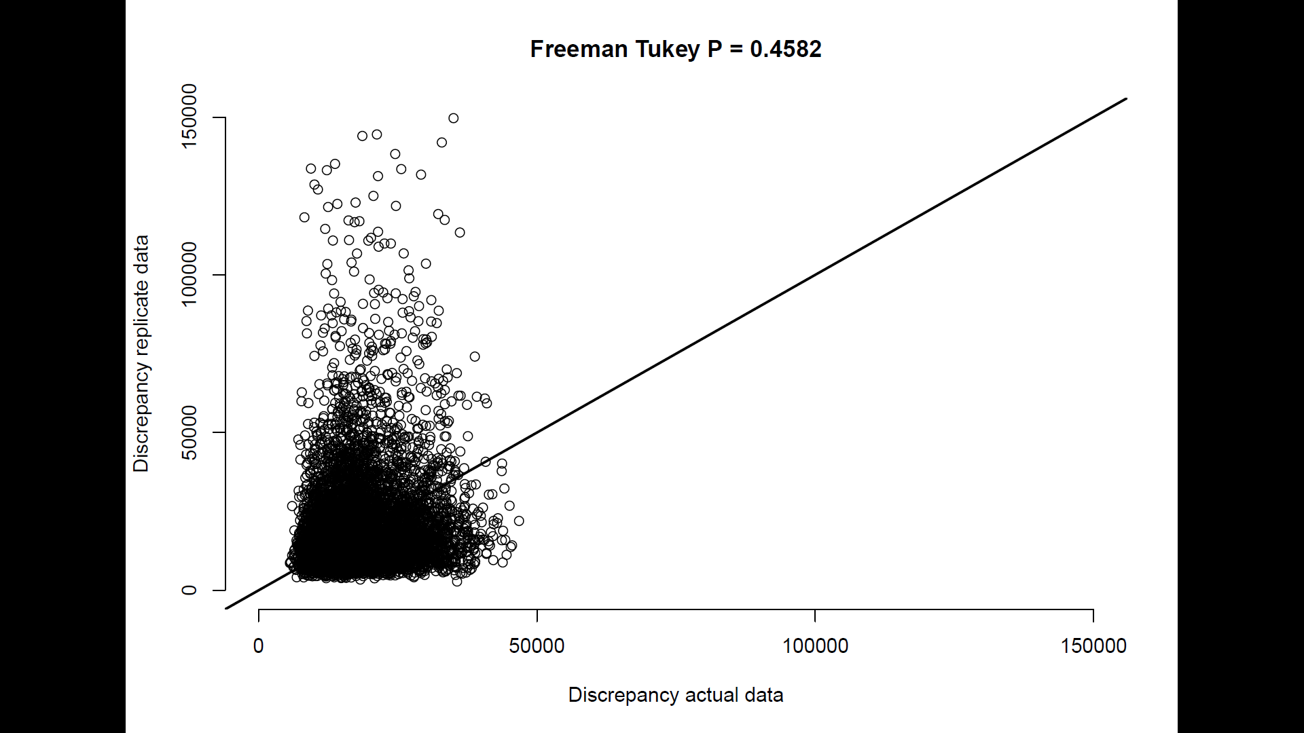
- 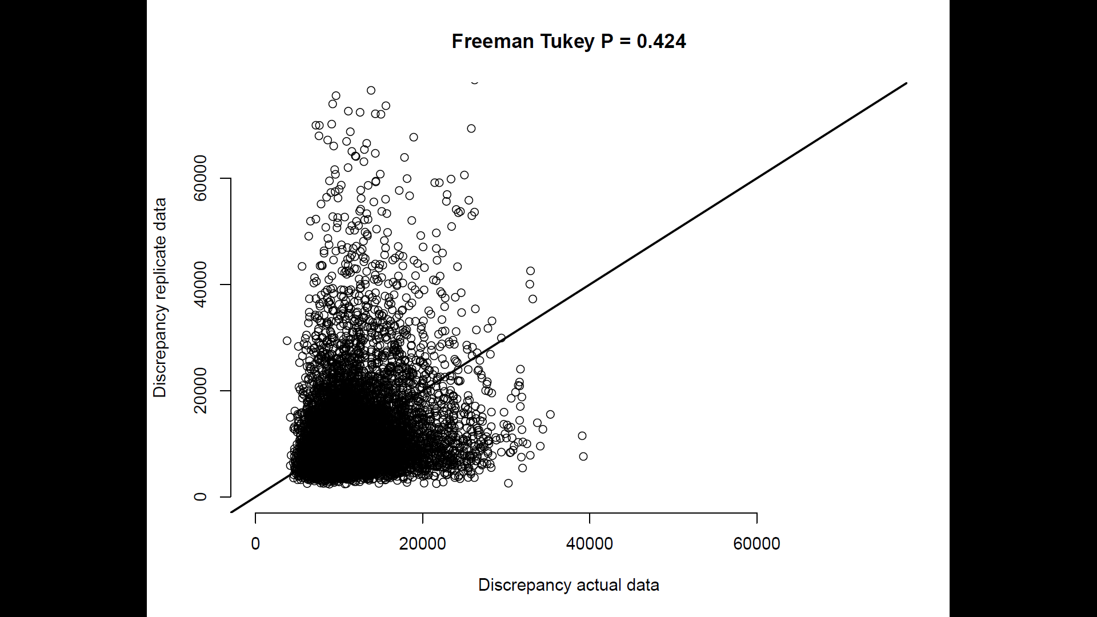
- 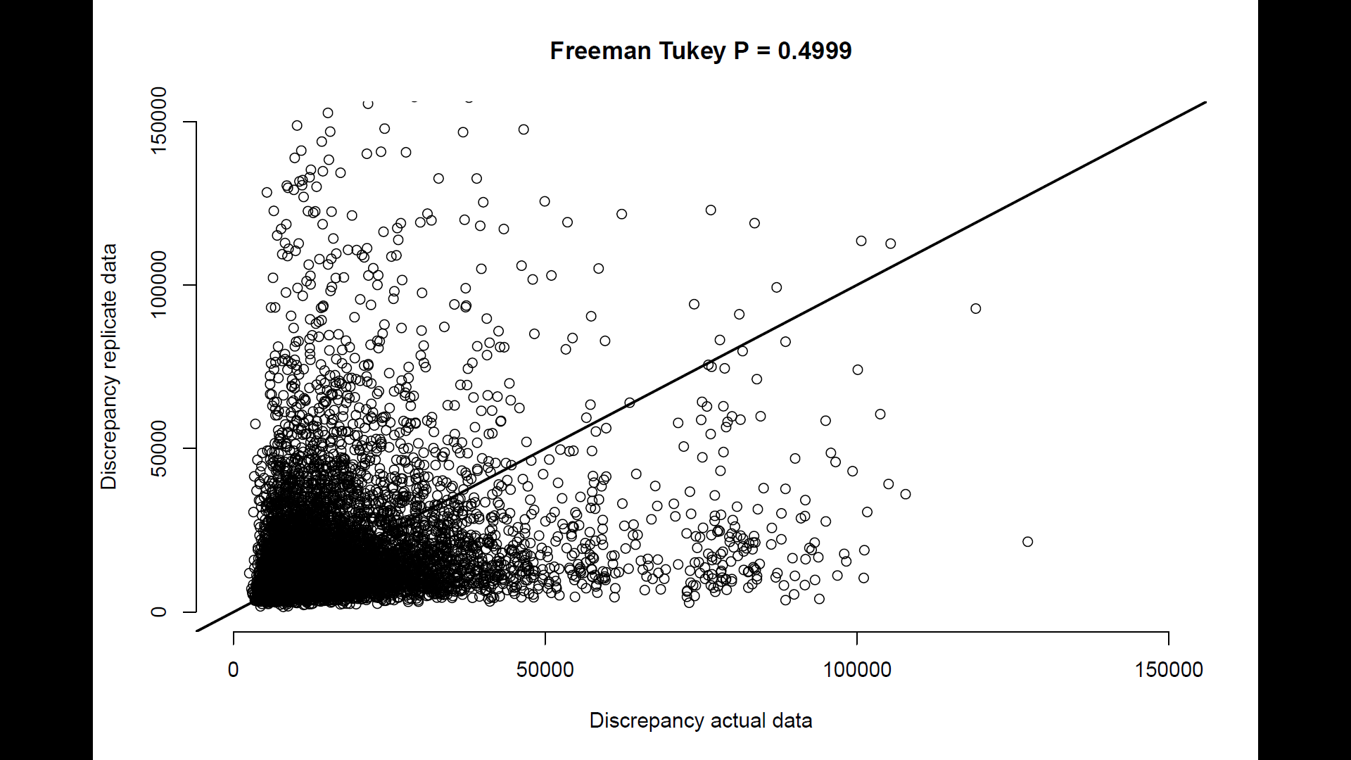
- 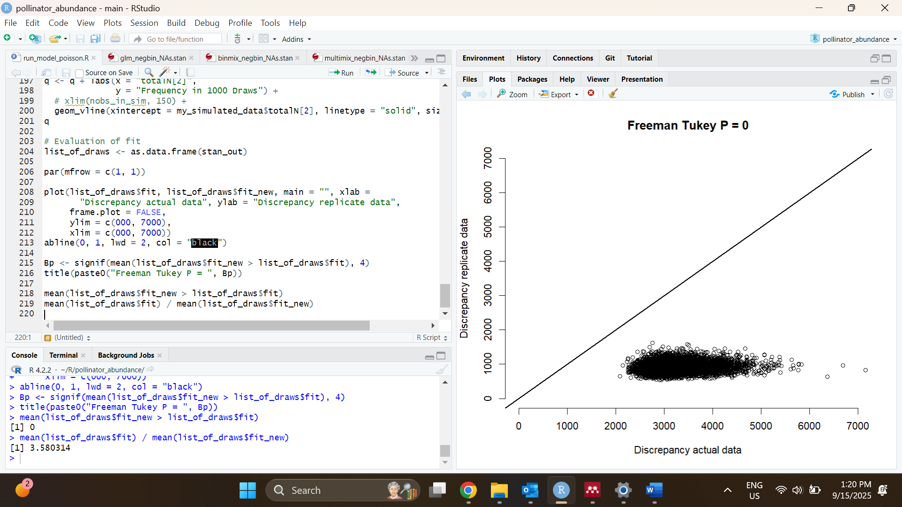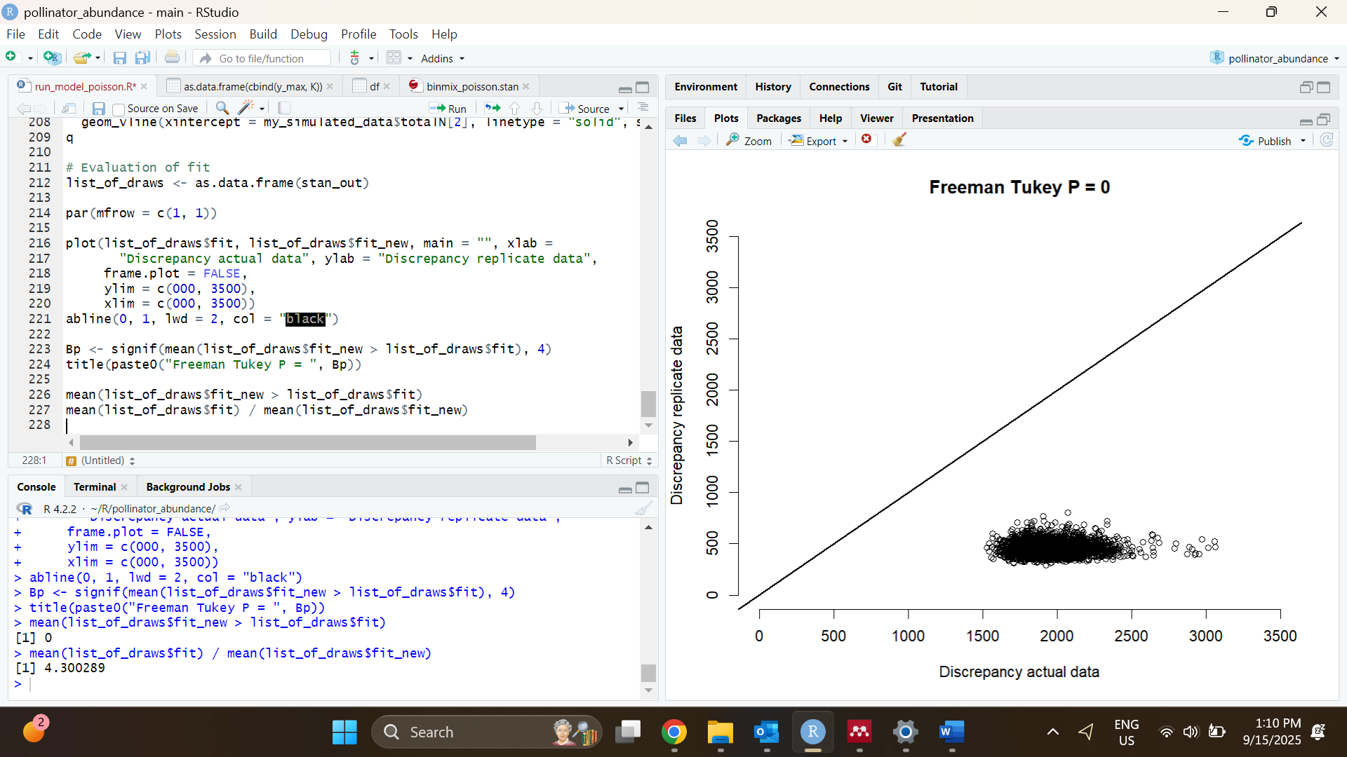
- 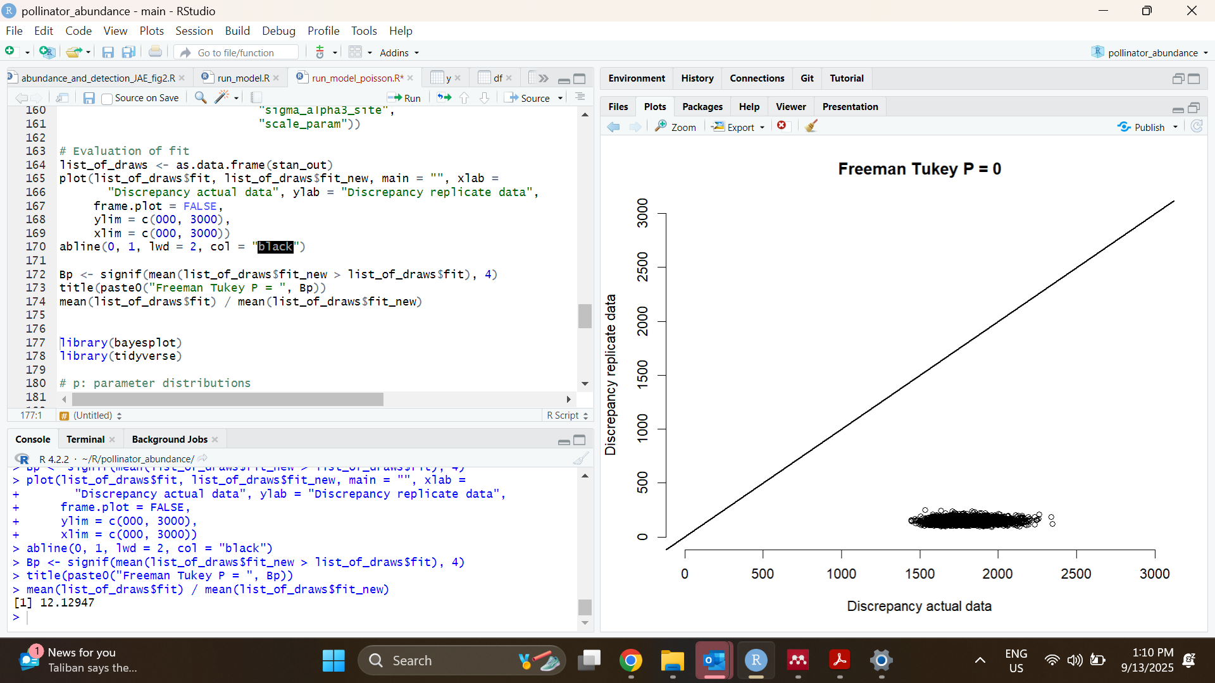
Figure S6: Posterior predictive check plots for GLMM (a), binmix model (b), and multimix model (c), and for models using a Poisson distribution for abundance which showed poor fit (d, e, and f). To assess model fit, we conducted Freeman-Tukey statistic discrepancy tests for each model (Conn et al., 2018; Kery and Royle, 2020). This test evaluates the difference in discrepancy between simulated data or real data versus an expected outcome. To conduct the test, we simulated some data (y_replicated) using the parameter estimates at each step of the HMC run. Data were counts of the number of individuals detected per species per site-survey (a, b) or the number of individuals detected at least once per species per site across all three surveys (c). We then simulated some new data from the same parameter estimates (y_new). We calculated the Freeman-Tukey discrepancy for all y_new across all sampling events i, and also for our actual data y:
$Fit discrepancy(y_{new})$ = $\sum_{i}^{R}{(square(y_new[i] - y_replicated [i]) / (y_replicated [i] + 0.5)}$
$Fit discrepancy(y)$ = $\sum_{i}^{R}{(square(y[i] - y_replicated [i]) / (y_replicated [i] + 0.5)}$
We then calculated the frequency in the posterior distribution of samples at which the fit discrepancy for $y_{new}$ is greater than the fit discrepancy for $y$. Values near 0.5 suggest reasonable goodness of fit, i.e., that newly simulated data tend to be more or less as far away from some other simulated data as our real data. Values below 0.05 or greater than 0.95 indicate critical lack of model fit. FTP values were less than 0.05 for models for our field data that used a Poisson distribution for the abundance random variable, which prompted us to use negative binomial distributions.
Conn, P. B., Johnson, D. S., Williams, P. J., Melin, S. R., & Hooten, M. B. (2018). A guide to Bayesian model checking for ecologists. Ecological Monographs, 88(4), 526-542.
Kéry, M., & Royle, J. A. (2020). Applied hierarchical modeling in ecology: Analysis of distribution, abundance and species richness in R and BUGS: Volume 2: Dynamic and advanced models. Academic Press.
- 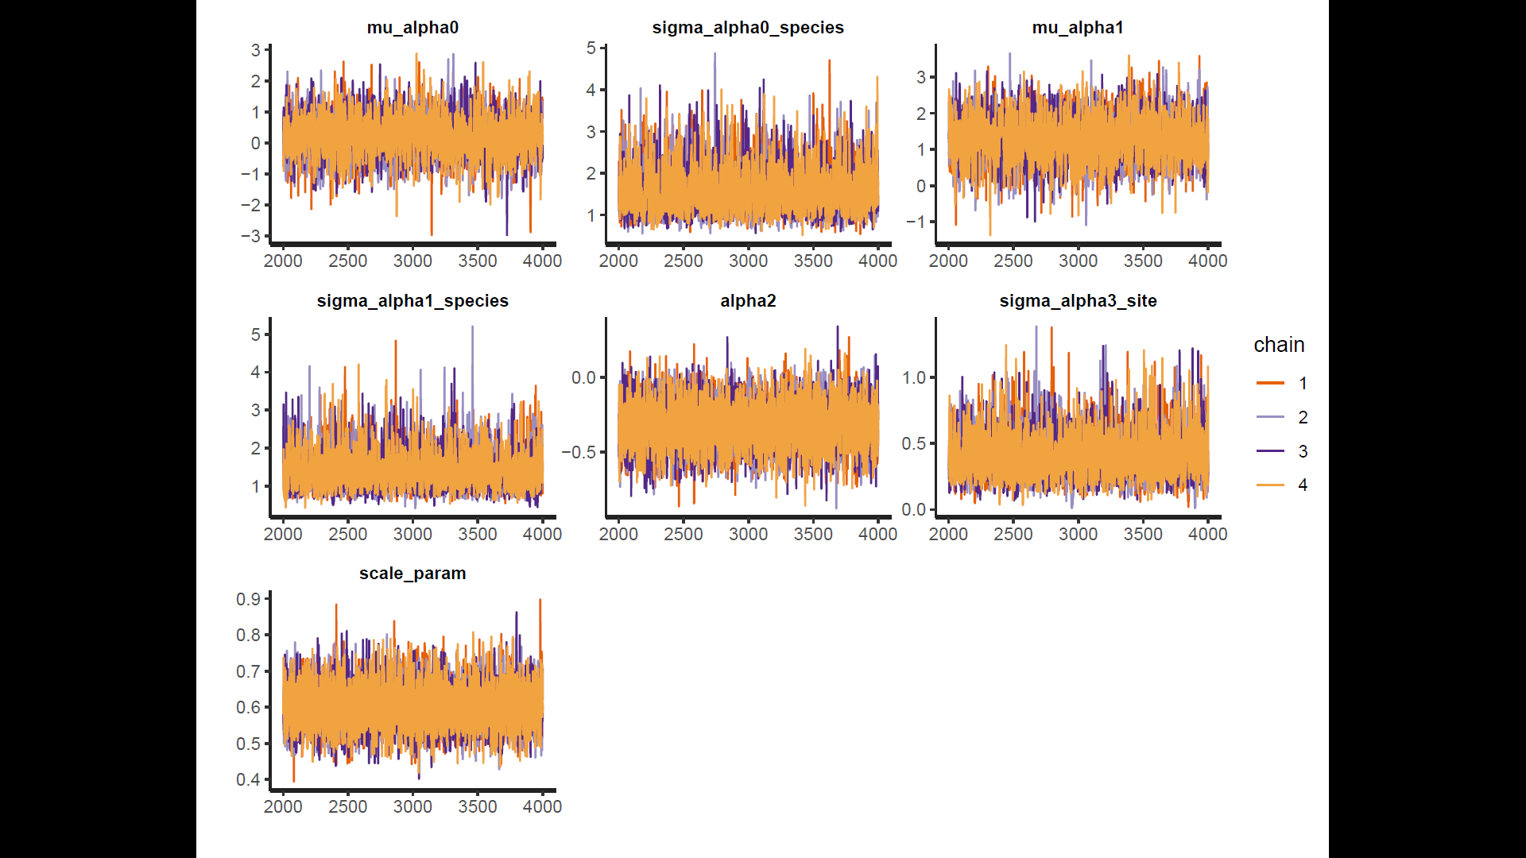
- 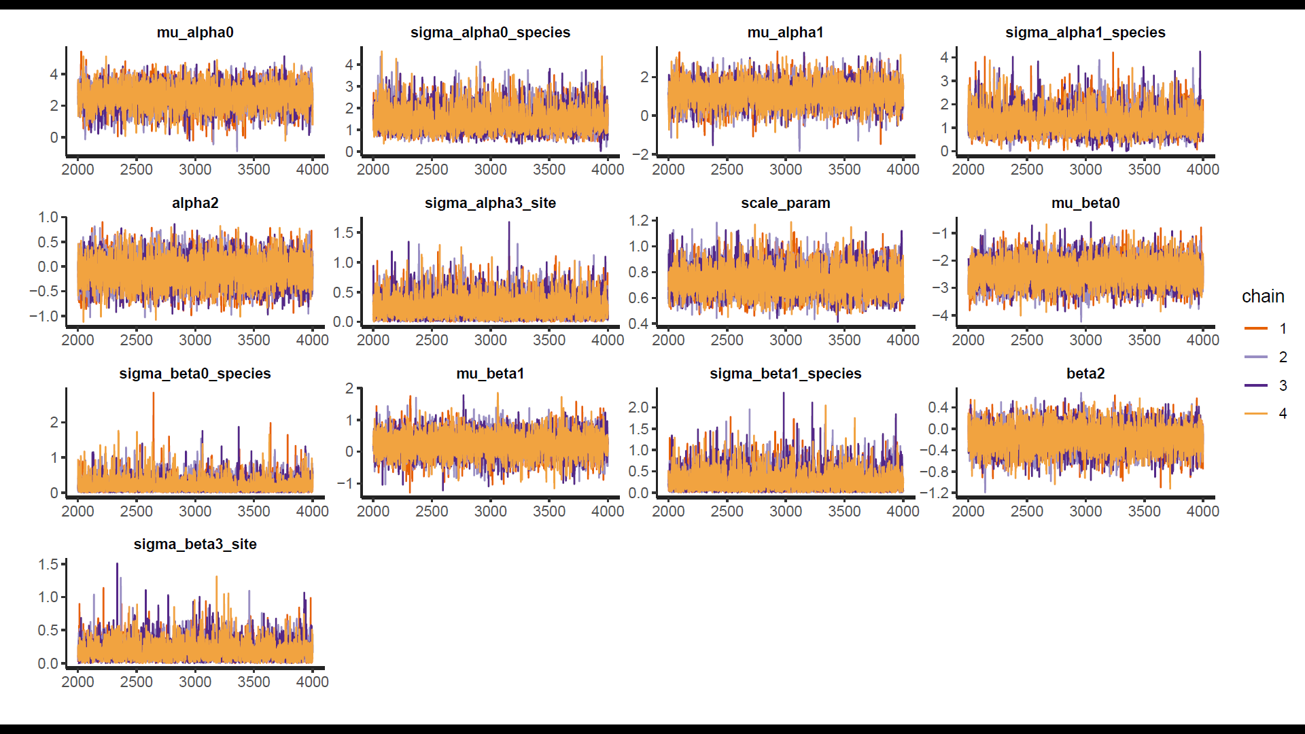
- 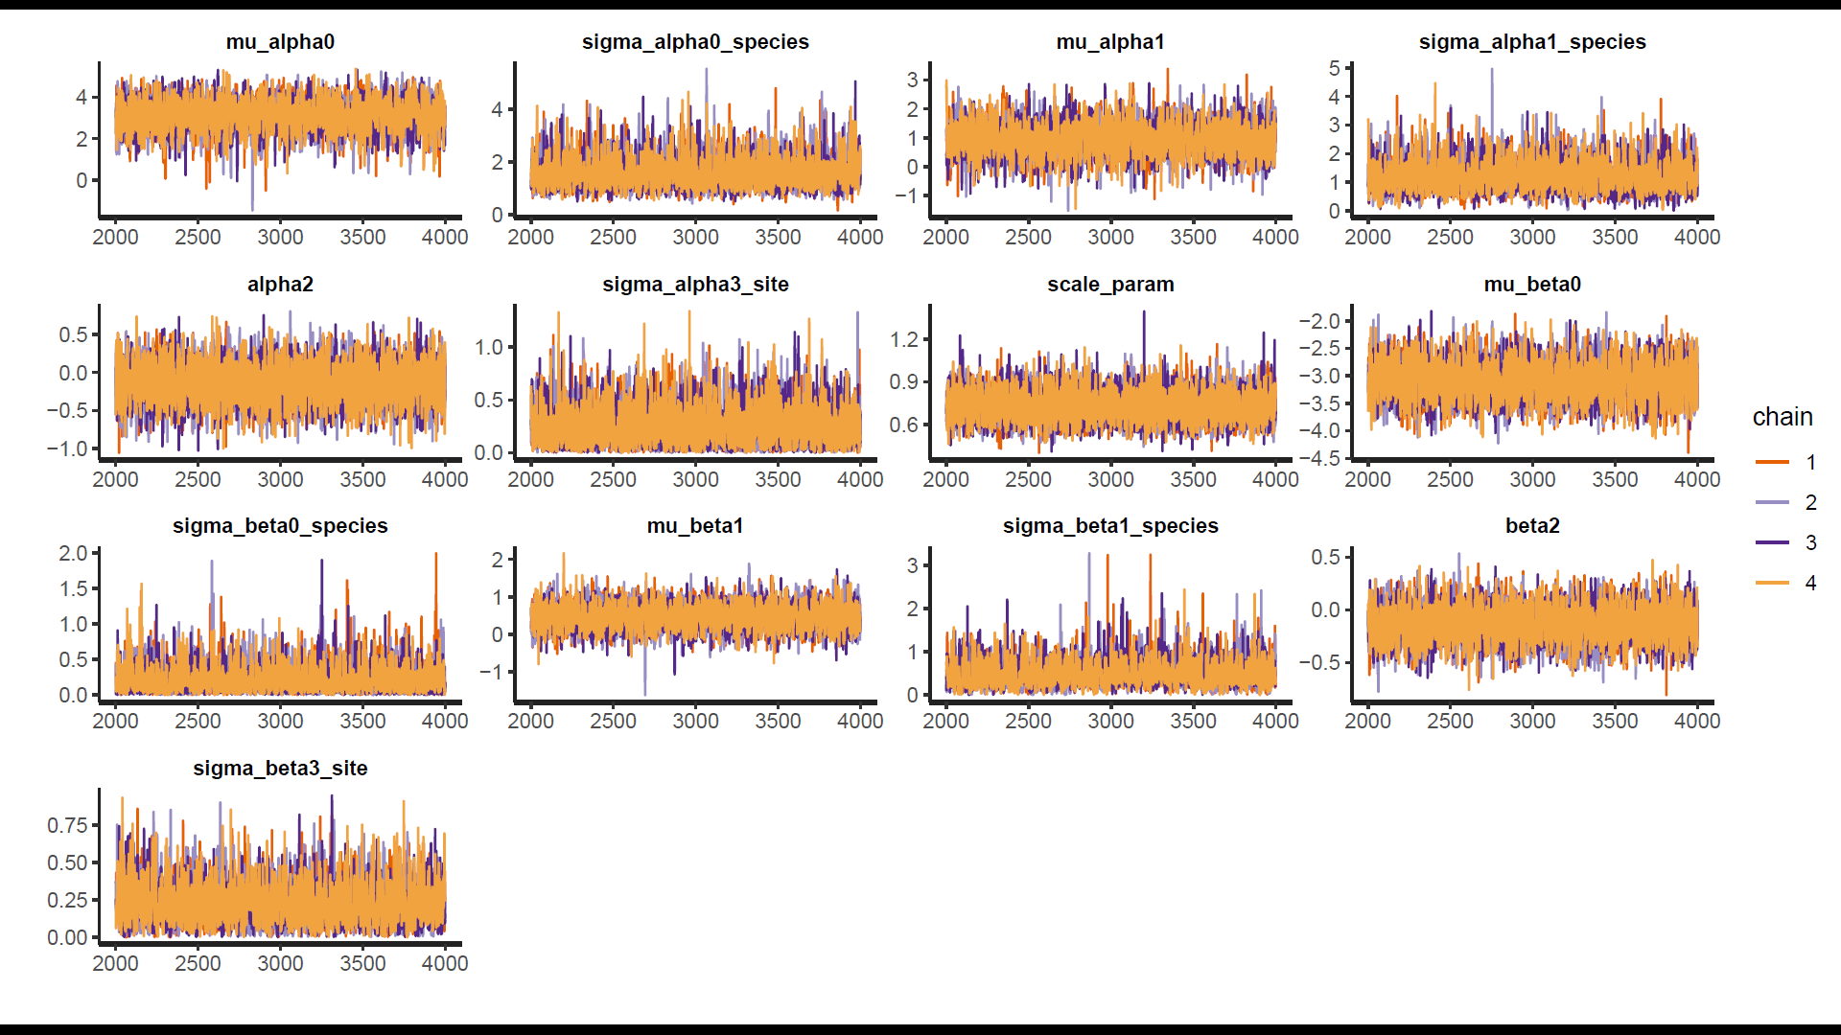
Figure S5: Traceplots for the GLMM (a), binmix model (b), and multimix model (c). Overlapping HMC traces indicate that all 4 chains have converged on a similar parameter space.

- 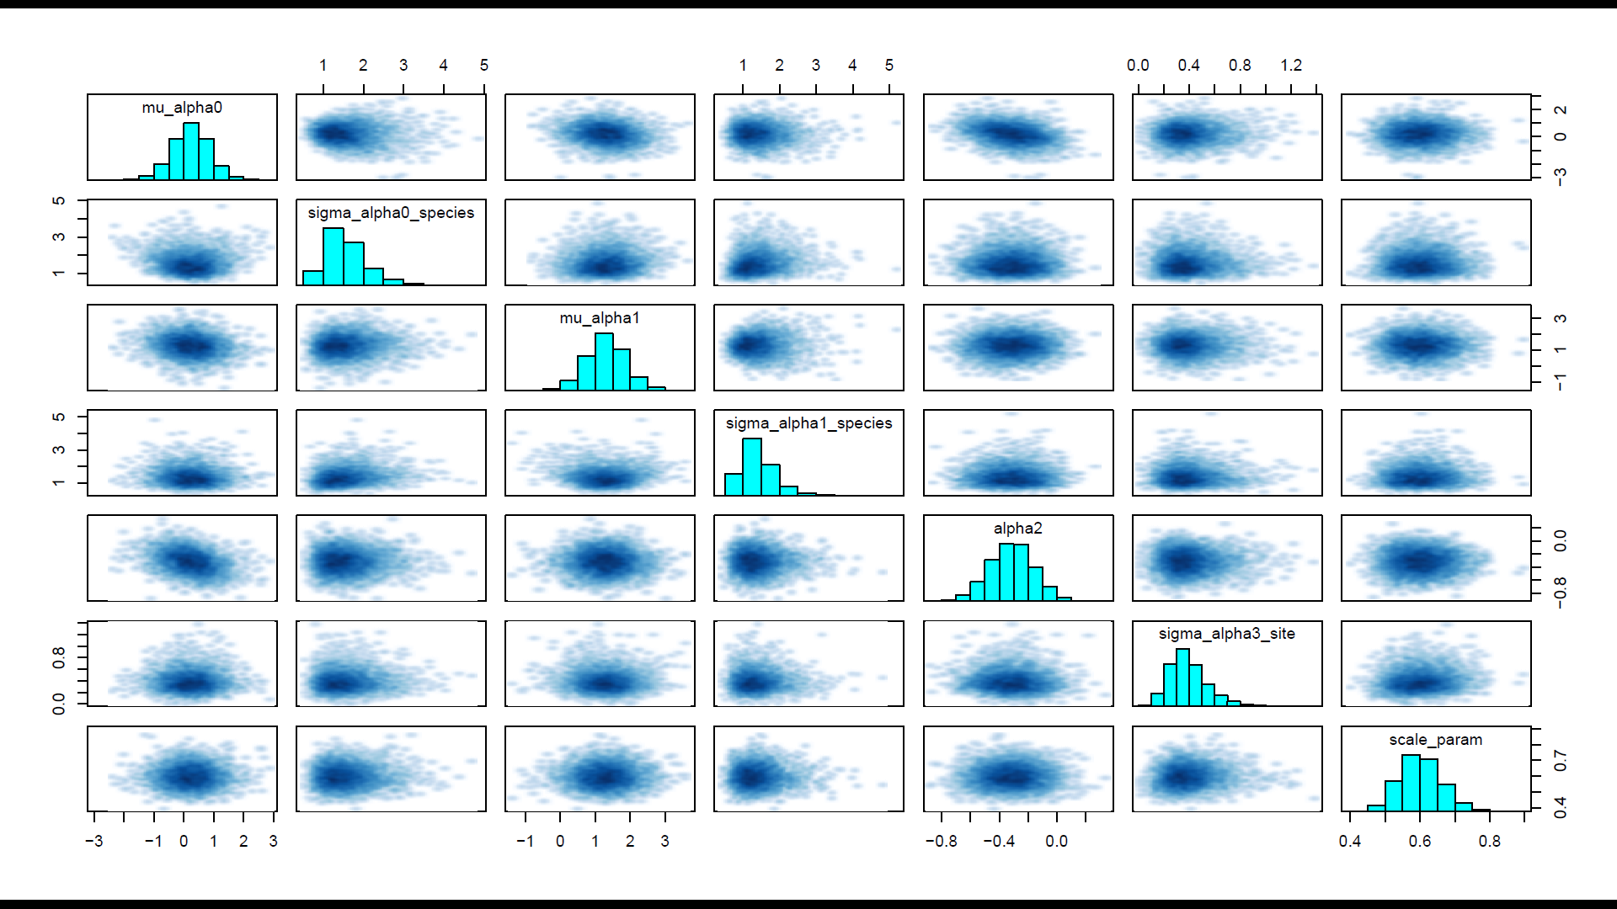
- 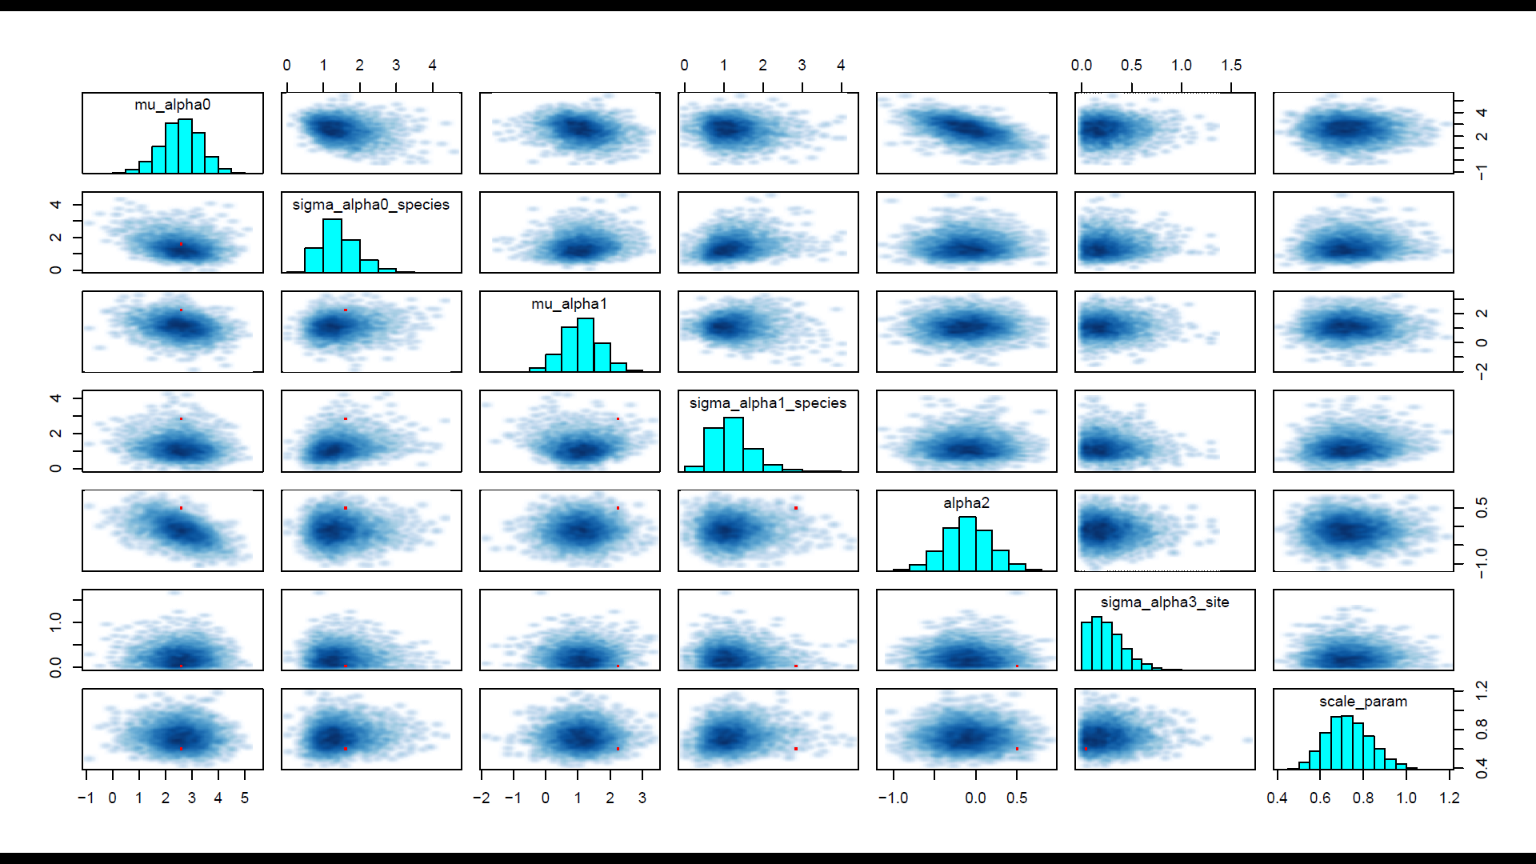
- 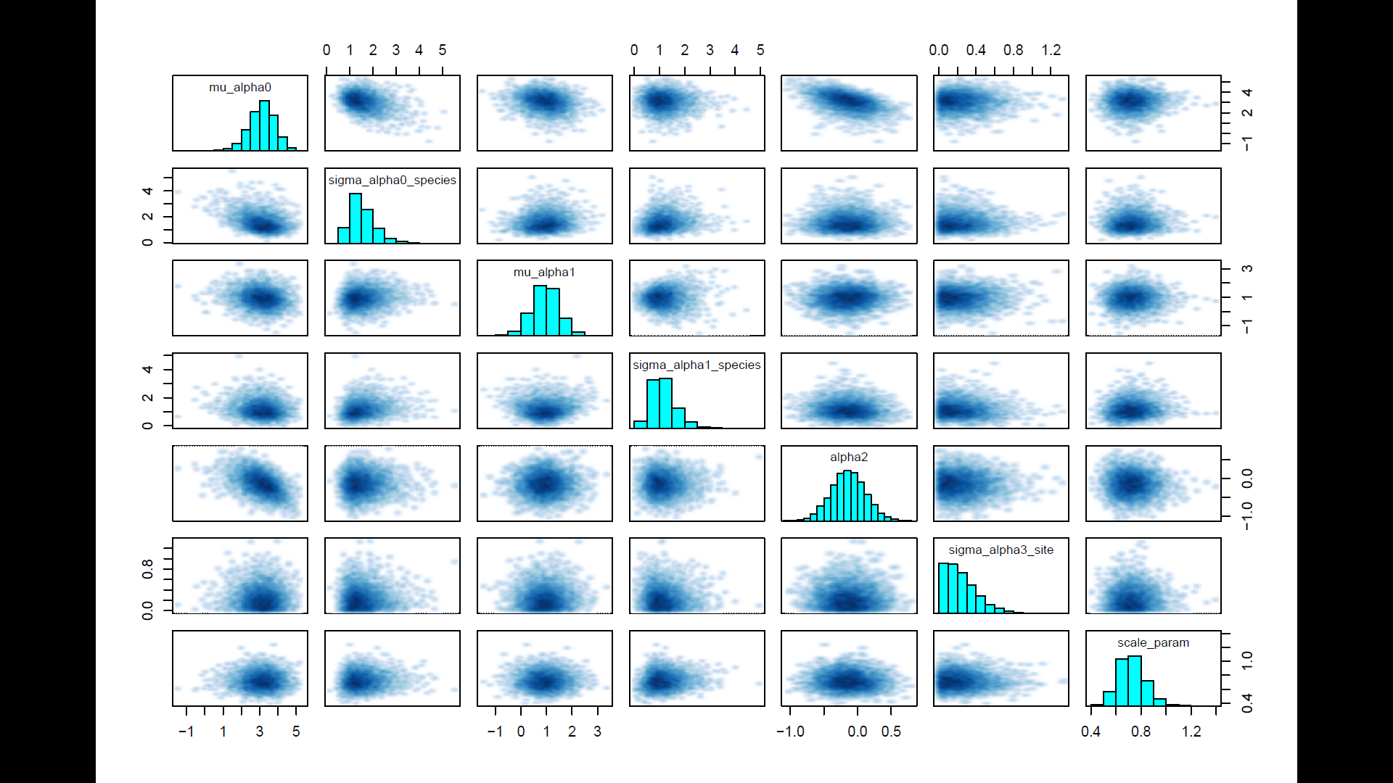
Figure S6: Pairs plots for the GLMM (a), binmix model (b), and multimix model (c). Pairs plot are shown for a sample subset of parameters (abundance parameters). The lack of divergent transitions and no visual barriers in the parameter space in these pairs plots search support that the posterior distribution has been fully explored.
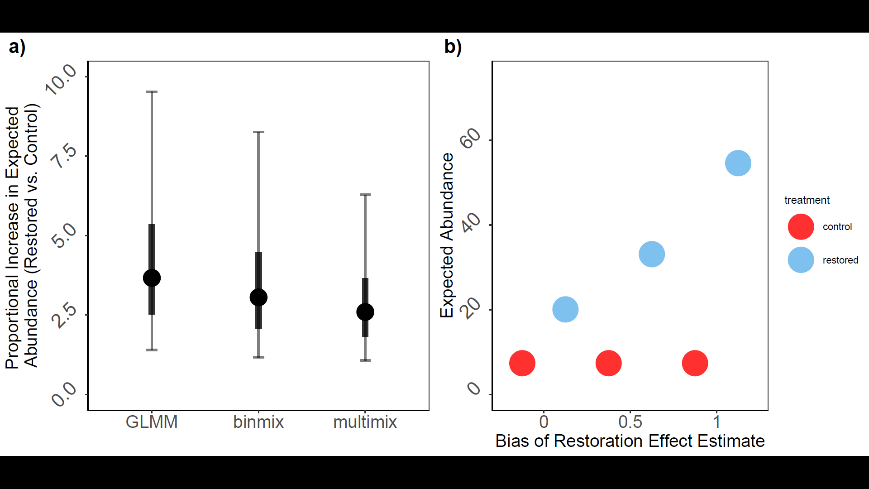
Figure S7: Expected increases in wild bee abundance in restored sites based on field data using GLMM, binmix, or multimix models (a); and change in increased expected abundance as bias for the restoration effect estimate increases (b). We calculated proportional increase in expected abundance (a) by dividing expected abundance for an average species at an average restored site by expected abundance for an average species at an average control site. Expected abundance at control sites was calculated as exp(intercept), while the expected abundance at restored sites was calculated as exp(intercept + estimated effect of restoration on abundance). The mean and 50% and 90% Bayesian credible intervals are shown. To demonstrate the effects of estimate bias on biological interpretation of an environmental driver of abundance we show the expected abundance in control and restored sites under different amounts of bias. We used our simulation settings with an abundance intercept of 2, and an effect of habitat restoration of 1. The expected abundance in a control site is exp(2) =~ 7. When bias = 0 (model estimates effect of restoration with high accuracy) the expected abundance in a restored site is exp(2 + 1) =~ 20. When bias = 0.5 (model overestimates effect of restoration by 0.5) the expected abundance in a restored site is exp(2 + 1+ 0.5) =~ 33. In this scenario, the biased model would overestimate increases by about 100% (increase of 26 individuals rather than true increase of 13). When bias = 1 (model overestimates effect of restoration by 1) the expected abundance in a restored site is exp(2 + 1+ 1) =~ 55. In this scenario, the biased model would overestimate increases by about 270% (increase of 48 individuals rather than true increase of 13).

