Working title: Estimating the drivers of insect abundance when detection is less than perfect: a comparison of GLM, binomial N-Mixture and multinomial N-Mixture (hierarchical mark-recapture) approaches.
Introduction
One of the primary goals of ecology is to determine the drivers of abundance (Krebs 1978; Gaston and McArdle 1994). Comparing the abundance of different species across space and time allows us to understand how the abiotic and biotic environment combine to shape patterns of biodiversity (Krebs 1978; Gaston and McArdle 1994). From a conservation perspective, quantifying the drivers of abundance allows us to assess population trends (e.g., Schultz and Hammond 2003 add ref), identify population threats (Rundlöf et al. 2015), or evaluate the success of a management intervention, for example, determining whether habitat restoration supports beneficial species (Waltz and Covington 2004; Blaauw and Isaacs 2014). Accurately and precisely estimating the drivers of abundance is especially critical for insects, a functionally important group that is facing widespread declines (Wagner et al. 2021).
Typically, ecologists estimate the drivers of insect abundance by fitting generalized linear models (GLM’s) to count data from transect or trap surveys. Yet, count data are almost always affected by false-negative and false-positive measurement errors (Kery and Royle 2020). False-negative measurement errors, i.e., the failure to detect individuals that are present, are likely to be especially rampant for insect counts. Compared to other taxonomic groups, insects are particularly small and are often highly mobile, making them difficult to detect and/or capture (Portman, Bruninga-Socolar, and Cariveau 2020). If false-negatives are commonplace, standard GLM’s will underestimate the true abundance of insects (Kery and Royle 2020). More importantly, systematic variation in detection rates could bias GLM estimates of the drivers of insect abundance (Williams et al. 2002). Crucially, GLM’s and their associated sampling protocols assume that the relationship between snapshot count surveys and true abundance is constant across space, time and species (Williams et al., 2002).
There are several reasons why insect detection rates could vary systematically (Box 1). For example, taller or more complex vegetation could obscure visibility and change the mobility or trap propensity of insects (ref). Alternatively, data collectors could improve their collecting skill or efficiency over time (ref). Species traits could create further variation in detection rate. For example, butterfly colouration and feature diversity patterns have been linked to ease of detection (Goldstein et al. 2024). Larger insects could also be easier to detect compared to smaller insects. Among wild bees, species can range in size of _ up to _, a _ order of magnitude difference (Danforth, Minckley, and Neff 2019). Additionally, wide variation in mobility (Greenleaf et al. 2007) could influence detection rate. These spatial, temporal and taxonomic detection biases have the potential to confound estimates of ecological drivers of abundance (Kery and Royle 2020). For example, a positive effect of a habitat type on detection rate could cause GLM’s to overestimate the effect of that habitat type on abundance (Kery and Royle 2020). Despite the strong potential for variation in insect detection rates to bias GLM estimates of the drivers of insect abundance, there is currently limited guidance on if or when other approaches should be considered.
Many different statistical models and associated sampling protocols have been developed to estimate the underlying drivers of abundance while accounting for imperfect detection. For decades, mark-recapture methods have been used for this purpose (Lincoln 1930), including for insects such as butterflies and bees (Haddad et al. 2008; Briggs et al. 2022). Mark-recapture methods infer the total number of species that are present using information about the proportion of marked individuals that are re-detected versus the number of unmarked individuals that are newly detected over a series of sampling occasions. Mark-recapture models are fit to capture history data for single species within single sites, often using the prepackaged accessible software Program MARK (White and Burnham 1999 ADD REF). For example, with wild bee abundance estimated independently for each species at each of a handful of study sites (Briggs et al. 2022). To estimate the drivers of abundance, this approach requires post-hoc regression between site-specific predictors (e.g., habitat type) and the independently derived abundance estimates (e.g., REF).
In contrast to classic mark-recapture, more recently developed hierarchical mark-recapture models use encounter histories from multiple sites and/or species to make more precise inference about the detection rates and the number of individuals that occur at each site (Royle and Young 2008). Hierarchical mark-recapture models allow detection rates and abundance to be specified as outcomes of site or species predictors (e.g., habitat type), enabling direct rather than post-hoc estimation of the drivers of abundance (Royle and Young 2008). A prevalent specification of the hierarchical mark-recapture is the multinomial-mixture model (hereafter, “multimix”) (Kery and Royle 2020), which treats encounter histories of marked individuals as the outcome of a multinomial distribution. Information about the frequency of individuals occurring in each observable encounter history category informs estimation of the number of individuals that were never detected (Box 1). For example, a majority of individuals being detected on most or all repeat visits suggests a lower probability of a large number of undetected individuals relative to a scenario with a majority of individuals that were detected on very few repeat visits. Hierarchical multimix models are increasingly popular for population studies of birds, mammals and reptiles and amphibians. While classic mark-recapture models are a standard of butterfly population monitoring (), hierarchical multimix models have only rarely been applied to insects.
While multimix models offer a solution for estimating the drivers of insect abundance when detection is less than perfect, these models also have drawbacks. In particular, mark-recapture data can be difficult and time consuming to collect, imposing financial costs (). Additionally, placing marks could damage or harm insects, an important consideration for rare or sensitive species (). Because they do not require information about individual identity, but rather the number of individuals with some unique encounter history, multimix modelling approaches can also be applied to data collected without non-marking sampling schemes, for example, removal sampling (), multiple observer recording schemes (), or territory tracking (). However, these other data collection schemes also come with logistical drawbacks especially for insect monitoring. For example, multiple observer recording is not possible if “detection” requires trap capture and identification (which is generally the case for small and difficult to identify insects). Territory tracking may not be applicable to most insects which unlike birds or large mammals, do not tend to occupy and defend unique positions in the landscape. Further, hierarchical multimix model implementation for mark-recapture data can be inaccessible, typically requiring custom tailored code and large computational resources.
Binomial N-mixture models (hereafter, “binmix” models) are another class of models that can account for imperfect detection that may also have the potential to circumvent some of the cost issues associated with multimix protocols. In particular, binmix models do not require the expensive mark data required for multimix models. Instead, binmix models leverage the distribution of the number of individuals that are detected across repeat surveys to approximate true abundance (Box 1). For example, at one end of the spectrum, a tight left-tailed distribution of repeat counts suggest a high probability that the true abundance is not much higher than the maximum observed count. Conversely, tightly distributed right-tailed counts suggest a high probability that only a fraction of the true abundance is ever observed. In the middle of these scenarios, a widely spread symmetrical distribution of counts suggests that individuals have an approximately 50/50 equal odds of being detected on each survey. Binmix models are also fit in hierarchical forms that allow for direct assessment of the effects of spatiotemporal or species covariates on abundance, while simultaneously accounting for detection biases. Binmix models have been used, for example, to estimate the effects of urban land use type on mosquito abundance (Manica et al., 2019), the impact of competitors and flower resource density on wild bee abundance (McCune et al., 2020), or land cover type and seasonality on Arctic fritillary abundance (Riva et al., 2020).
While binmix models may provide a cheap solution to accounting for detection bias, many have criticized the validity of this modeling approach, emphasizing that abundance estimates are highly sensitive to model assumption violations (e.g., Link et al., 2018). In particular, binmix models (along with multimix models) assume that population size is fixed across across time, i.e., that birth/death/immigration/emigration processes do not drive the variation across repeat counts (). Variation due to changes in true abundance should bias estimates of detection rate and estimates of true population size (Link et al., 2018), however, it is currently unclear how this violation impacts the bias and/or precision of estimates of the drivers of abundance. Because insects have high potential for closure assumptions to be violated (due to short life spans and high mobility) it is critical to understand how assumption violations impact the ability of these models to capture the drivers of insect abundance or whether more costly mark-recapture data is required to make reliable inference.
Ecologists or conservation biologists with resource constraints may wish to implement the simplest approach that accurately and precisely estimates drivers of insect abundance. GLMs, binmix models, and multimix models could have trade-offs in bias, precision and robustness. The required effort and financial and computing costs associated with the modeling and sampling protocols also vary, with multimix protocols requiring substantially higher input. Determining the appropriate modeling approach requires clearer knowledge of the ecological and study design conditions that could cause the conclusions made by these different methods to diverge. In this study, we first collected insect abundance data using a sampling protocol that was compatible with all three modeling approaches (GLM, binmix, and multimix). Specifically, we collected counts of eight wild bee species from five urban parks with habitat restorations and five control parks that were not restored. We collected the abundance data across two years (2022 and 2023), with three repeat surveys conducted within each season. We fit each model to the count data and compared the estimated effect of habitat restoration on abundance. This case study also provided field-realistic estimates of insect detection rates. To then understand more broadly how these modeling protocols compare, we used the field-realistic estimates to inform an insect population simulation study. For each modeling approach, we tested how key elements of insect ecology (baseline detection rate and population size) and study design (sample size and number of repeat visits) impact the bias and precision of the estimated effect of a simulated “restoration”. Further, we used the simulation to test whether multimix models versus binmix models are more robust to violations of population closure assumptions. Together, our results provide needed guidance on which approach to use to estimate the drivers of insect abundance when detection is less than perfect.
Methods
Field study
For our field-based case study, we aimed to estimate the effects of urban habitat restoration on the abundance of wild bees. To do so, we implemented an abundance protocol that was compatible with all three modeling approaches (GLM, binmix and multimix). We selected a sample of five urban parks in Vancouver, Canada, that received a habitat restoration. We compared these against five similar urban parks that did not receive a habitat restoration (hereafter, “control” parks). In another study, using a wider sample of parks that encompasses the ten that we studied here, we examined the effects of the habitat restoration and found that the restorations increased pollinator species occurrence (Ulrich and Sargent, 2024). Increased pollinator occurrence translated into sustained species richness gains in restored parks (Ulrich and Sargent, 2024). In that study, we did not quantify the effects on species abundance (Ulrich and Sargent, 2024). The restorations significantly increased flower species richness and marginally increased flower species abundance (Ulrich and Sargent, 2024). Although we did not measure vegetation complexity, vegetation was approximately knee-height in restored parks compared to approximately ankle-height in control parks (Supplemental figure with images of park vegetation). In restored parks, vegetation was unmowed during April – September season compared to mowed bi-weekly in control parks. Restored parks contained a mix of spontaneous and seeded flowers that provide food resources for wild bees; control parks were dominated by turfgrass but contained spontaneous flower resources (Ulrich and Sargent, 2024). Managed flowering woody plants (trees and shrubs) occurred sporadically across all sites (Ulrich and Sargent, 2024).
We targeted abundance surveys on eight wild bee species from four different wild bee families: Agapostemon texanus (Halictidae), Andrena prunorum (Andrenidae), Anthidium oblongatum (Megachilidae), Bombus flavifrons (Apidae), Bombus mixtus (Apidae), Halictus rubicundus (Halictidae), Megachile spp. (not including the invasive Megachile rotundata) (Megachilidae), and Melissodes microstictus (Apidae). We chose these species because we could identify them in the field. This allowed us to avoid lethal sampling which would cause violations of population closure assumptions. Additionally, the species were common enough in our system that previous studies (Ulrich and Sargent, 2024) could provide a priori information on the timing of peak abundance. Targeting our sampling at the timing of peak abundance allowed us to limit changes in abundance caused by rapid births or deaths which would also violate population closure assumptions. We collected counts in two periods: In early June we conducted three repeat surveys for the earlier phenology species A. texanus, B. flavifrons and B. mixtus; in the mid summer mid July we conducted the repeat surveys for species with later phenologies A. prunorum, A. oblongatum, H. rubicundus, Megachile spp., and Melissodes microstictus. To maintain closure, we conducted the repeat counts within the most rapid timescale possible. The first and last repeat surveys at each site were conducted within a maximum window of eight days. A. prunorum was only surveyed in the second year of the study.
A one-hectare survey area was designated for each park, focusing on a restored vegetation area for the restored parks or conventionally managed turfgrass space in control parks (the same survey areas used in Ulrich and Sargent, 2024). To collect pollinators, we used a sweep net, walking a spiral-transect through the survey area, netting all individuals from our focal species that we saw. We repeated the spiral transect until the survey time ended. Surveys lasted 45 minutes, with the timer paused for insect handling. Netted insects were placed on ice until the completion of the survey. After the survey ended, we marked the thorax of each captured bee. Marks were applied by placing chilled bees in vial with a plunger on one end and a wide mesh covering on the other. After pressing bees against the mesh, we painted a mark with a coloured paint pen (Molotow brand with 2.0mm round tip) (Figure 2). Marks were uniquely coloured by survey, allowing us to track the number of individuals with each possible detection history (a requirement of the multimix approach). Marking required approximately 30 seconds of effort per captured bee. Simple counts of the number of individuals captured during the survey were noted for the GLM or binmix approaches. To limit additional detection biases, all surveys were conducted by a single observer (J.U.), only during full sun conditions between 10:00 AM and 4:00 PM.
Statistical analyses
To estimate the effects of restoration on insect abundance, we developed custom-tailored models written in the probabilistic programming language Stan (), implemented in R using the package rstan (). These models use Bayesian inference to estimate distributions of parameter values that are consistent with the data and specified prior parameter distributions.
For the GLM model, we specified the counts $y_{i}$ as the outcome of a negative binomial trial with a mean $λ_{i}$ and dispersion $ϕ$ (Equation 1). We used negative binomial distributions for the GLM (and the binmix and multimix models) because our posterior predictive checks indicated that this overcame a strong lack of fit when using a Poisson distribution (supplement). We described variation in $λ_{i}$ using a log-link function (Equation 2), including a global abundance intercept ($α_{0}$), a species-specific random intercept effect ($α_{1}$), a site-specific random intercept effect ($α_{2}$), an effect of year ($α_{3}$), and a species-specific random effect of restoration ($α_{4}$), with restoration treated as a categorical variable.
- $y_{i} \sim negative binomial(λ_{i}, ϕ)$;
- $log(λ_{i})= α_{0}+ α_{1}\left[species\right]+α_{2}\left[site\right]+ α_{3}\left[year\right]+ α_{4}\left[species\right] ×restoration[i]$
For the binmix model, we specified true abundance as a latent variable $N_{i}$, which we considered to be the outcome of a negative binomial distribution with a mean $λ_{i}$ and dispersion $ϕ$ (Equation 3). Counts $y_{i}$ on repeat survey $j$ were specified as the outcome of a binomial trial with size $N_{i}$ and detection rate $p_{i}$. With this formulation, effects of predictors on abundance versus detection can be differentiated. We described variation in $λ_{i}$ as in Equation 2. We described variation in $p_{i}$ using a logit-link function (bounding the outcome to a probability range of 0 to 1) (Equation 5). We included a global detection intercept ($β_{0}$), a species-specific random intercept effect ($β_{1}$), a site-specific random intercept effect ($β_{2}$), and a species-specific random effect of restoration ($β_{3}$),
- $N_{i} \sim negative binomial(λ_{i}, ϕ)$;
- $y_{i,j} \sim binomial(N_{i}, p_{i})$;
- $logit(p_{i})= β_{0}+ β_{1}\left[species\right]+β_{2}\left[year\right]+β_{3}\left[species\right] ×restoration[i]$
The programming language Stan does not explicitly allow for latent discrete variable parameterization. As such we used a marginalized model form that calculates the log-likelihood of $y_{i,j}$ given a proposed detection rate $p_{i}$ across all possible values of $N_{i}$ in the range of max($y_{i,j}$) to some arbitrarily large integer $K$ (cite that salamander paper). Simultaneously our model estimates and sums the log-likelihood of each value of $N_{i}$ given the abundance generating process (salamander paper). Previous studies have shown that binmix models can be sensitive to the choice of $K$.

As $N_{i}$ gets increasingly large . The choice of K .
Finally, for the multimix, we specified a three-tiered model that simultaneously weighs the likelihood of an abundance generating process producing _ number of individuals, with the observer detecting _ number of individuals one or more times across all surveys and the likelihood that those individuals have some observable encounter histories _.
Simulation study

Results

Discussion

References
Blaauw, Brett R., and Rufus Isaacs. 2014. “Flower Plantings Increase Wild Bee Abundance and the Pollination Services Provided to a Pollination-Dependent Crop.” Journal of Applied Ecology 51 (4): 890–98. https://doi.org/10.1111/1365-2664.12257.
Briggs, Emma L, Christopher Baranski, Olivia Münzer Schaetz, Gabriela Garrison, Jaime A Collazo, and Elsa Youngsteadt. 2022. “Estimating Bee Abundance: Can Mark-Recapture Methods Validate Common Sampling Protocols?” Apidologie 53 (1): 10. https://doi.org/10.1007/s13592-022-00919-4.
Danforth, B, R Minckley, and J Neff. 2019. The Solitary Bees: Biology, Evolution, Conservation. Princeton University Press.
Gaston, K. J., and B. H. McArdle. 1994. “The Temporal Variability of Animal Abundances: Measures, Methods and Patterns.” Philosophical Transactions of the Royal Society of London. Series B: Biological Sciences 345 (1314): 335–58. https://doi.org/10.1098/RSTB.1994.0114.
Goldstein, Benjamin R., Sara Stoudt, Jayme M.M. Lewthwaite, Vaughn Shirey, Eros Mendoza, and Laura Melissa Guzman. 2024. “Logistical and Preference Bias in Participatory Science Butterfly Data.” Frontiers in Ecology and the Environment, October. https://doi.org/10.1002/FEE.2783.
Greenleaf, S., N. Williams, R. Winfree, and C. Kremen. 2007. “Bee Foraging Ranges and Their Relationship to Body Size.” Oecologia 153: 589–96. https://doi.org/10.1007/s00442-007-0752-9.
Haddad, Nick M., Brian Hudgens, Chris Damiani, Kevin Gross, Daniel Kuefler, and Ken Pollock. 2008. “Determining Optimal Population Monitoring for Rare Butterflies.” Conservation Biology 22 (4): 929–40. https://doi.org/10.1111/J.1523-1739.2008.00932.X.
Kery, M., and J. A. Royle. 2020. Applied Hierarchical Modeling in Ecology: Analysis of Distribution, Abundance and Species Richness in R and BUGS: Volume 2: Dynamic and Advanced Models. Academic Press.
Krebs, C. J. 1978. Ecology: The Experimental Analysis of Distribution and Abundance. 2d Ed. New York: Harper & Row.
Lincoln, F. C. 1930. “Calculating Waterfowl Abundance on the Basis of Banding Returns.” Washington DC.
Portman, Zachary M, Bethanne Bruninga-Socolar, and Daniel P Cariveau. 2020. “The State of Bee Monitoring in the United States: A Call to Refocus Away From Bowl Traps and Towards More Effective Methods.” Annals of the Entomological Society of America 113 (5): 337–42. https://doi.org/10.1093/aesa/saaa010.
Royle, J. Andrew, and K. Young. 2008. “A Hierarchical Model for Spatial Capture-Recapture Data.” Ecology 89 (8): 2281–89. https://doi.org/10.1890/10-1440.1.
Rundlöf, Maj, Georg Andersson, Riccardo Bommarco, Ingemar Fries, Veronica Hederstöm, Lina Herbertsson, Ove Jonsson, et al. 2015. “Seed Coating with a Neonicotinoid Insecticide Negatively Affects Wild Bees.” Nature 521: 77–80. https://doi.org/10.1038/nature14420.
Wagner, D., E. Grames, M. Forister, M. Berenbaum, and D. Stopak. 2021. “Insect Decline in the Anthropocene: Death by a Thousand Cuts.” PNAS 118 (2). https://doi.org/10.1073/PNAS.2023989118.
Waltz, Amy E.M., and W. Wallace Covington. 2004. “Ecological Restoration Treatments Increase Butterfly Richness and Abundance: Mechanisms of Response.” Restoration Ecology 12 (1): 85–96. https://doi.org/10.1111/J.1061-2971.2004.00262.X.

Figures
Figure 1: Comparison of three methods for estimating insect abundance
Figure 2: Mark-recapture methods
Figure 3: Field-study results
Figure 4: Bias and precision – ecological variation
Figure 5: Bias and precision – study design variation
Figure 6: Bias and precision – closure violatons
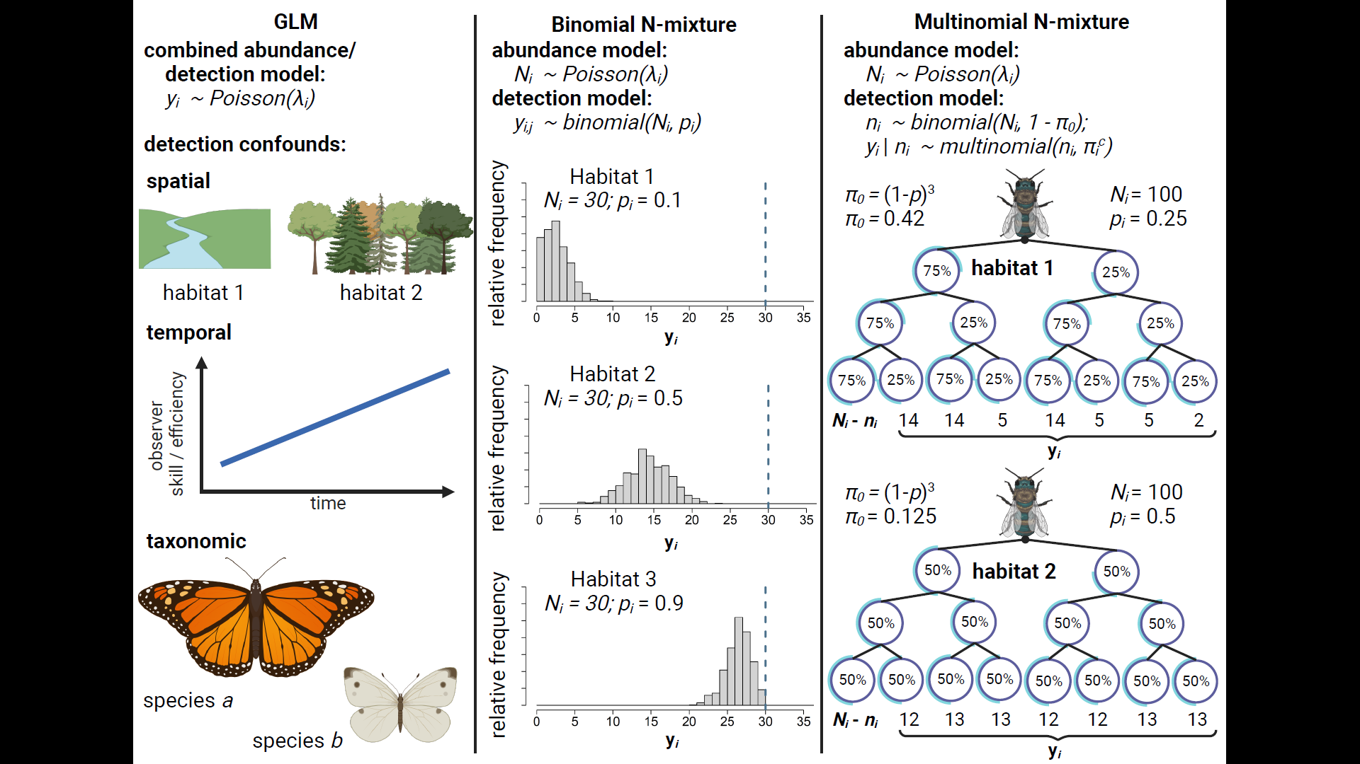
Figure 1: Comparison of three methods for estimating insect abundance. GLM’s (column 1) estimate the effects of spatiotemporal and taxonomic predictors ($λ_{i}$) on abundance by treating count data y_{i} as the outcome of a random process that generates positive integers, e.g., a Poisson distribution. GLM’s are unable to disentangle effects of these predictors on abundance from their potential effects on detection rate, e.g.: Habitat obscures detectability; observers improve their detection skills over time; or larger and more colorful species are detected at a higher rate than smaller and more dull-colored species. Binmix models (column 2) leverage the variation in counts $y$ across repeat surveys $j$ to units $i$ to simultaneously estimate detection rate $p$ and total abundance $N$. A more tightly clustered right-tailed distribution of repeat counts in Habitat 1 has a high likelihood when detection rate is low (counts heavily underestimate $N$); a tightly clustered left-tailed distribution of repeat counts in Habitat 3 has a high likelihood when detection rate is high (counts nearly approximate $N$); a wider and more symmetrical distribution in Habitat 1 has a higher likelihood when the detection rate is close intermediate. Multimix models (column 3) classify $y_{i}$ as the number of individuals in each observable encounter history, with the total number of individuals detected one or more times $n_{i}$ considered to be the outcome of a total population size and the probability of an individual having any of the observable detection histories (1 - $π_{0}$). In a study with three repeat surveys, the probability of never being captured ($π_{0}$) is equal to (1 - $p$)³. Encounter histories are typically tracked by placing marks on individual insects. Encounter histories that skew towards infrequent detection in Habitat 2 suggest that there is a high probability of failing to detect individuals across all repeat surveys, i.e., that $π_{0}$ is greater in Habitat 2 versus Habitat 1 and, correspondingly, that $n_{i}$ is a smaller proportion of $N_{i}$.
Insert fig with marking stuff.
Figure 2: Mark-recapture methods

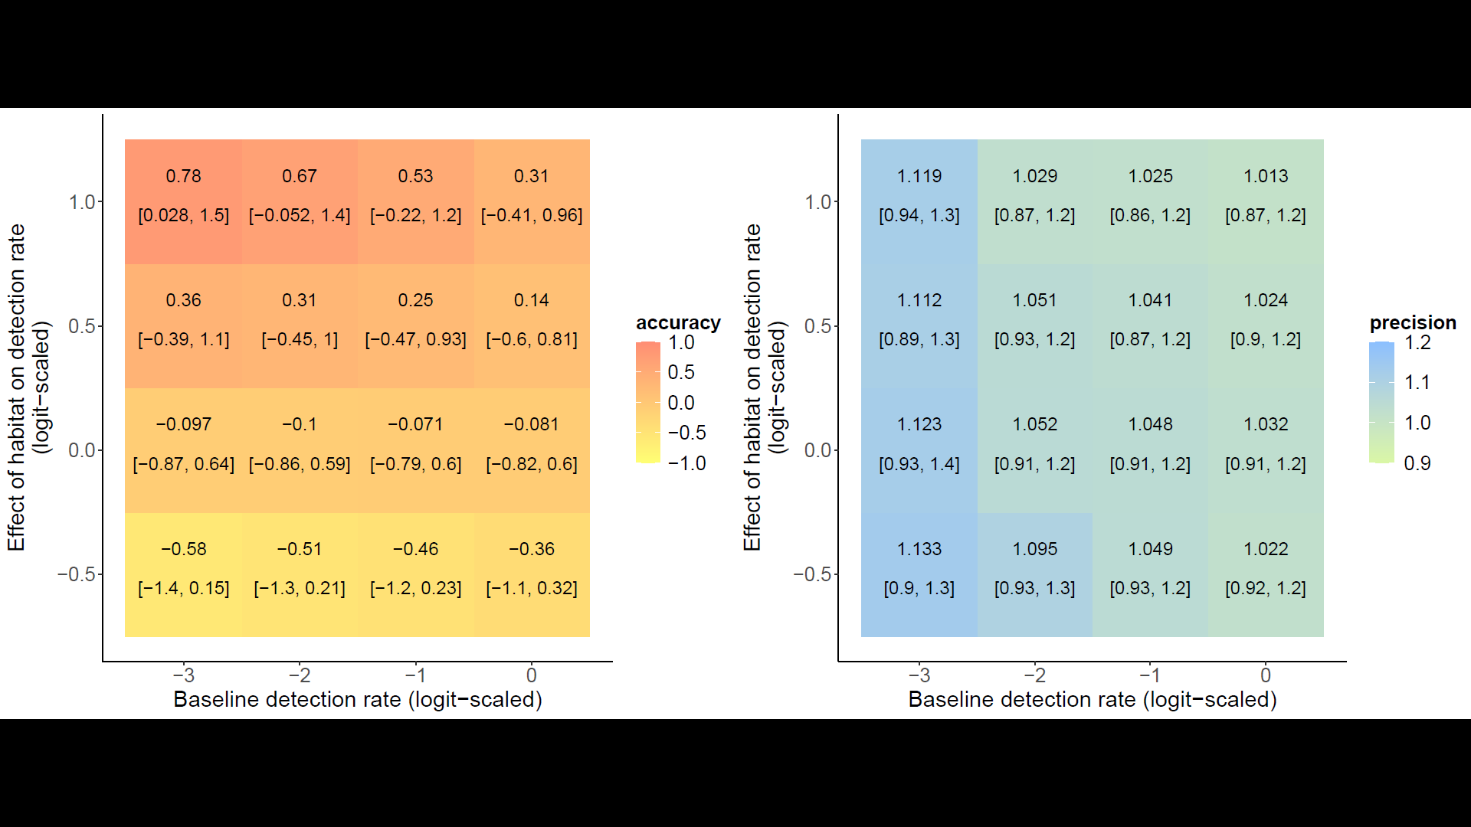
Figure 4A:

