Title Page
Title: Estimating the ecological drivers of insect abundance when detection is imperfect.
Authors: Jens Ulrich^{*1}, Risa D. Sargent¹
¹ Faculty of Land and Food Systems, University of British Columbia, Vancouver, Canada
*Corresponding Author Contact Information:
- address: 2357 Main Mall, Vancouver, BC, Canada, V6T 1Z4
- e-mail address: jensj27@gmail.com
Acknowledgements: Jack Tupper, Krista Voth, and Jo Fitzgibbons assisted with access to the field study sites. Jessica DeBiasio, Erin McHugh, and Daniel Yiyang Shen assisted with field work. Juli Carrillo and Claire Kremen provided valuable feedback throughout. This research was supported in part through the computational resources and services provided by Advanced Research Computing at the University of British Columbia. JU was supported by an NSERC graduate student fellowship and RDS was supported by an NSERC Discovery Grant.
Conflict of Interest: We have no conflicts of interest to declare.
Author Contributions: JU and RDS conceived the ideas and designed the methodology; JU collected and analysed the data; JU led the writing of the manuscript; RDS contributed critically to revisions of the drafts.
Statement on Inclusion: Our study includes researchers based in the region/country where the study was carried out (Vancouver, Canada). We worked directly with land planners and managers (Vancouver Parks Board) to ensure that our research outcomes help to address local management needs and questions.
Data Availability Statement: All data and code required to reproduce the field analyses and simulation analyses are available at: https://github.com/jensculrich/pollinator_abundance. Upon acceptance of the manuscript, the data and code will be submitted to a publicly available Dryad Digital Repository for permanent archival.
Abstract
Biodiversity conservation hinges on a clear understanding of the ecological drivers of species abundance. In ecological studies of insect abundance, researchers typically estimate effects of hypothesized drivers by applying generalized linear models (GLMs) to count data. However, a significant issue with conventional GLMs is that they cannot account for failure to detect some individuals that are present (‘imperfect detection’), which can bias model estimates. Some researchers have adopted hierarchical modelling approaches that account for imperfect detection, including multinomial N-mixture (multimix) models for mark-recapture data and binomial N-mixture (binmix) models for repeated count data. Currently, we lack side-by-side comparisons to determine the ecological and study design conditions that require the use of these more cumbersome approaches. Here, we collected abundance data on wild bees in a study designed to compare unrestored urban parks to restored parks, which had more flowers and taller vegetation. We applied all three modelling approaches to these data, using either mark-recapture data (multimix approach) or ignoring whether individuals were marked and treating the data as traditional counts (binmix and GLM approaches). Our models indicated that capture rates for individual bees were below ~5%. The multimix mark-recapture model indicated that bees were ~1.6 fold more likely to be detected in restored versus unrestored habitats. The GLM approach, which does not account for detection bias, overestimated the effects of restoration on bee abundance. Our results emphasize that environmental factors can influence our ability to detect insects in field studies, and that these factors may be confounded with the experimental design. Using simulation, we found that multimix mark-recapture models had highest accuracy and precision for estimating an abundance driver, including when individuals have the potential to move in/out of sampling areas; however, we also found that increasing baseline detection rates minimized the impacts of detection bias on GLM estimates. We recommend that studies planning to apply GLMs to count data prioritize methods that maximize improved detection over other aspects of study design such as the number of sites. Together, our results provide needed guidance on how to design and implement studies that accurately quantify the ecological drivers of insect abundance.
Keywords
Mark-recapture, multinomial N-mixture models, binomial N-mixture models, GLMs, abundance estimation, insect detection, insect sampling, habitat restoration
1. Introduction
Insects provide critical ecosystem services including pollination, decomposition, and biological control (Schowalter, Noriega, and Tscharntke 2018). At the same time, many insects are facing widespread declines (Biesmeijer et al. 2006; Koh et al. 2016; Sánchez-bayo and Wyckhuys 2019). In order to design evidence-based strategies for mitigating or reversing insect declines, we require a clear understanding of the environmental pressures that underlie species abundance patterns (Wagner et al. 2021). Quantifying the ecological drivers of species abundance allows us to assess population trends, identify population threats, and/or evaluate the success of management interventions (Schultz and Hammond 2003; Waltz and Covington 2004; Blaauw and Isaacs 2014; Rundlöf et al. 2015).
Accurately estimating the drivers of abundance is challenging because abundance itself is difficult to measure in natural environments. For insects, abundance data are often collected as counts from nets, traps or visual assessments (Mccravy 2018). Because many insect species are small, elusive, and/or mobile, these counts undoubtedly overlook some individuals (Nowicki et al. 2008; Taron and Ries 2015; Portman, Bruninga-Socolar, and Cariveau 2020). To quantify the ecological drivers of abundance, researchers typically apply generalized linear models (GLMs) to these imperfect counts (Bolker et al. 2009). Crucially, GLMs rely on the assumption that the relationship between imperfectly detected counts and the true abundance of insects is constant across space, time, and species (Williams, Nichols, and Conroy 2002). Systematic variation in the ability to detect individuals causes variation in this relationship and, consequently, can bias GLM estimates of abundance drivers (Figure 1) (Williams, Nichols, and Conroy 2002). For example, a concentration of food resources and/or habitat complexity could impact the ability to capture insects with nets or traps (Portman, Bruninga-Socolar, and Cariveau 2020). In a study of wild bees, researchers found that a higher density of flower resources on the day of a field survey improved the ability to detect insect species that were present (Ulrich and Sargent 2025). These effects of the environment on insect detection could confound GLM estimates for abundance (Kery and Royle 2020).
Mark-recapture is an alternative approach that estimates and accounts for imperfect detection. Essentially, researchers capture as many insects as possible within a prescribed location and time period. Researchers then mark captured individuals with identifiable labels or markers and then release them. After a set period of time, researchers return and resample the population, recording the number of newly captured individuals and recaptured (previously marked) individuals. Information about the odds of resighting marked individuals across successive sampling events allows researchers to quantify detection rate (Figure 1) (Williams, Nichols, and Conroy 2002). For decades, researchers have estimated abundance using mark-recapture (Lincoln 1930), including for insects such as butterflies and bees (Haddad et al. 2008; Briggs et al. 2022). Researchers have also used mark-recapture to estimate survival, movement, and phenology (Cormack 1964; Ovaskainen et al. 2008; Ehl et al. 2019).
Building on classic mark-recapture approaches for estimating abundance, hierarchical multinomial N-mixture models (hereafter, “multimix” models) allow researchers to pool mark-recapture data across multiple sites, treating site-specific detection histories as the outcome of a stochastic process that is informed by the data obtained from all sites (Kery and Royle 2010). This approach also allows researchers to estimate detection and abundance for sites with low or no recaptures. Compared to classic mark-recapture, sharing information about recapture rates across sites also increases estimate precision. In addition, this approach allows researchers to directly estimate predictors of abundance and detection such as site habitat quality. Further, these models can be extended to estimate detection and abundance for communities of species simultaneously, rather than for single species independently (Kery and Royle 2010).
While mark-recapture methods are considered the most rigorous way to estimate drivers of insect abundance, they also have significant limitations (Taron and Ries 2015). In particular, collecting mark-recapture data can be difficult and time consuming (Haddad et al. 2008; Taron and Ries 2015; Briggs et al. 2022; Hamm 2013). Additionally, placing marks could harm insects (Morton 1982). Further, multimix models for mark-recapture can require custom-tailored code and large computational resources (Kery and Royle 2020). Therefore, it is important to clarify the ecological and study design conditions that require the use of this more cumbersome method.
Binomial N-mixture models (“binmix” models) are a third approach for estimating the drivers of abundance. These models also accounts for imperfect detection. Binmix models are attractive because they can be applied to the same count data used for GLMs, provided that the counts are repeated at least for some sites (Royle 2004; Madsen and Royle 2023). Binmix models account for imperfect detection by leveraging information about the variation in the size of counts that are collected across repeat surveys (Figure 1) (Royle 2004). Binmix models are increasingly utilized for insect abundance studies (Mimnagh, Parnell, and Prado 2023). For example, researchers recently used them to determine the effects of urban land use on mosquito abundance, the impacts of flower resource density on wild bee abundance, and the effects of seasonality on butterfly abundance (Manica et al. 2019; Mccune et al. 2020; Riva et al. 2020).
While binmix approaches provide an easier way to account for detection biases, they are not without controversy (Barker et al. 2018; Madsen and Royle 2023). Both binmix and multimix mark-recapture models assume that populations are “closed”, i.e., that populations do not change across repeat survey events. Births and deaths or movement in/out of site sampling areas within the window of repeated surveys violates the assumption of population closure (Link et al. 2018; Kery and Royle 2020). For many ecological systems, especially those where sites do not have discrete borders that completely prohibit movement, it is unlikely that population closure assumptions are completely satisfied. Given the potential for closure violations, rather than considering estimates of abundance as the number of individuals contained within a sampling area during a sampling window, some researchers interpret estimates of abundance as estimates of the number of individuals that spend some portion of time within the sampling area during the window of repeated sampling events, i.e., a “superpopulation”, consisting of the total number of individuals that have some distributional overlap with the site (Kery and Royle 2020). However, even small variations in the number of individuals contained within a sampling area across repeated sampling events, such as would be caused by movement of individuals into or out of sites, can severely bias binmix estimates of the size of the superpopulation (Link et al. 2018). Because of these issues, Link et al. (2018) recommend mark-recapture methods, rather than binmix models for count data for estimating the size of a sampling area’s superpopulation abundance. Currently, however, we lack direct comparisons of how population closure violations impact the ability for binmix and multimix models to estimate effect sizes for environmental covariates that are hypothesized to drive abundance patterns (Fogarty and Fleishman 2021).
Multimix mark-recapture models, binmix models, and GLMs have trade-offs in terms of their required effort and performance. Researchers will want to implement the simplest approach that accurately and precisely estimates drivers of insect abundance. In this study, we first assessed the effects of an environmental covariate (park restoration) on the detectability and abundance of wild bees in an urban ecosystem. Here, we use “abundance” to mean to the number of individual bees that have some distributional overlap with a sampling area during the temporal window of sampling. For the field study, we used net-collection methods to obtain mark-recapture detection histories for eight wild bee species in five urban parks with habitat restorations and in five control parks without restorations. We replicated the study across two sampling years, with three repeat sampling events per year. Restored parks had taller, unmowed vegetation and more floral resources. While a number of authors have argued that habitats with more flowers or taller vegetation impact bee detection rates, we currently lack studies that quantify these effects (Portman, Bruninga-Socolar, and Cariveau 2020). We expected that restored habitats would increase wild bee detection rates: Bees foraging on flowers in taller vegetation in the restored parks might be easier to detect, since they would tend to be closer to the net collectors compared to bees foraging on ground-level flowers in control parks (McNeil et al. 2019); because floral resource density is associated with more sedentary insect foraging, greater floral resources could also make bees easier to see and capture (Heinrich 1979). To test this hypothesis, we fit a multimix model to the mark-recapture data to quantify effects of restoration on bee abundance while simultaneously estimating and accounting for impacts of restoration on detectability. In a second approach, we ignored the individual marks and treated our data as if they were simply repeated counts collected for a GLM or binmix model, allowing us to determine how ignoring potential detection bias or using a less robust detection model influenced our estimates of the drivers of insect abundance.
Next, using simulation, we investigated factors that could reduce or exacerbate the bias of less rigorous GLM and binmix approaches compared to the mark-recapture approach. In particular, we examined whether changes to baseline detection rate and/or number of study sites impacted the ability of these models to estimate an abundance covariate despite a confounding effect on detection. These tests aimed to provide guidance on whether GLMs can provide better estimates if studies prioritize increased sampling intensity as opposed to adding more site replicates. Finally, we used simulation to test the degree to which binmix and multimix model estimates for a hypothesized driver of abundance were robust to violations of model assumptions of population closure. To do so, we varied the probability that individual insects from the site superpopulation remained within a sampling area between successive surveys, while simultaneously varying whether those odds were impacted by a site environmental covariate. We then assessed accuracy of covariate estimates. In combination, our field and simulation studies provide needed information on how to better design and conduct unbiased insect abundance field studies.
2. Methods
2.1 Field study design and data collection
We collected abundance data from a sample of five urban parks in Vancouver, Canada, that had received habitat restoration amendments in 2020 (Table S1). As a comparison, we also collected data from five similar urban parks that had not received the habitat restoration (hereafter, “control” parks) (Table S1). In restored parks, conventional turfgrass vegetation was unmowed during April – September season compared to mowed bi-weekly in control parks. Restored parks were also seeded with flowers that provide food resources for wild bees. In a separate study we compared the plant communities in control and restored parks. We found that restoration was strongly associated with increased flower species richness and marginally associated with increased flower species abundance (Ulrich and Sargent 2025). Although we did not measure vegetation complexity, vegetation was approximately knee-height in restored parks compared to approximately ankle-height in control parks (Figure S1). We collected abundance data in 2022 and repeated our survey efforts again in 2023. Site centroids were separated by >1 km, approximately the maximum foraging distance for many bee species (Greenleaf et al. 2007). This allowed us to maintain spatial independence of the abundance for each site, despite the potential for individuals to move in and out of the site sampling areas.
We targeted our surveys on eight wild bee species from four different families: Agapostemon texanus (Halictidae), Andrena prunorum (Andrenidae), Anthidium oblongatum (Megachilidae), Bombus flavifrons (Apidae), Bombus mixtus (Apidae), Halictus rubicundus (Halictidae), Megachile spp. (not including the non-native alfalfa leafcutter, Megachile rotundata) (Megachilidae), and Melissodes microstictus (Apidae) (Figure S2). We chose these species because we could easily identify them in the field. Identification of many other species requires lethal sampling. However, we couldn’t kill bees and still carry out mark-recapture. Additionally, in our system, the species were common enough that we could estimate the timing of peak abundance from a previous study (Ulrich and Sargent 2025). Targeting our sampling at the timing of peak abundance allowed us to limit variation in site abundance caused by rapid births or deaths. We collected data during two different sampling periods. In early June we conducted three repeat surveys for species with ‘early’ phenology: Agapostemon texanus, B. flavifrons and B. mixtus. Then, in mid-July we conducted the repeat surveys for five species with ‘late’ phenology: Andrena prunorum, A. oblongatum, H. rubicundus, Megachile spp., and M. microstictus. To further reduce potential violations of population closure assumptions, we conducted repeat surveys within a rapid timescale, conducting the first and last repeat surveys at each site within a maximum of eight days. Our surveys only targeted female bees. Andrena prunorum was only surveyed in 2023.
We conducted the abundance surveys in one-hectare sampling areas. The sampling areas focused on a restored vegetation area for the restored parks or conventionally managed turfgrass area in control parks. We collected bees using a sweep net method, walking a spiral-transect through the survey area and netting all individuals thought to be one of our focal species. We repeated the spiral transect until the survey time ended. Surveys lasted 45 minutes, with the timer paused for insect handling. Netted insects were placed on ice until the completion of the survey. After the survey ended, we confirmed species identifications. We then applied marks by placing chilled bees in a vial with a plunger on one end and a mesh covering on the other (as in Briggs et al. 2022). Pressing bees against the mesh to inhibit movement, we painted a colour-coded mark on the back of the thorax (Molotow brand paint pen, 2.0mm round tip) (Figure S3). To implement the GLM and binmix model approaches, we recorded the total number of captured individuals, ignoring whether individuals were marked or not. To limit observer biases, all surveys were conducted by the same researcher, and only during full sun conditions between 10:00 AM and 4:00 PM.
2.2 Statistical analyses
To estimate the effects of restoration on insect abundance, we developed custom models written in the probabilistic programming language Stan (Stan Development Team 2023b), implemented in R (R Core Team 2022) using the package rstan (Stan Development Team 2023a). These models use Bayesian inference to estimate distributions of parameter values that are conditioned on our data and our specified prior probability distributions.
For the GLM model, we specified counts of $y_{i}$ individuals on each sampling event to be the outcome of a negative binomial distribution with an expected mean $λ_{i}$ and dispersion $ϕ$ (Equation 1). We used negative binomial distributions for the GLM (and the binmix and multimix models) because our posterior predictive checks indicated a clear lack of fit for Poisson models (Figure S4). Using a log-link function, we modelled variation in $λ_{i}$ (Equation 2) as a function of an intercept ($α_{0}$), a species-specific random intercept effect ($α_{1}$), a site-specific random intercept effect ($α_{2}$), an effect of year ($α_{3}$), and a species-specific random effect of restoration ($α_{4}$), with restoration treated as a categorical variable.
- $y_{i} \sim negative binomial(λ_{i}, ϕ)$;
- $log(λ_{i})= α_{0}+ α_{1}\left[species\right]+α_{2}\left[site\right]+ α_{3}\left[year\right]+ α_{4}\left[species\right] ×restoration[i]$
We assumed that species-specific random effects of restoration were normally distributed with a mean and a variance term estimated from the data, i.e., $α_{4}\left[species\right] \sim normal(μ_{α_{4}}, σ_{α_{4}})$. Species- and site-specific random effects for the intercept were centered on a mean of zero, and assumed to be normally distributed with a variance term that was estimated from the data.
For our binmix model, we assumed that there was an imperfectly observed latent abundance, $N_{i}$, for each site/species/year combination, $i$. We considered $N_{i}$ to be the outcome of a negative binomial distribution with a mean $λ_{i}$ and dispersion $ϕ$ (Equation 3). For each sampling event, $j$, we treated the number of successfully detected individuals, $y_{i,j}$, as the outcome of a binomial trial with a size of $N_{i}$ and a successful detection rate, $p_{i}$. This formulation allowed us to differentiate effects of predictors on abundance versus effects of predictors detection (Kery 2017). We described variation in $λ_{i}$ as in Equation 2. Using a logit-link function which bounds outcomes within a probability range of zero to one, we modelled variation in $p_{i}$ as function of a global detection intercept ($β_{0}$), a species-specific random intercept effect ($β_{1}$), a site-specific random intercept effect ($β_{2}$), an effect of year ($β_{3}$), and a species-specific random effect of restoration ($β_{4}$) (Equation 5). We presumed that species-specific random effects of habitat were normally distributed with a mean and a variance term estimated from the data, i.e., $β_{4}\left[species\right] \sim normal(μ_{β_{4}}, σ_{β_{4}})$:
- $N_{i} \sim negative binomial(λ_{i}, ϕ)$;
- $y_{i,j} \sim binomial(N_{i}, p_{i})$;
- $logit\left(p_{i}\right)= β_{0}+ β_{1}\left[species\right]+β_{2}\left[site\right]+β_{3}\left[year\right]+β_{4}\left[species\right] ×restoration[i]$
The programming language Stan does support sampling latent discrete variables, i.e., where the likelihood of the data is estimated with respect to a sampled value of $N_{i}$ (Stan Development Team 2023b). As such, we calculated the marginal likelihood of the data across a range of $N_{i}$, from a lower bound of $N_{i}=max(y_{i,1:3})$ to an upper bound of a large finite value $K_{i}$ (Royle 2004; Hocking et al. 2021). The lower bound is set at the maximum observed number of counts across occasion 1:$3$ as any lower values would allow the likelihood of a binomial trial to be zero (Royle 2004). $K$ should be large enough that values of $N$ approaching $K$ do not significantly contribute to the likelihood (Royle 2004). We evaluated the sensitivity of our estimates to the choice of $K$ to ensure that stable results were obtained (Kery 2017). For the field study, we used a value of $K_{i}=(max\left(y_{i,1:3}\right)+5) ×12$. Our model estimation proceeds by proposing new values for the abundance and detection parameters and then evaluating whether the likelihood of the data across all possible values of $N_{i}$ has improved.
Finally, for the multimix approach, we specified a three-level model with a multinomial observation process for detection histories (Kery and Royle 2010). Where 0 represents non-detection and 1 represents detection, the possible observable detection histories for three repeat surveys are: 111, 110, 101, 100, 011, 010, and 001. The eighth possible history, 000, is not observable (Royle et al. 2007). The outcome variable $y_{i}$ was defined as a vector with each element representing the number of individuals in each of the seven observable detection history categories (Figure 1). The likelihood of the observed detection histories is specified as the outcome of a multinomial trial with some number of individuals observed one or more times ($n_{i}$) with a vector of probabilities for each observable history ($π_{i}^{c}$) (Equation 6). To estimate the remaining number of individuals at the site, we treated the number of observed individuals ($n_{i}$) as the outcome of a binomial trial that depends on the size of the total population ($N_{i}$) and the probability of not being observed ($π_{i}^{0}$, i.e., probability of a detection history of 000) (Equation 7):
- $y_{i} \sim multinomial(n_{i}, π_{i}^{c})$;
- $n_{i} \sim binomial(N_{i}, 1-π_{i}^{0})$;
As with the binmix model, the population size $N_{i}$ was modelled as the outcome of a negative binomial distribution (Equation 3) with a dispersion term and a linear predictor for the mean (Equation 2). We bounded $N_{i}$ within the range $K_{i}=((n_{i}+5) ×12)$. Heterogeneity in detection rate was modelled using a linear predictor for $p_{i}$ (Equation 5), but where $p_{i}$ is estimated by defining its relation to $π_{i}^{1:8}$. For example, where probability of detection history 111 is $π_{i}^{1}= p_{i}×p_{i}×p_{i}$, or probability of detection history 110 is $π_{i}^{2}= p_{i}×p_{i}×(1-p_{i})$ (Figure 1). By tracking individual level detection histories, our multimix model estimates for $p_{i}$ combine the probability that an individual is alive and actively foraging in the sampling area at the time of a sampling event along with the probability that we see and capture the individual with a net.
We employed best practices for model development and fitting by (1) using weakly-informative priors to discourage unrealistic parameter values (Table S2 – S4); (2) confirming sufficient mixing of chains (Gelman-Rubin R-hat values < 1.05), minimal within-chain autocorrelation (effective sample size/steps > 0.1) and no divergent transitions (Figures S5 and S6); (3) running our model for a length of 4000 HMC steps, discarding the first 2000; and (4) using posterior predictive checks to assess the fit of our models (Figure S4) (Stan Development Team 2023b; Gelman, Hill, and Vehtari 2020; Kery and Royle 2020).
2.3 Simulation study
We wrote a simulation program in R (R Core Team 2022) to generate species abundance and detection patterns. We simulated abundance from a Poisson distribution. We included species, site, and year predictors for the mean of the Poisson generating process, as in Equation 2. Conditional on input abundance and detection rates, the program then produces mark-recapture histories or summarizes the histories as counts. The simulation script allows the detection rate to vary by species, site, and/or year, as in Equation 5. We ran all simulations on the University of British Columbia Sockeye Computing Platform.
We used this simulation to determine how particular aspects of the study design and violations of population closure assumptions impacted estimates of the effect size of an ecological driver of insect abundance. To accomplish this goal, we fit each of the three models to data that were simulated under a set of scenarios. For all simulations we specified half of the sites as “restored” and the other half of sites as “control”. In these simulations, restoration represents a hypothesized ecological driver of insect abundance that a researcher may wish to quantify; the term could be replaced with another hypothesized driver that might also impact detection such as land cover or the presence of an invasive species. The effect size of the restoration parameter, $μ_{α_{4}}$ ( Equation 2), was held constant at a value of 1, representing a positive effect.
First, we assessed how changes in baseline insect detection rates impact model bias and precision. To do so, we simulated detections for twenty sites, sixteen species, and two years, with three repeat surveys per year. We varied the detection intercept ($β_{0}$) across values of -3, -2, -1, and 0 (on a logit-scaled). On the probability scale, a value of 0 represents 50% odds of an individual insect being detected during a given survey given that it is present, whereas a value of -3 represents a <5% odds. For each level of detectability, we varied the effect of restoration on the detection rate ($μ_{β_{4}}$) across values of -0.5, 0, 0.5, and 1 (logit-scaled). A positive value corresponds to a scenario where restored sites increase detection rate. The abundance intercept was held constant at a value of 2 (log-scaled), with no effect of year on abundance or detection. For each combination of baseline detection rate and effect of restoration on detection we simulated insect abundance for ten systems, and then fit all three of the models to each of these systems. We then extracted 250 samples from the posterior distribution for each fit, equating to 2500 sampled estimates for each model type for each combination of detection parameters. To calculate model accuracy, we subtracted the sampled effect size estimates from the true value ($μ_{α_{4}})$ (i.e., calculated a measure of model bias). To assess model precision, we measured the 90% Bayesian Credible Intervals (BCI) of each model fit. Larger BCI’s indicate higher uncertainty in the value of the parameter.
Next, we assessed how changes in the number of sites included in a study impacted model bias and precision. To do so, we simulated scenarios with 10, 20 or 30 sites. For each scenario, we again varied the effect of restoration on detection rate between -0.5, 0, 0.5, and 1 (logit-scaled). The detection intercept was held constant at a value of -2 (logit-scaled). All other parameters and study dimensions were held constant as described in the previous paragraph. We used the same approach to quantify accuracy and precision.
Finally, we examined how violations of the population closure assumption impacted binmix and multimix estimates. For this test of model robustness, we still considered $N_{i}$ to be the outcome of a Poisson trial. However, we also included an ability for individuals to move in/out of sites: Each individual, $k$, for each site/species/year sampling unit, $i$, was randomly “available” for detection at the time of a sampling event, $j$, with some probability $θ_{i}$: ${availability}_{i,j, k} \sim binomial(N_{i}, θ_{i})$. Unavailable individuals represent those that moved out of a sampling area at the time of a survey event. We specified a linear predictor for $θ_{i}$, with an availability intercept $θ_{0}$ and a fixed effect of restoration on availability $θ_{1}$. We varied $θ_{0}$ between -1, 0, 1, and 2; and $θ_{1}$ between -1, 0 and 1 (logit-scaled). A negative value of $θ_{1}$ represents a scenario where individuals are less likely to remain within sampling areas if the site was restored, whereas a positive value would indicate a higher probability of remaining within sampling areas. A value of zero indicates a scenario where individuals may move in/out of the plot, but that restoration does not effect the odds of doing so. For these simulations, we held the abundance intercept at 3 (log-scaled) and kept the baseline detection rate constant at -2 (logit-scaled) with no effect of restoration on detection. All other parameters and study dimensions were held constant as described above, with the same approach used to quantify accuracy and precision.
3. Results
To determine the abundance and detection patterns for insect populations in the field, we fit each of our models to the wild bee abundance data collected from our ten field sites (Figure 2). As expected, given that GLMs do not account for imperfect detection, the GLM estimated a lower abundance intercept ($α_{0}$ mean = 0.23; 90% Bayesian credible interval (BCI) = [-0.82, 1.27]) compared to either the binmix or multimix models: The binmix model estimated a higher intercept with 98.7% probability and the multimix model with 99.5% probability. The GLM estimated a positive effect of restoration on insect abundance: $μ_{α_{4}}$mean = 1.30; 90% BCI = [0.34, 2.25]. Effect size estimates were smaller for the binmix model: $μ_{α_{4}}$mean = 1.11; 90% BCI = [0.16, 2.11]; 60% probability of a smaller effect size compared to the GLM approach. Effect size estimates were also smaller for the multimix model: $μ_{α_{4}}$mean = 0.91; 90% BCI = [0.05, 1.85]; 67% probability of a smaller effect size compared to the GLM approach.
The multimix model estimated a lower baseline detection rate ($β_{0}$ mean = -3.17; 90% BCI = [-3.66, -2.62]) than the binmix model ($β_{0}$ mean = -2.47; 90% BCI = [-3.2, -1.65]). On a probability scale, the mean estimate of the multimix model equates to a 4.3% odds of detecting an individual bee during a survey of a control plot (90% BCI = [2.5%, 7.4%]). The multimix model also estimated a positive effect of restoration on detection: $μ_{β_{4}}$ mean = 0.56; 90% BCI = [0.07, 1.05]. On a probability scale, the mean estimate of the multimix model equates to a 6.8% odds (1.6 fold increase) of detecting individual bees during surveys of restored sites (90% BCI = [3.9%, 11.8%]). The binmix model tended to estimate a positive effect of restoration on detection rate, although only the 50% BCI was in the positive direction: $μ_{β_{4}}$ mean = 0.25; 50% BCI = [0.01, 0.48].
We used simulation to determine how certain aspects of a study impact the ability of these models to estimate insect abundance drivers. First, we examined how changes in baseline detection rate and effects of habitat on detection rate impact the accuracy and precision of covariate estimates (Figure 3). We found that the GLM bias was marginal when the odds of detecting an individual insect were relatively high: When the odds of detecting an insect were 50% (0 on the logit scale), there was minimal bias even when restorations strongly increased detection rate (mean bias = 0.45; 90% BCI = [-0.2, 1.1]). The results remained relatively unbiased when the odds of detecting individual insects were set to ~25% (-1 on the logit scale). However, GLMs were not able to overcome confounding effects of restoration on abundance and detection when baseline detection rates were lower. For example, when the odds of detecting an insect were <5% (-3 on the logit scale), the GLM bias followed the direction of the effect of restoration on detection rate: There was a clear positive bias when restoration increased detection rate (mean bias = 0.81; 90% BCI = [0.23, 1.3]). In contrast, the binmix and multimix did not show any clear bias when we simulated confounding effects of restoration on abundance and detection. Mean estimates for the effect of restoration on abundance tended to be <0.1 from the true value of 1. The largest divergences occurred for the binmix models when baseline detection rates were lowest (at -3 on the logit scale and with a positive effect of restoration on detection rate, mean bias = 0.33; 90% BCI = [-0.85, 1.3]). For the GLM, precision did not vary systematically with detection patterns. However, binmix and multimix precision increased with baseline detection rate.
We found that increasing the number of sites made estimates from the GLM approach both more biased and more precise (Figure 4). For example, when there was a strong positive effect of restoration on detection rate and only ten study sites, GLMs slightly overestimated the effect of restoration on abundance (mean bias = 0.65; 90% BCI = [-0.3, 1.7]) and provided relatively wide confidence intervals (mean 90% BCI width = 0.91). When we increased the number of study sites to thirty, overestimates were larger (mean bias = 0.91; 90% BCI = 0.41, 1.6) and confidence intervals narrowed (mean 90% BCI width = 0.57). Binmix and multimix models were not clearly biased by changes in site number. Binmix and multimix precision increased systematically with increasing number of sites.
Finally, we assessed the robustness of binmix and multimix models to violations of the closure assumption (Figure 5). Across all simulation scenarios, binmix models underestimated the abundance intercept term, whereas the multimix model did not. For both model types, abundance covariate estimates were robust to closure violations when the probability of movement into/out of sites was unrelated to site conditions ($θ_{1}$ = 0). Binmix model estimates were more sensitive to systematic violation of the closure assumptions when the baseline odds of remaining in the site were low: When $θ_{0}$ = -1 and $θ_{1}$ = -1, the binmix model underestimated the effect of habitat restoration on abundance by an average of -0.61 (90% BCI = [-1.6, 0.4]). In contrast, across all simulation scenarios, the multimix model tended to miss the true effect of restoration on insect abundance by a magnitude of less than 0.15.
4. Discussion
To develop evidence-based strategies to mitigate or reverse insect declines, we require the ability to estimate the effects of ecological factors on insect abundance patterns with accuracy and precision (Wagner et al. 2021). At the same time, insects are difficult to detect with standard ecological survey tools, complicating our ability to quantify the drivers of their abundance. From a sample of urban parks that contained restored or unrestored habitat, we collected wild bee abundance data that we could treat either as mark-recapture histories or as traditional counts. Supporting our hypothesis that more flowers and taller vegetation improve detection, a multinomial N-mixture (multimix) model for the mark-recapture data estimated that bees were approximately 60% more likely to be detected in sites with restored habitats compared to control sites. Our binomial N-mixture (binmix) model for count data also suggested that individual bees were easier to detect in restored sites. To our knowledge, this provides the first quantitative evidence that habitat quality impacts our ability to measure wild-bee abundance. A GLM, which did not account for detection biases, overestimated the effects of restoration on bee abundance. This highlights that confounding effects on detection can bias GLM estimates of insect abundance drivers. As such, we should interpret effect sizes produced by GLMs with caution when the environment has the potential to influence our ability to observe or capture insects. Using simulation, we found that multimix mark-recapture models were the most robust and precise approach for estimating a hypothesized driver of abundance, however, we also found that increasing the baseline detection rate minimized the tendency for detection biases to impact GLM estimates. This emphasizes that studies making use of GLMs can increase their accuracy by prioritizing increased detection rate over other aspects of study design such as the number of sites. Together, our results provide needed guidance on how to design and implement studies that improve our understanding of how to conserve insects in a changing world.
While the GLM approach exaggerated the size of the effect, all three models estimated a positive effect of restorations on wild bee abundance, consistent with a positive effect of restorations on wild bee and hoverfly species occurrence (as found in a separate study of the same system, Ulrich and Sargent 2025). More broadly, habitat amendments that increase floral resources tend to be associated with increased abundance of insect pollinators such as bees and butterflies (Hyjazie and Sargent 2022; Waltz and Covington 2004). Pollinator habitat amendments including reduced turfgrass mowing and wildflower seeding are growing in popularity and offer a promising approach for supporting sustainable urban development (Wolfin et al. 2023; Cloutier et al. 2024).
We found that habitats with more flowers and taller vegetation increased detectability. Recent studies have uncovered other factors that impact insect detection. For example, looking at urban mosquito populations, Manica et al. (2019) found that dense vegetation cover improved trap capture rates, aligning with preferences in the location of mosquito oviposition. Other studies have pointed to observer differences as sources of insect detection bias. For example, in a study of UK butterfly populations, Isaac et al. (2011) found that one field team had a higher butterfly detection rate than another field team, potentially due to differences in surveyor’s prior field experience. Another study found that larger and more brightly coloured butterfly species were easier to detect during transect walks compared to smaller and duller species, which could bias species abundance comparisons made by GLMs (Kral-O’Brien et al. 2020). Taken together, these results emphasize that an array of different environmental factors have potential to confound GLM estimates of insect abundance drivers.
Still, conventional GLMs are popular with ecologists and are likely to remain the standard methodology for insect population and community studies. Our simulation showed that increasing baseline detection rate reduces tendency for bias. A confounding effect on detection rate did not consistently bias model estimates (90% BCI overlapping with zero) when baseline detection rates were held at ~25% or 50%. Conversely, adding more sites exacerbated GLM bias while simultaneously increasing precision (i.e., adding more sites increased the confidence in an inaccurate conclusion). If researchers planning to employ GLMs are concerned about a site covariate impacting detection, then study designed should prioritize increased detection rate over site replication. Increasing detection rate could be achieved by improved sampling intensity: for example, by increasing the duration of surveys, by increasing the number and/or expertise of surveyors, or by increasing the number of traps deployed per sampling location (Mccravy 2018).
Across our field sites, the mark-recapture model estimated bee detection rates that ranged between 2% and 12%. These estimates are consistent with those provided by other mark-recapture bee studies; for example, a study of bees in North Carolina forests estimated capture probabilities ranging between 4% and 52% (Briggs et al. 2022). Detection rates may be higher for some insects including butterflies. For example, researchers reported 86% detection rates for the Iolas blue, Iolana iolas (Heer et al. 2013). Conversely, detection rates for other insects might be lower, with researchers collecting mosquitos with passive traps reporting detection odds <1% (Manica et al. 2019). Our results about the relationship between baseline detection rate and GLM bias suggest that detection models or study design controls should especially be considered for insect taxa that tend to be more difficult to detect.
Even minor violations of the closure assumption are known to cause severe bias for binmix estimates of total population size (Duarte, Adams, and Peterson 2018; Fogarty and Fleishman 2021). Our closure violation simulations confirmed this: Binmix models consistently underestimated the abundance intercept. On the other hand, we found that binmix estimates of a hypothesized driver of abundance were only impacted by systematic closure violations. Specifically, estimates of the simulated abundance driver were biased when closure violations were rampant (i.e., baseline odds of being within a sampling plot at the time of a survey were less than 50%), and simultaneously when there was a confounding effect of habitat on the degree of closure violations (i.e., when $θ_{1}$ does not equal zero). Because it may be difficult to know whether the environment affects the rate of closure violations prior to implementing a study, more rigorous multimix mark-recapture models should be applied over binmix models in situations where populations are likely highly dynamic.
High mobility or rapid mortality make populations more dynamic and increase the chance of population closure violations. For our study, we surveyed one-hectare plots. Although they can move further (Greenleaf et al. 2007), wild bees tend to exhibit strong site fidelity within a few hundred metres (Ogilvie and Thomson 2016). This means that individual bees likely remained within the one-hectare sampling areas across repeated surveys. Insects with larger daily movements and no fixed nest position may be less likely to satisfy the assumption of high closure. For example, the checkered skipper butterfly, Carterocephalus palaemon, can move more than a kilometre in a single day (Wildman et al. 2024). In addition, unlike bees, butterflies do not maintain fixed nest locations and may even move among sampling areas (Ricketts 2001). Therefore, butterflies may be less suitable for binmix approaches. Habitat edges such as roads or hedges can impact insect movement (Markovits, Dorian, and Crone 2025; Wratten et al. 2003). Consequently, researchers using binmix models should standardize the presence of discrete site borders to minimize systematic closure violations caused by insect movement. Repeat surveys that are conducted more rapidly relative to insect lifespan would also improve the robustness of binmix models. Wild bees are typically active for several weeks, for example, with a flight period of about 18 days for Andrena hattorfiana (Larsson and Franzén 2008), a reasonably broad window for our repeat surveys, which were conducted within eight day periods. Conducting repeat surveys within a single day could help limit closure violations for insect groups with shorter lifespans (Nowicki et al. 2008). Overall, binmix models are most appropriate when mobility is limited and individual insects are longer-lived. These requirements were well satisfied when binmix models were used to estimate the abundance of a rare stag beetle, Lucanus cervus (Della Rocca et al. 2020). Adult L. cervus are long-lived with an active flight period of several months; simultaneously, they are also fairly immobile, tending to move by less than a few dozen meters per day (Tini et al. 2018).
In our simulation study, multimix models for mark-recapture data consistently provided the most accurate estimates of abundance drivers. Multimix models also provided more precise estimates of a hypothesized abundance driver, in agreement with other studies comparing estimates for total abundance (Bötsch, Jenni, and Kéry 2020). As such, multimix model approaches allow researchers to leverage maximum information from a limited sample size. This is especially important when a focal species is rare, occurs at a limited number of sites or where site survey permitting is a limiting factor. Multimix models can be applied to data generated using sampling protocols other than mark-recapture. Alternative protocols include removal sampling, multiple observer recording, territory tracking, or distance sampling (Kery and Royle 2020). Distance sampling appears promising for insect studies and has already been applied to studies of bumble bees and butterflies (McNeil et al. 2019; Kral-O’Brien et al. 2020). With this approach, a researcher typically walks a line transect through a sampling area, recording the distance between the observer and detected insects. Researchers then infer the detection probability from the observed pattern of distances (Taron and Ries 2015; Kery and Royle 2020). The distance sampling method is attractive because it does not require that individuals be marked, it does not require repeat surveys, and it does not require defining discrete sampling area boundaries (Taron and Ries 2015).
In this study, we showed that habitat restoration can simultaneously influence insect abundance and detection. Given their robustness and precision, we recommend using multimix approaches to account for detection biases, especially when insect mobility exceeds the spatial area of sampling or when insect life spans are shorter than the distance between repeat survey events. At the same time, multimix mark-recapture approaches are challenging to implement. New approaches for collecting mark-recapture data such as photographic or genetic mark-recapture could reduce these burdens (Wildman et al. 2024). Alternatively, researchers could use other techniques that do not require tracking individual detection histories, such as distance sampling (Kral-O’Brien et al. 2020). Integrated modelling approaches could also be useful, allowing researchers to combine powerful mark-recapture data from a subset of sites or species with simple count data from a larger number of sampling units (Besbeas et al. 2002; Jarrett et al. 2022). We anticipate that GLM approaches will remain common for studies of insect abundance. As such, we recommend designing studies that minimize detection bias. This can be achieved by prioritizing sampling intensity per site over the number of study sites. By accounting for detection biases or by minimizing detection biases through study design, researchers can provide the accurate and precise evidence needed to make recommendations for mitigating insect declines.
References
Barker, R., M. Schofield, W. Link, and J. Sauer. 2018. “On the Reliability of N-Mixture Models for Count Data.” Biometrics 74 (1): 369–77. https://doi.org/10.1111/BIOM.12734.
Besbeas, P., S. N. Freeman, B. J.T. Morgan, and E. A. Catchpole. 2002. “Integrating Mark–Recapture–Recovery and Census Data to Estimate Animal Abundance and Demographic Parameters.” Biometrics 58 (3): 540–47. https://doi.org/10.1111/J.0006-341X.2002.00540.X.
Biesmeijer, J. C., S. P.M. Roberts, M. Reemer, R. Ohlemüller, M. Edwards, T. Peeters, A. P. Schaffers, et al. 2006. “Parallel Declines in Pollinators and Insect-Pollinated Plants in Britain and the Netherlands.” Science 313 (5785): 351–54. https://doi.org/10.1126/science.1127863.
Blaauw, B., and R. Isaacs. 2014. “Flower Plantings Increase Wild Bee Abundance and the Pollination Services Provided to a Pollination-Dependent Crop.” Journal of Applied Ecology 51 (4): 890–98. https://doi.org/10.1111/1365-2664.12257.
Bolker, B., M. Brooks, C. Clark, S. Geange, J. Poulsen, M. Stevens, and J. White. 2009. “Generalized Linear Mixed Models: A Practical Guide for Ecology and Evolution.” Trends in Ecology and Evolution 24 (3): 127–35. https://doi.org/10.1016/J.TREE.2008.10.008.
Bötsch, Y., L. Jenni, and M. Kéry. 2020. “Field Evaluation of Abundance Estimates under Binomial and Multinomial N-Mixture Models.” Ibis 162 (3): 902–10. https://doi.org/10.1111/ibi.12802.
Briggs, E., C. Baranski, O. Schaetz, G. Garrison, J. Collazo, and E. Youngsteadt. 2022. “Estimating Bee Abundance: Can Mark-Recapture Methods Validate Common Sampling Protocols?” Apidologie 53 (1): 10. https://doi.org/10.1007/s13592-022-00919-4.
Cane, J., R. Minckley, and L. Kervin. 2000. “Sampling Bees (Hymenoptera: Apiformes) for Pollinator Community Studies: Pitfalls of Pan-Trapping.” Journal of the Kansas Entomological Society 73 (4): 225–31. https://www.jstor.org/stable/25085973.
Cloutier, S., P. Mendes, J. Cimon-Morin, S. Pellerin, V. Fournier, and M. Poulin. 2024. “Assessing the Contribution of Lawns and Semi-Natural Meadows to Bee, Wasp, and Flower Fly Communities across Different Landscapes.” Urban Ecosystems, 1–18. https://doi.org/10.1007/s11252-024-01516-2.
Cormack, R. M. 1964. “Estimates of Survival from the Sighting of Marked Animals.” Biometrika 51 (3/4): 429. https://doi.org/10.2307/2334149.
Duarte, A., M. Adams, and J. Peterson. 2018. “Fitting N-Mixture Models to Count Data with Unmodeled Heterogeneity: Bias, Diagnostics, and Alternative Approaches.” Ecological Modelling 374 (April): 51–59. https://doi.org/10.1016/J.ECOLMODEL.2018.02.007.
Ehl, S., S. Holzhauer, N. Ryrholm, and T. Schmitt. 2019. “Phenology, Mobility and Behaviour of the Arcto-Alpine Species Boloria Napaea in Its Arctic Habitat.” Scientific Reports 2019 9:1 9 (1): 1–9. https://doi.org/10.1038/s41598-019-40508-7.
Fogarty, F., and E. Fleishman. 2021. “Bias in Estimated Breeding-Bird Abundance from Closure-Assumption Violations.” Ecological Indicators 131 (November): 108170. https://doi.org/10.1016/J.ECOLIND.2021.108170.
Gelman, A., J. Hill, and A. Vehtari. 2020. Regression and Other Stories. Cambridge University Press.
Greenleaf, S., N. Williams, R. Winfree, and C. Kremen. 2007. “Bee Foraging Ranges and Their Relationship to Body Size.” Oecologia 153: 589–96. https://doi.org/10.1007/s00442-007-0752-9.
Haddad, N., B. Hudgens, C. Damiani, K. Gross, D. Kuefler, and K. Pollock. 2008. “Determining Optimal Population Monitoring for Rare Butterflies.” Conservation Biology 22 (4): 929–40. https://doi.org/10.1111/J.1523-1739.2008.00932.X.
Hamm, C. 2013. “Estimating Abundance of the Federally Endangered Mitchell’s Satyr Butterfly Using Hierarchical Distance Sampling.” Insect Conservation and Diversity 6 (5): 619–26. https://doi.org/10.1111/ICAD.12017.
Heer, P., J. Pellet, A. Sierro, and R. Arlettaz. 2013. “Evidence-Based Assessment of Butterfly Habitat Restoration to Enhance Management Practices.” Biodiversity and Conservation 22 (1): 239–52. https://doi.org/10.1007/S10531-012-0417-9.
Heinrich, B. 1979. “Resource Heterogeneity and Patterns of Movement in Foraging Bumblebees.” Oecologia 40 (3): 235–45. https://doi.org/10.1007/BF00345321/METRICS.
Hocking, D., J. Crawford, W. Peterman, J. Milanovich, and M. Joseph. 2021. “Abundance of Montane Salamanders over an Elevational Gradient.” 1378 | Ecology and Evolution 11: 1378–91. https://doi.org/10.1002/ece3.7142.
Hyjazie, B., and R. Sargent. 2022. “Floral Resources Predict the Local Bee Community: Implications for Conservation.” Biological Conservation 273: 109679. https://doi.org/10.1016/j.biocon.2022.109679.
Isaac, N., K. Cruickshanks, A. Weddle, Marcus R., T. Brereton, R. Dennis, D. Shuker, and C. Thomas. 2011. “Distance Sampling and the Challenge of Monitoring Butterfly Populations.” Methods in Ecology and Evolution 2 (6): 585–94. https://doi.org/10.1111/J.2041-210X.2011.00109.X.
Jarrett, C., D. Haydon, J. Morales, D. Ferreira, F. Forzi, A. Welch, L. Powell, and J. Matthiopoulos. 2022. “Integration of Mark–Recapture and Acoustic Detections for Unbiased Population Estimation in Animal Communities.” Ecology 103 (10): e3769. https://doi.org/10.1002/ECY.3769.
Joshi, N., T. Leslie, E. Rajotte, M. Kammerer, M. Otieno, and D. Biddinger. 2015. “Comparative Trapping Efficiency to Characterize Bee Abundance, Diversity, and Community Composition in Apple Orchards.” Annals of the Entomological Society of America 108 (5): 785–99. https://doi.org/10.1093/AESA/SAV057.
Kery, M. 2017. “Identifiability in N-Mixture Models: A Large-Scale Screening Test with Bird Data.” https://doi.org/10.1002/ecy.2093.
Kery, M., and J. A. Royle. 2010. “Hierarchical Modelling and Estimation of Abundance and Population Trends in Metapopulation Designs.” Journal of Animal Ecology 79: 453–61. https://doi.org/10.1111/j.1365-2656.2009.01632.x.
———. 2020. Applied Hierarchical Modeling in Ecology: Analysis of Distribution, Abundance and Species Richness in R and BUGS: Volume 2: Dynamic and Advanced Models. Academic Press.
Koh, I., E. Lonsdorf, N. Williams, C. Brittain, R. Isaacs, J. Gibbs, and T. Ricketts. 2016. “Modeling the Status, Trends, and Impacts of Wild Bee Abundance in the United States.” PNAS 113 (1): 140–45. https://doi.org/10.1073/pnas.1517685113.
Kral-O’Brien, K., B. Karasch, T. Hovick, R. Moranz, and J. Harmon. 2020. “Morphological Traits Determine Detectability Bias in North American Grassland Butterflies.” Ecosphere 11 (12): e03304. https://doi.org/10.1002/ECS2.3304.
Larsson, M., and M. Franzén. 2008. “Estimating the Population Size of Specialised Solitary Bees.” Ecological Entomology 33 (2): 232–38. https://doi.org/10.1111/J.1365-2311.2007.00956.X.
Lincoln, F. C. 1930. “Calculating Waterfowl Abundance on the Basis of Banding Returns.” Washington DC.
Link, W., M. Schofield, R. Barker, and J. Sauer. 2018. “On the Robustness of N-Mixture Models.” Ecology 99 (7): 1547–51. https://doi.org/10.1002/ECY.2362.
Madsen, L., and J. A. Royle. 2023. “A Review of N-Mixture Models.” Wiley Interdisciplinary Reviews: Computational Statistics 15 (6): e1625. https://doi.org/10.1002/WICS.1625.
Manica, M., B. Caputo, A. Screti, F. Filipponi, R. Rosà, A. Solimini, A. della Torre, and M. Blangiardo. 2019. “Applying the N-Mixture Model Approach to Estimate Mosquito Population Absolute Abundance from Monitoring Data.” Journal of Applied Ecology 56 (9): 2225–35. https://doi.org/10.1111/1365-2664.13454.
Markovits, C., N. Dorian, and E. Crone. 2025. “Roads Are Partial Barriers to Foraging Solitary Bees in an Urban Landscape.” Oecologia 207 (1): 1–11. https://doi.org/10.1007/S00442-024-05652-6.
Mccravy, K. 2018. “A Review of Sampling and Monitoring Methods for Beneficial Arthropods in Agroecosystems.” Insects 9 (4): 170. https://doi.org/10.3390/insects9040170.
Mccune, F., É. Normandin, M. Mazerolle, and V. Fournier. 2020. “Response of Wild Bee Communities to Beekeeping, Urbanization, and Flower Availability.” Urban Ecosystems 23: 39–54. https://doi.org/10.1007/s11252-019-00909-y.
McNeil, D., Cl. Otto, E. Moser, K. Urban-Mead, D. King, A. Rodewald, and J. Larkin. 2019. “Distance Models as a Tool for Modelling Detection Probability and Density of Native Bumblebees.” Journal of Applied Entomology 143 (3): 225–35. https://doi.org/10.1111/JEN.12583.
Mimnagh, N., A. Parnell, and E. Prado. 2023. “Bayesian N-Mixture Models Applied to Estimating Insect Abundance.” In Modelling Insect Populations in Agricultural Landscapes, 185–210. Springer International Publishing. https://doi.org/10.1007/978-3-031-43098-5_10.
Morton, A. C. 1982. “The Effects of Marking and Capture on Recapture Frequencies of Butterflies.” Oecologia 53 (1): 105–10. https://doi.org/10.1007/BF00377143.
Nowicki, P., J. Settele, P. Henry, and M. Woyciechowski. 2008. “Butterfly Monitoring Methods: The Ideal and the Real World.” Israel Journal of Ecology & Evolution 54 (1): 69–88. https://doi.org/10.1560/IJEE.54.1.69.
Ogilvie, J., and J. Thomson. 2016. “Site Fidelity by Bees Drives Pollination Facilitation in Sequentially Blooming Plant Species.” Ecology 97 (6): 1442–51. https://doi.org/10.1890/15-0903.1.
Ovaskainen, O., H. Rekola, E. Meyke, and E. Arjas. 2008. “Bayesian Methods for Analyzing Movements in Heterogenous Landscapes from Mark-Recapture Data.” Ecology 89 (2): 542–54. https://doi.org/10.1890/07-0443.1.
Portman, Z., B. Bruninga-Socolar, and D. Cariveau. 2020. “The State of Bee Monitoring in the United States: A Call to Refocus Away From Bowl Traps and Towards More Effective Methods.” Annals of the Entomological Society of America 113 (5): 337–42. https://doi.org/10.1093/aesa/saaa010.
R Core Team. 2022. “R: A Language and Environment for Statistical Computing.” R Foundation for Statistical Computing, Vienna, Austria. 2022. https://www.r-project.org/.
Ricketts, T. H. 2001. “The Matrix Matters: Effective Isolation in Fragmented Landscapes.” American Naturalist 158 (1): 87–99. https://doi.org/10.1086/320863.
Riva, F., G. Gentile, S. Bonelli, J. Acorn, F. Denes, A. Crosby, and S. Nielsen. 2020. “Of Detectability and Camouflage: Evaluating Pollard Walk Rules Using a Common, Cryptic Butterfly.” Ecosphere 11 (4): e03101. https://doi.org/10.1002/ECS2.3101.
Rocca, F. Della, P. Milanesi, F. Magna, Li. Mola, T. Bezzicheri, C. Deiaco, and F. Bracco. 2020. “Comparison of Two Sampling Methods to Estimate the Abundance of Lucanus Cervus with Application of N-Mixture Models.” Forests 2020, Vol. 11, Page 1085 11 (10): 1085. https://doi.org/10.3390/F11101085.
Royle, J. A. 2004. “N-Mixture Models for Estimating Population Size from Spatially Replicated Counts.” Biometrics 60 (1): 108–115. https://doi.org/https://doi.org/10.1111/j.0006-341X.2004.00142.x.
Royle, J. A., M. Kéry, R. Gautier, and H. Schmid. 2007. “Hierarchical Spatial Models of Abundance and Occurrence from Imperfect Survey Data.” Ecological Monographs 77 (3): 465–81. https://doi.org/10.1890/06-0912.1.
Rundlöf, M., G. Andersson, R. Bommarco, I. Fries, V. Hederstöm, L. Herbertsson, O. Jonsson, et al. 2015. “Seed Coating with a Neonicotinoid Insecticide Negatively Affects Wild Bees.” Nature 521: 77–80. https://doi.org/10.1038/nature14420.
Sánchez-bayo, F., and K. Wyckhuys. 2019. “Worldwide Decline of the Entomofauna: A Review of Its Drivers.” Biological Conservation 232 (September 2018): 8–27. https://doi.org/10.1016/j.biocon.2019.01.020.
Schowalter, T. D., J. A. Noriega, and T. Tscharntke. 2018. “Insect Effects on Ecosystem Services—Introduction.” Basic and Applied Ecology 26 (February): 1–7. https://doi.org/10.1016/J.BAAE.2017.09.011.
Schultz, C., and P. Hammond. 2003. “Using Population Viability Analysis to Develop Recovery Criteria for Endangered Insects: Case Study of the Fender’s Blue Butterfly.” Conservation Biology 17 (5): 1372–85. https://doi.org/10.1046/J.1523-1739.2003.02141.X.
Stan Development Team. 2023a. “RStan: The R Interface to Stan. R Package Version 2.21.8.” 2023. https://mc-stan.org/.
———. 2023b. “Stan Modeling Language Users Guide and Reference Manual, v2.31.0.” 2023. https://mc-stan.org.
Taron, D., and L. Ries. 2015. “Butterfly Monitoring for Conservation.” In Butterfly Conservation in North America: Efforts to Help Save Our Charismatic Microfauna, 35–57. Dordrecht: Springer Netherlands.
Tini, M., M. Bardiani, S. Chiari, A. Campanaro, E. Maurizi, I. Toni, F. Mason, P. Audisio, and G. Carpaneto. 2018. “Use of Space and Dispersal Ability of a Flagship Saproxylic Insect: A Telemetric Study of the Stag Beetle (Lucanus Cervus) in a Relict Lowland Forest.” Insect Conservation and Diversity 11 (1): 116–29. https://doi.org/10.1111/ICAD.12260.
Ulrich, J., and R. Sargent. 2025. “Habitat Restorations in an Urban Landscape Rapidly Assemble Diverse Pollinator Communities That Persist.” Ecology Letters 28 (1): e70037. https://doi.org/https://doi.org/10.1111/ele.70037.
Wagner, D., E. Grames, M. Forister, M. Berenbaum, and D. Stopak. 2021. “Insect Decline in the Anthropocene: Death by a Thousand Cuts.” PNAS 118 (2). https://doi.org/10.1073/PNAS.2023989118.
Waltz, A., and W. Covington. 2004. “Ecological Restoration Treatments Increase Butterfly Richness and Abundance: Mechanisms of Response.” Restoration Ecology 12 (1): 85–96. https://doi.org/10.1111/J.1061-2971.2004.00262.X.
Wildman, J., J. Ollerton, N. Bourn, S. O’Riordan, and D. McCollin. 2024. “Using Photographic Mark-Recapture to Estimate Population Size, Movement, and Lifespan of a Reintroduced Butterfly.” Biodiversity and Conservation 33 (6–7): 2011–36. https://doi.org/10.1007/S10531-024-02837-6.
Williams, B. K., J. D. Nichols, and M. J. Conroy. 2002. Analysis and Management of Animal Populations. Academic Press.
Wolfin, J., E. Watkins, I. Lane, Z. Portman, and M. Spivak. 2023. “Floral Enhancement of Turfgrass Lawns Benefits Wild Bees and Honey Bees (Apis Mellifera).” Urban Ecosystems 26: 361–75. https://doi.org/10.1007/s11252-023-01339-7.
Wratten, S., M. Bowie, J. Hickman, A. Evans, J. Sedcole, and J. Tylianakis. 2003. “Field Boundaries as Barriers to Movement of Hover Flies (Diptera: Syrphidae) in Cultivated Land.” Oecologia 134 (4): 605–11. https://doi.org/10.1007/S00442-002-1128-9.

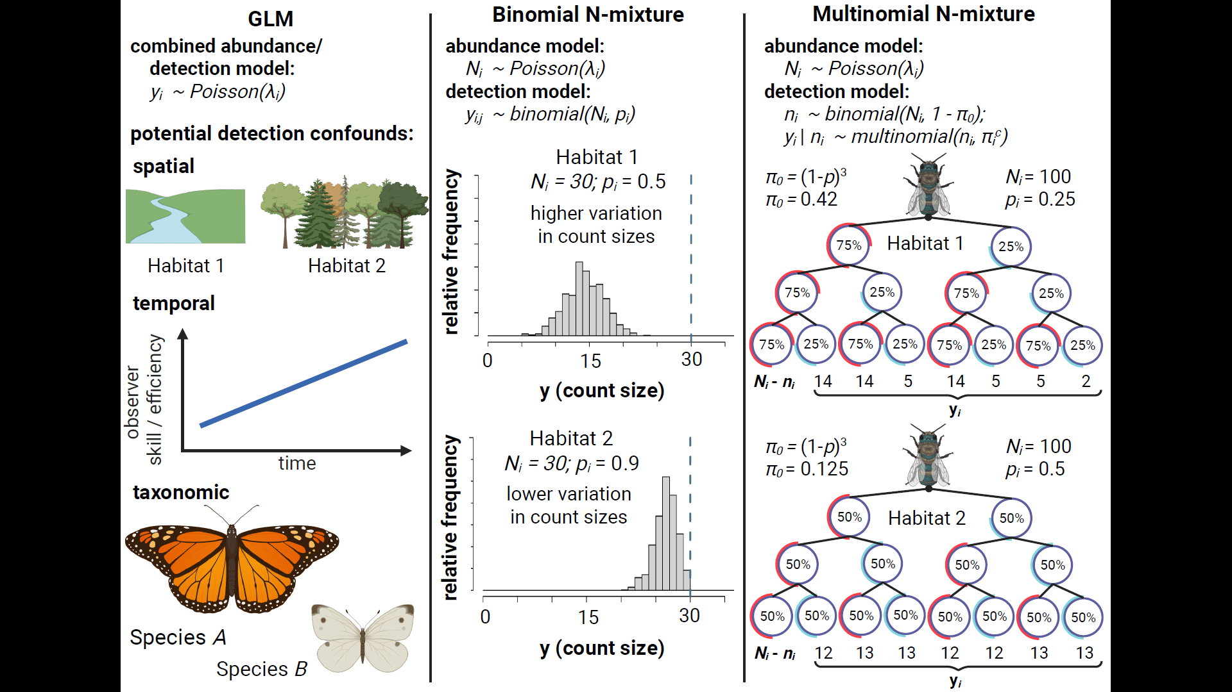
Figure 1: Comparison of three methods for estimating insect abundance. Abundance GLM’s (column 1) treat count data ($y_{i}$) as a stochastic outcome with a mean value ($λ_{i}$) that may vary among spatial units, time periods or species. GLM’s are unable to disentangle effects of these predictors on abundance from their potential effects on detection rate, e.g.: Habitat impacts detectability; observers improve detection skills over time; or larger and more colorful species are detected at a higher rate than smaller and more dull-colored species. Binmix models (column 2) leverage the variation in counts ($y_{i}$) across repeat surveys ($j$) to simultaneously estimate detection rate ($p$) and total abundance ($N_{i}$). Higher variation among counts in Habitat 1 is consistent with lower detection rate (counts heavily underestimate $N_{i}$), while lower variation among counts in Habitat 2 is consistent with higher detection rate (counts nearly approximate $N_{i}$). Multimix models for mark-recapture data (column 3) classify $y_{i}$ as the number of individuals in each observable encounter history, with the total number of individuals detected one or more times ($n_{i}$) dependent on a total population size $(N_{i}$) and the probability of an individual having any of the observable detection histories (1 - $π_{0}$). In a study with three repeat surveys, the probability of never being captured ($π_{0}$) is equal to (1 - $p$)³. Encounter histories can be tracked by placing marks on individual insects. Encounter histories that skew towards infrequent detection in Habitat 1 suggest that there is a high probability of failing to detect individuals across all repeat surveys, i.e., that $π_{0}$ is greater in Habitat 1 versus Habitat 2 and, correspondingly, that $n_{i}$ is likely a smaller proportion of $N_{i}$. Figure created in https://BioRender.com.
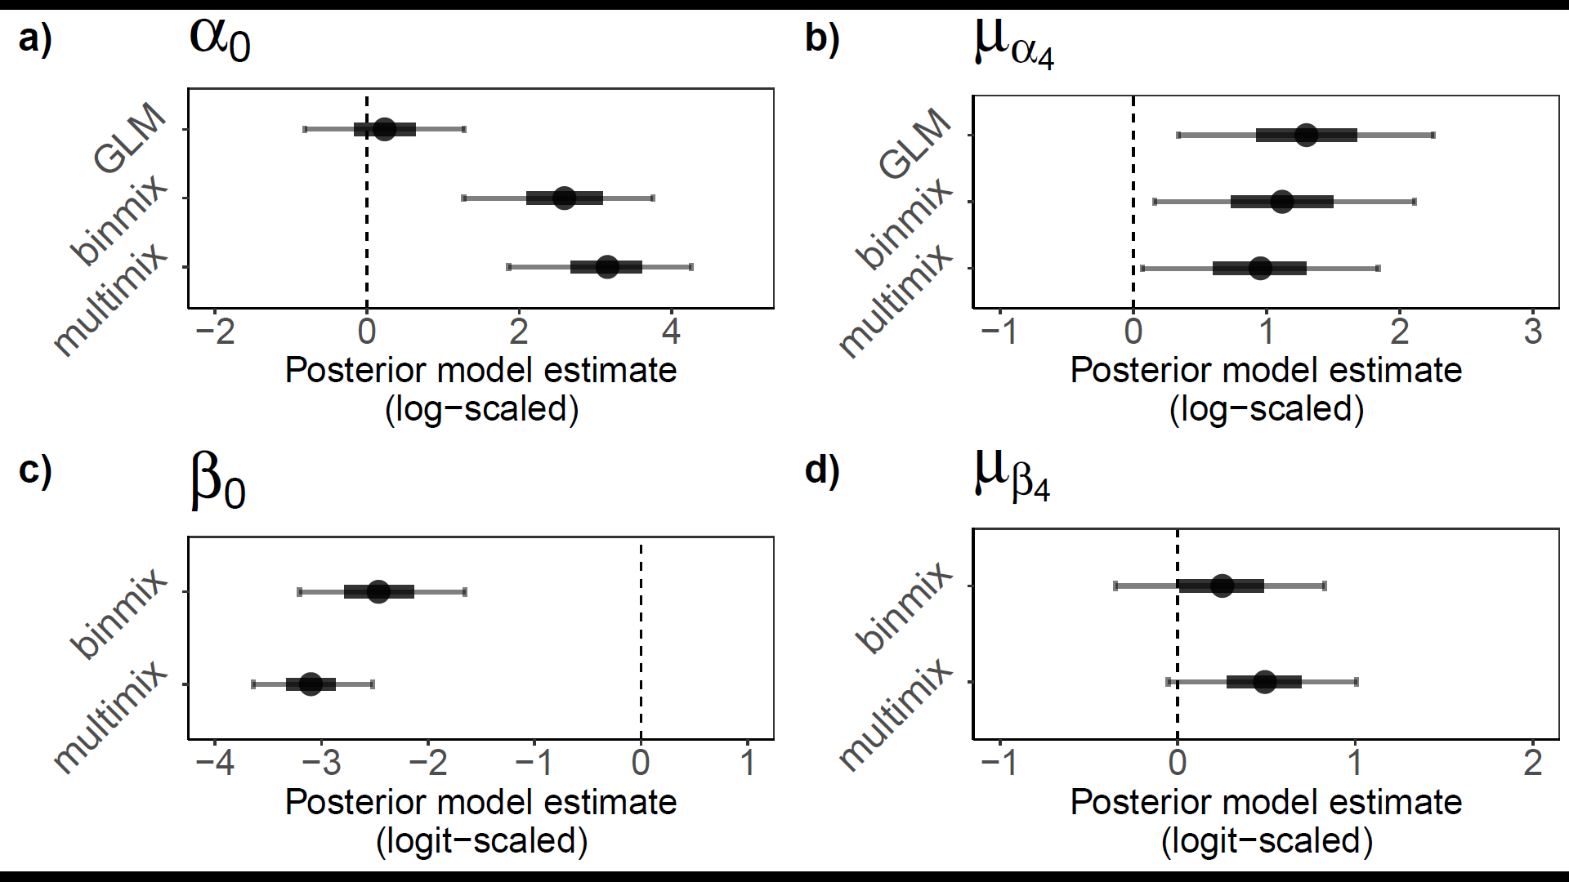
Figure 2: Field study estimates of wild bee abundance and detection. We estimated abundance intercepts (a) and community mean effect of restoration on abundance (b) with all three model types. We estimated detection rate intercepts (c) and community mean effect of restoration on detection (d) for binmix and multimix models, which are designed to estimate and account for imperfection detection. Mean estimates are displayed with filled circles. Thick and thin error bars represent 50% and 90% Bayesian credible intervals.

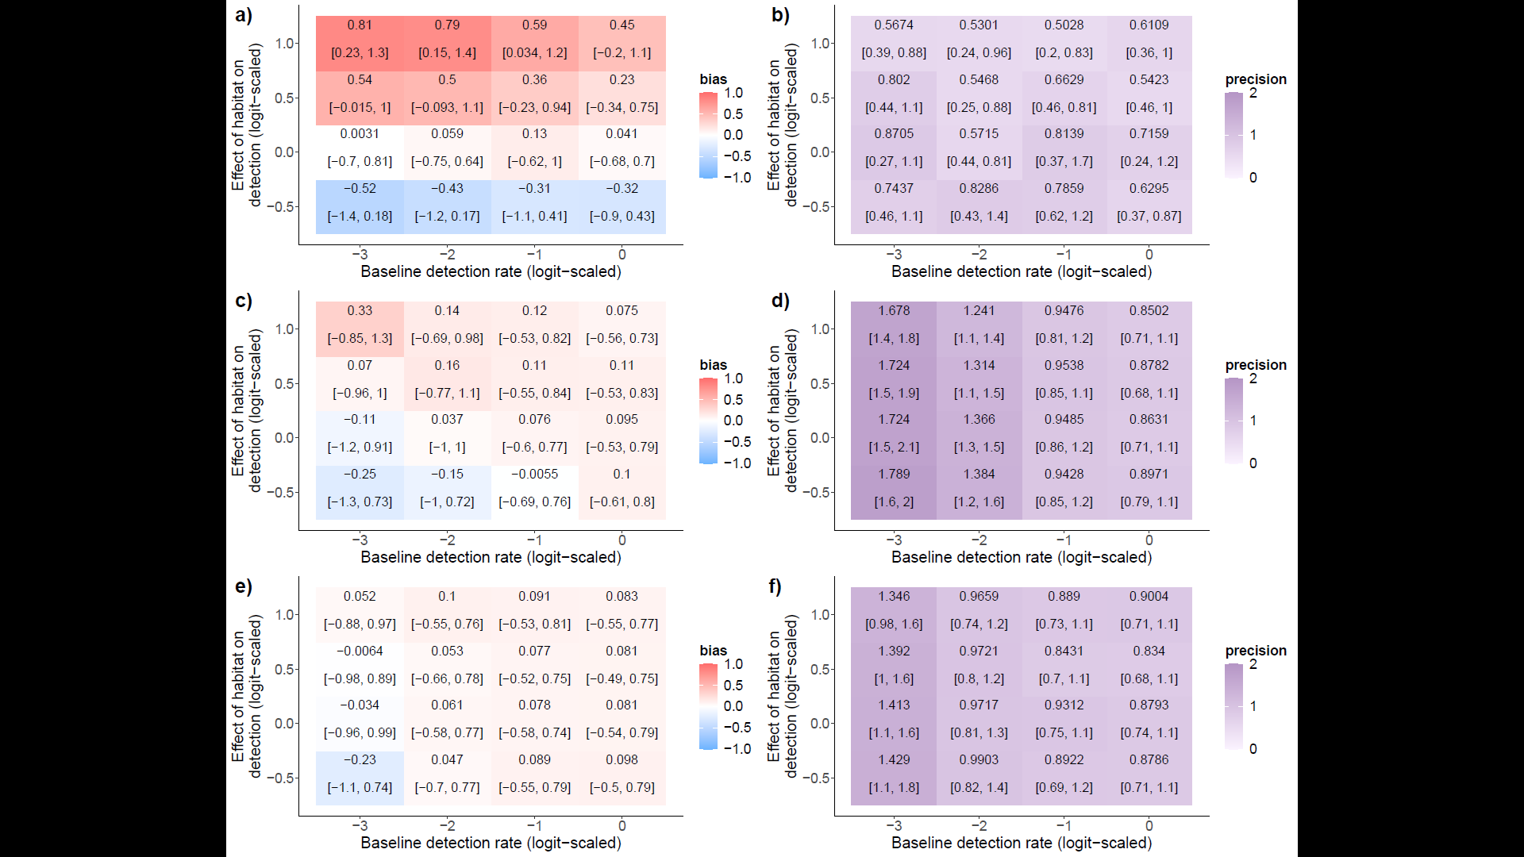
Figure 3: Bias and precision of abundance models under simulated changes in detection rate and effects of habitat restoration on detection: GLM bias (a) and precision (b); binmix bias (c) and precision (d); and multimix bias (e) and precision (f). Positive bias (red) indicates a tendency to overestimate the effect of habitat restoration on abundance while a negative bias (blue) indicates a tendency towards underestimation. Higher values for precision (dark purple) represent wider Bayesian credible intervals (BCIs). Lower values (light purple) represent BCIs with less uncertainty. The mean bias or precision and 90% Bayesian credible intervals are displayed for each simulation parameter combination.
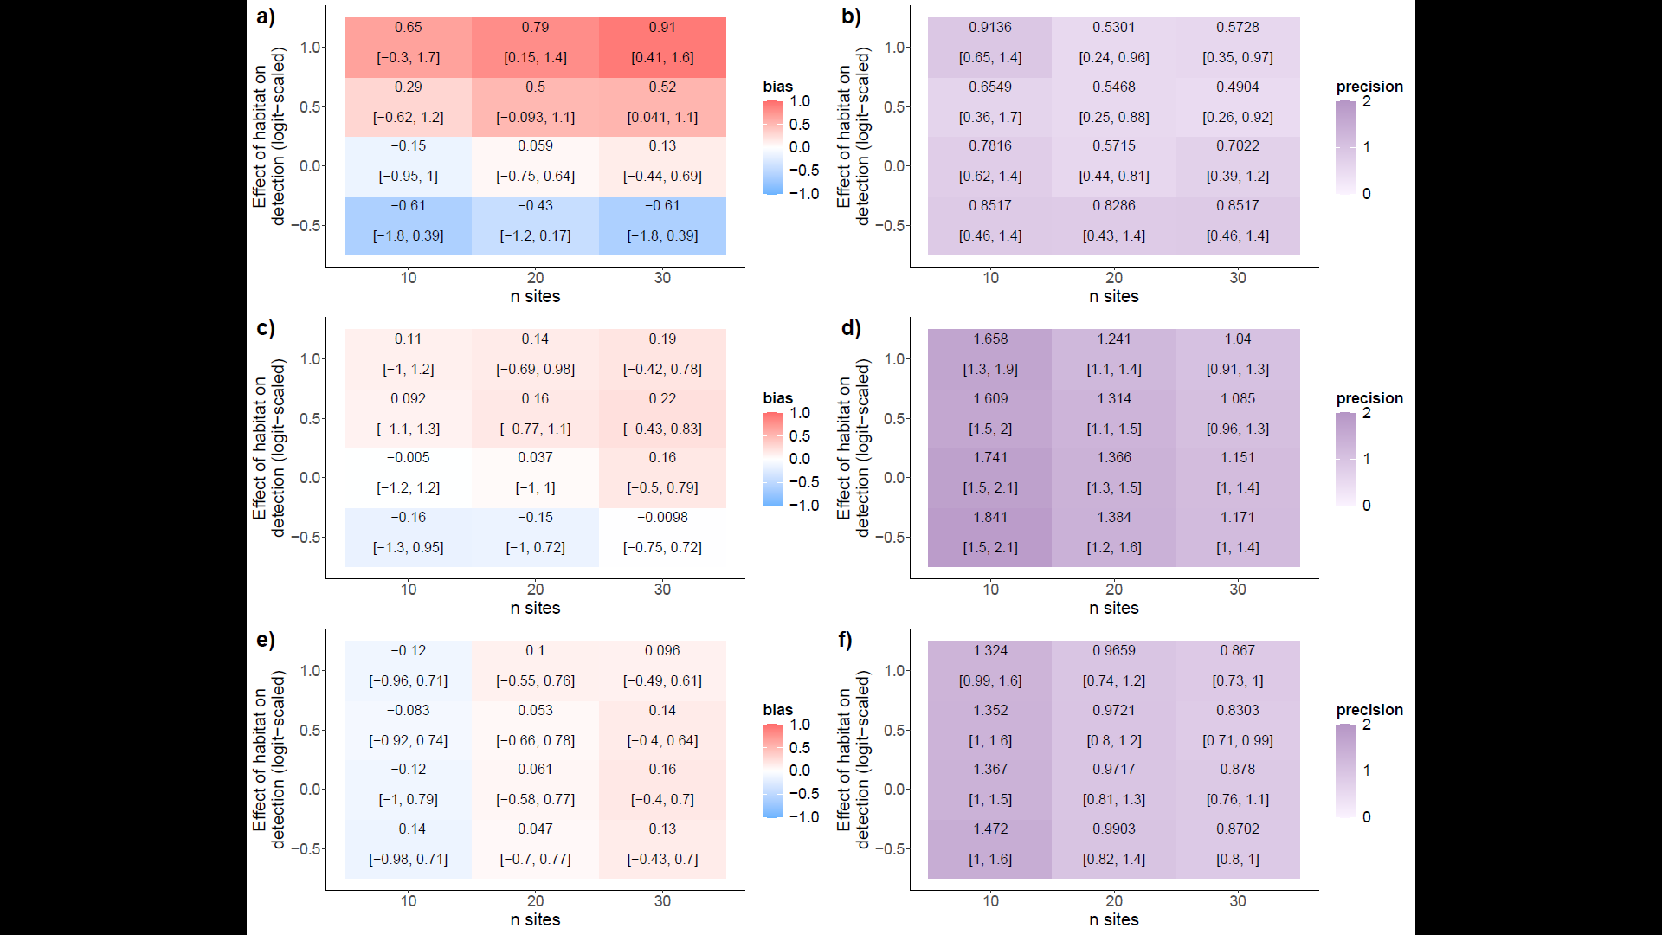
Figure 4: Bias and precision of abundance models under simulated changes in site number and effects of habitat category on detection. GLM bias (a) and precision (b); binmix bias (c) and precision (d); and multimix bias (e) and precision (f). Positive bias (red) indicates a tendency to overestimate the effect of habitat restoration on abundance while a negative bias (blue) indicates a tendency towards underestimation. Higher values for precision (dark purple) represent wider Bayesian credible intervals (BCIs). Lower values (light purple) represent BCIs with less uncertainty. The mean bias or precision and 90% Bayesian credible intervals are displayed for each simulation parameter combination.

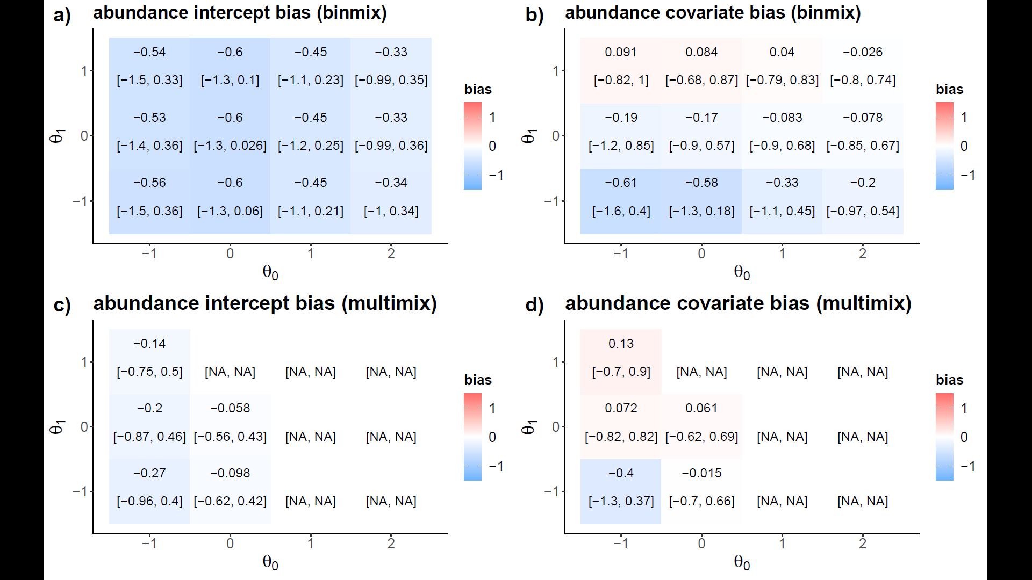
Figure 5: Robustness to closure violations. We simulated variation in the odds that insects remain within a sampling area at the time of a survey event ($θ_{0}$), and the degree to which a site covariate of habitat restoration impacts these odds either positively or negatively ($θ_{1}$). We recorded the bias for estimates of the abundance intercept and for the abundance covariate of restoration for both a binmix model (a and b) and for a multimix model (c and d). Positive bias (red) indicates a tendency to overestimate the target while a negative bias (blue) indicates a tendency towards underestimation. The mean bias and 90% Bayesian credible intervals are displayed for each simulation parameter combination.
Supplemental Materials
Supplemental Tables
Table S1: Site Details. We conducted wild bee abundance surveys in 1-hectare plots located in ten urban park sites in Vancouver, Canada. Detailed vegetation and site management data were reported by Ulrich and Sargent 2025.
Site name | Treatment group | Latitude | Longitude
Killarney Park | Restored | 49.227468 | -123.046616
Locarno Park | Restored | 49.273942 | -123.206008
Oak Meadows Park | Restored | 49.238607 | -123.126438
Prince of Wales Park | Restored | 49.243958 | -123.158084
West Memorial Park | Restored | 49.243227 | -123.189281
Bobolink Park | Control | 49.21503 | -123.057
Gordon Park | Control | 49.223993 | -123.069652
Kensington Park | Control | 49.23772 | -123.076
Moberly Park | Control | 49.215687 | -123.086136
Quilchena Park | Control | 49.242885 | -123.148097

Table S2: Prior distributions for parameters estimated by the abundance GLM.
Parameter | Parameter meaning | Prior Distribution | Justification
$$α_{0}$$ | Global intercept | $Normal$(0, 2) | Weakly-informative centered prior.
$$α_{1}\left[species\right]$$ | Species-specific intercept effects | $Normal$(0, $σ_{α_{1}}$) | Weakly-informative centered prior.
$$σ_{α_{1}}$$ | Variation in species-specific intercept effects | $Half-Normal$(0, 2) | Weakly-informative prior placing more weight near zero, i.e., small variation among groups (positive values only).
$$α_{2}\left[site\right]$$ | Site-specific intercept effects | $Normal$(0, $σ_{α_{2}}$) | Weakly-informative centered prior.
$$σ_{α_{2}}$$ | Variation in site-specific intercept effects | $Half-Normal$(0, 1) | Weakly-informative prior placing more weight near zero, i.e., small variation among groups (positive values only).
$$α_{3}\left[year\right]$$ | Year intercept effects | $Normal$(0, 1) | Weakly-informative centered prior.
$$α_{4}\left[species\right]$$ | Species-specific effects of restoration | $Normal$(0, $σ_{α_{4}}$) | Weakly-informative centered prior.
$$σ_{α_{4}}$$ | Variation in species-specific effects of restoration | $Half-Normal$(0, 2) | Weakly-informative prior placing more weight near zero, i.e., small variation among groups (positive values only).
$$ϕ$$ | Negative binomial dispersion parameter | $Half-Normal$(0, 1) | Weakly-informative prior placing more weight near zero, i.e., overdispersion in counts (positive values only).

Table S3: Prior distributions for parameters estimated by the binmix model.
Parameter | Parameter meaning | Prior Distribution | Justification
ABUNDANCE PARAMETERS
$$α_{0}$$ | Global intercept | $Normal$(0, 2) | Weakly-informative centered prior.
$$α_{1}\left[species\right]$$ | Species-specific intercept effects | $Normal$(0, $σ_{α_{1}}$) | Weakly-informative centered prior.
$$σ_{α_{1}}$$ | Variation in species-specific intercept effects | $Half-Normal$(0, 2) | Weakly-informative prior placing more weight near zero, i.e., small variation among groups (positive values only).
$$α_{2}\left[site\right]$$ | Site-specific intercept effects | $Normal$(0, $σ_{α_{2}}$) | Weakly-informative centered prior.
$$σ_{α_{2}}$$ | Variation in site-specific intercept effects | $Half-Normal$(0, 1) | Weakly-informative prior placing more weight near zero, i.e., small variation among groups (positive values only).
$$α_{3}\left[year\right]$$ | Year intercept effects | $Normal$(0, 1) | Weakly-informative centered prior.
$$α_{4}\left[species\right]$$ | Species-specific effects of restoration | $Normal$(0, $σ_{α_{4}}$) | Weakly-informative centered prior.
$$σ_{α_{4}}$$ | Variation in species-specific effects of restoration | $Half-Normal$(0, 2) | Weakly-informative prior placing more weight near zero, i.e., small variation among groups (positive values only).
$$ϕ$$ | Negative binomial dispersion parameter | $Half-Normal$(0, 1) | Weakly-informative prior placing more weight near zero, i.e., overdispersion in counts (positive values only).
ABUNDANCE PARAMETERS
$$β_{0}$$ | Global intercept | $Normal$(0, 2) | Weakly-informative centered prior.
$$β_{1}\left[species\right]$$ | Species-specific intercept effects | $Normal$(0, $σ_{β_{1}}$) | Weakly-informative centered prior.
$$σ_{β_{1}}$$ | Variation in species-specific intercept effects | $Half-Normal$(0, 2) | Weakly-informative prior placing more weight near zero, i.e., small variation among groups (positive values only).
$$β_{2}\left[site\right]$$ | Site-specific intercept effects | $Normal$(0, $σ_{β_{2}}$) | Weakly-informative centered prior.
$$σ_{β_{2}}$$ | Variation in site-specific intercept effects | $Half-Normal$(0, 1) | Weakly-informative prior placing more weight near zero, i.e., small variation among groups (positive values only).
$$β_{3}\left[year\right]$$ | Year intercept effects | $Normal$(0, 1) | Weakly-informative centered prior.
$$β_{4}\left[species\right]$$ | Species-specific effects of restoration | $Normal$(0, $σ_{β_{4}}$) | Weakly-informative centered prior.
$$σ_{β_{4}}$$ | Variation in species-specific effects of restoration | $Half-Normal$(0, 2) | Weakly-informative prior placing more weight near zero, i.e., small variation among groups (positive values only).

Table S4: Prior distributions for parameters estimated by the multimix model.
Parameter | Parameter meaning | Prior Distribution | Justification
ABUNDANCE PARAMETERS
$$α_{0}$$ | Global intercept | $Normal$(0, 2) | Weakly-informative centered prior.
$$α_{1}\left[species\right]$$ | Species-specific intercept effects | $Normal$(0, $σ_{α_{1}}$) | Weakly-informative centered prior.
$$σ_{α_{1}}$$ | Variation in species-specific intercept effects | $Half-Normal$(0, 2) | Weakly-informative prior placing more weight near zero, i.e., small variation among groups (positive values only).
$$α_{2}\left[site\right]$$ | Site-specific intercept effects | $Normal$(0, $σ_{α_{2}}$) | Weakly-informative centered prior.
$$σ_{α_{2}}$$ | Variation in site-specific intercept effects | $Half-Normal$(0, 1) | Weakly-informative prior placing more weight near zero, i.e., small variation among groups (positive values only).
$$α_{3}\left[year\right]$$ | Year intercept effects | $Normal$(0, 1) | Weakly-informative centered prior.
$$α_{4}\left[species\right]$$ | Species-specific effects of restoration | $Normal$(0, $σ_{α_{4}}$) | Weakly-informative centered prior.
$$σ_{α_{4}}$$ | Variation in species-specific effects of restoration | $Half-Normal$(0, 2) | Weakly-informative prior placing more weight near zero, i.e., small variation among groups (positive values only).
$$ϕ$$ | Negative binomial dispersion parameter | $Half-Normal$(0, 1) | Weakly-informative prior placing more weight near zero, i.e., overdispersion in counts (positive values only).
ABUNDANCE PARAMETERS
$$β_{0}$$ | Global intercept | $Normal$(0, 2) | Weakly-informative centered prior.
$$β_{1}\left[species\right]$$ | Species-specific intercept effects | $Normal$(0, $σ_{β_{1}}$) | Weakly-informative centered prior.
$$σ_{β_{1}}$$ | Variation in species-specific intercept effects | $Half-Normal$(0, 2) | Weakly-informative prior placing more weight near zero, i.e., small variation among groups (positive values only).
$$β_{2}\left[site\right]$$ | Site-specific intercept effects | $Normal$(0, $σ_{β_{2}}$) | Weakly-informative centered prior.
$$σ_{β_{2}}$$ | Variation in site-specific intercept effects | $Half-Normal$(0, 1) | Weakly-informative prior placing more weight near zero, i.e., small variation among groups (positive values only).
$$β_{3}\left[year\right]$$ | Year intercept effects | $Normal$(0, 1) | Weakly-informative centered prior.
$$β_{4}\left[species\right]$$ | Species-specific effects of restoration | $Normal$(0, $σ_{β_{4}}$) | Weakly-informative centered prior.
$$σ_{β_{4}}$$ | Variation in species-specific effects of restoration | $Half-Normal$(0, 2) | Weakly-informative prior placing more weight near zero, i.e., small variation among groups (positive values only).

Supplemental Figures
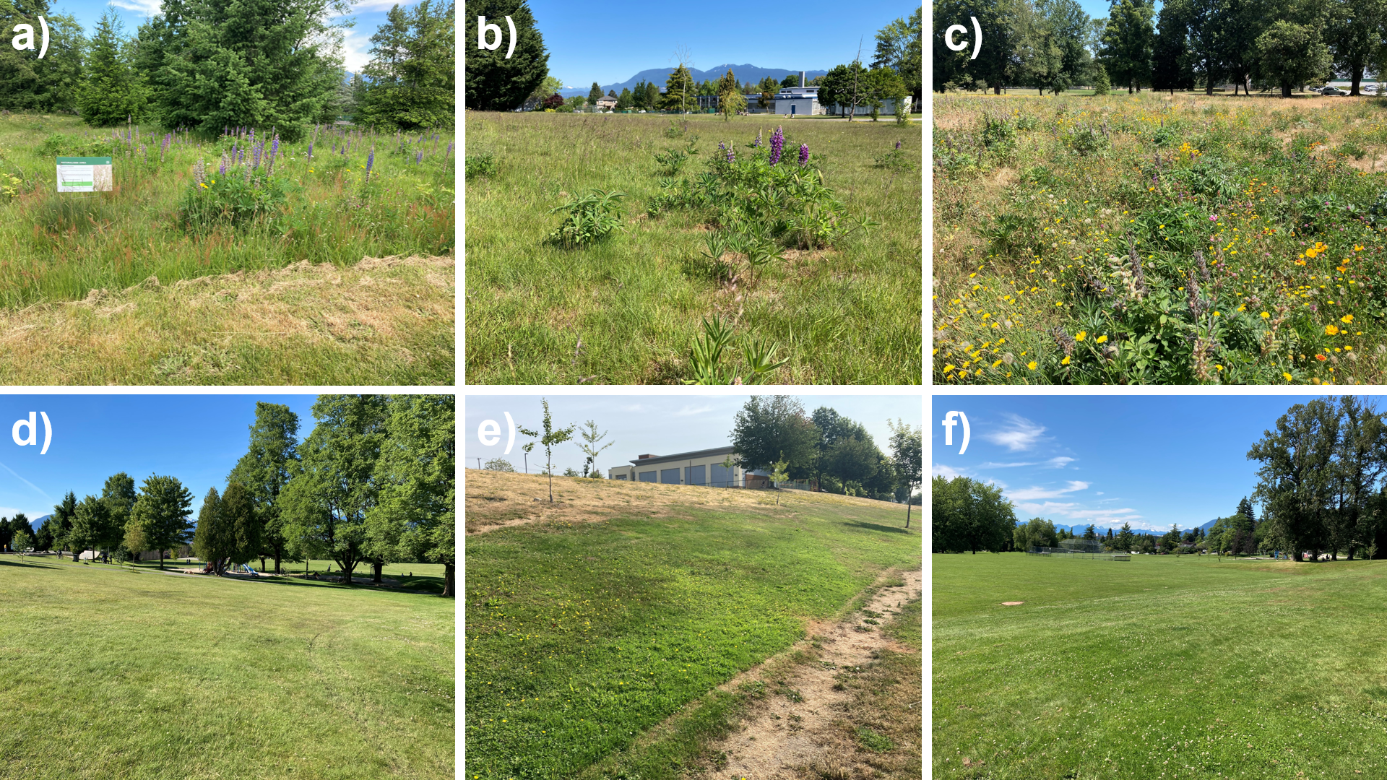
Figure S1: We conducted abundance surveys at ten urban park sites in Vancouver, Canada. Five of the sites were historically turfgrass dominated but received a restoration amendment of about 1 hectare area. The restoration consisted of herbaceous flower seeding combined with no mowing during the spring and summer months. Some restored site examples include Oak Meadows Park (a), Prince of Wales Park (b), and Killarney Park (c). In control sites, turfgrass areas were not amended with a restoration. Some control site examples include Kensington Park (d), Moberly Park (e), and Quilchena Park (f). Restored sites had significantly more flower resources and were characterized by taller herbaceous vegetation.

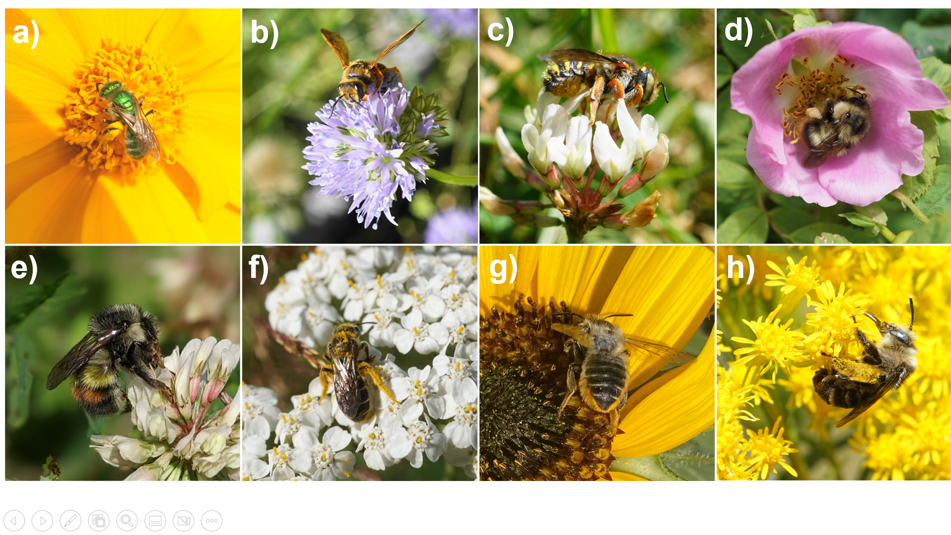
Figure S2: We targeted 8 wild species in our abundance surveys: Agapostemon texanus (a), Andrena prunorum (b), Anthidium oblongatum (c), Bombus mixtus (d), Bombus flavifrons (e), Halictus rubicundus (f), native Megachile spp. (g), and Melissodes microstictus (h). The picture of B. flavifrons was taken by Sarah Knoerr and used with permission.
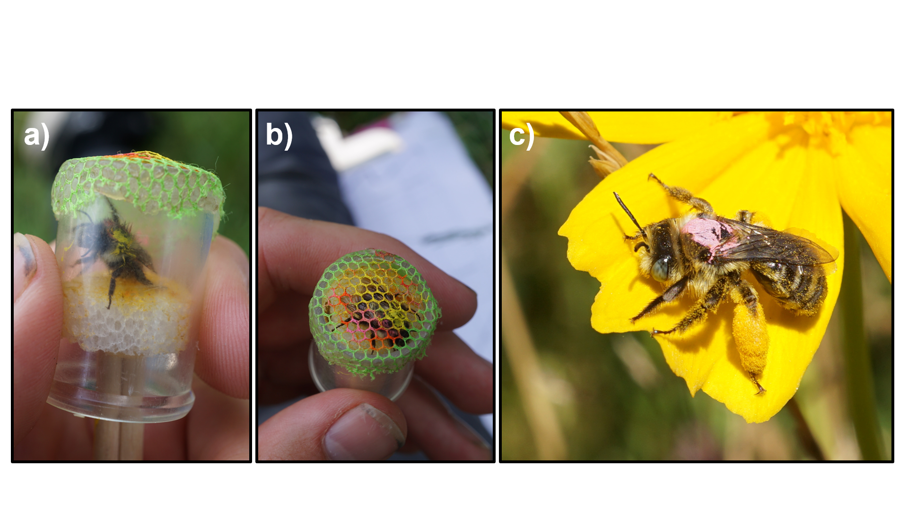
Figure S3: Mark-recapture method. We placed chilled bees in a modified vial with a styrofoam plunger on one end (a). Chilling the bees allowed for easier handling. We used the plunger to press the thorax of the bee against a mesh covering on the opposite side of the vial (b). We used a Molotow brand paint pen to place a mark on the thorax. The mark was colour-coded to correspond to the unique capture date. In (b), the bee was captured on two occasions. It has a yellow mark indicating the first capture and a pink mark representing the second. After marking, we released the bees back to the survey area. We observed that bees then resumed normal foraging behaviour, usually after sunning themselves for a few minutes (c).

- 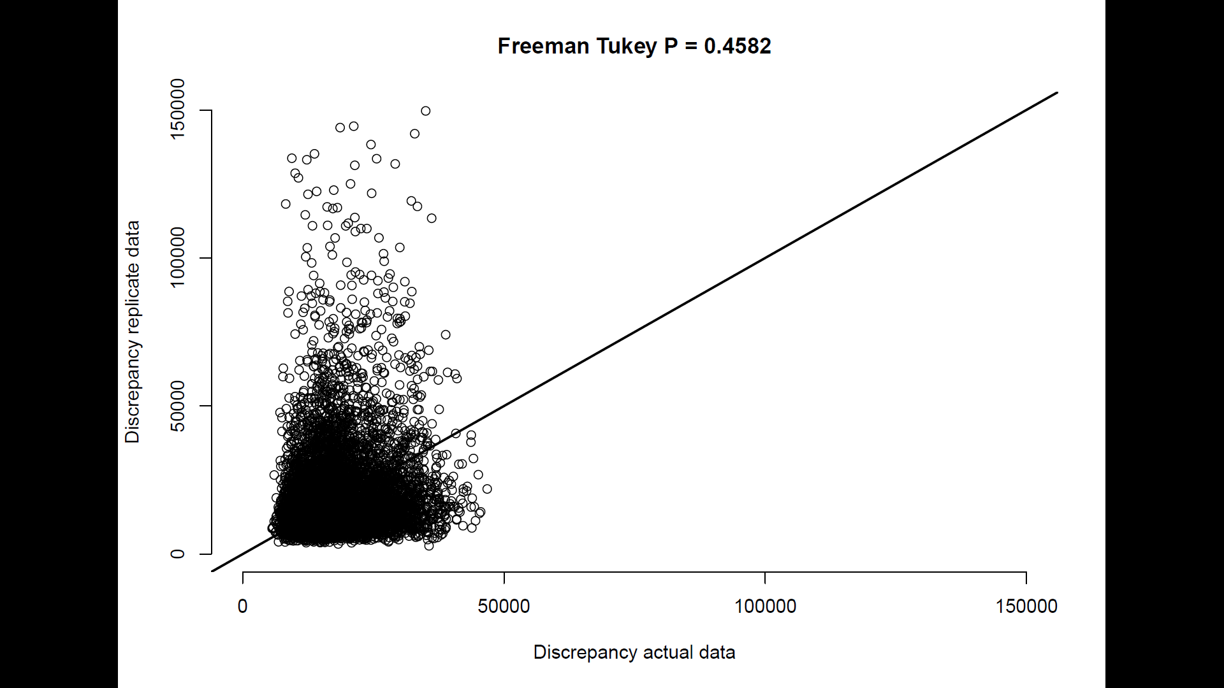
- 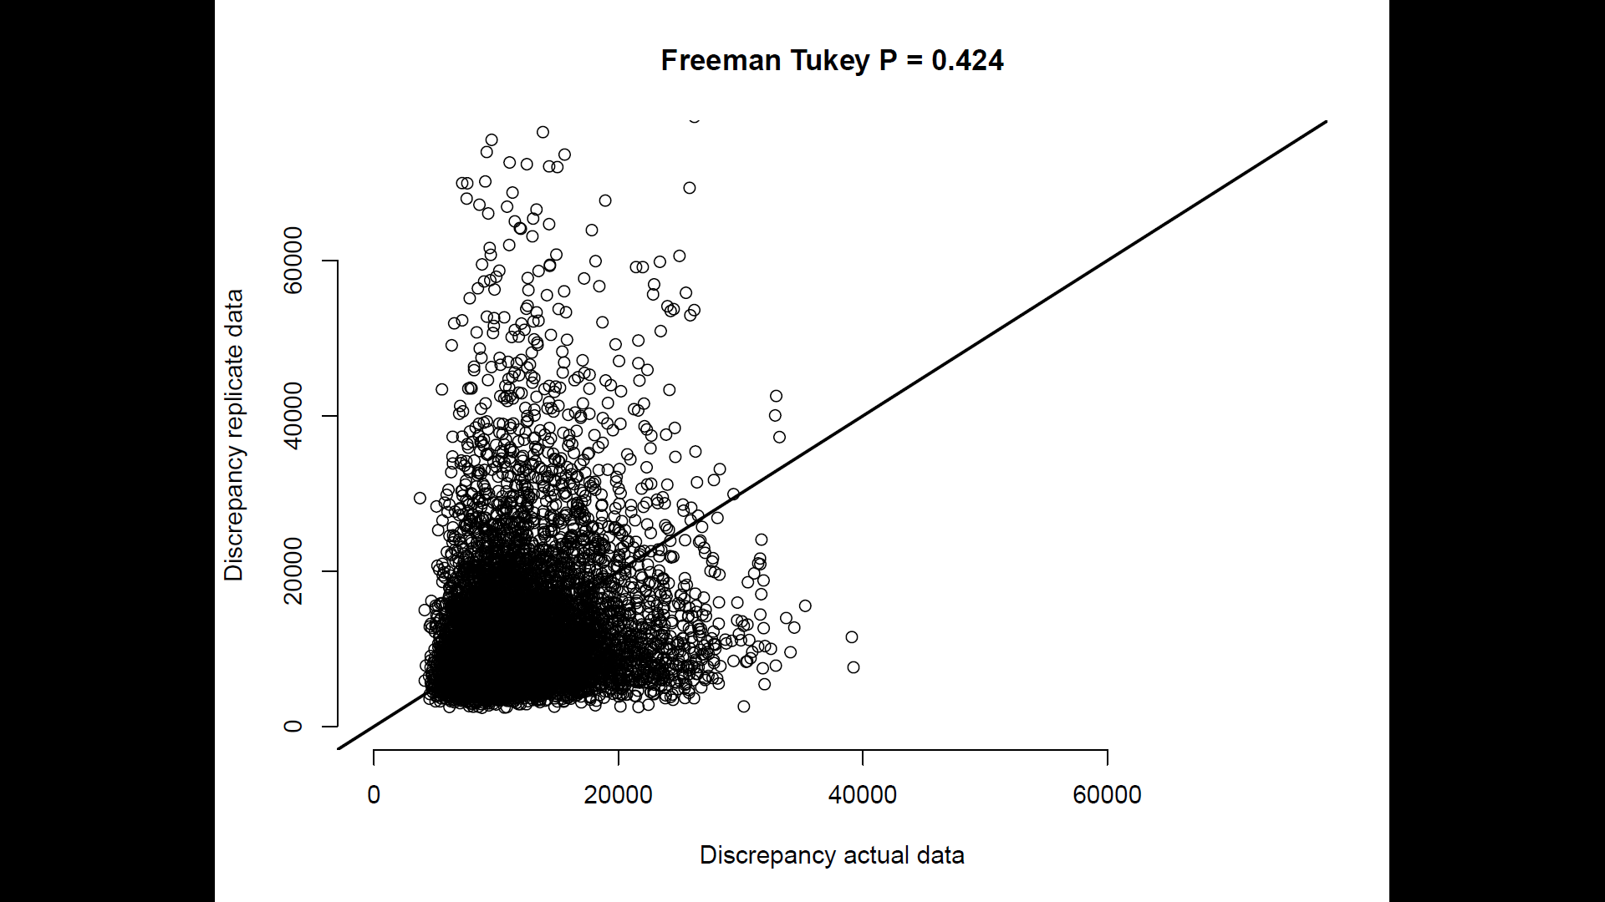
- 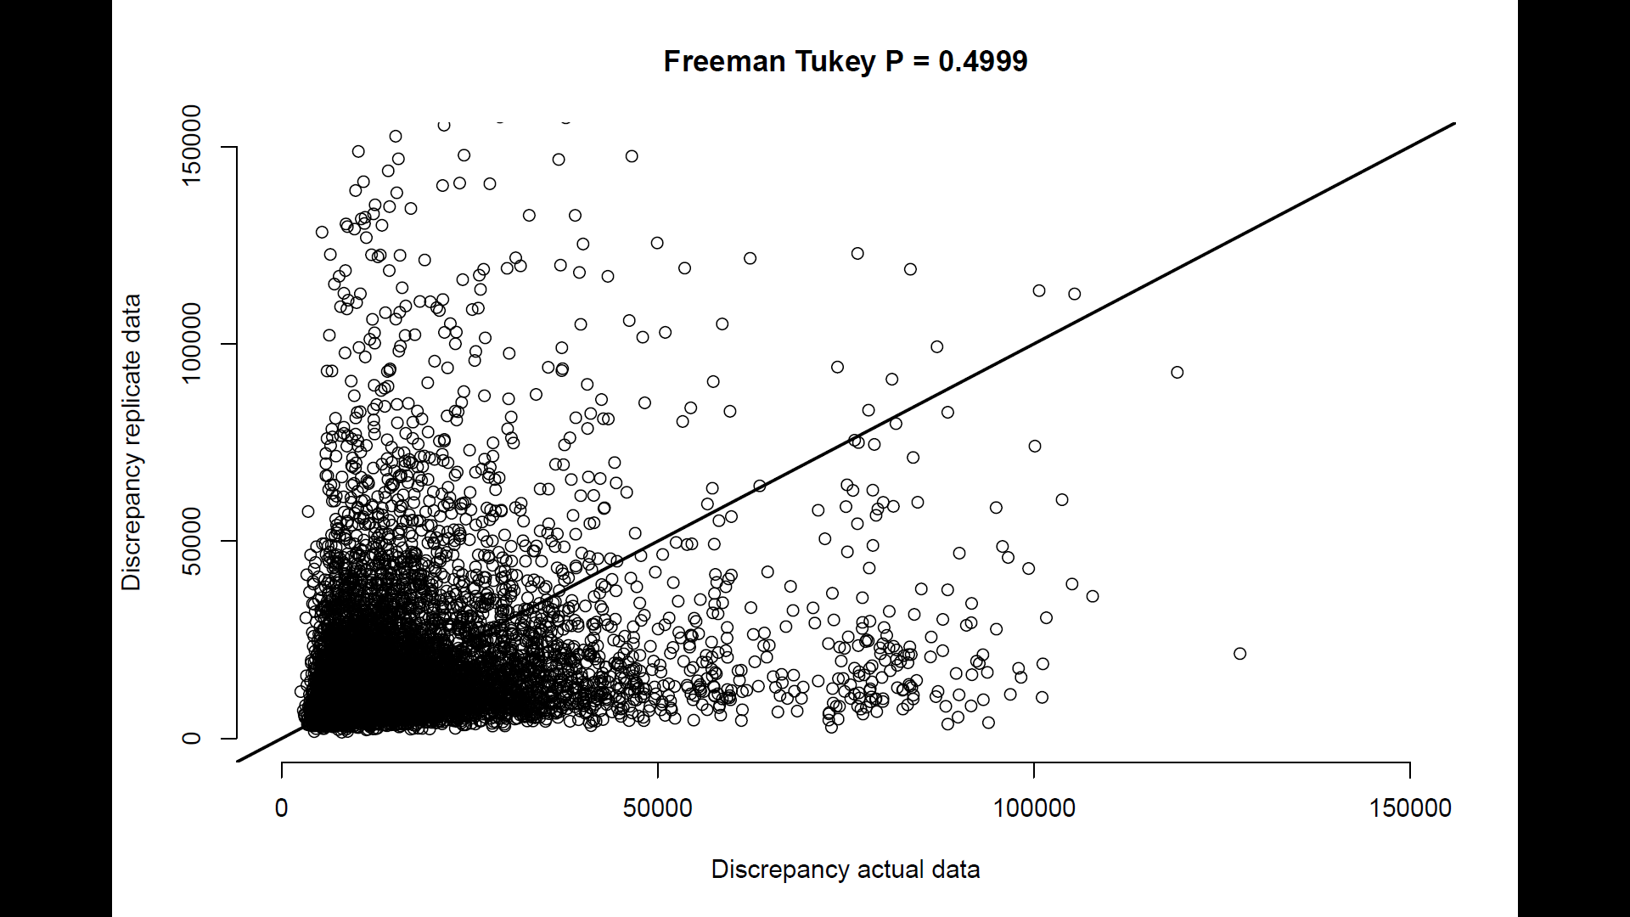
Figure S6: Posterior predictive check plots for GLM (a), binmix model (b), and multimix model (c), and for models using a Poisson distribution for abundance which showed poor fit (d, e, and f). To assess model fit, we conducted Freeman-Tukey statistic discrepancy tests for each model (Conn et al., 2018; Kery and Royle, 2020). This test evaluates the difference in discrepancy between simulated data or real data versus an expected outcome. To conduct the test, we simulated some data (y_replicated) using the parameter estimates at each step of the HMC run. Data were counts of the number of individuals detected per species per site-survey (a, b) or the number of individuals detected at least once per species per site across all three surveys (c). We then simulated some new data from the same parameter estimates (y_new). We calculated the Freeman-Tukey discrepancy for all y_new across all sampling events i, and also for our actual data y:
$Fit discrepancy(y_{new})$ = $\sum_{i}^{R}{(square(y_new[i] - y_replicated [i]) / (y_replicated [i] + 0.5)}$
$Fit discrepancy(y)$ = $\sum_{i}^{R}{(square(y[i] - y_replicated [i]) / (y_replicated [i] + 0.5)}$
We then calculated the frequency in the posterior distribution of samples at which the fit discrepancy for $y_{new}$ is greater than the fit discrepancy for $y$. Values near 0.5 suggest reasonable goodness of fit, i.e., that newly simulated data tend to be more or less as far away from some other simulated data as our real data. Values below 0.05 or greater than 0.95 indicate critical lack of model fit. FTP values were less than 0.05 for models for our field data that used a Poisson distribution for the abundance random variable, which prompted us to use negative binomial distributions.
Conn, P. B., Johnson, D. S., Williams, P. J., Melin, S. R., & Hooten, M. B. (2018). A guide to Bayesian model checking for ecologists. Ecological Monographs, 88(4), 526-542.
Kéry, M., & Royle, J. A. (2020). Applied hierarchical modeling in ecology: Analysis of distribution, abundance and species richness in R and BUGS: Volume 2: Dynamic and advanced models. Academic Press.

- 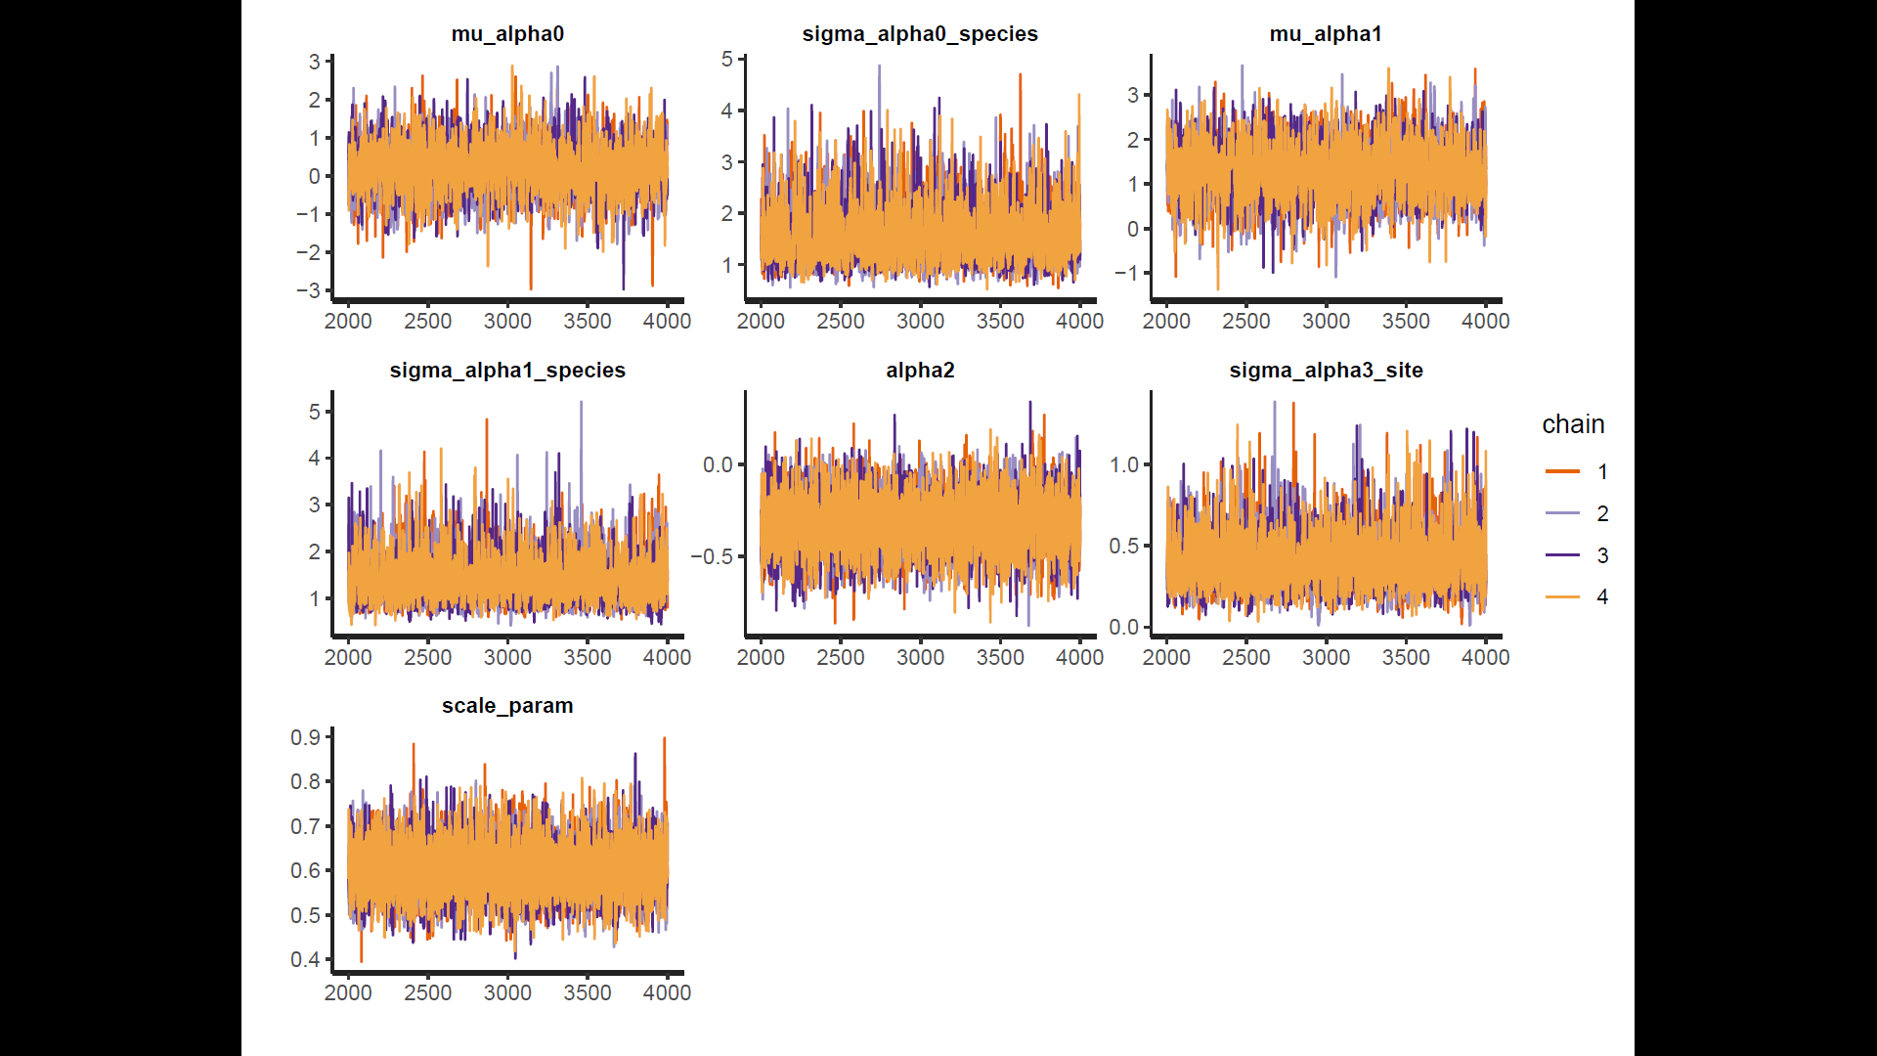
- 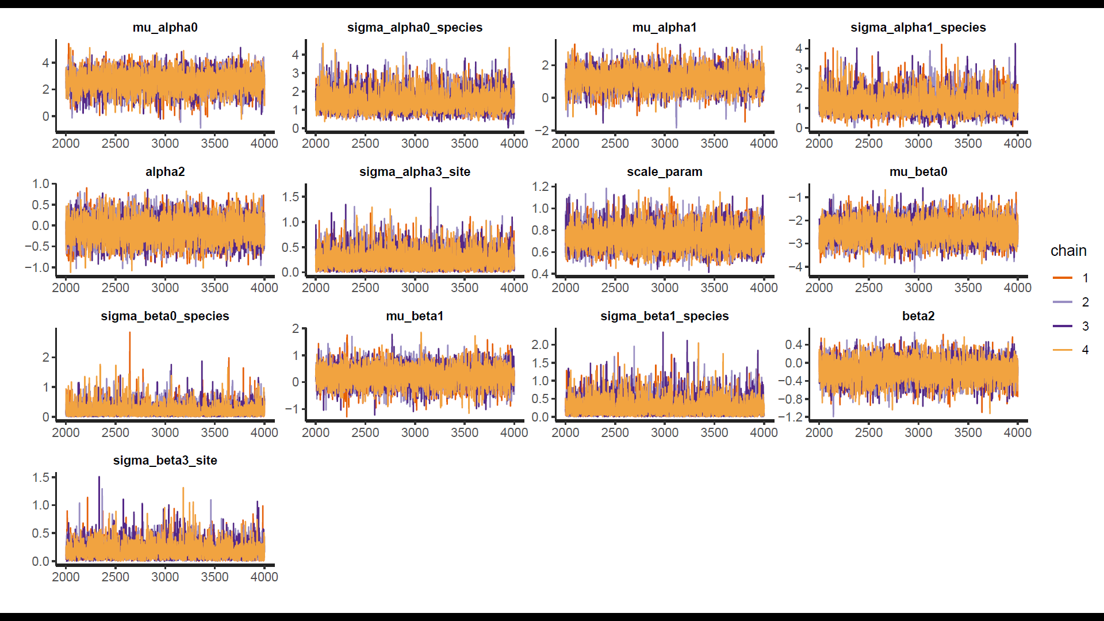
- 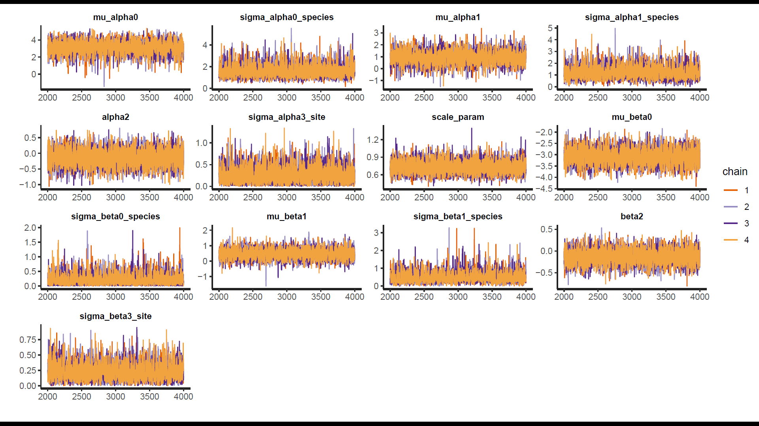
Figure S5: Traceplots for the GLM (a), binmix model (b), and multimix model (c). Overlapping HMC traces indicate that all 4 chains have converged on a similar parameter space.

- 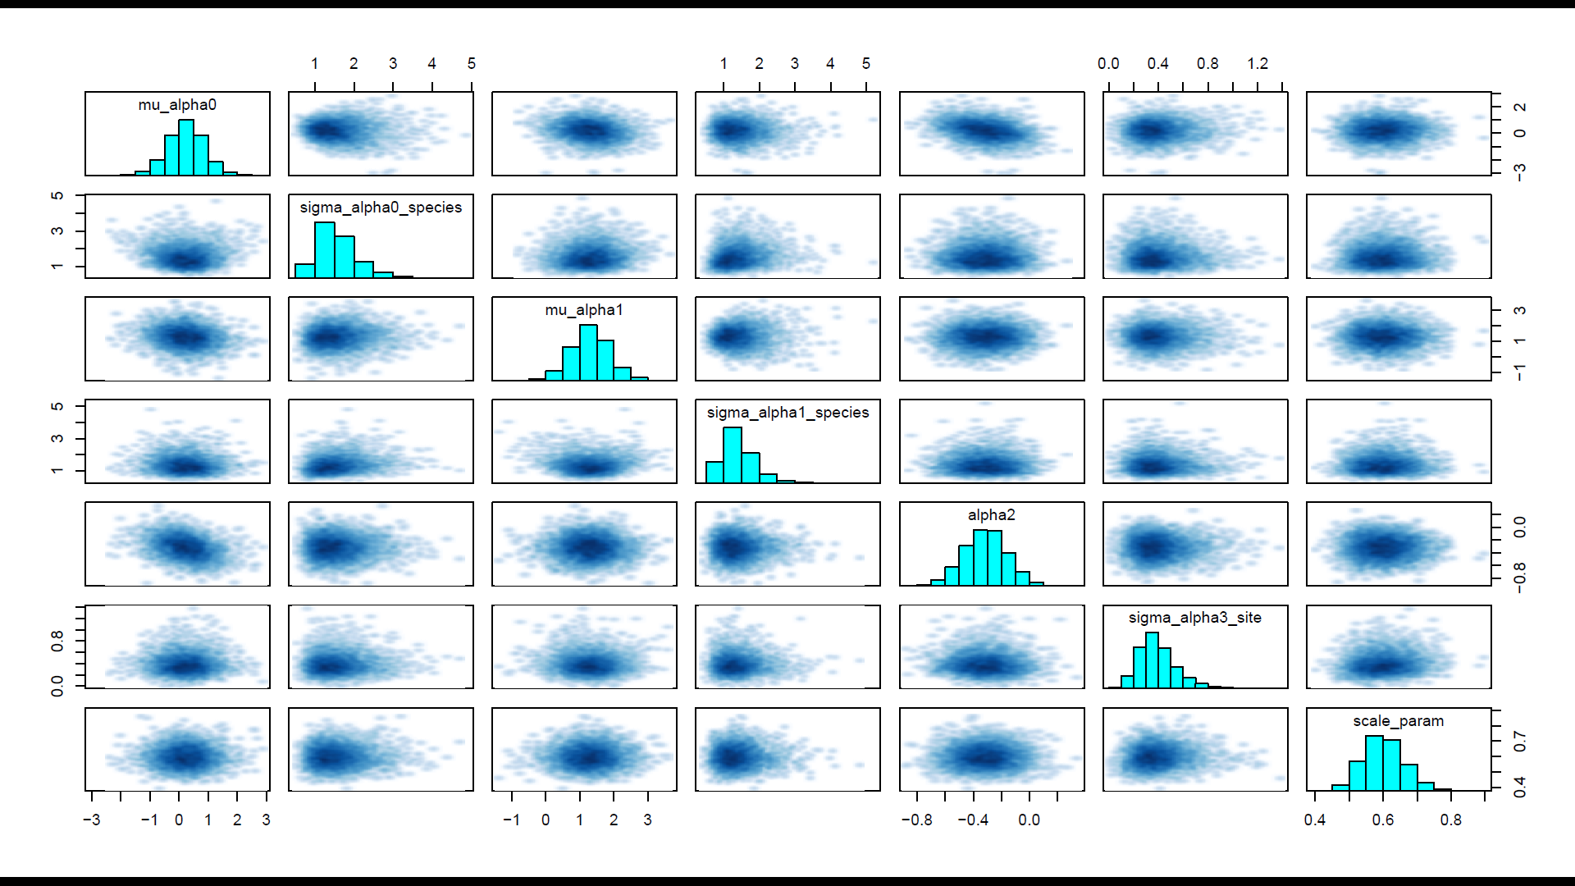
- 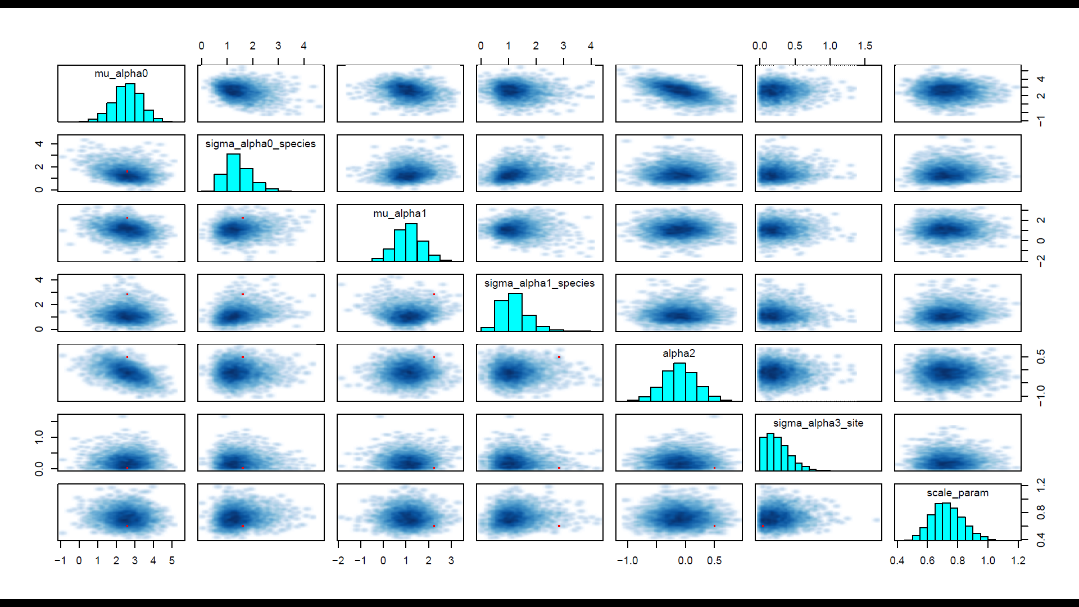
- 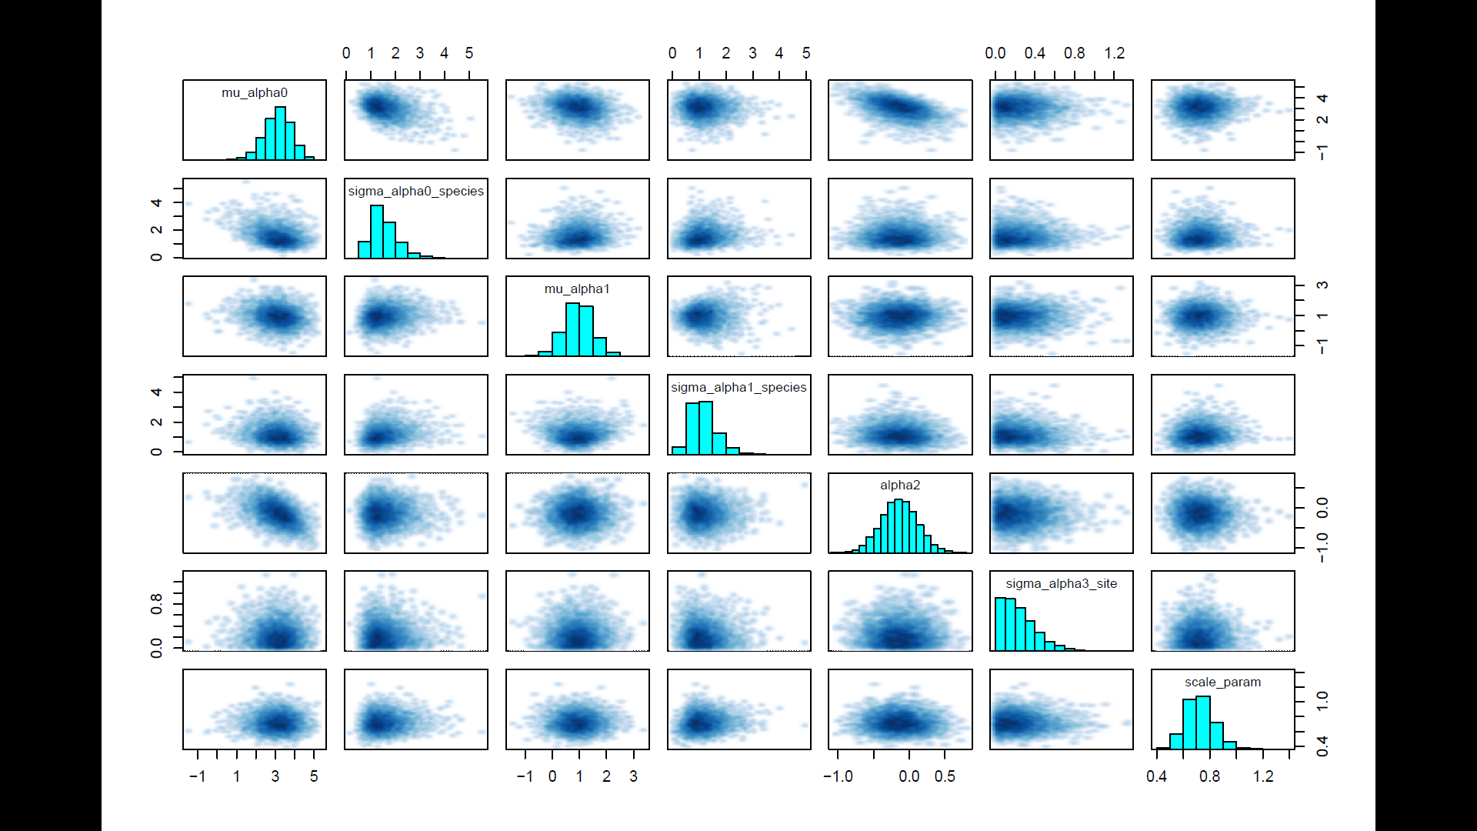
Figure S6: Pairs plots for the GLM (a), binmix model (b), and multimix model (c). Pairs plot are shown for a sample subset of parameters (abundance parameters). The lack of divergent transitions and no visual barriers in the parameter space in these pairs plots search support that the posterior distribution has been fully explored.

