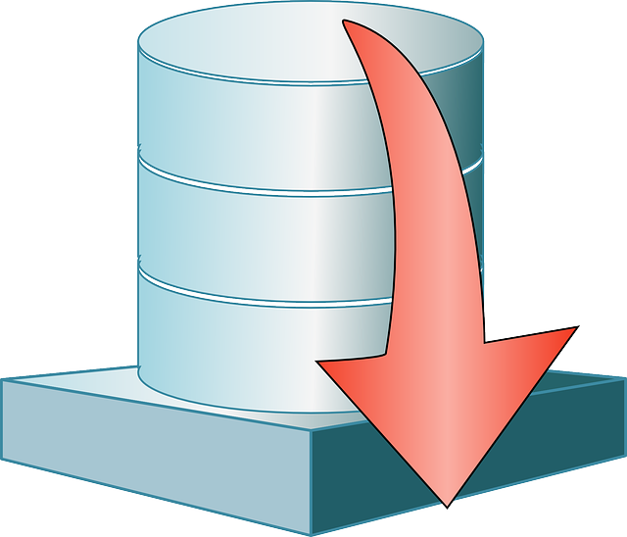

Jason Jensen and Ibra Cisse  CS 4318  February 21, 2016

Database project for CS 4318

# Team Members:

Ibra Cisse

Jason Jensen

Project Name: Recommendation of medication

**Table of Content**

1. Abstract………………………………………………………………………3
2. Introduction…………………………………………………………………4
3. Product Description……………………………………………………….5
4. Database Functionalities….…………………………………………….5
5. Relationship…………………………………………………………………6
6. E/Diagram…………………………………………………………………..7

**Abstract**

When sick, a trip to the drug store is an unpleasant endeavor. Even knowing your illness, choosing the best medication to alleviate your symptoms can be difficult due to the large number of options available. This project would make this choice, and therefore the trip, much simpler. By inputting a list of symptoms, the database will cross reference and recommend the best medication for your symptoms. Medication is ranked according to effectiveness based on an ever growing list of surveys. These symptoms would include: headaches, toothaches, stomachaches, allergies, etc.

**Introduction**

This project is meant to help regular people choose the best over the counter medication for minor illnesses. The concept is to develop a system where users can input the symptoms that they are experiencing and based on research and feedback from customers and medical documentation, we provide a recommendation of the best over the counter pills to take to alleviate the symptoms. The application will use several tables and databases which will have several indexed tables. The databases will be tied to each other with an index id to quicken queries. Once queried the application will search the databases that contain a medicines description and ranking, based on reviews from other users and scientific documentations, queries will then return the top sorted medicines for the specified symptoms along with their description. The results will be presented through a custom made user interface. Users will be able to select from drop down menus to view medicine descriptions and ranking. Users will also have the choice to log in and write reviews which will influence the ranking of medication.

**Database Description**

This database will allow most people to select the best medication to alleviate symptoms whilst sick. Our intent is to provide a recommendation for the best medication for minor illnesses that do not warrant a trip to a doctor or to simply have on hand as first aid. Within our ER diagram, we have included preliminary Primary keys and all references this project will have. This might change as we progress further into development and create a more consistent recommendation system based on ratings and reviews. Different users will have different views based on their level of access. For example, an administrator will be able to create, add, or delete rows based on the circumstances such as adding new medicine, archiving medicine that has poor reviews, or updating relevance of reviews and ratings. The typical user will be able to view medicines, rate medicine, and write a review for future users.

**Database Functionalities**

The following database will have tables and functions such as:

1. Table for clients which will include Index ID, username, password, first name, last name, age, and sex.
2. Another table will hold medicine which will be linked to the clients’ table by IDs as primary keys, and the rest will have foreign keys. As for medicines, they will have several rows that holds the brand and generic names as well as the description and usage.
3. A third table will hold all of the symptoms that someone might have. These will have a description field where they will be linked to other tables such as medicine and which users have listed them before.
4. A rating and review table which will be linked to client, medicine, and sickness by indexed ids. The remaining fields will have foreign keys for faster access to information.
5. Administrators will be able to update all fields, create new fields, update rows, and change ratings.
6. Administrator will be able to delete rows based on relevant information that have been given or recorded on the database
7. Users will be able to register and log in to write reviews, rate medicine, and give suggestion.

**Relationships between Tables**

* The client and medicine tables will be linked based on IDs which will be the primary key. The rest will be foreign keys.
* The medicine table will be linked with the symptom table, each medicine will become a member of a symptom, which will hold a description of that symptom and the medicine most recommended to alleviate it.
* Ratings and reviews will be linked to the symptom and the medicine tables, it will be based on how many reviews have been received. Each review will be rated from 1 to 10.
* Updating will go to the targeted field based on customer ID, then the symptom table and the medicine will be given a review and rating. The average rating, along with number of reviews, will be display towards top bar of the page.
  + Two different type of client: regular user and administrator
  + Administrator can make changes towards core database
  + User can only update information and rating systems through reviews.

E/R Diagram

