Systematic Review Data Repository (SRDR)
User Manual
Version 9.0

Tufts EPC
May 2012

Table of Contents

Introduction 3
What is the SRDR? 3
User Manual Goals 3
Getting Started 4
SRDR Overview 4
Public 7

Data Viewing 8

Search 8
CommentatorData Viewing 10

Search 10

Registration 10

Commenting 11
Contributor 12

Data Viewing 13

Registration 13

Your Workspace and Basic Navigation 13

Help and SRDR Iconography 13

How To 15

Create a Project 15

Edit an Existing Project 15

Add/Edit Users and User Roles 16
Create an Extraction Form 17
Edit an Existing Extraction Form 24
Add a Study 28

Extract a Study 28
Project Tools 33

FAQ 37

Introduction

What is the SRDR?

The Systematic Review Data Repository (SRDR) is a Web-based tool for the extraction and management of data for systematic review or meta-analysis. It is also an open and searchable archive of systematic reviews and their data. With the SRDR you can:

- Create flexible extraction forms for use by your research team
- Manage team members and their privileges
- View, validate and analyze data extracted for your systematic review project
Forthcoming:
- Easily import data from previous reviews or extracted with other software, for simplified search and management
- Search for, view, and download all archived reviews, data, and extraction forms

The SRDR was designed and implemented by the Tufts Evidence-based Practice Center with funding from the Agency of Healthcare Research and Quality. Its goal is to reduce the burden of conducting systematic reviews by encouraging researchers to contribute data to a shared archive, allowing the wider scientific community to easily find, evaluate, and repurpose these data in future research. The online software application component of the SRDR serves as the interface for this database as well as a compelling option for organizing and carrying out systematic review projects.

User Manual Goals

The purpose of this manual is to familiarize users with the SRDR software and archive, and to provide step-by-step instructions for all of the most common SRDR tasks. Specifically, users will be instructed how to:

- Create and edit systematic review projects
- Add users to projects and adjust user privileges
- Create and edit extraction forms
- Use an extraction form to enter data into a systematic review project

Getting Started
This section provides a brief overview of the general conventions of the user manual as well as the SRDR Web site, including basic terminology, how to navigate your workspace, the typical workflow and lifecycle of an SRDR project, and how to access the system’s online help resources.

SRDR Overview

All data within the SRDR are organized into projects. Projects are self-contained and comprise all information related to an individual systematic review. Among this information are the central research queries the project is intended to address, called key questions. At least one key question must be defined for any project. Projects further contain sub-elements called studies and extraction forms. Extraction forms are the dialogs by which users extract data from publications into an SRDR project. A study, as defined within the SRDR, represents an individual extracted publication (one filled in extraction form).

- Project: All data deposited within the SRDR are organized as individual projects. A project contains all information related to one systematic review (e.g., extraction forms, key questions, extracted studies, etc.).
- Key Question(s): The specific scientific queries an SRDR project is intended to address. All projects must include at least one key question.
- Extraction Form: The user-defined dialogue by which collaborators extract data from relevant publications into an SRDR project.
- Study: An individual publication extraction, consisting of one instance of a filled out extraction form.

Figure 1. SRDR Overview

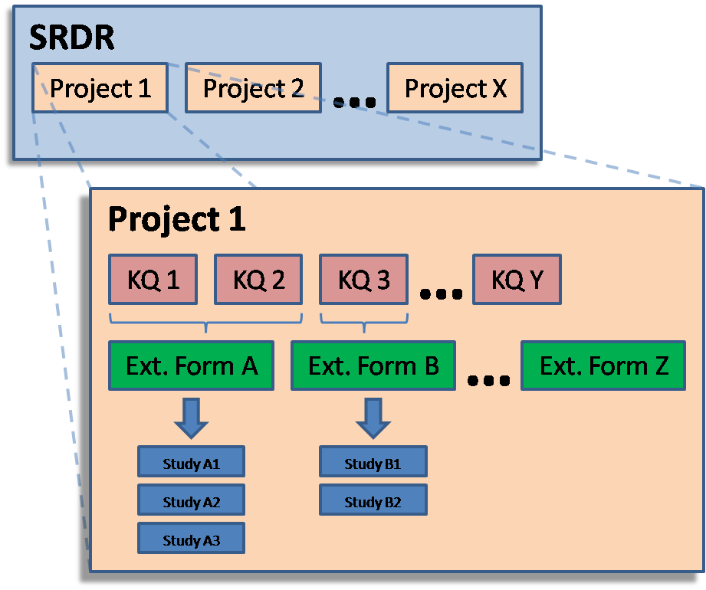

Access to projects and certain elements of project functionality are restricted based on the user’s role within a project (either lead or collaborator). When a new project is created, the creator is automatically designated as lead. The lead can add collaborators or designate new leads or collaborators (see Add/Edit Users and User Roles under How To for instructions). Only leads may create extraction forms or manage users. Collaborators may only use extraction forms to extract data into a project.

The general life-cycle of an SRDR project begins with its initial creation and then proceeds through the definition of the project’s key question(s), design of one or more extraction forms, addition/extraction of one or more studies, and finally review and publication. “Publication” denotes a project’s formal deposition into the SRDR, and the point at which it and its data become publically accessible.

Figure 2. SRDR Project Life-cycle

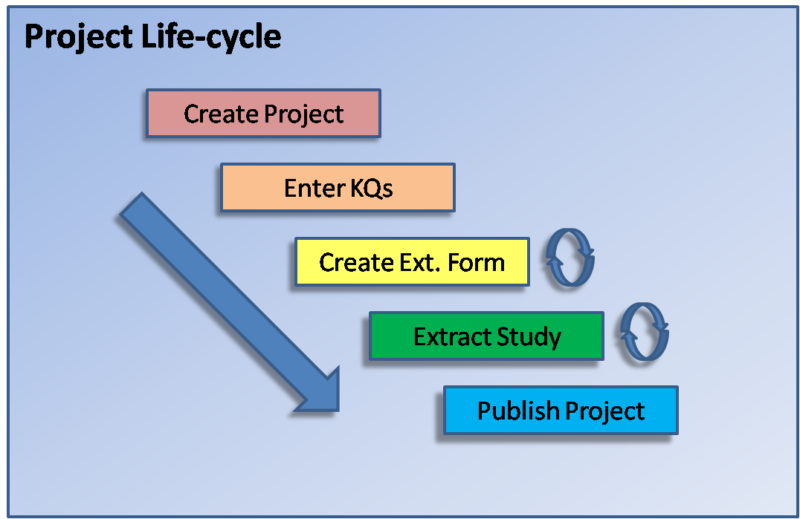

Public

Data Viewing

All members of the general public, including commentators and contributors, can view data from published projects from SRDR.

Click Preview for the project of interest under the Published Projects tab on the SRDR homepage. This allows all users to see the Title and Description, Key Questions, Associated Extraction Forms, and Associated Studies within the project.
Clicking an associated study will bring up the completed extraction form for a study.

Search
Within SRDR, the general public can search for both projects and studies using keywords.
- Click within the textbox next to the Search icon in the upper right corner of the SRDR interface
- Enter keywords most relevant to the project or study of interest
- Click the Search button.
- Results will appear under 2 headings: SR-Level Results or Study-Level Results.
- To choose the items you are interested in, simply click the title of the result within the list.
  - SR-Level Results will reveal a description of the project and all studies included in the review
  - Study-Level Results provide a description of the study as well as a description of the project to which it is included.
- Click the title of the result to open a description of the project or the study of interest

Commentator

Data Viewing

All members of the general public, including commentators and contributors, can view data from published projects from SRDR.

Click the project of interest under the Published Projects tab on the SRDR homepage. This allows all users to see the Title and Description, Key Questions, Associated Extraction Forms, and Associated Studies within the project.
- Clicking an associated study will bring up the completed extraction form for a study.

Search

Within SRDR, you can search for both projects and studies using keywords.
- Click within the textbox next to the Search icon in the upper right corner of the SRDR interface
- Enter keywords most relevant to the project or study of interest
- Click the Search button.
- Results will appear under 2 headings: SR-Level Results or Study-Level Results.
- To choose the items you are interested in, simply click the title of the result within the list.
  - SR-Level Results will reveal a description of the project and all studies included in the review
  - Study-Level Results provide a description of the study as well as a description of the project to which it is included.
- Click the title of the result to open a description of the project or the study of interest.

Registration

Before you can leave a comment in SRDR, you should register to create an account. To do so:

- Click the Register link on the SRDR home page.
- On the Create New Account page, you will be asked whether you wish to be able to create or contribute to new SRDR projects, or if you simply wish to view and comment on existing projects.
  - Fill out the provided form and choose a username and password indicating that you would like to become a Commentator.
  - A verification email will be sent to the email address you provided with instructions on how to activate your account.
  - Once your account has been activated, log in on the home page with your username and password.

Commenting
SRDR allows Commentators to add their comments on a particular project.
- To add a comment, click Post/View next to the Comment icon.
- In the pop-up window, you have the options of Post a Comment, Flag This Data Item, or sorting the comments to view.
- Post a Comment
  - After choosing to comment, you may enter your Comment into the assigned text box and select whether this statement is one of Fact, Opinion, or Both.
  - One you have entered your comments, click Post Comment.
  - Your comment should now appear under Private Comments which may be sorted.
- Flag This Data Item
  - Click Post/View next to the Comment icon in order to flag an item. You will then choose whether your flag is for Unclear data, a Typo or Other under the Flag Type.
  - Next select whether the flag is of Low or High priority
  - Enter any comments to the comment box and again choose whether they are of Fact, Opinion or Both.
  - Finally Submit Flag
  - Again your flag should appear under Private Comments.
- Sort
  - You can sort flags and comments by selecting one of the links above the Public Comment header.
  - The options for sorting are:
    - Newest flags first
    - Flag priority
    - Flag type
    - Most recent (Default)
    - Oldest
    - Fact/Opinion

- Once comments and flags are posted, you can choose to Email User to direct their attention to your comment.
- After the user addresses the comment, he/she also has the option to Post Reply to the comment.

Contributor

Data Viewing

All members of the general public, including commentators and contributors, can view data from published projects from SRDR.

Click the project of interest under the Published Projects tab on the SRDR homepage. This allows all users to see the Title and Description, Key Questions, Associated Extraction Forms, and Associated Studies within the project.

Registration

Before you can access the SRDR software or archive, you must first create an account. To do so:

- Click the Register link on the SRDR home page.
- On the Create New Account page, you will be asked whether you wish to be able to create or contribute to new SRDR projects, or if you simply wish to view and comment on existing projects.
  - Fill out the provided form and choose a username and password indicating that you would like to become a Contributor.
  - A verification email will be sent to the email address you provided with instructions on how to activate your account.
  - Once your account has been activated, log in on the home page with your username and password.

Your Workspace and Basic Navigation

After logging into the SRDR, you may access the projects you lead or those you collaborate on by clicking the My Projects link and navigating to the relevant tab.

To view a particular project:

Click Edit under the project name. A navigation/action menu will be displayed on the left-hand side of the screen when working within a particular project. This menu will allow you to navigate within/among tasks/sections when interacting with the various components of your projects, as well as providing context-specific action buttons.

To access individual extraction forms or studies associated with a particular project:

Click the corresponding link (View Full List or Complete List, respectively) from the nav/action menu.

Help and SRDR Iconography

You may access SRDR help resources from anywhere within the SRDR site.

Click the Help link

On the Help page, you can

View SRDR tutorial videos

Review the legend of commonly used icons and other graphical elements appearing within the SRDR (reproduced below)

Download the latest version of the SRDR manual.

How To

Create a Project

To create a new project, navigate to the My Projects page (use the My Projects link at the top of the page) and click New Project from the left-hand nav/action menu.

Project Information

Upon arriving at the Project Information page of your new project:

- Enter the project’s title, description, funding source, and any additional project notes in the data fields provided.

You must also add key questions to your review project on this page. To do so:

- Click Add Key Question at the bottom of the page
- Enter your question in the resulting pop-up.
- Click Save when finished, or Cancel if you’d like to return to the Project Information page without saving.
  - All key questions added to your project will appear in a table at the bottom of the page.
  - Questions are numbered in the order they are created; however, key questions can be reordered or deleted using the controls (the [Move Up Question] and [Delete Question] links, respectively) in the table’s right-most column.
  - Questions may be edited by clicking the [Edit Question] link next to the relevant question.
- Click Save when finished entering your project’s information.

Edit an Existing Project

To edit an existing project, first navigate to the My Projects page and then click on the name of the project you’d like to edit in the Projects that I lead tab. Initially, you will be taken to the selected project’s Project Information page. From here, you may edit the project’s general information (title, description, etc.), or proceed to any of the project’s other sections by using the navigation menu on the right-hand side of the page.

- Edit the project’s title, description, funding source, and any additional project notes in the data fields provided.
- You may also edit key questions by clicking the [Edit Question] link next to the relevant question.
- Click Save and Continue when finished editing your project’s information or Continue Without Saving to proceed to editing other sections of your project without saving any changes you may have made.

Add/Edit Users and User Roles

To add or edit a project’s users or their roles, first navigate to the My Projects page (use the My Projects link at the top of the page) and then click on the name of the desired project in the Projects that I lead tab. Initially, you will be taken to the selected project’s Project Information page. From there, navigate to the Managing Users page by clicking on the Manage Users link in the left-hand nav/action menu.

- If you’d like to add a user:
- Enter the email address or SRDR username of the user in the provided field, select their role (Lead or Collaborator), and then click Add User to Project. All project users will appear in a table at the top of the page.
- If you’d like to change an existing user’s role:
- Existing users’ roles can be changed or users removed by selecting the corresponding option in the table at the top of the page and then clicking Update User Roles.

Create an Extraction Form

To create a new extraction form to use in an SRDR project, you must first navigate to the Extraction Forms page of the relevant project. If you’ve just created a new project and finished filling out the project’s general information, you can simply click the Continue to Extraction Forms button at the bottom of the page (or click the Extraction Forms link in the left-hand nav/action menu).

To reach the Extraction Forms page from elsewhere within the SRDR site, first navigate to the My Projects page (use the My Projects link at the top of the page) and then click on the name of the project to which you’d like to add an extraction form in the Projects that I lead tab. Initially, you will be taken to the selected project’s Project Information page. From there, navigate to the Extraction Forms page by clicking on Extraction Forms in the left-hand nav/action menu.

Upon reaching the Extraction Forms page, you may choose to either to Add Extraction Form or Browse Form Templates.

By choosing to Browse Form Templates, SRDR will open to a window with all templates added to the Extraction Form Bank. After Previewing the extraction form of interest, simply click, Add to Project…under the extraction form selected to use the template in your project.

If you’d prefer to create an original extraction form, click Add Extraction Form to begin the extraction form creation dialogue.

Title and KQs

On the Title and KQs tab, you may specify the title of your extraction form, as well as the key question(s) it addresses.
- Enter the title of your extraction form in the field provided.
- Answer the question, Does this extraction form deal with test performance?, by selecting Yes or No from the dropdown menu.
- Finally, select the key question(s) that this extraction form will address by checking the corresponding boxes.
- Click Save when finished.

Publications

Please note: Although not enabled within the extraction form creation dialogue, additional publication identifiers can be added during individual study extraction.

Study Arms

In the Study Arms tab, you may suggest titles for the arms that will appear on your extraction form.

- If you would like to pre-specify an arm to your extraction form:
- Click Add Arm.
- In the resulting pop-up, enter the title and description in the fields provided, and click Save. To return to the Arms tab without saving, click Cancel. (Note: Previously added arms can be edited or deleted using the corresponding controls in the right-most column of the arms table, outside the pop-up.)
- Repeat steps 1 and 2 as needed.
- Click Next to continue editing the next section of your extraction form.

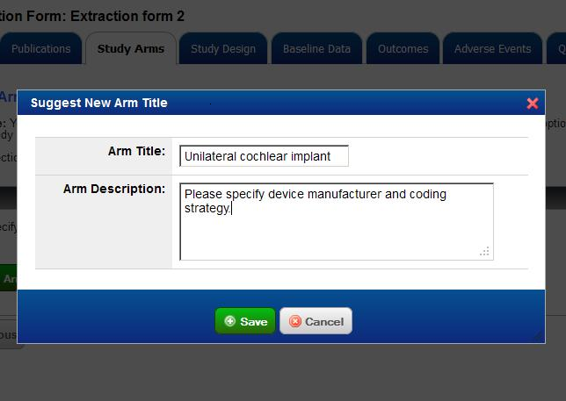

Study Design

In the Study Design tab, you may specify the queries concerning study design that will appear on your extraction form. Two questions are provided by default. These may be edited (see instructions below) or deleted by clicking the Edit Question or Delete Question links, respectively, next to the relevant query. If you are happy with the default options, simply click Next to continue. Otherwise:

- If you do not wish your extraction form to include a design details section:
- Select No from the drop-down menu within the shaded box at the top of the tab.
- Click Next to continue editing the next section of your extraction form.
- If you would like to edit existing design details queries:
- Click the [Edit Question] next to the relevant query.
- In the resulting pop-up, edit the question’s text and optional instructions to the extraction form’s user in the fields provided, and then change the query’s format from the drop-down menu as desired. The format may be one of five options (each option has a short description next to its name). Selecting any format other than Text will further allow you to specify the options presented in your extraction form. Additionally, all formats other than Text will allow you to add sub-questions by marking the corresponding check box. When finished click Save Edits, or to return to the Study Design tab without saving, click Cancel.
- Repeat steps 1 and 2 as needed.
- Click Next to continue editing the next section of your extraction form.
- If you would like your extraction form to include additional design detail queries:
- Click Add a New Design Detail.
- In the resulting pop-up, enter the question’s text and optional instructions to the extraction form’s user in the fields provided, and then select the query’s format from the drop-down menu. The format may be one of five options (each option has a short description next to its name). Selecting any format other than Text will further allow you to specify the options presented in your extraction form. Additionally, all formats other than Text will allow you to add sub-questions by marking the corresponding check box. When adding a sub-question, enter the text of the follow-up in the corresponding field and then choose which response option will trigger it by marking the relevant check box. When finished click Save, or to return to the Study Design tab without saving, click Cancel.
- Repeat steps 1 and 2 as needed.
- Click Next to continue editing the next section of your extraction form.

Baseline Data

In the Baseline Data tab, you may specify the queries concerning baseline characteristics that will appear on your extraction form.

- If you do not wish your extraction form to include a baseline characteristics section:
- Select No from the drop-down menu within the shaded box at the top of the tab.
- Click Next to continue editing your extraction form.
- If you would like to add a new baseline characteristics query to your extraction form:
- Click Add a New Baseline Characteristic.
- In the resulting pop-up, enter the question’s text and optional instructions to the extraction form’s user in the fields provided, and then select the query’s format from the drop-down menu. The format may be one of five options (each option has a short description next to its name). Selecting any format other than Text will further allow you to specify the options presented in your extraction form. Additionally, all formats other than Text will allow you to add sub-questions by marking the corresponding check box. When adding a sub-question, enter the text of the follow-up in the corresponding field, and then choose which response option will trigger it by marking the relevant check box. When finished click Save, or to return to the Baseline Data tab without saving, click Cancel.
- Repeat steps 1 and 2 as needed.
- Click Next to continue editing the next section of your extraction form.

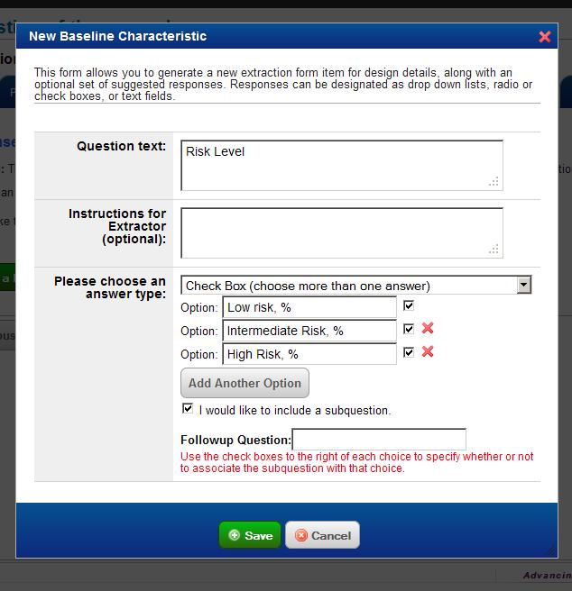

Outcomes

In the Outcomes tab, you may suggest the names of outcomes that will appear on your extraction form.

- If you do not wish your extraction form to include an outcomes section:
- Select No from the drop-down menu within the shaded box at the top of the tab.
- Click Next to continue editing your extraction form.
- If you would like to add a new outcome to your extraction form:
- Click Add a New Outcome Name.
- In the resulting pop-up, enter the outcome’s title and description in the fields provided, and then specify whether the outcome is categorical or continuous by selecting the corresponding option. When finished click Save, or to return to the Outcomes tab without saving, click Cancel.
- Repeat steps 1 and 2 as needed.
- Click Next to continue editing the next section of your extraction form.

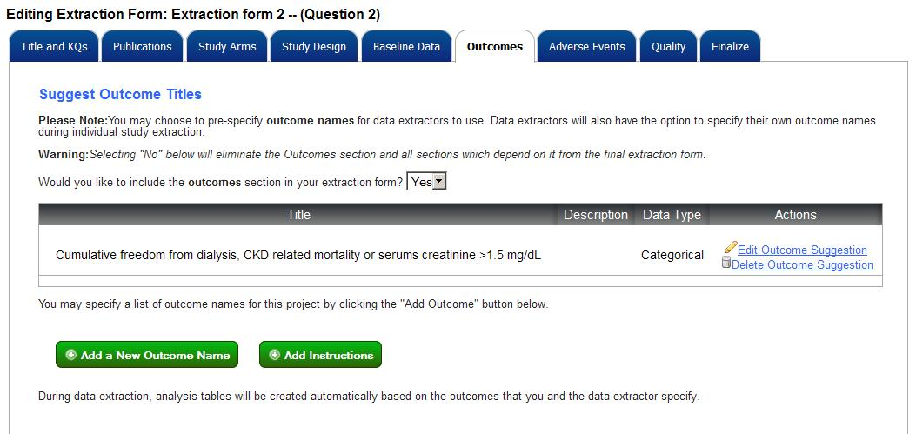

Adverse Events

In the Adverse Events tab, you may specify what information concerning adverse events will be queried on your extraction form by adding columns to an Adverse Events table. A number of columns are provided by default. These can be deleted by clicking the
next to the corresponding column header.

- If you do not wish your extraction form to include an adverse events section:
- Select No from the drop-down menu within the shaded box at the top of the tab.
- Click Next to continue editing your extraction form.
- If you would like to change how adverse events data are entered:
- Click the desired radio button option and then click Update Settings.
- If you would like to add a new column to the adverse events table on your extraction form:
- Click Add a New Adverse Event Column.
- In the resulting pop-up, enter the adverse event column title and description in the fields provided. You may also optionally specify a header. (Columns with the same header will be grouped together.) When finished click Add, or to return to the Adverse Events tab without saving, click Cancel.
- Repeat steps 1 and 2 as needed.
- Click Next to continue editing the next section of your extraction form.

Quality

In the Quality tab, you may specify what information concerning study quality will be queried on your extraction form by adding columns to a Quality Dimensions Data table. You will also be able to define the rating scale used within your extraction form.

- If you do not wish your extraction form to include a quality section:
- Select No from the drop-down menu within the shaded box at the top of the tab.
- Click Next to continue editing the next section of your extraction form.
- If you would like to add a new quality dimension field to the Quality Dimensions data table:
- Click Add a New Quality Dimension Field.
- In the resulting pop-up, choose the quality dimension name using the drop-down menu. A number of commonly used dimensions are provided as options, for your convenience; however, you may add one of your own by selecting the Add other dimension not in this list option at the bottom, and then specify it in the resulting text field. After specifying the dimension name, enter any relevant notes concerning this dimension to relate to users of your extraction form. When finished click Save, or to return to the Quality tab without saving, click Cancel.
- If you would like to add values to a Quality Ratings scale:
- Click Add a New Quality Rating Field.
- In the resulting pop-up, enter the rating value in the field provided. When finished click Add New Item, or to return to the Quality tab without saving, click Cancel.
- Repeat steps 1 and 2 as needed. Note that newly created ratings will appear in the order they are created, and that a preview of the drop-down menu that will be presented to users of your extraction form will appear below the table. Ratings may be reordered, edited, or deleted by using the [Move Up Rating Option], [Edit Ration Option], and [Delete Rating Option] links, respectively, in the right-most column of the ratings table.
- Click Next to continue editing the next section of your extraction form.

Finalize
In the Finalize tab, you may indicate that the extraction form design is complete.
• Upon entering to this tab, you will see that your Current Status is marked as Incomplete (Private).
• To finalize, click [Finalize this Extraction Form]. You will see the change to your Current Status as Finalized.

You may also choose to add your extraction for template to The Extraction Form Bank so it can be used for future projects.
• To add your template to the Bank, you will need to provide a Name for the extraction form and any Description useful for future projects.
• Next you can choose how public you would like this template to be. Simply select from the options:
o Make available to my team to share with only those assigned as users within your team, OR
o Make available to the world to share with all other contributors to the SRDR system.

Edit an Existing Extraction Form

To edit an existing extraction form, first navigate to the My Projects page (use the My Projects link at the top of the page) and then click on the name of the project to which the extraction form belongs in the Projects that I lead tab. Initially, you will be taken to the selected project’s Project Information page. From there, navigate to the Extraction Forms page by clicking on the link in left-hand nav/action menu. Finally, to begin editing an extraction form, click the corresponding [Edit Extraction Form] link in the extraction form table.

Title and KQs

On the Title and KQs tab, you may specify the title of your extraction form, as well as the key question(s) it addresses.

- Enter the title of your extraction form in the field provided, and select the key question(s) that this extraction form will address by checking the corresponding boxes.
- Click Save and Continue when finished.

Publications

Please note: Although not enabled within the edit extraction form dialogue, additional publication identifiers can be added during individual study extraction.

Study Arms

In the Study Arms tab, you may suggest titles for the arms that will appear on your extraction form.

- If you would like to pre-specify an arm to your extraction form:
- Click Add Arm.
- In the resulting pop-up, enter the title and description in the fields provided, and click Save. To return to the Arms tab without saving, click Cancel. (Note: Previously added arms can be edited or deleted using the corresponding controls in the right-most column of the arms table, outside the pop-up.)
- Repeat steps 1 and 2 as needed.
- Click Next to continue editing the next section of your extraction form.

Study Design

In the Study Design tab, you may specify the queries concerning study design that will appear on your extraction form. Two questions are provided by default. These may be edited (see instructions below) or deleted by clicking the [Edit Question] or [Delete Question] links, respectively, next to the relevant query. If you are happy with the default options, simply click Next to continue. Otherwise:

- If you do not wish your extraction form to include a design details section:
- Select No from the drop-down menu within the shaded box at the top of the tab.
- Click Next to continue editing the next section of your extraction form.
- If you would like to edit existing design details queries:
- Click the [Edit Question] next to the relevant query.
- In the resulting pop-up, edit the question’s text and optional instructions to the extraction form’s user in the fields provided, and then change the query’s format from the drop-down menu as desired. The format may be one of five options (each option has a short description next to its name). Selecting any format other than Text will further allow you to specify the options presented in your extraction form. Additionally, all formats other than Text will allow you to add sub-questions by marking the corresponding check box. When finished click Save Edits, or to return to the Study Design tab without saving, click Cancel.
- Repeat steps 1 and 2 as needed.
- Click Next to continue editing the next section of your extraction form.
- If you would like your extraction form to include additional design detail queries:
- Click Add a New Design Detail.
- In the resulting pop-up, enter the question’s text and optional instructions to the extraction form’s user in the fields provided, and then select the query’s format from the drop-down menu. The format may be one of five options (each option has a short description next to its name). Selecting any format other than Text will further allow you to specify the options presented in your extraction form. Additionally, all formats other than Text will allow you to add sub-questions by marking the corresponding check box. When adding a sub-question, enter the text of the follow-up in the corresponding field and then choose which response option will trigger it by marking the relevant check box. When finished click Save, or to return to the Study Design tab without saving, click Cancel.
- Repeat steps 1 and 2 as needed.
- Click Next to continue editing the next section of your extraction form.

Baseline Data

In the Baseline Data tab, you may specify the queries concerning baseline characteristics that will appear on your extraction form.

- If you do not wish your extraction form to include a baseline characteristics section:
- Select No from the drop-down menu within the shaded box at the top of the tab.
- Click Next to continue editing your extraction form.
- If you would like to add a new baseline characteristics query to your extraction form:
- Click Add a New Baseline Characteristic.
- In the resulting pop-up, enter the question’s text and optional instructions to the extraction form’s user in the fields provided, and then select the query’s format from the drop-down menu. The format may be one of five options (each option has a short description next to its name). Selecting any format other than Text will further allow you to specify the options presented in your extraction form. Additionally, all formats other than Text will allow you to add sub-questions by marking the corresponding check box. When adding a sub-question, enter the text of the follow-up in the corresponding field, and then choose which response option will trigger it by marking the relevant check box. When finished click Save, or to return to the Baseline Data tab without saving, click Cancel.
- Repeat steps 1 and 2 as needed.
- Click Next to continue editing the next section of your extraction form.

Outcomes

In the Outcomes tab, you may suggest the names of outcomes that will appear on your extraction form.

- If you do not wish your extraction form to include an outcomes section:
- Select No from the drop-down menu within the shaded box at the top of the tab.
- Click Next to continue editing your extraction form.
- If you would like to add a new outcome to your extraction form:
- Click Add a New Outcome Name.
- In the resulting pop-up, enter the outcome’s title and description in the fields provided, and then specify whether the outcome is categorical or continuous by selecting the corresponding option. When finished click Save, or to return to the Outcomes tab without saving, click Cancel.
- Repeat steps 1 and 2 as needed.
- Click Next to continue editing the next section of your extraction form.

Adverse Events

In the Adverse Events tab, you may specify what information concerning adverse events will be queried on your extraction form by adding columns to an Adverse Events table. A number of columns are provided by default. These can be deleted by clicking the
next to the corresponding column header.

- If you do not wish your extraction form to include an adverse events section:
- Select No from the drop-down menu within the shaded box at the top of the tab.
- Click Next to continue editing your extraction form.
- If you would like to change how adverse events data are entered:
- Click the desired radio button option and then click Update Settings.
- If you would like to add a new column to the adverse events table on your extraction form:
- Click Add a New Adverse Event Column.
- In the resulting pop-up, enter the adverse event column title and description in the fields provided. You may also optionally specify a header. (Columns with the same header will be grouped together.) When finished click Add, or to return to the Adverse Events tab without saving, click Cancel.
- Repeat steps 1 and 2 as needed.
- Click Next to continue editing the next section of your extraction form.

Quality

In the Quality tab, you may specify what information concerning study quality will be queried on your extraction form by adding columns to a Quality Dimensions data table. You will also be able to define the rating scale used within your extraction form.

- If you do not wish your extraction form to include a quality section:
- Select No from the drop-down menu within the shaded box at the top of the tab.
- Click Next to continue editing the next section of your extraction form.
- If you would like to add a new quality dimension field to the Quality Dimensions Data table:
- Click Add a New Quality Dimension Field.
- In the resulting pop-up, choose the quality dimension name using the drop-down menu. A number of commonly used dimensions are provided as options, for your convenience; however, you may add one of your own by selecting the Add other dimension not in this list option at the bottom, and then specify it in the resulting text field. After specifying the dimension name, enter any relevant notes concerning this dimension to relate to users of your extraction form. When finished click Save, or to return to the Quality tab without saving, click Cancel.
- If you would like to add values to a Quality Ratings scale:
- Click Add a New Quality Rating Field.
- In the resulting pop-up, enter the rating value in the field provided. When finished click Add New Item, or to return to the Quality tab without saving, click Cancel.
- Repeat steps 1 and 2 as needed. Note that newly created ratings will appear in the order they are created, and that a preview of the drop-down menu that will be presented to users of your extraction form will appear below the table. Ratings may be reordered, edited, or deleted by using the [Move Up Rating Option], [Edit Ration Option], and [Delete Rating Option] links, respectively, in the right-most column of the ratings table.
- Click Next to continue editing the next section of your extraction form.

Finalize

  - You may choose to edit within the Finalize tab by changing your choice of availability (i.e. Make available to my team vs. Make available to the world).
  - After you make the necessary edits, click Send to the Bank.

Add a Study

To add a study for extraction, navigate to the Projects that I lead tab in the My Projects page (use the My Projects link at the top of the page) and click the [Add a Study] link (under the Actions column) of the project you would like modify. Alternatively, if you are already within the desired project, you may click the Study List link in the left-hand nav/action menu and then click Add a New Study on the Add Studies to This Project page. (Note: You must have at least one extraction form associated with a project before adding a study.)

Upon arriving on the New Study page:

- If you’d like to add studies individually:
- Select the One study… radio button, and then indicate the key questions that are addressed by this study by marking the relevant check boxes. Click Save and Continue when finished.
- On the Publication Information page, enter the PubMed ID of the study you would like to add, and then click Retrieve. If the study is found, its identifying information will be automatically entered in the fields below. You may also enter a study’s information manually.
- Whether a study is automatically retrieved or entered manually, you may optionally add an additional identifier using the correspondingly labeled field at the bottom of the page. Make sure to indicate the identifier type from the drop-down menu as well. If you’d like to add more than one additional modifier, click Add an Identifier and fill in the relevant information. Repeat as necessary.
- If you’d like to associate one or more secondary publications with your study:
  - Click Add a New Secondary Publication at the bottom of the screen. The resulting pop-up will be identical to the primary publication information page with the addition of one drop-down menu, which allows for designation of the rationale for the secondary publication’s inclusion. Click Save once all information has been entered (or Cancel if you would like to quit out of the secondary publication dialogue). Repeat as necessary.
- If you’d like to add multiple studies at once:
- Select the Many studies… option, and then indicate the key questions that are addressed by the studies you will be adding by marking the relevant check boxes.
- Enter the PubMed IDs of the studies you would like to add (note: individual IDs should be separated by at least one space or line) and click Add Studies. You will then be taken to the Add Studies to This Project page, where the newly added studies should now appear among the list of all studies added to the current project.

Extract a Study

To begin, complete, or edit the extraction of a study, you must first navigate to the Add Studies to this Project page of the relevant project. If you are the designated lead on the project, first open the Projects that I lead tab on the My Projects page (to reach the My Projects page, click the My Projects link at the top of the page), select the desired project, and then click the [Add a Study] link in the right-hand navigation menu. If you are a Collaborator on the project, open the Projects on which I collaborate tab on the My Projects page, and then select the relevant project.

Upon arriving at the Add Studies to this Project page, click the [Edit Study] link of the study you’d like to extract. Note: While you may proceed through each stage of extraction in order, you may alternatively use the left-hand nav/action menu to view and/or edit particular portions of the study extraction dialogue.

- On the <Begin Data extraction> page, click Begin Editing to first define basic information regarding the study. To view a summary of the selected study at any time during the study extraction process, click View Study Preview at the top of the page.
- On the Key Questions page, indicate the key questions that are addressed by the selected study by marking all relevant check boxes, and then click Save Questions. Click Next when finished. (Note: The corresponding extraction form(s) [i.e., the extraction form or forms which have been previously designated as addressing the selected key questions] will be automatically chosen for you depending on your choices here.)
- On the Publication Information page, you may edit information concerning the primary publication from which the data for this particular study will be extracted. Data fields for title, authors, affiliation, and journal information (including name, year, volume, and issue) are provided by default. You may add additional identifying information by clicking Add an Identifier and filling out the resulting fields (and repeating as necessary). If the study was initially added manually and contains missing or incorrect information, you may opt to automatically retrieve identifying publication information by entering the PubMed ID into the appropriate field and clicking Retrieve. Once finished, click Save.
- If you’d like to associate a secondary publication(s) with your study:
- Click Add a New Secondary Publication at the bottom of the screen. The resulting pop-up will be identical to the primary publication information page with the addition of one drop-down menu, which allows for designation of the rationale for the secondary publication’s inclusion. Click Save once all information has been entered (or Cancel if you would like to quit out of the secondary publication dialogue). Repeat as necessary.
- Click Next to begin extracting study data using the associated extraction form(s).

You will now proceed through the extraction form(s) associated with your study. The particular sections appearing, as well as your ability to add to or modify default data fields, will vary depending on how the extraction form was defined by the project lead. Due to this variability, explicit step-by-step instructions are not provided for all sections. However, direction is provided for several sections because of their relative complexity. These include instructions for the Study Design, Study Arms, Baselines, Outcomes, Results, Adverse Events and Study Quality sections. They appear below.

Study Design

To enter the design details for a study:

- Click on the Study Design tab.
- Answer the prespecified questions regarding the study design:
  - For text answers, click within text box provided and type your answer.
  - For multiple choice questions, click within the circle or checkbox next to the appropriate answer.
- Click Save Data.
- Click Next to continue on to the next section of the extraction dialogue.

Study Arms

To define an arm for extraction:

- Click Add Arm.
- In the resulting pop-up, choose the arm title from the drop-down menu, and enter the description in the field provided. Suggested titles appearing in the drop-down menu are drawn from either the extraction form template (created by the project lead) or other previously extracted studies within the project. You may optionally enter your own arm title by selecting the Other option and filling in the corresponding text box. Click Save when finished. To return to the Arms tab without saving, click Cancel. (Note: Previously added arms can be edited or deleted using the corresponding controls in the right-most column of the arms table, outside the pop-up.)
- Repeat steps 1 and 2 as needed.
- Click Next to continue on to the next section of the extraction dialogue.

Baselines

To enter the baseline characteristics for a study:

- Click on the Baselines tab.
- Answer the prespecified questions regarding the study population:
  - For text answers, click within text box provided and type your answer
  - For multiple choice questions, click within the circle or checkbox next to the appropriate answer
- Click Save Data.
- Click Next to continue on to the next section of the extraction dialogue.

Outcomes

To add an outcome for extraction into your results table:

- Click Add a New Outcome.
- In the resulting pop-up, choose the outcome’s title from the drop-down menu, and enter the description in the field provided. Suggested titles appearing in the drop-down menu are drawn from either the extraction form template (created by the project lead) or other previously extracted studies within the project. You may optionally enter your own outcome title by selecting the Other option and filling in the corresponding text field.
- Specify whether the outcome is categorical, continuous or survival by selecting the corresponding option, and then enter the unit of the outcome measure in the corresponding text field.
- Add timepoints by clicking the Add a New Timepoint link. Enter the value and unit of the new timepoint using the resulting text field and drop-down menu. Repeat as necessary.
- By default, the patient population designated for a particular outcome includes all participants. To add additional subgroups, click the Add a Subgroup link and fill in the name and description of the new subgroup in the fields provided.
- You may optionally add notes to your newly defined outcome using the text box at the bottom of the pop-up.
- When finished click Save, or to close the pop-up without saving, click Cancel. (Note: Previously added outcomes can be edited or deleted using the corresponding controls in the right-most column of the outcomes table, outside the pop-up.)
- Repeat steps 1 and 7 as needed.
- Click Next to continue on to the next section of the extraction dialogue.

Results

To extract an outcome into your results table:

- Select the outcome you wish to enter data for from the drop-down menu. (Note: Outcomes are arranged according to type [i.e., continuous, categorical, survival].)
- Select the subgroup you wish to enter data for. (Note: If only one subgroup exists, it will be selected automatically.)
- Enter extracted data into the resulting table and click Save Table Data when finished. Each field in the outcome table may be appended with a footnote and marked as either having been drawn directly from the corresponding publication or calculated by the extractor. To do so, double-click in the desired field and fill out the resulting pop-up. (Make sure to click Save when finished). Calculated data fields will be highlighted with yellow in the results table, and those with a footnote will be marked with a numeral. (Note: At any point, you may click the View/Modify Existing Data Entries link to view all results which have been entered thus far, and edit or remove them by clicking the corresponding links in the preview.)
- Three measures are provided by default in the results table (N enrolled, counts, and standard deviation); however, you may add additional ones by clicking the Edit Measures link and marking the corresponding check boxes in the resulting pop-up. (You may also add a user-defined measure by clicking the corresponding link in the pop-up and filling out the resulting fields.) In the pop-up, you may also designate whether these measures should appear for all timepoints or for only the currently selected one by selecting the appropriate radio button. When finished editing outcome measures, click Save, or to return to the results dialogue without saving, click Cancel.
- To add between-arm comparisons to your results table, click the Create Between-Arm Comparison button on the right-hand side of your table. In the newly expanded portion of the table, select the arms to compare from the drop-down menus, and then fill in the data fields. You may add additional columns (comparisons) to the table by clicking the Add Column link at the bottom of the table. Added columns can be similarly removed by clicking the Remove Column link below the corresponding column. The entirety of the comparisons table can also be removed by clicking the Remove Comparisons link (or simply hidden from view by clicking the Hide link at the right-hand side of the table.
- Three measures are provided by default in the between-arms comparisons table (statistical test, odds ratio, and standard deviation); however, you may add additional ones by clicking the Edit Measures link and marking the corresponding check boxes in the resulting pop-up. (You may also add a user-defined measure by clicking the corresponding link in the pop-up and filling out the resulting fields.) In the pop-up, you may also designate whether these measures should appear for all rows in the comparisons table or for only the currently selected one by selecting the appropriate radio button. When finished between-arm comparison measures, click Save, or to return to the results dialogue without saving, click Cancel.
- Repeat steps 1 through 6 for each outcome and population.
- Click Next to continue on to the next section of the extraction dialogue.

Adverse Events

To add an adverse event for extraction:

- Click Add New Row and fill in the resulting data fields. You can delete a row at any time by clicking the corresponding Delete Adverse Event link in the right-most column of the table. When finished extracting adverse events, click Save Table Data.
- Click Next to continue on to the next section of the extraction dialogue.

Study Quality

To enter the design details for a study:

- Click on the Study Quality tab.
- Answer the prespecified questions for the quality dimensions:
  - Select an answer from the dropdown menu
  - Include comments in the textbox provided in the Notes column
- Click Save Table Data.
- To adjust the quality rating, enter the Quality Guideline Used in the textbox provided.
- Select a quality grade from the dropdown menu.
  - Although not required, a text box is provided to enter any relevant notes addressing the quality of a particular study.
- Click Save Quality Rating

Internal Commenting
SRDR allows members of a team to comment on any page as the data is being entered or reviewed
- To add a comment, click Post/View next to the Comment icon.
- In the pop-up window, you have the options of Post a Comment, Flag This Data Item, or sorting the comments to view.
- Post a Comment
  - After choosing to comment, you may enter your Comment into the assigned text box and select whether this statement is one of Fact, Opinion, or Both.
  - One you have entered your comments, click Post Comment.
  - Your comment should now appear under Private Comments which may be sorted.
- Flag This Data Item
  - Click Post/View next to the Comment icon in order to flag an item. You will then choose whether your flag is for Unclear data, a Typo or Other under the Flag Type.
  - Next select whether the flag is of Low or High priority
  - Enter any comments to the comment box and again choose whether they are of Fact, Opinion or Both.
  - Finally Submit Flag
  - Again your flag should appear under Private Comments.
- Sort
  - You can sort flags and comments by selecting one of the links above the Public Comment header.
  - The options for sorting are:
    - Newest flags first
    - Flag priority
    - Flag type
    - Most recent (Default)
    - Oldest
    - Fact/Opinion

- Once comments and flags are posted, you can choose to Email User to direct their attention to your comment.
- After the user addresses the comment, he/she also has the option to Post Reply to the comment.

Project Tools
Once data is entered into your project, there are a number of tools that can be used for data presentation, data cleaning, and project updates.

View Summary
You can view you’re the summary of your project, including all extraction forms and associated studies.
- Click View Summary under Project Tools.
- Click on the links for Associated Extraction Forms or Associated Studies to view the data, print the page, or create a PDF.

Publish Externally
Once you have reviewed the project to your satisfaction, click [Continue to Publish this Project] at the bottom of the page or the [Publish Externally] link in the left-hand nav/action menu. Upon arriving at the <Publish this Project> page:

- Update your project status from “Incomplete” to “Published” by selecting the appropriate radio button option, and click [Save].

Please note: Publication cannot be undone, so be sure that your project is complete prior to conversion.

Data Comparison Tool
SRDR includes a feature whereby you can compare the double data extraction by the team.
- After selecting the Data Comparison Tool on the left-hand side, choose the 2 studies to be compared by selecting the checkboxes in the far right column. Once the studies have been selected, click Compare Studies.
- In the window that appears you will see a new table with Data fields, extraction Created by user 1, extraction Created by user 2, and finally a Consensus Value.
- Within each accordion tab (Publication Information, Design Details, Baseline Characteristics, Adverse Events and Quality Dimensions), scan the results for inconsistencies. [Note that currently you cannot compare Results between studies with this comparison tool]
- When data is inconsistent, choose which user’s extraction to use by clicking the radio button within that user’s column or opt to add your own consensus value by entering it to the textbox in the Consensus Value column.
- Once this is complete, Merge/Create Consensus Study as your final version.

Data Export Tool
It is possible to export all of your data from SRDR to your Desktop.
- To export your data from the SRDR repository, you must first decide which format you would like the results to appear.
- Results can with be exported to:
  - Excel directly keeping all text entries to the system, OR
  - TSV file which will convert the data into codes of “0” and “1” for each possible non-text entry.
- To perform the export, click either Export to Excel, or Export to TSV within the row under My Projects or the [Data Export Tool] link in the left-hand nav/action menu

Summary Table Creator
Once data has been entered into SRDR, it has the ability to create data tables for the report based on your preferences.
- Under My Projects, you will find the Summary Table Creator under Project Tools in the left-hand navigator.
- You have the options of choosing a Saved Template from the dropdown menu or creating a new template.
- Under each of the tabs for Publications, Arms, Design, Baselines, Outcomes, Adverse Events, and Quality, you can choose which items you would like to see in the resulting table by simply checking or unchecking the textboxes to the left of the item list.
  - It is suggested that you do not select more than 9 items for each table to allow for proper format and layout.
- After selecting from these lists for each table, you must decide whether to Format data by Arms by checking the box to the left or leaving it unchecked.
  - By leaving this unchecked, only data Total (Both Arms) data will be included in the table.
- To preview your table, select Preview Report
- Once you are satisfied with the table, you can chose to Save report to Excel, Save report as MS Word, or Save report as PDF.
- .
- If you would like to save this table template for future reports, select Save Selections and Name the template.

Search
Within SRDR, you can search for both projects and studies enter to the repository using keywords.
- Click within the textbox next to the Search icon in the upper right corner of the SRDR interface.
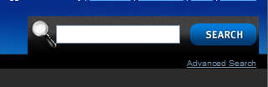
- Enter keywords most relevant to the project or study of interest
- Click the Search button.
- Results will appear under 2 headings: SR-Level Results or Study-Level Results.
- To choose the items you are interested in, simply click the title of the result within the list.
  - SR-Level Results will reveal a description of the project and all studies included in the review
  - Study-Level Results provide a description of the study as well as a description of the project to which it is included.

Copy Project
SRDR allows you to copy a project currently entered to the system,
- Click the Copy icon within the Actions column under My Projects.
- You will be asked to provide a Title for this copy.
- Once you’ve named your new project, please click Submit and the copied project should appear with the newly assigned name under My Projects.

FAQ

General

What is the Systematic Review Data Repository (SRDR)?
The Systematic Review Data Repository is a Web-based tool for data extraction and storage of systematic review data.

Who started the SRDR?
The SRDR was developed at the Tufts Evidence-based Practice Center at Tufts Medical Center in Boston, MA.

What problem does the SRDR intend to solve?
The intent of the SRDR is to provide the medical community with easy access to published systematic review data, as well as to ease the burden on systematic reviewers, both in data extraction and in updating systematic reviews.

What can the SRDR already do?
As of September, 2011, the SRDR facilitates data extraction and storage of systematic review data. After creating accounts, users have the ability to start new projects, create extraction forms, and extract data from relevant studies for storage and analysis.

What will the SRDR do in the future?
Future versions of SRDR will have a community-based system for data quality assurance. A wiki-like interface will allow users to comment on extracted data, point out errors, and request fixes or updates. This community-based curation process will improve reliability and make the SRDR one of the premier sources for medical information.

Who funds the SRDR?
The Systematic Review Data Repository is funded by the Agency for Healthcare Research and Quality, a division of the U.S. Department of Health and Human Services.

Who can I contact if I have general or technical questions about SRDR?
Any how-to or general SRDR questions may be directed to Nira Hadar at nhadar@tuftsmedicalcenter.org. For technical inquiries please contact a member of the programming staff, either Sarah Keefe or Chris Parkin, at skeefe@tuftsmedicalcenter.org or cparkin@tuftsmedicalcenter.org, respectively.

Access

What should I do if I’ve forgotten my username or password?
Your password may be retrieved by clicking on the [Forgot you password?] button of the user login screen. Be sure to use the email address associated with your SRDR account when retrieving your password.

Users

What are the different types of SRDR users? What level of access does each user type have?
By default, all SRDR users are registered as a “Member” of the system. While members cannot create or collaborate on systematic review projects, they do have the ability to view and comment on all public systematic review projects (projects only become publically viewable once the project lead has formally designated it as complete). They may also contact project leads to point out any data-entry errors in the data.

An “Editor” is a user who has the ability to create and collaborate on systematic review projects within the system. Users who can create projects (project leads) or contribute data (project collaborators) are examples of such users. Please contact SRDR system administrators to obtain an editor account.

What is the difference between a project lead and a project collaborator?
Any time a new project is created, the user creating that project is saved as the project lead. Project leads have the ability to save or update any details associated with the project including the project’s title, description, and key questions. Leads can create and update extraction forms to be used in the project and may add or remove project collaborators. In addition, project leads can add studies to the project, or edit/update existing studies created by other users collaborating on the project.

Project collaborators are assigned to a project by the project lead. Collaborators cannot change any of the details associated with the project itself but can add and remove studies from the project and save extracted data.

Can a project have more than one lead?
Yes, there is no limit to the number of project leads a project may have.

What is the maximum number of collaborators that can be assigned to a project?
There is no limit to the number of collaborators that may be assigned to any one project.

Data Entry Process

Project

What does project status mean? Can I modify the project after it was published?
When first created, all systematic review projects are designated as “Incomplete”. This indicates that the systematic review is not yet complete and should not be made available to the public.

A completed review can be made publicly searchable by updating the project status to “Published”. This signifies that no additional changes are expected to be made to the project, and ensures that the project will appear in the SRDR search dialogue.

Once published, edits to the systematic review can no longer be made. Instead, all corrections and updates must be made through the SRDR wiki interface.

Extraction Form

Can I create more than one extraction form per project?
Yes. A systematic review project may have multiple extraction forms associated with it, so long as they each address different key questions.

Can I create an extraction form that will not be associated with any of the project’s key questions?
No. Extraction forms must always be associated with at least one key question, as the key question is used to link a study with its appropriate extraction form.

What happens if I add/edit/delete data fields in an existing extraction form after I’ve already extracted study data using this extraction form?
Any data fields added to an extraction form will automatically propagate through to studies that have been assigned to that form. Edits to or deletion of data fields in an extraction form may only occur if no data has been saved for any associated studies.

Do I have to pre-specify arms and outcomes when I am creating an extraction form?
No, pre-specification of arms and outcomes is not required when creating an extraction form. Instead, users will be able to create their own arm and outcome names when extracting data.

Can I customize default values for extraction forms?
No, at present there are no customizable default values for extraction forms. However, form creators may provide a list of suggested terms for use by the project team during data extraction. By doing so, we hope to standardize user input, resulting in a more useful set of data.

Can I reuse an extraction form that I created for a different project?
The current version of the SRDR does not allow for users to re-use extraction forms for different projects. However, future versions will allow for users to make a clone of an extraction form and associate it with their own project. They will then have the ability to edit that form, tailoring it to make it more suitable for their specific needs.

Publication Data

Does the system work with any kind of study design or just RCTs?
Currently, the SRDR system has only been tested with for use with RCT study data. Testing of other study designs has not yet occurred, though we believe that the system will likely be able to accommodate them as well.

Saving and Advanced Features

How do I know my data have been saved?
Look for a “Saved successfully” notification any time you press the [Save] button. To double-check, you can navigate between pages to confirm that your data have been saved.

Must I finish an entire project/extracting an entire study before I can log off or move to a different project?
SRDR is designed such that you may stop your work at any time and continue whenever it is convenient for you.

How do I know if I am in the extraction form editor or actually extracting a study?
When editing an extraction form, you will see a window with tabs listing each of the potential sections for your form. This tabbed setup is not present when extracting study data.

I accidentally deleted a project/extraction form/study. How do I get it back?
At present, deletions in the SRDR are final. Proceed with the highest level of caution any time that deletions are being made, as they cannot be undone. It’s possible that future versions of SRDR may incorporate a retrieval system immediately after data is deleted, but the time-frame for this feature is unforeseeable.

Can I copy information from other projects/extraction forms/studies into my current project/extraction form/study?
Data cannot currently be copied from one project or study to another, though this feature may be incorporated into SRDR sometime in the next 12 months. Please contact the SRDR team if you feel this feature would greatly improve usability of the system.

Can I create more than one study record for the same publication?
Yes, multiple SRDR study records may be created for the same publication. Data from publications may be used in different ways depending on the systematic review topic, which would be reflected in the duplicated study records. Future versions of SRDR will allow for users to compare duplicated records to find any inconsistencies in extracted data elements.

Can multiple projects dealing with the same topic can be included in the system?
The SRDR system does not limit the number of projects covering the same topic. Allowing for multiple groups to publish concurrent research may help to strengthen the evidence for particular topics and make SRDR a more powerful resource to the systematic review community.

For the purpose of the manual going forward, we will focus on studies that do not deal with test performance. The flow of the extraction form creation will be the same however, where we refer to “arm” in the manual, test performance extraction forms will refer to “test”.

