 | WireGuard Credential Provider  How to connect to VPN before your Windows login

1 What is this for?
When working from home or on the road, your computer needs a VPN connection to log in to the company network. The problem: normally the VPN only starts after login – but you already need the VPN to log in.

💡 | The Solution  The WireGuard Credential Provider solves this problem: it adds an extra tile to the Windows login screen that lets you start the VPN – before you enter your password.

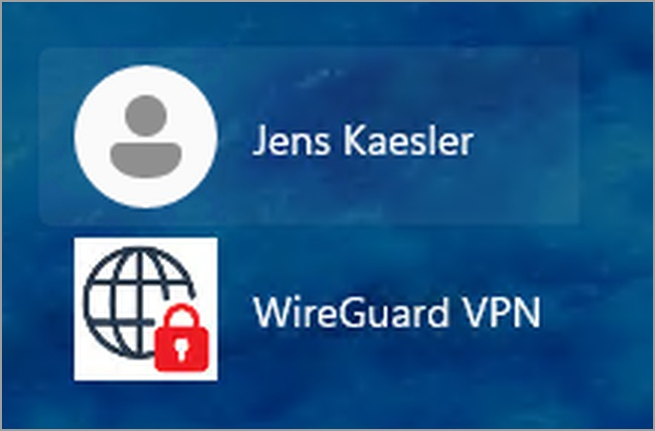
The login screen – the WireGuard tile appears next to your user account

2 How it works – Step by step

1 | Start your computer or unlock the screen  The Windows login screen appears.

2 | Click the WireGuard tile  Click the “WireGuard VPN” tile. You will see the VPN view with a red lock icon and a “Connect” button.

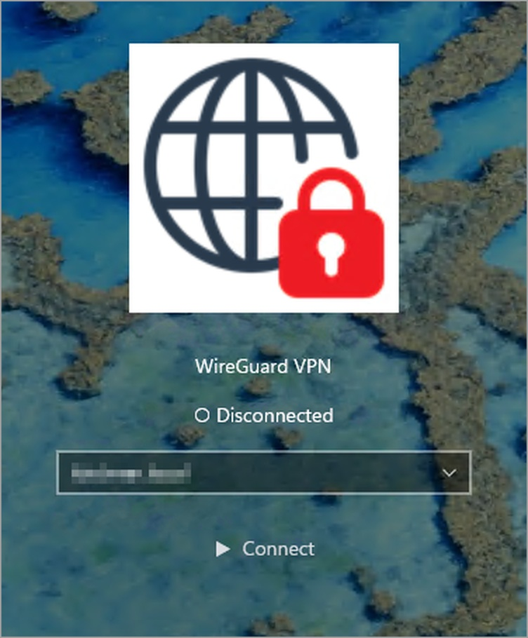
VPN tile in disconnected state – red icon, “Connect” button

3 | Click “Connect”  The lock icon turns green and shows how long the connection has been active.

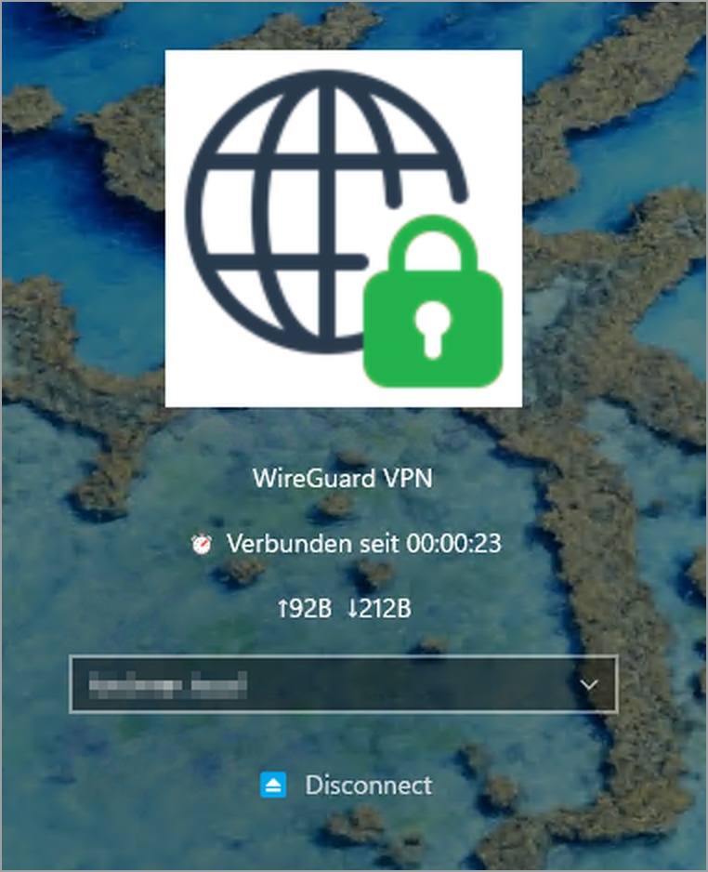
VPN tile in connected state – green icon, active connection time

4 | Log in as usual  Press the back arrow and log in as usual with your username and password.

✅ | That's it!  You don’t need to do anything else. The VPN disconnects automatically when the computer shuts down.

3 What do the icons mean?

Display | Meaning | What to do?
 | VPN is connected | All good – you can log in now
 | VPN is not connected | Click “Connect”

What does the connected tile show?  • Green lock icon  • How long the connection has been active  • How much data has been transferred (↑ Upload / ↓ Download) | 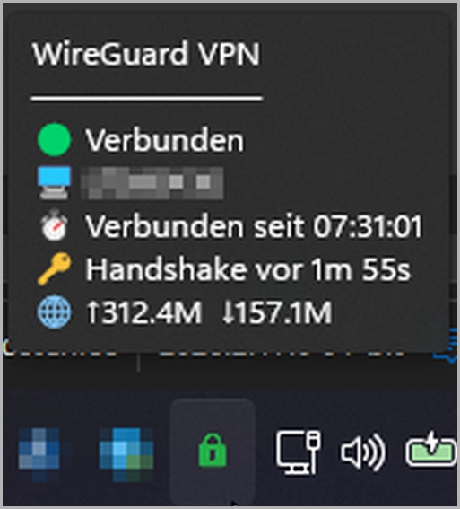

4 Log in with YubiKey (only if set up by IT)
Some organisations require a hardware key (YubiKey) for additional security. If that applies to you:

1 | Plug in your YubiKey  Insert the small key into a USB port on your computer.

2 | Enter your PIN and connect  The tile shows the detected YubiKey. Enter your PIN and click “Connect”.

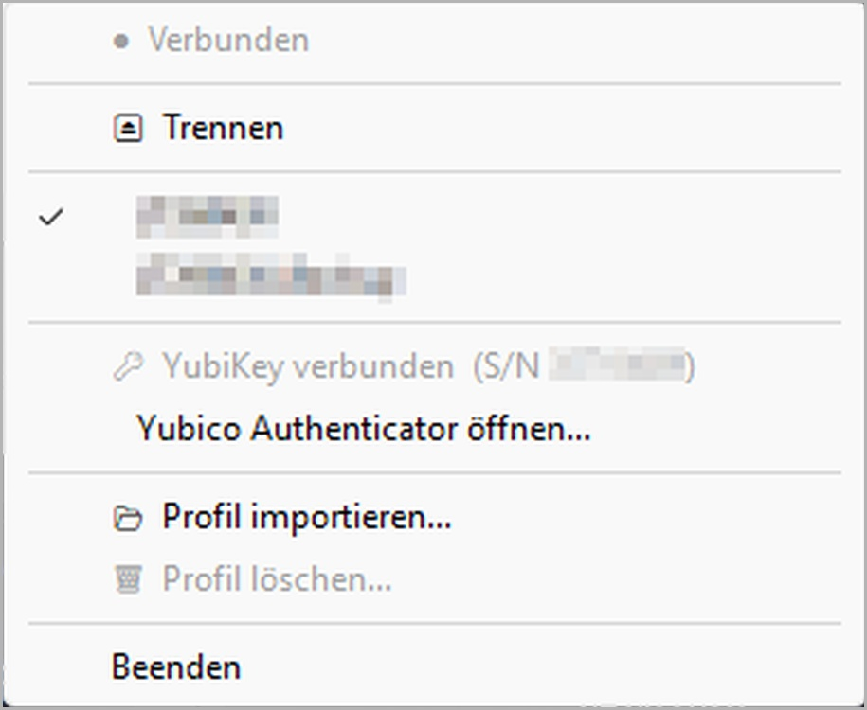
The tile shows the detected YubiKey

3 | Done  The VPN connects automatically. Then log in as usual.

ℹ️ | Note  If you don’t have your YubiKey with you or can’t remember your PIN: contact your IT department.

5 Frequently Asked Questions
What do I do if the icon stays red?
Check whether your computer has an internet connection (e. g. via Wi-Fi or network cable). If so, try again. If that doesn’t help, contact IT support.
Do I need to reconnect the VPN every day?
Yes, each time you start or unlock your computer you need to click “Connect” once. It only takes a few seconds.
Can I start my computer without VPN?
Yes. If you are in the office and directly connected to the company network, you don’t need the VPN on the login screen. Simply click your usual user tile.
What do I do if I can’t see the WireGuard tile?
Contact your IT department. The tool may not have been installed yet or may need to be restarted.

If you have any questions, please contact your IT department at any time.

