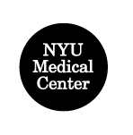
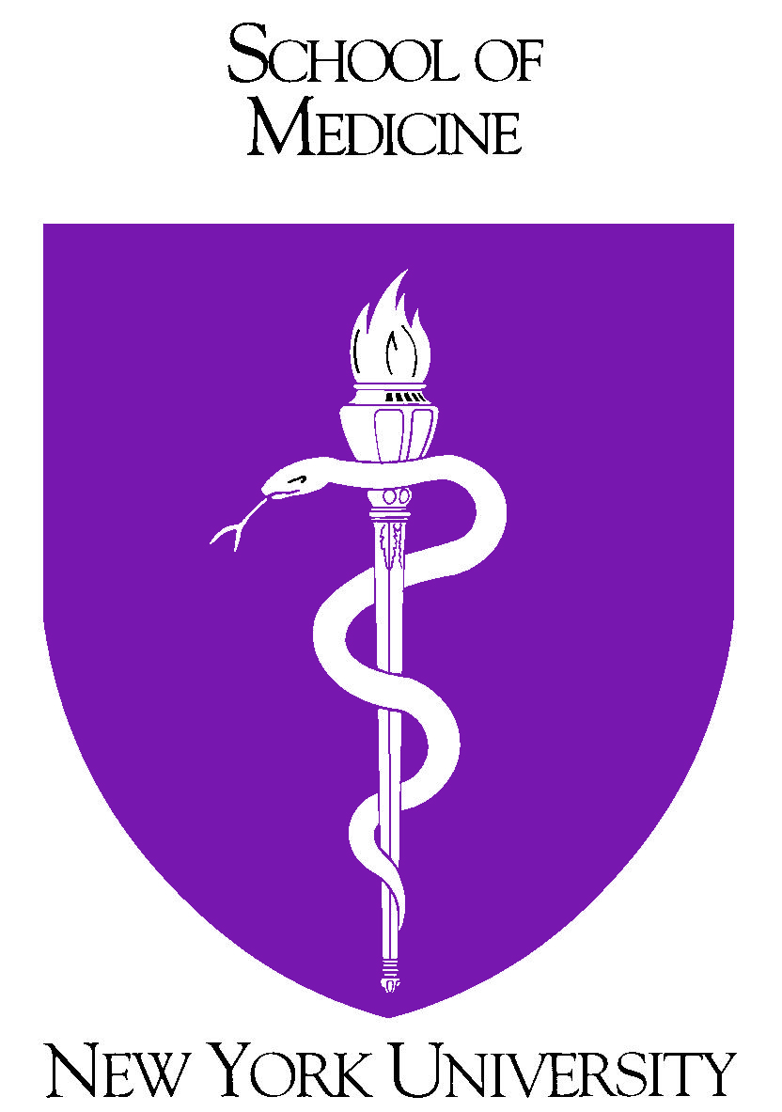

Benefits Services Department
One Park Avenue, 16th Floor
New York, NY 10016-5802
Tel: (212) 404-3787
Fax: (212) 404-3900
E-mail: NYUbenefits@msnyuhealth.org

January 2004

TO: Faculty and Staff of NYU School of Medicine, NYU Hospitals Center and the Hospital for Joint Diseases

FROM: Nancy Sanchez
Senior Director of Benefits

RE: New Mortgage and Banking Benefits

We are pleased to announce our new relationships with Merrill Lynch and HSBC Bank in offering employees of NYU School of Medicine, NYU Hospitals Center, and the Hospital for Joint Diseases special home financing, reality and banking services benefits.

Buying a home is one of the largest financial transactions you and your family can make. The formation of these relationships reflects our commitment in sponsoring benefits that support the diverse needs of our employees. The new Mortgage and Banking services are intended to help employees make wise decisions to achieve their overall financial objectives whether buying, re-financing, or saving for a home.

Merrill Lynch’s Corporate Home Financing ServicesSM program offers a number of benefits including:
- Large loan amounts and innovative loan features not available from many lenders
- A complimentary pre-approval review and letter to target your home search and maximize your negotiating power
- A dedicated toll-free number to apply over the phone in minutes
- Online loan and account status information
- Home equity lending with low rates and no upfront fees or closing costs (except mortgage recording tax where applicable)
- On-time closing guarantee
- Financial advice from a firm with more than 90 years of experience that considers both sides of your balance sheet

For guidance and information throughout the home buying and selling process, ask about the Merrill Lynch Realty Advisory Services Program offered through Cendant Mobility:
- Complimentary program available for all employees
- Guidance and advice throughout the home buying and/or selling process
- Community, school and property area information
- Referrals to specially trained real estate agents when buying and/or selling a home (not available for employees receiving a sponsored relocation)
- Cash-back bonus when a home is bought and/or sold through a referred agent (where state law permits)
- Program services available regardless of whether you obtain financing from Merrill Lynch

HSBC Exclusive Mortgage and Specialized Financial Services offers a number of benefits including:

- Dedicated Lending Officer offers exclusive personalized service
- Free Pre-approvals
- Community Works low cost mortgage program, discounted mortgage rates for qualified borrowers
- First Home Club, offering up to $5,000 in grant assistance for qualified borrowers
- An ExtraVantage checking account with no monthly maintenance fee
- No charge for any wallet-style checks
- Overdraft Protection (subject to credit approval)
- Premium Money Market account with no minimum balance required
- Select Line of Credit
- Pre-approved mortgage program with $100 discount on closing costs

Information sessions
The following information sessions will be held so that you can speak with representatives from Merrill Lynch and HSBC about their respective services:

Merrill Lynch* | HSBC*
NYU Medical Center  550 First Avenue  Wednesday, February 4, 2004  Representatives will be stationed at an Informational table in the Tisch Hospital lobby across from the Gift Shop from 9 am – 5 pm | NYU Medical Center  550 First Avenue  Wednesday, February 18, 2004  Representatives will be stationed at an Informational table in the Tisch Hospital lobby across from the Gift Shop from 9 am – 4 pm
Sterling Forest  Wednesday, February 11, 2004  Representatives will be onsite from 10 am –3 pm | Sterling Forest  Representatives will be at this location in March of 2004. The actual date and time will be furnished at a later date.
The Hospital for Joint Diseases  301 East 17th Street  Thursday, February 12, 2004  Representatives will be stationed at an Informational table by the Hospital’s Entrance from 9 am – 5 pm | The Hospital for Joint Diseases  301 East 17th Street  Wednesday, February 18, 2004  Representatives will be stationed at an Informational table by the Hospital’s Entrance from 9 am – 4 pm
*Representatives will have an onsite presence at the above locations on a periodic basis throughout the year.

Enclosed are flyers that outline these new benefits with greater detail.

If you have any questions or concerns, please call the Benefits Service Department at (212) 404-3787, or e-mail at NYUbenefits@msnyuhealth.org.

