**Instructions for Installing the Python Programming Language**

**Mac Installation**

The following instructions are for installing Python on a Windows computer. If you have a Mac, Python should come pre-installed. However, it is important that you have Python 3 and not Python 2. To check which version you have on a Mac, open a Terminal and type "which python" without the quotes then hit enter.

If you have Python 2, you will need to install Python 3. I think this is a good tutorial telling you how to do so:

<https://wsvincent.com/install-python3-mac/>

If you get stuck on this tutorial or if you know of a better tutorial, I welcome feedback.

**Windows Installation**

Go here: www.python.org/downloads/

Click on Download Python 3.7 

Double click and run the downloaded file.

You should see the following window. IMPORTANT: Make sure both boxes at the bottom are checked:

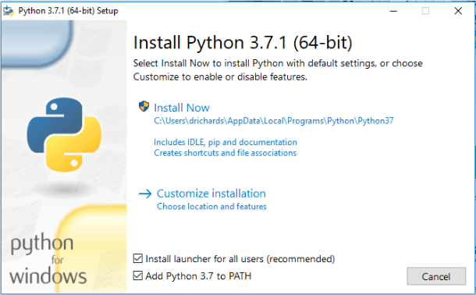

If the word “AppData” appears beneath “Install Now”, you will need to click on Customize installation, otherwise go ahead and click install now.

If you are doing a Custom Installation, click ok until you see Advanced Options. Click on Advanced Options and check the box labeled “Install for all users”

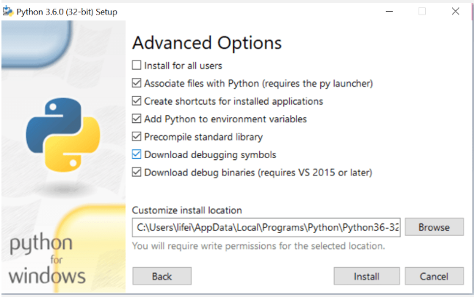

Finally click Install.

You will be asked, “Do you want to allow this program to make changes to this computer?” Choose: Yes.

Then you should see this: 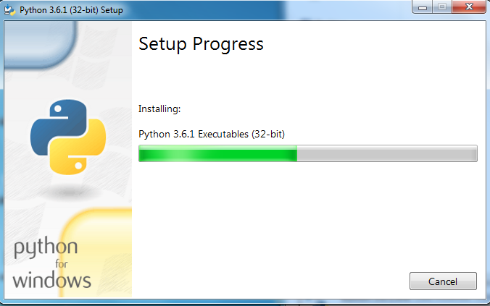

And finally you should see this: 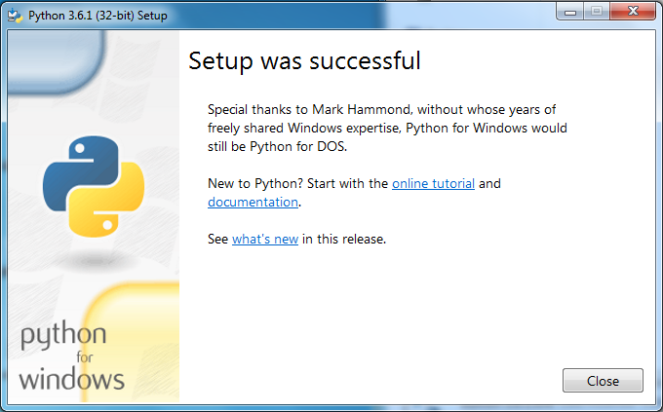

Check to make sure Python is installed. To do so, open a command prompt window by pressing the Windows key and R, then type in cmd, and hit enter. Type python into the resulting prompt, press enter, and see if you get an error or not. If everything worked you should see the following: 