[hoc.nclab.com/karel/](https://hoc.nclab.com/karel/)

For 100 points, go to the above website and complete the 15 levels of Karel the Robot while answering the following questions. You will turn in this document.

The website will tell you what commands you should use to control Karel as well as how many points you will get for programs of different lengths. Be aware that you CANNOT save your progress, so I recommend taking a stab at this during a long period. Of course, you can continue another day and you will be able to go much faster since you already know the answers.

**Short programs** give you more points. Short programs are valuable because they are usually easier to understand and easier to fix and often shorter programs run faster.

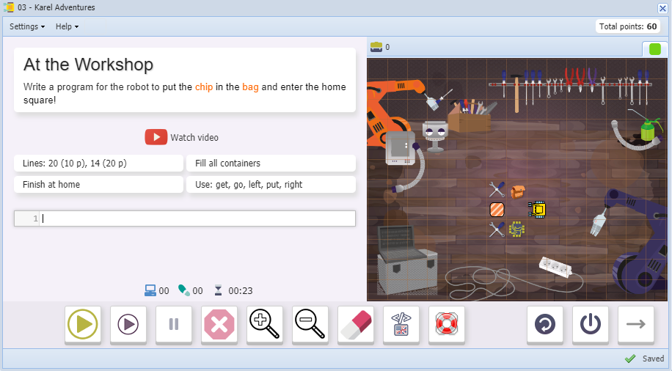

1) List the 5 basic commands:

Be aware that you will need to group code by indenting. The indentation is two spaces.

2) What does the **repeat** command let you do? What is it good for?

3) What does the **if** command let you do? What is it good for?

4) There is a trick to getting the shortest code on **level 09**. Think about putting a repeat command inside another repeat command. Remember that “inside” is determined by indentation. Copy down your best solution to level 09 here:

5) What does the **not** command let you do? What is it good for?

6) What does the **while** command let you do? What is it good for? If you don’t yet know, complete **Level 12** and read the notes after the level then come back to this question.

7) Why is it useful to have a **while** command and a separate **repeat** command?

8) Copy down your best solution to **level 11** “**Fortress**” here:

9) Copy down your best solution to **level 12** “**Dungeon**” here. Consider putting **if**s inside of other **if**s to get the points for the short code challenge.

10) **Level 13**: What is **def** short for?__________________

11) What is **def** used for?

12) How does **def** shorten your code significantly?

13) **Level 13**: The hashtag # (aka pound sign or number sign) is used to write a comment. A comment is a note to yourself or another human written in English. Write down one of the two comments in Level 13:

14) The body of a programmer-created command is typically ended with this word:

_____________

15) You might make it all the way to **Level 15** and then run into this error:

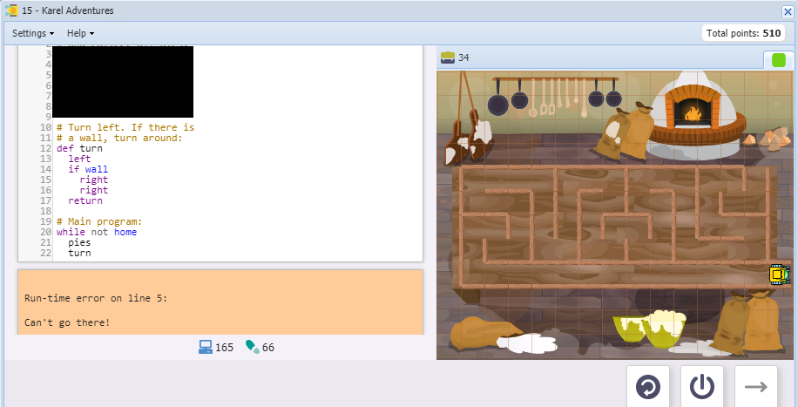

What happened was that your code sent Karel running past the **home** tile and off the end of the board.

One solution to this problem is to use **if** to only move if Karel is not home.

Another shorter solution is to use the keyword **and**, which lets you check two conditions at once.

Whichever solution you used, copy down your best **pies** code here:

16) How many points did you get?