For 280 points, fill in the code for the goToGoal function in action.py to enable the MazeRunner to navigate all 10 mazes.

RUN main.py, but WRITE code in action.py.

DO NOT use any loops in goToGoal. The goToGoal gets repeated automatically.

DO NOT modify any code outside of action.py

Use some or all of the following functions to get the Maze Runner to the goal.

runner.moveAhead(maze)

runner.turnLeft()

runner.turnRight()

runner.setHeading(north) #or south, east, west

#This function returns true if there is a wall ahead.

runner.wallAhead(maze)

#Returns the manhattan distance from the runner to the goal.

runner.distanceToGoal(goal_row, goal_col)

You should also consider using if statements to check which direction you need to move.

For instance:

#Check if the goal is to the north. If so, head that direction.

if goal_row < runner.row:

runner.setHeading(north)

ADVANCED: The maze runner also has a limited amount of memory. If you need the runner to remember something you can put the information in one of the following variables like so:

runner.memory0 = False

runner.memory1 = "Been here before"

up to

runner.memory9

This is not necessary, but may be useful on mazes 7 and 8, which are very challenging.

There is also a built in list object that can be used.

runner.memorylist.append( (runner.col,runner.row) )

You will need to consider how to navigate a variety of types of mazes. I recommend writing one strategy that works on some mazes and a different strategy that works on other mazes and then thinking about how to combine the two.

Mazes 7 and beyond are the most challenging. Save them for last.

Study the following mazes on paper first and design strategies for them.

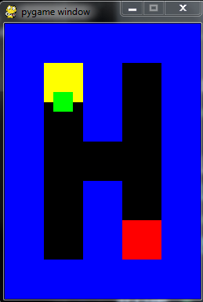 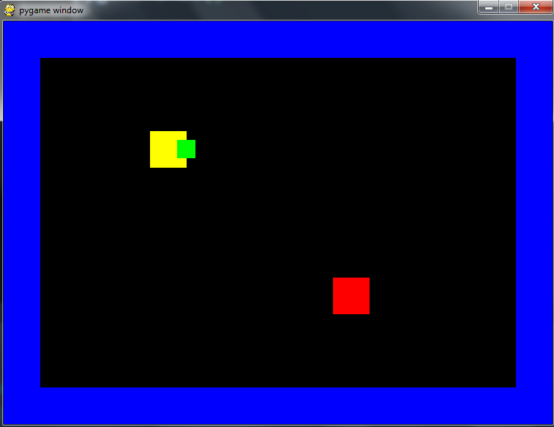

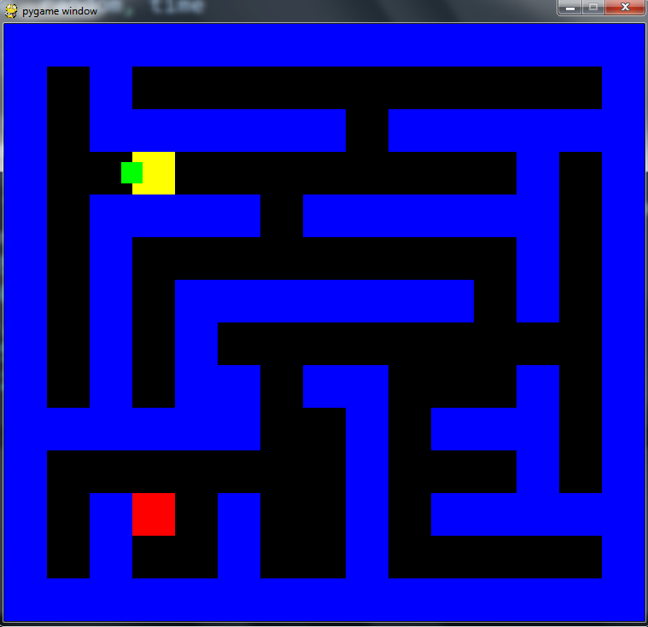 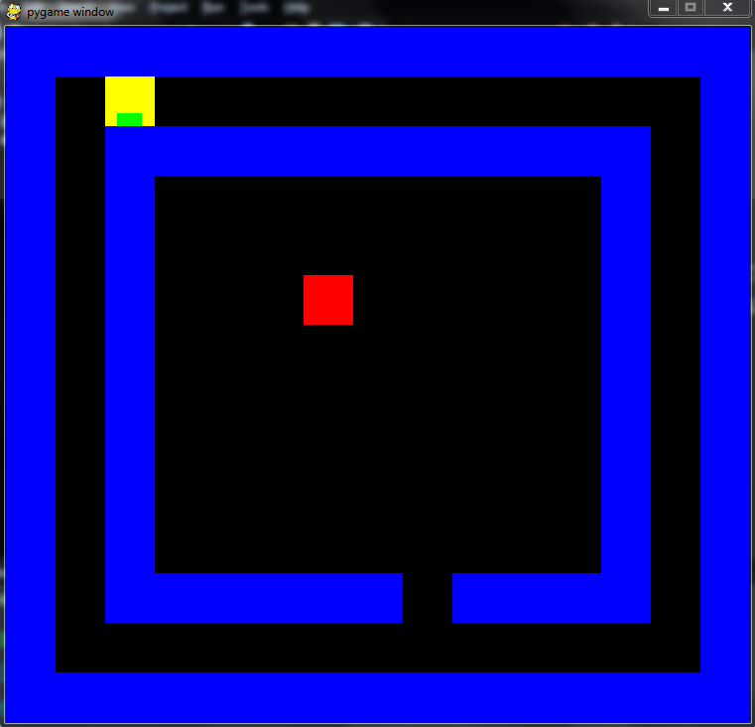

TIPS:

The following is not great code, but it seems ok at first glance. Does it work on any of the above mazes? What does this code do?

runner.moveAhead(maze)

runner.turnRight()

if not runner.wallAhead(maze):

runner.moveAhead(maze)

if runner.wallAhead(maze):

runner.turnLeft()

Many students want their robot to remember where it has been. All the mazes can be completed WITHOUT memory, but if you insist, here’s some example code to help your robot remember:

#Have I been here before?

if (runner.col,runner.row) in runner.memorylist:

print("I have been here before")

#Remember where I have been with no duplicates

if not( (runner.col,runner.row) in runner.memorylist ):

runner.memorylist.append( (runner.col,runner.row) )

print(runner.memorylist)