For 180 points, write a program to draw the most interesting tree (or forest) that you can using recursive functions.

This is an individual project. You must write all the code yourself. Before starting, create a Program Plan. You must write down the pieces of the program that are

Needed and in what order you plan to write them.

You will turn in your Program Plan and code.

You are given a program with two recursive functions. Read them, understand them, choose one to use. Each function draws a branching pattern. Modify these functions.

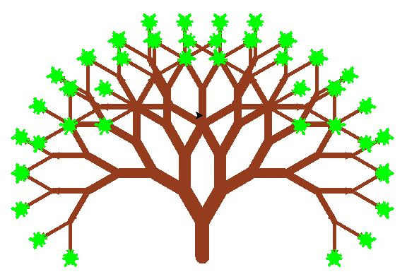Recursion is powerful. Here is Mr. Holtschulte’s tree written in 70 lines of code (including comments) **without** recursion:

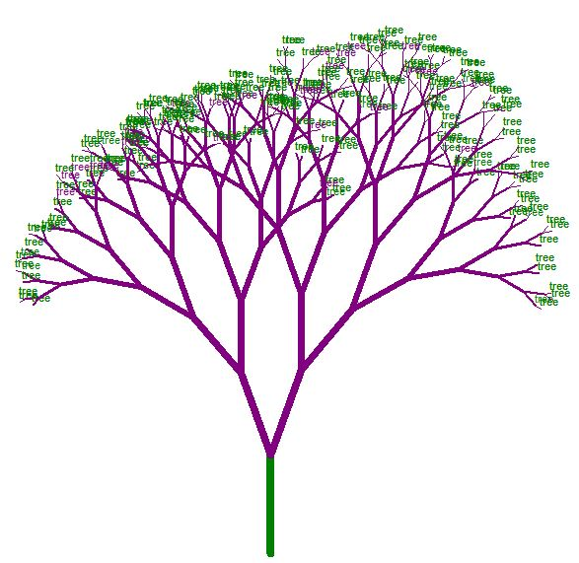

Here is a student’s tree written in 40 lines of code (including comments) with **recursion**:

To get full credit you must:

1. Draw an interesting tree

2. Use recursive functions

3. Comment your work. Explain the purpose of your code.

You are encouraged to use **random**

Examples:

import random, turtle

t = turtle.Turtle()

t.setheading(random.randint(0,360)) #Randomize the turtle’s direction

t.forward(t.random.randint(10,80)) #Move turtle forward random amount

t.color(random.random(),random.random(),random.random()) #Randomize color

t.right(random.randint(0,10)) #Turn right a random amount

t.pensize(random.randint(1,5)) #Randomize the width of the line drawn