**TO DO:**

* **Collect email and mailing addresses**
* **Set up RSVP form**
* **Set up Website**
  + Event Details
  + Hotel and Travel Recommendations
  + Gift Registry Information
  + RSVP
* **Create HTML Save the Date Email**
* **Finalize formal invite**
  + **Buy paper/ envelopes**
* **Design RSVP card**
  + **Language for RSVP**
  + **Buy paper**
* **Design out of town email**
  + Ice Cream Social/ Martha Bar
  + Coffee Donut Brunch
* **Program for the event**

**SAVE THE DATE**

for the Wedding of

Kristyn Stewart & Martin Brown

The Evening of January 14, 2017

The Painted Bride Art Center

Philadelphia, PA

We hope you can join us for a night of marriage, music, and margaritas!

A formal invitation will be sent via mail.

Can’t wait any longer to book your trip?

Check out the hotels that we have blocked for the event.

[Hotel Monaco](https://gc.synxis.com/rez.aspx?Hotel=56524&Chain=10179&Dest=PHILLY&locale=en-US&arrive=1/13/2017&depart=1/15/2017&adult=1&child=0&group=20000703376)

[The Franklin Hotel](http://www.marriott.com/meeting-event-hotels/group-corporate-travel/groupCorp.mi?resLinkData=Stewart%20Brown%20Wedding%20%5Ephlpr%60sbwsbwa%7Csbwsbwb%7Csbwsbwc%60159%60USD%60false%604%601/13/17%601/15/17%6012/13/16&app=resvlink&stop_mobi=yes)

**WEBSITE**

**Kristyn & Martin**

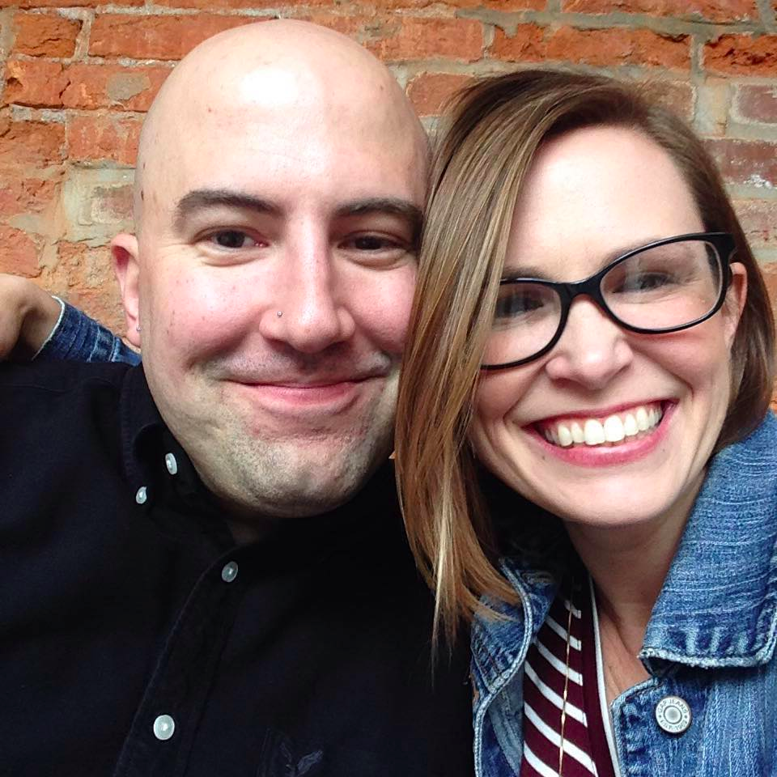

January 14, 2017

5:00pm

[The Painted Bride Art Center](https://paintedbride.org/)

230 Vine Street

Philadelphia, PA 19106

**RSVP via mail or by clicking HERE.**

The Wedding Venue

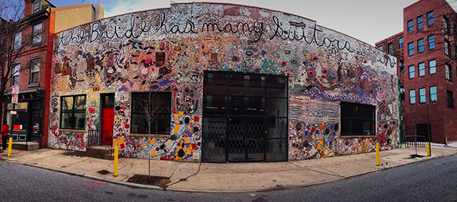

*The Painted Bride Art Center, Photo Credit: Emma Fried-Cassorla*

[The Painted Bride](https://paintedbride.org/) is a very unique venue. It houses a gallery space, an art café, and a black box theatre. Martin volunteered and worked at the Painted Bride during and after college and it remains his favorite place in Philadelphia. You can even [read a love note that Martin wrote](http://www.phillylovenotes.com/martin-brown-painted-bride/) to the Painted Bride to learn more about his long- term love affair with this very special place. As you can imagine, we are so excited to celebrate our wedding here with our family and friends!

The Painted Bride Art Center is conveniently located in historic Old City Philadelphia and just a fifteen-minute walk from the recommended hotels.

Schedule of Events

5:00pm Happy Hour

6:00pm Ceremony

7:00pm Dinner and Dancing

11:00pm After Party at Stratus Longue @ Hotel Monaco

Directions and Parking

If you are staying in Philadelphia, we recommend using a cab or Uber/Lyft service. The closest subway stop is the 2nd street stop on the Market Frankford Line.

If you are driving to the venue, street parking is limited. Refer to the [Painted Bride’s Parking Information](https://paintedbride.org/directions-parking/) for more details, especially their [very handy map of parking garages](https://www.google.com/maps/d/viewer?ll=39.955938%2C-75.143995&spn=0.005856%2C0.009645&hl=en&msa=0&z=17&ie=UTF8&mid=1mlP_nTVpwpCXzMqyZ7eZyi0pUfY) that are close to the venues.

Hotel and Travel Recommendations

We have reserved blocks of rooms for Friday the 13th and Saturday the 14th at the **Franklin Inn and Hotel Monaco**.

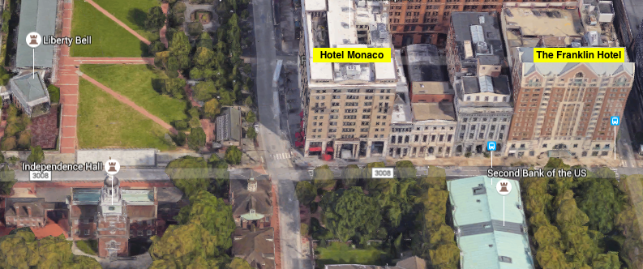

The hotels are located next to each other and conveniently located near the shops, galleries, and restaurants of Old City and all of Philadelphia’s historical attractions.

Please reserve a room at your earliest convenience by calling the hotel and mentioning the Stewart/Brown wedding or by following the unique link.

The special rate is valid until 12/12/17.

[**The Franklin Hotel at Independence Park**](http://www.marriott.com/hotels/travel/phlpr-the-franklin-hotel-at-independence-park/)

401 Chestnut Street

215-925-0000

[Stewart/Brown Reservation Link](http://www.marriott.com/meeting-event-hotels/group-corporate-travel/groupCorp.mi?resLinkData=Stewart%20Brown%20Wedding%20%5Ephlpr%60sbwsbwa%7Csbwsbwb%7Csbwsbwc%60159%60USD%60false%604%601/13/17%601/15/17%6012/13/16&app=resvlink&stop_mobi=yes)

[**Hotel Monaco Philadelphia**](http://www.monaco-philadelphia.com/)

433 Chestnut Street

215-925-2111

[Stewart/Brown Reservation Link](https://gc.synxis.com/rez.aspx?Hotel=56524&Chain=10179&Dest=PHILLY&locale=en-US&arrive=1/13/2017&depart=1/15/2017&adult=1&child=0&group=20000703376)

Gift Registry- TBD!

Sites and Attractions

Our Favorite Restaurants and Bars located within a few blocks of the hotel.

* Little Lion- Large gastro pub in an old bank building. Great for oysters, drinks, and quality America bar fare. Try the poutine!
* High Street- One of the best restaurants in the city from celebrity chef Eli Kulp. Amazing breads and pastas. Casual but high-end. Open for breakfast, lunch, and dinner.
* Capofitto- Authentic Neapolitan wood pizza al forno and hand made gelato. Owned by a friend of Martins. Very kid friendly and consistently a good meal.
* Farmacia- Farm to table contemporary bistro. Highly recommended for any meal of the day. Great brunch deals and fantastic happy hour.
* Amada- Traditional Spanish tapas from Iron Chef Jose Garces. Don’t miss the sangria. Make reservations!
* Eulogy- Belgian beer and frites. Impressive selection.
* Revolution House- Beer, sandwiches, and wood fired pizza. We love the eggplant parm sandwich. Try and sit upstairs for the cozy chairs and warm atmosphere.
* Wedge and Fig- Fantastic brunch, lunch, and dinner. Sophisticated and casual. This place is great for upscale soups, sandwiches, and salads. Specializes in all things cheesy.
* City Tavern- Historical fair and garb in an historic setting. We’ve never been but if you’re into history you might think it’s really cool!
* Zahav- One of our favs! High end Isreali from celebrity chef Michael Solomonov. Make reservations ASAP.
* Campanos- Convenient and quick cheesesteaks and hoagies.
* Fat Salmon- Kristyn’s favorite sushi in the city. Very modern. Make reservations.
* Continental- Retro vibe with small plates and fun drinks. Great lobster mac n’ cheese.
* Kyber Pass Pub- Very casual gastropub. Popular local hangout with good beers and burgers. Try the bacon fat popcorn.
* Sassafras- One of our favorite bars! Craft cocktails, beers, and wine. Good snacks. Kristyn loves the pomegranate martini and the dark and stormy. Live jazz most weekend nights.

Cafes

* Menagerie- Amazing coffee, friendly staff. Not a huge food selection.
* Old City Coffee- Good coffee and great for bagels and baked goods. On a cute street near historic Christ Church.
* Café Ole- Fast casual Mediterranean café with a large food and drink selection.

Must see: Winterfest! Penn’s Landing hosts an indoor/outdoor beer garden with fire pits, couches, games, ice-skating, and great river views. We like to order drinks, snag a couple rocking chairs, and people watch. If you don’t mind crowds then it’s a great way to kill an hour to two. Admission is free. Ice-skating costs money. Please don’t break your arm before (or after) our wedding.

Our VERY favorite places to eat that are not in Old City:

* Bud and Marilyn’s- Super chic Wisconsin-themed retro diner. The cheese curds. The hot buns. Oh MY God. Make a reservation.
* Nam Phuong- Casual family-style Vietnamese. Warm up with Martin’s favorite Pho!
* Le Virtu- The best pasta in the City. We live around the corner and could eat there every day. Make a reservation.
* Oyster House:-Oysters, seafood, and martinis.
* 20 Manning Grill- We just love this place. Consistently excellent American bistro food and cocktails. Great leather couches for lounging.
* Monk’s- The largest beer selection in the world or something. There are so many beers to choose from that you actually have to look through a book. The mussels and fried are also fantastic

Shopping

* Old City- Boutique Shopping
* Rittenhouse- Popular and Higher end brands
* South Street- Weird and Odd. Eyes Gallery is cool!

History

* Elfreth’s Alley
* Philadelphia History Museum
* Jewish History Museum
* African American History Museum
* Mutter Museum of Medical Oddities
* Independence Hall/ Liberty Bell- get tickets to tour Independence Hall HERE.

Art

* Philadelphia Museum of Art and Rodin Museum
* Barnes Foundation
* Moderne Gallery (Old City)
* Center for Art and Wood (Old City)
* Arch Enemy Gallery (Old City)
* Paradigm Gallery (Fabric Row)
* Mural Arts Bus Tours
* Magic Gardens- mosaic garden

Food Tourism

* Italian Market
* Pat’s and Geno’s (cheese steaks)
* Reading Terminal Market

Recreation and Outdoors

* Rittenhouse Square
* Japanese Garden
* Winterfest
* City Hall Observation Deck
* Liberty Tower Observation Deck

Bars and Music

* Bob and Barbara’s- Everything PABST. Kristyn’s favorite and a Philly classic. There is an organ trio Friday and Saturday nights. Ask for a city-wide special!
* Dirty Franks- The dirtiest dive bar in Philly. Martin’s college hang and still a reliable good time because of the unique décor and weird locals. The bartender never ages and has some great dance moves.
* Johnny Brendas- The bar that sparked the Fishtown revolution. A famed indie music venue featured in the movie Creed. Justin Bieber just visited so it must be super cool.
* XIX- Beautiful and upscale bar 19 floors above Center City. Amazing views and drinks.