

PtW Spa Control User Manual
For a PtW WiFi module for Bestway Lay-Z-Spa with the firmware already installed

English edition 0.5
6 October 2026
PtW Spa Control is an independent hobby project. This WiFi add-on is not an official Bestway module.
This manual explains how to connect the module to your home network, control the spa and add Google Home, Apple Home or Home Assistant. It starts with a module that already has the firmware installed. If you have a blank ESP32, install compatible firmware first; build it yourself if only source code is available. The repository has separate developer instructions.
For remote access, see pages 19 to 21. For an iPhone widget, see page 22. The illustrated screen guide is on pages 26 to 36.
Start with pages 3 and 4. You can then control the spa in a browser. Matter and Home Assistant are optional additions. For Google Home or Apple Home, continue on page 5. For the Home Assistant dashboard with charts and schedules, follow pages 13 to 18 in order.
Screenshots are preserved from the original manual; some show Dutch labels. Match the function described rather than the exact wording. Menu names can differ between phone and HA versions. Pump and module photos are on pages 37 to 39. The module fits between the original display plug and the vacated connector on the pump board.

Keep your module details
- Module ID: ........................................................
- Spa model: .........................................................
- Local IP address of the module: .....................................
- Home Assistant IP address, if used: ..................................
Store your Matter code privately. Use the codes on your own module, never a code from an example image.
Based on visualapproach's WiFi-remote-for-Bestway-Lay-Z-SPA. Project software uses GNU GPL version 3; see the repository LICENSE.

Contents
3 What you need and safe installation
4 First connection with AP and WiFi
5 First Matter pairing
6 Adding a second Matter connection
7 Dashboard and control panel
8 Scheduling in the module
9 History energy and maintenance
10 Customising the interface
11 Settings and hardware
12 Backups updates and diagnostics
13 Preparing Home Assistant
14 Installing and connecting MQTT
15 Installing HACS and extra cards
16 Placing HA files and packages
17 Activating scripts and the dashboard
18 Using the Home Assistant dashboard
19 Remote access with Home Assistant Cloud
20 Remote access with Tailscale
21 Reaching the ESP web page with Tailscale
22 An iPhone spa widget
23 Troubleshooting
24 Glossary and index
25 Checklist and official help
26 to 36 Illustrated screen guide
37 to 39 Pump and module photos

You do not need to set everything up at once
- Browser only: pages 3 and 4, then pages 7 to 12.
- Add Google Home or Apple Home: also page 5 and, if needed, page 6.
- Home Assistant dashboard: pages 13 to 18.
- A step fails: start on page 23. Erasing or resetting is not a normal fix.
In this manual, tap means one short touch. Hold means keeping your finger on a button briefly. Double tap means two quick touches. The action depends on the particular button; not every button supports all three gestures.

What you need and safe installation

Basic requirements
- A programmed PtW module suitable for your spa, with matching cables and enclosure.
- A pump and display with connectors compatible with the module; see pages 37 to 39.
- A phone, tablet or computer with a browser such as Safari, Chrome or Edge.
- A home network with 2.4 GHz WiFi and the correct WiFi password.
The module uses 2.4 GHz WiFi. A router can use one network name for both 2.4 and 5 GHz, provided 2.4 GHz is available. Google Home and Home Assistant are not required for normal browser control.

Connecting the module
1. Switch off the spa and unplug it from the mains before disconnecting cables.
2. Unplug the original display connector from the pump board; see page 38.
3. Connect that display plug to the display side of the module, marked DSP.
4. Connect the pump side of the module, marked CIO, to the vacated pump-board connector.
5. Mount the module in a dry, protected location. Check plugs, avoid trapped cables and close the enclosure.
6. Restore power to the spa and wait about one minute.
The connection is pump board → module → original display. Do not swap CIO and DSP. If the plugs do not match your version, stop and check compatibility. Do not force them. The photos on pages 37 to 39 show a particular installation, not universal pin assignments for every spa model.
Keep the spa's normal safety provisions and follow the Bestway instructions for water level, filtration and heating. Do not operate an empty spa as a test. Keep the configured model and hardware settings if they match your spa.

What you will see
The module has its own web interface. This is not a website requiring an account. You open it directly on your own network.

First connection with AP and WiFi

AP means the setup network
When the module is not connected to your home network, it can offer its own WiFi network: LazySpaSetup. This is for configuring the home connection. It has no internet access.

Connecting and configuring
1. After switching on a new module, wait about 45 seconds for the LazySpaSetup WiFi network to appear. Then open WiFi settings on your phone or computer.
2. Select LazySpaSetup. The current firmware does not require a password for this network.
3. If the phone says No internet, choose to stay connected anyway.
4. Open a browser and enter http://192.168.4.1 in its address bar, not a Google search box.
5. Open the menu at the top right, choose Settings and open WiFi. Tap Scan networks.
6. Select your home network, enter its WiFi password and confirm with the connection button.
7. Wait for the connection. LazySpaSetup may disappear; this is normal.
8. Reconnect your phone to your normal home WiFi.
9. Open http://bestwayspa.local. If that name does not work, use the module's IP address shown in your router's connected-device list.
10. In Settings > WiFi, check the network name and IP address. Record the address on page 1.

Success check
You can open the module web page while your phone is on your home network. The module's WiFi status is online.

If the page does not open
Temporarily turn off mobile data or a VPN if your phone bypasses the setup network. Avoid a guest network that isolates devices. If the home connection is lost, the recovery network normally appears after about 45 seconds. Try reconnecting through it first; do not erase other settings.

First Matter pairing

What Matter does
Matter lets you control the same spa from systems such as Google Home or Apple Home. This module communicates over WiFi, so it does not need a Thread network. Keep Bluetooth enabled on your phone during initial setup.

Preparing the module
1. Open the module web page on your home network and go to Settings.
2. Open Matter / Google Home / Apple Home.
3. Check Enable Matter. If it is off, turn it on and choose Save Matter setting and restart.
4. Reopen the page after the restart. Matter runtime must be active.
5. For a module with no existing pairing, use its permanent device code or QR code.
6. If the pairing window is closed, tap Open new pairing. The permanent code applies to the first pairing.

Google Home
Set up the Google Home app and a compatible Google Home Matter hub for your home first. In Google Home, choose Add and Device, then start adding a Matter device. Scan the QR code, or use manual Matter-code entry if scanning is not possible. Give the device a name and room and finish the app's steps.

Apple Home
Open the Home app, tap the plus and choose Add Accessory. Scan the QR code or use the alternative manual-entry option. With an iPhone running iOS 18 or later, local control of a Matter WiFi accessory can work without a home hub. For automations and remote access, a compatible HomePod or Apple TV home hub is the normal setup.

Practical tip
If the QR code is on the same phone you are pairing with, open the module page on a second screen or note its 11-digit code. Use manual Matter-code entry, not an eight-digit HomeKit code.

Success check
The spa appears in the chosen app and responds to a command. Check the actual pump status too. An app may display functions as separate generic switches.

Adding a second Matter connection

One spa in several apps
You can use Google Home and Apple Home together. A connection to a Matter system is called a fabric. Adding another connection does not remove existing ones.

Adding another system
1. Check that the existing app still controls the spa.
2. Open Settings > Matter / Google Home / Apple Home on the module web page.
3. Tap Open new pairing once and wait for the temporary code.
4. Use the Temporary code for additional pairing or its temporary QR code. Do not use the original permanent code for this step.
5. In the additional ecosystem's app, start adding a Matter device.
6. Scan the temporary QR code on another screen or enter the temporary code.
7. Finish within the five-minute pairing window.
8. Test control from both apps, then refresh Matter status in the module.
If the window expires, open a new one and use the newly displayed temporary code. Do not keep a temporary code as the permanent device code.

Home Assistant through Matter
Optionally add the Matter integration in HA through Settings > Devices & services > Add integration. Follow the Matter server setup instructions. Then add the device using the official HA Companion app on your phone. Choose the route for a device already in use and use a fresh shared or temporary Matter code. The exact choice depends on the app version.
This is separate from our detailed HA dashboard. That dashboard also requires MQTT and the files described on pages 13 to 18.

Why two fabrics can appear after one pairing
Pairing Google Home on an iPhone can also create an iOS system connection. Two fabrics therefore do not necessarily mean two people or two spa devices. They do not prove that the spa is already visible in the Apple Home app.
Leave Delete all Matter pairings and create new base code alone. It is an explicit reset, not a step for adding another phone or ecosystem.

Dashboard and control panel

Dashboard
This is the start page with water temperature, target temperature, control buttons and your selected information cards. Current temperature is measured water temperature; target temperature is what you want to reach.

Using the buttons
Tap Power, Filter, Heater or Bubbles to toggle the function. HydroJets only appear when supported by the selected spa model. Seeing a button does not mean a different model supports that function.
The button responds immediately to a touch. The module then corrects the display using actual pump status. Wait for confirmation before tapping again. A command may switch the spa on and unlock it before performing the requested action.

Heater enabled and actively heating
Heater enabled means heating is allowed. Actively heating means the pump is delivering heat at that moment. When the target is reached or the pump imposes a restriction, the heater can be enabled without active heating.

Setting the temperature
Use minus and plus next to the target. After a restart, the actual target may briefly be unknown. The module does not invent a value: a first temperature action may be needed to learn the real pump target. Wait for feedback afterwards.

Control panel
Choose Controls from the menu. This page provides controls corresponding to the physical display and the functions supported by your model. Use ordinary function buttons for daily operation. Special functions for other models may be absent; this is normal.

Lock
A closed padlock means locked. Normal function commands can unlock automatically when needed. Use the lock control if you deliberately want to lock or unlock the spa.

Offline
Information can be stale if the spa or controller is disconnected. Check the connection and power first. Repeatedly pressing several buttons is not a troubleshooting method.

Scheduling in the module

What the scheduler does
The scheduler runs commands on selected days and times. Rules are stored in the module. Your phone does not need to stay open after saving, but the module needs correct time, time zone and normal operation.

Adding a command
1. Open Scheduler from the menu.
2. Tap Add schedule.
3. Choose the time.
4. Choose an action such as Heater on, Filter off or Target temperature.
5. Select at least one day.
6. For Target temperature, enter the desired temperature. Other actions do not use that field as a temperature command.
7. Save and check the command appears on the intended days.

Example
Want to bathe at 18:00 on Saturday? Create a target-temperature command and a separate command to enable the heater early enough. Heater on is a start time, not a guarantee of warm water at that time. Required lead time depends on water temperature, weather and cover.

Changing and deleting
Open an existing rule to change its fields. Check all its days after saving. Delete selected removes selected commands; check the selection before confirming.

Switching off just one day
Use the switch beside that day's command in the web scheduler. Other days remain active. The off day becomes a separate disabled rule and matching rules are merged again when it is re-enabled. Splitting a rule needs a free slot; if all 24 slots are occupied, the change can be refused without altering the schedule.

Limits and time
The module supports up to 24 schedule items. A rule covering several days can be one item. Avoid conflicting commands at the same time. Check Settings > Region & Time for local time, time zone and synchronisation. HA edits the same scheduler; see page 18.

Success check
A safe test command a few minutes ahead remains visible after reopening and runs at the intended time. Only test a function appropriate for a filled spa.

History energy and maintenance

History
Open History to view water and target-temperature trends. Select an available period of 4, 12 or 24 hours. Minimum, average and maximum refer to the displayed measurements. Activity shows when functions were active.
A new module will not yet have a full chart. Let it run for a while. Clear deletes the module's stored history; use it only when you intend to discard those measurements.

Energy
Energy shows estimated consumption, cost and run hours. It uses configured power ratings and operating duration; it is not a certified measurement at the mains socket.
Under Calculation, enter known power ratings in watts for the functions. Enter the electricity price per kWh and currency, then save the energy settings. Check the rating plate and pump documentation if values are unknown; do not copy arbitrary ratings from another pump online.
Reset counters clears the relevant energy counters. Make a backup first if you want to keep the current figures. HA daily totals are separate calculations based on HA history and may differ from the module counters.

Maintenance
Open Maintenance for filter replacement, filter cleaning and chlorine addition. Set an interval in days for each task and save.
After actually completing a task, use Replaced today, Cleaned today or Added today. This updates its recorded date and next reminder. A reminder does not measure water quality or dispense chlorine. Continue testing the water and following the pump instructions.

Success check
History displays the selected period, energy values are plausible and a completed maintenance task shows the correct last date.

Customising the interface

Changing your screen
Open Settings > Web interface > Customise interface, or choose Customise interface directly from the menu.

Choosing cards and buttons
Select which dashboard buttons and cards are visible. Hiding a button does not switch off the pump function; it only hides that control on this screen. Save the dashboard layout with its save button.

Changing the order
Drag a card or button by its handle, then choose Save order. A default button restores the corresponding default order or visibility only.

Navigation
You can hide the bottom navigation bar or choose its tabs and their order. A page removed from the bottom bar remains available through the menu.

Style and light or dark
Under Appearance, choose Premium, Spa Resort or Spa Console. In the ESP web interface these change colours and shapes. Your customised page layout remains in place. The sun or moon at the top right switches between light and dark.
Accent colour, smooth animations and compact cards are separate settings. Disable animations if you prefer a calmer screen.

Language
Choose an available language manually or follow the browser language. The module website and HA have separate language choices. Our HA dashboard follows the language in your HA profile.

Home-screen shortcut
Save the module page as a shortcut on your phone. In Safari, use Share > Add to Home Screen. An Install app button or browser menu can serve the same purpose on other devices. This does not install new firmware on the module.

Per browser
Appearance and other local display choices are saved in your browser. Another phone can look different. Clearing browser data may remove these choices; spa settings are stored separately.

Settings and hardware

WiFi
Shows network name, IP address and signal. Scan networks helps configure another network. Forget WiFi removes the home connection; use it only when you intend to reconfigure WiFi. The setup network then becomes relevant again.

Matter
Shows enabled state, runtime, module ID, permanent code, fabrics and the new-pairing-window button. Follow pages 5 and 6 for pairing. Disabling Matter is not a way to add another ecosystem.

MQTT
Enter broker details for HA here. Expand MQTT settings if necessary to see the fields. MQTT and Matter can run together. Follow page 14.

Region and time
Set the time zone and local preferences. Check time synchronisation before using schedules. Units and local display choices may be in separate sections; check whether a save button is required.

Hardware
Controls model, protocol and module connections. The wrong model can cause incorrect controls or communication. A preconfigured module should already match your spa. Do not change these settings by guesswork.

Demo mode
Demo can simulate a spa. A simulated temperature does not prove that the real pump works. Use real operation for normal use. Demo is for deliberate testing without actual pump control.

Connector test
This is for testing the board outside the pump with the specified test setup. Do not start it during normal installation in a spa. Use it only with the correct test setup and project instructions.

Information
Shows module and system details. Include module ID, spa model and firmware version when asking for help. Do not post screenshots with readable Matter codes, passwords or private network details.

Backups updates and diagnostics

Making a backup
1. Open Settings > Backup & restore.
2. Choose the backup download button.
3. Save the JSON file on your computer or in a safe folder.
4. Give it a recognisable date. Do not edit its fields manually.
A backup can contain settings, maintenance, schedules, energy data and browser choices. It does not contain the WiFi password or a copy of Matter fabrics or unique Matter identity. Keep it private: other connection details can still be sensitive.

Restoring
Select the backup file in Backup & restore and follow confirmations. Restore can replace existing rules and settings. Afterwards check WiFi, MQTT, time, hardware and scheduler. If a restart is required, wait until the module is reachable again. Stop on an error and keep the message for investigation.

Updating firmware
OTA means updating over the network. Use only the correct firmware file for this project and your module. A source-code ZIP is not an OTA firmware file.
Open OTA or Firmware under Settings, select the correct .bin file and start uploading. Maintain power and WiFi throughout. Wait for upload, processing and restart; do not interrupt because the screen briefly stops responding. Reopen the page and check the version afterwards.

Diagnostics
Diagnostics provides system details, Self-test and Report. For a problem, Report is a useful first step. Debug logging is normally off and should not remain enabled during daily use.
Enable logging only when requested or for a short investigation. Reproduce the fault, download a report and disable logging again. Restarting is not a factory reset. Erasing pairings or settings is a separate significant action; only do that deliberately.

Preparing Home Assistant

What Home Assistant is
Home Assistant, or HA, runs on a device in your home and brings smart devices together. The phone app is its interface; the app alone does not replace that home device.

If you do not have HA yet
Install Home Assistant OS on suitable hardware using the official installation guide on page 25. This spa manual continues from a running HA installation with an administrator account. An existing Container installation has no built-in Apps store; have the equivalent services installed separately in that case.

First start
Open http://homeassistant.local:8123 or the HA device's IP address followed by :8123. Create your account, set home location and time zone, and store your login details. A computer with a keyboard is convenient for setup.
Enable Advanced mode in your HA profile, opened through your name or user icon. Install the official Home Assistant Companion app on your phone and connect it to the same HA server.

What we will add
- Mosquitto broker and the MQTT integration for spa data and commands.
- File editor to place the supplied files.
- HACS to install extra dashboard cards.
- Button card, Layout card, ApexCharts card and Card mod.
- Browser Mod integration for schedule popups.
- Buienradar for outside temperature and heating estimates.
- Dashboard YAML, JavaScript, planner scripts and two packages.

Apps and integrations are different
Apps, called add-ons in older versions, are extra programs. Integrations let HA communicate with a service. Dashboard cards change what you see. We therefore install both the MQTT broker and the MQTT integration.
Before changing HA, create and safely store an HA backup through Settings > System > Backups. Use a new dashboard for the spa so an existing dashboard is preserved.

Installing and connecting MQTT

MQTT in plain language
The broker receives spa data and commands and passes them between HA and the module. Normal operation does not require typing MQTT messages yourself.

In Home Assistant OS
1. Open Settings > Apps > Install app. Older versions call this Add-ons and the Add-on store.
2. Find Mosquitto broker, install and start it. Enable Start on boot.
3. In Settings > People > Users, create a separate user such as spa_mqtt with a strong password. Do not use the reserved names homeassistant or addons.
4. Open Settings > Devices & services and configure the discovered MQTT integration. If not discovered, add MQTT and follow the broker setup.

In the module
1. Open Settings > MQTT and expand MQTT settings.
2. Enable MQTT.
3. Enter the HA device's local IP address as the broker address. Do not use localhost or 127.0.0.1 here.
4. For the standard local Mosquitto connection, use port 1883.
5. Enter the new user's username and password.
6. Keep Base Topic set to layzspa for the supplied dashboard and scripts.
7. Enable Home Assistant Discovery and keep normal status publication enabled.
8. Use a unique Client ID. For one module the supplied default can be used; several modules must not share an ID.
9. Save the MQTT settings and wait for connection.

Check
Find the spa under Settings > Devices & services > MQTT in HA. Open it and check temperatures and functions. If water temperature updates and a safe command works, the connection is operating.

If something is missing
Check IP address, port, user, password and Discovery. A password field may look empty when reopened because the stored password is hidden; enter it again only if you intend to change it.
The supplied files assume one spa with standard entity names. Multiple spas need distinct topics and entities first. Do not blindly copy this dashboard for both devices.

Installing HACS and extra cards

Adding HACS to Home Assistant OS
1. Open Settings > Apps > Install app and the Repositories menu.
2. Add https://github.com/hacs/addons as a repository.
3. Install the Get HACS app and start it.
4. Open its log and follow the instructions. Restart HA if the installer requests it.
5. Then add the HACS integration through Settings > Devices & services > Add integration.
6. Follow GitHub sign-in. You need your own GitHub account. Enter the displayed device code on GitHub and authorise HACS.
This GitHub account is for HACS, not a spa account. Install a version compatible with your HA version. Screen names may change; official HACS links are on page 25.

Download the extra components
Search HACS for each project and choose Download:
- Button card by custom cards, for control buttons.
- Layout card by Thomas Lovén, for layout.
- ApexCharts card by RomRider, for charts.
- Card mod by Thomas Lovén, for styling and mod card.
- Browser Mod by Thomas Lovén, for popups.
After downloading Browser Mod, add it as an integration through Devices & services. Restart HA if requested and reload the browser. Downloading it in HACS alone is not enough.

Check resources
Open Settings > Dashboards > three-dot menu > Resources. If Resources is missing, check Advanced mode in your profile. HACS normally manages dashboard resources; do not add duplicates.
Our scheduler uses a popup in the current browser. Registering a browser is mainly useful for targeting it from other HA actions; it is not mandatory for a local tap on our planner button.

Success check
HACS and Browser Mod appear in integrations and the four dashboard projects are available. Then continue to the file-installation steps.

Placing HA files and packages

Use files from the same project version
You need the JavaScript resource, full dashboard, planner scripts and two packages. Open YAML files as text. Do not let Windows add an extra .txt extension.

File editor
Install File editor through Settings > Apps, start it and open its web interface. Find the directory containing configuration.yaml. This is the HA configuration directory, usually /config in HA OS. Do not create another config directory inside it.

Create these directories if absent
- www for bestway-language-card.js.
- packages for bestway_opwarming_package.yaml and bestway_gebruik_vandaag_package.yaml.
Place those three files in their directories. The dashboard YAML and scripts are handled on page 17 and do not belong in www.

Enable packages
Open configuration.yaml. If no homeassistant section exists, add:
homeassistant:
packages: !include_dir_named packages
If homeassistant: already exists, add only the indented packages line inside it. If packages is already configured, use that setup and do not duplicate the key. The supplied packages are designed for include_dir_named.
Indent using spaces, not tabs. Copy the original file before editing. Do not delete existing configuration just to replace it with this example.

Buienradar
Add Buienradar through Devices & services > Add integration and select a location. Find its weather entity under Developer tools > States. The supplied files expect weather.buienradar with a temperature attribute. If your entity has another name, update its reference in the heating package or deliberately rename that entity ID.
Check configuration under Developer tools > YAML. Restart only after validation passes; restarting is not a way to fix invalid YAML.

Activating scripts and the dashboard

Placing planner scripts
Open scripts.yaml in the HA configuration directory. The supplied layzspa_planner_popup_scripts.yaml contains three named scripts. Append them without an extra script: heading. Preserve existing scripts. If scripts.yaml is empty, this becomes its first content.
configuration.yaml should contain script: !include scripts.yaml. Add this only if no script configuration exists. If scripts use a different structure, put the three scripts in that structure; ask for help if unsure. Never add a second script: key.
Validate configuration and reload Scripts through Developer tools > YAML, or restart HA. Check these actions exist:
- script.layzspa_planner_add
- script.layzspa_planner_update
- script.layzspa_planner_delete

Our browser resource
Open Settings > Dashboards > three-dot menu > Resources. Add one resource with URL /local/bestway-language-card.js?v=4 and type JavaScript module. Edit an existing entry instead of duplicating it. /local is the browser route to www; do not enter /config/www as the URL.

Creating the dashboard
1. In Settings > Dashboards, create a new empty dashboard, for example Spa.
2. Open it and choose Edit dashboard. Take control of an automatic dashboard first if required.
3. Open the Raw configuration editor.
4. Paste all of layzspa_dashboard_3_layouts_7_talen.yaml and save. It contains button_card_templates and views; do not paste it as a single card.
5. Fully reload. On a computer, use Ctrl Shift R; on a phone, close and reopen HA if old content remains.

Check
The Spa dashboard shows temperatures, controls, charts, scheduler and system information. For Custom element doesn't exist, check the relevant HACS download or resource and reload first. Do not replace YAML at random.

Using the Home Assistant dashboard

Temperature and controls
The top card shows water and target temperature. Minus and plus change the target. Tap a function button to toggle it; hold opens more information. Lock on means locked; off means unlocked.
The display can react immediately and then receive confirmation from actual pump status. Heater enabled and actively heating are separate signals. Spa ready here means connection and spa data are ready, not that water has reached the target.

Layout and language
Choose Premium, Spa Resort or Spa Console at the top. The choice is saved in this browser. Resort and Console also have a different visual layout from Premium. The ESP style setting is separate.
The page follows your HA profile language: Dutch, French, German, English, Italian, Spanish or Polish. An entity you renamed yourself may keep its own name.

Charts and activity
Charts show 24 hours of temperature and activity. Spa Console also shows today's run time for active heating, filter and bubbles. Totals start at local midnight; new sensors do not yet have a full day's history.

Heating estimate
The estimate learns from actual heating periods with filtration on, bubbles off and valid temperatures. At least three comparable periods are required, which may take several heating sessions. Outside weather comes from Buienradar, not a sensor at the spa. Wind, cover and changing weather affect actual duration.

Scheduler
Tap COMMAND, or OPDRACHT in Dutch, to add a rule. Tap an existing row to open its editor. Select days, time, action and active state, then save. Active applies to the whole rule for its selected days. Delete in the popup removes that rule. In the current dashboard, hold and double tap on schedule rows have no action, even if an old hint says otherwise.
The ESP web scheduler can disable one day separately. HA then shows an active rule for remaining days and a disabled rule for that day. Matching rules merge when re-enabled.

System
The system card sits below the scheduler. Its position follows the number of visible rules. HydroJets and other model-specific functions appear only when available.

Remote access with Home Assistant Cloud

Choose one route
Home Assistant Cloud by Nabu Casa and Tailscale can both provide remote access to the HA spa dashboard. Both need HA running at home, home internet and phone internet. The module stays on your home WiFi with MQTT.
Home Assistant Cloud is a subscription service; check current terms with Nabu Casa. Tailscale uses its own account and a VPN app on the phone. You do not need to configure both routes.

Setting up Home Assistant Cloud
1. At home, open Settings > Home Assistant Cloud in HA.
2. Create a Nabu Casa account or sign in.
3. Enable Remote access and wait for the address to be ready.
4. Keep the displayed https address private.

Connecting the iPhone app
Install the official Home Assistant app from the App Store. Open it at home first and sign in to your HA server. Allow local-network access. Open Settings > Companion app > your server and its connection settings. Enable Connect via Cloud if offered. Otherwise use the Nabu Casa address as the external URL. Keep the internal URL as your local HA address, for example http://192.168.1.50:8123, using your actual address.

Test
Turn off iPhone WiFi and use mobile data. Open HA and the Spa dashboard. Check temperature and a safe command. Turn WiFi back on afterwards.

What this reaches
This route opens HA and its dashboard. It does not expose the separate ESP web page. Open module settings or OTA using its local address at home, or the additional Tailscale subnet route on page 21.

Remote access with Tailscale

Installing on Home Assistant OS
1. Create an account at https://tailscale.com/start.
2. Find Tailscale under Settings > Apps > Install app. If absent, add https://github.com/hassio-addons/repository.
3. Install and start it, and enable Start on boot.
4. Open its web interface and sign HA into your Tailscale account.
5. Check HA is online at https://console.tailscale.com.

Setting up HTTPS access
6. Under DNS in Tailscale administration, enable MagicDNS and HTTPS Certificates.
7. In HA, open Settings > System > Network > HTTP server > Reverse proxy. Enable Trust X Forwarded For and add 127.0.0.1 as a trusted proxy. Save; the interface restarts. This menu route applies from HA 2026.8.
8. In the Tailscale app, select Serve under Share Home Assistant. Copy its complete https address, for example https://homeassistant.your-network.ts.net. Use your own address.

On the iPhone
Install Tailscale from the App Store. Sign into the same Tailscale network and allow the VPN profile. Turn the connection on. Set that https address as the external URL in the HA app; keep your local HA address as the internal URL.

Check
Turn WiFi off and keep Tailscale connected. Open the https address in Safari, then the Spa dashboard in HA. Turn WiFi back on after testing.
Use Serve for this private connection. Funnel, an exit node and router port forwarding are not required for this route. Older HA versions have different proxy configuration; consult the matching official app documentation.

Reaching the ESP web page with Tailscale

Only for the module's own page
The previous route serves the HA dashboard. To reach ESP settings, backup or OTA remotely, Tailscale also needs a route to the home subnet. No Tailscale software is installed on the ESP itself.

Adding a network route
1. Find your router's local network range. For 192.168.1.x with mask 255.255.255.0, this is usually 192.168.1.0/24. Use this example only if it matches your network. Note the module IP too.
2. Open the HA Tailscale app configuration.
3. Add your range under Advertise routes or advertise_routes. Preserve other settings.
4. Save and restart that app.
5. In Tailscale administration, select the HA machine and approve its new subnet route.
6. Connect your iPhone to Tailscale. Temporarily turn WiFi off and open http:// followed by the module's local IP in Safari.

Example
If the module is at 192.168.1.120, open http://192.168.1.120. Use your actual address. bestwayspa.local is not a reliable route outside the home network.

Overlapping addresses
A visited WiFi network may use the same address range as home. If the route fails there, test mobile data first. Do not change subnets or assign a static module address at random to fix it.

Access
The subnet route lets authorised Tailscale devices reach the specified home network. Only add your own users and devices. Prefer a reserved module IP in your router so its link remains stable.

Remote OTA
Use the correct firmware file and maintain home power and connectivity during the update. No reset or new Matter pairing is required.

An iPhone spa widget

Test the connection first
The official HA app must open the Spa dashboard at home. For remote use, page 19 or 20 must also work. With Tailscale, keep the VPN connected. A widget is a small home-screen view, not a replacement for the full dashboard.

Creating your widget
1. In HA, open Settings > Companion app > Widgets > Create.
2. Choose a name such as Spa.
3. Add water, target, filter and heater. Find the exact entities listed below.
4. For temperatures, choose Nothing; for switches choose Default to toggle. Enable confirmation for control buttons.
5. Save the widget.

Adding it to the Home Screen
Hold an empty area on the iPhone Home Screen. Choose Edit > Add Widget, find Home Assistant and choose Custom Widget in a suitable size. Add it and tap Done. Hold the widget, choose Edit Widget and select your Spa configuration. Enable Show last update time.

Exact entities
- Water: sensor.bestway_lay_z_spa_watertemperatuur
- Target: number.bestway_lay_z_spa_doeltemperatuur
- Filter: switch.bestway_lay_z_spa_filter
- Heater: switch.bestway_lay_z_spa_heater
If a name is absent, find it in Developer tools > States; do not create duplicates. For actual heating, use binary_sensor.bestway_lay_z_spa_daadwerkelijk_verwarmen.

Simpler alternative
Add the HA Open Page widget and select the Spa dashboard. One tap opens the whole page. A Sensors widget can show temperatures only.

Freshness
iOS controls when widgets update. Displayed state can be old; open the app for current confirmation. Custom Widget and state display are described as beta in the HA app documentation used for this manual. Menu names may differ by version.

Troubleshooting

The module page will not open
Check the phone's WiFi network. Initial setup uses LazySpaSetup and http://192.168.4.1. Afterwards use home WiFi and the module IP address. Try the IP if bestwayspa.local fails. Temporarily disable a VPN and avoid isolated guest networks.

Matter code does not work
Check whether this is a first or additional pairing. First pairing uses the permanent code. Additional pairing uses a fresh window and temporary code. Check runtime, phone permissions and the same home network. Open a new window if expired. Do not reset as the first remedy.

MQTT device is missing
Check the broker app and MQTT integration in HA, then the module's broker address, username, password, port, Base Topic and Discovery. An online web page proves WiFi only, not MQTT connectivity.

A dashboard card reports an error
Custom element doesn't exist often indicates a missing resource, download or old browser cache. Check the exact project on page 15 and resource on page 17. Only our JavaScript resource needs v=4; do not randomly change HACS resource URLs.

The schedule popup fails
Check Browser Mod is an active integration and the three scripts exist. Check the full dashboard was pasted into the raw editor. Confirm MQTT is online before saving.

An HA value is missing
Find the entity in Developer tools > States. The entity ID is its technical name, such as sensor.bestway_lay_z_spa_watertemperatuur. Older devices or duplicate sensors may have another name or a _2 suffix. Adjust references deliberately; do not delete working devices to force names.

No heating estimate yet
This is normal while learning, without active heating, with bubbles on or with missing data. Check weather.buienradar and the packages. HA must retain relevant history. If Recorder uses include or exclude restrictions, include the spa and weather data it needs.

Asking for help
Record the step, error and time. Include module ID, firmware version and a diagnostic report. Never share passwords or pairing codes publicly. After an update fault, examine the report before making another change.

Glossary and index
AP is the module's temporary WiFi setup network. See page 4.
Broker is the server passing MQTT messages between HA and the module. See page 14.
Dashboard is a page of cards and controls. See page 7 for the module, and pages 17 and 18 for HA.
Entity is one function or measurement in HA. Its entity ID is the technical name used in dashboard files. See page 23.
Fabric is a Matter connection to a system. An iOS system connection may count too. See page 6.
Firmware is the module's built-in software. OTA updates it over the network. See page 12.
HACS is the community project store for HA. See page 15.
Integration lets HA communicate with a device or service. A card controls its display. See page 13.
MQTT is the messaging connection for the detailed HA dashboard. Matter is a separate smart-home connection. See pages 5 and 14.
Package is a file grouping related HA settings. In this setup it goes in packages. See page 16.
QR code is a scannable code containing Matter pairing information. See pages 5 and 6.
Runtime active means Matter is actually running. An enabled setting alone does not prove this. See page 5.
YAML is the text format used for HA settings. Space indentation is part of the format. See pages 16 and 17.
Tailscale is a private network connection for reaching home devices remotely. See pages 20 and 21.
Widget is a small iPhone Home Screen view. See page 22.

Index
Animations 10 · Apple Home 5 and 6 · Backup 12 · Bluetooth 5 · Browser Mod 15 and 17 · Buienradar 16 and 18 · Charts 9 and 18 · Codes 5 and 6 · Debug logging 12 · Energy 9 · Fabrics 6 · Filter 7 · Google Home 5 and 6 · Hardware 11 · Home Assistant 13 to 18 · Installation 3 · IP address 4 and 14 · Jets 7 · Language 10 and 18 · Lock 7 and 18 · Maintenance 9 · Matter 5 and 6 · MQTT 14 · Nabu Casa 19 · OTA 12 · Remote access 19 to 21 · Scheduler 8 and 18 · Style 10 and 18 · Tailscale 20 and 21 · Target temperature 7 and 18 · Time zone 8 and 11 · Widget 22 · WiFi 4 · www 16.

Checklist and official help
After initial installation
- The module is connected according to its installation instructions.
- Its website opens on the home network.
- The correct spa model and firmware version are known.
- Temperature and safe function controls work.
- Time zone and local time are correct.
- A backup is safely stored.
After adding Matter
- The selected app controls the spa.
- Both apps still work after adding a second system.
- The permanent code is stored privately; temporary codes are not recorded as permanent ones.
After adding Home Assistant
- MQTT is online and spa entities are present.
- HACS cards and Browser Mod are installed.
- Our resource is added once and the dashboard opens.
- A schedule popup can save a safe command.
- Buienradar supplies temperature; the estimate may still be learning.
- Debug logging is off again.
Official documentation
External installation sources below were consulted for the Dutch edition on 2 October 2026; remote access and widgets on 3 October. This English edition translates those instructions. Consult the relevant official guide if menus have changed.
Home Assistant installation and onboarding
https://www.home-assistant.io/installation/
https://www.home-assistant.io/getting-started/onboarding/
MQTT and packages
https://www.home-assistant.io/integrations/mqtt/
https://www.home-assistant.io/docs/configuration/packages/
HACS download and configuration
https://www.hacs.xyz/docs/use/download/download/
https://www.hacs.xyz/docs/use/configuration/basic/
Matter in Home Assistant and Apple
https://www.home-assistant.io/integrations/matter/
https://support.apple.com/102135
Google Home Matter setup
https://support.google.com/googlehome/answer/13127223
Browser Mod and Buienradar
https://github.com/thomasloven/hass-browser_mod
https://www.home-assistant.io/integrations/buienradar/
Remote access and iPhone widgets
https://www.nabucasa.com/pricing/
https://support.nabucasa.com/hc/en-us/articles/26474279202973
https://tailscale.com/blog/remotely-access-home-assistant
https://github.com/hassio-addons/addon-tailscale/blob/main/tailscale/DOCS.md
https://companion.home-assistant.io/docs/troubleshooting/networking/
https://companion.home-assistant.io/docs/integrations/ios-widgets/

Screen guide Dashboard
The dashboard shows water temperature on the left and target on the right. Minus and plus change the target. Buttons below control functions. Power ON means the spa is on; the water may still be cold. See page 7.
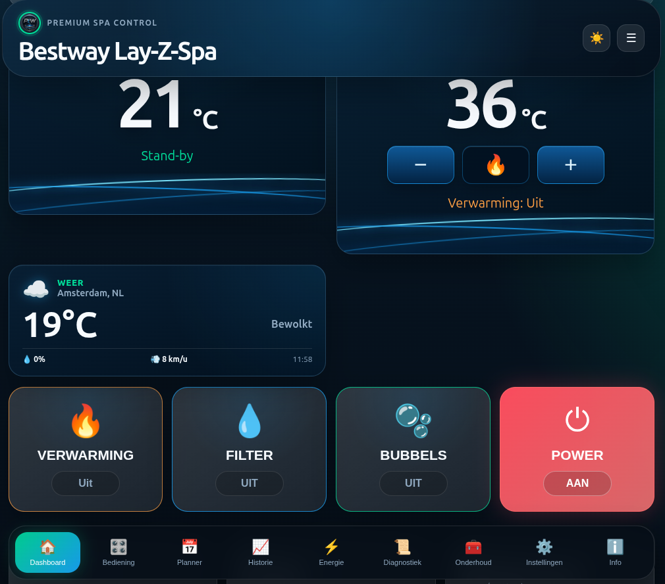
Dashboard with water at 21 degrees and a target of 36 degrees

Screen guide Control panel
Open Controls in the bottom navigation. Extra functions such as lock, units and timer appear here. Use only functions supported by your model. See page 7.
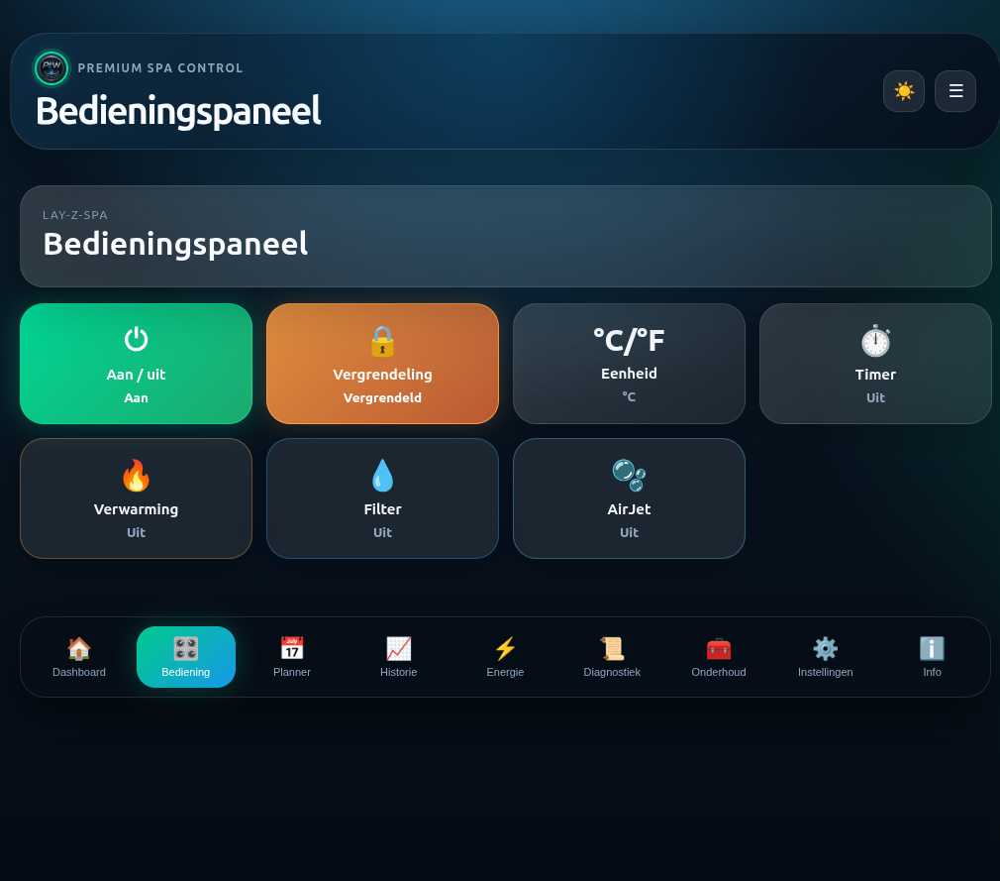
Control panel showing the status of each function

Screen guide Scheduler
Open Scheduler. Add schedule creates a command. Day cards show the commands for each day. Check days, time and action before saving. The example is not a recommended schedule. See page 8.
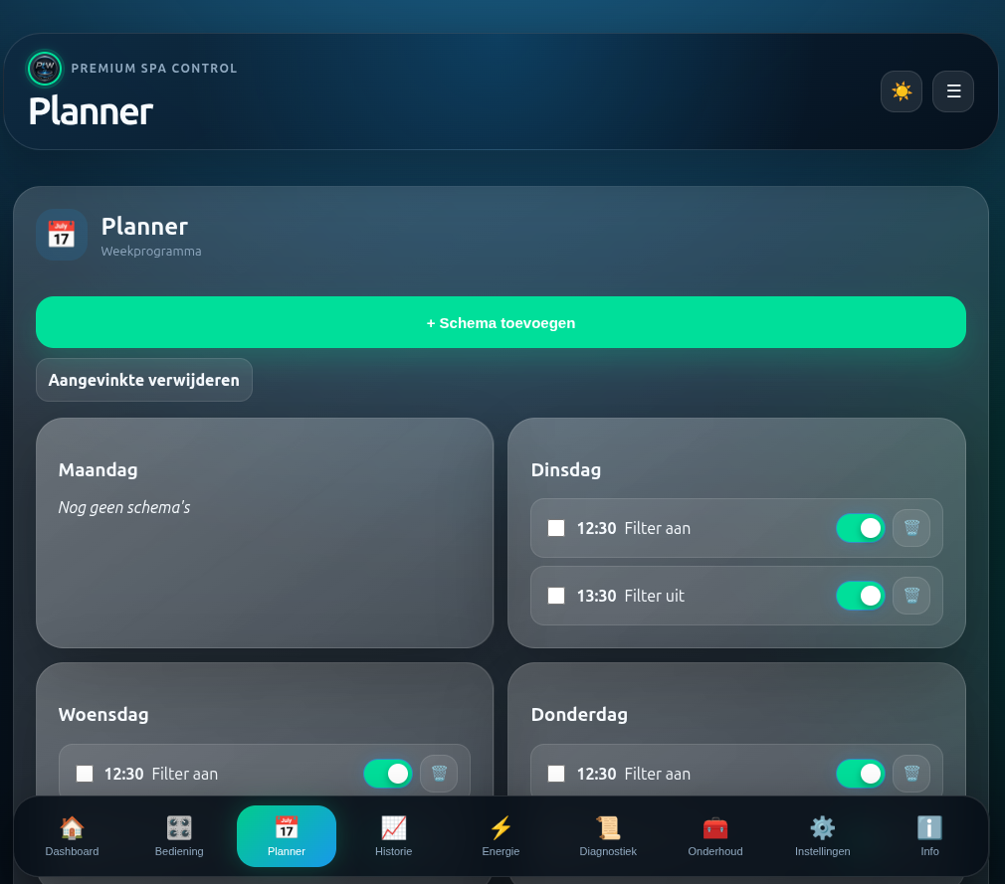
Scheduler showing commands for individual days

Screen guide History
Open History to see temperature trends and select a period. Clear deletes that history; it is not a refresh button. See page 9.
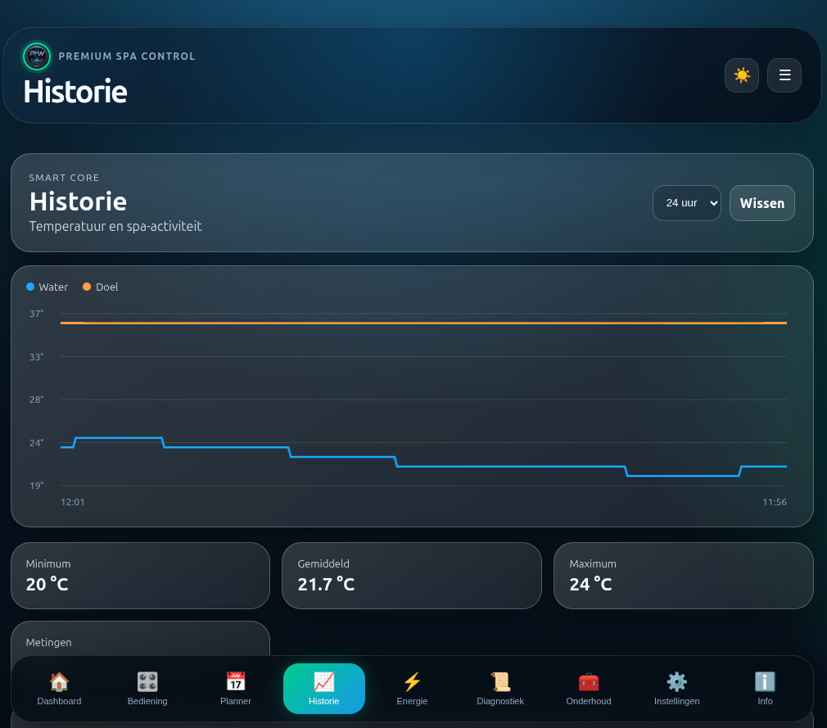
Temperature history with minimum average and maximum

Screen guide Energy
Energy shows estimated consumption and run hours, calculated from configured power ratings. Reset counters starts them again. Resetting is not required during installation. See page 9.
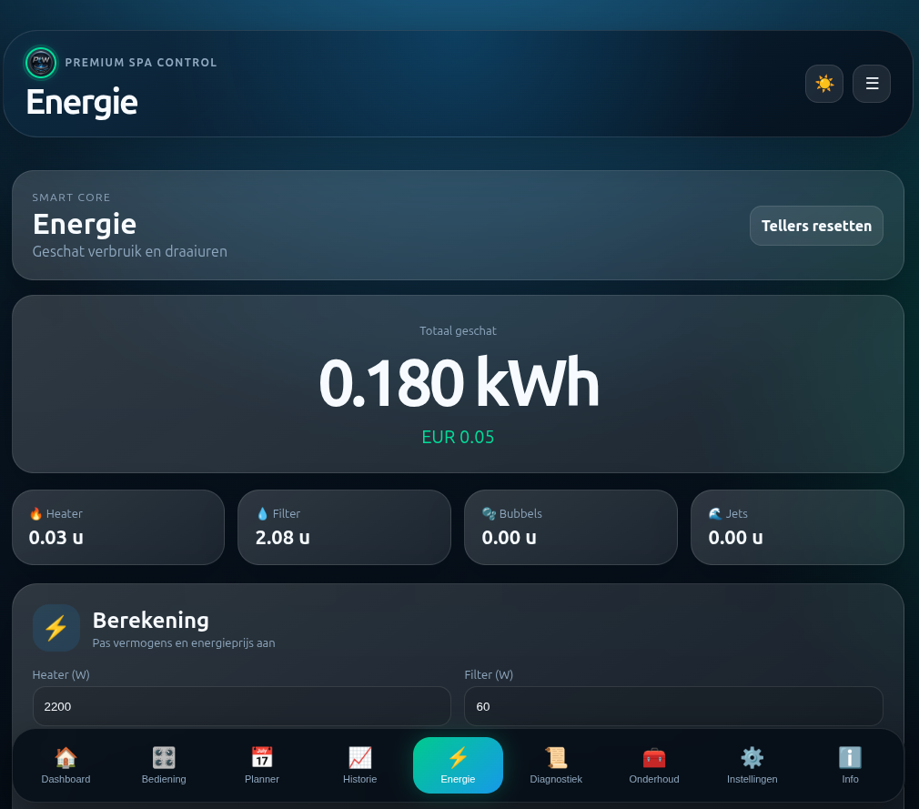
Energy page showing run hours and calculation settings

Screen guide Maintenance
Cards remind you to replace or clean the filter and add chlorine. Set suitable intervals. Use the confirmation button only after doing the work. The module does not measure water quality this way. See page 9.
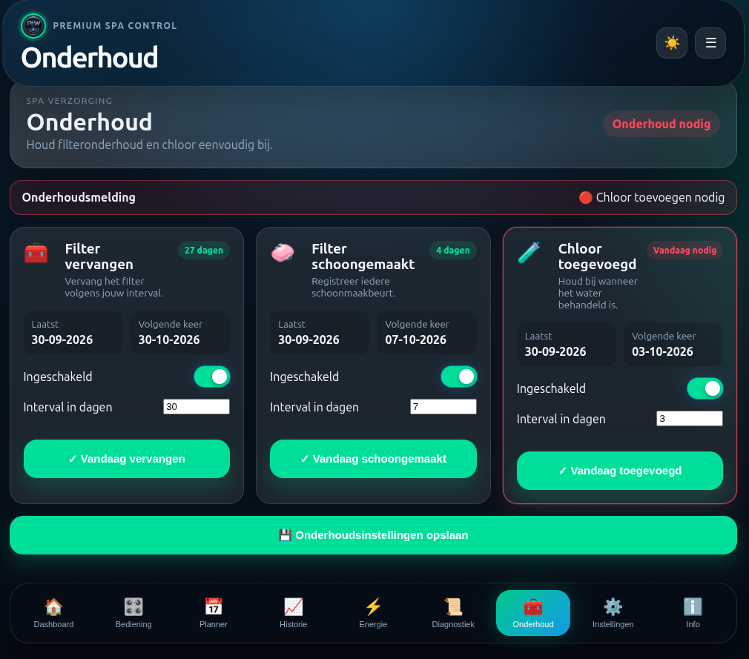
Maintenance with separate intervals and confirmation buttons

Screen guide Settings
Settings groups language, information, WiFi, Matter, MQTT, region and time, web interface and hardware. Open a section and scroll to others if needed. Information includes version and system details. See pages 10 to 12.
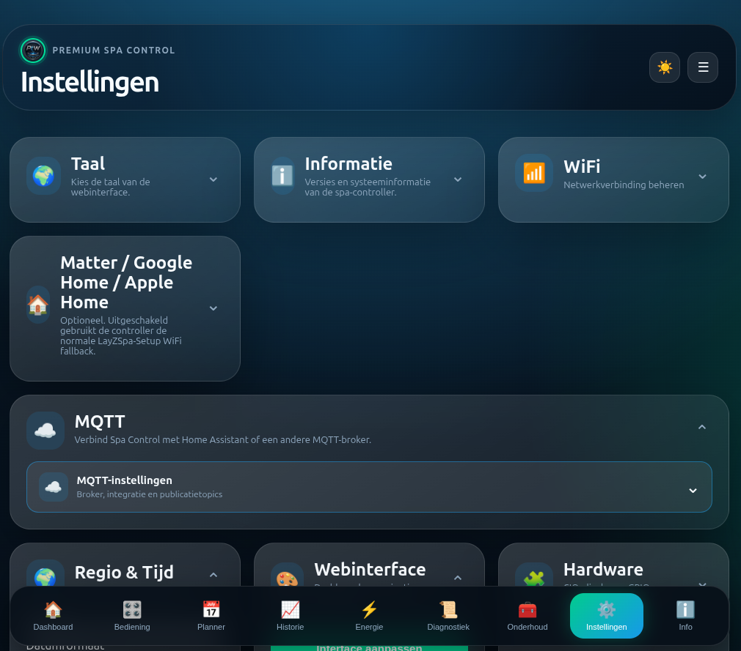
Settings with expandable sections

Screen guide Connecting WiFi
After Scan networks, choose your home network and enter its password. Choose Dynamic DHCP for normal automatic addressing. Static IP needs your own network details and is not required for initial setup. Then tap Connect. See page 4.
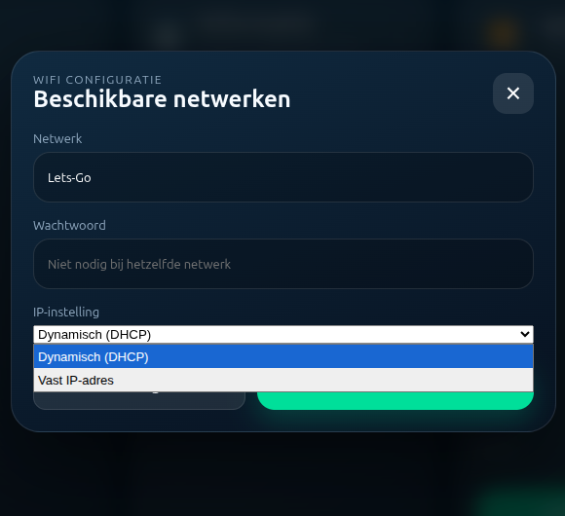
WiFi dialog with dynamic or static address selection

Screen guide Diagnostics
Diagnostics shows connection status and memory. Report helps investigate a specific problem. Debug logging is normally off; enable it temporarily for investigation, then disable it. A logging screenshot can contain private details. See page 12.
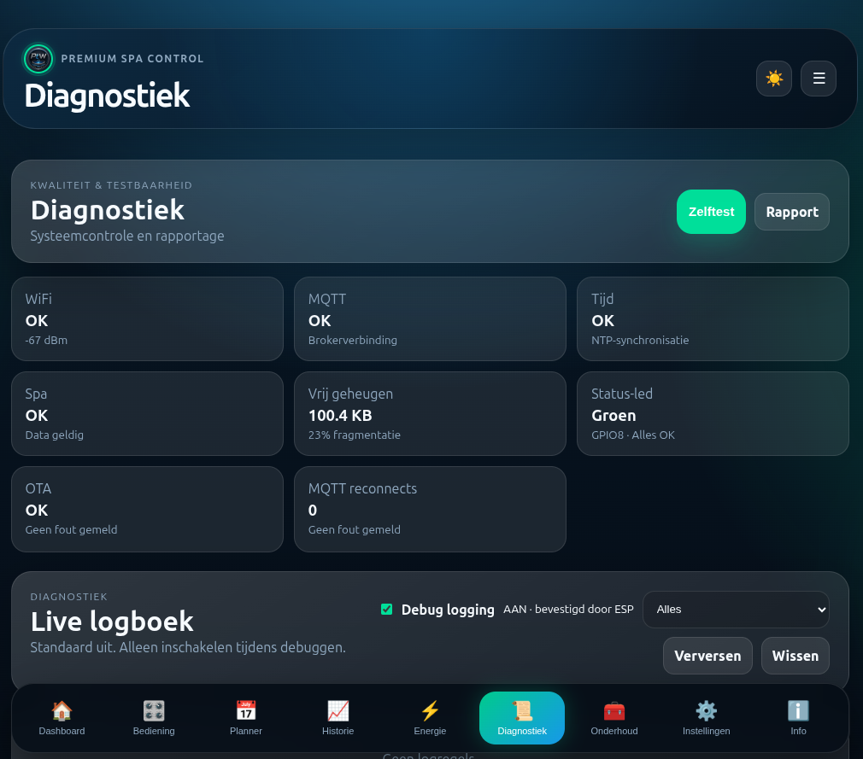
Diagnostics with report and live log

Screen guide Home Assistant
This is the HA dashboard, not the ESP's own page. This example uses English; the page follows your HA profile language. Temperature, controls and system status have the same functions. Scroll for charts and schedules. See page 18.
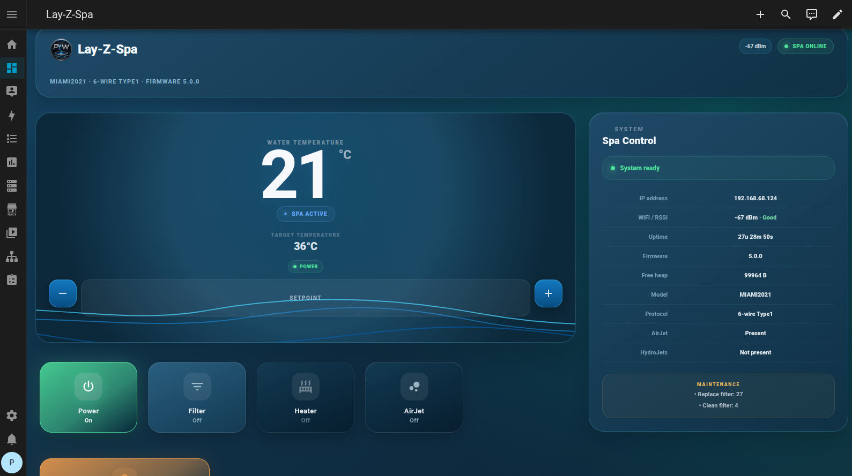
Home Assistant dashboard with temperature and system card

Screen guide HA schedule popup
Tap COMMAND, OPDRACHT in Dutch, or an existing rule. Choose active state, time, days and action. Temperature is used only for the target-temperature action. Heater on enables heating; it does not automatically set the target to that field's value. Tap Save. See page 18.
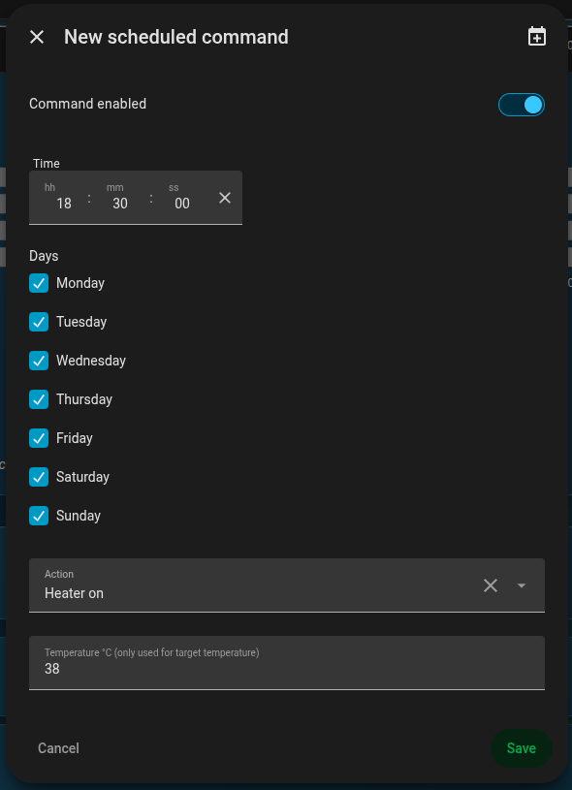
Home Assistant schedule editor with days and action

Overview photo of pump and module

Recognising the setup
The black enclosure labelled Lay Z Spa WiFi Module is the added controller. This overview shows it beside the electronics of an opened pump. The physical display cable runs towards the module and pump board.
The module belongs in the data connection between pump and display. Mounting location, plugs and fastening must suit the particular installation. A firmware model name alone does not prove every pump has the same connector.

Before opening
Unplug from the mains first. The pump contains mains terminals. Leave those, earth connections and thick power cables untouched. Working on an open, powered pump is not part of installation.
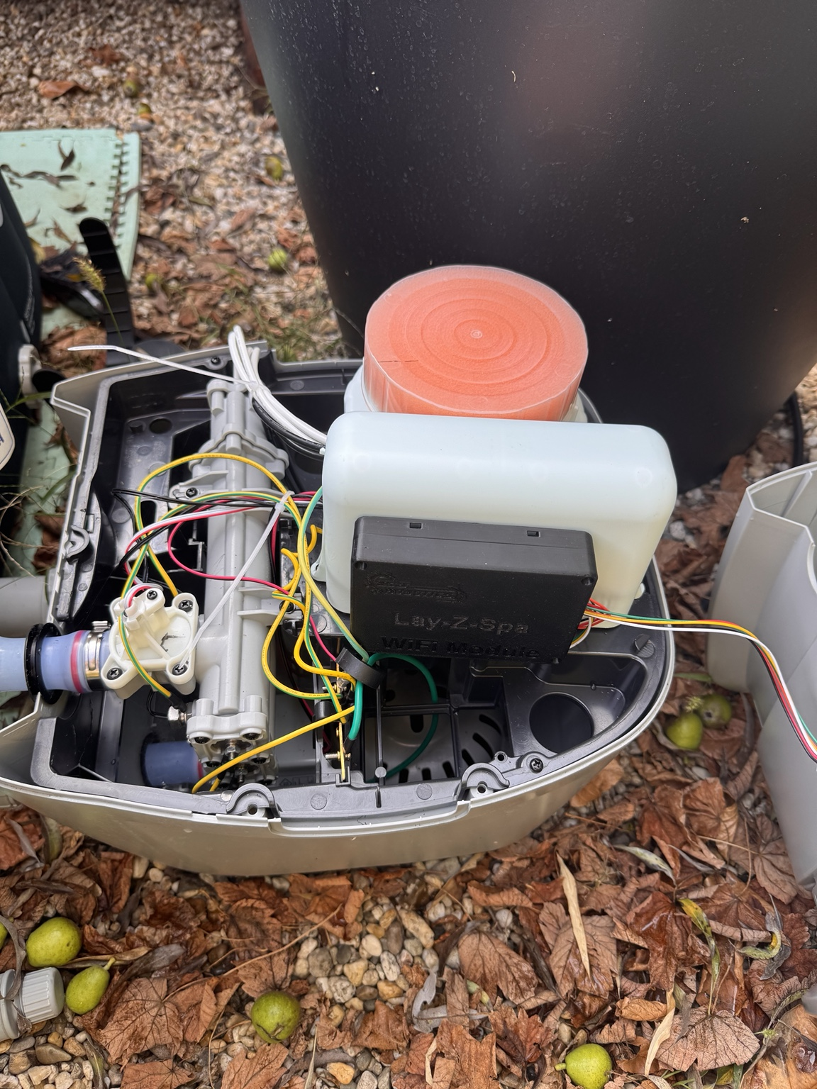
Overview of this pump with the added module. It shows placement, not a universal wiring diagram.

Photo of the disconnected display plug

Recognising the cable
At the bottom of this photo is a loose white plug with a red latch and coloured wires. The cable enters through the pump housing. The next photo shows such a plug connected to a module cable.

Inserting the module
The loose plug is the original display plug, disconnected from the pump board. Connect it to the module's display side, DSP. Connect the module's pump side, CIO, to the vacated white connector on the pump board. The module then sits between pump and display.
Use matching plugs and respect their latches. Do not force a plug or change wire positions based on colours in a photo.
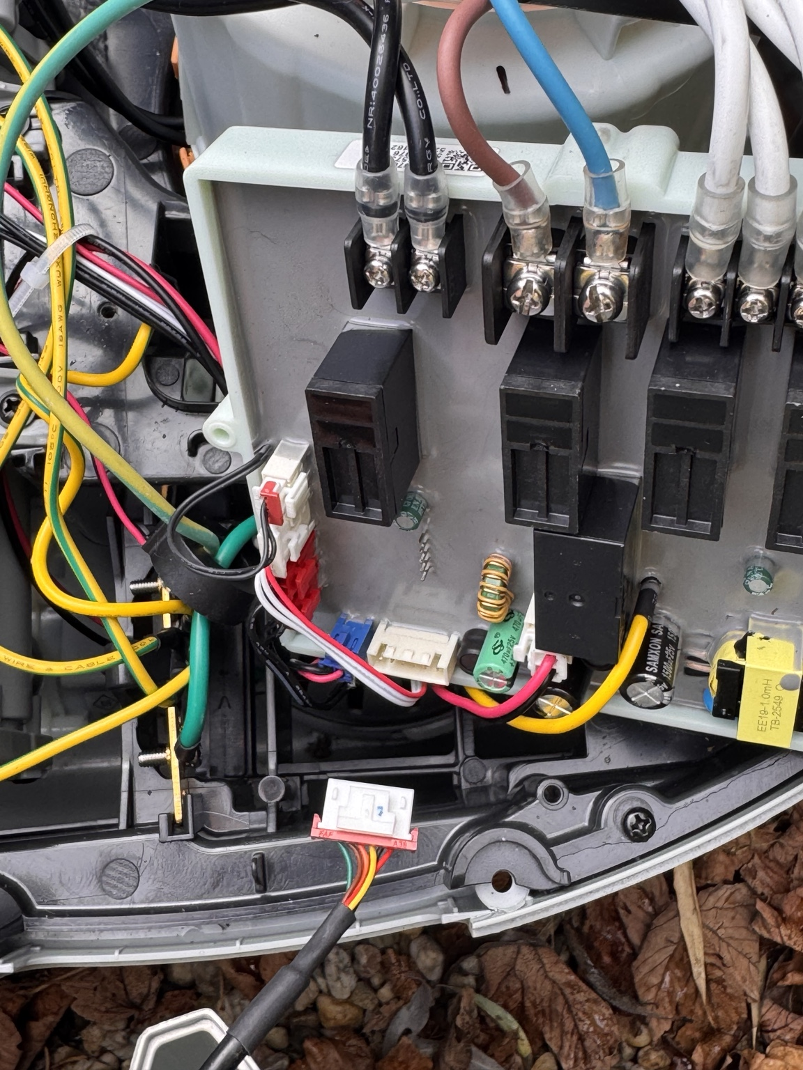
Disconnected display plug at the bottom. Mains terminals visible at the top are not part of the module connection instructions.

Photo of the connected module cable

Display-side connection
The white plug at the lower right is connected to a cable from the black module. This helps identify the connection. The other module cable, CIO on the pump side, connects to the pump-board socket that originally held the display plug.

Before closing
Check plugs are secure, cables cannot be trapped under a lid or screw, and the module is mounted securely. A black enclosure in a photo does not prove waterproofing. Keep the module dry and protected from water reaching its electronics.

After closing and powering up
Check the physical display first. Configure WiFi as on page 4, then check the web interface shows a connected spa and actual data. If there is a fault, disconnect power before opening the pump again.
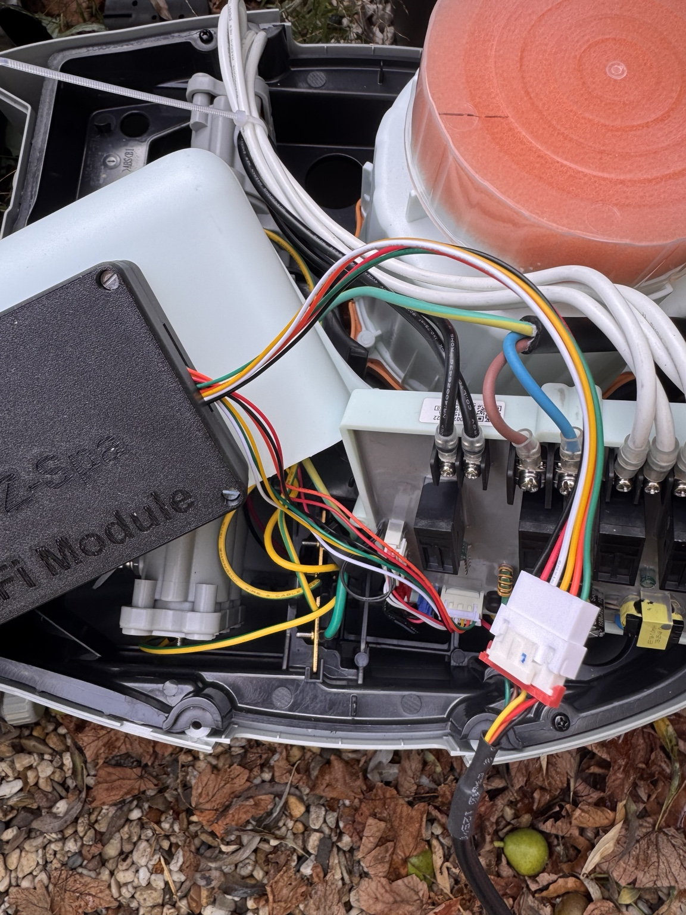
Module during installation: the original display plug connects to DSP; CIO connects to the vacated pump-board socket.

