

SRI LANKA INSTITUTE OF INFORMATION TECHNOLOGY

[Enterprise Standards and Best Practices for IT Infrastructure](http://courseweb.sliit.lk/course/view.php?id=137)

4th Year 2nd Semester 2016

|  |  |
| --- | --- |
| SLIIT ID | Student Name |
| IT13020118 | Sivarasan P. |
| IT13087234 | Piumal Dinuka W. |
| IT13020422 | Jenukshan C. |
| IT13024178 | Lakshitha Indunil L.H.G. |

Batch: - IT Batch

Practical Session: - Week Day (Wednesday Lab) - Assignment

Date of Submission: - 9/9/2016

Date of Evaluation : _____________________

Evaluators Signature : _____________________

**Requirements**

Since vMotion is intervening in an active virtual machine without that virtual machine’s knowledge, certain conditions must be fulfilled so that the process can run without problems or failures:

* CPU compatibility
* vMotion interface (minimum 1 Gb adapter)
* shared central mass storage
* same naming for virtual port groups
* sufficient resources on the target host
* at least one vSphere Essentials Plus license on the corresponding

1.First create Two ESXI Bare metals

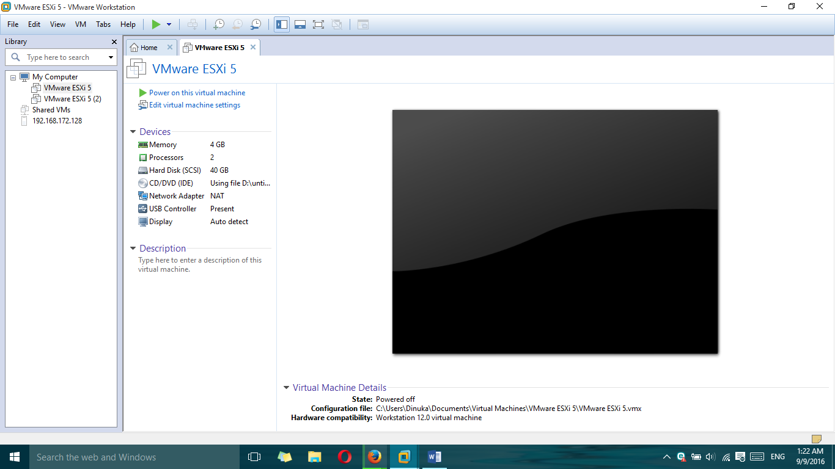

2.Boot screen

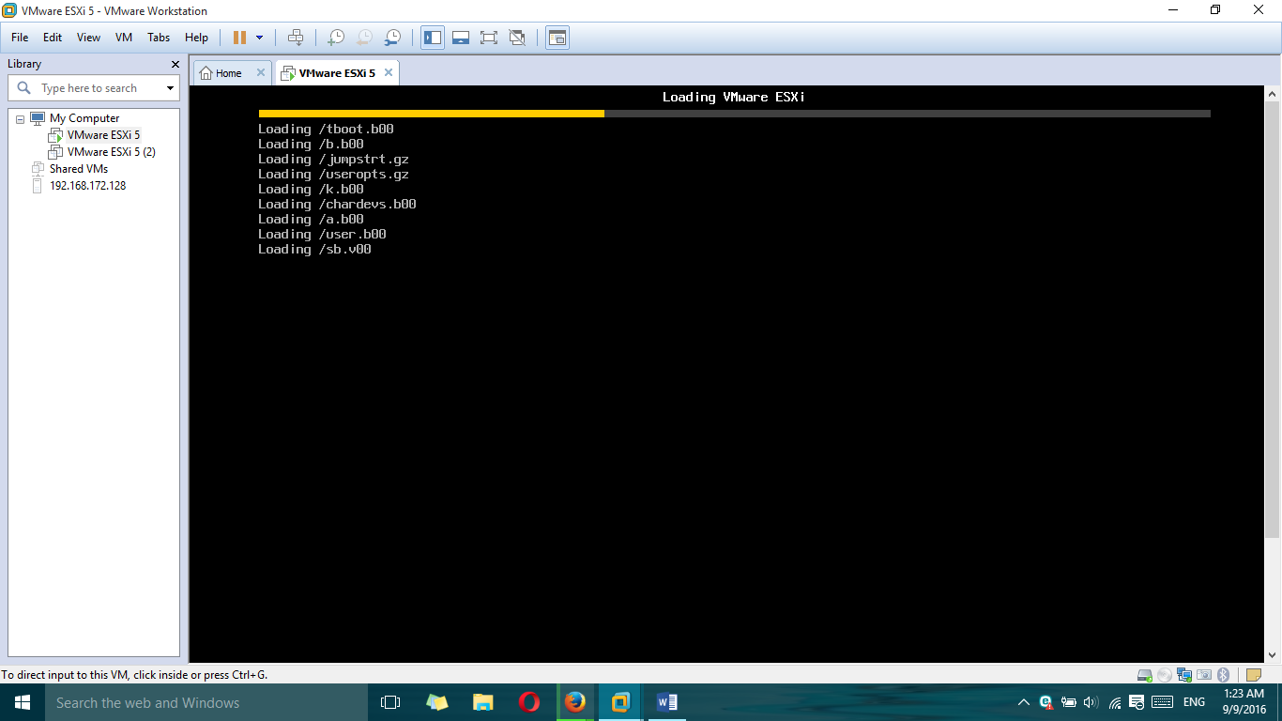

3.First virtual machine IP address

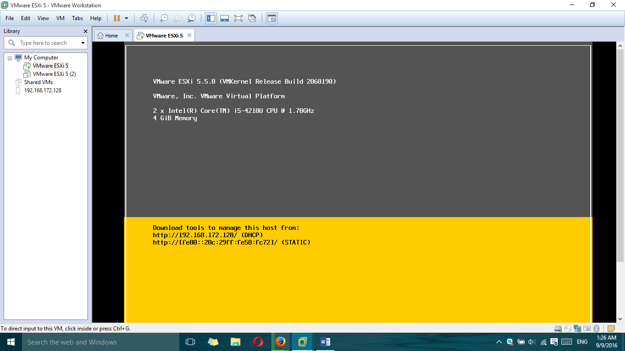

4.Connect to VMware vSphere Client

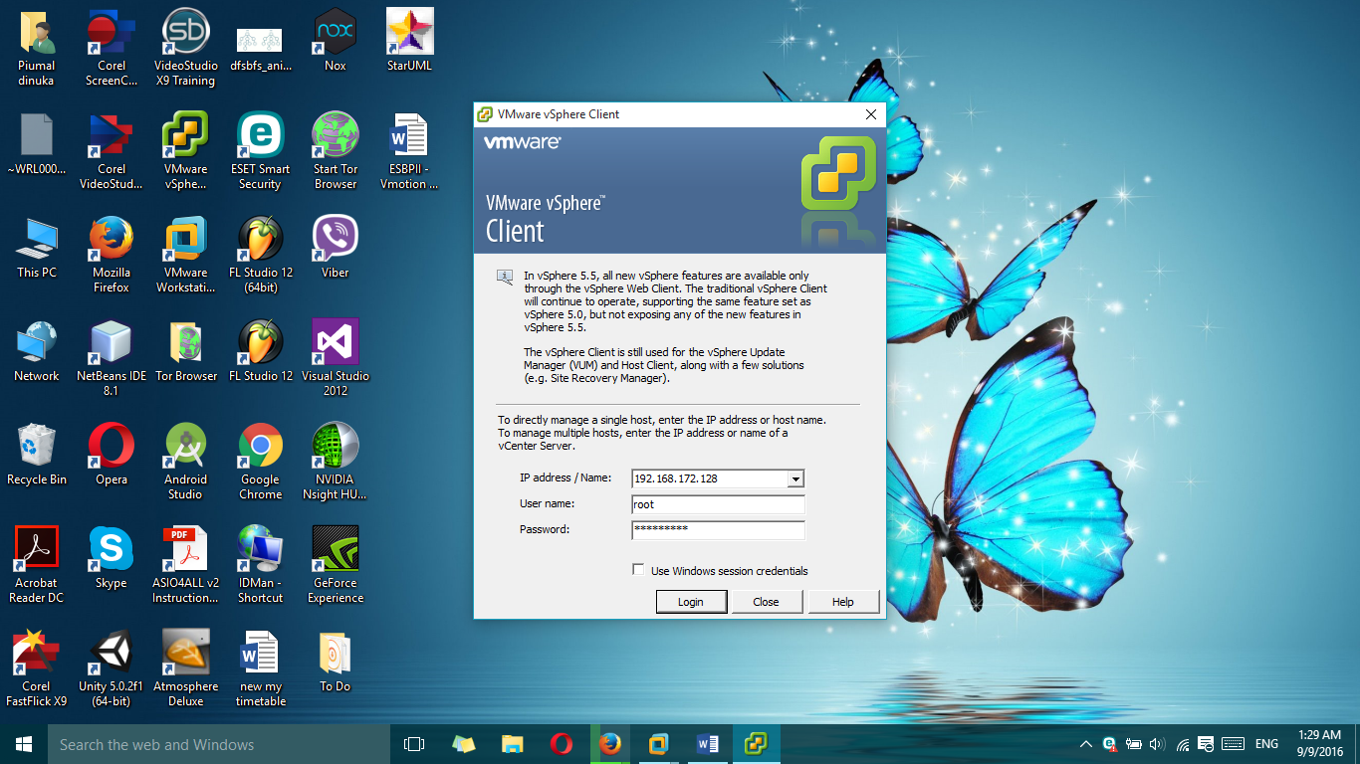

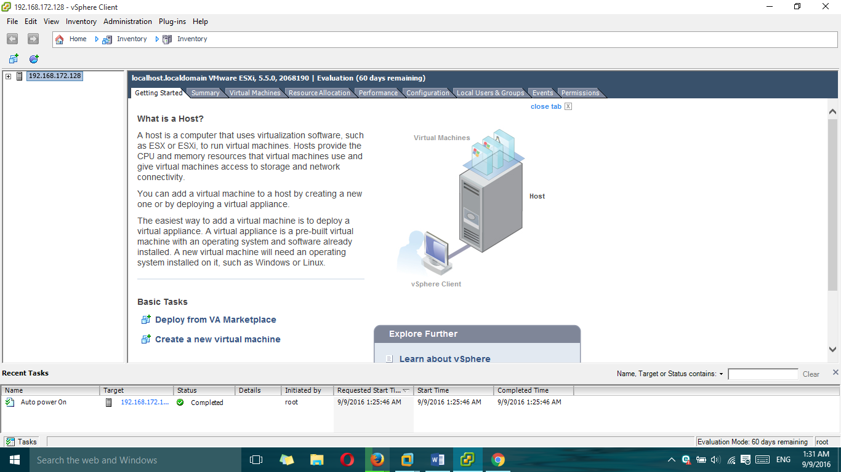

5.We select the tab **Configuration**

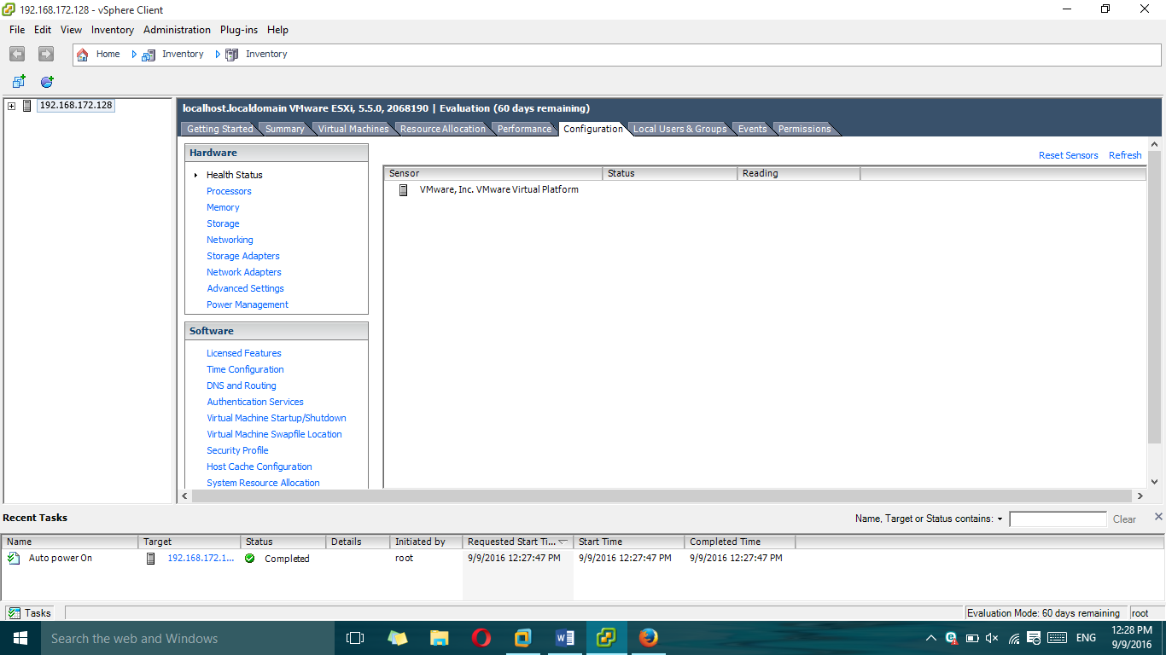

6.We select the tab **Configuration-> Networking**

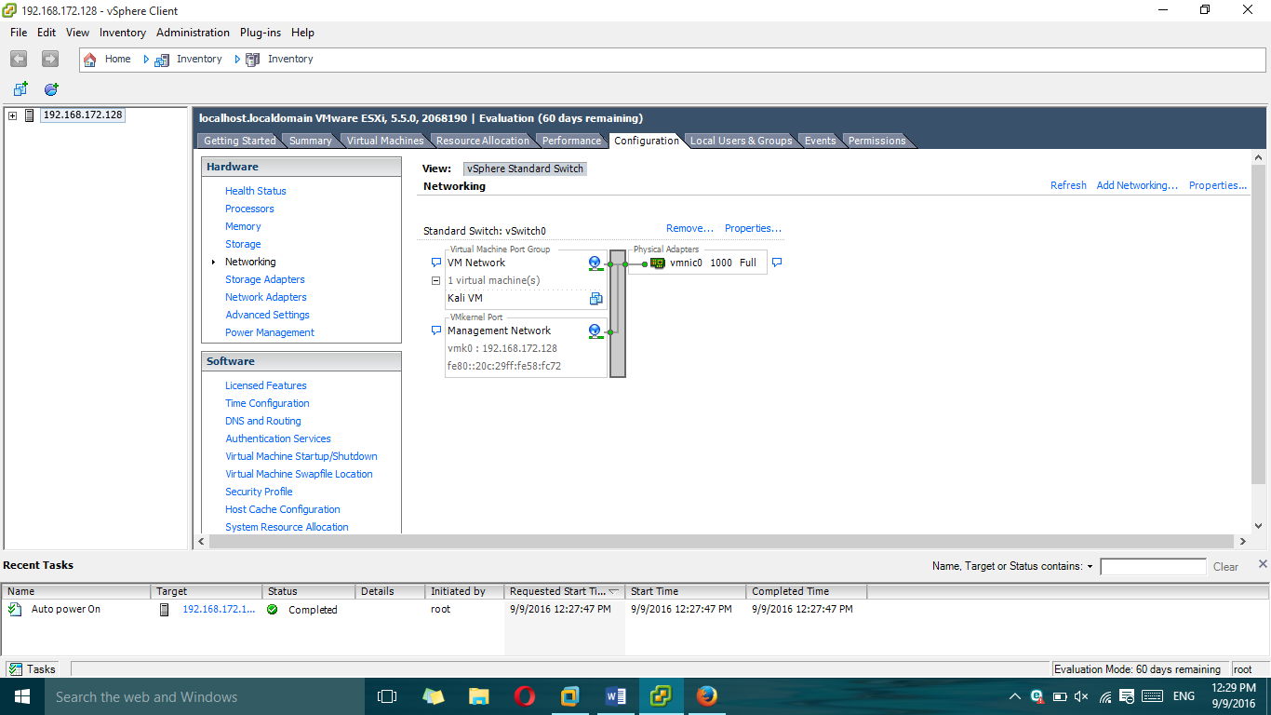

7.Click on **Add Networking** to create the vSwitch.

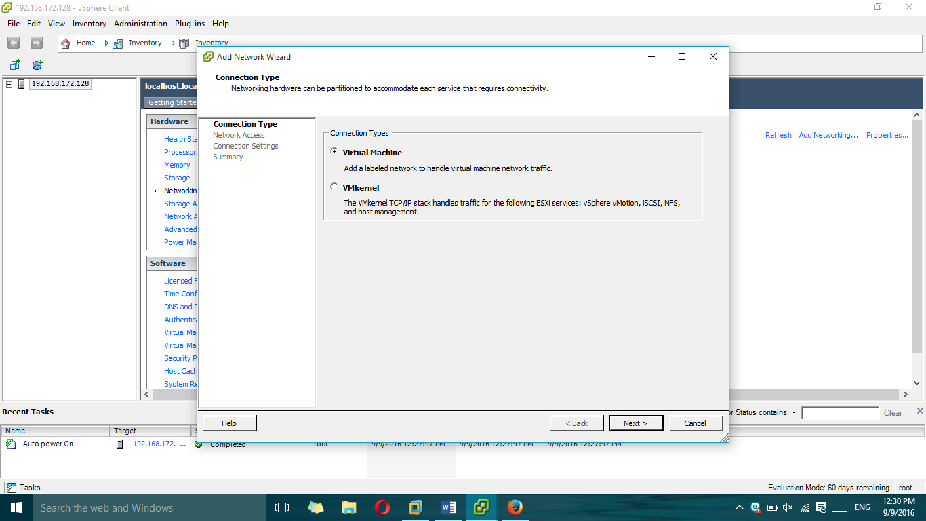

8.Select **VMKernel** and click on **Next.**

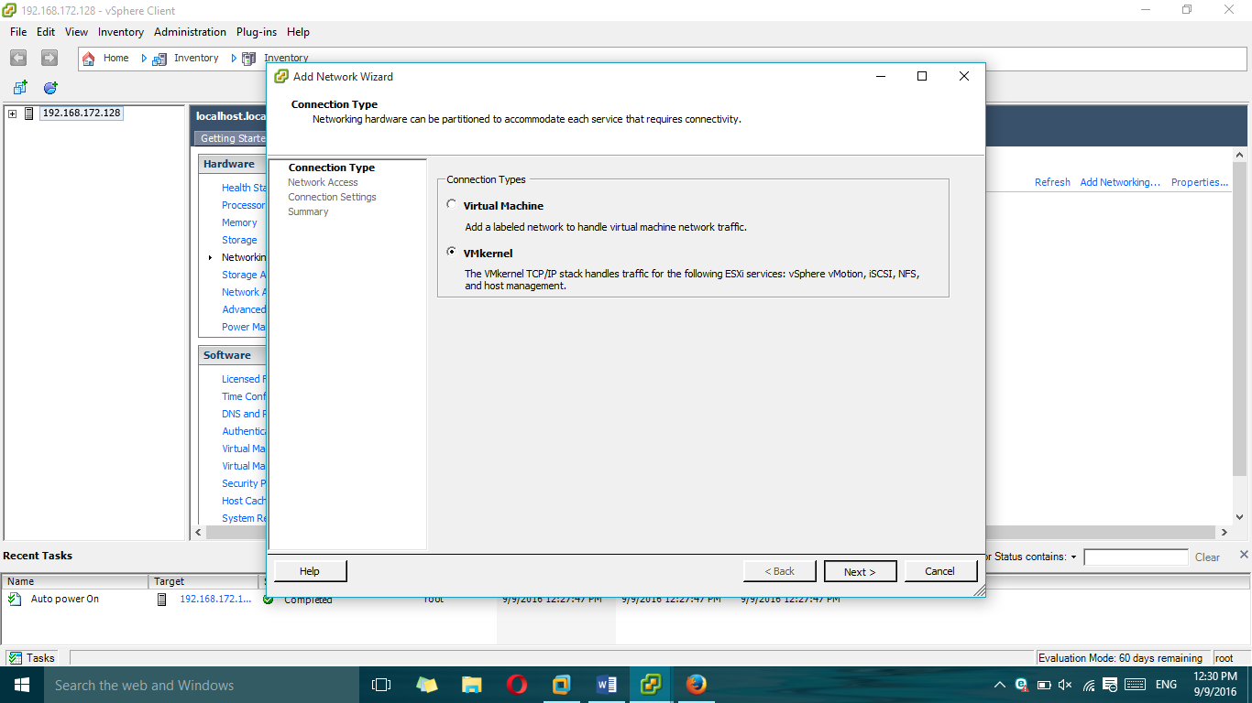

9.Making a network card or cards that have connected from one server to another

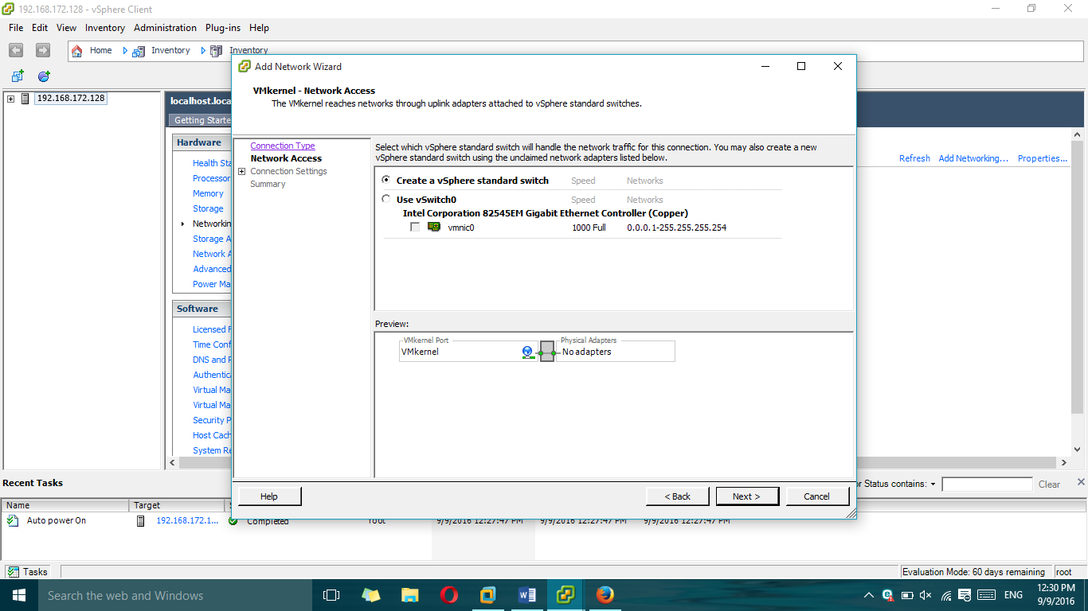

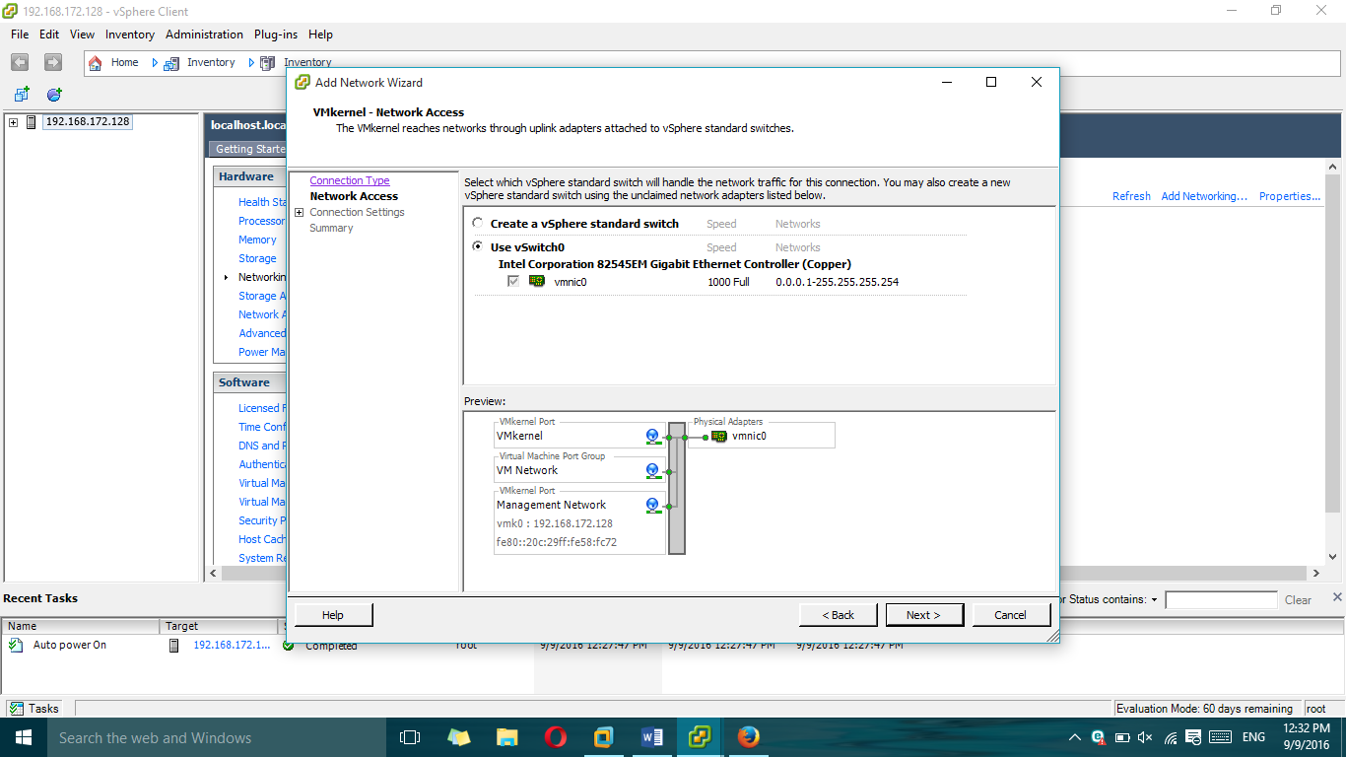

10.We set **Use this port group for vMotion.**

We wrote a **Label Network** different if you want (optional) and click on **Next.** We for example we put **Vmotion.**

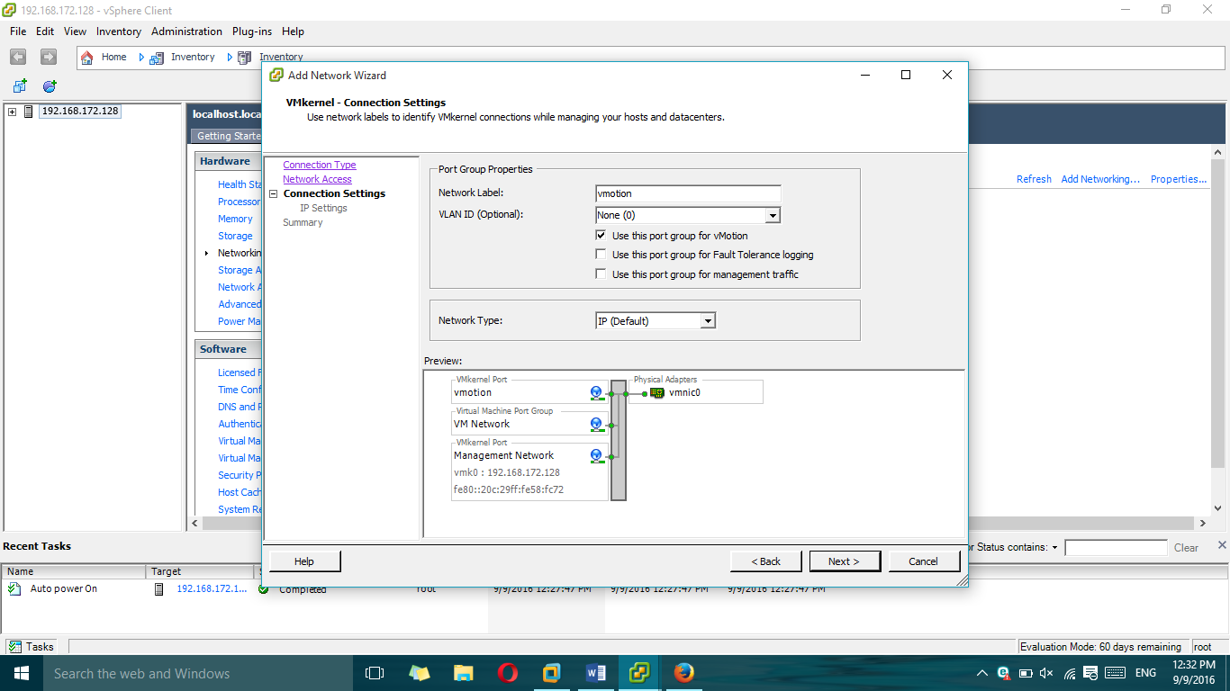

11.We set **Use the following IP settings:**

**IP Address: 50.50.50.1**

**Subnet Mask: 255.255.255.252** (Since we will use only 2 ip's).

Click on **Next.**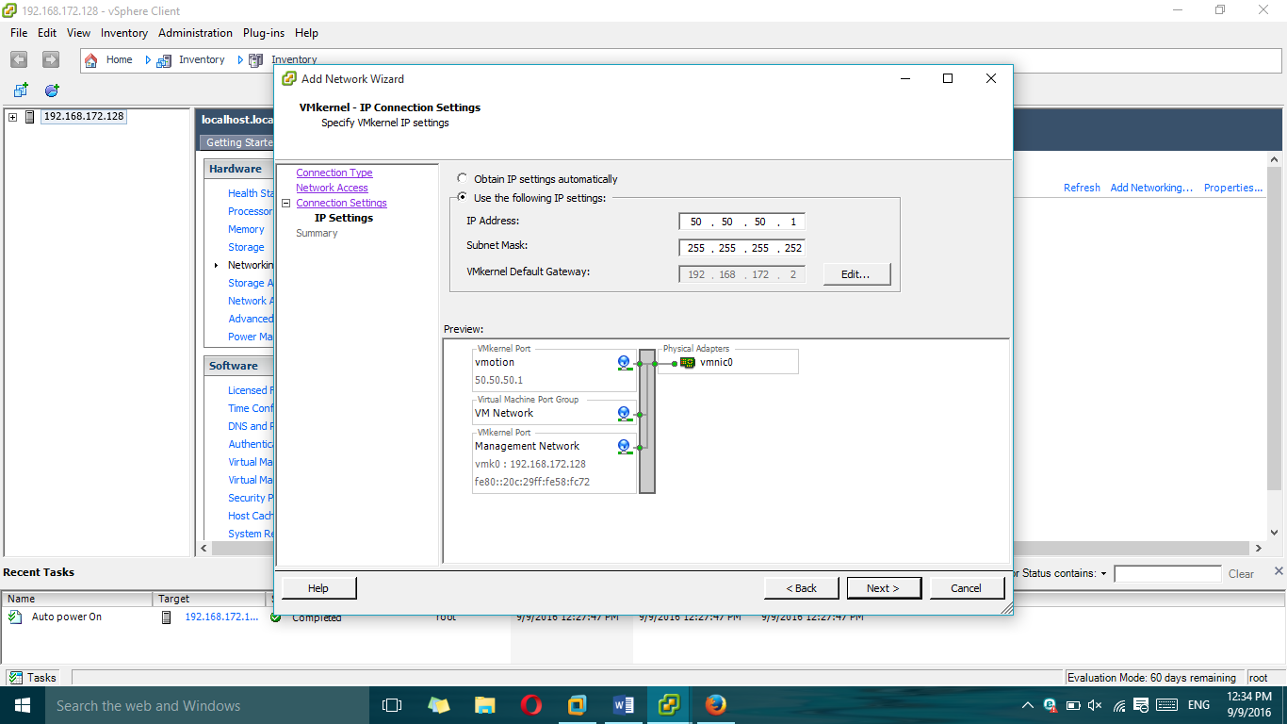

12.Click on **Finish.**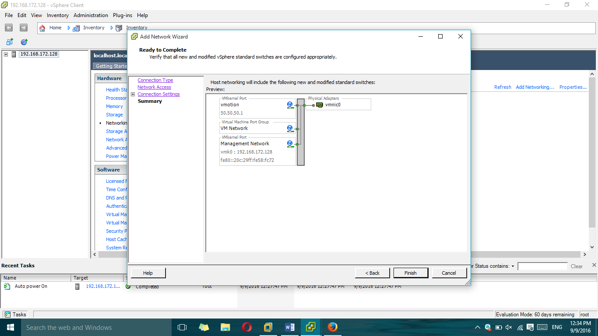

13.We select the tab **Configuration-> Network Adapters** and we see that we have visibility of the new connections.

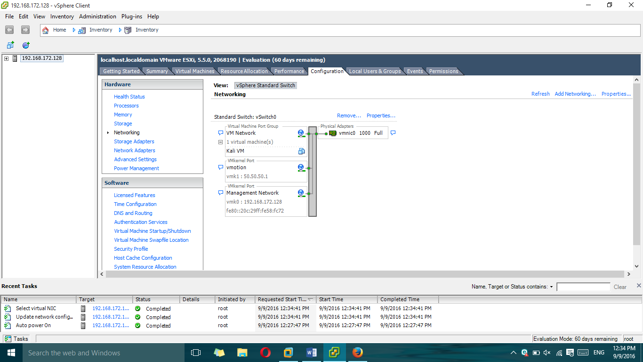

14.we look at the tab **Configuration-> Networking**

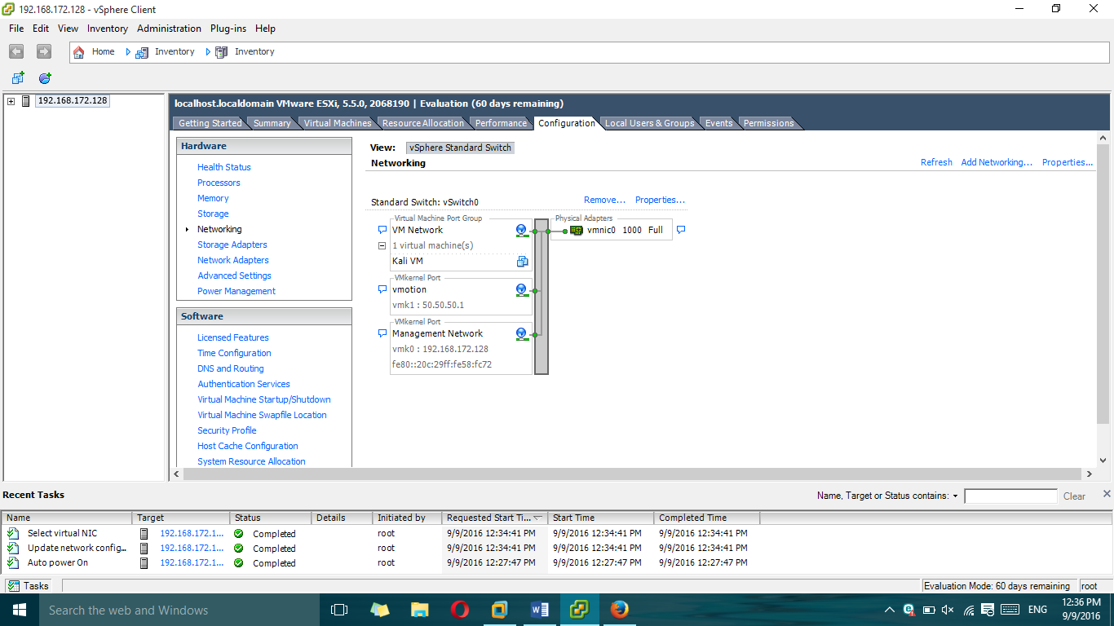

15.Click on **Add Networking** to create the vSwitch.

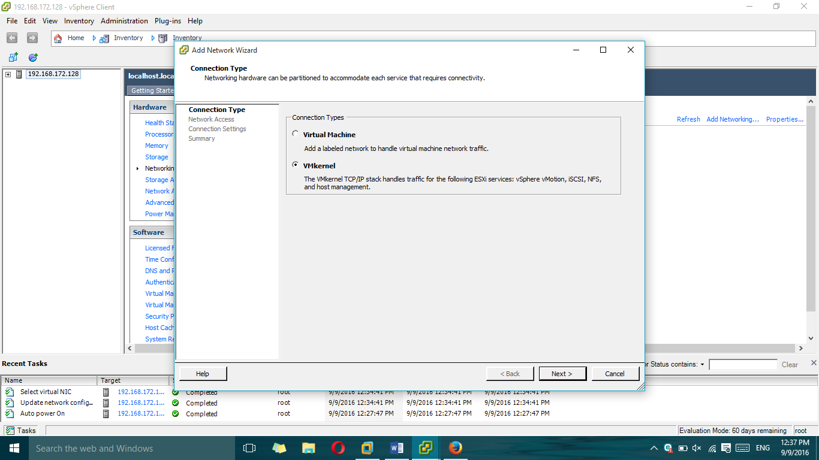

16Select **VMKernel** and click on **Next.**

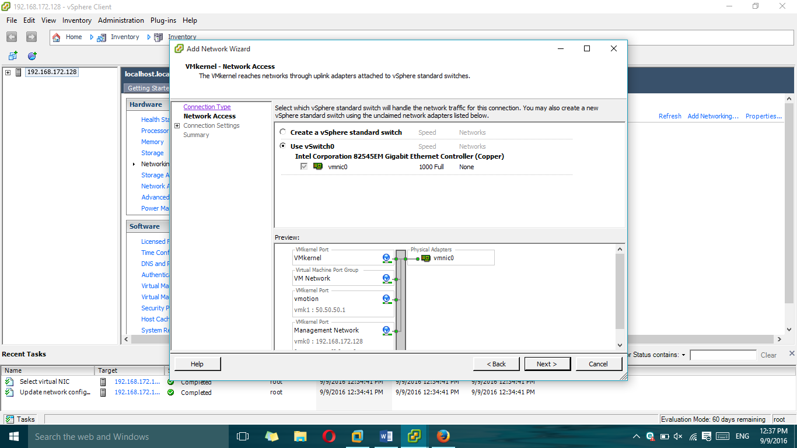

17.Making a network card or cards that have connected from one server to another and click on **Next**.

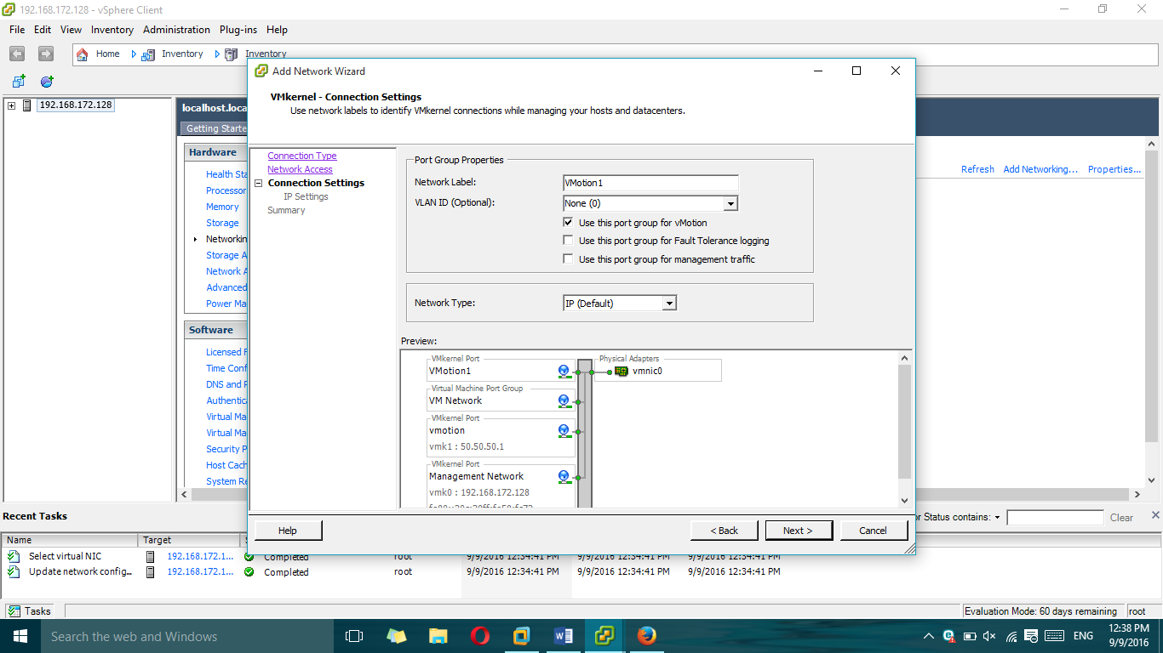

18.We set **Use this port group for VMotion1.**We wrote a **Label Network** different if you want (optional) and click on **Next.**

We set **Use the following IP settings:**

**IP Address: 50.50.50.2** (This ip must be different from the server that we configured earlier 1).

**Subnet Mask: 255.255.255.252** (Since we will use only 2 ip's).

Click on **Next.**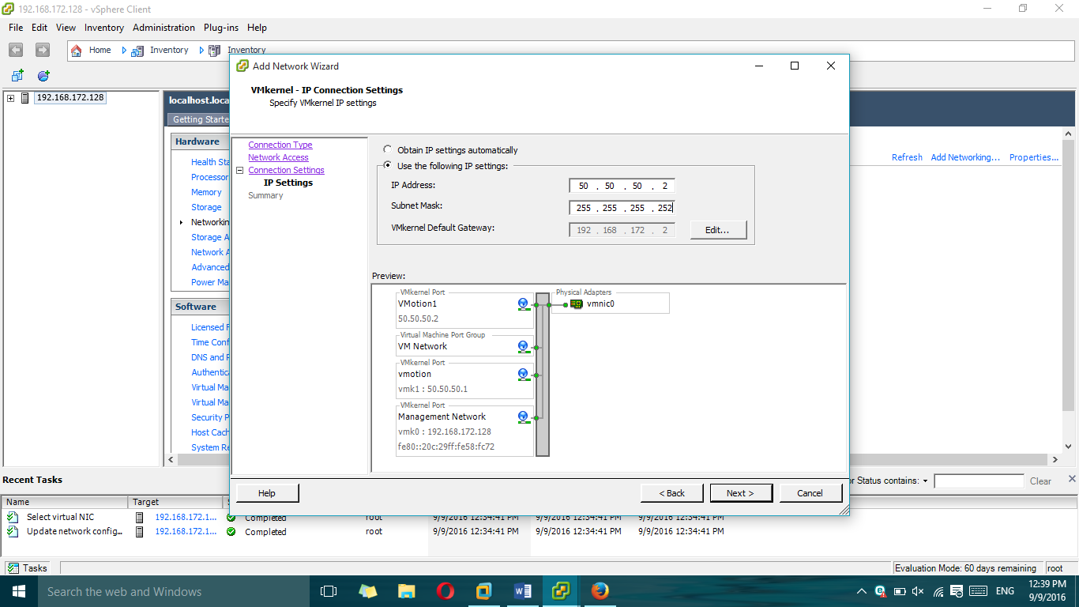

19.Click on **Finish**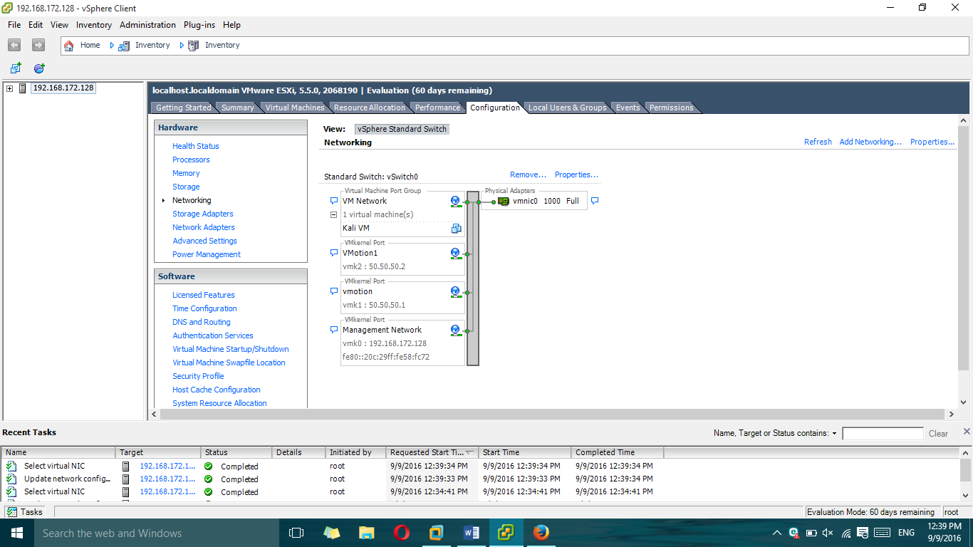

20.We press the right mouse button on a virtual machine.

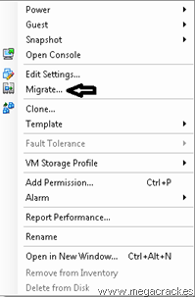

21.Click on **Migrate.**

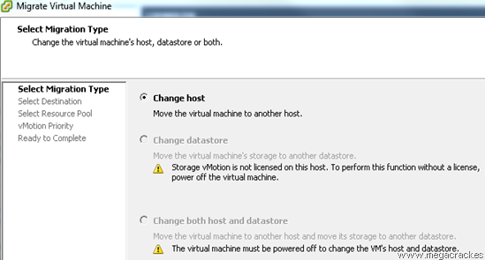

22.Select the target server where we will move the virtual machine.

Click on **Next.**

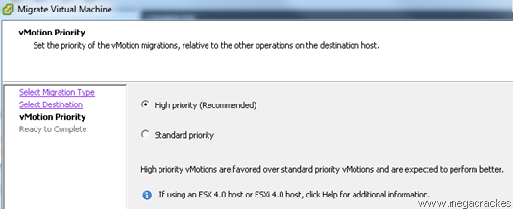

23.Click on **Finish** to start the migration.

We can`t did migration part, because our pc RAM capacity is less than 12 GB, so we couldn’t do Vmotion