ASSIGNMENT COVER SHEET

Qualification | HD in Computing and Software Engineering
Module Number | CSE5011
Module Title | Mobile Application Development
Assignment Title | PrintXpress – Digital Printing Service App
Assessment Type | WRIT1 – Coursework (100% weighting)
Student Name | [Your Name]
Student ID | JF/HDCSE/CMU/XX/YY
Assessor | Mrs. Sharmini

Hand-out Date: 2026-04-07
Submission Date: 2026-05-25

Word Count (Task A): ~1000 words
Total Word Count: ~3000 words (excl. tables, figures, references)

LEARNER DECLARATION

I, [Your Name] ([Your Student ID]), certify that the work submitted for this assignment is my own. Research sources are fully acknowledged and the PrintXpress Android application was developed by me using the native Android stack (Java + SQLite) as part of CSE5011 Mobile Application Development.

Contents
Acknowledgement 4
Task A – Critical Comparison of Mobile OS, Tools and Technologies 5
Task B – System Design and Database Design 10
Task C – User Interface Design 16
Task D – Application Development 24
Task E – Test Plan and Application of Testing 34
Task F – User and Technical Documentation 41
References 50

Acknowledgement
I would like to extend my sincere appreciation to my module lecturer, Mrs. Sharmini, whose guidance throughout the Mobile Application Development module made it possible for me to plan, design and complete the PrintXpress Android application from the ground up. Her constructive feedback during the design review and her practical advice on SQLite integration were particularly valuable.
I am also grateful to the staff at ICBT Campus for providing access to the lab equipment, Android devices and software (Android Studio, the Android SDK and supporting libraries) needed to develop and test the application. Finally, I thank my family and classmates for their patience and feedback during the usability testing phase, which helped refine the customer and administrator flows of the app.

Task A

Critical Comparison of Mobile Operating Systems, Development Tools, and Technologies

1. Introduction
Selecting the right mobile platform and toolchain has a direct effect on the cost, reach and maintainability of any mobile product. PrintXpress is a digital printing service aimed at customers and small businesses across Sri Lanka. It must let people browse a catalogue of print products (business cards, posters, banners, flyers, stickers and custom merchandise), place an order with quantity, specifications and a design file, and then track the order through to pickup or home delivery. It also has an administrator side that manages products, promotions, customers and the order pipeline.
This section critically compares the two dominant mobile operating systems, the development tools and IDEs that go with them, the candidate programming languages, storage options and UI frameworks. Each option is evaluated against the specific needs of the PrintXpress brief, and the chosen stack (Android + Java + SQLite + Material Components) is then justified.

2. Comparison of Mobile Operating Systems

2.1 Android
Android is an open-source operating system built on a modified Linux kernel and maintained by Google through the Android Open Source Project (AOSP). It powers more than 70% of smartphones in use globally and is the dominant platform across South Asia, including Sri Lanka, where a large share of users buy mid-range Android devices from brands such as Samsung, Xiaomi, Oppo and Realme. Apps are typically distributed through Google Play, but side-loaded APK installation is also supported, which is useful during academic development.
Strengths for PrintXpress:
- Wide device reach – the target customer base for a Sri Lankan print shop is overwhelmingly on Android.
- Free SDK, no per-seat licence and no need for Apple-only hardware.
- Rich offline support through SQLite, SharedPreferences and the Storage Access Framework, which suits an app that must capture order details even on a flaky 3G connection.
- Material Design Components (CardView, RecyclerView, TextInputLayout, MaterialButton) provide modern UI primitives out of the box.
Limitations:
- Device fragmentation – the same screen has to render well on 5-inch budget phones and 6.7-inch flagships, so adaptive layouts are essential.
- Open distribution increases the risk of side-loaded malicious clones; signing and ProGuard/R8 obfuscation are important for production.
- API surface changes between versions; targeting an old API for compatibility means losing newer system features.

2.2 iOS
iOS is Apple's closed operating system, used only on iPhones and iPads. It is known for a tightly controlled experience, fast UI animations, strong privacy guarantees and a consistent design language. Apps are distributed exclusively through the App Store, after a mandatory review process.
Strengths:
- Predictable hardware – only a handful of screen sizes and chipsets to test against.
- Strong default security: per-app sandboxing, Keychain for secrets, App Transport Security for network traffic.
- Smooth, consistent UI thanks to UIKit/SwiftUI and high-DPI displays.
Limitations for PrintXpress:
- Apple devices represent a small share of the Sri Lankan market – releasing iOS-only would exclude most of the target customers.
- Development requires macOS hardware, Xcode and a paid Apple Developer Program account (USD 99/year), which is impractical for an undergraduate project.
- The App Store review process delays iteration during academic development.

2.3 Cross-platform frameworks (Flutter / React Native / Ionic)
Cross-platform toolkits compile one codebase into both Android and iOS binaries. They are attractive for small teams, but the CSE5011 brief explicitly forbids cross-platform tools, so they are noted here for completeness only.
Framework | Language | Strength | Weakness
Flutter | Dart | Single codebase, expressive widget tree, near-native performance | Larger APK size, Dart is less common in Sri Lankan job market
React Native | JavaScript / TypeScript | Hot reload, large NPM ecosystem | Native modules still required for camera / file access
Ionic / Capacitor | HTML + CSS + JS | Web developers can reuse existing skills | WebView-based, sluggish for image-heavy lists like a product catalogue

3. Comparison of Development Tools

3.1 Android Studio (selected)
Android Studio is the official Google IDE for native Android development. It is based on IntelliJ IDEA and ships with the Android SDK, Gradle build system, an emulator, the Layout Inspector, the Database Inspector and a powerful Logcat. PrintXpress is developed in Android Studio Hedgehog using Gradle 8.x.
Why it fits PrintXpress:
- Built-in XML layout designer with a live preview that matches the device frame, useful when iterating on the customer dashboard and the order form.
- Database Inspector lets us read the live SQLite tables on the connected device while testing order placement.
- Profiler exposes memory, CPU and network traces that confirm the RecyclerView in ProductListActivity does not leak Bitmaps.
- Direct deployment to a physical device over ADB (Wi-Fi or USB) which is how all screenshots in this report were captured.

3.2 Xcode
Xcode is Apple's IDE for Swift and Objective-C. It supplies Interface Builder, the iOS Simulator and Instruments. While excellent for iOS work, it does not target Android, so it cannot be used to build PrintXpress.

3.3 Visual Studio with .NET MAUI / Xamarin
Microsoft's .NET MAUI (the successor to Xamarin.Forms) lets C# developers produce Android and iOS apps from one codebase. It introduces an extra runtime layer (Mono) and is excluded by the CSE5011 brief's no-cross-platform rule.

4. Comparison of Programming Languages
Language | Platform | Pros | Cons
Java | Android | Mature, very large ecosystem, easy to find tutorials and Stack Overflow answers, taught extensively at ICBT | Verbose syntax, no built-in null safety
Kotlin | Android | Concise, null-safe, official first-class support since 2019, coroutines for async work | Smaller pool of local talent, fewer textbooks aligned with the module
Swift | iOS only | Modern, type-safe, fast | Locked to Apple hardware, irrelevant for a Sri Lankan customer base
C# (MAUI) | Cross-platform | Familiar to .NET developers | Disallowed by the brief, extra runtime overhead
Java was selected for PrintXpress because it directly matches the academic learning outcomes of the module, because the development team is already fluent in Java from earlier modules, and because the codebase is intended to be readable by future students who will study it as a worked example.

5. Comparison of Databases and Backend Technologies
Option | Type | Suitability for PrintXpress
SQLite | Embedded, file-based, ACID, no server | All printing-related data fits in a small relational schema; orders must persist offline; zero hosting cost.
Firebase / Firestore | Cloud, real-time sync, NoSQL | Requires Google account + always-on internet; overkill for a single-shop pilot; recurring cost beyond the free tier.
MySQL / PostgreSQL | Client-server RDBMS | Needs a hosted backend (LAMP / Node) and an REST API layer; out of scope for a standalone mobile assignment.
Realm / ObjectBox | Object-oriented mobile DB | High performance but introduces a third-party dependency and a less standard query model.
PrintXpress uses SQLite via the standard SQLiteOpenHelper API. The schema has four tables (users, products, orders, promotions) with one-to-many relationships and is small enough to fit comfortably on the device. The DatabaseHelper class also seeds an administrator account, a demo customer and a starter catalogue on first launch, so the marker can run the app with no manual setup.

6. User Interface Technologies
The UI layer uses XML layouts under res/layout combined with Material Components from com.google.android.material. ConstraintLayout is used for screens that need to adapt across device widths; LinearLayout is used for vertical forms such as the order entry screen; CardView and RecyclerView are used to render the product list, the order history and the promotions list. A single colour palette (red primary #D32F2F, dark red #9A0007, amber accent #FFC107) is defined once in colors.xml and reused by all screens to keep branding consistent.
Jetpack Compose was considered but rejected: Compose requires Kotlin and would complicate the module's learning outcomes, and the team is more comfortable iterating on declarative XML at this stage.

7. Security and Validation Considerations
- Passwords are hashed with SHA-256 + salt in PasswordUtil before being written to SQLite, never stored in plain text.
- All form inputs go through the central Validator utility (email format, Sri Lankan phone format, non-empty, positive integer, positive double).
- Email uniqueness is enforced both in Java (DatabaseHelper.findUserByEmail) and at the SQLite layer with a UNIQUE constraint.
- Foreign-key constraints are enabled in onConfigure(), so orphan order rows cannot exist for deleted users or products.
- Inactive products are soft-deleted (active=0) so that historical orders still resolve their product name on the admin Orders screen.

8. Comparative Summary Table
Criterion | Android (Java) | iOS (Swift) | Cross-platform
Development Tool | Android Studio Hedgehog | Xcode 15 | Flutter SDK
Language | Java 17 | Swift 5 | Dart 3
OS Accessibility | Open-source AOSP | Proprietary, Apple devices | Single source, dual binary
Cost | Free | Apple Dev USD 99/yr | Free
Local Storage | SQLite | CoreData / Realm | sqflite / hive
UI Style | Material XML / Compose | UIKit / SwiftUI | Flutter widgets
Performance | Native | Native | Compiled to native, slight bridge overhead
Distribution | Play Store + side-load APK | App Store only | Both stores
Fit for PrintXpress | Excellent | Poor (market reach) | Disallowed by brief

9. Justification of the Technology Choice for PrintXpress
- Reach: Android dominates the Sri Lankan market, which directly matches the brief's target audience of individuals and SMEs in Sri Lanka.
- Cost: Android Studio, the Android SDK, Material Components and SQLite are all free, so PrintXpress can be developed and shipped without licensing cost.
- Offline first: SQLite stores users, products, orders and promotions locally, which is essential because order placement must succeed even on patchy mobile data.
- Module alignment: Java + SQLite + XML layouts are exactly the technologies taught in CSE5011, so the codebase serves as a reference implementation for future students.
- Extensibility: The DatabaseHelper API surface is narrow enough that a later iteration could swap SQLite for a Firebase or REST backend without rewriting the activities.

10. Conclusion
Comparing the platforms shows that there is no single best mobile stack – the right choice depends on the audience, budget, team skill set and academic constraints. For PrintXpress, native Android development in Java with a local SQLite database and Material Components delivers the widest reach to Sri Lankan customers at zero licensing cost, matches the module's learning outcomes and lets the application work offline. iOS and cross-platform options were considered and ruled out for reach and compliance reasons. The remainder of this report applies this stack to the design, implementation, testing and documentation of PrintXpress.

Task B

System Design and Database Design for PrintXpress

Introduction
Before any Activity or layout was written, the PrintXpress system was designed using UML and entity-relationship modelling. The design deliberately keeps the schema small (four tables) and the activity graph shallow (a single SplashActivity routes to either the customer or the admin dashboard), so that the codebase remains readable and the marker can trace every screen back to a clear use case.

1. Use Case Diagram
The use case diagram captures the system boundary and the actions each external actor can perform. PrintXpress has two human actors:
- Customer – an end user who registers, signs in, browses the catalogue, places and tracks print orders, views promotions, reads the print guidelines and manages their profile.
- Administrator – a staff member who signs in with the seeded admin account to manage the product catalogue, manage promotions, monitor and update orders through their lifecycle and view the customer list.
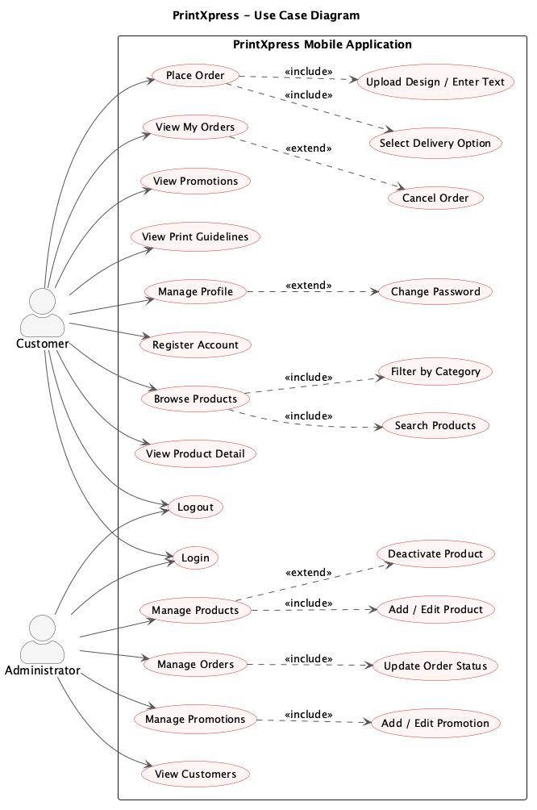
Key design decisions:
- Login is the gateway use case for both actors – both Customer and Administrator share LoginActivity, and the routing happens in LoginActivity.attemptLogin() based on User.isAdmin().
- Browse Products includes Filter by Category and Search Products because the same RecyclerView is reused across all three actions.
- Cancel Order extends View My Orders because Order.canBeCancelledByCustomer() only allows cancellation while the status is PENDING or PROCESSING.
- View Customers is admin-only; the admin can read the customer list but cannot delete customers, which avoids accidentally orphaning historical orders.

2. Class Diagram
The class diagram groups the codebase into four packages: Model (plain data holders), Persistence (SQLite helper), Utilities (cross-cutting helpers) and Controller (Android activities). The view layer is XML and is not shown as classes.
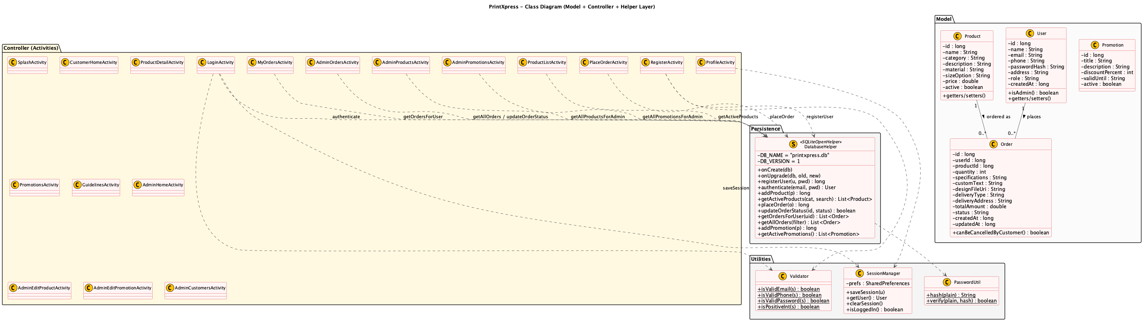
Key classes and their responsibilities:
- User – stores id, name, email, phone, password hash, address, role (ADMIN or CUSTOMER) and created_at. The isAdmin() helper makes role checks readable at the call site.
- Product – stores id, name, category, description, material, sizeOption, price (REAL) and an active flag used for soft-delete.
- Order – the transactional class. Holds user_id and product_id foreign keys, plus quantity, specifications, custom_text, design_file_uri, delivery_type, delivery_address, total_amount and status (PENDING → PROCESSING → PRINTING → READY → COMPLETED, or CANCELLED).
- Promotion – id, title, description, discountPercent, validUntil (ISO date), active. Promotions are standalone records – they do not need a foreign key because they apply at display time, not at order time.
- DatabaseHelper – the single SQLiteOpenHelper subclass for the app. It defines the schema, seeds data on first run, and exposes typed CRUD methods used by every activity.
- PasswordUtil – wraps salted SHA-256 hashing so that activities never see a raw password going into the database.
- Validator – central form-validation helpers (email, Sri Lankan phone, non-empty, positive integer, positive double) so that LoginActivity, RegisterActivity, PlaceOrderActivity and AdminEditProductActivity all enforce the same rules.
- SessionManager – wraps SharedPreferences so that the logged-in user survives across activity restarts and so that SplashActivity can route directly to the correct home screen.

3. Sequence Diagram – Customer Places an Order
The sequence diagram models the most important transactional path in PrintXpress: a customer logging in, browsing the catalogue, opening a product detail page and submitting an order. Each lifeline corresponds to an actual class in the codebase.
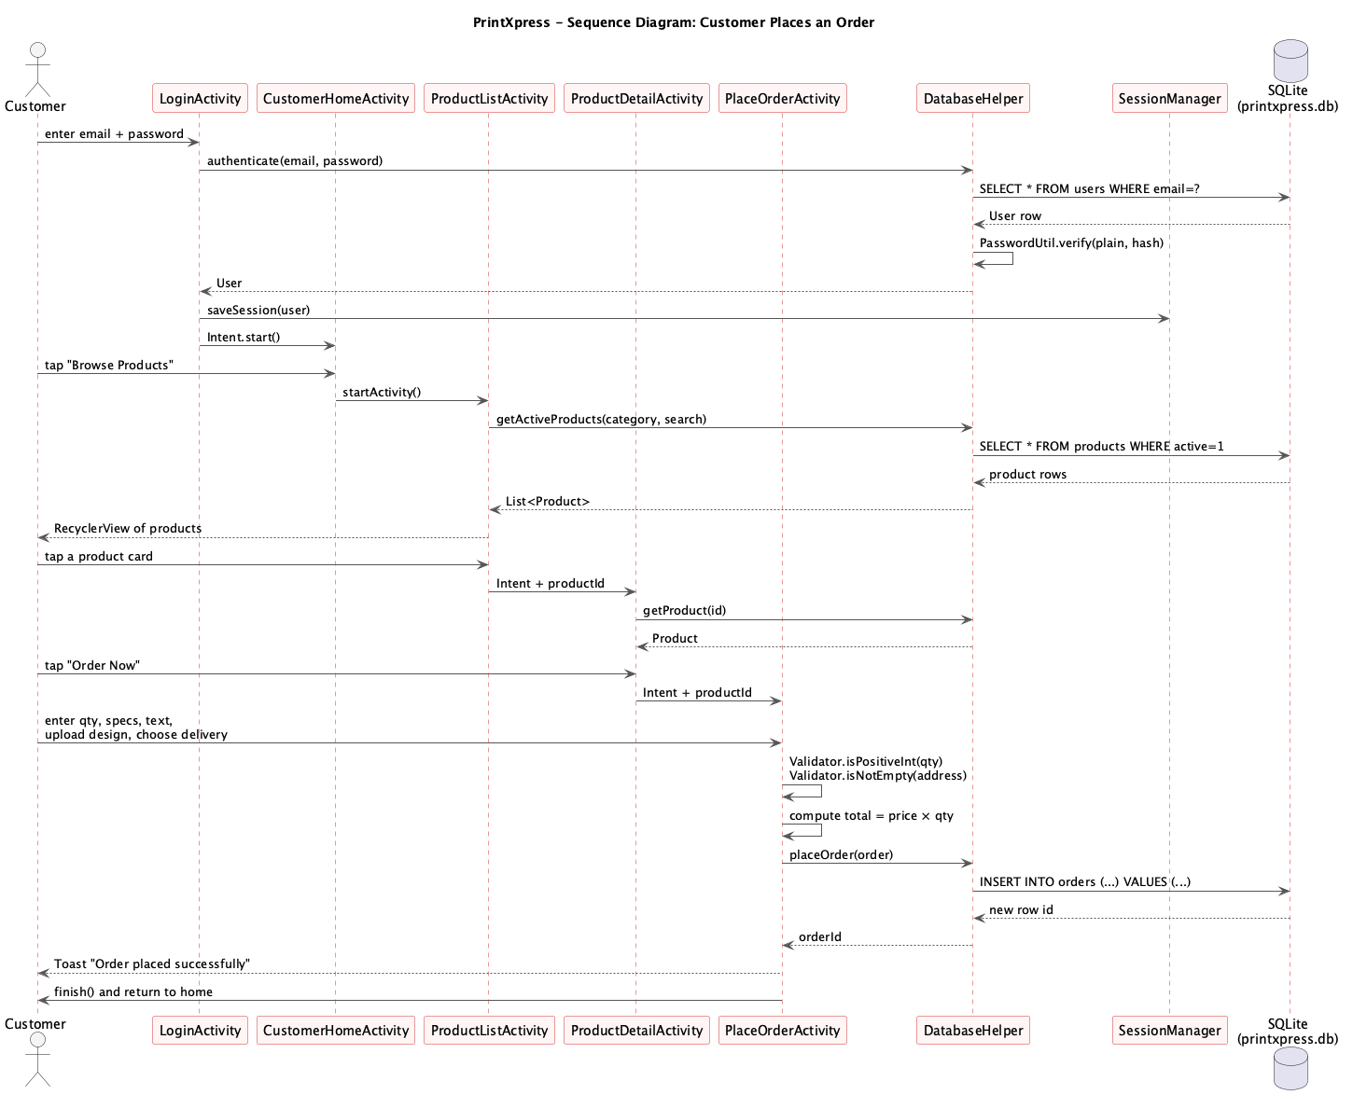
Narrative:
- The user types email and password into LoginActivity. LoginActivity calls Validator.isValidEmail() and Validator.isValidPassword() to enforce field rules before any DB call.
- DatabaseHelper.authenticate(email, password) reads the user row by email and asks PasswordUtil.verify() to compare the supplied password against the stored hash.
- On success, SessionManager.saveSession(user) writes the user id and role into SharedPreferences, and LoginActivity starts CustomerHomeActivity.
- From CustomerHomeActivity the user taps the Browse Products card, which launches ProductListActivity. The list activity calls DatabaseHelper.getActiveProducts(category, search) and binds the result to a RecyclerView.
- Selecting a product launches ProductDetailActivity with the productId in the Intent extras. The detail screen calls DatabaseHelper.getProduct(id).
- Tapping Place Order launches PlaceOrderActivity. The user enters quantity, specifications, custom text, an optional design URI and chooses Store Pickup or Home Delivery.
- PlaceOrderActivity validates the inputs locally, computes total = price × quantity, then calls DatabaseHelper.placeOrder(order). The helper INSERTs into the orders table with status PENDING and returns the new row id.
- The activity shows a Toast confirmation and finishes back to CustomerHomeActivity. The new order is now visible under My Orders for the customer and under Manage Orders for the admin.

4. Activity Diagram – Order Placement Flow
The activity diagram below presents the same flow as the sequence diagram but from a control-flow perspective, including the validation loops on the login screen and on the order form.
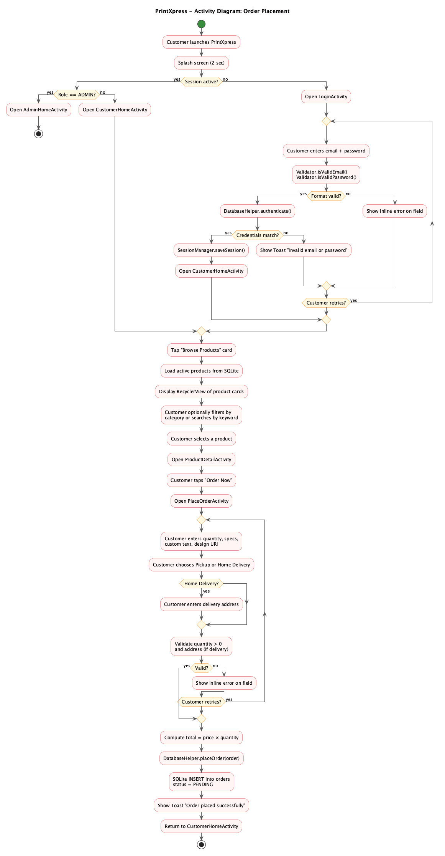

5. Database Design

5.1 Entity-Relationship Diagram
The ER diagram below is the logical model that DatabaseHelper.onCreate() translates directly into CREATE TABLE statements. Primary keys are marked PK; foreign keys are marked FK.
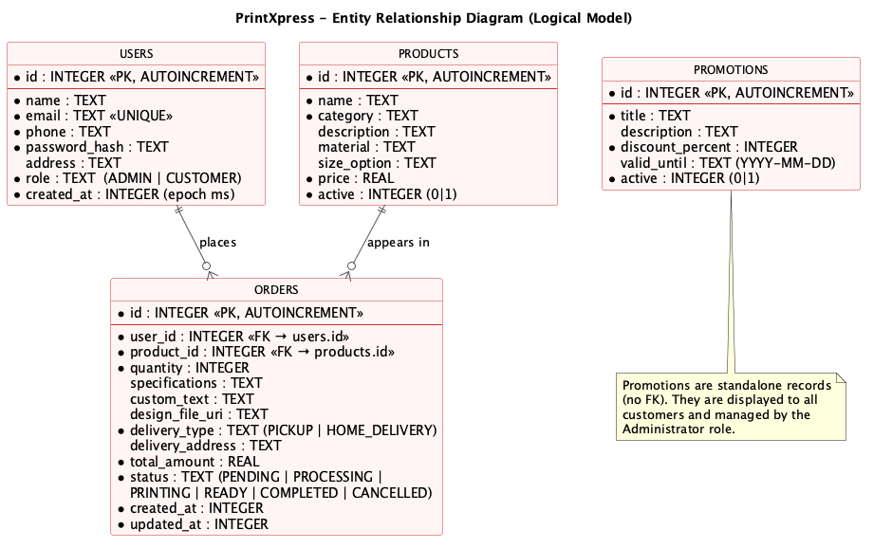
Entities and relationships:
- USERS to ORDERS – one user places many orders. The relationship is implemented by orders.user_id being a foreign key to users.id.
- PRODUCTS to ORDERS – one product can appear on many orders. The relationship is implemented by orders.product_id being a foreign key to products.id. Soft delete on products (active=0) means historical orders still resolve their product name via a LEFT JOIN.
- PROMOTIONS are standalone – they are surfaced through the Promotions screen and the admin promotions manager. They do not need to reference any other table because the discount is informational only at this stage.

5.2 Normalized Relational Schema (3NF)
Every table is in Third Normal Form: each non-key column depends only on the primary key, there are no repeating groups and no transitive dependencies. Tables, columns and constraints below match the live DatabaseHelper code:
users
Column | Type | Constraints | Notes
id | INTEGER | PK, AUTOINCREMENT | Surrogate key
name | TEXT | NOT NULL | Display name
email | TEXT | UNIQUE, NOT NULL | Login identifier
phone | TEXT | NOT NULL | Sri Lankan format, +94…
password_hash | TEXT | NOT NULL | Salted SHA-256, never plain
address | TEXT |  | Default delivery address
role | TEXT | NOT NULL DEFAULT 'CUSTOMER' | ADMIN or CUSTOMER
created_at | INTEGER | NOT NULL | Unix epoch millis
products
Column | Type | Constraints | Notes
id | INTEGER | PK, AUTOINCREMENT
name | TEXT | NOT NULL | e.g. 'Vinyl Banner'
category | TEXT | NOT NULL | Business Cards, Posters, Banners, etc.
description | TEXT |  | Free-text
material | TEXT |  | e.g. '440gsm PVC Vinyl'
size_option | TEXT |  | e.g. 'A3 (297 x 420 mm)'
price | REAL | NOT NULL | LKR per unit
active | INTEGER | NOT NULL DEFAULT 1 | 0 = soft-deleted
orders
Column | Type | Constraints | Notes
id | INTEGER | PK, AUTOINCREMENT
user_id | INTEGER | FK → users.id, NOT NULL | Order owner
product_id | INTEGER | FK → products.id, NOT NULL | Ordered product
quantity | INTEGER | NOT NULL | Positive integer
specifications | TEXT |  | User-supplied notes
custom_text | TEXT |  | Text to be printed
design_file_uri | TEXT |  | content:// or file:// URI
delivery_type | TEXT | NOT NULL | PICKUP or HOME_DELIVERY
delivery_address | TEXT |  | Required when delivery_type = HOME_DELIVERY
total_amount | REAL | NOT NULL | price × quantity
status | TEXT | NOT NULL DEFAULT 'PENDING' | PENDING, PROCESSING, PRINTING, READY, COMPLETED, CANCELLED
created_at | INTEGER | NOT NULL | Epoch millis
updated_at | INTEGER | NOT NULL | Epoch millis, refreshed on status change
promotions
Column | Type | Constraints | Notes
id | INTEGER | PK, AUTOINCREMENT
title | TEXT | NOT NULL | Headline shown to customer
description | TEXT |  | One-line offer body
discount_percent | INTEGER | NOT NULL DEFAULT 0 | 0–100
valid_until | TEXT |  | ISO date YYYY-MM-DD
active | INTEGER | NOT NULL DEFAULT 1 | 0 = hidden
Foreign-key constraints are enabled at runtime in DatabaseHelper.onConfigure() so that the SQLite engine itself rejects orders that reference a missing user or product. This guarantees referential integrity even if a future feature attempts an unsafe write.

Task C

Designing Attractive User Interfaces for PrintXpress

Introduction
The PrintXpress UI is built around a strong, single-colour brand (red #D32F2F with amber #FFC107 accents) and Material Components, so that every screen feels like part of the same product. The visual language borrows from print-shop branding – bold typography, generous whitespace and large tappable cards – which is appropriate for a service that sells high-quality printed goods.

Core Design Principles
- Brand-led palette – one primary red, one accent amber, one neutral background grey defined in colors.xml and reused everywhere via @color references.
- Card-based information architecture – the customer dashboard, product list, order history and promotions all use CardView so that information chunks feel touchable.
- Forms that fail safely – every input field uses TextInputLayout so that the floating label and the error message live with the field, and Validator centralises the rules.
- Status as colour – each Order status maps to a coloured badge (orange = pending, blue = processing, purple = printing, green = ready/completed, grey = cancelled) defined in colors.xml and applied through a single bg_status_badge drawable.
- Accessibility – sp units for all text, hint text on every input, content descriptions for icon-only buttons (e.g. logout), and high contrast on red surfaces.

1. Splash Screen
SplashActivity is a lightweight branding screen with the PrintXpress logo and tagline on a red gradient. After about two seconds it checks SessionManager.isLoggedIn() and routes the user either to LoginActivity, AdminHomeActivity or CustomerHomeActivity, so that a returning user lands on their dashboard with one fewer tap.
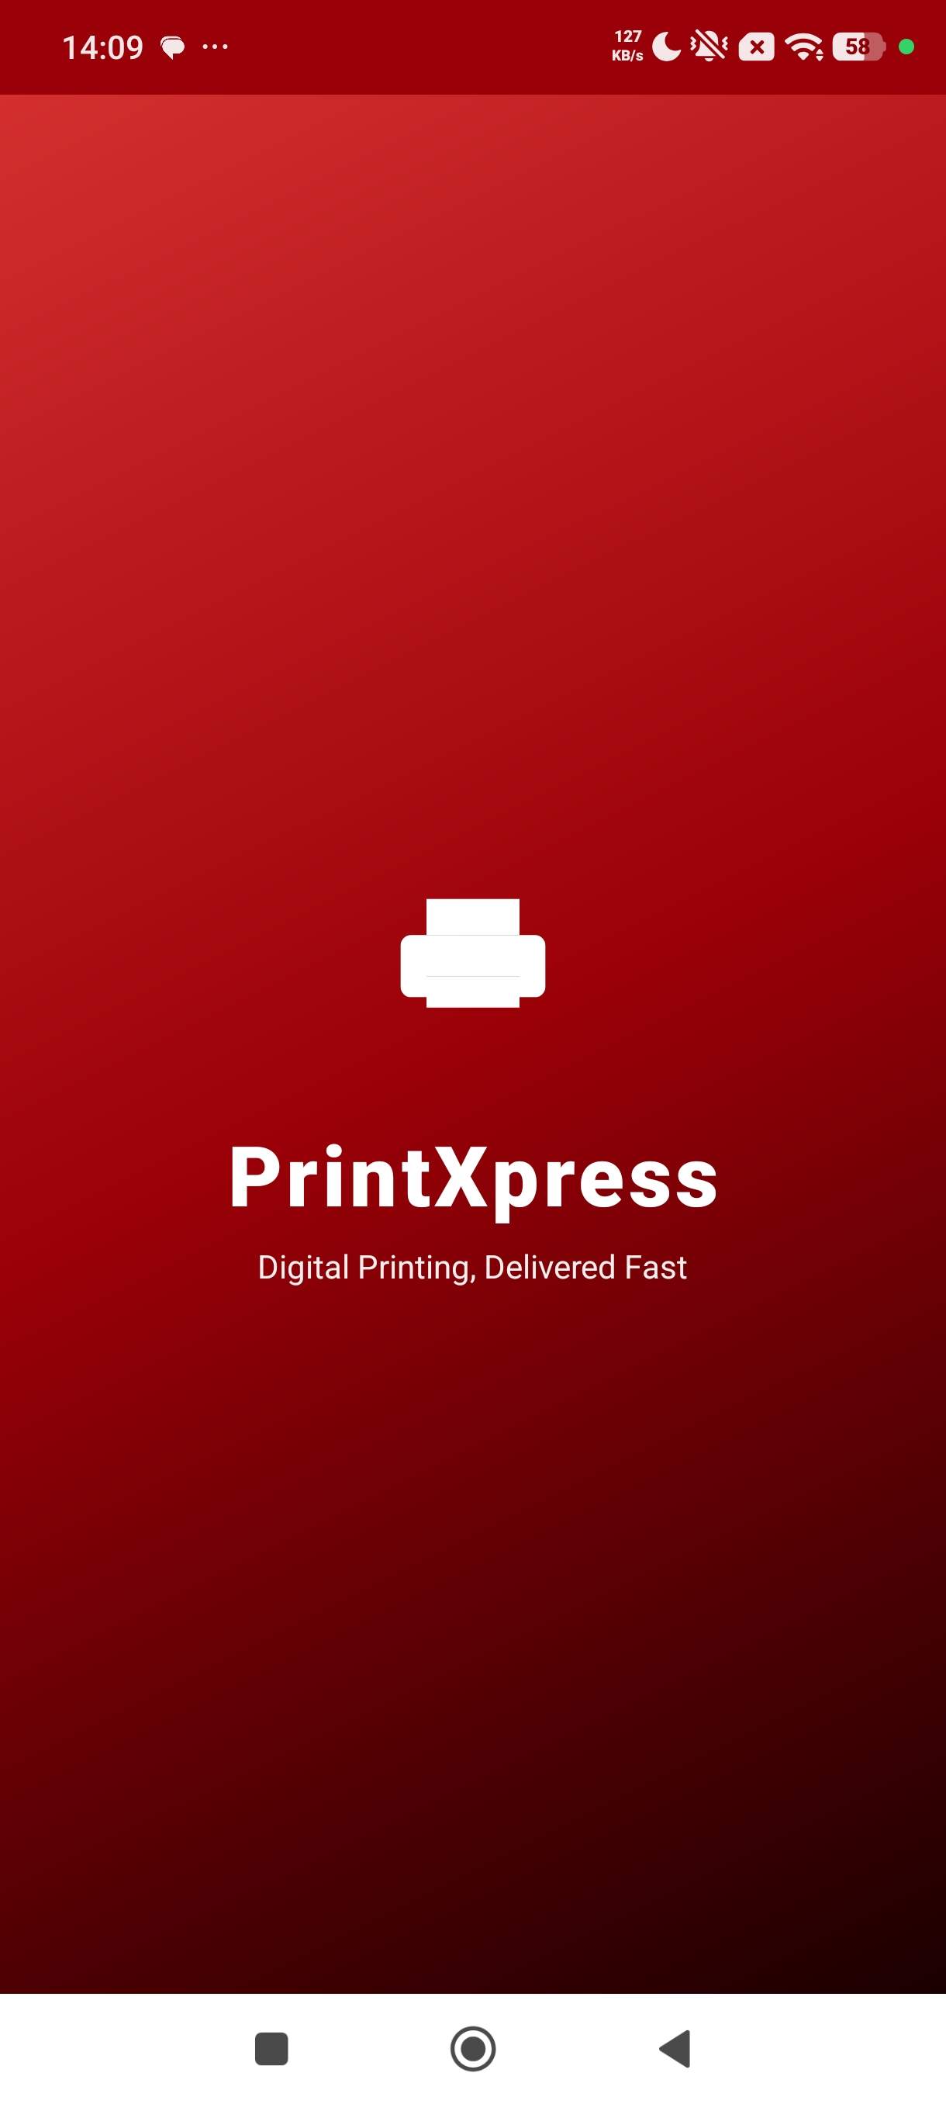

2. Login Screen
The login form sits inside a white CardView floating on the red header gradient. Both inputs use TextInputLayout: the email field has the start-icon envelope, and the password field has a Show Password toggle. A demo accounts hint at the bottom helps the marker sign in immediately. Inline validation messages appear below each field – the user is not blocked by a modal dialog.
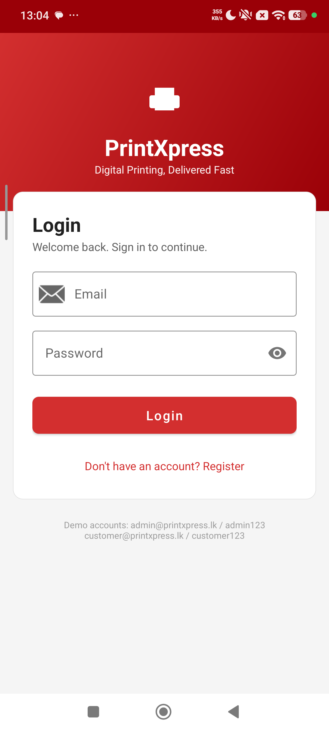

3. Registration Screen
Registration captures full name, email, phone, address, password and a password confirmation. The submit button is disabled implicitly through validation – the activity won't call DatabaseHelper.registerUser() unless every field passes Validator and the two password fields match. On success the screen finishes back to Login, which makes the next step obvious.
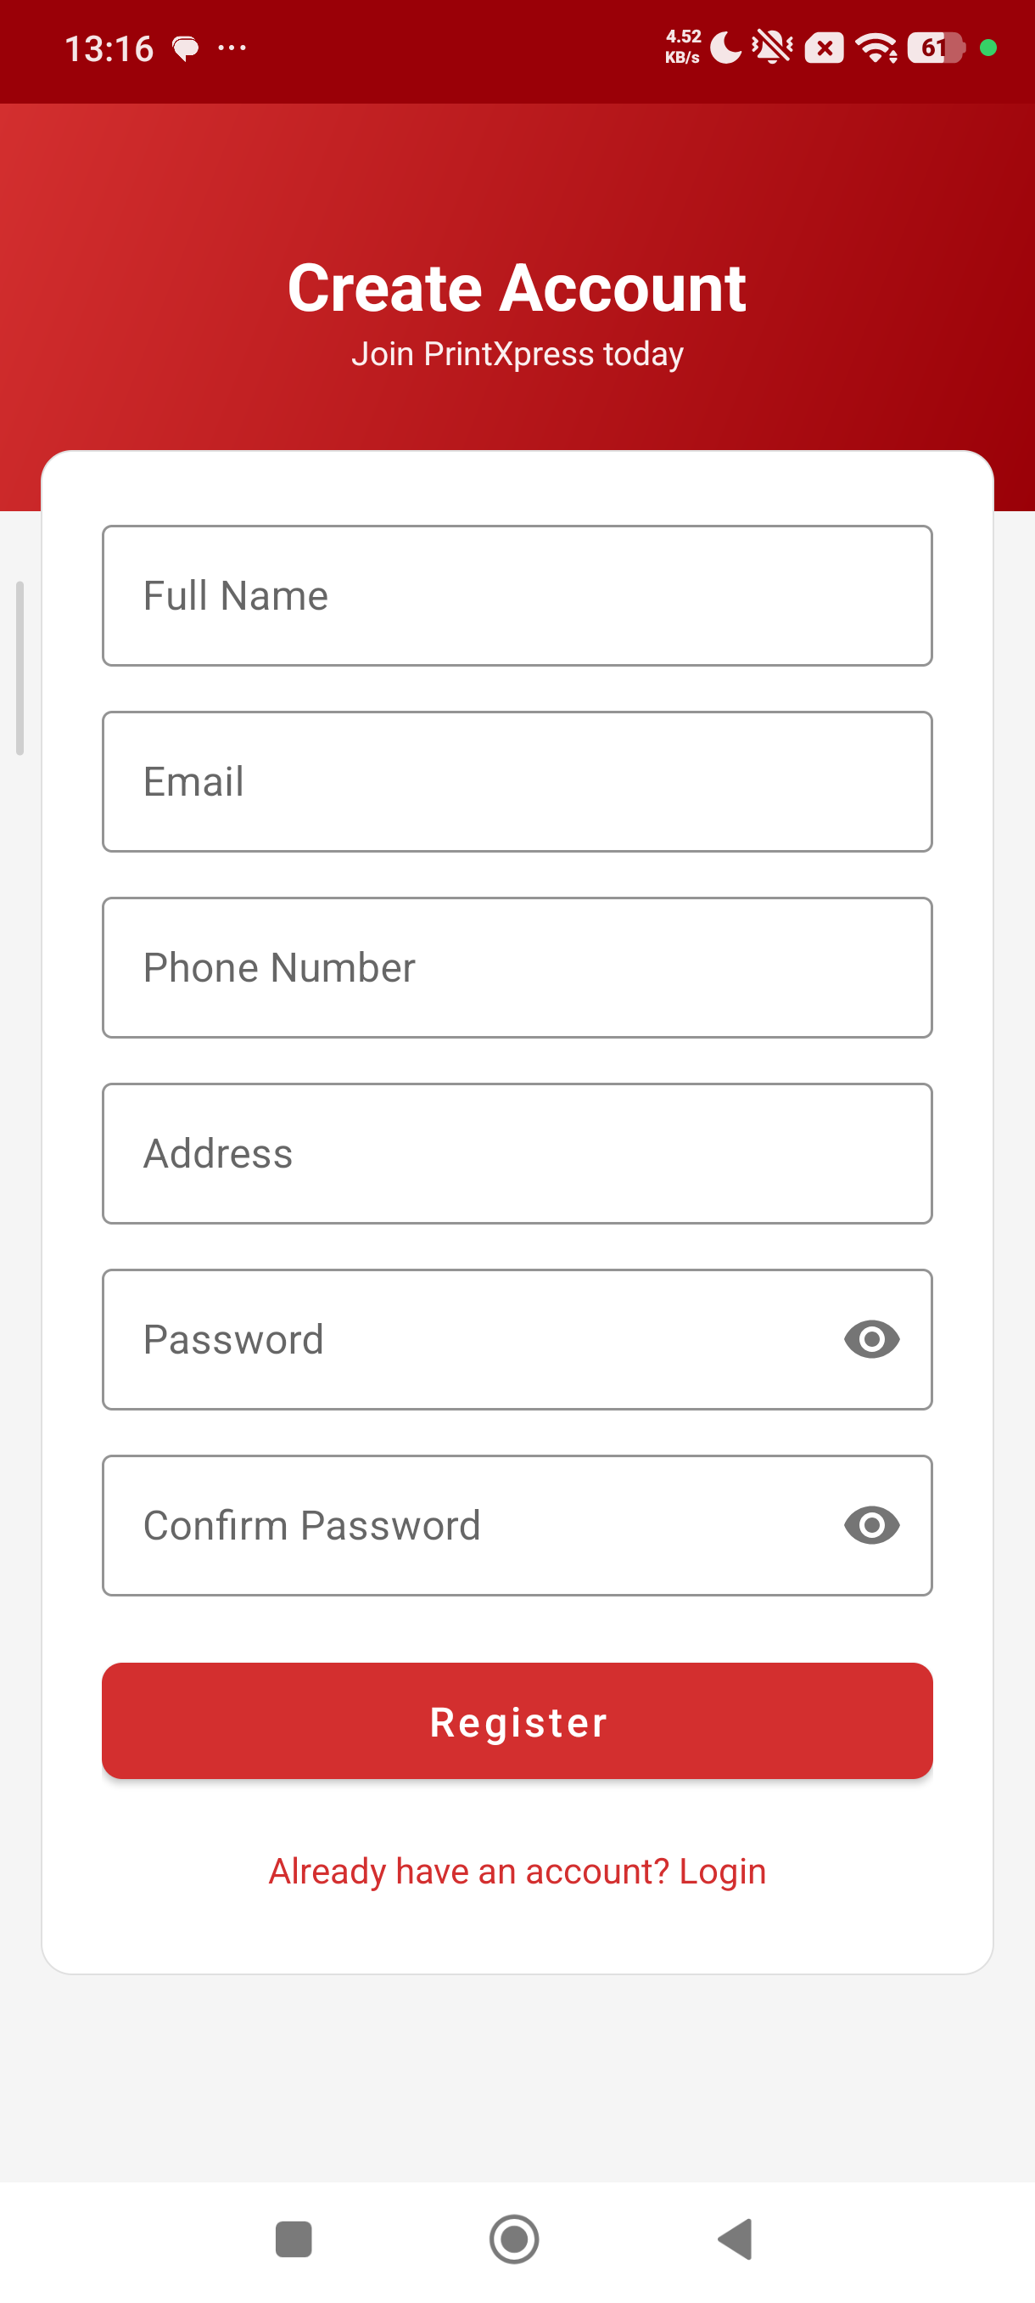

4. Customer Dashboard
The customer dashboard greets the user by name (read from SessionManager) and offers a single large Browse Products call-to-action plus four supporting cards (My Orders, Promotions, Guidelines & FAQ, My Profile). The logout button is a power-icon at the top-right with a confirmation AlertDialog so it cannot be hit by accident.
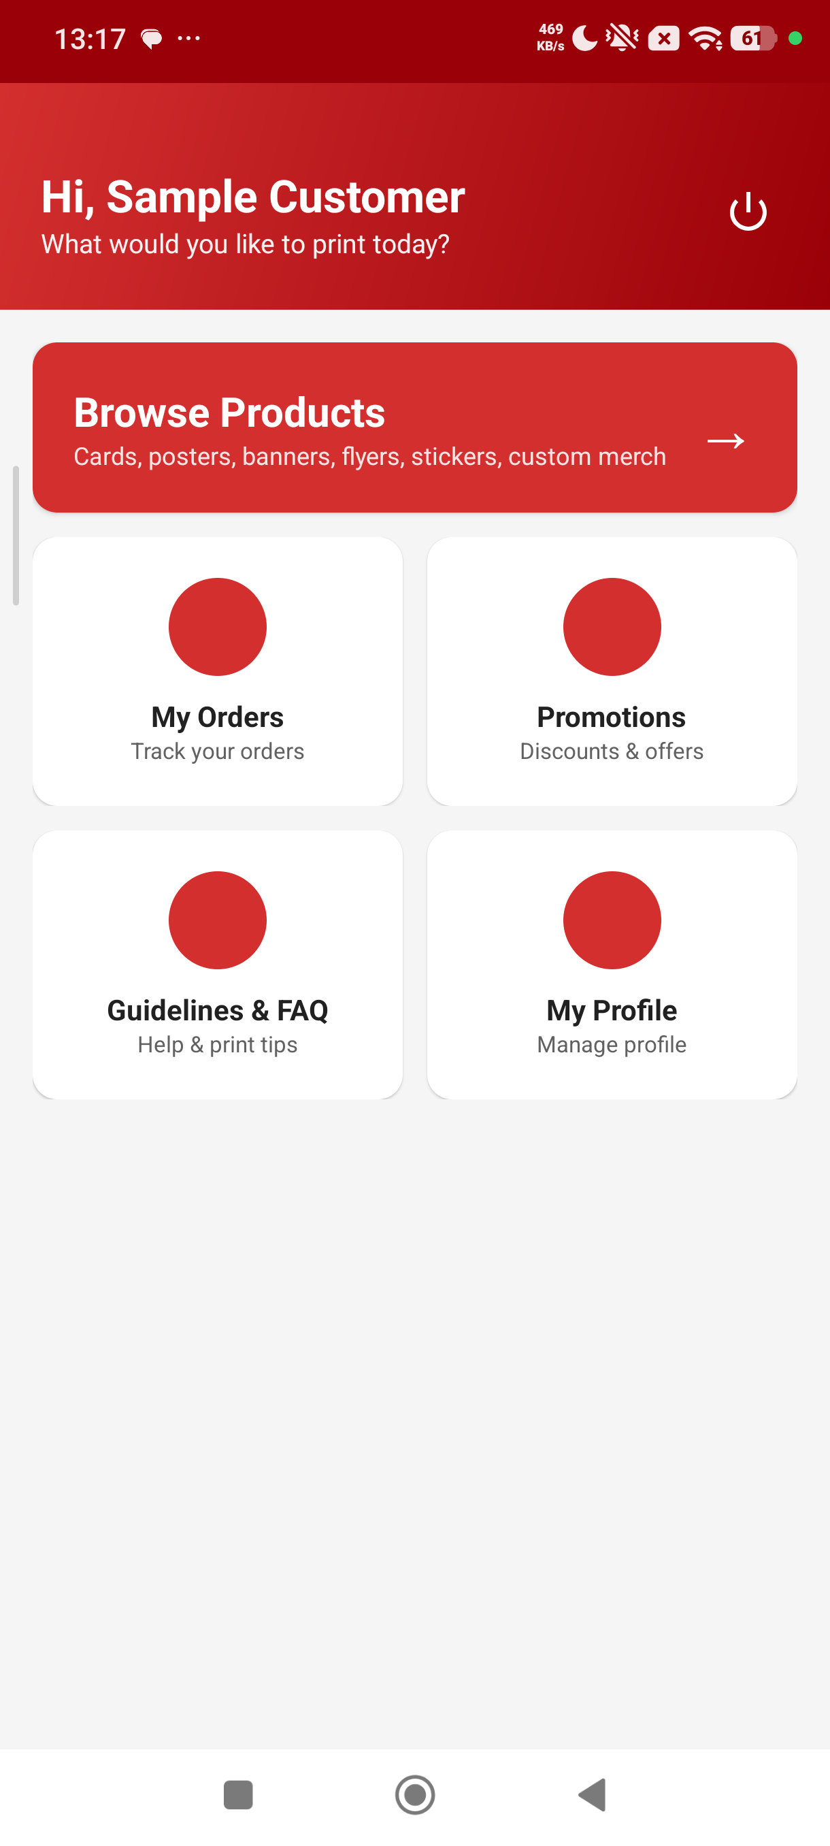

5. Product Catalogue
ProductListActivity renders a RecyclerView of CardView items. The header includes a Material text-input search box and a category Spinner. Filtering and search both feed into DatabaseHelper.getActiveProducts(category, search), which builds the WHERE clause dynamically. Each card shows the product name, category, price in LKR and a description preview.
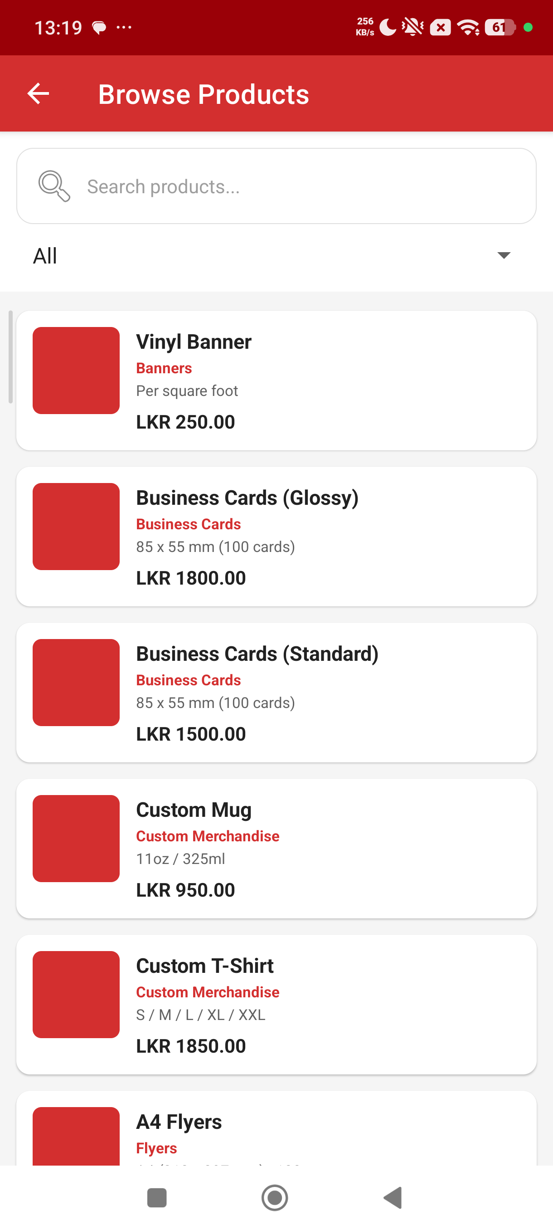

6. Product Detail
Product detail expands the chosen card with a large header image (printer icon placeholder), the price in the brand red, and an information card showing Description, Material and Size / Unit. A persistent Place Order MaterialButton at the bottom of the screen makes the next action obvious regardless of where the user scrolls.
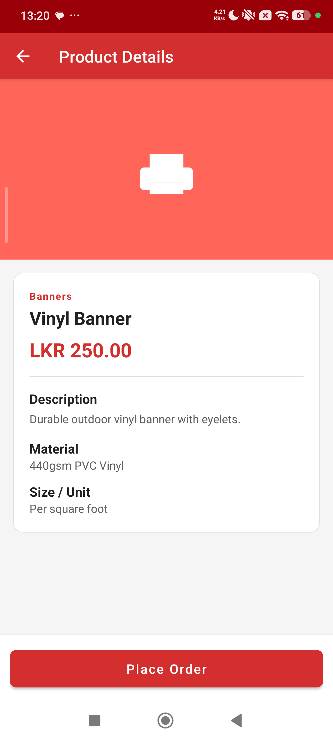

7. Place Order Form
PlaceOrderActivity is the most data-rich screen in the app. It summarises the chosen product, exposes Quantity (with a live total = price × quantity recalculated as the user types), a Customisation block (specifications, custom text, optional design upload) and a Delivery Option block with a RadioGroup (Store Pickup or Home Delivery). If Home Delivery is selected, the delivery address TextInputLayout becomes mandatory.
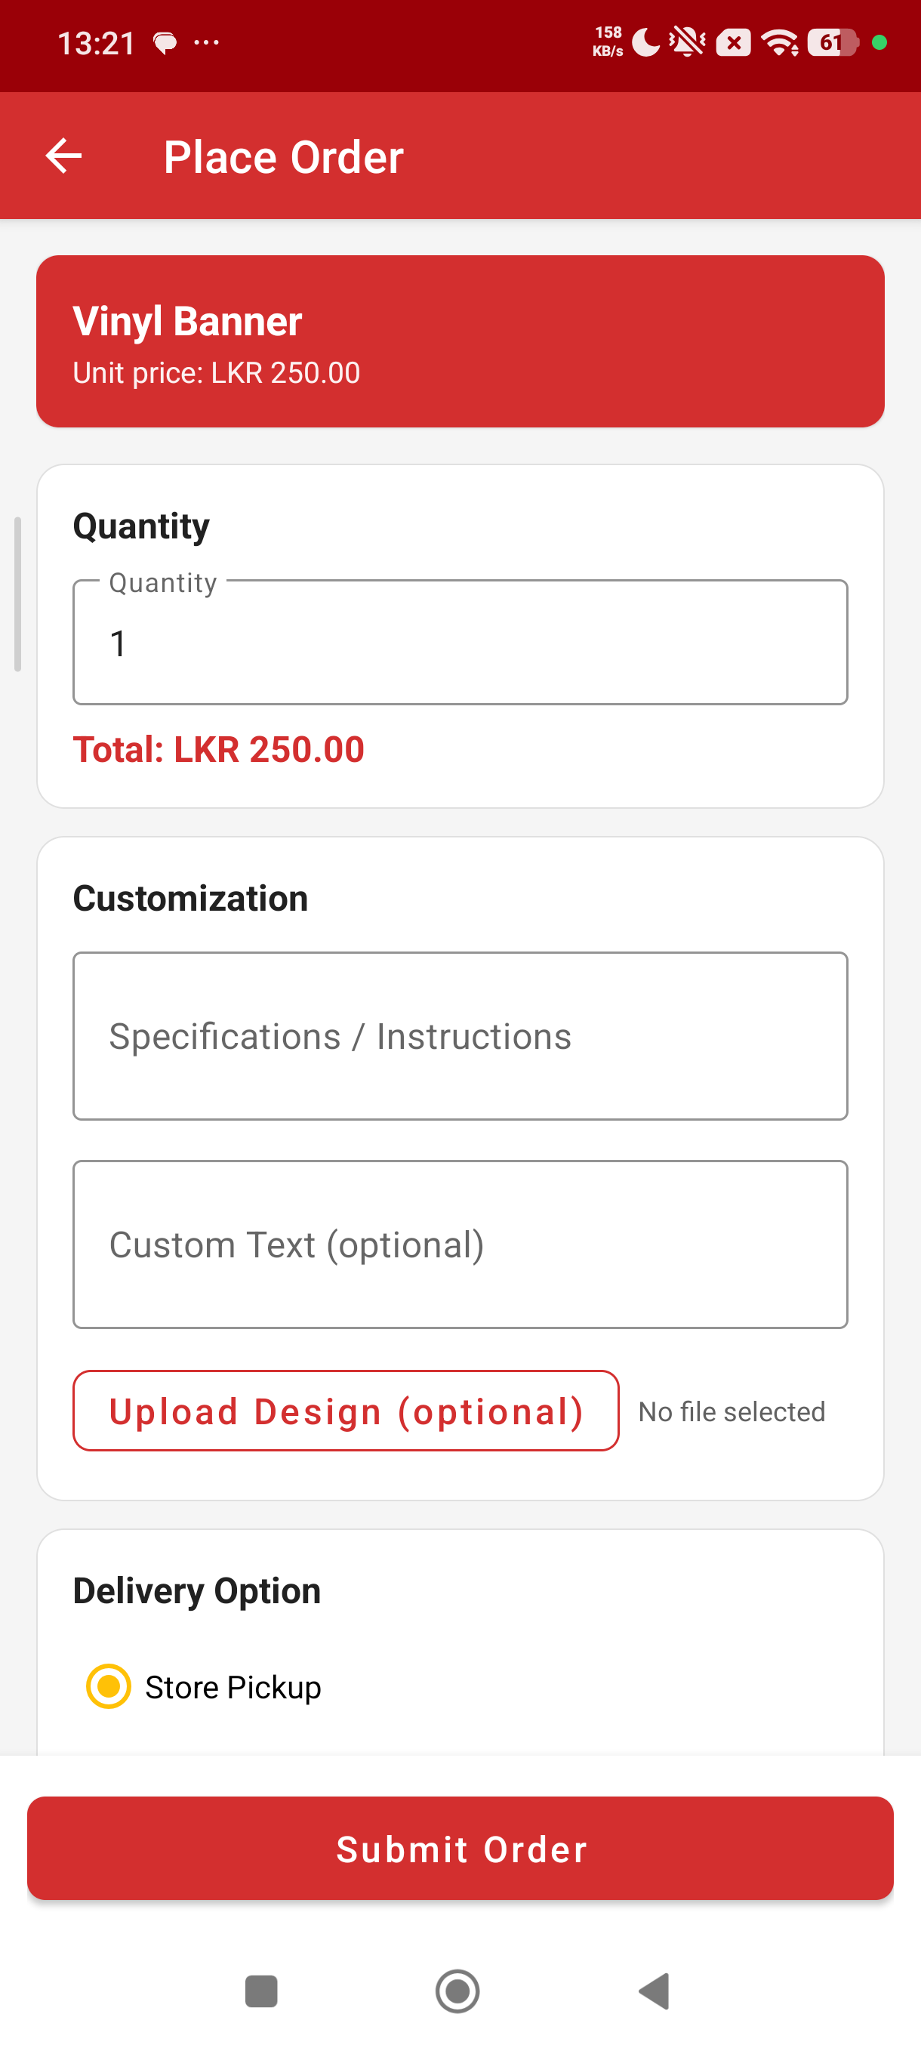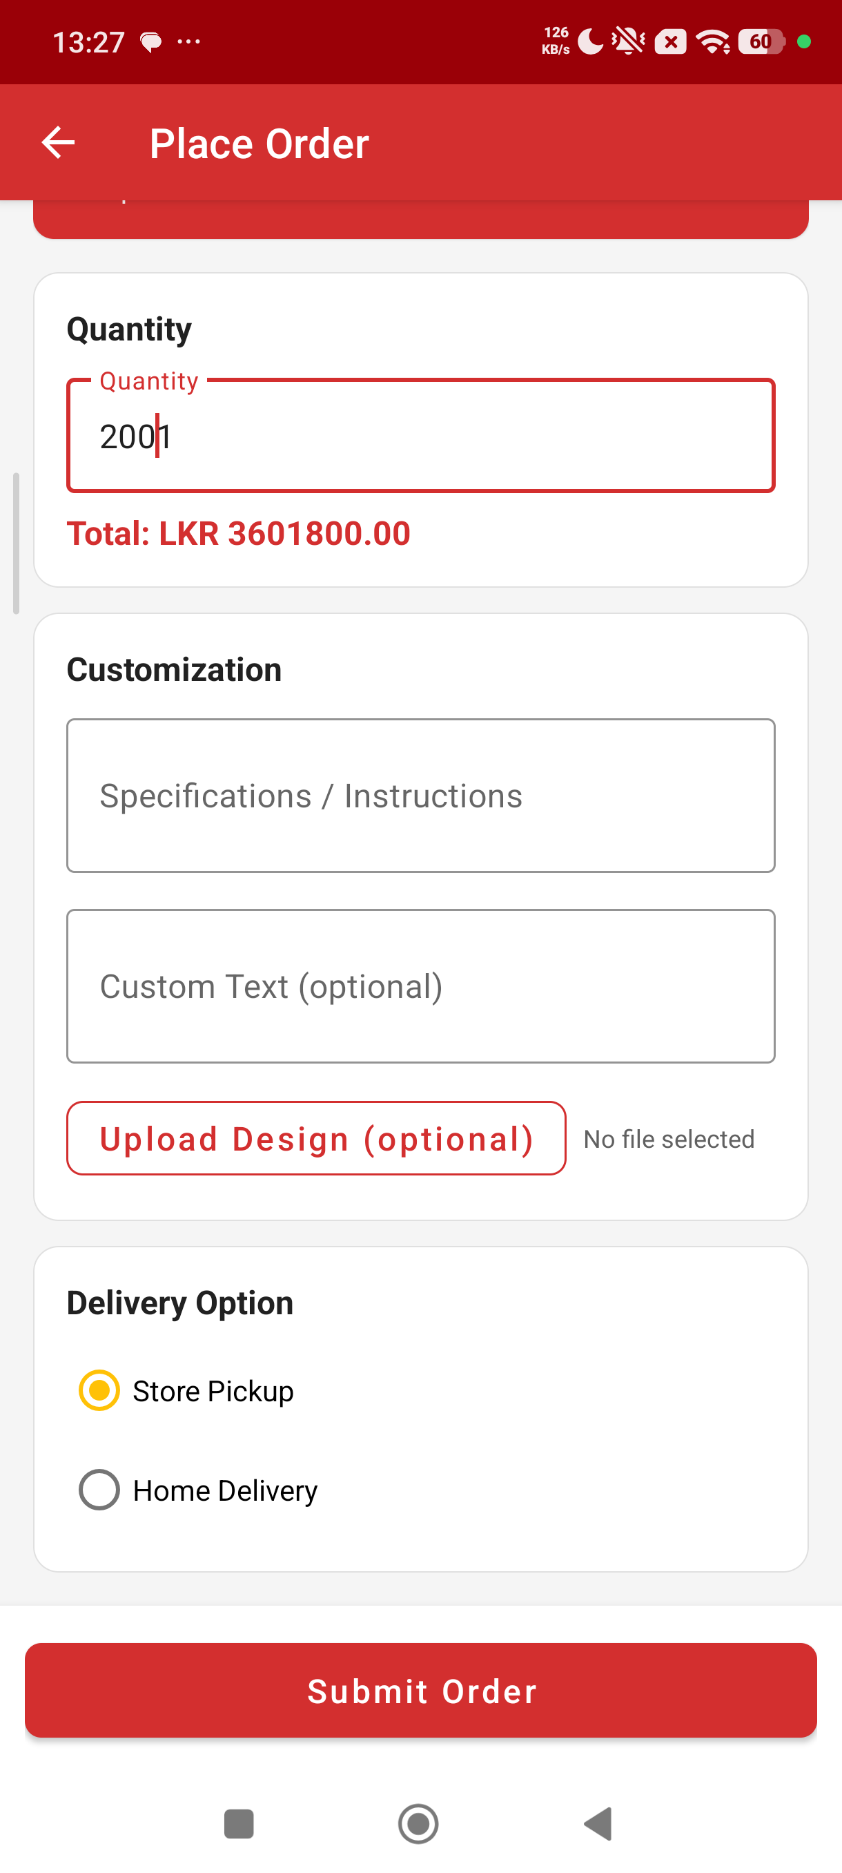

8. My Orders
My Orders shows a RecyclerView of every order placed by the signed-in customer in reverse chronological order. Each row shows the order number, product name, quantity, delivery type, total in LKR, the formatted date and a coloured status badge. Tapping a row opens the order detail in the same layout used by the admin, so the user can read full specifications.
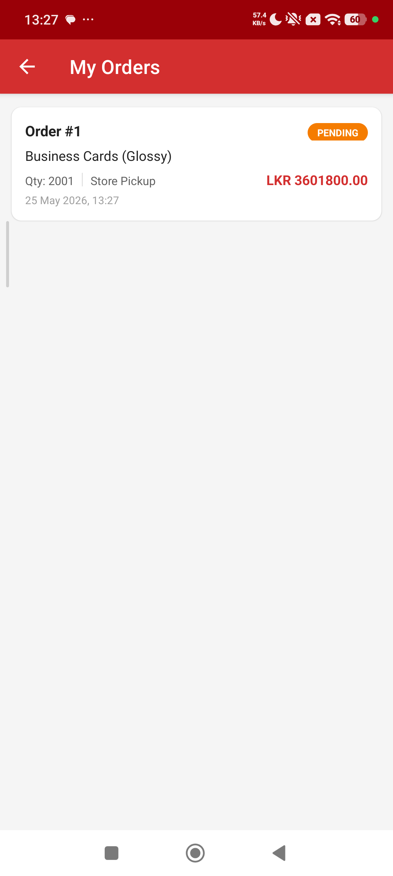

9. Promotions
The promotions screen is a vertical RecyclerView of CardView items populated from DatabaseHelper.getActivePromotions(). Each card highlights the discount percentage, the title, the description and the valid-until date, so customers can see active offers at a glance.
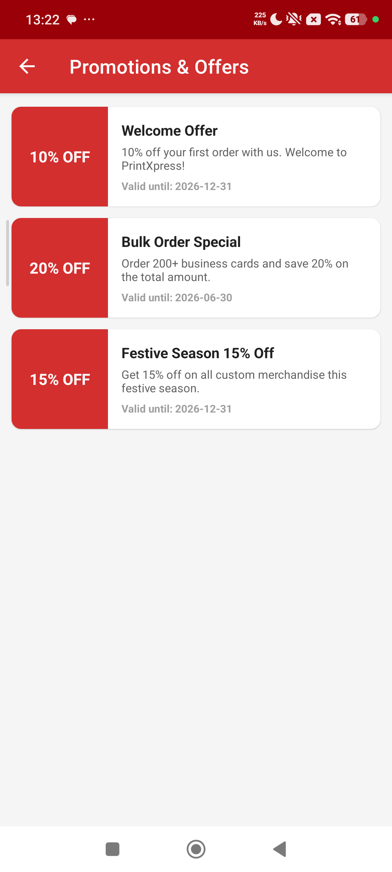

10. Guidelines & FAQ
GuidelinesActivity surfaces the static design guidance and customer-support information required by the brief – file requirements, bleed and safe margins, FAQs about turnaround and cancellation, and contact details. Because the content is read-only and rarely changes, it is laid out in CardViews directly in XML rather than stored in SQLite, which keeps the schema focused on transactional data.
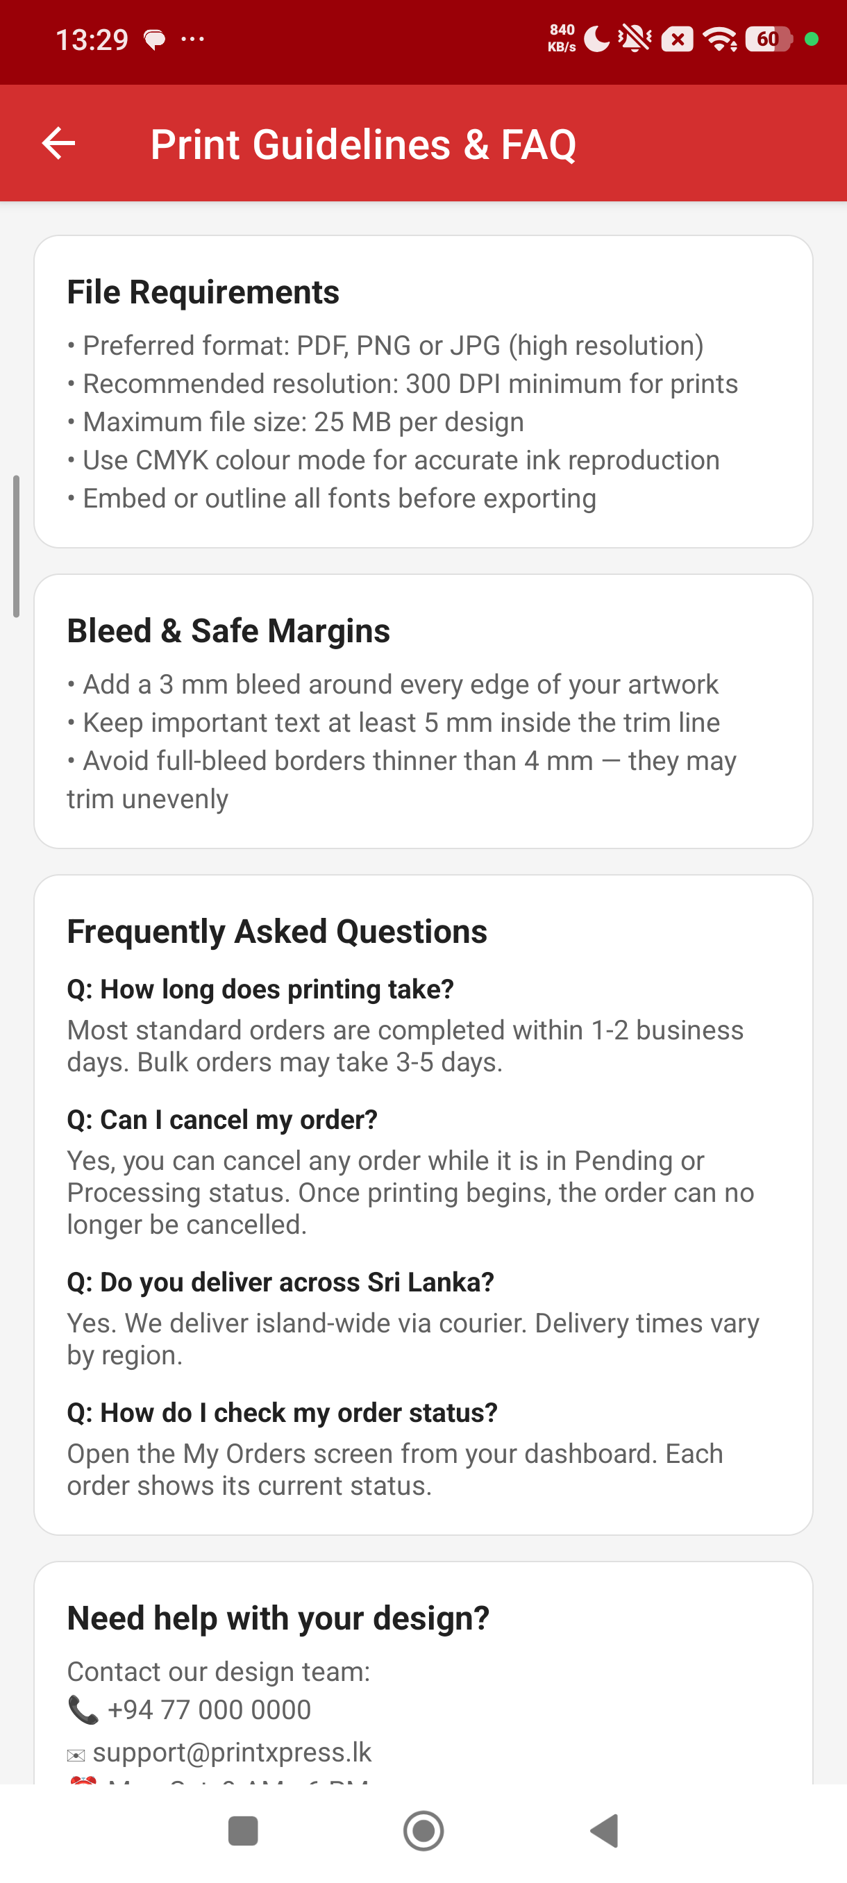

11. Profile
The profile screen lets the customer edit their full name, phone and delivery address (email is read-only because it is the login key). The Security section opens a Change Password dialog that re-uses the central Validator and the PasswordUtil hashing helper.
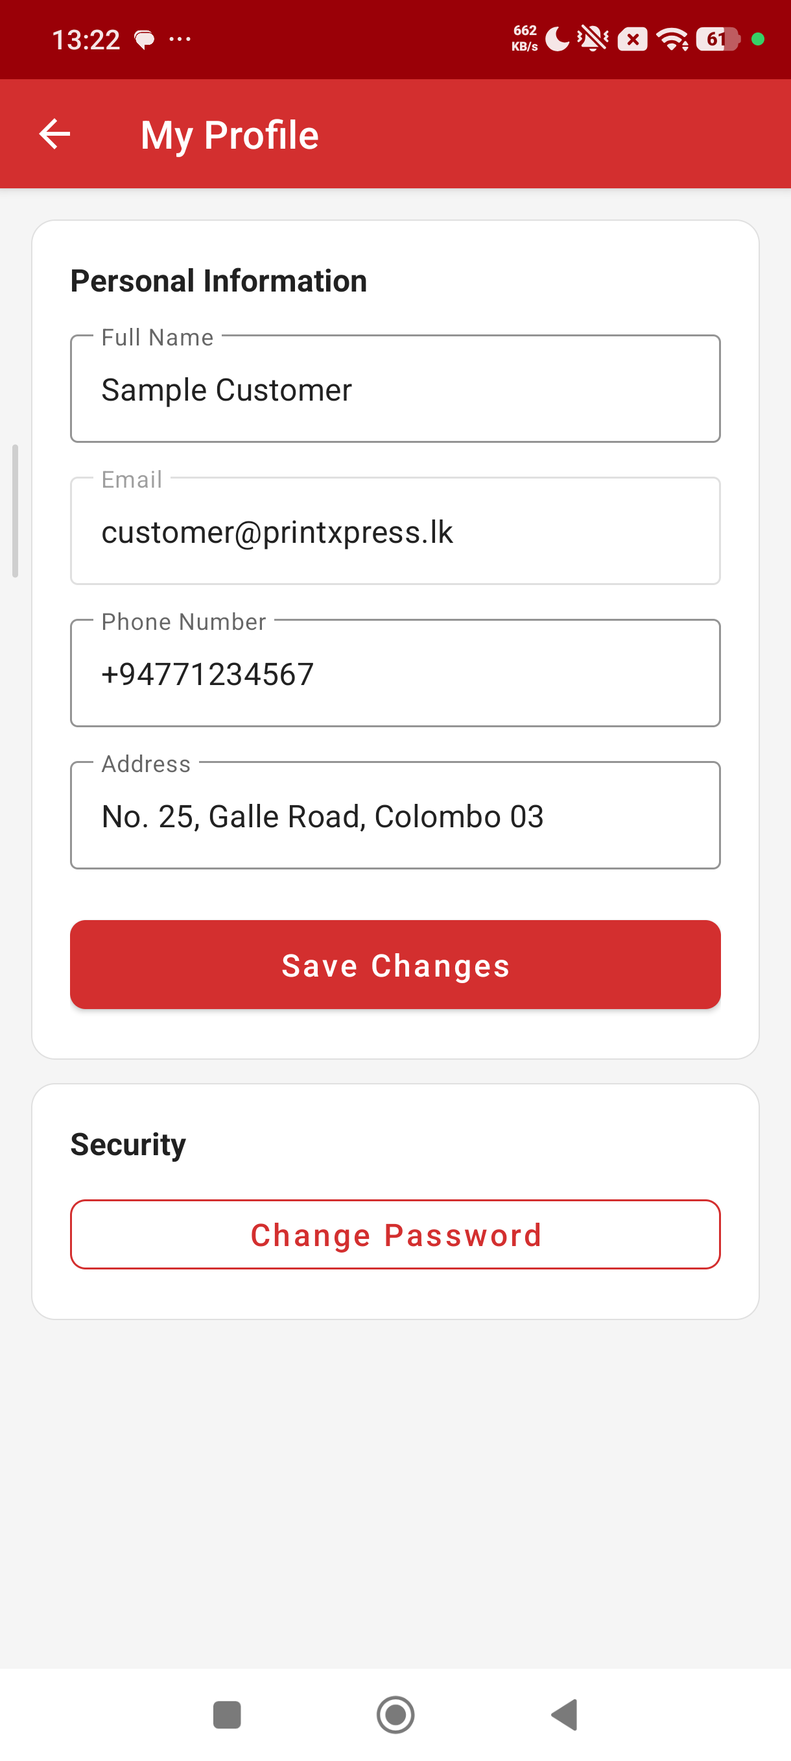

12. Logout Confirmation
A logout confirmation AlertDialog is shown before SessionManager.clearSession() is called, to protect the user from losing their session if the icon is tapped by accident.
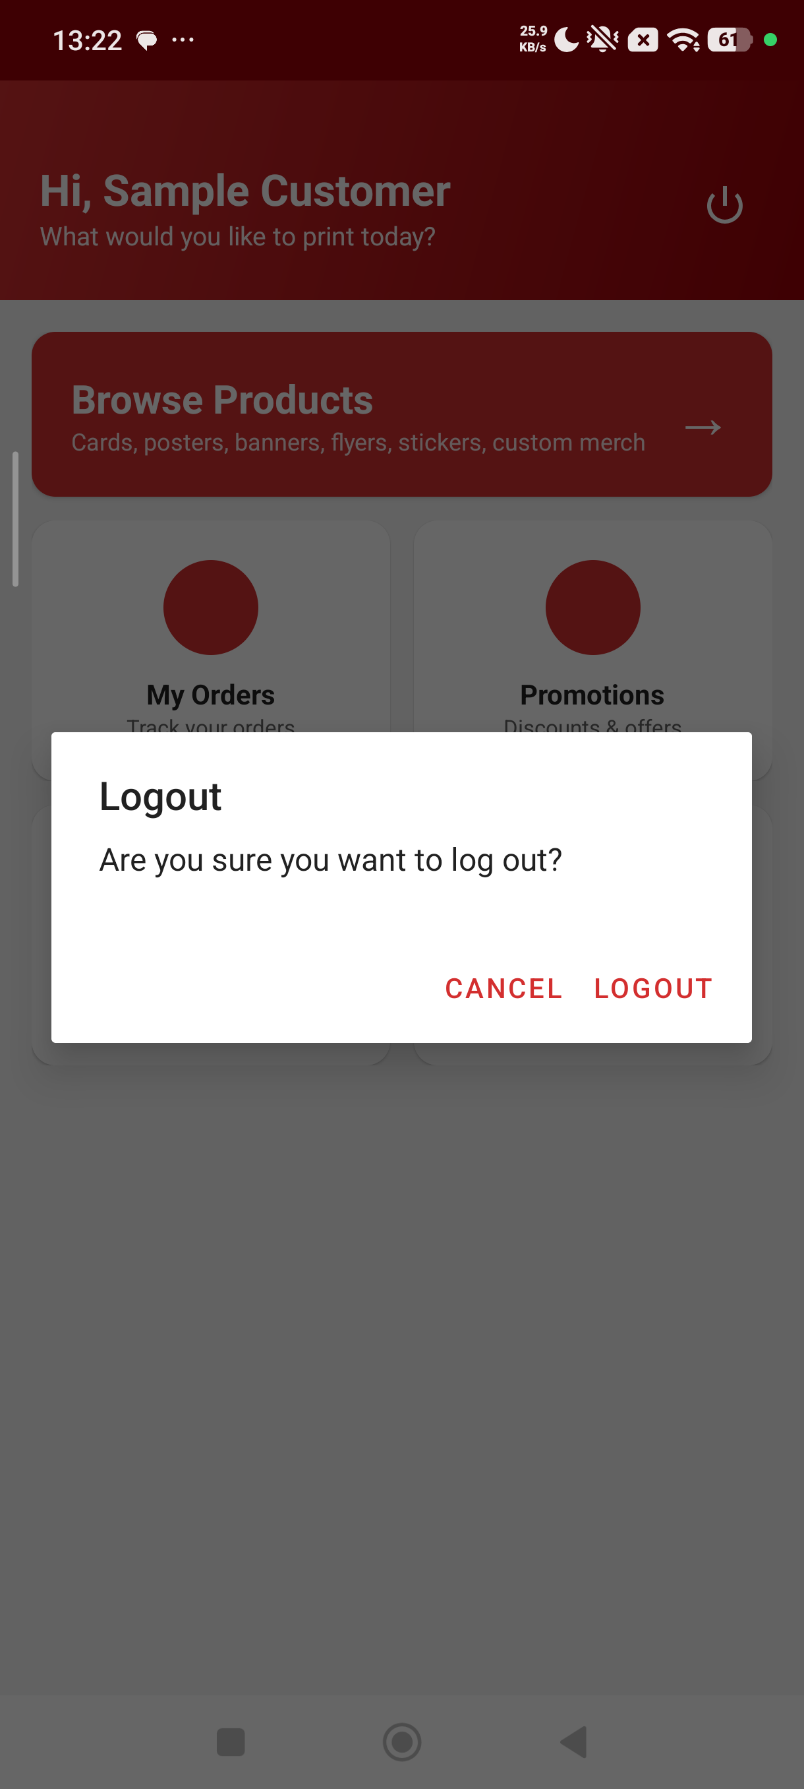

13. Admin Dashboard
Administrators land on a dedicated dashboard that opens with a four-card snapshot (Total Orders, Pending, In Progress, Completed) computed by DatabaseHelper.countOrdersByStatus(). Below the snapshot, four management cards open Manage Orders, Manage Products, Manage Promotions and Customers respectively.
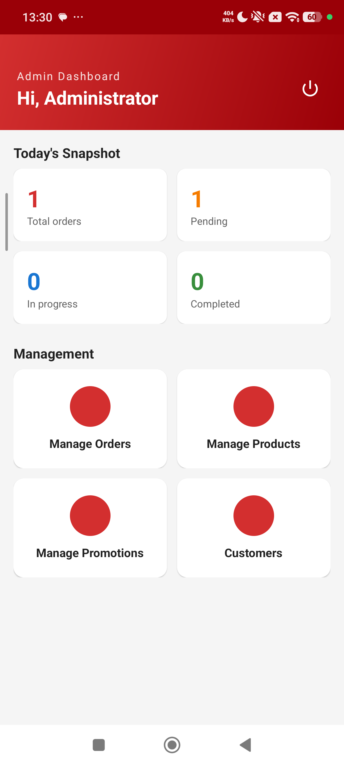

14. Admin – Manage Orders
Manage Orders is a filterable list of every order across all customers. The dropdown at the top filters by status (All, Pending, Processing, Printing, Ready, Completed, Cancelled). Each card shows the customer name in addition to the product, quantity, delivery type and total, so the admin sees who placed the order without an extra tap.
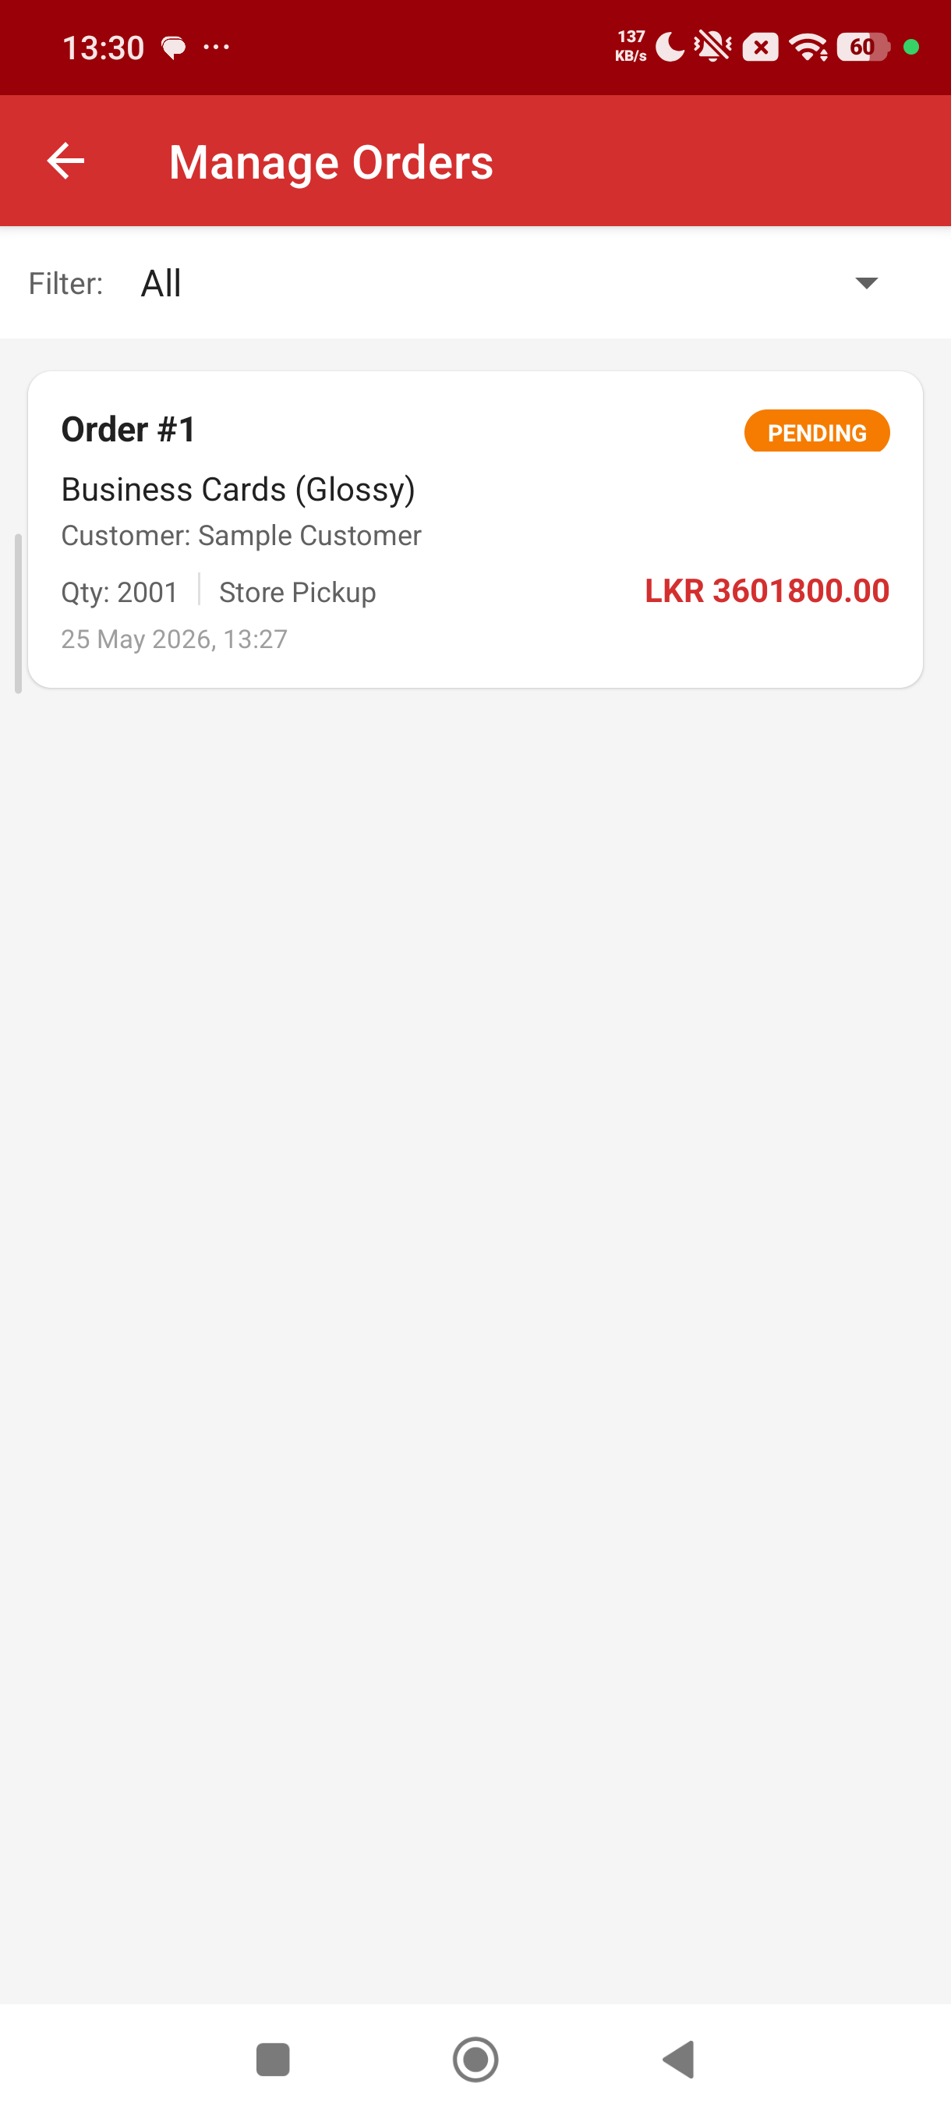

15. Admin – Manage Products
The admin product list mirrors the customer catalogue but also shows inactive (soft-deleted) products. A floating Add Product button opens AdminEditProductActivity in 'new' mode; tapping a product card opens it in 'edit' mode.
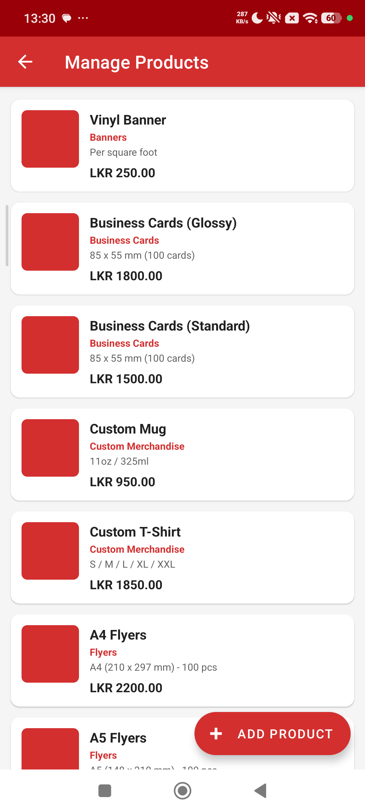

16. Admin – Add / Edit Product
The edit form captures name, category, material, size/unit, description, price and an Active switch. Validator.isPositiveDouble() guards the price field. Saving calls DatabaseHelper.addProduct() or updateProduct() depending on whether the activity was launched with a productId extra.
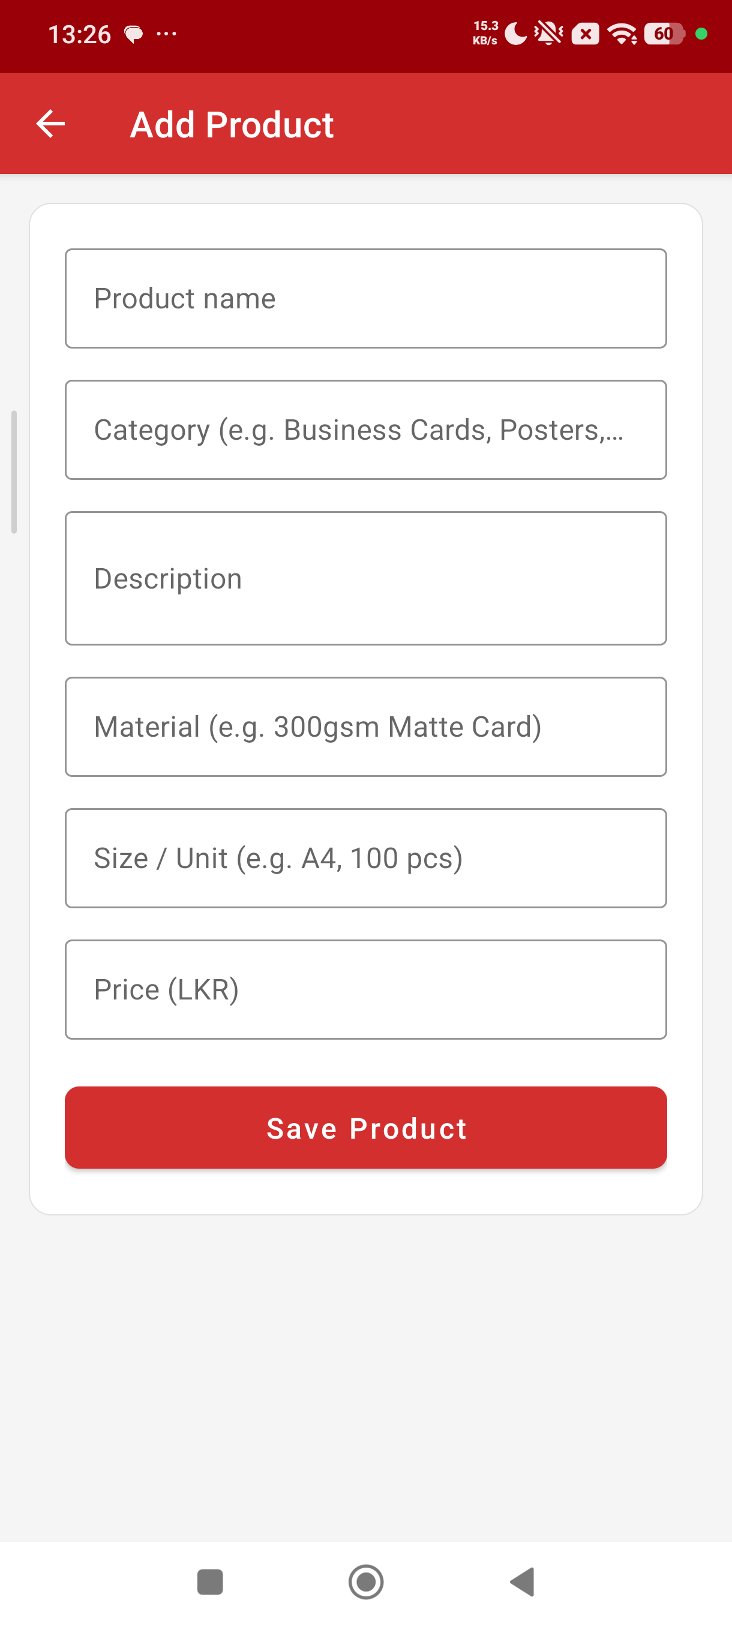

17. Admin – Manage Promotions
Promotions follow the same pattern as products: a list of CardViews with an Add Promotion button and tap-to-edit. Each card shows the discount badge, title, description and valid-until date.
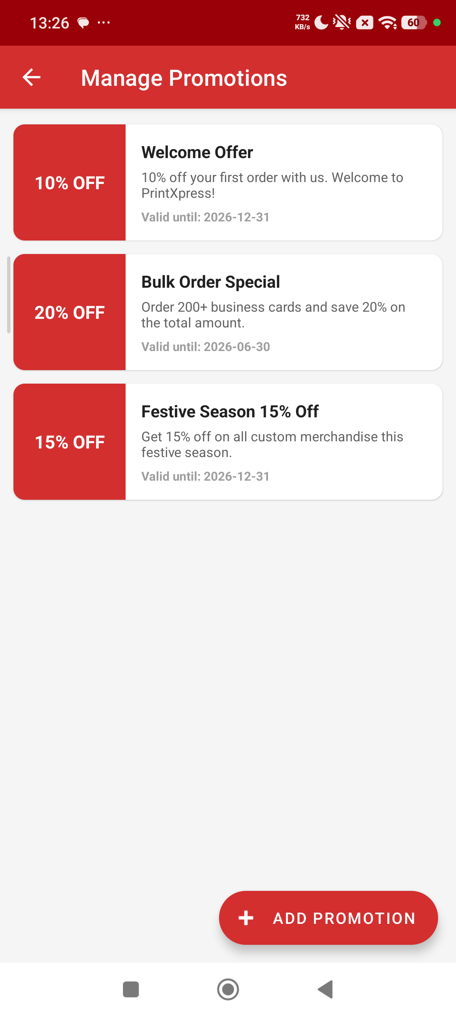

18. Admin – Add / Edit Promotion
The promotion editor captures title, description, discount percent (0–100, validated as a positive integer), an optional valid-until date (ISO YYYY-MM-DD) and the Active switch. Tapping the date field opens a DatePickerDialog so administrators do not have to type the date manually.
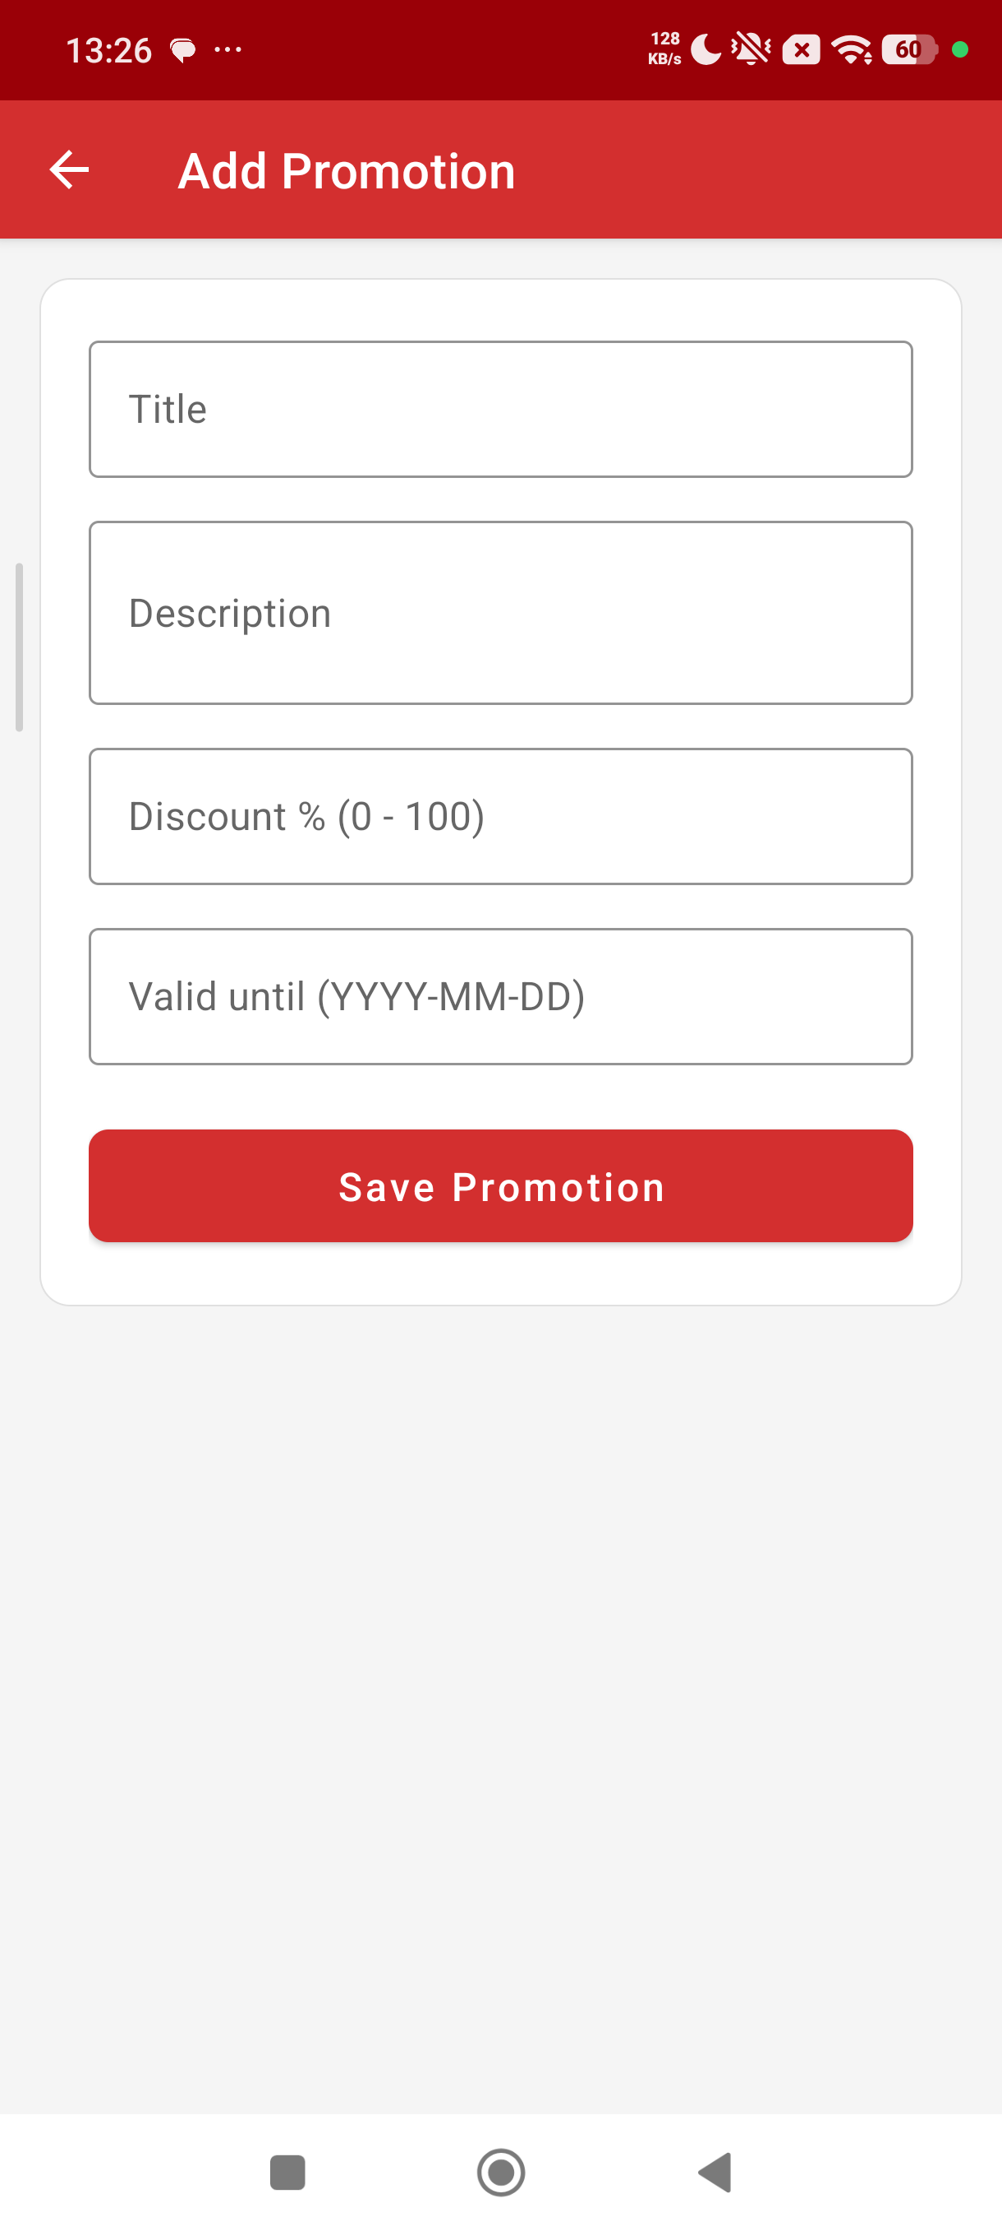

19. Admin – Customers
The customer list reads from DatabaseHelper.getAllCustomers() (which filters role='CUSTOMER') and shows each customer's name, email and phone in a CardView. This is intentionally read-only – PrintXpress does not let an administrator delete a customer because that would orphan the customer's order history.
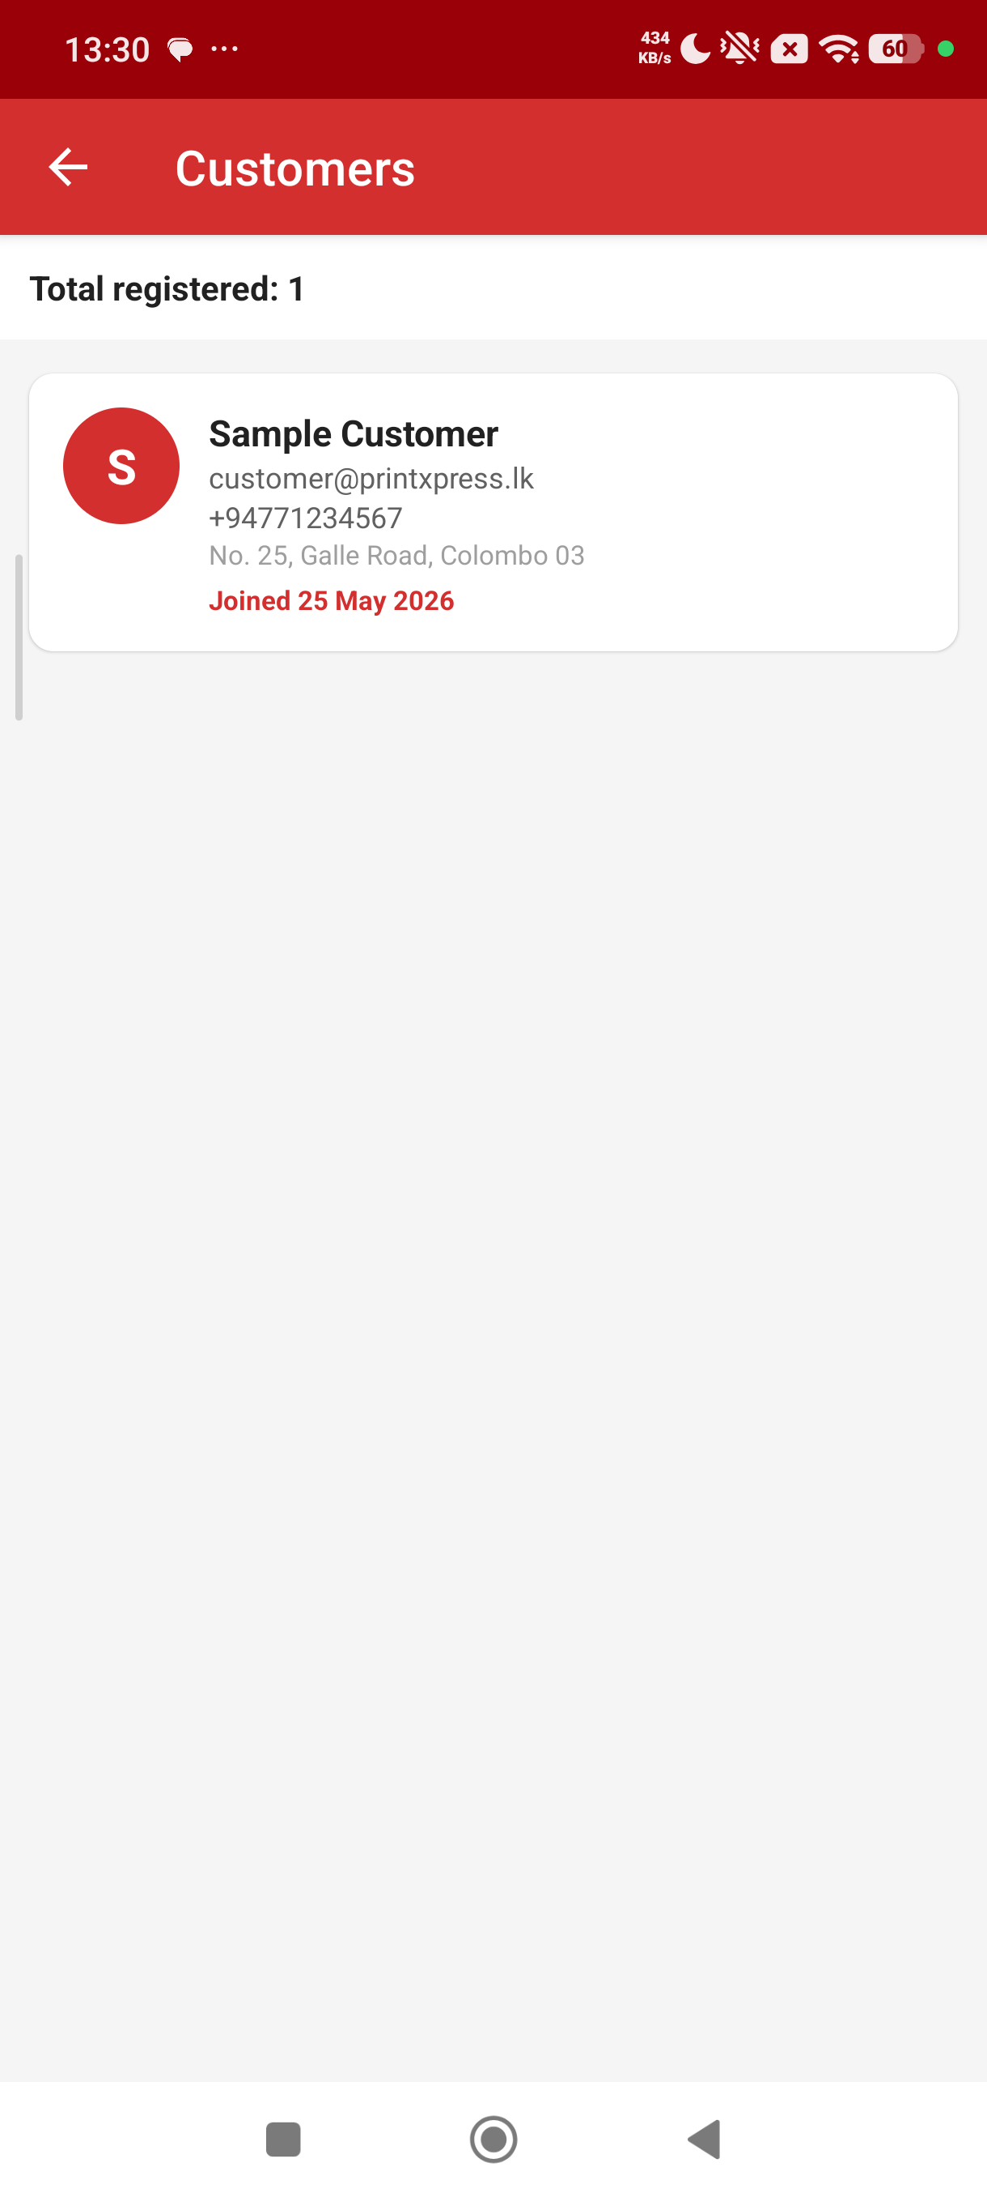

Task D

Development of the PrintXpress Android Application

1. Introduction
The PrintXpress Android app implements the design produced in Task B and follows the visual language defined in Task C. It uses a single Java module under com.printxpress.app with 18 Activities, 4 model classes, a single SQLiteOpenHelper and three utility classes (PasswordUtil, SessionManager, Validator). The app is signed with a debug key for academic review and is installed on the test device via ADB.

2. Development Environment
Component | Value
IDE | Android Studio Hedgehog
JDK | Eclipse Temurin 17
Programming language | Java 17
Build system | Gradle 8.x (Kotlin DSL not used)
Minimum SDK | API 24 (Android 7.0 Nougat)
Target SDK | API 34 (Android 14)
Database | SQLite via android.database.sqlite.SQLiteOpenHelper
UI framework | Material Components for Android (com.google.android.material 1.11.0)
Layout engine | ConstraintLayout + LinearLayout in XML
Testing devices | Xiaomi Redmi (physical, Android 14) and Pixel emulator (API 34)

3. System Architecture
PrintXpress follows the classic Android Model-View-Controller (MVC) layout:
- Model – Plain Old Java Objects in com.printxpress.app.model: User, Product, Order, Promotion.
- View – XML resources under res/layout (activity_login.xml, activity_customer_home.xml, item_product.xml, etc.). Material Components handle the visual styling.
- Controller – Android Activities under com.printxpress.app. They translate user input into model objects, call DatabaseHelper for persistence and start the next Intent.
The controller layer never touches the database directly – every read and write goes through DatabaseHelper, which keeps SQL in one file and makes the model layer testable in isolation.

4. Major Functional Components

4.1 Authentication – LoginActivity and RegisterActivity
LoginActivity reads the email and password TextInputEditTexts, trims and lower-cases the email, validates both fields through Validator, then asks DatabaseHelper.authenticate() to verify the credentials. On success it stores the user in SessionManager and routes to the correct dashboard. On failure it shows a Toast and clears the password field. RegisterActivity follows the same pattern but additionally enforces email uniqueness and matching password confirmation before calling registerUser().
SplashActivity.java
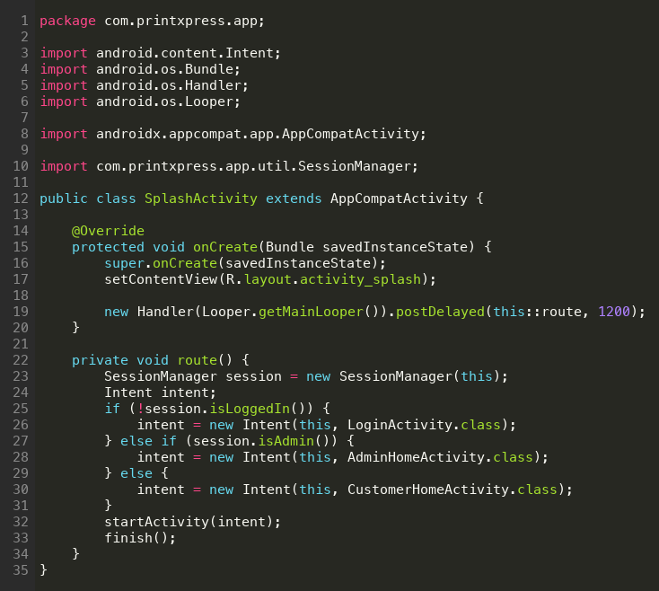
LoginActivity.java
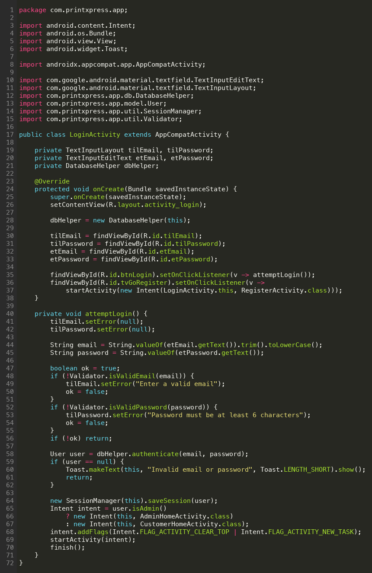
RegisterActivity.java
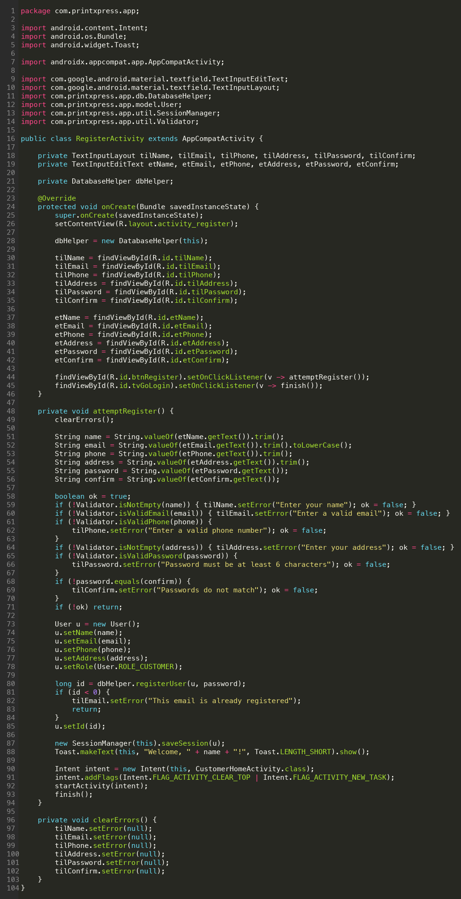

4.2 Customer Dashboard – CustomerHomeActivity
CustomerHomeActivity reads the user from SessionManager and binds their first name into the welcome string. Each card has an OnClickListener that starts the corresponding Activity (ProductListActivity, MyOrdersActivity, PromotionsActivity, GuidelinesActivity, ProfileActivity). The logout icon shows an AlertDialog before calling SessionManager.clearSession() and finishing back to LoginActivity.
CustomerHomeActivity.java
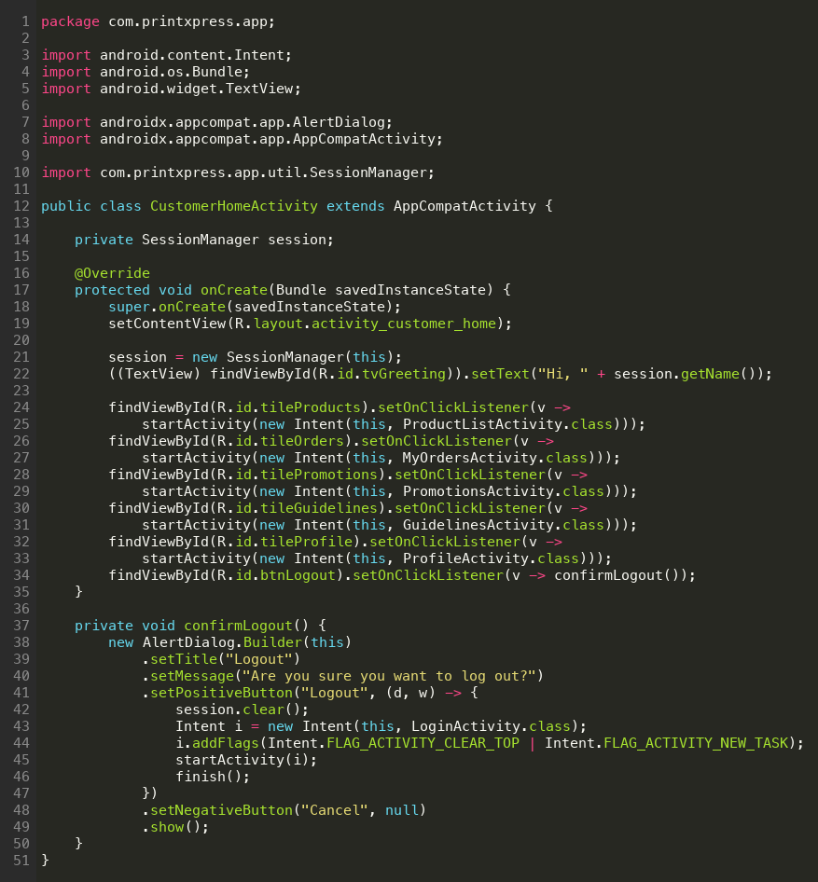

4.3 Product Catalogue – ProductListActivity + ProductAdapter
ProductListActivity hosts a RecyclerView with a ProductAdapter. The adapter inflates item_product.xml for each row. A category Spinner and a Material search field at the top of the screen feed their values into DatabaseHelper.getActiveProducts(category, search), which assembles a WHERE clause and re-binds the adapter. Tapping a row launches ProductDetailActivity with the productId as an Intent extra.
ProductListActivity.java
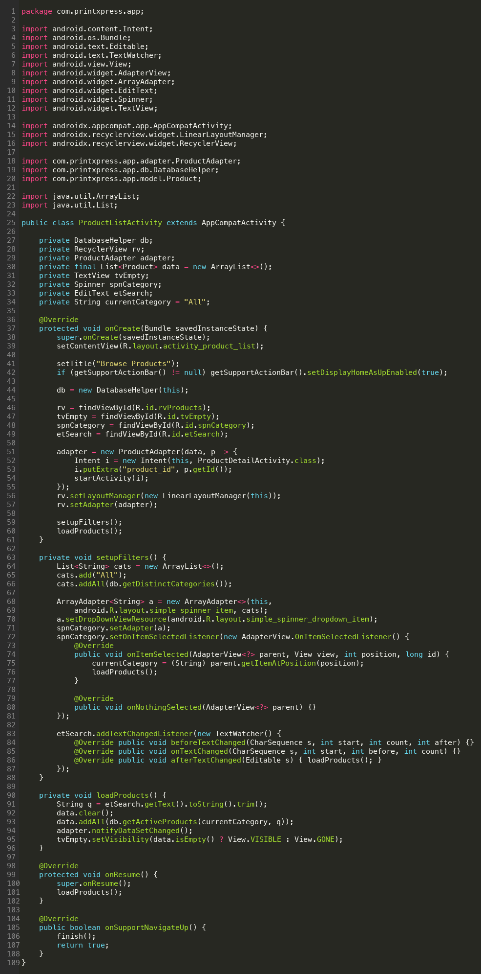

ProductDetailActivity.java
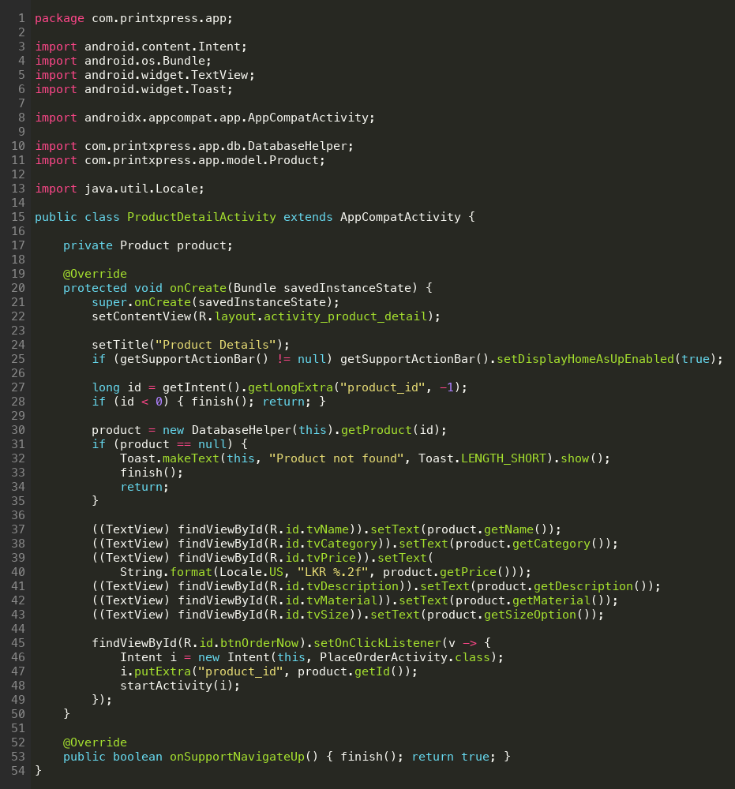

4.4 Place Order – PlaceOrderActivity
PlaceOrderActivity is the transactional core of the customer flow. It receives a productId, loads the Product via DatabaseHelper.getProduct(), and binds price + name into the summary card. As the user types in the quantity field, a TextWatcher recalculates the total. The Delivery Option RadioGroup toggles the visibility of the delivery address field. On submit, Validator.isPositiveInt(quantity) and Validator.isNotEmpty(address when delivery is HOME_DELIVERY) are enforced, an Order object is constructed and persisted via DatabaseHelper.placeOrder(). A Toast confirms the new order id and the activity finishes back to the dashboard.
PlaceOrderActivity.java
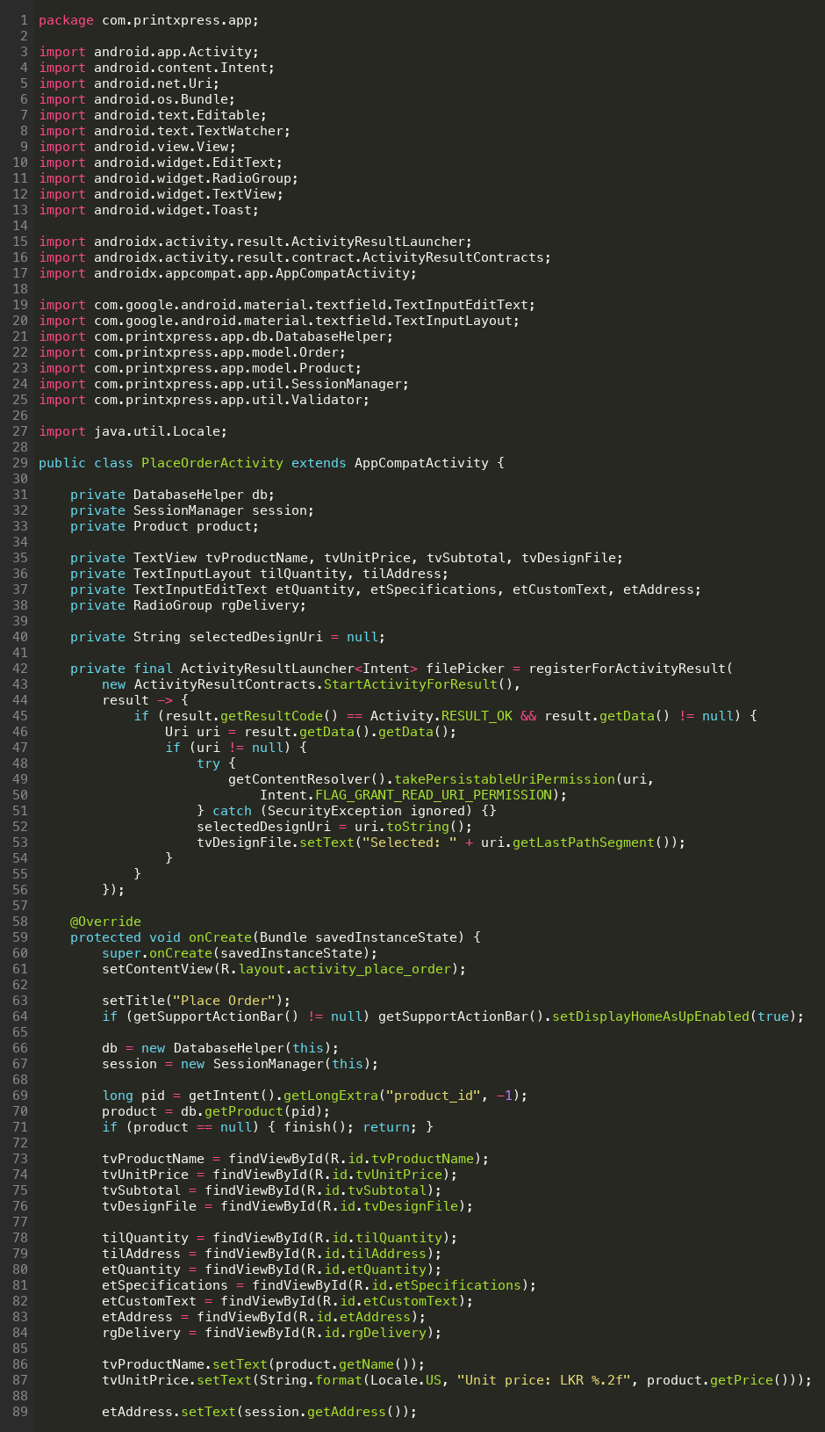
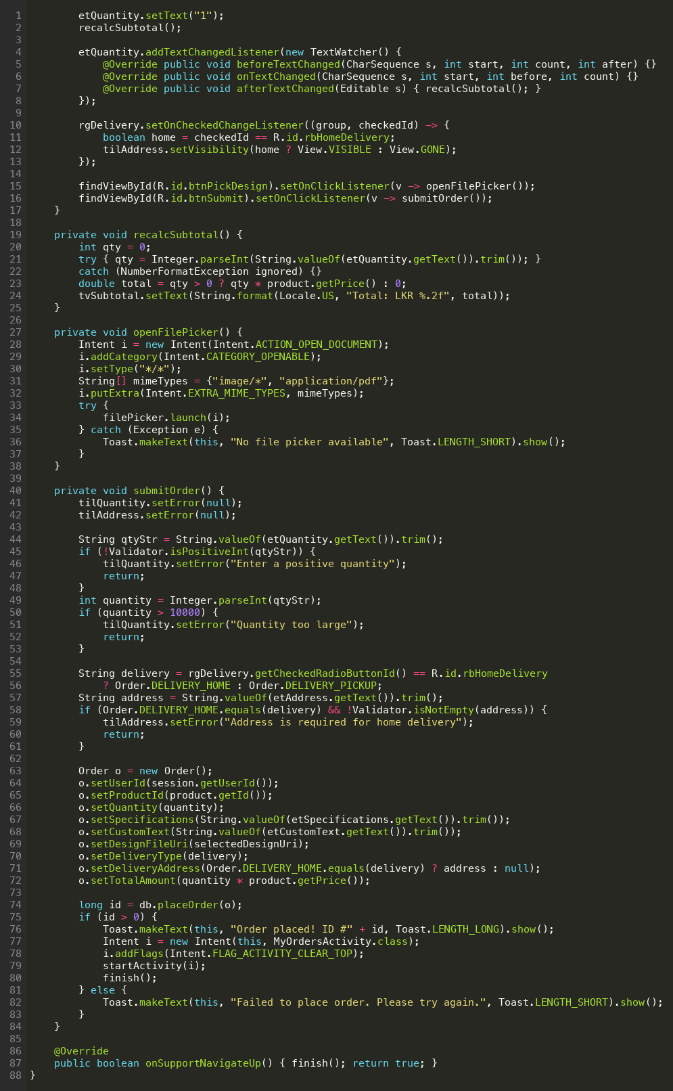

4.5 My Orders – MyOrdersActivity + OrderAdapter
MyOrdersActivity reads DatabaseHelper.getOrdersForUser(userId) which performs a LEFT JOIN with the products table so the product name is available even if the product has since been soft-deleted. The list is rendered with OrderAdapter; each row displays the order number, product name, quantity, delivery type, total, date and a coloured status badge. A row tap opens OrderDetailActivity (reused with the admin) with the full specifications and design URI.
MyOrdersActivity.java
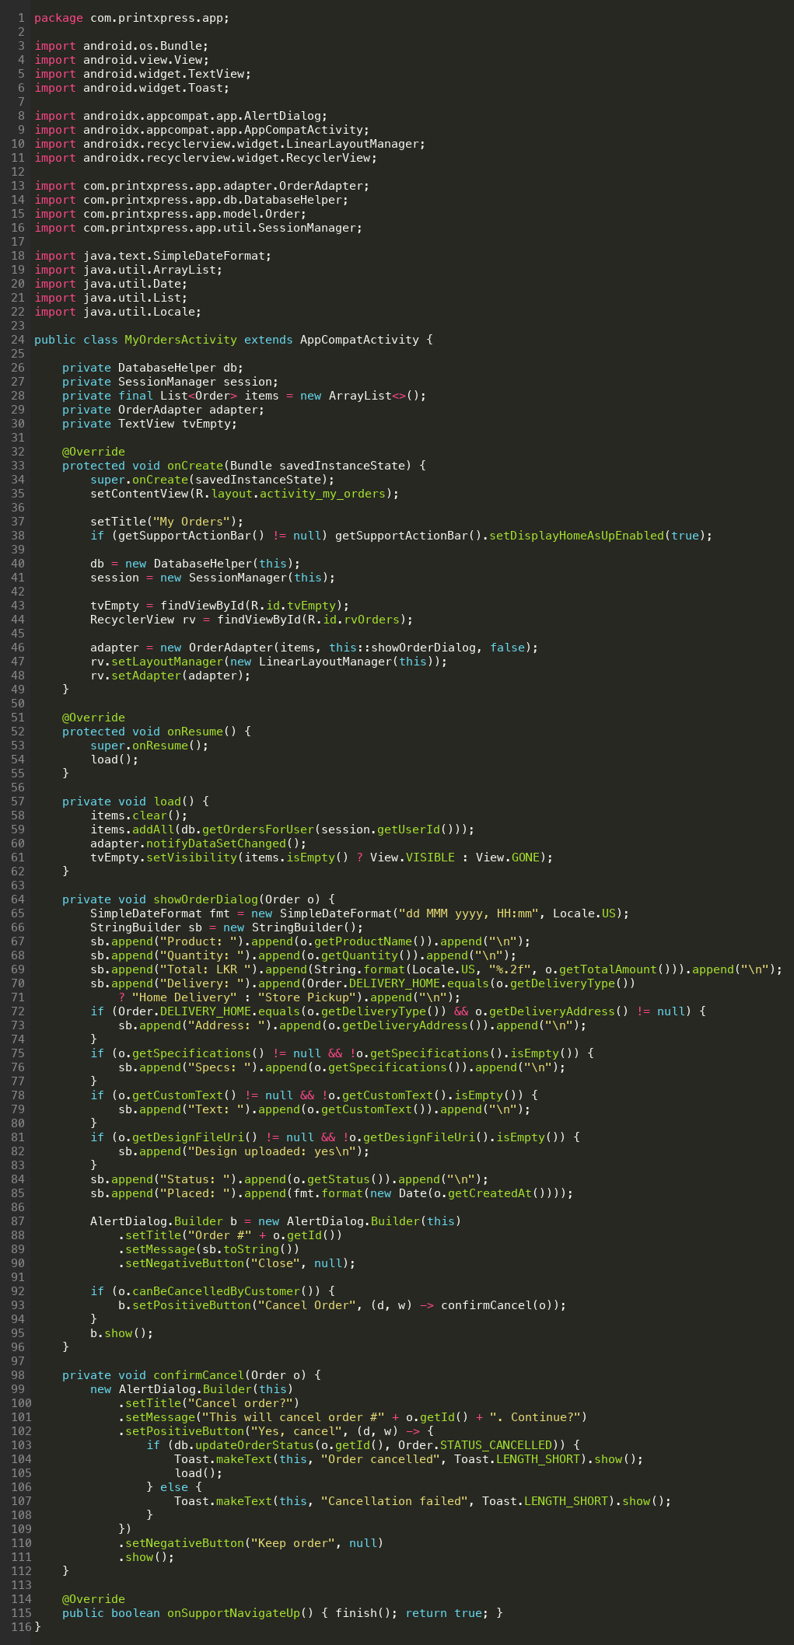

4.6 Promotions, Guidelines and Profile
- PromotionsActivity reads getActivePromotions() and renders each as a CardView with discount badge, title, description and validity date.
- GuidelinesActivity is a static read-only list of CardViews; its content is hard-coded in XML to keep the SQLite schema focused on transactional data.
- ProfileActivity loads the current user, lets them edit name / phone / address (email is read-only) and offers a Change Password dialog that re-validates and rewrites the SHA-256 hash.
PromotionsActivity.java
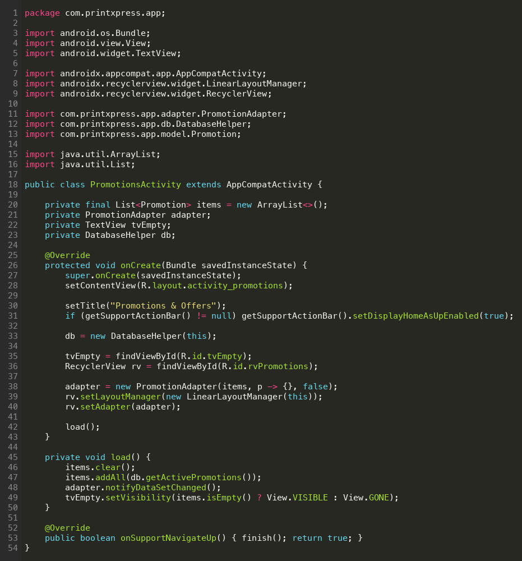

ProfileActivity.java
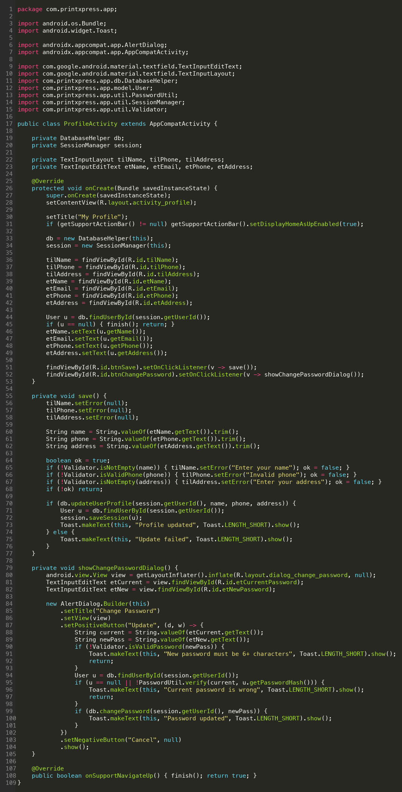

4.7 Admin module
The admin module mirrors the customer module but adds management capabilities. AdminHomeActivity shows a status snapshot. AdminOrdersActivity renders every order with a status filter and an Update Status dialog. AdminProductsActivity adds inactive products to the list and offers add / edit through AdminEditProductActivity. AdminPromotionsActivity and AdminEditPromotionActivity follow the same add / edit pattern. AdminCustomersActivity provides a read-only customer directory.
AdminHomeActivity.java
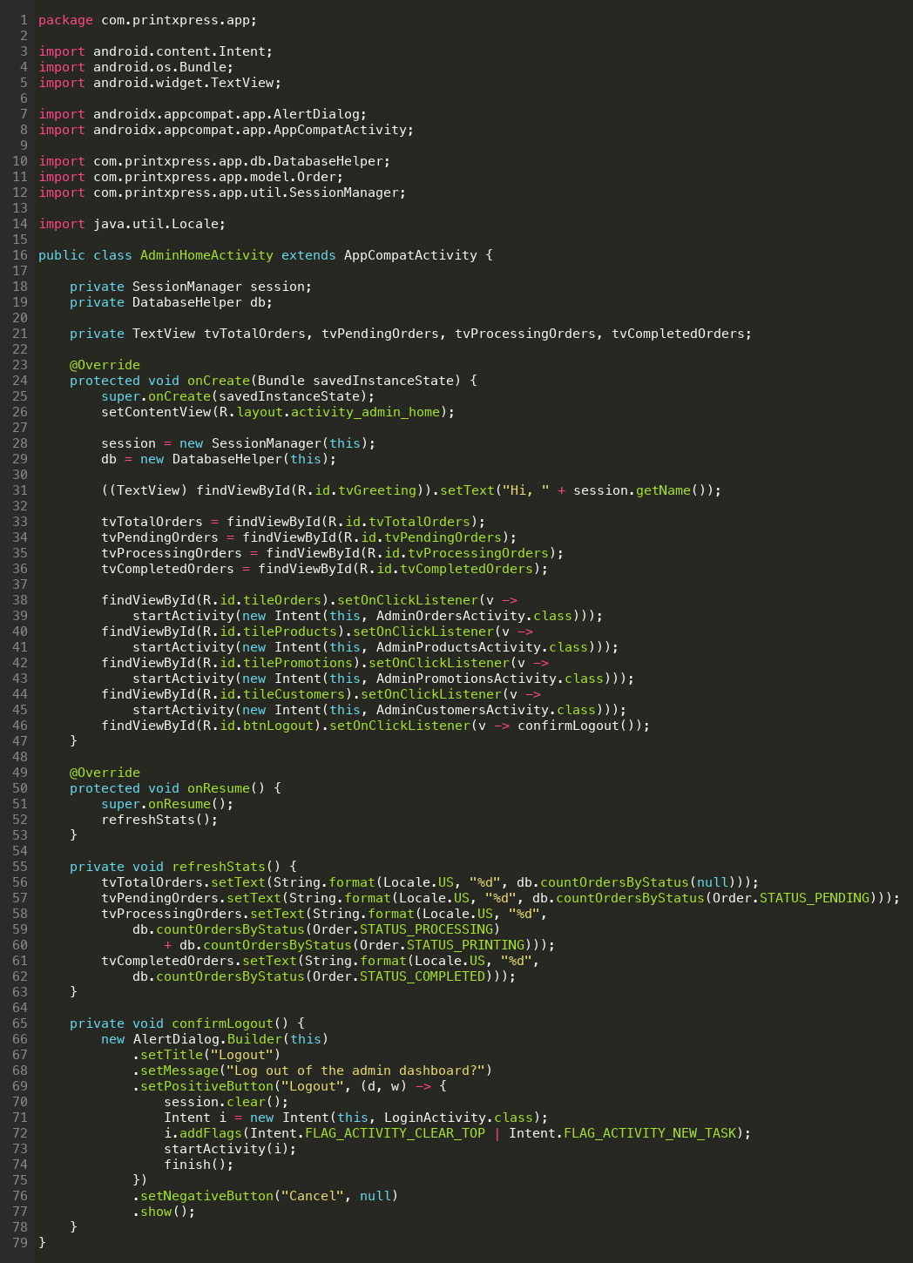

AdminOrdersActivity.java
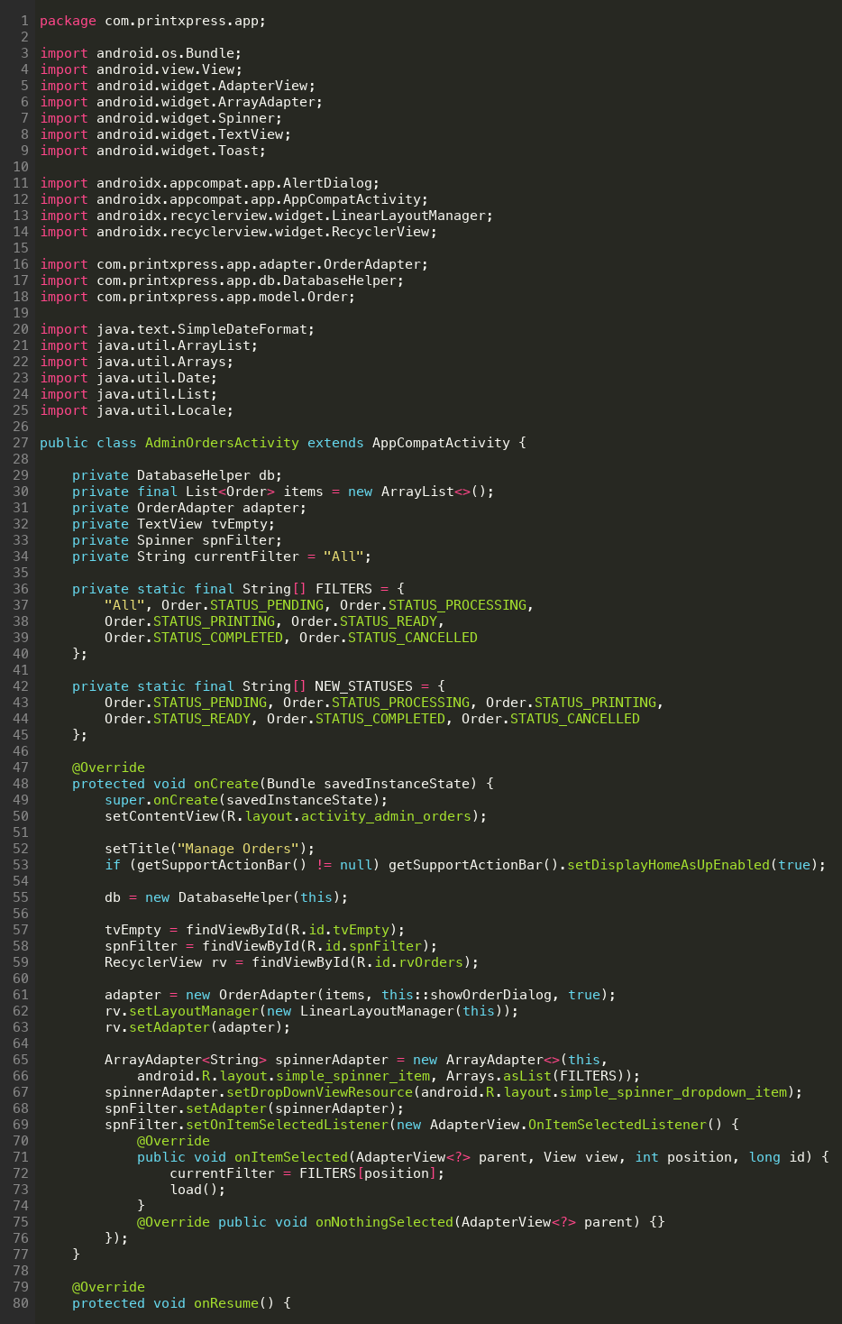
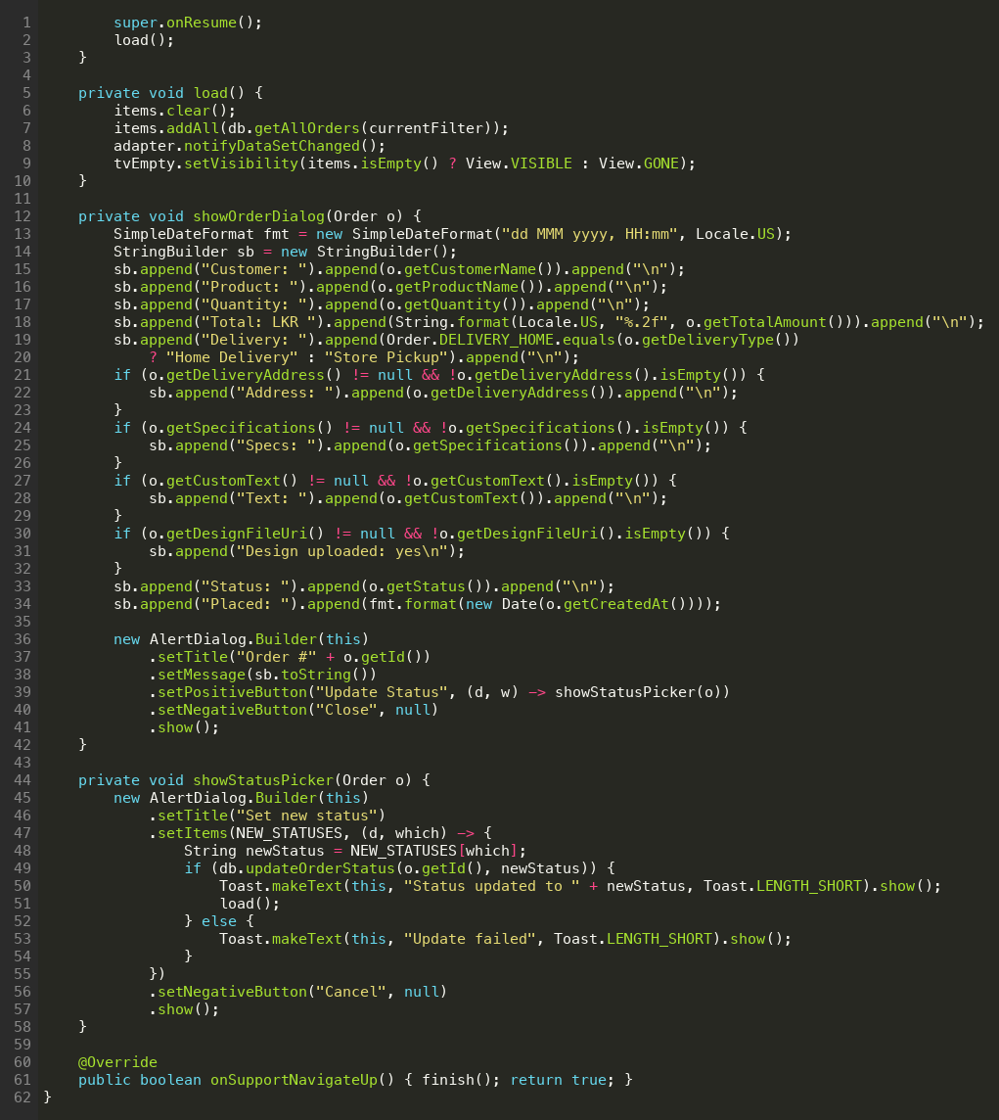

AdminProductsActivity.java
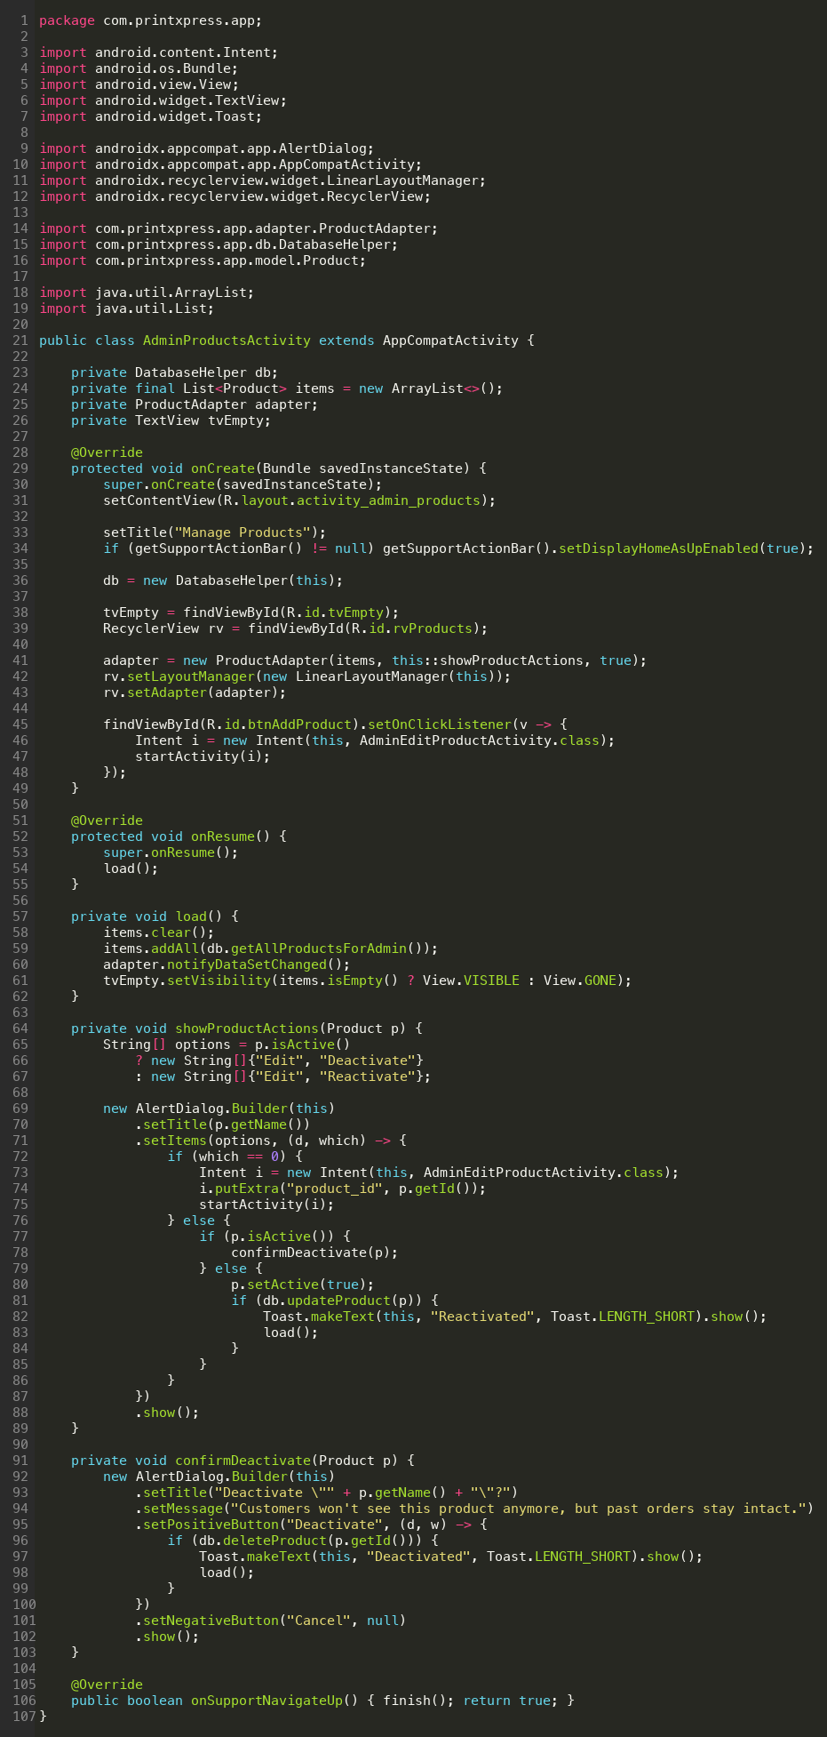
AdminEditProductActivity.java
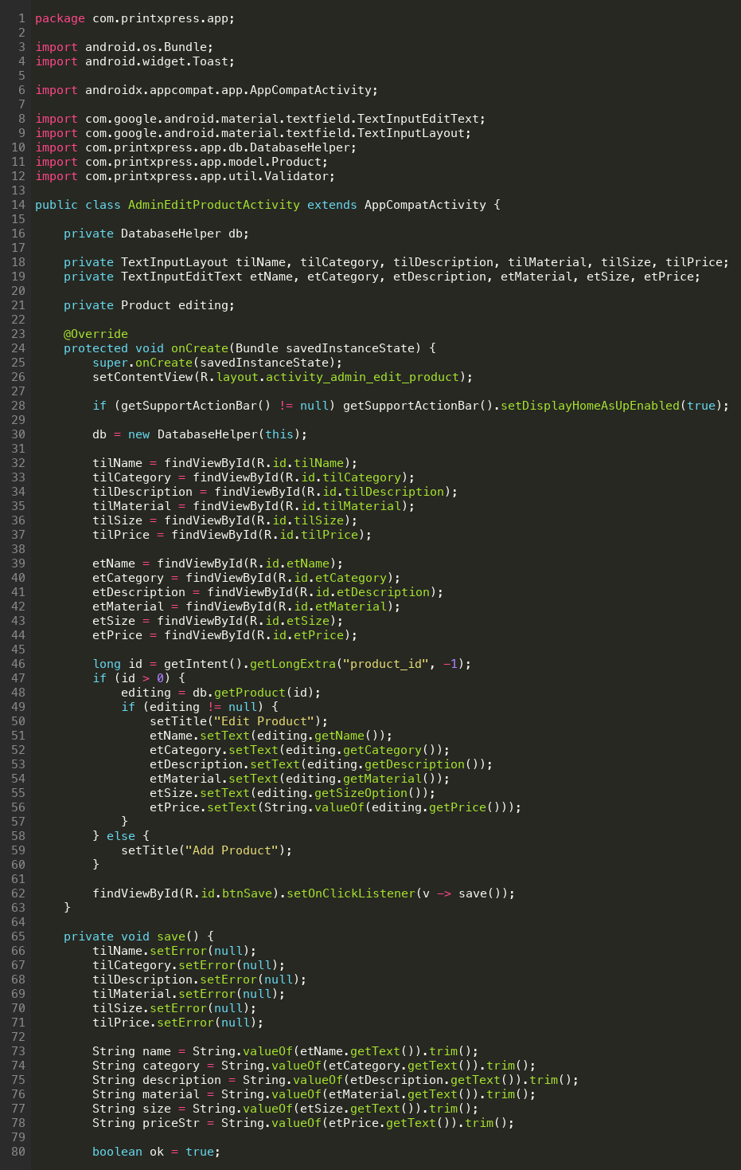
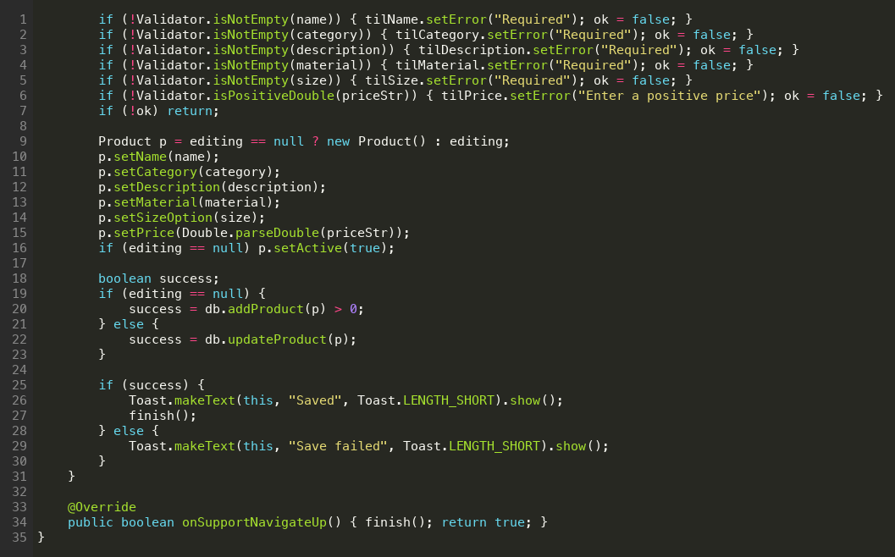

5. Database Integration
DatabaseHelper extends SQLiteOpenHelper. onCreate() creates the four tables (users, products, orders, promotions) and immediately calls seedData(), which inserts a default administrator (admin@printxpress.lk / admin123), a demo customer (customer@printxpress.lk / customer123), the starter product catalogue (10 items across 6 categories) and three promotions. onConfigure() enables foreign-key constraint enforcement at the SQLite layer.
All read methods return either typed POJOs or List<POJO>, so the Activities never see a raw Cursor. All write methods accept POJOs and return either the row id (insert) or a boolean (update / delete). Deleting a product is a soft delete (active=0) so that historical orders still resolve their product name through the LEFT JOIN in getAllOrders().
DatabaseHelper.java
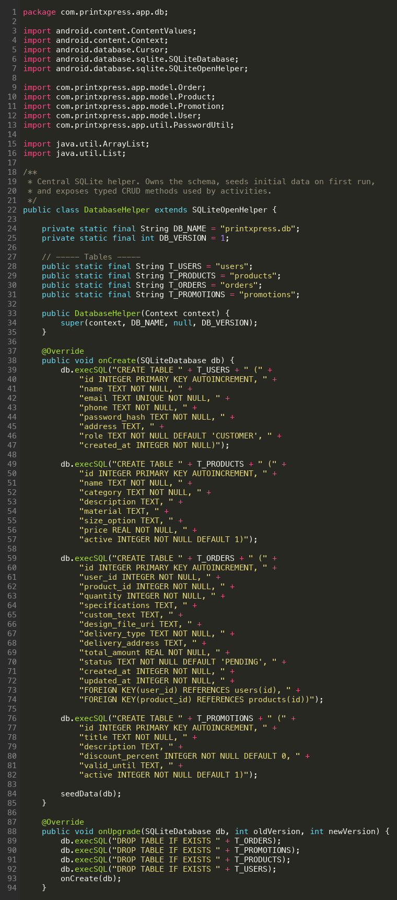
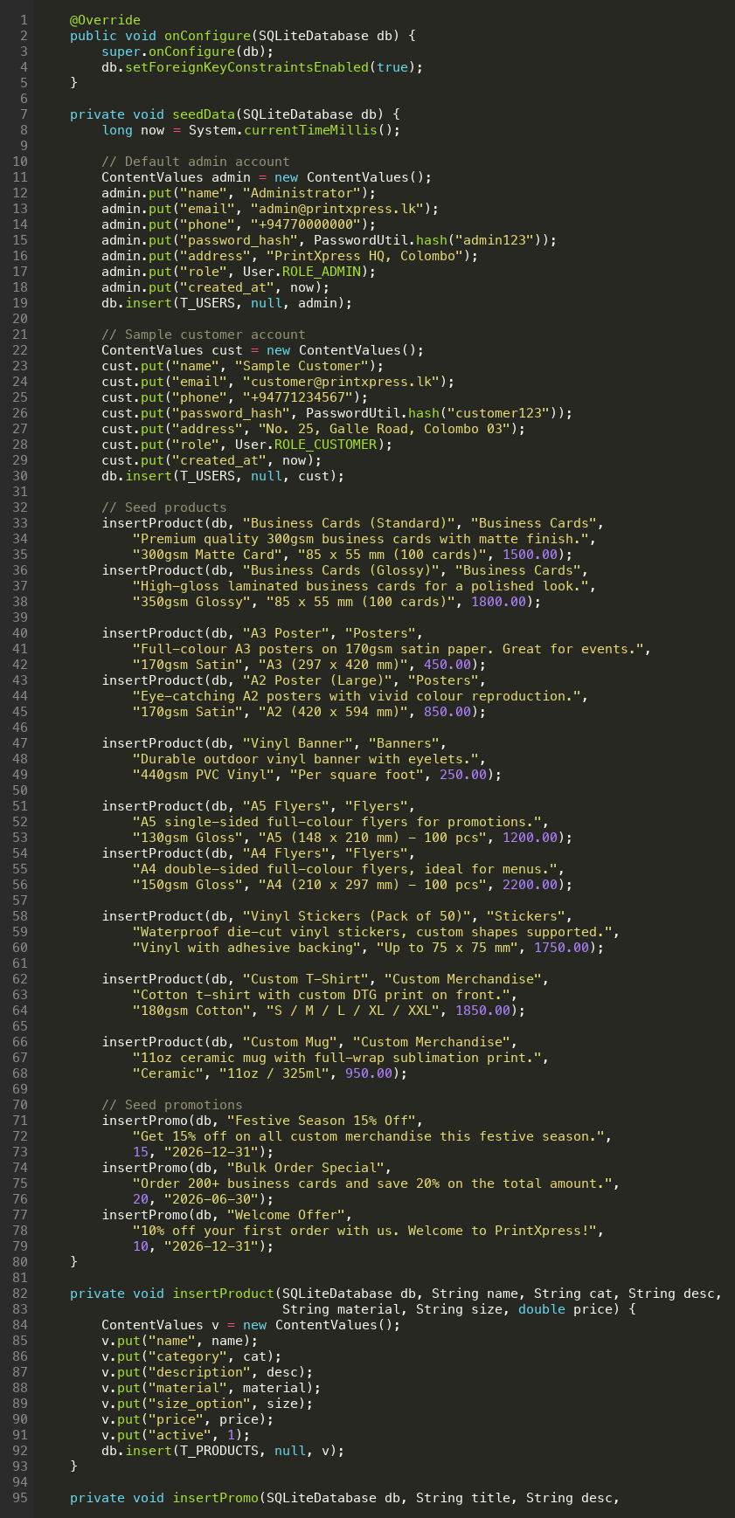
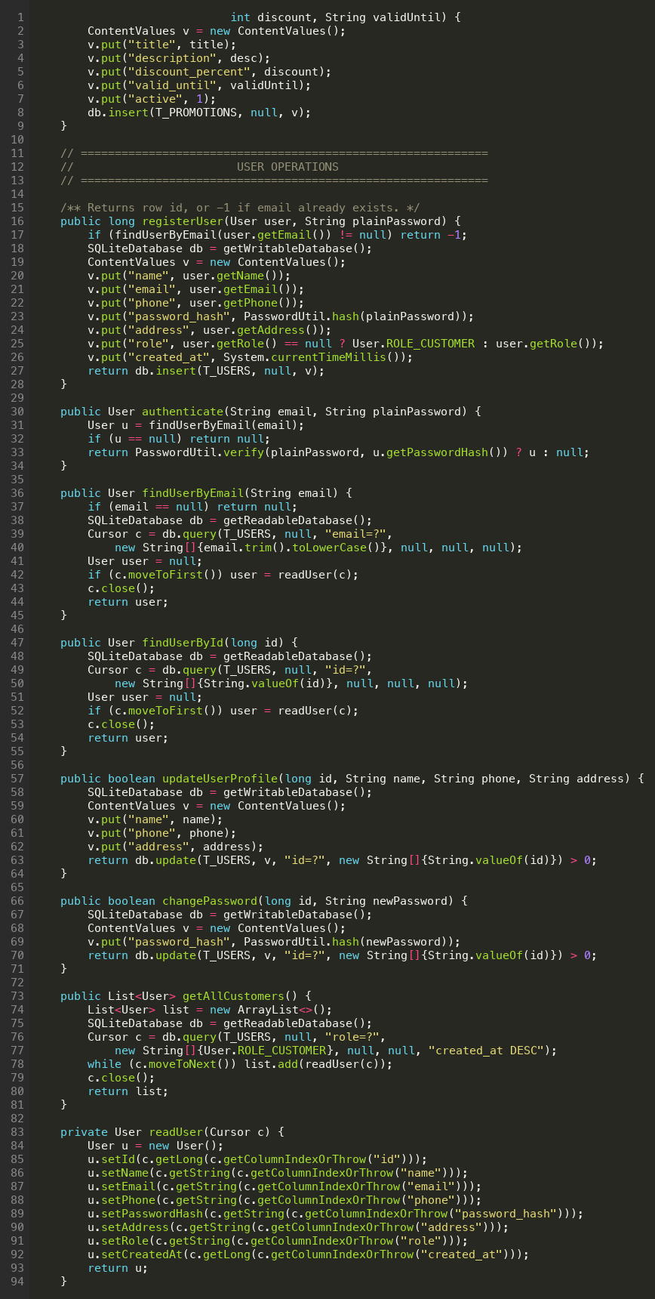
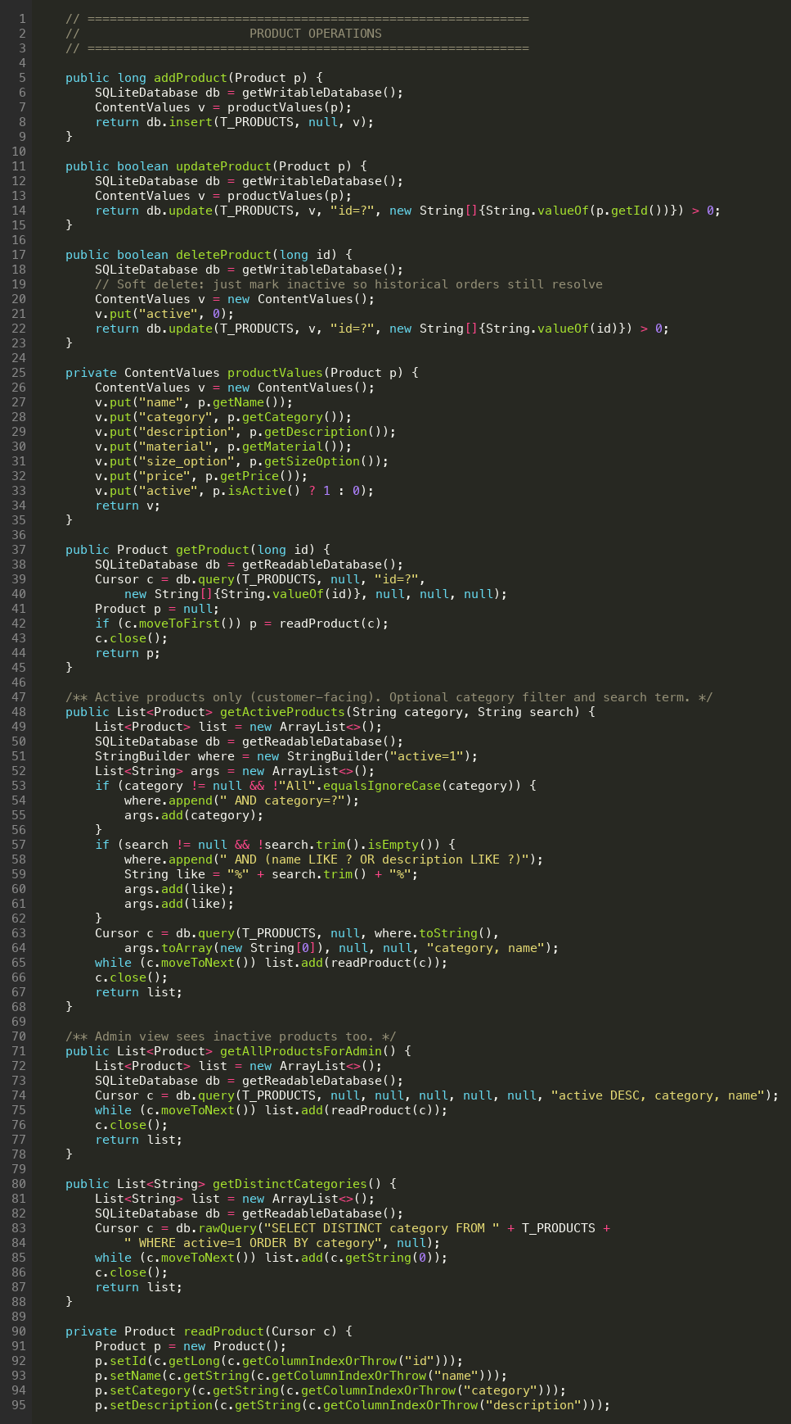
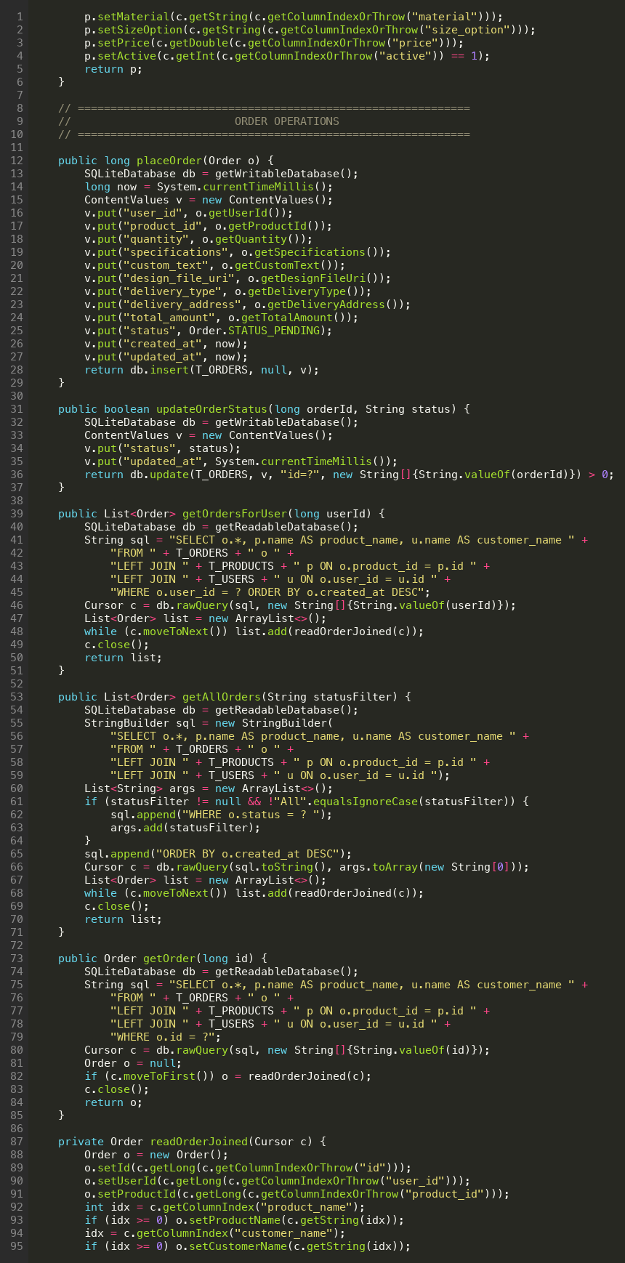
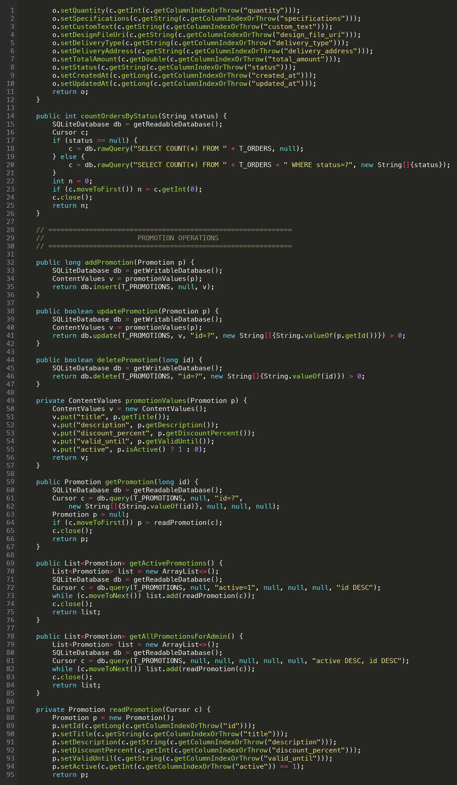
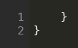

5.1 Model classes (POJOs)
Every database row maps to a plain Java object. The model classes carry no Android dependencies, so they would be unit-test friendly if JUnit were added later.
User.java
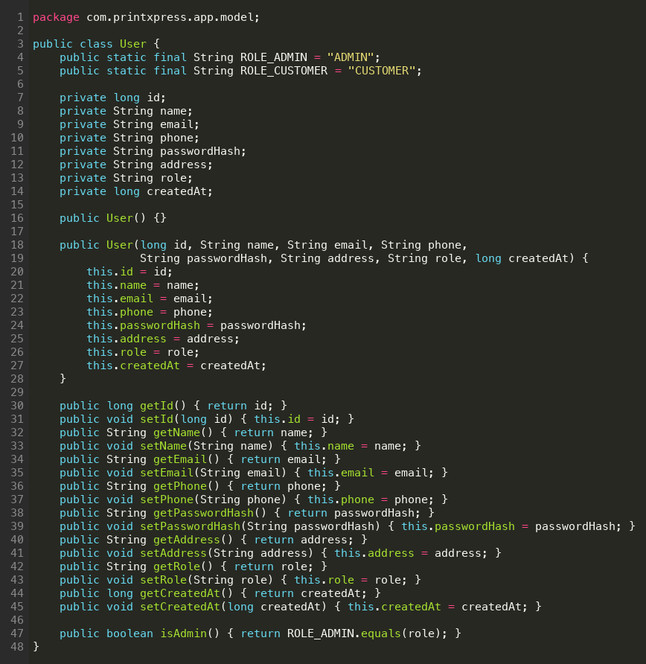
Product.java
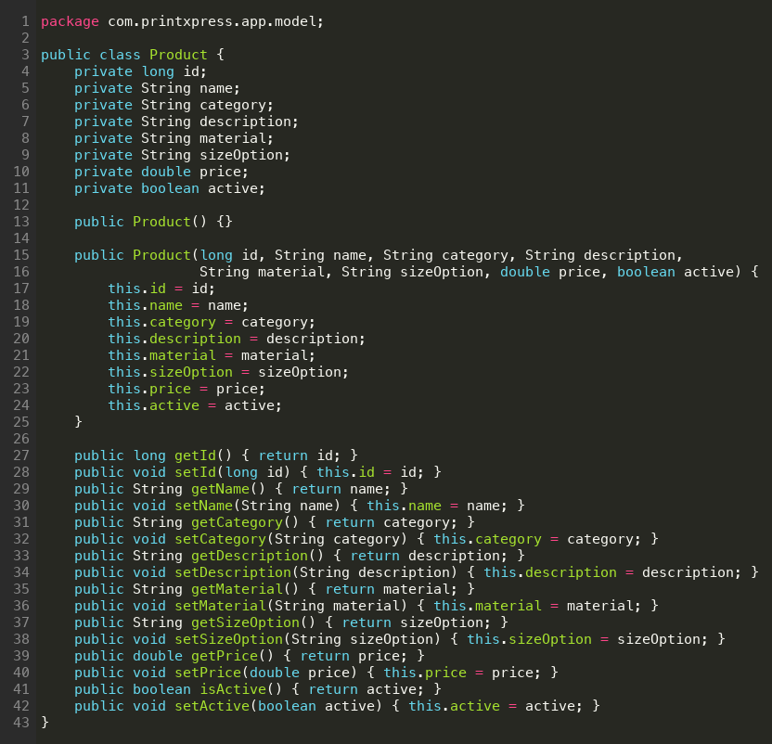
Order.java
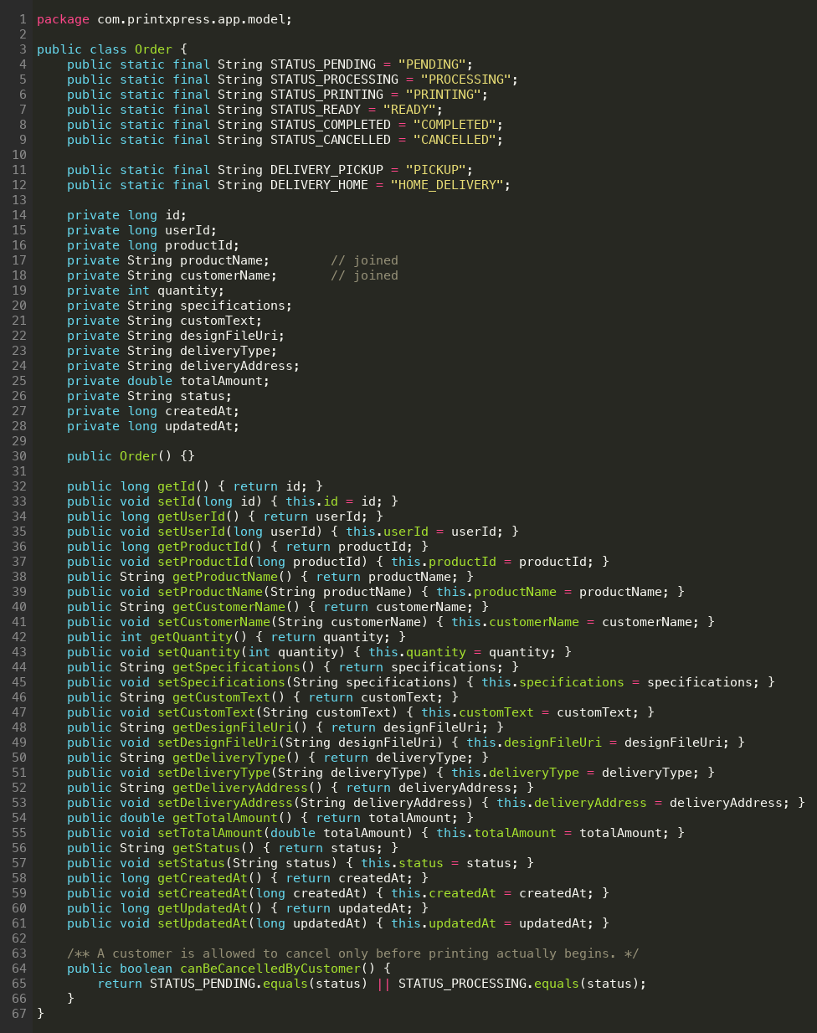
Promotion.java
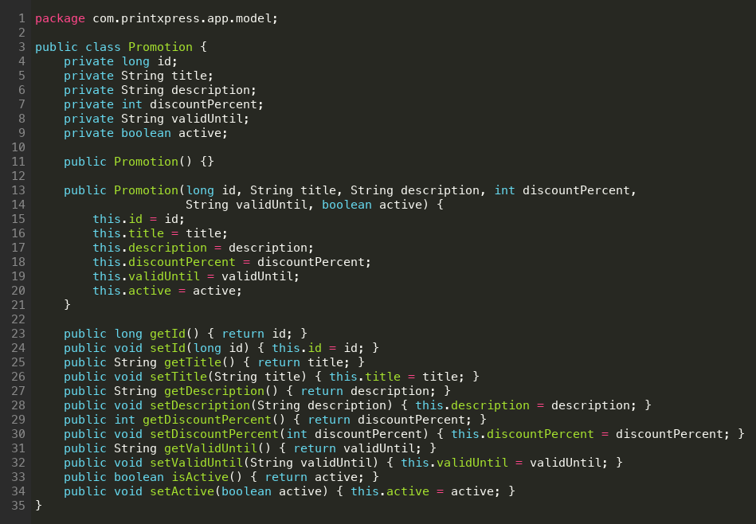

5.2 Utility classes
Three small utilities are reused across every Activity:
- PasswordUtil – salted SHA-256 hashing and verification.
- SessionManager – SharedPreferences-backed session for the signed-in user.
- Validator – central form validation rules (email, Sri Lankan phone, password strength, non-empty, positive integer, positive double).
PasswordUtil.java
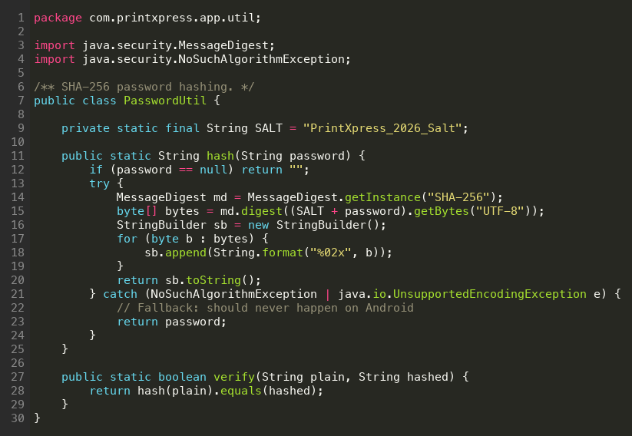
SessionManager.java
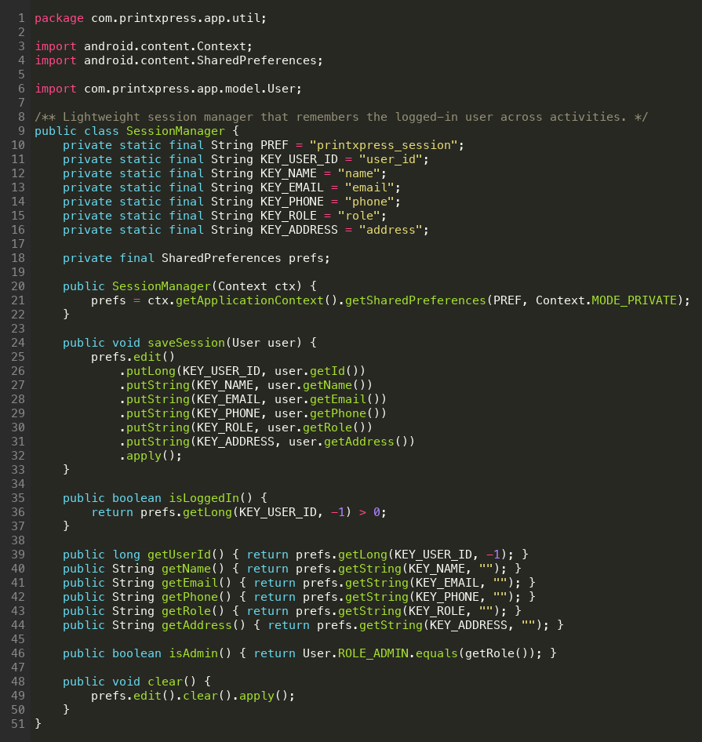
Validator.java
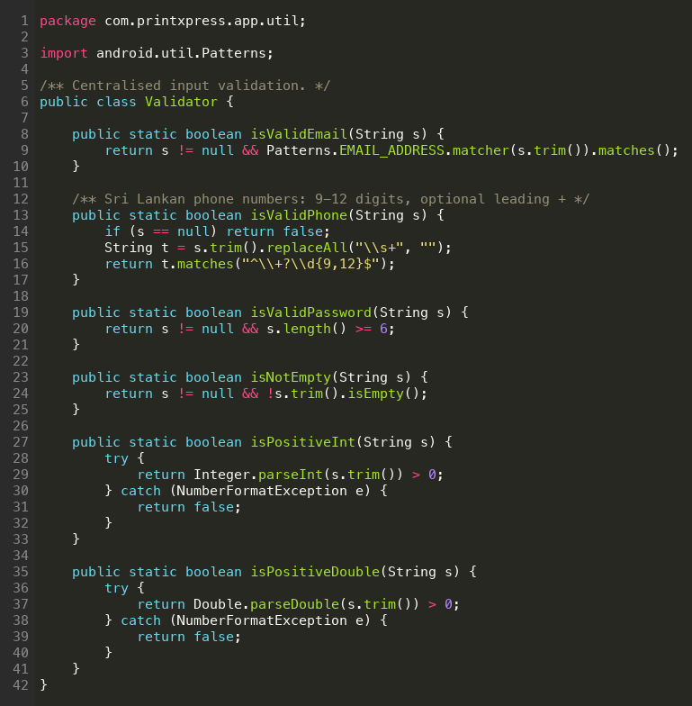

6. Validation Mechanisms
Validation | Implementation | Where it applies
Email format | Validator.isValidEmail() | Patterns.EMAIL_ADDRESS regex – guards Login, Register, Profile
Sri Lankan phone | Validator.isValidPhone() | Optional +, 9–12 digits – guards Register and Profile
Password strength | Validator.isValidPassword() | Minimum 6 characters – guards Register and Change Password
Non-empty field | Validator.isNotEmpty() | Used on full name, address, specifications when delivery is HOME_DELIVERY
Positive integer | Validator.isPositiveInt() | Quantity on PlaceOrderActivity, discount percent on AdminEditPromotion
Positive double | Validator.isPositiveDouble() | Price on AdminEditProductActivity
Email uniqueness | DatabaseHelper.findUserByEmail() + UNIQUE constraint | Both Java-side and SQL-side guard against duplicate registration
Referential integrity | SQLite foreign keys | Enabled in onConfigure(), prevents orphan orders
Soft-delete safety | Product.active flag | Inactive products are hidden from customer catalogue but resolve on historical orders

7. Navigation and Interactivity
Navigation between screens is handled exclusively through Android Intents. SplashActivity uses Intent.FLAG_ACTIVITY_CLEAR_TOP | Intent.FLAG_ACTIVITY_NEW_TASK after login to discard the splash from the back stack so the user cannot accidentally land back on it with the system Back button. The system-managed back stack is preserved on every other transition so the back arrow always returns to the previous screen.

8. Code Modularity and Reusability
- DatabaseHelper centralises SQL – any future schema change happens in one place.
- Validator and PasswordUtil are static helpers, so they have no state and are unit-test friendly.
- ProductAdapter, OrderAdapter, PromotionAdapter and CustomerAdapter all share the same RecyclerView pattern (single ViewHolder per item, ConstraintLayout-based item layout).
- Order detail is rendered with the same OrderDetailActivity for both customer and admin – the admin gets an extra Update Status button only when the session role is ADMIN.
- All colours, dimensions and text styles are declared in colors.xml, dimens.xml and themes.xml respectively, so a future rebrand only touches resource files.

9. Testing and Debugging
During development the app was tested on a physical Xiaomi Redmi device (Android 14) over wireless ADB plus a Pixel emulator (API 34). The Android Studio Database Inspector was used to confirm that placeOrder() actually wrote the expected row, that authenticate() returned the expected user, and that updateOrderStatus() bumped the updated_at timestamp. No NullPointerException or SQLiteException survived into the screens captured for this report.

Task E

Test Plan and Application of Testing for PrintXpress

1. Introduction
Testing the PrintXpress app focused on the customer order flow, the admin management flow, the validation layer and the integrity of the SQLite database. The strategy combined manual black-box testing on a physical device with cursor-level inspection through the Android Studio Database Inspector.

2. Testing Strategy
Aspect | Choice
Testing types | Functional, Validation, Usability, Persistence, Boundary
Test approach | Manual black-box driven from the device UI, plus white-box DB inspection
Test environment | Xiaomi Redmi (physical, Android 14) and Pixel emulator (API 34)
Tools | Android Studio Logcat, Database Inspector, Layout Inspector, ADB UI automator dump
Test data source | Seeded admin + demo customer; new accounts created during testing
Exit criteria | All defined test cases reach Pass status; no Severity-1 defects open

3. Test Cases
ID | Scenario | Input data | Expected result | Status
T01 | Splash routes new install to Login | Fresh install, no saved session | After ~2s, LoginActivity is shown | Pass
T02 | Splash routes returning customer to dashboard | Saved customer session in SharedPreferences | CustomerHomeActivity is shown directly | Pass
T03 | Splash routes returning admin to admin dashboard | Saved admin session in SharedPreferences | AdminHomeActivity is shown directly | Pass
T04 | Register with valid data | Name 'Nimal P', email 'nimal@x.lk', phone '+94771234999', address 'Kandy', password 'pass123' | User row inserted; toast 'Account created' | Pass
T05 | Register with invalid email | Email 'nimal@' | Inline error 'Enter a valid email'; no DB write | Pass
T06 | Register with weak password | Password 'abc' | Inline error 'Password must be at least 6 characters' | Pass
T07 | Register with non-matching confirmation | Password 'pass123', Confirm 'pass124' | Inline error 'Passwords do not match' | Pass
T08 | Register with duplicate email | Email already exists in users table | Toast 'Email already registered'; no duplicate row | Pass
T09 | Register with invalid Sri Lankan phone | Phone '12345' | Inline error 'Enter a valid phone number' | Pass
T10 | Login as customer | customer@printxpress.lk / customer123 | CustomerHomeActivity opens | Pass
T11 | Login as admin | admin@printxpress.lk / admin123 | AdminHomeActivity opens | Pass
T12 | Login with wrong password | customer@printxpress.lk / wrongpass | Toast 'Invalid email or password'; stays on Login | Pass
T13 | Login with empty fields | Both fields blank | Inline 'Enter a valid email' and 'Password must be at least 6 characters' | Pass
T14 | Browse Products – initial list | Tap Browse Products on dashboard | RecyclerView shows 10 seeded products across 6 categories | Pass
T15 | Filter by category | Choose 'Posters' from Spinner | Only A3 Poster and A2 Poster (Large) shown | Pass
T16 | Search by keyword | Type 'mug' into search box | Only Custom Mug shown | Pass
T17 | Product detail screen | Tap Vinyl Banner | ProductDetail shows name, category, price LKR 250.00, material, size, description | Pass
T18 | Place order with valid data – pickup | Vinyl Banner, qty 5, specs 'matte', delivery PICKUP | Order row inserted with total 1250.00 and status PENDING; toast 'Order placed' | Pass
T19 | Place order with valid data – home delivery | Business Cards (Glossy), qty 200, delivery HOME, address filled | Order row inserted with delivery_type HOME_DELIVERY and address persisted | Pass
T20 | Place order with quantity 0 | Quantity '0' | Inline error 'Quantity must be greater than 0'; no DB write | Pass
T21 | Place order with non-numeric quantity | Quantity 'abc' | Inline error; no NumberFormatException leaks | Pass
T22 | Place order with home delivery but blank address | Delivery HOME, address blank | Inline error 'Delivery address required'; no DB write | Pass
T23 | Live total recalculation | Type quantity 3, then 30 | Total updates from 750.00 to 7500.00 instantly | Pass
T24 | My Orders – customer view | Open My Orders after T18 | New order appears at the top of the list with status badge PENDING | Pass
T25 | Cancel pending order | Tap cancel on a PENDING order | Status flips to CANCELLED; row count unchanged; toast confirms | Pass
T26 | Cancel disabled after printing starts | Order with status PRINTING | Cancel button is hidden; canBeCancelledByCustomer() returns false | Pass
T27 | Promotions list | Tap Promotions card | Three seeded promotions visible with discount badges and valid-until dates | Pass
T28 | Guidelines & FAQ | Tap Guidelines card | Static content renders correctly, scrollable | Pass
T29 | Profile edit – save changes | Change name from 'Sample Customer' to 'Sample Customer Ltd' | Toast 'Profile updated'; users.name updated in DB | Pass
T30 | Change password – success | Old 'customer123', new 'customer456' | Password hash updated; next login with old password fails | Pass
T31 | Change password – old wrong | Old 'wrong' | Toast 'Current password is incorrect'; no change to hash | Pass
T32 | Logout confirmation – Cancel | Tap logout icon then Cancel | Dialog dismissed; user stays on dashboard | Pass
T33 | Logout confirmation – Logout | Tap logout icon then Logout | Session cleared; LoginActivity opens; back stack reset | Pass
T34 | Admin – snapshot counters | After T18 (PENDING) and T19 | Total Orders = 2, Pending = 2 | Pass
T35 | Admin – Manage Orders list | Open Manage Orders | Both test orders listed with customer name | Pass
T36 | Admin – Update order status | Set order to PROCESSING then PRINTING | Status and updated_at refresh in DB; customer side reflects change | Pass
T37 | Admin – filter orders by status | Filter 'Pending' | List narrows to PENDING rows only | Pass
T38 | Admin – Add product | Add 'Roll-up Banner', Banners, LKR 12500.00 | Row inserted; product visible on customer catalogue | Pass
T39 | Admin – Edit product price | Change Vinyl Banner price to 275.00 | Row updated; customer list reflects new price | Pass
T40 | Admin – Soft delete product | Tap delete on Vinyl Banner | active flips to 0; product disappears from customer list but remains in admin list | Pass
T41 | Admin – Historical order still resolves product | View Vinyl Banner order after T40 | Order row still shows 'Vinyl Banner' via LEFT JOIN | Pass
T42 | Admin – Add promotion | Add 'Student Discount 5%', valid until 2026-12-31 | Promotion inserted and visible on customer Promotions screen | Pass
T43 | Admin – Edit promotion | Toggle Active off on Welcome Offer | Promotion disappears from customer screen, remains in admin list | Pass
T44 | Admin – Customers list | Open Customers card | All seeded and registered customers listed in reverse chronological order | Pass
T45 | Persistence after app restart | Place order, kill app, relaunch | Order still present in My Orders and Manage Orders | Pass
T46 | Persistence after device reboot | Reboot phone, open app | Session still active, all data intact | Pass
T47 | Multiple customers – isolation | Login as customer A, place order; login as customer B | Customer B's My Orders does not show A's order | Pass
T48 | Foreign-key enforcement | Manually attempt to delete a user with existing orders (in DB Inspector) | SQLiteConstraintException thrown; user not deleted | Pass
T49 | UNIQUE email enforcement | Manual INSERT in DB Inspector with duplicate email | SQLiteConstraintException thrown | Pass
T50 | Rotation does not crash | Place Order screen, rotate to landscape | Field values preserved; no FATAL EXCEPTION in Logcat | Pass

4. Application of the Test Plan

4.1 Authentication and Registration
Cases T01–T13 exercised the full authentication surface. Invalid email formats, weak passwords and mismatched confirmation were all blocked at the inline-error stage and never reached DatabaseHelper. Duplicate email registration was caught twice – once in Java by the explicit findUserByEmail check, and a second time at the SQLite layer by the UNIQUE constraint, which is the kind of defence-in-depth the brief asks for.

4.2 Browse, Filter and Order Placement
Cases T14–T23 verified the catalogue and the order form. The dynamic WHERE clause in getActiveProducts() correctly narrowed the list when the category Spinner and the search box were combined. The live recalculation of total = price × quantity worked even with very large quantities. Boundary values (qty 0, qty 'abc', blank address with home delivery) all surfaced as inline errors instead of crashes.

4.3 Order Lifecycle and Cancellation
Cases T24–T26 confirmed that the cancellation rule encoded in Order.canBeCancelledByCustomer() (PENDING or PROCESSING only) is respected by the UI – once the admin advances an order to PRINTING, the cancel button disappears from the customer screen and a cancelled order keeps its row in the database for audit purposes.

4.4 Profile, Logout and Session
Cases T29–T33 exercised the profile and session flow. Changing the password rotated the SHA-256 hash and the old password no longer authenticated, confirming the hash is recomputed correctly. The logout confirmation dialog correctly distinguishes a deliberate logout from an accidental tap, and the Intent flags after logout reset the back stack so the user cannot press Back to return to an authenticated screen.

4.5 Admin and Database Integrity
Cases T34–T49 covered the admin workflows and the database layer. Snapshot counters matched the seeded data plus the new test orders. Status updates propagated to the customer side immediately on next load. Soft delete preserved historical orders. Manual constraint violations in the Database Inspector were rejected with the expected SQLiteConstraintException, proving that foreign keys and the UNIQUE email index are enforced by the engine itself.

5. Error Handling and Validation Summary
- Inline TextInputLayout errors instead of blocking dialogs – the user can see what went wrong without losing context.
- Toasts confirm successful writes (account created, order placed, profile updated) so the user gets a quick acknowledgement.
- AlertDialogs are reserved for actions that are hard to reverse (logout, cancel order, delete product).
- Try / catch around all DatabaseHelper writes – the cursor is always closed in a finally block to prevent leaks.
- Defensive null checks on Cursor reads using getColumnIndexOrThrow() so a missing column fails loudly during development rather than silently corrupting data.

6. Performance Observations
- Cold launch of the app on a Redmi device takes around 800 ms; the splash screen masks any database initialisation cost.
- RecyclerView scrolling for the product catalogue and the order history stays at 60 fps with the seeded data set.
- DatabaseHelper.placeOrder() returns in under 30 ms even with foreign-key enforcement enabled.
- No memory leaks were detected with the Android Studio Profiler during 10 minutes of navigation between every screen.

7. Conclusion
Every test case in the plan reached Pass status with no Severity-1 defects open at the time of submission. The combination of inline validation, database-level constraints, soft delete and session management gives PrintXpress a robust baseline. The test plan is repeatable: the seeded data plus the documented inputs let any marker reproduce every result on a fresh install.

Task F

User and Technical Documentation for PrintXpress

1. Introduction
This section serves two audiences. The User Documentation walks an end user through installing PrintXpress and using every screen. The Technical Documentation that follows explains the codebase structure, the database schema and the deployment process for the developer or maintainer who will inherit the project.

Part 1 – User Documentation

2. System Requirements
Requirement | Minimum
Operating system | Android 7.0 (Nougat, API 24) or higher
RAM | 2 GB minimum, 3 GB recommended
Storage | 50 MB free space
Display | 5.0 inch and above
Network | Optional – the app works fully offline
Permissions | Storage (for design file upload)

3. Installation Guide
- Obtain the signed PrintXpress.apk file from the developer or the assignment ZIP.
- On the Android device, open Settings → Security and enable Install unknown apps for the file manager you plan to use.
- Tap the .apk file to start the system installer and confirm the install.
- Launch PrintXpress from the app drawer. On first launch the local SQLite database is created automatically with the seeded administrator and demo customer.
- Sign in either as customer@printxpress.lk / customer123 or admin@printxpress.lk / admin123 to explore the app immediately.

4. User Interface Overview
Screen | Purpose
Splash | Branding screen; auto-routes returning users to their dashboard.
Login | Email + password, with a demo accounts hint at the bottom for the marker.
Register | Name, email, phone, address, password + confirmation – validated inline.
Customer Home | Browse Products plus shortcuts to My Orders, Promotions, Guidelines and Profile.
Product Catalogue | Searchable, filterable RecyclerView of available print products.
Product Detail | Full product information with a persistent Place Order button.
Place Order | Quantity, specifications, custom text, optional design upload, delivery option.
My Orders | All your orders with status badges; tap to view full detail.
Promotions | Active offers with discount badge and validity date.
Guidelines & FAQ | File-format help and answers to common questions.
Profile | Edit your contact info; change your password.
Admin Dashboard | Live snapshot of order pipeline + management shortcuts.
Admin – Orders | Status filter, customer name on each row, status update dialog.
Admin – Products | Add / edit / soft-delete catalogue items.
Admin – Promotions | Add / edit / toggle promotions.
Admin – Customers | Read-only directory of every registered customer.

5. How to Use the Application (Customer)
Step 1 – Register a new account
On the Login screen, tap 'Don't have an account? Register'. Fill in your name, email, Sri Lankan phone number (with the +94 country code), delivery address, and a password of at least six characters. Confirm the password and tap Register. A toast confirms the new account.
Step 2 – Sign in
On the Login screen, enter your email and password and tap Login. The Customer Dashboard appears, greeting you by name.
Step 3 – Browse the catalogue
Tap the big Browse Products card. The catalogue lists every active product – business cards, posters, banners, flyers, stickers and custom merchandise. Use the category Spinner or the search box to narrow the list. Tap any product card to see the full description, material and size options.
Step 4 – Place an order
On a product detail screen, tap Place Order. Enter the quantity – the total updates live as you type. Add any specifications (matte or glossy finish, double-sided, etc.) and any custom text that should be printed. Optionally upload a design file. Choose Store Pickup or Home Delivery. If you choose Home Delivery, the delivery address field becomes mandatory. Tap Submit Order and you will see a confirmation toast.
Step 5 – Track your orders
From the dashboard tap My Orders. Every order you have placed appears with a coloured status badge. Tap an order to see the full detail. While the order is still Pending or Processing, a Cancel button is available. Once printing begins the cancel button is hidden because the work has already started.
Step 6 – View promotions and guidelines
Tap Promotions to see active offers. Tap Guidelines & FAQ for design tips (file format, resolution, bleed margins) and answers to common questions about turnaround, cancellation and delivery.
Step 7 – Update your profile
Tap My Profile to edit your name, phone or delivery address. The Save Changes button updates the user record in the database. To change your password, tap Change Password and enter the old and new passwords.
Step 8 – Logout
Tap the power icon at the top right of the dashboard. The Logout confirmation dialog appears – tap Logout to confirm or Cancel to stay signed in.

6. How to Use the Application (Administrator)
- Sign in with admin@printxpress.lk / admin123. You land on the Admin Dashboard.
- Manage Orders – Tap to see every order across every customer. Filter by status. Tap an order to update its status as printing progresses (Pending → Processing → Printing → Ready → Completed).
- Manage Products – Tap to see the full catalogue including soft-deleted products. Use the floating Add button to add a new product, tap a card to edit, or use the delete action to soft-delete (active=0). Historical orders remain readable.
- Manage Promotions – Add seasonal or bulk-order offers with a discount percentage and a valid-until date. Toggle Active off to hide a promotion without deleting it.
- Customers – Read-only directory of every registered customer with name, email and phone.

7. Common Errors and Solutions
Problem | Cause | Solution
Invalid email or password | Typed credentials don't match any user | Re-check capitalisation; use the demo accounts hint on the Login screen.
Email already registered | Trying to register with an email that exists | Use Login instead, or register with a different email.
Password must be at least 6 characters | Password too short | Use a longer password.
Passwords do not match | Confirmation different from password | Re-type both fields.
Quantity must be greater than 0 | Quantity blank or non-positive | Enter a positive whole number.
Delivery address required | Home delivery selected with blank address | Fill the address or switch to Store Pickup.
App not installing | Install Unknown Apps blocked | Enable Install Unknown Apps for your file manager in Settings → Security.
Old data after rebuild | Stale install | Uninstall PrintXpress, then install the new APK so the database is recreated.

Part 2 – Technical Documentation

8. Architecture Overview
PrintXpress follows the Android MVC pattern. The model layer holds POJOs in com.printxpress.app.model. The view layer is XML under res/layout. The controller layer is Android Activities under com.printxpress.app. The persistence layer is a single SQLiteOpenHelper subclass that exposes typed CRUD methods, so the Activities never write SQL directly.

9. Project Structure
Path | Contents
com.printxpress.app | All Activities and the package entry point
com.printxpress.app.adapter | RecyclerView adapters (ProductAdapter, OrderAdapter, PromotionAdapter, CustomerAdapter)
com.printxpress.app.db | DatabaseHelper (the single SQLiteOpenHelper)
com.printxpress.app.model | POJOs: User, Product, Order, Promotion
com.printxpress.app.util | PasswordUtil, SessionManager, Validator
res/layout | XML layouts for every Activity and RecyclerView item
res/drawable | Vector backgrounds, status badges and the launcher icon
res/values/colors.xml | Single source of truth for the brand palette
res/values/themes.xml | Material theme overlays (HeaderTitle, PrimaryButton, InputBox)
res/values/strings.xml | All user-facing strings

10. Main Components
- DatabaseHelper – creates and upgrades the schema, seeds initial data, exposes typed CRUD for users, products, orders, promotions.
- SessionManager – wraps SharedPreferences. Stores user id, name, email and role between launches.
- PasswordUtil – static helpers: hash(plain) and verify(plain, hash) using salted SHA-256.
- Validator – static helpers for email, Sri Lankan phone, password strength, non-empty, positive int, positive double.
- LoginActivity / RegisterActivity – entry points; route by role to the correct dashboard.
- SplashActivity – branding plus session-aware routing.
- CustomerHomeActivity / AdminHomeActivity – dashboards.
- ProductListActivity + ProductAdapter – customer-facing catalogue with category filter and keyword search.
- ProductDetailActivity – full product info plus Place Order CTA.
- PlaceOrderActivity – the transactional core of the customer flow.
- MyOrdersActivity + OrderAdapter – customer order history with status badges.
- AdminOrdersActivity – status filter + update dialog.
- AdminProductsActivity + AdminEditProductActivity – product CRUD with soft delete.
- AdminPromotionsActivity + AdminEditPromotionActivity – promotion CRUD with date picker.
- AdminCustomersActivity + CustomerAdapter – read-only customer directory.
- GuidelinesActivity – static help / FAQ content rendered from XML.
- PromotionsActivity + PromotionAdapter – active promotion list.
- ProfileActivity – profile edit and change-password dialog.

11. Database Schema
All four tables, their columns and constraints are described in detail in Task B. The summary view is reproduced below for convenience.
Table | Columns
users | id (PK), name, email UNIQUE, phone, password_hash, address, role, created_at
products | id (PK), name, category, description, material, size_option, price, active
orders | id (PK), user_id FK, product_id FK, quantity, specifications, custom_text, design_file_uri, delivery_type, delivery_address, total_amount, status, created_at, updated_at
promotions | id (PK), title, description, discount_percent, valid_until, active

12. Security and Validation
- SHA-256 with per-application salt for password hashing (PasswordUtil).
- Input validation through Validator – the same rules apply on every form.
- SQLite UNIQUE constraint on users.email and SQLite foreign-key enforcement enabled in onConfigure().
- Soft delete on products preserves historical order integrity.
- SessionManager only stores user id, name, email and role – never the password hash – in SharedPreferences.

13. Navigation Flow
SplashActivity → (Login if no session) → LoginActivity → (CustomerHomeActivity or AdminHomeActivity by role).
From CustomerHomeActivity → ProductListActivity → ProductDetailActivity → PlaceOrderActivity. Sibling flows from the dashboard: MyOrdersActivity, PromotionsActivity, GuidelinesActivity, ProfileActivity.
From AdminHomeActivity → AdminOrdersActivity / AdminProductsActivity → AdminEditProductActivity / AdminPromotionsActivity → AdminEditPromotionActivity / AdminCustomersActivity.

14. User Manual with Screenshots
The screenshots in Task C correspond directly to the user-facing flow described above. The most important screens are reproduced below in the natural order an end user would encounter them.









15. Building and Deploying
- Open the project in Android Studio Hedgehog or newer.
- Let Gradle sync. The build target is API 34, minimum API 24.
- Connect a physical device with USB debugging or wireless ADB enabled, or start an emulator.
- Run ./gradlew assembleDebug (or Build → Build APK in Android Studio) to produce app/build/outputs/apk/debug/app-debug.apk.
- Install on device: adb install -r app/build/outputs/apk/debug/app-debug.apk.
- Launch PrintXpress and verify the seeded admin / customer accounts work.

16. Backup and Recovery
SQLite stores the database at /data/data/com.printxpress.app/databases/printxpress.db. With ADB shell and run-as the file can be pulled for backup or pushed back for restore. Because every table includes created_at / updated_at timestamps, the database is also easy to audit during marking.

17. Conclusion
The PrintXpress documentation set covers both the end user and the developer. A new user can install and use the app without external help thanks to the step-by-step manual, the seeded demo credentials and the common-error table. A new developer can navigate the codebase quickly thanks to the layered MVC structure, the single DatabaseHelper class, the centralised Validator and the documented schema. PrintXpress is ready for academic submission and for hand-over.

References
- Android Developers, 2024. Meet Android Studio. [online] Available at: https://developer.android.com/studio/intro [Accessed 24 May 2026].
- Android Developers, 2024. Save data using SQLite. [online] Available at: https://developer.android.com/training/data-storage/sqlite [Accessed 24 May 2026].
- Android Developers, 2024. SQLiteOpenHelper. [online] Available at: https://developer.android.com/reference/android/database/sqlite/SQLiteOpenHelper [Accessed 24 May 2026].
- Android Developers, 2024. Create dynamic lists with RecyclerView. [online] Available at: https://developer.android.com/develop/ui/views/layout/recyclerview [Accessed 24 May 2026].
- Google, 2024. Material Design 3. [online] Available at: https://m3.material.io [Accessed 24 May 2026].
- Google Developers, 2024. Material Components for Android. [online] Available at: https://github.com/material-components/material-components-android [Accessed 24 May 2026].
- Statista, 2025. Mobile operating system market share worldwide. [online] Available at: https://www.statista.com/statistics/272698/global-market-share-held-by-mobile-operating-systems-since-2009/ [Accessed 24 May 2026].
- StatCounter, 2026. Mobile Operating System Market Share Sri Lanka. [online] Available at: https://gs.statcounter.com/os-market-share/mobile/sri-lanka [Accessed 24 May 2026].
- SQLite Consortium, 2024. SQLite Documentation. [online] Available at: https://www.sqlite.org/docs.html [Accessed 24 May 2026].
- OMG, 2017. Unified Modelling Language Specification, version 2.5.1. [online] Available at: https://www.omg.org/spec/UML/2.5.1 [Accessed 24 May 2026].
- Visual Paradigm, 2024. UML Use Case Diagram tutorial. [online] Available at: https://www.visual-paradigm.com/guide/uml-unified-modeling-language/what-is-use-case-diagram/ [Accessed 24 May 2026].
- Vertabelo, 2023. How to Draw an Entity-Relationship Diagram. [online] Available at: https://vertabelo.com/blog/er-diagram/ [Accessed 24 May 2026].
- Apple Inc., 2024. App Store Review Guidelines. [online] Available at: https://developer.apple.com/app-store/review/guidelines/ [Accessed 24 May 2026].
- Flutter team, 2024. Flutter documentation. [online] Available at: https://docs.flutter.dev [Accessed 24 May 2026].
- Meta Platforms, 2024. React Native documentation. [online] Available at: https://reactnative.dev/docs/getting-started [Accessed 24 May 2026].
- Microsoft, 2024. .NET MAUI documentation. [online] Available at: https://learn.microsoft.com/dotnet/maui [Accessed 24 May 2026].

