Queries: **Date: 27/7/2021**

1. In Kentico, Page type field name should have the format **<page type code name>_<field name>**. The underscore ( _ ) is optional. This is to avoid any kind of DB related error when using the Kentico’s export/import feature.  
   Should we keep the field names following the above format?

**CT: Yes please do. I am not familiar with any consequences of the above. I would trust your expert opinion on this.  
Citytech: Thank you**

There is no such hard and fast rule mentioned in Kentico 13 documentation regarding the above. However, we see Kentico following the same for most of its internal tables.

For example: CMS_Tree, CMS_Document, CMS_User, CMS_UserSettings etc.

With reference to **ERB_EXTRANET_SPECIFICATIONS_V0.1.xlsx**

1. Sheet: FIELDS – COMMON Row: 4  
   **Application Type** value is to be filled from DDL also must have field size 40.  
   What should we store in value text / code / node GUID?  
   Currently we are storing node GUID of selected DDL item.
2. Sheet: FIELDS – COMMON Row: 7  
   **Responsible Banking Center** is to be filled from DDL and have field size as per list selection.  
   What should we store in value text / code / node GUID?  
   Currently we are storing node GUID of selected DDL item.

In the above two fields we select the value from a DDL then why one field has a field length predefined that we must follow?

**CT: All DDLs will have their:**

**GUID [this is your internal unique identifier]**

**VALUE [this is the value we display to the end users]**

**CODE [This is the code expected by the 3rd party systems)**

**In the XML export, we need to export VALUE and CODE (if applicable else NULL).**

**Citytech: Understood**

1. Some DDL items may have Code set for bank reference or use. What are the limitations for the code pattern?  
   *For example:*
   1. *Code size must not be more than 40.*
   2. *Code must be alphanumeric only.*

**CT: Yes. Please set above constraints for DDLs.   
Citytech: Ok**

1. **DocumentCreatedByUserID** – Kentico field to be used to store the user id of the creator.  
   **CreatedBy** – Text 255 field to store the creator’s name.  
   **CreatedOn** – Maps to Kentico field **DocumentCreatedWhen**  
   **CT: Correct.**
2. **DocumentModifiedByUserID** – Kentico field to be used to store the user id of the last modifier.  
   **LastModifiedBy** – Text 255 field to store the last modifier’s name.  
   **LastModifiedOn** – Maps to Kentico field **DocumentModifiedWhen**  
   **CT: Correct.**
3. **SubmittedBy** – Text 255 field to store the submitter’s name.  
   **SubmittedOn** – DateTime field to store the application submission date time.  
   Should we store submitter user id also in a field?  
   **CT: Correct.**

**Citytech: Ok**

1. Sheet: FIELDS – COMMON Row: 19  
   **Reason for opening the account** on additional requirements it is said that “*we need to save both ID and Value*”.  
   Please explain the requirement to save both. Should we create a new column to save the value?  
   Currently we are storing node GUID of selected DDL item.

**CT: Correct.**

**SOS NOTE**

**CT: All DDLs will have their:**

**GUID [this is your internal unique identifier]**

**VALUE [this is the value we display to the end users]**

**CODE [This is the code expected by the 3rd party systems)**

**In the XML export, we need to export VALUE and CODE (if applicable else NULL).**

**Citytech: Understood**

**Date: 29/7/2021**

1. Person Registry

Please share entry screen popup for this page.

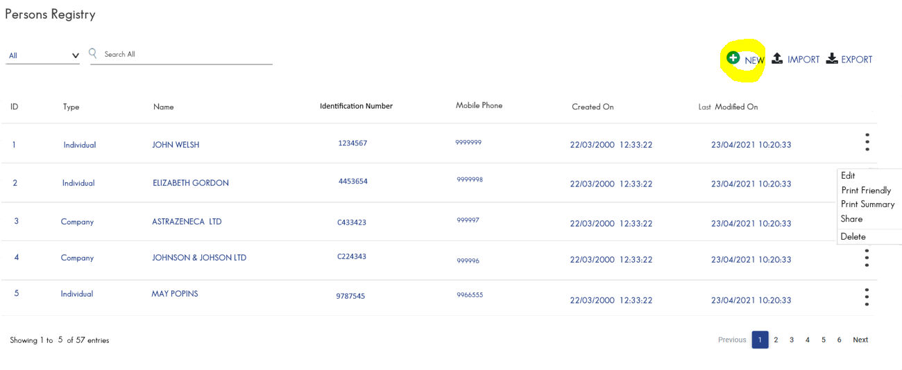

**CT: When a user clicks on the new button, we can do show a drop down to select:**

* **Physical Person**
* **Legal Person**

**Do we need to consider below screen?**

**CT: YES for Physical Person. We need the respective ones for the Legal Person.**

|  |  |  |
| --- | --- | --- |
|  |  |  |

1. Sheet: FIELDS – COMMON Row: 45  
   **Origin of Annual Income** DDL values?

**CT: For all DDL, add 3 dummy ones. E.g. for Origins of Annual Income add**

**ORIGIN 1**

**ORIGIN 2**

**ORIGIN 3**

1. Sheet: FIELDS-INDIVIDUAL Row: 28  
   **Nature of Business** field length is 5000 characters. Kentico supports a maximum of 4000 characters. In the front-end design image this field is shown as text box, which is not the correct control for a 5000-character field. Please check and confirm field length.

**CT: They indeed set it for 5000. Please limit it to 4000 and we will inform them. The same goes for field “Former Nature of Business”**

