**Block Diagram**

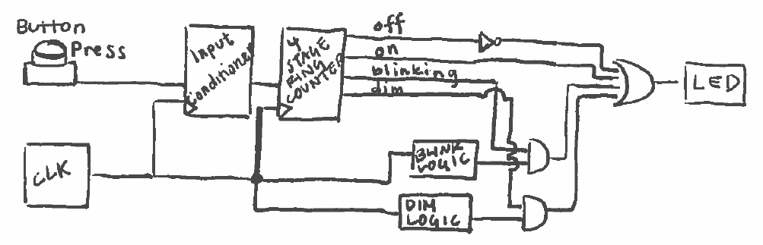

The system is made up of a button, an internal clock (clk), an input conditioner, a 4-stage ring counter that toggles between the four modes, logic for ‘blinking’, logic for ‘dim’, some basic components to manage various stages, and an LED driver.

**Total Cost Estimate**

|  |  |
| --- | --- |
| Component | Total |
| System Clock* | 2 |
| Input Conditioner | 533 |
| 4-Stage Ring Counter | 83 |
| Blink Logic | 182 |
| Dim Logic | 112 |
| Stage -> LED Driver Components*  (Inverter, one 4 Input OR, two 2 Input ANDs) | 1+5+3+3 |
| LED Driver* | 211 |
|  |  |
| ALL COMPONENTS | 1135 |

* = pre-baked

**Non-“Pre-Baked” Components**

* Input Conditioner
  + Specifications
    - The input conditioner takes in the noisy signal from the button press. Since the button noise/bouncing decays within 1 ms and the system clock runs at 32,768 Hz, the signal should settle after 32.768 clock cycles, so an assumption is made that the signal should settle after 32 clock cycles (2^5 clock cycles).
  + Inputs
    - **clk** is the clock input from the system clock.
    - **noisy signal** is a one-bit signal from the button.
  + Outputs
    - **conditioned** is a one-bit conditioned output.
  + Schematic

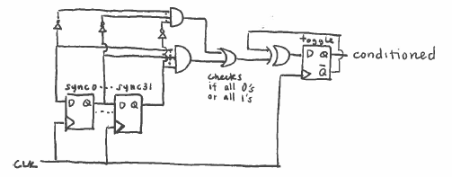

(NOTE: this is a more costly method and using a counter

* + Size of component in terms of the number of Gate Inputs it uses

|  |  |  |  |
| --- | --- | --- | --- |
| **Subcomponent** | **Cost per** | **# Used** | **Total** |
| Edge-Triggered D-Flip-Flop | 13 | 33 | 429 |
| 32 Input AND Gate | 33 | 2 | 66 |
| Inverter | 1 | 33 | 33 |
| 2 Input OR Gate | 2+1 | 1 | 3 |
| 2 Input XOR Gate | 2 | 1 | 2 |
|  |  |  | 533 |

* 4-Stage Ring Counter
  + Specifications
    - This parameterized component is a one-hot counter. When E is asserted, the hot bit moves one element down the ring each positive **clk** edge.
  + Inputs
    - **clk** is the clock input.
    - **E** is the enable input.
  + Outputs
    - **Q[3:0]** has exactly one bit high and all others are low. The high rotates through the group each positive **clk** edge when **E** is asserted high.
    - The **NOR** gate restarts the cycle when the hot bit is at the end of the ring.
  + Schematic

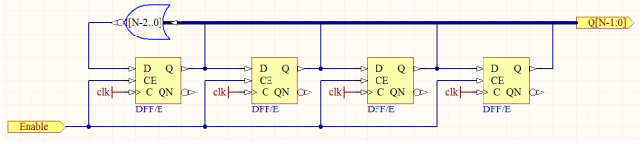

* + Size of component in terms of the number of Gate Inputs it uses

|  |  |  |  |
| --- | --- | --- | --- |
| **Subcomponent** | **Cost per** | **# Used** | **Total** |
| DFF w/ E | 20 | 4 | 80 |
| 3 NOR | 3 | 1 | 3 |

* Blink Logic
  + Specifications
    - The blink logic is to adjust the frequency specifically for the blink mode, which, on the specifications sheet is noted as having a frequency of 4.0 Hz. Thus, the blink logic consists of a chain of 13 flip-flops as each flip-flop halves the input frequency.
  + Inputs
    - **clk** is the clock input from the system clock.
  + Outputs
    - The output is a modified clock running at a frequency of 4.0 Hz.
  + Schematic

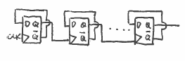

* + Size of component in terms of the number of Gate Inputs it uses

|  |  |  |  |
| --- | --- | --- | --- |
| **Subcomponent** | **Cost per** | **# Used** | **Total** |
| Edge Triggered D-Flip-Flop | 13 | 13 | 169 |
| Inverter | 1 | 13 | 13 |
|  |  |  | 182 |

* Dim Logic
  + Specifications
    - The dim logic is to adjust the frequency specifically for the dim mode, which is set to 128 Hz since that is the human vision flicker limitation. Thus, the dim logic consists of a chain of 8 flip-flops as each flip-flop halves the input frequency.
  + Inputs
    - **clk** is the clock input from the system clock.
  + Outputs
    - The output is a modified clock running at a frequency of 128 Hz.
  + Schematic



(Same logic as blink but with a different number of flip-flops)

* + Size of component in terms of the number of Gate Inputs it uses

|  |  |  |  |
| --- | --- | --- | --- |
| **Subcomponent** | **Cost per** | **# Used** | **Total** |
| Edge Triggered D-Flip-Flop | 13 | 8 | 104 |
| Inverter | 1 | 8 | 8 |
|  |  |  | 112 |