Abstract
Irish rivers are under significant constraints from urban wastewater, changing land use and agricultural runoff, with recent evaluations indicating that only 52 % of water bodies now achieve good ecological status. Classic monitoring methods use a sampling and laboratory-based approach, yielding results weeks or even months later, while standard index formulations fail to fully incorporate the non-linear network interactions of multiple physicochemical variables. These limitations leave regulators and catchment managers without timely and actionable forecasts, preventing effective intervention to prevent further declines in river health, putting the 2027 targets of the EU Water Framework Directive at risk. This study addressed that gap by developing and comparing machine-learning models capable of predicting the Water Quality Index directly from routine monitoring data while providing transparent explanations of the driving factors. Utilizing the EPA's national dataset of 29,159 records over a period of time, LabelEncoder was applied to the categorical variables and StandardScaler to each of the numerical parameters. Three regression methods, Linear Regression, Random Forest(RF) and XGBoost were trained and tuned with GridSearchCV with five-fold cross-validation after exploratory visualisation that aided in identifying seasonality and spatial trends. Evaluation on the held-out test set revealed a clear performance hierarchy. XGBoost achieved the highest accuracy (R² = 0.9968, RMSE = 0.48, MAE = 0.15), followed closely by Random Forest, while Linear Regression explained only 83 % of the variance with markedly higher errors. SHAP analysis also revealed three consistent dominant drivers, whose threshold effects affected the prediction of WQI of Irish rivers.

Table of Contents
1 Introduction 6
1.1 Background of WQI in Ireland 6
1.2 Problems related to the prediction of WQI of Irish rivers 6
1.3 Aim of the study for predicting WQI of Irish rivers 8
1.4 Objectives for predicting WQI of Irish rivers 8
1.5 Research Questions for predicting WQI of Irish rivers 9
1.6 Road map of report 9
2 Literature Review 11
2.1 Water Quality prediction using machine learning 11
2.2 Interpretation of water quality prediction 14
2.3 Predictive Analysis of water of Irish rivers using machine learning 15
2.4 Research Gap in WQI prediction using machine learning 17
3 Methodology 18
3.1 Business Understanding of the prediction of WQI in Irish rivers 18
3.2 Data Understanding of data related to WQI of Irish rivers 19
3.3 Preparing data related to WQI of Irish rivers 21
3.4 Modelling WQI prediction 22
3.5 Evaluation of Irish river WQI prediction 23
4 Implementation of WQI prediction of Irish rivers 24
4.1 Tools Used for WQI prediction of Irish rivers 24
4.2 Data Pre-processing of WQI related data 24
4.3 Exploratory Data Analysis on WQI related data 25
4.4 Label encoding of WQI related data 28
4.5 Training Models for WQI Prediction 29
4.6 Model Interpretation with SHAP for WQI prediction 33
4.7 Performance evaluation of WQI prediction models 33
4.8 Ethical Considerations in WQI prediction 34
5 Results of the performance of WQI prediction of Irish rivers 35
5.1 Predictive Performance of Regression Models in WQI prediction of Irish rivers 35
5.2 Explainable AI (XAI) Analysis using SHAP in the WQI prediction of Irish rivers 37
6 Discussion and evaluation 41
6.1 Discussion of the findings from the WQI prediction of Irish rivers 41
6.2 Evaluation of the findings from the WQI prediction of Irish rivers 44
7 Conclusion and future enhancements to the prediction of WQI of Irish rivers 47
References 48
Appendices 53
Appendix A 53
Appendix B 54

Table of figures
Figure (1): Distribution of CCME Values 26
Figure (2): Correlation Heatmap of Water qaulity Attributes 27
Figure (3): Alkalinity versus WQI scatter relationship analysis 28
Figure (4): SHAP summary plot for linear regression 37
Figure (5): SHAP summary plot for random forest regressor 38
Figure (6): SHAP summary plot for XGBoost regressor 39

List of tables
Table (1): Parameters used in Linear Regression Model 29
Table 2: Parameters used in Random Forest Regressor 31
Table (3): Parameters used for XGBoost Regressor 32
Table (4): Comparison table for R², RMSE and MAE values of 3 models 35

Introduction

Background of WQI in Ireland
The different factors that affect the quality of water, like, biological indicators, turbidity, nutrient concentrations, dissolved oxygen, and pH levels that can be condensed, into a single score, Water Quality Index (WQI) and this single score can be used for evaluating water quality. There are many countries in the world where, WQI is useful in assessing the quality of water because of the increase in pollution in rivers. Ireland is one such country and some major ecological issues have occurred in the rivers of regions like Cork (McDermott, 2025). The rivers that satisfy the good ecological standards came down to 52% in 2025 from 54%, before three years(Bicer, 2025). The factors that cause this pollution include, the release of excess nutrients into water bodies from agriculture, improper management of urban wastewater and forestry operations. These factors needed to be regulated to maintain the water quality in Irish rivers, since most of these factors are essential to the society, the WQI in a region needs to be understood before taking action to preserve or improve WQI by controlling the factors, responsible for water pollution.

Problems related to the prediction of WQI of Irish rivers
Even conventional WQI prediction and assessment methods that depend on manual sampling, laboratory analysis, and deterministic modelling are not equipped to meet these challenges needed for finding WQI. The collection and processing of the necessary sets of parameters is laborious, expensive and often provides results weeks to months after sampling. This lag precludes fast decision-making and restricts coverage to a very small number of sites. Similarly, traditional statistical or physics-based models struggle in capturing the nonlinear and complex interactions among climate, land use, seasonal flows and multiple sources of pollution that is typical of Irish rivers. A subjective element is introduced when calculating a sub-index to suggest the relative importance of different parameters, and small datasets or missing values can provide unreliable outcomes. In summary, these approaches can be reactive rather than preventative, resource-intensive and not particularly well-suited to the high-coverage, multivariate data now spooled out across new monitoring networks. These restrictions underscore the need for more flexible tools that can transform existing water-quality data into timely, accurate predictions to manage rivers effectively.
The issues, because of failing to anticipate and manage these declines, created effects more than riverbanks. The absence of dependable long-term Water Quality Index projections, it hasn’t been possible for authorities to act in time, to avert tipping points, fish kills or more permanent loss of sensitive species such as the Atlantic salmon or freshwater pearl mussel, collapse of entire food webs. The public health risks escalate too: higher nitrates in source waters are a hazard for infants, and polluted rivers constrain safe recreation and tourism dollars that many rural communities rely on. The economic costs add up in the form of increased water-treatment bills, deterioration of the commercial fishing and shellfish bed industries, and damage to Ireland’s “clean green” brand that undergirds food exports and tourist economies. Continued decline also threatens Ireland's compliance with its commitments under the EU Water Framework Directive, one of which requires that every surface water in the country be at least good ecological status by 2027. Forewarning, in contrast, could allow prioritisation of risk management measures , adjusting the timing of fertiliser application for example in high-risk catchments, newer upgraded waste water infrastructure and riparian buffer restoration , before problems set in or become a lot more expensive to rectify.
The large amount of data related to water quality of rivers in Ireland being available meant that this data can be utilised and one approach that can utilise this data is machine learning. The extensive data related to water quality can be used to train machine learning models and after training the models can forecast the WQI of a river in Ireland (Jones and Sah, 2023). Machine learning also offers the chance to understand the attributes of water quality that affect WQI as the forecast by the machine learning models can be interpreted to understand the features that affect WQI of the rivers in Ireland (Nagy and Molontay, 2023).

Aim of the study for predicting WQI of Irish rivers
The aim of the study is to predict the water quality index in Irish rivers and interpret the prediction to understand the factors that affect the prediction.

Objectives for predicting WQI of Irish rivers
- Compile, clean, and pre-process an extensive repository of physicochemical and biological attributes from Irish river monitoring stations, followed by an in-depth exploratory data analysis that employs a range of graphical diagnostics, including correlation heatmaps, and trends plots, to reveal latent patterns, seasonal dynamics, and inter-variable dependencies within the dataset.
- Train and optimise two regression architectures for WQI prediction, while comparing their predictive fidelity through a comprehensive suite of performance metrics (R², RMSE, MAE) to establish model performance under varying hydrological conditions.
- Conduct a comprehensive interpretability analysis of the selected models by quantifying the extent to which individual water-quality parameters influenced predicted WQI scores, applying established explainability methodologies which will reveal mechanistic drivers of water-quality degradation that would remain unexplored in conventional assessment approaches.

Research Questions for predicting WQI of Irish rivers
- How does the performance of different machine learning regression approaches compare in predicting Water Quality Index using the environmental data?
- Which environmental parameters contribute the most to Water Quality Index prediction?

Road map of report
After this ‘Introduction’ which outlines the background to river pollution in Ireland; the practical restrictions of traditional assessment techniques; and the particular aim of this study, to build and interpret ensemble regression models that can forecast WQI from river physicochemical data, the ‘Literature Review’ investigates existing work on machine-learning applications for water-quality modelling. It synthesises comparative studies of regression techniques and interpretability frameworks with previous endeavours, observed in the literature, to apply Random Forest and gradient-boosted models to freshwater systems, demonstrating both their strengths and deficiencies that this work hopes to build upon within an Irish context. The ‘Methodology’ chapter outlines the research framework in general terms, before outlining how the WQI was predicted in Irish rivers. It discusses the adoption of the CRISP-DM process as the guiding structure, the rationale for selecting Random Forest Regression and XGBoost Regression as the core predictive engines, the steps taken to prepare the multivariate dataset of Irish river attributes, and the explainable-AI methods (primarily SHAP values) chosen to open the black-box nature of the ensemble models. Specific focus here is on the decisions taken for both pre-processing and hyper-parameter tuning and cross-validation, which were guided by the need to deliver both accurate as well as interpretable forecasts in accordance with the purpose of this study being, predicting Irish river WQI.
Next in the ‘Implementation’ section, a description of how the models were built and used to predict Irish river WQI is provided. It details the actual working flow, from importing and pre-processing the CSV data, to producing the exploratory plots visualisation which uncovered a seasonal and spatial relationship with the WQI time-series studied, through to training and optimising and testing two regression architectures so that readers can see exactly how this methodology was transposed into workable code leading to reproducible results. The ‘Results’ chapter describes the quantitative results of that deployment. It presents the performance evaluations (R², RMSE, and MAE) of each model on held-out test data, compares their predictive fidelity under different hydrological conditions, and contains the full suite of visualisations and tables summarising water-quality parameters’ most influential values. The ‘Discussion and Evaluation’ section discusses the main findings from the building of the Irish river WQI prediction done, here. Finally, the ‘Conclusion and Future Work’ chapter summarises key accomplishments of this study, reiterates how these models further realise the core objective of accurate and interpretable WQI forecasting, and presents several ideas for future work that extends the research from the introduction of time steps through to true forecasting.

Literature Review

Water Quality prediction using machine learning
Water quality evaluation using machine learning algorithms was studied by (Zhu et al., 2022). The findings from the study showed that many studies have proposed machine learning models for evaluation of water quality. In one such study water quality was predicted using machine learning classification algorithms, like, Random Forest(RF), Support Vector and Decision Tree(DT), in the study by (Yan et al., 2024). Water quality and classification data of Lake Taal in the Philippines was used in the study. The findings from the study showed that machine learning models are able to learn water quality prediction based on the data related to water quality. The RF model achieved an accuracy at 95%. The most representative scenarios from a multi-site, multi-year water quality dataset was selected using a methodology that involves Time Series Analysis and Cluster Analysis, for training machine learning models, in the study by (Del Castillo et al., 2024). The water quality parameter data from Santiago River, Mexico was used. The machine learning models used in the study includes, SVM, Artificial Neural Network (ANN), and Adaptive Neuro-Fuzzy Inference System (ANFIS). This study showed that it supports the insights from the study by Yan et al.(2024), which showed that water quality parameter data can be used for training machine learning models.
Machine learning models were tuned and optimized for Water Quality Classification and predicting WQI, in the study by (Shams et al., 2023). The dataset used in the study contained 7 features and 1991 samples, showing that a dataset with 7 features and 1991 samples can be used for training machine learning models for Water Quality Classification and predicting WQI. The machine learning models used in the study includes, AdaBoost, Gradient Boosting, XGBoost, and RF for Water Quality Classification and for WQI prediction and Multi-Layer Perceptron (MLP) regressor, Support Vector Regressor (SVR), Decision Tree (DT) and K-nearest neighbor (KNN), this shows that regression models are needed for WQI prediction. The findings from the study showed that for WQI prediction the MLP regressor showed the best performance with an R-Squared value of 99.8%. This study shows that machine learning models can be tuned using the Grid Search method. Entropy weighting was integrated with the Pearson correlation coefficient for feature selection in a comprehensive weight-based approach for water quality prediction, by (Wang et al., 2023). The China Environmental Monitoring General Station dataset was used in the study. The machine learning algorithms used in the study includes, Long Short-Term Memory (LSTM), XGBoost, RF , MLP and SVMs. The study showed that the water quality data can contain missing values, with features having values in different numerical scales. This study showed that the GridSearchCV method can be used for improving the performance of machine learning, this insight is supported by the insights from the study by Shams et al.(2023).
The growth of contamination risk in Water Distribution Systems (WDS) was simulated and a smart monitoring system based on AI for quality control was proposed in the study by (William et al., 2023). The water quality data from India was used. The study showed that parameters of water quality like, pH can be used as a feature for training machine learning models. The machine learning models used in the study includes, K-nearest neighbours and feed-forward neural networks (FFNN), ANFIS and LSTM for grouping WQI and predicting WQI. The findings from the study showed that the best performance in the prediction of WQI was shown by SVM, with 97.01%.
The prediction of Gombak River's WQI utilising machine learning was proposed in the study by (Irwan et al., 2025). The data related to water quality parameters obtained from the Department of Environment, Malaysia was used. The study used Support Vector Machines (SVM) , Ensemble of Trees, Gaussian Process Regression (GPR) and Neural Networks (NN). This study showed that the performance of the machine learning models can be evaluated using the trains-test split method. The findings from the study showed that the NN showed the best performance with an R-Squared value of 0.9865. The river water quality was predicted and its index value was segregated using machine learning, in the study by (Nair and Vijaya, 2022). The data related to water quality parameters of Indian rivers was used. The study used machine learning algorithms like, RF, support vector regressor, linear regression and Multi-Layer Perceptron(MLP). The classification was done using MLP classifiers, DT, Naïve Bayes and SVM. The findings from the study showed that MLP showed the best performance with 2.432 RMSE for predicting WQI and 81% accuracy for classifying WQI. The study showed that the WQI can be predicted and it can be used for classifying the water quality in rivers. The study by Irwan et al.(2025) used deep learning models while Nair and Vijaya(2022) used machine learning models, the studies also showed performance metrics like RMSE and R-Squared score.
Water quality classification of the Kelantan River in Malaysia was done using supervised machine learning algorithms, in the study by (Malek et al., 2022). The data related to water quality of the Kelantan River was used. The machine learning models used in the study, includes, Gradient Boosting, RF, SVM, Naïve Bayes, KNN, DT and ANN., the best performance was shown by the Gradient Boosting model. This study showed that the water quality can be classified as good, bad or any other type based on the predicted WQI value.
A water quality prediction model using multi-task hybrid deep learning model in the study by (Wu et al., 2022). The dataset of the Lanzhou portion of the Yellow River was used in the study. The hybrid deep learning model used in the study includes, a CNN, LSTM and multi-task learning (MTL). The findings from the study showed that predicting water quality of rivers can be evaluated based on metrics like, MASE and MAE, showing that prediction of water quality is a regression problem. WQI of La Buong River, Vietnam was predicted using machine learning models in the study by (Khoi et al., 2022). The water quality related data from La Buong River was used in the study. The findings from the study showed that the performance of a model that predicts WQI can be evaluated using the values of metrics like, R-Squared and RMSE, with its values being 0.989 and 0.107. The use of the metrics like RMSE, MASE, etc., for WQI prediction was seen in the study by Khoi et al.(2022) and Wu et al.(2022).
The Entropy-River WQI of the Narmada River, India was predicted using machine learning models in the study by (Gupta and Mishra, 2023). The data related to water quality of the Narmada River was used. The machine learning models used included, Gradient Boosting, RF, KNN ,Support Vector and Logistic Regression. The Logistic Regression achieved the best performance in the study, it was seen from this study machine learning algorithms like, RF can be trained effectively using data related to river water quality, however, this study focused on Entropy-River WQI, instead of just WQI.

Interpretation of water quality prediction
A stacking framework was used for WQI prediction of ground water in Saudi Arabia, in the study by (Alshehri and Rahman, 2023). The data related to ground water quality in Saudi Arabia was used. The study showed that an XGboost model can be interpreted effectively using SHAP and the feature importance of features in WQI prediction can be found using SHAP. However, this study focused on the prediction of WQI of ground water and not the WQI in a river body.
Water potability was classified using machine learning models and the classification was predicted using Explainable Artificial Intelligence (XAI) to carry out parametric analysis, in the study by (Nallakaruppan et al., 2024). The data used in the study was split using train-test split method, which is an effective approach for evaluating a trained machine learning model. The RF model showed the best performance and it was seen from this study that the XAI method SHAP was effective in interpreting the classifications by the machine learning models and parametric analysis was done to find the significant features of water quality. Water quality assessment by machine learning models was interpreted using XAI techniques, in the study by (Makumbura et al., 2024). The dataset used in the study was the dataset related to Kelani River basin in Sri Lanka. The machine learning models used in the study includes, XGBoost, LightGBM and RF. The results of the study showed that the XGBoost showed the best performance with an R-Squared value of 0.992, RMSE of 1.381, and MAE of 0.825. The findings from the study was in-line with the study by Nallakaruppan et al., (2024), which showed that the SHAP method can be used for interpreting the water quality assessment done by machine learning models.
WQI was predicted using, machine learning algorithms like, XGBoost, RF and Gradient Boosting and the prediction was interpreted using XAI techniques, in the study by (Islam et al., 2024). The dataset used contained physicochemical parameters related to water quality. This study showed that train-test split can be used for evaluating the WQI prediction model. The findings from the study showed that XAI techniques can be used for interpreting the prediction of WQI. This study showed that XGBoost can be used for the prediction of WQI, which is in-line with the study by Makumbura et al.(2024), which showed the predictive abilities of the XGBoost model and interpretation by the XAI techniques.

Predictive Analysis of water of Irish rivers using machine learning
The chlorophyll levels in an Irish lake was predicted utilising the multi-sensor remote sensing reflectance by (Zhao and O’Loughlin, 2025). The data related to remote sensing reflectance was used. The approach involved machine learning models, SVM, extreme gradient boosting(XGBoost) and RF. The models were combined and the machine learning models were combined to predict chlorophyll levels. This study showed that if machine learning models are trained using data related to water quality then the models are able to predict the WQI of Irish rivers.
A hybrid architecture including on-premise and cloud hosting, Apache Spark and Hadoop for big data processing & storage, and Github for code management, are proposed in the study to classify biological status of Irish rivers(Sánchez, 2023). The study used more than 4.5 million chemical records from the EPA Ireland API dataset, showing that data related to chemical attributes can be used for training machine learning models. Among the main approaches used, cleaning data (removing null values), annual collection of chemical data, and duplicate handling, were done, this shows that the data related to water quality may contain unwanted data. The machine learning models considered by the study were Random Forest(Rf) Classifier, Naive Bayes Classifier, and Multilayer Perceptron (MLP), Linear Support Vector Classifier, Naive Bayes Classifier and RandomForest Classifier. The results showed that metrics like R-Squared can be used for evaluating the performance of biological status classification by machine learning models, as RF classifier showed the best performance and showed that machine learning models can learn data related to water quality to predict the WQI of Irish rivers. The implementation of Artificial Neural Network (ANN) approaches for evaluating and predicting water quality in River Liffey (Ireland) and Andarax River (Spain) was proposed by (Abushandi, 2025). The study showed that training machine learning models using features like, NPK levels, electrical conductivity, total dissolved solids, turbidity, pH, and dissolved oxygen, the water quality can be predicted. The study showed that there are relationships between the different features in the data related to water quality. The study was in-line with Sánchez(2023) as it showed that the data related to water quality may need to be pre-processed as normalization was done in this study. The Artificial Neural Network(ANN) model was done in the study. The ability of machine learning models to learn to predict water quality was supported by Abushandi(2025) and Sánchez(2023).

Research Gap in WQI prediction using machine learning
On studying the literature the main gap was that there were limited studies that focused on the prediction of water quality of Irish rivers using machine learning. The study by Abushandi, (2025), focused on only a single river in Ireland, which restricts the learning capacity of machine learning models as the data related to different rivers are not used. The studies by Irwan et al.(2025) and Nair and Vijaya(2022), focused on the WQI of rivers but the focus was not Irish rivers. The prediction of WQI of Irish rivers is crucial as the water quality of rivers in Ireland has been decreasing over years. It is also important to understand the factors that affect the prediction WQI.
The study proposed here builds models that predict the WQI in Irish rivers. Machine learning models are trained to perform the prediction and the prediction is interpreted using Explainable AI techniques. The findings from the study has shown that the SHAP method is effective for interpreting the prediction of water quality, so it is used for the interpretation of the WQI prediction of Irish rivers. The machine learning models can be optimised using the Gridsearch method.

Methodology

Business Understanding of the prediction of WQI in Irish rivers
This study was framed around the business understanding phase which was driven by current issues facing water-resource managers and regulators, in Ireland. The EU Water Framework Directive, which makes it clear that all surface waters must achieve at least “good” ecological status by 2027, is enforced across the country by the EPA and local authorities in conjunction with catchment managers who work at a smaller scale. However, a large number of rivers in Ireland fail to attain the goal. The business “problem” here isn’t necessarily collecting more water-quality data (the national monitoring network already generates thousands of physicochemical records each year), but rather the failure to transform those records into real-time actionable predictions that will enable timely intervention before river health worsens.
Retroactive appraisals of water quality are needed, resilient management requires proactive tools able to identify catchments that may be at risk to dip below acceptable Water Quality Index levels several months or seasons ahead of any regulatory reporting cycle. Such forecasts would allow for targeted actions, such as altering nutrient application timings on farms in high-risk sub-catchments, accelerating upgrades to specific wastewater outfalls or rehabilitating riparian buffers where model outputs suggest the highest parameter influence. Without such capabilities, responses are reactive, costs rise and achieving compliance with European obligations becomes more difficult. Thus, the aim of this study does directly target that gap: to build and interpret machine-learning models that translate standard monitoring parameters into robust predictions of WQI while shedding light on precisely what inputs drive those predictions, providing clear evidence-based priorities for action.
This problem of predicting WQI of Irish rivers can be solved using machine learning models. The CRISP-DM methodology can be followed and machine learning models can be built for predicting WQI of Irish rivers, the models can be built based on the data related to WQI of Irish rivers.

Data Understanding of data related to WQI of Irish rivers
Data used in this study was collected from the Environmental Protection Agency national water-quality monitoring program and available on Figshare publicly accessible database(Karim, Syeed and Rahman, 2024). It includes 29,159 rows after pivoting to group by the main physicochemical and biological parameters, Alkalinity-total (as CaCO₃), Ammonia-Total (as N), BOD-5 days (Total), Chloride, Conductivity at 25 °C, Dissolved Oxygen, ortho-Phosphate (as P), pH, Temperature, Total Hardness (as CaCO₃) and True Colour, along with the identifiers WaterbodyName with SampleDate and Years. Thus, each record is a full water-quality snapshot from one river monitoring station in set month of certain year, across the years 2007-2023 in several Irish catchments (the full list here includes Allua, Sullane, Abbeytown and Two Pot systems).
The reason why this dataset is particularly appropriate in present work is due to its directly conforming with the goal of producing interpretable machine-learning, model-based predictive Water Quality Index models. The eleven parameters chosen in the original data preparation are exactly those on which five known methods to calculate a WQI already implemented into the data are: CCME, WAWQI, Horton, Brown and SRDD. The target structure is built-in, requiring no manual index computation and enabling the regression models to learn complex nonlinear relationships that existing sub-indexes weighting schemes typically obscured. Coupled with the fact that the same waterbodies have been repeatedly observed over almost two decades, this makes for rich content to explore previously based on visualisation, temporal trend plots, seasonal boxplots and spatial distribution maps without needing to treat the Years and SampleDate columns as predictive features. In this way the dataset undergirds both the predictive core of the work as well as supporting an understanding of context demanded.
From the technical side of things, the data show some features that lend themselves towards the ensemble regression methods, such as Random Forest and XGBoost. The feature set is multivariate and heterogeneous (spanning nutrients, oxygen regimes, physical chemistry and visual indicators) which reflects the real world complexity of Irish rivers whose agricultural runoff, wastewater discharges and seasonal hydrology interact in non-linear fashion. There are few missing values after the pivot, interpretive outliers (i.e. far from covariant cluster center) in 18 trophic levels informed with environmental context, and pre-computed WQI scores providing five target variables for robustness checks on classic empirical processes. Crucially, the stratified analysis and grouped cross-validation was enabled due to the inclusion of the feature WaterbodyName in the dataset, the generalisation of WQI prediction was ensured as the data related to different types of rivers in Ireland was present in the dataset rather than the model performing WQI prediction based on site-specific patterns that are memorised.
The dataset’s provenance is equally crucial for the interpretability goal of the WQI prediction in the study. The measurements were collected following standardised EPA protocols, allowing discussion of the resulting models with confidence in regulatory and stakeholder environments. Pre-computation of the WQI values is yet another advantage, as it provides a ready reference to facilitate direct comparison between machine-learning predictions and conventional index methods. In other words, the WQI dataset isn’t just big or nicely formatted; it’s an accurate reflection of the monitoring reality faced by Irish water managers every year. Its structure, coverage and embedded targets thus form the perfect basis for achieving the dual aim of this study: accurate WQI prediction from routine parameters alongside interpretability regarding what drives those predictions. This phase of understanding the data confirmed that no further primary collection of WQI data related to Irish rivers would be necessary and that the selected modelling pathway could be tested rigorously against real regulatory requirements.

Preparing data related to WQI of Irish rivers
Label encoding and scaling were two operations that needed to be done on the WQI related data, for improving the quality of data. Encoding was needed in this study as some features related to WQI had categorical values. WaterbodyName is a high cardinality categorical variable, with dozens of distinct river or stream identifiers (i.e., Allua, Sullane_050, ABBEYTOWN_010). Inclusion of it as a categorical variable would have been impossible for the tree-based models, while conversion to numeric types was critical in allowing the algorithms to learn site-specific patterns without treating every river completely independently from others. The LabelEncoder method was chosen for encoding because it maps each waterbody to a simple integer label in one pass while preserving the full information in compact form. This kept the feature matrix at a manageable level and prevented dimensionality inflation which was key for accuracy across thousands of records. One-hot encoding was explicitly avoided as the number of waterbodies generated a huge number of sparse columns, severe multi-collinearity risk, and made subsequent SHAP explanations a lot less interpretable (Cerda and Varoquaux, 2020). Target or frequency encoding were also considered but rejected here as they introduce the risk of data leakage in a cross-validation setting and can obscure the direct site-level effects that were intended to be revealed by these models. LabelEncoder, in contrast, was entirely reversible and transparent in a way that supported the study’s interpretability focus but still allowed machine learning models to learn meaningful catchment-level differences.
The numerical features related to WQI of Irish rivers posed another set of challenges. Parameters in the WQI related data like Conductivity (approx 49–711 µS/cm), Alkalinity (8–356 mg/L as CaCO₃) and Dissolved Oxygen (41 % - 102 %) are on very different scales and have completely different units. This can create problems for the machine learning models during their training to perform the prediction of WQI of Irish rivers as the machine learning models consider the features having higher numerical values as the features that are more important to learning the prediction of WQI of Irish rivers. The features are scaled using the StandardScaler method. MinMaxScaler was considered as alternative but was not used since water-quality data have true outliers (e.g. extreme high conductivity after heavy rain or algal nutrient spikes in agricultural catchments). MinMaxScaler would have shrunk those extremes into the 0–1 range and distorted their relative impact on rare but environmentally meaningful events (Pagan, Zarlis and Candra, 2023).

Modelling WQI prediction
The RF, XGBoost and linear regression models are trained in the study to predict the WQI of Irish rivers. The RF Regression model was selected as an ensemble method due to its known performance handling noisy heterogeneous environmental monitoring records (Panaite et al., 2024). The process of building dozens of trees based on bootstrapped samples and averaging the predictions essentially guards against overfitting and reduces variance in the RF, an imperative when the data used here encompasses scores of individual waterbodies collected over 16 years. The gradient-boosting framework of Xgboost, bolstered by its built-in regularisation (L1 and L2 penalties), also enabled the model to capture subtle non-linear relationships in the data, such as nutrient concentration threshold effects on oxygen that simpler methods may gloss over , useful for Irish rivers, where small shifts in ammonia or conductivity can expose new risks of eutrophication, and its speed/efficiency with moderately sized tabular data (about 29k records) made hyper-parameter tuning possible within workable computational limits (Sibindi, Mwangi and Waititu, 2022). Linear regression was a simple model and it was used in this study as a representative for a simple model compared to the complex models like RF and Xgboost.
Neural networks were ruled out for this study because neither the dataset size nor its tabular structure warranting their extra complexity or black-box property and the objective of interpretability would have been undermined. Due to its sensitivity towards the varying scales of original parameters and poor scalability in the presence of high-cardinality categorical encoding, K-Nearest Neighbours was out of scope for the study proposed, here.

Evaluation of Irish river WQI prediction
The aim of the study here is to predict the WQI value of Irish rivers, so the trained model in this study produces a numerical value as prediction, which is the WQI value. So, such prediction of WQI values of Irish rivers, is a regression problem, so this regression problem can only be evaluated based on performance metrics that are apt for evaluating regression analysis. So, the performance metrics whose values were found in this study are R-Squared, RMSE and MAE.

Implementation of WQI prediction of Irish rivers

Tools Used for WQI prediction of Irish rivers
Python was selected as the primary programming language for this research. This study involved the implementation of advanced machine learning architectures, specifically Linear Regression, Random Forest Regression, and XGBoost Regression, to predict the Water Quality Index (WQI) of Irish rivers and provide a transparent interpretation of these predictions (Yurtsever and Emeç, 2023). Since the project required complex visual plots for analyzing data distributions and feature correlations, Python was an indispensable choice with its strong ecosystem around libraries such as Matplotlib and Seaborn. The technical requirements of this study, particularly the need for eXplainable AI (XAI) through the SHAP framework to meet the objective of interpreting model outputs, made Python a good viable option over other statistical languages like R, which do not offer the same level of integrated support for high-performance gradient boosting and model interpretability.

Data Pre-processing of WQI related data
The data used for this study was in raw CSV format, and needed to be heavily transformed before it could fit into a regression analysis. Because the dataset included various metadata and multiple versions of water quality indices, a sequence of pre-processing stages was required to isolate the core variables and make the data ready for the aim of predicting the CCME index. Initially, redundant features such as station IDs, dates, and alternative index calculations like WAWQI or Horton values were removed. This step was vital to ensure the models focused strictly on the raw physicochemical attributes, thereby preventing data leakage and ensuring the study remained grounded in chemical reality.
To handle the presence of missing values, which are common in nearly all types of reading from environmental sensors, a dual-pronged imputation strategy was used. For the numerical attributes, mean imputation is used, and for categorical features were handled using the most frequent value (Agbo et al., 2022). This ensured that no valuable Irish river samples were discarded, maintaining a robust dataset for training. Subsequently, the data was partitioned into a training set (80%) and a testing set (20%) using a random_state of 42. This split is fundamental to the study as it allows the performance of the models to be evaluated on unseen data, providing an unbiased assessment of their predictive accuracy. Finally, the numerical features were normalized using a standard scaling approach to ensure that parameters with different units, such as Conductivity and pH, contributed equally to the model’s learning process.

Exploratory Data Analysis on WQI related data
The analysis of the Irish river dataset was conducted by generating visual plots based on the available chemical and physical features. These visualizations were instrumental in interpreting the data’s underlying structure and recognizing the prevailing environmental patterns before the modelling phase.
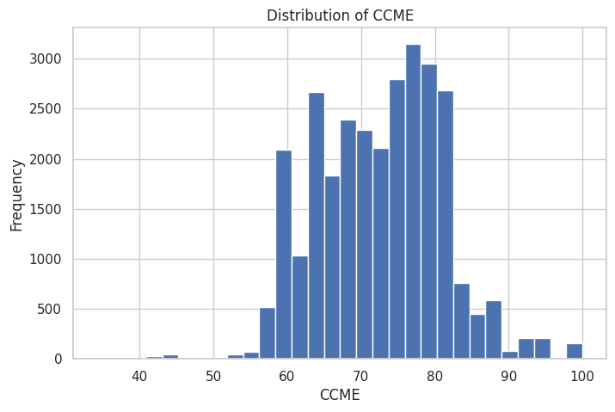
Figure (1): Distribution of CCME Values
From Figure (1), it can be observed that the CCME WQI values are not uniformly distributed across the samples. The frequency of certain water quality classes is higher than others, indicating that the dataset captures a specific range of river health conditions. Recognizing this distribution is essential for the study, as it informs how the Random Forest and XGBoost models will handle the variance in Irish water quality.
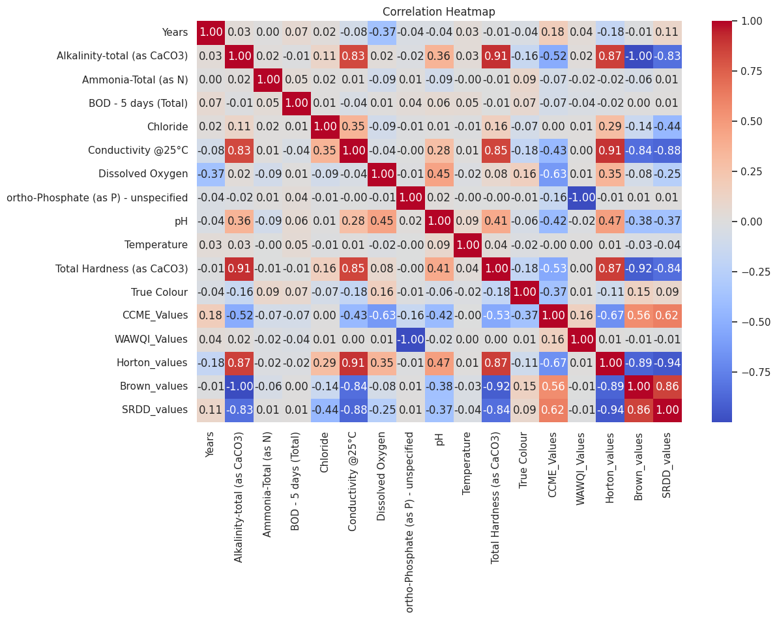
Figure (2): Correlation Heatmap of Water qaulity Attributes
Figure (2) illustrates the linear relationships between various physicochemical parameters and the target WQI. It is evident that some attributes, such as Dissolved Oxygen or Ammonia, show stronger correlations with the final index than others. This visualization confirms that the dataset contains meaningful predictive signals, supporting the study’s aim to use these attributes as the basis for automated WQI prediction.
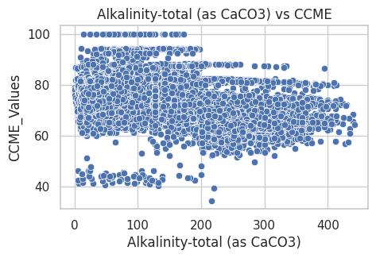
Figure (3): Alkalinity versus WQI scatter relationship analysis
Figure (3) illustrates the relationship between Alkalinity-total (as CaCO3) and the CCME Water Quality Index (WQI) values. The scatter distribution shows that the data points are widely dispersed, indicating a weak to moderate relationship between alkalinity levels and the overall water quality index. It can be observed that a large concentration of samples falls within mid-range alkalinity values, while the corresponding CCME values are spread across a broad range. This means that higher and lower WQI values often occur with a similar range of alkalinity levels, which suggests that water quality results are not strongly influenced by alkalinity alone.

Label encoding of WQI related data
Several features in the Irish river dataset were originally in categorical form and could not be directly processed by the regression algorithms. To address this, Label Encoding was applied to transform these categorical identifiers into numerical representations (Dahouda and Joe, 2021). This was a necessary step because machine learning models require mathematical inputs to perform the iterative calculations needed for prediction. By using Label Encoding rather than One-Hot Encoding, the study maintained a compact feature space, which is particularly beneficial when dealing with environmental datasets where maintaining the relationship between samples and their original categorical groupings is important for subsequent interpretation.

Training Models for WQI Prediction
Three distinct machine learning regressors, specifically Linear Regression, Random Forest (RF), and XGBoost, were trained in this study to predict the Irish river WQI. The rationale for using these specific models was to compare a baseline linear approach with advanced ensemble methods that can capture the non-linear complexities of water chemistry. To find the most accurate configurations, a 5-fold cross-validation (cv=5) strategy was implemented using GridSearchCV. The training set was split automatically, so that 80% of the training set was used for training the models and 20% was used for validation in 5-fold cross-validation, in the process 4 folds were used for training and 1 fold was used for evaluation.
The Linear Regression model was initialized to serve as a statistical baseline, enabling the evaluation of linear relationships within the dataset (Starbuck, 2023). It is an interpretable model and also can serve as a baseline comparison for more complex models.
Table (1): Parameters used in Linear Regression Model
Parameter | Value
fit_intercept | [True, False]
positive | [True, False]
cv | 5
scoring | r2
n_jobs | -1
verbose | 1

From Table (1), the fit_intercept parameter was explored with values set to True and False to determine whether including a bias term improves the model’s ability to capture underlying trends in the data. This is particularly relevant when the input features are not centered, as the intercept can significantly influence prediction accuracy. The positive parameter was configured with both True and False options to examine the effect of constraining model coefficients to non-negative values. This helps in understanding whether enforcing positive relationships between predictors and the target variable leads to more stable or interpretable outcomes The cv (cross-validation) parameter was set to 5, so the model’s performance is assessed on more than one subset of samples in the dataset (Azis, 2024). It improves the confidence of the outcome by diminishing results fluctuation and reaffirming a desirable generalization of the model. The scoring metric, by default was r2 (the coefficient of determination) which determines how well the variance in the target variable is explained by the model This metric is widely used for regression problems and provides a clear indication of model performance. The n_jobs parameter was set to -1 to enable parallel computation using all available processor cores, thereby improving computational efficiency during the grid search process. and the verbose parameter was set to 1 to provide progress updates during model training, allowing for better monitoring of the grid search procedure.
The Random Forest model was implemented as an ensemble learning approach to improve predictive performance by combining multiple decision trees (Liu, 2025). This approach improves the robustness of this model as it reduces variance and decreases overfitting risk in comparison with one single decision tree.

Table 2: Parameters used in Random Forest Regressor
Parameter | Value
n_estimators | [100, 200]
max_depth | [5, 10]
min_samples_split | [2, 5]
random_state | 42
cv | 5
scoring | r2
n_jobs | -1
verbose | 1

From Table (2), the n_estimators parameter was set to 100 and 200 to evaluate the optimal number of trees required to achieve stable and accurate predictions. Increasing the number of trees generally enhances model performance by reducing variance, while also increasing computational cost. The max_depth parameter was configured with values 5 and 10 to control the depth of each decision tree. Limiting the depth helps prevent overfitting by restricting the model from learning noise and overly specific patterns within the data. The min_samples_split parameter was set to 2 and 5 to determine the minimum number of samples required to split an internal node. This parameter influences the complexity of the trees, where higher values lead to simpler models and reduced risk of overfitting. The random_state parameter was fixed at 42 to ensure reproducibility of results. By controlling randomness in the model, consistent outputs can be obtained across multiple runs. The cv (cross-validation) parameter was set to 5 to evaluate model performance across different subsets of the data. This approach improves the robustness and generalizability of the model. The scoring metric was defined as r2 (coefficient of determination) to measure how well the model explains the variance in the target variable, providing a reliable evaluation of regression performance (Berggren, 2023).The n_jobs parameter was set to -1 to enable parallel processing, allowing the model to utilize all available computational resources and reduce execution time. and the verbose parameter was set to 1 to display progress updates during the grid search process, facilitating better tracking of model training.
An XGBoost Regressor model was used to apply gradient boosting for identifying higher-order feature interactions in the data (Guo and Chang, 2022). It sequentially constructs trees so that each additional tree attempts to reduce the errors from prior trees, thereby increasing predictive accuracy.
Table (3): Parameters used for XGBoost Regressor
Parameter | value
n_estimators | [100, 200]
learning_rate | [0.01, 0.1]
max_depth | [3, 7]
random_state | 42
cv | 5
scoring | r2
n_jobs | -1
verbose | 1

From Table (3) value of n_estimators was set to 100 and 200 to see which boosting iteration number is the optimal for predictions. Adding more estimators to the models increases the learning ability of that model, and also affects computational efficiency. Max_depth is configured between 3 and 7 is a parameter to control the complexity of individual trees. Small depth values are used to prevent overfitting, but larger ones allows the model to be trained on more complex patterns observed from the given data. The learning_rate parameter was assigned values 0.01 and 0.1 to regulate the contribution of each tree during the boosting process (Iranzad, 2021). A smaller learning rate promotes gradual learning and better generalization, while a larger value accelerates convergence The remaining parameters, including random_state, cv, scoring, n_jobs, and verbose, perform the same functionality as described in the Random Forest model, ensuring consistency in model evaluation, reproducibility, computational efficiency, and training monitoring.

Model Interpretation with SHAP for WQI prediction
To fulfill the study objective of interpreting the predictions, the SHapley Additive exPlanations(SHAP) framework was implemented for all trained models. While the ensemble models provide high accuracy, they often function as "black boxes," making it difficult to understand the reasoning behind a specific WQI score. The study employed both LinearExplainer for the linear model and TreeExplainer for the Random Forest and XGBoost models. This operation allows the study to quantify the exact contribution of each water quality parameter, such as Ammonia or Phosphate levels, to the final predicted index. By generating SHAP summary plots, the research provides a clear narrative of the environmental drivers impacting Irish rivers, transforming the machine learning output into actionable ecological insights.

Performance evaluation of WQI prediction models
The performance of the machine learning models was evaluated using a rigorous set of metrics tailored for regression tasks. The evaluation was conducted exclusively on the 20% test set to ensure the results accurately reflected the model's ability to predict WQI for new, unseen Irish river data. The model performances were primarily evaluated based on the variance explained by the model, using R-Squared (R2) scores, as well as two metrics that help quantify the average magnitude of errors in predictions: Root Mean Squared Error (RMSE) and Mean Absolute Error (MAE) (Hodson, 2022). Furthermore, the adjusted R2 was estimated and used to verify that multiple GCCs contributed reduced error without excessive complexity in the model. These metrics collectively demonstrate the reliability of the models in fulfilling the study's aim of accurate water quality assessment.

Ethical Considerations in WQI prediction
The data set used in this project was obtained from public environmental records published for ecological research in Ireland. This was a secondary data analysis study, therefore no direct contact or collection of sensitive personal information from human participants was conducted. All station-related data was treated purely as geographical and environmental markers, ensuring that the research adhered to standard data privacy and ethical guidelines. The focus remained entirely on the objective analysis of water quality attributes to promote environmental sustainability.

Results of the performance of WQI prediction of Irish rivers

Predictive Performance of Regression Models in WQI prediction of Irish rivers
The predictive performance of the developed models was evaluated using a structured experimental pipeline that incorporated data preprocessing, hyperparameter optimisation, and cross-validation. The Irish CW dataset of physicochemical indicators from river systems was pre-processed, with missing values and categorical features being encoded and features scaled for comparability across models. Subsequently, three regression methods Linear Regression, Random Forest, and Extreme Gradient Boosting (XGBoost) were fitted and tuned with a grid-search strategy using the approach of five-fold cross-validation to guarantee stability in parameter selection.
The final evaluation was performed on a test set, and performance was quantified using R², RMSE and MAE. The comparative results are presented in Table(4).
Table (4): Comparison table for R², RMSE and MAE values of 3 models
Model | R² | RMSE | MAE
Linear Regression | 0.833001 | 3.493072 | 2.597895
Random Forest | 0.990136 | 0.848955 | 0.466050
XGBoost | 0.996796 | 0.483866 | 0.148455

The Linear Regression model establishes a baseline with an R² value of approximately 0.83, indicating that a substantial portion of variance in WQI can be explained through linear combinations of input features. Nonetheless, the overall high RMSE and MAE values indicate a difficulty in accurately capturing spatial variation and non-linear dependencies tended to be seen by environmental data. Notice that such a problem is to be expected since the water quality dynamics are affected by complex interplays between many variables, including nutrient levels, turbidity and dissolved oxygen.
The Random Forest model yields a substantial boost in performance with the R² rising significantly above 0.99 at the same time as both RMSE and MAE drop considerably. This is due to its ensemble modelling structure, in which many decision trees work together to model nonlinear relationships and reduce variance via bootstrap aggregation. Random forest is particularly applicable for heterogeneous environmental data sets where the relationship between variables is seldom linear and independent, one of its many advantages being an innate ability to handle feature interactions without requiring that they be specifically specified.
The XGBoost model shows the most predictive potential of all the approaches tested, with almost perfect predicted vs observed WQI values. The test errors are significantly lower than the prediction error rates from input to output, as a result. In this case it can be seen that RMSE is below 0.5 and MAE approximately 0.15, this shows that the predictions have small errors and they all remain low consistently too. It was speculated that this better performance may be due to the gradient boosting mechanism, in which successive trees are trained over the residual errors of previous iterations. The regularisation and efficient tree construction in XGBoost helps it achieve high accuracy with generalisation.
These results are also confirmed with cross-validation, the R² scores over folds for both ensemble models having similar patterns and avoiding any artefacts induced by a particular arrangement of data. This also reflects high values of Adjusted R², which are calculated taking into consideration the number of predictors and therefore it can be reassured that based on their complexity they are not overfitting for Random Forest or XGBoost.
Overall, there is a clear hierarchy in the models, ensemble-based approaches far outperform the linear baseline. This points to the need for modelling non-linear relationships in WQI prediction and justifies using advanced machine learning methods in this study.

Explainable AI (XAI) Analysis using SHAP in the WQI prediction of Irish rivers
Along with the predictive assessment, an interpretative layer was implemented through SHAP (SHapley Additive exPlanations) for a deeper view into how the WQI score is framed by the input features. SHAP assigns a contribution value to each feature per prediction giving not only the magnitude but also the direction of influence. As shown having minute single-model-level attributions, the summary plots that are produced for each of those models provide a high-level impression by ordering elements on how large average effect they have, but also when across elements value (are typically normal) transferred to prediction up/down. This is especially true in environmental modelling, where understanding potential explanatory drivers of the prediction is as important as the prediction itself.
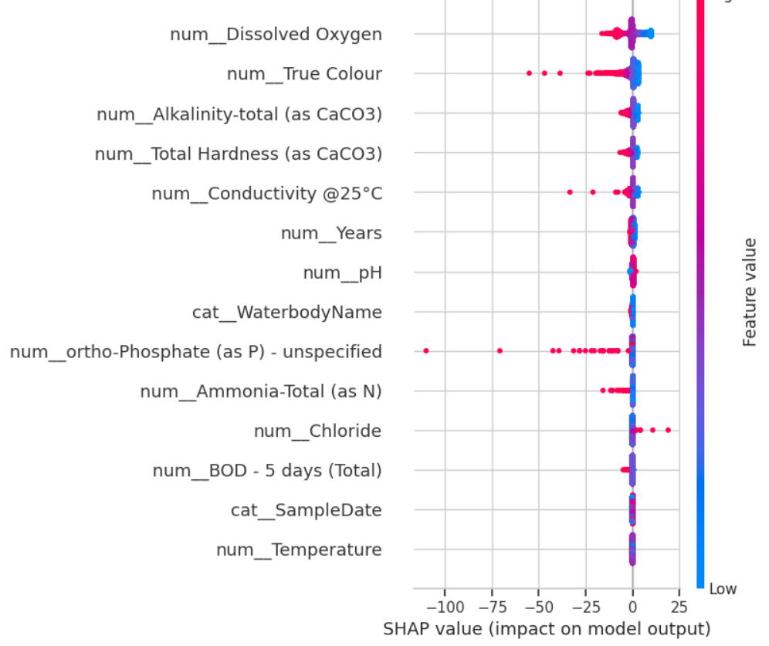
Figure (4): SHAP summary plot for linear regression
For the Linear Regression model (Figure(4)), the SHAP distribution reflects a relatively constrained and symmetric spread of feature contributions around zero. Quite a few features, especially num_Dissolved Oxygen and num_True Colour moderate effects, but they appear to be predominantly linear (some monotonic) and sparse. As shown in the colour gradient, positive and negative contributions of these features are agreed on in almost linear way, further supporting linearity assumptions made by the model. But, the lack of broader spread or clear segregation in SHAP values indicates that the model might not have strong nonlinear effects or threshold behaviour thus resulting in comparatively lower predictive accuracy.
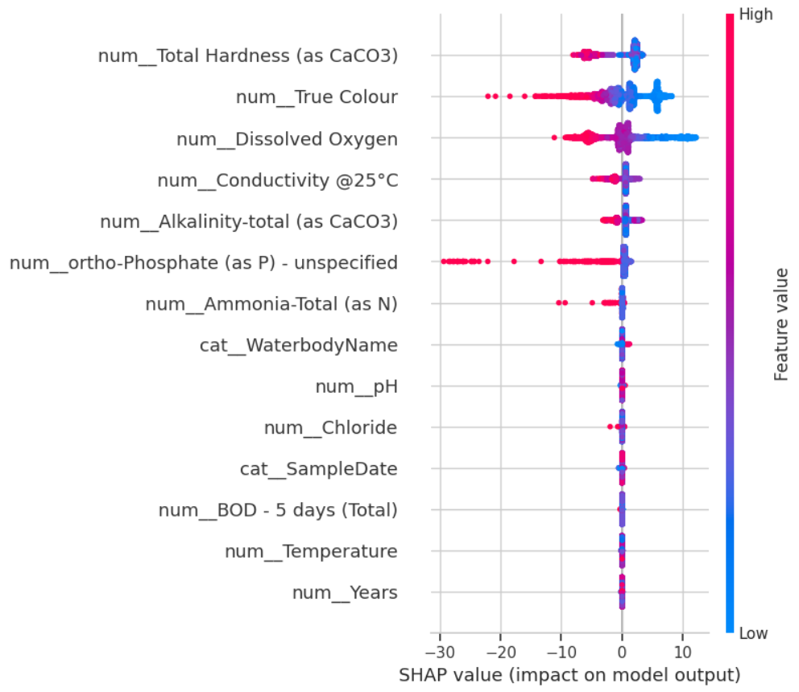
Figure (5): SHAP summary plot for random forest regressor
In the Random Forest model, the SHAP summary plot (Figure(5)) exhibits a noticeably broader spread of values, indicating stronger and more diverse feature contributions. num_Total Hardness(as CaCo3), num_True Colour, and num_Dissolved Oxygen appear to be strong predictors in that order with the distributions of their SHAP values showing marked asymmetry. High feature values (in red) have a tendency of pushing predictions in one way, while low values (blue) do the opposite, nonlinear relationships. Furthermore, some features (e.g., num_ortho-Phosphate(as P)-unspecified and num_Ammonia-Total(as N)) have long tails in their SHAP values, indicating the existence of outliers or effects that occur under certain conditions that can greatly influence WQI predictions. This behaviour reflects the model’s ability to partition the feature space and capture complex interactions.
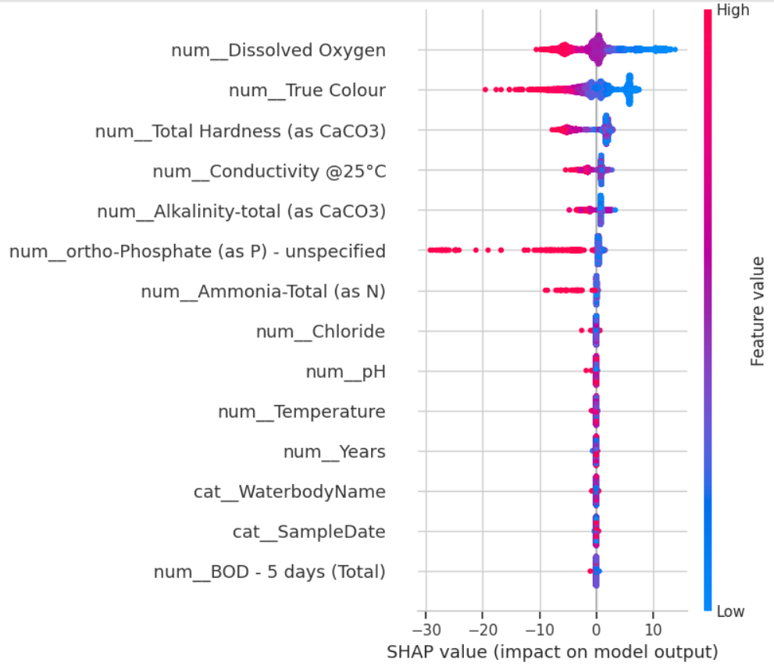
Figure (6): SHAP summary plot for XGBoost regressor
The XGBoost model demonstrates the most refined and structured SHAP distribution (Figure(6)) among all three models. The key features again including num_Total Hardness(as CaCo3), num_True Colour, and num_Dissolved Oxygen show highly concentrated yet distinctly separated SHAP value clusters, indicating consistent and strong influence across observations. The distribution here is much more controlled than Random Forest, implying that the boosting process has managed to eliminate noise whilst retaining important nonlinear relationships. Secondly, the consistent change in colour gradients with respect to pixels again show that the model has captured stable patterns of feature-response interaction since specific values of features consistently led to higher/lower WQI predictions. This corresponds with the better accuracy that can be seen in the performance metrics.
Overall, the SHAP analysis shows a continuous improvement in interpretability and sensitivity to features from Linear Regression to Random Forest and finally XGBoost. While the linear model captures only basic relationships, the ensemble models uncover deeper nonlinear structures and interactions within the data. The consistency of key influential features across the tree-based models strengthens confidence in the identified environmental drivers of WQI, while the sharper and more stable patterns observed in XGBoost further validate its suitability as the final predictive model.

Discussion and evaluation

Discussion of the findings from the WQI prediction of Irish rivers
The findings of this study provide strong evidence that machine learning models are highly effective for predicting the Water Quality Index (WQI) of Irish rivers, while also offering meaningful interpretability into the environmental drivers of water quality. A common trend among the results was that ensemble-based methods outperformed statistical models. Despite Linear Regression explaining a good amount of variance (R² ≈ 0.83), the high prediction errors imply that linear assumptions fail to describe the inherent complexity of river systems. In contrast, both Random Forest and XGBoost showed almost perfect predictivity performance. The best of these models was achieved by the XGBoost model with an accuracy of R² ≈ 0.997. This suggests that the relationship of physicochemical parameters as predictors of WQI can be nonlinear and interactive, emphasizing the importance of using advanced modelling tools to work with environmental datasets.
A major conclusion of this study is that the quality of water flowing through Irish rivers has an interconnected nature, with multiple parameters involved in complex non-linear relationships as opposed to simply fallout or influence from singular variables. This observation aligns closely with patterns identified during the exploratory data analysis, where weak individual correlations (e.g., alkalinity vs WQI) contrasted with strong predictive performance when features were considered collectively. SHAP-based interpretability also unveiled dependencies on specific features that remained consistent dominant factors in determining WQI across the models, while others had a negligible impact. Notably, the repeatability of important features across Random Forest and XGBoost increases confidence that these findings are robust, and indicates that the identified parameters are true environmental drivers as opposed to artefacts of model behaviour.
When compared with the existing literature, several insights from this study are strongly in-line with prior research. The first is that the performance of ensemble methods like Random Forest and XGBoost seen here corresponds with findings from studies such as Makumbura et al. (2024) and Islam et al. water quality modelling, which showed that gradient boosting was a better predictor (2024). In parallel, the limitations of linear models that were uncovered are aligned with previous studies highlighting the nonlinear character of environmental systems. Second, applying physicochemical parameters successfully to predict WQI strengthens the conclusions of studies such as Yan et al. (2024) and Abushandi (2025), which found that the water quality parameters alone suffice as accurate predictors. This study pushes that insight further, in particular focusing it on Irish river systems, thus addressing an important gap identified in the literature.
A further point of alignment with existing research is that of explainable artificial intelligence. The output of SHAP in this study validated the applicability of SHAP to interpret model predictions, as skin cancer was reported earlier by Nallakaruppan et al. (2024) and Alshehri & Rahman (2023). Quantifying feature contribution offers transparency and insight into prediction formation, turning models from prophetic devices to decision-support tools. This is especially important in the context of environmental management, where interpretability can guide decision-making and compliance to laws. More specifically, this study pushes the field in that interpretability does not have to compromise accuracy since both the more accurate than regular decision trees XGBoost of scale model has stable/profitable SHAP patterns.
In spite of these consistencies, the study also provides some differences from earlier work. Although many studies identified neural networks or hybrid deep learning models as their top performing methods, the results demonstrate that tree-based ensemble methods can reach similar, if not superior performance without a need for creating highly complex architectures. This is especially vital in applied contexts where computational resources and interpretability are constraints. In addition, while studies on single rivers or small datasets have been conducted in the past, this study draws on a multi-river Irish dataset which covers multiple years across different catchments, thus enhancing generalisability and significance in relation to water management at national scale.
In conclusion, the discussion of this present study shows that not only does it confirm key trends apparent in existing literature but also reinforces such trends originating from literature specific to Irish rivers. The high level of predictive accuracy and robustness in their interpretability reaffirms the applicability of machine learning as a technique to aid proactive water quality management.

Evaluation of the findings from the WQI prediction of Irish rivers
This study needs to be evaluated from both a technical (i.e., model performance, methodological vigor) as well as practical perspective (i.e., real world applicability). The models produced in the present research are shown to be very stable from a performance point-of-view. Utilizing multiple evaluation metrics (R², RMSE and MAE) provides a more comprehensive evaluation of predictive capability as well as extremely low margins of error in ensemble models. Combined with cross-validation and hyperparameter tuning using GridSearch, these results gain a lot more credibility, reinforcing that the model will be mapped to unseen data well.
A second strength of the study concerns its data handling and pre-processing approach. This approach of addressing missing values, scaling and encoding features helped maintain the integrity while ensuring it was in a form comprehensible to machine learning algorithms. Choosing not to use temporal identifiers like date in the predictive model itself, but using them and developing exploratory analysis without deletion for exploratory data, creates a commendable balance between good returns and interpretability. Moreover, using a large and standardised dataset from the EPA monitoring programmes allows for improved consistency and reproducibility of the results.
Implementation of the interpretability framework via SHAP is one of the significant contributions of this study. Unlike most predictive models, which operate as black boxes, this study developed models that deliver transparent “explanations” of the way input features are related to WQI predictions. This will have a profound impact on the applied value of the research, or rather that environmental stakeholders could use these insights to detect key drivers of water quality deterioration and prioritise measures accordingly. A crucial aspect of the analysis is the consistency of SHAP results across models, which adds an important level of confidence regarding the robustness of those relationships.
However, the study does have its limitations. One common issue is that it only works with static data, not dynamic forecasting techniques. These models have demonstrated strong predictive capabilities of WQI given current states but are not explicitly informed by time dependencies or seasonality in a forward-looking context. Using time-series methods like LSTM might improve forecasting even more. Furthermore, while the dataset is rich, it lacks explicit inclusion of land-use and anthropogenic features which may allow better model performance and interpretability.
Another aspect is the risk of overfitting for models with high accuracy (e.g., XGBoost). While cross-validation and test-set assessments demonstrate good generalisation, it would be prudent to evaluate the model on completely independent datasets considering near-perfect performance. This is important especially for the model robustness on new river systems and future data.
From a very practical point of view, shows pretty good methods that can be really applied to the real world. The created models can be a timely and convenient WQI prediction tool for environmental authorities, enabling them to stay ahead on factor decision-making. The interpretability aspect also enables these predictions to be transformed into decision-makers, e.g. pinpointing significant pollutants or focusing on high-risk catchments. Regulatory policymakers are keen to understand the hydrological impacts of climate change, and this is well aligned with work such as under the EU Water Framework Directive.
The first research question asked how the performance of different machine learning regression approaches compared when predicting the Water Quality Index from the Irish river monitoring data. Linear Regression, in contrast, yielded a reasonable but not very helpful baseline model yielding 83% of variance explained by WQI scores (R² = 0.833) but also significantly higher prediction errors (RMSE = 3.49, MAE = 2.60). By comparison, both ensemble methods produced greatly improved results in prediction WQI of Irish rivers. Using RF, an R-Squared value of 0.990 with RMSE and MAE being reduced to 0.85 and 0.47 respectively, demonstrating that by bagging up multiple decision trees simultaneously the variance was dampened, allowing to deal with heterogeneous environmental data. XGBoost was the best compared to all others: R² = 0.997, RMSE = 0.48 and MAE of 0.15.
The second research question was about identifying which environmental parameters contributed most strongly to the WQI prediction of Irish rivers. Of these, SHAP analysis provided a consistent and interpretable answer across all models. Three features , the equivalent of num_Total Hardness(as CaCo3), num_True Colour, and num_Dissolved Oxygen from the pre-processed dataset , emerged as significant drivers, such that high values of these parameters delivered a strong push either positively or negatively depending on the context in terms of their contribution to the final WQI score prediction.
In summary, evaluation results confirm high accuracy and interpretability for WQI prediction in this study. Thus, although there are areas where this framework could be expanded to address temporal dynamics or include additional data sources, it serves as valuable groundwork for future academic exploration and real world integration into environmental management systems.

Conclusion and future enhancements to the prediction of WQI of Irish rivers
This study set out to predict the Water Quality Index (WQI) of Irish rivers using routinely collected physicochemical parameters and to interpret those predictions so that the underlying drivers could be clearly understood. Starting with the EPA monitoring dataset from 2007-2023, the study involved data understanding, pre-processing (LabelEncoder, StandardScaler), exploratory visualisation and training of three regression models (Linear Regression, Random Forest, XGBoost) under the CRISP-DM framework. The results show that While Linear Regression had a baseline projection of R² ≈ 0.83, ensemble methods well outperformed them with the XGBoost taking it at an overall accuracy of R² = 0.9968, RMSE: 0.48 and MAE = 0.15 Random Forest also performed highly (R² = 0.990), suggesting that tree ensemble methods have an adaptability for capturing the complex, nonlinear system dynamics of Irish river systems in particular.
In addition to sheer predictive power, SHAP analysis was conducted and identified three key parameters that were consistently dominant drivers of WQI across the models. Their impact showed distinct threshold effects and directional influence that traditional index methods frequently hide. Not only did these results directly realise the study’s primary aim to predict WQI with high fidelity but also to contribute transparent, actionable insights into the drivers of water quality in Irish rivers.
The future directions for this work can look to augment the existing static models. To further improve its value, real-forecasting can be performed using temporal features, and land-use & climate variables for machine learning model with the best performance (the best pipelines would be XGBoost with SHAP), it would also serve as a decision-support tool.

References
Abushandi, E. (2025) 'Water quality assessment and forecasting along the Liffey and Andarax rivers by artificial neural network techniques toward sustainable water resources management,' Water, 17(3), p. 453. https://doi.org/10.3390/w17030453.
Alshehri, F. and Rahman, A. (2023) 'Coupling Machine and Deep Learning with Explainable Artificial Intelligence for Improving Prediction of Groundwater Quality and Decision-Making in Arid Region, Saudi Arabia,' Water, 15(12), p. 2298. https://doi.org/10.3390/w15122298.
Aysu Bicer(2025). Ireland’s rivers, lakes ‘struggling’ as water quality continues to decline. https://www.aa.com.tr/en/europe/ireland-s-rivers-lakes-struggling-as-water-quality-continues-to-decline/3716992#:~:text=The%20agency's%20latest%20report%20showed,contact%20us%20for%20subscription%20options.
Cerda, P. and Varoquaux, G. (2020) 'Encoding High-Cardinality String categorical variables,' IEEE Transactions on Knowledge and Data Engineering, 34(3), pp. 1164–1176. https://doi.org/10.1109/tkde.2020.2992529.
Del Castillo, A.F. et al. (2024) 'Improving river water quality prediction with hybrid machine learning and temporal analysis,' Ecological Informatics, 82, p. 102655. https://doi.org/10.1016/j.ecoinf.2024.102655.
Gupta, D. and Mishra, V.K. (2023) 'Development of entropy-river water quality index for predicting water quality classification through machine learning approach,' Stochastic Environmental Research and Risk Assessment, 37(11), pp. 4249–4271. https://doi.org/10.1007/s00477-023-02506-0.
Irwan, D. et al. (2025) 'River water quality monitoring using machine learning with multiple possible in-situ scenarios,' Environmental and Sustainability Indicators, 26, p. 100620. https://doi.org/10.1016/j.indic.2025.100620.
Islam, Md.J. et al. (2024) 'Machine Learning-Driven Water Quality Index Prediction: Enhancing Accuracy with Gradient Boosting and Explainable AI for Sustainable Water Monitoring,' Applied Agriculture Sciences, 2(1), pp. 1–7. https://doi.org/10.25163/agriculture.2110031.
Jones, K.I. and Sah, S. (2023) 'The Implementation of Machine Learning in The Insurance Industry with Big Data Analytics,' International Journal of Data Informatics and Intelligent Computing, 2(2), pp. 21–38. https://doi.org/10.59461/ijdiic.v2i2.47.
Karim, Md.R., Syeed, M.M.M. and Rahman, A. (2024) 'Water Quality Monitoring Dataset (Ireland),' Figshare. https://doi.org/10.6084/m9.figshare.25002131.
Karim, Md.R., Syeed, M.M.M. and Rahman, A. (2024) 'Water Quality Monitoring Dataset (Ireland),' Figshare. https://doi.org/10.6084/m9.figshare.25002131.
Khoi, D.N. et al. (2022) 'Using machine learning models for predicting the water quality index in the LA Buong River, Vietnam,' Water, 14(10), p. 1552. https://doi.org/10.3390/w14101552.
Makumbura, R.K. et al. (2024) 'Advancing water quality assessment and prediction using machine learning models, coupled with explainable artificial intelligence (XAI) techniques like shapley additive explanations (SHAP) for interpreting the black-box nature,' Results in Engineering, 23, p. 102831. https://doi.org/10.1016/j.rineng.2024.102831.
Malek, N.H.A. et al. (2022) 'Prediction of water quality classification of the Kelantan River Basin, Malaysia, using machine learning techniques,' Water, 14(7), p. 1067. https://doi.org/10.3390/w14071067.
McDermott, A. (2025) An ecological catastrophe on the blackwater — and a system that let it happen. https://swanireland.ie/2025/09/an-ecological-catastrophe-on-the-blackwater-and-a-system-that-let-it-happen/#:~:text=Pollution%20Every%20Single%20Day,them%20to%20account%20for%20this.
Nagy, M. and Molontay, R. (2023) 'Interpretable dropout prediction: towards XAI-Based Personalized intervention,' International Journal of Artificial Intelligence in Education, 34(2), pp. 274–300. https://doi.org/10.1007/s40593-023-00331-8.
Nair, J.P. and Vijaya, M.S. (2022) 'River Water Quality Prediction and index classification using Machine Learning,' Journal of Physics Conference Series, 2325(1), p. 012011. https://doi.org/10.1088/1742-6596/2325/1/012011.
Nallakaruppan, M.K. et al. (2024) 'Reliable water quality prediction and parametric analysis using explainable AI models,' Scientific Reports, 14(1), p. 7520. https://doi.org/10.1038/s41598-024-56775-y.
Pagan, M., Zarlis, M. and Candra, A. (2023) 'Investigating the impact of data scaling on the k-nearest neighbor algorithm,' Computer Science and Information Technologies, 4(2), pp. 135–142. https://doi.org/10.11591/csit.v4i2.p135-142.
Panaite, F.A. et al. (2024) 'Enhancing Air-Quality predictions on university campuses: A Machine-Learning Approach to PM2.5 Forecasting at the University of Petroșani,' Sustainability, 16(17), p. 7854. https://doi.org/10.3390/su16177854.
Sánchez, R.M. (2023) Applying Machine Learning to Biological Status (QValues) from Physio-chemical Conditions of Irish Rivers. https://doi.org/10.63227/239.830.98.
Shams, M.Y. et al. (2023) 'Water quality prediction using machine learning models based on grid search method,' Multimedia Tools and Applications, 83(12), pp. 35307–35334. https://doi.org/10.1007/s11042-023-16737-4.
Sibindi, R., Mwangi, R.W. and Waititu, A.G. (2022) 'A boosting ensemble learning based hybrid light gradient boosting machine and extreme gradient boosting model for predicting house prices,' Engineering Reports, 5(4). https://doi.org/10.1002/eng2.12599.
Wang, X. et al. (2023) 'Water quality prediction based on machine learning and comprehensive weighting methods,' Entropy, 25(8), p. 1186. https://doi.org/10.3390/e25081186.
William, P. et al. (2023) Artificial Intelligence based Models to Support Water Quality Prediction using Machine Learning Approach, pp. 1496–1501. https://doi.org/10.1109/iccpct58313.2023.10245020.
Wu, X. et al. (2022) 'A water quality prediction model based on Multi-Task Deep Learning: a case study of the Yellow River, China,' Water, 14(21), p. 3408. https://doi.org/10.3390/w14213408.
Yan, X. et al. (2024) 'A Comprehensive Review of Machine Learning for Water Quality Prediction over the Past Five Years,' Journal of Marine Science and Engineering, 12(1), p. 159. https://doi.org/10.3390/jmse12010159.
Zhao, M. and O’Loughlin, F. (2025) 'A multiplatform approach for chlorophyll level estimation for Irish lakes,' IEEE Journal of Selected Topics in Applied Earth Observations and Remote Sensing, 18, pp. 8261–8274. https://doi.org/10.1109/jstars.2025.3546060.
Zhu, M. et al. (2022) 'A review of the application of machine learning in water quality evaluation,' Eco-Environment & Health, 1(2), pp. 107–116. https://doi.org/10.1016/j.eehl.2022.06.001.

Appendices

Appendix A
The distribution of features.
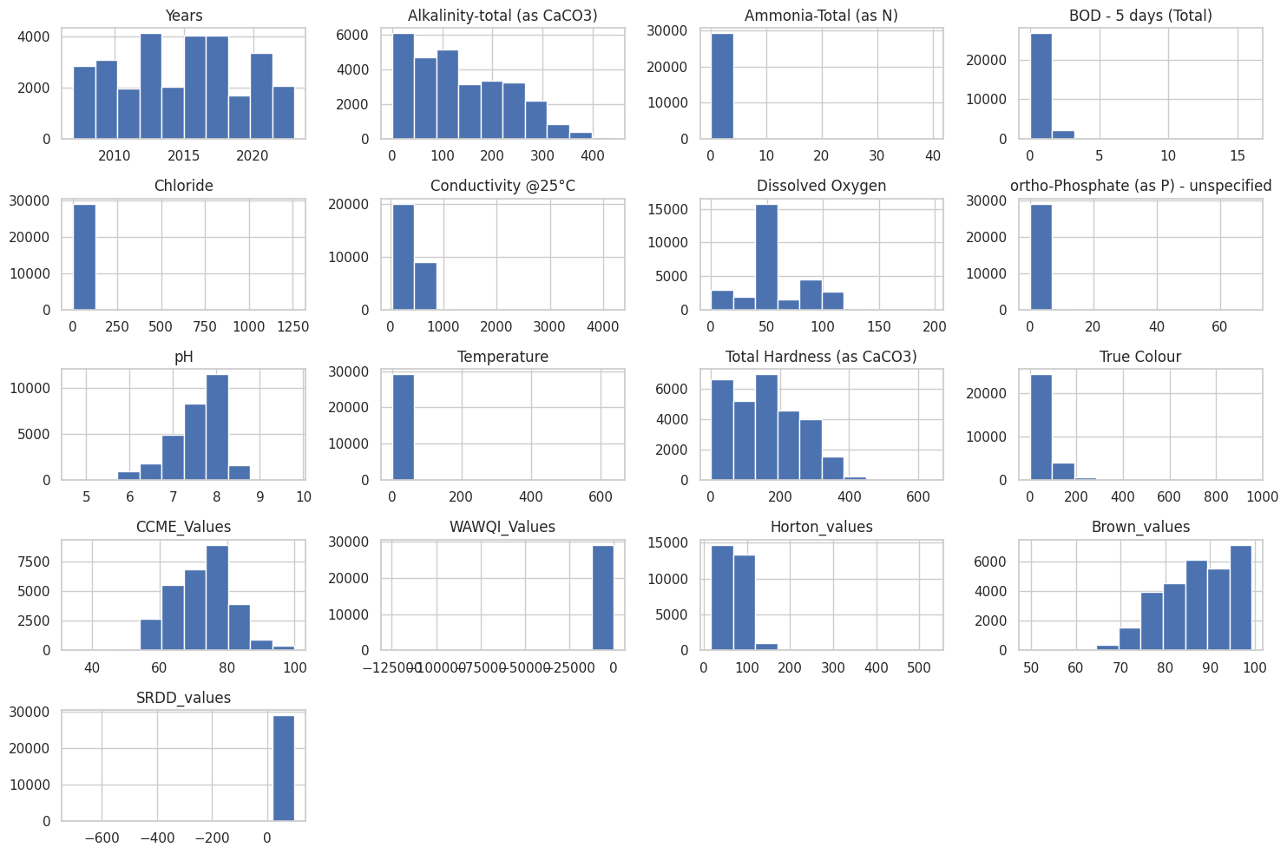

Appendix B

The code used for building the model.
