Technical Report for hospital resource availability Analysis using SSRS, SSIS, Tableau, and Neo4j

CONTENTS

1. Introduction
1.1. Reasons for selecting the data
1.3. Vision and Goals
1.4. Key Stake Holders
1.5. Business requirements
2. Schema
3. ETL
4. Visualization and reports
4.1. Visualizations
4.2. Reports
5. Graph Databases
5.1. Comparison to relational databases
6. Conclusions
7. Bibliography
Appendix A –Visualizations code
Appendix B – Neo 4J code

1. Introduction
This paper provides an end-to-end Business Intelligence (BI) platform using the New York Statewide Hospital Bed Capacity dataset. The objective of this study is to analyze the supply and availability of hospital resources, including acute care beds, intensive care unit (ICU) beds, and occupancy rates that allow for effective health capacity planning as well as informed operational decision-making. The implementation is through a full BI workflow, taking you from ETL processing in SSIS to data modeling on star schema and at-a-glance insights via SSRS analytics or relationship-based exploration through Neo4j graph integration (Schuetz and Schrefl, 2023).

The dataset categorizes, compiles and regularly reports accurate information on healthcare facilities throughout the state of Florida each day, providing a valuable resource for analysis of regional readiness, identifying capacity trends and supporting informed public health decision-making.

1.1. Reason for Selecting this Data
The chosen dataset offers real-world, critical healthcare operational information and is suitable for BI analysis because:
- It contains region-wise and facility-wise bed availability across New York State, enabling capacity assessment at multiple levels.
- This dataset encompasses data pertinent to both acute care and intensive care units, thereby facilitating a comprehensive understanding of hospital stressors and preparedness levels.
- It provides occupancy statistics organized by date, which is particularly advantageous for conducting time-series analyses and monitoring trends.
- It is structured and clean, making it suitable for dimensional modelling and star schema implementation.
The significance of this dataset in relation to healthcare operations and emergency preparedness renders it particularly appropriate for illustrating business intelligence workflows and analytical processes.
1.2 Vision and Goals
The primary goal of this BI solution is to build a data-driven decision support framework for healthcare administrators and policymakers by:
- Designing a star schema representing hospital facilities, dates, and geographical regions.
- Developing ETL pipelines to transform raw CSV data into fact and dimension tables.
- The building of sql server reporting services (SSRS) reports wraps up the use of hospital beds their availability and capacity by different regions.

- The application of Neo4j graph modelling facilitates the investigation of interrelationships among facilities, counties, and regions via Cypher Query Language (CQL).
- Using analytical capabilities of emergency management, resource allocation, and strategic planning is reinforced in this movement.
This integrated Business Intelligence (BI) ecosystem elucidates trends in bed availability, monitors occupancy metrics longitudinally, and enables comparative analyses of healthcare capacity across the regions of New York.
1.3 Key Stakeholders
The BI system targets several groups that rely on accurate and timely information for healthcare decision-making:
- State Health Department Officials – to monitor regional hospital readiness and prepare for emergency surges.
- Hospital Administrators – to compare internal facility loads against regional trends.
- Emergency Management Teams – for assessing ICU stress levels and planning resource distribution.
- Policy Analysts and Public Health Researchers – to evaluate how capacity varies across regions.
- BI Engineers & Data Analysts – using this project as a model for transforming raw public datasets into actionable dashboards and reports.

1.4. Business Requirements
The requirements guiding the design of the star schema, ETL processes, and SSRS reports include:
- Summarize total and available bed counts for each region to understand regional resource distribution.
- Track daily occupancy trends for acute care and ICU beds to identify operational pressure points.
- Provides the solution which supports longitudinal analysis to allow the decision-makers to evaluate how hospital capacity changes over time.

2. Schema

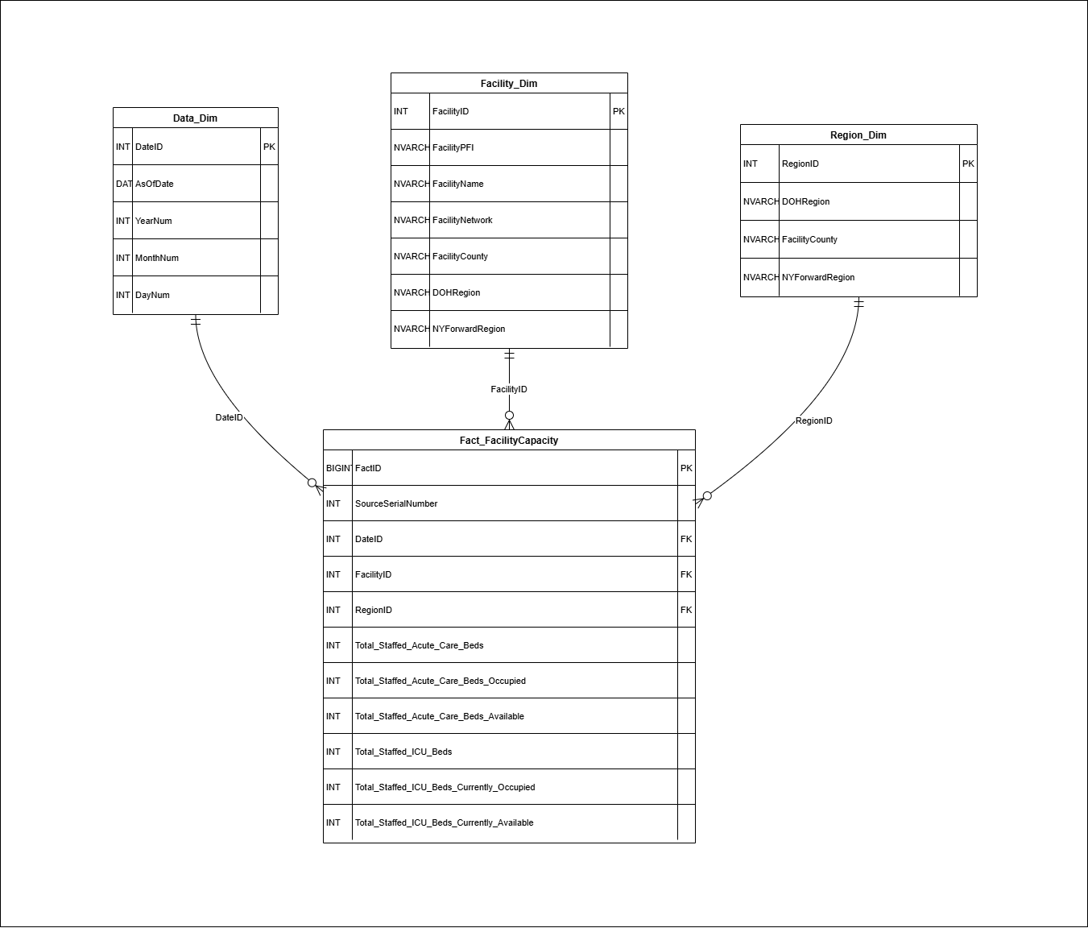
Fig: Star schema

The star schema designed for this project provides a clear, high-performance structure for analyzing statewide hospital bed capacity data. At the center of the model, the Fact_FacilityCapacity table stores all measurable metrics such as staffed acute-care beds, ICU occupancy, and availability. Here the fact table is linked to the three supporting dimension tables Data_Dim, Region_Dim, and Facility_Dim which provides the attributes required for filtering and slicing the data across multiple perspectives. The Data_Dim table provides a complete temporal breakdown (year, month, day) for trend and time-series analysis. Region_Dim captures geographical classifications including DOH Region, Facility County, and NY Forward Region, enabling regional performance comparisons. Facility_Dim describes hospital-level attributes such as Facility Name, PFI, and healthcare network, helping analysts drill down into specific facilities. In general, this model minimizes data redundancy, improves query performance and is aligned with good-practice dimensional modeling by clearly separating the factual measures from descriptive context (Li et al., 2024).

3. ETL Process
The ETL process for this project was developed using SQL Server Integration Services (SSIS) to extract, clean, transform, and load the statewide hospital bed capacity data into the star schema. The schema tables Data_Dim, Region_Dim, Facility_Dim, and Fact_FacilityCapacity were first created in SQL Server Management Studio (SSMS) using SQL DDL scripts.
Data extraction was performed using OLE DB Source components that imported records from the structured CSV source file. The SSIS package was created with four Data Flow Tasks, these are responsible for loading a specific part of the schema (Masson et al., 2022):
- Three Data Flows were used to populate the dimension tables individually (Data_Dim, Region_Dim, and Facility_Dim).
- One Data Flow was dedicated to populating the Fact_FacilityCapacity table.
Each Data Flow included essential SSIS transformation components such as:
- Data Conversion - ensuring data types from the CSV source aligned with SQL Server destination types (e.g., integers, dates, and text fields).
- Derived Column transformations - used to compute additional attributes such as date breakdowns (Year, Month, Day) for the Data_Dim table or standardized text fields.
- Lookup transformations - which retrieved corresponding surrogate keys (DateID, FacilityID, and RegionID) from already populated dimension tables to maintain referential integrity when loading the fact table (Ta’a et al., 2022).
After all transformations were applied, the cleaned and validated data was loaded into their respective destination tables using OLE DB Destination components. This ETL approach given accurate foreign key relationships, eliminated data inconsistencies, and supported efficient analytical queries in the star schema (Andriansyah, 2022). The screenshot of the four completed Data Flow Tasks is attached below.

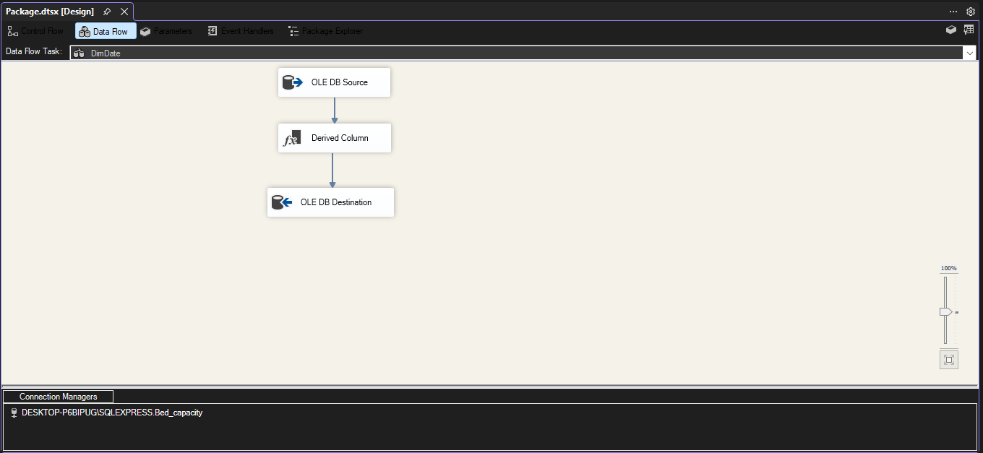
Fig: data flow task screenshot of first dimension table.

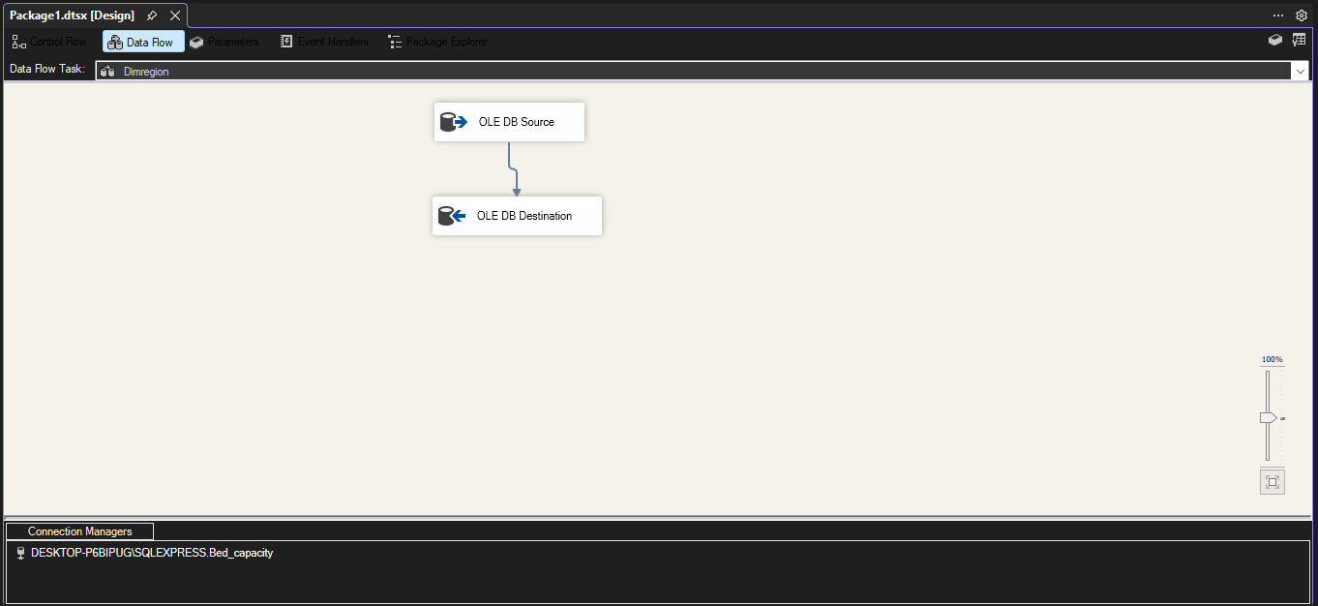
Fig: data flow task screenshot of second dimension table.

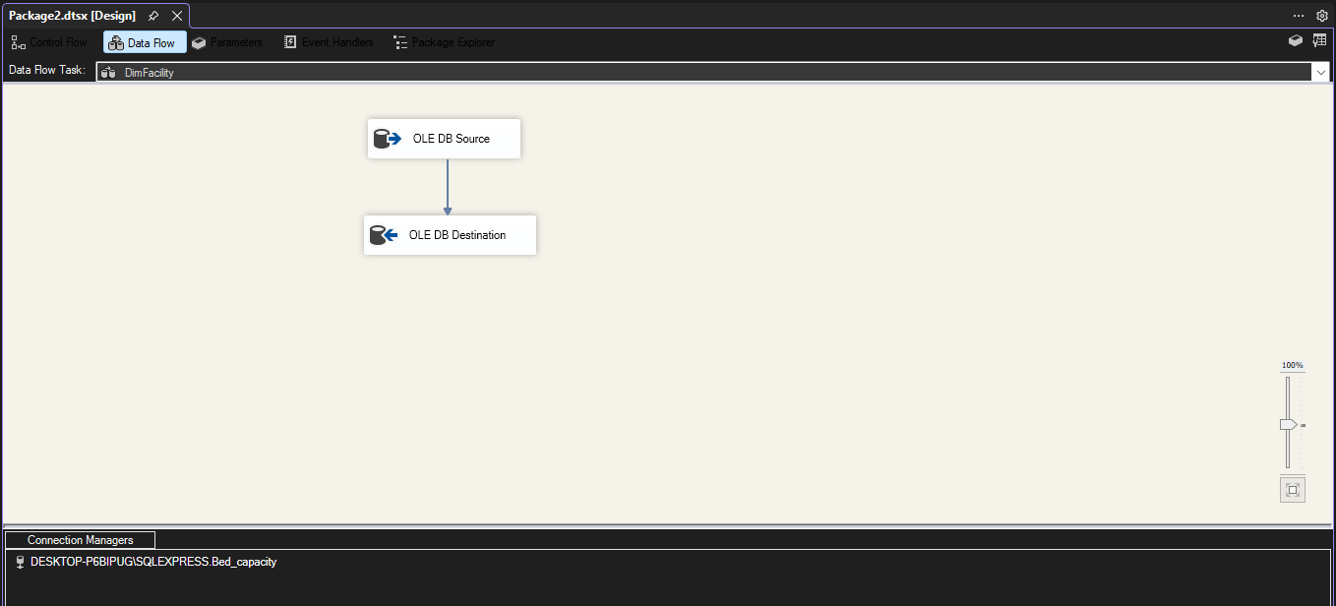
Fig: data flow task screenshot of third dimension table.

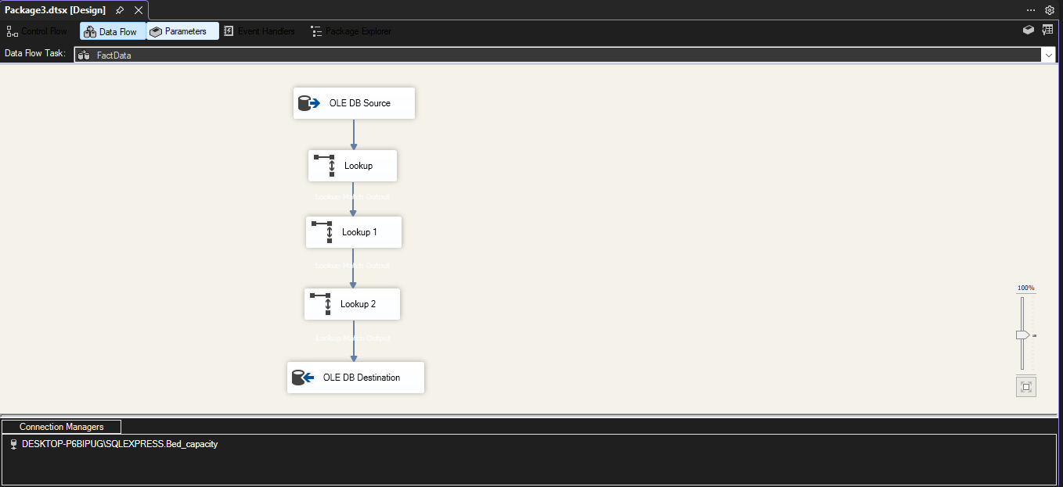
Fig: data flow task screenshot of fact table.

4. Reports and visualizations
This section highlights the key analytical outputs developed using SSRS and Tableau. The reports were generated from SQL Server using structured queries on the star schema, while visualizations were built in Tableau to provide a more interactive and intuitive exploration of the incident management dataset. The SQL queries used to generate these insights are included in the Appendix.

4.1 Reports
The following SSRS reports were created to address core business questions:
Report 1: Regional Hospital Bed Capacity Summary

- Objective:
Provide an overview of total and available hospital bed capacity—both Acute Care and ICU—across different NY Forward Regions.
- SQL Logic:
The query aggregates totals of staffed beds, available beds, and ICU capacity by joining Fact_FacilityCapacity with Region_Dim, then grouping by NYForwardRegion.
- Use Case:
Facilitates the analysis of capacity disparities among various regions for policymakers and healthcare administrators, enables the identification of locales with insufficient bed availability, and promotes the efficient allocation of emergency resources.

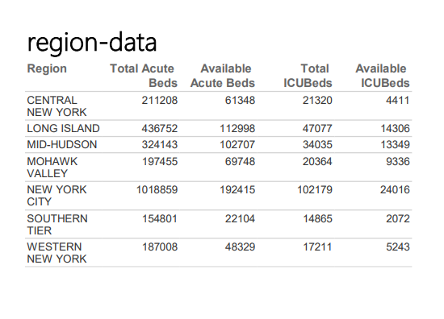
Fig: Report of Regional Hospital Bed Capacity Summary

Report 2: Daily Hospital Bed Occupancy Trends

- Objective:
Analyze day-to-day variations in Acute Care and ICU occupancy across all facilities.
- SQL Logic:
The query joins Fact_FacilityCapacity with Data_Dim, then summarizes daily totals of occupied Acute and ICU beds, including a combined occupancy metric.
- Use Case:
This analysis of trends is facilitated by illustrating the fluctuations in hospital burden over temporal intervals. This mechanism allows for the identification of spikes in bed occupancy and helps in forecasting and allocation of the resources.

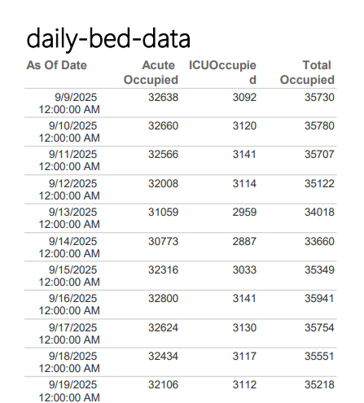
Fig: Report of Daily Hospital Bed Occupancy Trends

4.2 Visualizations
Using Tableau, the same data was visualized interactively with support for filters and drill-downs, offering better exploratory analysis capabilities:

Visualization 1: Region vs Bed counts

- Fields Used:
Region, TotalAcuteBeds, AvailableAcuteBeds, TotalICUBeds, AvailableICUBeds
- Visualization Type:
Clustered Bar Chart
- Description / Purpose:
This visualisation compares total bed capacity vs available beds across all New York regions for both Acute Care and ICU beds.

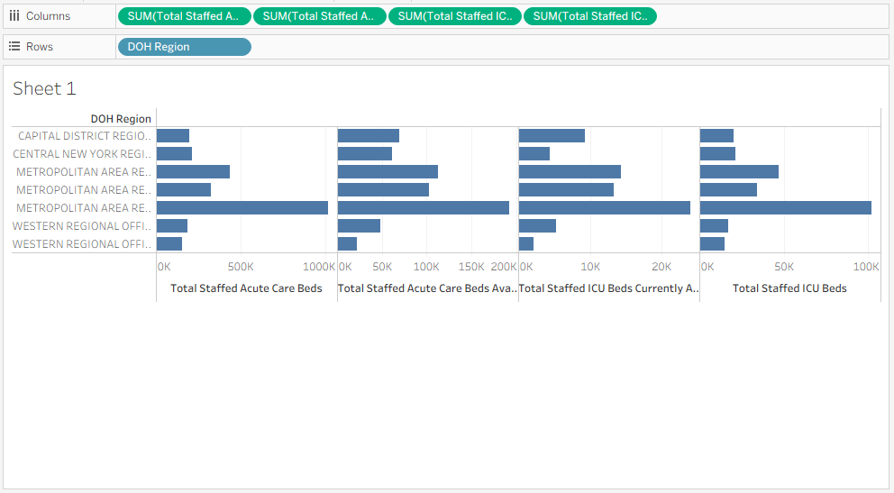
Fig: Tableau visualization of region vs bed counts

Visualization 2: Date vs Bed counts

- Fields Used:
AsOfDate, AcuteOccupied, ICUOccupied, TotalOccupied
- Visualization Type:
Line Chart
- Description / Purpose:
This visual shows daily occupancy trends for Acute Care beds, ICU beds, and total hospital occupancy.

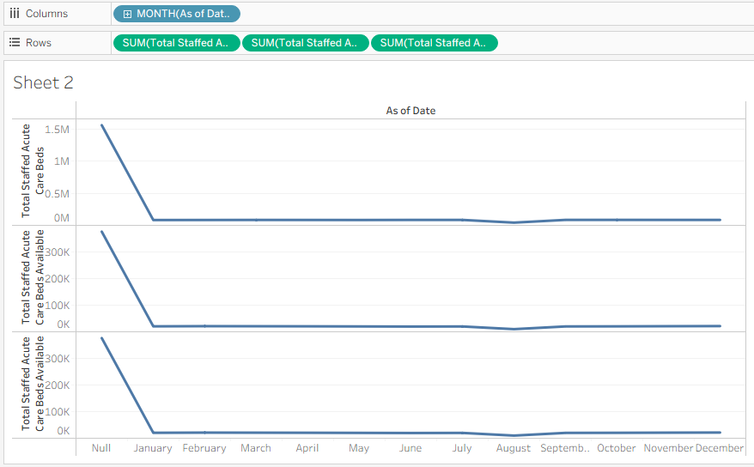
Fig: Tableau visualization of date vs bed counts

Dashboard:

Top Section – Regional Bed Capacity (Bar Chart)
- Highlights regional distribution of total vs available beds
- Users can compare Acute and ICU capacity across regions
Bottom Section – Daily Occupancy Trend (Line Chart)
- Shows monthly change in occupancy levels
- Helps monitor stress periods and overall utilisation

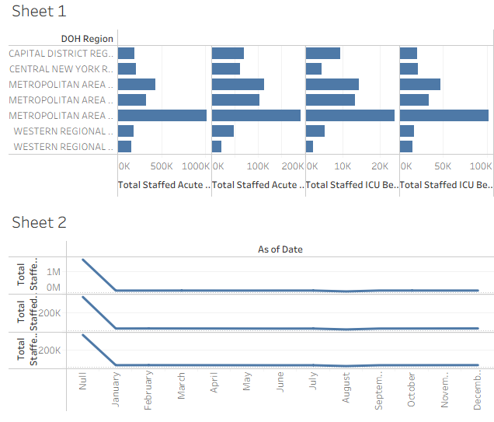
Fig: Tableau dashboard containing both plots

5. Graph Databases

Graph databases facilitate the storage of information through interlinked structures referred to as nodes, relationships, and properties, thereby rendering them particularly efficacious for datasets in which the interconnections among entities possess significant analytical implications (Akinnubi & Ajiboye, 2023). For better understand the dataset regarding hospital beds in New York State, the Neo4j graph database was utilized in the project. We chose to encapsulate the hierarchical organization of healthcare in Neo4j, due to its strong capabilities for modeling associations between entities in the real world (Lisin et al., 2023). They have defined three distinct types of nodes as the base elements of their model: Facility, County and Region. Facility nodes encompassed attributes such as the total number of staffed acute care beds, ICU beds, along with their respective available and occupied metrics. County nodes denoted the geographical counties in which the facilities are situated, whereas Region nodes illustrated the larger NY Forward Regions utilized in strategic healthcare planning at the state level.
To related these entities to each other, two basic kinds of relationships were defined. Each Facility was linked to its appropriate County through the LOCATED_IN relation, and each County was associated with its respective NY Forward Region by the PART_OF relation. These connections allowed for smooth traversal of the healthcare pyramid such that queries could be propagated from a region to its corresponding counties and in turn those clinics located within those counties. Cypher Query Language (CQL) was used to import and preprocess data, generate nodes, assign properties to nodes, and build relationships (Yuan et al., 2023). The complete set of Cypher statements used to build this graph model is listed in the appendix (Section A). Through this framework, Neo4j provided a means for efficient and intuitive examination of interrelated healthcare capacity data, thereby uncovering patterns that would be less discernible within a conventional flat relational structure.

5.1 Comparison to Relational Databases
In order to juxtapose the graph-based methodology with a conventional relational model, the identical dataset was executed within SQL Server employing a star-schema architecture. The relational model comprised dimension tables pertaining to temporal aspects, geographical regions, and healthcare facilities, along with a fact table that encapsulated quantifiable attributes such as the availability of acute care and intensive care unit beds. This model was subjected to queries formulated in SQL to facilitate SQL Server Reporting Services (SSRS) reports, which included summaries of regional capacity and daily occupancy trends, with the comprehensive SQL queries delineated in Appendix B. Although the relational model exhibited commendable performance for structured aggregations, the disparities between the two models became apparent upon scrutinizing the methodologies each employed in managing data relationships (Ye et al., 2023).
In the relational model, relation and link data representation was difficult without constraints such as foreign keys, normalised tables and JOIN operations, compounding into longer queries and inflexible schemas. In contrast, Neo4j provided a substantially more flexible and expressive environment with entities interconnected by relationships. This facilitated queries that involved multiple hierarchical levels such as the retrieval of all facilities associated with a region through their respective counties being significantly more straightforward and comprehensible in the graph model compared to SQL. Moreover, while SQL Server demonstrated proficiency in aggregations and static reporting contexts, the graph database exhibited distinct advantages in operations necessitating frequent traversal of interconnected data or the exploration of multi-tiered relationships (Festl et al., 2023). In summary, the comparative analysis illustrated that while relational databases continue to be effective for conventional reporting and structured data processing, graph databases provide enhanced modelling flexibility and clarity when engaging with highly interconnected datasets, such as regional healthcare infrastructure (Spyratos, 2023).

6. Conclusion
This research endeavor proficiently establishes a comprehensive end-to-end Business Intelligence (BI) framework for the analysis of statewide hospital bed capacity, effectively amalgamating conventional data warehousing techniques with graph-based analytical approaches. Utilizing the New York State Hospital Bed Capacity dataset, a meticulous analytical pipeline was engineered—initiating with Extract, Transform, Load (ETL) procedures in SQL Server Integration Services (SSIS), advancing through dimensional modelling employing a star schema, and culminating in interactive reporting via SQL Server Reporting Services (SSRS) and Tableau (Fischer et al., 2023).
The adoption of the star schema model contributed to improved organization and reduction in redundancy; high performance for analytical queries added the value by enabling intelligence both regionally and at the site level. Using SSRS, the project generated formatted reports that answered key questions about healthcare capacity at both region and time of day levels. Simultaneously, Tableau visualizations enabled dynamic and user-centric exploration of bed utilization patterns to empower stakeholders for data driven decision making.

The building of Neo4j allowed for much deeper analysis, as healthcare facilities, counties and regions were conceptualized as graph nodes. This relational approach allowed us to easily navigate across complex healthcare structures, with a depth not as easy to attain from traditional relational modeling. By comparing the two SQL relational query and Cypher graph query capabilities, we were able to interpret what strengths both paradigms bring to the table SQL is great with aggregations and structured reporting, but graphs offer more flexibility with how the relationships between multi-tiered related entities are navigated (Farías et al., 2023).

This initiative demonstrates the relevance of a hybrid Business Intelligence architecture that combines relational warehousing and graph-based modelling to meet the complex analytical needs arising in healthcare operations. The combined approach provides strong evidence for hospital preparedness, emergency response and public health decision-making thereby guiding stakeholders to achieve a more complete picture of hospital readiness, resources deployment, patient care demand evolution (Na et al., 2023).

7. Bibliography

Schuetz, C.G. and Schrefl, M. (2023) 'Conceptualizing Analytics: An Overview of Business Intelligence and Analytics from a Conceptual-Modeling Perspective,' in Digital Transformation, pp. 311–336. https://doi.org/10.1007/978-3-662-65004-2_13.

Li, X., Shen, Q., & Yang, T. (2024). Design and optimization of multidimensional data models for enhanced OLAP query performance and data analysis. Applied and Computational Engineering, 69(1), 161–166. https://doi.org/10.54254/2755-2721/69/20241503

Masson, M., Cayèré, C., Bessagnet, M., Sallaberry, C., Roose, P., & Faucher, C. (2022). An ETL-like platform for the processing of mobility data. Proceedings of the 37th ACM/SIGAPP Symposium on Applied Computing, 547–555. https://doi.org/10.1145/3477314.3507057

Ta’a, A., Ishak, N., Elias, E. M., & Mahidin, N. (2022). AN IMPACT ANALYSIS OF EXTRACT TRANSFORM LOAD PROCESS FOR MAINTAINING THE SYSTEM OF DATA WAREHOUSE. Journal of Information System and Technology Management, 7(27), 168–186. https://doi.org/10.35631/jistm.727014

Andriansyah, D. (2022). Implementasi Extract-Transform-Load (ETL) Data Warehouse Laporan Harian POOl. Jurnal Teknik Informatika, 8(2), 45–49. https://doi.org/10.51998/jti.v8i2.486

Akinnubi, A., & Ajiboye, J. (2023). Knowledge Graph: a survey. Journal of Robotics and Automation Research, 4(2). https://doi.org/10.33140/jrar.04.02.01

Lisin, V. A., Sery, A. S., & Sidorova, E. A. (2023). Domain Ontology Representation model based on graph databases. Vestnik NSU Series Information Technologies, 20(4), 24–38. https://doi.org/10.25205/1818-7900-2022-20-4-24-38

Yuan, D., Zhou, K., & Yang, C. (2023). Architecture and Application of Traffic Safety Management Knowledge Graph based on NEO4J. Sustainability, 15(12), 9786. https://doi.org/10.3390/su15129786

Ye, F., Sheng, X., Nedjah, N., Sun, J., & Zhang, P. (2023). A Benchmark for Performance Evaluation of a Multi-Model Database vs. Polyglot Persistence. Journal of Database Management, 34(3), 1–20. https://doi.org/10.4018/jdm.321756

Festl, K., Promitzer, P., Watzenig, D., & Yin, H. (2023). Performance of Graph Database Management Systems as route planning solutions for different data and usage characteristics. arXiv (Cornell University). https://doi.org/10.48550/arxiv.2306.07084

Spyratos, N. (2023). The context model: a graph database model. arXiv (Cornell University). https://doi.org/10.48550/arxiv.2305.13895

Fischer, M., Roessler, P., Sieben, P., Adamcic, J., Kirchherr, C., Straeubig, T., Kaminsky, Y., & Naumann, F. (2023). BCNF* - from normalized- to Star-Schemas and back again. Aa, 103–106. https://doi.org/10.1145/3555041.3589712

Farías, B., Rojas, C., & Vrgoč, D. (2023). PathFinder: A unified approach for handling paths in graph query languages. arXiv (Cornell University). https://doi.org/10.48550/arxiv.2306.02194

Na, L., Carballo, K. V., Pauphilet, J., Haddad-Sisakht, A., Kombert, D., Boisjoli-Langlois, M., Castiglione, A., Khalifa, M., Hebbal, P., Stein, B., & Bertsimas, D. (2023). Patient outcome predictions improve operations at a large hospital network. arXiv (Cornell University). https://doi.org/10.48550/arxiv.2305.15629

APPENDIX A - VISUALISATION CODE

1.
SELECT
r.NYForwardRegion AS Region,
SUM(f.Total_Staffed_Acute_Care_Beds) AS TotalAcuteBeds,
SUM(f.Total_Staffed_Acute_Care_Beds_Available) AS AvailableAcuteBeds,
SUM(f.Total_Staffed_ICU_Beds) AS TotalICUBeds,
SUM(f.Total_Staffed_ICU_Beds_Currently_Available) AS AvailableICUBeds
FROM Fact_FacilityCapacity f
LEFT JOIN Region_Dim r ON f.RegionID = r.RegionID
GROUP BY r.NYForwardRegion
ORDER BY r.NYForwardRegion;

2.

SELECT
d.AsOfDate,
SUM(f.Total_Staffed_Acute_Care_Beds_Occupied) AS AcuteOccupied,
SUM(f.Total_Staffed_ICU_Beds_Currently_Occupied) AS ICUOccupied,
SUM(
f.Total_Staffed_Acute_Care_Beds_Occupied +
f.Total_Staffed_ICU_Beds_Currently_Occupied
) AS TotalOccupied
FROM Fact_FacilityCapacity f
INNER JOIN Data_Dim d ON f.DateID = d.DateID
GROUP BY d.AsOfDate
ORDER BY d.AsOfDate;

APPENDIX B - NEO4J CODE

1.

LOAD CSV WITH HEADERS
FROM 'file:///New_York_State_Statewide_Hospital_Bed_Capacity.csv' AS row
MERGE (f:Facility {
name: trim(row.`Facility Name`)
})
SET f.acute_beds_total = toInteger(row.`Total Staffed Acute Care Beds`),
f.acute_beds_available = toInteger(row.`Total Staffed Acute Care Beds Available`),
f.acute_beds_occupied = toInteger(row.`Total Staffed Acute Care Beds Occupied`),
f.icu_beds_total = toInteger(row.`Total Staffed ICU Beds`),
f.icu_beds_available = toInteger(row.`Total Staffed ICU Beds Currently Available`),
f.icu_beds_occupied = toInteger(row.`Total Staffed ICU Beds Currently Occupied`);

2.

LOAD CSV WITH HEADERS
FROM 'file:///New_York_State_Statewide_Hospital_Bed_Capacity.csv' AS row
WITH trim(row.`Facility County`) AS county
WHERE county IS NOT NULL AND county <> ""
MERGE (:County {name: county});

3.

LOAD CSV WITH HEADERS
FROM 'file:///New_York_State_Statewide_Hospital_Bed_Capacity.csv' AS row
WITH trim(row.`NY Forward Region`) AS region
WHERE region IS NOT NULL AND region <> ""
MERGE (:Region {name: region});

4.

LOAD CSV WITH HEADERS
FROM 'file:///New_York_State_Statewide_Hospital_Bed_Capacity.csv' AS row
WITH trim(row.`Facility Name`) AS facility, trim(row.`Facility County`) AS county
MATCH (f:Facility {name: facility})
MATCH (c:County {name: county})
MERGE (f)-[:LOCATED_IN]->(c);

5.

LOAD CSV WITH HEADERS
FROM 'file:///New_York_State_Statewide_Hospital_Bed_Capacity.csv' AS row
WITH trim(row.`Facility County`) AS county, trim(row.`NY Forward Region`) AS region
MATCH (c:County {name: county})
MATCH (r:Region {name: region})
MERGE (c)-[:PART_OF]->(r);

SQL vs CQL Comparison Test Queries

CQL-1

MATCH (c:County)<-[:LOCATED_IN]-(f:Facility)
WITH c.name AS county, sum(COALESCE(f.acute_beds_available,0)) AS bedsAvailable
RETURN county, bedsAvailable
ORDER BY bedsAvailable DESC
LIMIT 10;

CQL-2

MATCH (r:Region)<-[:PART_OF]-(c:County)<-[:LOCATED_IN]-(f:Facility)
WHERE f.icu_beds_total IS NOT NULL AND f.icu_beds_total > 0
AND toFloat(f.icu_beds_occupied) / toFloat(f.icu_beds_total) > 0.8
RETURN r.name AS region, c.name AS county, f.name AS facility,
f.icu_beds_total AS icu_total,
f.icu_beds_occupied AS icu_occupied,
toFloat(f.icu_beds_occupied) / toFloat(f.icu_beds_total) AS icu_occupancy
ORDER BY icu_occupancy DESC
LIMIT 50;

SQL-1

SELECT TOP 10
[Facility County] AS county,
SUM(ISNULL([Total_Staffed_Acute_Care_Beds_Available], 0)) AS bedsAvailable
FROM New_York_State_Statewide_Hospital_Bed_Capacity
GROUP BY [Facility_County]
ORDER BY bedsAvailable DESC;

SQL-2

SELECT TOP 50
[NY_Forward_Region] AS region,
[Facility_County] AS county,
[Facility_Name] AS facility,
[Total_Staffed_ICU_Beds] AS icu_total,
[Total_Staffed_ICU_Beds_Currently_Occupied] AS icu_occupied,
CAST([Total_Staffed_ICU_Beds_Currently_Occupied] AS FLOAT) /
NULLIF(CAST([Total_Staffed_ICU_Beds] AS FLOAT), 0) AS icu_occupancy
FROM New_York_State_Statewide_Hospital_Bed_Capacity
WHERE [Total_Staffed_ICU_Beds] > 0
AND CAST([Total_Staffed_ICU_Beds_Currently_Occupied] AS FLOAT) /
CAST([Total_Staffed_ICU_Beds] AS FLOAT) > 0.8
ORDER BY icu_occupancy DESC;

APPENDIX C - TABLE CREATION CODE

CREATE TABLE Data_Dim (
DateID INT IDENTITY(1,1) PRIMARY KEY,
AsOfDate DATE NOT NULL,

YearNum INT NULL,
MonthNum INT NULL,
DayNum INT NULL
);
GO

CREATE TABLE Region_Dim (
RegionID INT IDENTITY(1,1) PRIMARY KEY,
DOHRegion NVARCHAR(100) NULL,
FacilityCounty NVARCHAR(100) NULL,
NYForwardRegion NVARCHAR(100) NULL
);
GO

CREATE TABLE Facility_Dim (
FacilityID INT IDENTITY(1,1) PRIMARY KEY,
FacilityPFI NVARCHAR(100) NULL,
FacilityName NVARCHAR(100) NULL,
FacilityNetwork NVARCHAR(100) NULL,

FacilityCounty NVARCHAR(100) NULL,
DOHRegion NVARCHAR(100) NULL,
NYForwardRegion NVARCHAR(100) NULL
);
GO

CREATE TABLE Fact_FacilityCapacity (
FactID BIGINT IDENTITY(1,1) PRIMARY KEY,

SourceSerialNumber INT NULL,
DateID INT NOT NULL,
FacilityID INT NOT NULL,
RegionID INT NULL,

Total_Staffed_Acute_Care_Beds INT NULL,
Total_Staffed_Acute_Care_Beds_Occupied INT NULL,
Total_Staffed_Acute_Care_Beds_Available INT NULL,

Total_Staffed_ICU_Beds INT NULL,
Total_Staffed_ICU_Beds_Currently_Occupied INT NULL,
Total_Staffed_ICU_Beds_Currently_Available INT NULL
);
GO

ALTER TABLE Fact_FacilityCapacity
ADD CONSTRAINT FK_Fact_Data
FOREIGN KEY (DateID) REFERENCES Data_Dim(DateID);

ALTER TABLE Fact_FacilityCapacity
ADD CONSTRAINT FK_Fact_Facility
FOREIGN KEY (FacilityID) REFERENCES Facility_Dim(FacilityID);

ALTER TABLE Fact_FacilityCapacity
ADD CONSTRAINT FK_Fact_Region
FOREIGN KEY (RegionID) REFERENCES Region_Dim(RegionID);
GO

