|  |
| --- |
| Rochester Institute of Technology |
| Final Project: Cyclometer |
| Design Document |
|  |
| **Nsama Chipalo & Jenny Zhen** |
| **5/6/2014** |

|  |
| --- |
|  |

Table of Contents

Statecharts 2

Main Statechart 2

Manual Statechart 3

Set Circumference Statechart 4

Class Diagrams 4

Sequence Diagrams 5

Calculations 6

Speed 6

Average Speed 6

Distance 6

# Statecharts

## Main Statechart

This is the main statechart. It consists of two superstates: the Cyclometer superstate and the Calculating superstate. The initial state for the Cyclometer is the Set_Units state, where the user sets the units to view the calculations in. Once done, the user sets the wheel circumference in centimeters. At which point, the system enters the Calculating superstate.

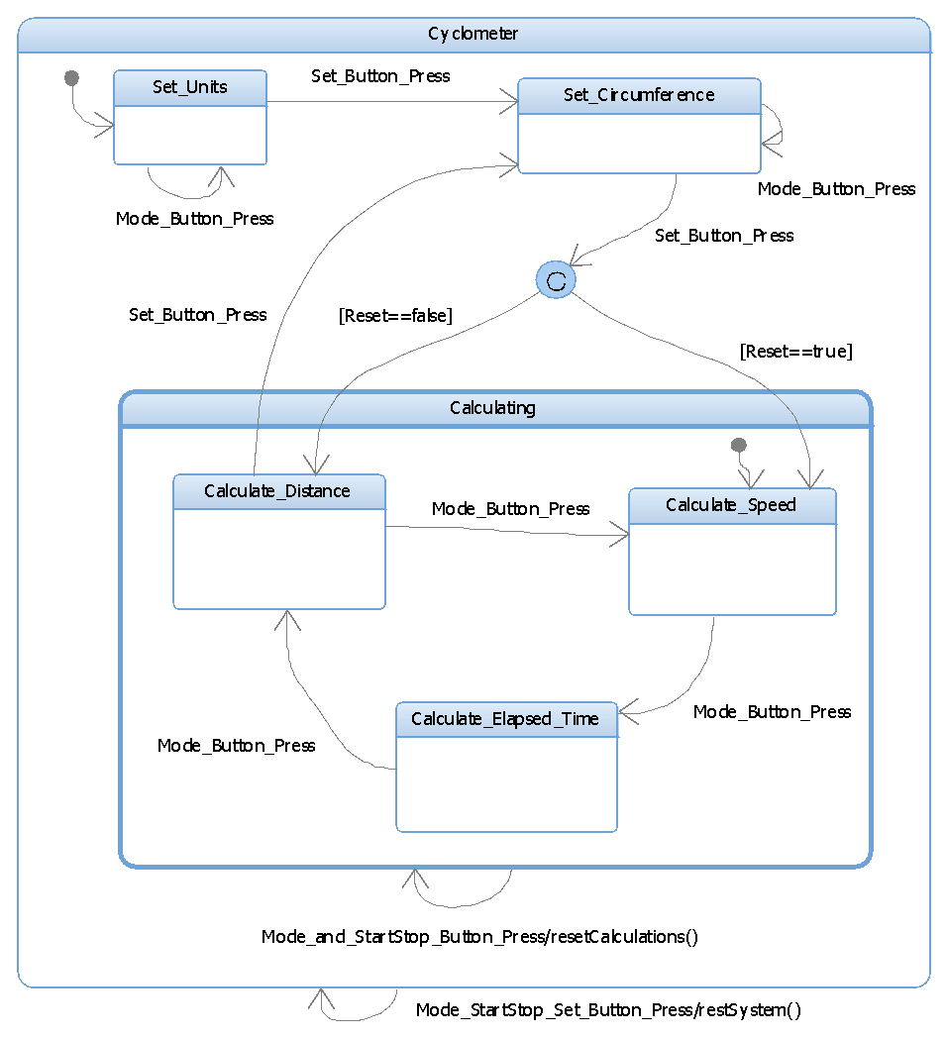

Manual Statechart  
This Manual state diagram will be inside both the Calculate_Speed and the Calculate_Elapsed_Time states.

It shows the details of transitioning between having calculations turned on (Active) and having them turned off (IDLE).

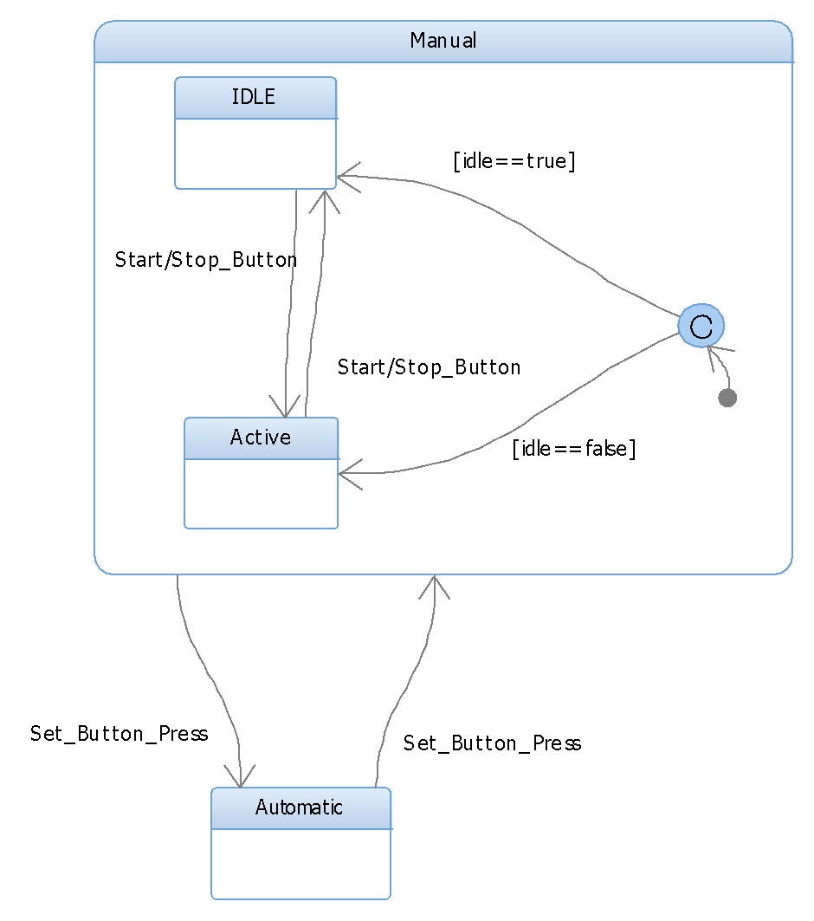

Set Circumference Statechart  
This state chart details the setting of the wheel circumference. The Idle state is where the circumference is displayed. It will determine if the user wants to increase the manual count by one, or auto increment. This is done by watching a counter to see how many button press signals are received in a predetermined amount of time.

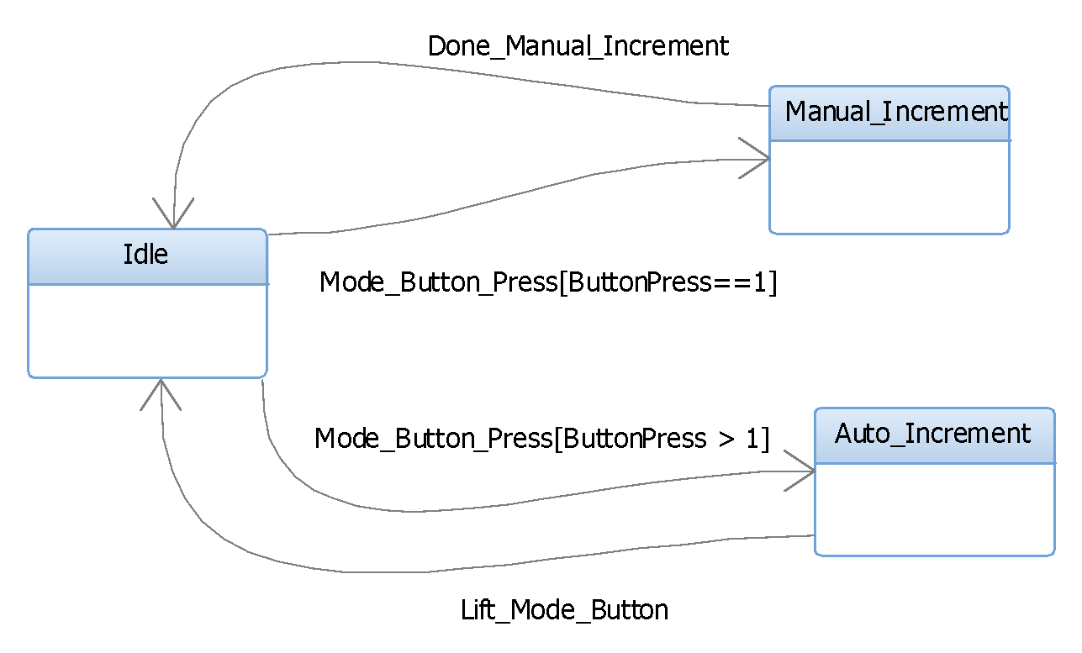

## Class Diagrams

For the classes that will represent the system, it was decided to represent the main state machines of the cyclometer. Those state machines being the Cyclometer superstate and the Calculating superstate. In addition, an input class was added to handle reading and a display class was added to handle writing to the board.   
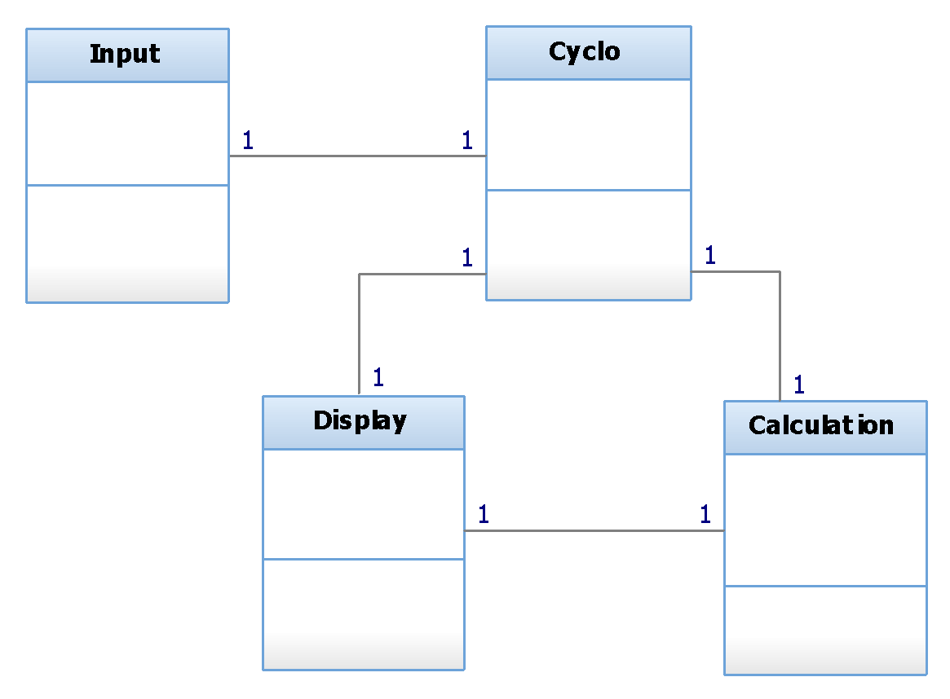

# Sequence Diagrams

The first diagram details the detection of wheel cycles ending with the calculation of speed.

The input object will have a thread detecting wheel pulses and another thread watching a counter. If the counter is higher than it was a second ago, then it knows that the bicycle is moving. It sends the new value of the counter to the cyclometer, that has an internal check on which state that system is in. Assuming the cyclometer is in a state that allows calculations to occur, it then sends a calculation message prompting a thread within the calculation class to computes the needed speeds.

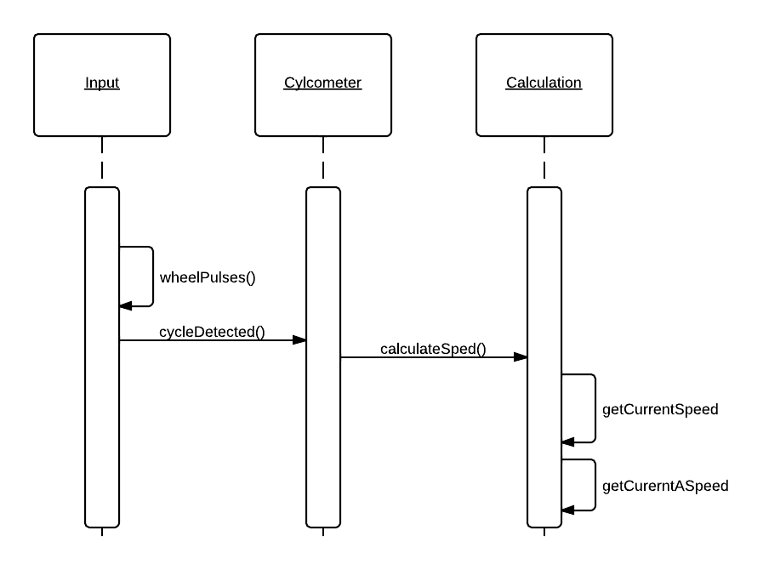

This shows the detection on stopping. If the thread watching the counter does not see an increase in wheel pulses within 2 seconds, it raises a stop flag. Which then, tells the cyclometer class that is has stopped. Which then, indicates the calculation class to stop calculating.

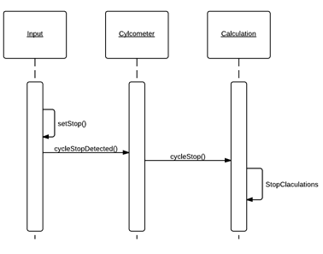

# Calculations

## Speed

As designed, the average speed and current speed will be displayed at the same time. Since the 4 digit display is used, this means that the maximum speed that can be display is 99. That is the same for the average speed.

A single thread will be tasked with watching the wheel rotations; this will be done every 200 ms. That was determined from the interval between pulses needed for cyclists to be traveling. At the average speed, one could expect a cyclist to travel a little faster. When a signal is received it increments a counter. Another thread will check that counter every second. It will determine if the cyclist is moving, if the counter is above the threshold. Based on the given spreadsheet for calculating speed, at 1 pulse a second a person will be traveling at 8 km/h or 5 mph. This means that for the thread checking each second, the cyclometer will not be able to show speeds below those.

## Average Speed

A thread will be dedicated to calculating average speed. It will calculate it using the equation (total distance)/(total time).

## Distance

Distance can be calculated from speed/time. the speed will be in (miles or kilometers) per hour and time in minutes. So, dividing the speed by 60 will allow the calculations to have the same time units.