|  |
| --- |
| Rochester Institute of Technology |
| Final Project: Cyclometer |
| Requirements Analysis |
|  |
| **Nsama Chipalo & Jenny Zhen** |
| **4/17/2014** |

|  |
| --- |
|  |

Table of Contents

Actors External to the System 2

Use Cases 2

Use Case Diagram 3

Requirements 3

Events 4

Miscellaneous 4

# Actors External to the System

* Bicycle wheel sensor
* Mode button
* Set button

# Use Cases

* Name: Auto Start/Stop of Measuring  
  Goal: Measure the data values when a pulse is received by the sensor  
  Actor: Bicycle wheel sensor
* Name: Manual Start/Stop of Measuring  
  Goal: Start or stop measuring data values when the user presses the set button  
  Actor: Set button
* Name: Shift of Lower Display  
  Goal: Display different data values.  
  Actor: Mode button
* Name: Enter Power Saving Function  
  Goal: Enter power saving mode if a signal has not been received after 10 minutes.  
  Actor: Bicycle wheel sensor/Mode button
* Name: Return from Power Saving Function  
  Goal: Return to normal display from power saving mode upon press of mode button, or signal from bicycle wheel sensor.  
  Actor: Bicycle wheel sensor/Mode button
* Name: Data Reset  
  Goal: Reset the measured data to zero for screens with the Reset mark in the OPERATION FLOW.  
  Actor: Mode button
* Name: Change Tire Size  
  Goal: Select the size of the tire from a preset size, or enter the tire’s circumference directly in increments of 1 cm.  
  Actor: Set button
* Name: Set Units of Measurement  
  Goal: Set the units to either km/h or mph.  
  Actor: Mode button
* Name: Set Current Time  
  Goal: Set the current time, using the 12 hour clock or 24 hour clock.  
  Actor: Set button
* Name: Initialize System  
  Goal: Initialize all data values to zero and reset other system values  
  Actor: Set button

# Use Case Diagram

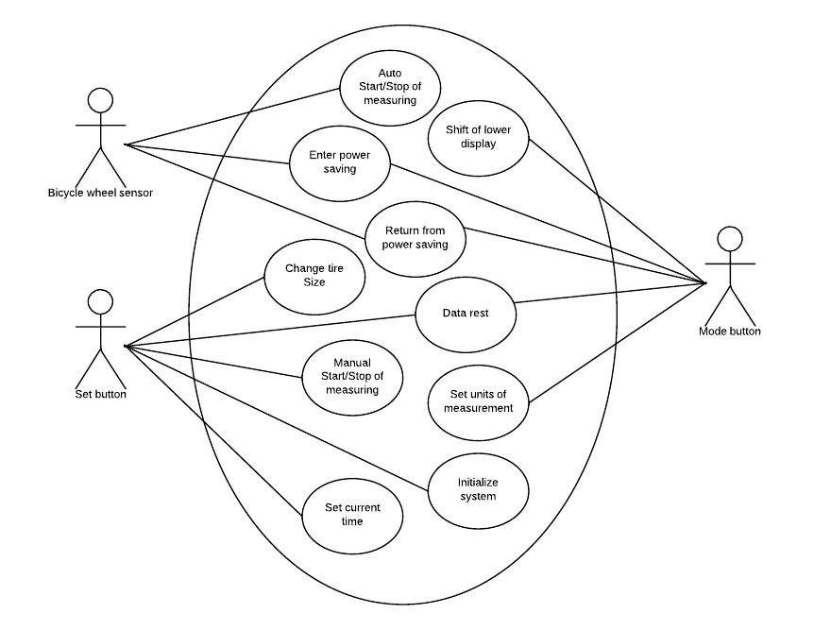

# Requirements

1. The cyclometer shall display the current speed of the bicycle in km/h or mph
2. The cyclometer shall display the average speed of the bicycle in km/h or mph
3. The cyclometer shall display the total distance traveled in km or miles
4. The cyclometer shall display the elapsed time in seconds
5. The cyclometer shall display the current time in 24h or 12h format
6. The cyclometer shall calculate the average speed, total distance, and elapsed time
7. The cyclometer shall allow the user to start the calculations
8. The cyclometer shall allow the user to fully reset the system
9. The cyclometer shall allow the user to set the current time in 24h or 12h format
10. The cyclometer shall allow the user to set the units of measurement in km/h or mph
11. The cyclometer shall allow the user to set the tire circumference in centimeters
12. The cyclometer shall perform an initialization of stored data and operations

# Events

Event name: Mode button push

Actor: Mode button

Timing characteristics: The system will poll for a button press every 500 ms.

Effects: Receiving a mode button push cycles between the different data values displayed (i.e. current speed, average speed, total distance, elapsed time, and current time).

Event name: Set button push

Actor: Set button

Timing characteristics:  The cyclometer will poll from the sensor every 500 ms.

Effects: Receiving a set button push sets the user settings (i.e. current time, 12 or 24 hour clock, km/h or mph).

Event name: Bicycle sensor

Actor: Sensor

Timing characteristics: The cyclometer will poll from the sensor every 250ms

Effects: Receiving a signal from the sensor indicates that the tire of the bike has taken one full revolution.

# Miscellaneous

The cyclometer will display speeds from 1 - 299 mph.

Calculating the current speed will be performed via these two equations depending on whether the user chose MPH or KPH.

(circumference *RPM*60)/(5280 (feet in a mile)*12(inches in a foot)*2.54) = RPM -> MPH

(circumference *RPM*60)/(3280.84 (feet in a km)*12(inches in a foot)*2.54) = RPM -> KPH

The calculation will be performed each time the cyclometer receives a signal from the sensor. The display will be updated every time the cyclometer calculates the speed. If the cyclometer cannot display decimals, then speeds with decimals of 0.5 or higher will be rounded up and anything lower will be rounded down. Otherwise, the cyclometer will show as many decimals as possible.

Average speed is defined as (total distance)/(total time). The cyclometer will keep track of the the total distance traveled and the time since you began traveling.

The cyclometer will detect that the bicycle has stopped when it has not received a signal from the sensor within a set amount of time.

To determine how fast the cyclometer will be polling the inputs (buttons, magnetic sensor), the average speed that people generally travel at on their bicycles was researched (14-16 mph). Based on that average speed that bicyclists usually go at, those speeds translate to be between 120 and 190 RPM which 2 to 3 revolutions a second. To catch all the signals the system will have to poll at a rate of 250 ms.