**INFORME ANUAL CURSO 2021/2022**

|  |  |
| --- | --- |
| **Alumno/a:** Alba Altozano García |  |
| **Profesor/a:** Eduardo Morales Mirón |
| **Clase:** 3º-A |
|  |

|  |  |  |  |  |  |
| --- | --- | --- | --- | --- | --- |
| **ASIGNATURA** | **PRIMER TRIMESTRE** | **SEGUNDO TRIMESTRE** | **TERCER TRIMESTRE** | **NOTA TOTAL** | |
| BIOLOGIA | 4.0 | 1.0 | 10.0 | **5.0** | APROBADO |
| CULTURA CLASICA | 9.8 | 10.0 | 10.0 | **9.9** | SOBRESALIENTE |
| EDUCACION FISICA | 2.0 | 10.0 | 10.0 | **7.3** | NOTABLE |
| EDUCACION PLASTICA | 9.3 | 8.8 | 10.0 | **9.3** | SOBRESALIENTE |
| ETICA | 9.0 | 9.5 | 10.0 | **9.5** | SOBRESALIENTE |
| FRANCES | 9.2 | 7.8 | 10.0 | **9.0** | SOBRESALIENTE |
| GEOGRAFIA E HISTORIA | 3.0 | 7.2 | 10.0 | **6.7** | APROBADO |
| INGLES | 2.0 | 8.5 | 10.0 | **6.8** | APROBADO |
| LENGUA CASTELLANA Y LITERATURA | 4.0 | 3.0 | 10.0 | **5.7** | APROBADO |
| MATEMATICAS | 2.0 | 9.2 | 10.0 | **7.1** | NOTABLE |
| MUSICA | 6.0 | 6.0 | 10.0 | **7.3** | NOTABLE |
| TECNOLOGIA | 9.1 | 7.3 | 10.0 | **8.8** | NOTABLE |

**Progreso trimestral:**

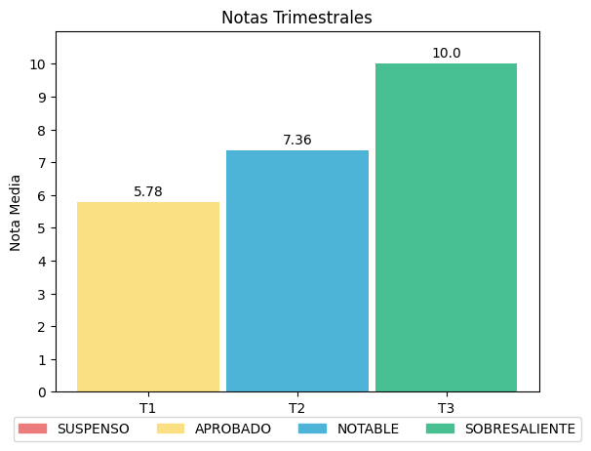

|  |
| --- |
| **COMENTARIOS** |
|  |
|