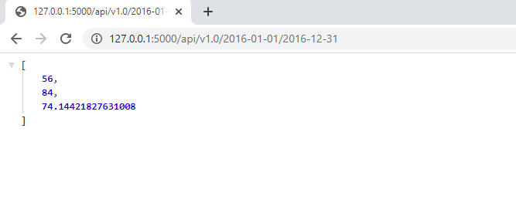

The date portion is working!!!! Hurray!!