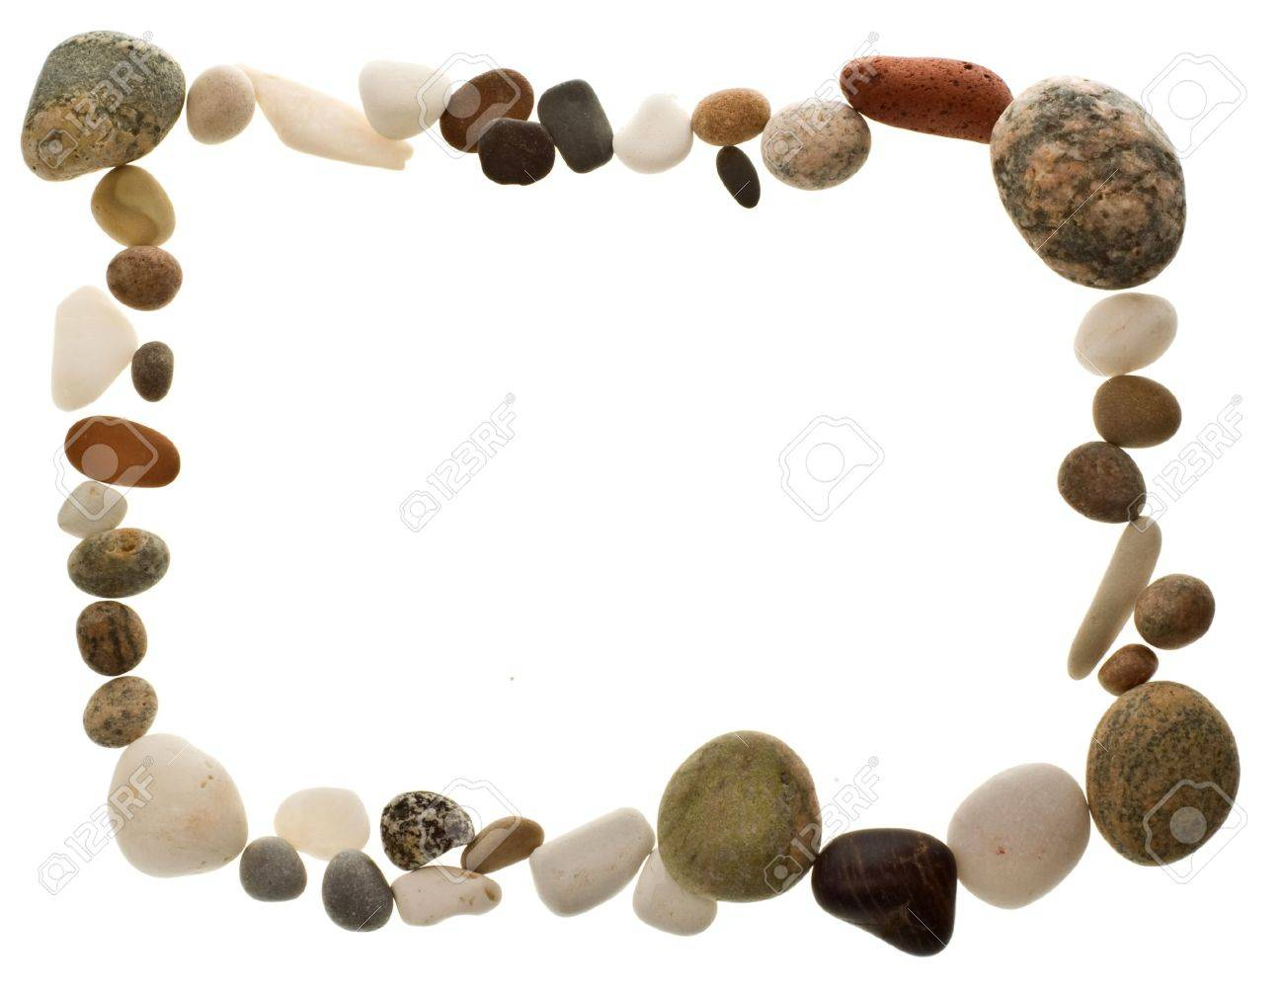

PROJECT IN SCIENCE

Submitted by:
Joshua Andrew G. Banaria

Submitted to:
Mrs. Catherine C. Abelinde
Science Teacher

TYPES OF ROCKS
Igneous Rocks
Igneous rocks form when magma or lava cools and solidifies. They are classified by where they cool — slowly underground (intrusive) or quickly at the surface (extrusive).
Intrusive (Plutonic)
Cools slowly deep underground, producing large, visible crystals (coarse-grained texture).
Granite
A light-colored, coarse-grained rock composed mainly of quartz, feldspar, and mica. One of the most common rocks in the continental crust and widely used in construction and countertops.
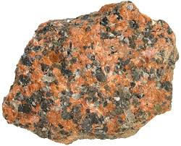
Gabbro
A dark, coarse-grained rock composed mainly of pyroxene and plagioclase feldspar. It forms the bulk of the oceanic crust beneath the basalt layer.
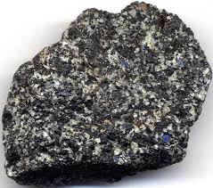
Diorite
An intermediate-colored, coarse-grained rock with a salt-and-pepper appearance. Used in ancient sculptures and as a construction material.
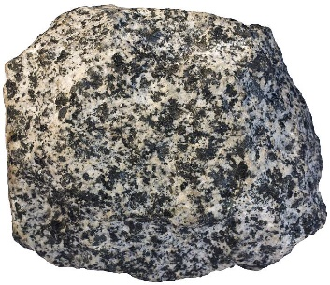
Peridotite
An ultramafic rock composed mostly of olivine and pyroxene. It makes up the majority of the Earth's upper mantle.
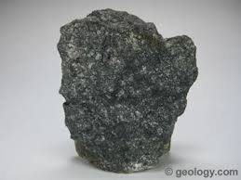
Extrusive (Volcanic)
Cools rapidly at or near the Earth's surface, producing fine-grained or glassy textures.
Basalt
A fine-grained, dark volcanic rock. The most common rock on Earth's surface, forming ocean floors and volcanic islands like Hawaii.
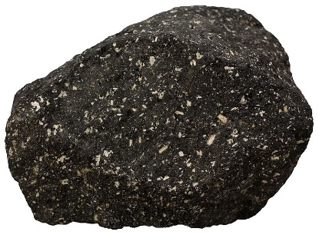
Obsidian
A naturally occurring volcanic glass formed from rapidly cooling lava. Its razor-sharp edges made it a prized tool material for early humans.
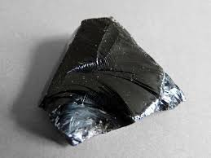
Pumice
A highly porous, lightweight volcanic rock formed from frothy, gas-rich lava. It is so light it can float on water and is used as an abrasive.
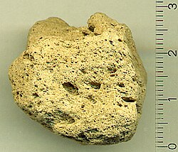
Rhyolite
The fine-grained volcanic equivalent of granite. Light-colored and silica-rich, it forms from viscous lava flows and explosive eruptions.
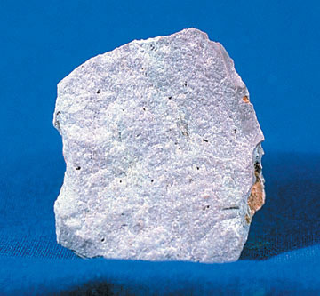

Sedimentary Rocks
Sedimentary rocks form at or near the Earth's surface from accumulated sediment, chemical precipitation, or organic material. They cover ~75% of Earth's land surface and commonly contain fossils.
Clastic (Detrital)
Formed from fragments of pre-existing rocks that are weathered, transported, deposited, and cemented together. Classified by grain size.
Sandstone
Composed of sand-sized grains (0.06–2 mm) cemented together. Commonly forms in rivers, beaches, and deserts. Porous enough to serve as a reservoir for oil and groundwater.
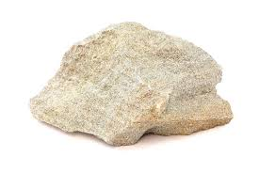
Shale
The most abundant sedimentary rock, composed of fine clay and silt particles. Forms in quiet, low-energy environments like deep ocean floors and lake beds. Splits easily into thin layers.
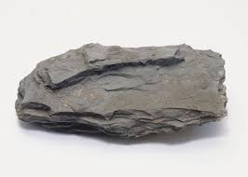
Conglomerate
Contains rounded pebble-sized or larger fragments embedded in a finer matrix. The rounded shape of clasts indicates long transport by water before deposition.
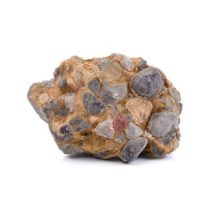
Breccia
Similar to conglomerate but made of angular, jagged fragments, suggesting the clasts were not transported far from their source before burial.
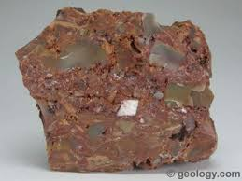
Chemical
Forms when dissolved minerals precipitate out of water due to evaporation or changes in water chemistry.
Rock Salt (Halite)
Forms by evaporation of saltwater bodies such as inland seas and lakes. Mined extensively for table salt, food preservation, and chemical production.
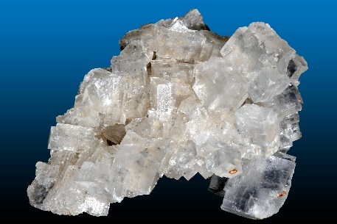
Rock Gypsum
An evaporite mineral that forms in arid environments when sulfate-rich water evaporates. Used in the production of plaster, cement, and drywall.
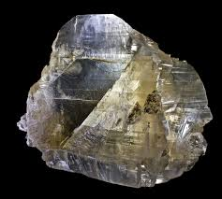
Travertine
A type of limestone deposited by mineral-rich springs or in caves. Forms stalactites and stalagmites and has been used as a building material since antiquity.
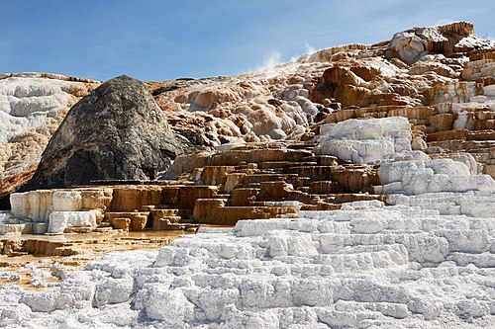
Organic (Biogenic)
Forms from the accumulation and compaction of plant or animal remains over millions of years.
Coal
Formed from compressed plant matter in ancient swamp environments. A major fossil fuel burned for energy, and a source of carbon for industrial chemicals.
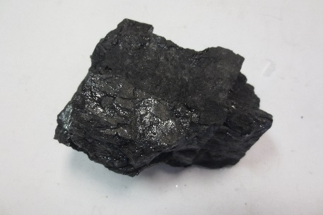
Chalk
A soft, fine-grained limestone made from the shells of microscopic marine organisms called coccolithophores. The white cliffs of Dover are a famous example.
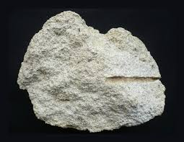
Fossiliferous Limestone
Contains visible fossils of shells, corals, and other marine organisms cemented in a calcium carbonate matrix. Used in cement production and as a building stone.
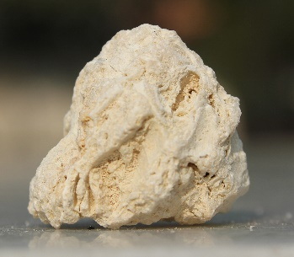

Metamorphic Rocks
Metamorphic rocks form when existing rocks are transformed by intense heat, pressure, or chemically active fluids deep within the Earth — without melting. The original rock is called the protolith.
Foliated
Have a layered or banded texture caused by directional pressure that forces minerals to align in parallel planes. Grade increases from slate → phyllite → schist → gneiss.
Slate
The lowest-grade foliated metamorphic rock, formed from shale. Very fine-grained with a flat cleavage that allows it to split into smooth sheets. Used in roofing, flooring, and blackboards.
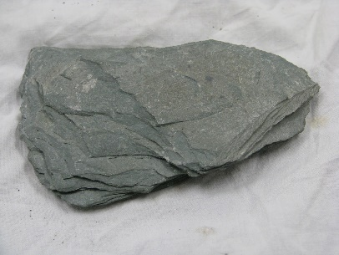
Phyllite
A slightly higher-grade rock than slate, still derived from shale. Has a silky, glossy sheen on its surface due to tiny aligned crystals of mica and chlorite.
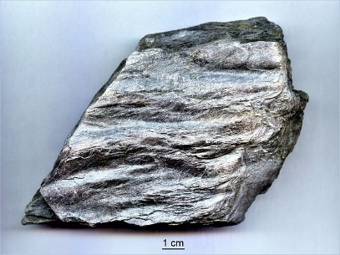
Schist
A medium- to high-grade foliated rock with large, clearly visible mica crystals that give it a sparkly, flaky appearance. Often contains garnet, staurolite, or kyanite.
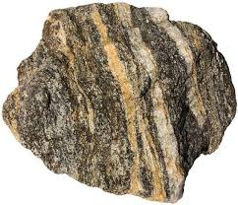
Gneiss
A high-grade metamorphic rock with distinct alternating light and dark bands. One of the most common rocks in Earth's crust. The light bands are rich in quartz and feldspar; dark bands in biotite and hornblende.
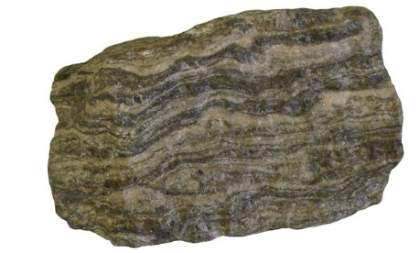
Non-Foliated
Lack layered texture because they formed under uniform (non-directional) pressure, or contain minerals such as calcite and quartz that do not align into visible layers.
Marble
Formed from the metamorphism of limestone or dolostone. Composed of recrystallized calcite or dolomite. Prized since antiquity for sculpture and architecture (e.g. the Parthenon, Michelangelo's David).
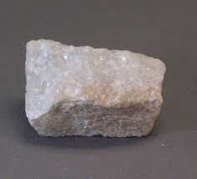
Quartzite
Formed from the metamorphism of sandstone. Extremely hard and resistant to weathering and chemical attack. Used in flooring, road construction, and as a decorative stone.
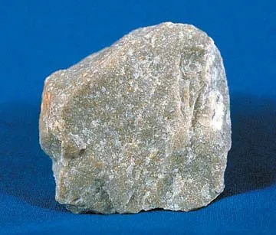
Hornfels
Formed by contact metamorphism — heat from a nearby magma intrusion bakes the surrounding rock. Very fine-grained, dense, and hard. Composition reflects the original rock type.
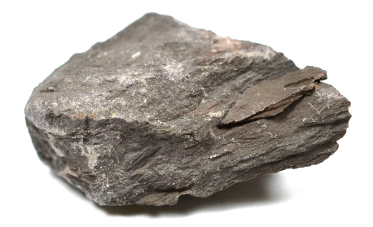
Anthracite
The highest grade of coal, formed when bituminous coal is subjected to intense heat and pressure. Hard, shiny black, burns hotter and cleaner than other coal grades.
