Stock Market Monitor

Wang Wei, Donghyeok Seo

This program provides information to help users to make the most profitable decision when they trade stocks. Since time is critical in stock market, information is updated in real time from WebAPIs. Program saves data in database to analyze, so user can view stock's history anytime as a graph and can compare to other stock.

User can search stock with filter such as range of price, business category and so on, and with order such as name, price, and category.

User can also trade their stock. There is automatic trade feature by target price, decreasing/increasing rate and time.

*Technologies

1. Mandatory

- WPF, C#

- SQL Database via Azure (at least 5 tables)

- Multiple windows, dialogs (at least 5 windows total)

- At least 10 unit tests, using NUnit

- Entity Framework

- External Libraries

a. DynamicPDF PrintManager : Printing, PDF-generation

b. LiveCharts : Drawing Charts on canvas

2. Additional

-Ribbon instead menus

-StackPanel, GridSplitter

-TabControl, ToolBar, TreeView

-LINQ

-Printing using WPF or additional library

-Drawing Charts on canvas

-WebAPIs client

a. [**Finnhub - Free realtime APIs for stock, forex and cryptocurrency.**](https://finnhub.io/docs/api#company-profile)

: Stock information

*Database Diagram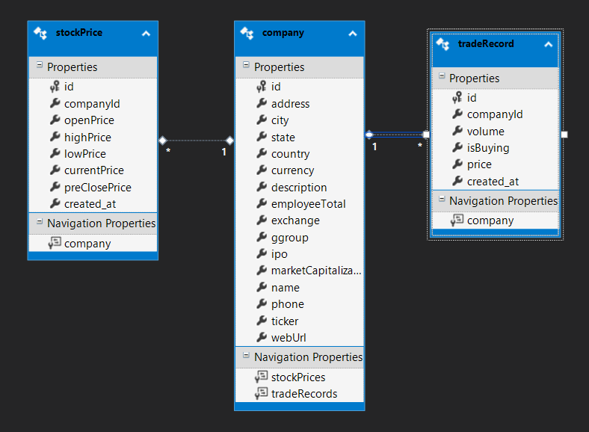

*Program Design(Screenshots)

1. Stock Information Window(Menu)

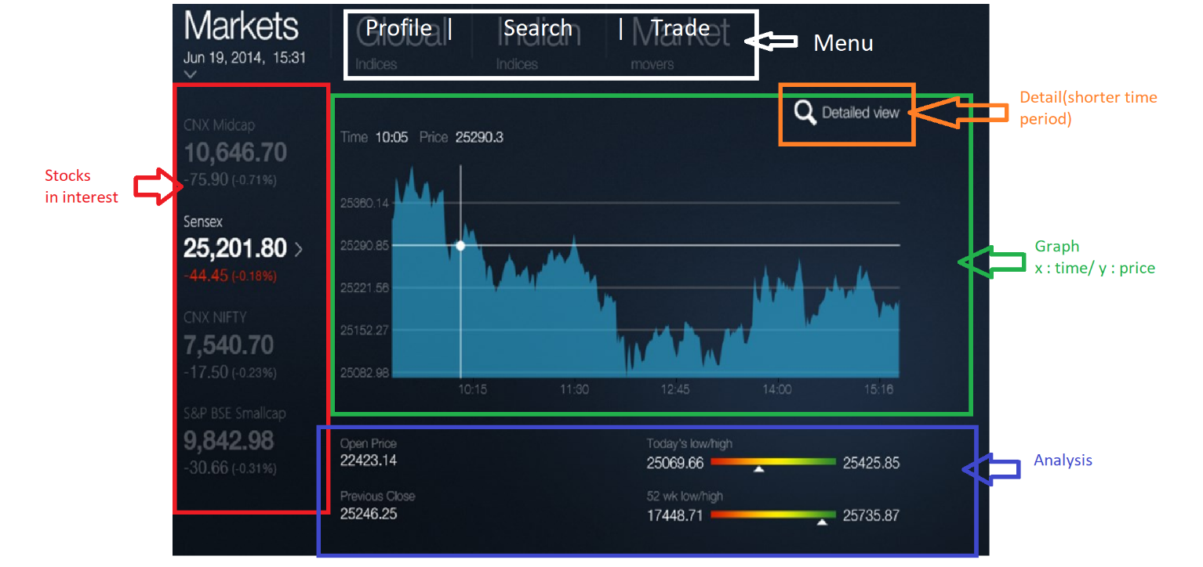

2. Search Window(Menu)

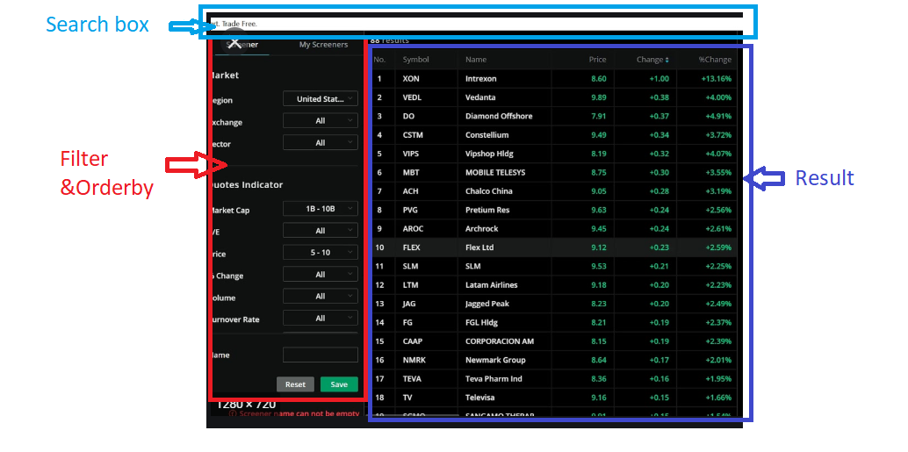

3. Stock Trade Dialog(Popup)