Term Project 1 Report: KOSPI Prediction using Regression Models
컴퓨터학부 20211426 손정인

Summary
This project is regression models to predict the next day's closing price of the KOSPI. It utilizes historical KOSPI Open, High, Low, Close, and Volume data from 2019 to 2022 for training and 2023 data for testing. The term project is divided into two parts. Part 1 established a baseline. We trained Linear Regression, Random Forest, and XGBoost models using original OHLCV data and a selected derived feature (5-day Moving Average). Time Series Cross-Validation was employed for model selection in this part. Part 2 aimed to improve prediction accuracy. This was done by adding publicly available data: the S&P 500 index and KRW/USD exchange rate. We also included a broader set of derived technical indicators. Data preprocessing included handling missing values and feature scaling. Models were re-trained and evaluated with the expanded features on the 2023 test data. Findings show that both approaches provide reasonable predictions. However, including external factors and comprehensive derived features generally leads to slight accuracy improvements (measured by RMSE).

Introduction
Predicting stock markets is a challenging but vital task in financial analysis. Accurate forecasting of indices like the KOSPI offers valuable insights for investors. The KOSPI is affected by domestic economics, company performance, and global trends. This project applies regression techniques to predict the KOSPI's next-day close. The study has two phases. First, we build a basic model using only historical KOSPI data. Second, we enhance this model by adding relevant external economic and market data. This aims to capture wider market influences and potentially boost prediction performance.

Methods
Data Collection and Preprocessing:
I used daily KOSPI data from kospi_train.csv (2019-2022) and kospi_test.csv (2023). This data included Open, High, Low, Close, and Volume. External data was also collected. This included the S&P 500 index (^GSPC) and the KRW/USD exchange rate (KRW=X). I fetched this data using the yfinance Python library for the relevant periods. Data loading involved parsing dates and setting the 'Date' as the index. Preprocessing included handling missing values. We used forward fill (ffill()) for time series data. Rows with remaining NaNs were dropped. Feature scaling used StandardScaler. It was fitted only on training data to avoid test data leakage.
Feature Engineering:
Part 1: I calculated a 5-day Moving Average (MA_5) of the Close price. This was used along with the original OHLCV.
Part 2: The feature set was expanded. We added more derived technical indicators: 20-day Moving Average (MA_20), daily Range (High - Low), High-to-Close Ratio, Close-to-Low Ratio, and Volume Change percentage. The external data columns (SP500_Close, KRW_USD_Close) were also added as predictors. The target variable for all models was the next day's Close price (Close.shift(-1)).
Models Used: We used three regression models:
Linear Regression (LR): A simple model assuming a linear relationship. It serves as a baseline.
Random Forest Regressor (RF): An ensemble tree model. It can capture non-linear relationships and feature interactions.
XGBoost Regressor (XGBoost): A gradient boosting framework. It is known for high performance.
Experimental Setup:
Part 1: Models were evaluated using Time Series Cross-Validation (TimeSeriesSplit) with 5 splits on the 2019-2022 training data. Hyperparameter tuning for RF and XGBoost used GridSearchCV within the CV loop. We used a smaller number of splits (e.g., 3) for tuning efficiency. The model with the lowest average RMSE across CV folds was chosen as the best for Part 1. This best model was then trained on the full Part 1 training data. Its final performance was evaluated on the Part 1 test data (2023).
Part 2: The same model types (LR, RF, XGBoost) were used. RF and XGBoost used the best hyperparameters found in Part 1 CV. These models were trained and evaluated using the expanded feature set. Training used the combined KOSPI and external training data (2019-2022). Evaluation used the corresponding combined test data (2023). Performance was again measured using RMSE on the test set.
Analysis: We primarily evaluated model performance using Root Mean Squared Error (RMSE). RMSE measures the average magnitude of prediction errors. We generated visualizations (line plots) of actual vs. predicted closing prices on the test data. These graphs show a qualitative comparison of the predictions.
GitHub Repository: https://github.com/jeong-inn/Term-project-1-of-Maching-Learning-2025-1

Results
This section presents the experimental findings from both Part 1 and Part 2 of the project.
Part 1: Basic Features + Selected Derived Feature We evaluated models using Time Series Cross-Validation on the training data. The average RMSE and standard deviation for each model are shown below:
Linear Regression : Avg CV RSME 32.15 ± 2.93
Random Forest: Avg CV RMSE 128.85 ± 84.29
XGBoost: Avg CV RMSE 127.11 ± 86.09
Based on these cross-validation results, the Linear Regression model showed the lowest average RMSE. Thus, it was selected as the best model for Part 1.
The final performance of the selected Linear Regression model on the 2023 test data was:
Test Data RMSE: 24.25
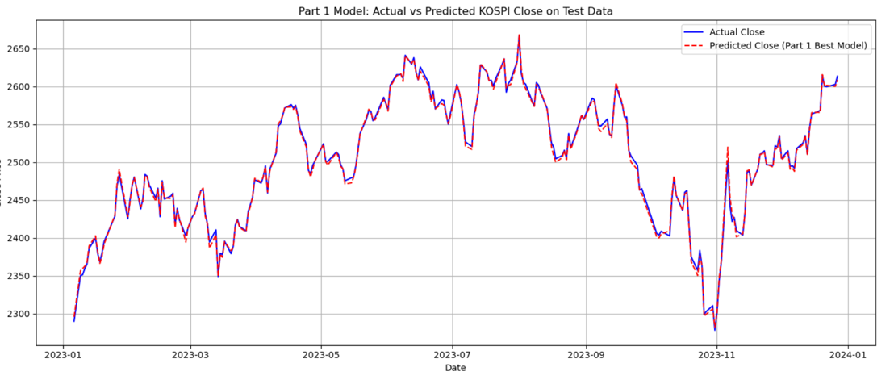
This graph visually compares the model's predictions against the true values over the test period.
Part 2: External Data + All Derived Features Models were trained using the expanded feature set, which included external data (S&P 500, KRW/USD) and a broader set of derived technical indicators. The training data shape for Part 2 was (966, 14) including the target, and the test data shape was (223, 14). This corresponds to 13 features used for prediction.
The performance of the models on the 2023 test data using the expanded features was:
Linear Regression: Test Data RMSE 23.75
Random Forest: Test Data RMSE 30.00
XGBoost: Test Data RMSE 27.29
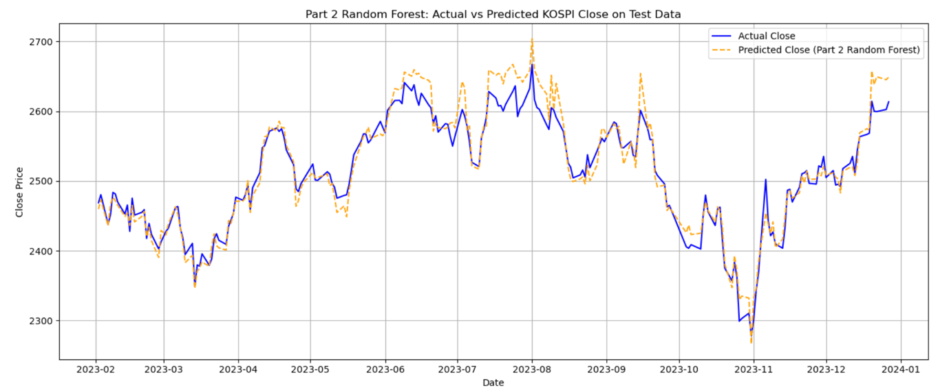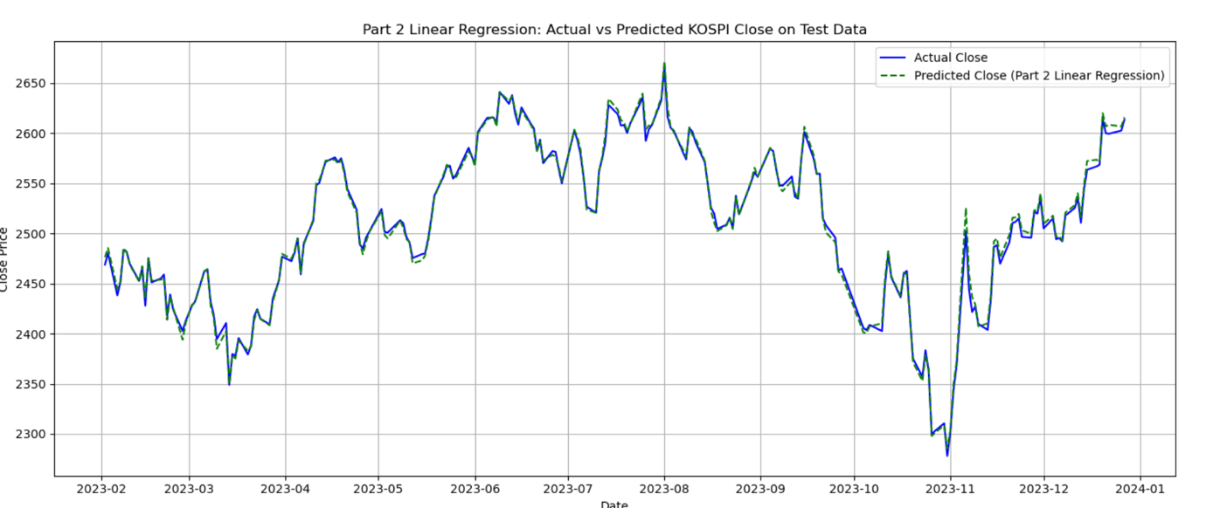
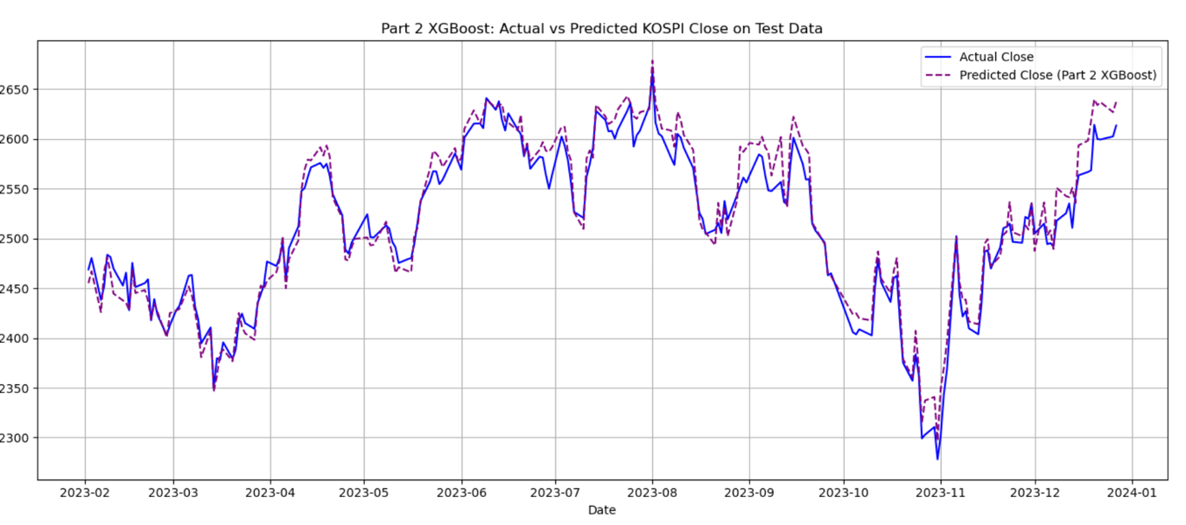
These visualizations help in assessing how well each model with the expanded features tracks the actual market movements.

Discussion
I compared test RMSEs from Part 1 and Part 2 to see the impact of added features. Part 1's best model, Linear Regression, had an RMSE of 24.25 on the test data. In Part 2, using expanded features, Linear Regression achieved an RMSE of 23.75. Random Forest got 30.00, and XGBoost got 27.29. Linear Regression performed best in Part 2, showing a slight improvement from Part 1 (24.25 to 23.75). LR also outperformed Random Forest and XGBoost with the expanded features. This suggests that adding external data can help improve predictions, as seen with the Linear Regression model. However, the benefit depends on the model used.

Conclusion
This project aimed to predict KOSPI's next-day close and improve predictions using external data. We successfully built regression models. Adding external market data and more derived features improved the Linear Regression model's accuracy on the test data (RMSE from 24.25 to 23.75). The Linear Regression model with expanded features showed the best performance overall. This suggests external factors can contribute to better models. However, the benefit depends on the model used.

