

Lecture with Computer Exercises:
Modelling and Simulating Social Systems with MATLAB

Project Report

Impact of Chemoprophylaxis on the Tuberculosis epidemiology

Mihye An & Ayoung Jeong

Zürich
16. Dec. 2011
IMPORTANT

You MUST include the ETH declaration of originality here; it is available for download on the course website or at

http://www.ethz.ch/faculty/exams/plagiarism/index_EN;

It can be printed as pdf and should be filled out in handwriting.
Agreement for free-download

We hereby agree to make our source code of this project freely available for download from the web pages of the SOMS chair. Furthermore, we assure that all source code is written by ourselves and is not violating any copyright restrictions.

Mihye An | Ayoung Jeong

Content

Abstract

Individual contributions

Introduction and Motivations
Epimediology and pathophysiology of tuberculosis
Tuberculosis (TB) is one of the most devastating infectious diseases killing around two million people worldwide every year. Although drugs are available since several decades, TB is still the second leading cause of death in the world and nearly one third of the whole human population is thought to be infected by Mycobacterium tuberculosis. And there isn’t an efficient vaccine yet.
When an individual is infected with M. tuberculosis, he/she can develop a primary TB, which means that the infected individual gets TB as an active disease within a year after the infection. However, they more often enter the latent phase: M. tuberculosis is contained in granulomas that limit further spread of the bacteria through the body. As long as the bacteria stay as latency, they don’t make any symptom, but they could suddenly develop an active disease by endogenous reactivation especially when the individual’s immune system gets weaker, for example in case of HIV/AIDS. The individual co-infected with HIV has a higher chance to develop a primary TB.

Treatment regimens and MDR-TB problem
There are well-established standard drug regimens for TB treatment. It is composed of several antibiotics such as isoniazid, rifampicin, pyrazinamide, streptomycin and ethambutol. Various combination of these drugs are recommended depending on the previous history of treatment and the appearance of clinical manifestation. Some bacteria strains of M. tuberculosis have resistance against these drugs and they’re called MDR-TB(multidrug-resistant tuberculosis) strains if they’re resistant to at least isoniazid and rifampicin. The MDR-TB cannot be treated by the standard drug regimens at all, so that they must be treated with reserve drugs such as levofloxacin, moxifloxacin etc. that cost much more than the standard drugs and have much more severe side effects. M. tuberculosis can have resistance naturally or acquire easily through a treatment failure.

Chemoprophylaxis as a new strategy to control tuberculosis
Either the standard drug regimens or reserve ones are to target the active disease with a variety of clinical manifestations. What if the latently infected individuals get treatment? This relatively new strategy is called chemoprophylaxis. Because it isn’t clinically manifested yet and thus it isn’t easy to identify the latently infected individuals, this strategy usually targets only a limited group of high risk such as prisoners or HIV/AIDS patients. How about implement this strategy to general publics? Would that help eradicating the disease faster? It has been discussed recently. What seems to be worrisome is the fact that the chemoprophylaxis consists of one drug, isoniazid, in most cases. On the one hand, chemoprophylaxis can reduce incidence because the latently infected individuals get treated and less develop into the infectious stage, which might help contribute to control the disease a lot. On the other hand, this monodrug therapy could enhance the development of drug resistance, which might have adverse impact on the epidemiology of the disease.
Now in this work is to investigate the question: whether the chemoprophylaxis would lead to an eradication of the disease or a MDR-TB pandemic?

Description of the Model
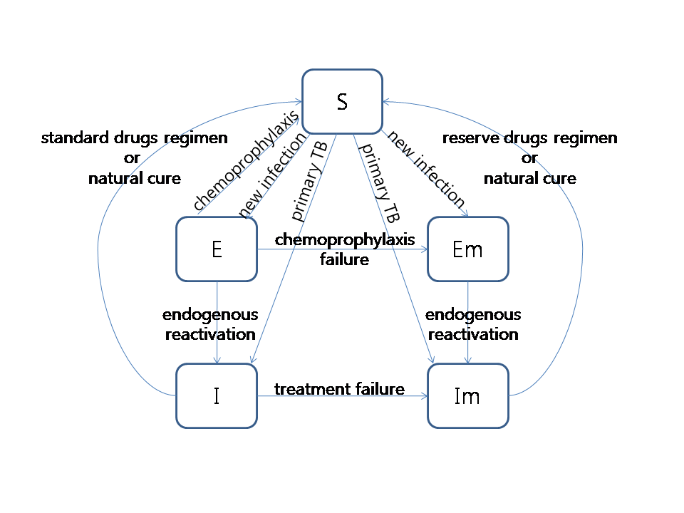
Our simulation is based on the SEIS model modified from the basic SIR model that consists of S(susceptible), I(infected) and R(recovered). Our SEIS model has S(susceptible), E(latently infected), I(active disease) and additionally Em(latently infected with MDR-TB strains) and Im(active disease by MDR-TB strains). This model doesn't consider R(recovered) as a discrete compartment because the individuals recovered from TB practically don’t have an immunity against M. tuberculosis and thus can be infected again with almost the same probability as the susceptible.

Fig.1 Structure of model. Population change due to birth and death from each compartments are not shown here.

SIR model is usually formulated using differential equations, but our simulation in implemented with agent-based cellular automata so that our model isn’t described as a set of differential equations. Instead, all the transition rates between the compartments are listed in a table below. All the parameters are reasonably adopted or calculated based on the empirical data provided by WHO except the chemophylaxis success rate, which is not known and thus estimated as 0.5 which is a little lower than the standard drug regimen’s success rate.

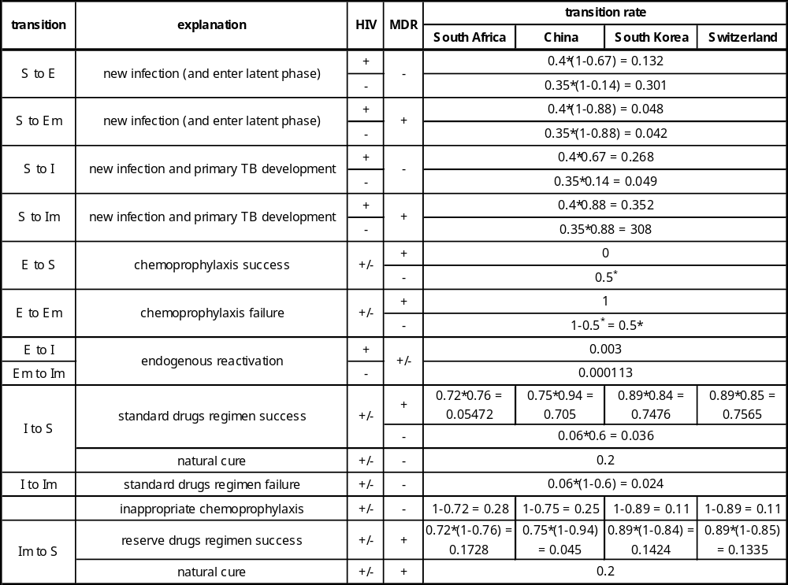
Table.1 Transition rates between the compartments. (*: estimated value)

Implementation
Class design: agent=individual, country=어떤 기준으로 골랐나

In this model an object defined by the class Agent is conceptually equal to an individual and this simulation should mimic the realistic conditions, but it’s not possible to simulate this model with agents as many as the actual number of population in a country. The biggest problem is the transmission of the disease, which is usually determined by the contact rate per capita(how many people in average does an individual get contacted with?) and the probability of the contagion in the original SIR model. In our model, the contact rate could be implemented through the speed or the maximal distance enabling contagions, but that approach would strongly influence the visualization. The number of agents is to adjust, instead, through a preliminary simulation.
A preliminary simulation is done to find out the appropriate number of agents and the further simulations are based on that number.

Simulation Results and Discussion
Preliminary simulation
In South Africa(countryID=1), the preliminary simulations with a varying number of agents from 200 to 500 are done to find out which number of agents will give a realistic incidence in South Africa, 0.00971. For each simulation run the incidence was followed up for 30 years of time and their average was calculated and plotted. The simulation was 10 times repeated for each number of agents. As shown in Fig.2, agents < 450 result in no incidence and about 475 agents is thought to give a reasonable incidence. A very wide error bar means that this simulation could lead to a vast variety of different results. Considering this result, 475 is set as the number of agent in South Africa for further simulations.
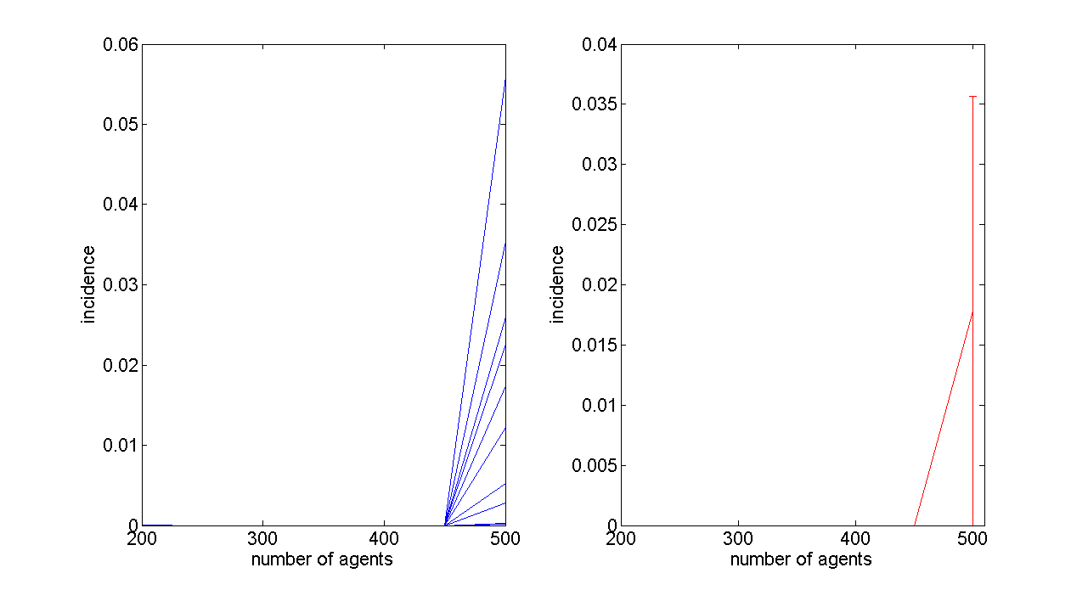
Fig.2 Preliminary simulation in South Africa: incidence in average of 30 years as a function of the number of agents for 10 different simulation runs. Left: each curve for one run. Right: average of every runs with error bars.

The appropriate number of agents is searched for China(countryID=2) in similar way. 200 to 500 agents have been shown not to be enough to reach the realistic value of incidence(Fig.3), so it was simulated once more with a higher range of numbers(Fig.4). Based on the latter result, the number was decided to be 675 which is believed to probably give incidence in the range around the realistic value, 0.00096. Due to the vast variety of the result, however, it was not expected to result in a sustainable value.
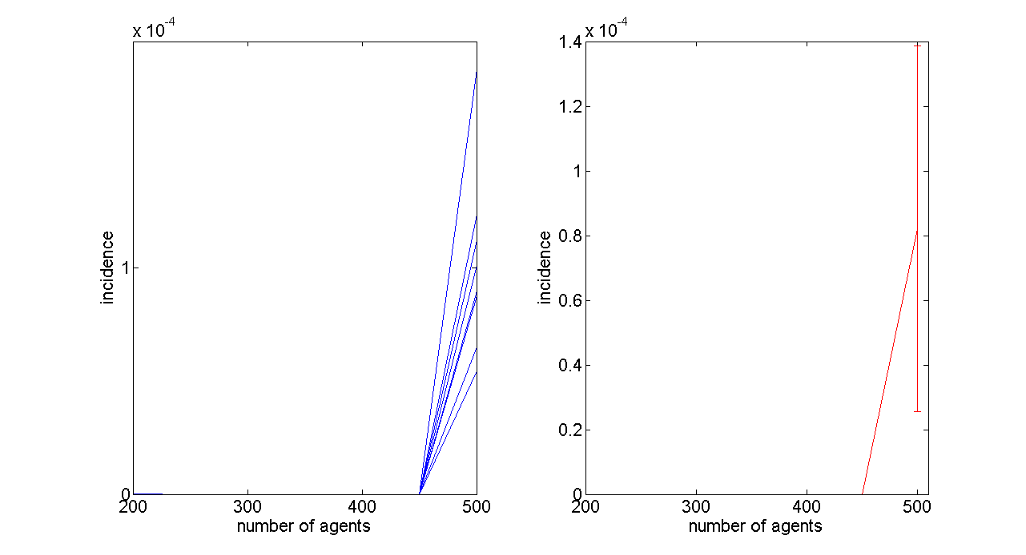
Fig.3 Preliminary simulation in China: incidence in average of 30 years as a function of the number of agents for 10 different simulation runs. Left: each curve for one run. Right: average of every runs with error bars.

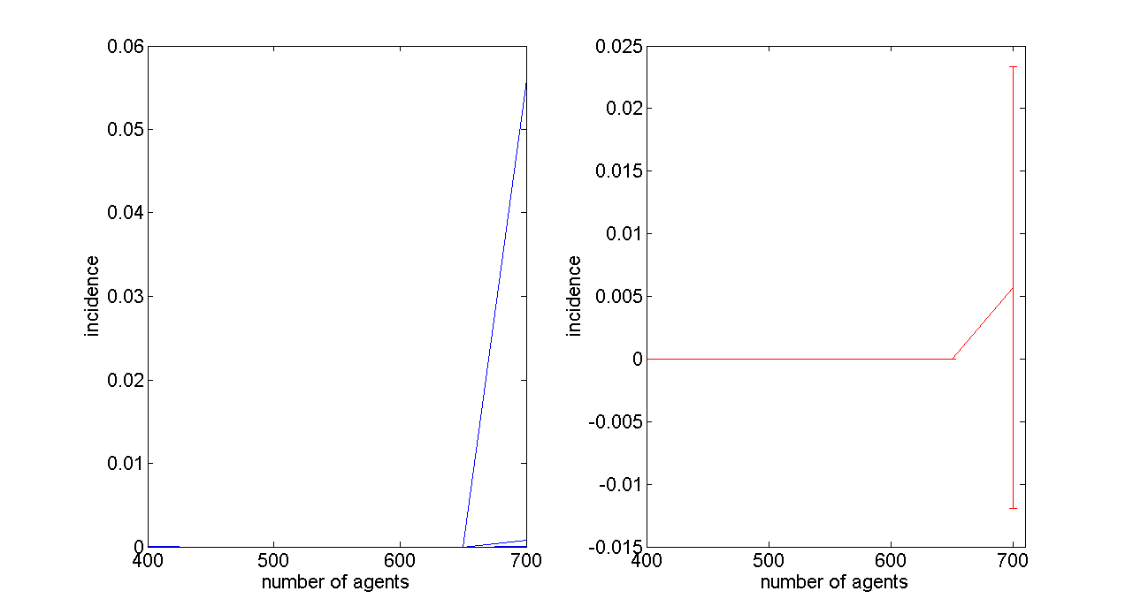
Fig.4 Second preliminary simulation in China: incidence in average of 30 years as a function of the number of agents for 10 different simulation runs. Left: each curve for one run. Right: average of every runs with error bars.

In a similar way the appropriate number of agents was estimated for South. The first simulation with the agent number from 200 to 500 resulted in too low incidence(Fig.5) but several further simulations with higher number of agents have shown us Korea to give an incidence in a reasonable range of the realistic value 0.00090(Fig.6). 560 was chosen for South Korea.
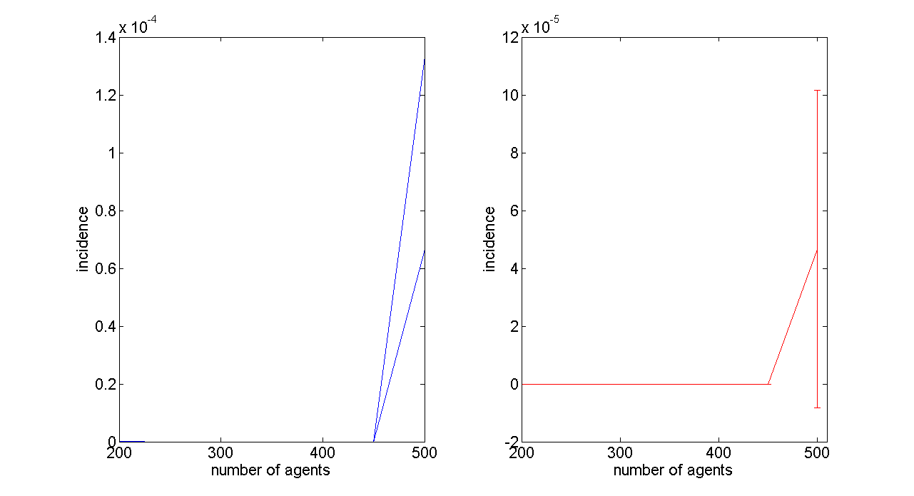
Fig.5 Preliminary simulation in South Korea: incidence in average of 30 years as a function of the number of agents for 10 different simulation runs. Left: each curve for one run. Right: average of every runs with error bars.

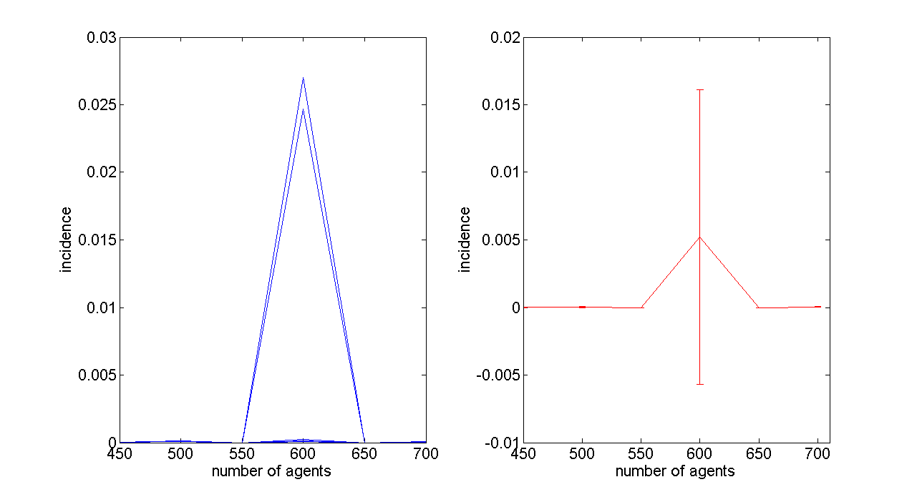
Fig.6 Summary of several further preliminary simulations in South Korea: incidence in average of 30 years as a function of the number of agents for 10 different simulation runs. Left: each curve for one run. Right: average of every runs with error bars.

The results of preliminary simulations above imply that this agent-based modelling might be inadequate to simulate an epidemiology over a huge population. Even in a country of middle burden, the incidence remain in a range of 10⁻³ to 10⁻⁴, for example 0.00090 in South Korea, which means that it may need to have more than 1000 agents to see at least one case each time step, a year, but it would be difficult to render a simulation with such high number of agents because of limited computing power. The number of agents needed would be much higher in case of low burden country like Switzerland where the incidence remains around 10⁻⁵. Considering that, we decided not to investigate further the low burden country with a very low incidence and only focus on the high burden countries, South Africa and China and the middle burden country, South Korea.

Evaluation of the impact chemoprophylaxis on MDR-TB prevalence
With the number of agents determined by the preliminary simulation above, the impact of the chemoprophylaxis in South Africa and China was examined. We repeated the simulation 20 times for each country with or without chemoprophylaxis to compensate the vast variety of possible results due to the relatively small number of agents.

South Africa
As shown in Fig.7, TB epidemiology has been shown to be getting worse for next couple of decades. After that time period the situation would be stabilized with a very high prevalence and incidence. Unlike some typical epidemiology describing infectious diseases, our model showed a plateau instead of a decrease after a peak. It is thought to be explained by the fact that the infected individuals usually don’t get immunity, which makes TB even more special infectious disease.
The situation wouldn’t be much different, if chemoprophylaxis is on act, except MDR-TB ratio. Prevalence of TB(blue curves in Fig.8 top) and MDR-TB(black curves in Fig.8 top) overlap nearly perfectly, which means almost all case of TB infection would consist of MDR-TB strains if chemoprophylaxis is chosen as a strategy to control TB over a whole population.
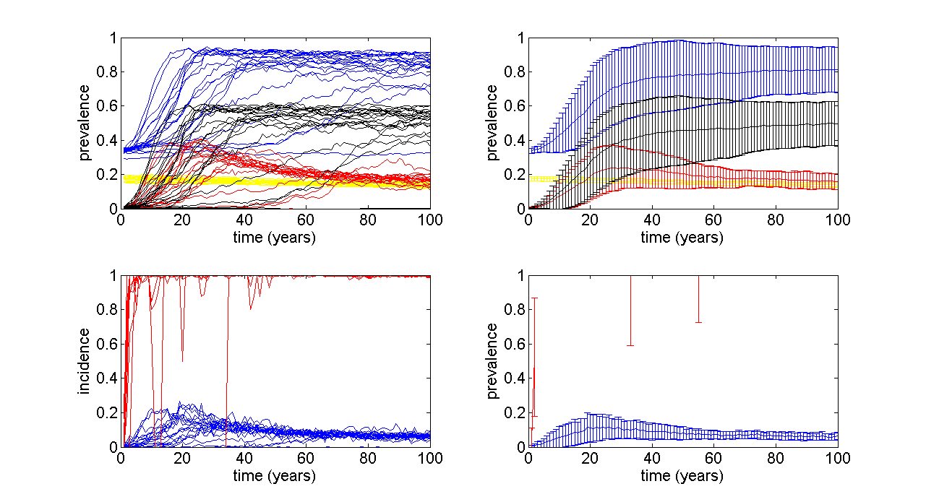
Fig. 7 South Africa without chemoprophylaxis: Top: prevalence of HIV(yellow), TB in all forms(blue), TB disease(red) and MDR-TB(black) follow up for 100 years, Bottom: incidence(blue) and ratio of MDR-TB to total TB(red). Left: each curve for one run. Right: average of every runs with error bars.

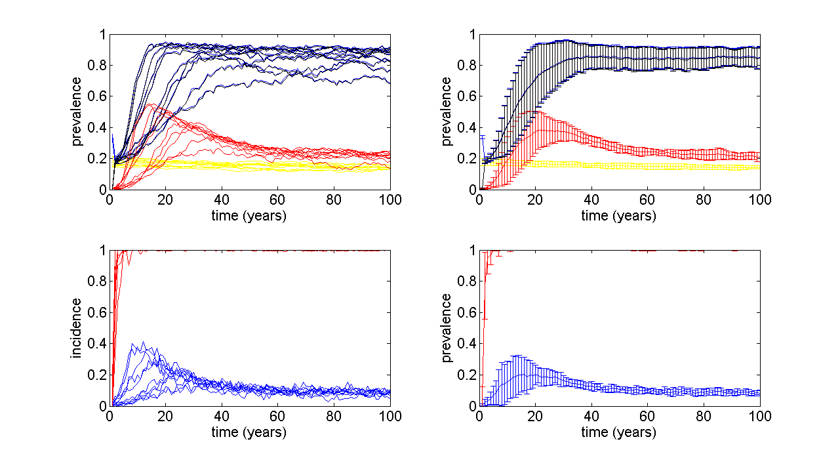
Fig. 8 South Africa with chemoprophylaxis: Top: prevalence of HIV(yellow), TB in all forms(blue), TB disease(red) and MDR-TB(black) follow up for 100 years, Bottom: incidence(blue) and ratio of MDR-TB to total TB(red). Left: each curve for one run. Right: average of every runs with error bars.

China
In the simulation results of China(Fig.9 top), you can read approximately three different scenarios: (1) TB reaches a plateau after a burst period, similar to South Africa, (2) TB stays stable for a very long time and suddenly increases, (3) TB stays stable for the whole time period simulated. This higher inconsistency compared to South Africa would be explained by the fact that China has much lower incidence of TB than South Africa. Although China and South Africa are classified into high burden country in regard to TB, the incidence is much lower in China than South Africa, which is thought to be mainly due to the lower HIV prevalence. HIV positive individuals have weaker immune system and thus higher probability of getting infected and of developing disease by endogenous reactivation.
The impact of chemoprophylaxis in China seems to be the same as in South Africa: almost all TB cases come from MDR-TB strains(Fig.10).
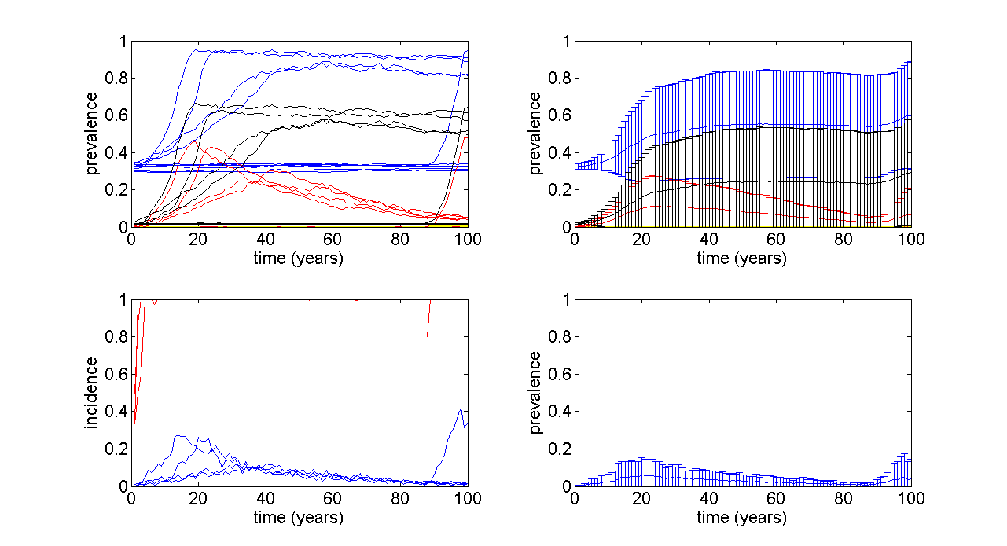
Fig.9 China without chemoprophylaxis: Top: prevalence of HIV(yellow), TB in all forms(blue), TB disease(red) and MDR-TB(black) follow up for 100 years, Bottom: incidence(blue) and ratio of MDR-TB to total TB(red). Left: each curve for one run. Right: average of every runs with error bars.

South Korea

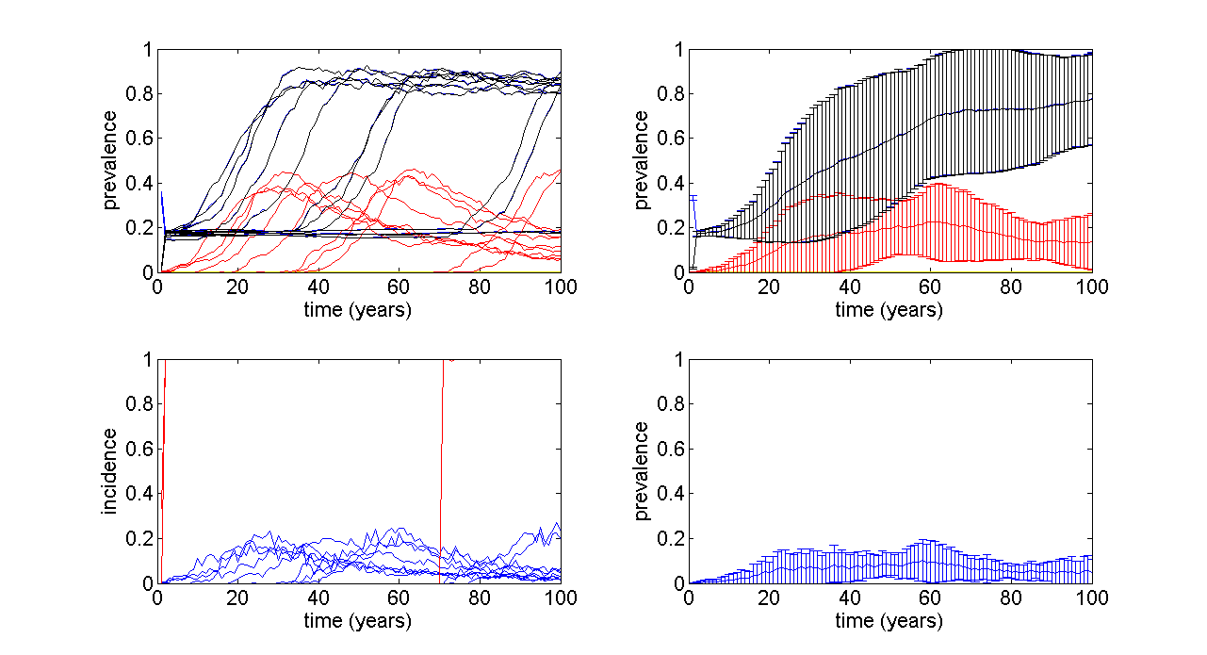
Fig.10 China with chemoprophylaxis: Top: prevalence of HIV(yellow), TB in all forms(blue), TB disease(red) and MDR-TB(black) follow up for 100 years, Bottom: incidence(blue) and ratio of MDR-TB to total TB(red). Left: each curve for one run. Right: average of every runs with error bars.

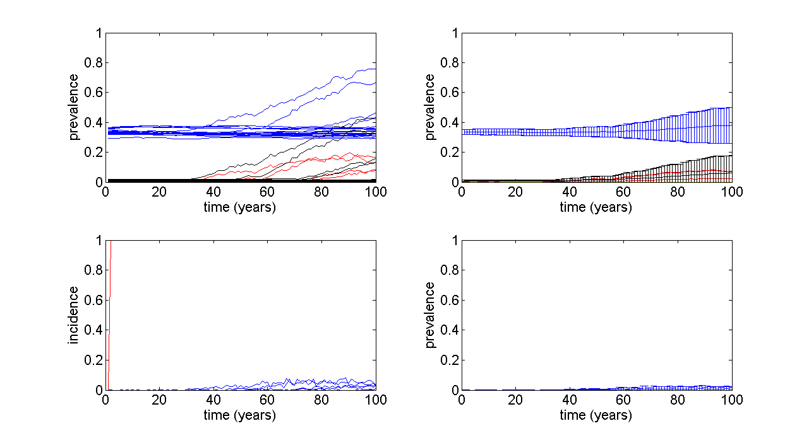
Fig.11 South Korea with chemoprophylaxis: Top: prevalence of HIV(yellow), TB in all forms(blue), TB disease(red) and MDR-TB(black) follow up for 100 years, Bottom: incidence(blue) and ratio of MDR-TB to total TB(red). Left: each curve for one run. Right: average of every runs with error bars.

Summary and Outlook

References
[1] C.P. Bhunu, W. Garira, Z. Mukandavire, M. Zimba. Tuberculosis Transmission Model with Chemoprophylaxis and Treatment, Bulletin of Mathematical Biology 2008.
[2] C. Dye, B.G. Williams, Criteria for the Control of Drug-Resistant Tuberculosis, PNAS 2000.
[3] T.R. Frieden, T.R. Sterling, S.S. Munsiff, C.J. Watt, C. Dye, Tuberculosis, Lancet 2003.
[4] Global tuberculosis control, WHO report 2011.
[5] Country statistics from http://apps.who.int/ghodata/?vid=16300&theme=country (27.11.2011)

