# The Component Database

# Overview

The Component Database (CDB) is a tool to assist in documenting, organizing, and tracking the components planned for use in the MBA accelerator. It assists in capturing the documentation of components, provides a repository for inspection and measurement data (e.g. travelers), and supports the logging of component history through the component’s life cycle. The CDB also provides links and interfaces to other commonly used tools, such as PDMLink, ICMS, PARIS, EDP, etc.

The CDB has the potential to capture a complete “Bill of Materials” for the MBA well before the installation timeframe. Having an exhaustive BOM in a relational database will facilitate careful planning and tracking of the construction and installation process, a prerequisite for such an ambitious schedule.

There are three primary “domains” captured by the CDB: Component Catalog, Designs, and Inventory. A clear understanding of these domains and how they interrelate is important for proper and consistent use of the CDB. Figure 1 illustrates these domains and indicates some of the links between them. The following sections describe these domains (tables) in greater detail.

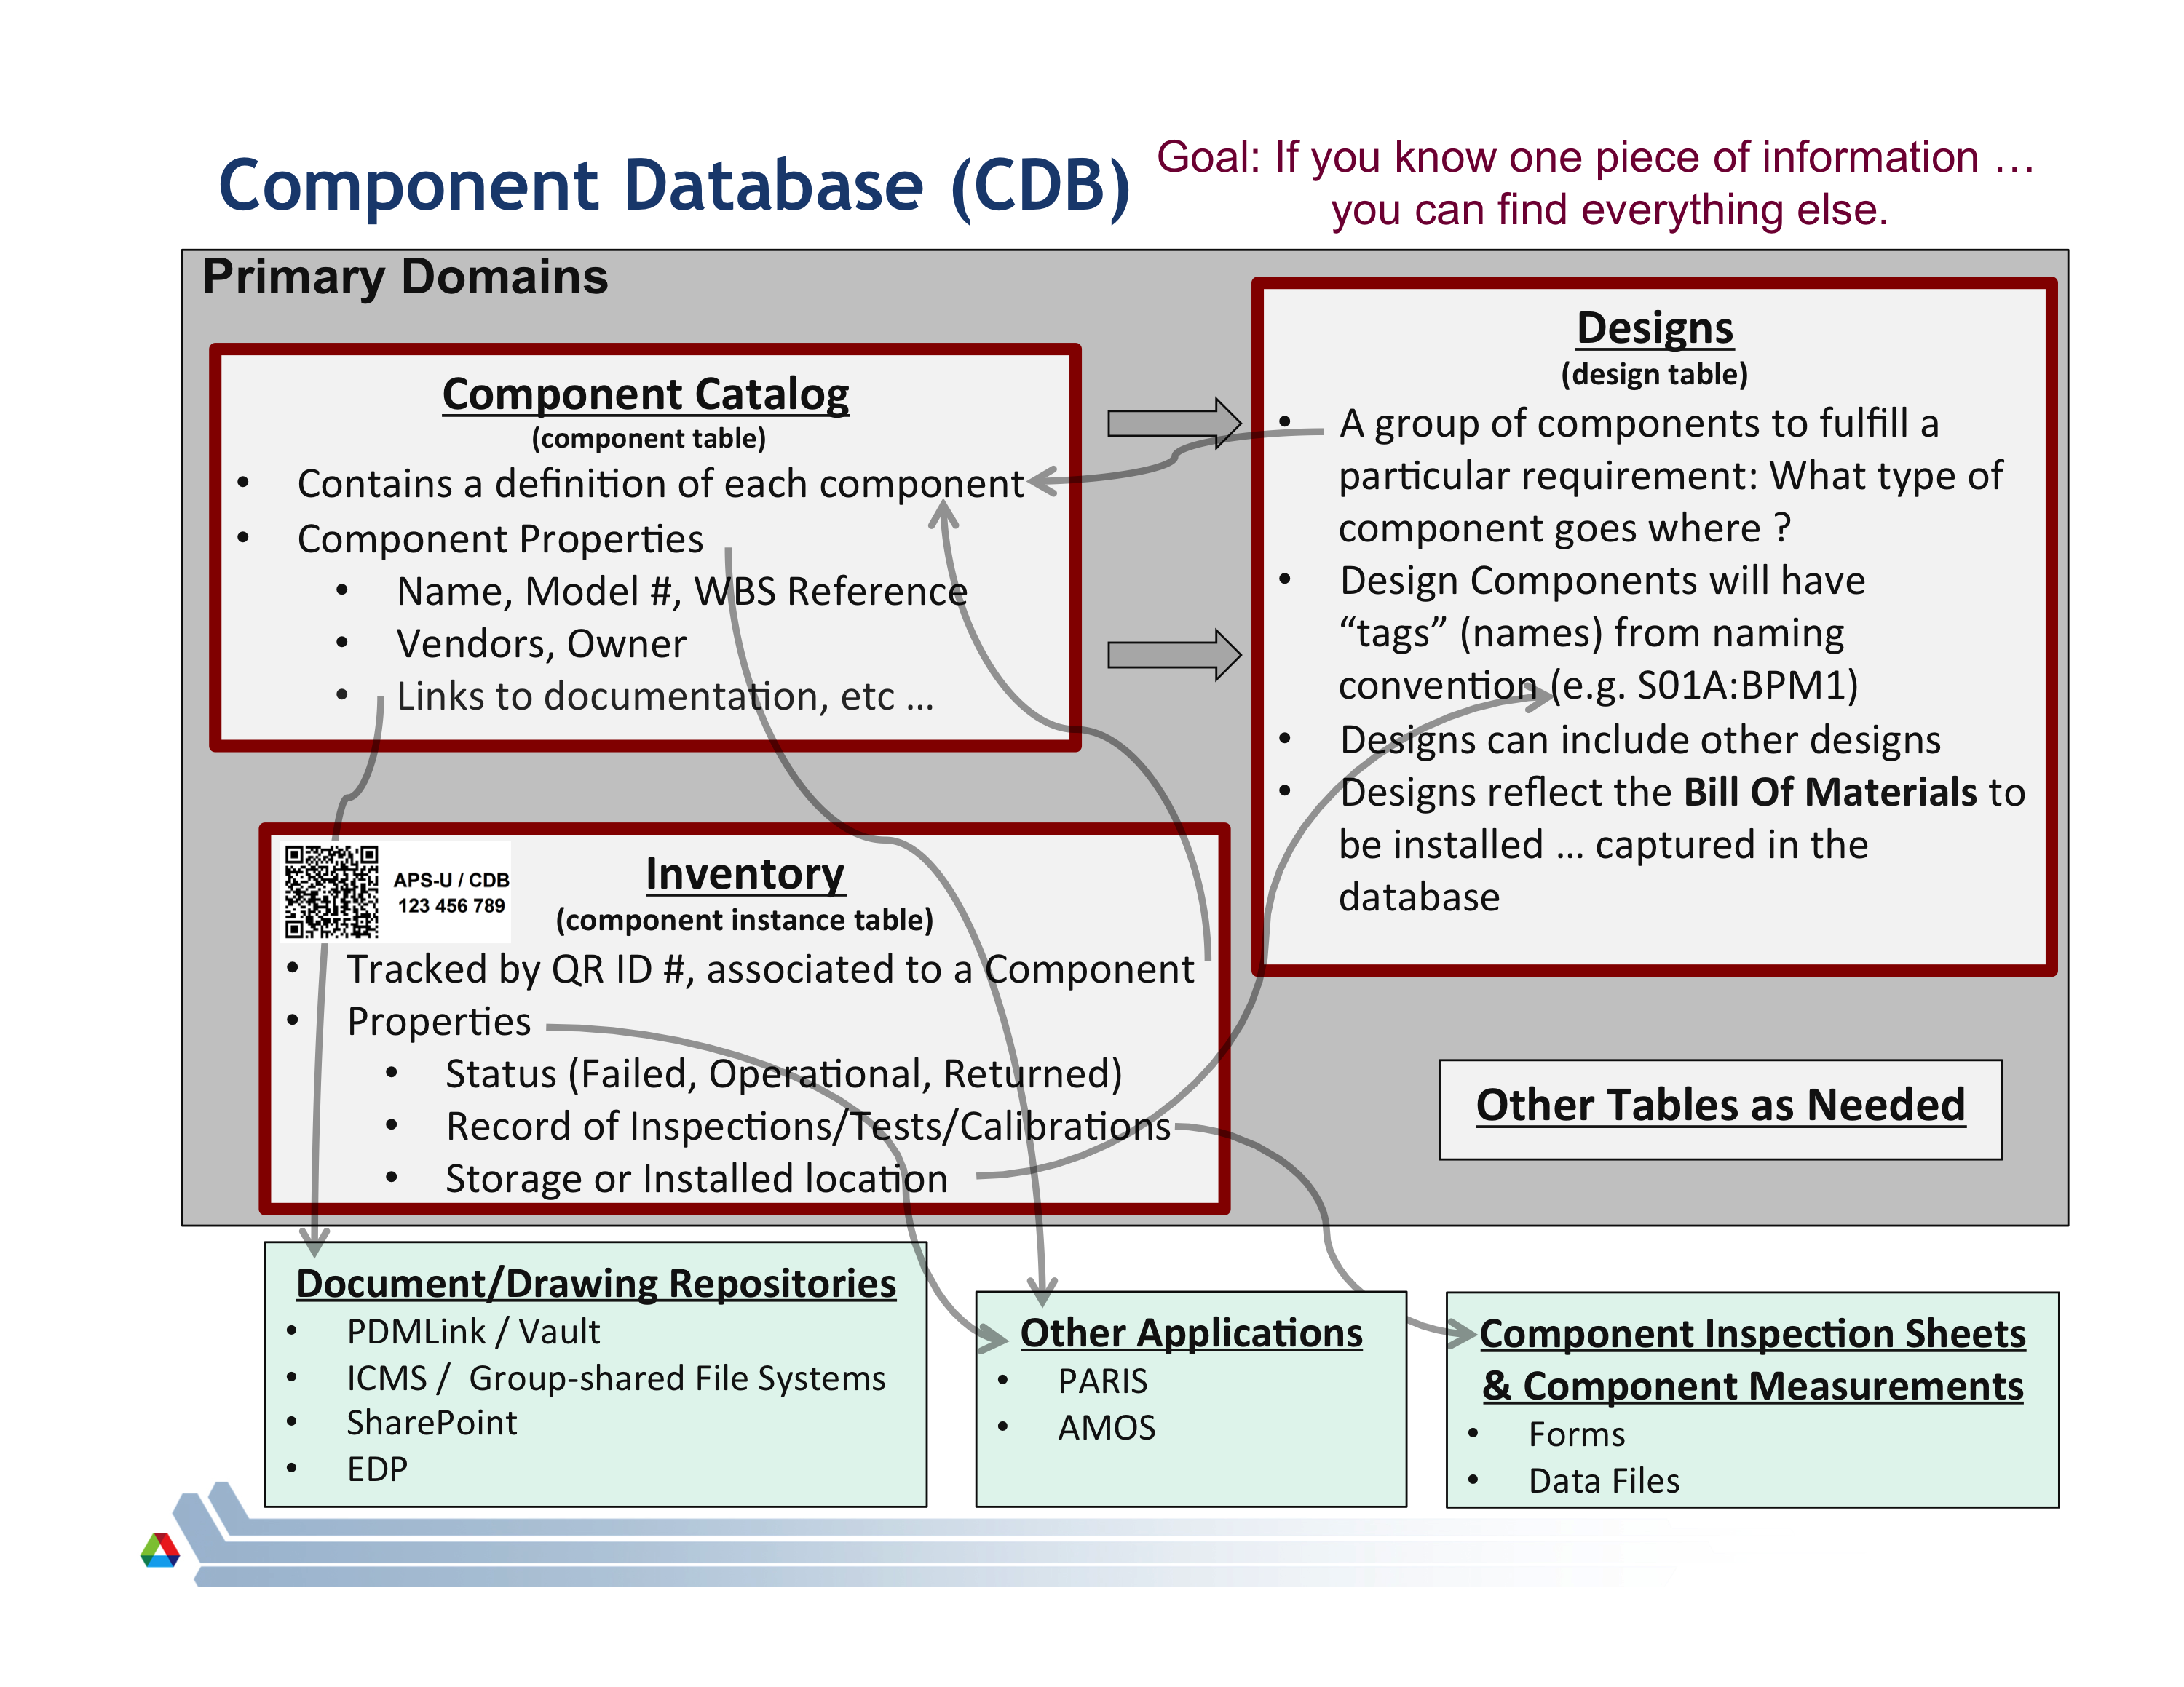

Figure

## Component Catalog (Component Table)

A core purpose of the CDB is to provide a “Component Catalog” for the MBA. This catalog will contain a list of all components planned for use on the MBA, both custom-fabricated and commercially available. This is implemented with a database table (the component table) that contains an entry for each unique component design. For example, each design of a gate valve, magnet, or vacuum chamber and each unique VME module will have an entry in the Component Catalog.

The minimum data required for a component entry is a Name, Component Type, Owner, and Owner Group. The Component Type is selected from a list of “Component Types” which represent generic components used on an accelerator. Figure 2 shows a screenshot of a few existing components in the Component Catalog.

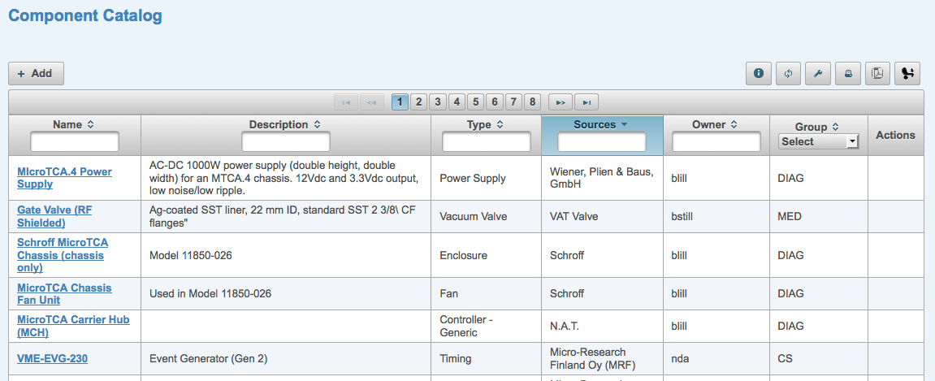

Figure

Optional meta-data for a component entry include Description, Sources (Vendor), images and component “Properties”. Figure 3 is a screenshot of a “Component Details” view that shows a significant amount of meta-data for a specific component. As can be seen, a thorough description consisting of many “properties” can be included in the definition of a component in the Component Catalog.

A key question in defining components is “at what level of granularity should I enter components?”. A good rule of thumb is to describe components that would be “field replaceable” or components for which you would have “spares” on hand.

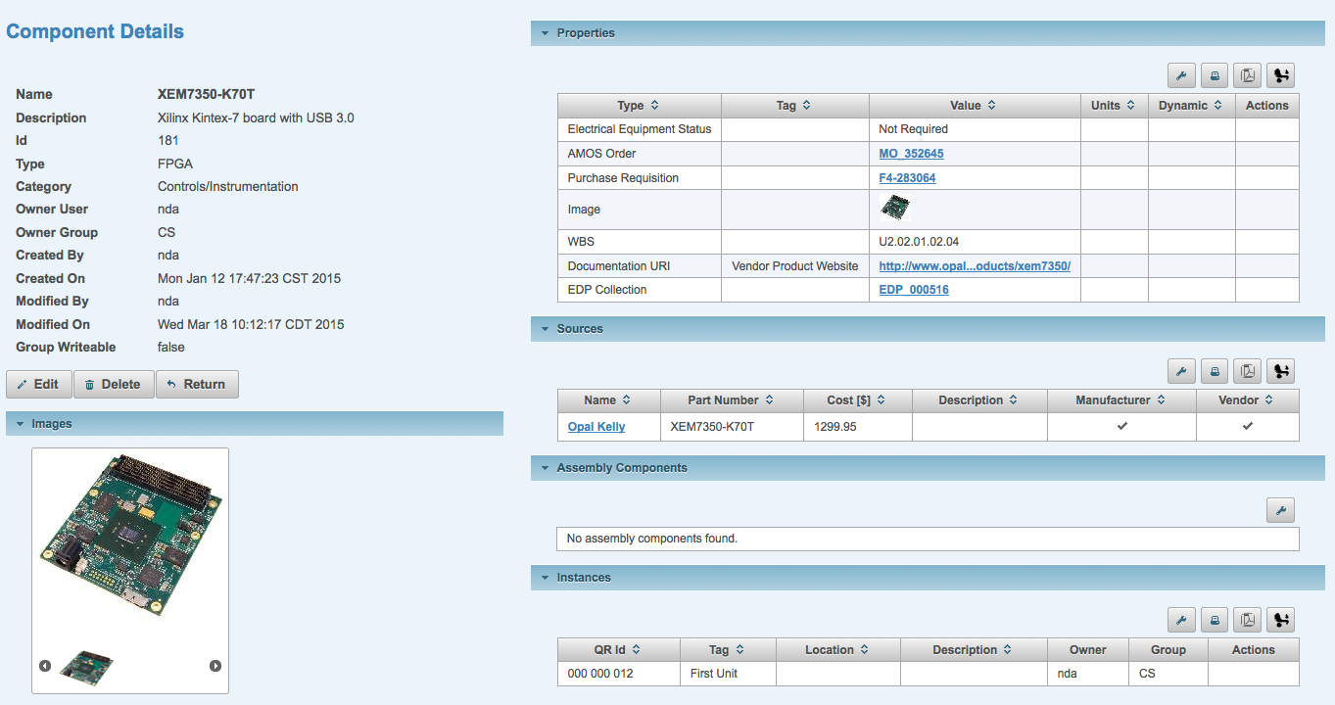

Figure

It is also possible to define “complex components” (or an “assembly”) made up of several other components. Figure 4 shows the definition of a *MicroTCA Chassis Assembly* which includes a bare chassis, two fan units, and a power supply. When a *MicroTCA Chassis Assembly* component is included in a design it is equivalent to adding all four components.

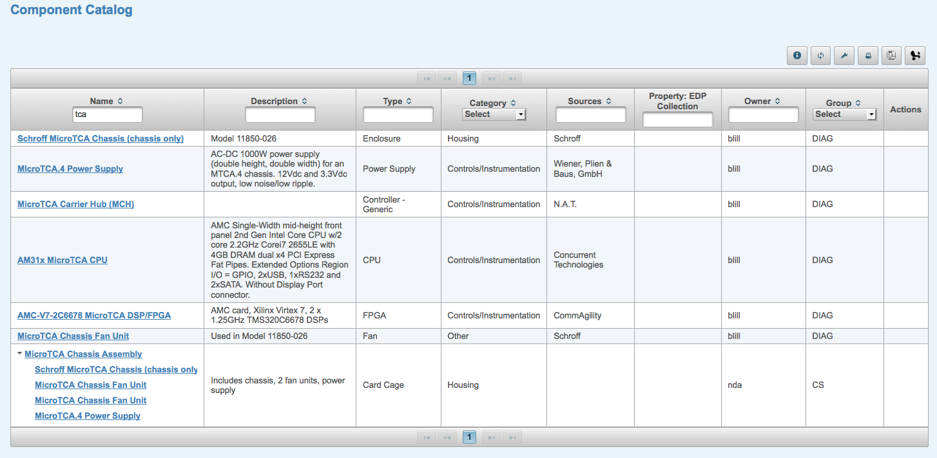

Figure

## Designs (Design Table)

The CDB allows the user to define “designs” which consist of several components grouped together to fulfill a particular functional requirement. A few examples of “Designs” for different technical systems would include:

### A PLC chassis with specific set of I/O modules

### A girder that supports several magnets and vacuum chamber components

### The contents of a power supply cabinet

### A BPM Processing System which consists of an analog front end chassis, an ADC chassis, four cables for the BPM buttons, and two cables between the other units

An example of how a Design is depicted in the CDB is illustrated in Figure 5. Key concepts of Designs are described below:

### Designs are made up of “design elements”

### Each design element may be component, complex component (assembly), or another design (allows hierarchical designs)

### Each “design element” is given a unique element name, normally derived from the official naming convention

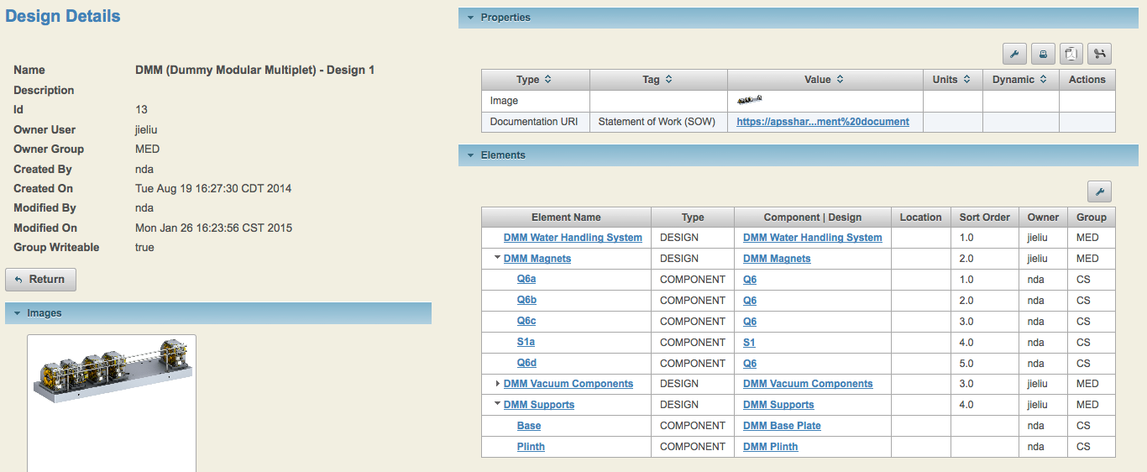

Figure

“Designs” are the mechanism by which an exhaustive Bill Of Materials can be acquired for the MBA. Groups will define designs necessary to fulfill their particular technical system requirements and by so doing will be contributing to a detailed list of the all the components required to build the new machine. Since this data resides in a relational database it can be “viewed” or analyzed in numerous ways.

## Inventory (Component Instance Table)

Component entries in the Component Catalog describe a specific component design or a particular model number of a commercially available component. The actual component fabricated or procured is referred to as a Component Instance of that component design. Component instances are tangible hardware components that require inspection, testing, storage, installation, and maintenance. Tracking component instances becomes an inventory management challenge.

Each component instance procured or fabricated for the MBA will be uniquely identified with a QR ID code. A sticker with the QR ID code will be adhered to the component in a visible location (if possible). An entry in the Component Instance table will relate the component instance to a particular component; thereby allowing all relevant information about this component instance to be referenced using the QR ID.

Figure 6 shows one view of the component instance table. Additional information is easily accessed from links in this table.

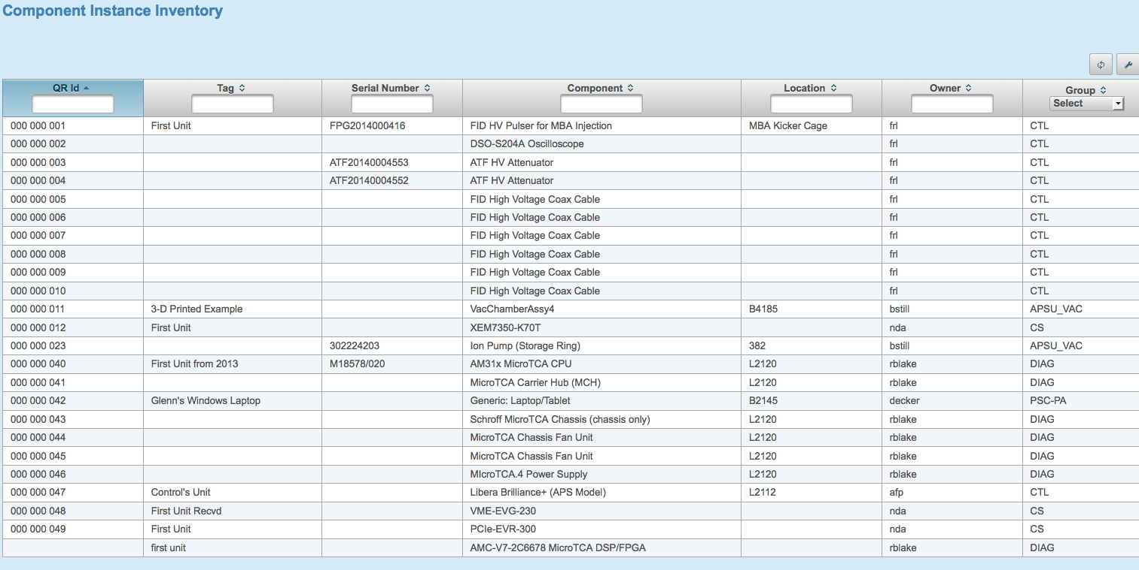

Figure

Several other tables provide additional information about components, designs, and instances. A short description of several of these tables is provided below.

## Component Types and Component Categories

There are two additional tables that allow for grouping of components for easier discovery, sorting, exporting, managing, etc. The component type table includes generic components typically used on an accelerator, such as motor, magnet, ADC, gate valve, etc. The component category table lists the engineering subsystems that are part of an accelerator, such as RF, Diagnostics, Vacuum, etc. Using these attributes, one can find all components that are “gate valves” or narrow the search for a component by filtering on the category “Diagnostics”.

These attributes provide a <virtual> structure to the “Component Catalog” as follows:

### Component Categories represent chapters within the component catalog, e.g. Controls, Magnets, RF, etc.

### Component Types represent sections within a chapter, e.g. ADCs, CPUs, Undulators, etc

### Components represent specific designs of the component type that is of interest

## Properties

The information one would like to capture in the CDB varies widely depending on the type of component, design, or instance. Therefore, it is impractical to attempt to define a single set of *meta-data* common to all of these objects. To provide a flexible mechanism for capturing component-dependent meta-data, the CDB associates *properties* to individual components, designs, and instances. This allows each element to have a unique set of meta-data which best describes and documents that element.

For example, a VME Chassis component might have properties of number of slots, height, and AC power requirements. In contrast, a quadrupole magnet component would have properties of maximum current, slot length, weight, and maximum field. Numerous other property types are shown in Figure 7. A complete list can be viewed in the CDB application.

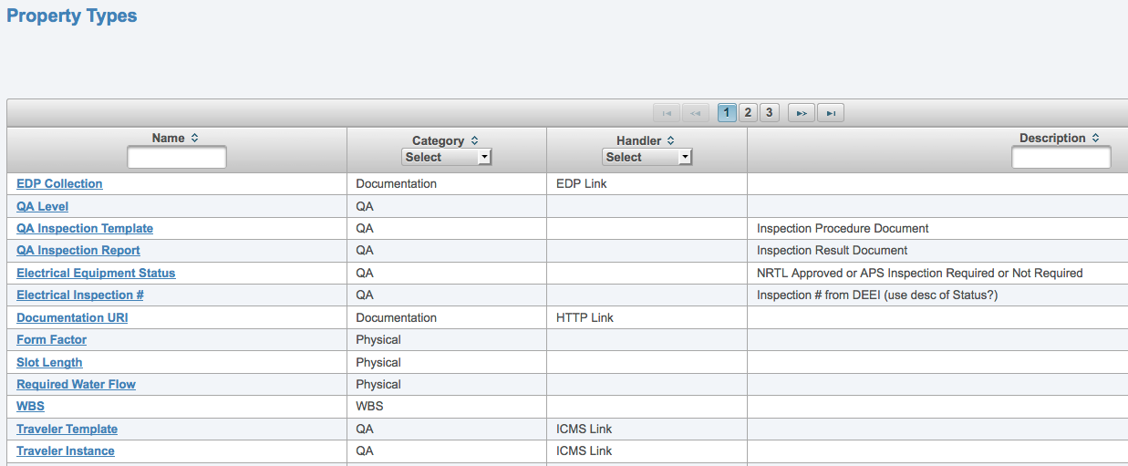

Figure

A summary of property characteristics is provided below.

### Property types are predefined. All available property types can be viewed in the CDB

### New property types can be easily added (by a System Administrator)

### Any number of properties can be associated with Components, Component Types, Designs, and Component Instances

### Properties can have “allowed values” (which show up as a menu selection) or generic text strings

### Properties can have “handlers” that run specific code for that property. For instance, the Purchase Requisition property knows how to formulate a web url to access a purchase requisition directly from PARIS.

### “Dynamic” properties are ones that <may> change with each instance, e.g. an inspection report

### When property values are changed, a history log is kept of all previous values.

## Sources

The “Sources” table contains a list of vendors that supply components described in the component catalog. Each component can have multiple sources associated with it and sources can be designated as the vendor (from whom you procure the component) and/or the manufacturer (the fabricator of the component).

## Location

Inventory management includes knowing where components are installed or stored. To assist in location tracking, a table of all buildings and rooms used by the APS Upgrade is included in the CDB. Component instances have a “Location” attribute that can be assigned to a specific room. If desired, adding cabinets, tables, or shelves to a room can create further granularity of a location.

# The Component Database Portal

This section gives an introduction to the CDB application. The HOME page of the CDB is shown in Figure 8 and can be reached at <cdb.aps.anl.gov>. You must be on the APS Intranet, the APS Visitor wifi, or in a VPN session to the APS intranet to access this site. One can view the contents of the CDB without logging in. In order to modify the contents you must have a CDB account (request one from a CDB administrator) and login using your APS LDAP password.

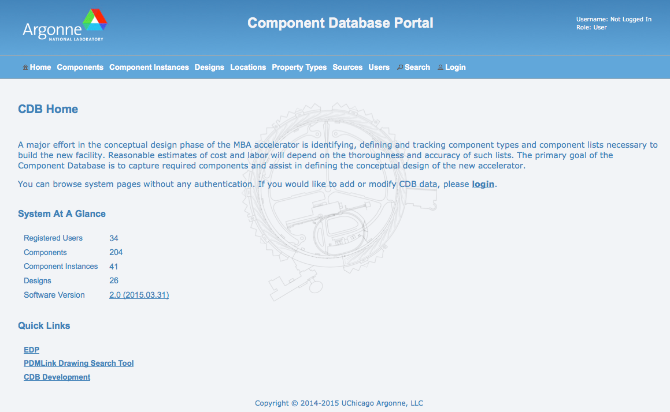

Figure

A separate “development” database has been provided for individuals to practice adding and modifying contents of the CDB while going through the learning process. One can navigate to the development version using the “CDB Development” link on the HOME page. The top title for the development area is “Component Database Portal – Development”. Changes made to this “sandbox” area are **not** permanent and may be discarded at any time. Once the user becomes familiar with the application, permanent entries must be entered in the main application.

Directly below the main title are is a row of “tabs” (Home | Components | Component Instances | …) to navigate to different tables of the CDB. The following sections describe these tabs and other important information about the CDB.

## Common Navigation Widgets (Filters, Buttons, Icons, etc.)

As one navigates through the tables of the CDB, the pages will have many navigation widgets in common. Figure 9 identifies many of the buttons/icons that will be encountered while interacting with the CDB. Some buttons will show up conditionally depending on the allowed actions on the page, e.g. the *Add* button will not show up if the user is not logged in. All “action” buttons have *tool tip help text* that can be viewed by hovering the cursor over the button or icon.

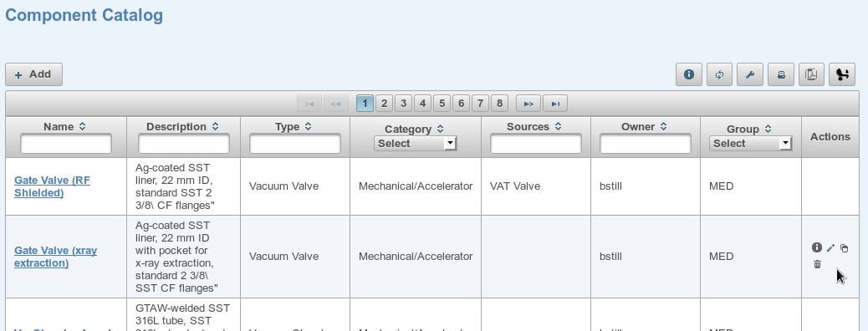

#9/#10/#11

#1

#2

#3 #4 #5 #6 #7 #8

#12

Figure

#1: On many pages that display a table (such as the Component Catalog shown in Figure 9) the row headers include widgets (either a menu or a text entry box) to specify a “filter” to narrow the list of displayed elements. When a menu item is selected or a text string typed into one of the headers, the table is filtered to only display elements that meet the criteria. Additionally, the displayed items can be sorted by any column in which the up/down arrows are visible.

#2: The Add button is context sensitive. The *tool tip help text* displays the exact action that will occur when the button is pressed. In Figure 9 it would initiate the action of adding a component to the component catalog. The Add button will only be displayed when the user is logged in and authorized to add to the specific table.

#3: The Info (“i”) button is also context sensitive and typically displays more information about the table being viewed. The *tool tip help text* displays the exact action that will occur when the button is pressed. For this Component Catalog context, the Info button will display the Component Type table.

#4: The button labeled #3 (“Reset list filters”) clears all the filters (see #1) to their default value, thereby listing the entire contents of the table.

#5: On most pages that display a table (such as the Component Catalog shown in Figure 9) the user can customize the columns that are displayed. The button labeled #4 (“Customize list view”) brings up a selection window of all possible columns and allows the user to select those that will be shown. Another configurable parameter for tables is the “Display Number of Items Per Page”. This determines the length of each page when there are more items than can fit on the screen. Entering a large number will display the table in one long scrollable page.

If the user is logged in, a “Save” button will also be displayed on the Custom List Display that will save the values and use them for future sessions.

#6, #7, #8: These three buttons initiate the printing, exporting to pdf, or exporting to a spreadsheet respectively of the displayed table.

The icons under the Actions column are only visible when the mouse is hovered over that particular row. Also, the set of icons displayed will change to only reflect the allowed operations (similar to the #1 Add button above). There is a *tool tip help text* display for each icon. Their operations are:

#9 (“i”): display more information about this element

#10 (pencil): edit this element

#11 (double clip board): clone this element, i.e. make a copy of it as a new element

#12 (trash can): delete this element

Not Shown (“h”): When displayed, this icon will show the history of the value of the parameter

Not Shown (up arrow): When displayed, this icon will initiate the Upload of a file or image to the CDB.

## *Components* Tab (Component Catalog)

**Finding a Component:** The Components tab provides access to the Component Catalog (See Figure 9). From this page one can search for any defined component by using the filters in the table header. Popular filters are a substring in the Name, Description, or Type column, a user name in the Owner column, or selecting a group in the Group column. Once the component of interest is shown, details of that component can be viewed by hitting the Name link or by hitting the “i” icon in the Actions column. This will open the Component Details page (see Figure 3).

**Editing a Component:** If the user is authorized to edit a particular component, the pencil icon will be visible in the Actions column (when the mouse is hovered over that particular row). Hitting the pencil icon will open the Edit Component page for that component (Figure 10). Another way to open the Edit Component page is to hit the Edit button on the Component Details page shown in Figure 3 (only visible if you are allowed t edit the component).

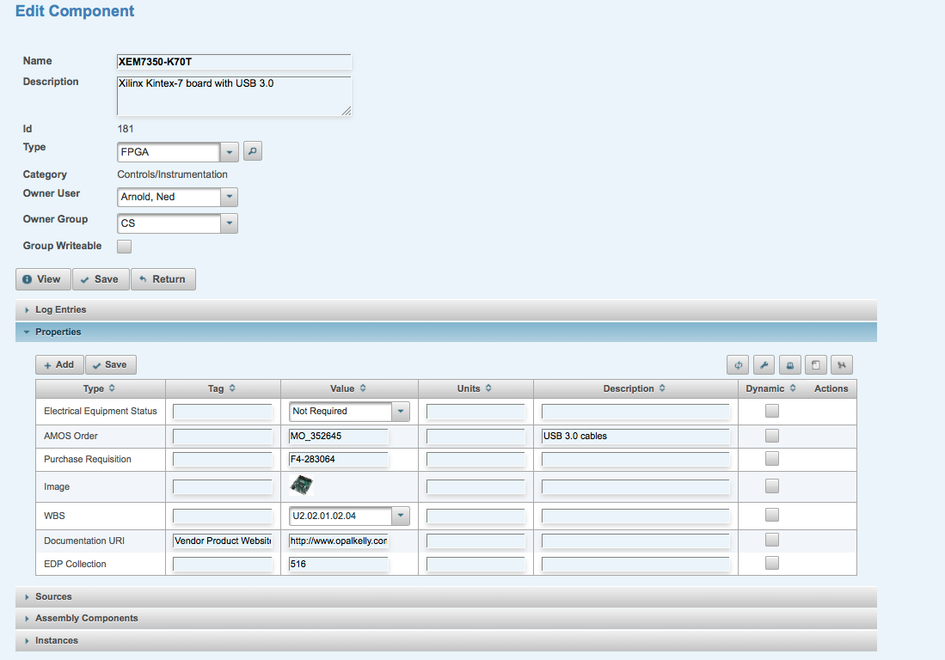

Figure

The Edit Component page (Figure 10) has several regions that can be expanded or collapsed by hitting the arrow on the header bar. Regions include Log Entries, Properties, Sources, Assembly Components, and Instances. When the region is expanded, Add and Save buttons will be visible which are used to add new items and save changes. Always hit the Save button to complete the operation.

**Adding a New Component:** To add a new component, hit the Add button on the top of the Components Catalog page (only visible if the user is logged in). This brings up the Add Component page where the basic information (Name, Description, Type, etc) is entered. When finished entering data, hit the Save button. This will bring you to the Component Details page where Properties, Sources, etc. can be added.

A more convenient method for adding a component is to find an existing component that is similar to the one desired and then hit the Clone button in the Actions column. This duplicates the entire component (including properties and sources, but excludes log entries and instances) and allows you to edit only what you need changed from the original component.

## *Component Types*

Every component in the component catalog is assigned to a “component type” which best describes its basic purpose on an accelerator. This allows staff to find components based on the function it provides; e.g. vacuum valve, ADC, BPM, etc. The list of component types can be viewed by hitting the “i” button on the Components Catalog page (Button #3 in Figure 9). The component types are grouped by “component type categories” to associate them with a technical group or discipline.

The assignment of a component type is not always exact or obvious. If necessary, additional component types can be defined by a CDB Administrator.

## *Designs Catalog* Tab

The Design tab shows the Designs that have been defined within the CDB. Specific Designs can be found by filtering the Design list by owner, group, or a substring within the Design name or description. After finding a design (or creating a new one), it can be edited by entering the “Edit Design” screen shown in Figure 11. Similar to Components, new Designs can be added using the Add button or by cloning an existing Design.

Referring to the Edit Design screen in Figure 11, a Design can have its own “Log entries” and its own set of Properties. Below the “Elements” header is where one adds the “Design Elements”, where a Design Element can be a component or another Design. When adding a Design Element, either the “Component” column will be used to specify the element as a Component, or the “Child Design” column will be used to specify the element as another Design. Do not specify both a Component and Design for a single element.

Each Design Element can have properties that describe certain characteristics of that element *for this particular design*. For example, a quadrupole component in a design may have a property describing it’s operational current. The same quadrupole component may have a different operational current in a different design. This allows the engineer to describe numerous aspects of a design within the CDB. Design element properties are defined Design Element Details page, which can be reached by hitting the link in the Element Name column of a Design (when viewing the Design).

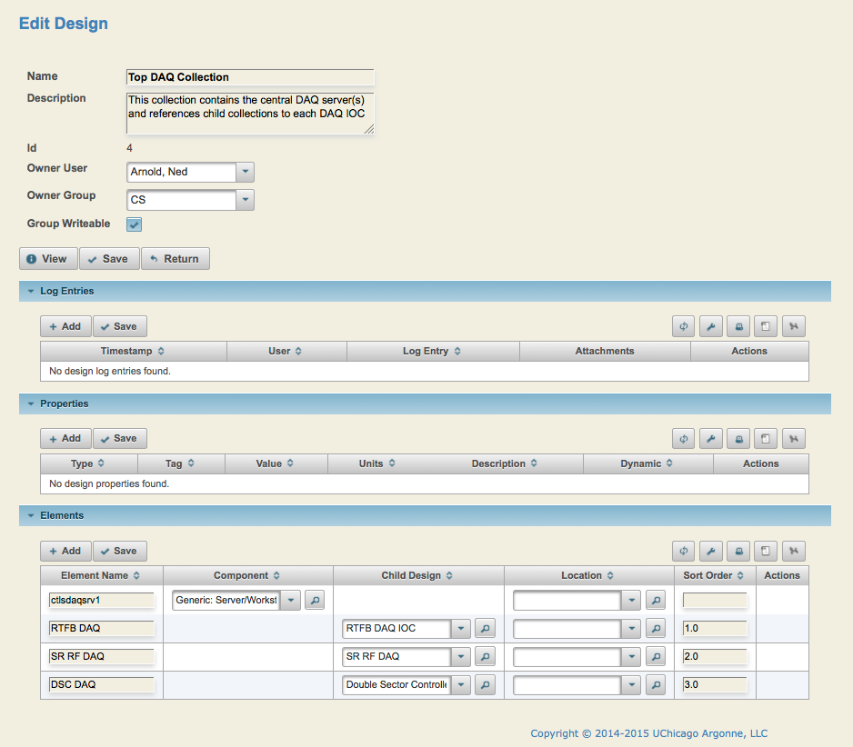

Figure

## *Locations* Tab

The Locations tab shows a list of all buildings and rooms used by the APS Upgrade is included in the CDB. Optionally, cabinets, racks, and tables can be added for further accuracy. Changes to the Locations table are limited to CDB administrators.

## *Property Types* Tab

The Property tab shows a list of all defined properties for use in the CDB. Changes to the Properties table are limited to CDB administrators.

## *Sources* Tab

The Sources tab shows a list of all vendors defined in the CDB. Changes to the Sources table are limited to CDB administrators.

## *Users* Tab

The Property tab shows a list of all users able to add or modify CDB entries. Changes to the Users table are limited to CDB administrators.

## *Search* Tab

The Search tab allows one to do a search across numerous tables to find information about the contents of the CDB. The “Search Options” button can be used to constrain the search to specific tables or to make the search case-sensitive (by default it is **not** case-sensitive).

## *Settings* Tab

Dozens of settings can be adjusted on a per user basis and retained for future sessions. Most settings control the table columns to be displayed or search filters to be used when displaying data from the CDB and can be changed throughout the CDB application. The Settings tab shows all user-defined options in a single place.