Template

Jeongmin Kim

2019. 02. 28.

Table of Contents

1. Paragraph 1

2. Heading level 1 2

2.1. Heading level 2 2

2.1.1. Heading level 3 2

3. Tables 2

4. Figures 3

5. References 3

# Paragraph

First paragraph. First paragraph. First paragraph. First paragraph. First paragraph. First paragraph. First paragraph. First paragraph. First paragraph. First paragraph.

Second paragraph. Second paragraph. Second paragraph. Second paragraph. Second paragraph. Second paragraph. Second paragraph. Second paragraph. Second paragraph. Second paragraph.

Footnote[1].

Citation(Jeongmin 2019).

# Heading level 1

## Heading level 2

### Heading level 3

# Tables

|  |  |  |  |  |
| --- | --- | --- | --- | --- |
| Sepal.Length | Sepal.Width | Petal.Length | Petal.Width | Species |
| 5.1 | 3.5 | 1.4 | 0.2 | setosa |
| 4.9 | 3.0 | 1.4 | 0.2 | setosa |
| 4.7 | 3.2 | 1.3 | 0.2 | setosa |
| 4.6 | 3.1 | 1.5 | 0.2 | setosa |
| 5.0 | 3.6 | 1.4 | 0.2 | setosa |
| 5.4 | 3.9 | 1.7 | 0.4 | setosa |

# Figures

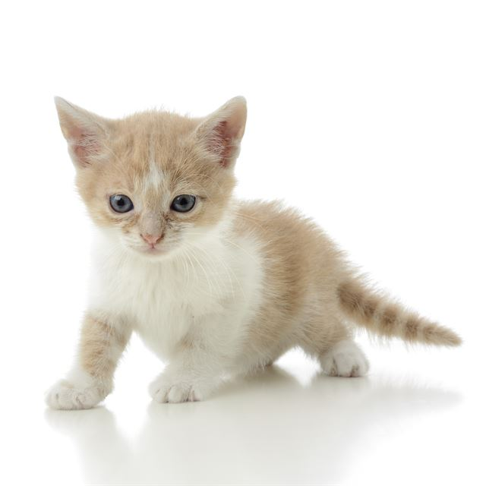

So cute!

# References

1. Jeongmin, Kim. 2019. “Example Article.” *Awesome Journal* 1 (1).

1. This is footnote.