Name of the system:
EventSync - Event Organizer Management System

Group Number and Section:
Group 3 – BSIT 2-2

Course Name:
BA/OOP

Instructor Name:
Inst. Ma. Michaella Alejandria

Institution Name:
PUPQC

Date of Submission:
March 28, 2026
TABLE OF CONTENTS:
INTRODUCTION 3
OBJECTIVE OF THE PROJECT 4
CORE FUNCTIONALITIES 5
Core Functionality #1: User Authentication and Role Management 5
Core Functionality #2: Event Scheduling 6
Core Functionality #3: Venue Reservation 7
Core Functionality #4: Notification and Reminder System 8
Core Functionality #5: Event Dashboard / Overview 9
TEAM MEMBERS AND MEMBER ROLES 11
HIGH-LEVEL ARCHITECTURE 12
TECHNOLOGY STACK TO USE 13
STAKEHOLDERS 14

INTRODUCTION
This project proposes the development of an EventSync system based on identified needs and initial consultations with stakeholders within a school environment, aimed at improving the efficiency and organization of event planning and management. While the system is primarily intended for school-based use, its structure is adaptable enough to support similar event-management workflows in other organized institutions. The system aims to help student organizations, faculty members, administrators, and event organizers manage events, venue reservations, schedules, and notifications in a more organized and automated manner. Schools regularly conduct various activities such as seminars, meetings, workshops, school programs, and organizational events, which require proper scheduling and coordination of venues and participants. Because of these challenges, and as observed during stakeholder consultations, there is a need for a reliable system that can manage multiple event requests, schedules, and venue reservations efficiently while ensuring proper coordination among organizers and administrators.
Currently, many schools still manage event scheduling and venue reservations manually through paper forms, emails, or messaging platforms, which can lead to scheduling conflicts, lost requests, miscommunication, and unorganized event records. These issues were further confirmed through discussions with involved stakeholders, highlighting the need for a more structured and automated approach to event management. To address these challenges identified through stakeholder input, this proposal aims to develop an EventSync system that will manage event reservations, organizer records, event schedules, venue reservations, notifications, and event monitoring through a centralized dashboard. The system will improve school operations by organizing information in a centralized database, reducing manual errors, preventing double bookings, and improving communication through automated notifications and reminders. Overall, the proposed system aims to provide a centralized platform that will help the school manage events more efficiently and ensure smooth planning and execution of school events and activities.

OBJECTIVE OF THE PROJECT
EventSync primarily aims to develop a versatile Event Organizer Management System specifically designed to handle the complexities of academic events while maintaining the flexibility required for general event planning. The system aims to provide a centralized dashboard that empowers organizers with near real-time tracking of schedules and venues, alongside an accessible interface that streamlines communication and collaborative planning for general users. By leveraging a robust and optimized tech stack, the project focuses on delivering a high-performance, reliable platform with a straightforward UI design, ensuring a seamless user experience that effectively fulfills the functional requirements of end-to-end event execution.
To achieve the general objective, the project aims to fulfill the following specific goals:
- To implement a secure User Authentication and Role Management system that distinguishes permissions between administrators, organizers, and clients to ensure data integrity.
- To develop an automated Event Scheduling module that allows for the creation, modification, and tracking of event timelines to prevent scheduling conflicts.
- To create a near real-time Venue Reservation system backed by a MySQL database to manage availability and ensure organized booking of physical spaces.
- To integrate an automated Notification and Reminder System using node-cron to facilitate timely communication via alerts for upcoming deadlines and event updates.
- To design a centralized Event Dashboard that provides a comprehensive overview of all active events, pending reservations, and system status for efficient monitoring.
- To utilize a full-stack development approach (HTML/CSS/JS for frontend and Node.js/Express for backend) to build a responsive and optimized web application.
- To ensure the system is straightforward and user-centric, providing a high-performance experience that simplifies the transition from manual to automated event management.

CORE FUNCTIONALITIES
- User Authentication and Role Management
- Event Scheduling
- Venue Reservation
- Notification and Reminder System
- Event Dashboard / Overview

Core Functionality #1: User Authentication and Role Management
Functional Requirements
- User Registration
- The system shall allow new users to create an account using a valid email address.
- The system shall require users to provide complete and valid registration details before account creation.
- The system shall verify user credentials through email confirmation.
- User Login and Authentication
- The system shall allow registered users to log in using valid credentials.
- The system shall authenticate users before granting access to the system.
- Role Management
- The system shall support user roles such as Administrator, Organizer, and Participant/Attendee.
- The system shall restrict access to features and pages based on the user’s assigned role.
Non-Functional Requirements
- Security
- User passwords shall be securely stored using encryption or hashing.
- The system shall protect user accounts from unauthorized access.
- Performance
- User login and authentication responses shall be processed within a few seconds under normal conditions.
- Usability
- The authentication interface shall be simple, clear, and easy to use on both desktop and mobile devices.

Core Functionality #2: Event Scheduling
Functional Requirements
- Event Creation
  - The system shall allow authorized users to create new events.
  - The system shall validate all event details before saving the event.
  - The system shall require users to provide complete event details such as event title, description, date, time, venue, and expected number of attendees.
- Event Reservation Booking
  - The system shall allow users to submit reservation requests for approval.
  - The system shall allow users to select a venue and schedule an event based on available time slots.
- Event Approval and Status Management
  - The system shall allow the Administrators or the authorized personnel to approve or prohibit event reservation requests. (The system administrator or authorized personnel are to review the pending request of event reservation whether to approve or reject.)
  - The system shall update the status of events as Pending, Approved, or Rejected.
  - The system shall notify the users about the status of their reservations.

Non-Functional Requirements
- Performance
- The system shall display event schedules and availability in real-time or near real-time.
- The system shall process reservation requests within an acceptable response time.
- Reliability
- The system shall ensure that no double-booking occurs for the same venue and time slot.
- The system shall maintain the accuracy and consistency of the scheduling data at all times.

Core Functionality #3: Venue Reservation
Functional Requirements
- Venue Browsing and Selection
- The system shall allow users to view the list of available venues.
- The system shall allow users to filter and search venues based on criteria such as capacity, availability, or type.
- The system shall display the venue details such as name, location, capacity, and available facilities.
- Availability Checking
- The system shall provide a visual schedule to show occupied and available time slots.
- The system shall display the availability status of each venue based on selected time and date.
- The system shall prevent users from selecting venues that are already reserved during the chosen schedule.

- Reservation Management
- The system shall allow users to reserve a selected venue for a specific time and date.
- The system shall allow users to modify or cancel their reservations before approval or within allowed conditions.
- The system shall store and manage all reservation records for tracking and reference.
Non-Functional Requirements
- Usability
- The system shall allow users to complete venue reservation assignment with minimal steps.
- The system shall provide an intuitive and user-friendly interface.
- Scalability
- The system shall support multiple users accessing and reserving venues simultaneously.
- The system shall handle increasing numbers of venues and reservations without degradation in performance.

Core Functionality #4: Notification and Reminder System
Functional Requirements
- Event Notifications
  - The system shall generate automated reminders for upcoming events based on a defined schedule, such as one week or one day before the event.
  - The system shall notify users of changes in event details, including schedule, venue, or time.
  - The system shall allow users to configure notification preferences, including notification type and timing

- Notification Processing
  - The system shall use a scheduling mechanism to trigger time-based reminders automatically.
  - The system shall support asynchronous processing of notifications to ensure system performance is not affected.
- User Interaction
  - The system shall allow users to receive, view, and manage notifications through the system interface.
  - The system shall provide a notification panel where users can mark notifications as read or unread.
Non-Functional Requirements
- Timeliness
  - The system shall deliver notifications within 60 seconds of the scheduled trigger time
- Reliability
  - Scheduled reminders shall execute accurately and consistently.
  - The system shall minimize the risk of missed notifications.
- Scalability
  - The system shall support multiple notification tasks without significant performance loss.
- Usability
- Notifications shall be easy to access, read, and manage from the user interface.

Core Functionality #5: Event Dashboard / Overview
Functional Requirements
- Dashboard View
  - The system shall provide a dashboard that summarizes upcoming events, reservations, and notifications.
  - The system shall allow users to view relevant information based on their role.
- Event Monitoring
  - The system shall display event status, reservation status, and reminder alerts in one centralized view.
  - The system shall allow organizers and administrators to monitor event progress efficiently.
- Quick Access
  - The system shall provide shortcuts to commonly used functions such as event creation, venue reservation, and notification viewing.
Non-Functional Requirements
- Clarity
  - The dashboard shall present information in a clean and organized layout.
- Performance
  - The dashboard shall load quickly even when displaying multiple data items.
- Accessibility
  - The dashboard shall be usable on both web and mobile devices.

TEAM MEMBERS AND MEMBER ROLES
Role | Responsible | Responsibilities
Business Analyst | All members | Requirements gathering and documentation
Designer | Adoray, Trish Anne  Campano, Agnes  Escorel, John Mark | System modeling and architecture
Developer | Hernandez, Jeoffrey Isaiah  Sia, Erwin  Jabaan, Roe Mabli  Micompal, Daniel | Technical feasibility and implementation planning
Document Lead | All members | Proposal writing and formatting

HIGH-LEVEL ARCHITECTURE
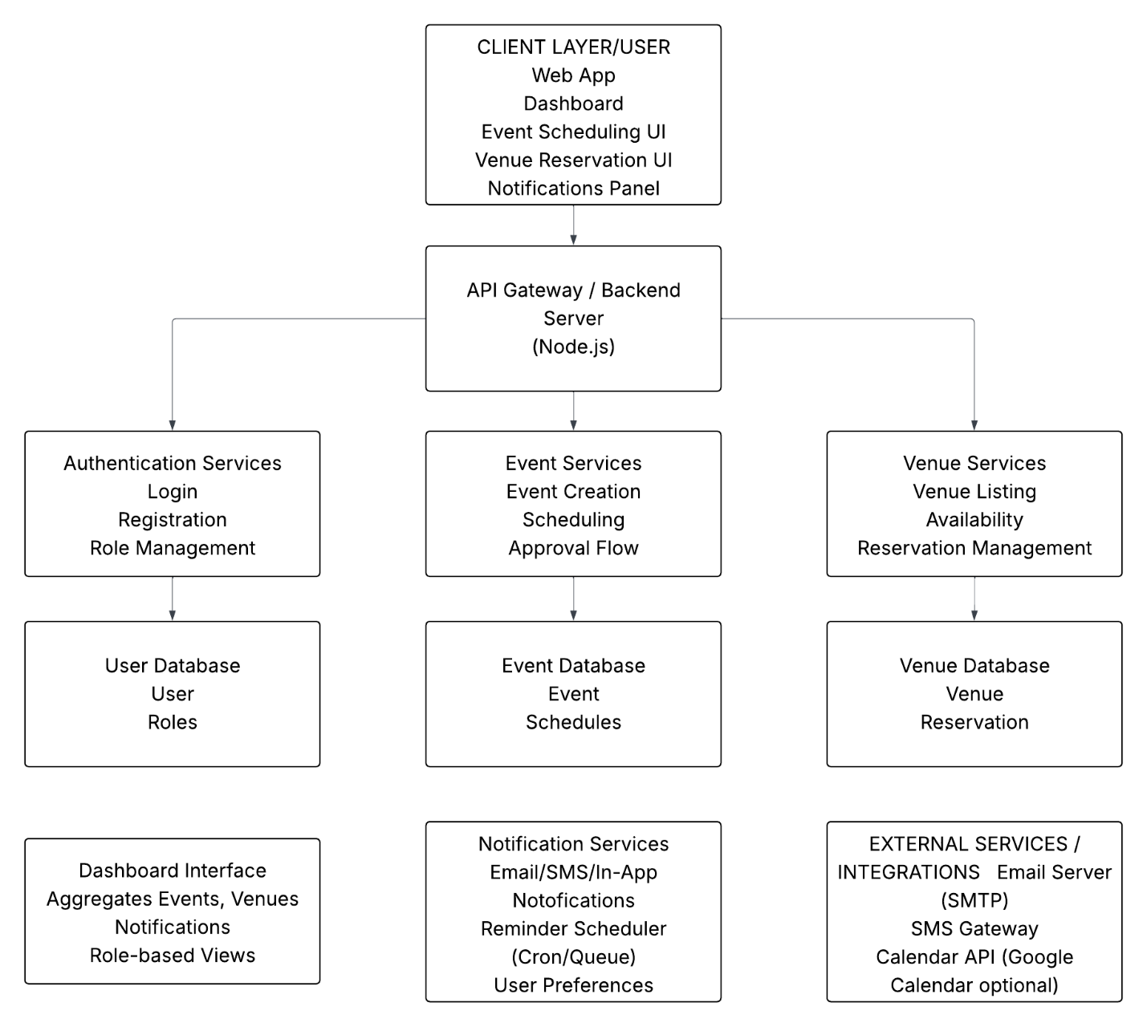

TECHNOLOGY STACK TO USE
- Frontend:
  - HTML - for structuring the web pages
  - CSS - for design and layout
  - JavaScript - for interactivity and user actions
- Backend: Node.js + Express.js
- Scheduler (Notification): node-cron
- Database Layer: MySQL - for structured data storage
- Development Tools:
  - Visual Studio Code - for development
  - Node.js environment – for running the system locally
  - GitHub – for version control and collaboration

STAKEHOLDERS
Stakeholders
Individual/Groups | Description
Event Organizers | These users run the core workflow by initiating event requests and finding the right spaces for them. They count on the platform to validate details instantly and remove the risk of scheduling errors while they are in the planning phase.
Venue Managers | They are the primary decision-makers for space usage; they use the system to review and approve or decline requests based on live availability. The visual scheduling tools take the guesswork out of their day-to-day work by automatically blocking double-bookings.
System Administrators | They handle the technical health of the platform, from managing user permissions to keeping data secure through encryption. Their main goal is ensuring the system stays fast and liable for everyone, even when multiple users are active at once.
General Users | Their experience is built around the dashboard and notifications. They benefit from having a single, clear place to check event details and getting automated alerts the moment a schedule or location changes.
Executives | They use the system to maintain a high-level view of all organizational activities. Having a centralized way to monitor event progress helps them ensure that resources are being used wisely and that team goals are actually being met.

