Challenges to transboundary fisheries management in North America under climate change

[Response to Reviewers - Second Round]

Juliano Palacios-Abrantes1 U. Rashid Sumaila1 William W. L. Cheung1

1 Institute for the Oceans and Fisheries, University of British Columbia, Vancouver, Canada

## Abstract

Climate change is shifting the distribution of fish stocks that straddle between Exclusive Economic Zones (EEZ), challenging transboundary fisheries management. Here, we examine the projected sharing of jointly managed transboundary fish stocks between Canada and the United States. We hypothesize that ocean warming will alter the sharing of fish stocks between the two countries, and that such changes will intensify under a high carbon emission scenario. We look at the specific cases of the International Pacific Halibut Commission that manages Pacific halibut (*Hippoglossus stenolepis*) and a resource sharing arrangement in the Gulf of Maine for cod (*Gadus morhua*), haddock (*Melanogrammus aeglefinus*) and yellowtail flounder (*Limanda ferruginea*) to discuss the management consequences of shifts in transboundary stocks. We rely on multiple Earth system models’ simulations and species distribution models to estimate the change in catch potential and stock share ratio of each transboundary stock in the century under two climate change scenarios. Results show that, even under a low emission scenario, most transboundary fish stocks sharing ratios, i.e., the proportion of the total catch of a fish stock taken by a given country, will change by 2050 relative to present. The overall reduction in catch potential, in addition to the changes in stock-share will further exacerbate trade-offs between changes in species catch potential. Such trade-offs in the Atlantic and Pacific regions will be amplified if a high emission scenario is followed, relative to a low carbon emission scenario. Based on the simulation results, we examine possible solution options to reduce climate risks on transboundary fish stocks and fisheries.

Keywords: *Transboundary fisheries management; climate change; joint fisheries management; species distribution shift*

## INTRODUCTION

In 1982, the United Nations Law of the Sea Convention (UNCLOS) formalized the concept of economic exclusive zones (EEZs) creating what we know today as shared stocks (United Nations 1986), i.e. stocks that migrate between countries EEZs (known as transboundary stocks) or between EEZs and the high seas (also called straddling stocks) (Song et al. 2017a). Today, an estimated 347 (Teh and Sumaila 2015) to 1500 (Caddy 1997) fish stocks cross national borders, some of them jointly managed by two or more countries. These stocks are responsible for almost 50% of these countries total fish catches (Teh and Sumaila 2015). Under Article 63, UNCLOS incentives actions to cooperate on the management of shared stocks (United Nations 1986) as often management success depends on effective cooperation between parties (Miller and Munro 2002, Sumaila 2013). Since the definition of shared stocks, game theory has been one of the most common approaches used to analyze the management of these type of stocks. However, shared stocks’ management can be convoluted due to the participation of several fishing “players”, different countries and sometimes jurisdictions within a country, the migration patterns of the stock, and their abundance fluctuation within space and time (Miller and Munro 2002, Engler and Saunders this Special Feature). In addition, international treaties might not be prepared to address the effects that climate change will bring to shared fish stocks (Engler and Saunders this Special Feature, Koubrak and VanderZwaag, this Special Feature).

The ocean is getting warmer (Rheim et al. 2013), less oxygenated (Schmidtko et al. 2017), and increasing in acidity (Ross et al. 2011, IPCC 2019). To cope with these changes in ocean biophysic properties, marine species, including shared fish stocks, have been shifting their distribution towards the poles and/or deeper waters (Poloczanska et al. 2016). As climate change reshapes the ocean’s environment worldwide (Gattuso et al. 2015), shared fisheries’ delicate governance is threatened as new migration patterns may arise (Miller et al. 2013, Pinsky et al. 2018), historic distribution and abundances might shift (Cheung et al. 2010), and species basic natural traits may modify (Pauly and Cheung 2018). Catches of shared stocks like tunas, have significantly increased in some regions such as the subtropical Atlantic and western Pacific Oceans and are projected to continue (Monllor-Hurtado et al. 2017, Erauskin-Extramiana et al. 2019). Multiple shared species in North America have been observed to shift in distribution following changes in optimal conditions such as sockeye salmon (*Oncorhynchus nerka*) (McDaniels et al. 2010), Atlantic cod (Pershing et al. 2015), and flounders (Pinsky and Fogarty 2012). Moreover, these shifts are projected to continue towards the end of the century (Cheung 2018). As a result, some countries or management jurisdictions may see more shared fisheries and their catches shifting into their waters while others will stand to lose (Pinsky et al. 2018, Oremus et al. 2020). Nevertheless, management rules for shared stocks (e.g. quota or spatial delimitation) are often determined based on current and/or historic knowledge of the stock’s distribution and do not consider future shifts in distributions (Fredston-Hermann et al. 2018).

The shifts in distribution of shared fish stocks will impact the economics of their fisheries (Pinsky and Fogarty 2012, Sumaila 2019, Sumaila et al., this Special Feature), and create international disputes between countries (Miller and Munro 2002, Spijkers and Boonstra 2017, Pinsky et al. 2018). Canada and the US share important transboundary stocks of salmon (*Oncorhynchus spp.*), Pacific halibut (*Hippoglossus stenolepis*), and Atlantic cod (*Gadus morhua*) offering a unique lens to understand the extent to which climate-induced distributional shifts will challenge the future sustainability of transboundary fisheries. These countries have a long history of fisheries cooperation participating in diverse, jointly managed, commercial transboundary stocks through various fisheries management organizations (NOAA 2018). Furthermore, climate-related fluctuations in stocks’ distribution have historically created disputes between Canada and the US, increasing international conflict and threatening the health of diverse transboundary stocks (Miller and Munro 2002, CIA 2017).

It is expected that climate induced shifts in stocks’ distribution will affect the rules in place that keep international treaties alive. Therefore, the main objective of this article is to assess the level of exposure that bi-lateral transboundary fisheries treaties between Canada and the US have to climate change through shifts in stock distributions. Specifically, we rely on a species distribution model and scenario planning to project the changes in the distribution of selected fish stocks jointly managed by Canada and the United States focusing on two case studies (the International Pacific Halibut Commission and a fisheries arrangement for the Gulf of Maine) Finally, we explore similar situations around the world and identify opportunities to improve the adaptability of transboundary stocks management to climate change in North America. Despite an overall expectation of species following a poleward shift, important geographic constraints (e.g. Gulf of Alaska representing a latitudinal block) (Kleisner et al. 2016), geo-political features (e.g. the localization of Alaska in reference to Canada and the contiguous states), and management rules (e.g. quota allocations, spatial management rules) may play an important role in the redistribution of benefits. Understanding these stocks shifts will shed a light on future conditions and inform decision-makers on the paths to follow under a changing climate.

## METHODS

### Study Area and Fisheries

The current study used the International Pacific Halibut Commission (IPHC) and the Gulf of Maine arrangement (hereafter referred as GoMA) as case studies to discuss the implications that climate change could have in the management of transboundary stocks. For the IPHC, we used the most updated spatial regulatory data along its 12 regulatory areas (IPHC and Gustafson 2017, IPHC 2019). For this specific case, we considered Alaska as a separate entity, the US contiguous states as a second one (Washington, Oregon and California), and lastly British Columbia (Canada). For the GoMA we used the Northwest Atlantic Fisheries Organization’s (NAFO) divisions 5Y, 5Ze, and 4X[1] within latitudes 46.2°N and 41.5°S, and longitudes -72°W and -64°E (Fig. 1). Is worth mention that, while NAFO’s divisional zones were used in this study for domestic management, NAFO does not manage fisheries within the EEZs of Canada and the United States. Fisheries data fpr the projections was gathered from the Sea Around Us from 1951 to 2014 (Zeller et al. 2016).

<insert Figure 1>

### The International Pacific Halibut Commission

The IPHC was established by Canada and the United States to oversee the management of Pacific halibut (*Hippoglossus stenolepis*) (IPHC 2014). There are 12 regulatory areas from which 3AB holds 51.2% of the stock, followed by regions 2ABC and 4ACDE with 23.1% and 20.4%, respectively, and lastly region 4B with only 5.2% of the stock distribution (IPHC and Gustafson 2018). In terms of management, the IPHC implements a total allowable catch (TAC) based on a yearly sampling of the Convention area in addition to a series of regulations to control fishing effort (IPHC and Gustafson 2018). The TAC is divided between recreational, subsistence and commercial fishery, with a portion set aside for bycatch of other fisheries (IPHC 2019). The commercial fishing season starts in March ending around November with restrictions allowing only set line gear with J-type hooks targeting individuals over 81.3 cm of total length (IPHC 2019).

<insert Table 1>

### The Gulf of Maine Arrangement

Since 1998 Canada and the US have used a “Resource Sharing Understanding” to inform the management of Eastern George Bank’s Atlantic cod (*Gadus morhua*) and haddock (*Melanogrammus aeglefinus*) and, yellowtail flounder (*Limanda ferruginea*) (Pudden and VanderZwaag 2007, TRAC 2016, Song et al. 2017b). From 2010 onward, the GoMA suggests catch-limits based on a weighted method where 10% represents the stocks’ historical distribution (from 1967 to 1994) and 90% current distributions produced by quarterly surveys and catch (TRAC 2016). Since its introduction, the average quota allocation for each species proposed by the GoMA has been; Atlantic cod 77% Canada and 23% US, haddock 55% Canada and 45% US, and yellowtail flounder 34% Canada and 66% US (Table 1, TRAC 2015a, 2015b, 2015c, 2018a, 2018b, 2018c, Lake 2019). However, because this is an unofficial agreement, Canada and the US ultimately take single management decisions (Soboil and Sutinen 2006). In terms of management, the US has a multi species harvest control with area and season closures, mesh sizes, effort control, and mobile gear vessels that use bottom otter trawl gear (Soboil and Sutinen 2006). In contrast, Canada has a quota system in addition to limited-entry licensing, fleet allocations, and mesh and fish size regulation, among other input controls. Canada inshore vessels fish cod with longline and gillnet while haddock is mainly caught with bottom otter trawl gear (Soboil and Sutinen 2006).

<insert Table 2>

### Projecting Future Species Distribution

We used a Dynamic Bioclimatic Envelope Model (DBEM) to project the distribution of species from 2015 to 2100 under two scenarios of climate change (Cheung et al. 2010, 2016c). The DBEM algorithm integrated ecophysiology and habitat suitability with spatial population dynamics of exploited fishes and invertebrates to project shifts in abundance and potential fisheries catches under climate change. The algorithm predicted species distribution based on depth and latitudinal range, habitat preferences and an index of species association with major habitat types to estimate changes in abundance distribution over a **0.5º x 0.5º** grid of the world ocean. For each grid cell and time step, the model then calculated species carrying capacity according to sea surface temperature, salinity, oxygen content, sea ice extent (for polar species) and bathymetry, as well as the species preferences to these conditions. It then incorporated the intrinsic population growth, settled larvae, and net migration of adults from surrounding cells using an advection-diffusion-reaction equation. Finally, the model also simulated the effects of changes in temperature and oxygen content on growth of individuals (Cheung et al. 2013, 2016c). Ultimately, the model simulated spatial and temporal population dynamics, and estimated a proxy of maximum sustainable yield (MSY) by applying fishing at MSY level for each grid cell, hereafter referred as maximum catch potential (MCP).

We projected the DBEM using three Earth system models (ESM), the Geophysical Fluid Dynamics Laboratory Earth System Models 2M (GFDL)[2], the Institute Pierre Simon Laplace Climate Model 5 (IPSL-CM5)[3], and the Max Planck Institute for Meteorology Earth System Model (MPI)[4]. Each model was downscaled to match the DBEM  **x**  grid using the nearest neighbor method, and in some cases, bilinear interpolation (Cheung et al. 2016b). Finally, we used the model outputs for two scenarios of the Intergovernmental Panel on Climate Change (IPCC)-Representative Concentration Pathways (RCP) 2.6 and 8.5 representing a low greenhouse gas emission (strong mitigation) and a high greenhouse gas emission (week mitigation) scenario, respectively (IPCC 2014). To estimate model robustness and capture the structural uncertainty build within ESM models, we averaged the DBEM results for all three models **( +- )** and marked regions where at least one ESM disagree in direction with the rest.

### Estimation of Maximum Catch Potential Change

For estimating the percentage change of MCP at the regional scale, we first aggregated the yearly mean MCP of all species per region () and period:

where *y* is year, *r* is region, *s* is species, *n* is total number of species, and is the MCP averaged by the three ESMs. In the case of the GoMA, region was defined as the  **x**  grid-cell within the specific NAFO divisional zones. For the IPHC analysis, region was defined as the Commission’s regulatory areas (Fig. 1). We then averaged the values in three time periods (*t*) to reduce temporal model sensitivity. Thus, we computed the regional percentage change in MCP **(MCPr)** as follows:

Where is the future average MCP for each of the two time periods analyzed in this study and is the present averaged MCP ( 2005-2014). Note that in cases where = 0 and > 0, then **(MCPr)** = 100%, consequently, the opposite case would give a -100% result. This way, Equ. 2 shows the percentage change in MCP by mid century when = 2041-2060, and end of century when = 2080-2099, relative to today (). The rationale between choosing these time periods was to provide a relative short-term projection (mid-century) that would be more policy-relevant but also show the long-term trend (end of century).

In addition, we borrowed the concept of “threat point” from game theory defined as the minimum payoff that a player is willing to receive in order to cooperate with other players (see Sumaila et al., this Special Feature). Thus, we estimated the change in the MCP (threat point) that each country (players) would have for each species (hereafter referred as stock-share ratio), for both the IPHC and the GoMA. The stock-share ratio can be seen as the proportion of the stock’s distribution within the study area that each country has. For this, we first modified Equ. 1, to estimate the aggregated yearly mean MCP of each species per region. We then averaged the results by the same previously motioned periods (present, mid and end of the **21st** century). Next, for each species we estimated the stock-share ratio **( s)** that each region had during each time period:

Where **rt** is the species’ aggregated of each region at time period *t*, and **rt** is the species’ aggregated of the whole specie’s distribution within the study area at the same time period. Finally, we estimated the percentage change in stock-share ratio substituting and by **t0** and **t**, respectively in Equ. 2. The process was carried out for each ESM and results presented as average **+-** standard deviation (sd). All of the analysis was done in the statistical software *R* version 3.5.2 (2018-12-20) with the associated packages, *data.table* (Dowle et al. 2019), *ggrepel* (Slowikowski et al. 2019), *gridExtra* (Auguie 2017), *knirt* (Xie 2020), *RColorBrewer* (Neuwirth 2014), *sf* (Pebesma et al. 2018), and *tidyverse* (Wickham 2017). All code is available at <http://www.github.com/jepa/OC_Transboundary>.

## RESULTS

### Projected change to species managed by the IPHC

At least one third of the IPHC regulatory areas will see a reduction in MCP of Pacific halibut by 2050 relative to current MCP, regardless of the climate change scenario (Fig. 2). It is likely that the stock shift from the US. contiguous states towards Canada will offset the shift of the later towards northern regions, resulting in undetectable changes in Canadian area 2B and Alaskan 2C under both climate change scenarios. The potential movement of halibut westward will increase the MCP of regulatory areas 3B (under a low emission scenario) and 4ABCE along the Aleutian Islands and Bering Sea. Regions 4DE, the most poleward regulatory areas of the IPHC, are expected to gain MCP by mid (Fig. 2) and end of the century (Fig. A1.1) under a high emission scenario due to the expansion of halibut suitable habitat as sea ice retreats (Fig. A2.1). In contrast, under a low emission scenario, sea ice is expected to stabilize towards mid 21st century, thus providing less “new” suitable habitat for Pacific halibut and resulting in undetectable changes in MCP for the region (Fig. 2B) and decreasing even more towards 2100 (Fig. A1.1).

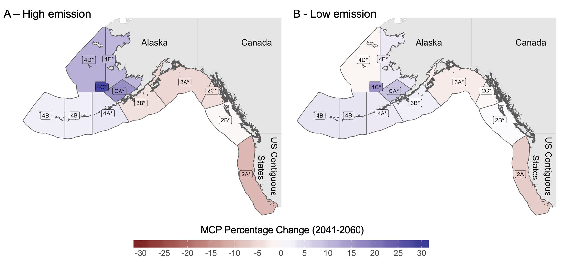

Fig. 2. Percentage change of MCP for species managed by the IPHC for mid 21st century (2041-2060) relative to present 2005-2014 under a A) high emission scenario and B) low emission scenario. Labels marked with "*" represent regions where models do not agree in direction of change.

The same poleward trend is expected in the change of Pacific halibut stock-share ratio with the average proportion increasing up to 25% in some northern regions and decreasing by 10% in southern regions, relative to the present proportion (Fig. 3). Maintaining emissions to lower levels through 2050 would potentially leave unchanged the stock-share ratio of three regulatory areas (3AC, and 4D) and negatively change regulatory area 2A. On the other hand, failing to achieve such target will decrease the stock-share ratio in the most productive regulatory areas (2AC, 3AB).

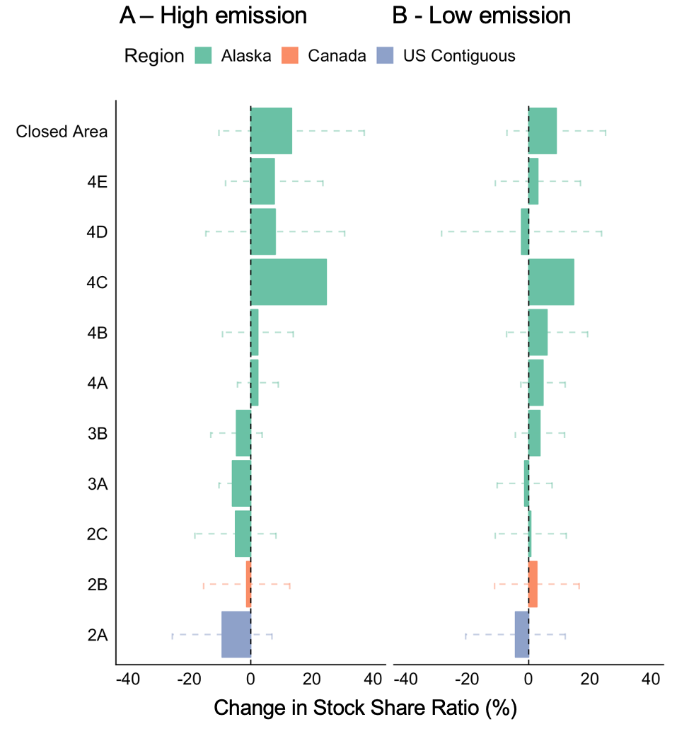

Fig. 3. Percentage change of stock-share ratio for IPHC under A) high emission scenario and B) low emission scenario for mid 21st century (2041-2060) relative to present 2005-2014. Values represent the mean of 3 ESM; error bars represent sd.

### Projected change to species managed under the Gulf of Maine arrangement

While some regulatory areas of the IPHC will see an incremental increase in Pacific halibut MCP, the results for the Gulf of Maine show an overall decrease in MCP by 2050, regardless of the climate change scenario or ESM (Fig. 4), intensifying by the end of the century (Fig. A1.2). For cod and haddock, MCP will decrease within the whole Gulf with no apparent win for any country in reference to the current period (Fig. 4). For yellowtail flounder, despite an overall reduction, some discrete areas are expected to increase with no particular pattern and high uncertainty, as ESMs in these regions do not agree in the direction of change (Fig. A2.3). Despite the overall reduction in MCP for all three species in comparison to current values, there is a benefit of achieving a low emission scenario as reductions intensify under the high emission scenario.

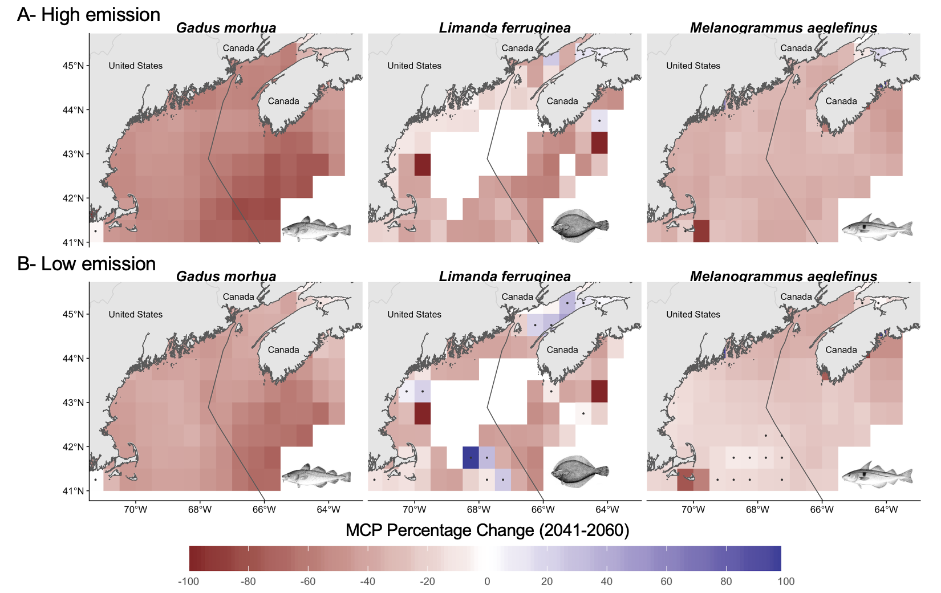

Fig. 4. Percentage change of MCP in the Gulf of Maine under, A) high emission scenario; and B) low emission for mid-century (2041-2060) relative to present (2005-2014). Points represent regions where models do not agree in direction of change.

Despite the expected decrease in MCP for the region, changes in the stock-share ratio of species within the Gulf of Maine show different outcomes dependent on the climate change scenario and species in question. Following a high emission path will affect mostly Canada’s share of yellowtail flounder and in less degree haddock, with an increase of cod share. under the low emission scenario, haddock and cod patterns intensify, while yellowtail flounder’s share approaches almost no change (Fig. 5). Such pattern is likely the combination of the bathymetry or the Gulf, the warming gradient, and the species distribution (see discussion).

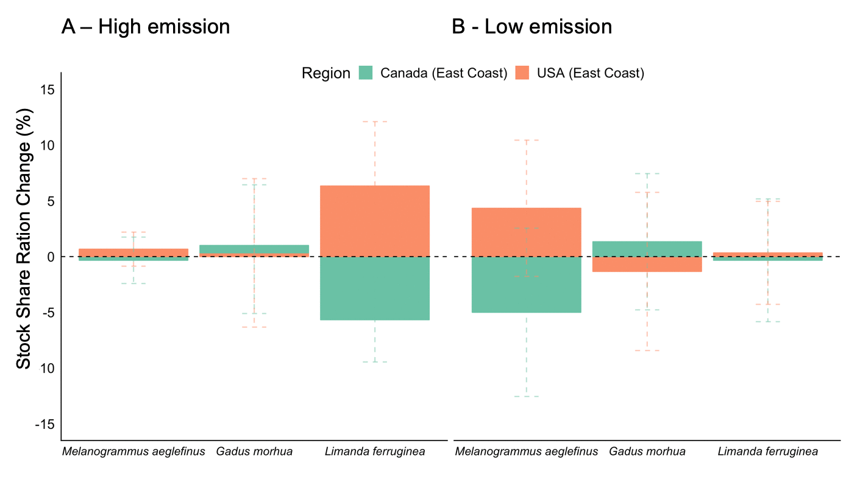

Fig. 5. Changes in MCP stock-share ratio for Gulf of Maine under (A) high emission; and (B) low emission scenarios for mid 21st century (2041-2060) relative to present (2005-2014). Values represent the mean of 3 ESM; error bars represent sd.

## DISCUSSION

The results of the present study suggest that climate change will alter the MCP of jointly managed transboundary fish stocks in North America consequently altering Canada’s and the US’s species’ stock-share ratio, regardless of the climate change scenario. These results are aligned with regional (Morley et al. 2018) projections suggesting that climate change will push marine species towards the poles and deeper water (Pinsky et al. 2013) in search of their ecological niche (Poloczanska et al. 2016). Moreover, IPHC data[5] suggest that some of these shits are already happening. For example, since 2010, the distribution proportion of Pacific halibut has increased from 9% to 11% in region 2B, from 7.5% to 13% in region 2C, and from 12.3% to 13.5% in region 4CDE. On the other hand, regions 3A and 3B have seen the largest decreases in the IPHC regulatory areas since 2010, from 35.3% to 30.6% and 20.6% to 15.9%, respectively. Similarly, in the Gulf of Maine, the projected stock-share gain of yellowtail flounder and haddock by the US (Fig. 5) follows a historical trend where in 2019, Canada’s stock-share decreased from 35% to 32% and 60% to 40% relative to 2010, respectively (Lake 2019).

Geographic barriers (Cheung et al. 2015, Kleisner et al. 2016), local temperature gradients (Pinsky et al. 2013), species interactions and human activities (Serpetti et al. 2017) might change the rate and direction of species shifts. For the IPHC, geographic barriers might induce a westward increase of stock-share in IPHC regions where species can only migrate northward into the Arctic Ocean through the Bering Sea and Bering Strait (Cheung et al. 2015) (Fig. 3). In the Gulf of Maine, future projections could be a response to a temperature gradient shift combined with geographic barriers as southern waters are deeper and warming slower than northern waters according to the ESMs (Fig. A2.2). Moreover, Maine has seen its landings of yellowtail flounder increased at the expenses of southern states (Pinsky and Fogarty 2012). This could be influencing the US gain in MCP in the GoMA in relation to Canada as species shift their distribution from lower latitudes naturally reaching the US (lower) region first. As the effects of climate change endure, even with high mitigation, joint plans should prepare to face changes in the stock-share ratio of transboundary stocks along both coast of North America.

The shifts in the distribution of transboundary stocks can jeopardize management objectives such as conservation measures and gear operation. Fish moving out of fishing grounds and into protected areas could result in a pressure increase to open such area to fishing. Moreover, overlapping shifting stocks could interfere in gear-limitation management rules of multiple fisheries generating conflicts between fleets (Van Der Voo 2016). The effectiveness of the IPHC-Closed Area (“CA” in Fig.1.) in terms of protecting juveniles has been historically questioned as trawling for other species is still allowed in the area (Karim et al. 2010, IPHC 2017). In 2015, for example, 97% of the trawl by-catch in areas 4CDE and the Closed Area were juveniles (IPHC 2017). Consequently, the Alaskan trawl fisheries has been closed before reaching annual quota due to the attainment of Pacific halibut bycatch quota limits (Karim et al. 2010). Thus, the commission has been asked to open the closed area for Pacific halibut fishing, under the premise that the expansion of the trawl fishery is likely reducing any conservation goal for juvenile Pacific halibut (IPHC 2017). Although not assessed in this study, some trawling target species like Pacific cod (*Gadus macrocephalus*), flathead sole (*Hippoglossoides elassodon*), and Alaskan plaice (*Limanda aspera*) have already shift their distributions due to warming waters (Stram and Evans 2009) and some are expected to continue shifting in similar direction than Pacific halibut (Pinsky et al. 2013). The overlap of target species could be addressed by applying ecosystem-based management and dynamic management tools (Hazen et al. 2018) to manage these fisheries and reduce potential loss of sustainable harvest for both the halibut and the trawl fisheries.

Quota allocation ruled by historic distributions will most likely be outdated incentivizing maladaptation (Miller et al. 2013, FAO 2018, Gaines et al. 2018). In Europe, for example, the EU Common Fisheries Policy quota allocation is based on historic reference period of the 70’s (Harte et al. 2019). However, climate change has shifted the distribution of multiple European commercial stocks (Baudron et al. 2020), outdating the fixed quotas and thus compromising the sustainability of European fisheries (FAO 2018, Baudron et al. 2020). Management regimes that include a dynamic harvest control (e.g. adjusting the quota based on the stocks distribution) have the potential of increasing fish biomass, harvest and profits under climate change (Gaines et al. 2018). In North America, poleward shifts of Pacific halibut along the coast of Oregon, Washington and British Columbia have been previously addressed by the IPHC resulting in the adoption of a dynamic quota allocation method (McCaughran and Hoag 1992). By allocating quotas based on yearly surveys along the Convention area, the IPHC should be able to capture shifts in Pacific halibut distribution due to climate change, reducing the chances of over exploitation of the stock due to this shifts (Miller et al. 2013). Similarly, for the Gulf of Maine, since the GoMA’s method to estimate quota allocation is weighted based on stocks distribution (90%) and historical catch (10%) (TRAC 2016). This process is especially important for cod and haddock due to their distribution variation within the Gulf (Soboil and Sutinen 2006, TRAC 2016). However, since 2010, when the weighted method was implemented, the quota allocation has favored the US over Canada, especially in terms of haddock and yellowtail flounder (Lake 2019). A perpetuation of this trend with no mitigation policy could jeopardize the arrangement as Canada’s quota reduction could disincentive cooperation (see Sumaila et al., this Special Feature).

Side payments have been previously used to address changes in species distribution, including cases caused by environmental forcings. In game theory, a side payment is received by a player as a compensation from the other player in a shared resource agreement, with the premise that cooperation will result in a better overall outcome (Bjørndal and Munro 2012, Sumaila 2013). Side payments do not have to be in monetary form and are widely used in transboundary stocks around the world. For example, Norway and Russia have implemented a quota swap strategy for jointly managed stocks of cod, haddock and capelin in the Barents Sea.[6] Similarly, species’ quota swaps are allowed, up to a degree, within regulatory areas of the European union (Baudron et al. 2020). Specifically, for northern European spring spawning herring (*Clupea harengus*), Norway, Iceland, Faroe Islands, Russia and the EU reached an agreement to manage the stock after its collapsed, partially due to climate variations (Miller et al. 2013). Among the implemented rules, the agreement established a dynamic quota allocation, allowing members to fish part of their quota within Norway’s EEZ, and land the catch in Norwegian ports. In North America, Canada and the US have previous history with the utilization of side payments when in the 70’s Pacific salmon shifted its distribution resulting in large interceptions of Canada’s salmon by Alaskan fisheries (Miller et al. 2013, Song et al. 2017b). The conflict was resolved by the implementation of a conservation fund that worked as a side payment for both Canada and the state of Alaska (Miller et al. 2013, Song et al. 2017b). The potential adaptation of side payments in terms of quota swaps or allocating EEZ-fishing rights across the Gulf of Maine EEZs could be a potential solution as stocks shift due to climate change.

Transboundary fisheries management have to be prepared for the uncertainty that comes with a changing world. Future climate change will depend on the path society as a whole will take, and thus we rely on scenario planning to account for the uncertainty build in future decision making (Vuuren et al. 2011). In our results, the “winners and losers” of climate change, and the intensity of the change, will be scenario dependent. For instance, stock-share of yellowtail flounder under a high emission scenario will be larger for the US while Canada’s gain of cod stock-share will be larger under a low emission scenario (Fig. 5). Applying previously describe strategies (e.g. quota swaps or EEZ-fishing rights) could increase the resilience of treaties by preventing members from leaving the agreement due to a shift in threat points, as happened in the Pacific salmon case (Miller et al. 2013).

Models are attempts to represent reality (in our case a future reality) based on observational data, previously established theory, and future scenarios, and are thus, subjected to different degrees of uncertainty (Payne et al. 2016). An ensemble of models is a way to present a more robust result that accounts for differences in the structural composition of each model (Cheung et al. 2016a). In here we used three ESMs to project future changes in species maximum catch potential. The levels of uncertainty related to the ESMs differ among case studies. Overall, results for the Gulf of Maine agree with a reduction in MCP of all three species. However, some discrete areas show a positive change for yellowtail flounder by mid century (Fig. 3), mainly driven by the GFDL model (Fig. A2.3). Potential model artifacts could also be contributing to the results, especially in the northern part of the study area (Bay of Fundy) as most disagreeing grids are covered by land, which could be influencing the results. In contrast, considerable uncertainty exists in the change of MCP along the IPHC Convention area shown by a disagreement between ESMs (Fig. A2.4). Off the coast of British Columbia, increasing temperature trends are consistent among ESMs, however, other processes such as acidification and deoxygenation are still not well understood from British Columbia to the Gulf of Alaska (Talloni-Álvarez et al. 2019). Moreover, considerable uncertainty exists along the Bering Sea (Douglas 2010) and Antarctic Pacific regarding the extent and intensity of future sea-ice reduction under climate change (Steiner et al. 2015, IPCC 2019). Regarding the DBEM, its structural uncertainty has been previously tested for agreement against commonly used species distribution algorithms such as Maxent (Phillips et al. 2006) and AquaMaps (Ready et al. 2010, Kaschner et al. 2011) resulting in no qualitative differences in trends between algorithms (Cheung et al. 2016c). Finally, is worth mentioning that future changes to species distributions could be influenced by factors not captured by our model such as interactions between species (Pecl et al. 2017), adaptation of species to environmental changes, and anthropogenic factors (Serpetti et al. 2017). However, these factors are expected to increase the rate of range-shifting of the species making our results conservative (Cheung et al. 2010, Serpetti et al. 2017).

## CONCLUSIONS

Shifts in stocks distribution due to climate change have the potential of creating local extinction of economically important stocks while enhancing fisheries in areas where they were not present before. In this paper, we have explored the potential impacts of climate change in the joint management of selected transboundary stocks managed by Canada and the US. We found that, transboundary stocks are likely to shift in the upcoming years changing the proportion of the catch of jointly managed fisheries of Canada and the US. Lessons from other countries can provide solutions to such challenges. More specific, side payments, dynamic management, and interchangeable quotas were identified as potential solutions for North American region. While not directly addressed in this study, socio-economic impacts of shifting transboundary stocks could add an extra layer of complexity to the problem. Addressing shifts in stocks distribution sooner rather than latter could avert the so called “fish wars”, improve sustainability of jointly managed stocks, and secure the livelihood of thousands of families that depend on stocks that move freely between national jurisdictions. Finally, preparing for an uncertain future is key to achieve sustainable fisheries.

# LITERATURE CITED

# SUPPLEMENTS

Auguie, B. 2017. Package gridExtra; Miscellaneous Functions for "Grid" Graphics R (3.5.0).

Baudron, A. R., T. Brunel, M. A. Blanchet, M. Hidalgo, G. Chust, E. J. Brown, K. M. Kleisner, C. Millar, B. R. MacKenzie, N. Nikolioudakis, J. A. Fernandes, and P. G. Fernandes. 2020. Changing fish distributions challenge the effective management of European fisheries. *Ecography* 43:1.

Bjørndal, T., and G. Munro. 2012. *The economics and management of world fisheries*. 1st editions. Oxford University Press.

Caddy, J. 1997. Establishing a consultative mechanism or arrangement for managing shared stocks within the jurisdiction of contiguous states. Pages 80–123 *in* D. A. Hancock, editor. *Taking stock defining and managing shared resources*. Australian Society for Fish Biology, Darwin.

Cheung, W. W. L. 2018. The future of fishes and fisheries in the changing oceans. *Journal of Fish Biology* 92(3):790–803.

Cheung, W. W. L., R. D. Brodeur, T. A. Okey, and D. Pauly. 2015. Projecting future changes in distributions of pelagic fish species of Northeast Pacific shelf seas. *Progress in Oceanography* 130(C):19–31.

Cheung, W. W. L., T. L. Frölicher, R. G. Asch, M. C. Jones, M. L. Pinsky, G. Reygondeau, K. B. Rodgers, R. R. Rykaczewski, J. L. Sarmiento, C. Stock, and J. R. Watson. 2016a. Building confidence in projections of the responses of living marine resources to climate change. *ICES Journal of Marine Science* 73(5):1283–1296.

Cheung, W. W. L., M. C. Jones, V. W. Y. Lam, D. D Miller, Y. Ota, L. Teh, and U. R. Sumaila. 2016b. Transform high seas management to build climate resilience in marine seafood supply. *Fish and Fisheries*:1–11.

Cheung, W. W. L., M. C. Jones, G. Reygondeau, C. A. Stock, V. W. Y. Lam, and T. L. Frölicher. 2016c. Structural uncertainty in projecting global fisheries catches under climate change. *Ecological Modelling* 325:57–66.

Cheung, W. W. L., V. W. Lam, and J. L. Sarmiento. 2010. Large-scale redistribution of maximum fisheries catch potential in the global ocean under climate change. *Global Change Biology* 16:24–35.

Cheung, W. W. L., R. Watson, and D. Pauly. 2013. Signature of ocean warming in global fisheries catch. *Nature* 497(7449):365–369.

CIA. 2017. The US-Canadian Dispute Over the Georges Bank:1–10.

Douglas, D. C. 2010. ***Arctic Sea Ice Decline: Projected Changes in Timing and Extent of Sea Ice in the Bering and Chukchi Seas***. Resto, Virginia, US.

Dowle, M., A. Srinivasan, J. Gorecki, M. Chirico, P. Stetsenko, T. Short, S. Lianoglou, E. Antonyan, M. Bonsch, H. Parsonage, and S. Ritchie. 2019. Package data.table; Extension of ‘data.frame‘ R (>= 3.1.0):MPL–2.0 | file LICENSE.

Erauskin-Extramiana, M., H. Arrizabalaga, A. J. Hobday, A. Cabré, L. Ibaibarriaga, I. Arregui, H. Murua, and G. Chust. 2019. Large-scale distribution of tuna species in a warming ocean. *Global Change Biology* 25(6):gcb.14630–2060.

FAO. 2018. *Impacts of climate change on fisheries and aquaculture Synthesis of current knowledge, adaptation and mitigation options*. Food; Agriculture Organization of the United Nations, Rome, Italy.

Fredston-Hermann, A., S. D. Gaines, and B. S. Halpern. 2018. Biogeographic constraints to marine conservation in a changing climate. *Annals of the New York Academy of Sciences* 367:49–13.

Gaines, S. D., C. Costello, B. Owashi, T. Mangin, J. Bone, J. G. Molinos, M. Burden, H. Dennis, B. S. Halpern, C. V. Kappel, K. M. Kleisner, and D. Ovando. 2018. Improved fisheries management could offset many negative effects of climate change. *Science Advances* 4(eaao1378):1–8.

Gattuso, J. P., A. Magnan, R. Billé, W. W. L. Cheung, E. L. Howes, F. Joos, D. Allemand, L. Bopp, S. R. Cooley, C. M. Eakin, O. Hoegh-Guldberg, R. P. Kelly, H. O. Pörtner, A. D. Rogers, J. M. Baxter, D. Laffoley, D. Osborn, A. Rankovic, J. Rochette, U. R. Sumaila, S. Treyer, and C. Turley. 2015. Contrasting futures for ocean and society from different anthropogenic CO2 emissions scenarios. *Science* 349(6243):aac4722–aac4722.

Harte, M., R. Tiller, G. Kailis, and M. Burden. 2019. Countering a climate of instability: the future of relative stability under the Common Fisheries Policy. *BioScience* 76(7):1951–1958.

Hazen, E. L., K. L. Scales, S. M. Maxwell, D. K. Briscoe, H. Welch, S. J. Bograd, H. Bailey, S. R. Benson, T. Eguchi, H. Dewar, S. Kohin, D. P. Costa, L. B. Crowder, and R. L. Lewison. 2018. A dynamic ocean management tool to reduce bycatch and support sustainable fisheries. *Science Advances* 4(5).

IPCC. 2014. *Climate Change 2014 Impacts, Adaptation, and Vulnerability*. (C. B. Field, V. R. Barros, D. J. Dokken, K. J. Mach, and M. D. Mastrandrea, editors). Cambridge University Press, Cambridge.

IPCC. 2019. IPCC Special Report on the Ocean and Cryosphere in a Changing Climate. (H. O. Pörtner, D. C. Roberts, V. Masson-Delmotte, P. Zhai, M. Tignor, E. Poloczanska, K. Mintenbeck, M. Nicolai, A. Okem, J. Petzold, B. Rama, and N. Weyer, editors). Cambridge University Press, Cambridge.

IPHC. 2014. *The Pacific Halibut: Biology, Fishery, and Management*. Seattle, WA.

IPHC. 2017. ***IPHC Closed Area (Section 10)***.

IPHC. 2019. *International Pacific Halibut Commission, Pacific halibut fishery regulations*. Seattle, WA.

IPHC, and K. Gustafson. 2017. *IPHC Annual Report 2016*. Seattle.

IPHC, and K. Gustafson. 2018. *International Pacific Halibut Commission, Annual Report*. IPHC, Seattle, WA.

Karim, T., A. Keizar, S. Busch, J. Dicosimo, J. Gasper, J. Mondragon, M. Culver, and G. Williams. 2010. *Report of the 2010 Halibut Bycatch Work Group*. IPHC.

Kaschner, K., D. P. Tittensor, J. Ready, T. Gerrodette, and B. Worm. 2011. Current and Future Patterns of Global Marine Mammal Biodiversity. *PLoS ONE* 6(5):e19653.

Kleisner, K. M., M. J. Fogarty, S. McGee, A. Barnett, P. Fratantoni, J. Greene, J. A. Hare, S. M. Lucey, C. McGuire, J. Odell, V. S. Saba, L. Smith, K. J. Weaver, and M. L. Pinsky. 2016. The Effects of Sub-Regional Climate Velocity on the Distribution and Spatial Extent of Marine Species Assemblages. *PLoS ONE* 11(2):e0149220.

Lake, T. T. 2019. 2019 TRAC Status Reports. NEFMC Meeting Gloucester, MA September 25, 2019.

McCaughran, D. A., and S. H. Hoag. 1992. *The 1979 Protocol To The Convention and Related Legislation*. Seattle.

McDaniels, T., S. Wilmot, M. Healey, and S. Hinch. 2010. Vulnerability of Fraser River sockeye salmon to climate change: A life cycle perspective using expert judgments. *Journal of Environmental Management* 91(12):2771–2780.

Miller, K. A., G. R. Munro, U. R. Sumaila, and W. W. L. Cheung. 2013. Governing Marine Fisheries in a Changing Climate: A Game-Theoretic Perspective. *Canadian Journal of Agricultural Economics/Revue canadienne d’agroeconomie* 61(2):309–334.

Miller, K., and G. Munro. 2002. *Cooperation and Conflicts in the Management of Transboundary Fishery Resources*. Proceeding of the Second World Conference of the Second World Congress of the American; European Associations of Environmental; Resource Economics, Monterey, California.

Monllor-Hurtado, A., M. G. Pennino, and J. L. Sanchez-Lizaso. 2017. Shift in tuna catches due to ocean warming. *PLoS ONE* 12(6):e0178196.

Morley, J. W., R. L. Selden, R. J. Latour, T. L. Frölicher, R. J. Seagraves, and M. L. Pinsky. 2018. Projecting shifts in thermal habitat for 686 species on the North American continental shelf. *PLoS ONE* 13(5):e0196127.

Neuwirth, E. 2014. ColorBrewer Palettes [R package RColorBrewer version 1.1-2] R (>2.0.0):Apache License 2.0.

NOAA. 2018. International Agreements Concerning Living Marine Resources of Interest to NOAA Fisheries. National Oceanic; Atmospheric Administration (NOAA). Office of International Affairs; Seafood Inspection, Silver Spring, Maryland, United States.

Oremus, K. L., J. Bone, C. Costello, J. G. Molinos, A. Lee, T. Mangin, and J. Salzman. 2020. Governance challenges for tropical nations losing fish species due to climate change. *Nature Sustainability* 6:1–4.

Pauly, D., and W. W. L. Cheung. 2018. Sound physiological knowledge and principles in modeling shrinking of fishes under climate change. *Global Change Biology* 24(1):e15–e26.

Payne, M. R., M. Barange, W. W. L. Cheung, B. R. MacKenzie, H. P. Batchelder, X. Cormon, T. D. Eddy, J. A. Fernandes, A. B. Hollowed, M. C. Jones, J. S. Link, P. Neubauer, I. Ortiz, A. M. Queirós, and J. R. Paula. 2016. Uncertainties in projecting climate-change impacts in marine ecosystems. *ICES Journal of Marine Science* 73(5):1272–1282.

Pebesma, E., R. Bivand, E. Racine, M. Sumner, I. Cook, T. Keitt, R. Lovelace, H. Wickham, J. Ooms, and K. Müller. 2018. Package sf; Simple Features for R R (>= 3.3.0)(GPL-2 | MIT + file LICENSE).

Pecl, G. T., M. B. Araújo, J. D. Bell, J. Blanchard, T. C. Bonebrake, I.-C. Chen, T. D. Clark, R. K. Colwell, F. Danielsen, B. Evengård, L. Falconi, S. Ferrier, S. Frusher, R. A. Garcia, R. B. Griffis, A. J. Hobday, C. Janion-Scheepers, M. A. Jarzyna, S. Jennings, J. Lenoir, H. I. Linnetved, V. Y. Martin, P. C. McCormack, J. McDonald, N. J. Mitchell, T. Mustonen, J. M. Pandolfi, N. Pettorelli, E. Popova, S. A. Robinson, B. R. Scheffers, J. D. Shaw, C. J. B. Sorte, J. M. Strugnell, J. M. Sunday, M.-N. Tuanmu, A. Vergés, C. Villanueva, T. Wernberg, E. Wapstra, and S. E. Williams. 2017. Biodiversity redistribution under climate change: Impacts on ecosystems and human well-being. *Science* 355(6332):eaai9214.

Pershing, A. J., M. A. Alexander, C. M. Hernandez, L. A. Kerr, A. Le Bris, K. E. Mills, J. A. Nye, N. R. Record, H. A. Scannell, J. D. Scott, G. D. Sherwood, and A. C. Thomas. 2015. Slow adaptation in the face of rapid warming leads to collapse of the Gulf of Maine cod fishery. *Science* 350(6262):809–812.

Phillips, S. J., R. P. Anderson, and R. E. Schapire. 2006. Maximum entropy modeling of species geographic distributions. *Ecological Modelling* 190(3-4):231–259.

Pinsky, M. L., and M. Fogarty. 2012. Lagged social-ecological responses to climate and range shifts in fisheries. *Climatic Change* 115(3-4):883–891.

Pinsky, M. L., G. Reygondeau, R. Caddell, J. Palacios-Abrantes, J. Spijkers, and W. W. L. Cheung. 2018. Preparing ocean governance for species on the move. *Science* 360(6394):1189–1191.

Pinsky, M. L., B. Worm, M. J. Fogarty, J. L. Sarmiento, and S. A. Levin. 2013. Marine Taxa Track Local Climate Velocities. *Science* 341(6151):1239–1242.

Poloczanska, E. S., M. T. Burrows, C. J. Brown, J. Garcı'a Molinos, B. S. Halpern, O. Hoegh-Guldberg, C. V. Kappel, P. J. Moore, A. J. Richardson, D. S. Schoeman, and W. J. Sydeman. 2016. Responses of Marine Organisms to Climate Change across Oceans. *Frontiers in Marine Science* 3(28):515–21.

Pudden, E. J., and D. L. VanderZwaag. 2007. Canada-USA Bilateral Fisheries Management in the Gulf of Maine: Under the Radar Screen. *Review of European, Comparative and International Environmental Law* 16(1):36–44.

Ready, J., K. Kaschner, A. B. South, P. D. Eastwood, T. Rees, J. Rius, E. Agbayani, S. Kullander, and R. Froese. 2010. Predicting the distributions of marine organisms at the global scale. *Ecological Modelling* 221:467–478.

Rheim, M., S. R. Rintoul, S. Aoki, E. Campos, D. Chambers, R. A. Freely, S. Gulev, S. A. Josey, A. Kostiany, C. Mauritzen, D. Roemmich, L. D. Talley, and F. Wang. 2013. Foreword. Pages v–vi *in* IPCC, T. F. Stocker, D. Quin, G. K. Plattner, M. Tigor, S. K. Allen, J. Boschung, A. Nauels, Y. Xia, V. Bex, and P. M. Midgley, editors. *Climate change 2013 - the physical science basis*. Cambridge University Press, Cambridge.

Ross, P. M., L. Parker, W. A. O’Connor, and E. A. Bailey. 2011. The Impact of Ocean Acidification on Reproduction, Early Development and Settlement of Marine Organisms. *Water* 3(4):1005–1030.

Schmidtko, S., L. Stramma, and M. Visbeck. 2017. Decline in global oceanic oxygen content during the past five decades. *Nature* 542(7641):335–339.

Serpetti, N., A. R. Baudron, M. T. Burrows, B. L. Payne, P. Helaouët, P. G. Fernandes, and J. J. Heymans. 2017. Impact of ocean warming on sustainable fisheries management informs the Ecosystem Approach to Fisheries. *Scientific Reports* 7(1):13438.

Slowikowski, K., A. Schep, S. Hughes, S. Lukauskas, J.-O. Irisson, Z. N. Kamvar, T. Ryan, D. Christophe, Y. Hiroaki, and P. Gramme. 2019. Package; ’ggrepel’ Automatically Position Non-Overlapping Text Labels with ’ggplot2’ R (>= 3.0.0):GPL–3.

Soboil, M. L., and J. G. Sutinen. 2006. Empirical analysis and transboundary management for Georges Bank multispecies fishery. *Canadian Journal of Fisheries and Aquatic Sciences* 63(4):903–916.

Song, A. M., J. Scholtens, J. Stephen, M. Bavinck, and R. Chuenpagdee. 2017a. Transboundary research in fisheries. *Marine Policy* 76(C):8–18.

Song, A., O. Temby, G. Krantzberg, and G. M. Hickey. 2017b. Institutional Features of US-Canadian Transboundary Fisheries Governance. Pages 156–179 *in* O. Temby and P. J. Stoett, editors. *Towards continental environmental policy*. books.google.com, New York.

Spijkers, J., and W. J. Boonstra. 2017. Environmental change and social conflict: the northeast Atlantic mackerel dispute. *Regional Environmental Change* 17(6):1835–1851.

Steiner, N., K. Azetsu-Scott, J. Hamilton, K. Hedges, X. Hu, M. Y. Janjua, D. Lavoie, J. Loder, H. Melling, A. Merzouk, W. Perrie, I. Peterson, M. Scarratt, T. Sou, and R. Tallmann. 2015. Observed trends and climate projections affecting marine ecosystems in the Canadian Arctic. *Environmental Reviews* 23(2):191–239.

Stram, D. L., and D. C. K. Evans. 2009. Fishery management responses to climate change in the north pacific. *ICES Journal of Marine Science* 66(7):1633–1639.

Sumaila, U. R. 2013. *Game Theory and Fisheries*. First editions. Routledge.

Sumaila, U. R. 2019. Climate Change: Impact on Marine Ecosystems and World Fisheries. Pages 218–222 *in* *Encyclopedia of food security and sustainability*. Elsevier.

Talloni-Álvarez, N. E., U. R. Sumaila, P. Le Billon, and W. W. L. Cheung. 2019.. *Marine Policy* 104:163–176.

Teh, L. S. L., and U. R. Sumaila. 2015. Trends in global shared fisheries. *Marine Ecology Progress Series* 530:243–254.

TRAC. 2015a. *Eastern Georges Bank Cod. TRAC Transboundary Resources Assessment Committee (TRAC) Status Update 2015/01.*

TRAC. 2015b. *Eastern Georges Bank Haddock. Transboundary Resources Assessment Committee (TRAC) Status Report 2015/02.*

TRAC. 2015c. *Georges Bank Yellowtail Flounder. Transboundary Resources Assessment Committee (TRAC) Status Update 2015/03.*

TRAC. 2016. *Proceedings of the Transboundary Resources Assessment Committee for Eastern Georges Bank Cod and Haddock, and Georges Bank Yellowtail Flounder*. Fisheries; Oceans Canada (DFO); National Marine Fisheries Services (NOAA Fisheries), Woods Hole, MA.

TRAC. 2018a. *Eastern Georges Bank Cod. Transboundary Resources Assessment Committee (TRAC) Status Update 2018/01.*

TRAC. 2018b. *Eastern Georges Bank Haddock. Transboundary Resources Assessment Committee (TRAC) Status Update 2018/02.*

TRAC. 2018c. *Georges Bank Yellowtail Flounder. Transboundary Resources Assessment Committee (TRAC) Status Update 2018/xx.*

United Nations. 1986. United Nations Convention on the Law of the Sea (UNCLOS) - Part V.

Van Der Voo, L. 2016. Conflict threatens to close Bering Sea halibut fishery. *Anchorage Daily News*.

Vuuren, D. P. van, J. Edmonds, M. Kainuma, K. Riahi, A. Thomson, K. Hibbard, G. C. Hurtt, T. Kram, V. Krey, J.-F. Lamarque, T. Masui, M. Meinshausen, N. Nakicenovic, S. J. Smith, and S. K. Rose. 2011. The representative concentration pathways: an overview. *Climatic Change* 109(1-2):5–31.

Wickham, H. 2017. Package tidyverse; Easily Install and Load the ’Tidyverse’ R (3.5.0)(1.2.1):MIT + file LICENSE.

Xie, Y. 2020. A General-Purpose Package for Dynamic Report Generation in R [R package knitr version 1.27] R ( 3.2.3):GPL–2 | GPL–3.

Zeller, D., M. L. D. Palomares, A. Tavakolie, M. Ang, D. Belhabib, W. W. L. Cheung, V. W. Y. Lam, E. Sy, G. Tsui, K. Zylich, and D. Pauly. 2016. Still catching attention: Sea Around Us reconstructed global catch data, their spatial expression and public accessibility. *Marine Policy* 70:145–152.

1. Northwest Atlantic Fisheries Organization, Available at <https://www.nafo.int/Science/>
2. Geophysical Fluid Dynamics Laboratory Earth System Models 2M [online] <https://www.gfdl.noaa.gov>
3. Institute Pierre Simon Laplace Climate Model 5 [online] <https://www.icmc.ipsl.fr>
4. Max Planck Institute for Meteorology Earth System Model [online] <https://www.mpimet.mpg.de/en/science/models>
5. See IPHC Time Series Datasets, Modelled FISS Stock Distribution Estimates [internet] <https://www.iphc.int/data/time-series-datasets>
6. Joint Fish, joint Russian-Norwegian Fisheries Commission [internet] <http://www.jointfish.com/eng/THE-FISHERIES-COMMISSION/HISTORY.html>