**Appendix 2.** Projected environmental variables under climate change.

**Fig A2.1.** Projected environmental variables under climate change from 2010 to 2010 for Arctic regions of the IPHC (Top:4D, Bottom, 4E). The solid line represents the average of all three ESMs and the shaded area represents the model’s uncertainty (s.d.).

**Fig. A2.2.** Depth profile (A) and bottom water warming of the Gulf of Maine. Everything deeper than 1000 meters is colored in green. B) Percentage change of bottom temperature relative to the present showing more intense warming in northern regions, especially under a high emission climate change scenario.

**Fig A2.3.** Changes in maximum catch potential of yellowtail flounder (*Limanda ferruginea*) within the study area by mid-century relative to present time. Results for the three global circulation models (GFDL, IPSL, MPIS) used in the current study and two climate change scenarios (Top: High emission – RCP 8.5, Bottom: Low Emission – RCP 2.6). Grid-cells marked in yellow represent discrete areas where average MCP is projected to increase by mid-century.

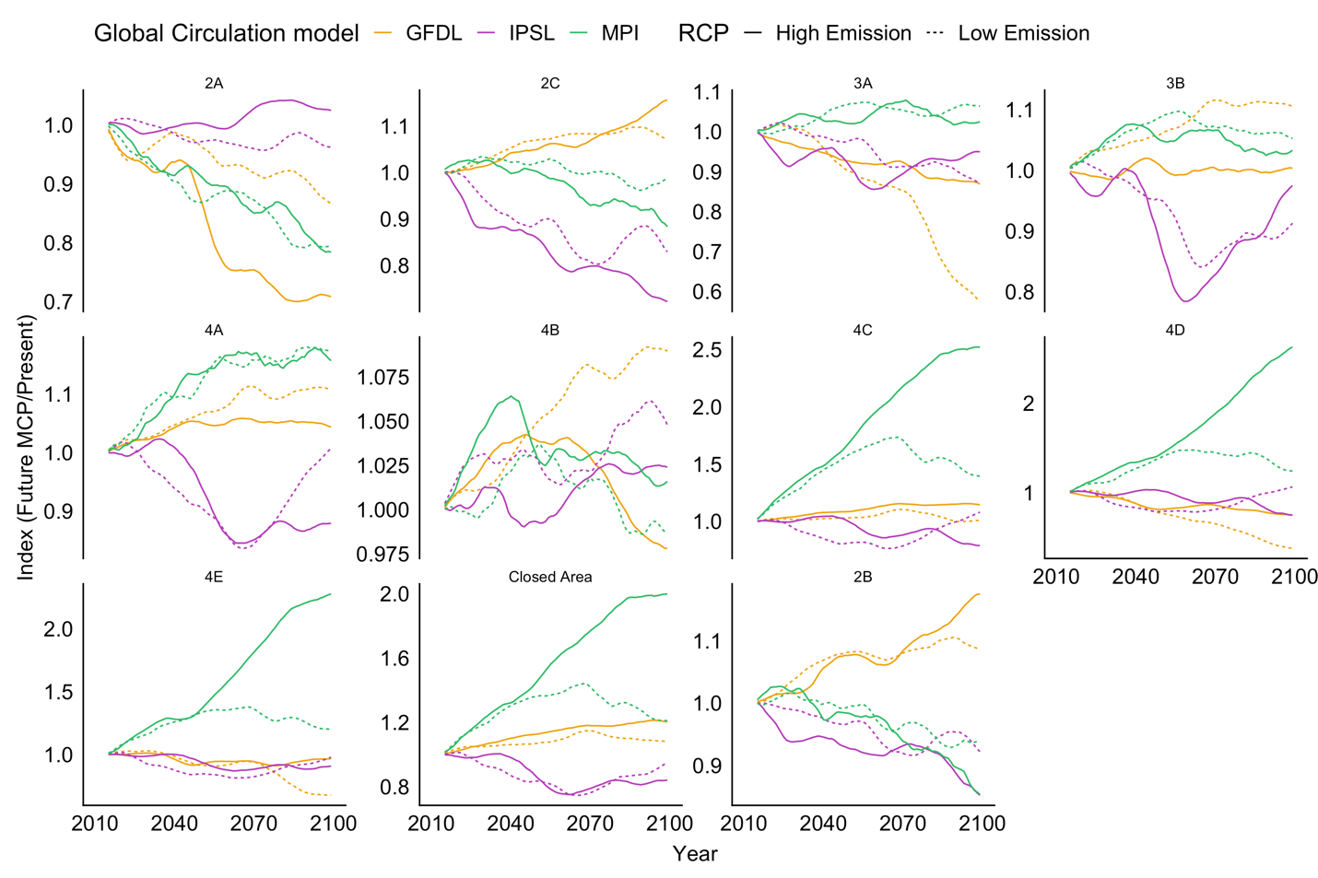 **Fig A2.4.** Projected max catch potential change relative to present (2005-2014) for each IPHC regulatory area. Colors represents the different ESM used in the study. Solid line represents a high emission scenario (RCP 8.5) and dashed line represents a low emission scenario (RCP 2.6)