Challenges to transboundary fisheries management in North America under climate change

[Response to Reviewers]

Juliano Palacios-Abrantes1 U. Rashid Sumaila1 William W. L. Cheung1

1 Institute for the Oceans and Fisheries, University of British Columbia, Vancouver, Canada

# Abstract

Climate change is shifting the distribution of fish stocks that straddle between Exclusive Economic Zones (EEZ), challenging transboundary fisheries management. In this paper, we examine the projected sharing of jointly managed transboundary fish stocks between the EEZs of Canada and the United States. We hypothesize that ocean warming will alter the sharing of fish stocks between the two countries, and that such changes will intensify under a high carbon emission scenario impacting the stock-share ratio of different stocks. Firstly, we projected changes in potential catch of 33 transboundary stocks of North America in the century based on multiple Earth system models’ simulations and species distribution models, under two climate change scenarios. We then look at the specific cases of the International Pacific Halibut Commission that manages pacific halibut (*Hippoglossus stenolepis*) and a resource sharing **DV arrangement** in the Gulf of Maine for cod (*Gadus morhua*), haddock (*Melanogrammus aeglefinus*) and yellowtail flounder (*Limanda ferruginea*) **to discuss the management consequences of shifts in transboundary stocks**. Results show that, even under a low emission scenario, most transboundary fish stocks sharing ratios, i.e., the proportion of the total catch of a fish stock taken by a given country, will change by 2050 relative to present in the direction as expected from the effects of ocean warming. The overall reduction in catch potential, in addition to the changes in stock-share will further exacerbate trade-offs between changes in species catch potential. Such trade-offs in the Atlantic and Pacific regions will be amplified if a high emission scenario is followed, relative to a low carbon emission scenario. Our paper highlights the challenges that transboundary fisheries management will face as species shift their current distribution under a changing climate.

Keywords: *Transboundary fisheries management; climate change; joint fisheries management; species distribution shift*

# INTRODUCTION

In 1982, the United Nations Law of the Seas (UNCLOS) formalized the concept of economic exclusive zones (EEZs) creating what we know today as sahred stocks (United Nations 1986). Shared stocks can move freely between countries EEZs (known as transboundary stocks) or between EEZs and the high seas (also called straddling stocks) (Song et al. 2017). Today, an estimated 347 (Teh and Sumaila 2015) to 1500 (Caddy 1997) fish stocks cross national borders, some of them jointly managed by two or more countries. These stocks are responsible for almost 50% of these countries total fish catches (Teh and Sumaila 2015). While not a law, UNCLOS incentivizes actions to cooperate on the management of shared stocks (United Nations 1986). Today, game theory is one of the most common approaches used to analyze the management of shared stocks, as often, success depends on effective cooperation between parties (Miller and Munro 2002, Sumaila 2013). Management of these stocks’ can be convoluted due to the participation of several fishing “players”, different countries and sometimes jurisdictions within a country, the migration patterns of the stock, and their abundance fluctuation within space and time (Miller and Munro 2002). In addition, international treaties might not be prepared to address the effects that climate change will bring to shared fish stocks (Koubrak and VanderZwaag, this Special Feature).

The ocean is getting warmer (Rheim et al. 2013), less oxygenated (Schmidtko et al. 2017), and increasing in acidity (Ross et al. 2011). To cope with these changes in ocean biophysic properties, marine species, including shared fish stocks, have been shifting their distribution towards the poles and/or deeper waters (Poloczanska et al. 2016). As climate change reshapes the ocean’s environment worldwide (Gattuso et al. 2015), shared fisheries’ delicate governance is threatened as new migration patterns may arise (Miller et al. 2013, Pinsky et al. 2018), historic distribution and abundances might shift (Cheung et al. 2010), and species basic natural traits may modify (Pauly and Cheung 2018). Catches of shared stocks like tunas, have significantly increased in some regions such as the subtropical Atlantic and western Pacific Oceans and are projected to continue (Monllor-Hurtado et al. 2017, Erauskin-Extramiana et al. 2019). Multiple shared species in North America have been observed to shift in distribution following changes in optimal conditions such as sockeye salmon (*Oncorhynchus nerka*) (McDaniels et al. 2010), Atlantic cod (Pershing et al. 2015), and flounders (Pinsky and Fogarty 2012). Moreover, these shifts are projected to continue towards the end of the century (Cheung 2018). As a result, some countries or management jurisdictions may see more shared fisheries and their catches shifting into their waters while others will stand to lose (Miller et al. 2013, Pinsky et al. 2018). Nevertheless, management rules for shared stocks (e.g. quota or spatial delimitation) are often determined based on current and/or historic knowledge of the stock’s distribution and do not consider future shifts in distributions (Fredston-Hermann et al. 2018).

The shifts in distribution of shared fish stocks will impact the economics of their fisheries (Pinsky and Fogarty 2012, Sumaila 2019, Sumaila et al., This Volume), and create international disputes between countries (Miller and Munro 2002, Spijkers and Boonstra 2017, Pinsky et al. 2018). Canada and the US share important transboundary stocks of salmon (*Oncorhynchus spp.*), Pacific halibut (*Hippoglossus stenolepis*), and Atlantic cod (*Gadus morhua*) offering a unique lens to understand the extent to which climate-induced distributional shifts will challenge the future sustainability of transboundary fisheries. These countries have a long history of fisheries cooperation participating in diverse, jointly managed, commercial transboundary stocks through various fisheries management organizations (Munro 2015). Furthermore, climate-related fluctuations in stocks’ distribution have historically created disputes between Canada and the US, increasing international conflict and threatening the health of diverse transboundary stocks (Miller and Munro 2002, CIA 2017).

It is expected that climate induced shifts in stocks’ distribution will affect the rules in place that keep international treaties alive. Therefore, the main objective of this article is to assess the level of exposure that bi-lateral transboundary fisheries treaties between Canada and the US have to climate change through shifts in stock distributions. Specifically, we rely on a species distribution model and scenario planning to project the changes in the distribution of 33 fish stocks jointly managed by Canada and the US. Moreover, we use two specific case studies (the International Pacific Halibut Comission -IPHC- and a fisheries arrangement for the Gulf of Maine -GoMA-) to explore the potential impacts that climate change will have on selected transboundary stocks management. Finally, we explore similar situations around the world and identify opportunities to improve the adaptability of transboundary stocks management to climate change in North America. Despite an overall expectation of species following a poleward shift, important geographic constraints (e.g. Gulf of Alaska representing a latitudinal block) (Kleisner et al. 2016), geo-political features (e.g. the localization of Alaska in reference to Canada and the contiguous states), and management rules (e.g. quota allocations, spatial management rules) may play an important role in the redistribution of benefits. Understanding these stocks shifts will shed a light on future conditions and inform decision-makers on the paths to follow under a changing climate.

# METHODS

#### Study Area and Fisheries

The current study focuses on 33 transboundary stocks jointly managed by Canada and the US for both the Atlantic and the Pacific coasts. The analysis was carried out within the 200 nautical miles of both nation’s EEZ from the Gulf of Mexico to The Labrador Sea in the Atlantic, and from California to Chukchi Sea, in the Pacific coast. The species analyzed (Table A2.1) were selected based on five treaties in both the Atlantic and Pacific coast of North America (Table 1). All species under the IPHC, Pacific Salmon Comission, the Pacific Whiting Treaty, and the GoMA arrangement were analyzed as these are bi-lateral agreements. However, in the case of NAFO, a subset of 26 species reported was made based on those fished in regions that fall within the EEZs of Canada and the United States (NAFO subareas 2s, 3s with the exception of 3M and 3N and limited to the EEZ, 4s, 5s and 6 A,B, and C) (NAFO n.d.). Data related to fisheries was gathered from the Sea Around Us from 1951 to 2014 (Zeller et al. 2016).

Table 1. Treaties and number of species included in the current analysis.

|  |  |  |
| --- | --- | --- |
| International Treaty | Species | Coast |
| International Pacific Halibut Commission (IPHC) | 1 | Pacific |
| Pacific Salmon Commission (PSC) | 5 | Pacific |
| Pacific Whiting Treaty | 1 | Pacific |
| Convention on Cooperation in the Northwest Atlantic Fisheries (NAFO) | 26 | Atlantic |
| Gulf of Maine Agreement (GoMA) † | 3† | Atlantic |

† These species are also managed under NAFO

We used the IPHC and the Gulf of Maine arrangement (hereafter refered as GoMA) as case studies to discuss the implications that climate chage could have in the management of transboundary stocks. For the IPHC, we used the most updated spatial regulatory data along its 12 regulatory areas (IPHC and Gustafson 2017, IPHC 2019). For this specific case, we considered Alaska as a separate entity, the US contiguous states as a second one (Washington, Oregon and California), and lastly British Columbia (Canada). For the GoMA we used NAFO’s divisions 5Y, 5Ze, and 4X within latitudes 46.2°N and 41.5°S, and longitudes -72°W and -64°E (Fig. 1).

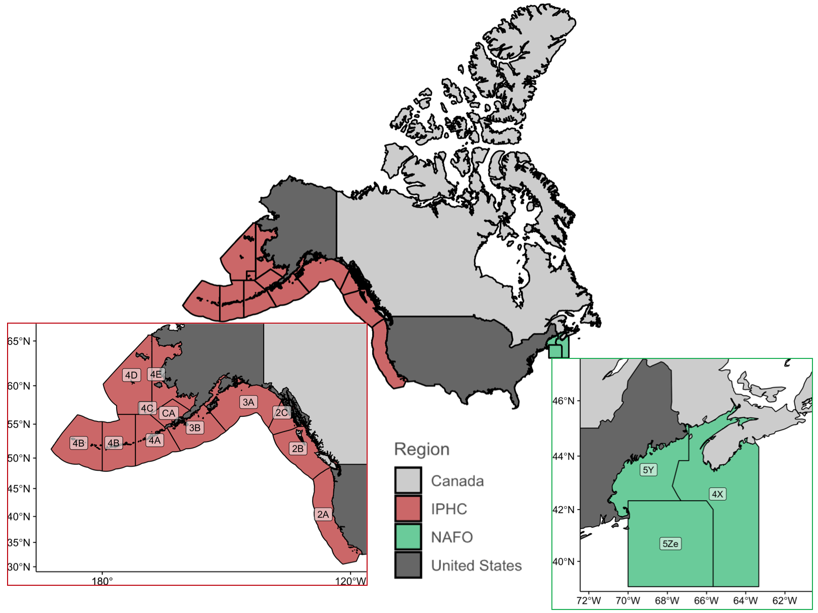

Fig 1. Map of North America with the regulatory areas of the International Paific Halibut Comission and the NAFO sub-region containing the Gulf of Maine arrangement

##### The International Pacific Halibut Comission

The IPHC was established by Canada and the United States to oversee the management of Pacific halibut (*Hippoglossus stenolepis*) (IPHC 2014). There are 12 regulatory areas from wich 3AB holds 51.2% of the stock, followed by regions 2ABC and 4ACDE with 23.1% and 20.4%, respectively, and lastly region 4B with only 5.2% of the stock distribution (IPHC and Gustafson 2018). In terms of management, the IPHC implements a total allowable catch (TAC) based on a yearly sampling of the Convention area in addition to a series of regulations to control fishing effort (IPHC and Gustafson 2018). The TAC is divided between recreational, subsistence and commercial fishery, with a portion set aside for bycatch of other fisheries (IPHC 2019). The commercial fishing season starts in March ending around November whith restrictions allowing only set line gear with J-type hooks targeting individuals over 81.3 cm with head on (IPHC 2019).

##### The Gulf of Maine Arrangement

Since 1998 Canada and the US celebrate a “Resource Sharing Understanding” to inform the management of George Bank’s Atlantic cod (*Gadus morhua*), and Eastern George Bank’s haddock (*Melanogrammus aeglefinus*) and, yellowtail flounder (*Limanda ferruginea*) (Pudden and VanderZwaag 2007, TRAC 2016, CIA 2017). The GoMA suggests catch-limits based on stocks’ distribution produced by quaterly surveys and historical catch (TRAC 2016), and so Canada and the US ultimatley take single management decissions (Soboil and Sutinen 2006). In terms of manangement, the US has a multi species harvest control with area and season cloasures, mesh sizes, effort control, and mobile gear vessels that use bottom otter trawl gear (Soboil and Sutinen 2006). In contrast, Canada has a quota system in addition to limited-entery licensig, fleet allocations, and mesh and fish size regulation, among other input controls. Canada inshore vessels fish Cod with longline and gillnet while haddock is mainly caught with bottom otter trawl gear (Soboil and Sutinen 2006).

#### Projecting Future Species Distribution

We used a Dynamic Bioclimatic Envelope Model (DBEM) to project the distribution of species from 2015 to 2100 under two scenarios of climate change (Cheung et al. 2010, Cheung, Jones, Reygondeau, et al. 2016). The DBEM algorithm integrated ecophysiology and habitat suitability with spatial population dynamics of exploited fishes and invertebrates to project shifts in abundance and potential fisheries catches under climate change. The algorithm predicted species distribution based on depth and latitudinal range, habitat preferences and an index of species association with major habitat types to estimate changes in abundance distribution over a 0.5º x 0.5º grid of the world ocean. For each grid cell and time step, the model then calculated species carrying capacity according to sea surface temperature, salinity, oxygen content, sea ice extent (for polar species) and bathymetry, as well as the species preferences to these conditions. It then incorporated the intrinsic population growth, settled larvae, and net migration of adults from surrounding cells using an advection-diffusion-reaction equation. Finally, the model also simulated the effects of changes in temperature and oxygen content on growth of individuals (Cheung et al. 2013). Ultimately, the model simulates spatial and temporal population dynamics, and estimates a proxy of maximum sustainable yield (MSY) by applying fishing at MSY level for each grid cell, hereafter referred as maximum catch potential (MCP).

The DBEM was projected using three earth system models (ESM), the Geophysical Fluid Dynamics Laboratory Earth System Models 2M (GFDL)[1], the Institute Pierre Simon Laplace Climate Model 5 (IPSL-CM5)[2], and the Max Planck Institute for Meteorology Earth System Model (MPI)[3]. Each model was downscaled to match the DBEM 0.5’ x 0.5’ grid using the nearest neighbor method, and in some cases, bilinear interpolation (Cheung, Jones, Lam, et al. 2016). Finally, we used the model outputs for two scenarios of the Intergovernmental Panel on Climate Change (IPCC)-Representative Concentration Pathways (RCP) 2.6 and RCP 8.5 representing a low greenhouse gas emission (strong mitigation) and a high greenhouse gas emission (week mitigation) scenario, respectively (IPCC (Intergovernmental Panel on Climate Change) 2014). To estimate model robustness and capture the structural uncertanty build within ESM models, we averaged the DBEM results for all three models () and marked regions where at least one ESM disagree in direction with the rest.

#### Estimation of Maximum Catch Potential Change

For estimating the percentage change of MCP at the regional scale, we frst aggregated the yearly mean MCP of all species per region () and period:

where *y* is year, *r* is region, *s* is species, *n* is total number of species, and is the MCP averaged by the three ESMs. In the case of North America as a whole, and the GoM arrangement, region is defined as the 0.5’ x 0.5’ grid-cell within the EEZ and the specific NAFO regulatory areas, respectiveley. For the IPHC analysis, region is defined as the Comission’s regulatory areas (Fig. 1). We then average the values in three time periods (*t*) to reduce temporal model sensitivity. Thus, we computed the regional percentage change in MCP () as follows:

where is the future averaged MCP for each of the two time periods analized in this study and is the present averaged MCP ( 2005-2014). This way, Equ. 2 shows the percentage change in MCP by mid century when = 2041-2060, and end of century when = 2080-2099, relative to today (). The rationale between choosing these time periods was to provide a relative short-term projection (mid-century) that would be more policy-relevant but also show the long term trend (end of century).

In addition, we borrowed the concept of “threat point” from game theory defined as the minimum payoff that a player is willing to receive in order to cooperate with other players (see Sumaila et al., this Special Feature). Thus, we estimate the change in the RA (threat point) that each country RA (players) would have for each species (hereafter referred as stock-share ratio), for both the IPHC and the GoMA. RA The stock-share ratio can be seen as the proportion of the stock’s distribution within the study area that each country has. For this, we first modify Equ. 1, to estimate the aggregated yearly mean MCP of each species per region. We then average the results by the same previouslly metioned periods (present, mid and end of the century). Next, for each species we estimated the stock-share ratio () that each region had during each time period:

where is the species’ aggregated of each region at time period *t*, and is the species’ aggregated of the whole specie’s distribution within the study area at the same time period. Finally, we estimated the percentage change in stock-share ratio substituting and by and , respectively in Equ. 2. The process was carried out for each ESM and results presented as mean standard deviation (sd). All of the analysis was done in the statistical software *R* version 3.5.2 (2018-12-20) with the associated packages, *data.table* (Dowle et al. 2019), *ggrepel* (Slowikowski et al. 2019), *gridExtra* (Auguie 2017), *knirt* (Xie 2020), *RColorBrewer* (Neuwirth 2014), *sf* (Pebesma et al. 2018), and *tidyverse* (Wickham 2017). All code is available at <https://github.com/jepa/OC_Transboundary>.

# RESULTS

### North American transboundary RB stocks are shifting poleward

Shifts in the distribution of 33 jointly managed transboundary stocks of North America show that by 2050 MCP of transboundary stocks will increase in Atlantic-Canadian and Alaskan waters and decrease in Pacific-Canadian and the US contiguous states waters (Fig. 2). Such changes will be more intense under the high emission scenario (Fig. 2-A). Under the low emission scenario, MCP will be reduced in a reduced area and with lower intensity (Fig. 2-B). Impacts of cliamte change are expected to intensify towards the end of the century, although with greater uncertainty (Fig A1.1).

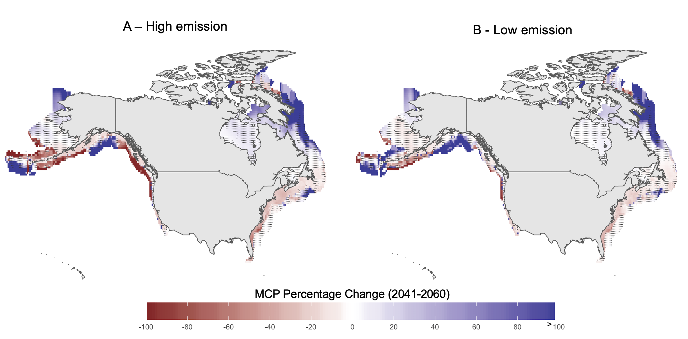

Fig 2. Percentage change of MCP of transboundary stocks of North America for mid century (2041-2060) relative to present (2005-2014) under a A) lohighw emission scenario and; B) low emission scenario. Points represent areas where at least one model do not agree in the direction of change

In consequence, each country’s share-ratio of different species will change with an overall benefit to northern regions, regardless of the RCP scenario. Overall, shifts will be amplified under the high emission scenario relative to the low greenhouse emission scenario pathway (Table 2).

Table 2. Average (standard deviation) of 33 transboundary species stock-share of all models for each EEZ and emission scenario for mid and end of the century. Averages might not add to 100% due to model differences (e.g., standard deviation).

|  |  |  |  |
| --- | --- | --- | --- |
| EEZ | RCP | Mid-century (2041–2060) | End of Century (2081–2100 |
| Alaska | High | 82.04 (6.41) | 83.82 (6.43) |
| Canada West (British Columbia) | Emission | 10.74 (2.65) | 9.91 (2.95) |
| U.S. contiguous states |  | 18.94 (31.05) | 18.24 (30.6) |
| Canada East |  | 78.24 (26) | 82.78 (22.87) |
| United States East |  | 22.63 (26.15) | 17.9 (23.06) |
| Alaska | Low | 81.28 (6.35) | 81.84 (6.58) |
| Canada West (British Columbia) | Emission | 11.6 (2.71) | 11.51 (2.96) |
| U.S. contiguous states |  | 18.73 (30.04) | 18.34 (29.81) |
| Canada East |  | 76.78 (26.76) | 77.2 (26.79) |
| United States East |  | 24.15 (26.88) | 23.71 (26.92) |

### Projected change to species managed by the IPHC

In the case of the IPHC, at least one third of regulatory areas will see a reduction in MCP of Pacific halibut by 2050 relative to current MCP, regardless of the climate change scenario (Fig. 3). It is likely that the stock shift from the U.S. contiguous states towards Canada will offset the shift of the later towards northern regions, resulting in undetectable changes in Canadian area 2B and Alaskan 2C under both climate change scenarios. The potential movement of halibut westward will increase the MCP of regulatory areas 3B (under a low emission scenario) and 4ABCE along the Aleutian Islands and Bering Sea. Regions 4DE, the most poleward regulatory areas of the IPHC, are expected to gain MCP by mid (Fig. 3) and end of the century (Fig. A1.2) under a high emission scenario due to the expansion of halibut suitable habitat as sea ice retreats (Fig. A3.1). In contrast, under a low emission scenario, sea ice is expected to stabilize towards mid century, thus providing less “new” suitable habitat for P. halibut and resulting in undetectable changes in MCP for the region (Fig 3. B) and decreasing even more towards 2100 (Fig. A1.2).

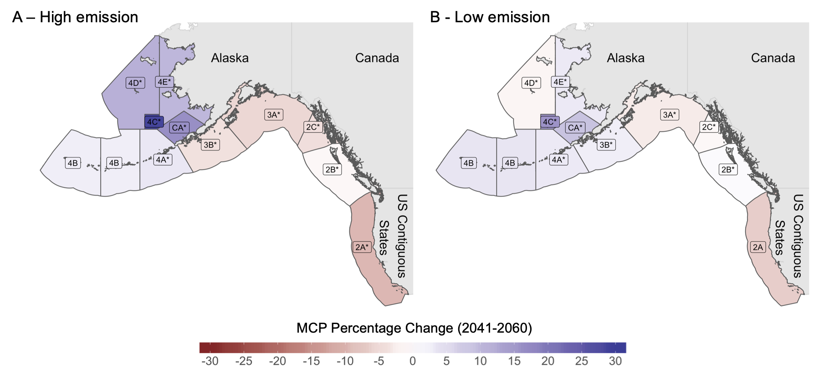

Fig 3. Percentage change of MCP for species managed by the IPHC for mid century (2041-2060) relative to present 2005-2014 under a A) low emission scenario and B) high emission scenario. Labels marked with "*" represent regions where models do not agree in direction of change.

The same poleward trend is expected in the change of Pacific halibut stock-share ratio with the average proportion increasing up to 25% in some northern regions and decreasing by 10% in southern regions, relative to the present proportion (Fig. 4). Maintaining emissions to lower levels through 2050 would potentially leave unchanged the stock-share ratio of three regulatory areas (3AC, and 4D) and negatively change regulatory area 2A. On the other hand, failing to achieve such target will decrease the stock-share ratio in the most productive regulatory areas (2AC, 3AB).

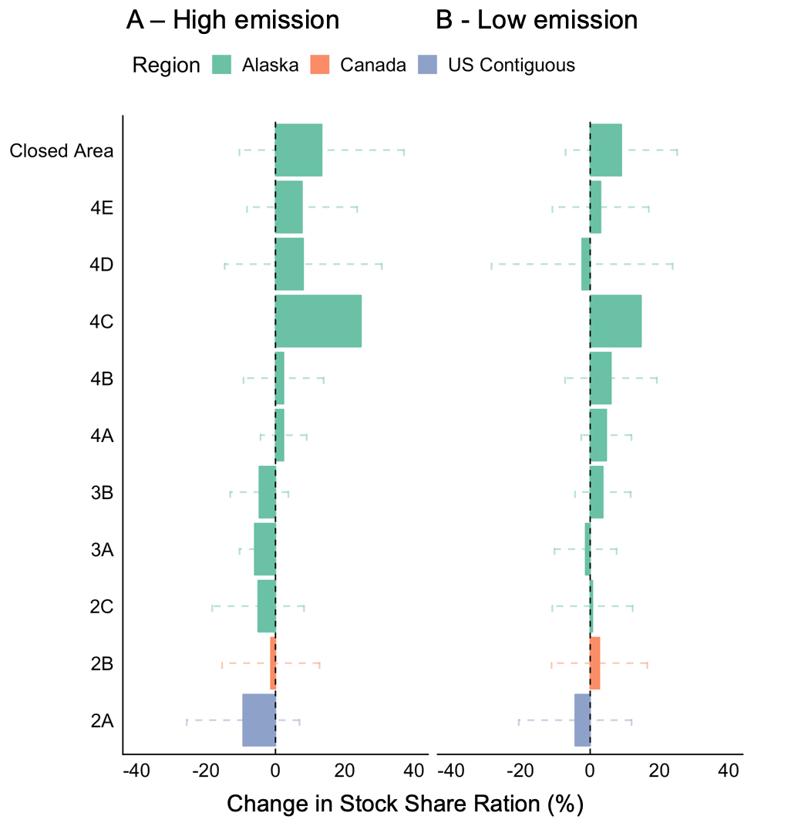

Fig 4. Percentage change of stock-share ratio for IPHC under A) low emission scenario and B) high emission scenario for mid century (2041-2060) relative to present 2005-2014. Values represent the mean of 3 ESM; error bars represent sd.

### Projected change to species managed under the GoM DV arrangement

While some regulatory areas of the IPHC will see an incremental increase in P. halibut MCP, the results for the Gulf of Maine show an overall decrease in MCP by 2050, regardless of the climate change scenario or ESM (Fig. 5), intensifying by the end of the century (Fig. A1.3). For cod and haddock, MCP will decrease within the whole Gulf with no apparent win for any country in reference to the current period (Fig. 5). For Y. flouder, despite an overall reduction, some discrete areas are expected to increase with no particular pattern and high uncertainty as ESMs in these regions do not agree in the direction of change. Despite the overall reduction in MCP for all three species in comparison to current values, there is a benefit of achieving a low emission scenario as reductions intensify under the high emission scenario.

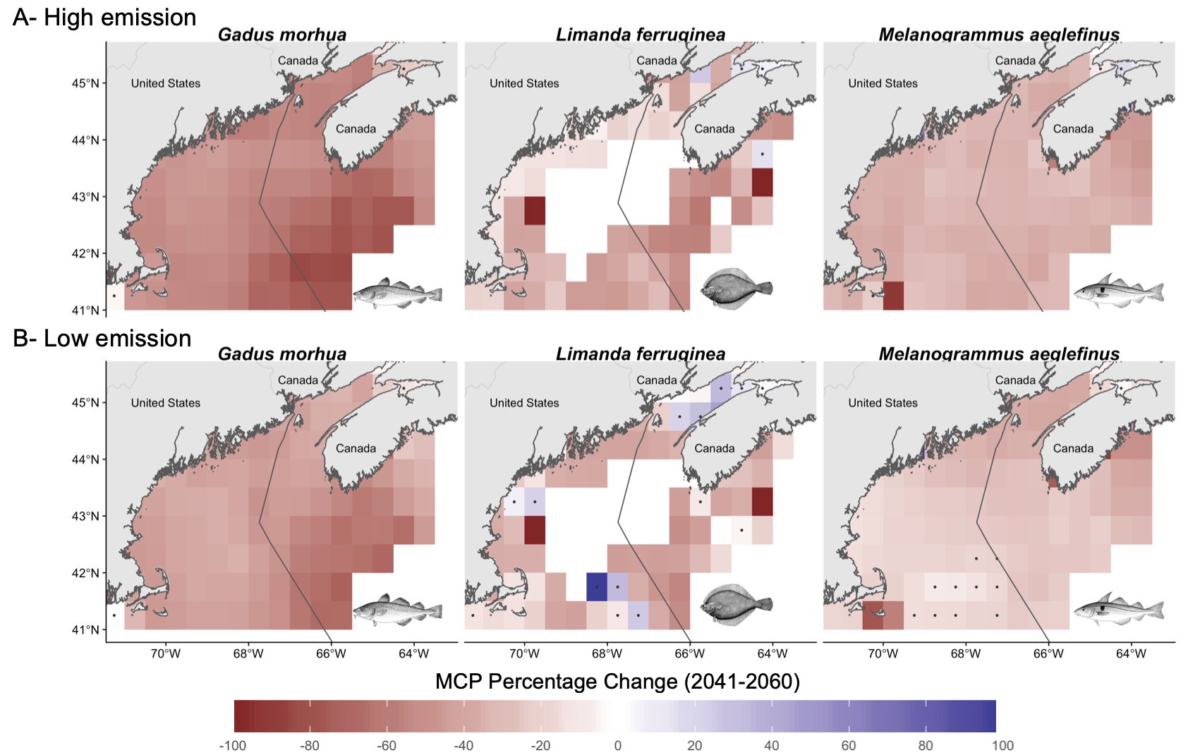

Fig 5. Percentage change of MCP in the Gulf of Maine under, A) high emission scenario; and B) low emission for mid century (2041-2060) relative to present (2005-2014). Points represent regions where models do not agree in direction of change.

Despite the expected decrease in MCP for the region, changes in the stock-share ratio of species within the Gulf of Maine show different outcomes dependent on the climate change scenario and species in question. Following a high emission path will affect mostly Canada’s share of Y. flouder and in less degree haddock, with an increase of cod share. Under the low emission scenario, haddock and cod patterns intensify, while Y. flouder’s share approaches almost no change (Fig 6). Such pattern is likely the combination of the bathymetry or the Gulf, the warming gradient, and the species distribution (see discussion).

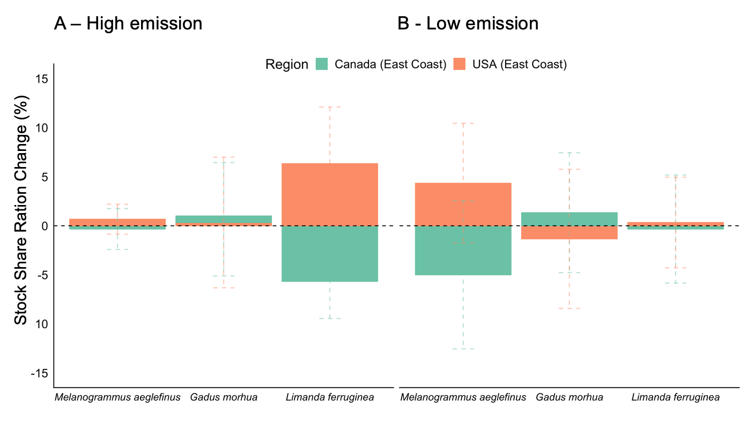

Fig 6. Changes in MCP stock-share ratio for Gulf of Maine under (A) high emission; and (B) low emission scenarios for mid century (2041-2060) relative to present. Values represent the mean of 3 ESM; error bars represent sd. (2005-2014)

# DISCUSSION

The results of the present study suggest that climate change will alter the MCP of 33 transboundary fish stocks in North America consequently altering Canada’s and the US’s species’ stock-share ratio, regardless of the climate change scenario. These results are aligned with regional (Morley et al. 2018) projections suggesting that climate change will push marine species towards the poles and deeper water (Pinsky et al. 2013) in search of their ecological niche (Poloczanska et al. 2016). Poleward shifts in Eastern Atlantic off the coast of the US include American lobster (*Homarus americanus*), summer (*Paralichthys dentatus*) and yellow flounders, and red hake (*Urophycis chuss*) from North Carolina to Maine (Pinsky and Fogarty 2012). However, geographic barriers (Cheung et al. 2015, Kleisner et al. 2016), local temperature gradients (Pinsky et al. 2013), species interactions and human activities (Serpetti et al. 2017) might change the rate and direction of species shifts. Species such as haddock in the Atlantic (Morley et al. 2018), and big skate (*Raja binoculata*) in the pacific coast (Pinsky et al. 2013) have been projected to shift away from the poles. In the Gulf of Maine, the stock-share gain of Y. flounder and haddock by the US (Fig. 6) could be a response to a temperature gradient shift combined with geographic barriers as southern waters are deeper, and warming slower than northern waters (Fig A3.1). In the other hand, Maine has seen its landings of Y. flouder increased at the expenses of southern states (Pinsky and Fogarty 2012). This could be influencing the US gain in MCP in the GoM in relation to Canada as species shift their distribution from lower latitudes naturally reaching the US (lower) region first. Geographic barriers also affect the westward increase of stock-share in IPHC regions where species can only migrate northward into the Arctic Ocean through the Bering Sea and Bering Strait (Cheung et al. 2015) (Fig. 4). As the effects of climate change endure, even with high mitigation, joint plans should prepare to face changes in the stock-share ratio of transboundary stocks along both coast of North America.

The shifts in the distribution of transboundary stocks can jeopardize management objectives such as conservation measures and gear operation. Fish moving out of fishing grounds and into protected areas could result in a pressure increase to open such area to fishing. Moreover, overlapping shifting stocks could interfere in gear-limitation management rules of multiple fisheries generating conflicts between fleets (Van Der Voo 2016). The effectiveness of the IPHC-Closed Area (“CA” in Fig 1.) in tems of protecting juveniles has been historically questioned as trawling for other species is still allowed in the area (Karim et al. 2010, IPHC 2017). In 2015, for example, 97% of the trawl by-catch in areas 4CDE and the Closed Area were juveniles (IPHC 2017). Consequently, the Alaskan trawl fisheries has been closed before reaching annual quota due to the attainment of P. halibut bycatch quota limits (Karim et al. 2010). Thus the comission has been asked to open the closed area for P. halibut fishing, under the premise that the expansion of the trawl fishery is likely reducing any conservation goal for juvenile P. halibut (IPHC 2017). Although not assessed in this study, some trawling target species like Pacific cod (*Gadus macrocephalus*), flathead sole (*Hippoglossoides elassodon*), and Alaskan plaice (*Limanda aspera*) have already shift their distributions due to warming waters (Stram and Evans 2009) and some are expected to continue shifting in similar direction than P. halibut (Pinsky et al. 2013). The overlap of target species could be addressed by applying ecosystem-based management and dynamic management tools (Hazen et al. 2018) to manage these fisheries and reduce potential lost of sustainable harvest for both the halibut and the trawl fisheries.

Quota allocation ruled by historic distributions will most likely be outdated incentivizing maladaptation (Miller et al. 2013, FAO 2018, Gaines et al. 2018). In Europe, for example, the EU Common Fisheries Policy quota allocation is based on historic reference period of 1973-1978 (Harte et al. 2019). However, climate change has shifted the distribution of multiple European commercial stocks (Baudron et al. 2020), outdating the fixed quotas and thus compromising the sustainability of European fisheries (FAO 2018, Baudron et al. 2020). Management regimes that inclued a dynamic harvest control (e.g. adjusting the quota based on the stocks distribution) have the potential of increasing fish biomass, harvest and profits under climate change (Gaines et al. 2018). In North America, poleward shifts of P. halibut along the coast of Oregon, Washington and British Columbia have been previouslly addressed by the IPHC resulting in the adoption of a dynamic quota allocation method (McCaughran and Hoag 1992). By allocating quotas based on yearly surveys along the Convention area, the IPHC should be able to capture shifts in P. halibut distribution due to climate change, reducing the chances of overexploitation of the stock due to this shifts (Miller et al. 2013). Similarly, since 2010 GoMA sets weighted quotas based on stocks distribution and historical catch (TRAC 2016). This process is especially important for cod and haddock due to their distribution variation within the gulf (Soboil and Sutinen 2006, TRAC 2016).

Side payments have been previously used to address changes in species distribution due to environmental forcings. In game theory, a side payment is received by a player as a compensation from the other player in a shared ressource agreement, with the premise that cooperation will result in a better overall outcome (Bjørndal and Munro 2012, Sumaila 2013). Side payments do not have to be in monetary form and are widely used in transboundary **RB stocks** around the world. For example, Norway and Russia have implemented a quota swap strategy for jointly managed stocks of cod, haddock and capelin in the Barents Sea.[4] Similarly, species’ quota swaps are permited, up to a degree, within regulatory areas of the European union (Baudron et al. 2020). Specifically, for northern European spring spawning Herring (*Clupea harengus*), Norway, Iceland, Faroe Islands, Russia and the EU reached an agreement to manage the stock after its collapsed, partially due to climate variations (Miller et al. 2013). Among the implemented rules, the agreement sets a dynamic quota allocation, allows memebers to fish part of their quota within Norway’s EEZ, and land the catch in Norwegian ports. In North America, Canada and the US have previous history with the utilization of side payments when in the 70’s Pacific Salmon shifted its distribution resulting in large interceptions of Canada’s salmon by Alaskan fisheries (Miller et al. 2013). The conflict was resolved by the implementation of a conservation fund that work as a side payment for both Canada and the state of Alaska (Miller et al. 2013). The potential adaptation of side payments in terms of quota swaps or allowing free quota fishing within across the Gulf of Maine EEZs could be a potential solution as stocks shift due to climate change.

Transboundary fisheries management have to be prepared for the uncertanty that comes with a changing world. Future climate change will depend on the path society as a whole will take, and thus we rely on scenario planning to account for the uncertainty build in future decision making (Vuuren et al. 2011). In our results, the “winners and loosers” of climate change, and the intensity of the change, will be scenario dependant. For instance, stock-share of Y. flounder under a high emission scenario will be larger for the US while Canada’s gain of haddock stock-share will be larger under a low emission scenario (Fig. 6). Applying previouslly describe strategies (e.g. quota swaps or EEZ-fishing rights) could increase the resilience of treaties by preventing members from leaving the agreement due to a shift in threat points, as happened in the P. salmon case (Miller et al. 2013).

Models are attempts to represent reality (in our case a future reality) based on observational data, previously established theory, and future scenarios, and are thus, subjected to different degrees of uncertainty (Payne et al. 2016). An ensamble or models is a way to present a more robust result that accounts for differnces in the structural composition of each model (Cheung, Frölicher, et al. 2016). In here we used three ESMs to project future changes in species maximum catch potential. The levels of uncertainty related to the ESMs differ among case studies. Overall, results for the Gulf of Maine agree with a reduction in MCP of all three species. However, some discrete areas show a positive change for Y. flounder by mid century (Fig. 4), mainly driven by the GFDL model (**Fig A3.2**). Potential model artifacts could also be contributing to the results, especially in the northern part of the study area (Bay of Fundy) as most disagreeing grids are covered by land, which could be influencing the results. In contrast, considerable uncertainty exists in the change of MCP along the IPHC Convention area shown by a disagreement between ESMs (**Fig A3.2**). Off the coast of British Columbia, increasing temperature trends are consistant among ESMs, however, other processes such as acidification and deoxygenation are still not well understood from British Columbia to the Gulf of Alaska (Talloni-Álvarez et al. 2019). Moreover, considerable uncertainty exists along the Berring Sea (Douglas 2010) and Antartic Pacific regarding the extent and intensity of future sea-ice reduction under climate change (Steiner et al. 2015, IPCC (Intergovernmental Panel on Climate Change) 2019). **RA Structural uncertainty within the DBEM has been previously tested for agreement against commonly used species distribution algorithms such as Maxent (Phillips et al. 2006) and AquaMaps (Ready et al. 2010, Kaschner et al. 2011) resulting in no qualitative differences in trends between algorithms (Cheung, Jones, Reygondeau, et al. 2016). Is worth mentioning that future changes to species distributions could be influenced by factors not captured by our model such as interactions between species (Pecl et al. 2017), adaptation of species to environmental changes, and anthropogenic factors (Serpetti et al. 2017). However, these factors are expected to increase the rate of range-shifting of the species making our results conservative (Cheung et al. 2010, Serpetti et al. 2017).**

# CONCLUSIONS

Shifts in **RB stocks** distribution due to climate change have the potential of creating local extinction of economically important **RB stocks** while enhancing fisheries in areas where they were not present before. In this paper, we have explored the potential impacts of climate change in the joint management of 33 transboundary stocks managed by Canada and the US. We found that, transboundary **RB stocks** are likely to shift in the upcoming years changing the proportion of the catch of jointly managed fisheries of Canada and the US. Lessons from other countries can provide solutions to such challenges. More specific, side payments, dynamic management, and interchangeable quotas were identified as potential solutions for North American region. While not directly addressed in this study, socio-economic impacts of shifting transboundary stocks could add an extra layer of complexity to the problem. Addressing shifts in **RB stocks** distribution sooner rather than latter could avert the so called “fish wars”, improve sustainability of jointly managed stocks, and secure the livelihood of thousand of families that depend on stocks that move freely between national jurisdictions. Finaly, preparing for an uncertain future is key to achieve sustainable fisheries.

# ACKNOWLEDGEMENTS

This is a product of the *OceanCanada* Partnership funded by the Social Sciences and Humanities Research Council of Canada.

# LITERATURE CITED

Auguie, B., 2017. Package gridExtra; Miscellaneous Functions for "Grid" Graphics, R (3.5.0).

Baudron, A. R., Brunel, T., Blanchet, M. A., Hidalgo, M., Chust, G., Brown, E. J., Kleisner, K. M., Millar, C., MacKenzie, B. R., Nikolioudakis, N., Fernandes, J. A., and Fernandes, P. G., 2020. Changing fish distributions challenge the effective management of European fisheries. *Ecography*, 43, 1.

Bjørndal, T. and Munro, G., 2012. The economics and management of world fisheries.

Caddy, J., 1997. Establishing a consultative mechanism or arrangement for managing shared stocks within the jurisdiction of contiguous states. *Australian Society for Fish Biology*.

Cheung, W. W. L., 2018. The future of fishes and fisheries in the changing oceans. *Journal of Fish Biology*, 92 (3), 790–803.

Cheung, W. W. L., Brodeur, R. D., Okey, T. A., and Pauly, D., 2015. Projecting future changes in distributions of pelagic fish species of Northeast Pacific shelf seas. *Progress in Oceanography*, 130 (C), 19–31.

Cheung, W. W. L., Frölicher, T. L., Asch, R. G., Jones, M. C., Pinsky, M. L., Reygondeau, G., Rodgers, K. B., Rykaczewski, R. R., Sarmiento, J. L., Stock, C., and Watson, J. R., 2016. Building confidence in projections of the responses of living marine resources to climate change. *ICES Journal of Marine Science*, 73 (5), 1283–1296.

Cheung, W. W. L., Jones, M. C., Lam, V. W. Y., D Miller, D., Ota, Y., Teh, L., and Sumaila, U. R., 2016. Transform high seas management to build climate resilience in marine seafood supply. *Fish and Fisheries*, 1–11.

Cheung, W. W. L., Jones, M. C., Reygondeau, G., Stock, C. A., Lam, V. W. Y., and Frölicher, T. L., 2016. Structural uncertainty in projecting global fisheries catches under climate change. *Ecological Modelling*, 325, 57–66.

Cheung, W. W. L., Lam, V. W., and Sarmiento, J. L., 2010. Large-scale redistribution of maximum fisheries catch potential in the global ocean under climate change. *Global Change Biology*, 16, 24–35.

Cheung, W. W. L., Watson, R., and Pauly, D., 2013. Signature of ocean warming in global fisheries catch. *Nature*, 497 (7449), 365–+.

CIA, 2017. The US-Canadian Dispute Over the Georges Bank, 1–10.

Douglas, D. C., 2010. ***Arctic Sea Ice Decline: Projected Changes in Timing and Extent of Sea Ice in the Bering and Chukchi Seas***. Resto, Virginia, US. No. Open-File Report 20101176.

Dowle, M., Srinivasan, A., Gorecki, J., Chirico, M., Stetsenko, P., Short, T., Lianoglou, S., Antonyan, E., Bonsch, M., Parsonage, H., and Ritchie, S., 2019. Package data.table; Extension of ‘data.frame‘, R (>= 3.1.0), MPL–2.0 | file LICENSE.

Erauskin-Extramiana, M., Arrizabalaga, H., Hobday, A. J., Cabré, A., Ibaibarriaga, L., Arregui, I., Murua, H., and Chust, G., 2019. Large-scale distribution of tuna species in a warming ocean. *Global Change Biology*, 25 (6), gcb.14630–2060.

FAO, 2018. *Impacts of climate change on fisheries and aquaculture Synthesis of current knowledge, adaptation and mitigation options*. Rome, Italy: Food; Agriculture Organization of the United Nations. No. 627.

Fredston-Hermann, A., Gaines, S. D., and Halpern, B. S., 2018. Biogeographic constraints to marine conservation in a changing climate. *Annals of the New York Academy of Sciences*, 367, 49–13.

Gaines, S. D., Costello, C., Owashi, B., Mangin, T., Bone, J., Molinos, J. G., Burden, M., Dennis, H., Halpern, B. S., Kappel, C. V., Kleisner, K. M., and Ovando, D., 2018. Improved fisheries management could offset many negative effects of climate change. *Science Advances*, 4 (eaao1378), 1–8.

Gattuso, J. P., Magnan, A., Billé, R., Cheung, W. W. L., Howes, E. L., Joos, F., Allemand, D., Bopp, L., Cooley, S. R., Eakin, C. M., Hoegh-Guldberg, O., Kelly, R. P., Pörtner, H. O., Rogers, A. D., Baxter, J. M., Laffoley, D., Osborn, D., Rankovic, A., Rochette, J., Sumaila, U. R., Treyer, S., and Turley, C., 2015. Contrasting futures for ocean and society from different anthropogenic CO2 emissions scenarios. *Science*, 349 (6243), aac4722–aac4722.

Harte, M., Tiller, R., Kailis, G., and Burden, M., 2019. Countering a climate of instability: the future of relative stability under the Common Fisheries Policy. *ICES Journal of Marine Science*, 76 (7), 1951–1958.

Hazen, E. L., Scales, K. L., Maxwell, S. M., Briscoe, D. K., Welch, H., Bograd, S. J., Bailey, H., Benson, S. R., Eguchi, T., Dewar, H., Kohin, S., Costa, D. P., Crowder, L. B., and Lewison, R. L., 2018. A dynamic ocean management tool to reduce bycatch and support sustainable fisheries. *Science Advances*, 4 (5).

IPCC (Intergovernmental Panel on Climate Change), 2014. *Climate Change 2014 Impacts, Adaptation, and Vulnerability*. Cambridge: Cambridge University Press.

IPCC (Intergovernmental Panel on Climate Change), 2019. The Ocean and Cryosphere in a Changing. Summary for Policymakers. *In*: Pörtner, H. O., Roberts, D. C., Masson-Delmotte, V., Zhai, P., Tignor, M., Poloczanska, E., Mintenbeck, K., Nicolai, M., Okem, A., Petzold, J., Rama, B., and Weyers, N., eds. *IPCC special report on the ocean and cryosphere in a changing climate*. 42.

IPHC, 2014. *The Pacific Halibut: Biology, Fishery, and Management*. Seattle, WA. No. 59.

IPHC, 2017. ***IPHC Closed Area (Section 10)***. No. IPHC-2018-AM094-PropA1.

IPHC, 2019. *International Pacific Halibut Commission, Pacific halibut fishery regulations*. Seattle, WA.

IPHC and Gustafson, K., 2017. *IPHC Annual Report 2016*. Seattle.

IPHC and Gustafson, K., 2018. *International Pacific Halibut Commission, Anual Report*. Seattle, WA: IPHC.

Karim, T., Keizar, A., Busch, S., Dicosimo, J., Gasper, J., Mondragon, J., Culver, M., and Williams, G., 2010. *Report of the 2010 Halibut Bycatch Work Group*. IPHC. No. 57.

Kaschner, K., Tittensor, D. P., Ready, J., Gerrodette, T., and Worm, B., 2011. Current and Future Patterns of Global Marine Mammal Biodiversity. *PLoS ONE*, 6 (5), e19653.

Kleisner, K. M., Fogarty, M. J., McGee, S., Barnett, A., Fratantoni, P., Greene, J., Hare, J. A., Lucey, S. M., McGuire, C., Odell, J., Saba, V. S., Smith, L., Weaver, K. J., and Pinsky, M. L., 2016. The Effects of Sub-Regional Climate Velocity on the Distribution and Spatial Extent of Marine Species Assemblages. *PLoS ONE*, 11 (2), e0149220.

McCaughran, D. A. and Hoag, S. H., 1992. *The 1979 Protocol To The Convention and Related Legislation*. Seattle. No. 26.

McDaniels, T., Wilmot, S., Healey, M., and Hinch, S., 2010. Vulnerability of Fraser River sockeye salmon to climate change: A life cycle perspective using expert judgments. *Journal of Environmental Management*, 91 (12), 2771–2780.

Miller, K. A., Munro, G. R., Sumaila, U. R., and Cheung, W. W. L., 2013. Governing Marine Fisheries in a Changing Climate: A Game-Theoretic Perspective. *Canadian Journal of Agricultural Economics/Revue canadienne d’agroeconomie*, 61 (2), 309–334.

Miller, K. and Munro, G., 2002. *Cooperation and Conflicts in the Management of Transboundary Fishery Resources*. Monterey, California: Proceeding of the Second World Conference of the Second World COngress of the American; European Associations of Environmental; Resource Economics.

Monllor-Hurtado, A., Pennino, M. G., and Sanchez-Lizaso, J. L., 2017. Shift in tuna catches due to ocean warming. *PLoS ONE*, 12 (6), e0178196.

Morley, J. W., Selden, R. L., Latour, R. J., Frölicher, T. L., Seagraves, R. J., and Pinsky, M. L., 2018. Projecting shifts in thermal habitat for 686 species on the North American continental shelf. *PLoS ONE*, 13 (5), e0196127.

Munro, G. R., 2015. Internationally Shared Fish Stocks, the High Seas, and Property Rights in Fisheries. *Marine Resource Economics*, 22 (4), 425–443.

Neuwirth, E., 2014. ColorBrewer Palettes [R package RColorBrewer version 1.1-2], R (>2.0.0), Apache License 2.0.

Pauly, D. and Cheung, W. W. L., 2018. Sound physiological knowledge and principles in modeling shrinking of fishes under climate change. *Global Change Biology*, 24 (1), e15–e26.

Payne, M. R., Barange, M., Cheung, W. W. L., MacKenzie, B. R., Batchelder, H. P., Cormon, X., Eddy, T. D., Fernandes, J. A., Hollowed, A. B., Jones, M. C., Link, J. S., Neubauer, P., Ortiz, I., Queirós, A. M., and Paula, J. R., 2016. Uncertainties in projecting climate-change impacts in marine ecosystems. *ICES Journal of Marine Science*, 73 (5), 1272–1282.

Pebesma, E., Bivand, R., Racine, E., Sumner, M., Cook, I., Keitt, T., Lovelace, R., Wickham, H., Ooms, J., and Müller, K., 2018. Package sf; Simple Features for R, R (>= 3.3.0) (GPL-2 | MIT + file LICENSE).

Pecl, G. T., Araújo, M. B., Bell, J. D., Blanchard, J., Bonebrake, T. C., Chen, I.-C., Clark, T. D., Colwell, R. K., Danielsen, F., Evengård, B., Falconi, L., Ferrier, S., Frusher, S., Garcia, R. A., Griffis, R. B., Hobday, A. J., Janion-Scheepers, C., Jarzyna, M. A., Jennings, S., Lenoir, J., Linnetved, H. I., Martin, V. Y., McCormack, P. C., McDonald, J., Mitchell, N. J., Mustonen, T., Pandolfi, J. M., Pettorelli, N., Popova, E., Robinson, S. A., Scheffers, B. R., Shaw, J. D., Sorte, C. J. B., Strugnell, J. M., Sunday, J. M., Tuanmu, M.-N., Vergés, A., Villanueva, C., Wernberg, T., Wapstra, E., and Williams, S. E., 2017. Biodiversity redistribution under climate change: Impacts on ecosystems and human well-being. *Science*, 355 (6332), eaai9214.

Pershing, A. J., Alexander, M. A., Hernandez, C. M., Kerr, L. A., Le Bris, A., Mills, K. E., Nye, J. A., Record, N. R., Scannell, H. A., Scott, J. D., Sherwood, G. D., and Thomas, A. C., 2015. Slow adaptation in the face of rapid warming leads to collapse of the Gulf of Maine cod fishery. *Science*, 350 (6262), 809–812.

Phillips, S. J., Anderson, R. P., and Schapire, R. E., 2006. Maximum entropy modeling of species geographic distributions. *Ecological Modelling*, 190 (3-4), 231–259.

Pinsky, M. L. and Fogarty, M., 2012. Lagged social-ecological responses to climate and range shifts in fisheries. *Climatic Change*, 115 (3-4), 883–891.

Pinsky, M. L., Reygondeau, G., Caddell, R., Palacios-Abrantes, J., Spijkers, J., and Cheung, W. W. L., 2018. Preparing ocean governance for species on the move. *Science*, 360 (6394), 1189–1191.

Pinsky, M. L., Worm, B., Fogarty, M. J., Sarmiento, J. L., and Levin, S. A., 2013. Marine Taxa Track Local Climate Velocities. *Science*, 341 (6151), 1239–1242.

Poloczanska, E. S., Burrows, M. T., Brown, C. J., Garcı'a Molinos, J., Halpern, B. S., Hoegh-Guldberg, O., Kappel, C. V., Moore, P. J., Richardson, A. J., Schoeman, D. S., and Sydeman, W. J., 2016. Responses of Marine Organisms to Climate Change across Oceans. *Frontiers in Marine Science*, 3 (28), 515–21.

Pudden, E. J. and VanderZwaag, D. L., 2007. CanadaUSA Bilateral Fisheries Management in the Gulf of Maine: Under the Radar Screen. *Review of European …*.

Ready, J., Kaschner, K., South, A. B., Eastwood, P. D., Rees, T., Rius, J., Agbayani, E., Kullander, S., and Froese, R., 2010. Predicting the distributions of marine organisms at the global scale. *Ecological Modelling*, 221, 467–478.

Rheim, M., Rintoul, S. R., Aoki, S., Campos, E., Chambers, D., Freely, R. A., Gulev, S., Josey, S. A., Kostiany, A., Mauritzen, C., Roemmich, D., Talley, L. D., and Wang, F., 2013. Foreword. *In*: IPCC, Stocker, T. F., Quin, D., Plattner, G. K., Tigor, M., Allen, S. K., Boschung, J., Nauels, A., Xia, Y., Bex, V., and Midgley, P. M., eds. *Climate change 2013 - the physical science basis*. Cambridge: Cambridge University Press, v–vi.

Ross, P. M., Parker, L., O’Connor, W. A., and Bailey, E. A., 2011. The Impact of Ocean Acidification on Reproduction, Early Development and Settlement of Marine Organisms. *Water*, 3 (4), 1005–1030.

Schmidtko, S., Stramma, L., and Visbeck, M., 2017. Decline in global oceanic oxygen content during the past five decades. *Nature*, 542 (7641), 335–339.

Serpetti, N., Baudron, A. R., Burrows, M. T., Payne, B. L., Helaouët, P., Fernandes, P. G., and Heymans, J. J., 2017. Impact of ocean warming on sustainable fisheries management informs the Ecosystem Approach to Fisheries. *Scientific Reports*, 7 (1), 13438.

Slowikowski, K., Schep, A., Hughes, S., Lukauskas, S., Irisson, J.-O., Kamvar, Z. N., Ryan, T., Christophe, D., Hiroaki, Y., and Gramme, P., 2019. Package; ’ggrepel’ Automatically Position Non-Overlapping Text Labels with ’ggplot2’, R (>= 3.0.0), GPL–3.

Soboil, M. L. and Sutinen, J. G., 2006. Empirical analysis and transboundary management for Georges Bank multispecies fishery. *Canadian Journal of Fisheries and Aquatic Sciences*, 63 (4), 903–916.

Song, A. M., Scholtens, J., Stephen, J., Bavinck, M., and Chuenpagdee, R., 2017. Transboundary research in fisheries. *Marine Policy*, 76 (C), 8–18.

Spijkers, J. and Boonstra, W. J., 2017. Environmental change and social conflict: the northeast Atlantic mackerel dispute. *Regional Environmental Change*, 17 (6), 1835–1851.

Steiner, N., Azetsu-Scott, K., Hamilton, J., Hedges, K., Hu, X., Janjua, M. Y., Lavoie, D., Loder, J., Melling, H., Merzouk, A., Perrie, W., Peterson, I., Scarratt, M., Sou, T., and Tallmann, R., 2015. Observed trends and climate projections affecting marine ecosystems in the Canadian Arctic. *Environmental Reviews*, 23 (2), 191–239.

Stram, D. L. and Evans, D. C. K., 2009. Fishery management responses to climate change in the north pacific. *ICES Journal of Marine Science*, 66 (7), 1633–1639.

Sumaila, U. R., 2013. *Game Theory and Fisheries*. 1st ed. Routledge.

Sumaila, U. R., 2019. Climate Change: Impact on Marine Ecosystems and World Fisheries. *In*: *Encyclopedia of food security and sustainability*. Elsevier, 218–222.

Talloni-Álvarez, N. E., Sumaila, U. R., Le Billon, P., and Cheung, W. W. L., 2019. *Marine Policy*, 104, 163–176.

Teh, L. S. L. and Sumaila, U. R., 2015. Trends in global shared fisheries. *Marine Ecology Progress Series*, 530, 243–254.

TRAC, 2016. *Proceedings of the Transboundary Resources Assessment Committee for Eastern Georges Bank Cod and Haddock, and Georges Bank Yellowtail Flounder*. Woods Hole, MA: Fisheries; Oceans Canada (DFO); National Marine Fisheries Services (NOAA Fisheries). No. 2016/01.

United Nations, 1986. United Nations Convention on the Law of the Sea (UNCLOS) - Part V.

Van Der Voo, L., 2016. Conflict threatens to close Bering Sea halibut fishery.

Vuuren, D. P. van, Edmonds, J., Kainuma, M., Riahi, K., Thomson, A., Hibbard, K., Hurtt, G. C., Kram, T., Krey, V., Lamarque, J.-F., Masui, T., Meinshausen, M., Nakicenovic, N., Smith, S. J., and Rose, S. K., 2011. The representative concentration pathways: an overview. *Climatic Change*, 109 (1-2), 5–31.

Wickham, H., 2017. Package tidyverse; Easily Install and Load the ’Tidyverse’, R (3.5.0) (1.2.1), MIT + file LICENSE.

Xie, Y., 2020. A General-Purpose Package for Dynamic Report Generation in R [R package knitr version 1.27], R ( 3.2.3), GPL–2 | GPL–3.

Zeller, D., Palomares, M. L. D., Tavakolie, A., Ang, M., Belhabib, D., Cheung, W. W. L., Lam, V. W. Y., Sy, E., Tsui, G., Zylich, K., and Pauly, D., 2016. Still catching attention: Sea Around Us reconstructed global catch data, their spatial expression and public accessibility. *Marine Policy*, 70, 145–152.

1. More information related to the Geophysical Fluid Dynamics Laboratory Earth System Models 2M can be found at www.gfdl.noaa.gov
2. More information related to the Institute Pierre Simon Laplace Climate Model 5 can be found at www.icmc.ipsl.fr/
3. More information related to the Max Planck Institute for Meteorology Earth System Model can be found at www.mpimet.mpg.de/en/science/models/
4. Joint Fish, joint Russian-Norwegian Fisheries Comission available at <http://www.jointfish.com/eng/THE-FISHERIES-COMMISSION/HISTORY.html>