Contributions of marine capture fisheries to the domestic livelihoods and seafood consumption of Brazil Chile and Peru

Draft report prepared for Oceana

Juliano Palacios Abrantes, Camila Vargas, Daniel Viana, Maria I. Rivera, Rocío López, Santiago de la Puente, Andrés M. Cisneros-Montemayor

October 26, 2018

Table of Contents

## readxl dplyr tidyr ggplot2 wesanderson purrr   
## TRUE TRUE TRUE TRUE TRUE TRUE   
## knitr kableExtra data.table ggrepel gridExtra rgdal   
## TRUE TRUE TRUE TRUE TRUE TRUE   
## tools   
## TRUE

# Project Goal and Objectives

* Determine the contribution of specific fisheries to domestic fish consumption and domestic livelihoods throughout Brazil, Chile, and Peru.
* Critical analysis highlighting important capture fisheries for domestic food security, in the context of vulnerable populations and regions.
* Determine most important capture fisheries for food provision, and domestic seafood consumption patterns through time and space.
* Determine most important capture fisheries and fisheries sectors for regional employment and income.
* Determine most important capture fisheries and fisheries sectors for domestic catch and landed value.
* Deliverable - Final report including a critical analysis of domestic seafood consumption, related fisheries employment and income, and general fishery conditions of each nation included (Brazil, Chile and Peru). - National datasets and associated R-script, properly documented for replicating analyses and results. - Summary of key uncertainties, data gaps and priority areas for future research and policy.

# Executive Summary

# Resúmen Ejecutivo

# Background

Latin American nations include some of the world’s most important producers of seafood from capture fisheries and aquaculture and, with a high (51%) proportion of net seafood production traded locally **ref**, domestic fisheries remain highly important for national food security across the region. The UN Food and Agriculture Organization (FAO) estimates that Latin American countries consumed around 6.2 million tons of fish in 2015, averaging a per capita food fish consumption of 9.8 kg/year **ref SOFIA**. The contribution of fisheries to food security and livelihoods is particularly pertinent given the adoption of the UN Sustainable Development Goals (SDGs) **ref Agenda 2030**, where adequate management of marine fisheries can be directly linked to the achievement of goals related to decreasing hunger and poverty throughout the world **ref Singh**. There has been a further increase in attention to global capture fisheries due to the ongoing World Trade Organization (WTO) negotiations on fishery subsidies disciplines **ref**, as these are partially intended to avoid trade and operational distortions that may threaten local food security in maritime nations.

In 2016, total fish landings in Chile and Peru, two of the world’s top fishing nations, averaged 8 million tons per year [@Fishstat]. In Peru, the seafood sector generates over US1.7 billion per year, supporting over 200 thousand jobs. Moreover, Chile’s aquaculture production is among the largest of the world1 and fish meal and salmon exports generate over US$2.2 billion per year4. Despite comparatively lower catches, Brazil’s fisheries sustain thousands of local families in coastal areas5-6, and inland captures along riverine systems including the Amazon basin are among the largest in the world1. Aside from seafood production volumes, fisheries in Latin America are extremely important as a source of employment and livelihoods along coastal regions, and further inland through value chains. Around 90% of all motorized fishing vessels in Latin America are part of the small-scale fisheries sector (SSF) and are under 12m length1. Despite supporting some **XXXX** people **ref**, this sector is among the most marginalized groups in the region 7, despite it being critical to achieving critical development goals **ref Agenda 2030**, as highlighted by the recent FAO small scale fisheries guidelines that explicitly link the sector with food security, poverty eradication, and social **equity ref FAO SSF Guidelines** [@Fishstat].

Given the increasing pressures on vulnerable populations, including climate change but also rapid national and international policy and market shifts, it is imperative to highlight the critical importance of particular capture fisheries for meeting domestic seafood supply. This knowledge can help guide future policies to ensure economic development does not jeopardize health and livelihoods, either in fishing communities or at the national scale.

# Methods

The objective of this project is to determine the most important species for domestic seafood consumption (regionally, as possible) produced by wild capture fisheries in Brazil, Chile, and Peru, and their relationship with local employment. Given that seafood is a widely traded commodity and that aquaculture has steadily increased market supply, meeting this objective involved using species-specific data on domestic catches, aquaculture, and seafood imports and exports to highlight the most important species and fisheries that contribute to local and national food security and livelihoods.

## Analytical framework

Given the nature of fisheries data and governance systems, each of the nations considered presented unique analytical challenges (see ‘Data sources’), but a consistent methodological framework (**Fig. 1**) was used to maintain consistency in methods and comparability of results across nations.

Based on the best available data in each country, total seafood supply was estimated as the sum of per-species production of domestic catch and aquaculture (minus exports), plus the sum of species net imports. Catch statistics were separated by sectors whenever possible, including artisanal, industrial, and subsistence catches. In the case of domestic catch, inputs to aquaculture are subtracted from production (similar to exports); this is particularly relevant for large industrialized fisheries for small pelagics that are almost entirely reduced into fish feeds. The distribution of consumption (demand) of this seafood supply was based on regional (as available) estimates of seafood consumption per capita and regional populations. An important additional aspect for the critical analysis portion of the project was the linking of regions with available socioeconomic and governance indicators, providing a basis for discussing relative vulnerabilities to potential changes in seafood supply.

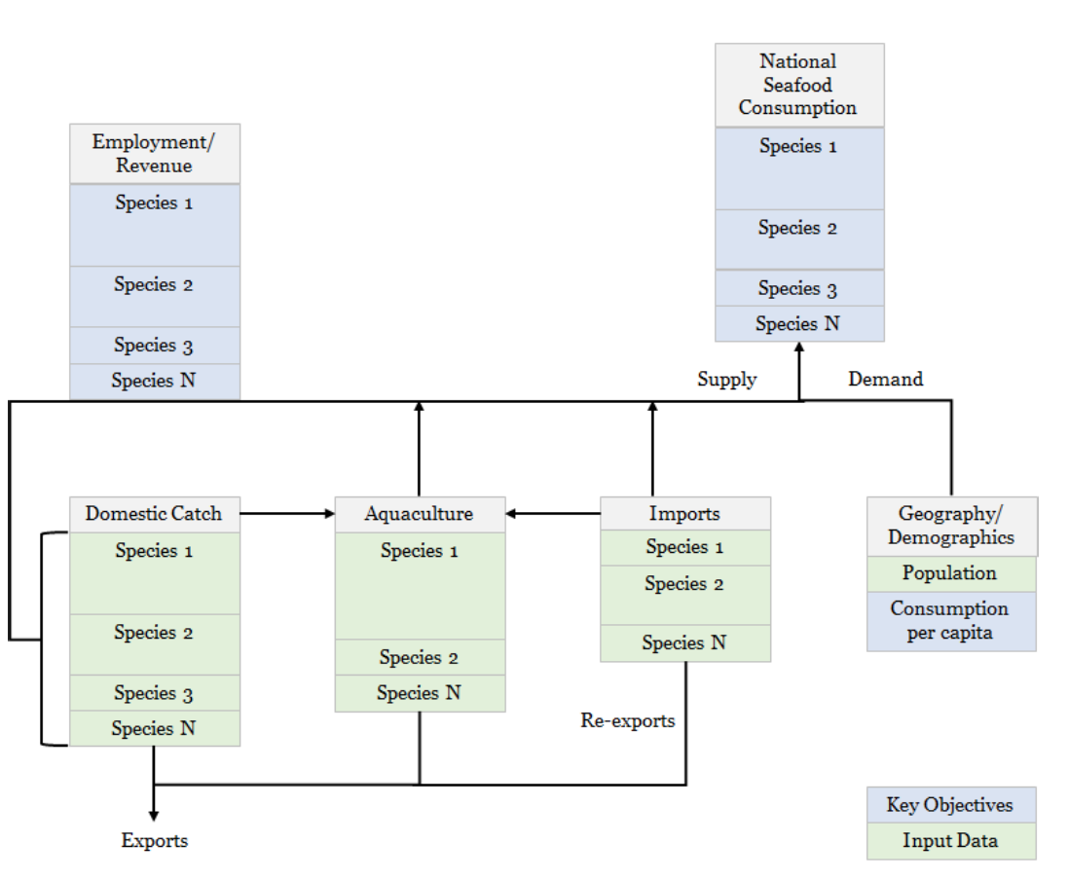

Fig 1. Methodological framework to estimate national food consumption, employment, and revenue from fisheries.

The following sections provide detailed methods for estimating i) net seafood supply and ii) revenues for key species in each country. This focuses on production from capture fisheries, but also includes aquaculture and trade supply. This analysis was applied across all countries using different datasets. Results will vary within countries according to the dataset (source) used.

## Estimating National Seafood Supply

We used the framework proposed (Figure 1) to design a model to estimate total seafood supply. The model included fish providing from for wild (ocean) domestic catch, farmed fish, and trade. In addition, estimations accounted for discards at sea and biomass losses due to processing (Table 1).

|  |  |
| --- | --- |
| Symbol | Description |
| C | Fish catch, i.e., wild capture production. |
| A | Aquaculture production. |
| I | Fish imports. |
| E | Fish exports. |
| D | Rate of losses () from discards (D) at sea. |
| O | Rate of losses from other uses (O), i.e., not for human consumption. |
| P | Rate of losses from processing (P), i.e., during canning, filleting, etc. |
| L | Landings from wild capture production (catch minus discards). |
| TDFS | Total domestic fish supply. Total amount of fish produced in the country. |
| NDFS | Net domestic fish supply. Total amount of fish produced in the country, minus exports and discards. |
| TFS | Total fish supply. Total amount of fish in the country (NDFS plus imports). |
| NSS | Net seafood supply. Effective amount of fish for human consumption in the country (TFS for human consumption, minus processing waste). |

The model first estimated the total domestic catch of fish supply per species (*i*) from wild captures and aquaculture as follows:

$$TDFS_{i}=C_{i}+A_{i}$$

Note that, to avoid double-counting fish production, domestic catch that is fed to farmed fish was subtracted from overall production. This was done as possible given available country information and context (i.e., this may be more of an issue for some countries than others). Then, not domestic fish supply was estimated from fish landed (catch minus discards), aquaculture and exports as follows:

$$NDFS_{i}=L_{i}+A_{i}−E_{i}$$

$$L_{i}=C_{i}−(C_{i}*λ_{d,i})$$

where the second term in Equation 3 allows for a calculation of total discards in each country. In Equations 4 and 5, we assume that all imported seafood (we do not include imports not for human consumption, e.g., fish meal) is ready to be consumed and thus do not include losses from processing. We also assume that all aquaculture production is for human consumption and that none of this production is discarded, though processing losses do occur as in production from capture fisheries (e.g., farmed and wild caught shrimps would receive similar processing).

$$TFS_{i}=NDFS_{i}+I_{i}$$

Therefore, national seafood supply will be estimated for each country and species as follows:

$$NSS_{i}=[(L_{i}−L_{i}*λ_{o,i}+A_{i}]*λ_{p,i}−E_{i}+I_{i}$$

## Estimating National Economic Participation

Estimations of economic participation of fish in each country was computed based on fisheries landings, trade, aquaculture, and market value. Note that landings will have different ex-vessel price depending in the buyer (e.g. direct human consumption, fish meal or fish oil).

|  |  |
| --- | --- |
| Symbol | Description |
| beta | Ex-vessel price for catch landed for direct human consumption |
| alpha | Ex-vessel price for catch landed for indirect human consumption |
| I | Imports. Economic value of imported fish |
| RI | Re-Imports. Economic value of fish products re imported in the country |
| E | Exports. Economic value of exported fish |
| FR | Fishing Revenue. The total revenue for that species provided by the fishing activity |
| NT | Net trade. Economic value of fish traded considering both exports and imports |

Fishing revenue integrates the different ex-vessel price that landings have, depending on the final destination: direct human consumption (DHC) and indirect human consumption (IHC). Therefore, total revenue (R) is estimated in the SAU database as follows:

$$FR=\sum_{i=1}^{n}{(}L_{i}*β_{i})*βP_{i}+(L_{i}*α_{i})*αP_{i}$$

In addition to the landings data, we used the FAO (SOFIA 2016) database to determine the value (US dollars) of fish and crustaceans, mollusks and other aquatic invertebrates imported and exported by Brazil, Chile and Peru. We estimate the net trade (NT) as follows:

$$NT=(E−I)−RI$$

## Data descriptions

This section outlines the sources, types, and limitations of available input data for the models described above. Data searches and analysis were undertaken at two levels. The first collated and used intergovernmental (e.g., FAO) datasets that were comparable across countries but involved various uncertainties. The second involved in-country data searches and validation and, though data quality varied across countries, results represent estimates using the best available information for each country.

### Intergovernmental Analysis

The first approach using intergovernmental data is a somewhat broad analysis, though it provides general and easily comparable trends in national production by species groups. This also provides a good starting point for highlighting key areas and species of interest that could then be addressed during in-country searches. The intergovernmental analysis used three main datasets:

1. The FAO-SOFIA Catch and trade database. Expand on description
2. The Sea Around Us Dataset (SAU) has reconstructed fisheries catches for all three countries dating from 1950 to 2014. These data present a more accurate and complete picture of global fisheries than nationally collected data (nor the FAO dataset) [@Zeller2016].
3. A recent study estimated the proportion of fish landings designated to human direct consumption and fish meal and fish oil[@Cashion:2018]. Such study used the SAU database, internal reports and other methods for estimating total landings devoted to each segment for all countries in the world.
4. The FISHMAR database for names homologation.

For the former analysis we used the FAO database to estimate the total landings (tons) of Chile, Brasil, and Peru in 2014, the last year with results in all database. All fishing sectors were aggregated (Industrial, Subsistence and Artisanal) and ** COMMENT: “Recreational” was ignored as it does not contribute to local food security.** Other countries that fish within Chile, Peru and Brasil were also not included in the analysis for the same reason. Landings were grouped by taxa excluding those not identified (e.g. “Marine fishes not identified”). We used the SAU database under the same method to estimate the revenue (US dollars) from each fishery.The SAU landings database reconstruction methods for each country can be accessed for Brazil[@REF], Chile[@REF], and Peru[@REF]. We then used the Tim *et al., 2018* database to estimate how much of the landings go to direct human consumption and how much goes to indirect human consumption…

Data extracted from SAU for Chile included the islands Juan Fernandez, Easter, and Desventuradas. For Brazil landings data included Fernando de Noronha, St Paul and St. Peter Archipelagos, and Trindade & Martim Vaz islands.

#### EEZ limits ###  
  
path_eez_world <- ("international/information/raw_databases/Spatial/World_EEZ_v9_20161021/")  
#The File  
fnam_eez_world <- "eez.shp"  
#Load it!  
  
#### Extract  
eez_world <- readOGR(dsn = path_eez_world,  
 layer =file_path_sans_ext(fnam_eez_world))

## OGR data source with driver: ESRI Shapefile   
## Source: "international/information/raw_databases/Spatial/World_EEZ_v9_20161021/", layer: "eez"  
## with 281 features  
## It has 23 fields  
## Integer64 fields read as strings: PolygonID MRGID MRGID_Ter1 MRGID_Sov1 MRGID_Ter2 MRGID_Sov2 MRGID_Ter3 MRGID_Sov3 MRGID_EEZ

Countries <- c("Brazil","Chile","Peru")  
  
South_America <- eez_world[eez_world$Territory1 %in% Countries,]  
  
South_America_f <- fortify(South_America) %>%   
 filter(id != 14)

## Regions defined for each Polygons

South_America_f$id<- gsub("10","Chile",South_America_f$id)  
South_America_f$id<- gsub("243","Peru",South_America_f$id)  
South_America_f$id<- gsub(255,"Brazil",South_America_f$id)  
  
  
path.ne.coast <- "international/information/raw_databases/Spatial/TM_WORLD_BORDERS-0.3"  
file_name <- "TM_WORLD_BORDERS-0.3.shp"  
  
# Loading the shapefile:  
World_Land <- readOGR(dsn = path.ne.coast,   
 layer = file_path_sans_ext(file_name),  
 verbose = FALSE  
 )  
  
# Central_A@data$NAME  
  
South_Border <- c("Brazil",  
 "Peru",  
 "Chile",  
 "Argentina",  
 "Colombia",  
 "Venezuela",  
 "Guyana",  
 "Suriname",  
 "French Guiana",  
 "Ecuador",  
 "Uruguay",  
 "Bolivia",  
 "Paraguay")  
  
  
South_America_Land <- subset(World_Land, NAME %in% South_Border)  
  
ggplot() +  
 geom_polygon(data = South_America_Land,  
 aes(  
 x = long,  
 y = lat,  
 group = group  
 ),  
 fill = "lightgray",  
 colour = "white"  
 ) +  
 geom_polygon(data = South_America_f,  
 aes(  
 x = long,  
 y = lat,  
 group = group,  
 fill = id  
 )  
 ) +  
 scale_fill_manual(values = wes_palette("Darjeeling1", 5, type = "discrete")) +  
 coord_fixed(xlim = c(-85, -26),   
 ylim = c(-60, 5), ratio = 1.2) +  
 # facet_wrap(~Type,  
 # scales = "free") +  
 ggtheme_map()

## Regions defined for each Polygons

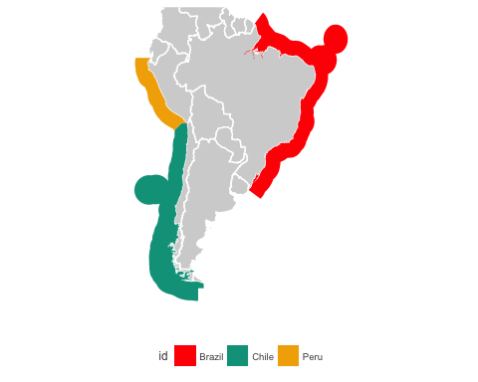

### Country-specific data, Brazil

There is no basic fisheries statistics in the country since 2008. The lack of national fisheries statistics posed a great challenge to this study. Several researchers and fisheries managers consulted during the study pointed out the lack of data to provide basic information on Brazilian fisheries (Supplemental Material X). Information such as how much the country produces, how much it consumes or even the number of fishers in the country is very sparse. In an interview with the most renowned fisheries scientist in the country, Dr. Fabio Hazin (President of The Committee on Fisheries (COFI) of the FAO), he pointed out that there are between 400 thousand and one million fishers in the country. We contacted people from all fisheries sectors to find out what was available.

After an extensive search, we gathered the following six different databases representing the different fisheries sectors and conducted an extensive literature research. We also identified other potential sources of information that we were not able to obtain in time for this study.

1. *SIGSIF* - Data obtained from the sanitary inspection services of the Brazilian Ministry of Agriculture. This database contains all seafood processed by fishing industries that caries a federal inspection certificate. This certificate is required for industries to commercialize their product to different states of Brazil and to export and import seafood products. It is a rigorous inspection program, where one of the requirements is to report all seafood that enters each company. Thus, this database includes all seafood products by species imported or from domestic production that enters all seafood processing companies with the federal inspection certificate (total of 472 companies). It includes both aquaculture and wild caught products from both freshwater and the oceanic species. 2016-2017.
2. *CEAGESP* - is the largest wholesale open seafood market in Latin America, located in the city of São Paulo. It is run by a state-owned company where sellers and buyers from all over the country gather to commercialize seafood and seafood products. We obtained information on all the seafood products commercialized in the market by species and price of commercialization. 2016-2017.
3. *MDIC* - Import and Export data from the Ministry of Development, Industry and Foreign Trade. This database contains all seafood imported and exported in Brazil. 2014-2017.
4. *State fisheries landings* - Fisheries landings data from three states of Brazil were there is continuous data collection and data are publicly available. These three states (São Paulo, Parana and Santa Catarina) are located in Southern Brazil and have a continuous data collection program sponsored by Petrobras in partnership with Universities. Petrobras is required to collect landings information for insurance purposes and has made some of its data publicly available for research projects. 2016-2017.
5. *IBGE* - Brazilian Institute of Geography and Statistics. This federal institute is responsible for surveying the country to provide basic information on all social aspects of Brazil. We gathered two pieces of information to inform our analysis: household food consumption and income by region of Brazil (last survey dates from 2009 and 2010).
6. *Fishing Permits* - Number of registered fishers in the country from the extinct Ministry of Fisheries and Aquaculture (MPA). 2003 - 2010.

### Country-specific data, Chile

1. *SERNAPESCA* - The Chilean National Service of Fisheries is in charge of keeping track of landings and other fisheries and aquaculture related data in Chile. In their website there is public access to databases reporting landings per sector (artisanal, industrial and factory vessels) and aquaculture harvest. We also received from them datasets with information on prices of first transaction in artisanal fisheries and number of fishers and fisher vessels officially registered as proxi to estimate employment in this sector. SERNAPESCA data is reportes at a specie level and for each geopolitical region of the country.
2. *RPA* - The RPA holds information regarding the gender, date of birth, location and type of activities performed by each fisher (e.i. diver, fisher, boat owner, shore gatherer).
3. *Aduanas Chile (Chilean Costumes)*. This source details products (amount and prices) imported and exported for each region of the country. We expect to be able to estimates of the domestic consumption of local species by understanding how much of what is landed is being exported.

### Country-specific data, Peru

Landings of marine living resources reported by Peru’s national marine research institute **(Instituto del Mar del Perú – IMARPE)** between 1997 and 2012 include registries for at least 258 fish species, 43 species of molluscs, 30 species of crustaceans, 4 species of echinoderms, 4 species of brown algae, 2 species of red algae and 1 species of tunicate (**Table xxx**) **[Sueiro & De la Puente 2015]**.

# Results

The results section is divided in two main subsections representing Intergovernmental datasets (*Intergovernmental results*) and local datasets (*Brazil/Chile/Peru*). Results follow the same structure for each country from a fisheries context to a fish consumption supply to an employment and income section. Overall results show the average value of the last 5 years of data, although data provided along with this report dates several years ago.

## Regional Overview

### Fisheries Context

**SAU MAP**

Results from the initial analysis of intergovernmental data show a clear dominance in fisheries landings of both Chile and Peru over Brazil, even thou Brazil captures around 3 times more species than the former. In terms of total fishing revenue, all nations are similar (**Table XX**).

Summary of results. Database used: SOFIA-FAO. Thousand tones

|  |  |  |  |  |  |
| --- | --- | --- | --- | --- | --- |
| Country | Exploited Species | Aquaculture | Capture | Exports | Imports |
| Brazil | 429 | 504 | 766 | 315 | 2,091 |
| Chile | 402 | 1,020 | 2,624 | 6,811 | 599 |
| Peru | 280 | 98 | 5,077 | 4,619 | 354 |

When we analyze the top ten species in terms of landing volume in tones using the SAU database we found different trends between and within countries (**Fig. XX**). Brazil’s most exploited specie (in terms of landings) was the ray-finned fish *Sardinella brasiliensis*. For both Chile and Peru, the most most landed species was *Engraulis ringens*.

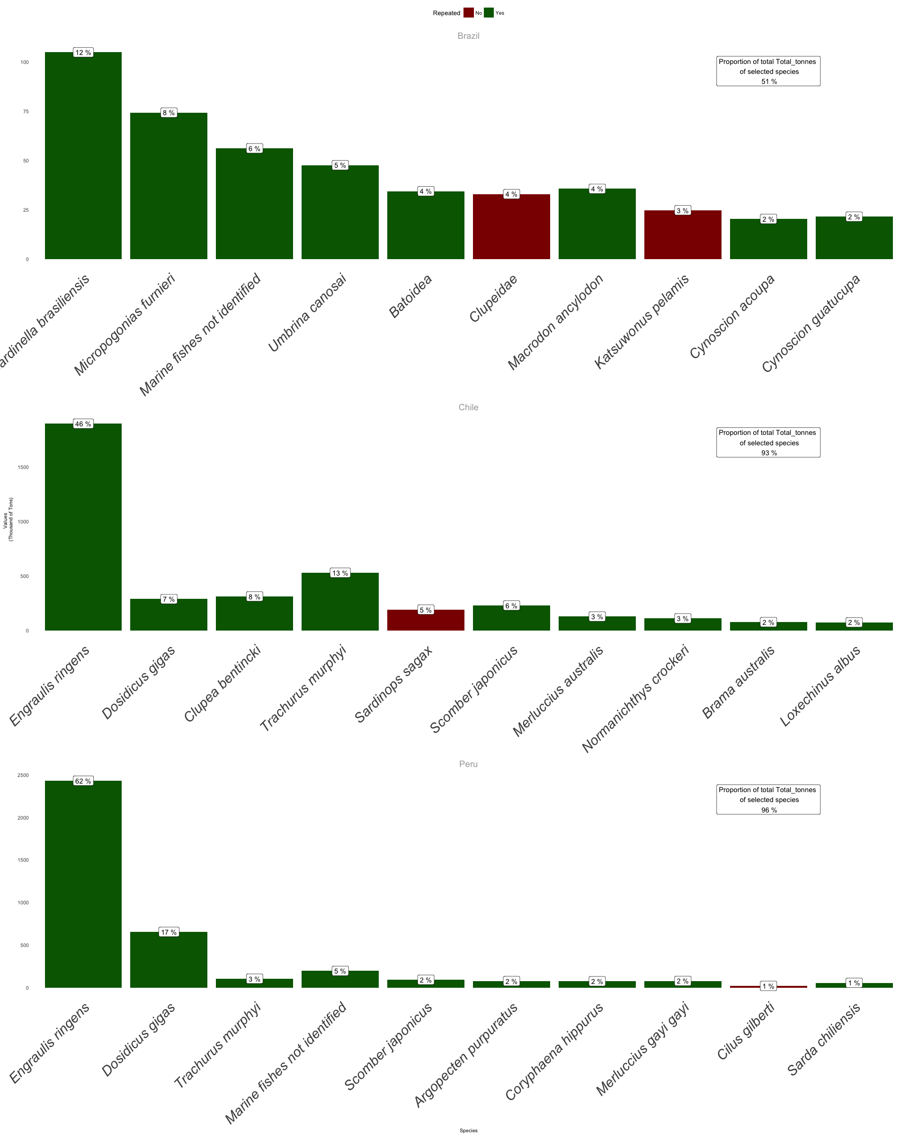

Top 10 species by landings from the SAU dataset. Red bars represent species not present in the other category. White boxes represent the contribution of that speciest to the total country landing

In addition to the internal fish production, Brazil, Chile and Peru all import and export fish (**Fig. XXX**). According to FAO-SOFIA data, imports and exports balances….

### Estimating National Seafood Supply

**Talk about FAO consumptios rates per country. I believe the WHO also has a simliar study. Also describe the table…**

|  |  |  |  |  |  |
| --- | --- | --- | --- | --- | --- |
| Country | Specie | Landings Food Supply | Aquaculutre Food Supply | Net Imports | National Seafood Supply |
| Brazil | Alaska.pollock.fillets.frozen | 0.000 | 0.000000e+00 | 127266.000 | 127266.00 |
| Brazil | Atlantic.and.Danube.salmons.fresh.or.chilled | 0.000 | 0.000000e+00 | 431685.800 | 431685.80 |
| Brazil | Fish.fillets.frozen.nei | 0.000 | 0.000000e+00 | 141905.286 | 141905.29 |
| Brazil | Salmons.fresh.or.chilled.nei | 0.000 | 0.000000e+00 | 218395.500 | 218395.50 |
| Brazil | Tilapias nei | 5804.617 | 1.522695e+05 | 0.000 | 158074.10 |
| Chile | Atlantic salmon | 0.000 | 3.502650e+05 | 0.000 | 350265.03 |
| Chile | Chilean jack mackerel | 64901.542 | 0.000000e+00 | 1727.286 | 66628.83 |
| Chile | Coho.=Silver..salmon | 0.000 | 1.126623e+05 | 0.000 | 112662.29 |
| Chile | Rainbow trout | 0.000 | 1.340369e+05 | 0.000 | 134036.91 |
| Chile | Tunas.prepared.or.preserved.not.minced.nei | 0.000 | 0.000000e+00 | 76113.571 | 76113.57 |
| Peru | Chilean jack mackerel | 46214.506 | 0.000000e+00 | 5881.286 | 52095.79 |
| Peru | Jack.and.horse.mackerel.frozen | 0.000 | 0.000000e+00 | 31647.600 | 31647.60 |
| Peru | Marine fishes nei | 36594.377 | 2.285714e-01 | 0.000 | 36594.61 |
| Peru | Pacific chub mackerel | 27167.687 | 0.000000e+00 | 5881.286 | 33048.97 |
| Peru | Tunas.prepared.or.preserved.not.minced.nei | 0.000 | 0.000000e+00 | 51337.714 | 51337.71 |

### Estimating National Economic Participation

In terms of landing values Brazil’s most prolific fishery in 2014 was *Umbrina canosai*, a croaker fished in the southern part of the country. For Chile, the most valuable fishery was *Engraulis ringens*, Peruvian anchoveta. Finally, Peru most valuable fishery in 2014 was the Peruvian scallop *Argopecten purpuratus*.

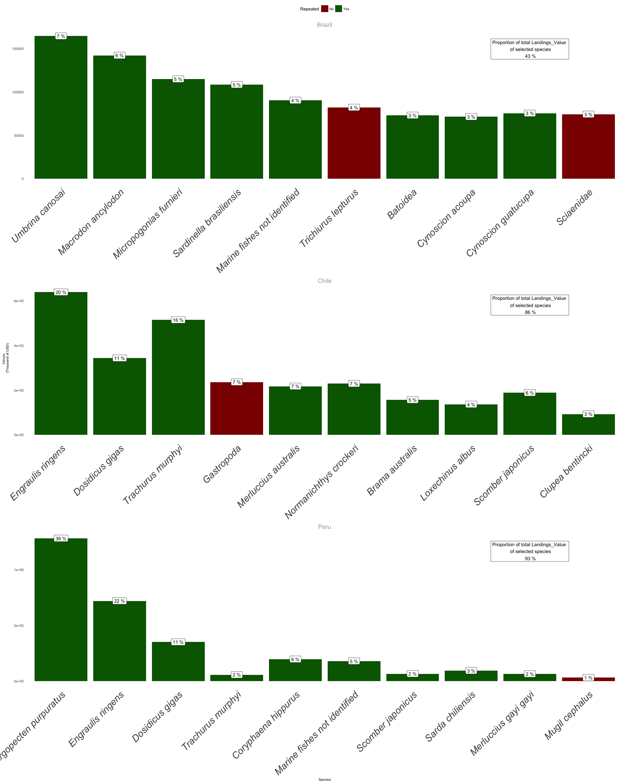

Top 10 species by landings value from the SAU dataset. Red bars represent species not included as top 10 most landed species. White boxes represent the contribution of that speciest to the total country value

Trade is an importat component of fisheries. From the countries analyzed Brazil was the only country to have a net import of fish. Brazil spends more money importing fish than what it makes from producing it and exporting that production. In the other hand, both Chile and Peru have positive surplus from their fisheries and commerce activities being Chile the most “*profitable*” country.

## Results Brazil

### Fisheries Context

As previouslly mentioned, there is no fishereis statistics data in Brazil since 2008. Therefore, the only country-wide assesment can be done using the SAU and SOFIA-FAO datasets.

### Estimating National Seafood Supply

Using data from FAO and quantity imported and exported, it is possible to estimate the amount of seafood that is consumed in Brazil per year. The estimated consumption of seafood in Brazil is: 760k tonnes from fisheries plus 750k tonnes from aquaculture plus 380k tonnes from imports minus 37k tonnes from exports. This sums to about 1.86 million tonnes of seafood consumed in Brazil. If we divide this number by the number of people (about 200 million) we estimate a consumption of about 9.3 kg/capita/year.

Despite large potential for seafood production from both capture fisheries and aquaculture, Brazil imports large quantities of seafood for domestic consumption. In 2017, Brazil imported more than 380 thousand tonnes of fish and seafood products, while exporting less than 10% of that value (**Figure xx**).

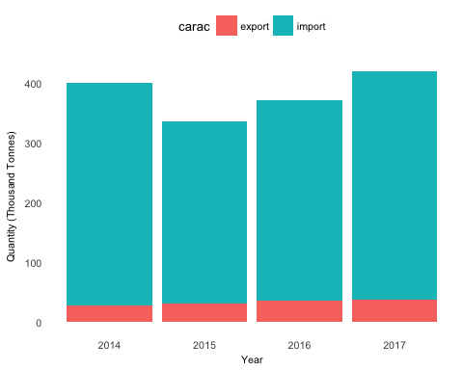

Seafood and fish imports and exports from Brazil between 2014 to 2017 (Source: MDIC)

Fish and seafood import data shows that the main imported species in 2017 was the sardine followed by salmon, catfish fillet (pagasius) and hake fillet (**Table xxx**). There was a major increase in the import of sardine in the last two years, from 17 thousand tonnes imported in 2014 to 90 thousand tonnes in 2017.

Main species imported in 2017, Brazil (Source, MDIC)

|  |  |  |
| --- | --- | --- |
| Product | Quantity | Percent |
| Sardines, frozen | 93,085 | 24 |
| Atlantic salmon and danube salmon, fresh or chilled | 71,753 | 19 |
| Catfish fillet(Pangasius spp., Silurus spp., Clarias spp.,Ictalurus spp.), frozen | 42,999 | 11 |
| Fillets of hake and abrotea, frozen | 34,080 | 9 |
| Fish, salted or in brine only (excl. herrings, cod, anchovies and fillets in general) | 23,808 | 6 |
| Fillet of hake from alasca(theragra chalcogramma),froze | 20,145 | 5 |
| Dogfish and other sharks | 19,454 | 5 |
| Other fish, excluding livers and roes | 10,241 | 3 |
| Cod Gadus morhua, Gadus ogac, Gadus macrocephalus, salted or in brine only (excl. fillets) | 10,035 | 3 |

Data from SEAGESP market suggests that the main species consumed in Brazil in 2017 was tilapia, followed by croaker, sardine, salmon, sharks and weakfishes (**Table xxx**).

Main species commercialized in CEAGESP market, Sao Paulo, Brazil in 2017 (Source: CEAGESP)

|  |  |  |
| --- | --- | --- |
| Species | Quantity | Percent |
| Sardine | 9,705 | 23 |
| Tilapia | 4,399 | 11 |
| Croaker | 3,587 | 9 |
| Maria mole weakfish | 2,891 | 7 |
| Shark | 2,232 | 5 |
| Salmon | 2,075 | 5 |
| Triggerfish | 1,883 | 4 |
| Shrimp | 1,839 | 4 |
| Goete weakfish | 1,543 | 4 |

Data from SIGSIF shows that the main species processed in the country in 2017 was tilapia, followed by tambaqui (Colossoma macropomum), sardine, croaker, tambatinga (hybrid aquaculture species from the Amazon), catfish, salmon and tuna (Table 8).

Main species comercialized by seafood industries with SIGSIF certificate in Brazil (Source: Minitry of Agriculture)

|  |  |  |
| --- | --- | --- |
| Species | Quantity | Percent |
| Tilapia | 41,513 | 12 |
| Cachama | 27,363 | 8 |
| Sardine | 26,823 | 7 |
| Croaker | 21,618 | 6 |
| Salmon | 21,322 | 6 |
| Tambatinga | 18,654 | 5 |
| Catfish | 15,968 | 4 |
| Tuna | 14,301 | 4 |
| False herring | 13,020 | 4 |

Consumption of fish and seafood products in Brazil increases significantly during religious dates. Data from SEAGESP suggests that seafood consumption increases during Easter, when other types of meat are not consumed in respect of Christian tradition. For this reason, there is a significant peak in fish and seafood consumption during Easter week (**Figure xxx**).

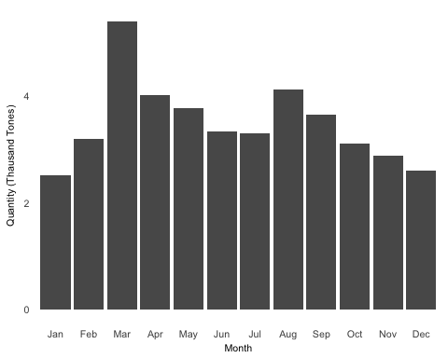

Quantity of fish and seafood products commercialized per month in 2017 at CEAGESP market (Source: CEAGESP)

Fish and seafood consumption in Brazil has distinct patterns according to the region of the country. As shown in IBGE data, the top consumers of fish and seafood products in the country are from the north and northeast regions (**Figure xxx**). These regions are the poorest of the country (**Figure xxx**) and have the greatest number of registered fishers (**MPA, 2013**), especially from the small-scale sector.

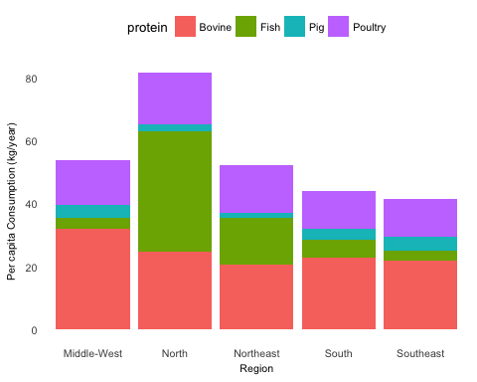

Per capita consumption of protein types per region of Brazil (Source: IBGE)

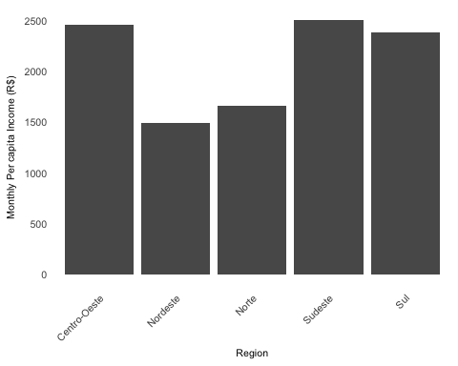

Monthly per capta income by region of Brazil in 2014 (Source: IBGE)

Data on the main species consumed in Brazil suggests that consumers are mostly driven by price, although there are some exceptions. From the top 10 seafood products sold in CEAGESP, 7 where below the 0.5 percentile of prices (**Table xxx**).

Price (RS/Kg) and quantity (Tones) of main species commercialized in CEAGESP market, Sao Paulo, Brazil in 2017

|  |  |  |  |
| --- | --- | --- | --- |
| Species | Quantity_kg | Price_RS | Price_percentile |
| Sardine | 9,705.1 | 3.6 | 0.2 |
| Tilapia | 4,398.6 | 5.8 | 0.5 |
| Croaker | 3,587.1 | 4.1 | 0.3 |
| Maria mole weakfish | 2,890.5 | 3.8 | 0.3 |
| Shark | 2,231.8 | 8.2 | 0.6 |
| Salmon | 2,074.7 | 30.9 | 1.0 |
| Triggerfish | 1,882.6 | 3.5 | 0.2 |
| Shrimp | 1,838.5 | 25.2 | 1.0 |
| Goete weakfish | 1,543.3 | 3.4 | 0.2 |

### Estimating National Economic Participation

To respond to the economic question we put together several pieces of information from different sources to have an estimate of the importance of fisheries for employment in Brazil. Data from IBGE (2013) estimates that Brazil had about 500 thousand fishers throughout the country, with 90% from the small-scale sector and 10% from the industrial sector **(Campos and Chaves 2016)**. Data from the extinct Ministry of Fisheries and Aquaculture (MPA) suggests there are many more fishers in Brazil **(Figure xxx)**. According to these data, there were about 900 thousand registered fishers in 2010 throughout the country, with 95% of the registered fishers from the small-scale sector **(MPA, 2013**).

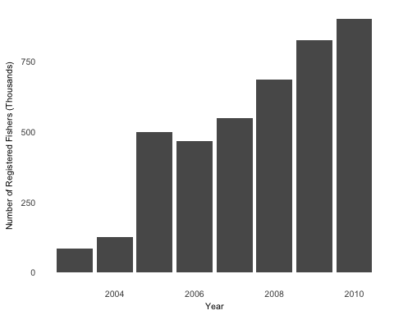

Number of registered fishers in Brazil from 2003 to 2010 (Source: Minitry of Fisheries and Aquaculture)

Employment along the supply chain varies according to the region, fisheries and species commercialized.

Assuming that the number of fishers are between 500 thousand and 1 million, and that about 90% of them are from the small-scale sector, the most important fisheries for employment in the country are those from the artisanal sector.

Most of the registered fishers in Brazil are from the North and Northeast regions (MPA report, 2013). In these regions, freshwater resources from the Amazon and estuarine fisheries are very important. From the Amazonas state, the top commercialized fish are: curimatã (*Prochilodus nigricans*), jaraqui (*Semaprochilodus spp.*), matrinchã (*Brycon amazonicus*), pacu *(Mylossoma duriventre*), tambaqui (*Colossoma macropomum*) and tucunaré (*Cichla monoculus*) (**data from the secretary of fisheries in the Amazon state - Sepror, 2018**).

Industrial fisheries in Brazil employ only about 10% of the fishers and is responsible for about 30-50% of the fisheries production. The industrial sector in Brazil is mainly concentrated in the south of the country, especially in Santa Catarina state where the main industrial fisheries port is located (**Itajai port**). Landings data from Santa Catarina indicate that sardines are the most important species, followed by corvina and skipjack tuna (**Table X**).

Main species caught (Thousand tones) in Santa Catarina state, Brazil in 2017 (Source: Univali)

|  |  |  |
| --- | --- | --- |
| Species | Production | Percent |
| Croaker | 11,319 | 17 |
| Brazilian sardinella | 11,080 | 16 |
| Atlantic thread herring | 8,641 | 13 |
| Skipjack tuna | 5,581 | 8 |
| Leerfish | 4,906 | 7 |
| Argentine croaker | 2,975 | 4 |
| Other fish | 2,787 | 4 |
| East Atlantic Red Gurnard | 2,760 | 4 |
| Brazilian codling | 2,536 | 4 |
| Shark | 1,996 | 3 |

In the industrial sector, the majority of the catch is processed by large companies to be distributed in supermarkets and restaurants all over the country. According to data published by the Seafood Industry Association (ABIPESCA), the seafood industry employs about 8 thousand direct employments and 30 thousand indirect employments. Data from the seafood companies (SIGSIF) indicates that the most important industrial fisheries are sardines, croacker, tuna and piramutaba catfish (**Table xxx**). Thus, the industrial sector employs relatively less people per ton of captured fish compared to the artisanal sector.

Main species comercialized (thousand tpones) by seafood industries with SIF certificate in Brazil (Source: Ministry of Agriculture)

|  |  |  |
| --- | --- | --- |
| Species | Quantity | Percent |
| Sardine | 26,776 | 12 |
| Croaker | 21,604 | 9 |
| Tuna | 14,183 | 6 |
| False herring | 13,020 | 6 |
| Piramutaba catfish | 11,945 | 5 |
| Weakfish | 10,759 | 5 |
| Argentine croaker | 9,771 | 4 |
| Hake | 8,780 | 4 |
| Zabaleta anchovy | 8,541 | 4 |
| Skipjack tuna | 7,996 | 3 |

Because there is no reliable national-level landings data in Brazil since 2008, it is challenging to determine the top fisheries by income generated in the country. Data available are mainly from the industrial sector, where sardines, croaker and tuna are the main species caught. However, information from the SIGSIF (**Table xxx**) and Santa Catarina state landings does not have any information on price.

Data from SEAGESP market have important information on the value of seafood in the country. This database contains quantity and price information for all seafood products. Products sold in the market are both from industrial and artisanal sectors. **Table xxx** shows the main species ranked by value sold in the CEAGESP market in 2017. The most valuable species in this year were sardines followed by sharks, croaker, tuna and acoupa weakfish (**Table 3**).

Main species comercialized (thousand tones) in 2017 at CEAGESP fishmarket, Sao Paulo, Brazil (Source: CEAGESP)

|  |  |  |
| --- | --- | --- |
| Species | Value_RS | Percent |
| Sardine | 26,296 | 14 |
| Shark | 19,430 | 11 |
| Croaker | 16,581 | 9 |
| Tuna | 14,773 | 8 |
| Acoupa weakfish | 11,880 | 6 |
| Maria mole weakfish | 8,929 | 5 |
| Squid | 8,250 | 4 |
| Triggerfish | 7,016 | 4 |
| Brazilian codling | 6,393 | 3 |
| Goete weakfish | 6,128 | 3 |

Another important piece of information regarding income generated are the main species exported in Brazil. Data from the Ministry of Development, Industry and Foreign Trade (MDIC) show that the main species exported are lobsters, followed by other fish, swim bladders and pelagic fish (tunas and swordfish) (**Table xxx**).

Main species exported in 2017, Brazil (Source: MDIC). Thousand of USD

|  |  |  |
| --- | --- | --- |
| Product | Value_USS | Percent |
| Rock lobster and other sea crawfish (Palinurus spp, Panulir spp, Jasus spp) | 73,855 | 32 |
| Other fish, excluding livers and roes | 66,558 | 28 |
| Heads, tails, and swim bladders of fish | 15,579 | 7 |
| Frozen skipjack or stripe-bellied bonito Euthynnus -Katsuwonus- pelamis | 11,544 | 5 |
| Other fish of families Bregmacerotidae, Gadidae, etc.. | 10,243 | 4 |
| Livers and male gonads, frozen | 7,412 | 3 |
| Swordfish (Xiphias gladius), fresh or chilled | 6,361 | 3 |
| Freshwater ornamental fish | 5,966 | 3 |
| Fresh or chilled bigeye tunas Thunnus obesus | 5,445 | 2 |
| Other fish fillets, frozen | 5,125 | 2 |

## Results Chile

### Fisheries Context

Landing and harvest data was obtained through the National Service of Fisheries of Chile. In general, wild caught fish has almost double the tons of the amount harvested in the last five years.

According to SERNAPESCA information in the last five years the most important fisheries in terms of landings have been Anchovy (*Engraulis ringens*), Chilean jack mackerel (*Trachurus murphy*) and Araucanian herring (*Strangomera bentincki*) (**Figure xx**), all three of them mainly catch by the industrial fleet. This pelagic fishes are mainly used to produce fish meal. Other species that contribute importantly to industrial catch are merluza comun, merluza del sur, merluza de tres aletas, cod, merluza de cola, and langostinos amarillo and colorado.

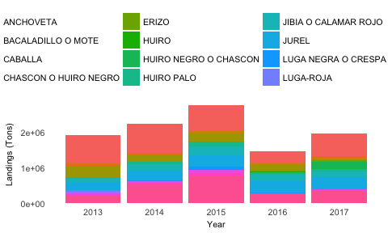

Main fisheries in Chile in the last five years accordint to wild catch landings

In terms of aquaculture production the main species harvested in the last 5 years have been: Atlantic salmon (*Salmo salar*), mussels (*Mytilus chilensis*) and coho salmon (*Oncorhynchus kisutch*) in descending order (Figure 2).

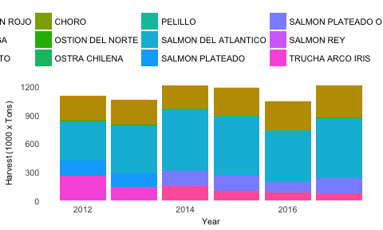

Main fisheries in Chile in the last five years according to aquaculture harvests

### Estimating National Seafood Supply

### Estimating National Economic Participation

#### Artisanal sector

By 2017, there were 80,056 artisanal fishers officially registered along with 11,819 vessels.

**Figure xxx** shows the number of fishers in each region that perform a particular activity based on the 2018 RPA for women (upper panel) and men.

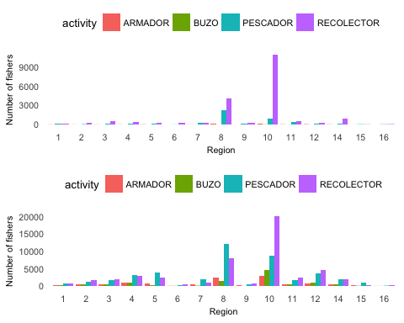

Number of fishers participating in different activities in each Chilean region based RPA 2018, provided by SERNAPESCA. The upper panel refers to women while the panel below to men. A single fisher can be register under multiple activities.

The artisanal sector generates employment beyond the extraction stage. After extraction, most resources are directly sold by the fishers in commercial facilities near their landing points, some are sold to local restaurants

#### Industrial sector

For the industrial fishing sector, SERNAPESCA holds records only on the number of boats and its owners. There are currently 472 industrial vessels owned by 164 different companies based on official registers. Estimates from SUBPESCA indicate that the overall operation of industrial vessels provide around 3,500 jobs nationwide.

Most of the catch from the industrial sector ends up going to processing facilities where it is transformed in products for domestic consumption, exportation or as supplies for the aquaculture industry.

In terms of processing SERNAPESCA holds records on the self-reported number of permanent and temporal jobs in each facility. There were 7,751 permanent job positions and another 1,233 temporal positions in processing facilities in 2017.

## Results Peru

### Fisheries Context

Based on the most recent data published by the Ministry of Production, the ten most commonly landed marine species of Peru were responsible for 97% of the country’s marine capture production (MCP) between 2010 and 2016 (**Table xxx**) [@PRODUCE:2018]. Anchoveta (*Engraulis ringens*) represented 80% of these landings. On average, 3.93 (± 1.56) million tonnes of this species were annually reduced into fishmeal and fish oil during the studied period, and used in feed producing value chains abroad [@Christensen et al. 2014; @Majluf et al. 2016]. Furthermore, 91% of the macroalgae landings reported by PRODUCE correspond to species of the genera Lessonia and Macrocystis [@Guevara-CarrascoBertrand 2017]. These are sundried, minced and exported to be used in agriculture (e.g., seaweed fertilizers) and pharmaceutic (e.g., nutritional supplements) value chains.

#### Freshwater captures

In addition, between 2010 and 2016 Peruvian freshwater systems produced average estimated yields of 68.30 (± 10.11) thousand tonnes per year. The reported freshwater capture production by PRODUCE during the study period totalled 478 thousand tonnes [PRODUCE 2018], amounting to 1% of the marine capture production.

#### Aquaculture

Peruvian marine aquaculture production is much smaller than the country’s marine capture production. Marine aquaculture is focused two species: the Peruvian calico scallop (Argopecten purpuratus) and the Whiteleg shrimp (Litopenaeus vannamei) (**Table xxx**).

Scallop aquaculture is a semi-intensive to extensive industry with annual average yields of 42,913 ± 19,804 tonnes per year. Only a minor segment of the producing entities purchases seeds from hatcheries and uses suspended cultures [Mendo et al. 2016; Lopez de la lama et al. 2018].

Shrimp aquaculture has been increasing steadily during the study period, with an average annual production of 18,538 ± 3,045 tonnes per year. This is an intensive industry that uses closed-system cultures [Christensen et al. 2014] in large pools near mangrove forest in northern Peru [PRODUCE 2018].

#### Trade

Peru is both a major importer and exporter of seafood products [Adex Data Trade 2017]. Between 2010 and 2016, Peru imported 727.86 thousand tonnes of seafood products, at a rate of 103.98 ± 24.62 thousand tonnes per year **(Table xxx)** [@SUNAT2018]. The main imported species by line of production (in volume) are included in **Table xxx**.

Peruvian seafood exports however are much larger than their imports. Between 2010 and 2016, Peru exported 10.76 million tonnes of seafood products, at a rate of 1.54 ± 0.39 million tonnes per year (Table 3) [SUNAT 2018]. The main exported species by line of production (in volume) are included in **Table xxx**.

### Estimating National Seafood Supply

Between 2010 and 2016, only 22% of the Peruvian reported maritime landings were used in direct human consumption value chains (**Figure xxx**), at a rate of 1.11 (± 0.13) million tonnes per year.

### Estimating National Economic Participation

Between 2010 and 2016 the total value of fish imports was USD 1.31 billion (USD 187.26 ± 47.99 million per year) and exports was USD 19.15 billion (USD 2.74 ± 0.42 billion per year) (**Table xxx**).

# Critical Analysis

## Overall of the region

### Brazil

### Chile

### Peru

# Conclusions

# References

# Data

# Supplemental Material List