Template

This is the subtitle

Juliano Palacios Abrantes

10/25/2018

# This is one title

In 2016, total fish landings in Chile and Peru, two of the world’s top fishing nations, averaged 8 million tons per year [@Fishstat]. In Peru, the seafood sector generates over US1.7 billion per year, supporting over 200 thousand jobs. Moreover, Chile’s aquaculture production is among the largest of the world1 and fish meal and salmon exports generate over US$2.2 billion per year4. Despite comparatively lower catches, Brazil’s fisheries sustain thousands of local families in coastal areas5-6,

1. asdkjaslkjdjaskldjaslkdjas
2. asljdalksdjalskdjklasjdsa
3. aksjdnaksjdhaksjldhaskjdhjklas

## 

## This is a second title

* aksjdaskd alksjdhalksjd aksd aslkjhd alksjhdsa
* aksjdaskd alksjdhalksjd aksd aslkjhd alksjhdsa
* aksjdaskd alksjdhalksjd aksd aslkjhd alksjhdsa

### 

### And a third level

Latin America are part of the small-scale fisheries sector (SSF) and are under 12m length1. Despite supporting some **XXXX** people **ref**, this sector is among the most marginalized groups in the region 7, despite it being critical to achieving critical development goals **ref Agenda 2030**, as highlighted by the recent FAO small scale fisheries guidelines that explicitly link the sector with food security, poverty eradication, and social **equity ref FAO SSF Guidelines** [@Fishstat].

#### And finally…

the region 7, despite it being critical to achieving critical development goals **ref Agenda 2030**, as

|  |  |
| --- | --- |
|  |  |
|  |  |

## Including Plots

You can also embed plots, for example:

* La reconcha de su madre
* Y de su ptra madre

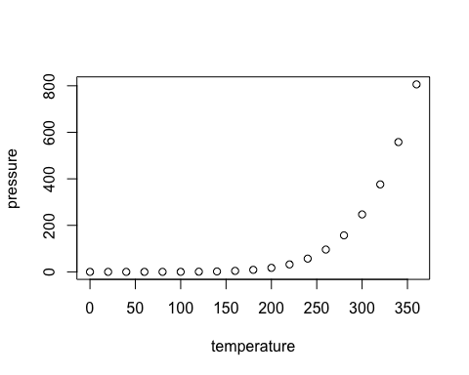

La donna immobile

This is one title 1

This is a second title 1

And a third level 1

Including Plots 2