A metadata approach to evaluate the state of ocean knowledge: Strengths, limitations, and application to Mexico

Palacios-Abrantes, J; Cisneros-Montemayor, A.M.; Cisneros-Mata, M.A; Rodríguez, L.; CONABIO; Arreguín-Sánchez, F; Cheung, W.W.L

πInstitute for the Oceans and Fisheries, The University of British Columbia. Vancouver, Canada, V6T1Z4 *Instituto Nacional de Pesca y Acuacultura. Guaymas, Sonora, México 85400.

# Introduction

Ocean contributes substantially to human wellbeing by providing food, wealth and culture as well as a wide range of other contributions to people around the world [1,2]. However, climate change, unmanaged resource extraction, and pollution are reshaping global marine ecosystems [3–6]. Moreover, such impacts go beyond ecological systems as ocean’s contribution to people are linked to much broader social-ecological systems outcomes [7]. Mitigating and managing these human drivers and achieving sustainable ocean development require knowledge and data from different disciplines, scales, and knowledge types to set tangible targets, evaluate status and trends, and develop scenarios for effective policies design and implementations [8].

Metadata repositories can respond directly to these challenges by improving data access and fostering collaboration among stakeholders [9]. Although human-natural marine systems have been widely studied by multiple disciplines and generated large amounts of data, such information is often under-utilized because they are scattered and held by different institutes or researchers, not harmonized across scale, time or disciplines, and not available in existing databases [6,8]. Metadata describes existing data, including: type, content, source, quality, format, structure, and accessibility and facilitate their harmonization across scales and domains. Metadata is particularly useful in area where information is perceived to be limited due to a lack of knowledge about available information [10]. Metadata can also support the creation of platforms that facilitate access and queries of information through structuring and compiling region-wide, multidisciplinary, and inter-institutional information. Metadata repositories also increase data longevity, foster potential collaboration, and facilitate subsequent analyses and refinement of the data itself, or its structure [9,11]. Such repositories can be used as tools to perform gap analysis to inform ocean policies at the local and national level [9]. Existing country-wide metadata repositories for marine systems include Canada [9], Australia [11] and the Canary Islands in Spain[1].

## Secondary Heading

The challenges for integrating ocean-related data for Mexico exemplify those in other countries with extended coastline and bordering multiple oceans [10]. Academic and government projects in Mexico have generated thousands of data records from multiple research fields. Different subsets of these data are haphazardly curated by different institutions such as the open data portal of the National Autonomous University of Mexico (UNAM) [12], dataMares based at UC San Diego [13], and the Southeast Costal Observatory [14]. Other efforts are led by Civil Society Organizations (CSO) (e.g., FMCN-Monitoreo Noroeste [15]) and the federal government of Mexico through the Open Data Policy [16] [10]. In addition, specialized government institutions such as the National Commission for the Knowledge and Use of Biodiversity (CONABIO; www.conabio.gob.mx) maintain, curate, and make available biological, oceanographic and social data related to marine and terrestrial environments. These initiatives are an important effort to compile and promote the use of data, the importance of which has been boosted through recent partnerships aiming to achieve the cross-disciplinary UN Sustainable Development Goals[2]. However, to facilitate effective use of data to support sustainable ocean development, there is a need for metadata repositories to link and harmonize these different datasets.

### Third Heading

Here, we develop and test a framework for interdisciplinary marine metadatabase that aims to support decision making for sustainable ocean development using Mexico as an example. Specifically, we describe the design of the metadatabase, its processes of information collation, and methods to link and harmonize datasets from different scales and domains. We then analyze

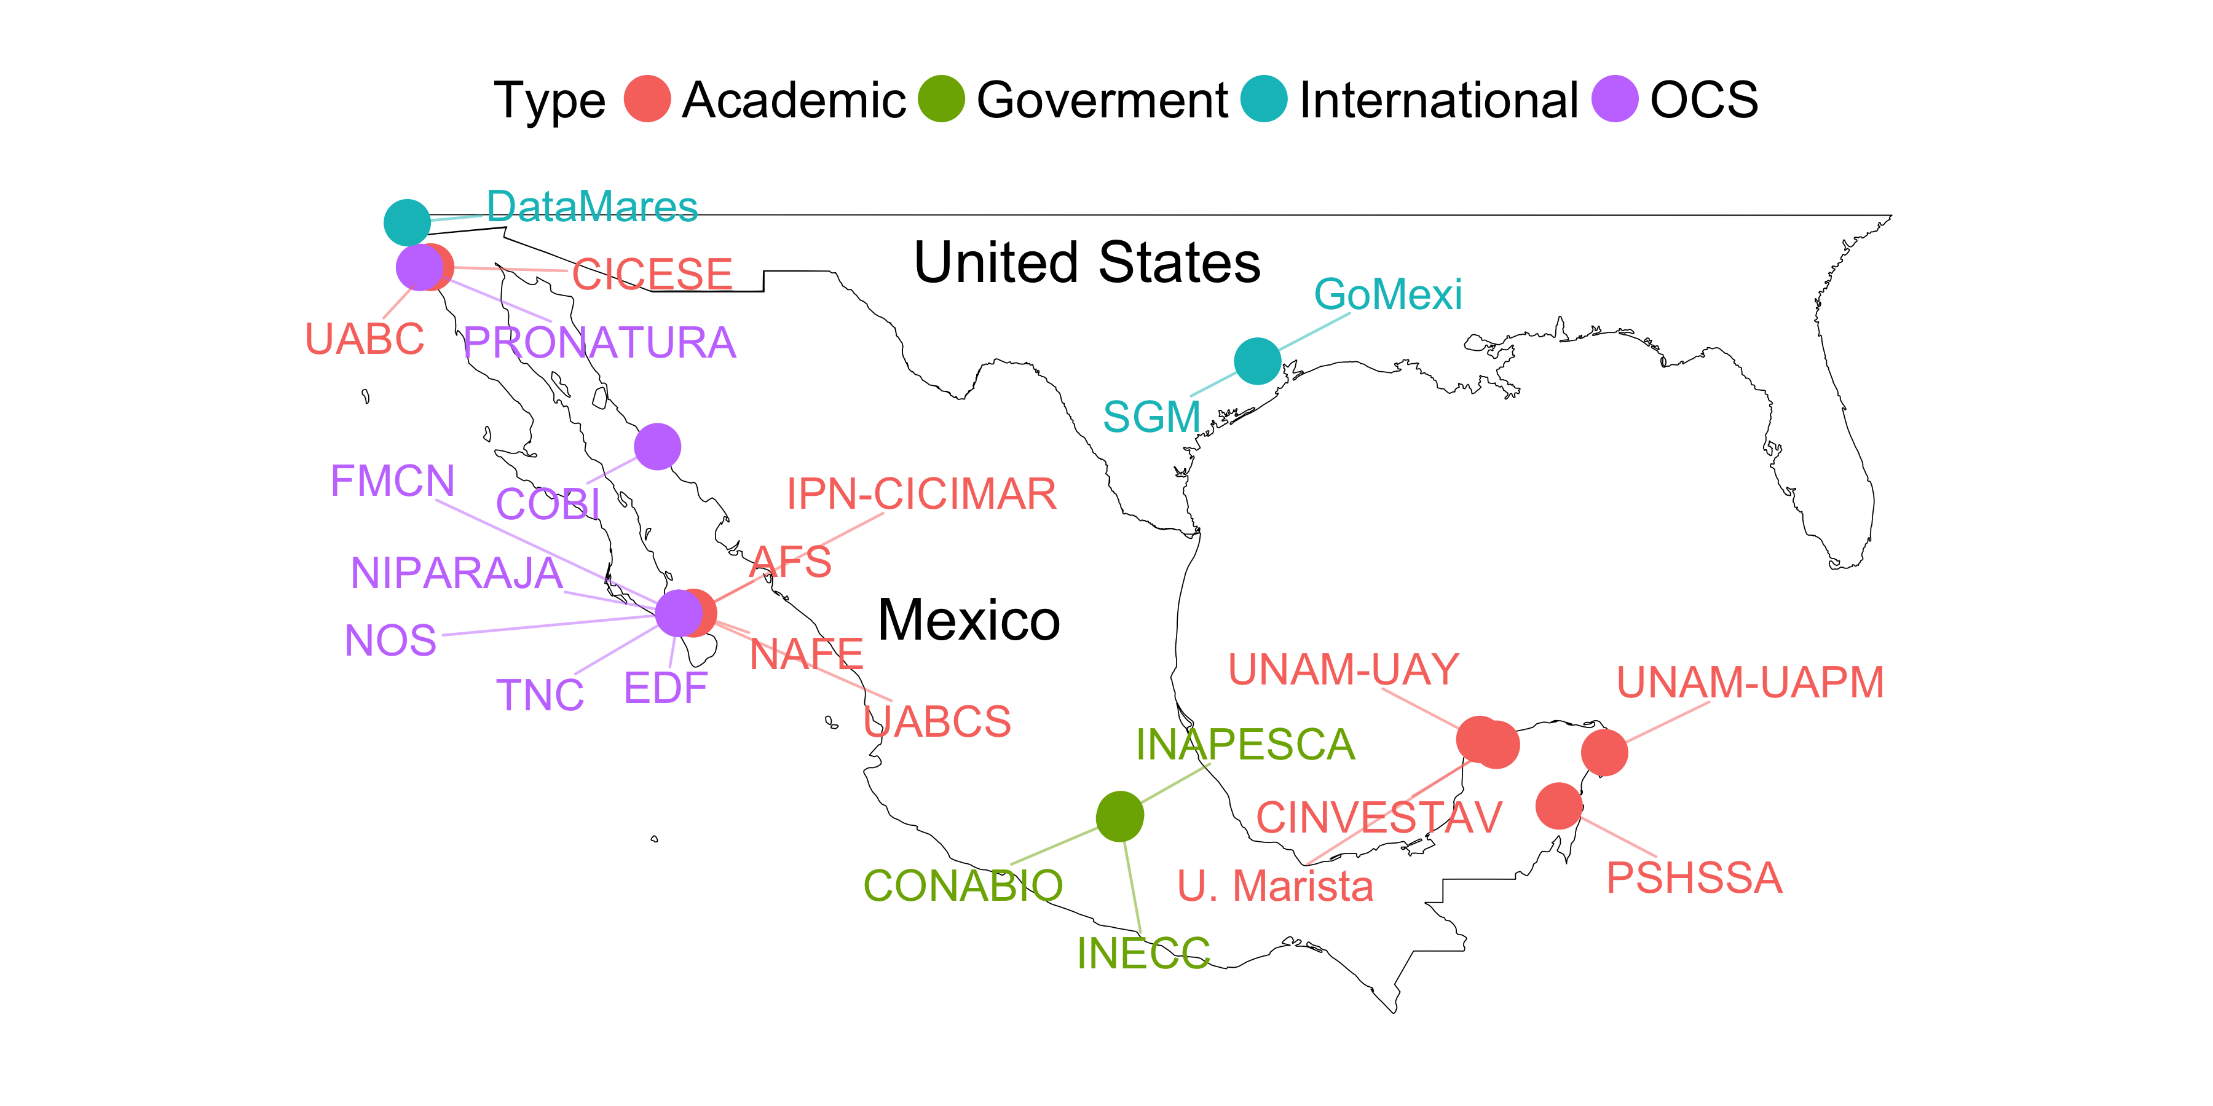

Figure 2. Data collection effort. Location of the places where data were collected. CSO = Civil Society Organizations. Full locations information can be found in Table S3

1. Repositorio de datos marinos integrados de Canarias (REDMIC). Available at: <https://redmic.es/home>
2. United Nations Agenda 2030. Available at: <https://sustainabledevelopment.un.org/partnership/?p=9691>