**NUTRIWISE: NUTRITIONAL WELLNESS INFORMATION SYSTEM AND EDUCATION FOR NUTRITION AND DIETETICS STUDENTS**

*Jephthah Jehosaphat Landicho*

*Clarence Phol Bautista Andino*

*Cleo Angelo Lopez Dimailig*

***Milestones:***

***Deliverables:***

* Login/Signup design
* Functionality of Login/Signup
* Create a homepage
* Create public view of web application.
* UI/UX of web application for three modules (Student, Course Facilitator, Client).
* Back-end functionality of the web application.
* Create database structure for both web and mobile application.
* UI/UX of mobile application for three modules.
* Back-end functionality of the mobile application.
* Uploading of both web and mobile applications online.

***Diagrams:***

**System Architecture**

**Requirements Analysis**

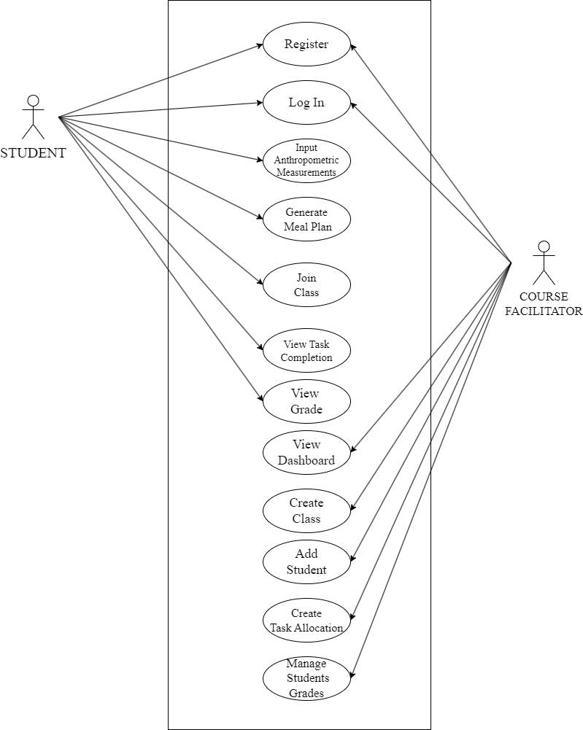**Use Case Diagram**

**Context Diagram**

**Data Flow Diagram**

**Entity-Relationship Diagram**

