🚀 Portfolio Concept (Platform PortAncest): JEAN PIERRE JOSEPH — ENGINEERING THE FUTURE
The overall style should be:
- Futuristic but professional
- Dark, premium interface
- Clean typography
- Subtle animations
- Engineering/technology aesthetic
- Lots of visual storytelling
- Strong project demonstrations
- No excessive neon or "gamer" styling
- Designed to make recruiters immediately understand who you are, what you build, and what you can do
Your portfolio can position you as:
Computer Engineer • AI Engineer • IoT & Systems Developer
with your electronics engineering background providing the foundation.

1. Homepage — The "Command Center"
The first screen should immediately communicate who you are.

Hero
JEAN PIERRE JOSEPH

COMPUTER ENGINEER
AI • IoT • SOFTWARE • SYSTEMS

I design and build intelligent systems
that connect software, hardware, data,
and the real world.

[ Explore My Work ] [ View Resume ]
On the right side:
A futuristic interactive 3D/animated representation of your engineering ecosystem:
AI
│
▼
┌─────────────────┐
│ INTELLIGENT │
│ SYSTEMS │
└─────────────────┘
▲ ▲ ▲
│ │ │
IoT Cloud Data
│ │ │
Hardware Software Network
But visually, not as a literal diagram.
Think:
glowing nodes + connecting lines + subtle motion + floating system cards.

2. Navigation
Keep the navigation extremely clean.
JEAN
────────────────────────────────────────

ABOUT PROJECTS EXPERIENCE SKILLS
CERTIFICATIONS RESUME

[ CONTACT ]
On mobile, collapse into a sleek menu.
The navigation should remain visible as the user scrolls.

3. About Me
Don't make this a giant biography.
Instead:

ABOUT
Engineer. Builder. Problem Solver.
Then a short professional introduction.
For example:
I am a computer engineering student and technology professional with a foundation in electronic engineering and a passion for building intelligent, connected systems.
My work sits at the intersection of software, artificial intelligence, networking, embedded systems, IoT, and automation. I enjoy transforming complex technical problems into practical systems that people can actually use.
Then underneath, create four capability cards:
┌──────────────────┐
│ SOFTWARE │
│ Web • Python │
│ Java • Systems │
└──────────────────┘

┌──────────────────┐
│ AI & DATA │
│ AI Applications │
│ Computer Vision │
└──────────────────┘

┌──────────────────┐
│ IoT & EMBEDDED │
│ Arduino • ESP32 │
│ Raspberry Pi │
└──────────────────┘

┌──────────────────┐
│ INFRASTRUCTURE │
│ Networking │
│ Windows • Linux │
└──────────────────┘

4. Engineering Timeline
This would make your portfolio stand out.
Instead of simply saying "Education" and "Experience," create a horizontal/vertical timeline.

MY JOURNEY
ELECTRONICS ENGINEERING
│
▼
TECHNOLOGY & IT
│
▼
NETWORKING & SYSTEMS
│
▼
COMPUTER ENGINEERING
│
▼
AI + SOFTWARE + IoT
│
▼
INTELLIGENT SYSTEMS
Then attach your actual milestones to it.
For example:

🎓 Education
Bachelor's — Electronic Engineering
↓

🎓 Computer Engineering
Florida Atlantic University
↓

💻 Technology
Systems, networking, software and infrastructure
↓

🤖 AI
AI-focused coursework and projects
↓

🚀 Innovation
EEMS and other engineering projects

5. Projects — Make This the Star of the Website
This should be your strongest section.
Don't make projects look like GitHub cards.
Make each project feel like a case study.

Featured Project

EEMS
Electrical Energy Management System
Large visual:
┌─────────────┐
│ EEMS │
│ PLATFORM │
└──────┬──────┘
│
┌───────────────┼───────────────┐
│ │ │
ENERGY SECURITY IoT
│ │ │
Sensors Cameras Devices
Circuits Alarms Controls
Then:
PROBLEM
How can multiple electrical, security,
and IoT systems be managed from one platform?

SOLUTION
A centralized intelligent management platform
connecting devices, data, automation and users.

TECHNOLOGIES
Embedded Systems • IoT • Networking
Software • Sensors • Automation
Then buttons:
[ Live Demo ] [ GitHub ] [ Case Study ]

6. Your Other Projects
Create a filterable project gallery.

FILTER
ALL AI SOFTWARE IoT EMBEDDED
NETWORKING HARDWARE
Cards:

PawPal+
Pet Care Management System

Music Recommender
Recommendation / simulation project

CreatorVerse
Full-stack creator management platform

St. Andrews Community Portal
Private community platform

Explore-Bot
Robotics / embedded project

VHDL Multiplier
Digital hardware design

RTSP / Camera Platform
Video streaming and computer vision
You have enough projects that the portfolio should not display everything at once. Let visitors explore.

7. Project Detail Pages
This is where your portfolio can become genuinely impressive.
When someone clicks:
EEMS →
They should enter a full-screen case study.
EEMS
Electrical Energy Management System

[ HERO SYSTEM VISUAL ]

Overview
────────────────────────

The problem
────────────────────────

The architecture
────────────────────────

Hardware
────────────────────────

Software
────────────────────────

Networking
────────────────────────

Challenges
────────────────────────

What I learned
────────────────────────

[ GitHub ] [ Demo ]
You can even have animated architecture diagrams.

8. Skills — Don't Use a Giant List
Avoid:
Python
Java
C++
JavaScript
SQL
React
...
That looks like a résumé from 2015.
Instead organize skills by engineering domains.

ENGINEERING STACK
Software Engineering
React · JavaScript · Python · Java · Web Applications
AI & Computer Vision
Artificial Intelligence · Computer Vision · OpenCV · Data Processing
Embedded & IoT
Arduino · ESP32 · Raspberry Pi · Sensors · Automation
Systems & Infrastructure
Windows Server · Linux · Networking · Virtualization · PowerShell
Development
Git · GitHub · VS Code · NetBeans · Maven
Engineering
Electronics · Digital Systems · VHDL · Hardware Design · PCB Design

9. Experience
Your professional experience should be presented separately from projects.

EXPERIENCE
Technology / Engineering
Focus on what you solve, not merely your job title.
Then your current professional experience can be presented cleanly:

The Home Depot
Sales Associate — Lumber & Building Materials
Instead of making this section dominate the portfolio, keep it concise and professional.
You can also include your Learning Assistant experience as a separate entry.

10. Certifications
Use compact premium cards.
┌─────────────────────┐
│ CodePath │
│ │
│ AI110 │
│ Artificial │
│ Intelligence │
│ │
│ 2026 │
└─────────────────────┘
Then:
- CompTIA A+
- CodePath programs
- FAU programs
- Other certifications
Your certifications shouldn't simply be text. Give each one a visual identity.

11. "What I Build"
This could be one of the coolest sections.
Instead of only talking about yourself, show the types of systems you build.
INTELLIGENT SYSTEMS

┌─────────────┐
│ AI │
└──────┬──────┘
│
▼
┌─────────┐ ┌─────────┐ ┌─────────┐
│ HARDWARE│──│ SYSTEM │──│ SOFTWARE│
└─────────┘ └─────────┘ └─────────┘
│
▼
┌──────────┐
│ IoT │
└──────────┘
Then a statement:
From hardware to software, I build systems that connect the physical and digital worlds.
That's a much stronger personal brand than simply listing technologies.

12. Resume Section
Have a dedicated:

RESUME
JEAN PIERRE JOSEPH
Computer Engineer • AI • IoT • Systems

[ Download Resume PDF ]

Education
Experience
Projects
Skills
Certifications
Also include:
View Resume Online
so visitors don't have to download anything.

13. Contact Section
Make the final section feel like the end of a futuristic system.
LET'S BUILD
SOMETHING
MEANINGFUL.

Have an idea?
Have a project?
Looking for an engineer?

[ START A CONVERSATION ]

LinkedIn
GitHub
Email
Then a very small footer:
© 2026 Jean Pierre Joseph

Designed & engineered by Jean Pierre Joseph

14. Visual Design
I'd recommend this exact aesthetic:

Background
Almost-black:
#070A0F
with slightly lighter panels:
#0D1117
#111827

Accent
Use one primary futuristic accent, rather than five neon colors.
Something around:
#38BDF8
or a blue → violet gradient.

Typography
Use something modern like:
Inter
for normal text and:
Space Grotesk
for headings.

15. Visual Language
Use:
- thin borders
- glass-like panels
- subtle gradients
- small glowing accents
- grid backgrounds
- animated connection lines
- hover elevation
- smooth page transitions
- subtle particle effects
- code/engineering-inspired details
But don't overdo the effects.
The goal should be:
NASA/engineering lab + modern software company
not:
gaming website.

16. A Futuristic Hero Effect
I particularly recommend putting a subtle animated grid behind your hero:
╱╲╱╲╱╲╱╲╱╲╱╲╱╲╱╲
──────────────────
╲╱╲╱╲╱╲╱╲╱╲╱╲╱╲╱
──────────────────
●
╱│╲
╱ │ ╲
●──●──●
│
●
The nodes could represent:
AI → Software → IoT → Hardware → Data → Systems
and slowly animate.
That would immediately establish your engineering identity.

17. The Overall Site Structure
I'd build the portfolio like this:
/
│
├── HOME
│
├── ABOUT
│
├── PROJECTS
│ ├── EEMS
│ ├── PawPal+
│ ├── CreatorVerse
│ ├── St Andrews Portal
│ ├── Explore-Bot
│ └── Other Projects
│
├── EXPERIENCE
│
├── EDUCATION
│
├── SKILLS
│
├── CERTIFICATIONS
│
├── RESUME
│
└── CONTACT
But from the visitor's perspective, I would make it feel like one continuous experience, rather than a collection of disconnected pages.

⭐ Most important: your personal branding
I wouldn't brand you simply as:
"Computer Engineering Student"
That's too limiting.
I'd position the portfolio around:

JEAN PIERRE JOSEPH

Engineer • Builder • Systems Thinker
AI · Software · IoT · Embedded Systems · Infrastructure
Then your supporting statement:
Building intelligent systems that connect the digital and physical worlds.
That gives you room to showcase your electronics background, computer engineering education, AI work, software projects, networking/infrastructure experience, IoT work, and EEMS without making the portfolio feel scattered.

Absolutely. If you’re building a portfolio platform, rather than just a personal portfolio, I’d design it as a modern multi-user professional identity platform: each person can create an account, build a professional profile, manage projects/experience/education, and publish a polished portfolio page.

Recommended concept
Working name: Profolio / Nexfolio / Porta / ProfileX
Core idea:
A modern professional portfolio platform where users can create, manage, and share a dynamic digital profile that showcases their experience, education, skills, projects, certifications, and professional interests.

Futuristic visual direction
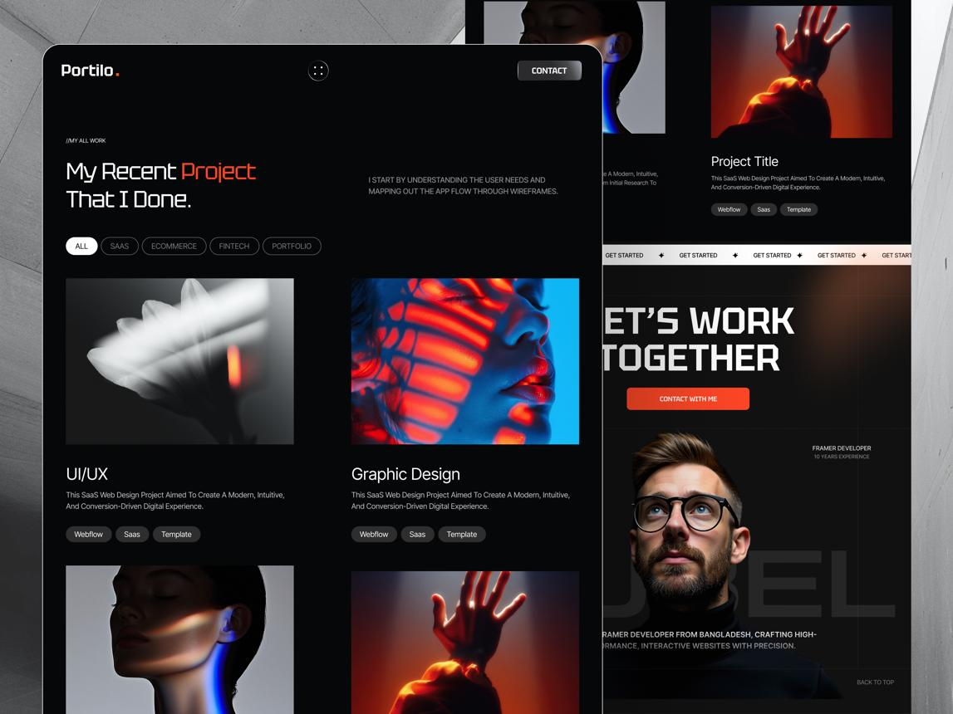
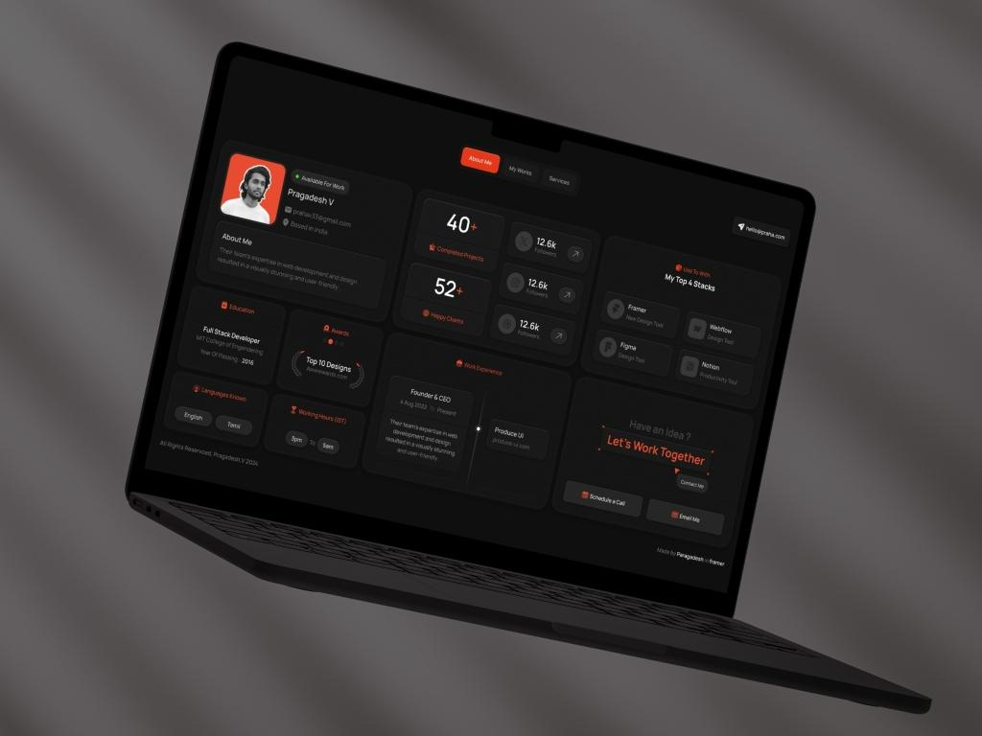
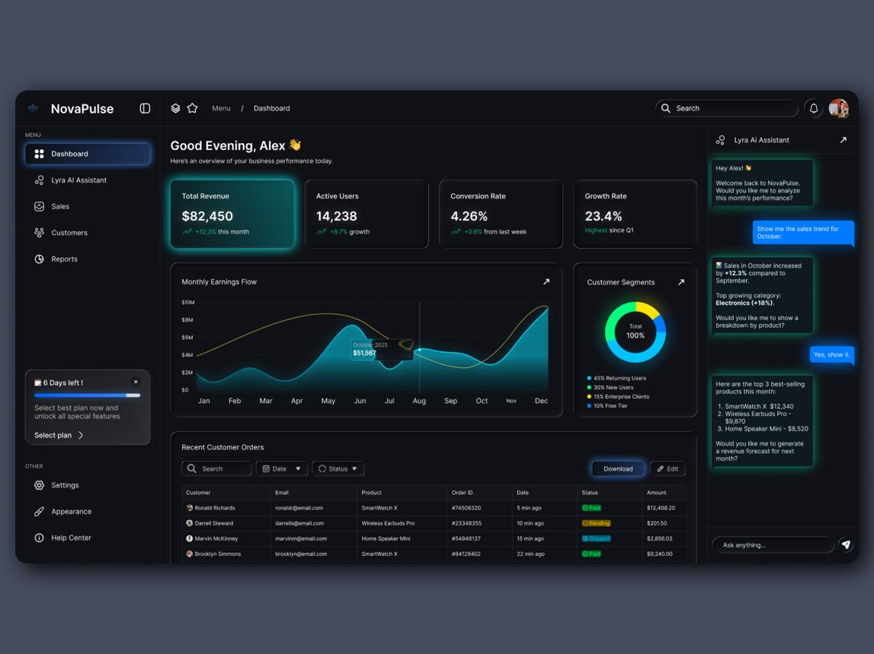
6
I would go with:
- 🌑 Dark-first interface
- ✨ Subtle gradients and glowing accents
- 🪟 Glass/soft-transparent cards
- 🎨 One primary accent color, such as electric blue, violet, or cyan
- 📱 Fully responsive
- 🎞️ Subtle animations, not excessive effects
- 🧩 Modular profile sections
- 📊 Professional dashboard
- 🔗 Shareable public portfolio URL
For example:
yourplatform.com/u/jean-pierre-joseph

1. Platform structure
I would divide the application into three major parts:
┌─────────────────────────┐
│ PORTFOLIO │
│ PLATFORM │
└────────────┬────────────┘
│
┌──────────────────┼──────────────────┐
│ │ │
▼ ▼ ▼
┌───────────┐ ┌───────────┐ ┌───────────┐
│ Frontend │ │ Backend │ │ Database │
│ React │◄────►│ API │◄────►│ MSSQL │
└───────────┘ └───────────┘ └───────────┘
│ │
▼ ▼
User Interface Authentication
Dashboard Business Logic
Portfolio Builder Authorization
Public Profiles Data Management

Frontend
React would handle:
- Landing page
- Login / registration
- Dashboard
- Portfolio editor
- Profile preview
- Project management
- Experience management
- Education management
- Skills
- Certifications
- Public portfolio
- Settings

Backend
The backend would handle:
- Authentication
- User accounts
- Authorization
- CRUD operations
- Portfolio management
- Image/file management
- Public profile retrieval
- Validation
- Security
- Database communication

Database
MSSQL would store things such as:
Users
Profiles
Projects
Experience
Education
Skills
Certifications
SocialLinks
PortfolioSettings
Messages

2. User experience
The most important part is that the user shouldn't have to understand the technical structure.
After registration:
Create Account
↓
Create Professional Profile
↓
Choose Portfolio Style
↓
Add Information
↓
Preview
↓
Publish
↓
yourplatform.com/u/username

3. Dashboard
The dashboard should feel like a professional SaaS application.
Something like:
┌──────────────────────────────────────────────────────────────┐
│ ◈ PROPORTFOLIO Jean ⚙ │
├───────────────┬──────────────────────────────────────────────┤
│ │ │
│ Dashboard │ Welcome back, Jean │
│ │ │
│ My Portfolio │ Your portfolio is 85% complete │
│ │ │
│ Projects │ ┌──────────┐ ┌──────────┐ ┌──────────┐ │
│ │ │ Projects │ │ Skills │ │ Views │ │
│ Experience │ │ 12 │ │ 18 │ │ 1,284 │ │
│ │ └──────────┘ └──────────┘ └──────────┘ │
│ Education │ │
│ │ Portfolio │
│ Skills │ ┌──────────────────────────────────────┐ │
│ │ │ │ │
│ Certificates │ │ Portfolio Preview │ │
│ │ │ │ │
│ Settings │ │ [View Portfolio] │ │
│ │ │ │ │
│ │ └──────────────────────────────────────┘ │
│ │ │
└───────────────┴──────────────────────────────────────────────┘

4. Portfolio editor
This is where your application can become much more interesting than a normal portfolio website.
Instead of forcing users to edit HTML, give them sections:
Portfolio Editor
Bio
Location
Profile Picture

[ About ]

Professional summary

[ Experience ]

+ Add Experience

Company
Position
Start Date
End Date
Description

[ Education ]

+ Add Education

School
Degree
Field
Graduation Date

[ Projects ]

+ Add Project

Project Name
Description
Technologies
GitHub
Live Demo
Project Image

[ Skills ]

+ Add Skill

Python
Java
React
SQL
Networking

[ Certifications ]

+ Add Certification

Certification
Organization
Date
Credential URL

[ Social Links ]

LinkedIn
GitHub
Website
YouTube

[ Save Draft ] [ Preview ] [ Publish ]
This makes it a portfolio builder, not simply a portfolio.

5. Public portfolio
The public-facing portfolio should be completely different from the dashboard.
For example:
┌──────────────────────────────────────────────────────────────┐
│ JP About Projects│
│ │
│ JEAN PIERRE JOSEPH │
│ Computer Engineer │
│ │
│ Building technology that connects │
│ hardware, software and intelligent systems. │
│ │
│ [ View Projects ] [ Contact ] │
│ │
├──────────────────────────────────────────────────────────────┤
│ │
│ ABOUT ME │
│ │
│ Professional summary... │
│ │
├──────────────────────────────────────────────────────────────┤
│ EXPERIENCE │
│ │
│ ─── Company │
│ Position │
│ Description │
│ │
├──────────────────────────────────────────────────────────────┤
│ PROJECTS │
│ │
│ ┌─────────────┐ ┌─────────────┐ ┌─────────────┐ │
│ │ Project │ │ Project │ │ Project │ │
│ │ │ │ │ │ │ │
│ └─────────────┘ └─────────────┘ └─────────────┘ │
│ │
├──────────────────────────────────────────────────────────────┤
│ SKILLS │
│ │
│ React Python Java SQL IoT Networking │
│ │
└──────────────────────────────────────────────────────────────┘

6. Database design
Since you're using MSSQL, I recommend keeping the database normalized rather than putting the entire portfolio into one giant Users table.
For example:

Users
Users
-------------------------
Id
Email
PasswordHash
Username
CreatedAt
UpdatedAt

Profiles
Profiles
-------------------------
Id
UserId
FirstName
LastName
ProfessionalTitle
Bio
Location
ProfileImage
Website
CreatedAt
UpdatedAt

Projects
Projects
-------------------------
Id
UserId
Title
Description
ImageUrl
GithubUrl
LiveUrl
CreatedAt
UpdatedAt

Experience
Experience
-------------------------
Id
UserId
Company
Position
Description
StartDate
EndDate
IsCurrent

Education
Education
-------------------------
Id
UserId
Institution
Degree
Field
StartDate
EndDate
Description

Skills
Skills
-------------------------
Id
UserId
Name
Level

Certifications
Certifications
-------------------------
Id
UserId
Name
Issuer
IssueDate
CredentialUrl

SocialLinks
SocialLinks
-------------------------
Id
UserId
Platform
Url
The important relationship is:
User
│
├── Profile
│
├── Projects
│
├── Experience
│
├── Education
│
├── Skills
│
├── Certifications
│
└── Social Links
That will make the platform much easier to expand later.

7. Backend API
Your React application shouldn't directly communicate with MSSQL.
Use:
React
│
│ HTTP / REST API
▼
Backend API
│
│ Database queries
▼
MSSQL
For example:
POST /api/auth/register
POST /api/auth/login
POST /api/auth/logout

GET /api/profile
PUT /api/profile

GET /api/projects
POST /api/projects
PUT /api/projects/:id
DELETE /api/projects/:id

GET /api/experience
POST /api/experience
PUT /api/experience/:id
DELETE /api/experience/:id

GET /api/education
POST /api/education
PUT /api/education/:id
DELETE /api/education/:id

GET /api/skills
POST /api/skills
DELETE /api/skills/:id
And for public portfolios:
GET /api/public/:username
So someone visiting:
yourplatform.com/u/jean-pierre-joseph
could cause the frontend to request:
GET /api/public/jean-pierre-joseph
and construct the portfolio from the returned information.

8. Authentication
Because this is a multi-user platform, authentication should be designed from the beginning.
You want:
Registration
↓
Password hashing
↓
Login
↓
Authentication token/session
↓
Authenticated dashboard
↓
User-specific data
Most importantly, every database record should be associated with the appropriate UserId.
That prevents something like:
Jean logs in and somehow edits John's projects.
Authorization belongs on the backend, not just the React frontend.

9. Professional/futuristic features
Once the core application works, you could add features that make it stand out:

Portfolio themes
Allow users to choose:
◉ Minimal
○ Professional
○ Creative
○ Futuristic
○ Developer
○ Academic

Portfolio preview
A live preview:
EDITOR PREVIEW

Name: Jean ┌───────────────────────┐
Title: Engineer │ JEAN PIERRE JOSEPH │
Bio: ... │ Computer Engineer │
│ │
│ About │
│ Projects │
│ Experience │
└───────────────────────┘

Completion indicator
Portfolio completion

████████████████░░░░ 82%

✓ Profile
✓ Experience
✓ Education
✓ Projects
✓ Skills
○ Certifications

Public/private control
Portfolio Visibility

● Public
○ Private

Custom URL
yourplatform.com/u/jean-pierre-joseph
Eventually:
jeanpierre.com
could point to the user's portfolio.

10. Recommended project structure
For React:
portfolio-platform/
│
├── frontend/
│ │
│ ├── src/
│ │ ├── components/
│ │ │ ├── Navbar/
│ │ │ ├── Sidebar/
│ │ │ ├── ProjectCard/
│ │ │ ├── ExperienceCard/
│ │ │ └── SkillBadge/
│ │ │
│ │ ├── pages/
│ │ │ ├── Landing/
│ │ │ ├── Login/
│ │ │ ├── Register/
│ │ │ ├── Dashboard/
│ │ │ ├── ProfileEditor/
│ │ │ ├── Projects/
│ │ │ └── PublicPortfolio/
│ │ │
│ │ ├── services/
│ │ │ └── api.js
│ │ │
│ │ ├── context/
│ │ │ └── AuthContext.jsx
│ │ │
│ │ ├── App.jsx
│ │ └── main.jsx
│ │
│ └── package.json
│
├── backend/
│ │
│ ├── controllers/
│ ├── routes/
│ ├── middleware/
│ ├── models/
│ ├── services/
│ ├── config/
│ ├── server.js
│ └── package.json
│
├── database/
│ ├── schema.sql
│ ├── seed.sql
│ └── migrations/
│
├── README.md
└── .gitignore
This is a much better architecture for your idea than putting everything into a single React project.
And because you already have experience with React, Java, SQL, networking, IoT, and full-stack projects, this could become a very strong portfolio project itself: you're demonstrating not only that you can build a website, but that you understand frontend architecture, APIs, authentication, database design, CRUD, security, and deployment.

I would build it in this order
Phase 1 — Foundation
- Create React frontend
- Create backend API
- Create MSSQL database
- Establish frontend → backend → database communication
Phase 2 — Authentication
5. Registration
6. Login
7. Logout
8. Protected dashboard
9. User authorization
Phase 3 — Portfolio
10. Profile
11. Projects
12. Experience
13. Education
14. Skills
15. Certifications
16. Social links
Phase 4 — Publishing
17. Portfolio preview
18. Public portfolio URL
19. Publish/unpublish
20. Portfolio themes
Phase 5 — Professional polish
21. Responsive design
22. Dark/futuristic UI
23. Animations
24. Image handling
25. Validation/error handling
26. Deployment
27. Documentation
That gives you a real full-stack portfolio SaaS platform, not just another static portfolio site

Absolutely. Since we already have the platform concept and the public URL structure, I recommend we build it like a real production platform, not just as a portfolio CRUD exercise.
We'll go from A → Z, but in controlled checkpoints so you always know what we're doing and why.

🚀 Platform concept
For now, let's call it PortfolioHub as a working name. We can rename it later.
The platform will allow someone to:
- Create an account
- Log in securely
- Build their professional profile
- Create their public portfolio
- Add projects
- Add education
- Add work experience
- Add skills
- Add certifications
- Add social/professional links
- Customize their portfolio
- Publish/unpublish their portfolio
- Share it through a URL such as:
yourplatform.com/u/jeanjoseph56
Visitors can view public portfolios without logging in.

🏗️ Overall architecture
We're going to build three major layers:
┌─────────────────────┐
│ VISITOR │
└──────────┬──────────┘
│
▼
/u/jeanjoseph56
│
▼
┌──────────────────────────────────────────────────────┐
│ REACT FRONTEND │
│ │
│ Landing Page │
│ Login / Register │
│ Dashboard │
│ Profile Editor │
│ Projects │
│ Experience │
│ Education │
│ Skills │
│ Certifications │
│ Public Portfolio │
└──────────────────────────┬───────────────────────────┘
│
│ HTTP / JSON
▼
┌──────────────────────────────────────────────────────┐
│ BACKEND API │
│ │
│ Authentication │
│ User Management │
│ Portfolio Management │
│ Projects │
│ Experience │
│ Education │
│ Skills │
│ Certifications │
│ Public Profiles │
└──────────────────────────┬───────────────────────────┘
│
▼
┌──────────────────────────────────────────────────────┐
│ MICROSOFT SQL SERVER │
│ │
│ Users │
│ Profiles │
│ Projects │
│ Experience │
│ Education │
│ Skills │
│ Certifications │
│ SocialLinks │
└──────────────────────────────────────────────────────┘
This is a much better fit for the platform you described than putting everything directly in React.

🧭 Our A → Z roadmap
We'll follow this order.

Phase 1 — Foundation
Step 1: Define the project architecture
Step 2: Create the React frontend
Step 3: Create the backend API
Step 4: Create the SQL Server database
Step 5: Connect backend → SQL Server
Step 6: Connect React → backend

Phase 2 — Authentication
Step 7: Registration
Step 8: Password hashing
Step 9: Login
Step 10: Sessions/JWT authentication
Step 11: Logout
Step 12: Protected routes

Phase 3 — User identity
Step 13: User profile
Step 14: Username generation
Step 15: Username availability checking
Step 16: Change username
Step 17: Public URL
Example:
/u/jeanjoseph56

Phase 4 — Portfolio builder
Step 18: Professional summary
Step 19: Profile picture
Step 20: Contact information
Step 21: Skills
Step 22: Education
Step 23: Work experience
Step 24: Projects
Step 25: Certifications
Step 26: Social links

Phase 5 — Portfolio presentation
Step 27: Public portfolio layout
Step 28: Professional navigation
Step 29: Hero section
Step 30: About section
Step 31: Skills section
Step 32: Experience section
Step 33: Projects section
Step 34: Education section
Step 35: Certifications section
Step 36: Contact/social section

Phase 6 — Portfolio management
Step 37: Dashboard
Step 38: Edit profile
Step 39: Add/edit/delete projects
Step 40: Add/edit/delete experience
Step 41: Add/edit/delete education
Step 42: Add/edit/delete certifications
Step 43: Preview portfolio
Step 44: Publish/unpublish

Phase 7 — Professional features
Step 45: Portfolio themes
Step 46: Theme customization
Step 47: Responsive design
Step 48: SEO metadata
Step 49: Social sharing
Step 50: Copy portfolio link
Step 51: Public portfolio search

Phase 8 — Security & production
Step 52: Input validation
Step 53: Authorization
Step 54: SQL injection protection
Step 55: Rate limiting
Step 56: Error handling
Step 57: Environment variables
Step 58: Production configuration
Step 59: Deployment
Step 60: Testing
That gives us a real portfolio platform, rather than simply a portfolio website.

📁 Step 1 — Project structure
I recommend a single project containing separate frontend and backend applications:
portfolio-platform/
│
├── frontend/
│ ├── public/
│ ├── src/
│ │ ├── assets/
│ │ ├── components/
│ │ ├── pages/
│ │ ├── layouts/
│ │ ├── services/
│ │ ├── context/
│ │ ├── hooks/
│ │ ├── styles/
│ │ ├── App.jsx
│ │ └── main.jsx
│ │
│ ├── package.json
│ └── vite.config.js
│
├── backend/
│ ├── src/
│ │ ├── config/
│ │ ├── controllers/
│ │ ├── middleware/
│ │ ├── models/
│ │ ├── routes/
│ │ ├── services/
│ │ ├── utils/
│ │ └── server.js
│ │
│ ├── .env
│ ├── package.json
│ └── .gitignore
│
├── database/
│ ├── schema/
│ ├── seed/
│ └── migrations/
│
├── README.md
└── .gitignore

Why separate frontend and backend?
Because eventually you'll have:
React
↓
REST API
↓
Business logic
↓
SQL Server
rather than:
React
↓
Database
That separation is much more professional and gives you a strong portfolio project to talk about.

🛠️ Step 2 — Technologies
For your platform, I'd use:

Frontend
- React
- Vite
- React Router
- CSS
- Fetch/Axios

Backend
- Node.js
- Express
- REST API
- Authentication middleware

Database
- Microsoft SQL Server

Development
- VS Code
- Git
- GitHub
- .env configuration
We can add things such as image storage, email verification, or deployment later rather than complicating the initial setup.

🗄️ Step 3 — Database design
Before writing the backend, we should design the database correctly.
At minimum:
Users
Profiles
Projects
Experience
Education
Skills
Certifications
SocialLinks
The relationships will look approximately like:
Users
│
│ 1:1
▼
Profiles
│
┌────────────┼────────────┐
│ │ │
▼ ▼ ▼
Projects Experience Education
│
│
├──────── Skills
│
├──────── Certifications
│
└──────── SocialLinks
And importantly:
Users
├── Email
├── PasswordHash
└── Username
│
▼
/u/:username
So your public portfolio doesn't need to expose the user's email address.

🔐 One architectural decision I want us to make now
For authentication, don't store passwords as plain text.
We will eventually have:
Email
Password
↓
Password hashing
↓
PasswordHash
↓
SQL Server
The database should never contain:
Password = MyPassword123
Instead it contains a secure password hash.
We'll implement this when we reach authentication.

🎨 And the UI
Since you want a futuristic, professional portfolio platform, I would build the interface around something like:
┌──────────────────────────────────────────────────────┐
│ PORTFOLIOHUB Login Sign Up │
├──────────────────────────────────────────────────────┤
│ │
│ BUILD YOUR PROFESSIONAL IDENTITY │
│ │
│ Create a portfolio that represents you. │
│ │
│ [ Create Your Portfolio ] │
│ │
├──────────────────────────────────────────────────────┤
│ │
│ Explore Professionals │
│ │
│ ┌──────────┐ ┌──────────┐ ┌──────────┐ │
│ │ Photo │ │ Photo │ │ Photo │ │
│ │ │ │ │ │ │ │
│ │ Jean │ │ Sarah │ │ Michael │ │
│ │ Engineer │ │ Designer │ │ Developer│ │
│ └──────────┘ └──────────┘ └──────────┘ │
│ │
└──────────────────────────────────────────────────────┘
Then a public portfolio could look like:
┌──────────────────────────────────────────────────────┐
│ │
│ JEAN PIERRE JOSEPH │
│ Computer Engineer │
│ │
│ AI • IoT • Networking • Software │
│ │
│ [ LinkedIn ] [ GitHub ] [ Contact ] │
│ │
├──────────────────────────────────────────────────────┤
│ │
│ ABOUT │
│ │
│ Professional summary... │
│ │
├──────────────────────────────────────────────────────┤
│ │
│ EXPERIENCE │
│ │
│ ── Company │
│ Position │
│ 2025 – Present │
│ │
├──────────────────────────────────────────────────────┤
│ │
│ PROJECTS │
│ │
│ ┌─────────────┐ ┌─────────────┐ │
│ │ Project │ │ Project │ │
│ │ │ │ │ │
│ └─────────────┘ └─────────────┘ │
│ │
└──────────────────────────────────────────────────────┘

🚦 Let's actually start
Don't create the database yet.
Since we're doing this step-by-step, our first practical checkpoint should be:

Step 1A — Create the project
Open VS Code and create a folder:
portfolio-platform
Then open that folder in VS Code.
Open the VS Code terminal and run:
npm create vite@latest frontend -- --template react
Then:
cd frontend
npm install
npm install react-router-dom
Then start it:
npm run dev
You should get a local address similar to:
http://localhost:5173

Stop here after that.
Once the Vite React application opens successfully, tell me “frontend is running”.
Then we'll do Step 1B: clean the Vite starter project and build the professional foundation/layout, before we touch the backend or SQL Server. That way we won't mix five different things together and make troubleshooting difficult.

For a professional portfolio, call it the About section—not Professional Summary.
A résumé and portfolio can use the same career information, but the writing style and purpose differ:
Résumé: Professional Summary | Portfolio: About
Usually 45–100 words | Usually 100–250 words
Concise and position-specific | Personal and narrative
Often avoids “I,” “me,” and “my” | First-person language is appropriate
Focuses on immediate qualifications | Explains background, interests, values, and goals
Customized for each résumé | Usually represents the broader professional identity
Optimized for recruiters and ATS | Optimized for visitors and potential clients/employers
Your portfolio order should generally be:
- Profile header
- About
- Experience
- Skills
- Projects
- Education
- Certifications
- Contact
For someone with your mix of IT systems administration, computer engineering, software development, and EEMS work, the About section should connect those areas into one professional story.
For the public professional portfolio, use one main scrolling page containing About, Experience, Skills, Projects, Education, and Certifications as sections—not a separate route for every information type.
For the private dashboard where you manage the information, separate pages or tabs are appropriate.

Recommended architecture
Area | Recommended organization
Private dashboard/editor | Separate management pages
Public professional portfolio | One scrolling portfolio page
Large project case studies | Optional dedicated pages
Public résumé | Dedicated résumé page

Private dashboard
Your internal application can continue using separate routes such as:
/profile
/experience
/skills
/projects
/education
/certifications
/resumes
/portfolio-settings
This makes forms and data management easier.

Public portfolio
Use one route:
/portfolio/:username
For example:
https://portfolio.motich.com/portfolio/jean-pierre-joseph
That page would render:
- Hero/profile header
- About
- Experience
- Skills
- Featured projects
- Education
- Certifications
- Résumés or download résumé
- Contact
The navigation can scroll to anchors:
About | Experience | Skills | Projects | Education | Certifications | Contact
Each link moves to a section of the same page:
/portfolio/jean-pierre-joseph#about
/portfolio/jean-pierre-joseph#experience
/portfolio/jean-pierre-joseph#skills
/portfolio/jean-pierre-joseph#projects

Component structure
Create:
frontend/src/pages/PublicPortfolio/
├── PublicPortfolio.jsx
├── PublicPortfolio.css
└── components/
├── PortfolioNavigation/
├── PortfolioHero/
├── PortfolioAbout/
├── PortfolioExperience/
├── PortfolioSkills/
├── PortfolioProjects/
├── PortfolioEducation/
├── PortfolioCertifications/
├── PortfolioResumes/
└── PortfolioContact/
The main page composes those components:
function PublicPortfolio() {
return (
<main className="public-portfolio">
<PortfolioNavigation />

<PortfolioHero />

<PortfolioAbout />

<PortfolioExperience />

<PortfolioSkills />

<PortfolioProjects />

<PortfolioEducation />

<PortfolioCertifications />

<PortfolioResumes />

<PortfolioContact />
</main>
);
}
Each section receives only its required data:
<PortfolioAbout about={portfolio.about} />

<PortfolioExperience
experiences={portfolio.experiences}
/>

<PortfolioSkills skills={portfolio.skills} />

<PortfolioProjects projects={portfolio.projects} />

Dedicated project pages
Projects are the main exception. The portfolio page should show project cards, while important projects may have dedicated case-study routes:
/portfolio/jean-pierre-joseph/projects/eems
A case-study page can contain:
- Problem
- Proposed solution
- Your role
- Technologies
- Architecture
- Development process
- Challenges
- Screenshots or demo
- Results
- GitHub and live-demo links
This is more professional than forcing the entire EEMS explanation into one project card.

Recommended user experience
The visitor gets a fast overview without repeatedly loading pages, while recruiters can open a project case study or résumé when they want more detail.
Therefore, your best structure is:
- Separate pages for managing information
- One scrolling page for presenting the public portfolio
- Dedicated pages only for detailed projects and public résumés

So if the About Section will tell about my data information like resume summary, Profile header, Experience, Skills, Featured projects, Education, Certifications, I want it to have AI generated option as well (3 generated like resume summary) so let's start doing the About section

Data flow

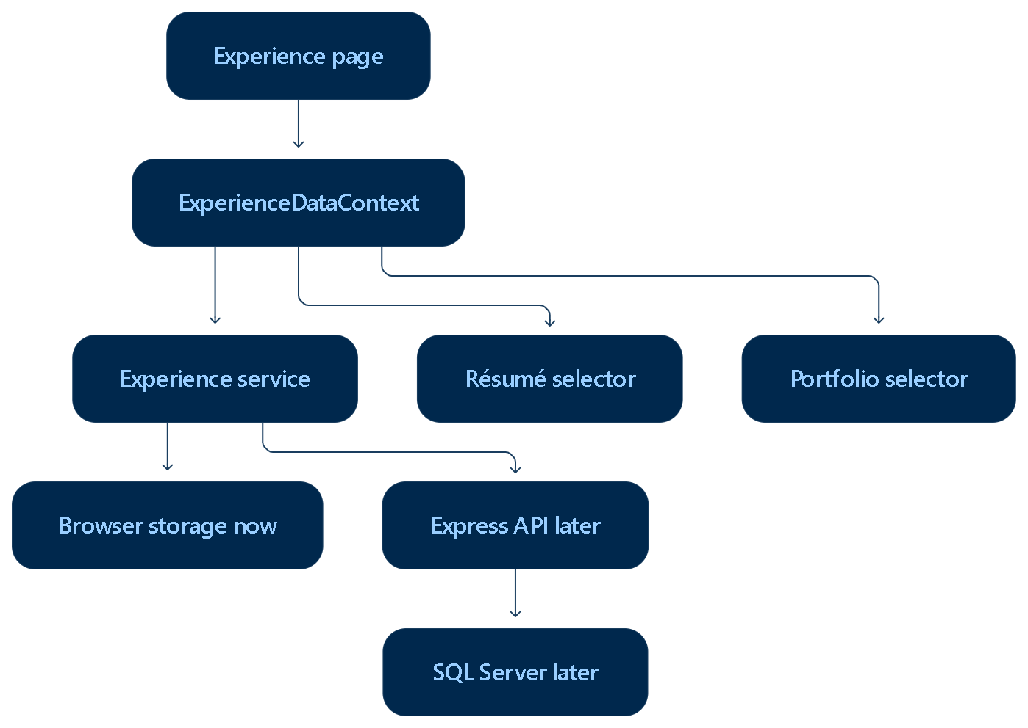

Next Phase
The next step should be ExperienceTechnologyEditor. It completes the remaining structured Experience content before we build the final experience list/cards.
Create:
ExperienceForm/
└── ExperienceTechnologyEditor/
├── ExperienceTechnologyEditor.jsx
└── ExperienceTechnologyEditor.css
It should support:
- Adding tools, platforms, frameworks, software, equipment, and technologies used in the experience
- Selecting an existing item from the central Skill Library
- Creating a new reusable technology/skill
- Preventing duplicates
- Editing, removing, and reordering technologies
- Optional category and proficiency
- Synchronizing newly created technologies with the future Skills page
- Supplying technologies as context for:
  - Experience Overview AI generation
  - Experience Skills AI suggestions
  - Résumé content
  - Portfolio Experience sections
The experience form order will then become:
01 Role and Organization
02 Dates and Location
03 Experience Overview
04 Responsibilities
05 Achievements
06 Skills
07 Technologies and Tools
08 Leadership
09 Private Information
10 Visibility and Status
After that, the remaining sequence should be:
- Build ExperienceTechnologyEditor.jsx and CSS.
- Connect it to ExperienceForm.jsx.
- Ensure technologies affect Experience Overview stale detection and readiness.
- Build ExperienceList.jsx.
- Build ExperienceCard.jsx.
- Connect saved Experience records to résumé and portfolio selectors.
- Replace temporary browser storage with the Express API and SQL Server persistence.
The best design is to use the existing central Skill Library for technologies instead of creating an unrelated technology database. A technology is still a skill-library item, but its relationship to an experience can contain experience-specific information such as proficiency and usage details.

Current component | New component
PersonalInformation.jsx | ProfileDashboard/ProfileDashboard.jsx
PersonalInformationForm.jsx | ProfileForm/ProfileForm.jsx
Identity section | NameEditor/NameEditor.jsx
Professional title form section | ProfessionalTitleEditor/ProfessionalTitleEditor.jsx
RepeatableInformationSection for emails | EmailEditor/EmailEditor.jsx
Phones configuration | PhoneEditor/PhoneEditor.jsx
Locations configuration | LocationEditor/LocationEditor.jsx
Websites configuration | WebsiteEditor/WebsiteEditor.jsx
Social links configuration | SocialLinkEditor/SocialLinkEditor.jsx
Picture configuration | ProfilePictureEditor/ProfilePictureEditor.jsx
Current page header | ProfilePageHeader/ProfilePageHeader.jsx
ContactInformation.jsx | Reusable display component inside ProfileDashboard
ContactInformationItem.jsx | Reusable display item inside ProfileDashboard
ProfessionalTitle.jsx | Reusable display component inside ProfileDashboard
ProfessionalTitleItem.jsx | Reusable display item inside ProfileDashboard

Existing file | New file
PersonalInformation.jsx | ProfileDetails/ProfileDetails.jsx
PersonalInformation.css | ProfileDetails/ProfileDetails.css
ProfessionalTitle.jsx | ProfileProfessionalTitles/ProfileProfessionalTitles.jsx
ProfessionalTitle.css | ProfileProfessionalTitles/ProfileProfessionalTitles.css
ProfessionalTitleItem.jsx | ProfileProfessionalTitleItem/ProfileProfessionalTitleItem.jsx
ProfessionalTitleItem.css | ProfileProfessionalTitleItem/ProfileProfessionalTitleItem.css
ContactInformation.jsx | ProfileContactSection/ProfileContactSection.jsx
ContactInformation.css | ProfileContactSection/ProfileContactSection.css
ContactInformationItem.jsx | ProfileContactItem/ProfileContactItem.jsx
ContactInformationItem.css | ProfileContactItem/ProfileContactItem.css
PersonalInformationForm.jsx/css | Delete after verifying unused
RepeatableInformationSection.jsx/css | Delete after verifying unused

professionalTitles

• Finish Skills and Experience relationships — completed.
• Build Projects.
• Build Education.
• Build Certifications.
• Build Training.
• Connect usage relationships across those libraries.
• Build Résumé using all central records.
• Build Portfolio using all central records.
• Add backend/MSSQL persistence later.

Final Platform Architecture Plan
Your platform should be organized as a professional career-management application with four clear areas:
- Public website
- Authentication system
- Authenticated user application
- Administration system
Your database remains undecided between Azure SQL and your privately hosted MSSQL server. The architecture below supports either one without requiring major frontend changes.

- Recommended technology architecture

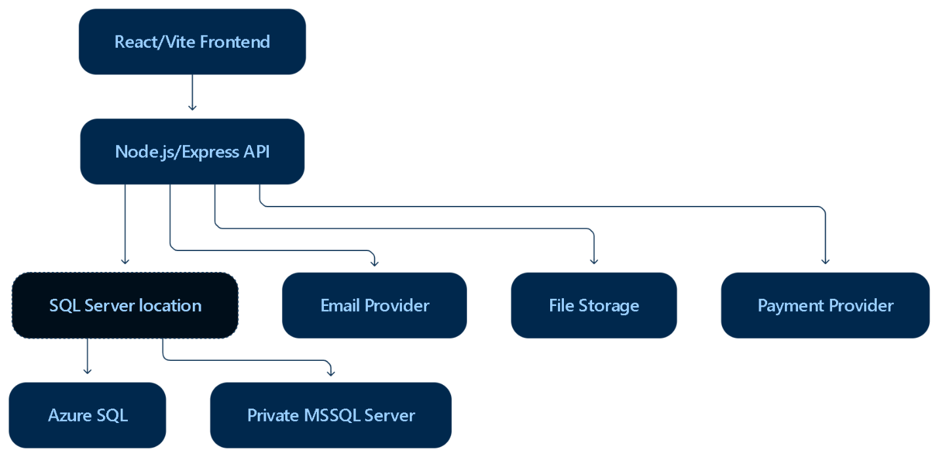
Recommended stack:
Layer | Technology
Frontend | React, Vite, JavaScript, CSS
Frontend hosting | Azure Static Web Apps
Backend | Node.js and Express
Backend hosting | Azure App Service or another Node host
Database engine | Microsoft SQL Server
Production database option 1 | Azure SQL
Production database option 2 | Privately hosted MSSQL
Authentication | Custom Node/Express authentication
Password hashing | Argon2id, with bcrypt as an acceptable alternative
OTP delivery | Transactional email provider through SMTP or API
File storage | Azure Blob Storage or another object-storage service
Payments | Stripe, PayPal, or Square hosted checkout
Authorization | Role-based access control enforced by Express
Validation | Zod, Joi, or Express Validator
Logging | Structured server and audit logging
Database changes | Version-controlled SQL migrations
The most important design decision is:
React should communicate only with your Express API. React should never connect directly to Azure SQL or your home MSSQL database.
This lets you change the database location by changing the backend connection configuration rather than rewriting your pages and components.

2. Database strategy

Keep both MSSQL options available
Develop the application against Microsoft SQL Server without writing code that depends specifically on Azure SQL.
Your Express backend can use environment variables:
DB_HOST=
DB_PORT=1433
DB_NAME=
DB_USER=
DB_PASSWORD=
DB_ENCRYPT=true
DB_TRUST_SERVER_CERTIFICATE=false
Use a database connection module and repository/service layers:
React component
↓
Express controller
↓
Application service
↓
Repository
↓
MSSQL database
For example:
projectController
↓
projectService
↓
projectRepository
↓
SQL Server
No React component should know whether the database is running on Azure or in your home.

Option A: Azure SQL
Azure SQL would be the preferred production option if your student subscription makes it affordable.
Advantages:
- Located near your Azure backend
- Managed backups
- Managed availability and patching
- Easier firewall configuration
- Better public production reliability
- No dependence on your home internet or electricity
Disadvantages:
- Possible cost after student credits expire
- Azure configuration and monitoring requirements
- Storage and compute limitations based on the selected tier
Before selecting it, check the exact Azure SQL benefits shown in your student subscription. Do not base the platform on an assumed free tier until the portal confirms it.

Option B: Privately hosted MSSQL
Your home MSSQL server can be useful for:
- Development
- Testing
- Learning
- Early private demonstrations
- A controlled initial deployment
For a real public platform, it introduces additional risks:
- Home internet interruptions
- Power outages
- Upload bandwidth limitations
- Higher latency between Azure and your home
- Hardware failure
- Backup responsibility
- Firewall and network security responsibility
If you use your own server:
- Never expose SQL Server port 1433 broadly to the internet.
- Restrict access to the backend server.
- Prefer a private VPN or protected tunnel.
- Use an encrypted SQL connection.
- Use a dedicated application database account.
- Do not use the SQL Server administrator account from Express.
- Maintain encrypted off-site backups.
- Test database restoration regularly.
- Use a UPS for the database host and network equipment.
- Monitor disk space, uptime, login failures, and backup status.

Recommended decision
Use the same MSSQL schema for both environments:
- Local MSSQL during development
- Azure SQL for production if your student account supports it affordably
- Privately hosted MSSQL remains an alternative or controlled fallback
Supabase can remain a possible future alternative, but it is no longer a committed part of this plan.

3. Application layouts and routes

Public layout
These pages are accessible without authentication:
/
├── /about
├── /how-it-works
├── /opportunities
├── /support
├── /support/thank-you
├── /contact
├── /privacy
├── /terms
└── /portfolio/:username/:portfolioSlug
Recommended public navigation:
Home | About | How It Works | Opportunities | Support Us | Sign In | Create Account

Landing page sections
The homepage should include:
- Navigation header
- Hero section
- Platform value proposition
- Feature overview
- How the platform works
- Example portfolio presentation
- Professional-management benefits
- Opportunities and announcements
- Clearly labeled sponsored promotion
- About preview
- Support the Platform section
- Final account-creation call to action
- Footer with legal and contact links
Do not put a complete login form directly inside the homepage. Use clear Sign In and Create Account buttons leading to the authentication pages.

Authentication layout
Authentication pages should have a clean, focused design without advertisements or unnecessary navigation.
/auth
├── /auth/login
├── /auth/login/verify
├── /auth/register
├── /auth/register/verify
├── /auth/set-password
├── /auth/forgot-password
├── /auth/reset-password
└── /auth/session-expired
The authentication layout can show:
- Platform logo
- Short security message
- Authentication form
- Help link
- Privacy and Terms links
- Return to homepage link
It should not show:
- Advertisements
- Promotions
- Donation requests
- Dashboard navigation
- Private user information

Authenticated layout
Your existing DashboardLayout should contain:
/dashboard
/profile
/projects
/experience
/education
/training
/skills
/certifications
/resumes
/portfolio
/settings
/settings/security
/settings/sessions
A protected route should verify the session before rendering this layout.
Unauthenticated users attempting to open a private page should be redirected to:
/auth/login?returnTo=/projects
After successful login and OTP verification, the application returns them to the requested page.

Administration layout
/admin
├── /admin/users
├── /admin/users/:userId
├── /admin/promotions
├── /admin/announcements
├── /admin/contributions
├── /admin/reports
├── /admin/audit-logs
└── /admin/platform-settings
The admin interface should use its own AdminLayout, even if it reuses visual components from the dashboard.

4. Registration process
Your proposed registration process is strong. The professional implementation should be:
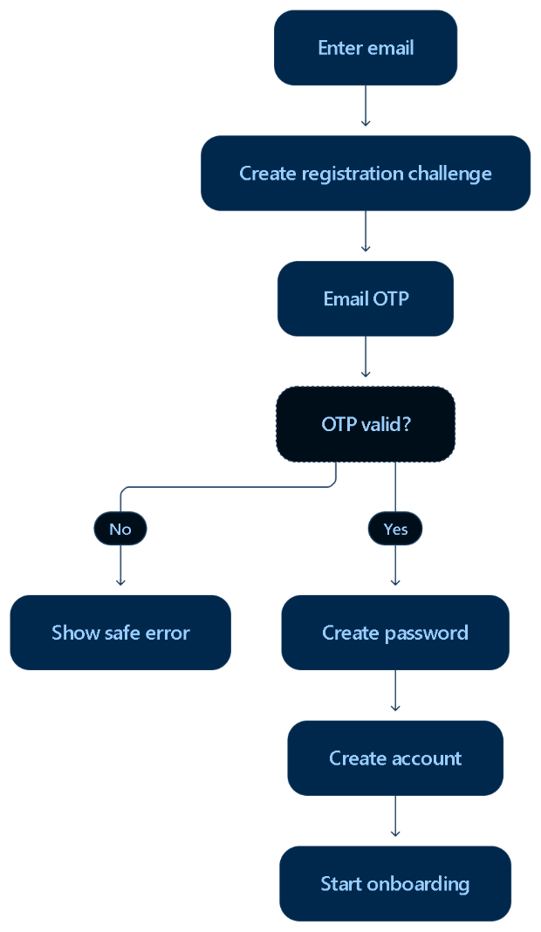

Registration steps
- User enters their email address.
- Backend normalizes the address.
- Backend creates a cryptographically secure OTP.
- Backend stores only the OTP hash.
- Email provider sends the OTP.
- User submits the OTP.
- Backend verifies expiration, attempts, purpose, and usage status.
- Backend issues a short-lived password-setup token.
- User creates a password.
- Backend hashes the password.
- Backend creates the user and initial profile.
- User receives an authenticated session.
- User begins onboarding.
The account should not be considered complete until the email is verified and the password is configured.

- Login process

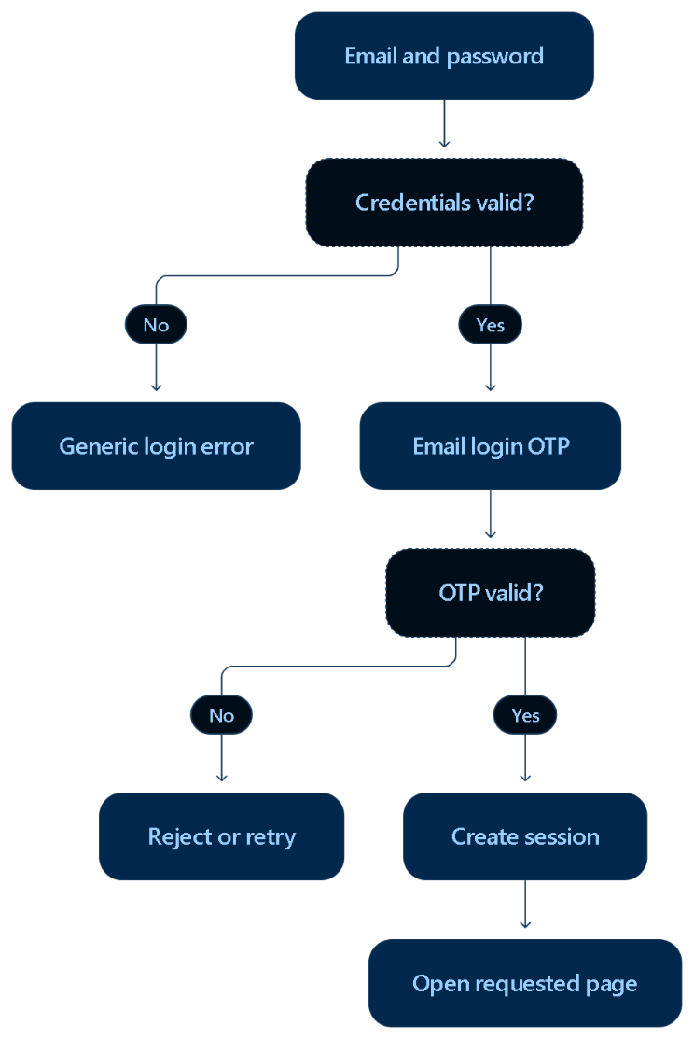

Login steps
- User submits email and password.
- Backend validates them.
- Backend creates a login OTP challenge.
- OTP is sent to the verified email.
- User enters the OTP.
- Backend validates the challenge.
- Backend creates the full session.
- Session identifier is delivered through a secure HttpOnly cookie.
- Login is added to the security audit history.
Do not create the full authenticated session immediately after the password succeeds. The session should be issued only after the OTP succeeds.

6. Authentication security

Passwords
Use Argon2id for password hashing. Bcrypt is an acceptable fallback when Argon2id is unavailable. Passwords must never be encrypted for later recovery or stored in plaintext. OWASP recommends modern, slow password-hashing algorithms such as Argon2id, bcrypt, or PBKDF2.
Recommended rules:
- Minimum length of at least 12 characters
- Permit long passwords and passphrases
- Do not silently truncate passwords
- Allow password managers and pasting
- Check passwords against commonly compromised values
- Never email a password to the user

OTP challenges
Each OTP record should contain:
id
user_id or pending_email
purpose
code_hash
expires_at
attempt_count
maximum_attempts
last_sent_at
consumed_at
created_at
request_ip_hash
Possible purposes:
- registration
- login
- password_reset
- email_change
- sensitive_action
Recommended behavior:
- Six-digit cryptographically generated code
- Five- to ten-minute expiration
- Single use
- Maximum number of verification attempts
- Resend cooldown
- Old challenge invalidated when a new one is created
- Email and IP rate limiting
- Generic responses that do not reveal whether an account exists

Sessions
Create a sessions table containing:
id
user_id
refresh_token_hash
created_at
last_used_at
expires_at
revoked_at
ip_address_hash
user_agent
device_name
The user should be able to view and revoke active sessions from:
/settings/sessions
Security actions such as password reset should optionally revoke every existing session.

7. Roles and authorization
Start with these roles:
- user
- admin
Prepare the schema for future roles:
- content_manager
- support_admin
- moderator
- super_admin
Authorization must be enforced by Express middleware:
requireAuthentication
requireVerifiedEmail
requireRole("admin")
requireResourceOwnership
A protected React route improves navigation, but it is not a security boundary. Every API endpoint must independently verify identity, role, and record ownership.

First administrator
Never show an administrator checkbox during registration.
Create the first admin using one of these approaches:
- Version-controlled database seed
- Protected command-line script
- One-time server-side setup command
- Direct database migration
After that, only authorized administrators should be able to grant administrative roles.

8. Administration capabilities
Administrators should be able to:
- Search users
- Review user status
- Suspend or restore accounts
- Assign permitted roles
- Review failed login activity
- Review reported content
- Publish announcements
- Schedule promotions
- Review contribution transactions
- Review system audit records
- Configure platform-wide settings
Administrators should not be able to:
- View password hashes
- View OTP codes
- View session tokens
- silently impersonate users
- Modify security records without an audit trail
- Delete audit history through the normal admin interface
Important actions should require the administrator to re-enter an OTP.

9. Initial database design

Identity and security tables
users
user_profiles
roles
user_roles
user_settings
auth_challenges
sessions
login_audit_events
password_reset_requests
audit_logs

Career-management tables
experiences
education_records
training_records
skills
user_skills
certifications
projects
project_skills
project_media
resumes
resume_sections
portfolios
portfolio_sections
supporting_documents
media_assets
Every user-owned table should contain:
id
user_id
created_at
updated_at
record_status
Add foreign keys and indexes for:
- user_id
- public usernames
- portfolio slugs
- resume slugs
- record status
- created and updated timestamps
Use a unique constraint for normalized email addresses and public usernames.

Public content tables
announcements
promotions
promotion_placements
content_reports
platform_settings
A promotion should support:
id
title
description
image_url
destination_url
placement
sponsor_name
status
starts_at
ends_at
created_by
created_at
updated_at
All promotional content displayed to users should be visibly labeled “Sponsored” or “Promotion.”

10. Support and contribution system
The strongest approach remains:
- “Support Us” button in the public header and footer
- Complete /support page
- Secure hosted checkout
- /support/thank-you result page

Support page content
Include:
- Platform mission
- What contributions fund
- One-time and monthly support
- Suggested amounts
- Custom amount
- Anonymous contribution option
- Secure payment statement
- Refund/contact information
- Tax-deductibility disclosure
Unless you establish an eligible nonprofit organization, display language such as:
Contributions support the development and operation of the platform and are not tax-deductible.

Payment architecture
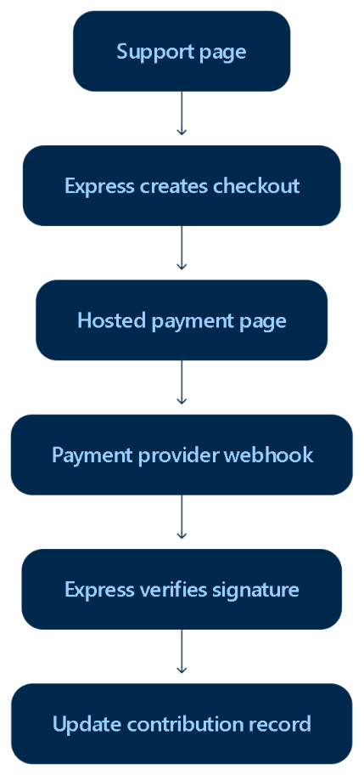
Do not create your own card-number form and do not store card information.
Stripe Checkout, for example, supports a provider-hosted payment page and both one-time and recurring transactions. Payment confirmation should come from a verified webhook rather than relying on the user reaching the thank-you page. Stripe Checkout documentation, Stripe webhook guidance

Contribution tables
contributions
- id
- user_id nullable
- contributor_email
- provider
- provider_customer_id
- provider_transaction_id
- amount
- currency
- contribution_type
- status
- is_anonymous
- created_at
- updated_at
For recurring support:
contribution_subscriptions
- id
- user_id
- provider_subscription_id
- amount
- currency
- interval
- status
- started_at
- canceled_at
- updated_at
Also store processed webhook identifiers so duplicate webhook deliveries do not create duplicate contributions.

11. File and media storage
Do not store uploaded images, résumés, certificates, or project videos directly as large database values unless there is a specific reason.
Use object storage for file contents and SQL Server for metadata:
media_assets
- id
- user_id
- storage_provider
- storage_key
- original_file_name
- mime_type
- file_size
- visibility
- status
- created_at
Possible storage choices:
- Azure Blob Storage
- Cloudflare R2
- A secured private file server
Azure Blob Storage is the most natural choice if the frontend and backend remain on Azure.
Private documents should be downloaded through authorized backend endpoints or short-lived signed URLs.

12. Frontend structure
A professional frontend structure could become:
src/
├── layouts/
│ ├── PublicLayout/
│ ├── AuthLayout/
│ ├── DashboardLayout/
│ └── AdminLayout/
├── pages/
│ ├── Public/
│ │ ├── Home/
│ │ ├── About/
│ │ ├── HowItWorks/
│ │ ├── Opportunities/
│ │ ├── Support/
│ │ ├── Contact/
│ │ ├── Privacy/
│ │ └── Terms/
│ ├── Auth/
│ │ ├── Login/
│ │ ├── Register/
│ │ ├── VerifyOtp/
│ │ ├── SetPassword/
│ │ ├── ForgotPassword/
│ │ └── ResetPassword/
│ ├── Dashboard/
│ └── Admin/
├── context/
│ ├── AuthContext.jsx
│ └── existing data contexts
├── routes/
│ ├── ProtectedRoute.jsx
│ ├── GuestRoute.jsx
│ └── AdminRoute.jsx
└── services/
├── apiClient.js
├── authService.js
├── supportService.js
└── existing services
Eventually, existing data contexts should call the API instead of localStorage, sessionStorage, or IndexedDB for permanent records.
Temporary draft information can still use browser storage when appropriate.

13. Backend structure
backend/src/
├── config/
│ ├── database.js
│ ├── environment.js
│ └── email.js
├── controllers/
├── services/
├── repositories/
├── routes/
├── middleware/
├── validators/
├── security/
├── email/
├── payments/
├── storage/
├── jobs/
├── migrations/
└── app.js
Recommended API groups:
/api/auth
/api/users
/api/profile
/api/projects
/api/experience
/api/education
/api/training
/api/skills
/api/certifications
/api/resumes
/api/portfolios
/api/support
/api/public
/api/admin
Public and private portfolio endpoints should be separate:
GET /api/public/portfolios/:username/:slug
GET /api/portfolios/:id
PUT /api/portfolios/:id
POST /api/portfolios/:id/publish
POST /api/portfolios/:id/unpublish
The public endpoint must transform the portfolio into a public-safe response instead of returning the complete private database record.

14. What we already have for frontend
src/
¦ App.jsx
¦ index.css
¦ main.jsx
¦ project_structure_Fontend.txt
¦
+---components
¦ +---Header
¦ ¦ Header.css
¦ ¦ Header.jsx
¦ ¦
¦ +---Sidebar
¦ ¦ Sidebar.css
¦ ¦ Sidebar.jsx
¦ ¦
¦ +---SideNavigation
¦ SideNavigation.css
¦ SideNavigation.jsx
¦
+---config
¦ api.js
¦ certificationConfig.js
¦ documentConfig.js
¦ educationConfig.js
¦ experienceConfig.js
¦ profileConfig.js
¦ projectConfig.js
¦ skillConfig.js
¦ trainingConfig.js
¦
+---context
¦ CertificationDataContext.jsx
¦ EducationDataContext.jsx
¦ ExperienceDataContext.jsx
¦ PortfolioDraftContext.jsx
¦ ProfileDataContext.jsx
¦ ProjectDataContext.jsx
¦ ResumeDataContext.jsx
¦ SkillDataContext.jsx
¦ TrainingDataContext.jsx
¦
+---layouts
¦ +---DashboardLayout
¦ DashboardLayout.css
¦ DashboardLayout.jsx
¦
+---models
¦ certificationModel.js
¦ educationModel.js
¦ experienceModel.js
¦ profileModel.js
¦ projectModel.js
¦ skillModel.js
¦ trainingModel.js
¦
+---pages
¦ +---Certifications
¦ ¦ ¦ Certifications.css
¦ ¦ ¦ Certifications.jsx
¦ ¦ ¦
¦ ¦ +---components
¦ ¦ +---CertificationDashboard
¦ ¦ ¦ CertificationDashboard.css
¦ ¦ ¦ CertificationDashboard.jsx
¦ ¦ ¦
¦ ¦ +---CertificationDocumentPreview
¦ ¦ ¦ CertificationDocumentPreview.css
¦ ¦ ¦ CertificationDocumentPreview.jsx
¦ ¦ ¦
¦ ¦ +---CertificationDocumentViewer
¦ ¦ ¦ CertificationDocumentViewer.css
¦ ¦ ¦ CertificationDocumentViewer.jsx
¦ ¦ ¦
¦ ¦ +---CertificationForm
¦ ¦ ¦ CertificationForm.css
¦ ¦ ¦ CertificationForm.jsx
¦ ¦ ¦
¦ ¦ +---CertificationItem
¦ ¦ ¦ CertificationItem.css
¦ ¦ ¦ CertificationItem.jsx
¦ ¦ ¦
¦ ¦ +---CertificationLibrary
¦ ¦ ¦ CertificationLibrary.css
¦ ¦ ¦ CertificationLibrary.jsx
¦ ¦ ¦
¦ ¦ +---CertificationPageHeader
¦ ¦ CertificationPageHeader.css
¦ ¦ CertificationPageHeader.jsx
¦ ¦
¦ +---Dashboard
¦ ¦ ¦ Dashboard.css
¦ ¦ ¦ Dashboard.jsx
¦ ¦ ¦
¦ ¦ +---components
¦ ¦ +---ProfileCompletion
¦ ¦ ¦ ¦ ProfileCompletion.css
¦ ¦ ¦ ¦ ProfileCompletion.jsx
¦ ¦ ¦ ¦
¦ ¦ ¦ +---CompletionItem
¦ ¦ ¦ CompletionItem.css
¦ ¦ ¦ CompletionItem.jsx
¦ ¦ ¦
¦ ¦ +---PublicPortfolioCard
¦ ¦ ¦ PublicPortfolioCard.css
¦ ¦ ¦ PublicPortfolioCard.jsx
¦ ¦ ¦
¦ ¦ +---QuickActions
¦ ¦ ¦ QuickActions.css
¦ ¦ ¦ QuickActions.jsx
¦ ¦ ¦
¦ ¦ +---RecentActivity
¦ ¦ ¦ RecentActivity.css
¦ ¦ ¦ RecentActivity.jsx
¦ ¦ ¦
¦ ¦ +---Statistics
¦ ¦ ¦ ¦ Statistics.css
¦ ¦ ¦ ¦ Statistics.jsx
¦ ¦ ¦ ¦
¦ ¦ ¦ +---StatisticCard
¦ ¦ ¦ StatisticCard.css
¦ ¦ ¦ StatisticCard.jsx
¦ ¦ ¦
¦ ¦ +---WelcomeCard
¦ ¦ WelcomeCard.css
¦ ¦ WelcomeCard.jsx
¦ ¦
¦ +---Education
¦ ¦ ¦ Education.css
¦ ¦ ¦ Education.jsx
¦ ¦ ¦
¦ ¦ +---components
¦ ¦ +---EducationDashboard
¦ ¦ ¦ EducationDashboard.css
¦ ¦ ¦ EducationDashboard.jsx
¦ ¦ ¦
¦ ¦ +---EducationDocumentEditor
¦ ¦ ¦ EducationDocumentEditor.css
¦ ¦ ¦ EducationDocumentEditor.jsx
¦ ¦ ¦
¦ ¦ +---EducationForm
¦ ¦ ¦ EducationForm.css
¦ ¦ ¦ EducationForm.jsx
¦ ¦ ¦
¦ ¦ +---EducationItem
¦ ¦ ¦ EducationItem.css
¦ ¦ ¦ EducationItem.jsx
¦ ¦ ¦
¦ ¦ +---EducationLibrary
¦ ¦ ¦ EducationLibrary.css
¦ ¦ ¦ EducationLibrary.jsx
¦ ¦ ¦
¦ ¦ +---EducationOrderedItemEditor
¦ ¦ ¦ EducationOrderedItemEditor.css
¦ ¦ ¦ EducationOrderedItemEditor.jsx
¦ ¦ ¦
¦ ¦ +---EducationPageHeader
¦ ¦ ¦ EducationPageHeader.css
¦ ¦ ¦ EducationPageHeader.jsx
¦ ¦ ¦
¦ ¦ +---EducationSkillsEditor
¦ ¦ EducationSkillsEditor.css
¦ ¦ EducationSkillsEditor.jsx
¦ ¦
¦ +---Experience
¦ ¦ ¦ Experience.css
¦ ¦ ¦ Experience.jsx
¦ ¦ ¦
¦ ¦ +---components
¦ ¦ +---AchievementEditor
¦ ¦ ¦ AchievementEditor.css
¦ ¦ ¦ AchievementEditor.jsx
¦ ¦ ¦
¦ ¦ +---ExperienceBuilder
¦ ¦ ¦ ExperienceBuilder.css
¦ ¦ ¦ ExperienceBuilder.jsx
¦ ¦ ¦
¦ ¦ +---ExperienceCard
¦ ¦ ¦ ExperienceCard.css
¦ ¦ ¦ ExperienceCard.jsx
¦ ¦ ¦
¦ ¦ +---ExperienceDashboard
¦ ¦ ¦ ExperienceDashboard.css
¦ ¦ ¦ ExperienceDashboard.jsx
¦ ¦ ¦
¦ ¦ +---ExperienceFilters
¦ ¦ ¦ ExperienceFilters.css
¦ ¦ ¦ ExperienceFilters.jsx
¦ ¦ ¦
¦ ¦ +---ExperienceForm
¦ ¦ ¦ ¦ ExperienceForm.css
¦ ¦ ¦ ¦ ExperienceForm.jsx
¦ ¦ ¦ ¦
¦ ¦ ¦ +---ExperienceTechnologyEditor
¦ ¦ ¦ ExperienceTechnologyEditor.css
¦ ¦ ¦ ExperienceTechnologyEditor.jsx
¦ ¦ ¦
¦ ¦ +---ExperienceList
¦ ¦ ¦ ExperienceList.css
¦ ¦ ¦ ExperienceList.jsx
¦ ¦ ¦
¦ ¦ +---ExperienceOverviewBuilder
¦ ¦ ¦ ¦ ExperienceOverviewBuilder.css
¦ ¦ ¦ ¦ ExperienceOverviewBuilder.jsx
¦ ¦ ¦ ¦
¦ ¦ ¦ +---ExperienceOverviewReadiness
¦ ¦ ¦ ¦ ExperienceOverviewReadiness.css
¦ ¦ ¦ ¦ ExperienceOverviewReadiness.jsx
¦ ¦ ¦ ¦
¦ ¦ ¦ +---ExperienceOverviewSuggestions
¦ ¦ ¦ ExperienceOverviewSuggestions.css
¦ ¦ ¦ ExperienceOverviewSuggestions.jsx
¦ ¦ ¦
¦ ¦ +---ExperiencePageHeader
¦ ¦ ¦ ExperiencePageHeader.css
¦ ¦ ¦ ExperiencePageHeader.jsx
¦ ¦ ¦
¦ ¦ +---ExperienceSkillsEditor
¦ ¦ ¦ ¦ ExperienceSkillsEditor.css
¦ ¦ ¦ ¦ ExperienceSkillsEditor.jsx
¦ ¦ ¦ ¦
¦ ¦ ¦ +---ExperienceSkillSuggestions
¦ ¦ ¦ ExperienceSkillSuggestions.css
¦ ¦ ¦ ExperienceSkillSuggestions.jsx
¦ ¦ ¦
¦ ¦ +---ExperienceTechnologyEditor
¦ ¦ ¦ ExperienceTechnologyEditor.css
¦ ¦ ¦ ExperienceTechnologyEditor.jsx
¦ ¦ ¦
¦ ¦ +---ResponsibilityEditor
¦ ¦ ResponsibilityEditor.css
¦ ¦ ResponsibilityEditor.jsx
¦ ¦
¦ +---Portfolio
¦ ¦ ¦ Portfolio.css
¦ ¦ ¦ Portfolio.jsx
¦ ¦ ¦ project_structure.txt
¦ ¦ ¦
¦ ¦ +---components
¦ ¦ ¦ +---Certifications
¦ ¦ ¦ ¦ ¦ Certifications.css
¦ ¦ ¦ ¦ ¦ Certifications.jsx
¦ ¦ ¦ ¦ ¦
¦ ¦ ¦ ¦ +---CertificateViewer
¦ ¦ ¦ ¦ ¦ CertificateViewer.css
¦ ¦ ¦ ¦ ¦ CertificateViewer.jsx
¦ ¦ ¦ ¦ ¦
¦ ¦ ¦ ¦ +---CertificationForm
¦ ¦ ¦ ¦ ¦ CertificationForm.css
¦ ¦ ¦ ¦ ¦ CertificationForm.jsx
¦ ¦ ¦ ¦ ¦
¦ ¦ ¦ ¦ +---CertificationItem
¦ ¦ ¦ ¦ CertificationItem.css
¦ ¦ ¦ ¦ CertificationItem.jsx
¦ ¦ ¦ ¦
¦ ¦ ¦ +---Education
¦ ¦ ¦ ¦ ¦ Education.css
¦ ¦ ¦ ¦ ¦ Education.jsx
¦ ¦ ¦ ¦ ¦
¦ ¦ ¦ ¦ +---EducationItem
¦ ¦ ¦ ¦ EducationItem.css
¦ ¦ ¦ ¦ EducationItem.jsx
¦ ¦ ¦ ¦
¦ ¦ ¦ +---Experience
¦ ¦ ¦ ¦ ¦ Experience.css
¦ ¦ ¦ ¦ ¦ Experience.jsx
¦ ¦ ¦ ¦ ¦
¦ ¦ ¦ ¦ +---ExperienceItem
¦ ¦ ¦ ¦ ExperienceItem.css
¦ ¦ ¦ ¦ ExperienceItem.jsx
¦ ¦ ¦ ¦
¦ ¦ ¦ +---PortfolioAboutBuilder
¦ ¦ ¦ ¦ ¦ PortfolioAboutBuilder.css
¦ ¦ ¦ ¦ ¦ PortfolioAboutBuilder.jsx
¦ ¦ ¦ ¦ ¦
¦ ¦ ¦ ¦ +---AboutContextReadiness
¦ ¦ ¦ ¦ ¦ AboutContextReadiness.css
¦ ¦ ¦ ¦ ¦ AboutContextReadiness.jsx
¦ ¦ ¦ ¦ ¦
¦ ¦ ¦ ¦ +---AboutEditor
¦ ¦ ¦ ¦ ¦ AboutEditor.css
¦ ¦ ¦ ¦ ¦ AboutEditor.jsx
¦ ¦ ¦ ¦ ¦
¦ ¦ ¦ ¦ +---AboutSuggestions
¦ ¦ ¦ ¦ AboutSuggestions.css
¦ ¦ ¦ ¦ AboutSuggestions.jsx
¦ ¦ ¦ ¦
¦ ¦ ¦ +---PortfolioHero
¦ ¦ ¦ ¦ PortfolioHero.css
¦ ¦ ¦ ¦ PortfolioHero.jsx
¦ ¦ ¦ ¦
¦ ¦ ¦ +---PortfolioHeroSettings
¦ ¦ ¦ ¦ ¦ PortfolioHeroSettings.css
¦ ¦ ¦ ¦ ¦ PortfolioHeroSettings.jsx
¦ ¦ ¦ ¦ ¦
¦ ¦ ¦ ¦ +---PortfolioTaglineGenerator
¦ ¦ ¦ ¦ PortfolioTaglineGenerator.css
¦ ¦ ¦ ¦ PortfolioTaglineGenerator.jsx
¦ ¦ ¦ ¦
¦ ¦ ¦ +---PortfolioNavigation
¦ ¦ ¦ ¦ PortfolioNavigation.css
¦ ¦ ¦ ¦ PortfolioNavigation.jsx
¦ ¦ ¦ ¦
¦ ¦ ¦ +---PortfolioPageHeader
¦ ¦ ¦ ¦ PortfolioPageHeader.css
¦ ¦ ¦ ¦ PortfolioPageHeader.jsx
¦ ¦ ¦ ¦
¦ ¦ ¦ +---ProfileHeader
¦ ¦ ¦ ¦ ProfileHeader.css
¦ ¦ ¦ ¦ ProfileHeader.jsx
¦ ¦ ¦ ¦
¦ ¦ ¦ +---ProfileInformationSelector
¦ ¦ ¦ ¦ ProfileInformationSelector.css
¦ ¦ ¦ ¦ ProfileInformationSelector.jsx
¦ ¦ ¦ ¦
¦ ¦ ¦ +---Projects
¦ ¦ ¦ ¦ ¦ Projects.css
¦ ¦ ¦ ¦ ¦ Projects.jsx
¦ ¦ ¦ ¦ ¦
¦ ¦ ¦ ¦ +---ProjectItem
¦ ¦ ¦ ¦ ProjectItem.css
¦ ¦ ¦ ¦ ProjectItem.jsx
¦ ¦ ¦ ¦
¦ ¦ ¦ +---Skills
¦ ¦ ¦ ¦ ¦ Skills.css
¦ ¦ ¦ ¦ ¦ Skills.jsx
¦ ¦ ¦ ¦ ¦
¦ ¦ ¦ ¦ +---SkillsItem
¦ ¦ ¦ ¦ SkillsItem.css
¦ ¦ ¦ ¦ SkillsItem.jsx
¦ ¦ ¦ ¦
¦ ¦ ¦ +---SocialLinks
¦ ¦ ¦ SocialLinks.css
¦ ¦ ¦ SocialLinks.jsx
¦ ¦ ¦
¦ ¦ +---PortfolioPreview
¦ ¦ ¦ PortfolioPreview.css
¦ ¦ ¦ PortfolioPreview.jsx
¦ ¦ ¦
¦ ¦ +---PortfolioPublic
¦ ¦ ¦ PortfolioPublic.css
¦ ¦ ¦ PortfolioPublic.jsx
¦ ¦ ¦
¦ ¦ +---PortfolioView
¦ ¦ PortfolioView.css
¦ ¦ PortfolioView.jsx
¦ ¦
¦ +---Profile
¦ ¦ ¦ Profile.css
¦ ¦ ¦ Profile.jsx
¦ ¦ ¦
¦ ¦ +---components
¦ ¦ +---ProfileContactSection
¦ ¦ ¦ ¦ ProfileContactSection.css
¦ ¦ ¦ ¦ ProfileContactSection.jsx
¦ ¦ ¦ ¦
¦ ¦ ¦ +---ProfileContactItem
¦ ¦ ¦ ProfileContactItem.css
¦ ¦ ¦ ProfileContactItem.jsx
¦ ¦ ¦
¦ ¦ +---ProfileDashboard
¦ ¦ ¦ ProfileDashboard.css
¦ ¦ ¦ ProfileDashboard.jsx
¦ ¦ ¦
¦ ¦ +---ProfileDetails
¦ ¦ ¦ ProfileDetails.css
¦ ¦ ¦ ProfileDetails.jsx
¦ ¦ ¦
¦ ¦ +---ProfileForm
¦ ¦ ¦ ¦ ProfileForm.css
¦ ¦ ¦ ¦ ProfileForm.jsx
¦ ¦ ¦ ¦
¦ ¦ ¦ +---EmailEditor
¦ ¦ ¦ ¦ EmailEditor.css
¦ ¦ ¦ ¦ EmailEditor.jsx
¦ ¦ ¦ ¦
¦ ¦ ¦ +---LocationEditor
¦ ¦ ¦ ¦ LocationEditor.css
¦ ¦ ¦ ¦ LocationEditor.jsx
¦ ¦ ¦ ¦
¦ ¦ ¦ +---NameEditor
¦ ¦ ¦ ¦ NameEditor.css
¦ ¦ ¦ ¦ NameEditor.jsx
¦ ¦ ¦ ¦
¦ ¦ ¦ +---PhoneEditor
¦ ¦ ¦ ¦ PhoneEditor.css
¦ ¦ ¦ ¦ PhoneEditor.jsx
¦ ¦ ¦ ¦
¦ ¦ ¦ +---ProfessionalTitleEditor
¦ ¦ ¦ ¦ ProfessionalTitleEditor.css
¦ ¦ ¦ ¦ ProfessionalTitleEditor.jsx
¦ ¦ ¦ ¦
¦ ¦ ¦ +---ProfileCollectionEditor
¦ ¦ ¦ ¦ ProfileCollectionEditor.css
¦ ¦ ¦ ¦ ProfileCollectionEditor.jsx
¦ ¦ ¦ ¦
¦ ¦ ¦ +---ProfilePictureEditor
¦ ¦ ¦ ¦ ProfilePictureEditor.css
¦ ¦ ¦ ¦ ProfilePictureEditor.jsx
¦ ¦ ¦ ¦
¦ ¦ ¦ +---SocialLinkEditor
¦ ¦ ¦ ¦ SocialLinkEditor.css
¦ ¦ ¦ ¦ SocialLinkEditor.jsx
¦ ¦ ¦ ¦
¦ ¦ ¦ +---WebsiteEditor
¦ ¦ ¦ WebsiteEditor.css
¦ ¦ ¦ WebsiteEditor.jsx
¦ ¦ ¦
¦ ¦ +---ProfilePageHeader
¦ ¦ ¦ ProfilePageHeader.css
¦ ¦ ¦ ProfilePageHeader.jsx
¦ ¦ ¦
¦ ¦ +---ProfileProfessionalTitles
¦ ¦ ¦ ProfileProfessionalTitles.css
¦ ¦ ¦ ProfileProfessionalTitles.jsx
¦ ¦ ¦
¦ ¦ +---ProfileProfessionalTitleItem
¦ ¦ ProfileProfessionalTitleItem.css
¦ ¦ ProfileProfessionalTitleItem.jsx
¦ ¦
¦ +---Projects
¦ ¦ ¦ Projects.css
¦ ¦ ¦ Projects.jsx
¦ ¦ ¦
¦ ¦ +---components
¦ ¦ +---ProjectDetailViewer
¦ ¦ ¦ ProjectDetailViewer.css
¦ ¦ ¦ ProjectDetailViewer.jsx
¦ ¦ ¦
¦ ¦ +---ProjectDocumentEditor
¦ ¦ ¦ ProjectDocumentEditor.css
¦ ¦ ¦ ProjectDocumentEditor.jsx
¦ ¦ ¦
¦ ¦ +---ProjectFilters
¦ ¦ ¦ ProjectFilters.css
¦ ¦ ¦ ProjectFilters.jsx
¦ ¦ ¦
¦ ¦ +---ProjectForm
¦ ¦ ¦ ProjectForm.css
¦ ¦ ¦ ProjectForm.jsx
¦ ¦ ¦
¦ ¦ +---ProjectItem
¦ ¦ ¦ ProjectItem.css
¦ ¦ ¦ ProjectItem.jsx
¦ ¦ ¦
¦ ¦ +---ProjectList
¦ ¦ ¦ ProjectList.css
¦ ¦ ¦ ProjectList.jsx
¦ ¦ ¦
¦ ¦ +---ProjectMediaEditor
¦ ¦ ¦ ProjectMediaEditor.css
¦ ¦ ¦ ProjectMediaEditor.jsx
¦ ¦ ¦
¦ ¦ +---ProjectMediaViewer
¦ ¦ ¦ ProjectMediaViewer.css
¦ ¦ ¦ ProjectMediaViewer.jsx
¦ ¦ ¦
¦ ¦ +---ProjectRelationshipEditor
¦ ¦ ProjectRelationshipEditor.css
¦ ¦ ProjectRelationshipEditor.jsx
¦ ¦
¦ +---Resumes
¦ ¦ ¦ Resumes.css
¦ ¦ ¦ Resumes.jsx
¦ ¦ ¦
¦ ¦ +---components
¦ ¦ +---ProfessionalSummaryBuilder
¦ ¦ ¦ ProfessionalSummaryBuilder.css
¦ ¦ ¦ ProfessionalSummaryBuilder.jsx
¦ ¦ ¦
¦ ¦ +---ResumeDocument
¦ ¦ ¦ ResumeDocument.css
¦ ¦ ¦ ResumeDocument.jsx
¦ ¦ ¦
¦ ¦ +---ResumeHeaderBuilder
¦ ¦ ¦ ResumeHeaderBuilder.css
¦ ¦ ¦ ResumeHeaderBuilder.jsx
¦ ¦ ¦
¦ ¦ +---ResumePreviewModal
¦ ¦ ResumePreviewModal.css
¦ ¦ ResumePreviewModal.jsx
¦ ¦
¦ +---skills
¦ ¦ ¦ Skills.css
¦ ¦ ¦ Skills.jsx
¦ ¦ ¦
¦ ¦ +---components
¦ ¦ +---SkillForm
¦ ¦ ¦ SkillForm.css
¦ ¦ ¦ SkillForm.jsx
¦ ¦ ¦
¦ ¦ +---SkillItem
¦ ¦ ¦ SkillItem.css
¦ ¦ ¦ SkillItem.jsx
¦ ¦ ¦
¦ ¦ +---SkillsDashboard
¦ ¦ ¦ SkillsDashboard.css
¦ ¦ ¦ SkillsDashboard.jsx
¦ ¦ ¦
¦ ¦ +---SkillSelector
¦ ¦ ¦ SkillSelector.css
¦ ¦ ¦ SkillSelector.jsx
¦ ¦ ¦
¦ ¦ +---SkillsLibrary
¦ ¦ ¦ SkillsLibrary.css
¦ ¦ ¦ SkillsLibrary.jsx
¦ ¦ ¦
¦ ¦ +---SkillsPageHeader
¦ ¦ SkillsPageHeader.css
¦ ¦ SkillsPageHeader.jsx
¦ ¦
¦ +---Training
¦ ¦ Training.css
¦ ¦ Training.jsx
¦ ¦
¦ +---components
¦ +---TrainingDashboard
¦ ¦ TrainingDashboard.css
¦ ¦ TrainingDashboard.jsx
¦ ¦
¦ +---TrainingDocumentEditor
¦ ¦ TrainingDocumentEditor.css
¦ ¦ TrainingDocumentEditor.jsx
¦ ¦
¦ +---TrainingForm
¦ ¦ TrainingForm.css
¦ ¦ TrainingForm.jsx
¦ ¦
¦ +---TrainingItem
¦ ¦ TrainingItem.css
¦ ¦ TrainingItem.jsx
¦ ¦
¦ +---TrainingLibrary
¦ ¦ TrainingLibrary.css
¦ ¦ TrainingLibrary.jsx
¦ ¦
¦ +---TrainingOrderedItemEditor
¦ ¦ TrainingOrderedItemEditor.css
¦ ¦ TrainingOrderedItemEditor.jsx
¦ ¦
¦ +---TrainingPageHeader
¦ ¦ TrainingPageHeader.css
¦ ¦ TrainingPageHeader.jsx
¦ ¦
¦ +---TrainingSkillsEditor
¦ TrainingSkillsEditor.css
¦ TrainingSkillsEditor.jsx
¦
+---services
¦ +---Certification
¦ ¦ certificationDocumentStorage.js
¦ ¦ certificationService.js
¦ ¦ certificationStorage.js
¦ ¦ certificationTrainingMigrationService.js
¦ ¦ certificationTrainingRelationshipService.js
¦ ¦ certificationUtils.js
¦ ¦ certificationValidation.js
¦ ¦
¦ +---Documents
¦ ¦ documentStorage.js
¦ ¦ documentUtils.js
¦ ¦
¦ +---Education
¦ ¦ educationService.js
¦ ¦ educationStorage.js
¦ ¦ educationUtils.js
¦ ¦ educationValidation.js
¦ ¦
¦ +---Experience
¦ ¦ experienceService.js
¦ ¦ experienceStorage.js
¦ ¦ experienceUtils.js
¦ ¦ experienceValidation.js
¦ ¦
¦ +---PersonalInformation
¦ ¦ contactInformationConfig.js
¦ ¦
¦ +---Portfolio
¦ ¦ portfolioService.js
¦ ¦ portfolioStyleUtils.js
¦ ¦ profileSelectionUtils.js
¦ ¦
¦ +---Profile
¦ ¦ profileService.js
¦ ¦ profileStorage.js
¦ ¦ profileUtils.js
¦ ¦ profileValidation.js
¦ ¦
¦ +---Project
¦ ¦ projectAssetStorage.js
¦ ¦ projectService.js
¦ ¦ projectStorage.js
¦ ¦ projectUtils.js
¦ ¦ projectValidation.js
¦ ¦
¦ +---Resume
¦ ¦ resumeSelectionUtils.js
¦ ¦ resumeSummaryUtils.js
¦ ¦
¦ +---Skill
¦ ¦ skillService.js
¦ ¦ skillStorage.js
¦ ¦ skillUtils.js
¦ ¦ skillValidation.js
¦ ¦
¦ +---Training
¦ trainingService.js
¦ trainingStorage.js
¦ trainingUtils.js
¦ trainingValidation.js
¦
+---styles
global.css

15. Implementation phases

Phase 1 — Foundation
- Confirm backend hosting.
- Verify whether Azure SQL is included affordably in your student subscription.
- Configure local MSSQL for development.
- Add backend environment validation.
- Create the database connection module.
- Create migration tracking.
- Create consistent API error responses.

Phase 2 — Identity database
- Create users.
- Create user_profiles.
- Create roles and user_roles.
- Create auth_challenges.
- Create sessions.
- Create login and administrative audit tables.
- Seed the standard roles.
- Create the first administrator securely.

Phase 3 — Authentication backend
- Email registration endpoint
- Registration OTP endpoint
- OTP verification endpoint
- Password setup endpoint
- Password login endpoint
- Login OTP endpoint
- Session creation and renewal
- Logout
- Forgot-password flow
- Session revocation
- Rate limiting and account lock protection

Phase 4 — Authentication frontend
- Build AuthLayout.
- Build registration page.
- Build OTP page.
- Build password setup page.
- Build login page.
- Build password recovery pages.
- Add AuthContext.
- Add session restoration.
- Add ProtectedRoute.
- Add AdminRoute.

Phase 5 — Route reorganization
- Make / the landing page.
- Move authenticated dashboard access to /dashboard.
- Apply PublicLayout.
- Apply AuthLayout.
- Protect the existing career-management pages.
- Add AdminLayout.
- Preserve the public portfolio route.

Phase 6 — Data migration
Migrate one module at a time:
- Profile
- Skills
- Experience
- Education
- Training
- Certifications
- Projects
- Résumés
- Portfolios
- Media and documents
During migration, maintain compatibility with existing browser data until records are successfully imported into the database.

Phase 7 — Public website
- Landing page
- About
- How It Works
- Opportunities
- Contact
- Privacy
- Terms
- Announcements and promotions

Phase 8 — Support system
- Support page
- Hosted payment checkout
- Payment webhook
- Contribution database records
- Thank-you page
- Email receipt
- Admin contribution view
- Recurring contribution cancellation instructions

Phase 9 — Administration
- User search
- User detail and account status
- Account suspension and restoration
- Role management
- Promotion management
- Announcement management
- Contribution reports
- Audit-log viewer
- Platform settings

Phase 10 — Production readiness
- Automated database backups
- Restoration testing
- HTTPS everywhere
- Secret management
- Server and database monitoring
- Email delivery monitoring
- Dependency security scans
- Authentication tests
- Authorization and ownership tests
- Accessibility review
- Privacy and retention policies
- Production deployment checklist

Final direction
Yes—this is the right major next phase. We will replace temporary frontend state with authenticated Azure SQL persistence.
We should not move every page simultaneously. The safest order is:
- Profile
- Skills
- Experience
- Education
- Training
- Certifications
- Projects and their relationships
- Résumés
- Portfolio configuration and publishing
- Dashboard aggregation
The Dashboard should generally read summaries from those records rather than duplicate everything in a separate dashboard table.

First phase: Profile persistence
Profile should come first because:
- The user/profile relationship already exists.
- Other records belong to the authenticated user.
- Your backend already has profile migration, repository, service, controller, schema, and routes started.
- It establishes the pattern we will reuse for every subsequent module.
The profile implementation will include:
- Azure SQL schema review
- Protected profile endpoints
- Ownership enforced from request.auth.userId
- Server-side validation
- Repository queries with parameterized SQL
- API tests
- Frontend profile service
- Loading existing data
- Saving changes
- Loading, success, validation, and error states
- Removing local seed data after database loading works
We will not accept a userId from the frontend. The backend will always obtain it from the authenticated HttpOnly session.

Send the existing Profile implementation
From the project root, run this PowerShell script:
$backendFiles = @(
"backend/src/database/migrations/002_user_profiles.sql",
"backend/src/repositories/profileRepository.js",
"backend/src/services/Service/profileService.js",
"backend/src/controllers/profileController.js",
"backend/src/schemas/profileSchemas.js",
"backend/src/routes/profileRoutes.js",
"backend/src/middleware/profile/authorizationMiddleware.js",
"backend/src/middleware/profile/profileOwnershipMiddleware.js",
"backend/src/middleware/profile/uploadMiddleware.js",
"backend/src/app.js",
"backend/package.json"
)

$frontendFiles = Get-ChildItem `
"frontend/src/pages/Profile",
"frontend/src/context",
"frontend/src/services" `
-Recurse `
-File |
Where-Object {
$_.Extension -in ".js", ".jsx" -and
(
$_.FullName -match "\\Profile\\" -or
$_.Name -match "Profile"
)
} |
Select-Object -ExpandProperty FullName

$output = foreach ($file in $backendFiles) {
if (Test-Path $file) {
"`n============================================================"
"FILE: $file"
"============================================================`n"

Get-Content $file
}
}

$output += foreach ($file in $frontendFiles) {
"`n============================================================"
"FILE: $file"
"============================================================`n"

Get-Content $file
}

$output | Set-Content profile-persistence-files.txt
Upload or paste:
profile-persistence-files.txt
Also run this to identify existing profile tests:
Get-ChildItem backend/test -Recurse -File |
Where-Object {
$_.Name -match "profile"
} |
Select-Object -ExpandProperty FullName
If it returns files, include them too.
Once I review those files, I’ll provide complete replacement files for the first Profile persistence phase—not disconnected code fragments. We will get Profile loading and saving successfully against Azure SQL, test it, and then use that exact architecture for Skills and the remaining career records.
+++++++++++++++++++++++++++++++++++++++++++++++++++++++++++++++++++++
The complete first Profile persistence implementation is ready:
profile-persistence-phase-1.zip
It contains:
- Migration 005_profile_details.sql
- Complete Profile repository
- Backend Zod validation
- Profile service, controller, and protected routes
- Profile API tests
- API-based frontend Profile service
- Updated ProfileDataContext.jsx
- Installation and verification instructions
Key architecture:
- GET /api/profile/me
- PUT /api/profile/me
- Ownership comes exclusively from request.auth.userId
- Profile updates run atomically in a SQL transaction
- Existing migration 002 remains unchanged
- Titles, contacts, pictures, ordering, archive status, primary selections, and visibility persist in Azure SQL
- localStorage is removed from the active Profile flow
- Picture metadata is supported, but browser blob: and Base64 data: URLs are rejected until Azure Blob Storage is implemented
Start by extracting the ZIP. Open its README.md, then copy the files to their matching locations.
Two files need renaming when copied:
frontend/src/services/Profile/profileApiService.js
→ frontend/src/services/Profile/profileService.js
frontend/src/context/ProfileDataContext.api.jsx
→ frontend/src/context/ProfileDataContext.jsx
You must also update backend/src/app.js:
import profileRoutes from "./routes/profileRoutes.js";
Add before notFoundHandler:
app.use("/api/profile", profileRoutes);
Then run:
cd backend

npm run check
npm run db:migrate
npm run test:profile-api
npm test
npm run dev
Start the frontend in another terminal:
cd frontend
npm run dev
I verified the generated backend JavaScript files with Node’s syntax checker. The full integration tests must run in your actual repository after copying the files because they depend on your installed packages and existing application modules.

Yes. We’ll do one step at a time, test it, and only move forward after it passes.
I reviewed backend-cloudflare-migration.txt. Your backend is already suitable for this migration: npm start runs node src/server.js, the server listens on the configurable PORT, defaulting to 5000, and it connects to SQL before accepting requests when database variables are configured. Your health endpoints are also already exactly what we need for testing.
We are not touching Cloudflare yet.

Step 1 — Prove this backend runs locally on the home server
Our progression will be:
STEP 1
Home server → Express
↓
localhost:5000
↓
TEST

STEP 2
Express → Database
↓
TEST

STEP 3
Cloudflare Tunnel → Express
↓
TEST

STEP 4
api.motich.com → Cloudflare Tunnel → Express
↓
TEST

STEP 5
CORS from portfolio.motich.com
↓
TEST

STEP 6
Azure frontend → api.motich.com
↓
TEST

STEP 7
Login/authentication
↓
TEST

STEP 8
Profile persistence
↓
TEST
Your backend expects PORT, FRONTEND_URL, database settings, authentication secrets, email configuration and session configuration through the environment.
For now, don't copy the project to the server and don't change .env yet.
First, on the Windows server that will host this backend, open PowerShell and run:
node --version
npm --version
Then:
Get-NetTCPConnection -State Listen |
Where-Object {
$_.LocalPort -in 3000,3001,5000,5001,5002,5003,5004,8080
} |
Select-Object LocalAddress, LocalPort, OwningProcess
This second command is important because you already have other Node.js backends on this machine. We don't want to accidentally assign your portfolio API a port already being used by another application.
If it returns something like:
LocalAddress LocalPort OwningProcess
------------ --------- -------------
0.0.0.0 5000 1234
0.0.0.0 5001 5678
that's fine—we'll select another port.
If you want to identify the processes too, also run:
Get-Process -Id (
Get-NetTCPConnection -State Listen |
Where-Object {
$_.LocalPort -in 3000,3001,5000,5001,5002,5003,5004,8080
}
).OwningProcess |
Select-Object Id, ProcessName, Path
Stop there after these commands. Paste the output here. We'll choose the portfolio backend's permanent local port from the actual state of your server, then proceed to Step 1B: getting the backend onto that server and running /api/health locally.

Multer will handle multipart/form-data. Your existing express.json({ limit: "1mb" }) only handles JSON bodies; it isn't the mechanism we want for an actual image file.
After installation, run:
npm list multer
Send me that output.
Then we'll create the upload middleware. We won't touch the controller, frontend, database, or production server until that middleware is correct.

