🚀 Portfolio Concept: JEAN PIERRE JOSEPH — ENGINEERING THE FUTURE
The overall style should be:
- Futuristic but professional
- Dark, premium interface
- Clean typography
- Subtle animations
- Engineering/technology aesthetic
- Lots of visual storytelling
- Strong project demonstrations
- No excessive neon or "gamer" styling
- Designed to make recruiters immediately understand who you are, what you build, and what you can do
Your portfolio can position you as:
Computer Engineer • AI Engineer • IoT & Systems Developer
with your electronics engineering background providing the foundation.

1. Homepage — The "Command Center"
The first screen should immediately communicate who you are.

Hero
JEAN PIERRE JOSEPH

COMPUTER ENGINEER
AI • IoT • SOFTWARE • SYSTEMS

I design and build intelligent systems
that connect software, hardware, data,
and the real world.

[ Explore My Work ] [ View Resume ]
On the right side:
A futuristic interactive 3D/animated representation of your engineering ecosystem:
AI
│
▼
┌─────────────────┐
│ INTELLIGENT │
│ SYSTEMS │
└─────────────────┘
▲ ▲ ▲
│ │ │
IoT Cloud Data
│ │ │
Hardware Software Network
But visually, not as a literal diagram.
Think:
glowing nodes + connecting lines + subtle motion + floating system cards.

2. Navigation
Keep the navigation extremely clean.
JEAN
────────────────────────────────────────

ABOUT PROJECTS EXPERIENCE SKILLS
CERTIFICATIONS RESUME

[ CONTACT ]
On mobile, collapse into a sleek menu.
The navigation should remain visible as the user scrolls.

3. About Me
Don't make this a giant biography.
Instead:

ABOUT
Engineer. Builder. Problem Solver.
Then a short professional introduction.
For example:
I am a computer engineering student and technology professional with a foundation in electronic engineering and a passion for building intelligent, connected systems.
My work sits at the intersection of software, artificial intelligence, networking, embedded systems, IoT, and automation. I enjoy transforming complex technical problems into practical systems that people can actually use.
Then underneath, create four capability cards:
┌──────────────────┐
│ SOFTWARE │
│ Web • Python │
│ Java • Systems │
└──────────────────┘

┌──────────────────┐
│ AI & DATA │
│ AI Applications │
│ Computer Vision │
└──────────────────┘

┌──────────────────┐
│ IoT & EMBEDDED │
│ Arduino • ESP32 │
│ Raspberry Pi │
└──────────────────┘

┌──────────────────┐
│ INFRASTRUCTURE │
│ Networking │
│ Windows • Linux │
└──────────────────┘

4. Engineering Timeline
This would make your portfolio stand out.
Instead of simply saying "Education" and "Experience," create a horizontal/vertical timeline.

MY JOURNEY
ELECTRONICS ENGINEERING
│
▼
TECHNOLOGY & IT
│
▼
NETWORKING & SYSTEMS
│
▼
COMPUTER ENGINEERING
│
▼
AI + SOFTWARE + IoT
│
▼
INTELLIGENT SYSTEMS
Then attach your actual milestones to it.
For example:

🎓 Education
Bachelor's — Electronic Engineering
↓

🎓 Computer Engineering
Florida Atlantic University
↓

💻 Technology
Systems, networking, software and infrastructure
↓

🤖 AI
AI-focused coursework and projects
↓

🚀 Innovation
EEMS and other engineering projects

5. Projects — Make This the Star of the Website
This should be your strongest section.
Don't make projects look like GitHub cards.
Make each project feel like a case study.

Featured Project

EEMS
Electrical Energy Management System
Large visual:
┌─────────────┐
│ EEMS │
│ PLATFORM │
└──────┬──────┘
│
┌───────────────┼───────────────┐
│ │ │
ENERGY SECURITY IoT
│ │ │
Sensors Cameras Devices
Circuits Alarms Controls
Then:
PROBLEM
How can multiple electrical, security,
and IoT systems be managed from one platform?

SOLUTION
A centralized intelligent management platform
connecting devices, data, automation and users.

TECHNOLOGIES
Embedded Systems • IoT • Networking
Software • Sensors • Automation
Then buttons:
[ Live Demo ] [ GitHub ] [ Case Study ]

6. Your Other Projects
Create a filterable project gallery.

FILTER
ALL AI SOFTWARE IoT EMBEDDED
NETWORKING HARDWARE
Cards:

PawPal+
Pet Care Management System

Music Recommender
Recommendation / simulation project

CreatorVerse
Full-stack creator management platform

St. Andrews Community Portal
Private community platform

Explore-Bot
Robotics / embedded project

VHDL Multiplier
Digital hardware design

RTSP / Camera Platform
Video streaming and computer vision
You have enough projects that the portfolio should not display everything at once. Let visitors explore.

7. Project Detail Pages
This is where your portfolio can become genuinely impressive.
When someone clicks:
EEMS →
They should enter a full-screen case study.
EEMS
Electrical Energy Management System

[ HERO SYSTEM VISUAL ]

Overview
────────────────────────

The problem
────────────────────────

The architecture
────────────────────────

Hardware
────────────────────────

Software
────────────────────────

Networking
────────────────────────

Challenges
────────────────────────

What I learned
────────────────────────

[ GitHub ] [ Demo ]
You can even have animated architecture diagrams.

8. Skills — Don't Use a Giant List
Avoid:
Python
Java
C++
JavaScript
SQL
React
...
That looks like a résumé from 2015.
Instead organize skills by engineering domains.

ENGINEERING STACK
Software Engineering
React · JavaScript · Python · Java · Web Applications
AI & Computer Vision
Artificial Intelligence · Computer Vision · OpenCV · Data Processing
Embedded & IoT
Arduino · ESP32 · Raspberry Pi · Sensors · Automation
Systems & Infrastructure
Windows Server · Linux · Networking · Virtualization · PowerShell
Development
Git · GitHub · VS Code · NetBeans · Maven
Engineering
Electronics · Digital Systems · VHDL · Hardware Design · PCB Design

9. Experience
Your professional experience should be presented separately from projects.

EXPERIENCE
Technology / Engineering
Focus on what you solve, not merely your job title.
Then your current professional experience can be presented cleanly:

The Home Depot
Sales Associate — Lumber & Building Materials
Instead of making this section dominate the portfolio, keep it concise and professional.
You can also include your Learning Assistant experience as a separate entry.

10. Certifications
Use compact premium cards.
┌─────────────────────┐
│ CodePath │
│ │
│ AI110 │
│ Artificial │
│ Intelligence │
│ │
│ 2026 │
└─────────────────────┘
Then:
- CompTIA A+
- CodePath programs
- FAU programs
- Other certifications
Your certifications shouldn't simply be text. Give each one a visual identity.

11. "What I Build"
This could be one of the coolest sections.
Instead of only talking about yourself, show the types of systems you build.
INTELLIGENT SYSTEMS

┌─────────────┐
│ AI │
└──────┬──────┘
│
▼
┌─────────┐ ┌─────────┐ ┌─────────┐
│ HARDWARE│──│ SYSTEM │──│ SOFTWARE│
└─────────┘ └─────────┘ └─────────┘
│
▼
┌──────────┐
│ IoT │
└──────────┘
Then a statement:
From hardware to software, I build systems that connect the physical and digital worlds.
That's a much stronger personal brand than simply listing technologies.

12. Resume Section
Have a dedicated:

RESUME
JEAN PIERRE JOSEPH
Computer Engineer • AI • IoT • Systems

[ Download Resume PDF ]

Education
Experience
Projects
Skills
Certifications
Also include:
View Resume Online
so visitors don't have to download anything.

13. Contact Section
Make the final section feel like the end of a futuristic system.
LET'S BUILD
SOMETHING
MEANINGFUL.

Have an idea?
Have a project?
Looking for an engineer?

[ START A CONVERSATION ]

LinkedIn
GitHub
Email
Then a very small footer:
© 2026 Jean Pierre Joseph

Designed & engineered by Jean Pierre Joseph

14. Visual Design
I'd recommend this exact aesthetic:

Background
Almost-black:
#070A0F
with slightly lighter panels:
#0D1117
#111827

Accent
Use one primary futuristic accent, rather than five neon colors.
Something around:
#38BDF8
or a blue → violet gradient.

Typography
Use something modern like:
Inter
for normal text and:
Space Grotesk
for headings.

15. Visual Language
Use:
- thin borders
- glass-like panels
- subtle gradients
- small glowing accents
- grid backgrounds
- animated connection lines
- hover elevation
- smooth page transitions
- subtle particle effects
- code/engineering-inspired details
But don't overdo the effects.
The goal should be:
NASA/engineering lab + modern software company
not:
gaming website.

16. A Futuristic Hero Effect
I particularly recommend putting a subtle animated grid behind your hero:
╱╲╱╲╱╲╱╲╱╲╱╲╱╲╱╲
──────────────────
╲╱╲╱╲╱╲╱╲╱╲╱╲╱╲╱
──────────────────
●
╱│╲
╱ │ ╲
●──●──●
│
●
The nodes could represent:
AI → Software → IoT → Hardware → Data → Systems
and slowly animate.
That would immediately establish your engineering identity.

17. The Overall Site Structure
I'd build the portfolio like this:
/
│
├── HOME
│
├── ABOUT
│
├── PROJECTS
│ ├── EEMS
│ ├── PawPal+
│ ├── CreatorVerse
│ ├── St Andrews Portal
│ ├── Explore-Bot
│ └── Other Projects
│
├── EXPERIENCE
│
├── EDUCATION
│
├── SKILLS
│
├── CERTIFICATIONS
│
├── RESUME
│
└── CONTACT
But from the visitor's perspective, I would make it feel like one continuous experience, rather than a collection of disconnected pages.

⭐ Most important: your personal branding
I wouldn't brand you simply as:
"Computer Engineering Student"
That's too limiting.
I'd position the portfolio around:

JEAN PIERRE JOSEPH

Engineer • Builder • Systems Thinker
AI · Software · IoT · Embedded Systems · Infrastructure
Then your supporting statement:
Building intelligent systems that connect the digital and physical worlds.
That gives you room to showcase your electronics background, computer engineering education, AI work, software projects, networking/infrastructure experience, IoT work, and EEMS without making the portfolio feel scattered.

Absolutely. If you’re building a portfolio platform, rather than just a personal portfolio, I’d design it as a modern multi-user professional identity platform: each person can create an account, build a professional profile, manage projects/experience/education, and publish a polished portfolio page.

Recommended concept
Working name: Profolio / Nexfolio / Porta / ProfileX
Core idea:
A modern professional portfolio platform where users can create, manage, and share a dynamic digital profile that showcases their experience, education, skills, projects, certifications, and professional interests.

Futuristic visual direction
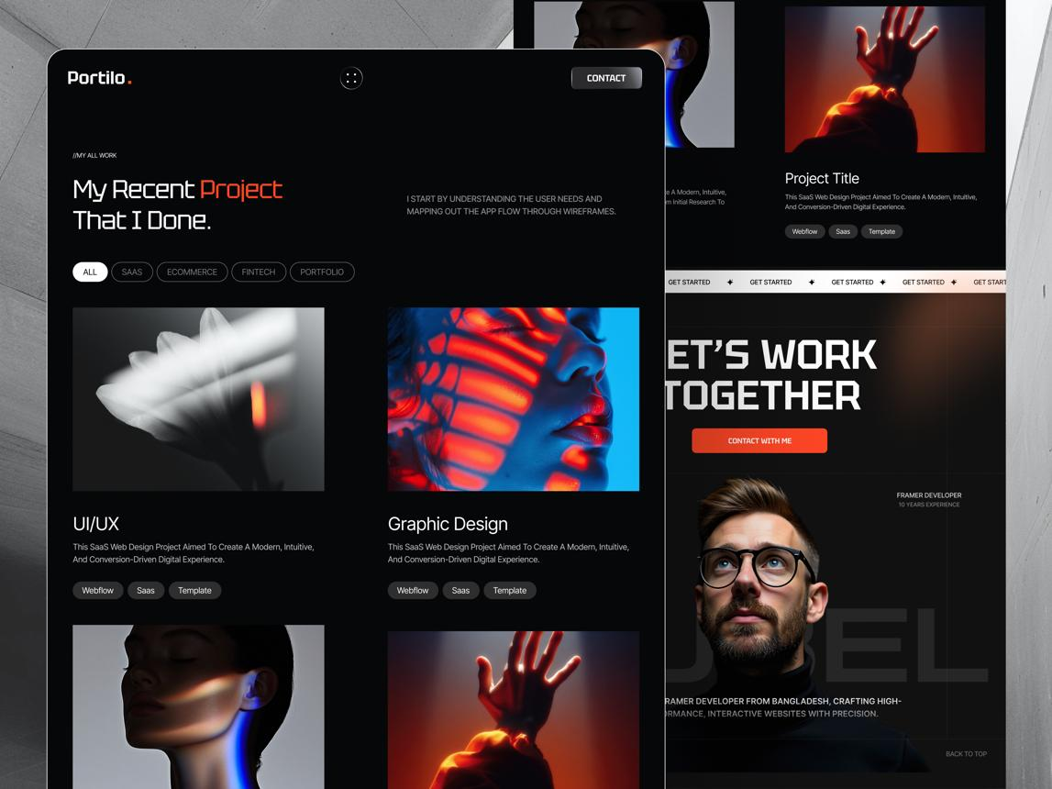
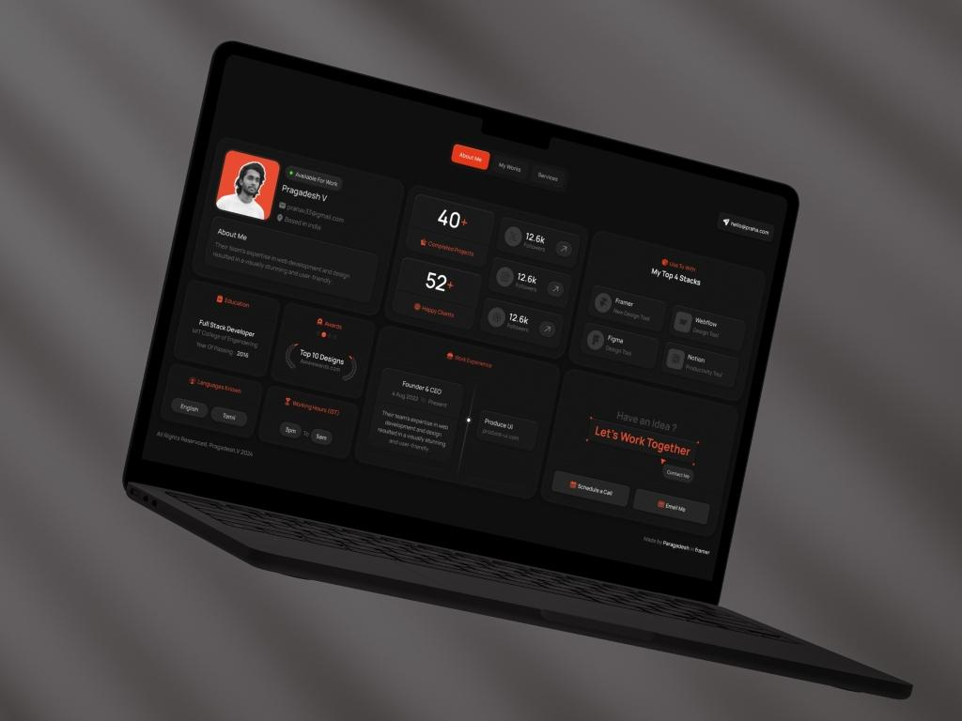
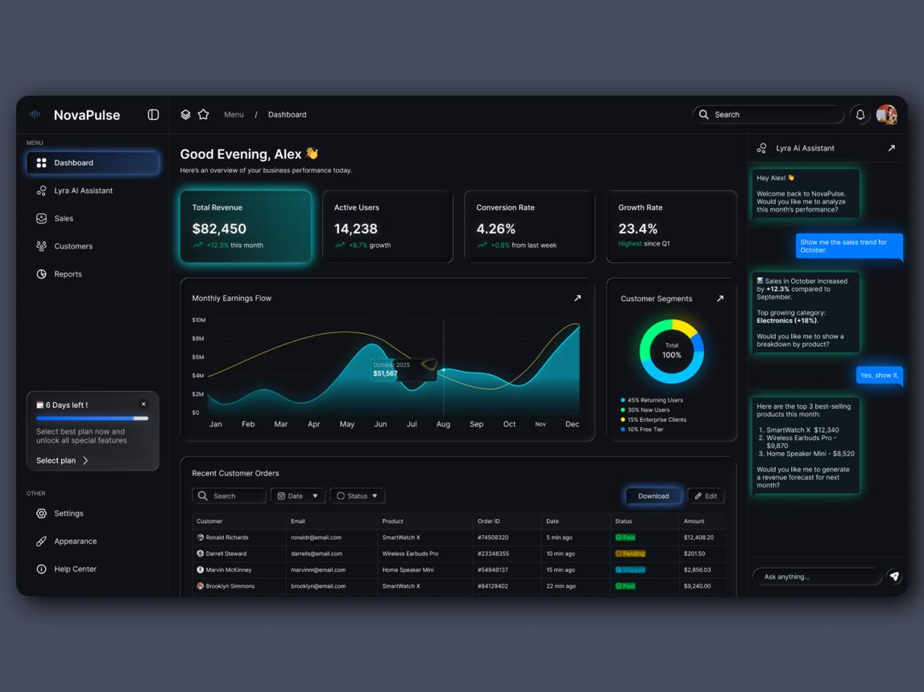
6
I would go with:
- 🌑 Dark-first interface
- ✨ Subtle gradients and glowing accents
- 🪟 Glass/soft-transparent cards
- 🎨 One primary accent color, such as electric blue, violet, or cyan
- 📱 Fully responsive
- 🎞️ Subtle animations, not excessive effects
- 🧩 Modular profile sections
- 📊 Professional dashboard
- 🔗 Shareable public portfolio URL
For example:
yourplatform.com/u/jean-pierre-joseph

1. Platform structure
I would divide the application into three major parts:
┌─────────────────────────┐
│ PORTFOLIO │
│ PLATFORM │
└────────────┬────────────┘
│
┌──────────────────┼──────────────────┐
│ │ │
▼ ▼ ▼
┌───────────┐ ┌───────────┐ ┌───────────┐
│ Frontend │ │ Backend │ │ Database │
│ React │◄────►│ API │◄────►│ MSSQL │
└───────────┘ └───────────┘ └───────────┘
│ │
▼ ▼
User Interface Authentication
Dashboard Business Logic
Portfolio Builder Authorization
Public Profiles Data Management

Frontend
React would handle:
- Landing page
- Login / registration
- Dashboard
- Portfolio editor
- Profile preview
- Project management
- Experience management
- Education management
- Skills
- Certifications
- Public portfolio
- Settings

Backend
The backend would handle:
- Authentication
- User accounts
- Authorization
- CRUD operations
- Portfolio management
- Image/file management
- Public profile retrieval
- Validation
- Security
- Database communication

Database
MSSQL would store things such as:
Users
Profiles
Projects
Experience
Education
Skills
Certifications
SocialLinks
PortfolioSettings
Messages

2. User experience
The most important part is that the user shouldn't have to understand the technical structure.
After registration:
Create Account
↓
Create Professional Profile
↓
Choose Portfolio Style
↓
Add Information
↓
Preview
↓
Publish
↓
yourplatform.com/u/username

3. Dashboard
The dashboard should feel like a professional SaaS application.
Something like:
┌──────────────────────────────────────────────────────────────┐
│ ◈ PROPORTFOLIO Jean ⚙ │
├───────────────┬──────────────────────────────────────────────┤
│ │ │
│ Dashboard │ Welcome back, Jean │
│ │ │
│ My Portfolio │ Your portfolio is 85% complete │
│ │ │
│ Projects │ ┌──────────┐ ┌──────────┐ ┌──────────┐ │
│ │ │ Projects │ │ Skills │ │ Views │ │
│ Experience │ │ 12 │ │ 18 │ │ 1,284 │ │
│ │ └──────────┘ └──────────┘ └──────────┘ │
│ Education │ │
│ │ Portfolio │
│ Skills │ ┌──────────────────────────────────────┐ │
│ │ │ │ │
│ Certificates │ │ Portfolio Preview │ │
│ │ │ │ │
│ Settings │ │ [View Portfolio] │ │
│ │ │ │ │
│ │ └──────────────────────────────────────┘ │
│ │ │
└───────────────┴──────────────────────────────────────────────┘

4. Portfolio editor
This is where your application can become much more interesting than a normal portfolio website.
Instead of forcing users to edit HTML, give them sections:
Portfolio Editor
Bio
Location
Profile Picture

[ About ]

Professional summary

[ Experience ]

+ Add Experience

Company
Position
Start Date
End Date
Description

[ Education ]

+ Add Education

School
Degree
Field
Graduation Date

[ Projects ]

+ Add Project

Project Name
Description
Technologies
GitHub
Live Demo
Project Image

[ Skills ]

+ Add Skill

Python
Java
React
SQL
Networking

[ Certifications ]

+ Add Certification

Certification
Organization
Date
Credential URL

[ Social Links ]

LinkedIn
GitHub
Website
YouTube

[ Save Draft ] [ Preview ] [ Publish ]
This makes it a portfolio builder, not simply a portfolio.

5. Public portfolio
The public-facing portfolio should be completely different from the dashboard.
For example:
┌──────────────────────────────────────────────────────────────┐
│ JP About Projects│
│ │
│ JEAN PIERRE JOSEPH │
│ Computer Engineer │
│ │
│ Building technology that connects │
│ hardware, software and intelligent systems. │
│ │
│ [ View Projects ] [ Contact ] │
│ │
├──────────────────────────────────────────────────────────────┤
│ │
│ ABOUT ME │
│ │
│ Professional summary... │
│ │
├──────────────────────────────────────────────────────────────┤
│ EXPERIENCE │
│ │
│ ─── Company │
│ Position │
│ Description │
│ │
├──────────────────────────────────────────────────────────────┤
│ PROJECTS │
│ │
│ ┌─────────────┐ ┌─────────────┐ ┌─────────────┐ │
│ │ Project │ │ Project │ │ Project │ │
│ │ │ │ │ │ │ │
│ └─────────────┘ └─────────────┘ └─────────────┘ │
│ │
├──────────────────────────────────────────────────────────────┤
│ SKILLS │
│ │
│ React Python Java SQL IoT Networking │
│ │
└──────────────────────────────────────────────────────────────┘

6. Database design
Since you're using MSSQL, I recommend keeping the database normalized rather than putting the entire portfolio into one giant Users table.
For example:

Users
Users
-------------------------
Id
Email
PasswordHash
Username
CreatedAt
UpdatedAt

Profiles
Profiles
-------------------------
Id
UserId
FirstName
LastName
ProfessionalTitle
Bio
Location
ProfileImage
Website
CreatedAt
UpdatedAt

Projects
Projects
-------------------------
Id
UserId
Title
Description
ImageUrl
GithubUrl
LiveUrl
CreatedAt
UpdatedAt

Experience
Experience
-------------------------
Id
UserId
Company
Position
Description
StartDate
EndDate
IsCurrent

Education
Education
-------------------------
Id
UserId
Institution
Degree
Field
StartDate
EndDate
Description

Skills
Skills
-------------------------
Id
UserId
Name
Level

Certifications
Certifications
-------------------------
Id
UserId
Name
Issuer
IssueDate
CredentialUrl

SocialLinks
SocialLinks
-------------------------
Id
UserId
Platform
Url
The important relationship is:
User
│
├── Profile
│
├── Projects
│
├── Experience
│
├── Education
│
├── Skills
│
├── Certifications
│
└── Social Links
That will make the platform much easier to expand later.

7. Backend API
Your React application shouldn't directly communicate with MSSQL.
Use:
React
│
│ HTTP / REST API
▼
Backend API
│
│ Database queries
▼
MSSQL
For example:
POST /api/auth/register
POST /api/auth/login
POST /api/auth/logout

GET /api/profile
PUT /api/profile

GET /api/projects
POST /api/projects
PUT /api/projects/:id
DELETE /api/projects/:id

GET /api/experience
POST /api/experience
PUT /api/experience/:id
DELETE /api/experience/:id

GET /api/education
POST /api/education
PUT /api/education/:id
DELETE /api/education/:id

GET /api/skills
POST /api/skills
DELETE /api/skills/:id
And for public portfolios:
GET /api/public/:username
So someone visiting:
yourplatform.com/u/jean-pierre-joseph
could cause the frontend to request:
GET /api/public/jean-pierre-joseph
and construct the portfolio from the returned information.

8. Authentication
Because this is a multi-user platform, authentication should be designed from the beginning.
You want:
Registration
↓
Password hashing
↓
Login
↓
Authentication token/session
↓
Authenticated dashboard
↓
User-specific data
Most importantly, every database record should be associated with the appropriate UserId.
That prevents something like:
Jean logs in and somehow edits John's projects.
Authorization belongs on the backend, not just the React frontend.

9. Professional/futuristic features
Once the core application works, you could add features that make it stand out:

Portfolio themes
Allow users to choose:
◉ Minimal
○ Professional
○ Creative
○ Futuristic
○ Developer
○ Academic

Portfolio preview
A live preview:
EDITOR PREVIEW

Name: Jean ┌───────────────────────┐
Title: Engineer │ JEAN PIERRE JOSEPH │
Bio: ... │ Computer Engineer │
│ │
│ About │
│ Projects │
│ Experience │
└───────────────────────┘

Completion indicator
Portfolio completion

████████████████░░░░ 82%

✓ Profile
✓ Experience
✓ Education
✓ Projects
✓ Skills
○ Certifications

Public/private control
Portfolio Visibility

● Public
○ Private

Custom URL
yourplatform.com/u/jean-pierre-joseph
Eventually:
jeanpierre.com
could point to the user's portfolio.

10. Recommended project structure
For React:
portfolio-platform/
│
├── frontend/
│ │
│ ├── src/
│ │ ├── components/
│ │ │ ├── Navbar/
│ │ │ ├── Sidebar/
│ │ │ ├── ProjectCard/
│ │ │ ├── ExperienceCard/
│ │ │ └── SkillBadge/
│ │ │
│ │ ├── pages/
│ │ │ ├── Landing/
│ │ │ ├── Login/
│ │ │ ├── Register/
│ │ │ ├── Dashboard/
│ │ │ ├── ProfileEditor/
│ │ │ ├── Projects/
│ │ │ └── PublicPortfolio/
│ │ │
│ │ ├── services/
│ │ │ └── api.js
│ │ │
│ │ ├── context/
│ │ │ └── AuthContext.jsx
│ │ │
│ │ ├── App.jsx
│ │ └── main.jsx
│ │
│ └── package.json
│
├── backend/
│ │
│ ├── controllers/
│ ├── routes/
│ ├── middleware/
│ ├── models/
│ ├── services/
│ ├── config/
│ ├── server.js
│ └── package.json
│
├── database/
│ ├── schema.sql
│ ├── seed.sql
│ └── migrations/
│
├── README.md
└── .gitignore
This is a much better architecture for your idea than putting everything into a single React project.
And because you already have experience with React, Java, SQL, networking, IoT, and full-stack projects, this could become a very strong portfolio project itself: you're demonstrating not only that you can build a website, but that you understand frontend architecture, APIs, authentication, database design, CRUD, security, and deployment.

I would build it in this order
Phase 1 — Foundation
- Create React frontend
- Create backend API
- Create MSSQL database
- Establish frontend → backend → database communication
Phase 2 — Authentication
5. Registration
6. Login
7. Logout
8. Protected dashboard
9. User authorization
Phase 3 — Portfolio
10. Profile
11. Projects
12. Experience
13. Education
14. Skills
15. Certifications
16. Social links
Phase 4 — Publishing
17. Portfolio preview
18. Public portfolio URL
19. Publish/unpublish
20. Portfolio themes
Phase 5 — Professional polish
21. Responsive design
22. Dark/futuristic UI
23. Animations
24. Image handling
25. Validation/error handling
26. Deployment
27. Documentation
That gives you a real full-stack portfolio SaaS platform, not just another static portfolio site

Absolutely. Since we already have the platform concept and the public URL structure, I recommend we build it like a real production platform, not just as a portfolio CRUD exercise.
We'll go from A → Z, but in controlled checkpoints so you always know what we're doing and why.

🚀 Platform concept
For now, let's call it PortfolioHub as a working name. We can rename it later.
The platform will allow someone to:
- Create an account
- Log in securely
- Build their professional profile
- Create their public portfolio
- Add projects
- Add education
- Add work experience
- Add skills
- Add certifications
- Add social/professional links
- Customize their portfolio
- Publish/unpublish their portfolio
- Share it through a URL such as:
yourplatform.com/u/jeanjoseph56
Visitors can view public portfolios without logging in.

🏗️ Overall architecture
We're going to build three major layers:
┌─────────────────────┐
│ VISITOR │
└──────────┬──────────┘
│
▼
/u/jeanjoseph56
│
▼
┌──────────────────────────────────────────────────────┐
│ REACT FRONTEND │
│ │
│ Landing Page │
│ Login / Register │
│ Dashboard │
│ Profile Editor │
│ Projects │
│ Experience │
│ Education │
│ Skills │
│ Certifications │
│ Public Portfolio │
└──────────────────────────┬───────────────────────────┘
│
│ HTTP / JSON
▼
┌──────────────────────────────────────────────────────┐
│ BACKEND API │
│ │
│ Authentication │
│ User Management │
│ Portfolio Management │
│ Projects │
│ Experience │
│ Education │
│ Skills │
│ Certifications │
│ Public Profiles │
└──────────────────────────┬───────────────────────────┘
│
▼
┌──────────────────────────────────────────────────────┐
│ MICROSOFT SQL SERVER │
│ │
│ Users │
│ Profiles │
│ Projects │
│ Experience │
│ Education │
│ Skills │
│ Certifications │
│ SocialLinks │
└──────────────────────────────────────────────────────┘
This is a much better fit for the platform you described than putting everything directly in React.

🧭 Our A → Z roadmap
We'll follow this order.

Phase 1 — Foundation
Step 1: Define the project architecture
Step 2: Create the React frontend
Step 3: Create the backend API
Step 4: Create the SQL Server database
Step 5: Connect backend → SQL Server
Step 6: Connect React → backend

Phase 2 — Authentication
Step 7: Registration
Step 8: Password hashing
Step 9: Login
Step 10: Sessions/JWT authentication
Step 11: Logout
Step 12: Protected routes

Phase 3 — User identity
Step 13: User profile
Step 14: Username generation
Step 15: Username availability checking
Step 16: Change username
Step 17: Public URL
Example:
/u/jeanjoseph56

Phase 4 — Portfolio builder
Step 18: Professional summary
Step 19: Profile picture
Step 20: Contact information
Step 21: Skills
Step 22: Education
Step 23: Work experience
Step 24: Projects
Step 25: Certifications
Step 26: Social links

Phase 5 — Portfolio presentation
Step 27: Public portfolio layout
Step 28: Professional navigation
Step 29: Hero section
Step 30: About section
Step 31: Skills section
Step 32: Experience section
Step 33: Projects section
Step 34: Education section
Step 35: Certifications section
Step 36: Contact/social section

Phase 6 — Portfolio management
Step 37: Dashboard
Step 38: Edit profile
Step 39: Add/edit/delete projects
Step 40: Add/edit/delete experience
Step 41: Add/edit/delete education
Step 42: Add/edit/delete certifications
Step 43: Preview portfolio
Step 44: Publish/unpublish

Phase 7 — Professional features
Step 45: Portfolio themes
Step 46: Theme customization
Step 47: Responsive design
Step 48: SEO metadata
Step 49: Social sharing
Step 50: Copy portfolio link
Step 51: Public portfolio search

Phase 8 — Security & production
Step 52: Input validation
Step 53: Authorization
Step 54: SQL injection protection
Step 55: Rate limiting
Step 56: Error handling
Step 57: Environment variables
Step 58: Production configuration
Step 59: Deployment
Step 60: Testing
That gives us a real portfolio platform, rather than simply a portfolio website.

📁 Step 1 — Project structure
I recommend a single project containing separate frontend and backend applications:
portfolio-platform/
│
├── frontend/
│ ├── public/
│ ├── src/
│ │ ├── assets/
│ │ ├── components/
│ │ ├── pages/
│ │ ├── layouts/
│ │ ├── services/
│ │ ├── context/
│ │ ├── hooks/
│ │ ├── styles/
│ │ ├── App.jsx
│ │ └── main.jsx
│ │
│ ├── package.json
│ └── vite.config.js
│
├── backend/
│ ├── src/
│ │ ├── config/
│ │ ├── controllers/
│ │ ├── middleware/
│ │ ├── models/
│ │ ├── routes/
│ │ ├── services/
│ │ ├── utils/
│ │ └── server.js
│ │
│ ├── .env
│ ├── package.json
│ └── .gitignore
│
├── database/
│ ├── schema/
│ ├── seed/
│ └── migrations/
│
├── README.md
└── .gitignore

Why separate frontend and backend?
Because eventually you'll have:
React
↓
REST API
↓
Business logic
↓
SQL Server
rather than:
React
↓
Database
That separation is much more professional and gives you a strong portfolio project to talk about.

🛠️ Step 2 — Technologies
For your platform, I'd use:

Frontend
- React
- Vite
- React Router
- CSS
- Fetch/Axios

Backend
- Node.js
- Express
- REST API
- Authentication middleware

Database
- Microsoft SQL Server

Development
- VS Code
- Git
- GitHub
- .env configuration
We can add things such as image storage, email verification, or deployment later rather than complicating the initial setup.

🗄️ Step 3 — Database design
Before writing the backend, we should design the database correctly.
At minimum:
Users
Profiles
Projects
Experience
Education
Skills
Certifications
SocialLinks
The relationships will look approximately like:
Users
│
│ 1:1
▼
Profiles
│
┌────────────┼────────────┐
│ │ │
▼ ▼ ▼
Projects Experience Education
│
│
├──────── Skills
│
├──────── Certifications
│
└──────── SocialLinks
And importantly:
Users
├── Email
├── PasswordHash
└── Username
│
▼
/u/:username
So your public portfolio doesn't need to expose the user's email address.

🔐 One architectural decision I want us to make now
For authentication, don't store passwords as plain text.
We will eventually have:
Email
Password
↓
Password hashing
↓
PasswordHash
↓
SQL Server
The database should never contain:
Password = MyPassword123
Instead it contains a secure password hash.
We'll implement this when we reach authentication.

🎨 And the UI
Since you want a futuristic, professional portfolio platform, I would build the interface around something like:
┌──────────────────────────────────────────────────────┐
│ PORTFOLIOHUB Login Sign Up │
├──────────────────────────────────────────────────────┤
│ │
│ BUILD YOUR PROFESSIONAL IDENTITY │
│ │
│ Create a portfolio that represents you. │
│ │
│ [ Create Your Portfolio ] │
│ │
├──────────────────────────────────────────────────────┤
│ │
│ Explore Professionals │
│ │
│ ┌──────────┐ ┌──────────┐ ┌──────────┐ │
│ │ Photo │ │ Photo │ │ Photo │ │
│ │ │ │ │ │ │ │
│ │ Jean │ │ Sarah │ │ Michael │ │
│ │ Engineer │ │ Designer │ │ Developer│ │
│ └──────────┘ └──────────┘ └──────────┘ │
│ │
└──────────────────────────────────────────────────────┘
Then a public portfolio could look like:
┌──────────────────────────────────────────────────────┐
│ │
│ JEAN PIERRE JOSEPH │
│ Computer Engineer │
│ │
│ AI • IoT • Networking • Software │
│ │
│ [ LinkedIn ] [ GitHub ] [ Contact ] │
│ │
├──────────────────────────────────────────────────────┤
│ │
│ ABOUT │
│ │
│ Professional summary... │
│ │
├──────────────────────────────────────────────────────┤
│ │
│ EXPERIENCE │
│ │
│ ── Company │
│ Position │
│ 2025 – Present │
│ │
├──────────────────────────────────────────────────────┤
│ │
│ PROJECTS │
│ │
│ ┌─────────────┐ ┌─────────────┐ │
│ │ Project │ │ Project │ │
│ │ │ │ │ │
│ └─────────────┘ └─────────────┘ │
│ │
└──────────────────────────────────────────────────────┘

🚦 Let's actually start
Don't create the database yet.
Since we're doing this step-by-step, our first practical checkpoint should be:

Step 1A — Create the project
Open VS Code and create a folder:
portfolio-platform
Then open that folder in VS Code.
Open the VS Code terminal and run:
npm create vite@latest frontend -- --template react
Then:
cd frontend
npm install
npm install react-router-dom
Then start it:
npm run dev
You should get a local address similar to:
http://localhost:5173

Stop here after that.
Once the Vite React application opens successfully, tell me “frontend is running”.
Then we'll do Step 1B: clean the Vite starter project and build the professional foundation/layout, before we touch the backend or SQL Server. That way we won't mix five different things together and make troubleshooting difficult.

