MERIDIAN TECHNOLOGIES · BOARD STRATEGIC REVIEW · CONFIDENTIAL
Meridian has one healthy engine, one stalling engine, and one burning — and twelve months to decide which bets to make before the AI window closes.

Catherine Park, CEO · Annual Board Strategic Review · Opening Remarks (~5 min)
Opening
Thank you. My five minutes, used directly. This is my first annual review as your CEO. I have spent the year making early bets — segment reorg, AI acquisition, harder line on SMB. I believe those were right. But I'm not here to declare victory. I'm here to tell you what worries me and what I need from this board.
ISSUE 1 OF 3 The AI race: early signs of life, but we are not yet safe.
Copilot hit GA in September: 710 paying seats, 44% attach on Q4 enterprise renewals, $3.5M ARR. Early proof points — not yet a growth driver. Meanwhile Asana bundled AI into its standard tier; Monday surpassed us by ARR; Atlassian's agentic Jira enters our enterprise deals directly for the first time. Our magic number fell from 1.20 to 0.92 over eight quarters (meridian_kpis_2024.csv); CAC payback stretched from 18 to 22 months. R&D is at 25.4% of revenue — highest since IPO — and it is not yet showing up in growth. The board needs to weigh in on one pricing question: hold $40/seat add-on or bundle Copilot into mid-market to defend NRR? That is a strategic decision, not a product one.
ISSUE 2 OF 3 Mid-market erosion: the hidden time bomb.
Mid-market is 47% of our ARR — $194M — our single largest segment. NRR has compressed from 115% in 2022 to 102% today, declining every single quarter for three years (Chart 4). Gross logo churn has risen from 9.1% to 10.2%. At 102%, mid-market is barely generating net expansion — two quarters away from shrinking in absolute ARR. (meridian_segments_overview.md; meridian_kpis_2024.csv)
The trigger is live: Asana bundles AI at no extra charge and our customers know it. The resource management module — top-three customer ask — has been deferred twice, now to Q2 2026. We have no specific intervention yet that breaks the compression curve. This is the issue that can be invisible in the headlines until it isn't.
ISSUE 3 OF 3 Organizational capacity: the binding constraint on all of it.
We are running five parallel tracks in 2026: Helio integration, new AI product suite, pricing model transition, three segment P&Ls going live, and Investor Day in six weeks. The survey is clear: 31% of engineers cited 'roadmap thrash' — three AI pivots in 18 months. 19% company-wide said they no longer know what Meridian stands for. Six of twelve 2025 commitments slipped; two were deferred. (meridian_employee_survey_2025.md; meridian_product_roadmap_2025.md)
For the Compensation Committee: 27% of senior engineers flagged pay. People team estimates 15–25 at imminent attrition risk. Helio's cash cliff arrives in 2026 — if that team unwinds early, the agent-builder roadmap loses its architects.

My One Ask of This Board
Plan approval comes at Investor Day, March 11. Today I have one ask: a board position on mid-market Copilot pricing before we leave this room. Hold $40/seat add-on and accept potential NRR compression — or authorize a Q1 bundling trial for mid-market renewals to defend the segment? That decision touches 2026 revenue guidance, operating margin, and competitive positioning. It cannot wait until March. Everything else I can manage. This one I need the board to own with me.

Supporting Data — Quantitative Deep-Dive
The 12-panel chart below covers all key trends cited above. Panels 4 and 12 are most directly relevant to Issue 2. Panel 6 (magic number / CAC payback) supports Issue 1. Full data sources: meridian_financials_2022_2025.csv and meridian_kpis_2024.csv.
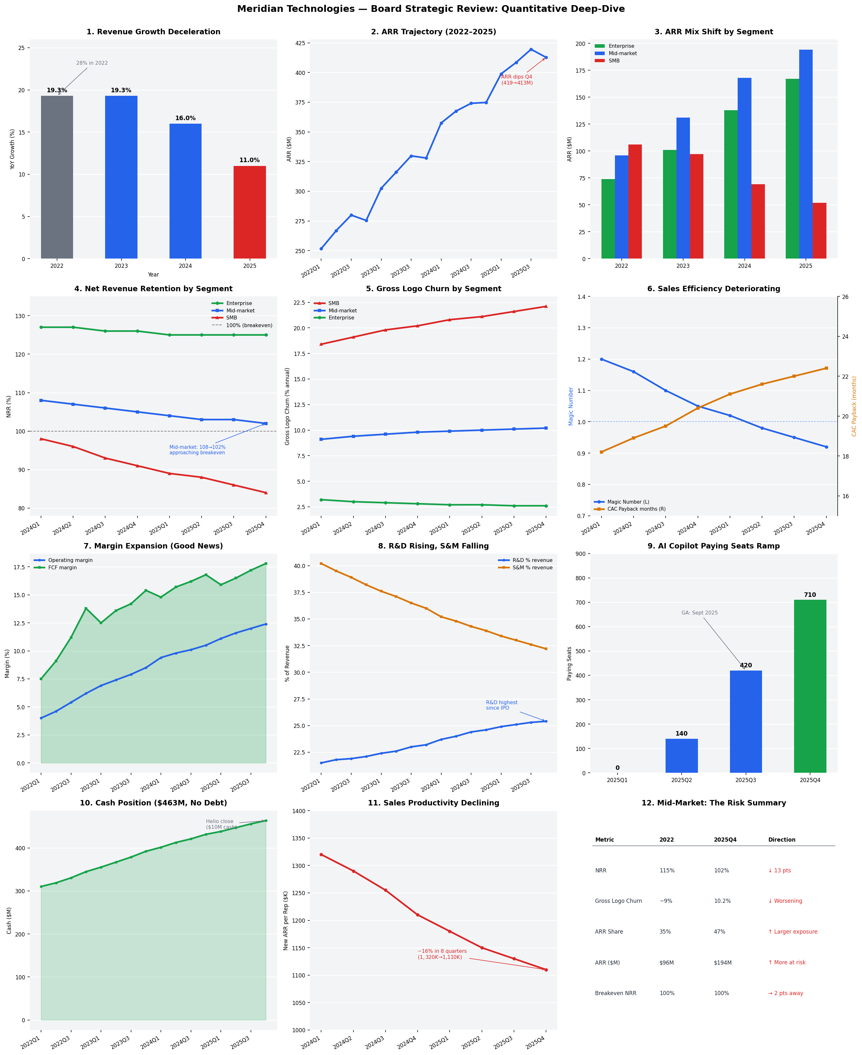
Figure 1: Meridian Technologies — Board Strategic Review Quantitative Deep-Dive | Source: meridian_financials_2022_2025.csv, meridian_kpis_2024.csv
I am proud of what this team has done in a difficult year. I am clear-eyed about what remains undone. Let's get to work.
Confidential — prepared for the Meridian Technologies Board of Directors. Not for distribution.

